Volume 05. Path Planning and Autonomous Navigation

Chapter 12. Reversing and Parking

12.1 Reversing Control Fundamentals
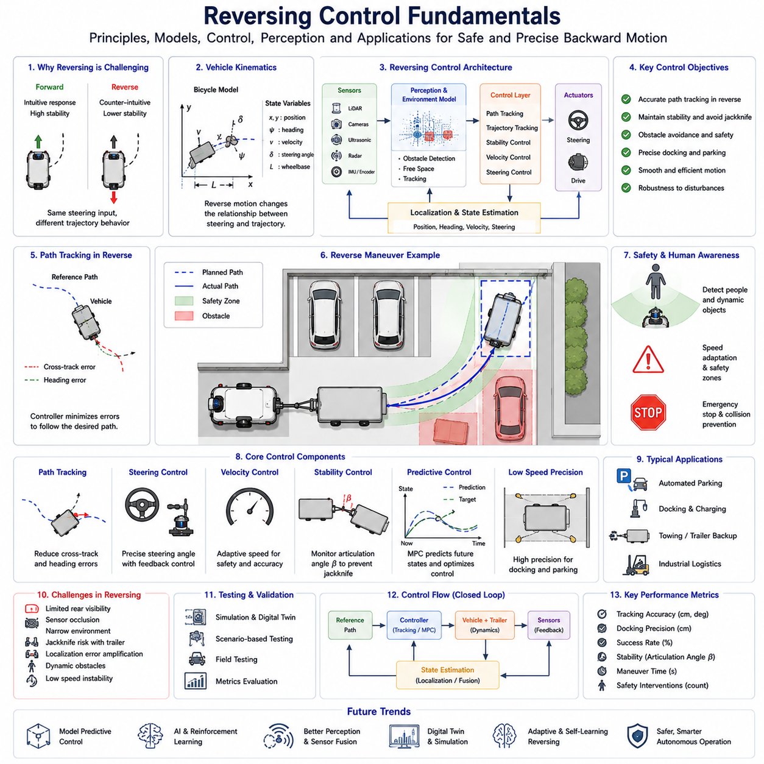

Reversing Control Fundamentals form the foundation of autonomous backward driving, trailer maneuvering, automated parking, docking operations, and precision positioning systems used in modern Autonomous Mobile Robots (AMRs), autonomous vehicles, industrial towing robots, autonomous forklifts, and logistics automation platforms. While forward motion is generally considered a stable and relatively straightforward control problem, reversing introduces a completely different set of dynamic behaviors, control challenges, safety concerns, and vehicle response characteristics. Understanding these fundamentals is essential for designing reliable autonomous systems capable of performing accurate backward movements in confined industrial environments.
The complexity of reversing control arises primarily from the fact that most ground vehicles are designed around forward motion. Steering geometry, vehicle kinematics, sensor placement, perception systems, and path planning algorithms are naturally optimized for forward travel. When a vehicle moves backward, many of these assumptions become invalid. Vehicle response characteristics change significantly, sensor visibility often decreases, and stability margins become smaller. As a result, reversing control requires dedicated algorithms and specialized control strategies rather than simply applying forward driving algorithms in reverse.
From a kinematic perspective, reversing alters the relationship between steering inputs and vehicle trajectory evolution. During forward motion, steering the front wheels to the left generally causes the vehicle heading to rotate left while the vehicle progresses along a predictable path. During reverse motion, the same steering action may produce a trajectory that appears counterintuitive because the vehicle's center of rotation shifts relative to the direction of travel. This reversal of motion dynamics requires careful mathematical modeling and control system design.
The fundamental mathematical representation of reversing motion begins with vehicle kinematic models. The most widely used model is the bicycle model, which simplifies the vehicle into a single front steering wheel and a single rear wheel while preserving the essential geometric relationships. The bicycle model allows engineers to analyze vehicle position, heading angle, steering angle, velocity, wheelbase, and turning radius. Although simplified, this model provides valuable insights into reversing behavior and serves as the foundation for many autonomous driving controllers.
In autonomous robotics, vehicle state estimation plays a critical role in reversing control. The robot must continuously estimate its position, orientation, velocity, steering angle, and surrounding environment. Localization systems based on LiDAR, cameras, GNSS, IMU sensors, wheel encoders, and sensor fusion algorithms provide the information required for accurate control. Since reversing often occurs in confined environments where precision is essential, localization accuracy requirements are typically higher than those for ordinary forward navigation.
One of the most important concepts in reversing control is path tracking. Path tracking refers to the process of guiding a vehicle along a predefined trajectory while minimizing deviations from the desired path. During reverse motion, path tracking becomes more challenging because vehicle dynamics are less stable and tracking errors can grow rapidly if not corrected promptly. Small steering errors that may be insignificant during forward motion can produce substantial deviations during reversing maneuvers.
Path tracking controllers must therefore continuously monitor lateral position error, heading error, curvature error, and velocity error. These errors are used to calculate steering commands that guide the vehicle back toward the desired trajectory. The controller must achieve an appropriate balance between responsiveness and stability. Excessively aggressive corrections may introduce oscillations, while overly conservative corrections may result in large tracking errors.
Several control strategies are commonly used for reversing operations. Pure Pursuit control is one of the simplest and most widely adopted approaches. The controller identifies a look-ahead point on the desired path and computes the steering angle required to reach that point. Although effective in many applications, Pure Pursuit often requires modifications when applied to reverse driving because the geometric assumptions differ from those of forward motion.
Stanley controllers represent another widely used approach. Originally developed for autonomous vehicle applications, Stanley control combines heading error and lateral position error to generate steering commands. When adapted for reverse operation, the controller must account for the reversed relationship between steering actions and vehicle movement. Proper tuning is essential to maintain stability and prevent oscillatory behavior.
Model Predictive Control (MPC) has become increasingly popular for advanced reversing applications. MPC uses a mathematical model to predict future vehicle states over a finite time horizon. At each control cycle, the controller evaluates multiple possible steering sequences and selects the one that minimizes a predefined cost function. This optimization framework allows the controller to consider vehicle dynamics, steering constraints, obstacle avoidance requirements, and safety margins simultaneously. MPC is particularly valuable for reversing because it can anticipate future instability and compensate proactively.
The concept of stability is central to reversing control. Stability refers to the ability of the vehicle to maintain controlled motion despite disturbances, modeling errors, or environmental variations. During reverse motion, many vehicle configurations exhibit reduced stability compared to forward motion. Small deviations can grow rapidly, especially when towing trailers or operating in narrow spaces. Therefore, stability monitoring and stabilization mechanisms are often integrated into autonomous reversing systems.
Steering control plays a significant role in reversing performance. The steering system must provide precise angle control, low latency, and consistent response characteristics. Steering errors directly influence trajectory tracking accuracy. Advanced control systems often incorporate steering feedback loops that continuously monitor actual steering angle and compensate for mechanical imperfections, actuator delays, and nonlinear steering behavior.
Velocity control is equally important. Reversing maneuvers are generally performed at relatively low speeds to maximize safety and improve controllability. Lower speeds provide additional reaction time for obstacle avoidance and reduce the consequences of potential collisions. However, excessively slow movement may reduce operational efficiency. Therefore, autonomous systems typically implement adaptive speed control that adjusts vehicle velocity according to environmental complexity, available free space, localization confidence, and mission requirements.
Perception systems provide the environmental awareness necessary for safe reversing operations. LiDAR sensors generate three-dimensional or two-dimensional representations of nearby obstacles. Cameras provide visual information regarding environmental features, parking spaces, docking targets, and human activity. Ultrasonic sensors offer highly accurate short-range distance measurements. Radar sensors contribute robust obstacle detection under adverse environmental conditions. Sensor fusion combines information from multiple sources to create a comprehensive environmental model.
Obstacle avoidance during reverse motion requires specialized consideration. The area behind the vehicle often contains limited visibility and restricted maneuvering space. Dynamic obstacles such as pedestrians, forklifts, carts, and other robots may enter the reversing path unexpectedly. Therefore, autonomous systems continuously monitor safety zones and update collision predictions throughout the maneuver. Predictive algorithms estimate future obstacle positions and adjust trajectories accordingly.
Human safety remains one of the highest priorities in reversing operations. Industrial environments frequently involve close interaction between robots and personnel. Human-aware navigation systems monitor pedestrian behavior, estimate movement trajectories, and maintain appropriate safety margins. Dynamic safety zones expand or contract based on vehicle speed, environmental conditions, and risk assessments. Emergency stop systems provide an additional layer of protection in situations where collision risk becomes unacceptable.
Automated parking systems represent a practical application of reversing control principles. Parking tasks require the vehicle to maneuver into constrained spaces while satisfying geometric and environmental constraints. Parallel parking, perpendicular parking, angled parking, and industrial docking procedures all rely heavily on precise reverse motion control. These applications combine path planning, trajectory generation, localization, obstacle detection, and closed-loop control into a unified operational framework.
Docking operations introduce additional precision requirements. Autonomous robots frequently need to align accurately with charging stations, conveyor systems, loading docks, manufacturing equipment, storage racks, and transfer mechanisms. Positioning errors of only a few centimeters may cause docking failure. Consequently, reversing control systems often transition into high-precision operating modes as the vehicle approaches its final target.
Trajectory planning serves as a bridge between navigation and control. The trajectory planner generates feasible motion profiles that satisfy vehicle kinematic constraints while avoiding obstacles. During reversing operations, trajectory generation algorithms must account for steering limitations, minimum turning radius requirements, available free space, and dynamic safety margins. Common planning approaches include Hybrid A*, lattice planning, optimization-based trajectory generation, and sampling-based methods.
The presence of trailers introduces an entirely new level of complexity. Articulated vehicle systems exhibit highly nonlinear behavior during reverse motion. Small steering inputs may generate large trailer movements, and instability can develop rapidly if articulation angles are not properly controlled. This phenomenon is commonly referred to as jackknifing. Preventing jackknife conditions requires continuous monitoring of hitch angles, predictive control algorithms, and trailer-aware path planning strategies.
Environmental conditions significantly influence reversing performance. Floor friction, surface irregularities, slopes, weather conditions, lighting variations, and sensor contamination can all affect vehicle behavior. Industrial systems must therefore incorporate robust control strategies capable of adapting to changing environmental conditions. Adaptive control, gain scheduling, and machine learning techniques are increasingly being used to improve robustness.
Testing and validation play essential roles in reversing control development. Simulation environments allow engineers to evaluate algorithms across thousands of scenarios before deploying physical vehicles. Digital twins replicate vehicle dynamics, sensor characteristics, environmental conditions, and operational workflows. Field testing then verifies system performance under real-world conditions. Performance metrics typically include tracking accuracy, docking precision, maneuver completion time, obstacle avoidance success rate, stability indicators, and safety intervention frequency.
Modern autonomous systems increasingly leverage artificial intelligence to enhance reversing performance. Machine learning algorithms can identify complex patterns within operational data and improve controller performance over time. Reinforcement learning approaches enable autonomous systems to learn optimal reversing behaviors through extensive simulation training. Vision-language models and embodied AI systems may eventually support higher-level reasoning during reversing tasks, enabling more adaptive and intelligent behavior.
The future of reversing control is expected to combine classical control theory, optimization methods, digital twins, artificial intelligence, and cloud-connected robotics platforms. Autonomous systems will become increasingly capable of handling complex reverse maneuvers, adapting to unfamiliar environments, learning from operational experience, and collaborating with other robots and human workers. As industrial automation continues to expand, reversing control fundamentals will remain a critical discipline underpinning autonomous parking, docking, towing, logistics automation, warehouse robotics, smart manufacturing systems, and next-generation autonomous mobility platforms.
Ultimately, reversing control fundamentals provide the theoretical and practical framework necessary for safe, reliable, and efficient backward motion. Mastery of these principles enables autonomous systems to perform tasks that were once considered difficult even for experienced human operators. Whether applied to a compact warehouse robot, a hospital logistics platform, a towing AMR, an autonomous forklift, or a large industrial transport vehicle, reversing control remains one of the most important capabilities in the field of autonomous navigation and robotic mobility.

12.2 Backward Path Planning
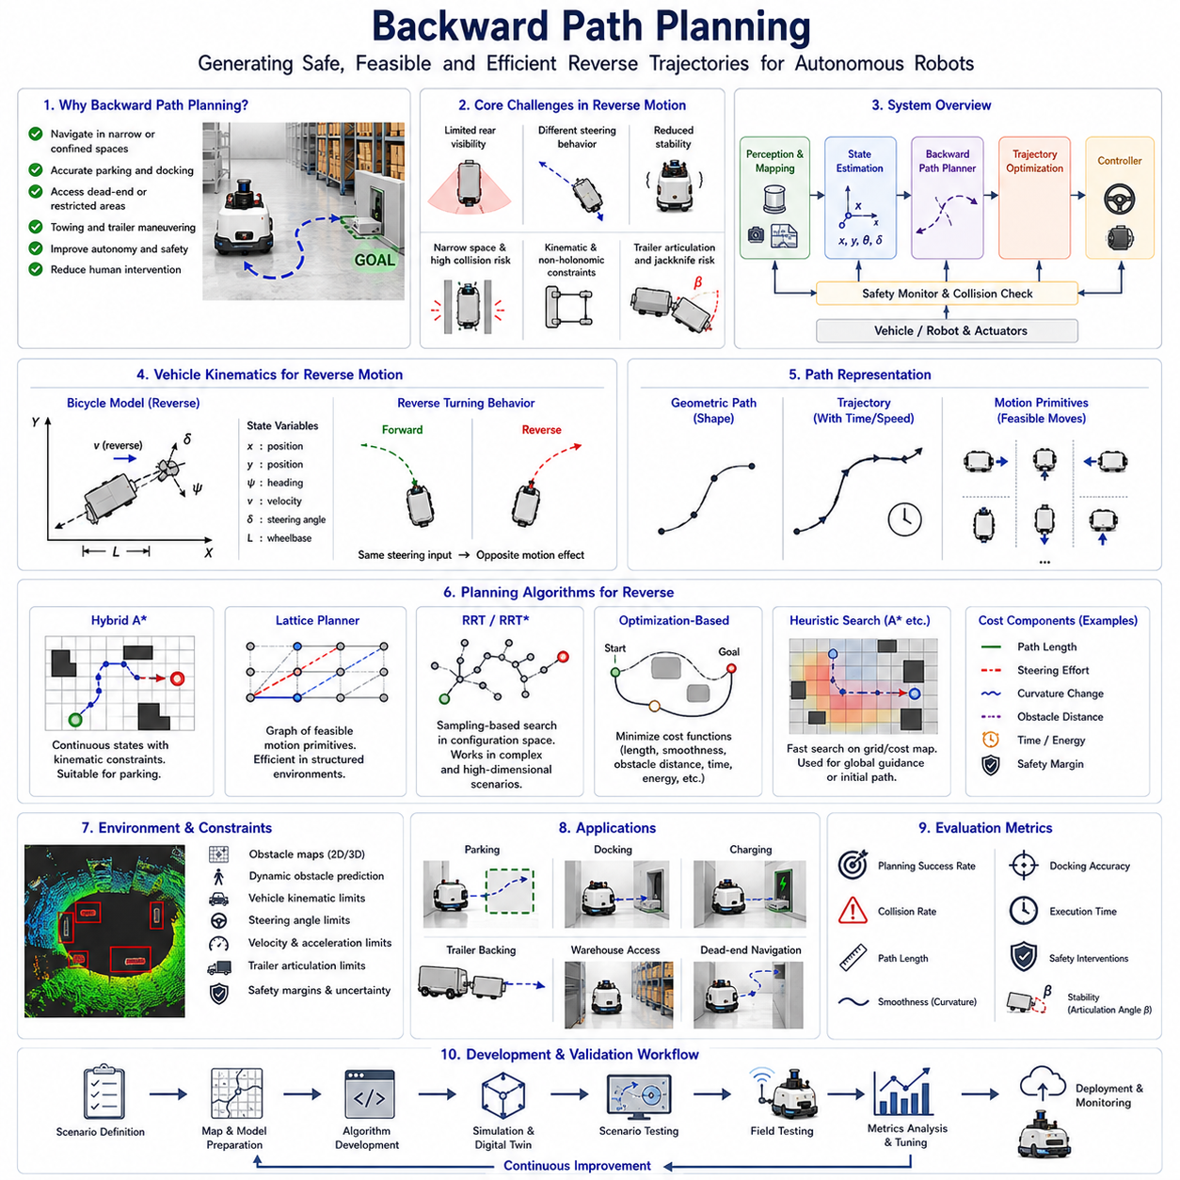
Backward Path Planning is a specialized field within autonomous navigation that focuses on generating safe, feasible, and efficient trajectories for vehicles and robots operating in reverse. Unlike conventional path planning, which primarily assumes forward vehicle motion, backward path planning must consider unique kinematic constraints, reduced stability, limited sensor visibility, altered steering behavior, and increased collision risk. These challenges become even more significant in industrial environments where Autonomous Mobile Robots (AMRs), autonomous forklifts, towing robots, automated guided vehicles, warehouse transport systems, and outdoor autonomous platforms frequently perform reverse maneuvers within confined spaces.
The importance of backward path planning has increased significantly as modern robotic systems have become more autonomous and capable of performing complex logistics operations. Many industrial tasks require robots to enter narrow loading areas, align precisely with docking stations, position trailers into storage locations, access charging stations, navigate dead-end corridors, and maneuver within highly constrained workspaces. In such situations, reverse driving is not simply an optional capability but an operational necessity. Effective backward path planning enables robots to complete these tasks safely, efficiently, and without requiring human intervention.
The fundamental objective of backward path planning is to compute a collision-free trajectory that guides a vehicle from its current state to a desired target state while satisfying all vehicle kinematic, dynamic, environmental, and safety constraints. The target state typically includes position, orientation, velocity, and sometimes articulation angles for trailer systems. Unlike forward navigation, where multiple feasible paths may exist, backward planning often operates under more restrictive conditions because steering behavior and motion dynamics become more constrained.
The theoretical foundation of backward path planning begins with vehicle kinematics. Every ground vehicle possesses a set of motion constraints that determine how it can move. These constraints include wheelbase geometry, steering limits, turning radius limitations, velocity boundaries, acceleration capabilities, and tire-ground interaction characteristics. During reverse motion, the relationship between steering input and vehicle trajectory changes significantly. Consequently, path planning algorithms must incorporate reverse-specific kinematic models to accurately predict vehicle behavior.
The bicycle model is one of the most widely used representations for backward planning. This model simplifies the vehicle into a single front steering wheel and a single rear wheel while preserving the essential geometric characteristics. The bicycle model enables path planners to estimate future vehicle states and evaluate whether a candidate path is physically feasible. More advanced systems may employ multi-body vehicle models, articulated vehicle models, or dynamic models that incorporate inertia, tire forces, and suspension effects.
One of the defining characteristics of backward path planning is non-holonomic motion constraints. Most wheeled vehicles cannot move freely in arbitrary directions. Instead, they must follow trajectories consistent with their steering and wheel configurations. This constraint significantly reduces the set of feasible paths and increases planning complexity. Path planners must therefore generate trajectories that respect vehicle motion limitations while still achieving the desired goal.
Path representation plays an important role in backward planning. Several trajectory formats are commonly used. Geometric paths represent the spatial route without specifying timing information. Trajectories extend geometric paths by incorporating velocity and acceleration profiles. Motion primitives represent predefined feasible vehicle movements that can be combined to construct more complex maneuvers. In reverse navigation systems, motion primitives often include specialized backward movements, reverse turns, parking maneuvers, and docking approaches.
Search-based planning algorithms are widely used for backward path generation. One of the most influential methods is Hybrid A*. Hybrid A* extends the traditional A* algorithm by incorporating continuous vehicle states and kinematic feasibility constraints. Unlike grid-based A*, which generates unrealistic vehicle motions, Hybrid A* produces smooth, executable trajectories suitable for real-world vehicles. The algorithm explores forward and backward motion primitives simultaneously and selects the optimal path according to predefined cost functions.
Hybrid A* is particularly effective for parking applications because it naturally handles orientation constraints and narrow-space maneuvering. The planner evaluates multiple candidate trajectories while considering vehicle dimensions, obstacle proximity, steering effort, path length, and maneuver complexity. The resulting trajectory often includes a combination of forward and reverse segments that minimize total navigation cost.
Another widely used approach is lattice-based planning. Lattice planners construct a graph of feasible vehicle states connected by precomputed motion primitives. The planner searches this graph to identify a collision-free path from the initial state to the goal state. Since all motion primitives satisfy vehicle kinematic constraints, every generated path is inherently feasible. Lattice planning is especially useful in structured environments such as warehouses, factories, ports, and logistics facilities where predictable navigation behavior is required.
Sampling-based methods such as Rapidly Exploring Random Trees (RRT), RRT*, and Probabilistic Roadmaps (PRM) can also be applied to backward path planning. These algorithms explore the vehicle configuration space by generating random samples and connecting feasible states. Sampling-based planners are particularly effective in complex environments with high-dimensional state spaces. However, additional mechanisms are often required to ensure smooth and controllable reverse trajectories.
Optimization-based planning has become increasingly popular due to advances in computational power and numerical optimization techniques. In optimization-based planning, the trajectory generation problem is formulated as a mathematical optimization task. The planner minimizes a cost function while satisfying all constraints. Typical cost terms include path length, steering effort, curvature variation, obstacle proximity, travel time, energy consumption, and safety margins. Optimization frameworks can generate highly smooth and efficient backward trajectories suitable for industrial automation applications.
Obstacle avoidance represents one of the most critical aspects of backward path planning. Reverse maneuvers frequently occur in confined spaces where obstacle clearance is limited. Warehouses, manufacturing facilities, hospitals, airports, and logistics centers often contain shelves, machinery, walls, pallets, workstations, parked vehicles, and human workers. The path planner must account for these obstacles while ensuring safe navigation.
Collision checking algorithms continuously evaluate candidate trajectories to determine whether any part of the vehicle intersects environmental obstacles. Modern planners use occupancy grids, cost maps, point clouds, semantic maps, and three-dimensional environment models to perform collision analysis. Safety margins are incorporated to compensate for localization uncertainty, sensor noise, dynamic obstacles, and modeling inaccuracies.
Sensor limitations create additional challenges during reverse motion. Many vehicle sensor systems provide greater coverage in the forward direction than in the rear direction. Cameras, LiDAR sensors, and radar systems may exhibit blind spots that reduce environmental awareness during reversing. Consequently, backward path planners often incorporate conservative safety margins and uncertainty-aware planning strategies to compensate for incomplete perception information.
Localization accuracy becomes increasingly important during reverse navigation. Small position estimation errors may result in significant trajectory deviations, particularly in narrow environments. Therefore, backward navigation systems typically rely on high-precision localization technologies such as LiDAR SLAM, Visual SLAM, GNSS RTK, sensor fusion frameworks, and map-based localization techniques. Accurate localization ensures that the planned path corresponds closely to the actual vehicle position.
Backward path planning becomes substantially more complex when trailers are involved. Articulated vehicle systems introduce additional degrees of freedom and highly nonlinear behavior. During reverse motion, trailer instability can develop rapidly, leading to jackknife conditions where the articulation angle between the towing vehicle and trailer becomes excessive. Path planners must therefore explicitly model trailer dynamics and articulation constraints.
Trailer-aware planning algorithms generate trajectories that maintain stable articulation angles throughout the maneuver. The planner continuously predicts future trailer positions and evaluates whether the proposed trajectory remains controllable. In advanced towing systems, Model Predictive Control (MPC) may be integrated with path planning to jointly optimize vehicle and trailer behavior.
Parking applications represent one of the most important use cases for backward path planning. Automated parking systems must identify feasible reverse trajectories that place the vehicle within a designated parking space while avoiding nearby obstacles. Parallel parking, perpendicular parking, angled parking, and industrial parking scenarios all require specialized planning strategies. The planner must account for vehicle geometry, available free space, steering constraints, and final alignment requirements.
Docking operations impose even stricter precision requirements. Autonomous robots frequently need to align accurately with charging stations, conveyor interfaces, loading docks, manufacturing equipment, storage racks, and trailer coupling systems. Successful docking often requires centimeter-level positioning accuracy. Path planners therefore generate highly precise terminal trajectories that minimize final positioning error and maximize docking success rates.
Human safety remains a primary consideration throughout backward path planning. Industrial environments frequently involve shared workspaces where robots and personnel operate together. Human-aware planning systems incorporate pedestrian prediction models, dynamic safety zones, and risk assessment mechanisms. These systems adjust planned trajectories based on anticipated human movement and maintain safe operating distances throughout the maneuver.
Environmental variability further complicates backward navigation. Floor friction, surface irregularities, lighting conditions, weather effects, slope gradients, sensor contamination, and temporary obstacles can influence vehicle behavior. Robust path planning systems continuously monitor environmental conditions and adapt trajectory generation accordingly. Adaptive planning strategies improve navigation reliability under changing operational conditions.
Simulation plays a crucial role in backward path planning development. Digital twin environments enable engineers to evaluate planning algorithms across thousands of scenarios before physical deployment. Simulation platforms accurately model vehicle kinematics, environmental geometry, sensor behavior, obstacle interactions, and operational workflows. Large-scale simulation testing helps identify failure modes and refine planning strategies efficiently.
Field validation is equally important because real-world environments often contain complexities that are difficult to model accurately. Field testing evaluates path planning performance under operational conditions and measures metrics such as planning success rate, maneuver completion time, path smoothness, obstacle avoidance performance, docking accuracy, safety intervention frequency, and overall mission reliability.
Recent advances in artificial intelligence are beginning to influence backward path planning methodologies. Machine learning algorithms can learn efficient maneuvering strategies from large datasets of human driving behavior and robot operation logs. Reinforcement learning systems can optimize reverse maneuver generation through simulation-based training. Foundation models and embodied AI systems may eventually enable robots to reason about complex environments and generate highly adaptive reverse navigation strategies.
Future backward path planning systems are expected to integrate traditional search algorithms, optimization techniques, digital twins, predictive world models, and AI-driven decision-making frameworks. Cloud-connected robotics platforms may continuously improve planning performance by learning from fleet-wide operational data. Advanced simulation environments may automatically generate challenging scenarios for algorithm validation and improvement.
As autonomous systems continue expanding into manufacturing, logistics, healthcare, airports, ports, agriculture, construction, and smart cities, backward path planning will remain a fundamental enabling technology. The ability to safely and efficiently navigate in reverse is essential for achieving full autonomy in real-world operations. By combining rigorous vehicle modeling, advanced planning algorithms, robust perception systems, precise localization technologies, and intelligent control architectures, modern backward path planning provides the foundation for reliable autonomous reversing, parking, docking, towing, and maneuvering applications across the next generation of robotic mobility systems.

12.3 Parking Space Detection
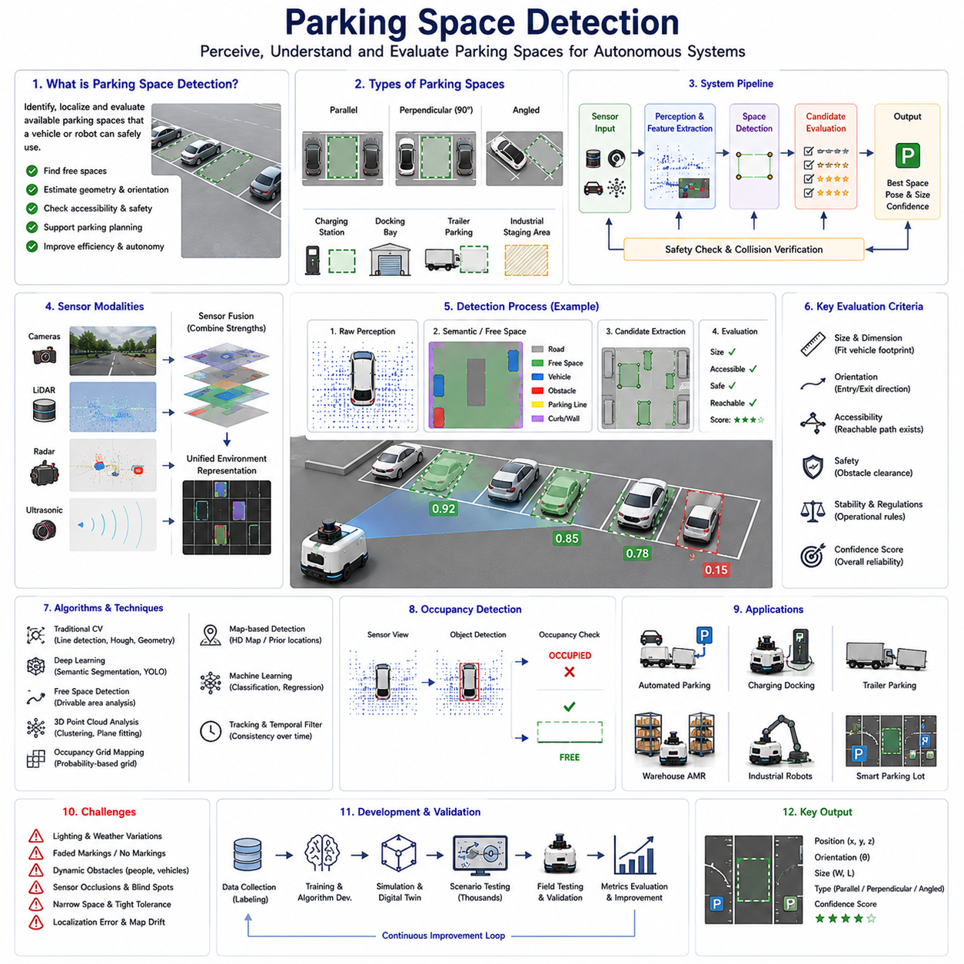
Parking Space Detection is a fundamental technology within autonomous navigation, automated parking systems, intelligent transportation systems, and robotic mobility platforms. The primary objective of parking space detection is to identify, classify, localize, and evaluate available parking locations that can safely accommodate a vehicle or robot. In autonomous systems, parking space detection serves as the critical bridge between environmental perception and parking trajectory generation. Without accurate parking space recognition, even the most advanced path planning and vehicle control systems cannot successfully perform automated parking maneuvers. As autonomous vehicles, Autonomous Mobile Robots (AMRs), autonomous forklifts, towing robots, and intelligent logistics platforms continue to evolve, parking space detection has become an increasingly important component of modern robotic navigation architectures.
The concept of parking space detection extends far beyond simply identifying an empty area. A parking system must understand the geometry, accessibility, orientation, dimensions, occupancy status, surrounding obstacles, and operational constraints associated with a candidate parking location. The system must determine whether the space is physically large enough, whether it can be reached safely, whether sufficient maneuvering room exists, and whether parking regulations or operational rules permit its use. These requirements transform parking space detection into a complex perception and decision-making problem.
Historically, parking assistance systems relied primarily on ultrasonic sensors and simple distance measurements. Early systems informed drivers about nearby obstacles but did not understand the structure of parking spaces. As sensing technology advanced, camera-based and LiDAR-based perception systems enabled vehicles to identify parking boundaries, lane markings, curbs, walls, and surrounding vehicles. Modern autonomous parking systems now employ sophisticated multi-sensor perception architectures capable of constructing detailed environmental representations and performing real-time parking space analysis.
Parking spaces can be classified into several categories. Parallel parking spaces are positioned alongside roadways and require vehicles to enter from the front and settle into a narrow longitudinal gap. Perpendicular parking spaces are oriented at ninety degrees relative to the driving lane and are common in parking lots, warehouses, and industrial facilities. Angled parking spaces simplify vehicle entry and exit by positioning spaces at intermediate orientations. Industrial environments often introduce additional parking categories such as charging stations, docking bays, trailer storage locations, robot waiting zones, pallet staging areas, and automated loading positions. Each category presents unique detection and planning requirements.
The foundation of parking space detection begins with environmental perception. Sensors continuously observe the surrounding environment and provide raw information regarding obstacles, free space, structural boundaries, and potential parking locations. Cameras represent one of the most widely used sensing modalities because they provide rich visual information. Monocular cameras, stereo cameras, fisheye cameras, surround-view camera systems, and panoramic camera configurations can all contribute to parking space perception.
Vision-based parking detection systems analyze visual features such as painted parking lines, lane boundaries, pavement markings, curbs, wheel stops, parking signs, and nearby vehicles. Computer vision algorithms extract these features and estimate parking space geometry. Traditional approaches relied heavily on edge detection, Hough transforms, feature extraction methods, and geometric reasoning. While effective under controlled conditions, these methods often struggled in environments with poor lighting, faded markings, shadows, weather effects, and visual clutter.
Recent advances in deep learning have significantly improved camera-based parking detection performance. Convolutional Neural Networks (CNNs), semantic segmentation networks, object detection architectures, transformer-based perception models, and vision foundation models can directly identify parking spaces from camera imagery. These systems learn complex visual patterns from large datasets and often outperform traditional feature-based approaches in diverse operating conditions.
Semantic segmentation plays an especially important role in parking detection. Segmentation models classify every pixel within an image into semantic categories such as road surface, parking lines, curbs, vehicles, pedestrians, obstacles, and free space. The resulting semantic map enables the parking system to understand environmental structure at a detailed level. Parking spaces can then be extracted through geometric analysis of segmented regions.
LiDAR sensors provide an alternative perception modality that offers highly accurate geometric information. Unlike cameras, LiDAR directly measures distances to surrounding objects and generates detailed three-dimensional point clouds. Parking detection algorithms use these point clouds to identify walls, curbs, parked vehicles, structural boundaries, and open spaces. LiDAR-based approaches often demonstrate superior performance in low-light environments and under challenging illumination conditions.
Point cloud processing techniques play a central role in LiDAR-based parking detection. Ground segmentation algorithms separate floor surfaces from obstacles. Clustering algorithms identify nearby objects. Geometric fitting techniques estimate boundaries and free-space regions. Parking candidates are then evaluated according to size, accessibility, and safety criteria. Three-dimensional perception is particularly valuable in industrial environments where parking areas may contain irregular structures, equipment, pallets, containers, and machinery.
Radar sensors contribute additional robustness to parking space detection systems. Radar performs well under adverse weather conditions including rain, fog, snow, and dust. While radar generally provides lower spatial resolution than cameras and LiDAR, it offers reliable obstacle detection and object tracking capabilities. Modern autonomous systems frequently combine radar with other sensor modalities to improve perception reliability.
Ultrasonic sensors remain widely used for short-range parking operations. These sensors provide highly accurate distance measurements within close proximity to obstacles. During final parking maneuvers, ultrasonic sensors support precise positioning and collision avoidance. Although they are insufficient as standalone parking detection systems, they provide valuable complementary information within multi-sensor architectures.
Sensor fusion has emerged as one of the most important technologies in modern parking space detection. Each sensing modality possesses unique strengths and limitations. Cameras provide rich semantic information but may struggle under poor lighting conditions. LiDAR provides accurate geometry but may have difficulty interpreting visual markings. Radar offers robustness but limited resolution. Ultrasonic sensors provide excellent short-range accuracy but limited environmental coverage. Sensor fusion combines information from multiple sources to create a more comprehensive and reliable environmental representation.
Occupancy grid mapping is frequently used within parking perception systems. The environment is divided into discrete cells, each representing the probability of occupancy. Sensor observations continuously update the occupancy grid as the vehicle moves. Free-space analysis algorithms identify regions that are sufficiently large to accommodate parking maneuvers. Occupancy grids are particularly useful for autonomous robots operating in warehouses, factories, airports, hospitals, and logistics facilities.
Free-space detection represents another fundamental component of parking perception. Rather than searching explicitly for parking markings, free-space algorithms identify navigable areas that are unoccupied and potentially suitable for parking. This approach is especially valuable in industrial environments where conventional parking markings may be absent. Robots can evaluate candidate locations based on geometric dimensions, accessibility, safety margins, and operational requirements.
Map-based parking detection integrates prior environmental knowledge into the perception process. High-definition maps may contain predefined parking locations, charging stations, docking points, waiting zones, and operational staging areas. During operation, localization systems determine vehicle position relative to the map, allowing parking candidates to be retrieved directly from stored infrastructure data. Dynamic perception systems then verify availability and accessibility before parking execution begins.
Machine learning and artificial intelligence are increasingly transforming parking space detection methodologies. Deep neural networks can learn complex environmental features directly from sensor data. Large-scale training datasets containing diverse parking scenarios enable robust generalization across different operating environments. Foundation models and multimodal perception systems may eventually provide even higher levels of environmental understanding and reasoning capability.
Parking occupancy detection represents a closely related problem. In many applications, identifying an available parking space is not sufficient; the system must also determine whether the space is currently occupied. Occupancy detection algorithms analyze vehicle presence, obstacle positions, object classifications, and environmental context. This capability is particularly important in smart parking systems, autonomous logistics facilities, and fleet management applications.
Industrial parking space detection introduces additional complexity beyond traditional automotive applications. Autonomous forklifts, towing robots, warehouse AMRs, hospital delivery robots, airport logistics vehicles, and industrial transport systems often operate in highly dynamic environments. Parking locations may change throughout the day based on operational demands. Temporary obstacles, pallets, containers, trailers, equipment, and human workers frequently alter environmental conditions. Consequently, industrial parking detection systems must continuously update their understanding of parking availability.
Trailer parking and docking operations introduce further challenges. The parking system must evaluate not only vehicle geometry but also trailer dimensions, articulation constraints, turning radius limitations, and reverse maneuver requirements. Specialized parking detection algorithms may generate parking candidates specifically optimized for articulated vehicle systems and towing operations.
Human safety remains a central concern throughout parking space detection and parking execution. Parking areas often contain pedestrians, operators, maintenance personnel, and nearby vehicles. Human-aware perception systems continuously monitor surrounding activity and incorporate safety constraints into parking decisions. Dynamic safety zones, collision prediction algorithms, and risk assessment models help ensure safe operation within shared environments.
Environmental variability significantly affects parking perception performance. Lighting conditions, weather effects, sensor contamination, shadows, reflections, pavement quality, faded markings, and seasonal changes can all influence detection accuracy. Robust parking systems employ adaptive perception strategies capable of maintaining performance under diverse operating conditions.
Simulation and digital twin technologies play important roles in parking detection development. Virtual environments enable engineers to generate thousands of parking scenarios for algorithm training and validation. Simulation platforms support controlled experimentation across varying environmental conditions, sensor configurations, obstacle arrangements, and operational workflows. This significantly accelerates development while reducing testing costs.
Field validation remains essential because real-world environments contain complexities that are difficult to reproduce accurately in simulation. Testing programs evaluate detection accuracy, false positive rates, false negative rates, localization precision, parking success rates, occupancy classification accuracy, and operational reliability. Long-term deployments provide valuable data regarding system robustness and performance stability.
Future parking space detection systems are expected to become increasingly intelligent through integration with artificial intelligence, digital infrastructure, connected vehicle technologies, cloud-based perception services, and cooperative robotics platforms. Smart facilities may communicate parking availability directly to autonomous vehicles. Shared environmental models may enable multiple robots to collaborate and exchange parking information in real time. Foundation models and embodied AI systems may eventually reason about parking opportunities using high-level semantic understanding rather than purely geometric analysis.
As autonomous mobility continues expanding across transportation, logistics, manufacturing, healthcare, airports, ports, warehouses, and smart cities, parking space detection will remain a critical enabling technology. Accurate identification of safe, accessible, and operationally appropriate parking locations is essential for automated parking, charging, docking, staging, fleet management, and autonomous transportation systems. By combining advanced perception technologies, multi-sensor fusion, machine learning, environmental modeling, and intelligent decision-making frameworks, modern parking space detection provides the foundation for reliable and scalable autonomous parking operations across the next generation of robotic and autonomous mobility platforms.

12.4 Automatic Parking Strategies
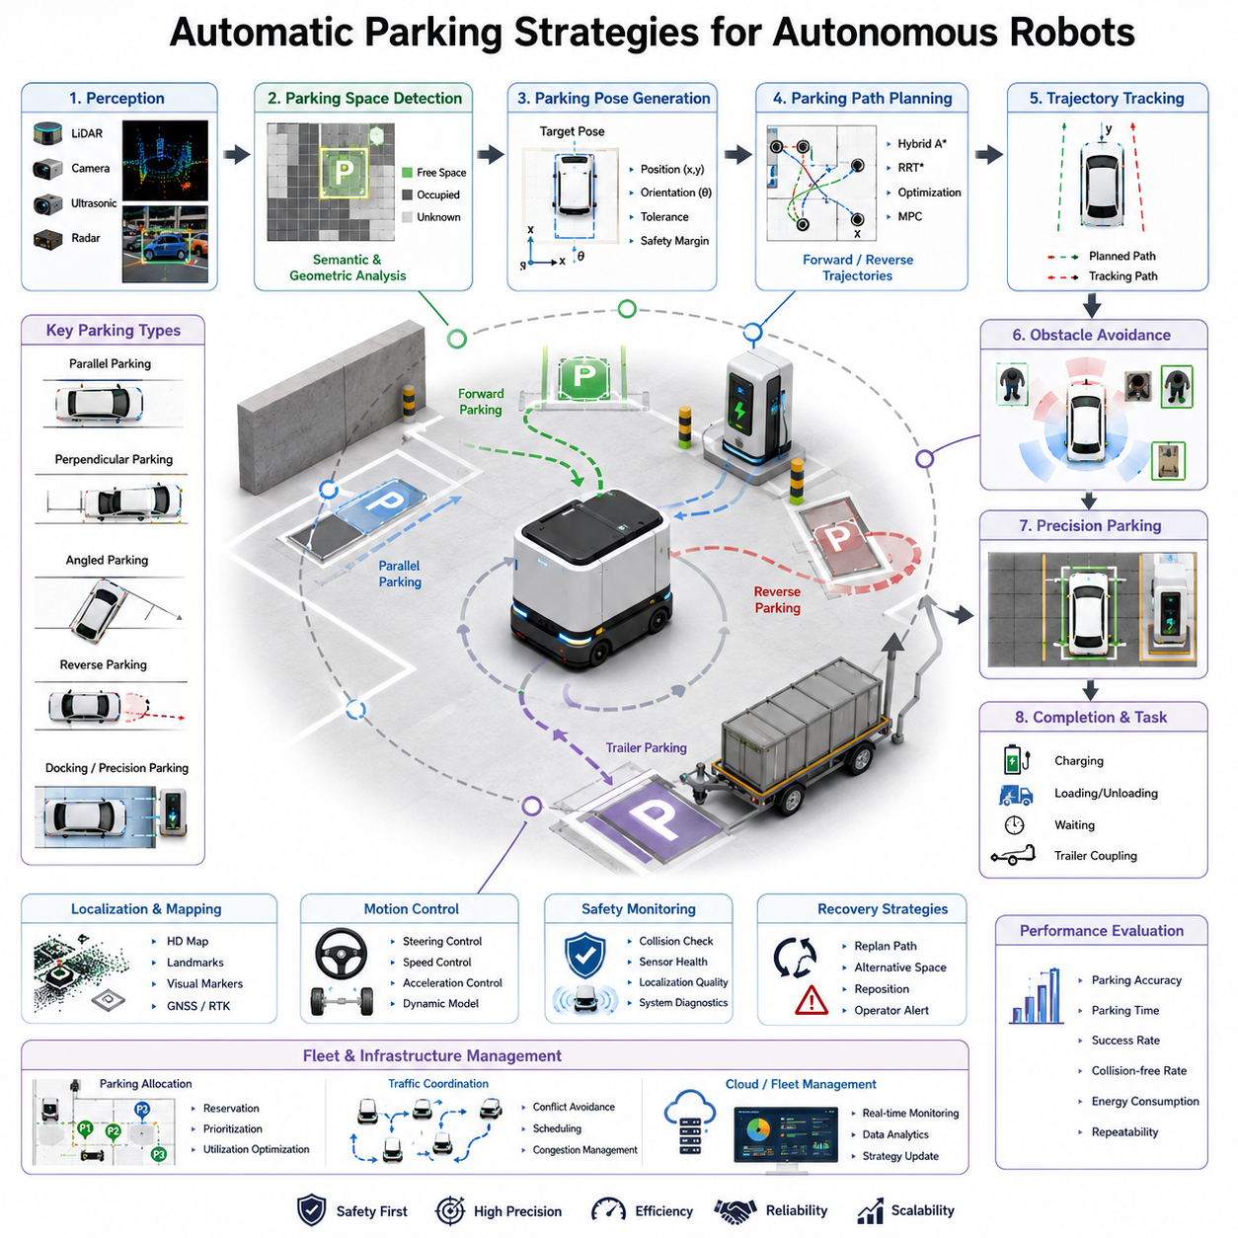
Automatic parking is one of the most sophisticated capabilities within autonomous navigation systems because it requires the robot to operate accurately in confined environments where even small positioning errors can lead to collisions, mission failures, or safety hazards. In autonomous mobile robots, towing robots, logistics platforms, hospital delivery robots, industrial transport vehicles, and outdoor autonomous machines, parking is not merely a terminal navigation action. Instead, it represents a complex sequence of perception, localization, path planning, trajectory generation, motion control, obstacle avoidance, safety validation, and recovery behaviors that must function together seamlessly. Within the overall navigation architecture, automatic parking serves as the final precision maneuver that enables the robot to reach a designated operational state, whether that involves docking, charging, loading, unloading, waiting, staging, coupling to a trailer, or positioning itself for human interaction. The importance of automatic parking strategies continues to increase as autonomous systems become more integrated into industrial workflows and large-scale fleet operations.
The fundamental objective of automatic parking is to move a robot from an arbitrary starting pose to a target parking pose while respecting environmental constraints, vehicle kinematic limitations, dynamic safety requirements, and mission objectives. Unlike conventional path following, parking often occurs in highly constrained spaces where the available clearance may be only slightly larger than the robot itself. In such situations, navigation algorithms must optimize both path feasibility and positioning accuracy. The parking system must understand not only where the robot is located but also how its dimensions, turning radius, payload, trailer configuration, and safety zones influence the parking maneuver.
Modern parking systems typically begin with parking space identification. Before a parking maneuver can be planned, the robot must determine whether a parking location is available and whether it satisfies operational constraints. This process may involve LiDAR scanning, camera-based perception, semantic mapping, occupancy grid analysis, or preconfigured infrastructure maps. In industrial environments, parking spaces may be represented as fixed map coordinates associated with loading stations, charging stations, storage areas, elevators, or waiting zones. In more dynamic environments, the robot must identify free parking spaces in real time by analyzing surrounding obstacles and free-space availability.
Parking spaces can be classified into multiple categories. Parallel parking involves positioning the robot alongside a boundary or wall. Perpendicular parking requires the robot to enter a space directly facing the target area. Angled parking combines aspects of both approaches and is common in structured industrial facilities. Precision docking parking requires alignment with charging connectors, conveyor interfaces, pallet transfer systems, or trailer couplers. Reverse parking requires the robot to drive backward into a designated area, often to maximize operational efficiency or improve departure trajectories. Each parking type introduces unique planning and control requirements.
A critical component of automatic parking is parking pose generation. Rather than simply specifying a target coordinate, advanced systems define a complete parking pose consisting of position, orientation, velocity constraints, alignment tolerances, and safety margins. The parking pose must ensure that the robot can perform subsequent tasks without requiring additional adjustments. For example, when parking at an automatic charging station, orientation accuracy may be more important than positional accuracy because charging connectors require precise alignment. Conversely, when parking within a warehouse staging area, maximizing space utilization may take priority.
Path planning for parking differs significantly from conventional navigation. During normal navigation, global planners focus on efficiency and obstacle avoidance across large environments. Parking planners, however, must generate feasible trajectories within limited spaces while respecting vehicle kinematics. Nonholonomic robots cannot move arbitrarily in all directions, meaning their parking trajectories must account for steering limitations and turning constraints. As a result, parking planners often employ specialized algorithms designed specifically for constrained maneuvering.
One common approach uses geometric parking trajectories. These trajectories are generated based on predefined curves and mathematical relationships between vehicle dimensions and parking space geometry. Circular arcs, clothoid curves, spline trajectories, and Bézier curves are frequently used to create smooth and feasible parking motions. Geometric methods offer computational efficiency and predictable behavior, making them attractive for industrial applications where parking environments are relatively structured.
Optimization-based parking strategies have become increasingly popular in advanced autonomous systems. These methods formulate parking as an optimization problem where the objective is to minimize path length, maneuver count, energy consumption, execution time, or control effort while satisfying collision avoidance and kinematic constraints. Model Predictive Control plays a particularly important role in such systems because it continuously predicts future vehicle states and adjusts control commands to maintain trajectory accuracy. This enables the robot to handle uncertainties, disturbances, and changing environmental conditions during parking maneuvers.
Sampling-based planning algorithms such as RRT, RRT*, Hybrid A*, and state lattice planners are frequently used for complex parking scenarios. Hybrid A* has become particularly popular because it combines graph search techniques with vehicle kinematic models. Unlike traditional grid-based planning, Hybrid A* generates feasible paths that can be directly executed by real vehicles. This capability makes it highly effective for reverse parking, trailer parking, and confined-space maneuvering where simple geometric approaches may fail.
Reverse parking is among the most challenging automatic parking operations. Human drivers often struggle with reverse maneuvers because vehicle orientation changes nonlinearly during backing motions. Autonomous systems face similar challenges but must solve them algorithmically. During reverse parking, localization accuracy becomes more critical because the robot’s rear section may approach obstacles more closely than during forward motion. Sensor coverage, obstacle tracking, and trajectory tracking performance must therefore be enhanced. Reverse parking planners often generate multiple candidate trajectories and evaluate them based on safety, smoothness, and execution reliability.
For towing robots and autonomous trailer systems, parking complexity increases substantially. Trailer articulation introduces additional degrees of freedom that must be controlled carefully. Jackknifing, trailer swing, and articulation instability can occur if reverse maneuvers are not planned properly. Advanced parking strategies therefore incorporate trailer dynamic models into the planning process. Predictive control algorithms estimate future trailer states and continuously adjust steering commands to maintain stability throughout the parking maneuver. These capabilities are particularly important in logistics facilities, factories, airports, and distribution centers where towing AMRs operate.
Perception systems play a crucial role throughout automatic parking operations. LiDAR sensors provide accurate distance measurements and environmental geometry. RGB cameras contribute visual understanding and parking marker recognition. Depth cameras generate three-dimensional obstacle information. Ultrasonic sensors offer highly reliable close-range obstacle detection. Radar sensors provide robustness under adverse environmental conditions. The integration of these sensing modalities enables the parking system to maintain situational awareness even when individual sensors experience limitations.
Sensor fusion enhances parking performance by combining complementary information sources. A LiDAR sensor may accurately detect walls and structural features, while cameras identify visual markers and semantic information. Ultrasonic sensors provide precise short-range measurements near obstacles, helping compensate for LiDAR blind spots. Fusion algorithms combine these inputs to generate a unified representation of the parking environment. This representation serves as the foundation for path planning, collision checking, and trajectory execution.
Localization requirements become increasingly stringent during parking operations. While normal navigation may tolerate several centimeters of positioning error, automatic parking often requires sub-centimeter precision. High-definition maps, visual fiducials, LiDAR landmarks, GNSS RTK systems, and local reference markers may all contribute to enhanced localization accuracy. In industrial facilities, artificial landmarks are frequently installed near parking stations to improve repeatability and reliability.
Trajectory tracking performance directly influences parking success. Even if a planner generates an optimal parking trajectory, poor tracking performance can cause collisions or positioning errors. Modern parking controllers employ feedback loops that continuously compare actual vehicle motion with planned trajectories. Deviations are corrected through steering, velocity, and acceleration adjustments. Advanced controllers may incorporate vehicle dynamics, wheel slip estimation, payload effects, and terrain characteristics to improve tracking accuracy.
Obstacle avoidance remains active throughout the parking maneuver. Unlike traditional navigation, parking often occurs in close proximity to obstacles. Consequently, parking systems require highly sensitive collision monitoring capabilities. Dynamic obstacles such as pedestrians, forklifts, vehicles, and other robots may enter the parking area unexpectedly. The parking controller must continuously evaluate collision risks and determine whether to continue, slow down, stop, or replan the maneuver.
Safety represents the highest priority in automatic parking operations. Safety monitoring systems continuously evaluate sensor health, localization confidence, obstacle proximity, vehicle stability, actuator status, and control performance. If abnormal conditions are detected, emergency procedures may be activated. These procedures can include controlled stopping, trajectory cancellation, parking maneuver suspension, or operator notification. Functional safety architectures ensure that hazardous failures do not lead to unsafe vehicle behavior.
Recovery strategies are essential because parking operations inevitably encounter unexpected situations. The robot may discover that a parking space is occupied, a sensor has become unavailable, localization confidence has degraded, or an obstacle blocks the planned trajectory. Recovery systems analyze the failure cause and select an appropriate corrective action. The robot may attempt a new parking trajectory, reposition itself, select an alternative parking location, request human intervention, or postpone the parking operation until conditions improve.
Fleet-level parking management introduces another layer of complexity. In facilities containing dozens or hundreds of robots, parking resources must be allocated efficiently. Traffic management systems coordinate parking assignments, reserve parking spaces, prevent congestion, and optimize parking utilization. Cloud-based fleet managers often maintain real-time knowledge of parking occupancy and robot status, enabling intelligent parking decisions that improve operational efficiency across the entire fleet.
Machine learning is increasingly influencing automatic parking strategies. Deep learning models can identify parking spaces, estimate free-space boundaries, predict obstacle behavior, and evaluate parking feasibility. Reinforcement learning approaches allow robots to learn parking behaviors through simulation and experience. Vision-language models and embodied AI systems may eventually enable robots to understand high-level parking instructions such as parking near a specific loading zone or selecting the safest available parking location.
Simulation plays a major role in parking system development. High-fidelity simulation environments allow engineers to test thousands of parking scenarios under varying environmental conditions, sensor configurations, and vehicle parameters. Simulation enables rapid validation of parking algorithms before deployment in real-world systems. Digital twins further enhance this capability by creating virtual representations of operational environments where parking strategies can be evaluated continuously.
Performance evaluation for automatic parking systems typically considers multiple metrics. Parking accuracy measures the difference between the final pose and the desired pose. Parking time evaluates operational efficiency. Maneuver count reflects path complexity. Collision-free execution measures safety performance. Energy consumption indicates operational efficiency. Success rate evaluates overall reliability across diverse scenarios. Repeatability assesses consistency over multiple parking attempts.
As autonomous robotics continues to evolve, automatic parking strategies are expected to become increasingly intelligent, adaptive, and autonomous. Future systems will integrate advanced perception, semantic reasoning, world models, predictive planning, and embodied AI to perform parking operations with human-level precision and situational understanding. Robots will be capable of understanding complex environmental contexts, predicting future changes, coordinating with other robots, and autonomously selecting optimal parking behaviors. These capabilities will transform parking from a simple terminal navigation task into a fully integrated component of intelligent autonomous mobility systems, enabling safer, more efficient, and more scalable robotic operations across industrial, commercial, healthcare, logistics, and outdoor environments.

12.5 Trailer Backward Control
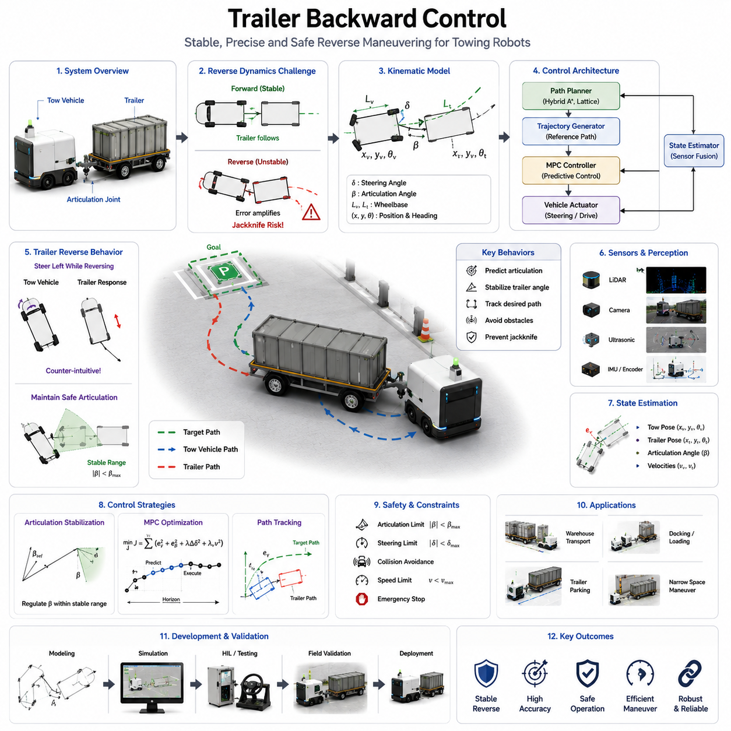
Trailer backward control is one of the most challenging problems in autonomous vehicle navigation, industrial automation, and mobile robotics. While forward motion of a towing vehicle is generally stable and predictable, reversing with an attached trailer introduces complex nonlinear dynamics that significantly increase control difficulty. In autonomous mobile robots, towing AMRs, logistics vehicles, airport baggage carriers, warehouse transport systems, agricultural robots, and industrial towing platforms, trailer backward control is a critical capability that enables efficient maneuvering in confined environments. Without reliable reverse control, many practical operations such as trailer parking, docking, loading, unloading, warehouse positioning, and precision logistics handling would be impossible to automate effectively. Trailer backward control therefore represents a key enabling technology for next-generation autonomous transport systems.
The fundamental challenge of trailer backward control originates from the articulated structure between the towing vehicle and the trailer. During forward motion, the trailer naturally follows the path of the towing vehicle due to the stabilizing effect of the hitch geometry. Small disturbances tend to self-correct as the trailer aligns itself with the direction of travel. During reverse motion, however, the opposite behavior occurs. Small articulation angle errors are amplified rather than reduced. As the towing vehicle moves backward, the trailer becomes dynamically unstable and may rapidly diverge from the desired trajectory if corrective steering actions are not applied. This instability creates the well-known jackknife phenomenon, in which the trailer rotates excessively relative to the towing vehicle and reaches an uncontrollable configuration.
Understanding trailer kinematics is essential for developing effective backward control systems. A trailer system typically consists of a tractor vehicle connected to one or more trailers through articulated joints. The position and orientation of each segment are coupled through nonlinear geometric relationships. When the towing vehicle changes its steering angle, the resulting motion propagates through the hitch connection and influences the trailer orientation. During reverse motion, the control system must predict how steering inputs will affect future trailer positions and continuously compensate for the resulting articulation dynamics.
The complexity of trailer backward control increases significantly as additional trailers are added. A single-trailer configuration already exhibits nonlinear instability characteristics, but multi-trailer systems introduce additional articulated joints and dynamic interactions. Each articulation point contributes another degree of freedom that must be controlled simultaneously. In long trailer trains commonly used in logistics facilities, airports, ports, and manufacturing plants, the difficulty of reverse maneuvering grows exponentially with the number of connected trailers. Autonomous control algorithms must therefore incorporate sophisticated prediction and stabilization mechanisms to maintain safe operation.
The geometric behavior of a trailer during reverse motion differs substantially from forward driving. When the towing vehicle steers left while reversing, the trailer initially responds in a manner that may appear counterintuitive. The articulation angle changes in a direction that can increase trajectory deviation if not properly controlled. Human operators often require extensive training to master reverse trailer maneuvering because steering corrections must anticipate future trailer behavior rather than simply responding to current position errors. Autonomous systems must replicate and often exceed this level of predictive control capability.
Mathematical modeling forms the foundation of trailer backward control. Kinematic models describe the geometric relationships between vehicle states, steering inputs, articulation angles, and trailer positions. These models are commonly derived from bicycle models, articulated vehicle models, and multi-body dynamic systems. The resulting equations describe how the vehicle-trailer system evolves over time and provide the basis for trajectory planning, state estimation, and controller design.
Low-speed industrial towing systems often rely primarily on kinematic models because inertial forces are relatively small. In warehouse environments where towing AMRs typically operate at speeds below 10 km/h, geometric constraints dominate vehicle behavior. Under these conditions, accurate kinematic models can provide sufficient control performance while minimizing computational requirements. As vehicle speed increases, however, dynamic effects such as tire slip, load transfer, inertia, and surface interactions become increasingly important and must be incorporated into the control architecture.
Trajectory generation for trailer backward control requires specialized planning algorithms. Unlike standard mobile robots, trailer systems cannot simply reverse along arbitrary paths. The generated trajectory must satisfy vehicle kinematic constraints, trailer articulation limits, steering constraints, collision avoidance requirements, and stability criteria. Planning algorithms must ensure that articulation angles remain within controllable ranges throughout the maneuver. If the planned path causes excessive articulation, the trailer may become unstable before reaching its destination.
Hybrid A* planning has become one of the most widely adopted approaches for trailer reverse path generation. Hybrid A* extends traditional graph-search methods by incorporating vehicle kinematic constraints directly into the search process. The resulting paths are physically feasible and suitable for execution by articulated vehicle systems. State lattice planners provide a similar capability by constructing motion primitives that account for trailer dynamics and steering limitations. These approaches are particularly effective in confined industrial environments where precise maneuvering is required.
Model Predictive Control has emerged as a leading solution for trailer backward control. MPC continuously predicts future system states over a finite planning horizon and computes optimal steering commands that minimize trajectory tracking errors while respecting system constraints. Because trailer systems exhibit unstable reverse dynamics, predictive control offers significant advantages over purely reactive approaches. The controller can anticipate future articulation behavior and apply corrective actions before instability develops. This predictive capability greatly improves control accuracy and robustness.
Another common approach involves articulation angle stabilization. Instead of directly controlling trailer position, the controller regulates the articulation angle between the towing vehicle and the trailer. By maintaining articulation within a stable operating range, the system prevents jackknife conditions and preserves controllability. Higher-level path tracking algorithms then generate articulation references that guide the trailer toward its desired trajectory. This hierarchical control architecture separates stabilization and navigation functions, improving overall system performance.
State estimation plays a critical role in trailer backward control. The controller requires accurate knowledge of vehicle position, trailer position, orientation, articulation angles, and system velocities. These states may be estimated using wheel encoders, steering sensors, IMUs, LiDAR systems, cameras, GNSS receivers, and other perception sensors. Sensor fusion algorithms combine measurements from multiple sources to provide robust state estimates even when individual sensors experience noise or temporary failures.
Perception systems are particularly important during reverse maneuvers because the trailer often occupies regions that are difficult to observe directly from the towing vehicle. Rear-facing cameras, LiDAR sensors, ultrasonic sensors, radar units, and depth cameras are commonly deployed to monitor the surrounding environment. These sensors provide obstacle detection capabilities and ensure that reverse maneuvers can be executed safely within confined spaces. Sensor placement must be carefully designed to minimize blind spots and maximize environmental awareness.
Collision avoidance becomes more challenging during trailer reversing operations. The swept path of the trailer differs from the path followed by the towing vehicle, creating additional collision risks. Obstacles that appear safely distant from the tractor may still intersect the trailer trajectory. Advanced collision checking algorithms therefore evaluate the future motion envelopes of both the towing vehicle and the trailer. Continuous trajectory validation ensures that all vehicle segments remain collision-free throughout the maneuver.
Industrial towing AMRs frequently operate in environments where precision positioning is essential. Manufacturing facilities may require trailers to be aligned with loading docks, conveyor systems, robotic manipulators, storage racks, or automated transfer stations. Positioning tolerances may be measured in centimeters or even millimeters. Trailer backward control systems must therefore achieve exceptional trajectory tracking accuracy while maintaining stability and safety. Advanced control algorithms often incorporate fine positioning modes that reduce vehicle speed and increase control resolution during final approach phases.
Load conditions significantly influence trailer backward control performance. Empty trailers behave differently from heavily loaded trailers due to changes in mass distribution, inertia, tire deformation, and dynamic response characteristics. Industrial towing systems may transport loads ranging from a few hundred kilograms to several tons. Adaptive control algorithms can compensate for these variations by adjusting controller parameters based on estimated payload characteristics. Such adaptation improves performance consistency across diverse operating conditions.
Environmental factors further complicate reverse control operations. Uneven surfaces, slopes, wet floors, gravel roads, industrial debris, and varying friction conditions can all affect trailer behavior. Wheel slip may cause deviations from predicted trajectories, while surface irregularities can introduce unexpected articulation changes. Robust control architectures incorporate disturbance estimation and compensation mechanisms to maintain stability under these challenging conditions.
Safety considerations are paramount in trailer backward control. Reverse maneuvers often occur near personnel, equipment, storage racks, vehicles, and infrastructure. Even low-speed collisions can result in significant damage or injury. Safety systems continuously monitor obstacle proximity, articulation limits, vehicle speed, sensor health, localization confidence, and controller status. If hazardous conditions are detected, emergency braking or maneuver cancellation procedures may be activated immediately.
Functional safety architectures provide multiple layers of protection during reverse operations. Independent monitoring systems verify that articulation angles remain within safe limits. Safety controllers supervise motion commands and intervene if abnormal behavior is detected. Redundant sensing systems ensure reliable obstacle detection even in the presence of component failures. These safety mechanisms are particularly important in industrial facilities where autonomous towing systems operate alongside human workers.
Simulation environments play a critical role in trailer backward control development. High-fidelity simulation platforms allow engineers to evaluate control algorithms under thousands of operating scenarios without exposing physical equipment to risk. Simulations can model various trailer configurations, payloads, surface conditions, sensor failures, and environmental obstacles. Digital twin technologies further enhance validation by replicating actual deployment environments with high accuracy.
Field testing remains essential despite advances in simulation technology. Real-world environments contain uncertainties and disturbances that are difficult to model completely. Comprehensive testing programs typically evaluate trailer backward control performance across diverse operating conditions, including different payload levels, parking geometries, surface conditions, obstacle configurations, and weather environments. Validation metrics often include tracking accuracy, articulation stability, maneuver completion time, collision-free operation, and recovery performance.
Recovery strategies are necessary because reverse trailer maneuvers occasionally encounter situations that exceed controller capabilities. Excessive articulation, blocked paths, localization failures, sensor degradation, or unexpected obstacles may prevent successful maneuver completion. Recovery systems analyze the failure condition and determine appropriate corrective actions. These actions may include repositioning the vehicle, generating alternative trajectories, reducing maneuver complexity, or requesting operator assistance.
Fleet-level deployment introduces additional coordination requirements. Multiple towing robots operating simultaneously within a logistics facility must coordinate their reverse maneuvers to avoid conflicts and congestion. Traffic management systems allocate maneuvering spaces, reserve parking zones, and schedule reverse operations to maximize overall efficiency. Cloud-based fleet management platforms provide centralized supervision while allowing individual vehicles to maintain local autonomy.
Artificial intelligence is increasingly being integrated into trailer backward control systems. Machine learning models can predict articulation behavior, estimate environmental constraints, identify optimal maneuver strategies, and improve trajectory generation. Reinforcement learning approaches enable controllers to learn complex reverse behaviors through extensive simulation training. Vision-based AI systems can recognize parking zones, loading stations, and docking targets while adapting to changing environmental conditions.
Future trailer backward control systems will likely combine classical control theory, optimization algorithms, predictive planning, advanced perception, and embodied AI into unified autonomous driving architectures. These systems will possess greater situational awareness, improved predictive capabilities, enhanced robustness, and superior adaptability to diverse operational environments. Autonomous towing robots will be capable of performing highly complex reverse maneuvers with minimal human supervision, supporting large-scale deployment across factories, warehouses, airports, ports, hospitals, logistics centers, agricultural facilities, and smart infrastructure ecosystems. As robotic transportation systems continue to evolve, trailer backward control will remain a foundational capability that enables safe, precise, and efficient autonomous material movement in increasingly complex real-world environments.

12.6 Close Range Sensor Integration
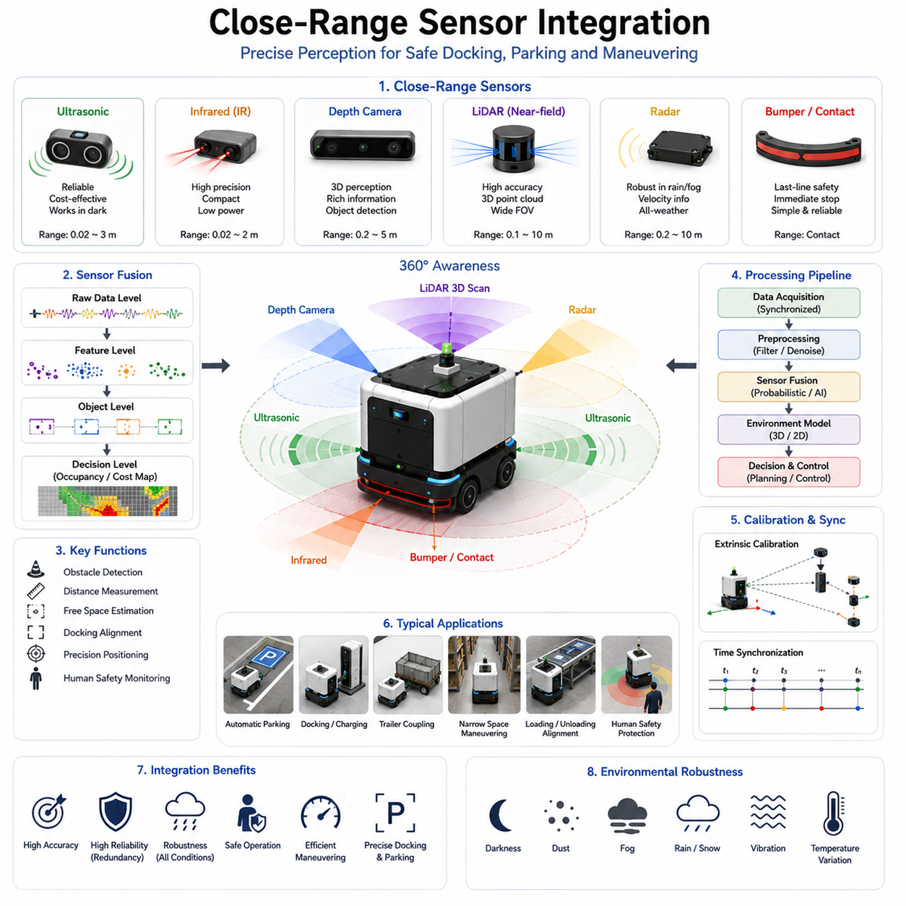
Close-range sensor integration is a critical component of autonomous navigation systems, particularly in applications involving reversing, parking, docking, trailer control, charging operations, precision positioning, and maneuvering within highly constrained environments. While global navigation and long-range perception systems provide situational awareness across large operational areas, close-range sensing focuses on the final meters and often the final centimeters of robot movement. In many autonomous mobile robot systems, the most difficult and safety-critical portion of a mission occurs not during long-distance travel but during the final approach to a target location. Whether the robot is parking in a narrow space, aligning with a charging station, docking to a conveyor system, coupling with a trailer, positioning near a hospital bed, or approaching industrial equipment, precise close-range perception becomes essential for successful operation. As a result, close-range sensor integration represents one of the most important enabling technologies for achieving reliable autonomous behavior in real-world environments.
The primary objective of close-range sensor integration is to provide accurate, reliable, and redundant environmental information within the immediate vicinity of the robot. Unlike long-range perception systems that focus on navigation planning and obstacle detection at distances of several meters to hundreds of meters, close-range sensing concentrates on distances typically ranging from a few millimeters to several meters. Within this operational zone, even small measurement errors can result in collisions, docking failures, equipment damage, or unsafe interactions with people and infrastructure. Therefore, close-range sensing systems must achieve significantly higher accuracy, reliability, update frequency, and environmental robustness than many long-range perception solutions.
Autonomous robots frequently operate in environments where precise positioning requirements exceed the capabilities of standard navigation sensors. A mobile robot may navigate through a warehouse using LiDAR-based localization with centimeter-level accuracy, yet require millimeter-level precision when aligning with a charging connector. Similarly, a towing robot may successfully travel hundreds of meters through a logistics facility but require highly accurate close-range sensing when reversing a trailer into a loading bay. These examples demonstrate why specialized sensor integration architectures are necessary during final positioning operations.
A variety of sensor technologies are commonly employed for close-range perception. Ultrasonic sensors remain one of the most widely used solutions due to their simplicity, reliability, and cost-effectiveness. These sensors measure distances by transmitting acoustic waves and calculating the return time of reflected signals. Ultrasonic sensors perform particularly well when detecting walls, vehicles, pallets, storage racks, and other large objects at short distances. Their ability to function in darkness, dust, fog, and varying lighting conditions makes them valuable for industrial environments.
Infrared sensors represent another common close-range sensing technology. Infrared systems emit light in the infrared spectrum and measure reflected energy to estimate object proximity. These sensors can achieve high measurement precision within short operating ranges and are frequently used for docking alignment, edge detection, object presence detection, and safety monitoring. Their compact size and low power consumption make them attractive for embedded robotic systems.
Depth cameras have become increasingly important in modern autonomous platforms. Unlike traditional RGB cameras, depth cameras generate three-dimensional information about the environment. Technologies such as structured light, stereo vision, and time-of-flight sensing enable accurate distance measurements across an entire scene. Depth cameras provide rich spatial information that supports obstacle detection, free-space analysis, docking guidance, object recognition, and precise localization during close-range operations.
LiDAR systems also play a significant role in close-range perception. Although LiDAR is often associated with long-range mapping and navigation, modern high-resolution LiDAR sensors provide excellent short-range performance. Near-field LiDAR data can be used to detect obstacles, estimate surface geometry, measure clearances, and support precise vehicle positioning. Multi-layer LiDAR systems are particularly effective because they provide three-dimensional coverage around the robot and help eliminate blind spots.
Radar technology is increasingly being integrated into close-range sensing architectures. Radar offers advantages in environments affected by rain, snow, fog, dust, smoke, and low visibility conditions. While radar traditionally provides lower spatial resolution than LiDAR or cameras, recent advances in imaging radar technologies have significantly improved performance. Radar contributes valuable redundancy and environmental robustness within safety-critical perception systems.
Contact sensors and bump sensors continue to serve important roles despite advances in perception technology. These sensors provide a final layer of protection when all other sensing mechanisms fail. Industrial robots often incorporate contact strips, pressure-sensitive bumpers, and tactile sensors that immediately stop vehicle motion upon physical contact. Such systems are particularly valuable in safety-critical environments where human interaction is common.
The integration of multiple close-range sensing modalities provides significant advantages over relying on a single sensor type. Every sensor technology possesses inherent limitations. Ultrasonic sensors may struggle with irregular surfaces and angled reflections. Cameras are sensitive to lighting conditions. LiDAR performance may be affected by certain surface materials. Radar typically provides lower geometric resolution. By combining complementary sensing technologies, autonomous systems can compensate for individual weaknesses while enhancing overall perception performance.
Sensor fusion forms the foundation of close-range sensor integration. Fusion algorithms combine measurements from multiple sensors into a unified environmental representation. This process may occur at raw data level, feature level, object level, or decision level. The resulting integrated perception model provides more accurate, reliable, and comprehensive situational awareness than any individual sensor can achieve independently.
Time synchronization is a crucial requirement in close-range sensor integration. Multiple sensors often operate at different update frequencies and communication latencies. If measurements are not properly synchronized, inconsistencies may arise that degrade perception accuracy. Accurate timestamping, hardware synchronization mechanisms, and temporal alignment algorithms ensure that sensor observations correspond to the same physical moment in time.
Spatial calibration is equally important. Each sensor possesses a unique position and orientation relative to the robot coordinate system. Calibration procedures determine these geometric relationships and enable sensor measurements to be transformed into a common reference frame. Precise calibration is essential for accurate sensor fusion, obstacle localization, and trajectory planning. Even small calibration errors can significantly impact close-range operations where positional accuracy requirements are extremely stringent.
Close-range perception plays a particularly important role in automatic parking systems. During parking maneuvers, robots frequently operate within narrow spaces where clearance distances may be measured in centimeters. Close-range sensors continuously monitor surrounding obstacles, estimate available space, and guide the robot toward its target parking position. Sensor fusion enables accurate perception of walls, vehicles, equipment, and infrastructure while maintaining safe operating margins throughout the maneuver.
Docking applications represent another major use case for close-range sensor integration. Autonomous robots commonly interact with charging stations, conveyors, pallet transfer systems, loading docks, elevators, and automated machinery. Successful docking requires precise alignment between the robot and external infrastructure. Close-range sensors provide the detailed positional information necessary to achieve this alignment while compensating for localization uncertainty and environmental variability.
Trailer operations present unique challenges for close-range perception. During reverse maneuvers, portions of the trailer may extend beyond the direct field of view of onboard sensors. Additional sensors are often mounted on both the towing vehicle and trailer structure to provide comprehensive environmental coverage. Integrated perception systems monitor articulation angles, obstacle proximity, loading dock alignment, and trailer position throughout the maneuver.
Human safety is a primary consideration in close-range sensor design. Autonomous robots frequently share workspaces with human operators, pedestrians, medical staff, warehouse personnel, and maintenance teams. Close-range sensors continuously monitor human proximity and support dynamic safety zone generation. When a person enters a predefined safety area, the robot may reduce speed, modify its trajectory, issue warnings, or initiate an emergency stop procedure.
Dynamic obstacle detection becomes increasingly important within close operating ranges. Forklifts, carts, vehicles, robots, and pedestrians may move unpredictably within the robot's immediate environment. High-frequency sensing and rapid data processing enable the perception system to identify dynamic hazards and generate appropriate avoidance responses. Low-latency perception pipelines are essential because reaction times directly influence collision avoidance performance.
Artificial intelligence is becoming increasingly integrated into close-range perception systems. Deep learning algorithms enhance object recognition, semantic scene understanding, free-space estimation, and obstacle classification. Neural networks can identify specific infrastructure components such as charging ports, docking markers, pallet positions, and parking references. AI-based perception systems improve adaptability and robustness across diverse operating conditions.
Visual markers and fiducial systems are often used to enhance close-range positioning accuracy. Technologies such as AprilTags, QR codes, ArUco markers, reflective targets, and structured visual patterns provide highly reliable reference points during docking and parking operations. These markers simplify localization and reduce dependence on complex environmental feature extraction algorithms.
Environmental conditions significantly influence close-range sensor performance. Dust, moisture, fog, direct sunlight, reflective surfaces, transparent materials, vibration, temperature variation, and electromagnetic interference can affect measurement quality. Robust sensor integration architectures account for these factors through redundancy, confidence estimation, sensor health monitoring, and adaptive fusion strategies.
Sensor health monitoring is an essential component of reliable perception systems. The robot must continuously evaluate sensor functionality, signal quality, communication status, calibration validity, and measurement consistency. If a sensor becomes degraded or fails completely, the perception system must automatically compensate using alternative sensing modalities while maintaining safe operation.
Functional safety standards increasingly require redundancy within close-range perception architectures. Safety-certified systems often incorporate multiple independent sensing technologies to reduce the probability of hazardous failures. Redundant perception paths ensure that obstacle detection remains available even if individual sensors malfunction. This approach is particularly important in industrial environments where autonomous robots operate near people and expensive equipment.
Simulation and digital twin technologies provide valuable tools for developing close-range sensor integration systems. Virtual environments enable engineers to evaluate sensor configurations, fusion algorithms, failure scenarios, and environmental conditions before deployment. Large-scale simulation testing accelerates development while reducing risk and validation costs.
Real-world testing remains indispensable because many close-range sensing challenges emerge only under actual operating conditions. Field validation programs typically evaluate sensor performance across varying lighting conditions, weather environments, obstacle configurations, infrastructure layouts, and operational scenarios. Comprehensive testing ensures that perception systems maintain reliability throughout the robot’s intended deployment environment.
Performance evaluation metrics for close-range sensor integration commonly include measurement accuracy, obstacle detection rate, false positive rate, false negative rate, update frequency, latency, docking accuracy, parking precision, collision-free operation, sensor availability, and fault tolerance. These metrics provide quantitative measures of system effectiveness and support continuous improvement efforts.
Future close-range sensor integration systems will likely combine advanced sensing technologies, AI-driven perception, multimodal sensor fusion, predictive environmental modeling, and embodied intelligence into unified perception architectures. Autonomous robots will achieve increasingly human-like spatial awareness within confined environments, enabling safer, more efficient, and more precise operations. As autonomous systems become more capable and widespread, close-range sensor integration will remain a foundational technology that bridges the gap between high-level navigation and real-world physical interaction, enabling robots to perform complex tasks with confidence, reliability, and exceptional precision.

12.7 Safety in Reversing Operations
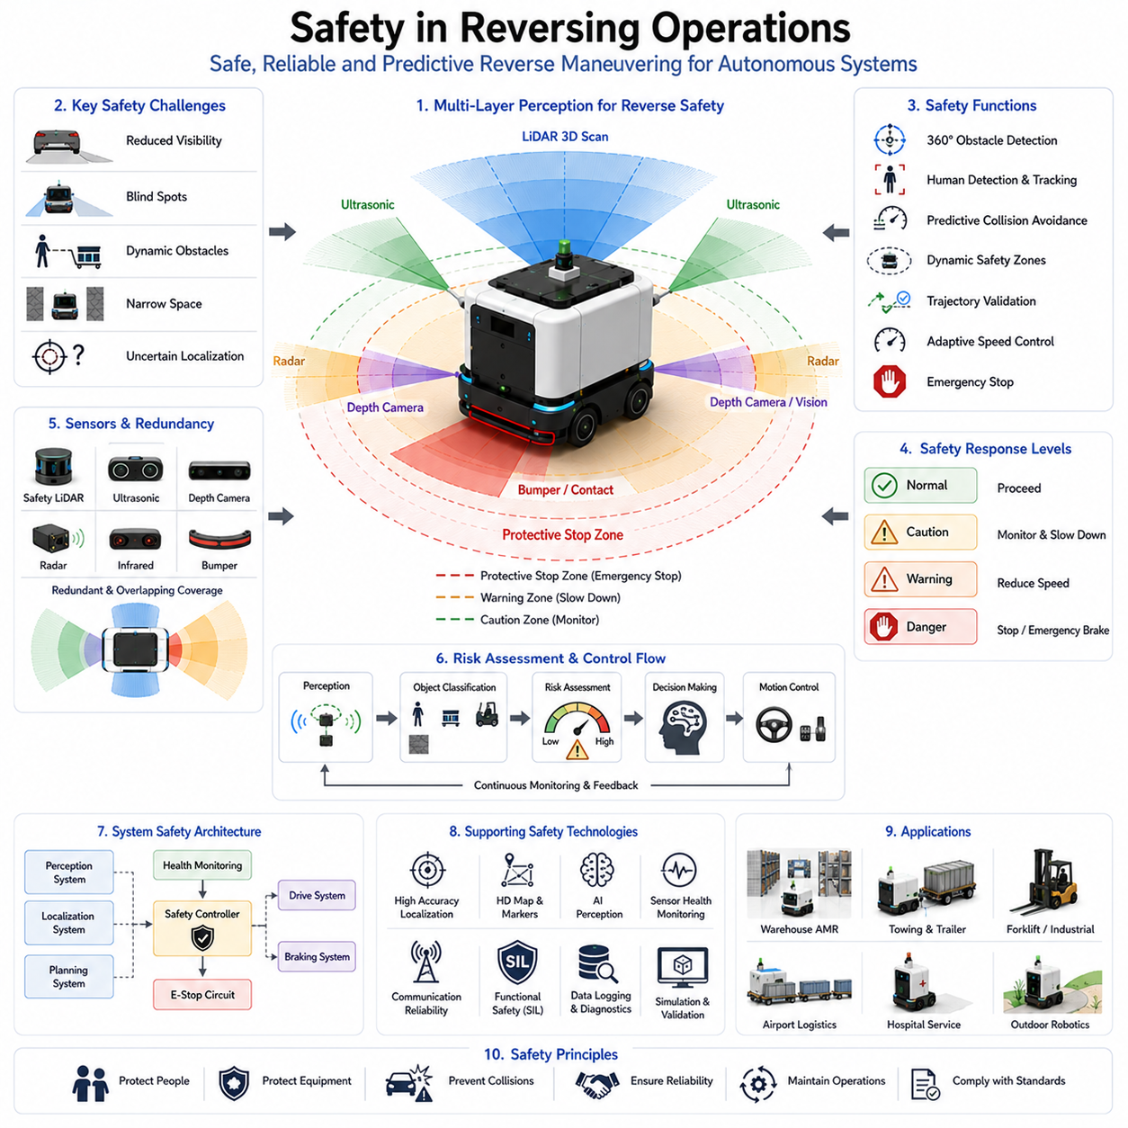
Safety in reversing operations is one of the most critical aspects of autonomous navigation, industrial vehicle control, mobile robotics, logistics automation, and intelligent transportation systems. While autonomous robots are typically designed to navigate safely during forward motion, reverse movement introduces a unique set of challenges that significantly increase operational risk. Human operators naturally rely on direct visual observation when driving forward, but both humans and autonomous systems experience reduced visibility, decreased situational awareness, and increased uncertainty during reversing maneuvers. In autonomous mobile robots, towing AMRs, autonomous forklifts, warehouse transport vehicles, airport logistics systems, hospital service robots, and outdoor autonomous platforms, reversing operations frequently occur within highly constrained spaces where safety margins are limited and environmental complexity is high. Consequently, reversing safety must be treated not as an additional feature but as a fundamental component of the overall navigation architecture.
The primary objective of reversing safety is to ensure that autonomous systems can execute backward movements without causing harm to people, equipment, infrastructure, cargo, or the robot itself. Unlike forward navigation, where most sensors and perception systems are naturally optimized for the direction of travel, reversing often requires perception and control systems to operate in regions that may contain blind spots, limited sensor coverage, and dynamic obstacles. Safety mechanisms must therefore compensate for these disadvantages through enhanced sensing, predictive reasoning, redundant monitoring, and conservative control strategies.
One of the most significant safety challenges during reversing operations is reduced visibility. Even advanced autonomous systems may experience perception limitations when moving backward. Obstacles that were previously outside the robot’s immediate operational area may suddenly become relevant during reverse motion. In industrial facilities, warehouses, hospitals, ports, airports, and manufacturing plants, equipment, pallets, carts, vehicles, and pedestrians may occupy regions behind the robot. The perception system must therefore maintain continuous awareness of all areas that may intersect with the robot’s future trajectory.
Close-range sensing plays a central role in reversing safety. Because reverse maneuvers often occur near obstacles, the robot must continuously monitor its immediate surroundings with high precision. Ultrasonic sensors, short-range LiDAR units, depth cameras, radar sensors, infrared sensors, and contact bumpers are commonly integrated to provide comprehensive coverage around the vehicle. These sensors create overlapping detection zones that minimize blind spots and provide redundant safety information. If one sensor becomes degraded or unavailable, other sensing modalities can continue to support safe operation.
Safety LiDAR systems are particularly important during reversing operations. Unlike standard perception LiDARs, safety-certified LiDAR sensors are specifically designed to support functional safety requirements. These systems continuously monitor configurable safety zones behind and around the robot. If an obstacle enters a predefined protective field, the safety controller can automatically initiate speed reduction, warning generation, controlled stopping, or emergency braking procedures. Safety LiDAR technology has become a foundational component of industrial autonomous vehicle deployments.
Dynamic safety zones further enhance operational safety. Rather than maintaining a fixed protective area around the robot, dynamic safety systems adjust safety boundaries according to vehicle speed, payload characteristics, braking distance, environmental conditions, and maneuver complexity. During high-speed reverse movement, larger safety zones may be required to account for increased stopping distances. During precision docking or parking operations, safety zones may be adjusted to balance safety requirements with operational efficiency.
Human detection is among the highest-priority functions within reversing safety architectures. Autonomous robots frequently operate in shared environments where pedestrians, operators, maintenance personnel, medical staff, and logistics workers move unpredictably. Human-aware perception systems combine computer vision, LiDAR tracking, thermal sensing, and AI-based classification algorithms to identify human presence and estimate future movement trajectories. These capabilities allow the robot to proactively adjust its behavior before hazardous situations develop.
Predictive collision avoidance provides another layer of protection. Traditional obstacle detection systems react to current obstacle locations, but reversing safety often requires anticipation of future interactions. Predictive systems estimate future positions of both the robot and surrounding objects. By analyzing projected trajectories, the navigation system can identify potential collision risks before they become immediate threats. Early detection provides additional time for safe and controlled responses.
Trajectory validation is an essential element of safe reverse operation. Before a reversing maneuver is executed, the planned trajectory must be evaluated against environmental constraints, obstacle locations, vehicle dimensions, articulation limits, and safety margins. Continuous trajectory validation remains active throughout execution. If environmental conditions change or new obstacles appear, the system may modify the trajectory, reduce speed, pause operation, or initiate replanning procedures.
Speed management is closely tied to reversing safety. Reverse motion generally carries higher uncertainty than forward travel, particularly in confined spaces. Consequently, autonomous systems often apply lower speed limits during reversing operations. Adaptive speed control mechanisms adjust vehicle velocity according to environmental complexity, sensor confidence, obstacle proximity, localization accuracy, and task requirements. Slower motion increases reaction time and reduces collision severity in the event of unexpected hazards.
Localization accuracy significantly influences reversing safety. Position estimation errors that may be acceptable during long-range navigation can become dangerous during close-range reverse maneuvers. High-precision localization technologies such as LiDAR localization, visual markers, GNSS RTK systems, fiducial markers, and map-based positioning techniques are often employed to improve accuracy during reversing operations. Confidence estimation algorithms continuously evaluate localization quality and may restrict vehicle motion if uncertainty exceeds predefined thresholds.
Towing robots and articulated vehicle systems introduce additional safety challenges during reversing. Trailer articulation dynamics create complex vehicle behavior that can lead to instability, path deviation, and jackknife conditions. Safety systems must continuously monitor articulation angles and evaluate stability margins throughout the maneuver. If articulation exceeds safe operating limits, corrective actions must be applied immediately to prevent loss of control.
Obstacle classification improves the effectiveness of safety responses. Not all obstacles present the same level of risk. Static infrastructure, movable equipment, vehicles, pallets, and humans require different handling strategies. AI-enhanced perception systems classify detected objects and assign risk levels based on object type, motion characteristics, environmental context, and operational priorities. This contextual understanding enables more intelligent and effective safety decisions.
Emergency stopping mechanisms represent the final protective layer within reversing safety architectures. If all other safety measures fail or if an imminent collision risk is detected, the robot must be capable of stopping immediately. Emergency stop systems typically operate independently of higher-level navigation software and rely on safety-certified hardware and control pathways. Redundant emergency braking systems ensure that safe stopping remains possible even during partial system failures.
Functional safety standards play a major role in the design of reversing safety systems. Industrial autonomous vehicles often comply with standards related to machinery safety, autonomous mobile robots, industrial trucks, and functional safety certification. These standards define requirements for hazard analysis, risk assessment, safety integrity levels, redundancy, fault tolerance, emergency response, and system validation. Compliance ensures that safety mechanisms meet rigorous reliability and performance requirements.
Hazard analysis forms the foundation of safety engineering for reversing operations. Engineers systematically identify potential failure modes, operational hazards, environmental risks, and human interaction scenarios. Each identified hazard is evaluated according to severity, probability, and detectability. Risk mitigation strategies are then developed to reduce residual risk to acceptable levels. This process guides both system design and operational procedures.
Environmental conditions can significantly influence reversing safety. Lighting changes, dust, fog, rain, snow, reflective surfaces, narrow corridors, crowded workspaces, and uneven terrain all affect sensor performance and maneuver complexity. Robust safety architectures continuously evaluate environmental conditions and adapt operational behavior accordingly. Under degraded sensing conditions, the system may reduce speed, increase safety margins, or suspend reverse operation until conditions improve.
Sensor redundancy is a key principle in safety-critical reversing systems. Relying on a single sensor type creates vulnerability to environmental limitations and hardware failures. Multiple sensing modalities provide independent verification of obstacle presence and environmental conditions. Redundant sensing pathways improve reliability and reduce the probability of hazardous perception failures.
Health monitoring systems continuously evaluate the condition of sensors, actuators, controllers, communication networks, and power systems. If abnormalities are detected, the system can enter a safe operational mode before a hazardous condition develops. Examples include reduced-speed operation, restricted maneuvering, increased safety margins, or controlled shutdown procedures. Proactive fault detection significantly enhances operational safety.
Communication between subsystems is also essential. Reversing safety requires coordination among perception systems, localization modules, path planners, motion controllers, fleet managers, and safety controllers. Reliable communication infrastructure ensures that critical safety information is distributed throughout the robot architecture without delay. Safety-related communication pathways often employ redundancy and deterministic communication protocols to guarantee reliability.
Fleet-level safety management becomes increasingly important as multiple autonomous robots operate within the same environment. Reversing maneuvers may create conflicts with nearby robots, vehicles, and infrastructure. Fleet management systems coordinate vehicle movements, reserve maneuvering spaces, manage traffic flow, and prevent interactions that could compromise safety. Centralized supervision complements local autonomy to achieve facility-wide safety objectives.
Human-machine interaction represents another important aspect of reversing safety. Visual indicators, warning lights, audible alarms, projected safety zones, display panels, and communication interfaces inform nearby personnel about robot intentions. Clear communication reduces uncertainty and helps humans respond appropriately to robot behavior. Advanced systems may even predict human reactions and adjust maneuver strategies accordingly.
Simulation-based safety validation has become an indispensable development tool. High-fidelity simulation environments enable engineers to evaluate thousands of reversing scenarios, including rare and hazardous situations that would be difficult or dangerous to reproduce in real-world testing. Simulation supports verification of perception systems, safety logic, emergency procedures, and failure recovery mechanisms under a wide range of operating conditions.
Field testing remains essential despite advances in simulation. Real-world validation exposes the system to practical challenges that cannot always be modeled accurately. Comprehensive testing programs evaluate performance across diverse environments, obstacle configurations, traffic conditions, payload levels, weather conditions, and operational scenarios. Safety metrics such as collision-free operation, emergency stop effectiveness, obstacle detection performance, and risk mitigation success rates provide quantitative measures of system robustness.
Artificial intelligence is increasingly contributing to reversing safety. Deep learning algorithms improve human detection, behavior prediction, obstacle classification, free-space estimation, and anomaly detection. Reinforcement learning techniques support the development of safer maneuver strategies through extensive simulation training. Future AI systems may provide predictive risk assessment capabilities that continuously evaluate environmental hazards before they become operational threats.
Future reversing safety architectures will likely integrate advanced perception, multimodal sensor fusion, predictive world models, embodied intelligence, cloud-connected safety analytics, and adaptive risk management into unified safety ecosystems. Autonomous robots will possess greater awareness of their surroundings, improved predictive capabilities, and more sophisticated decision-making mechanisms. These advancements will enable safer operation in increasingly complex environments while maintaining high levels of productivity and efficiency.
As autonomous mobile robots become more widespread across logistics, manufacturing, healthcare, transportation, agriculture, smart cities, and infrastructure inspection applications, reversing safety will remain one of the most important engineering disciplines within autonomous navigation. Effective reversing safety systems protect people, equipment, infrastructure, and operational continuity while enabling robots to perform complex maneuvers with confidence, precision, and reliability. Ultimately, the success of autonomous systems in real-world deployment depends heavily on their ability to execute reversing operations safely under all anticipated operating conditions.

12.8 Reversing and Parking Validation
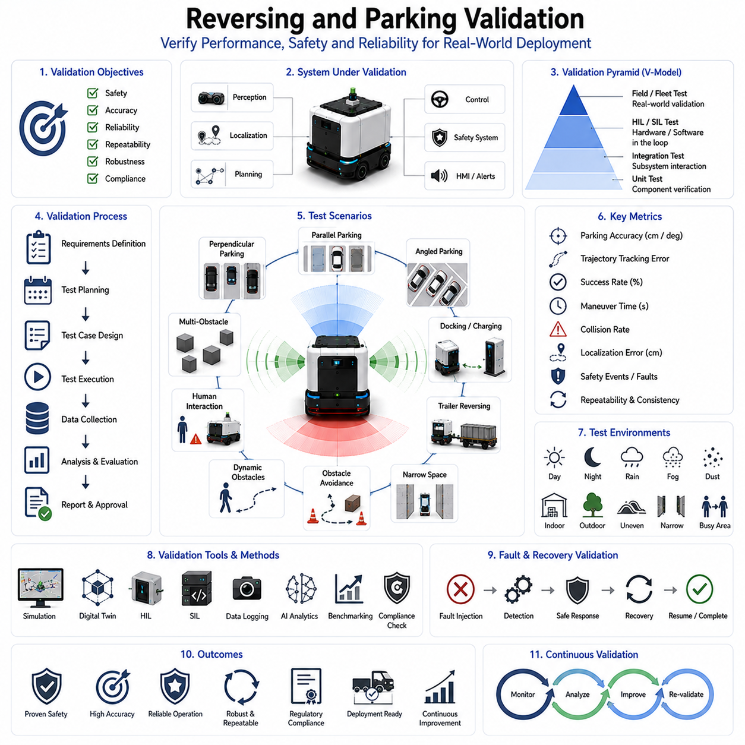
Reversing and parking validation represents the final and most critical stage in the development of autonomous navigation systems responsible for backward maneuvering, precision parking, docking, trailer control, and confined-space vehicle operations. While reversing algorithms, parking planners, sensor integration systems, localization modules, and motion controllers may perform successfully in laboratory environments, their true effectiveness can only be verified through a comprehensive validation process. Validation ensures that the complete autonomous system performs safely, accurately, reliably, and consistently under real-world operating conditions. In autonomous mobile robots, towing AMRs, warehouse vehicles, autonomous forklifts, hospital service robots, airport logistics platforms, agricultural robots, and outdoor autonomous systems, reversing and parking validation serves as the foundation for operational deployment and commercial acceptance. Without rigorous validation, even highly sophisticated algorithms cannot be trusted in safety-critical industrial environments.
The primary objective of reversing and parking validation is to confirm that the robot can consistently execute backward motion and parking maneuvers while satisfying predefined performance, safety, reliability, and operational requirements. Validation activities evaluate not only whether a maneuver can be completed successfully, but also whether it can be repeated thousands of times with acceptable accuracy and safety margins. The validation process must therefore assess the entire autonomous navigation stack, including perception systems, localization subsystems, path planning algorithms, trajectory generation modules, control systems, safety mechanisms, and recovery strategies.
A successful validation program begins with requirement definition. Before testing can occur, engineers must establish measurable performance criteria. These criteria typically include parking accuracy, trajectory tracking error, collision-free operation, maneuver completion time, success rate, localization accuracy, obstacle avoidance effectiveness, trailer articulation stability, safety compliance, and fault recovery capability. Each metric must be associated with quantifiable acceptance thresholds. Clearly defined requirements enable objective evaluation and support regulatory certification efforts.
Simulation-based validation is usually the first stage of the testing process. Modern simulation environments provide highly detailed digital representations of vehicles, sensors, infrastructure, obstacles, and operational scenarios. Engineers can evaluate thousands of reversing and parking situations without exposing physical equipment to risk. Simulation allows rapid identification of algorithmic weaknesses and supports iterative development cycles. Large-scale simulation campaigns may include various parking geometries, obstacle configurations, environmental conditions, vehicle sizes, trailer configurations, and sensor failure scenarios.
Digital twin technology significantly enhances simulation-based validation. A digital twin provides a virtual replica of the real deployment environment, including infrastructure layouts, operational workflows, traffic patterns, and environmental characteristics. By reproducing actual operating conditions with high fidelity, digital twins enable more realistic evaluation of reversing and parking performance. This approach reduces development risk and increases confidence prior to field deployment.
Unit testing forms the foundation of system-level validation. Individual software components such as parking planners, trajectory generators, localization modules, collision checkers, and control algorithms are tested independently to verify correct functionality. Unit testing ensures that each subsystem behaves as expected before integration into the larger autonomous navigation architecture. This approach simplifies debugging and reduces the likelihood of hidden software defects propagating into operational environments.
Integration testing follows unit-level verification. During integration testing, multiple subsystems are combined and evaluated as a unified system. Sensor fusion, localization, planning, control, and safety modules must exchange information reliably and consistently. Engineers verify data synchronization, communication latency, coordinate transformations, fault handling behavior, and system interoperability. Many operational failures originate from subsystem interactions rather than individual component defects, making integration testing particularly important.
Hardware-in-the-loop validation provides a bridge between simulation and real-world deployment. In this testing approach, actual controllers, sensors, communication systems, and vehicle components are connected to simulated environments. Hardware-in-the-loop testing enables engineers to evaluate real hardware behavior under controlled conditions while maintaining the flexibility of simulation. Timing constraints, communication performance, controller stability, and sensor interfaces can all be assessed before full vehicle deployment.
Software-in-the-loop validation is similarly valuable. Entire navigation software stacks can be executed within simulation environments using realistic sensor data streams and vehicle dynamics models. This approach supports rapid testing of software updates, parameter modifications, and algorithm improvements without requiring physical vehicle operation. Continuous integration pipelines frequently incorporate software-in-the-loop testing to maintain software quality throughout development.
Field validation represents the most important stage of reversing and parking verification. Real-world environments introduce complexities that are difficult to reproduce in simulation, including surface irregularities, environmental noise, sensor degradation, unexpected obstacles, human behavior, weather effects, and infrastructure variability. Comprehensive field testing confirms that the autonomous system can maintain performance under realistic operating conditions.
Parking accuracy is one of the primary performance metrics evaluated during validation. The final vehicle position and orientation are compared against the desired target pose. Position error, orientation error, lateral deviation, longitudinal deviation, and docking alignment accuracy are measured across repeated trials. High-performance systems may require positioning accuracy within a few centimeters or even millimeters depending on application requirements.
Trajectory tracking performance is another critical evaluation metric. During reversing and parking operations, the vehicle must closely follow planned trajectories while compensating for disturbances and uncertainties. Tracking error measurements assess the difference between desired and actual vehicle motion. Excessive tracking error may indicate controller deficiencies, localization problems, vehicle dynamics modeling inaccuracies, or environmental influences.
Repeatability is particularly important for industrial applications. A robot that successfully completes a parking maneuver once but fails intermittently cannot be considered reliable. Validation programs therefore include repeated execution of identical maneuvers under controlled conditions. Statistical analysis of repeated trials provides insight into system consistency, robustness, and operational reliability. Repeatability metrics often become key performance indicators during product qualification.
Collision avoidance validation ensures that safety systems function correctly throughout reversing and parking operations. Test scenarios include static obstacles, dynamic obstacles, unexpected obstacle appearances, human interactions, and obstacle-rich environments. Engineers evaluate obstacle detection accuracy, reaction time, braking performance, avoidance effectiveness, and emergency response behavior. Successful collision avoidance validation is essential for safety certification and operational approval.
Human safety testing occupies a central role within validation programs. Autonomous robots frequently operate in environments shared with human workers. Validation scenarios evaluate pedestrian detection performance, human tracking accuracy, safety zone effectiveness, emergency stop activation, warning systems, and human-aware navigation behavior. These tests verify that the robot responds appropriately to human presence and maintains safe operating conditions at all times.
Environmental robustness testing examines system performance under diverse operating conditions. Lighting variations, rain, fog, dust, snow, reflective surfaces, temperature changes, vibration, electromagnetic interference, and surface irregularities can all influence reversing and parking performance. Validation campaigns expose the robot to these conditions and measure resulting changes in perception accuracy, localization quality, trajectory tracking performance, and overall maneuver success rates.
Trailer reversing validation introduces additional complexity. Towing robots and articulated vehicle systems must demonstrate stable trailer behavior throughout reverse maneuvers. Engineers evaluate articulation angle control, jackknife prevention, trailer trajectory tracking, load influence effects, and multi-trailer stability. Specialized testing procedures assess performance under varying payload conditions and trailer configurations.
Close-range sensor validation is essential because reversing and parking operations rely heavily on near-field perception. Ultrasonic sensors, depth cameras, LiDAR systems, radar units, infrared sensors, and contact sensors must all be evaluated for measurement accuracy, detection reliability, latency, environmental robustness, and failure handling. Sensor fusion performance is also validated to ensure that integrated perception outputs remain accurate and reliable.
Localization validation focuses on the robot’s ability to maintain accurate position estimates during precision maneuvers. Validation procedures measure localization drift, pose estimation accuracy, map matching quality, marker detection reliability, and recovery performance following temporary localization degradation. Since parking often requires centimeter-level precision, localization validation standards are typically more stringent than those applied to general navigation tasks.
Fault injection testing evaluates system resilience under abnormal conditions. Engineers intentionally introduce sensor failures, communication disruptions, localization errors, actuator malfunctions, power fluctuations, and software faults. The objective is to verify that safety mechanisms, redundancy architectures, and recovery strategies function correctly. Robust autonomous systems must continue operating safely or transition to safe states when faults occur.
Recovery validation assesses the robot’s ability to respond to operational failures. Parking spaces may become occupied unexpectedly, obstacles may block trajectories, localization confidence may decrease, or environmental conditions may deteriorate. Recovery testing verifies that the robot can detect these situations, diagnose root causes, and execute appropriate corrective actions. Effective recovery behavior significantly enhances operational reliability.
Performance benchmarking provides objective comparisons between different algorithms, system configurations, and software versions. Standardized benchmark scenarios allow engineers to quantify improvements and identify performance regressions. Benchmarking metrics commonly include parking accuracy, maneuver duration, trajectory smoothness, energy consumption, collision rate, computational efficiency, and success probability.
Fleet-level validation becomes necessary when multiple autonomous vehicles operate simultaneously. Parking coordination, traffic management, space allocation, collision prevention, and shared infrastructure utilization must all be evaluated under realistic operational loads. Fleet testing verifies that individual vehicle performance scales effectively within larger autonomous ecosystems.
Regulatory compliance validation ensures adherence to applicable standards and safety requirements. Autonomous vehicle deployments may require compliance with industrial safety standards, machinery regulations, functional safety frameworks, autonomous robot standards, and customer-specific requirements. Validation evidence supports certification efforts and demonstrates that the system satisfies mandatory safety criteria.
Data logging and analytics play a critical role throughout the validation process. Comprehensive recording of sensor data, localization outputs, control commands, vehicle states, safety events, and environmental conditions enables detailed post-test analysis. Engineers use these datasets to identify failure patterns, optimize algorithms, improve system performance, and validate corrective actions. Data-driven validation methodologies have become increasingly important as autonomous systems grow more complex.
Artificial intelligence is increasingly contributing to validation activities. Machine learning algorithms analyze large testing datasets, identify anomalies, classify failure modes, predict operational risks, and recommend performance improvements. AI-assisted validation accelerates testing cycles and enables deeper understanding of system behavior across diverse operating conditions.
Continuous validation has emerged as an important concept within modern robotics development. Rather than treating validation as a one-time activity, autonomous systems undergo ongoing evaluation throughout their operational lifecycle. Software updates, sensor replacements, hardware modifications, and environmental changes all trigger additional validation activities. Continuous validation ensures that system performance remains acceptable as the platform evolves over time.
Future reversing and parking validation frameworks will increasingly leverage digital twins, cloud-based testing infrastructures, AI-driven analytics, large-scale simulation environments, autonomous test generation, and real-time operational monitoring. Validation processes will become more automated, scalable, and data-driven while maintaining rigorous safety standards. These advancements will support the deployment of increasingly sophisticated autonomous systems across logistics, manufacturing, healthcare, transportation, agriculture, smart infrastructure, and industrial automation.
Ultimately, reversing and parking validation serves as the final proof that an autonomous system can safely and reliably perform one of the most demanding categories of vehicle maneuvers. Through comprehensive testing, objective measurement, rigorous analysis, and continuous improvement, validation transforms theoretical capability into operational trust. As autonomous robots become more deeply integrated into real-world environments, robust reversing and parking validation will remain a cornerstone of safe, reliable, and commercially successful autonomous mobility systems.

