Volume 05. Path Planning and Autonomous Navigation

Chapter 10. Multi-Robot Navigation

10.1 Multi-Robot Navigation Overview
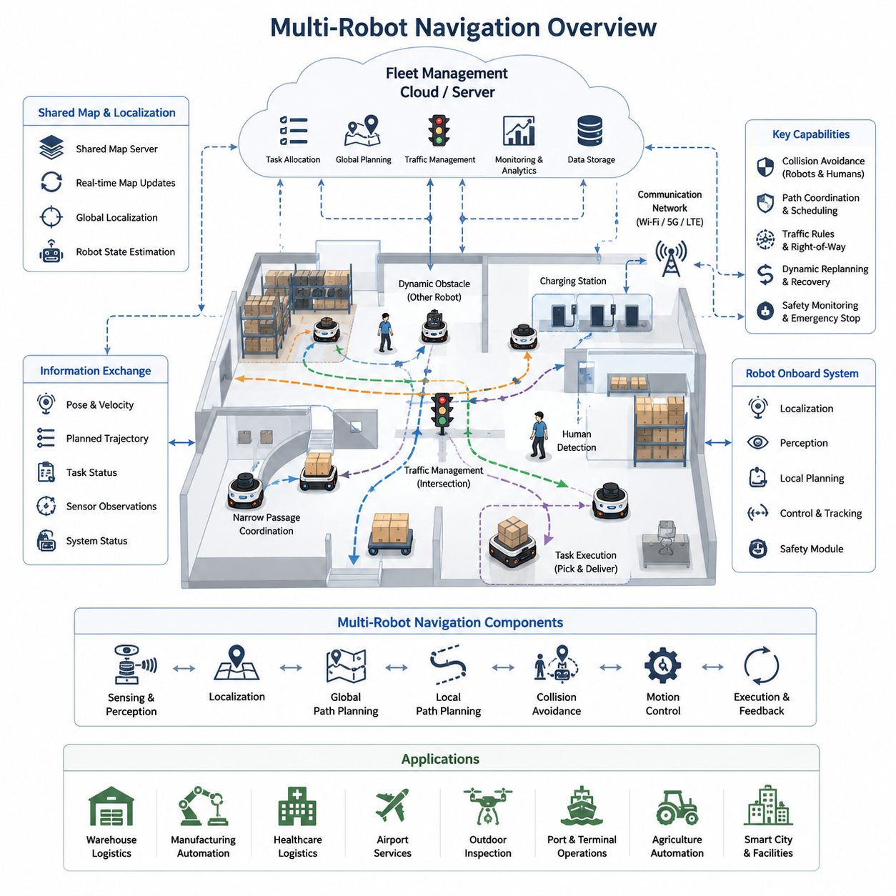
Multi-robot navigation represents one of the most important advancements in modern autonomous mobile robot systems. While traditional navigation algorithms focus on enabling a single robot to move safely and efficiently through an environment, multi-robot navigation extends these concepts to support coordinated operation among many robots sharing the same physical space. As industries increasingly deploy fleets of autonomous mobile robots in warehouses, factories, hospitals, airports, logistics centers, ports, smart cities, and outdoor industrial facilities, the ability for multiple robots to navigate cooperatively has become a fundamental requirement for scalable automation systems. The topic serves as the foundation for shared localization, collaborative planning, traffic management, fleet optimization, and large-scale autonomous operations.
The primary objective of multi-robot navigation is to allow multiple autonomous robots to perform tasks simultaneously while minimizing conflicts, maximizing efficiency, and maintaining safe operations. Unlike single-robot systems where navigation decisions affect only one platform, multi-robot systems must continuously consider the actions, intentions, and future trajectories of other robots operating within the environment. Every robot becomes both a navigation participant and a dynamic obstacle that influences the behavior of the entire fleet. This creates a highly interconnected navigation problem that requires advanced coordination mechanisms and intelligent decision-making strategies.
Modern autonomous robot deployments often involve dozens, hundreds, or even thousands of robots operating simultaneously. Large warehouse automation systems may employ hundreds of mobile robots transporting inventory between storage locations and picking stations. Hospital logistics robots may deliver medication, meals, linens, laboratory samples, and medical supplies throughout multiple floors of a healthcare facility. Manufacturing plants may utilize fleets of material-handling robots moving components between production cells. Outdoor autonomous platforms may coordinate inspection, surveillance, mapping, maintenance, and transportation activities across large industrial facilities. In all these scenarios, multi-robot navigation provides the operational framework necessary to ensure that robots work together efficiently rather than competing for the same resources.
One of the key advantages of multi-robot systems is scalability. Instead of relying on a single robot to perform all tasks, organizations can increase productivity simply by adding more robots to the fleet. However, scalability introduces significant navigation challenges. As the number of robots increases, the likelihood of congestion, path conflicts, deadlocks, communication bottlenecks, and inefficient resource utilization also increases. Multi-robot navigation architectures must therefore be designed to maintain system performance as fleet size grows. Effective scalability requires efficient communication protocols, distributed decision-making mechanisms, optimized traffic management systems, and robust fleet coordination algorithms.
A multi-robot navigation system typically consists of several major components. These include robot localization systems, map management systems, path planning modules, collision avoidance systems, communication networks, traffic management controllers, task allocation engines, and fleet management software. Together, these components create a comprehensive ecosystem that allows robots to share information and coordinate their actions. Each robot maintains its own local perception and navigation capabilities while simultaneously participating in a larger fleet-level coordination framework.
Localization plays a critical role in multi-robot navigation. Every robot must know its position accurately while also understanding the locations of other robots operating within the environment. Shared localization systems often rely on common maps, synchronized coordinate frames, and centralized or distributed localization services. Indoor systems may utilize LiDAR-based SLAM, visual SLAM, QR code markers, UWB infrastructure, or hybrid localization techniques. Outdoor systems may combine GNSS RTK, inertial navigation, LiDAR localization, visual localization, and HD maps. Accurate localization ensures that robots can predict potential interactions and coordinate movement safely.
Shared maps are another essential component of multi-robot navigation. Instead of each robot maintaining an independent representation of the environment, fleet systems often utilize centralized map servers or distributed map-sharing architectures. These shared maps allow robots to operate within a common understanding of the environment. Dynamic updates such as newly detected obstacles, blocked corridors, temporary construction zones, or environmental changes can be distributed throughout the fleet, enabling all robots to react appropriately. Shared mapping improves consistency, reduces navigation errors, and enhances fleet-level situational awareness.
Communication infrastructure forms the backbone of coordinated navigation. Robots continuously exchange information related to position, velocity, planned trajectories, task assignments, environmental observations, system status, and operational constraints. Communication may occur through Wi-Fi, private LTE networks, 5G infrastructure, industrial wireless systems, mesh networks, or cloud-based communication services. Reliable communication is essential for maintaining fleet coordination and preventing navigation conflicts. However, communication failures must also be anticipated, requiring robust fallback strategies and autonomous local decision-making capabilities.
Path planning in multi-robot systems differs significantly from traditional single-robot planning. Instead of generating a path solely based on static obstacles and environmental constraints, planners must also account for the future movements of other robots. Time becomes an important dimension of the planning problem. Two robots may safely occupy the same physical location if they arrive at different times, while collisions may occur if they arrive simultaneously. Consequently, many multi-robot planning systems utilize space-time planning approaches that incorporate both spatial and temporal constraints.
Collision avoidance between robots represents one of the most visible aspects of multi-robot navigation. Robots must detect potential conflicts before they occur and adjust their behavior accordingly. Collision avoidance mechanisms may include local obstacle avoidance algorithms, trajectory prediction models, velocity coordination methods, reservation systems, and traffic control policies. Modern systems often combine reactive collision avoidance with predictive planning to achieve both safety and efficiency. Robots continuously evaluate the trajectories of neighboring robots and adjust their motion plans to prevent conflicts while maintaining progress toward their assigned goals.
Traffic management becomes increasingly important as fleet size grows. Similar to urban transportation systems, robot fleets require mechanisms to regulate movement through shared infrastructure such as corridors, intersections, doorways, elevators, loading stations, and charging areas. Traffic management systems may implement right-of-way rules, virtual traffic lights, reservation-based navigation, one-way traffic corridors, congestion control strategies, and dynamic rerouting mechanisms. Effective traffic management reduces delays, improves throughput, and minimizes energy consumption across the fleet.
Task allocation and navigation are closely interconnected in multi-robot systems. Assigning tasks without considering navigation constraints may lead to inefficient fleet behavior. Modern fleet management systems therefore integrate task planning with navigation optimization. Robots are assigned tasks based not only on availability but also on location, predicted travel time, battery status, traffic conditions, workload distribution, and operational priorities. This integrated approach maximizes fleet productivity while minimizing unnecessary movement and congestion.
Centralized and decentralized architectures represent two fundamental approaches to multi-robot navigation. In centralized systems, a fleet management server maintains a global view of all robots and coordinates navigation decisions. Centralized architectures provide strong optimization capabilities and simplified coordination but may introduce scalability limitations and single points of failure. In decentralized systems, robots make decisions locally while sharing information with neighboring robots. Decentralized approaches improve robustness and scalability but may face challenges in achieving globally optimal behavior. Many industrial systems employ hybrid architectures that combine centralized fleet-level planning with decentralized local navigation.
Cloud robotics has emerged as a significant enabler of large-scale multi-robot navigation. Cloud platforms provide computational resources for fleet optimization, global planning, traffic management, data analytics, and machine learning. Robots can offload computationally intensive tasks to cloud infrastructure while maintaining local autonomy for safety-critical operations. Cloud-based navigation architectures enable real-time coordination across geographically distributed fleets and facilitate continuous system improvement through centralized data collection and analysis.
Multi-robot navigation systems must also address operational uncertainties. Dynamic obstacles, human workers, environmental changes, sensor failures, communication disruptions, localization errors, and unexpected robot behaviors can all affect navigation performance. Robust systems incorporate fault detection mechanisms, recovery procedures, redundancy strategies, and adaptive planning algorithms. When navigation failures occur, robots must be capable of safely recovering while minimizing disruption to overall fleet operations.
Safety remains the highest priority in multi-robot environments. Industrial deployments often operate in close proximity to people, equipment, and valuable assets. Safety systems must ensure collision-free operation under both normal and abnormal conditions. Safety mechanisms may include protective zones, speed restrictions, emergency stop protocols, predictive collision detection, human-aware navigation behaviors, and compliance with international safety standards. Fleet-level safety monitoring provides additional protection by detecting system-wide risks and coordinating appropriate responses.
Simulation and digital twin technologies play a crucial role in the development of multi-robot navigation systems. Before deploying robots in real environments, engineers can evaluate fleet behaviors in virtual simulations. Large-scale simulations enable testing of traffic management algorithms, collision avoidance strategies, communication architectures, task allocation policies, and recovery mechanisms. Digital twins further allow real-world fleet operations to be monitored, analyzed, and optimized using virtual representations of physical systems.
Industrial applications demonstrate the practical value of multi-robot navigation. Warehouse automation systems coordinate large fleets to transport inventory efficiently. Hospital logistics systems enable autonomous delivery throughout healthcare facilities. Manufacturing robots support just-in-time material movement across production lines. Airport robots assist with baggage handling and service operations. Outdoor inspection robots coordinate infrastructure monitoring activities across large industrial sites. Agricultural robots collaborate to perform planting, spraying, monitoring, and harvesting operations. Each application introduces unique navigation challenges that drive ongoing innovation in fleet coordination technologies.
Recent advances in artificial intelligence are transforming multi-robot navigation. Machine learning models can predict traffic patterns, optimize task assignments, improve path planning, and enhance collision avoidance. Multi-agent reinforcement learning enables robots to learn cooperative behaviors through experience. Foundation models, world models, and embodied AI systems are beginning to influence how robot fleets perceive, reason about, and interact with complex environments. These technologies promise to make future fleets more adaptive, efficient, and autonomous.
The future of multi-robot navigation will likely involve increasingly intelligent and interconnected robotic ecosystems. Large fleets operating across factories, hospitals, logistics hubs, ports, smart cities, and outdoor industrial environments will share maps, exchange knowledge, coordinate decisions, and adapt collectively to changing conditions. Advances in cloud robotics, edge computing, artificial intelligence, digital twins, 5G communications, and autonomous fleet management will continue to expand the capabilities of multi-robot systems. As robotic deployments grow in scale and complexity, multi-robot navigation will remain one of the foundational technologies enabling safe, efficient, and scalable autonomous operations across virtually every sector of industry.

10.2 Shared Map and Localization
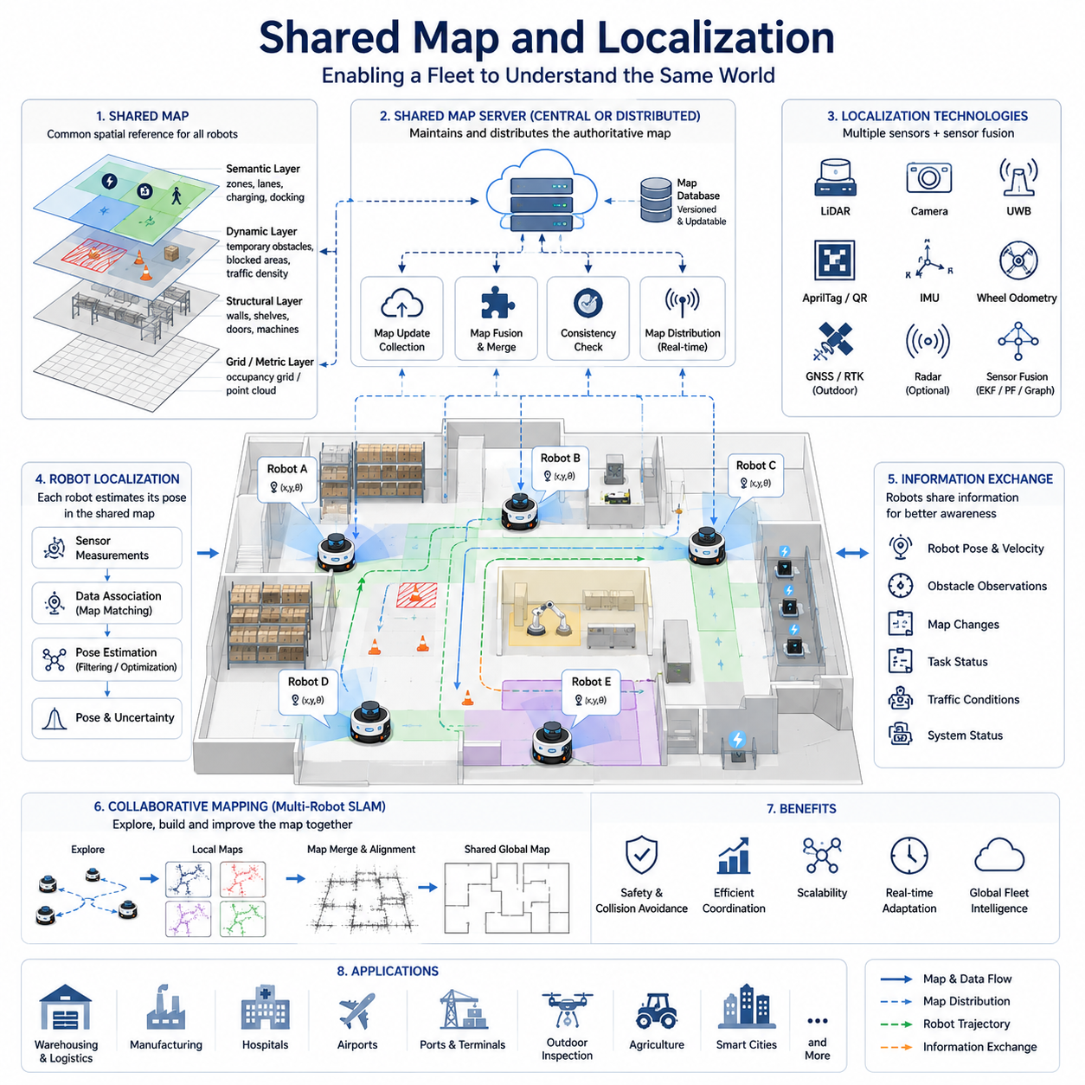
Shared Map and Localization is one of the most critical technologies in multi-robot navigation systems because it provides a common spatial understanding that allows multiple autonomous robots to operate as a coordinated fleet rather than as independent machines. In a single-robot navigation system, localization focuses on estimating the position and orientation of one robot within a known or unknown environment. In contrast, multi-robot systems require every robot to understand not only its own location but also the positions of all other robots operating in the shared workspace. This collective understanding forms the foundation for collision avoidance, path coordination, traffic management, fleet optimization, collaborative task execution, and large-scale autonomous operations. Within modern industrial environments, the ability to maintain a consistent shared map and a common localization framework directly influences operational efficiency, safety, scalability, and overall system reliability.
The concept of a shared map begins with the creation of a unified representation of the environment. Instead of maintaining separate maps for individual robots, a fleet of robots utilizes a common map database that can be accessed, updated, and distributed throughout the system. This shared representation serves as the spatial reference used by all navigation components. Every robot interprets its surroundings according to the same coordinate system, map structure, and environmental model. As a result, fleet-wide navigation decisions become significantly more consistent and predictable. Robots can exchange information about obstacles, routes, restricted zones, charging stations, loading docks, work cells, intersections, and traffic conditions without ambiguity because all information is referenced within the same spatial framework.
In industrial AMR deployments, shared maps often contain multiple layers of information. The foundational layer typically consists of geometric information such as walls, corridors, doors, workstations, racks, storage locations, machinery, and structural features. Above this geometric layer, semantic information may be incorporated to provide contextual understanding. Areas may be labeled as production zones, warehouse aisles, hospital wards, loading bays, inspection sectors, maintenance regions, or pedestrian walkways. Dynamic information layers can further include temporary obstacles, construction zones, blocked passages, traffic density information, and operational constraints. By integrating these various layers into a shared map architecture, robots gain a richer understanding of the environment and can make more intelligent navigation decisions.
Localization refers to the process through which a robot estimates its current position and orientation within the shared map. In multi-robot systems, localization accuracy becomes even more important because errors propagate beyond individual robots and affect fleet-level coordination. If one robot experiences significant localization drift, its planned trajectory may conflict with the trajectories of neighboring robots. Therefore, robust localization mechanisms are essential for maintaining operational safety and efficiency.
A shared localization framework allows all robots to operate within a common coordinate reference system. This common reference frame enables robots to exchange positional information directly without requiring coordinate transformations or additional alignment procedures. Whether the system uses a global coordinate frame, facility-level reference frame, building map frame, or geospatial coordinate system, consistency across the fleet is essential. Every robot must interpret positional data identically to ensure proper coordination.
Several localization technologies are commonly employed within shared localization architectures. In indoor environments, LiDAR-based localization is widely used because of its robustness and high accuracy. Robots compare live LiDAR scans against the shared map and estimate their pose by matching observed features with known environmental structures. Visual localization techniques use cameras and visual landmarks to estimate robot positions relative to the map. QR codes, AprilTags, fiducial markers, and artificial landmarks may also be deployed to improve localization reliability in challenging environments. Ultra-Wideband systems provide infrastructure-assisted localization through anchor-based ranging measurements. Wheel odometry and inertial measurement units contribute additional motion information that supports continuous pose estimation between external observations.
Outdoor shared localization systems introduce additional complexity due to larger operational areas and changing environmental conditions. GNSS and RTK technologies provide global positioning information, while LiDAR localization and visual localization offer local refinement. High-definition maps often serve as reference models for precise localization. Sensor fusion techniques combine GNSS, IMU, wheel odometry, LiDAR, cameras, radar, and other sensing modalities to achieve robust localization under varying weather, lighting, and terrain conditions.
Multi-robot systems frequently employ simultaneous localization and mapping technologies to support shared map generation. During deployment in previously unknown environments, multiple robots may collaborate to construct a common map while simultaneously localizing themselves within that map. This process is known as collaborative SLAM or multi-robot SLAM. Each robot contributes observations collected from its local environment. These observations are integrated into a shared map that grows and improves as additional information becomes available. Collaborative mapping accelerates map generation, improves coverage, increases redundancy, and reduces overall deployment time.
Map merging represents a fundamental challenge in collaborative mapping systems. When multiple robots independently explore different regions of an environment, their local maps must eventually be aligned and combined into a unified representation. This process requires identifying common features, establishing coordinate correspondences, and estimating transformation relationships between map segments. Successful map merging allows information collected by one robot to become immediately useful to all other robots within the fleet.
Modern shared map architectures often utilize centralized map servers. A map server maintains the authoritative version of the environment and distributes updates to all connected robots. Robots periodically upload observations, localization estimates, environmental changes, and mapping updates to the server. The server integrates this information and redistributes updated map data throughout the fleet. Centralized architectures simplify synchronization and consistency management while providing a global view of the environment.
Distributed mapping architectures represent an alternative approach. Instead of relying on a single map server, robots exchange mapping information directly with one another. Distributed architectures improve robustness by eliminating single points of failure and may reduce communication bottlenecks in large-scale deployments. However, maintaining consistency across distributed maps introduces additional complexity and requires sophisticated synchronization mechanisms.
Real-time map updating is particularly important in dynamic environments. Warehouses, factories, hospitals, and outdoor facilities continuously change as equipment moves, inventory shifts, temporary barriers are installed, and operational conditions evolve. Shared maps must therefore support dynamic updates that reflect the current state of the environment. Robots that detect new obstacles or environmental changes can publish updates to the fleet, allowing all robots to adapt their navigation plans accordingly.
The integration of localization and mapping creates a feedback loop that improves both capabilities. Accurate localization enables robots to contribute high-quality observations to the shared map. Improved maps subsequently enhance localization performance by providing more reliable reference information. This mutually reinforcing relationship is one of the key reasons why shared map and localization architectures are so effective in multi-robot systems.
Time synchronization plays a crucial role in shared localization frameworks. Robots continuously generate observations from sensors operating at different frequencies. Accurate timestamps are required to align sensor data, coordinate robot positions, merge observations, and maintain consistency across the fleet. Network Time Protocol, Precision Time Protocol, GPS time synchronization, and hardware synchronization methods are commonly employed to ensure temporal consistency.
Communication infrastructure strongly influences shared localization performance. Position updates, map modifications, sensor observations, and fleet coordination messages must be exchanged reliably and efficiently. Industrial deployments typically utilize Wi-Fi, private LTE networks, 5G communication systems, mesh networks, or dedicated industrial communication infrastructures. Network latency, bandwidth limitations, packet loss, and communication interruptions must all be considered when designing shared localization architectures.
Cloud robotics is increasingly being integrated into shared mapping systems. Cloud platforms provide centralized storage, large-scale computation, long-term map maintenance, and fleet-wide optimization capabilities. Robots can offload computationally intensive mapping tasks to cloud servers while maintaining local localization functionality for safety-critical operations. Cloud-based map services enable large fleets to share information across multiple facilities, geographical regions, and operational environments.
Localization uncertainty management is an essential aspect of fleet navigation. Every localization estimate contains some degree of uncertainty due to sensor noise, environmental ambiguity, and modeling errors. Shared localization systems often represent uncertainty explicitly using covariance matrices, probability distributions, particle representations, or confidence scores. Fleet coordination algorithms can then incorporate localization uncertainty into decision-making processes, reducing the likelihood of navigation conflicts caused by inaccurate position estimates.
Shared maps also support higher-level fleet intelligence. Traffic management systems use map information to coordinate movement through intersections, corridors, and narrow passages. Task allocation systems use spatial information to assign work efficiently. Predictive analytics systems use localization histories to identify bottlenecks, congestion patterns, and operational inefficiencies. Digital twin platforms use shared maps as the foundation for virtual representations of real-world facilities.
Safety applications benefit significantly from shared localization frameworks. Robots can monitor the positions of neighboring robots, human workers, vehicles, and critical assets within the shared coordinate system. Potential collision risks can be identified early, allowing proactive avoidance actions. Emergency response mechanisms can leverage fleet-wide localization information to coordinate safe stopping procedures, evacuation behaviors, or system-wide operational adjustments.
Scalability is a major design consideration for shared map architectures. Small deployments may involve only a few robots operating within limited facilities. Large-scale deployments may involve hundreds or thousands of robots distributed across extensive operational environments. Shared localization systems must scale efficiently while maintaining accuracy, consistency, responsiveness, and reliability. Hierarchical map structures, regional map partitioning, cloud-edge architectures, and distributed processing frameworks are commonly employed to support scalability.
Simulation and digital twin technologies play a valuable role in the development and validation of shared map and localization systems. Engineers can evaluate mapping algorithms, localization performance, communication architectures, synchronization strategies, and fleet coordination mechanisms within virtual environments before deploying them in real facilities. Simulation accelerates development while reducing risk and deployment costs.
Future shared map and localization systems will likely become increasingly intelligent through the integration of artificial intelligence, semantic understanding, foundation models, and world models. Robots will not only share geometric maps but also semantic knowledge, operational experience, environmental predictions, and learned behaviors. Dynamic world models may continuously evolve as robots observe and interpret their surroundings. Cloud-native mapping platforms may support global fleets operating across multiple facilities while maintaining a unified understanding of spatial and operational information.
As multi-robot systems continue to expand across logistics, manufacturing, healthcare, transportation, agriculture, infrastructure inspection, smart cities, and defense applications, shared map and localization technologies will remain among the most fundamental building blocks of autonomous fleet operations. They provide the common language through which robots perceive their environment, understand their positions, coordinate their actions, and operate collectively as a unified intelligent system. Through advances in sensing, communication, cloud computing, artificial intelligence, and collaborative robotics, shared map and localization architectures will continue to evolve, enabling increasingly sophisticated, scalable, and autonomous robotic ecosystems.

10.3 Collision Avoidance Between Robots
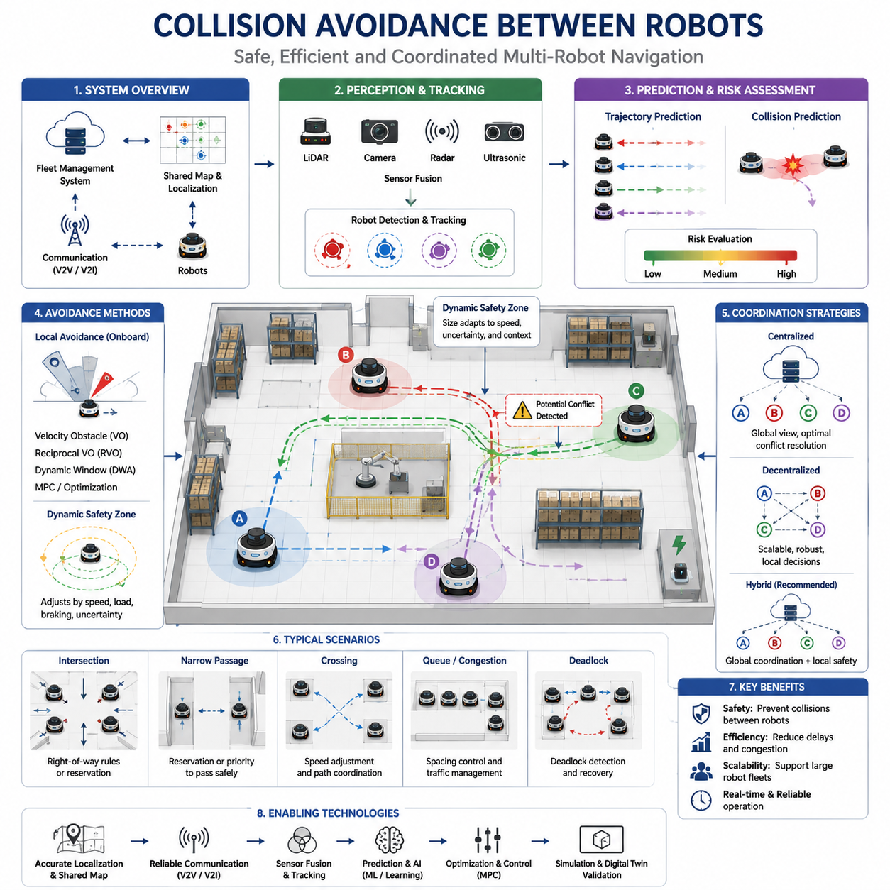
Collision avoidance between robots is one of the most fundamental capabilities required for safe and efficient operation in multi-robot navigation systems. As autonomous mobile robots become increasingly common in warehouses, manufacturing plants, hospitals, airports, logistics centers, smart cities, ports, agricultural environments, and outdoor industrial facilities, the ability for multiple robots to share the same workspace without colliding becomes essential. Unlike single-robot navigation, where obstacles primarily consist of static structures and occasional moving objects, multi-robot systems introduce a unique challenge because every robot simultaneously acts as both an autonomous decision maker and a dynamic obstacle. Each robot continuously moves, changes direction, modifies speed, executes tasks, and adapts to environmental conditions. Consequently, collision avoidance between robots requires sophisticated perception, prediction, communication, planning, and control mechanisms that operate in real time while maintaining fleet-wide efficiency and safety.
The primary objective of robot-to-robot collision avoidance is to prevent physical contact between autonomous platforms while minimizing disruptions to operational productivity. A well-designed collision avoidance system must not only prevent accidents but also ensure that robots continue to accomplish their assigned tasks efficiently. Excessively conservative avoidance behaviors may reduce collisions but can significantly decrease throughput, create congestion, and increase travel times. Conversely, aggressive navigation strategies may improve efficiency while increasing operational risks. Therefore, successful collision avoidance requires a careful balance between safety and performance.
In a multi-robot environment, every robot continuously observes its surroundings and maintains awareness of neighboring robots. This awareness may be achieved through onboard sensors, communication networks, shared localization systems, fleet management platforms, or combinations of these technologies. Each robot must estimate not only the current positions of nearby robots but also predict their future movements. Collision avoidance therefore becomes a predictive problem rather than a purely reactive one. Robots must anticipate potential conflicts before they occur and take corrective actions early enough to avoid dangerous situations.
One of the most important concepts in multi-robot collision avoidance is shared situational awareness. When robots operate within a common map and localization framework, each robot can access accurate information regarding the positions, velocities, trajectories, and intentions of other robots. Shared situational awareness significantly improves collision avoidance performance because robots no longer rely solely on local sensing. Instead, they can utilize fleet-wide information to predict interactions and coordinate movements proactively. This capability becomes particularly valuable in environments containing blind corners, narrow corridors, intersections, elevators, loading stations, and other locations where direct line-of-sight sensing may be limited.
Collision avoidance begins with accurate robot detection and tracking. Robots must continuously identify neighboring robots operating within their vicinity. Detection may be performed using LiDAR sensors, cameras, depth sensors, radar systems, ultrasonic sensors, or combinations of multiple sensing modalities. Sensor fusion techniques combine observations from various sensors to improve detection reliability and reduce false positives or missed detections. Robust robot tracking systems maintain estimates of neighboring robot positions, velocities, accelerations, orientations, and motion histories. These estimates provide the foundation for future trajectory prediction and collision risk assessment.
Trajectory prediction represents a critical component of robot-to-robot collision avoidance. Once neighboring robots are detected and tracked, their future movements must be estimated. Simple prediction models may assume constant velocity or constant acceleration behavior. More advanced approaches incorporate planned trajectories, navigation goals, traffic rules, behavioral models, machine learning algorithms, and fleet coordination information. By predicting future robot positions several seconds in advance, collision avoidance systems can identify potential conflicts early and generate smooth corrective actions.
Collision prediction algorithms evaluate the likelihood that two or more robots will occupy the same space at the same time. Many systems use concepts such as Time to Collision, Closest Point of Approach, Predicted Occupancy Regions, or Dynamic Safety Zones. These metrics quantify collision risk and allow robots to prioritize avoidance actions appropriately. Collision prediction often extends beyond pairwise interactions and considers multiple robots simultaneously operating within complex environments.
Dynamic safety zones are commonly used to protect robots from collisions. A safety zone represents a protected region surrounding each robot that other robots are not permitted to enter. The size and shape of safety zones may vary depending on robot speed, payload, braking capability, environmental conditions, localization uncertainty, and operational context. High-speed robots generally require larger safety zones than slow-moving robots. Similarly, robots carrying heavy loads may require additional stopping distance and therefore larger protective regions. Dynamic safety zones continuously adapt to changing operating conditions to maintain appropriate levels of protection.
Local collision avoidance algorithms operate directly on individual robots and provide immediate responses to nearby threats. These algorithms continuously analyze sensor data and modify robot motion commands to prevent collisions. Common approaches include velocity obstacle methods, reciprocal velocity obstacle algorithms, dynamic window approaches, model predictive control, artificial potential fields, and optimization-based navigation techniques. Local avoidance systems typically operate at high frequencies to ensure rapid responses to dynamic situations.
Velocity obstacle methods have become widely used in multi-robot systems because they explicitly consider the future motion of neighboring robots. The velocity obstacle framework identifies regions of velocity space that would result in future collisions. Robots then select safe velocity commands that avoid these dangerous regions while maintaining progress toward navigation goals. Reciprocal velocity obstacle algorithms further improve coordination by assuming that all robots actively participate in avoidance behaviors. This cooperative assumption often produces smoother and more efficient interactions between robots.
Model Predictive Control has emerged as a powerful approach for multi-robot collision avoidance. MPC continuously predicts future robot trajectories over a finite planning horizon while optimizing motion commands subject to safety constraints. Collision avoidance constraints are incorporated directly into the optimization problem, ensuring that generated trajectories remain safe. MPC can simultaneously consider multiple robots, dynamic obstacles, vehicle dynamics, operational objectives, and environmental constraints. This capability makes MPC particularly attractive for complex industrial environments.
Centralized collision avoidance architectures rely on fleet management systems to coordinate robot movements. A centralized controller maintains a global view of all robot positions, trajectories, and operational objectives. Potential conflicts are detected at the fleet level, and corrective actions are assigned to individual robots. Centralized systems can achieve globally optimized solutions and reduce unnecessary avoidance maneuvers. However, they may introduce communication dependencies, computational bottlenecks, and single points of failure.
Decentralized collision avoidance systems distribute decision making among individual robots. Each robot independently evaluates collision risks and generates avoidance actions based on locally available information. Decentralized approaches improve scalability, robustness, and fault tolerance. They are particularly suitable for large fleets operating across extensive environments. However, decentralized systems may occasionally produce suboptimal behaviors if robots lack sufficient information regarding fleet-wide conditions.
Hybrid architectures combine centralized and decentralized strategies to achieve the advantages of both approaches. Fleet management systems perform high-level coordination and conflict prediction while individual robots maintain local avoidance capabilities for immediate safety responses. Such architectures are commonly employed in industrial AMR deployments because they provide both scalability and operational robustness.
Robot communication significantly enhances collision avoidance performance. Robots may exchange information regarding current positions, velocities, intended trajectories, navigation priorities, operational status, and planned maneuvers. Communication allows robots to coordinate movements explicitly rather than relying solely on sensor observations. For example, one robot may inform another that it intends to cross an intersection, enter a narrow passage, access a charging station, or perform a docking operation. This shared information enables more predictable and efficient avoidance behaviors.
Intersections represent one of the most challenging scenarios in multi-robot environments. Multiple robots may approach an intersection simultaneously from different directions while pursuing independent navigation objectives. Without proper coordination, collisions or deadlocks may occur. Many systems implement virtual traffic management mechanisms including right-of-way rules, reservation systems, traffic signals, scheduling algorithms, and priority assignments. These mechanisms regulate robot access to shared infrastructure and reduce the likelihood of conflicts.
Narrow corridors and constrained passages present additional challenges. In such environments, two robots moving in opposite directions may encounter situations where passing is impossible. Collision avoidance systems must determine which robot should proceed, which robot should yield, and whether rerouting is necessary. Reservation-based navigation methods are often employed to manage access to constrained spaces. Robots reserve occupancy rights before entering narrow regions, ensuring that conflicts are avoided before they occur.
Deadlock prevention is closely related to collision avoidance. Deadlocks occur when multiple robots block one another's progress, creating situations where none can continue moving. Although no physical collision occurs, operational productivity may be severely impacted. Effective collision avoidance systems therefore incorporate deadlock detection and resolution mechanisms. Strategies may include priority assignment, path replanning, temporary retreat maneuvers, traffic management policies, and centralized coordination.
Human-aware collision avoidance extends robot-to-robot safety concepts to environments containing human workers. In warehouses, factories, hospitals, and public facilities, robots frequently share space with people. Human motion is often less predictable than robot motion, requiring more conservative safety strategies. Robots must simultaneously avoid collisions with both other robots and nearby humans while maintaining efficient operations.
Localization accuracy plays a crucial role in collision avoidance performance. Position estimation errors can cause robots to misjudge distances, velocities, and future trajectories. Consequently, localization uncertainty must be incorporated into collision prediction models. Many systems enlarge safety zones or reduce operating speeds when localization confidence decreases. By accounting for uncertainty explicitly, robots maintain safe behavior even under imperfect sensing conditions.
Environmental factors also influence collision avoidance effectiveness. Lighting changes, weather conditions, sensor occlusions, reflective surfaces, communication disruptions, and dynamic obstacles can all affect robot perception and coordination. Robust collision avoidance systems employ redundant sensing modalities, fault-tolerant algorithms, adaptive safety mechanisms, and recovery procedures to maintain safe operations under challenging conditions.
Simulation plays a vital role in the development and validation of collision avoidance systems. Large-scale simulation environments enable engineers to evaluate avoidance algorithms under thousands of operational scenarios before deployment. Simulations can model high-density robot traffic, communication failures, localization errors, sensor noise, unexpected behaviors, and emergency situations. Digital twin platforms further support continuous monitoring and optimization of deployed fleets.
Machine learning and artificial intelligence are increasingly being integrated into collision avoidance systems. Learning-based approaches can improve trajectory prediction, traffic optimization, behavioral modeling, and conflict resolution. Multi-agent reinforcement learning allows robots to learn cooperative avoidance strategies through repeated interactions. Artificial intelligence may also help identify emerging traffic patterns, predict congestion, and optimize fleet-wide movement strategies.
Future collision avoidance systems will likely evolve toward highly collaborative navigation ecosystems in which robots continuously exchange information, predict one another's intentions, and coordinate actions proactively. Advanced world models, semantic understanding, cloud robotics, edge AI, 5G communication networks, and large-scale fleet intelligence platforms will enable increasingly sophisticated coordination capabilities. Instead of merely avoiding collisions, future robot fleets will optimize collective movement, minimize congestion, maximize operational throughput, and adapt dynamically to changing environmental conditions.
As autonomous mobile robots continue to expand across logistics, manufacturing, healthcare, transportation, agriculture, infrastructure inspection, defense, and smart city applications, collision avoidance between robots will remain one of the most important enabling technologies. It serves not only as a safety mechanism but also as a foundation for efficient fleet coordination, scalable deployment, intelligent traffic management, and reliable autonomous operations. Through continued advances in sensing, communication, localization, artificial intelligence, and multi-agent coordination, robot-to-robot collision avoidance will continue to play a central role in the evolution of large-scale autonomous robotic ecosystems.

10.4 Path Coordination and Scheduling
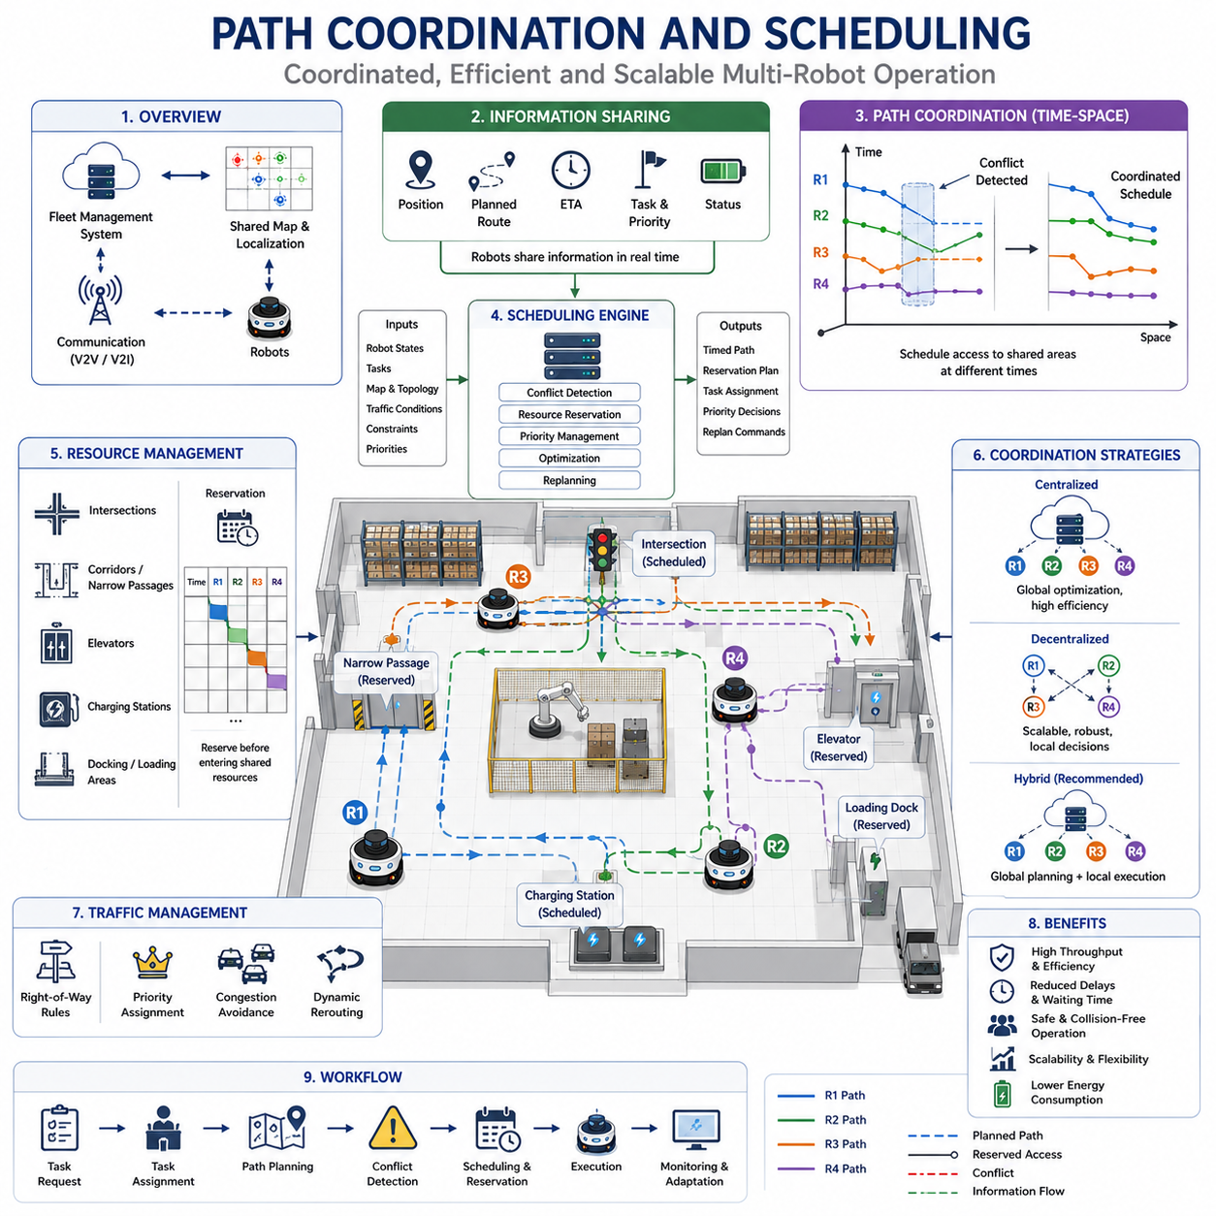
Path Coordination and Scheduling is one of the most important technologies in multi-robot navigation systems because it enables multiple autonomous robots to move efficiently through shared environments without creating conflicts, congestion, deadlocks, or unsafe operating conditions. While collision avoidance focuses primarily on preventing physical contact between robots, path coordination and scheduling address a broader operational challenge. The goal is not only to avoid collisions but also to optimize the movement of an entire robot fleet so that tasks are completed efficiently, resources are utilized effectively, and overall system productivity is maximized. In large-scale autonomous robot deployments such as warehouses, manufacturing plants, hospitals, airports, ports, logistics centers, and smart city environments, path coordination and scheduling serve as the operational backbone that transforms a collection of independent robots into a coordinated intelligent transportation system.
In a single-robot navigation environment, path planning is relatively straightforward. A robot determines its current position, identifies a destination, generates a collision-free path, and follows that path to completion. In a multi-robot environment, however, every robot influences the movement possibilities of every other robot. A path that appears optimal for one robot may create delays, congestion, or conflicts for neighboring robots. Consequently, path planning must be extended into a fleet-level optimization problem where individual robot objectives are balanced against global operational goals.
The concept of path coordination refers to the process of ensuring that multiple robots can execute their planned trajectories without interfering with one another. Coordination requires robots to share information regarding their current positions, intended routes, expected arrival times, operational priorities, and task assignments. By understanding the future intentions of neighboring robots, each robot can adjust its movement proactively rather than reacting only when conflicts become imminent. Effective coordination reduces unnecessary stopping, minimizes route conflicts, and improves traffic flow throughout the operational environment.
Scheduling introduces the temporal dimension into path coordination. In many cases, conflicts occur not because two robots require the same physical location, but because they require access to that location at the same time. Scheduling algorithms determine when each robot should occupy specific regions of the environment. By controlling access times rather than merely controlling spatial positions, scheduling enables significantly higher fleet densities while maintaining safe operation.
Time-space coordination forms the foundation of most modern scheduling systems. Traditional path planning considers only spatial information, but multi-robot coordination requires simultaneous consideration of both space and time. Every robot trajectory becomes a time-dependent sequence of occupied positions. Scheduling algorithms analyze these trajectories to identify potential conflicts and generate timing adjustments that prevent overlap. Through this approach, multiple robots can safely utilize the same corridor, intersection, charging station, elevator, or loading area at different times without interference.
One of the primary objectives of path coordination is maximizing fleet throughput. Throughput refers to the number of completed tasks or transported items within a given period. Poor coordination often leads to excessive waiting times, inefficient detours, congestion, and resource contention. Even when collisions are avoided, overall productivity may suffer significantly if robots spend excessive time waiting for access to shared resources. Advanced coordination algorithms seek to maximize throughput while minimizing delays and maintaining operational safety.
Path coordination systems often operate at multiple levels. Strategic coordination occurs at the fleet level and involves long-term planning decisions such as route allocation, task scheduling, traffic balancing, and congestion avoidance. Tactical coordination occurs during mission execution and addresses emerging conflicts, traffic fluctuations, dynamic obstacles, and changing operational priorities. Operational coordination occurs directly on the robots themselves and includes local trajectory adjustments, speed control, yielding behavior, and conflict resolution actions. The interaction between these coordination layers enables robust and scalable fleet operation.
Shared maps and shared localization systems play a central role in path coordination. Since all robots operate within a common coordinate framework, path schedules can be generated consistently across the fleet. Shared maps provide information regarding corridors, intersections, workstations, charging stations, restricted zones, safety areas, and operational constraints. Localization systems ensure that robots accurately follow assigned schedules and maintain awareness of their relative positions within the fleet.
Traffic management is closely integrated with path coordination and scheduling. In many respects, large robot fleets resemble urban transportation systems. Corridors function like roads, intersections function like traffic junctions, charging stations resemble service facilities, and robots behave as autonomous vehicles. Traffic management systems regulate movement through shared infrastructure, assign right-of-way priorities, control access to constrained spaces, and dynamically reroute robots when congestion develops.
Intersection management is one of the most important applications of path scheduling. Intersections represent locations where multiple robot trajectories converge, creating potential conflicts. Simple collision avoidance strategies may cause robots to stop frequently, reducing efficiency. Scheduling systems instead assign crossing times and movement priorities before robots arrive at the intersection. By coordinating intersection access in advance, robots can often maintain continuous motion while avoiding conflicts.
Narrow passages present another significant challenge. When two robots approach a constrained corridor from opposite directions, a conflict arises because both cannot pass simultaneously. Scheduling algorithms determine which robot receives priority, whether one robot should wait, or whether alternative routes should be assigned. Reservation-based scheduling approaches are commonly used in such environments. Robots reserve access rights to constrained regions before entering them, ensuring conflict-free movement.
Reservation systems represent one of the most widely used coordination techniques in industrial robot fleets. Under this approach, important resources such as intersections, corridors, elevators, docking stations, loading zones, and charging facilities are treated as reservable assets. Robots request access before arrival, and scheduling systems allocate resources according to predefined policies. Reservations provide predictability, reduce conflicts, and simplify coordination across large fleets.
Priority management is another important aspect of scheduling. Not all tasks possess equal importance. Emergency deliveries in hospitals may require higher priority than routine supply transport. Production-critical materials in manufacturing environments may take precedence over less urgent tasks. Scheduling systems incorporate priority information when resolving conflicts, allocating resources, and assigning movement permissions. Priority-based scheduling ensures that critical operations receive appropriate attention without compromising overall system stability.
Task scheduling and path scheduling are deeply interconnected. Assigning tasks without considering navigation implications can produce inefficient fleet behavior. Modern fleet management systems therefore integrate task allocation with route planning and movement scheduling. When assigning a task, the system evaluates robot locations, predicted travel times, traffic conditions, battery status, operational priorities, and resource availability. This integrated approach improves both task efficiency and navigation performance.
Deadlock prevention represents a major motivation for path coordination systems. Deadlocks occur when multiple robots block one another's movement, creating situations where none can proceed. Deadlocks frequently emerge in dense traffic environments containing narrow corridors, intersections, and constrained resources. Scheduling algorithms actively identify potential deadlock situations before they occur and modify robot schedules to eliminate these risks. Prevention strategies include priority assignment, path reservation, route diversification, temporal separation, and centralized conflict resolution.
Congestion management is equally important. As fleet density increases, localized traffic jams may emerge even when collisions are avoided. Congestion reduces throughput, increases energy consumption, extends task completion times, and decreases overall operational efficiency. Scheduling systems continuously monitor traffic conditions and dynamically adjust routes, priorities, and access permissions to balance workload distribution across the facility.
Real-time replanning capabilities are essential because industrial environments are inherently dynamic. Equipment may move unexpectedly, temporary obstacles may appear, communication delays may occur, and operational priorities may change rapidly. Static schedules quickly become obsolete under such conditions. Modern coordination systems continuously update plans based on current conditions and generate revised schedules whenever significant deviations occur.
Centralized scheduling architectures maintain a global view of the fleet and perform optimization across all robots simultaneously. A central fleet management server collects position updates, task information, environmental observations, and operational constraints from every robot. Using this information, the scheduler generates coordinated movement plans that optimize fleet-level objectives. Centralized scheduling often produces highly efficient solutions but requires reliable communication and substantial computational resources.
Decentralized scheduling distributes decision-making authority among individual robots. Each robot negotiates movement permissions, resolves conflicts locally, and adjusts its schedule based on information received from neighboring robots. Decentralized approaches improve scalability and robustness because fleet operation does not depend on a single controller. However, achieving globally optimal behavior becomes more challenging when decisions are distributed.
Hybrid scheduling architectures combine centralized optimization with decentralized execution. Fleet-level schedulers provide strategic coordination and long-term planning, while robots perform local adjustments in response to immediate environmental conditions. This architecture is commonly adopted in industrial deployments because it balances optimization quality, scalability, robustness, and operational flexibility.
Communication infrastructure plays a critical role in path coordination. Scheduling decisions depend on timely exchange of information regarding robot positions, task status, predicted trajectories, resource reservations, and operational priorities. Wireless communication systems such as Wi-Fi, private LTE, 5G, industrial wireless networks, and mesh communication architectures support these information exchanges. Communication reliability directly influences scheduling effectiveness and fleet performance.
Cloud robotics increasingly contributes to large-scale path coordination. Cloud platforms provide computational resources capable of solving complex optimization problems involving hundreds or thousands of robots simultaneously. Fleet-wide scheduling, traffic prediction, congestion analysis, and long-term route optimization can be performed in cloud environments while robots execute local control functions at the edge. This cloud-edge architecture enables scalable fleet management across geographically distributed facilities.
Artificial intelligence is beginning to transform path coordination and scheduling. Machine learning models can predict traffic patterns, estimate congestion levels, forecast task demand, and optimize resource allocation. Reinforcement learning algorithms can discover efficient scheduling policies through experience. Multi-agent learning approaches enable fleets to develop cooperative behaviors that improve overall performance. AI-based scheduling systems continuously adapt to changing operational conditions and may outperform manually designed scheduling rules.
Digital twin technologies provide valuable support for scheduling development and validation. Virtual representations of facilities allow engineers to simulate fleet operations, evaluate scheduling algorithms, identify bottlenecks, and test optimization strategies before deployment. Digital twins also support continuous operational improvement by analyzing historical traffic patterns and identifying opportunities for efficiency gains.
Large-scale industrial deployments demonstrate the practical importance of path coordination and scheduling. In warehouse automation systems, hundreds of robots may simultaneously transport inventory between storage locations and picking stations. Hospital fleets coordinate deliveries of medication, laboratory samples, meals, and medical supplies throughout complex facilities. Manufacturing robots move materials between production cells according to tightly synchronized schedules. Airport robots manage baggage transportation, cleaning operations, and passenger services. Outdoor autonomous fleets coordinate inspection, maintenance, security, and logistics operations across extensive industrial sites.
Future path coordination systems will evolve beyond simple conflict avoidance toward predictive, adaptive, and intelligent fleet orchestration. Advanced world models, cloud-native fleet management platforms, large-scale optimization engines, semantic understanding systems, and AI-driven decision-making frameworks will enable robots to coordinate their movements with unprecedented efficiency. Instead of merely avoiding conflicts, future fleets will proactively optimize traffic flow, anticipate operational demands, minimize energy consumption, balance workload distribution, and maximize overall system productivity.
As autonomous robot deployments continue to expand across logistics, manufacturing, healthcare, transportation, infrastructure inspection, agriculture, defense, and smart city applications, path coordination and scheduling will remain among the most important enabling technologies. They provide the mechanisms through which large numbers of robots can share limited resources, cooperate effectively, avoid operational conflicts, and function as a unified intelligent system. Through advances in optimization, communication, artificial intelligence, cloud robotics, and multi-agent coordination, path scheduling will continue to play a central role in the evolution of scalable autonomous robotic ecosystems.

10.5 Fleet Level Traffic Optimization
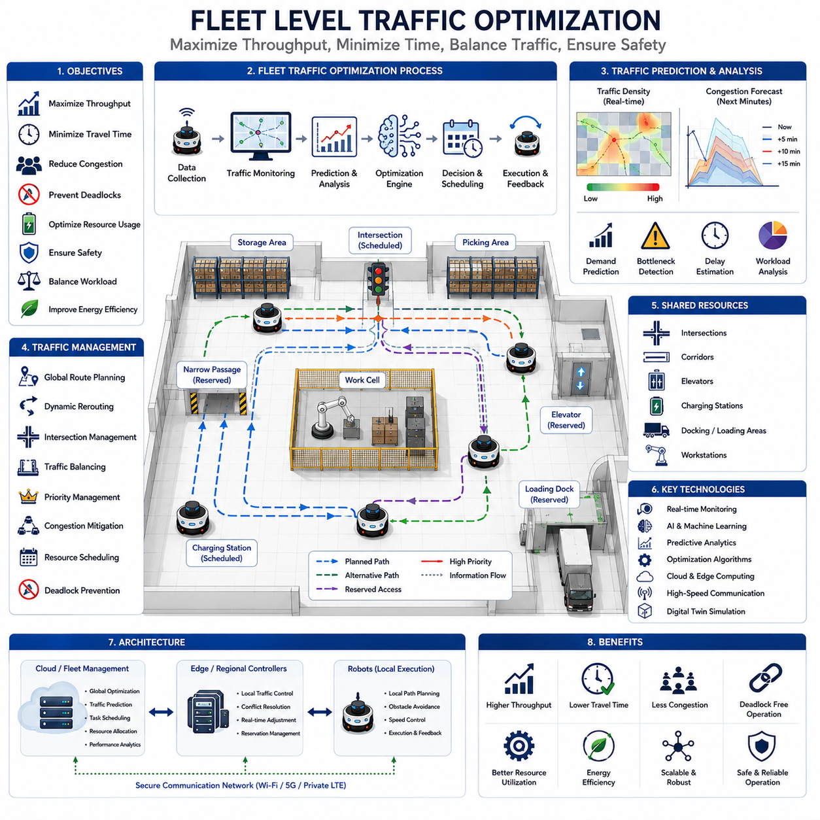
Fleet Level Traffic Optimization is one of the most advanced and strategically important functions within modern multi-robot navigation systems. While individual robots are capable of planning routes, avoiding obstacles, and executing assigned tasks autonomously, large-scale robotic operations require a higher level of intelligence that manages the movement of the entire fleet as a unified system. Fleet-level traffic optimization focuses on maximizing overall operational efficiency rather than optimizing the behavior of individual robots. The objective is to ensure that hundreds or even thousands of robots can move simultaneously through shared environments while minimizing congestion, reducing travel time, preventing deadlocks, maximizing throughput, balancing workloads, and maintaining safe operations. In modern warehouses, manufacturing facilities, hospitals, airports, logistics hubs, ports, smart cities, and outdoor industrial sites, fleet-level traffic optimization has become a fundamental requirement for scalable autonomous operations. This topic forms a core component of Multi-Robot Navigation within the broader Path Planning and Autonomous Navigation framework.
The need for fleet-level optimization emerges because local navigation decisions that appear optimal for individual robots are often suboptimal when evaluated from a system-wide perspective. A robot may select the shortest route to its destination, but if many robots simultaneously choose the same route, severe congestion can occur. This congestion may reduce productivity for the entire fleet. Fleet-level optimization therefore evaluates navigation decisions from a global perspective, considering the interactions among all robots operating within the environment. Instead of asking what is best for a single robot, the system asks what is best for the fleet as a whole.
A fleet can be viewed as a dynamic transportation network similar to a city-wide traffic system. Corridors function as roads, intersections act as traffic junctions, charging stations resemble service facilities, elevators behave as vertical transportation resources, and robots operate as autonomous vehicles. Fleet-level traffic optimization applies principles from transportation engineering, operations research, artificial intelligence, and distributed systems to coordinate robot movement efficiently. The objective is not simply collision avoidance but rather the continuous optimization of traffic flow throughout the operational environment.
One of the primary goals of fleet-level optimization is throughput maximization. Throughput refers to the amount of productive work completed within a given period. In warehouse environments, throughput may represent the number of items transported per hour. In manufacturing facilities, throughput may correspond to the movement of materials between production stations. In hospitals, throughput may represent the number of deliveries completed successfully. Increasing throughput directly improves operational efficiency and business value. Fleet-level optimization continuously seeks routing strategies, scheduling policies, and resource allocation methods that maximize productivity.
Travel time minimization is another critical objective. Every minute spent traveling reduces overall operational efficiency. Long travel times increase energy consumption, reduce robot availability, and limit system productivity. Traffic optimization algorithms continuously evaluate route alternatives, congestion levels, and predicted delays to minimize travel duration. Unlike conventional path planning algorithms that focus solely on shortest-distance routes, fleet optimization often selects slightly longer routes if they reduce congestion and improve overall traffic flow.
Congestion management is one of the most challenging aspects of fleet traffic optimization. As fleet density increases, robots naturally concentrate in high-demand regions such as intersections, loading docks, charging stations, elevators, production cells, and storage areas. These bottlenecks can significantly degrade system performance. Advanced traffic optimization systems monitor congestion levels in real time and dynamically redistribute traffic throughout the facility. Alternative routes may be assigned, priorities adjusted, or schedules modified to balance traffic loads and prevent excessive accumulation of robots in specific regions.
Traffic prediction plays a vital role in modern optimization systems. Instead of reacting only after congestion occurs, predictive systems anticipate future traffic conditions based on historical patterns, current robot activities, task assignments, and environmental conditions. By forecasting congestion before it develops, optimization systems can proactively reroute robots, adjust schedules, and allocate resources more effectively. Predictive traffic management transforms fleet operations from reactive control into proactive optimization.
Global route planning serves as a fundamental component of fleet-level traffic management. While local planners generate immediate motion commands, global traffic optimization systems evaluate the entire transportation network and determine strategic routing policies. Routes are selected not only based on distance but also according to expected congestion, traffic density, resource availability, task priority, energy consumption, and fleet workload distribution. Global route planning continuously adapts to changing operational conditions and seeks to maintain optimal traffic flow throughout the environment.
Traffic balancing is another important optimization objective. Certain corridors, intersections, and operational zones may experience significantly higher traffic volumes than others. Uneven traffic distribution often creates bottlenecks that reduce overall efficiency. Fleet optimization systems monitor traffic density across the facility and encourage more balanced utilization of available infrastructure. By distributing robots across multiple routes and operational regions, the system improves capacity utilization and reduces localized congestion.
Intersection management is a critical aspect of fleet traffic optimization. Intersections represent locations where multiple robot trajectories converge, creating high potential for conflicts and delays. Traditional collision avoidance methods often result in frequent stopping and inefficient movement. Fleet-level optimization introduces coordinated scheduling, reservation systems, virtual traffic signals, and priority assignment mechanisms that allow robots to traverse intersections smoothly while maintaining safety. Efficient intersection management significantly improves overall traffic flow and reduces cumulative delays.
Resource optimization extends beyond navigation corridors to include shared operational resources. Charging stations, elevators, docking areas, loading zones, maintenance facilities, and workstations often become critical constraints in large-scale robot deployments. Fleet-level optimization systems coordinate access to these resources through scheduling and reservation mechanisms. By preventing excessive waiting times and balancing resource utilization, the system improves operational efficiency and reduces idle robot time.
Task-aware traffic optimization integrates navigation decisions with operational objectives. Navigation cannot be optimized independently from task execution because robot movement exists solely to support mission completion. Modern fleet management systems therefore evaluate task priorities, deadlines, service requirements, operational constraints, and customer expectations when making traffic optimization decisions. A robot transporting urgent medical supplies may receive preferential routing compared to robots performing lower-priority activities. Task-aware optimization ensures that traffic management supports broader operational goals.
Energy efficiency has become increasingly important in fleet optimization. Robot travel consumes battery power, and inefficient traffic patterns can significantly increase energy usage. Traffic optimization systems seek to minimize unnecessary movement, reduce waiting times, avoid excessive acceleration and deceleration, and coordinate charging schedules effectively. Energy-aware traffic management improves operational sustainability, extends battery life, and reduces infrastructure requirements.
Deadlock prevention and recovery represent essential responsibilities of fleet-level optimization systems. Deadlocks occur when groups of robots block one another's progress, creating situations where movement becomes impossible. Although no physical collisions occur, productivity can decline dramatically. Traffic optimization systems continuously analyze robot interactions, identify emerging deadlock risks, and implement preventive actions. These actions may include route modifications, priority reassignment, temporary holding strategies, or centralized coordination interventions.
Scalability is one of the defining characteristics of fleet-level optimization architectures. Small deployments involving only a few robots may function effectively with relatively simple coordination mechanisms. However, modern industrial facilities increasingly deploy hundreds or thousands of autonomous robots simultaneously. Optimization systems must therefore scale efficiently without experiencing exponential growth in computational complexity. Hierarchical traffic management architectures, distributed optimization frameworks, cloud-based computation, and regional traffic control systems are commonly employed to support large-scale deployments.
Centralized traffic optimization architectures maintain a global view of all robots operating within the environment. A fleet management server continuously receives position updates, task information, environmental observations, and operational metrics from every robot. Using this information, optimization algorithms generate coordinated traffic strategies that improve fleet-wide performance. Centralized systems often achieve highly efficient solutions but may require substantial computational resources and robust communication infrastructure.
Distributed traffic optimization architectures distribute decision-making responsibilities across individual robots or regional controllers. Rather than relying on a single central authority, robots collaborate to optimize traffic flow locally. Distributed systems improve fault tolerance, scalability, and robustness while reducing communication requirements. However, achieving globally optimal solutions may become more challenging because decision makers possess only partial information regarding system-wide conditions.
Hybrid optimization architectures combine the strengths of centralized and distributed approaches. Strategic traffic planning occurs at the fleet level, while tactical adjustments are performed locally by individual robots. This hybrid structure provides scalability, responsiveness, fault tolerance, and optimization quality simultaneously. Many commercial fleet management systems employ hybrid architectures because they perform well across diverse operational scenarios.
Communication infrastructure directly influences fleet traffic optimization performance. Real-time traffic management requires continuous exchange of information regarding robot locations, velocities, planned routes, task assignments, congestion levels, resource reservations, and operational priorities. High-bandwidth communication networks such as Wi-Fi 6, private LTE, 5G, industrial wireless systems, and edge-cloud communication platforms provide the connectivity required for large-scale optimization.
Cloud robotics increasingly supports fleet-level optimization. Cloud platforms provide virtually unlimited computational resources that can process large amounts of fleet data, solve complex optimization problems, and support advanced predictive analytics. Cloud-based optimization engines continuously evaluate system performance, analyze traffic patterns, generate optimization recommendations, and distribute updated policies to robots operating in the field. Edge computing complements cloud resources by providing low-latency decision-making capabilities near operational environments.
Artificial intelligence is transforming fleet-level traffic optimization. Machine learning algorithms analyze historical operational data to identify recurring traffic patterns, predict congestion, estimate task demand, and optimize routing strategies. Reinforcement learning systems can learn effective traffic management policies through experience. Multi-agent learning approaches allow robots to develop cooperative behaviors that improve collective performance. AI-driven optimization systems continuously adapt to changing environments and often outperform manually designed rule-based approaches.
Digital twin technology provides a powerful platform for traffic optimization development and deployment. Digital twins create virtual representations of physical facilities and robot fleets. Engineers can simulate thousands of traffic scenarios, evaluate optimization algorithms, identify bottlenecks, and validate scheduling strategies before deployment. During operation, digital twins support continuous monitoring, performance analysis, and operational improvement by comparing predicted behaviors with actual fleet performance.
Industrial deployments provide numerous examples of fleet-level traffic optimization in practice. Large warehouse automation systems coordinate hundreds of robots transporting inventory simultaneously. Manufacturing facilities synchronize material flow across multiple production lines. Hospital logistics fleets manage deliveries of medication, meals, laboratory samples, and medical equipment. Airport robotic systems coordinate baggage transport, cleaning operations, and passenger services. Outdoor industrial robots perform inspection, maintenance, surveillance, and transportation tasks across expansive facilities. In each case, traffic optimization directly influences productivity, reliability, and economic performance.
Future fleet-level traffic optimization systems will likely evolve toward fully autonomous traffic ecosystems driven by artificial intelligence, cloud-native platforms, semantic understanding, world models, and predictive operational intelligence. Rather than simply responding to current traffic conditions, future systems will anticipate demand, predict environmental changes, optimize resource allocation proactively, and coordinate fleet behavior at unprecedented scales. Real-time global world models, multi-agent AI systems, and advanced fleet orchestration platforms will enable robot fleets to function as highly adaptive and intelligent transportation networks.
As autonomous mobile robots continue to expand across logistics, manufacturing, healthcare, agriculture, transportation, infrastructure inspection, defense, and smart city applications, fleet-level traffic optimization will remain one of the most important enabling technologies. It serves as the mechanism through which large robot fleets achieve high efficiency, maintain safe operations, maximize resource utilization, and scale successfully. Within the broader AMR ecosystem, fleet-level traffic optimization represents the convergence of navigation, traffic engineering, operations research, artificial intelligence, cloud robotics, and systems engineering into a unified framework for intelligent autonomous mobility.

10.6 Cloud-Based Navigation Control
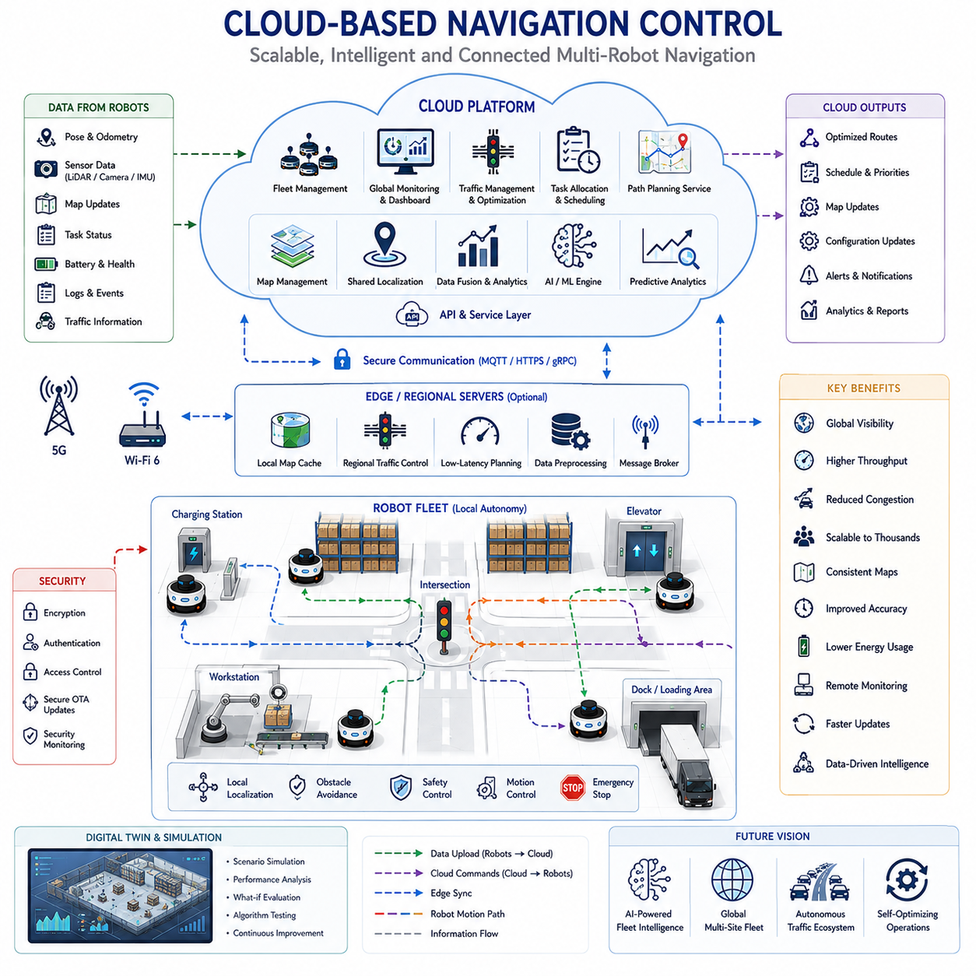
Cloud-Based Navigation Control represents one of the most significant evolutions in autonomous mobile robot systems and large-scale robotic fleet management. Traditional robot navigation architectures were primarily designed around onboard computation, where each robot independently performed localization, mapping, path planning, obstacle avoidance, and decision-making using its local processing resources. While such architectures remain effective for small deployments, they become increasingly difficult to scale as fleet sizes grow and operational complexity increases. Cloud-Based Navigation Control addresses these challenges by introducing centralized and distributed cloud infrastructure that supports navigation, coordination, optimization, monitoring, and intelligence functions across entire robot fleets. This approach transforms navigation from an isolated robot-level capability into a cloud-connected ecosystem capable of managing hundreds or thousands of autonomous robots simultaneously.
The fundamental principle of cloud-based navigation is the separation of computational responsibilities between robots and cloud infrastructure. Safety-critical and latency-sensitive functions remain on the robot, while computationally intensive, data-intensive, and fleet-wide optimization tasks are executed in cloud environments. This division enables robots to maintain safe autonomous operation even when communication disruptions occur while benefiting from the computational power and global awareness available through cloud services.
Modern robot fleets generate enormous volumes of operational data. Localization information, sensor observations, map updates, task status reports, navigation logs, obstacle detections, traffic conditions, battery status information, and fleet performance metrics are continuously produced by every robot. Processing this information locally on individual robots can quickly become inefficient and difficult to manage. Cloud-based systems aggregate data from all robots into centralized platforms where information can be analyzed, correlated, and transformed into actionable intelligence. This shared knowledge enables significantly more effective navigation and coordination than isolated robot-level processing.
One of the most important functions of cloud-based navigation control is centralized fleet visibility. In conventional robot systems, each robot possesses only local awareness of its environment and immediate surroundings. Cloud platforms, however, maintain a global view of the entire fleet. They continuously monitor robot locations, routes, tasks, traffic conditions, charging states, operational priorities, and environmental changes. This comprehensive visibility allows fleet managers and optimization algorithms to make informed decisions that improve overall system performance.
Cloud-based map management represents another major advantage. In large robot deployments, maintaining consistent maps across hundreds of robots can become a significant challenge. Cloud map servers provide a centralized repository for environmental information, ensuring that every robot operates using the most current map version. When a robot discovers a new obstacle, environmental change, or map correction, the update can be uploaded to the cloud and distributed automatically to the entire fleet. This continuous synchronization ensures consistent navigation behavior across all robots.
Shared localization services further enhance navigation accuracy. Cloud platforms can integrate localization data from multiple robots simultaneously, improving overall map quality and positioning reliability. In collaborative localization architectures, robots contribute observations to a common localization framework. Cloud services fuse these observations, identify inconsistencies, correct map drift, and provide refined localization information back to the fleet. This approach is particularly valuable in large facilities where maintaining long-term localization accuracy is challenging.
Multi-robot coordination is one of the primary motivations for cloud-based navigation control. As fleet sizes increase, robot interactions become increasingly complex. Robots compete for access to corridors, intersections, elevators, charging stations, loading docks, and operational resources. Cloud coordination platforms continuously evaluate fleet-wide conditions and generate coordinated navigation strategies that minimize conflicts and maximize efficiency. Instead of each robot making decisions independently, cloud systems orchestrate robot movement from a global perspective.
Fleet traffic management is closely integrated with cloud navigation systems. Cloud platforms continuously monitor traffic density, congestion levels, bottlenecks, route utilization, and resource availability. Using this information, optimization algorithms dynamically adjust routing decisions, modify schedules, assign priorities, and balance traffic loads throughout the facility. Traffic optimization improves throughput, reduces delays, minimizes energy consumption, and enhances overall fleet productivity.
Cloud-based path planning extends traditional navigation capabilities beyond local route generation. Rather than relying solely on onboard path planners, robots can request optimized routes from cloud services that possess awareness of fleet-wide conditions. Cloud planners consider traffic congestion, operational priorities, future reservations, resource availability, and predicted environmental changes when generating navigation plans. This broader perspective often produces more efficient routes than local planning alone.
Task allocation and navigation optimization are frequently integrated within cloud platforms. Modern fleet management systems do not treat navigation as an isolated problem. Instead, task assignment, route planning, scheduling, resource allocation, and traffic management are solved simultaneously. Cloud systems evaluate robot locations, travel times, battery levels, workload distribution, operational priorities, and facility conditions before assigning tasks. This integrated optimization significantly improves overall operational efficiency.
Scalability represents one of the strongest advantages of cloud-based architectures. As organizations expand from tens to hundreds or thousands of robots, local coordination approaches become increasingly difficult to manage. Cloud platforms provide virtually unlimited computational resources through distributed computing infrastructure. Additional processing capacity can be allocated dynamically as fleet size grows, allowing navigation systems to scale without requiring fundamental architectural changes.
Artificial intelligence plays an increasingly important role within cloud-based navigation systems. Large datasets collected from robot fleets can be analyzed using machine learning algorithms to identify traffic patterns, predict congestion, optimize routing policies, improve scheduling decisions, and enhance navigation performance. AI models trained in the cloud can continuously learn from operational data and distribute improvements throughout the fleet. This creates a feedback loop in which navigation performance improves over time through collective experience.
Predictive analytics is a particularly powerful capability enabled by cloud computing. Traditional navigation systems react to current conditions, while cloud-based systems can anticipate future conditions. By analyzing historical data, current traffic patterns, task demand forecasts, and environmental trends, cloud platforms can predict congestion, identify emerging bottlenecks, forecast resource utilization, and proactively adjust fleet operations. Predictive navigation significantly improves operational efficiency and reduces unexpected disruptions.
Digital twin technology is often closely integrated with cloud navigation architectures. A digital twin serves as a virtual representation of the physical fleet and operational environment. Cloud platforms continuously update digital twin models using real-time data collected from robots. Engineers and operators can use these models to simulate navigation scenarios, evaluate optimization strategies, test software updates, and analyze operational performance. Digital twins provide valuable insights that support continuous system improvement.
Cloud-based monitoring and supervision capabilities provide operators with comprehensive visibility into fleet operations. Dashboards display robot positions, active tasks, traffic conditions, battery levels, system health metrics, communication status, and operational performance indicators. Alerts and notifications can be generated automatically when anomalies, failures, safety concerns, or performance degradation are detected. Centralized monitoring significantly improves operational management and reduces maintenance costs.
Remote operation and teleoperation services also benefit from cloud integration. In situations where autonomous navigation encounters unexpected conditions, remote operators can access robot systems through cloud platforms. Operators may review sensor data, intervene in navigation decisions, assist with recovery procedures, or remotely control robots when necessary. Cloud infrastructure enables efficient management of geographically distributed robot deployments from centralized control centers.
Cloud robotics facilitates continuous software deployment and lifecycle management. Navigation software, localization algorithms, traffic management policies, AI models, and configuration parameters can be updated centrally and distributed automatically across entire fleets. Over-the-air updates eliminate the need for manual software installation on individual robots and ensure consistent system behavior throughout the fleet.
Cybersecurity becomes increasingly important in cloud-connected navigation systems. Communication between robots, cloud services, edge servers, and operational platforms must be protected against unauthorized access, data tampering, and cyber threats. Secure communication protocols, encryption mechanisms, authentication systems, access control policies, and continuous security monitoring are essential components of cloud navigation architectures. Robust cybersecurity measures are particularly important in industrial, healthcare, logistics, and critical infrastructure environments.
Cloud-edge collaboration represents a key architectural principle in modern navigation systems. While cloud platforms provide global intelligence and optimization, edge computing resources provide low-latency processing near operational environments. Edge servers may perform regional traffic management, local map synchronization, intermediate data processing, and fast decision-making functions. This layered architecture combines the scalability of cloud computing with the responsiveness of local control systems.
Communication reliability remains a critical consideration. Navigation systems must continue operating safely even when connectivity is interrupted. Consequently, robots typically maintain local autonomy for essential navigation functions including localization, obstacle avoidance, emergency stopping, and basic path following. Cloud services enhance performance but do not replace fundamental safety functions. Hybrid autonomy ensures operational continuity under varying network conditions.
The emergence of 5G communication networks significantly strengthens cloud-based navigation capabilities. High bandwidth, low latency, improved reliability, and massive device connectivity support real-time data exchange between robots and cloud services. 5G enables more responsive cloud control architectures and facilitates large-scale deployment of connected autonomous systems across industrial and urban environments.
Industrial applications demonstrate the practical value of cloud-based navigation control. Warehouses utilize cloud platforms to coordinate inventory transport across large robot fleets. Manufacturing facilities employ cloud systems to optimize material flow between production cells. Hospitals use cloud navigation platforms to manage deliveries of medication, meals, laboratory samples, and medical equipment. Airports coordinate baggage handling robots, cleaning systems, and passenger service robots through centralized cloud infrastructure. Outdoor industrial facilities leverage cloud-based control for inspection, maintenance, surveillance, and logistics operations across large geographical areas.
Future cloud-based navigation systems will likely evolve toward globally connected robotic ecosystems. Cloud-native fleet management platforms, real-time world models, large-scale AI reasoning systems, semantic environment understanding, and autonomous decision-making frameworks will enable unprecedented levels of coordination and intelligence. Robot fleets operating across multiple facilities, cities, or countries may eventually share knowledge, maps, operational experiences, and optimization strategies through interconnected cloud infrastructures.
As autonomous robots become increasingly integrated into logistics, manufacturing, healthcare, transportation, agriculture, infrastructure inspection, defense, and smart city applications, cloud-based navigation control will continue to serve as a foundational technology for scalable robotic operations. By combining cloud computing, artificial intelligence, edge processing, communication networks, digital twins, and fleet management systems, cloud-based navigation transforms individual autonomous robots into highly coordinated, intelligent, and adaptive robotic ecosystems capable of operating efficiently at unprecedented scale.

10.7 Multi-Robot Recovery Strategies
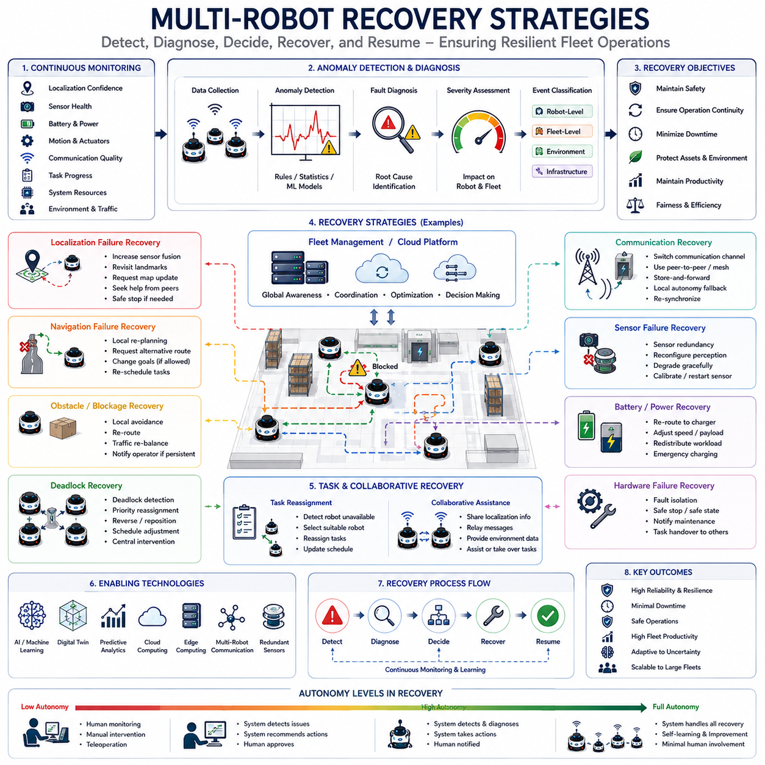
Multi-Robot Recovery Strategies represent a critical component of modern autonomous fleet operations. While navigation, localization, mapping, path planning, and task execution receive significant attention during system development, real-world deployments inevitably encounter unexpected situations that cannot be fully prevented. Robots may become blocked by obstacles, lose localization accuracy, experience communication interruptions, encounter hardware malfunctions, suffer sensor degradation, enter deadlock situations, face environmental changes, or experience software anomalies. In large-scale robotic fleets, the probability of such events increases proportionally with fleet size and operational complexity. Consequently, recovery mechanisms are not merely optional features but essential capabilities that ensure continuous operation, maintain safety, preserve productivity, and support long-term autonomy. Multi-Robot Recovery Strategies provide the framework through which robot fleets detect failures, diagnose causes, coordinate corrective actions, and restore normal operations with minimal human intervention.
Traditional robotics often focused on fault avoidance, attempting to eliminate failures entirely through careful engineering. However, modern autonomous systems recognize that failures are unavoidable in complex real-world environments. Instead of assuming perfect operation, recovery-oriented architectures are designed to anticipate failures and respond intelligently when they occur. This shift from fault avoidance to fault resilience has become a defining characteristic of large-scale autonomous systems. Recovery strategies enable fleets to maintain operational continuity even when individual robots, subsystems, or environmental conditions deviate from expected behavior.
Recovery in multi-robot systems differs significantly from recovery in single-robot systems. When a single robot encounters a problem, recovery primarily affects that individual robot. In contrast, failures within a multi-robot fleet often have cascading consequences. A blocked robot may create traffic congestion. A localization failure may affect shared maps. A communication outage may disrupt coordination. A charging station malfunction may influence fleet scheduling. Therefore, recovery mechanisms must consider both local robot-level impacts and broader fleet-level implications.
One of the most important aspects of recovery is anomaly detection. Before recovery actions can be initiated, the system must recognize that an abnormal condition exists. Modern robot fleets continuously monitor a wide range of operational indicators including localization confidence, sensor health, battery status, motor performance, communication quality, navigation accuracy, obstacle detection consistency, task execution progress, and system resource utilization. Machine learning models, statistical monitoring techniques, rule-based diagnostics, and predictive analytics may all contribute to anomaly detection frameworks. Early detection significantly improves recovery effectiveness because corrective actions can be initiated before problems escalate.
Localization failure is among the most common recovery scenarios in autonomous navigation systems. Localization algorithms may become unreliable due to sensor degradation, environmental changes, feature-poor environments, dynamic obstacles, lighting variations, weather conditions, or accumulated estimation errors. When localization confidence falls below acceptable thresholds, recovery procedures are activated. Robots may slow down, increase sensor fusion weighting, perform active localization maneuvers, revisit known landmarks, request map updates, or seek assistance from neighboring robots. In severe cases, robots may transition into safe standby modes until localization reliability is restored.
Map inconsistency recovery is closely related to localization recovery. Shared maps evolve continuously as robots operate within dynamic environments. Construction activities, moved equipment, temporary obstacles, environmental modifications, and mapping errors can create discrepancies between stored maps and actual conditions. Recovery mechanisms identify inconsistencies and update maps accordingly. Collaborative mapping frameworks allow multiple robots to contribute observations that correct map inaccuracies and restore environmental consistency throughout the fleet.
Navigation failure recovery addresses situations where robots cannot reach their intended destinations. Obstacles may block planned routes, traffic conditions may change unexpectedly, or environmental conditions may invalidate previously generated plans. Navigation recovery systems continuously monitor progress toward goals and detect deviations from expected behavior. When navigation failures occur, robots may perform local replanning, request alternative routes from fleet management systems, negotiate access to constrained resources, or modify operational objectives. Dynamic recovery prevents minor navigation disruptions from becoming major operational problems.
Obstacle-related recovery scenarios are particularly common in industrial environments. Unexpected obstacles such as misplaced inventory, parked vehicles, construction materials, equipment failures, or human activities may obstruct robot movement. Recovery systems first attempt local avoidance strategies. If local avoidance fails, alternative routing options are evaluated. Fleet-level coordination may reroute neighboring robots to prevent congestion. In cases where obstacles persist, maintenance personnel may be notified automatically. Effective obstacle recovery minimizes disruption while maintaining safety.
Deadlock recovery represents one of the most important challenges in multi-robot systems. Deadlocks occur when groups of robots block one another's movement, creating situations where progress becomes impossible despite the absence of physical collisions. Deadlocks often emerge at intersections, narrow corridors, shared resources, loading areas, or congested traffic regions. Recovery systems continuously analyze robot interactions to identify emerging deadlock patterns. Once detected, priority reassignment, route modifications, temporary retreats, scheduling adjustments, or centralized coordination interventions may be employed to restore movement. Advanced deadlock recovery algorithms seek to minimize productivity losses while preserving fairness among participating robots.
Communication recovery is essential in cloud-connected and fleet-managed environments. Communication disruptions may arise from wireless interference, network congestion, infrastructure failures, hardware malfunctions, cybersecurity incidents, or environmental conditions. Recovery architectures typically employ multiple communication layers and fallback mechanisms. Robots may switch between Wi-Fi, private LTE, 5G, mesh networks, or peer-to-peer communication channels depending on availability. Local autonomy ensures that essential safety functions continue operating even when connectivity is temporarily lost. Once communication is restored, synchronization procedures update fleet information and restore coordinated operation.
Sensor failure recovery is another critical aspect of autonomous system resilience. Modern robots rely on numerous sensors including LiDAR, cameras, radar, ultrasonic sensors, GNSS receivers, IMUs, encoders, and environmental monitoring devices. Sensor failures may occur due to contamination, physical damage, calibration drift, environmental interference, or hardware degradation. Recovery strategies often utilize sensor redundancy and sensor fusion techniques. When one sensor becomes unavailable, remaining sensors compensate by providing alternative sources of information. Adaptive perception systems dynamically reconfigure sensing pipelines to maintain operational capability under degraded conditions.
Battery-related recovery plays an important role in long-duration autonomous operations. Battery degradation, unexpected energy consumption, charging station failures, or inaccurate energy predictions may threaten mission completion. Fleet management systems continuously monitor battery health, energy consumption rates, charging schedules, and operational priorities. Recovery actions may include dynamic task reassignment, emergency charging procedures, route modifications, reduced-speed operation, or coordinated fleet-level workload redistribution. Energy-aware recovery strategies prevent individual battery issues from disrupting broader operational objectives.
Hardware failure recovery addresses mechanical and electrical faults affecting robot operation. Motor failures, steering malfunctions, actuator degradation, power system anomalies, thermal overload conditions, and onboard computer issues may compromise robot performance. Diagnostic systems continuously evaluate hardware health and identify potential failures before catastrophic breakdowns occur. Predictive maintenance algorithms leverage operational data to estimate component remaining useful life and schedule preventive interventions. When hardware failures occur unexpectedly, affected robots may enter safe states while neighboring robots assume responsibility for unfinished tasks.
Task recovery ensures mission continuity despite robot-level disruptions. When a robot becomes unavailable due to failure, its assigned tasks must be reassigned efficiently. Fleet management systems maintain awareness of task progress, robot availability, operational priorities, and resource constraints. Recovery algorithms identify suitable replacement robots and redistribute workloads dynamically. This capability allows fleets to continue operating effectively even when individual robots experience failures.
Collaborative recovery represents one of the most distinctive features of multi-robot systems. Unlike isolated robots, fleet members can assist one another during recovery processes. Neighboring robots may provide localization references, share environmental observations, relay communication messages, transport critical payloads, inspect failed robots, or assume unfinished responsibilities. Collaborative recovery transforms the fleet into a resilient distributed system where collective resources compensate for individual failures.
Cloud-based recovery architectures further enhance resilience. Cloud platforms aggregate diagnostic information from across the fleet, enabling centralized analysis and coordinated response strategies. Machine learning models operating in cloud environments can identify emerging failure patterns, predict future disruptions, and recommend corrective actions. Cloud-based recovery systems benefit from fleet-wide visibility and historical operational knowledge that may not be available to individual robots.
Digital twins play an increasingly important role in recovery management. Virtual representations of robot fleets allow engineers and operators to analyze failure scenarios, evaluate recovery strategies, and simulate corrective actions before implementation. During real-world incidents, digital twins provide valuable situational awareness and support informed decision-making. Recovery plans can be tested virtually and optimized before deployment to physical systems.
Artificial intelligence is transforming recovery capabilities across autonomous fleets. Traditional recovery systems relied heavily on predefined rules and manually engineered procedures. AI-based recovery frameworks can learn from historical failures, adapt to new conditions, identify previously unseen anomalies, and generate context-aware recovery strategies. Reinforcement learning approaches enable robots to discover effective recovery behaviors through experience. Predictive AI systems may anticipate failures before they occur and initiate preventive actions proactively.
Safety remains the highest priority throughout all recovery operations. Recovery mechanisms must never compromise human safety, robot safety, or environmental protection. When uncertainty exists regarding system status, conservative safety policies take precedence over productivity objectives. Emergency stop procedures, safe shutdown mechanisms, protective zones, and fail-safe behaviors ensure that recovery activities do not introduce additional risks. Recovery systems are therefore designed with multiple layers of redundancy and verification.
Scalability presents unique challenges for recovery management. Small robot deployments may handle failures manually, but large fleets containing hundreds or thousands of robots require automated recovery frameworks. Recovery architectures must operate efficiently at scale without overwhelming communication networks, computational resources, or human operators. Hierarchical management structures, distributed diagnostics, regional recovery coordinators, and cloud-based orchestration platforms are often employed to support scalable recovery operations.
Industrial applications illustrate the practical importance of multi-robot recovery strategies. Warehouse automation systems must recover from blocked aisles, damaged inventory, communication interruptions, and charging station failures. Manufacturing robots must adapt to equipment malfunctions, production schedule changes, and material shortages. Hospital logistics fleets must maintain reliable delivery services despite elevator outages, corridor obstructions, and changing operational priorities. Outdoor industrial robots must recover from weather conditions, GNSS disruptions, terrain challenges, and infrastructure modifications. In every case, recovery capabilities directly influence operational reliability and business performance.
Future recovery systems will likely evolve toward self-healing robotic ecosystems. Advanced AI models, world models, predictive analytics, cloud robotics, digital twins, and autonomous fleet intelligence will enable increasingly sophisticated recovery capabilities. Rather than merely responding to failures after they occur, future systems will continuously monitor operational conditions, predict emerging risks, implement preventive actions, and optimize fleet resilience proactively. Recovery will become an integral component of autonomous decision-making rather than a separate emergency process.
As autonomous robots continue to expand across logistics, manufacturing, healthcare, transportation, agriculture, infrastructure inspection, defense, and smart city applications, Multi-Robot Recovery Strategies will remain one of the most important enabling technologies for reliable autonomous operation. They provide the mechanisms through which robot fleets maintain productivity, preserve safety, adapt to uncertainty, and achieve long-term operational resilience. Through advances in sensing, communication, artificial intelligence, cloud computing, and collaborative robotics, recovery systems will continue to evolve into highly intelligent frameworks capable of supporting the next generation of large-scale autonomous robotic ecosystems.

10.8 Fleet Validation and Testing
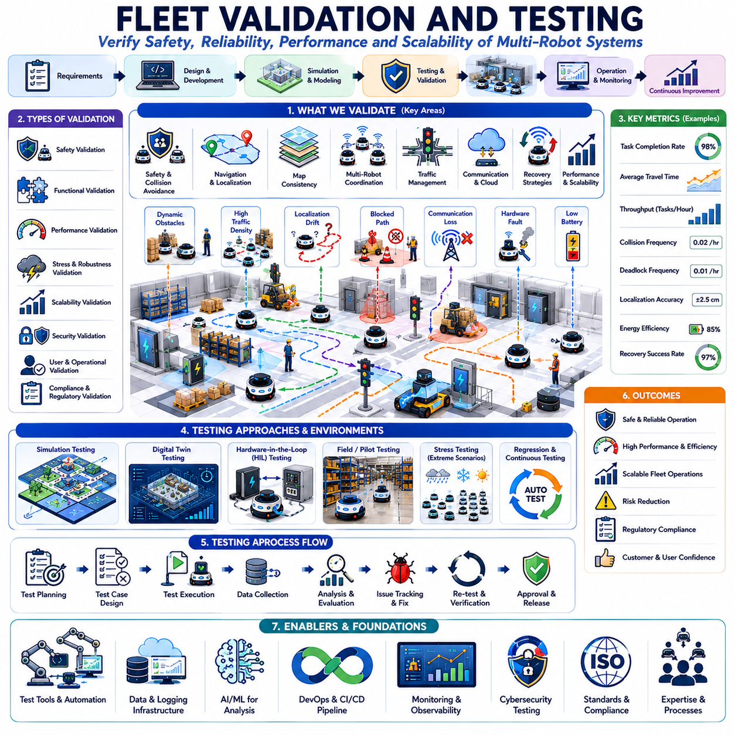
Fleet Validation and Testing is a critical discipline within multi-robot navigation systems because it determines whether an autonomous robot fleet can operate safely, reliably, efficiently, and consistently under real-world conditions. While individual navigation algorithms, localization modules, path planning systems, fleet management software, and communication infrastructures may perform well during development, successful deployment requires comprehensive validation of the entire robotic ecosystem. Fleet validation goes beyond testing individual robots and focuses on evaluating the behavior of the complete system, including robot interactions, traffic management, resource allocation, recovery mechanisms, cloud integration, communication networks, and operational workflows. As autonomous mobile robots continue to expand into logistics, manufacturing, healthcare, transportation, agriculture, infrastructure inspection, defense, and smart city applications, rigorous fleet validation has become an essential requirement for large-scale deployment.
The primary objective of fleet validation is to verify that all components of the system function together as intended. Autonomous fleets are complex cyber-physical systems composed of hardware, software, communication infrastructure, cloud services, artificial intelligence models, sensing technologies, and operational procedures. Failures rarely originate from a single component. Instead, they often emerge from interactions among multiple subsystems. Fleet validation therefore examines not only individual component performance but also the collective behavior of the entire operational ecosystem.
One of the most important aspects of fleet validation is system-level verification. Individual robots may successfully complete navigation tasks when tested independently, yet unexpected behaviors can emerge when multiple robots operate simultaneously. Traffic congestion, deadlocks, communication bottlenecks, resource contention, scheduling conflicts, and coordination failures may appear only under fleet-scale conditions. System-level validation evaluates these interactions and ensures that the fleet performs reliably under realistic operational loads.
Safety validation forms the foundation of all testing activities. Autonomous robots frequently operate near people, equipment, vehicles, inventory, and critical infrastructure. Consequently, every fleet deployment must demonstrate that safety requirements are consistently satisfied. Safety validation includes obstacle avoidance testing, emergency stop verification, collision prevention assessment, human-robot interaction analysis, safe speed enforcement, recovery mechanism validation, fail-safe operation verification, and fault tolerance evaluation. The objective is to ensure that no foreseeable operating condition can result in unacceptable safety risks.
Navigation validation is one of the core elements of fleet testing. Localization accuracy, map consistency, path planning performance, obstacle avoidance behavior, route-following precision, and destination achievement rates must all be evaluated. Navigation testing measures how effectively robots can travel through operational environments while maintaining accuracy, efficiency, and safety. Testing scenarios often include both nominal conditions and challenging situations involving dynamic obstacles, environmental changes, sensor degradation, and communication disruptions.
Localization validation ensures that robots can accurately determine their positions within operational environments. Position estimation errors directly affect navigation quality, collision avoidance performance, traffic management effectiveness, and task execution reliability. Validation procedures evaluate localization accuracy under varying environmental conditions, including changes in lighting, weather, infrastructure modifications, dynamic obstacles, sensor noise, and map updates. Long-duration testing is particularly important because localization drift may accumulate gradually over extended operational periods.
Map validation focuses on ensuring that robots operate using accurate and consistent environmental representations. Shared maps serve as the foundation for navigation, coordination, traffic management, and operational planning. Validation activities assess map completeness, geometric accuracy, semantic correctness, update consistency, and synchronization across the fleet. Testing may include deliberate environmental changes to evaluate how effectively robots detect modifications and update shared maps.
Multi-robot coordination testing evaluates how robots interact with one another while sharing common environments. This includes validation of collision avoidance systems, path coordination mechanisms, scheduling algorithms, resource allocation strategies, and traffic optimization frameworks. Coordination testing often involves high-density operational scenarios designed to stress the system and reveal weaknesses in cooperative behavior. Performance metrics may include throughput, delay, congestion frequency, deadlock occurrence, and resource utilization efficiency.
Traffic management validation is essential for large-scale fleet deployments. Traffic optimization systems must demonstrate the ability to maintain smooth flow under varying workload conditions. Testing evaluates congestion prediction algorithms, route optimization strategies, intersection management mechanisms, reservation systems, priority assignment policies, and dynamic scheduling frameworks. High-density traffic scenarios are particularly valuable because they expose limitations that may not appear during low-load operation.
Communication validation examines the reliability and performance of information exchange throughout the fleet. Modern autonomous systems depend heavily on communication networks for coordination, monitoring, cloud integration, software updates, and operational management. Testing evaluates network latency, bandwidth utilization, packet loss tolerance, synchronization accuracy, failover mechanisms, and recovery procedures. Communication testing must include adverse conditions such as interference, network congestion, partial outages, and infrastructure failures.
Cloud integration testing has become increasingly important as cloud-based navigation architectures gain adoption. Validation activities evaluate cloud connectivity, data synchronization, fleet management services, digital twin integration, centralized optimization systems, remote monitoring capabilities, and software deployment mechanisms. Testing must verify that robots continue operating safely when cloud services become unavailable and that synchronization procedures function correctly when connectivity is restored.
Artificial intelligence validation presents unique challenges because AI behavior may be probabilistic and data dependent. Machine learning models used for perception, prediction, planning, traffic optimization, anomaly detection, and recovery management must be evaluated under diverse conditions. Validation datasets should represent realistic operational scenarios, environmental variability, sensor noise, and rare events. Explainability, robustness, fairness, and generalization performance are increasingly important evaluation criteria for AI-enabled fleets.
Recovery strategy validation is critical because failures are inevitable in real-world deployments. Testing evaluates the fleet's ability to detect anomalies, diagnose faults, execute recovery procedures, and restore normal operation. Recovery validation includes localization failures, sensor malfunctions, communication disruptions, hardware faults, battery issues, navigation failures, deadlock situations, cloud outages, and environmental changes. Effective recovery testing ensures that individual failures do not escalate into broader operational disruptions.
Scalability testing evaluates how system performance changes as fleet size increases. A fleet consisting of ten robots may behave very differently from one consisting of one hundred or one thousand robots. Validation procedures progressively increase fleet density, workload intensity, communication traffic, and operational complexity to identify scalability limitations. Metrics such as throughput, response time, computation load, network utilization, and resource efficiency are carefully monitored throughout scalability assessments.
Stress testing deliberately pushes the fleet beyond normal operating conditions. Extreme traffic density, communication overload, resource shortages, environmental disruptions, sensor failures, and computational bottlenecks are introduced to evaluate system resilience. Stress testing reveals hidden weaknesses and provides valuable insights regarding operational limits. Understanding these limits helps organizations establish safe deployment boundaries and contingency plans.
Performance benchmarking provides quantitative measurements that support objective evaluation. Key performance indicators typically include task completion rate, average travel time, throughput, localization accuracy, collision frequency, deadlock frequency, communication reliability, energy consumption, recovery success rate, resource utilization, and system availability. Benchmarking allows engineers to compare different algorithms, configurations, hardware platforms, and operational strategies.
Simulation-based validation plays a central role in fleet testing. Modern simulation environments enable thousands of operational scenarios to be evaluated rapidly and cost-effectively. Digital simulations allow engineers to examine rare events, dangerous situations, large-scale fleet interactions, and hypothetical environmental conditions that may be difficult or expensive to reproduce physically. Simulation testing significantly accelerates development while reducing validation costs.
Digital twin technology extends simulation capabilities by creating virtual replicas of operational environments and robot fleets. Digital twins continuously synchronize with real-world data and provide realistic testing platforms for software updates, optimization strategies, traffic management policies, and recovery procedures. Engineers can evaluate proposed changes within digital twins before deployment, reducing operational risk and improving validation coverage.
Hardware-in-the-loop testing bridges the gap between simulation and physical deployment. Real robot hardware interacts with simulated environments, enabling realistic evaluation of sensing systems, control algorithms, communication architectures, and fleet management software. Hardware-in-the-loop testing provides higher fidelity than pure simulation while maintaining flexibility and safety.
Field testing remains the ultimate stage of fleet validation. Despite advances in simulation technology, real-world operation exposes robots to environmental complexity, human behavior, infrastructure variability, weather conditions, and operational uncertainties that cannot be fully replicated virtually. Field testing typically progresses through multiple phases, beginning with small pilot deployments and gradually expanding toward full operational scale. Each phase provides valuable data that supports system refinement and risk reduction.
Acceptance testing determines whether the fleet satisfies predefined operational requirements. Customers, operators, regulators, and certification organizations often define acceptance criteria covering safety, reliability, performance, maintainability, and operational functionality. Formal acceptance testing provides objective evidence that deployment goals have been achieved and that the system is ready for operational use.
Regulatory compliance validation is increasingly important as autonomous systems become more widespread. Safety standards, cybersecurity regulations, industrial automation requirements, transportation guidelines, healthcare regulations, and data protection laws may all influence fleet deployment. Validation activities must demonstrate compliance with applicable standards and certification requirements. Documentation, traceability, auditability, and testing evidence are often critical components of regulatory approval processes.
Cybersecurity testing has become an essential element of fleet validation. Autonomous fleets rely heavily on software, communication networks, cloud platforms, and connected infrastructure. Validation procedures assess vulnerability exposure, authentication mechanisms, encryption systems, access control policies, intrusion detection capabilities, software integrity protections, and incident response procedures. Cybersecurity validation helps ensure that fleet operations remain resilient against malicious attacks and unauthorized access.
Human factors testing evaluates interactions between robots and people. Autonomous fleets frequently share environments with operators, maintenance personnel, customers, patients, workers, and the general public. Testing assesses human understanding of robot behavior, interface usability, alarm effectiveness, operational transparency, trust, situational awareness, and overall user experience. Human-centered validation supports safer and more effective deployment.
Operational readiness testing focuses on long-term sustainability. Maintenance procedures, software update workflows, spare parts availability, diagnostic capabilities, operator training programs, recovery protocols, monitoring systems, and support infrastructure must all be validated before large-scale deployment. Operational readiness ensures that fleets remain reliable throughout their lifecycle rather than only during initial demonstrations.
Future fleet validation methodologies will increasingly leverage artificial intelligence, digital twins, cloud analytics, automated testing frameworks, and continuous validation systems. Rather than treating testing as a one-time activity performed before deployment, future autonomous fleets will undergo continuous validation throughout their operational lives. Real-time monitoring, predictive analytics, adaptive testing, and self-assessment capabilities will allow fleets to continuously evaluate their own performance and identify emerging risks.
As autonomous robot fleets continue to grow in size, complexity, and operational significance, Fleet Validation and Testing will remain one of the most important disciplines within robotics engineering. It provides the evidence necessary to establish safety, reliability, efficiency, scalability, and trust. Through comprehensive validation methodologies that integrate simulation, digital twins, hardware testing, field trials, AI evaluation, cybersecurity assessment, and operational readiness analysis, organizations can confidently deploy autonomous fleets that deliver consistent performance in demanding real-world environments.

