Volume 05. Path Planning and Autonomous Navigation

Chapter 02. Global Path Planning

02.1 Global Path Planning Concepts
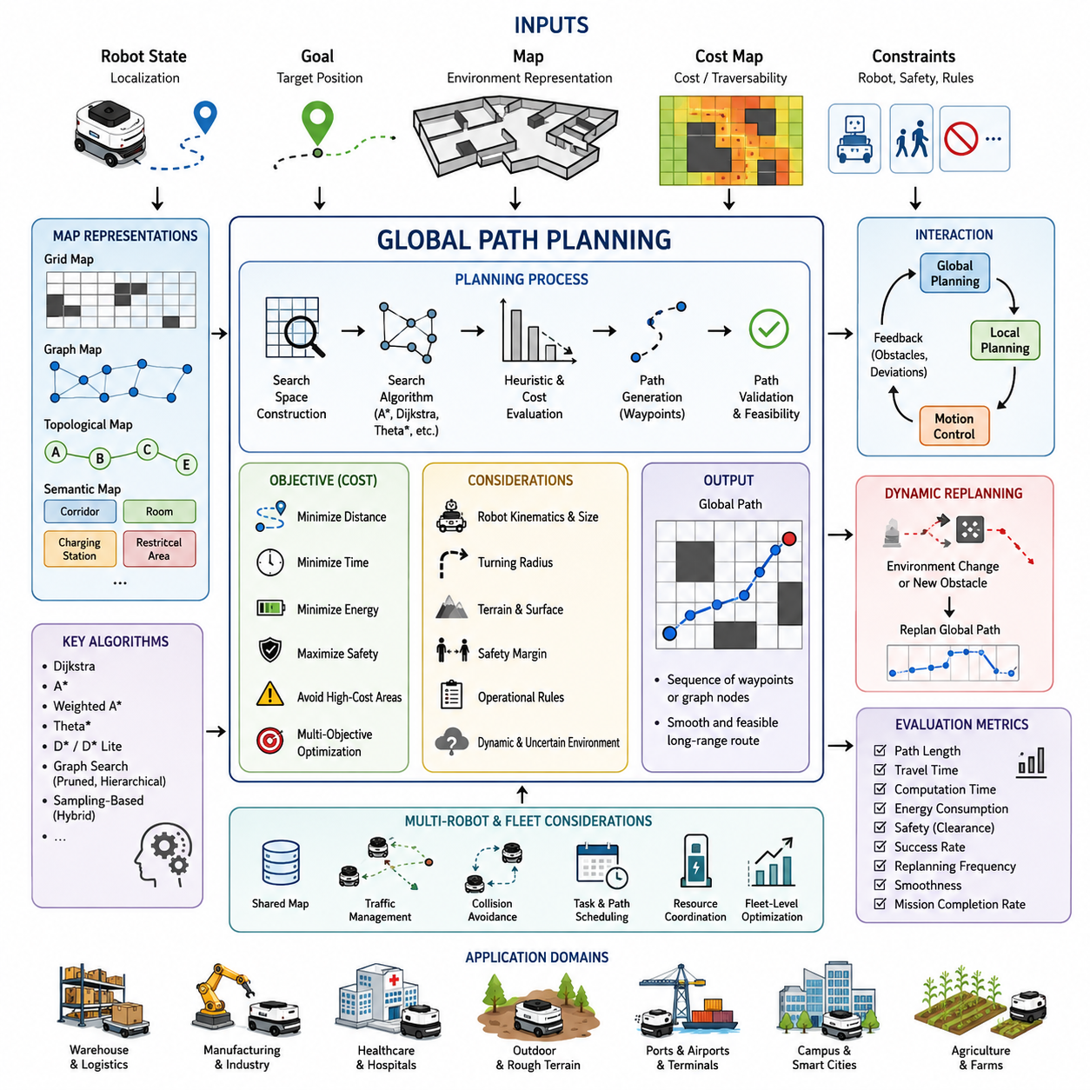
Global path planning is one of the most fundamental capabilities in autonomous mobile robots and intelligent navigation systems. It serves as the strategic layer of navigation responsible for determining how a robot moves from its current position to a distant destination while considering the structure of the environment, operational constraints, mission objectives, and safety requirements. Within the navigation hierarchy of an autonomous robot, global path planning operates above local planning and motion control, providing a high-level route that guides the robot through known or partially known environments. In modern AMR systems, global path planning is the foundation upon which reliable autonomous navigation is built. It transforms environmental information into actionable routes that enable robots to perform transportation, inspection, delivery, patrol, surveillance, mapping, and industrial automation tasks efficiently and safely. The topic is positioned within the Global Path Planning section of the Path Planning and Autonomous Navigation volume and serves as the conceptual basis for subsequent discussions on grid-based planning, graph-based planning, cost map generation, path optimization, and replanning methodologies.
At its core, global path planning answers a simple question: how can a robot travel from a start location to a goal location through an environment while minimizing cost and avoiding obstacles? Although the question appears straightforward, solving it efficiently in real-world environments involves complex computational reasoning. A robot must interpret maps, understand navigable regions, evaluate alternative routes, predict traversal costs, and generate a path that satisfies mission objectives. Depending on the application, optimization criteria may include shortest distance, minimum travel time, lowest energy consumption, maximum safety margin, minimal terrain difficulty, or a balanced combination of several objectives.
The concept of global path planning originates from classical graph theory, operations research, artificial intelligence, and robotics. Historically, route planning problems were studied in transportation networks, logistics systems, and communication networks. Many of the mathematical foundations developed in these fields later became essential components of robotic navigation. As mobile robots evolved from structured factory environments into dynamic indoor and outdoor spaces, global path planning expanded to incorporate map representations, uncertainty modeling, environmental semantics, and real-time adaptation.
A global planner typically assumes that a map of the environment is available. This map may be generated through SLAM, obtained from CAD drawings, derived from digital twins, or downloaded from cloud-based mapping services. The map serves as a representation of navigable and non-navigable areas. Obstacles such as walls, machinery, shelves, vehicles, fences, buildings, and terrain hazards are encoded within the map so that the planner can avoid them during route generation.
Different map representations influence how global planning algorithms operate. Occupancy grids represent environments as discrete cells that indicate free space, occupied space, or unknown regions. Topological maps describe environments using nodes and connectivity relationships. Graph maps represent navigation spaces as vertices and edges. Semantic maps incorporate contextual information such as rooms, corridors, roads, charging stations, elevators, loading docks, pedestrian zones, and restricted areas. Each representation offers advantages and limitations depending on the scale and complexity of the application.
Global path planning differs significantly from local path planning. The global planner focuses on strategic route selection over long distances using complete or semi-complete environmental knowledge. The local planner operates at a shorter time horizon and reacts to immediate obstacles, dynamic changes, and motion constraints. The global planner may compute a route spanning hundreds of meters or even kilometers, while the local planner continuously adjusts motion commands over a range of only a few meters. Together, these layers form a hierarchical navigation architecture commonly used in industrial AMRs, autonomous vehicles, outdoor robots, warehouse systems, agricultural robots, and service robots.
The concept of optimality is central to global path planning. A path is considered optimal when it minimizes a defined objective function. The simplest objective is geometric distance, where the shortest route is selected. However, practical robotic systems often require more sophisticated optimization criteria. A path passing through narrow corridors may be shorter but less safe. A path crossing rough terrain may increase mechanical wear. A route through congested regions may increase travel time. Therefore, modern planners frequently use weighted cost functions that incorporate multiple factors including distance, safety, energy consumption, terrain quality, traffic density, and operational priorities.
Cost maps play a critical role in implementing these concepts. A cost map assigns numerical values to different regions of the environment. Low-cost regions represent preferred traversal areas, while high-cost regions indicate obstacles, hazards, or undesirable locations. During planning, the robot seeks routes that minimize accumulated cost rather than simply minimizing geometric distance. This approach enables robots to make intelligent decisions that align with operational objectives.
In industrial warehouse environments, global planning often emphasizes efficiency and throughput. Robots must navigate among shelves, workstations, loading zones, and charging stations while minimizing travel distance and avoiding congestion. In hospitals, planners must consider patient safety, elevator integration, restricted medical areas, and pedestrian interactions. Outdoor autonomous robots may incorporate terrain slope, weather conditions, road quality, GNSS availability, and environmental risk factors into planning decisions. Each application domain introduces unique requirements that influence planning strategies.
The planning process generally begins with localization. Before a path can be generated, the robot must estimate its position within the map. Localization systems may rely on LiDAR, cameras, GNSS, IMUs, wheel odometry, radar, or multi-sensor fusion techniques. Once the robot's current pose and target location are known, the planner searches the map to identify a feasible route connecting the two locations. The resulting route is typically represented as a sequence of waypoints, graph nodes, or continuous trajectories that guide subsequent navigation modules.
Search algorithms are fundamental components of global planning systems. Algorithms such as Dijkstra, A*, Weighted A*, Theta*, D*, D* Lite, and various graph-search methods evaluate potential paths and identify optimal or near-optimal solutions. These algorithms differ in computational complexity, memory requirements, optimality guarantees, and responsiveness to environmental changes. A* has become one of the most widely adopted methods because it efficiently balances optimality and computational performance through the use of heuristic functions.
Heuristics represent another important concept in global path planning. A heuristic estimates the remaining cost from a given position to the goal. By incorporating informed estimates into the search process, planners can significantly reduce computation time while maintaining solution quality. The effectiveness of a heuristic often determines the practical performance of a planning algorithm, especially in large-scale environments containing millions of navigable cells or graph nodes.
Scalability is a major challenge in modern robotic systems. As operational environments grow larger, planning complexity increases dramatically. A warehouse containing thousands of storage locations, a hospital spanning multiple floors, or an outdoor industrial site covering several square kilometers may contain vast navigation spaces. Efficient global planning requires hierarchical representations, graph abstraction techniques, map partitioning strategies, and computational optimization methods that allow rapid route generation despite increasing environmental complexity.
Another important concept is feasibility. A mathematically optimal route may not be physically executable by a robot. Vehicle dimensions, turning radius, wheelbase, steering mechanisms, acceleration limits, braking capabilities, payload conditions, and terrain interactions must all be considered. Therefore, practical global planners often incorporate vehicle constraints directly into the planning process. For example, an outdoor autonomous robot with a heavy payload may require wider turning paths than a compact indoor AMR. Similarly, towing robots must account for trailer dynamics and articulation constraints during route generation.
Safety considerations influence nearly every aspect of global path planning. Autonomous systems must maintain safe distances from obstacles, avoid restricted zones, comply with operational regulations, and preserve stability during navigation. Industrial environments frequently include safety corridors, pedestrian crossings, emergency access routes, and protected work areas. Cost maps and planning constraints are often designed to ensure that generated routes remain consistent with functional safety requirements and organizational policies.
Environmental uncertainty presents another challenge. Real-world maps are never perfect representations of reality. Objects may move, construction may alter layouts, temporary obstacles may appear, and sensor errors may introduce inaccuracies. Global planning systems therefore operate under varying degrees of uncertainty. Some planners assume static environments, while more advanced systems incorporate probabilistic representations and dynamic replanning capabilities. The ability to update routes in response to changing conditions is essential for maintaining operational robustness.
Global path planning also interacts closely with fleet management systems. In multi-robot environments, route selection cannot be performed independently for each robot. Shared resources such as corridors, intersections, loading stations, elevators, and charging areas require coordinated planning. Fleet-level optimization considers traffic flow, resource allocation, task priorities, and congestion management to ensure efficient operation of large robotic deployments.
Modern cloud-connected robotics platforms increasingly support distributed planning architectures. In these systems, computationally intensive planning operations may be performed on edge servers, cloud infrastructure, or centralized fleet controllers. Individual robots receive optimized routes while maintaining local autonomy for obstacle avoidance and motion control. This architecture enables large-scale deployment of autonomous systems across factories, hospitals, campuses, logistics centers, ports, airports, and smart city environments.
The emergence of AI-driven navigation introduces additional dimensions to global planning. Machine learning models can predict environmental changes, estimate traversal costs, recognize semantic context, and improve planning efficiency. Semantic navigation systems allow robots to understand concepts such as offices, hallways, entrances, storage areas, and delivery zones. Rather than planning solely through geometric spaces, future navigation systems will increasingly reason about functional and contextual relationships within environments.
Digital twins are becoming valuable tools for global path planning development and validation. Engineers can construct virtual replicas of operational environments and evaluate planning algorithms under controlled conditions. Simulation platforms enable testing across diverse scenarios, including rare edge cases that may be difficult or dangerous to reproduce in physical environments. This approach accelerates development while improving reliability and safety.
Validation of global planning performance requires quantitative metrics. Common evaluation criteria include path length, travel time, computational latency, memory utilization, energy efficiency, obstacle clearance, route smoothness, success rate, replanning frequency, and mission completion rate. Benchmarking against these metrics allows engineers to compare planning algorithms objectively and identify areas for improvement.
As autonomous systems continue to evolve, global path planning is expanding beyond traditional route generation. Future systems will integrate perception, reasoning, prediction, world modeling, and decision-making into unified navigation frameworks. Robots will not only determine where to go but also understand why certain routes are preferable, anticipate future environmental changes, coordinate with other agents, and adapt dynamically to mission objectives. Advanced planning architectures will combine classical optimization techniques with AI-based reasoning to create more intelligent, scalable, and resilient navigation systems.
In the broader context of autonomous navigation, global path planning serves as the strategic intelligence layer that transforms maps into missions and destinations into executable routes. It provides the long-range guidance necessary for safe, efficient, and autonomous operation across industrial, commercial, healthcare, logistics, agricultural, and smart city applications. Understanding the concepts underlying global path planning is therefore essential for robotics engineers, AI developers, system architects, and researchers seeking to build next-generation autonomous robotic platforms capable of operating reliably in increasingly complex environments. This conceptual foundation naturally leads to deeper exploration of grid-based methods, graph-based methods, cost map generation, optimization techniques, replanning strategies, and large-scale navigation systems that form the remainder of the Global Path Planning chapter.

02.2 Grid-Based Path Planning
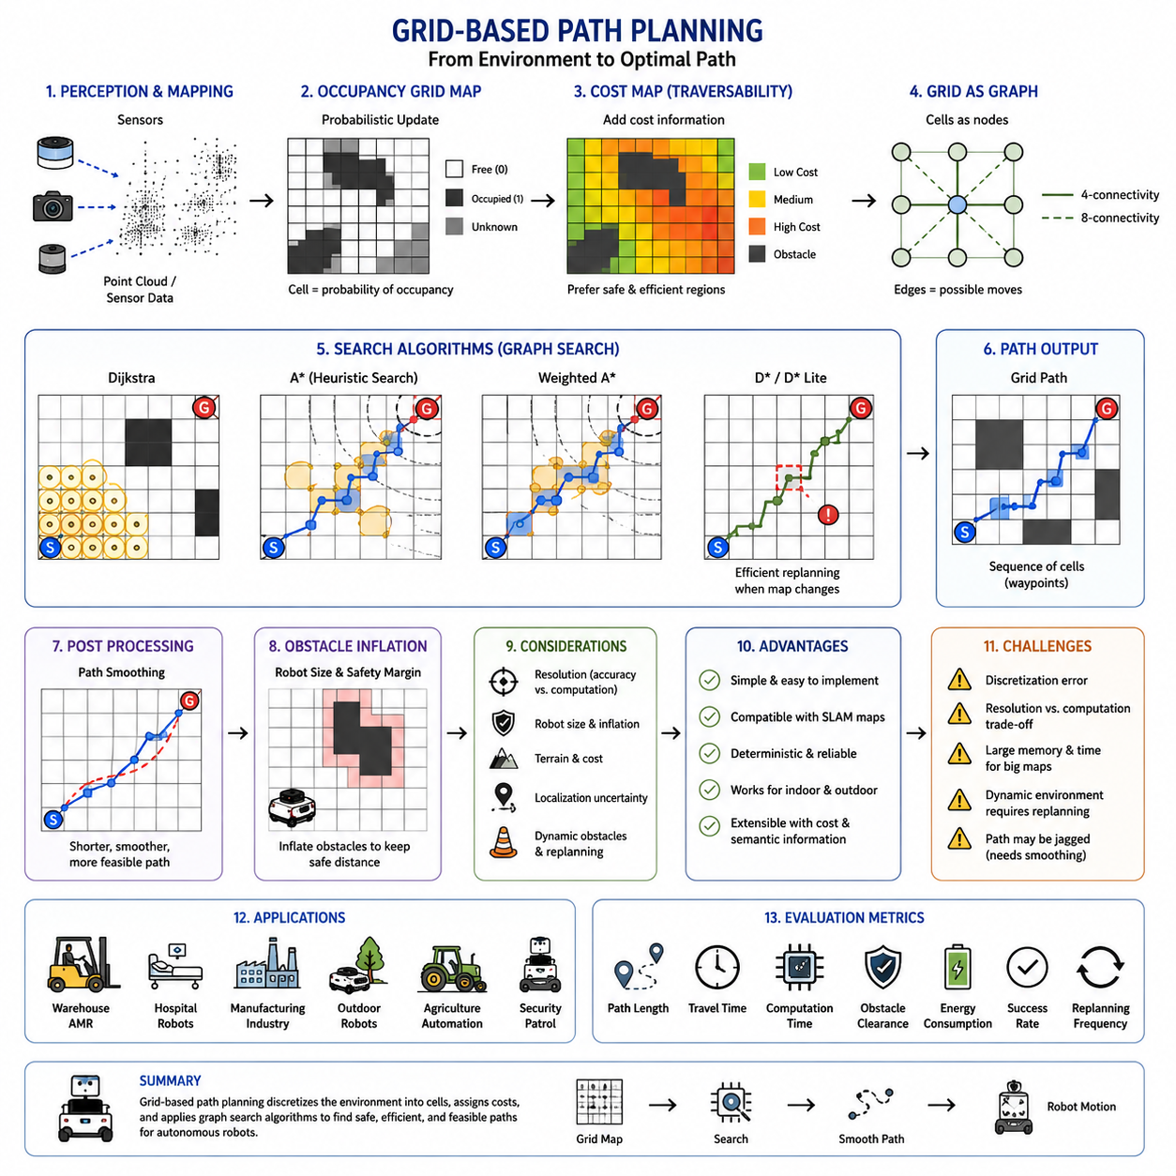
Grid-Based Path Planning is one of the most fundamental and widely adopted approaches in autonomous robot navigation. It provides a structured method for representing environments and computing feasible routes between a start location and a destination. The approach is particularly important because it serves as the foundation for many classical path planning algorithms, including Dijkstra, A*, Weighted A*, Theta*, D*, and numerous variants that have become standard components of modern autonomous mobile robot systems. In both academic research and industrial applications, grid-based planning remains a dominant methodology due to its simplicity, robustness, and compatibility with occupancy maps generated by SLAM systems. Within the broader navigation architecture of an AMR, grid-based path planning forms a critical bridge between environmental perception and autonomous decision-making.
The central concept behind grid-based path planning is the discretization of the environment into a collection of uniformly sized cells. Instead of representing space as a continuous geometric area, the environment is divided into a two-dimensional or three-dimensional lattice where each cell contains information about its occupancy state. A cell may represent free space, occupied space, unknown space, or a cost value associated with traversing that location. This discretized representation transforms a continuous navigation problem into a graph search problem, enabling the use of efficient computational algorithms for route generation.
Grid maps are particularly attractive because they can be directly generated from sensor data. LiDAR scans, depth cameras, radar systems, stereo vision sensors, and SLAM algorithms naturally produce occupancy information that can be stored within a grid structure. Each cell becomes a compact representation of environmental knowledge. As a result, grid maps provide a universal framework for integrating perception, mapping, localization, obstacle avoidance, and path planning into a unified navigation system.
The process begins with environmental sensing. Sensors collect information about surrounding objects and free space. The data is then converted into an occupancy grid map where each cell contains a probability indicating whether the area is occupied by an obstacle. Probabilistic occupancy mapping is particularly useful because sensor measurements inherently contain uncertainty. Instead of classifying cells as simply occupied or free, probabilistic approaches maintain confidence values that improve map reliability and support more robust planning decisions.
Grid resolution plays a crucial role in planning performance. A high-resolution grid contains small cells and provides detailed environmental representation. Such maps can accurately capture narrow passages, small obstacles, and complex geometries. However, higher resolution significantly increases memory consumption and computational requirements. A low-resolution grid reduces computational burden but may fail to represent critical environmental details. Selecting an appropriate grid size requires balancing accuracy, computational efficiency, and operational requirements.
For indoor AMRs operating in warehouses, hospitals, and factories, grid resolutions between five and twenty centimeters are commonly used. These values provide sufficient accuracy while maintaining real-time planning performance. Outdoor autonomous robots often employ larger cell sizes because they operate in expansive environments where computational scalability becomes more important than fine geometric detail. In large industrial sites, agricultural fields, mining areas, and infrastructure inspection applications, cell sizes ranging from twenty centimeters to several meters may be appropriate depending on the mission objectives.
Once the environment has been discretized, each grid cell can be interpreted as a node within a graph. Neighboring cells are connected through edges that represent possible movements. The resulting graph structure allows classical search algorithms to compute optimal routes. Four-connectivity and eight-connectivity are the most common neighborhood configurations in two-dimensional planning. Four-connectivity allows movement only in horizontal and vertical directions, while eight-connectivity additionally permits diagonal motion. The choice affects path quality, computational complexity, and motion realism.
The concept of traversability is fundamental in grid-based planning. Not all free cells are equally desirable for navigation. A cell located near an obstacle may be technically traversable but poses greater collision risk. Similarly, uneven terrain, slippery surfaces, steep slopes, pedestrian zones, and restricted areas may require special consideration. Therefore, modern grid-based systems often augment occupancy information with traversal costs. These costs influence path selection and enable the planner to generate safer and more efficient routes.
Cost maps extend the occupancy grid concept by assigning numerical penalties to individual cells. Low-cost cells represent preferred travel areas, while high-cost cells indicate undesirable regions. The global planner attempts to minimize the accumulated cost of the route rather than merely minimizing geometric distance. This capability allows robots to maintain safe distances from obstacles, avoid congested regions, reduce energy consumption, and comply with operational constraints.
Obstacle inflation is another essential concept. Robots possess physical dimensions and cannot be treated as point objects. To account for vehicle size, occupancy maps are often expanded through an inflation process. Cells surrounding obstacles are assigned elevated costs or marked as non-traversable. The inflation radius depends on robot dimensions, localization uncertainty, sensor accuracy, and required safety margins. Proper inflation ensures that generated paths remain executable under real-world operating conditions.
Grid-based path planning provides several important advantages. One of its greatest strengths is simplicity. The underlying data structures are easy to understand, implement, debug, and maintain. This simplicity has contributed to widespread adoption across robotics platforms ranging from educational robots to industrial AMRs and autonomous vehicles. Another advantage is compatibility with diverse sensor technologies and mapping systems. Since occupancy grids can be generated from virtually any perception modality, grid-based planners are highly adaptable to different environments and operational requirements.
The method also offers deterministic behavior. Given the same map, start location, and goal location, a grid-based planner consistently generates the same solution. Deterministic planning is particularly valuable in safety-critical industrial applications where predictability and repeatability are essential. Validation, certification, and debugging activities become more manageable when navigation behavior remains consistent across repeated trials.
Despite these strengths, grid-based planning introduces several challenges. The most significant limitation arises from discretization itself. Continuous environments are approximated by discrete cells, introducing representation errors. Narrow corridors may disappear if grid resolution is too coarse. Obstacle boundaries become stair-stepped approximations rather than smooth curves. Consequently, generated paths may contain unnecessary turns and geometric artifacts that require post-processing before execution.
Path smoothness is therefore an important consideration. Classical grid search algorithms often produce jagged routes consisting of multiple directional changes. While mathematically valid, such paths may not be suitable for physical robots. Excessive steering activity increases mechanical wear, energy consumption, and trajectory tracking errors. Path smoothing algorithms are commonly applied after route generation to create more continuous and dynamically feasible trajectories.
Computational complexity represents another challenge. Large environments can contain millions of cells. Search algorithms must evaluate numerous candidate paths before identifying an optimal solution. As map size increases, memory usage and computation time grow significantly. Hierarchical planning methods, map partitioning strategies, multiresolution grids, and heuristic search algorithms have been developed to address scalability limitations.
Dynamic environments introduce additional complexity. Traditional grid-based planning assumes static maps. However, real-world environments continuously change as people, vehicles, machinery, and temporary obstacles move through operational spaces. Dynamic obstacle integration requires planners to update occupancy information and re-evaluate routes whenever significant environmental changes occur. This capability is commonly referred to as replanning.
Incremental planning methods have emerged to support efficient replanning. Instead of recomputing an entire route from scratch, these algorithms update only affected portions of the search space. Techniques such as D* and D* Lite are particularly effective in environments where map changes occur frequently. They enable robots to adapt to evolving conditions while maintaining real-time navigation performance.
Grid-based planning is closely connected to robot localization. The planner assumes that the robot's position within the grid is known with reasonable accuracy. Localization errors can cause deviations between planned and actual trajectories. Consequently, modern navigation systems integrate localization confidence measures into planning processes. Areas with high localization uncertainty may receive elevated traversal costs to reduce navigation risk.
The approach is equally applicable to indoor and outdoor environments. Indoor facilities typically provide structured layouts consisting of corridors, rooms, workstations, shelves, and charging stations. Grid representations effectively capture these geometries and support reliable route generation. Outdoor environments present additional challenges including vegetation, rough terrain, GNSS uncertainty, weather effects, and changing surface conditions. Nevertheless, grid-based methods remain widely used because they can incorporate environmental costs and terrain information directly into map representations.
For outdoor autonomous robots performing infrastructure inspection, agricultural automation, security patrol, mining operations, or smart city services, grid maps may include elevation information, terrain classifications, slope estimates, vegetation density, soil characteristics, and weather-related hazards. Such enriched grid representations enable robots to select routes that balance safety, efficiency, and operational effectiveness.
Multi-layer grid maps further enhance planning capabilities. Instead of storing a single occupancy value per cell, advanced systems maintain multiple information layers. One layer may contain obstacle data, another may store terrain characteristics, while additional layers represent traffic density, semantic information, safety restrictions, or energy consumption estimates. The planner combines these layers to generate context-aware navigation strategies.
Semantic grid maps represent an important evolution of traditional occupancy grids. In addition to geometric information, cells may contain semantic labels such as corridor, office, warehouse aisle, charging zone, pedestrian area, restricted zone, loading dock, or emergency exit. These labels allow planners to incorporate contextual reasoning into route selection. For example, a hospital robot may prioritize public corridors while avoiding sensitive clinical areas whenever possible.
Grid-based planning also serves as a foundation for fleet-level navigation. In environments containing multiple robots, shared grid maps provide a common representation for traffic management and coordination. Fleet management systems can reserve cells, predict congestion, coordinate route assignments, and optimize overall traffic flow. Such capabilities are increasingly important in large-scale warehouse automation, hospital logistics systems, manufacturing facilities, airports, and distribution centers.
Simulation plays a major role in the development and validation of grid-based planning systems. Platforms such as ROS 2 Navigation Stack, Gazebo, Isaac Sim, and digital twin environments allow engineers to evaluate planning performance under controlled conditions. Simulated environments facilitate testing across thousands of scenarios, including rare edge cases that may be difficult to reproduce in physical deployments. Through simulation, planners can be benchmarked for computational efficiency, path quality, obstacle avoidance effectiveness, safety margins, and mission success rates.
Performance evaluation typically focuses on several key metrics. Path length measures route efficiency. Travel time evaluates operational productivity. Computation latency assesses responsiveness. Path smoothness reflects motion quality. Obstacle clearance indicates safety performance. Energy consumption estimates operational efficiency. Success rate measures navigation reliability. Replanning frequency reflects environmental adaptability. Together, these metrics provide a comprehensive assessment of planner effectiveness.
Recent advances in artificial intelligence are expanding the capabilities of grid-based planning systems. Machine learning models can predict environmental changes, estimate traversal costs, infer semantic information, and improve search efficiency. Hybrid architectures combine classical graph-search algorithms with AI-based prediction systems, leveraging the strengths of both approaches. Rather than replacing grid-based planning, AI increasingly acts as an enhancement layer that improves decision quality and adaptability.
Future grid-based path planning systems will likely become more hierarchical, semantic, predictive, and collaborative. Multi-resolution maps will support large-scale environments while maintaining local detail. Semantic reasoning will enable context-aware navigation. Predictive models will anticipate future obstacles and traffic conditions. Fleet-wide optimization will coordinate hundreds or thousands of robots simultaneously. Integration with digital twins, cloud robotics, embodied AI, and world models will further transform how autonomous systems understand and navigate their environments.
Grid-based path planning remains one of the most important technologies in autonomous navigation because it provides a practical balance between mathematical rigor, computational efficiency, implementation simplicity, and operational reliability. It forms the conceptual and technological foundation for many modern navigation systems and continues to evolve alongside advances in robotics, artificial intelligence, sensor technology, and autonomous mobility. Understanding grid-based planning is therefore essential for robotics engineers, navigation developers, AI researchers, and system architects seeking to design robust and scalable autonomous robot platforms capable of operating effectively in real-world environments.

02.3 Graph-Based Path Planning
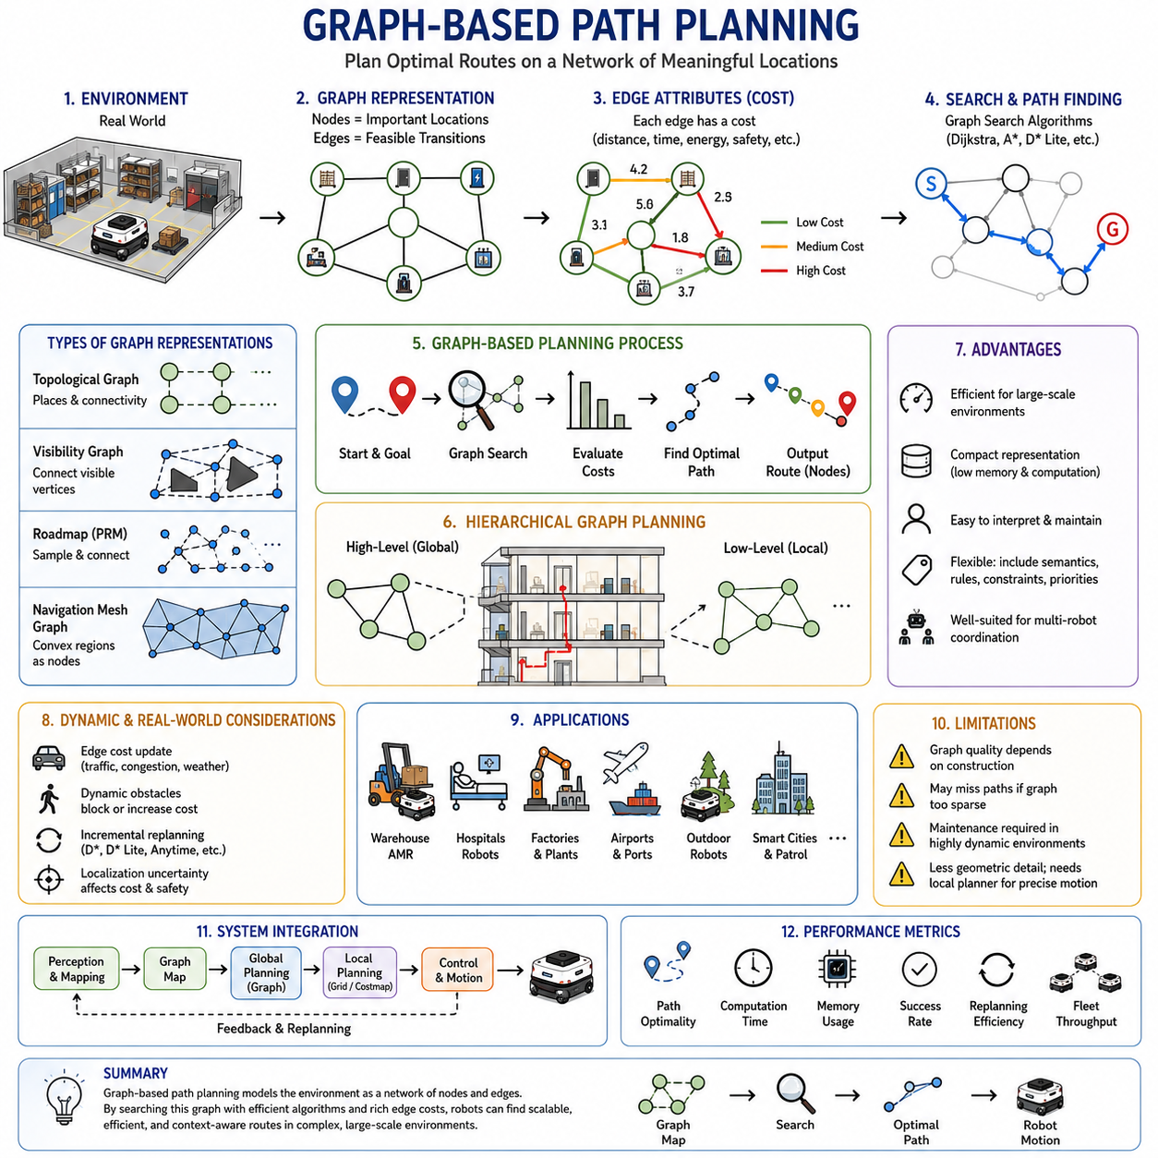
Graph-Based Path Planning is one of the most important methodologies in autonomous robot navigation and intelligent transportation systems. Unlike grid-based approaches that discretize the environment into uniformly sized cells, graph-based planning represents the environment as a collection of interconnected nodes and edges. This representation provides a more compact and computationally efficient abstraction of navigable space, making it particularly suitable for large-scale environments, structured facilities, transportation networks, and complex robotic systems. Graph-based planning forms the mathematical foundation of many modern navigation architectures and is widely used in autonomous mobile robots, autonomous vehicles, warehouse automation systems, fleet management platforms, service robots, and outdoor autonomous machines.
The fundamental idea behind graph-based path planning is to model the environment as a graph. A graph consists of vertices, commonly referred to as nodes, and connections between those nodes known as edges. Each node represents a meaningful location within the environment, while edges represent feasible transitions between locations. The planning problem then becomes a graph search problem in which the objective is to find an optimal sequence of nodes connecting the start location to the goal location.
Graph representations offer significant advantages over dense grid maps. Rather than evaluating every small region of space, graph-based planners focus only on strategically important locations. This dramatically reduces memory requirements and computational complexity, particularly in large environments. For example, a warehouse occupying tens of thousands of square meters may require millions of grid cells but only hundreds or thousands of graph nodes. This reduction enables efficient route planning while preserving essential navigation information.
The concept of graph representation originates from graph theory, one of the most important branches of discrete mathematics. Graph theory provides a formal framework for modeling connectivity, relationships, and movement through structured spaces. Many path planning algorithms used in robotics today are direct applications of graph-theoretical principles originally developed for transportation networks, communication systems, logistics optimization, and operations research.
Nodes serve as the primary building blocks of graph-based navigation. A node may represent a room, corridor intersection, doorway, charging station, loading dock, waypoint, inspection point, parking location, or any other meaningful position within an environment. The selection of node locations significantly influences navigation performance. Too few nodes may oversimplify the environment and limit path quality, while too many nodes can increase computational burden and reduce the advantages of graph abstraction.
Edges define how nodes are connected. Each edge represents a feasible path segment between two locations. Edges may contain various attributes such as distance, travel time, energy cost, terrain difficulty, safety level, traffic density, or operational constraints. By incorporating these attributes into planning calculations, graph-based systems can optimize routes according to diverse mission objectives rather than simply minimizing geometric distance.
The weight assigned to an edge plays a critical role in route selection. Edge weights represent traversal costs and influence how search algorithms evaluate alternative paths. In the simplest case, edge weights correspond to physical distance. More advanced systems incorporate additional factors such as energy consumption, vehicle dynamics, terrain quality, congestion levels, safety margins, weather conditions, or business priorities. The resulting weighted graph provides a flexible framework for multi-objective optimization.
Graph construction is one of the most important aspects of graph-based path planning. Several approaches can be used to generate navigation graphs. Manual graph creation is common in structured industrial facilities where engineers define navigation routes and connectivity relationships. Automated graph generation techniques derive graphs from occupancy maps, SLAM outputs, CAD drawings, digital twins, or sensor data. Hybrid approaches combine human expertise with automated processing to achieve optimal results.
Topological maps represent one of the most common forms of graph-based navigation. In topological mapping, nodes correspond to significant places and edges describe connectivity between those places. Unlike metric maps that focus on precise geometric coordinates, topological maps emphasize relationships and accessibility. This abstraction allows efficient navigation in environments where exact spatial detail is less important than connectivity structure.
Visibility graphs constitute another important graph representation. In a visibility graph, nodes are placed at obstacle vertices and edges connect nodes that can directly see each other without obstruction. Visibility graphs often produce near-optimal shortest paths in polygonal environments. However, they can become computationally expensive in highly complex scenes containing numerous obstacles.
Roadmap-based planning methods extend graph concepts further. Probabilistic Roadmaps, commonly known as PRMs, construct graphs by randomly sampling navigable space and connecting feasible configurations. These methods are particularly effective in high-dimensional planning problems involving robotic manipulators, articulated vehicles, and complex motion constraints. Once a roadmap has been constructed, multiple planning queries can be answered efficiently using graph search techniques.
Navigation meshes represent another graph-oriented approach frequently used in robotics and simulation environments. Rather than representing space as grids, navigation meshes partition free space into convex regions. Each region becomes a node within a navigation graph. This representation often produces smoother and more natural paths while reducing memory requirements compared to occupancy grids.
Graph-based planning naturally supports hierarchical navigation architectures. Large environments can be represented using multiple graph layers. High-level graphs describe connectivity between buildings, floors, sectors, or operational zones. Lower-level graphs provide detailed navigation within local regions. Hierarchical planning significantly improves scalability by reducing the search space associated with long-distance route planning.
Search algorithms are central components of graph-based planning systems. Dijkstra’s algorithm remains one of the most fundamental approaches. It systematically explores the graph and guarantees identification of the shortest path in weighted graphs with non-negative edge costs. Although computationally robust, Dijkstra’s algorithm may become inefficient in large environments because it explores many unnecessary nodes.
The A* algorithm improves efficiency by incorporating heuristic estimates of remaining travel cost. Rather than treating all nodes equally, A* prioritizes nodes that appear closer to the goal. This heuristic guidance significantly reduces computational effort while preserving optimality under appropriate conditions. As a result, A* has become one of the most widely deployed algorithms in autonomous navigation systems.
Weighted A*, Theta*, D*, D* Lite, Anytime Repairing A*, Lifelong Planning A*, and numerous other variants further extend graph-search capabilities. These algorithms address challenges such as dynamic environments, real-time replanning, computational constraints, and large-scale deployments. Their continued evolution reflects the growing complexity of modern autonomous systems.
One of the greatest strengths of graph-based planning is computational efficiency. Because the graph contains only essential navigation information, search algorithms evaluate significantly fewer states compared to dense grid representations. This efficiency becomes increasingly valuable as environment size grows. Large industrial campuses, airports, ports, hospitals, logistics centers, smart cities, and agricultural operations benefit substantially from graph abstraction.
Graph-based planning also provides superior interpretability. Human operators can easily understand graph structures because nodes often correspond to meaningful locations. Routes generated through graph navigation are intuitive and align naturally with operational workflows. This characteristic simplifies debugging, validation, maintenance, and fleet management activities.
Flexibility represents another important advantage. Graphs can incorporate diverse information beyond geometry. Semantic attributes, operational policies, traffic rules, safety constraints, maintenance schedules, restricted zones, charging infrastructure, and task priorities can all be encoded within graph structures. This capability enables sophisticated decision-making that extends beyond shortest-path optimization.
For industrial AMRs operating in factories and warehouses, graph-based planning often uses predefined transportation corridors and operational zones. Nodes may represent storage areas, production stations, quality inspection points, loading docks, charging stations, and maintenance facilities. By incorporating operational semantics directly into the graph, navigation behavior becomes more aligned with business processes.
In hospital environments, graph nodes may represent patient rooms, nursing stations, elevators, pharmacies, laboratories, operating rooms, and supply areas. Edges can incorporate restrictions related to infection control, patient privacy, emergency operations, or traffic management. Graph-based planning enables healthcare robots to navigate efficiently while complying with complex operational requirements.
Outdoor autonomous robots also benefit from graph representations. Inspection robots, agricultural platforms, mining vehicles, security patrol systems, and infrastructure maintenance robots often operate across extensive geographic regions. Graphs can represent roads, pathways, service routes, inspection checkpoints, charging locations, and operational zones. Compared to dense grids, graph representations significantly reduce computational requirements for long-distance navigation.
Dynamic environments introduce additional challenges. Real-world environments continuously change due to moving people, vehicles, equipment, and temporary obstacles. Graph-based systems address these challenges through dynamic edge updates, adaptive weighting mechanisms, and incremental replanning algorithms. When environmental conditions change, only affected graph components need to be updated, improving computational efficiency compared to complete map reconstruction.
Multi-robot systems further highlight the advantages of graph-based planning. Shared navigation graphs provide a common framework for coordinating fleets of robots. Traffic management systems can reserve graph edges, schedule route assignments, prevent collisions, minimize congestion, and optimize overall fleet performance. These capabilities are particularly important in large logistics facilities and smart factories where hundreds of robots may operate simultaneously.
Cloud robotics and fleet management platforms increasingly rely on graph-based navigation. Centralized servers maintain global navigation graphs while individual robots perform local navigation and obstacle avoidance. This architecture supports scalable deployment across distributed facilities and enables coordinated operation of large robot fleets.
Graph-based planning also integrates naturally with digital twin technologies. Virtual representations of facilities can be converted directly into navigation graphs, allowing planners to evaluate routes, optimize operations, and test new configurations before physical deployment. Digital twins facilitate simulation-based validation and reduce deployment risk.
Recent advances in artificial intelligence have expanded the capabilities of graph-based navigation. Graph Neural Networks, commonly referred to as GNNs, enable machine learning models to operate directly on graph structures. These models can predict traffic patterns, estimate traversal costs, optimize route selection, detect anomalies, and improve navigation performance. AI-enhanced graph planning represents a rapidly growing research area with significant industrial potential.
Semantic graph representations further extend navigation intelligence. Nodes and edges can contain contextual information describing environmental functions, operational significance, human activity patterns, or mission relevance. This semantic layer allows robots to make decisions based not only on geometric connectivity but also on environmental meaning and operational context.
Despite its many strengths, graph-based planning has limitations. Graph quality depends heavily on graph construction. Poorly designed graphs may omit important navigation opportunities or introduce inefficient routes. Maintaining accurate graphs in rapidly changing environments can also be challenging. Additionally, graph abstraction may remove geometric details that are important for precise motion planning. Consequently, graph-based planners are often combined with local planners and continuous trajectory optimization modules.
Hybrid navigation architectures are increasingly common. High-level route planning is performed using graph-based methods, while local navigation relies on grid maps, cost maps, obstacle avoidance algorithms, and trajectory optimization techniques. This combination leverages the scalability of graph planning and the precision of local navigation systems.
Performance evaluation of graph-based planning systems typically considers path optimality, planning latency, memory consumption, scalability, success rate, route smoothness, replanning efficiency, fleet throughput, congestion reduction, and mission completion rates. These metrics provide objective measures of planner effectiveness across different operational scenarios.
The future of graph-based path planning is closely connected to developments in AI, digital twins, cloud robotics, semantic navigation, and embodied intelligence. Navigation graphs will become increasingly dynamic, context-aware, and predictive. Future systems will continuously update graph structures based on real-time observations, operational feedback, environmental predictions, and collaborative information sharing among robots.
Ultimately, graph-based path planning provides a powerful and scalable framework for autonomous navigation. By representing environments as interconnected networks of meaningful locations, graph-based systems achieve efficient route planning, intuitive interpretation, operational flexibility, and large-scale scalability. As autonomous robots continue to expand into factories, hospitals, cities, transportation systems, agricultural environments, and infrastructure applications, graph-based planning will remain one of the foundational technologies enabling intelligent and reliable autonomous mobility.

02.4 Cost Map Generation
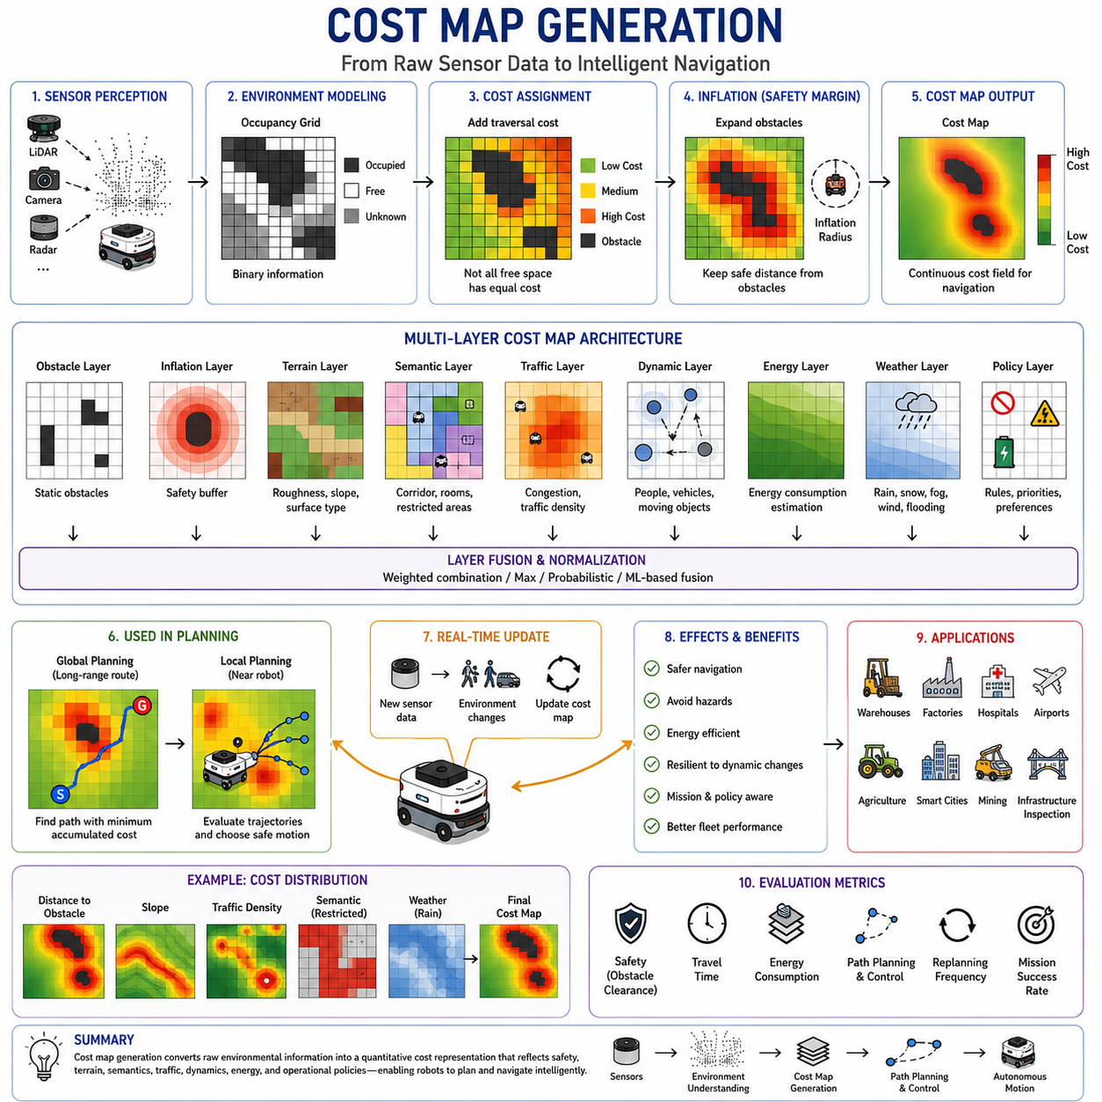
Cost Map Generation is one of the most critical components in autonomous navigation systems because it transforms raw environmental information into a navigational representation that enables intelligent path planning and motion decision-making. While occupancy maps identify whether a location is free or occupied, cost maps provide a richer representation by assigning numerical traversal costs to different regions of the environment. These costs allow autonomous mobile robots to evaluate alternative routes based not only on geometric distance but also on safety, efficiency, energy consumption, terrain difficulty, operational constraints, and mission objectives. As a result, cost maps serve as the fundamental bridge between environmental perception and optimal navigation behavior.
In modern AMR systems, cost maps are used extensively in both global path planning and local path planning. The global planner utilizes cost maps to determine long-range routes across the environment, while the local planner continuously evaluates nearby regions to generate safe and feasible motion commands. Without a cost map, a planner would simply seek the shortest path. With a cost map, the planner can select routes that balance multiple objectives and better reflect real-world operating conditions.
The concept of a cost map originates from the observation that not all traversable locations are equally desirable. Two paths may both connect the same start and goal locations, but one path may pass dangerously close to obstacles, traverse rough terrain, enter congested areas, or consume more energy. Cost maps quantify these differences by assigning higher costs to less desirable regions and lower costs to preferred regions. Path planning algorithms then seek routes that minimize accumulated traversal cost rather than merely minimizing physical distance.
At its most basic level, a cost map is a two-dimensional or three-dimensional spatial representation in which every cell, node, or region is associated with a numerical value. These values represent the relative difficulty, risk, or expense of traversing a particular location. High-cost regions discourage navigation, while low-cost regions attract navigation. Obstacles are typically assigned extremely high costs or treated as completely non-traversable areas.
The generation of a cost map begins with environmental perception. Sensors such as LiDAR, RGB cameras, depth cameras, stereo vision systems, radar sensors, ultrasonic sensors, GNSS receivers, and IMUs continuously collect information about the surrounding environment. This raw sensor data is processed through perception algorithms that identify obstacles, free space, terrain characteristics, dynamic objects, and environmental features. The resulting information forms the foundation upon which cost values are assigned.
Occupancy grids often serve as the starting point for cost map generation. An occupancy grid indicates whether individual cells are occupied, free, or unknown. Cost map generation extends this representation by introducing varying traversal penalties. Instead of representing space with binary occupancy values, each cell receives a continuous or discrete cost value that reflects navigation preferences and constraints.
Obstacle information is one of the most important contributors to cost maps. Areas containing physical obstacles such as walls, machinery, shelving systems, vehicles, barriers, trees, rocks, poles, or infrastructure elements are assigned very high costs. These regions effectively become forbidden zones that path planners avoid. However, the influence of obstacles often extends beyond their physical boundaries through a process known as obstacle inflation.
Obstacle inflation accounts for the physical dimensions of the robot and the uncertainties associated with localization, sensing, and control. Rather than treating obstacles as infinitely thin boundaries, surrounding cells are assigned gradually increasing costs as they approach obstacle surfaces. This creates safety buffers that encourage planners to maintain adequate clearance during navigation. The inflation radius depends on robot size, sensor accuracy, operational speed, stopping distance, and safety requirements.
The inflation process is particularly important in industrial environments where collisions can damage equipment, interrupt operations, or endanger personnel. For large outdoor autonomous robots carrying heavy payloads, inflation distances may be significantly larger than those used for compact indoor AMRs. In high-speed applications, safety margins often increase further because greater stopping distances are required.
Distance transforms are commonly used to compute obstacle-related costs. These algorithms calculate the distance from every cell to the nearest obstacle. Cost values are then derived from these distances using mathematical functions such as exponential decay, linear scaling, Gaussian distributions, or custom safety models. The resulting cost gradients guide robots toward safer regions while maintaining navigational flexibility.
Terrain characteristics represent another important factor in cost map generation. In outdoor environments, not all surfaces are equally suitable for traversal. Asphalt roads, concrete pathways, compact soil, gravel surfaces, grass fields, mud, sand, and rocky terrain may each impose different traversal costs. Terrain-aware cost maps allow robots to select routes that minimize risk, energy consumption, and mechanical stress.
For agricultural robots, cost maps may incorporate crop locations, irrigation systems, soil moisture levels, vegetation density, and field boundaries. Mining robots may consider slope stability, ground hardness, equipment traffic zones, and hazardous regions. Infrastructure inspection robots may incorporate road conditions, shoulder accessibility, construction zones, and utility access points. These specialized cost layers enable mission-specific optimization.
Elevation information frequently contributes to outdoor cost maps. Slopes increase energy consumption, reduce stability, and introduce rollover risks for mobile robots. Cells associated with steep inclines may therefore receive elevated costs. More sophisticated systems evaluate terrain gradients, curvature, roughness, and vehicle dynamics simultaneously. This approach supports safer navigation across challenging outdoor environments.
Dynamic objects introduce additional complexity into cost map generation. Humans, vehicles, forklifts, mobile equipment, and other moving entities continuously alter environmental conditions. Dynamic cost maps update in real time to reflect changing obstacle positions and predicted motion trajectories. Cells associated with moving objects receive temporary cost increases that influence path planning decisions.
Human-aware navigation systems often assign specialized costs around people. Rather than merely avoiding collisions, robots maintain socially acceptable distances and behaviors. Cost values may increase near pedestrian pathways, gathering areas, waiting zones, or workstations. Such considerations improve safety, comfort, and acceptance in shared human-robot environments.
Semantic information significantly enhances modern cost maps. Traditional cost maps focus primarily on geometric obstacles and physical traversability. Semantic cost maps incorporate contextual understanding of the environment. Hospitals, warehouses, factories, airports, and office buildings contain locations with different operational significance. Corridors, patient rooms, emergency exits, loading docks, elevators, clean rooms, hazardous areas, and restricted zones may each receive customized cost values reflecting organizational policies and mission objectives.
Traffic conditions also influence cost map generation. In multi-robot systems and large industrial facilities, congestion can significantly impact operational efficiency. Traffic-aware cost maps assign higher costs to frequently occupied areas, busy intersections, bottlenecks, or heavily utilized corridors. This encourages route diversification and improves overall fleet throughput.
Energy-aware navigation represents another important application. Mobile robots operating on batteries must carefully manage power consumption. Cost maps can estimate the energy required to traverse different regions based on terrain, slope, surface type, speed limits, and vehicle dynamics. Energy-aware planners then generate routes that maximize operational efficiency while preserving battery life.
Weather conditions may also affect cost maps in outdoor applications. Rain, snow, fog, ice, strong winds, flooding, and reduced visibility can alter navigation safety and performance. Dynamic weather-aware cost maps allow robots to adapt route selection according to environmental conditions. For example, slippery surfaces may receive increased costs during rain events, while flooded regions may become temporarily inaccessible.
Multi-layer cost map architectures have become standard in modern navigation systems. Rather than maintaining a single cost representation, advanced systems utilize multiple layers that contribute independently to overall navigation cost. Common layers include obstacle layers, inflation layers, terrain layers, semantic layers, traffic layers, dynamic object layers, weather layers, and operational policy layers. The final cost map is generated by combining these layers through weighted fusion mechanisms.
Layer fusion strategies vary according to application requirements. Some systems use additive cost accumulation, while others employ maximum-value selection, probabilistic fusion, fuzzy logic, or machine-learning-based approaches. The choice of fusion method significantly influences navigation behavior and system performance.
Cost normalization plays an important role in multi-layer systems. Different data sources may generate costs with varying numerical ranges and units. Normalization ensures that cost contributions remain balanced and meaningful when combined. Without proper normalization, one layer may dominate the planning process and suppress important information from other layers.
Real-time updating is essential for effective cost map generation. Autonomous robots operate in continuously changing environments. Sensor updates, localization corrections, dynamic obstacles, traffic conditions, and mission changes all require ongoing cost map maintenance. Modern navigation systems often update local cost maps at frequencies ranging from several hertz to tens of hertz, ensuring that planners operate using current environmental information.
Computational efficiency represents a major design consideration. Large environments may contain millions of cells, each requiring cost calculations and updates. Efficient data structures, parallel processing, GPU acceleration, hierarchical representations, and region-of-interest updates help maintain real-time performance while preserving map quality.
Cost maps are closely integrated with path planning algorithms. Global planners such as Dijkstra, A*, Weighted A*, Theta*, and D* evaluate cumulative traversal costs during route generation. Local planners such as Dynamic Window Approach, Timed Elastic Band, Model Predictive Control, and sampling-based methods use cost maps to evaluate candidate trajectories and select safe motions.
Simulation environments provide valuable platforms for cost map development and validation. Tools such as ROS 2 Navigation Stack, Gazebo, Isaac Sim, digital twins, and custom simulation frameworks enable engineers to visualize cost distributions, evaluate navigation behavior, and optimize parameter settings before deployment. Visualization tools often display cost maps using color gradients that highlight low-cost and high-cost regions, making debugging and tuning more intuitive.
Performance evaluation of cost map systems typically considers navigation safety, obstacle clearance, path optimality, travel time, computational efficiency, energy consumption, collision avoidance effectiveness, replanning frequency, and mission success rate. Sensitivity analysis is often performed to determine how cost parameters influence overall navigation performance.
Artificial intelligence is increasingly being incorporated into cost map generation. Machine learning models can estimate traversability, predict environmental changes, infer semantic context, recognize hazards, and automatically optimize cost parameters. Deep learning approaches enable robots to learn navigation preferences directly from operational experience, reducing the need for manually tuned cost functions.
Future cost map systems are expected to become more predictive, adaptive, and context-aware. Rather than reacting only to current environmental conditions, next-generation systems will anticipate future events, predict traffic flows, estimate risk evolution, and optimize navigation decisions proactively. Integration with world models, digital twins, cloud robotics, fleet management platforms, and embodied AI architectures will further enhance cost map intelligence.
In advanced autonomous systems, cost maps will evolve from static navigation aids into dynamic decision-making frameworks that continuously synthesize perception, prediction, semantics, operations, and safety considerations. They will not merely describe the environment but actively guide intelligent behavior across complex and changing operational landscapes.
Ultimately, cost map generation serves as the decision-making foundation of autonomous navigation. By converting environmental observations into quantitative measures of traversal desirability, cost maps enable robots to reason about safety, efficiency, risk, and operational objectives simultaneously. Whether operating inside warehouses, hospitals, factories, airports, ports, farms, mining sites, smart cities, or infrastructure inspection corridors, autonomous robots rely on cost maps to transform environmental understanding into intelligent navigation behavior. As robotic systems become increasingly autonomous and intelligent, cost map generation will remain one of the most essential technologies underlying reliable and effective autonomous mobility.

02.5 Path Smoothing and Optimization
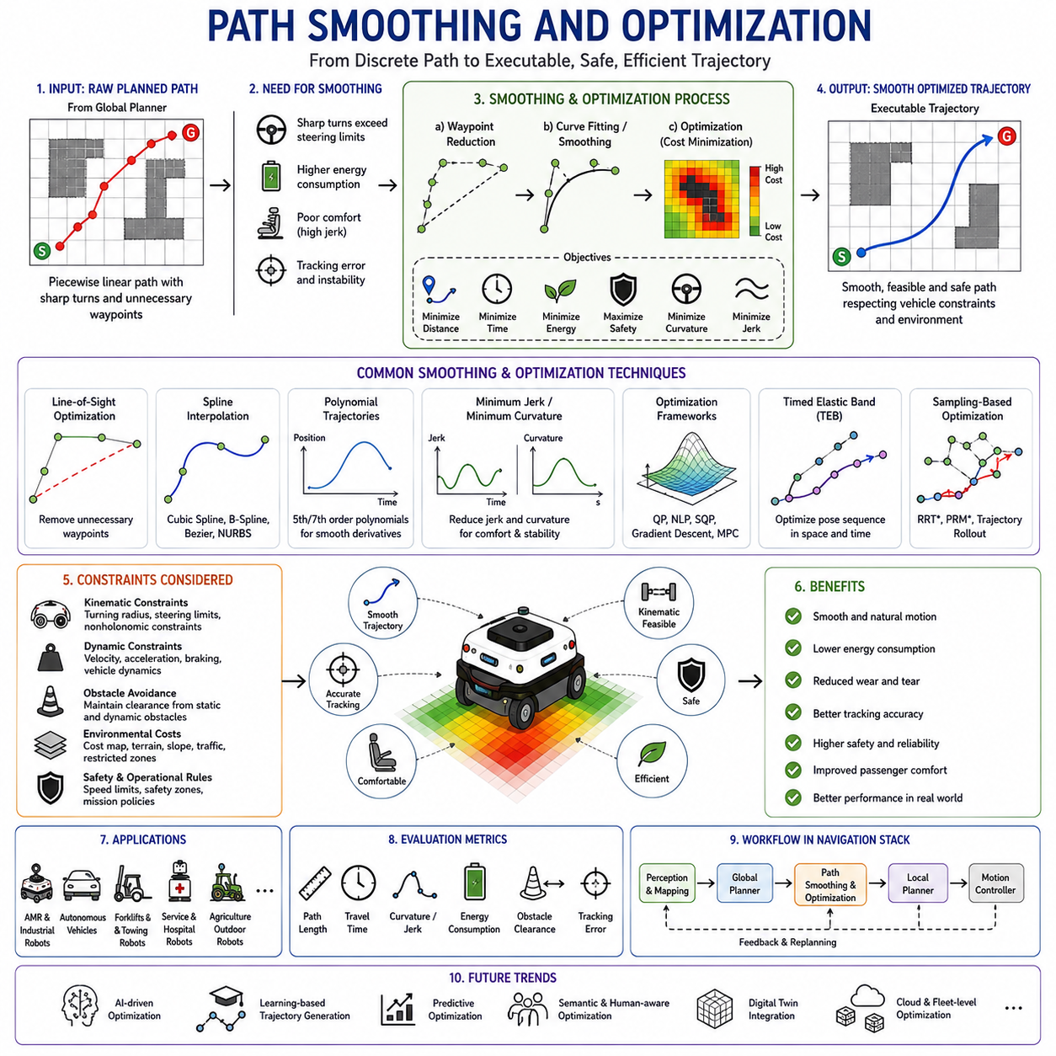
Path Smoothing and Optimization is a critical stage in autonomous navigation systems that transforms a mathematically valid path into a physically executable, safe, efficient, and comfortable trajectory. While global path planning algorithms such as A*, Dijkstra, Graph Search, and Grid-Based Planning are highly effective at finding collision-free routes, the resulting paths often contain abrupt turns, jagged segments, unnecessary waypoints, and discontinuities that are not suitable for real-world robot motion. Path smoothing and optimization address these limitations by refining the planned route into a trajectory that respects vehicle kinematics, dynamics, safety constraints, operational objectives, and environmental conditions. Within the overall navigation architecture, this process serves as a bridge between path planning and motion control, ensuring that a robot can accurately follow the planned route while maintaining stability, efficiency, and reliability.
The need for path smoothing arises from the discrete nature of many planning algorithms. Grid-based planners represent the environment as collections of cells, while graph-based planners operate on networks of nodes and edges. As a result, the generated paths frequently consist of piecewise linear segments connected by sharp directional changes. Although these paths may be optimal from a graph-search perspective, they often require excessive steering actions, sudden velocity changes, and unrealistic motion commands. Such behavior increases energy consumption, mechanical wear, tracking errors, passenger discomfort, and safety risks. Therefore, smoothing transforms the geometric path into a continuous and more natural trajectory.
The concept of path optimization extends beyond smoothing alone. Optimization seeks to improve overall path quality according to one or more objective functions. These objectives may include minimizing travel distance, reducing travel time, lowering energy consumption, maximizing safety margins, minimizing steering effort, reducing curvature, limiting acceleration changes, improving stability, or balancing multiple competing requirements simultaneously. Optimization algorithms evaluate candidate trajectories and select solutions that best satisfy the chosen objectives while respecting all operational constraints.
Path smoothing begins with the observation that a robot cannot instantaneously change direction. Every mobile robot possesses physical limitations related to steering geometry, wheel configuration, vehicle dimensions, and dynamic response. Differential-drive robots, Ackermann-steering vehicles, omnidirectional platforms, tracked vehicles, articulated robots, towing robots, and autonomous forklifts each have unique motion characteristics. The generated trajectory must be compatible with these characteristics to ensure successful execution.
Curvature is one of the most important concepts in path smoothing. Curvature describes how rapidly a path changes direction at a given point. High curvature corresponds to sharp turns, while low curvature corresponds to gentle curves. Excessive curvature may exceed the steering capabilities of the robot, cause wheel slip, reduce stability, or increase passenger discomfort. Smoothing algorithms therefore seek to reduce curvature while maintaining adherence to environmental constraints.
Continuity is another fundamental property of smooth trajectories. A continuous path exhibits gradual transitions in position, heading, velocity, acceleration, and higher-order motion derivatives. Discontinuities can create control challenges and degrade navigation performance. Modern trajectory optimization techniques often enforce multiple levels of continuity to ensure physically realistic robot motion.
One of the simplest smoothing approaches involves waypoint reduction. Many planned paths contain redundant intermediate points that do not contribute meaningfully to navigation. By removing unnecessary waypoints while preserving obstacle clearance, planners can significantly simplify the trajectory. This process often serves as an initial preprocessing step before more advanced optimization techniques are applied.
Line-of-sight optimization is a commonly used technique in waypoint reduction. If two non-adjacent waypoints can be connected directly without intersecting obstacles, intermediate points may be removed. This approach shortens path length and reduces unnecessary directional changes. Algorithms such as Theta* incorporate line-of-sight reasoning directly into the planning process, producing smoother paths than traditional grid-based methods.
Spline interpolation represents one of the most widely used path smoothing techniques. Splines generate smooth curves that pass through or near a sequence of control points. Cubic splines, B-splines, Bezier curves, and NURBS are commonly used in robotics applications. These mathematical representations provide continuous derivatives and allow smooth transitions between path segments. Spline-based methods are computationally efficient and suitable for both offline planning and real-time applications.
Bezier curves are particularly attractive because they offer intuitive geometric control through a set of control points. By adjusting these points, engineers can influence path shape while maintaining smoothness. Bezier-based trajectories are frequently used in mobile robots, autonomous vehicles, and industrial automation systems.
B-splines provide greater flexibility and local control compared to standard Bezier curves. Modifying one control point affects only a limited portion of the trajectory rather than the entire curve. This property makes B-splines well suited for dynamic environments where localized path modifications may be required.
Polynomial trajectory generation constitutes another major category of smoothing techniques. Polynomial functions describe position as a function of time, allowing explicit control over velocity, acceleration, jerk, and higher-order motion characteristics. Fifth-order and seventh-order polynomials are particularly common because they provide sufficient degrees of freedom to satisfy multiple boundary conditions while ensuring smooth motion profiles.
Minimum-jerk optimization has become an important concept in autonomous navigation. Jerk refers to the rate of change of acceleration. High jerk values produce abrupt and uncomfortable motions, increase mechanical stress, and reduce tracking performance. Minimum-jerk trajectories seek to minimize these effects by generating smooth acceleration transitions. Such trajectories are especially important for service robots, hospital robots, passenger transportation systems, and collaborative robots operating near humans.
Minimum-curvature optimization is another widely used objective. Rather than minimizing distance alone, the planner seeks trajectories with gentle directional changes. This approach improves vehicle stability, reduces steering effort, and enhances passenger comfort. In autonomous driving applications, curvature minimization often plays a central role in trajectory generation.
Vehicle kinematic constraints must be incorporated into optimization processes. Every vehicle possesses a minimum turning radius determined by its steering geometry and wheelbase. Trajectories that violate these constraints cannot be executed in practice. Kinematic optimization ensures that generated paths remain feasible for the target platform. This consideration is particularly important for large outdoor autonomous robots, heavy industrial vehicles, autonomous forklifts, and towing AMRs.
Dynamic constraints introduce additional complexity. Kinematic feasibility alone does not guarantee safe execution. Vehicle mass, inertia, tire-ground interaction, payload distribution, acceleration limits, braking capabilities, and actuator response characteristics all influence trajectory execution. Dynamic optimization considers these factors to ensure that generated paths remain stable and controllable under real operating conditions.
Obstacle avoidance remains a fundamental requirement during smoothing and optimization. A path that becomes smoother but violates obstacle clearance requirements is unacceptable. Modern optimization frameworks therefore include collision constraints that maintain safe distances from static and dynamic obstacles throughout the optimization process. Cost functions often incorporate obstacle proximity penalties to encourage safer trajectories.
Cost maps play a significant role in path optimization. Rather than optimizing solely based on geometry, trajectories are evaluated according to environmental costs. High-cost regions associated with obstacles, hazards, congestion, rough terrain, restricted zones, or operational risks influence optimization outcomes. The resulting trajectories balance efficiency and safety while respecting environmental preferences.
Trajectory optimization frequently involves solving constrained optimization problems. Objective functions define desired behaviors, while constraints define acceptable solutions. Mathematical optimization techniques such as gradient descent, quadratic programming, sequential convex optimization, nonlinear programming, and stochastic optimization are commonly employed. The choice of optimization framework depends on computational resources, real-time requirements, and problem complexity.
Model Predictive Control (MPC) has emerged as one of the most powerful approaches for trajectory optimization. MPC predicts future vehicle behavior over a finite time horizon and continuously solves optimization problems to generate control commands. By incorporating vehicle dynamics, obstacle information, and operational objectives, MPC produces highly optimized trajectories that adapt to changing conditions in real time.
Timed Elastic Band (TEB) optimization is another influential technique widely used in ROS-based navigation systems. TEB treats the trajectory as a deformable structure consisting of interconnected states. Optimization adjusts these states to satisfy kinematic constraints, obstacle avoidance requirements, and temporal objectives. The resulting trajectories are smooth, dynamically feasible, and computationally efficient.
Sampling-based optimization approaches offer additional flexibility. Methods such as RRT*, PRM*, and trajectory rollout generate multiple candidate trajectories and evaluate them according to cost functions. The best trajectory is then selected for execution. These approaches are particularly useful in high-dimensional or highly constrained environments.
Energy-aware optimization is becoming increasingly important in battery-powered robots. Trajectories influence power consumption through acceleration patterns, terrain interactions, steering activity, and travel distance. Optimization frameworks can explicitly minimize estimated energy consumption, extending operational endurance and improving overall system efficiency.
Safety considerations strongly influence optimization objectives. Autonomous robots must maintain adequate obstacle clearance, respect safety zones, comply with speed limits, and preserve stability margins. Safety-aware optimization incorporates these requirements directly into cost functions and constraints. Industrial applications often prioritize safety over absolute efficiency.
Human-aware trajectory optimization extends safety considerations further. Robots operating near people must generate motions that appear predictable, comfortable, and socially acceptable. Sudden direction changes, aggressive maneuvers, or close approaches may reduce trust and acceptance. Human-aware optimization therefore includes social navigation objectives that encourage natural interactions.
Outdoor autonomous navigation introduces additional optimization challenges. Terrain variability, weather conditions, GNSS uncertainty, slope gradients, vegetation, surface roughness, and environmental hazards all influence trajectory quality. Optimization frameworks for outdoor robots often incorporate terrain-aware costs, stability constraints, and environmental risk assessments.
For heavy-duty outdoor robots such as infrastructure inspection platforms, agricultural robots, mining vehicles, and towing AMRs, optimization becomes even more important. Large vehicle dimensions, significant payloads, high inertia, and challenging terrain conditions require careful trajectory design to ensure safe and efficient operation.
Multi-robot environments add another layer of complexity. Individual trajectory optimization must consider interactions with other robots. Traffic management systems, collision avoidance mechanisms, shared resource constraints, and fleet-level objectives influence optimization decisions. Coordinated trajectory optimization can significantly improve overall fleet efficiency.
Simulation environments play a vital role in path smoothing and optimization development. Platforms such as ROS 2 Navigation Stack, Gazebo, Isaac Sim, and digital twins allow engineers to evaluate trajectory quality under controlled conditions. Simulation supports parameter tuning, algorithm comparison, safety validation, and performance benchmarking before deployment in physical environments.
Performance evaluation typically considers path length, travel time, smoothness, curvature, jerk, obstacle clearance, energy consumption, computational latency, tracking accuracy, mission success rate, and passenger comfort. These metrics provide objective measures of optimization effectiveness and support systematic algorithm improvement.
Artificial intelligence is increasingly enhancing trajectory optimization. Machine learning models can predict future environmental conditions, estimate traversability, learn driving preferences, and automatically tune optimization parameters. Reinforcement learning approaches can generate highly optimized navigation behaviors based on experience rather than manually designed cost functions.
Future path smoothing and optimization systems are expected to become more predictive, adaptive, and intelligent. Integration with semantic navigation, world models, digital twins, cloud robotics, embodied AI, and large-scale fleet management platforms will enable robots to generate trajectories that consider not only current environmental conditions but also future events, operational goals, and collaborative opportunities.
Ultimately, path smoothing and optimization transform navigation from a purely geometric planning problem into a comprehensive motion intelligence framework. They ensure that paths generated by global planners become safe, efficient, comfortable, dynamically feasible, and operationally effective trajectories. As autonomous robots continue to expand into factories, hospitals, logistics centers, smart cities, agricultural environments, infrastructure inspection projects, and complex outdoor operations, path smoothing and optimization will remain essential technologies enabling reliable and intelligent autonomous mobility.

02.6 Large Scale Map Navigation
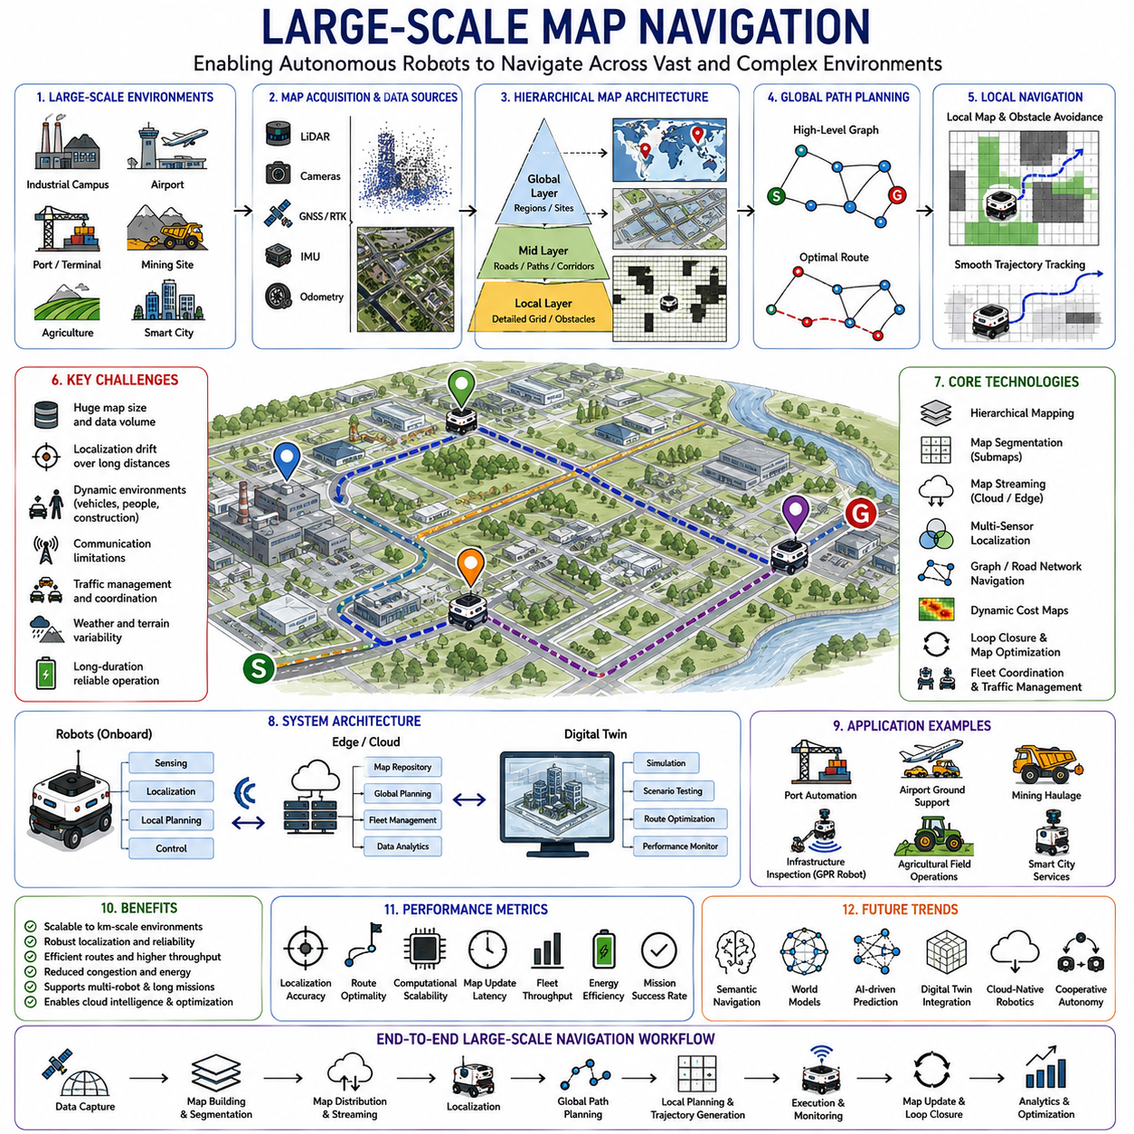
Large-Scale Map Navigation refers to the set of technologies, algorithms, architectures, and operational strategies that enable autonomous robots to navigate efficiently and reliably across extensive environments that may span hundreds of meters, several kilometers, multiple buildings, industrial campuses, logistics centers, airports, ports, mines, agricultural fields, smart cities, and critical infrastructure networks. While traditional navigation systems are often designed for relatively compact environments such as single warehouses or office floors, large-scale navigation introduces unique challenges related to map size, computational scalability, localization robustness, communication infrastructure, environmental variability, and long-duration autonomous operation. As autonomous mobile robots continue expanding into industrial, commercial, and public environments, large-scale map navigation has become one of the most important disciplines within modern autonomous navigation systems. It represents a natural extension of global path planning and serves as a foundational capability for next-generation outdoor autonomous robots, multi-site AMR deployments, and smart city robotic ecosystems.
The primary objective of large-scale map navigation is to enable a robot to understand, localize within, and navigate across extensive environments while maintaining operational efficiency, safety, and reliability. Unlike small indoor facilities where maps may contain only a few thousand square meters of navigable space, large-scale environments often contain millions of map elements, numerous operational zones, multiple navigation layers, dynamic environmental conditions, and complex infrastructure interactions. Navigation systems must therefore be designed with scalability as a fundamental requirement.
One of the defining characteristics of large-scale navigation is map size. As environmental coverage increases, the amount of data required to represent the environment grows significantly. High-resolution occupancy grids that work well in small facilities may become computationally impractical when applied to industrial campuses, transportation hubs, or outdoor infrastructure networks. A map covering several square kilometers at centimeter-level resolution may require enormous memory resources and processing power. Consequently, large-scale navigation systems employ specialized map representations and hierarchical architectures to manage complexity.
Hierarchical mapping is one of the most important concepts in large-scale navigation. Instead of representing the entire environment using a single navigation layer, the environment is divided into multiple levels of abstraction. High-level maps represent major regions, buildings, roads, sectors, or operational zones. Mid-level maps describe corridors, pathways, transportation routes, and connections between regions. Low-level maps provide detailed local geometry for obstacle avoidance and precise motion control. This hierarchical structure significantly reduces computational burden while preserving navigation accuracy.
Map segmentation is another widely used strategy. Large environments are partitioned into smaller manageable regions called submaps. Each submap contains detailed information for a localized area while maintaining connectivity information with neighboring regions. Robots load only the portions of the map that are relevant to their current location and mission objectives. This approach reduces memory consumption and improves computational efficiency.
The concept of map streaming has emerged as an important technology for large-scale autonomous systems. Rather than storing the entire environment locally, robots dynamically download and update map segments as needed. Cloud-connected navigation architectures support this approach by maintaining centralized map repositories while distributing relevant map data to robots operating in the field. This enables navigation across environments that would otherwise exceed onboard storage limitations.
Localization becomes significantly more challenging as environment size increases. Small localization errors that are acceptable in limited spaces can accumulate over long distances and eventually result in substantial navigation failures. Large-scale navigation systems therefore rely on robust localization technologies including LiDAR localization, Visual Localization, GNSS positioning, RTK corrections, IMU integration, wheel odometry, radar localization, and multi-sensor fusion frameworks. The combination of multiple sensing modalities improves localization robustness and reduces drift over extended operations.
Outdoor navigation often depends heavily on GNSS technologies. Standard GNSS provides global positioning capabilities but may suffer from meter-level inaccuracies. RTK GNSS improves positioning accuracy to centimeter-level precision under favorable conditions. However, GNSS alone is insufficient for reliable autonomous navigation because signal degradation can occur near buildings, trees, tunnels, bridges, industrial structures, and urban canyons. Consequently, large-scale navigation systems typically integrate GNSS with LiDAR, vision, IMU, and map-based localization methods.
Long-term localization stability is particularly important in large-scale deployments. Robots operating continuously for hours or days must maintain accurate positioning despite environmental changes, sensor drift, and dynamic conditions. Techniques such as loop closure, map correction, pose graph optimization, and periodic localization recalibration are commonly employed to maintain long-term accuracy.
Global path planning in large-scale environments presents unique computational challenges. Traditional search algorithms such as Dijkstra and A* can become computationally expensive when applied directly to very large maps. Hierarchical path planning addresses this issue by separating strategic routing from local navigation. High-level planners determine major route segments across regions, while local planners generate detailed trajectories within each region. This significantly reduces search complexity while maintaining route quality.
Graph-based navigation plays a central role in large-scale systems. Instead of planning through dense occupancy grids, environments are often represented using topological graphs, road networks, navigation meshes, or transportation graphs. Nodes represent meaningful locations such as intersections, buildings, loading zones, charging stations, checkpoints, inspection points, or infrastructure assets. Edges represent traversable connections between locations. Graph-based representations dramatically reduce computational requirements while preserving essential navigational information.
Road network navigation is especially important in outdoor robotic systems. Industrial campuses, airports, seaports, logistics facilities, agricultural sites, and smart cities often contain extensive road infrastructures. Navigation systems can leverage these structured transportation networks to simplify route planning and improve scalability. Routes are generated using road connectivity information rather than exhaustive grid searches.
Cost map management becomes increasingly important in large-scale navigation. Environmental conditions vary across different regions. Terrain quality, traffic density, weather effects, safety constraints, infrastructure restrictions, and operational priorities may differ significantly from one area to another. Large-scale navigation systems often maintain regional cost maps that adapt dynamically to local conditions while remaining integrated within the overall navigation framework.
Dynamic environments introduce additional complexity. Large-scale operational spaces are rarely static. Vehicles, people, construction activities, maintenance operations, temporary barriers, and environmental changes continuously alter navigation conditions. Dynamic map updating mechanisms enable navigation systems to incorporate these changes without requiring complete map reconstruction. Incremental updates improve efficiency and maintain operational continuity.
Fleet-level navigation becomes particularly important in large-scale deployments. Multiple robots frequently operate within the same environment and must coordinate movement efficiently. Fleet management systems optimize traffic flow, allocate resources, assign tasks, manage charging schedules, and prevent congestion. Navigation decisions are therefore influenced not only by individual robot objectives but also by overall system performance.
Traffic management represents a critical component of large-scale navigation architectures. High-density robot deployments may experience congestion at intersections, corridors, loading zones, elevators, charging stations, and shared infrastructure resources. Traffic-aware navigation systems monitor resource utilization and dynamically adjust routes to improve throughput and reduce delays.
Communication infrastructure plays a major role in large-scale navigation. Robots operating across extensive environments often rely on wireless networks for map updates, fleet coordination, remote monitoring, and cloud services. Wi-Fi, private 5G, LTE, mesh networks, and industrial wireless systems may all contribute to navigation support. Navigation architectures must remain robust even when communication quality varies across different regions.
Cloud robotics has become an increasingly important enabler of large-scale navigation. Cloud platforms provide centralized map management, fleet coordination, route optimization, analytics, digital twin integration, and computational offloading. Robots maintain local autonomy while leveraging cloud resources for large-scale operational optimization.
Digital twins offer powerful capabilities for large-scale map navigation. A digital twin serves as a virtual representation of the operational environment, continuously synchronized with real-world conditions. Navigation planners can evaluate routes, test operational scenarios, simulate infrastructure changes, and optimize fleet operations within the digital twin before implementing decisions in the physical environment.
Industrial applications provide compelling examples of large-scale navigation challenges. In ports and container terminals, autonomous vehicles must navigate extensive transportation networks while coordinating with cranes, trucks, ships, and logistics infrastructure. Airports require navigation across runways, service roads, terminals, maintenance areas, and cargo facilities. Mining operations involve navigation through vast open environments with changing terrain conditions. Agricultural robots may operate across hundreds or thousands of hectares while interacting with crops, equipment, and environmental factors.
Infrastructure inspection represents another important application domain. Inspection robots responsible for pipelines, railways, highways, utility corridors, power networks, and underground infrastructure frequently operate across large geographic regions. Navigation systems must support long-distance autonomy while maintaining precise positioning at inspection targets. For GPR-based infrastructure inspection robots, accurate localization and large-scale route management are particularly critical because collected inspection data must be accurately associated with geographic locations.
Large-scale navigation is also highly relevant to outdoor autonomous robot platforms such as industrial patrol robots, agricultural robots, smart city service robots, security robots, and autonomous delivery systems. These platforms must navigate across environments that are orders of magnitude larger than typical indoor AMR deployments. Scalability therefore becomes a primary design objective rather than a secondary consideration.
Simulation and validation play essential roles in large-scale navigation development. Testing extensive operational environments physically can be expensive, time-consuming, and potentially unsafe. Simulation platforms such as Isaac Sim, Gazebo, and digital twin environments allow engineers to evaluate navigation performance across large maps, multiple robots, dynamic obstacles, communication failures, and environmental uncertainties. Large-scale simulation supports algorithm development, benchmarking, and operational planning before deployment.
Performance evaluation for large-scale navigation typically includes route optimality, localization accuracy, computational scalability, memory utilization, communication efficiency, map update latency, mission completion rate, fleet throughput, traffic congestion levels, energy consumption, and long-term operational reliability. These metrics provide quantitative measures of navigation effectiveness and system scalability.
Artificial intelligence is increasingly influencing large-scale navigation architectures. AI models can predict traffic patterns, estimate environmental changes, identify navigation bottlenecks, optimize fleet operations, and improve route selection. Machine learning approaches also support adaptive localization, terrain classification, risk assessment, and predictive maintenance. These capabilities enhance the efficiency and resilience of large-scale autonomous systems.
Future large-scale navigation systems are expected to integrate world models, semantic understanding, digital twins, cloud-native architectures, foundation models, and embodied AI technologies. Rather than navigating solely through geometric maps, robots will increasingly reason about environmental context, operational objectives, infrastructure relationships, and future events. Navigation systems will become more predictive, collaborative, and intelligent, enabling coordinated operation across entire industrial campuses, transportation networks, smart cities, and national-scale infrastructure systems.
Ultimately, large-scale map navigation extends autonomous mobility beyond the confines of individual buildings and localized environments. It provides the architectural foundation necessary for robots to operate effectively across vast and complex operational landscapes. As autonomous systems continue expanding into logistics, agriculture, infrastructure inspection, mining, transportation, healthcare, defense, and smart city applications, large-scale map navigation will remain a fundamental technology enabling reliable, scalable, and intelligent autonomous operations.

02.7 Global Path Replanning
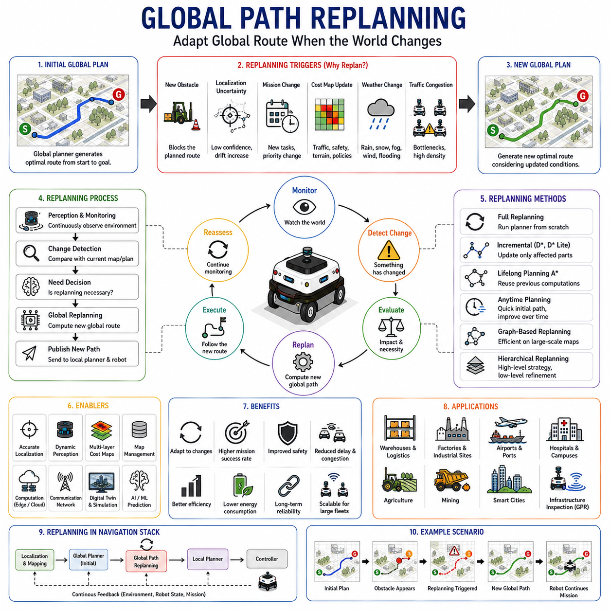
Global Path Replanning is a fundamental capability in modern autonomous navigation systems that enables robots to modify previously generated global routes when environmental conditions, mission objectives, operational constraints, or system states change. While traditional global path planning assumes that a valid route can be generated once and followed until the destination is reached, real-world environments are rarely static. Roads become blocked, obstacles appear unexpectedly, traffic conditions evolve, localization uncertainty increases, weather conditions change, and mission priorities shift. Global Path Replanning addresses these realities by allowing autonomous systems to continuously reassess and update navigation strategies throughout mission execution.
In the hierarchical navigation architecture of autonomous robots, global replanning serves as the strategic decision-making layer responsible for long-range route adaptation. Local planners typically react to nearby obstacles and short-term environmental changes, while global replanning evaluates the overall route structure and determines whether a fundamentally different path should be selected. This distinction is important because local obstacle avoidance alone may not be sufficient when significant environmental changes occur. In many cases, the optimal solution requires revisiting the entire route and generating a new global navigation strategy.
The need for replanning arises from the dynamic nature of operational environments. Warehouses continuously change due to forklift traffic, temporary storage locations, and human activities. Hospitals experience fluctuating pedestrian densities and restricted-access zones. Airports, ports, and industrial facilities frequently modify operational routes because of maintenance activities or equipment movement. Outdoor environments are even more dynamic, with weather, terrain conditions, construction zones, and traffic patterns affecting navigation feasibility. A route that was optimal at the beginning of a mission may become inefficient or completely unusable later.
Global replanning can be viewed as a continuous optimization process rather than a one-time computation. Instead of assuming that the world remains unchanged after planning, modern navigation systems maintain a persistent awareness of environmental conditions and periodically evaluate whether the current route remains appropriate. If significant deviations from expected conditions are detected, the system initiates replanning procedures to generate a more suitable path.
One of the most common triggers for global replanning is obstacle discovery. During execution, sensors may detect obstacles that were not present in the original map. These obstacles may include parked vehicles, construction barriers, fallen objects, equipment, temporary fencing, or unexpected environmental changes. When such obstacles block critical portions of the planned route, replanning becomes necessary to maintain mission continuity.
Localization uncertainty is another important replanning trigger. Autonomous navigation depends heavily on accurate position estimation. If localization confidence decreases due to sensor degradation, poor environmental features, GNSS signal loss, visual ambiguity, or accumulated drift, the robot may need to modify its route to improve localization reliability. For example, a robot operating in a featureless outdoor environment may choose a route closer to known landmarks to improve localization accuracy.
Mission changes frequently require global replanning. In industrial operations, delivery priorities may change dynamically. Inspection robots may receive additional tasks while already executing a route. Fleet management systems may redirect robots to higher-priority assignments. Emergency situations may require immediate route modifications. In such cases, replanning ensures that navigation behavior remains aligned with operational objectives.
Cost map updates represent another major driver of replanning decisions. Modern navigation systems maintain dynamic cost maps that incorporate obstacles, traffic conditions, safety zones, terrain information, and operational policies. As cost distributions evolve, previously optimal routes may become suboptimal. Replanning allows the robot to continuously adapt its route according to the latest environmental cost information.
Weather conditions can significantly influence outdoor navigation and often necessitate replanning. Heavy rain, snow, flooding, fog, ice, strong winds, and reduced visibility can alter terrain traversability and safety characteristics. Routes that are normally preferred may become hazardous under adverse weather conditions. Weather-aware replanning systems adjust navigation strategies to maintain safety and operational effectiveness.
Traffic congestion plays an increasingly important role in large-scale robotic deployments. Multi-robot systems frequently encounter bottlenecks at intersections, charging stations, loading docks, elevators, and shared corridors. Fleet-level traffic management systems may initiate replanning to distribute robots more evenly across available routes, reducing congestion and improving overall throughput.
The concept of replanning frequency is a critical design consideration. Some systems perform replanning at fixed intervals, such as every few seconds or minutes. Others employ event-driven strategies that trigger replanning only when significant changes occur. Hybrid approaches combine periodic monitoring with event-based activation. The optimal strategy depends on environmental dynamics, computational resources, mission requirements, and system architecture.
Frequent replanning provides greater adaptability but increases computational demand and may lead to route instability. Excessive route changes can confuse operators, reduce predictability, and create inefficient behavior. Conversely, infrequent replanning may cause robots to continue following suboptimal routes for extended periods. Balancing responsiveness and stability is therefore a key challenge.
Path stability is an important consideration in global replanning. While adapting to environmental changes is desirable, excessive route modifications can introduce unnecessary complexity. Modern replanning algorithms often include stability terms within optimization objectives to discourage unnecessary deviations from existing routes unless significant benefits can be achieved.
Several algorithmic approaches support global replanning. Classical replanning methods repeatedly execute traditional planning algorithms such as A* or Dijkstra whenever environmental changes occur. Although conceptually simple, complete replanning can become computationally expensive in large environments.
Incremental planning algorithms provide more efficient alternatives. Rather than recomputing the entire route from scratch, these methods update only affected portions of the search space. D* and D* Lite are among the most widely used incremental replanning algorithms. Originally developed for dynamic environments, they efficiently incorporate map changes while preserving previously computed information.
Lifelong Planning A* extends traditional A* by supporting repeated planning operations within changing environments. Instead of discarding prior computations after each planning cycle, the algorithm reuses relevant information to accelerate future updates. This significantly improves computational efficiency in environments where changes occur frequently.
Anytime planning algorithms provide another important approach. These methods generate an initial feasible solution quickly and then progressively improve route quality as additional computation time becomes available. In highly dynamic environments, anytime planners allow robots to react immediately while continuing to optimize navigation performance in the background.
Graph-based replanning is particularly effective in large-scale environments. Since graph representations contain significantly fewer states than dense occupancy grids, route modifications can often be computed rapidly. Transportation networks, road systems, industrial campuses, and logistics facilities frequently employ graph-based replanning architectures to support scalable navigation.
Hierarchical replanning further improves scalability. High-level planners evaluate strategic route alternatives across large geographic regions, while local planners manage detailed navigation within individual areas. This separation allows long-distance route changes to be evaluated efficiently without requiring complete reanalysis of low-level map details.
Global replanning relies heavily on environmental perception. Sensors continuously provide information regarding obstacles, traffic conditions, terrain changes, and operational status. Perception systems must accurately distinguish temporary changes from persistent environmental modifications. Incorrect classifications can result in unnecessary replanning or failure to respond to genuine hazards.
Map management systems play a central role in replanning architectures. As environmental observations accumulate, maps must be updated consistently and efficiently. Dynamic obstacles may be represented differently from permanent map changes. Temporary barriers, construction zones, weather effects, and traffic conditions may require specialized map layers that influence replanning decisions without permanently altering the underlying map.
Multi-layer cost maps are particularly valuable in replanning systems. Obstacle layers, traffic layers, weather layers, semantic layers, safety layers, and operational policy layers can all contribute to route selection. Replanning algorithms evaluate these layers collectively to determine whether alternative routes provide meaningful advantages.
Fleet management systems often perform centralized global replanning. Instead of each robot making independent decisions, a centralized coordinator evaluates overall system performance and assigns optimized routes across the fleet. This approach improves resource utilization, reduces congestion, and enhances operational efficiency in large deployments.
Cloud robotics further expands replanning capabilities. Computationally intensive replanning tasks can be performed on edge servers or cloud platforms while robots focus on local execution and obstacle avoidance. Cloud-based architectures enable large-scale optimization across extensive environments and robot fleets.
Digital twins provide powerful support for global replanning. Virtual representations of operational environments allow planners to evaluate route alternatives before implementation. Simulation-based prediction enables navigation systems to anticipate congestion, infrastructure conflicts, and environmental risks. Digital twins effectively transform replanning from a reactive process into a predictive decision-making framework.
Artificial intelligence is increasingly integrated into global replanning systems. Machine learning models can predict future traffic patterns, estimate obstacle persistence, forecast weather impacts, identify operational bottlenecks, and anticipate environmental changes. By incorporating predictive information, replanning systems can proactively select routes that remain effective over longer time horizons.
Predictive replanning represents one of the most promising directions in autonomous navigation. Rather than reacting only after changes occur, predictive systems anticipate future events and modify routes before problems arise. This capability improves efficiency, reduces delays, and enhances overall mission success rates.
Semantic understanding further enriches replanning decisions. Modern navigation systems increasingly incorporate contextual information regarding environmental function, operational significance, human activity patterns, and mission priorities. Replanning decisions can therefore consider not only geometric feasibility but also operational meaning and organizational objectives.
Outdoor autonomous robots particularly benefit from advanced replanning capabilities. Infrastructure inspection robots, agricultural robots, mining vehicles, security patrol systems, and smart city service robots often operate across large geographic regions where environmental variability is significant. Replanning allows these systems to adapt continuously to changing operational conditions.
For GPR-based underground infrastructure inspection robots, replanning is especially important because inspection missions often span long distances and involve dynamic field conditions. Construction activities, traffic disruptions, restricted-access zones, weather effects, and safety requirements may require frequent route modifications. Efficient replanning ensures that inspection coverage remains complete while maintaining operational efficiency.
Performance evaluation of replanning systems typically includes route optimality, replanning latency, computational efficiency, mission completion rate, navigation reliability, traffic reduction effectiveness, energy consumption, path stability, and overall operational productivity. These metrics help quantify the effectiveness of replanning strategies under realistic conditions.
Future global replanning systems will increasingly integrate world models, semantic navigation, digital twins, cloud-native architectures, foundation models, and embodied AI. Replanning will evolve from reactive route adjustment into a comprehensive predictive decision-making capability that continuously balances environmental conditions, operational objectives, fleet coordination, infrastructure constraints, and future uncertainties.
Ultimately, Global Path Replanning transforms autonomous navigation from a static planning problem into a dynamic and adaptive intelligence process. It enables robots to respond effectively to changing environments, evolving missions, and operational uncertainties while maintaining safety, efficiency, and reliability. As autonomous systems become more widespread across factories, hospitals, logistics centers, smart cities, transportation networks, agricultural environments, and infrastructure inspection operations, global replanning will remain a foundational technology enabling robust and resilient autonomous mobility.

02.8 Global Path Validation
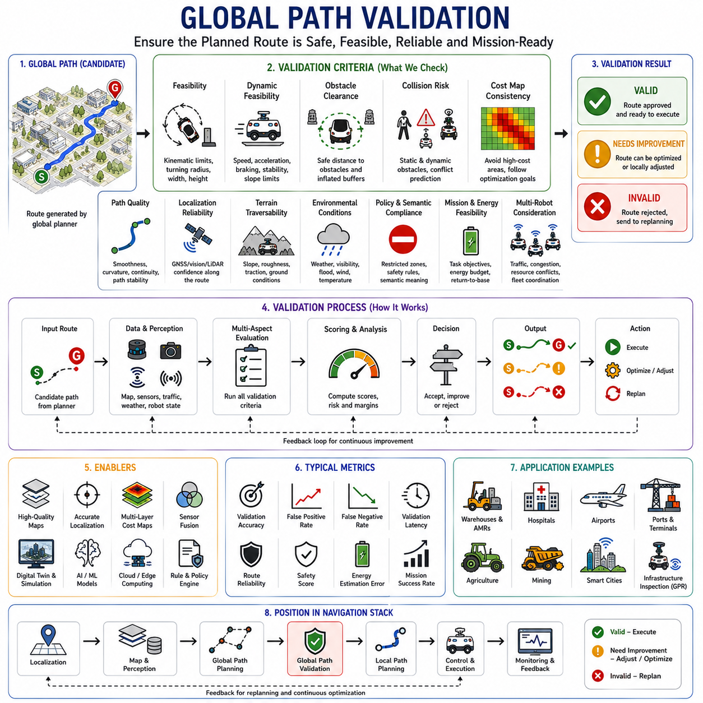
Global Path Validation is a critical process within autonomous navigation systems that ensures a generated global route is safe, feasible, reliable, efficient, and executable before it is transmitted to downstream navigation modules. While global path planning focuses on finding a route from a starting position to a destination, validation determines whether the generated route satisfies all operational, environmental, kinematic, dynamic, safety, and mission-specific requirements. In modern autonomous systems, path generation alone is insufficient because a mathematically optimal route may still be impractical, unsafe, inefficient, or impossible for a real robot to execute. Global Path Validation therefore acts as a quality assurance mechanism that evaluates planned routes before and during mission execution.
The importance of path validation increases as autonomous systems move from controlled laboratory environments into complex real-world applications. Warehouses, hospitals, factories, airports, ports, agricultural fields, mining sites, transportation corridors, and infrastructure inspection environments all contain uncertainties, dynamic changes, operational constraints, and safety requirements that cannot be fully addressed by path planning algorithms alone. Validation provides a final assessment layer that ensures navigation decisions remain trustworthy under realistic conditions.
The primary objective of Global Path Validation is to determine whether a planned route satisfies predefined acceptance criteria. These criteria may include obstacle clearance requirements, path continuity, vehicle kinematic feasibility, dynamic stability, localization reliability, operational policy compliance, environmental safety, mission efficiency, and regulatory constraints. A route that fails validation may be modified, optimized, rejected, or replaced through replanning procedures.
Validation begins immediately after global path generation. The planner produces a candidate route connecting the start location and destination. This route is then passed to validation modules that analyze its characteristics using various evaluation methods. Validation may occur as a single-stage process or as a multi-stage pipeline depending on system complexity.
Path feasibility represents one of the most fundamental validation criteria. A generated route must be physically traversable by the target robot. Even if a route appears valid on a map, it may violate vehicle-specific constraints such as turning radius limitations, steering geometry restrictions, width requirements, height clearances, articulation limits, or towing constraints. Feasibility validation ensures that the robot can actually execute the planned motion without exceeding physical capabilities.
Vehicle kinematics play a central role in feasibility assessment. Different robotic platforms possess different motion characteristics. Differential-drive robots can rotate in place but may experience tracking difficulties in narrow spaces. Ackermann-steering vehicles require larger turning radii. Omnidirectional robots support lateral movement but may have limitations related to payload stability. Autonomous forklifts, towing vehicles, and heavy-duty outdoor robots introduce additional constraints. Validation systems must account for these differences when evaluating routes.
Dynamic feasibility extends beyond kinematic constraints. A path that satisfies geometric requirements may still be dynamically unsafe. Factors such as vehicle mass, inertia, acceleration limits, braking performance, tire-ground interaction, payload distribution, suspension characteristics, and terrain conditions influence execution safety. Dynamic validation evaluates whether the robot can safely follow the route under expected operating conditions.
Obstacle clearance analysis represents another critical validation function. Path planning algorithms often generate routes that maximize efficiency while maintaining minimum obstacle avoidance requirements. Validation systems verify that sufficient safety margins exist throughout the route. Clearance requirements may vary depending on robot size, operational speed, localization uncertainty, environmental risk, and organizational safety policies.
Obstacle inflation models are frequently incorporated into validation procedures. Rather than evaluating only direct obstacle collisions, validation assesses proximity to hazards and ensures compliance with required buffer zones. In industrial environments, these buffers may protect equipment, personnel, infrastructure assets, or sensitive operational areas.
Collision risk assessment is particularly important in dynamic environments. Static validation examines fixed obstacles represented within the map, while dynamic validation considers moving objects such as pedestrians, vehicles, forklifts, service equipment, and other robots. Predictive models may estimate future object movements and identify potential conflicts before they occur.
Cost map validation evaluates route quality relative to environmental costs. Modern navigation systems often generate paths based on multi-layer cost maps that incorporate obstacles, terrain conditions, safety constraints, traffic density, weather effects, operational policies, and semantic information. Validation ensures that the route remains consistent with cost optimization objectives and does not traverse excessively expensive regions without justification.
Path continuity is another important validation criterion. Navigation systems generally require smooth and continuous trajectories to support stable control performance. Abrupt heading changes, sharp corners, excessive curvature, discontinuous segments, or unrealistic waypoint distributions may degrade execution quality. Validation algorithms assess path smoothness and identify segments that may require further optimization.
Curvature analysis plays a particularly significant role in path quality assessment. Excessive curvature may exceed steering capabilities, increase energy consumption, reduce stability, or compromise passenger comfort. Validation systems compute curvature metrics and verify compliance with vehicle-specific operational limits.
Localization reliability assessment has become increasingly important in modern autonomous systems. A route that passes through regions with poor localization performance may introduce navigation risks even if the geometric path itself appears valid. Areas with weak GNSS coverage, sparse visual features, repetitive structures, reflective surfaces, or limited LiDAR observability may reduce localization confidence. Validation systems evaluate expected localization performance along the planned route and may recommend alternatives when reliability falls below acceptable thresholds.
Large-scale navigation environments often require special localization validation procedures. Long-distance missions introduce cumulative localization drift and environmental variability. Validation systems assess whether localization support remains sufficient throughout the route and identify areas requiring additional caution or corrective strategies.
Terrain validation is particularly important for outdoor autonomous robots. Unlike structured indoor environments, outdoor terrain may vary significantly in slope, roughness, traction, vegetation density, moisture content, and surface stability. Validation systems evaluate terrain traversability and determine whether route segments remain compatible with vehicle capabilities.
Slope analysis represents a common component of terrain validation. Excessive inclines may increase rollover risk, reduce traction, increase energy consumption, or exceed vehicle climbing capabilities. Heavy-duty autonomous robots operating in mining, agriculture, construction, or infrastructure inspection environments often require detailed terrain validation before route approval.
Environmental conditions influence route validity as well. Weather-aware validation systems evaluate the impact of rain, snow, ice, flooding, fog, wind, temperature extremes, and visibility conditions. Environmental factors can significantly alter navigation safety and performance. Validation frameworks therefore incorporate dynamic environmental assessments to maintain operational reliability.
Operational policy compliance forms another major aspect of Global Path Validation. Many environments contain organizational rules governing robot behavior. Hospitals may restrict access to sensitive areas. Airports may enforce operational boundaries. Industrial facilities may designate safety zones, hazardous regions, pedestrian corridors, and restricted-access areas. Validation systems verify that generated routes comply with all applicable policies and regulations.
Semantic validation extends policy compliance by considering the functional meaning of different locations. A route may be geometrically feasible yet operationally undesirable. For example, a logistics robot may be prohibited from entering patient care areas within a hospital or pedestrian-dense regions during peak hours. Semantic validation ensures that navigation decisions align with organizational objectives and environmental context.
Multi-robot environments introduce additional validation requirements. Routes that appear valid for a single robot may create conflicts when multiple robots share the same operational space. Fleet-level validation examines traffic interactions, resource conflicts, congestion risks, charging station availability, intersection management, and shared infrastructure utilization. Coordinated validation improves overall system performance and prevents emergent navigation problems.
Traffic-aware validation evaluates expected route congestion and throughput impacts. High-density robotic deployments often experience bottlenecks near elevators, loading docks, charging stations, intersections, and narrow corridors. Validation systems identify potential congestion points and recommend alternative routing strategies when necessary.
Mission-level validation considers task objectives and operational priorities. Different missions may impose different navigation requirements. Emergency response robots prioritize speed and accessibility. Inspection robots prioritize coverage and positioning accuracy. Delivery robots emphasize efficiency and reliability. Security patrol robots focus on surveillance coverage. Validation frameworks adapt evaluation criteria according to mission objectives.
Energy validation has become increasingly important in battery-powered robotic systems. Route characteristics directly influence power consumption through travel distance, terrain interactions, acceleration demands, steering activity, and environmental conditions. Validation systems estimate energy requirements and ensure that available battery capacity remains sufficient for mission completion.
Long-duration missions often require battery reserve validation. Navigation plans must account for contingency operations, unexpected delays, localization recovery procedures, and return-to-base requirements. Energy-aware validation reduces the likelihood of mission interruptions caused by power limitations.
Global Path Validation frequently relies on simulation technologies. Digital twins, physics simulators, and virtual environments provide opportunities to evaluate route performance before physical execution. Simulation-based validation can identify safety risks, performance limitations, and operational inefficiencies under diverse scenarios.
Platforms such as ROS 2 Navigation Stack, Gazebo, Isaac Sim, and industrial digital twin systems support extensive validation workflows. Engineers can evaluate route feasibility, obstacle interactions, localization performance, fleet coordination behavior, and mission outcomes within controlled simulation environments.
Monte Carlo validation techniques are increasingly used in autonomous navigation. Rather than evaluating a single deterministic scenario, Monte Carlo methods simulate numerous variations involving sensor noise, localization uncertainty, environmental changes, and operational disturbances. Statistical analysis of these simulations provides more robust assessments of route reliability.
Formal verification methods represent another emerging area. Mathematical verification techniques analyze navigation plans against safety requirements and system specifications. Although computationally intensive, formal methods provide strong guarantees regarding route correctness and safety properties.
Artificial intelligence is increasingly contributing to path validation processes. Machine learning models can estimate route risk, predict obstacle behavior, evaluate terrain traversability, assess localization confidence, and identify potential navigation failures. AI-enhanced validation systems often detect issues that are difficult to capture using purely rule-based approaches.
Predictive validation represents an important future direction. Traditional validation focuses primarily on current environmental conditions. Predictive systems anticipate future changes such as traffic evolution, weather impacts, infrastructure availability, and mission interactions. This forward-looking perspective enables more robust navigation decisions.
Digital twin integration further enhances validation capabilities. Continuously synchronized virtual environments allow navigation systems to evaluate route performance against evolving real-world conditions. Validation becomes an ongoing process rather than a one-time approval step.
For large-scale outdoor autonomous robots such as agricultural platforms, mining vehicles, infrastructure inspection systems, and GPR-based underground utility inspection robots, validation assumes exceptional importance. These systems often operate over long distances, encounter highly variable terrain, experience changing environmental conditions, and perform safety-critical tasks. Comprehensive validation ensures mission success while minimizing operational risk.
Performance evaluation of Global Path Validation systems typically includes validation accuracy, false-positive rates, false-negative rates, computational efficiency, route reliability, safety performance, mission success rates, localization robustness, energy prediction accuracy, and operational productivity. These metrics help quantify validation effectiveness and guide continuous improvement efforts.
Future validation frameworks will likely combine classical rule-based verification, physics-based simulation, machine learning prediction, semantic reasoning, world models, digital twins, cloud robotics, and embodied AI. Validation will evolve from simple route checking into a comprehensive decision intelligence capability capable of evaluating complex operational consequences before navigation actions are executed.
Ultimately, Global Path Validation serves as the final quality assurance layer within autonomous navigation systems. It ensures that planned routes are not only mathematically correct but also physically feasible, operationally appropriate, environmentally safe, mission-effective, and robust against uncertainty. As autonomous robots continue expanding into increasingly complex environments, Global Path Validation will remain an essential technology for achieving trustworthy, reliable, and scalable autonomous mobility.

