Volume 02 Embedded Software Engineering

08. Real-Time Embedded Design

08.01 Real-Time System Definitions: Hard, Soft, Firm
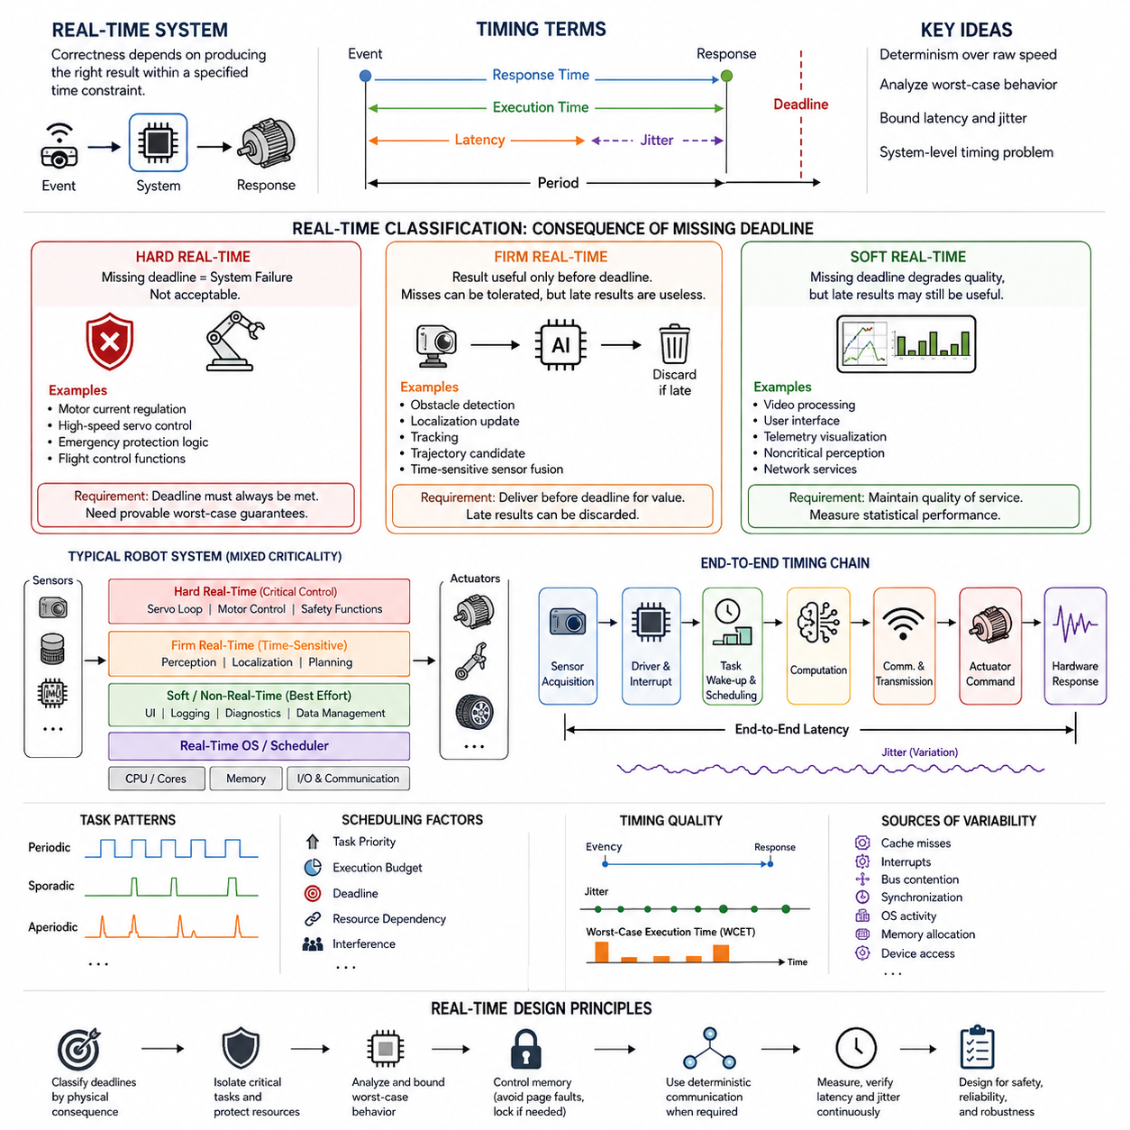
Real-time systems are computing systems in which correctness depends not only on producing the logically correct result but also on producing that result within a specified time constraint. In embedded robotics, this distinction is fundamental because software interacts directly with motors, sensors, communication buses, safety devices, and physical environments. A calculation that is mathematically correct but delivered too late can therefore be operationally incorrect.
A real-time requirement is normally expressed through timing constraints associated with an event, task, or control cycle. When an input event occurs, the system must detect it, execute the required computation, and produce an output before an associated deadline. Important quantities include response time, execution time, period, deadline, latency, and jitter. Real-time engineering focuses on bounding these quantities rather than simply maximizing average computational performance.
Determinism is consequently more important than raw speed in many real-time embedded systems. A processor that normally completes a control task in 100 microseconds but occasionally requires several milliseconds may be less suitable than a slower processor whose execution time remains predictably bounded. Robot controllers therefore require analysis of worst-case behavior, including scheduling delays, interrupt latency, memory access, communication delays, and interference from other software components.
A hard real-time system is one in which missing a specified deadline is considered a system failure. The deadline represents a strict correctness condition rather than a performance preference. Such requirements commonly appear where delayed computation can produce unsafe physical behavior, loss of control, or violation of a critical protection function. Motor current regulation, high-speed servo control, emergency protection logic, and some flight-control functions can therefore require hard real-time guarantees.
Hard real-time design requires engineers to establish credible upper bounds on execution and response times. Scheduling policies, interrupt architecture, memory behavior, synchronization mechanisms, communication paths, and operating-system services must all be evaluated for their worst-case effects. Dynamic behavior that introduces unpredictable latency is often restricted. The objective is not zero latency, which is physically impossible, but bounded latency that remains below every critical deadline under defined operating conditions.
A soft real-time system has timing requirements, but an occasional deadline miss does not make the entire system incorrect or unsafe. Instead, late results usually reduce service quality, responsiveness, smoothness, or user experience. Video processing, graphical interfaces, telemetry visualization, noncritical perception pipelines, and some network services often operate under soft real-time constraints. Their performance remains timing-sensitive even though isolated delays can normally be tolerated.
Soft real-time does not mean that timing is unimportant. A perception pipeline that repeatedly delivers camera frames too late may cause navigation quality to deteriorate even if no individual deadline miss immediately causes failure. Engineers therefore measure latency distributions, frame rates, jitter, queue depth, dropped data, and processing throughput. Statistical performance can be meaningful here because occasional outliers may be acceptable within a defined quality-of-service envelope.
Firm real-time systems occupy an important middle category. A result has useful value only when it arrives before its deadline, but occasional deadline misses can be tolerated without causing catastrophic system failure. Once the deadline has passed, completing the computation may provide little or no benefit, so the obsolete result can often be discarded. This behavior distinguishes firm real-time processing from many soft real-time workloads, where delayed output may still retain partial usefulness.
Robot perception provides useful examples of firm timing behavior. Suppose an obstacle-detection result corresponds to a sensor observation captured significantly earlier. If the robot has already moved and newer observations are available, finishing the old inference may be less useful than dropping it and processing current information. Similar reasoning applies to localization updates, tracking results, trajectory candidates, and time-sensitive sensor fusion when stale outputs should not propagate into downstream decisions.
The difference among hard, firm, and soft real-time systems is therefore primarily determined by the consequence of missing a deadline. In hard real-time operation, a missed deadline constitutes unacceptable failure. In firm real-time operation, occasional misses are tolerable, but late results lose their usefulness. In soft real-time operation, late results may still be useful, although system quality degrades as timing violations become more frequent or severe.
These categories should be assigned to individual functions rather than casually applied to an entire robot. A modern autonomous robot is typically a mixed system containing several timing classes simultaneously. A servo loop may have hard timing constraints, obstacle perception may behave as firm real-time processing, and diagnostic logging may have soft or even non-real-time requirements. System architecture must preserve these distinctions so that low-criticality workloads cannot disrupt time-critical execution.
Periodicity also influences real-time behavior. Periodic tasks execute at regular intervals, such as a motor-control loop running every millisecond. Sporadic tasks occur irregularly but have a known minimum separation, while aperiodic tasks may arrive without such predictable timing. Real-time scheduling must account for these activation patterns together with task priorities, execution budgets, deadlines, resource dependencies, and interference among concurrently executing functions.
Latency describes the elapsed time between an initiating event and the corresponding system response, while jitter describes variation in timing from one execution to another. Both matter in physical control. Even when every control cycle technically satisfies its deadline, excessive jitter can disturb sampling regularity and actuator timing. This can degrade control stability or estimation quality, making temporal consistency an engineering property that must be measured alongside average response time.
Worst-case execution time is particularly important for hard real-time analysis because average execution time cannot prove that every deadline will be satisfied. Cache misses, interrupts, bus contention, synchronization, operating-system activity, memory allocation, and device access can create rare but significant delays. Engineers must identify these sources of nondeterminism and either bound them, isolate them, eliminate them, or include sufficient timing margin in the system design.
Real-time behavior also depends on the complete execution chain rather than on application code alone. Sensor acquisition, device drivers, interrupt handling, task wake-up, scheduling, computation, inter-process communication, network transmission, actuator commands, and hardware response all contribute to end-to-end latency. Optimizing one component cannot guarantee a deadline if another layer introduces unpredictable delay. Real-time design must therefore be approached as a system-level timing problem.
In robotics, the classification of deadlines should ultimately follow physical consequences. Engineers should ask what happens if a result is delivered late, whether the result remains useful, how frequently lateness can be tolerated, and whether timing failure can create hazardous behavior. These questions transform hard, firm, and soft real-time from abstract definitions into practical architectural decisions governing scheduling, isolation, communication, validation, and safety mechanisms.
A well-designed real-time embedded robot consequently combines deterministic execution for critical control with appropriately flexible computation for less critical workloads. Hard real-time functions receive protected resources and rigorously bounded timing, firm functions prioritize freshness and may discard obsolete work, and soft functions optimize responsiveness without requiring absolute guarantees. This layered approach provides the foundation for the deterministic timing, task isolation, memory control, real-time communication, and servo-loop implementation topics that follow in real-time embedded design.

08.02 Real-Time Embedded Design Principles: Deterministic Timing
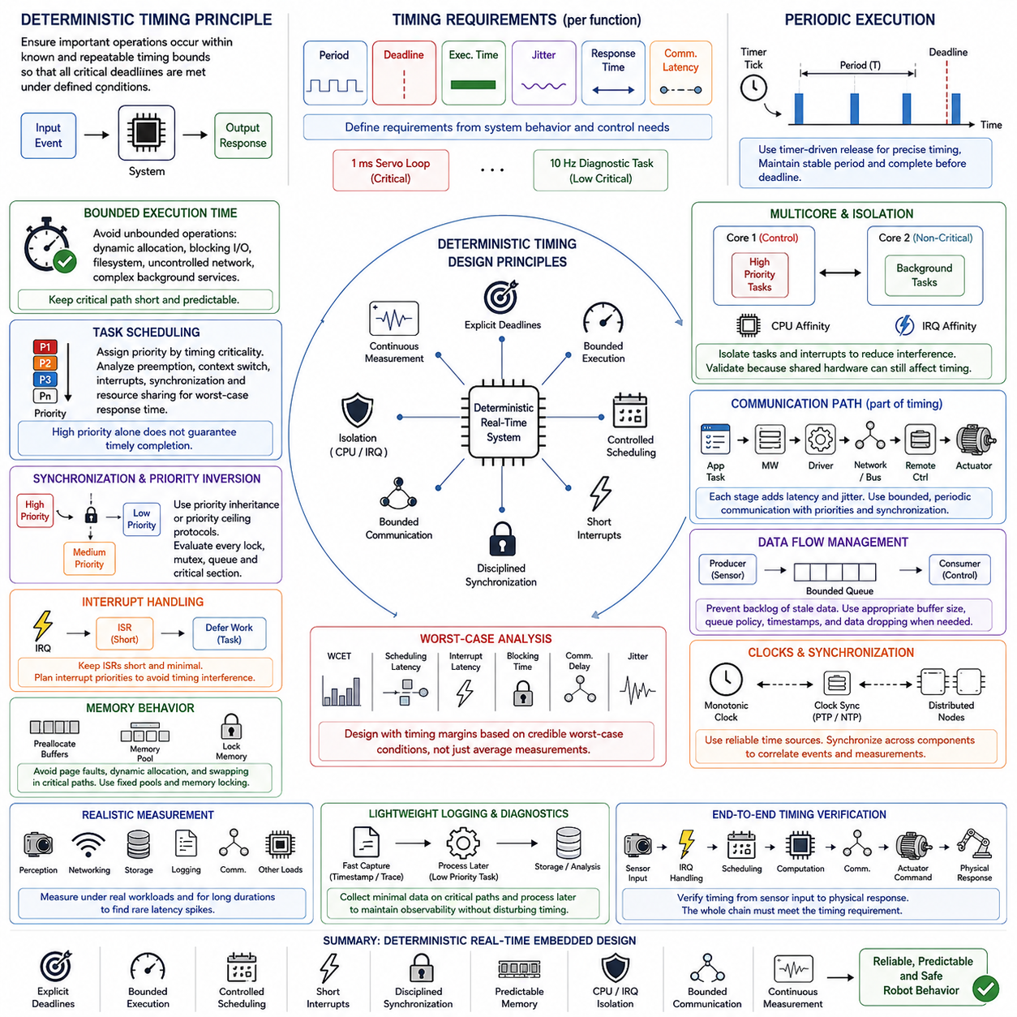
A deterministic real-time embedded system is designed so that important operations occur within known and repeatable timing bounds. Deterministic timing does not require every execution to consume exactly the same number of microseconds. Instead, the system must provide sufficiently predictable upper bounds for response time, execution latency, and scheduling delay so that critical deadlines can be demonstrated to remain satisfied under defined operating conditions.
This principle is especially important in robotics because software timing directly affects physical behavior. A motor controller may calculate the correct command, but a command delivered after the intended control instant can reduce stability or produce undesirable motion. Sensor acquisition, state estimation, actuator updates, and safety monitoring therefore need temporal correctness as well as logical correctness, making timing behavior an architectural property rather than a final-stage performance optimization.
Deterministic design begins by identifying the timing requirements of individual functions. Engineers define task periods, deadlines, expected execution times, allowable jitter, communication latency, and response-time limits according to the physical function being controlled. A one-millisecond servo loop and a ten-hertz diagnostic task should not receive identical treatment because their timing consequences differ substantially. Timing requirements must therefore originate from system behavior and control needs.
Periodic execution is commonly used for control functions because it establishes a predictable temporal structure. A periodic task is released at defined intervals, performs its computation, and should complete before the next relevant deadline. Maintaining a stable period reduces sampling-time variation and simplifies control analysis. Timer-driven activation is generally preferable to arbitrary polling when precise timing is required, because the intended execution instant becomes explicitly associated with a hardware or operating-system timing source.
Execution time must also remain bounded. Dynamic memory allocation, unpredictable blocking calls, filesystem access, uncontrolled network operations, and complex background services can introduce large variations into otherwise fast software. Critical paths should minimize operations whose completion time cannot be reliably constrained. Where such operations are necessary, they can be moved to lower-criticality tasks, executed asynchronously, or isolated so that their delays do not propagate into time-critical control loops.
Task scheduling is another central element of deterministic timing. The scheduler decides when runnable tasks receive processor time, so priority assignment must reflect timing criticality rather than convenience. High-priority control functions should be protected from excessive interference by lower-priority computation. At the same time, engineers must analyze how preemption, context switching, interrupts, synchronization, and shared resources affect worst-case response time rather than assuming that a high priority automatically guarantees timely completion.
Priority inversion illustrates why scheduling must be considered together with synchronization. A high-priority task can be indirectly delayed when it waits for a resource held by a lower-priority task while intermediate-priority work continues executing. Real-time synchronization mechanisms such as priority inheritance or priority ceiling protocols can limit this effect. The broader principle is that every shared lock, mutex, queue, and critical section should be evaluated according to its possible contribution to blocking time.
Interrupt handling requires similar discipline. Hardware interrupts provide rapid response to external events, but long or excessive interrupt service routines can disturb scheduled tasks and increase latency. Interrupt handlers should generally perform only the work required for immediate hardware servicing and defer longer processing to an appropriate task context. Interrupt priorities must also be planned carefully because uncontrolled interrupt activity can create timing interference that is difficult to observe through application-level profiling alone.
Memory behavior is a major source of nondeterminism in advanced embedded platforms. Page faults, swapping, cache effects, memory allocation, and contention for shared memory resources can produce execution-time variation. Real-time processes may therefore preallocate required buffers, reuse fixed memory pools, lock important memory regions, and avoid allocation inside critical loops. The objective is to prevent an apparently simple memory operation from unexpectedly extending the response time of a deadline-sensitive task.
Multicore processors provide additional computing capacity but introduce new timing interactions. Tasks executing on different cores can compete for caches, memory bandwidth, buses, interrupts, and I/O resources. Real-time design can use processor affinity to place critical tasks on selected CPU cores and interrupt affinity to control where important device interrupts execute. Isolation reduces interference, but it should be validated because shared hardware below the CPU-core level can still affect execution timing.
Communication paths must be treated as part of the timing architecture. A control command may travel through an application task, middleware, device driver, network interface, communication bus, remote controller, and actuator before producing physical action. Each stage contributes latency and jitter. Deterministic communication therefore requires attention to queueing, message priorities, transmission periods, synchronization, and bounded delivery behavior, particularly when technologies such as EtherCAT or time-sensitive networking are used for periodic control.
Data-flow design should also prevent stale information from accumulating. Queues that grow without bounds can convert temporary processing delays into progressively increasing latency. For time-sensitive sensor or control data, the newest information may be more valuable than a backlog of obsolete samples. Buffer sizes, queue policies, timestamps, and data-dropping strategies should therefore reflect whether every message must be processed or whether temporal freshness is the more important requirement.
Clock selection and synchronization are equally important because timing measurements are meaningful only when timestamps and execution intervals refer to reliable time sources. Monotonic clocks are generally appropriate for measuring elapsed time because they are not affected by ordinary wall-clock corrections. Distributed robot components may additionally require synchronized clocks so that sensor observations, control commands, and communication events can be correlated accurately across processors and networked devices.
Worst-case analysis distinguishes deterministic engineering from optimization based only on averages. An average latency of 200 microseconds provides little assurance if occasional operations require several milliseconds and violate a critical deadline. Engineers therefore examine worst-case execution time, maximum scheduling latency, interrupt latency, blocking time, communication delay, and observed jitter. Timing margins should account for credible operating extremes rather than measurements obtained only when the system is lightly loaded.
Measurement must reproduce realistic system conditions. Real-time performance should be tested while perception, networking, storage, logging, communication, and other expected workloads are active because resource contention often appears only under load. Long-duration measurements are also valuable for discovering rare latency spikes. A system that behaves deterministically for several seconds but experiences severe outliers during hours of operation may still be unsuitable for continuous robotic deployment.
Logging and diagnostics must themselves respect timing requirements. Excessive console output, synchronous file writes, or detailed tracing inside critical loops can alter the behavior being measured. Real-time systems therefore commonly separate fast event capture from slower formatting and storage. Lightweight timestamps or trace records can be collected on critical paths and processed later by lower-priority tasks, allowing observability without introducing unacceptable interference into the function under observation.
Deterministic timing should ultimately be verified from sensor input to physical response rather than only at individual software boundaries. Sensor acquisition, interrupt handling, scheduling, computation, communication, actuator command generation, and hardware response form a complete end-to-end chain. Local timing guarantees are valuable, but the robot succeeds only when the entire chain satisfies the timing requirement associated with the physical operation.
A robust real-time embedded architecture therefore combines explicit deadlines, bounded execution, controlled scheduling, short interrupt paths, disciplined synchronization, predictable memory usage, CPU and IRQ isolation, bounded communication, and continuous latency measurement. These techniques transform real-time behavior from an assumption into an engineered property. They also establish the foundation for practical mechanisms such as PREEMPT_RT, CPU affinity, IRQ affinity, memory locking, deterministic industrial communication, and control-loop latency optimization addressed in subsequent real-time embedded design topics.

08.03 PREEMPT RT Patch Application and Latency Analysis [w/Code]
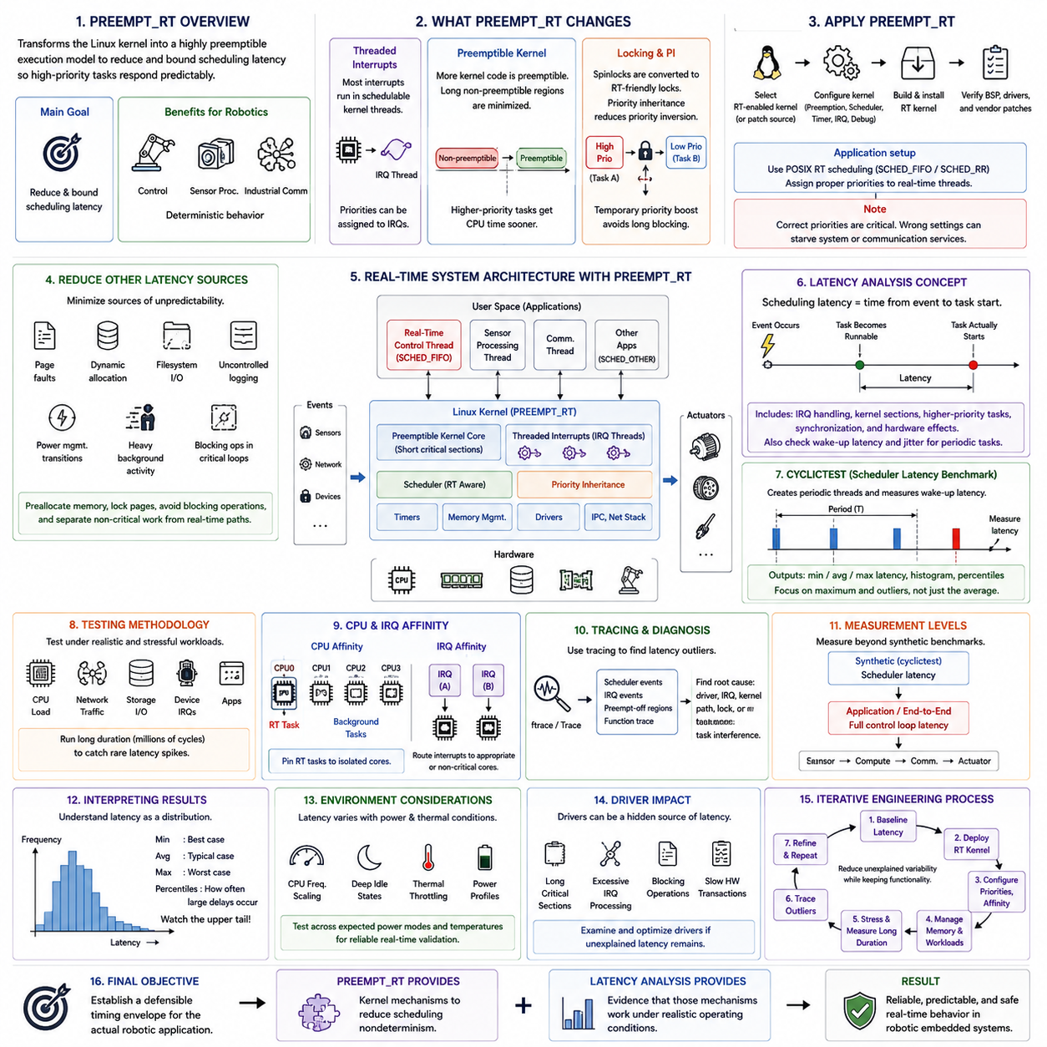
PREEMPT_RT is a Linux real-time technology that transforms the general-purpose kernel toward a highly preemptible execution model. Its purpose is not simply to make Linux faster, but to reduce and bound scheduling latency so that high-priority tasks can respond predictably to events. In embedded robotics, this makes Linux more suitable for control, sensor processing, industrial communication, and other timing-sensitive workloads that require deterministic behavior.
A standard Linux kernel prioritizes throughput, fairness, and overall system efficiency, which can allow kernel activities to delay a time-critical application. PREEMPT_RT changes this behavior by making significantly more kernel execution preemptible. Operations that previously prevented task scheduling for relatively long intervals are reorganized so that a higher-priority real-time task can obtain CPU time sooner, reducing worst-case scheduling latency and improving temporal predictability.
One important mechanism is threaded interrupt handling. In conventional configurations, substantial interrupt processing may execute in interrupt context and temporarily prevent normal tasks from running. PREEMPT_RT moves most interrupt handling into schedulable kernel threads, allowing priorities to be assigned to interrupt activity. Engineers can therefore coordinate the priority relationship among hardware interrupts, device processing, and application-level real-time tasks rather than treating interrupt execution as largely uncontrollable interference.
PREEMPT_RT also changes kernel locking behavior to reduce long non-preemptible regions. Many traditional spinlock-based critical sections are converted into mechanisms compatible with real-time preemption, while priority-inheritance techniques help reduce priority inversion. When a high-priority task waits for a lock held by a lower-priority task, priority inheritance temporarily raises the effective priority of the lock owner so that the blocking resource can be released sooner.
Applying PREEMPT_RT begins with selecting a compatible Linux kernel and real-time configuration. Depending on the kernel generation and distribution, real-time support may be provided through an RT-enabled kernel package or appropriate kernel source and configuration. The resulting kernel must enable the required preemption model together with relevant scheduling, timer, interrupt, and debugging options. Embedded deployment additionally requires verifying compatibility with board-support packages, device drivers, and vendor-specific kernel modifications.
Kernel configuration alone does not make an application real-time. The application must use an appropriate scheduling policy and priority, commonly through POSIX real-time scheduling facilities such as SCHED_FIFO or SCHED_RR. A critical control thread can then preempt ordinary SCHED_OTHER workloads when it becomes runnable. Priority values should be assigned according to system timing requirements because incorrectly prioritized real-time threads can starve essential operating-system or communication services.
The system should also minimize sources of latency outside the scheduler. Page faults, dynamic allocation, filesystem operations, uncontrolled logging, power-management transitions, and heavy background activity can produce timing variation even with an RT kernel. Real-time applications commonly preallocate memory, lock required pages into RAM, avoid blocking operations inside critical loops, and separate noncritical processing from deadline-sensitive execution paths. PREEMPT_RT should therefore be considered one component of a complete deterministic design.
Latency analysis focuses on the delay between an event that makes a real-time task runnable and the point at which that task actually begins executing. Scheduling latency includes interference from interrupt handling, kernel critical sections, higher-priority tasks, synchronization, and hardware effects. For periodic control applications, engineers also examine wake-up latency and jitter because variation in the actual activation time can disturb sampling intervals even when the average execution time remains low.
Cyclictest is widely used to characterize Linux real-time scheduling latency. It creates periodic threads, requests wake-ups at defined intervals, and measures the difference between the intended wake-up time and actual execution time. The resulting minimum, average, and maximum latency values provide a practical indication of scheduler behavior. For real-time qualification, maximum observed latency and the distribution of outliers are usually more significant than a favorable average value.
A meaningful latency test should run under realistic or deliberately stressful workloads. CPU-intensive computation, network traffic, storage access, graphics activity, device interrupts, and application processes can expose interference that remains invisible on an idle system. Tests should also run for sufficiently long periods because rare latency spikes may appear only after millions of scheduling cycles. A short benchmark with an excellent maximum value cannot establish robust long-duration behavior.
CPU affinity can improve PREEMPT_RT behavior by controlling where important threads execute. A real-time control task can be assigned to a selected CPU core while background services are directed toward other cores. This reduces scheduler interference and cache disruption. However, CPU isolation alone is insufficient because interrupts, kernel threads, memory traffic, and shared hardware resources may still affect the isolated core unless the complete resource topology is considered.
IRQ affinity complements CPU affinity by controlling the processor cores that handle hardware interrupts. High-frequency network, storage, camera, or sensor interrupts can disturb a real-time task if they execute on the same CPU. Engineers can route selected interrupts away from critical cores or deliberately place a required device IRQ near its corresponding real-time thread. The correct strategy depends on whether minimizing interference or minimizing device-to-task handoff latency is the dominant requirement.
Tracing tools are required when cyclictest or application measurements reveal unexpected latency spikes. Kernel tracing mechanisms such as ftrace can expose scheduler events, interrupt execution, preemption-disabled regions, and function activity surrounding an outlier. Rather than merely observing that a deadline was nearly missed, engineers can reconstruct what the CPU was executing during the delay and identify whether the cause originated in a driver, interrupt, kernel path, synchronization operation, or competing task.
Application-level latency should be measured in addition to synthetic scheduler latency. A robot control loop includes timer activation, task wake-up, sensor access, computation, communication, actuator command transmission, and potentially remote device processing. Excellent cyclictest results demonstrate useful kernel behavior but do not guarantee that this complete chain satisfies the control deadline. End-to-end measurements must therefore accompany kernel-level benchmarks when validating an actual robotic system.
Latency results should be interpreted as distributions rather than as a single performance number. Minimum latency describes favorable behavior, average latency describes typical operation, and maximum latency reveals the most severe observed delay. Percentiles can show how frequently larger delays occur, while histograms expose long-tail behavior. For hard or highly critical real-time functions, engineering attention naturally shifts toward the upper tail because rare outliers can determine whether a deadline guarantee is credible.
Testing should also consider thermal and power-management conditions. CPU frequency scaling, deep idle states, thermal throttling, and changing power profiles can modify wake-up and execution latency. An embedded robot may operate for hours while temperature and computational load change substantially. Real-time qualification should therefore reproduce expected power modes and thermal conditions instead of relying only on measurements collected immediately after boot under favorable laboratory conditions.
Drivers are another important source of real-time latency. A poorly behaving device driver can contain long critical sections, excessive interrupt processing, blocking operations, or hardware transactions that interfere with high-priority execution. PREEMPT_RT reduces many kernel-level sources of nondeterminism, but it cannot automatically transform every driver into a predictable component. Driver behavior must therefore be examined when unexplained latency remains after scheduler and CPU configuration have been optimized.
A practical PREEMPT_RT deployment is consequently an iterative engineering process rather than a single patching operation. Engineers establish baseline latency, enable or deploy the real-time kernel, configure application priorities, control CPU and IRQ placement, manage memory and background workloads, apply stress, measure long-duration behavior, trace outliers, and refine the configuration. Each iteration should reduce unexplained timing variability while preserving required system functionality.
For robotic embedded systems, the final objective is not to obtain the smallest benchmark number but to establish a defensible timing envelope for the actual application. PREEMPT_RT provides the kernel mechanisms needed to reduce scheduling nondeterminism, while latency analysis determines whether those mechanisms are effective under realistic operating conditions. Together they provide the practical bridge between deterministic real-time design principles and subsequent techniques such as CPU affinity, IRQ affinity, memory locking, and control-loop latency optimization.

08.04 Real-Time Task Isolation: CPU Affinity / IRQ Affinity [w/Code]
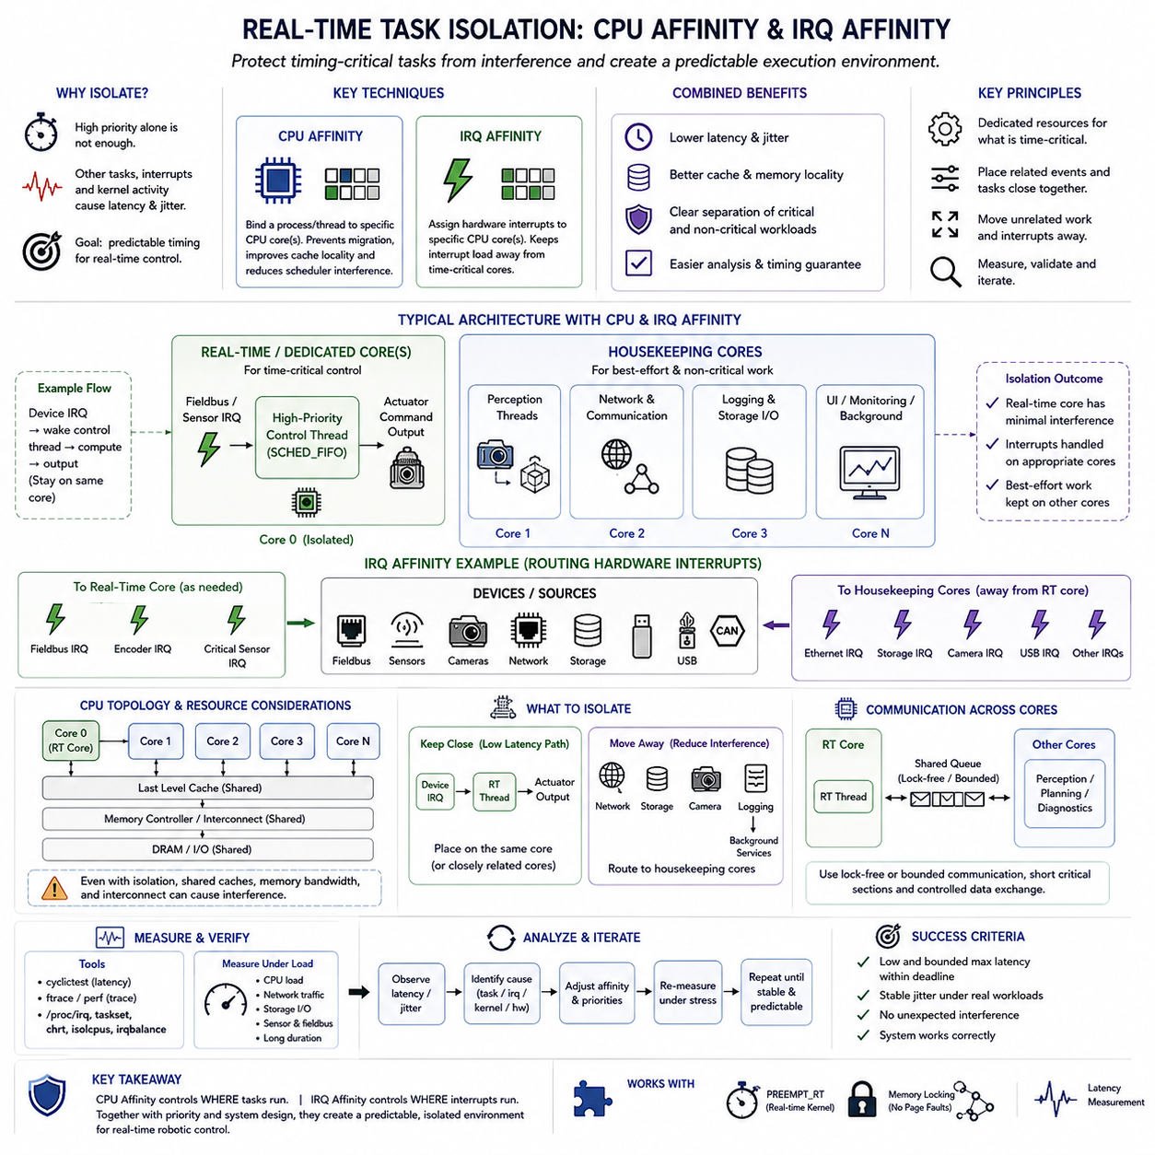
Real-time task isolation is the practice of protecting timing-critical software from interference caused by other tasks, interrupts, kernel activity, and shared computing resources. On multicore embedded Linux platforms, simply assigning a high scheduling priority is often insufficient. A critical control thread can still experience latency when unrelated workloads execute on the same CPU or when hardware interrupts unexpectedly consume processor time.
CPU affinity provides a mechanism for controlling which processor cores are allowed to execute a process or thread. Instead of allowing the Linux scheduler to migrate a real-time task among all available cores, engineers can bind that task to a selected CPU. This reduces migration overhead, improves cache locality, and creates a more predictable execution environment in which the timing behavior of critical control functions can be analyzed more reliably.
A common architecture reserves one or more cores primarily for real-time execution while assigning general application workloads to the remaining cores. For example, a multicore robot computer may dedicate one CPU to a high-frequency servo or motion-control thread while perception, logging, user interfaces, and background services execute elsewhere. This separation reduces direct scheduling competition and provides a clearer boundary between timing-critical and best-effort computation.
CPU affinity by itself does not create complete isolation because the operating system can still schedule kernel threads or other allowed processes on the selected core. Real-time designs may therefore combine affinity with CPU-isolation mechanisms and carefully configured scheduler behavior. The objective is to minimize unexpected execution on the critical CPU while retaining enough kernel functionality for timers, synchronization, communication, and other services required by the real-time application.
IRQ affinity addresses another major source of interference: hardware interrupts. Devices such as network adapters, cameras, storage controllers, USB interfaces, CAN controllers, and sensor interfaces generate interrupts that must be serviced by the processor. If these interrupts execute on the same CPU as a time-critical task, they can introduce additional latency and jitter even when ordinary application workloads have already been moved to other cores.
Linux allows many hardware interrupt requests to be associated with selected CPU cores. By configuring IRQ affinity, engineers can route high-frequency or unrelated device interrupts away from a core dedicated to real-time control. Network, storage, graphics, and camera interrupts may be handled on housekeeping CPUs, while the real-time CPU is protected from unnecessary disturbance. This arrangement can significantly reduce interrupt-induced latency variation.
However, moving every interrupt away from a real-time CPU is not always optimal. A control task may depend directly on an interrupt from a specific sensor, communication interface, or industrial fieldbus device. Placing that IRQ and its associated real-time thread on the same CPU can reduce handoff latency and improve cache locality. The correct configuration therefore depends on the relationship between the device event and the deadline-sensitive computation.
With PREEMPT_RT, many interrupt handlers execute as schedulable IRQ threads, making priority and affinity configuration particularly important. An IRQ thread can compete with application-level real-time threads according to scheduling priority. Engineers must establish a deliberate priority hierarchy among critical device interrupts, control tasks, communication threads, and background activities so that an important event is serviced quickly without allowing excessive interrupt activity to dominate processor execution.
Task isolation should therefore be designed as a coordinated combination of CPU placement, IRQ placement, and scheduling priority. Consider a robot in which a fieldbus interrupt activates a servo-control task. The device IRQ may execute on the same dedicated core, wake a high-priority control thread, and allow that thread to compute the actuator command immediately. Unrelated Ethernet, storage, camera, and logging activity can then be directed toward separate housekeeping cores.
CPU topology must be considered when selecting isolated cores. Modern processors may share last-level caches, memory controllers, interconnects, and other resources even when software executes on separate CPU cores. Simultaneous multithreading, where applicable, can also create interference between logical processors sharing execution resources. Physical separation at the scheduler level therefore does not necessarily imply complete temporal isolation at the hardware level.
Memory bandwidth contention can remain particularly important in robotic systems. A GPU-assisted perception pipeline, camera processing task, or large memory copy can consume substantial memory bandwidth while a supposedly isolated control core accesses its own data. Although the tasks run on different CPUs, shared memory infrastructure can increase execution time. Real-time validation must therefore examine resource contention beyond the scheduler and processor-affinity configuration.
Cache behavior is another reason to keep critical tasks on stable CPU assignments. Frequent migration between cores can invalidate useful cache locality and introduce variable memory-access delays. Pinning a real-time thread to a specific core allows its instructions and working data to remain more consistently associated with that processor's caches. This does not eliminate cache misses, but it removes one avoidable source of execution-time variability.
Housekeeping CPUs provide a useful architectural pattern for managing non-real-time work. Operating-system services, logging, monitoring, shell activity, storage operations, network management, and other background tasks can be concentrated on selected housekeeping cores. Dedicated real-time cores can then execute a much smaller and more controlled workload. This division simplifies analysis because engineers know which classes of activity are intentionally permitted on each processor.
Isolation should not accidentally starve essential kernel services. Some timers, kernel threads, communication mechanisms, and deferred work remain necessary for correct system operation. Aggressive isolation without understanding these dependencies can create unexpected failures or even increase latency. Engineers should therefore progressively configure isolation, verify functionality after each change, and measure actual timing behavior rather than assuming that stronger isolation automatically produces better results.
NUMA behavior can become relevant on larger embedded or industrial computing platforms. When memory is physically associated with different processor regions, a real-time task may experience additional latency if its CPU repeatedly accesses remote memory. CPU placement and memory placement should then be considered together. Even on smaller systems without explicit NUMA organization, locality remains useful because shared caches and memory paths can influence deterministic execution.
Affinity configuration must also account for communication between real-time and non-real-time components. A control task may exchange data with perception, planning, diagnostics, or network processes running on other CPUs. Poorly designed shared queues, locks, or memory structures can reintroduce blocking across the isolation boundary. Lock-free or bounded communication mechanisms, short critical sections, and carefully controlled data exchange help preserve the timing benefits gained from CPU isolation.
The effectiveness of isolation must be demonstrated through measurement. Tools such as cyclictest can compare scheduling latency before and after CPU and IRQ affinity changes, while tracing mechanisms can reveal which task or interrupt caused an unexpected delay. Measurements should record maximum latency and jitter under realistic CPU, network, storage, sensor, and communication loads rather than evaluating only average latency on an otherwise idle computer.
Stress testing is especially important because an affinity configuration that appears effective during light operation may fail when the complete robotic workload is active. Camera streams, AI inference, ROS2 communication, fieldbus traffic, storage logging, and network transfers can simultaneously generate processor, memory, and interrupt pressure. Long-duration testing helps reveal rare interference patterns that short laboratory benchmarks may not expose.
Isolation strategies should ultimately be derived from the timing-critical data path. Engineers first identify the sensor events, communication interfaces, control threads, and actuator outputs associated with a deadline. They then determine which resources must remain close together for low latency and which workloads should be moved away to reduce interference. CPU affinity and IRQ affinity become architectural tools for shaping this physical-to-software execution path rather than isolated tuning parameters.
A robust real-time robot computer consequently uses layered isolation. Scheduling priorities determine which runnable work executes first, CPU affinity controls where critical threads execute, IRQ affinity controls where hardware events are serviced, and housekeeping cores absorb most noncritical activity. Memory, caches, communication, and shared hardware resources are then analyzed to identify interference that processor placement alone cannot remove.
The objective is not to maximize CPU utilization but to create a predictable timing environment for critical functions. Reserving computational capacity may appear inefficient from a throughput perspective, yet that unused margin can provide essential protection against latency spikes. For real-time robotics, predictable response is often more valuable than keeping every processor core continuously busy, because physical control depends on meeting deadlines rather than maximizing average computational throughput.
Real-time task isolation therefore extends deterministic design from software scheduling into the physical organization of multicore computing resources. CPU affinity establishes stable execution locations, IRQ affinity controls interrupt interference, and systematic isolation separates critical control from best-effort workloads. Together with PREEMPT_RT, memory locking, deterministic communication, and latency measurement, these techniques form a practical foundation for predictable embedded robotic control.

08.05 Memory Locking: mlockall and Page Fault Prevention [w/Code]
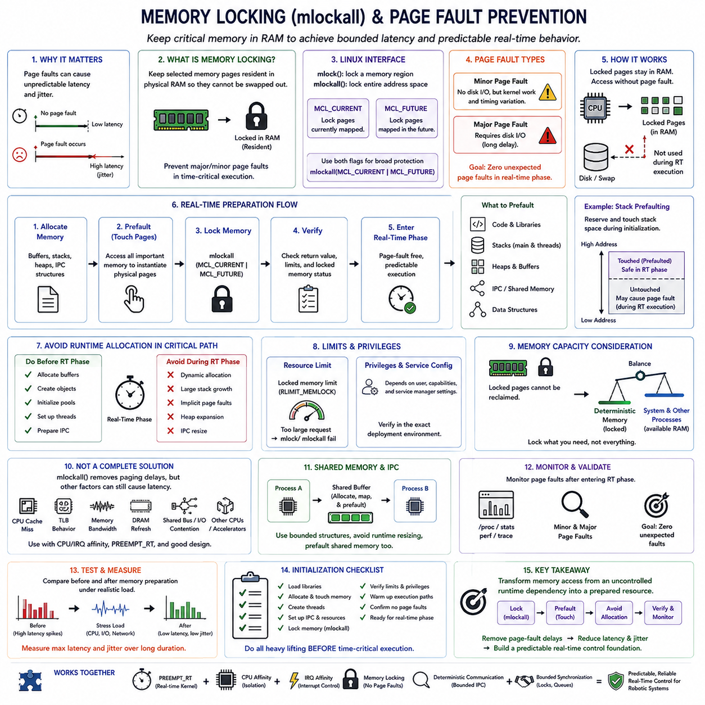
Memory locking is a real-time memory-management technique used to keep critical process pages resident in physical RAM and prevent unpredictable delays caused by demand paging or swapping. In a conventional virtual-memory system, a process may access a page that is not immediately resident, forcing the operating system to resolve a page fault. For ordinary applications this behavior is acceptable, but for a deadline-sensitive control task it can create unacceptable latency and jitter.
Linux provides the mlock() and mlockall() system calls to lock selected memory regions or an entire process address space into RAM. For real-time applications, mlockall() is particularly useful because it can protect the process from paging-related delays across multiple memory regions. When correctly configured, the kernel keeps the locked pages resident so that critical execution does not unexpectedly wait for storage-backed memory recovery during a control cycle.
The mlockall() interface commonly uses the MCL_CURRENT and MCL_FUTURE flags. MCL_CURRENT requests that pages currently mapped into the process address space be locked, while MCL_FUTURE requests that memory mapped later also be locked. Using both flags provides broad protection for a real-time process, but successful locking depends on operating-system limits, process privileges, available physical memory, and the total amount of memory that the application attempts to reserve.
Memory locking should be understood in relation to page faults. A major page fault may require data to be retrieved from storage, producing delays that are completely unsuitable for a tightly bounded real-time loop. Minor page faults do not normally require storage I/O, but they can still invoke kernel memory-management work and introduce timing variation. Preventing both types from occurring inside critical execution paths improves temporal predictability even when their average cost appears small.
Calling mlockall() alone does not guarantee that every required page has already been physically instantiated. Some virtual pages may remain untouched until the application first accesses them. Real-time software therefore commonly performs memory prefaulting during initialization. Buffers, stacks, and other required memory are allocated and deliberately accessed before the time-critical phase begins so that necessary page mappings and physical pages are established in advance.
Stack memory deserves particular attention because a real-time thread may expand its stack while executing deeper function calls or using larger local variables. If previously untouched stack pages are accessed during the control loop, page faults can occur despite otherwise careful memory preparation. A common strategy is to reserve sufficient stack space and touch the expected stack region during initialization, ensuring that the pages required by normal real-time execution are already resident.
Heap allocation can introduce similar unpredictability. Dynamic allocation functions may request additional pages, modify allocator metadata, acquire internal locks, or trigger memory-management activity. Real-time programs therefore tend to allocate buffers, message objects, control structures, and working memory before entering their critical execution phase. Reusing preallocated objects or fixed-size memory pools reduces both page-fault risk and allocator-induced execution-time variability.
The objective is not to prohibit dynamic memory throughout the entire application. Initialization, configuration, diagnostics, and noncritical worker threads may still use flexible allocation when appropriate. The architectural goal is to remove unpredictable memory behavior from deadline-sensitive paths. Separating real-time and non-real-time memory activity allows the system to retain general-purpose functionality while preserving deterministic behavior where physical control deadlines must be satisfied.
Memory locking also interacts with process resource limits. Linux can restrict the amount of memory that a process is permitted to lock through the locked-memory resource limit, commonly associated with RLIMIT_MEMLOCK. If the requested amount exceeds the permitted limit, mlock() or mlockall() can fail. Real-time applications must therefore check return values and verify configuration rather than assuming that a memory-locking request has succeeded simply because the program continues running.
Privileges and service configuration must be considered during deployment. A program that works when executed manually with elevated privileges may fail to lock the same memory when launched through a production service manager under a restricted account. Real-time deployment should therefore verify locked-memory limits, capabilities, service settings, and application startup behavior in the exact environment used by the robot rather than relying only on development-shell tests.
Physical memory capacity becomes important because locked pages cannot be reclaimed in the normal way while they remain locked. Excessive memory locking can reduce the RAM available to other processes and may negatively affect overall system behavior. Engineers should lock the memory needed for deterministic execution without unnecessarily reserving the complete memory footprint of large noncritical components, particularly on systems that simultaneously run perception, planning, logging, and user applications.
Large robotic applications often contain both lightweight real-time control and memory-intensive AI workloads. Locking the entire address space of a process containing large models or extensive image buffers may therefore be inappropriate. A cleaner architecture can separate critical control into a smaller process with a bounded memory footprint while perception or AI inference runs independently. This makes memory residency easier to control and reinforces isolation between deterministic and best-effort workloads.
Memory locking does not eliminate every form of memory-related latency. CPU cache misses, translation lookaside buffer behavior, memory-controller contention, DRAM refresh, shared-memory traffic, and bandwidth competition from other CPUs or accelerators can still affect execution time. mlockall() specifically addresses virtual-memory paging behavior; it should not be interpreted as a guarantee that every memory access will have constant latency.
For multicore robotic computers, memory bandwidth interference can remain significant after page faults have been removed. Camera pipelines, GPU transfers, AI inference, network processing, and large data copies can generate heavy traffic through shared memory resources. A real-time control task may therefore experience timing variation even though all of its pages are locked. CPU isolation and memory-access discipline should complement memory locking when strict latency bounds are required.
Shared memory and inter-process communication also require preparation. If a real-time process communicates through shared buffers, those buffers should be allocated, mapped, and accessed before critical operation when possible. Communication structures should have bounded sizes, and runtime resizing should be avoided on the critical path. This extends the prefaulting principle from private application memory to the data structures used between cooperating real-time components.
Page-fault monitoring provides an important validation mechanism. Engineers can examine process statistics, tracing information, or performance counters to determine whether minor or major page faults occur after the system enters its real-time operating phase. The desired result is not merely a low average fault rate but ideally zero unexpected page faults within the deadline-sensitive execution interval. Any remaining fault should be investigated because it identifies memory that was not prepared as intended.
Latency testing should compare system behavior before and after memory preparation. A periodic control loop or cyclictest-style workload can be exercised under CPU, storage, network, and memory pressure while maximum latency and jitter are recorded. If page faults were contributing to long-tail delays, memory locking and prefaulting should reduce those outliers. Measurements should be performed over long durations because rare memory-related events may not appear during short tests.
Initialization consequently becomes a deliberate real-time preparation phase. The application loads required libraries, allocates buffers, creates threads, establishes communication resources, locks memory, touches relevant pages, warms important execution paths, and verifies configuration before enabling time-critical control. Work that might unpredictably invoke the memory subsystem is intentionally moved out of the operational phase and into this controlled startup period.
Error handling must also avoid reintroducing uncontrolled allocation. A real-time path that normally performs no dynamic allocation may suddenly allocate memory when constructing an exception message, expanding a log buffer, or handling an unusual condition. Critical error paths should therefore be reviewed with the same discipline as normal execution. Preallocated diagnostic structures and deferred logging can prevent exceptional behavior from becoming a hidden source of page faults.
Memory locking is most effective when combined with the broader real-time architecture. PREEMPT_RT reduces kernel scheduling nondeterminism, CPU affinity limits task interference, IRQ affinity controls interrupt placement, and memory locking removes paging-related uncertainty. Deterministic communication and bounded synchronization further constrain the execution path. No single technique provides real-time guarantees independently; predictable behavior emerges from controlling multiple sources of latency together.
The practical goal of mlockall() and page-fault prevention is therefore to transform memory access from an uncontrolled runtime dependency into a prepared system resource. By locking required pages, prefaulting stacks and buffers, avoiding critical-path allocation, validating resource limits, and monitoring page faults under realistic load, engineers can remove one major source of long-tail latency and build a more predictable foundation for high-frequency embedded robotic control.

08.06 Real-Time Communication: EtherCAT, TSN, Periodic Control
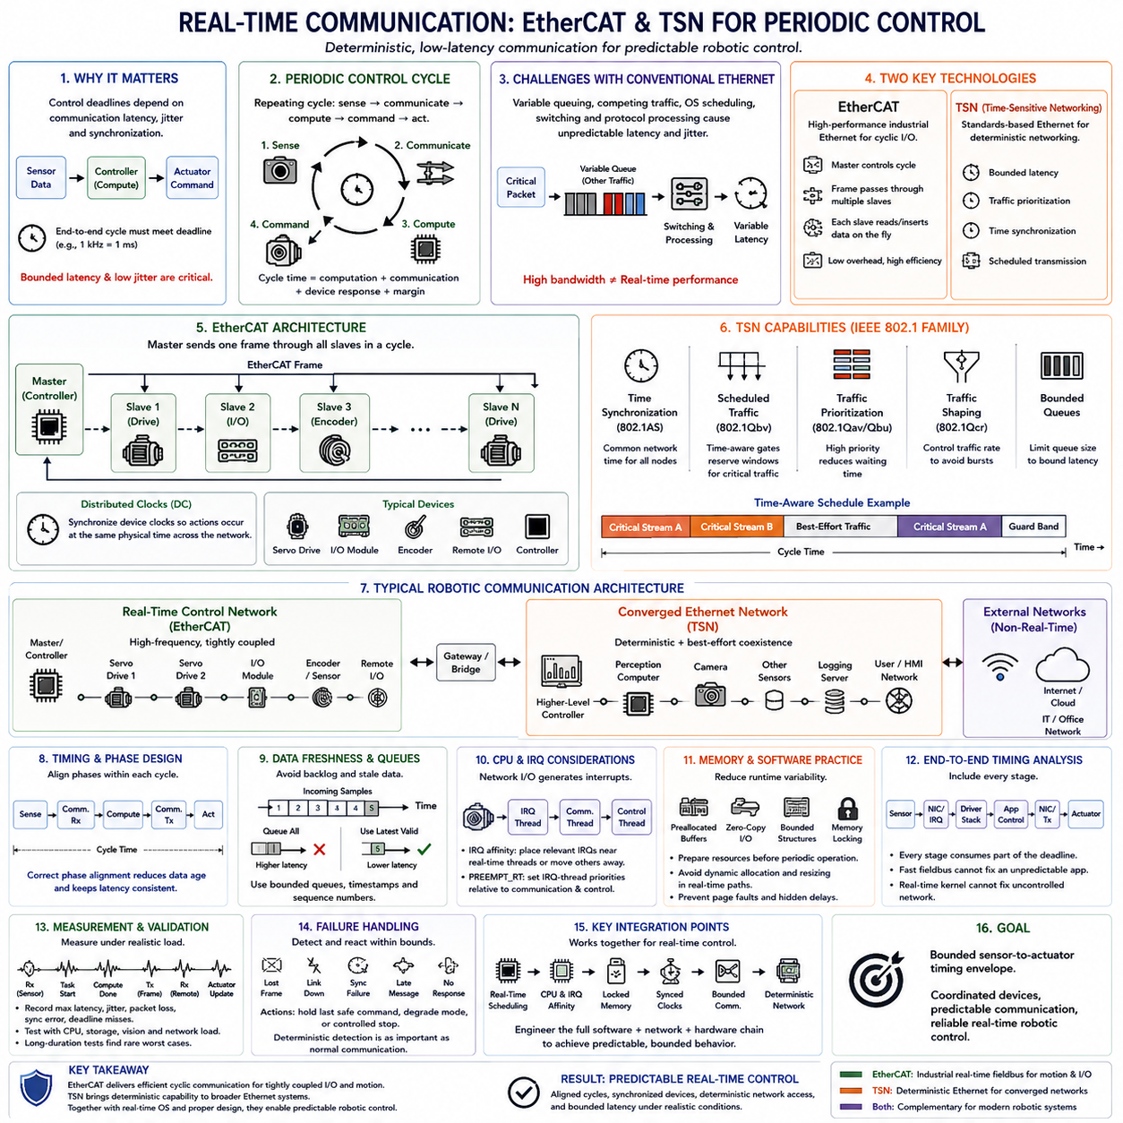
Real-time communication extends deterministic computing beyond a single processor by ensuring that sensor data, control commands, and synchronization information are exchanged within predictable timing bounds. In robotic systems, a control task may execute precisely on schedule yet still fail its deadline if network transmission is delayed. Communication latency, jitter, synchronization accuracy, and bounded delivery must therefore be treated as integral parts of the real-time control architecture.
Periodic control communication is organized around repeating cycles in which sensors are sampled, data is transmitted, control algorithms execute, and actuator commands are delivered. A 1 kHz servo system, for example, provides only one millisecond for the relevant end-to-end sequence. The communication subsystem must fit inside this timing budget together with computation and device response, leaving sufficient margin for worst-case variations rather than merely satisfying the average cycle.
Conventional Ethernet was originally optimized for flexible data networking rather than deterministic industrial control. Variable queueing, competing traffic, operating-system scheduling, switch behavior, and protocol processing can introduce unpredictable latency. High bandwidth alone therefore does not imply real-time performance. A gigabit network can transmit data rapidly while still producing unacceptable jitter if critical packets must unpredictably wait behind unrelated traffic.
EtherCAT addresses this problem through an industrial Ethernet architecture designed for fast cyclic communication. Instead of treating every device exchange as an independent conventional Ethernet transaction, an EtherCAT master transmits frames that pass through multiple slave devices. Each slave can read or insert relevant process data while the frame passes through it, reducing protocol overhead and enabling efficient exchange of distributed input and output data within a periodic control cycle.
The EtherCAT master establishes the communication cycle and coordinates process-data exchange with connected slaves such as servo drives, I/O modules, encoders, and distributed controllers. A real-time application can wake periodically, exchange process data through the master, compute control outputs, and prepare commands for the next transmission cycle. Predictable master execution is therefore closely related to Linux scheduling latency, CPU affinity, IRQ handling, and memory behavior.
Distributed Clocks are an important EtherCAT mechanism for coordinating timing among networked devices. Local device clocks can be synchronized so that sampling and actuation occur with a consistent temporal relationship across the network. This is particularly valuable for coordinated multi-axis motion because several servo drives may need to apply commands at nearly the same physical instant rather than merely receiving packets in approximately the correct order.
Clock synchronization and deterministic transmission solve different but complementary problems. Deterministic communication controls when information arrives, while synchronized clocks establish a common temporal reference for when distributed actions occur. A robot with several actuators can therefore separate packet arrival from precise execution time. Commands may be communicated during a defined window and then applied by synchronized devices at an agreed control instant.
Time-Sensitive Networking, or TSN, extends standard Ethernet with mechanisms intended to provide bounded latency, traffic prioritization, time synchronization, and scheduled transmission for critical traffic. TSN is not a single protocol but a family of IEEE 802.1 technologies that can be combined according to system requirements. Its broader goal is to allow deterministic and best-effort traffic to coexist on converged Ethernet infrastructure while preserving timing guarantees for selected streams.
Precise time synchronization is commonly associated with IEEE 802.1AS in TSN environments. Devices establish a shared notion of network time that can support coordinated scheduling, timestamping, sensing, and actuation. Accurate synchronization is especially important in distributed robotic systems where cameras, sensors, controllers, and actuators may reside on different computing nodes yet their data must be interpreted as belonging to a common physical timeline.
Scheduled traffic can be controlled using time-aware mechanisms such as IEEE 802.1Qbv. Transmission gates associated with network queues can open and close according to a defined schedule, creating windows for critical traffic. Instead of allowing an urgent control frame to compete unpredictably with ordinary packets, the network can reserve transmission opportunities for time-sensitive streams. This converts part of Ethernet communication from contention-based behavior into planned temporal behavior.
Traffic prioritization alone should not be confused with complete determinism. Assigning a high priority to control packets can reduce average waiting time, but a critical frame may still encounter interference from other transmissions or implementation-specific delays. Deterministic networking therefore combines prioritization with synchronization, scheduling, traffic shaping, bounded queueing, and suitable switch behavior so that worst-case delivery can be analyzed rather than merely expected to be fast.
EtherCAT and TSN address overlapping real-time communication requirements but are commonly associated with different architectural scopes. EtherCAT is particularly effective for tightly coupled machine control, distributed I/O, and high-frequency servo networks with a master-controlled cyclic structure. TSN provides deterministic capabilities within more general Ethernet infrastructures and is attractive when multiple traffic classes, distributed computers, sensors, and conventional network services must coexist.
A robotic architecture may therefore use both technologies at different layers. EtherCAT can connect a real-time motion controller to servo drives and distributed I/O, while TSN-capable Ethernet can connect higher-level controllers, perception computers, synchronized sensors, and other network nodes. The appropriate boundary depends on control frequency, topology, required synchronization accuracy, interoperability, bandwidth, hardware support, and the acceptable worst-case latency.
Periodic control requires careful phase design in addition to selecting the network technology. Sensor acquisition, communication, control computation, and actuator update should occur in a defined temporal order. If these phases drift relative to each other, a task may process old sensor data or miss the intended transmission window. Coordinating task wake-up times with communication cycles can reduce data age and create a more consistent sensor-to-actuator latency.
Data freshness is particularly important when communication cycles are faster than some computational workloads. If a control process receives several sensor samples while processing an older one, blindly queueing every message can increase latency. Depending on the application, using the most recent valid sample may be preferable. Bounded queues, timestamps, sequence counters, and explicit stale-data policies help prevent communication backlogs from turning temporary overload into persistent timing failure.
Network interface interrupts also influence real-time communication. Packet reception and transmission completion generate IRQ activity that must be handled by the CPU. IRQ affinity can place relevant network interrupts near the associated real-time communication thread or move unrelated network traffic away from a dedicated control core. With PREEMPT_RT, IRQ-thread priorities can additionally be coordinated with communication and control-thread priorities to create a controlled execution sequence.
Zero-copy and preallocated communication buffers can further reduce runtime variability. Repeated allocation, copying, buffer resizing, and unpredictable middleware processing can add latency even when the physical network is deterministic. Real-time communication software should therefore use bounded data structures and prepare required resources before periodic operation begins. Memory locking can prevent communication buffers and associated working memory from generating page faults during critical cycles.
End-to-end timing analysis must include more than network transmission time. A sensor event may pass through device electronics, an interface controller, an IRQ, a driver, a communication stack, a user-space task, a control algorithm, another network transfer, and finally an actuator. Each stage consumes part of the deadline. A fast fieldbus cannot compensate for an unpredictable application scheduler, just as a real-time kernel cannot compensate for an uncontrolled network.
Measurement should therefore observe complete communication cycles under realistic load. Engineers can timestamp sensor reception, task activation, computation completion, frame transmission, remote reception, and actuator update. Maximum latency, cycle jitter, packet loss, synchronization error, and deadline misses should be recorded while CPU, storage, perception, and background network traffic are active. Long-duration tests are necessary because rare contention patterns may dominate worst-case behavior.
Failure handling must also respect real-time requirements. Lost frames, broken links, synchronization failures, late messages, or unresponsive devices should be detected within bounded intervals. The control architecture should define what happens when valid communication is not available, such as holding a safe command, transitioning to a degraded mode, or initiating a controlled stop. Deterministic failure detection can be as important as deterministic communication during normal operation.
A robust periodic-control architecture consequently coordinates real-time scheduling, CPU and IRQ affinity, locked memory, synchronized clocks, bounded communication, and deterministic network access. EtherCAT provides an efficient cyclic mechanism for tightly coupled industrial control, while TSN introduces scheduled and synchronized behavior into broader Ethernet networks. Neither technology alone guarantees real-time control unless the complete software, network, and hardware execution chain is engineered together.
The central objective is a bounded sensor-to-actuator timing envelope rather than simply a fast network. Communication cycles must align with computation, distributed devices must share suitable timing references, critical traffic must receive predictable access to network resources, and latency must remain bounded under realistic interference. These principles allow distributed robotic components to behave as a coordinated real-time system instead of a collection of independently fast devices.

08.07 Control Loop Latency Measurement and Optimization [w/Code]
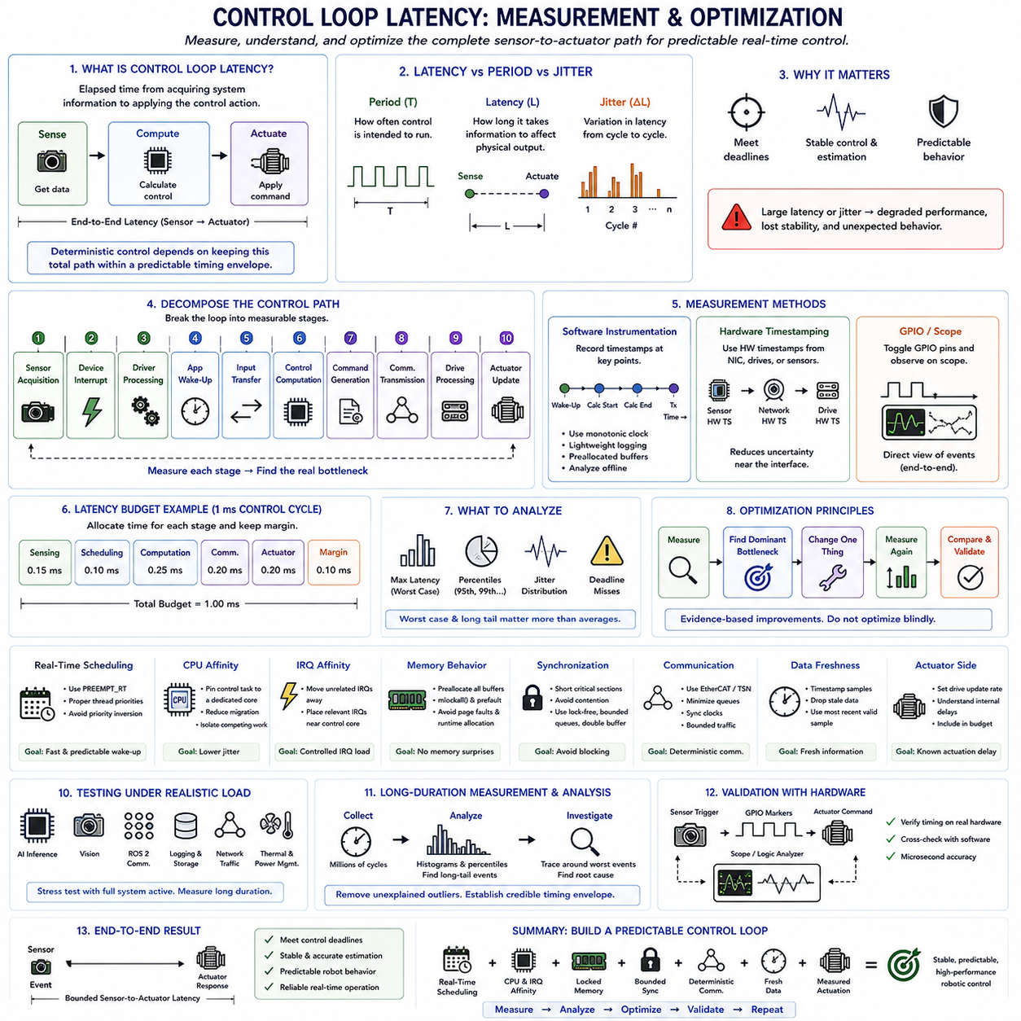
Control-loop latency is the elapsed time between acquiring information about a physical system and applying the corresponding control action. In an embedded robot, this path may include sensor sampling, interrupt handling, task wake-up, data transfer, state estimation, control computation, communication, and actuator response. Reliable control therefore depends not only on algorithm quality but also on keeping this complete sensor-to-actuator path within a predictable timing envelope.
Latency must be distinguished from control-loop period. A controller may be configured to execute every one millisecond, but its actual response to each sensor event can vary within or beyond that interval. The period defines how frequently control is intended to occur, while latency describes how long information takes to influence the physical output. Both quantities matter, and excessive variation in either can degrade deterministic control.
Jitter represents variation in timing from one control cycle to another. Even when average latency is small, occasional large deviations can disturb sampling intervals and actuator update timing. Control algorithms often assume reasonably consistent temporal spacing between observations and commands. Large jitter can therefore reduce estimation accuracy, alter effective loop dynamics, consume stability margin, and make the physical behavior more difficult to predict.
Control-loop analysis should begin by decomposing the complete timing path into measurable stages. A typical sequence is sensor acquisition, device interrupt, driver processing, application wake-up, input transfer, control calculation, command generation, network transmission, drive processing, and actuator update. Measuring only the control algorithm hides delays elsewhere. End-to-end decomposition allows engineers to determine which component actually dominates the timing budget.
Accurate timestamps are essential for this analysis. Monotonic clocks are generally appropriate for measuring elapsed time because ordinary wall-clock corrections do not disturb their progression. When events occur across multiple processors or devices, synchronized clocks are required so timestamps can be compared meaningfully. Hardware timestamps can further reduce uncertainty by recording events close to the actual sensor, network, or actuator interface rather than after software processing.
Software instrumentation can record timestamps at important boundaries such as task wake-up, sensor-data availability, control calculation start and completion, and command transmission. The instrumentation itself should remain lightweight because detailed logging can modify the timing being measured. A practical design stores compact trace records in preallocated buffers and performs formatting, visualization, or disk writing later in a lower-priority context.
Hardware-assisted measurement can provide an independent view of end-to-end timing. GPIO pins may be toggled at selected points in the control path and observed with an oscilloscope or logic analyzer. A sensor trigger and actuator command can then be compared directly without depending entirely on software clocks. This technique is particularly valuable when validating microsecond-scale timing or investigating discrepancies between application timestamps and physical behavior.
Latency should be expressed as a budget rather than as one undifferentiated number. If a one-millisecond control cycle is required, portions of that interval can be allocated to sensing, scheduling, computation, communication, and actuator processing while preserving a safety margin. A timing budget makes architectural tradeoffs explicit and prevents one component from consuming nearly the entire deadline while leaving no capacity for normal variation elsewhere.
Worst-case behavior is more important than favorable average performance for critical control. A loop with an average latency of 200 microseconds but occasional two-millisecond spikes cannot reliably satisfy a one-millisecond deadline. Engineers should therefore examine maximum latency, high percentiles, jitter distributions, and deadline misses in addition to averages. Long-tail events frequently reveal scheduling, memory, interrupt, communication, or driver problems hidden by aggregate statistics.
Optimization should first target the largest and least predictable contributors rather than simply reducing computation time. If the controller itself requires only 50 microseconds but scheduling occasionally adds 500 microseconds, optimizing arithmetic provides little benefit. Measurements should guide engineering effort toward the dominant source, whether it is task wake-up, an interrupt storm, page faults, lock contention, network queues, device drivers, or actuator-side processing.
PREEMPT_RT can reduce scheduling-related latency by making Linux kernel execution more preemptible and moving much interrupt processing into schedulable threads. A high-priority control task can therefore respond more quickly when it becomes runnable. However, the real-time kernel should be combined with carefully selected scheduling priorities because poorly configured application or IRQ priorities can still produce excessive blocking or starvation.
CPU affinity can reduce control-loop jitter by assigning the critical thread to a stable processor core. This limits migration and reduces competition with unrelated application workloads. IRQ affinity can complement this arrangement by moving unnecessary interrupts away from the control core or deliberately placing a relevant device interrupt near the control task. The optimal arrangement depends on whether interference reduction or minimum device-to-task handoff latency is more important.
Memory behavior should also be removed from the critical timing path where possible. Page faults and runtime allocation can introduce unpredictable delays, so buffers and control structures should be allocated before periodic execution begins. Memory locking with mechanisms such as mlockall(), combined with prefaulting of stacks and buffers, helps ensure that required pages are resident before the controller enters its real-time operating phase.
Synchronization mechanisms must be examined because locks can introduce blocking that is difficult to see from computation profiles alone. Critical sections should remain short, resource ownership should be predictable, and priority inversion should be controlled. Where appropriate, bounded queues, lock-free data exchange, double buffering, or carefully designed shared-memory structures can reduce coupling between high-priority control and lower-priority perception, planning, logging, or diagnostic tasks.
Communication latency becomes part of the control loop whenever sensors or actuators are networked. EtherCAT can provide efficient cyclic exchange for tightly coupled motion and I/O, while TSN mechanisms can provide synchronized and scheduled traffic within broader Ethernet architectures. Regardless of technology, queueing, network interrupts, synchronization error, transmission windows, and remote processing must be included in the sensor-to-actuator timing measurement.
Data freshness should be considered alongside latency. A control calculation completed quickly can still be ineffective if it operates on an old sensor sample that waited in a queue. Each important sample should therefore carry timing information that allows the system to estimate its age. For some real-time pipelines, discarding obsolete data and processing the newest valid sample provides better control behavior than processing every queued observation in sequence.
The actuator side of the loop should not be treated as instantaneous. A command may be received by a motor drive, buffered until the next internal cycle, processed by local control electronics, and only then applied to the power stage. These delays can be substantial relative to a high-frequency control period. End-to-end optimization must therefore include device configuration and internal update rates rather than stopping measurement at network transmission.
Testing must reproduce realistic interference. AI inference, camera processing, ROS2 communication, storage logging, network transfers, background services, and thermal or power-management behavior can all affect control-loop timing. Stress testing under representative workloads reveals whether the timing architecture remains stable when the complete robotic software stack is active rather than only when the controller is tested in isolation.
Long-duration measurement is necessary because rare latency spikes may occur only after millions of cycles. Histograms and percentile statistics help characterize the latency distribution, while traces surrounding the worst events can identify their causes. The objective is to progressively eliminate unexplained outliers and establish a timing envelope that remains credible over the intended operating duration and workload range.
Optimization should be iterative. Engineers establish a baseline, identify the dominant latency source, make one controlled architectural or configuration change, repeat the measurement, and compare the resulting distribution. This approach avoids attributing improvements to unrelated modifications and produces evidence for each optimization. Changes that reduce average latency but worsen the maximum or increase jitter should be evaluated carefully for real-time control.
A well-optimized control loop therefore combines predictable scheduling, isolated CPU resources, controlled IRQ placement, prepared memory, bounded synchronization, deterministic communication, fresh data, and measured actuator behavior. The final objective is not the smallest possible latency under ideal conditions, but a stable and defensible sensor-to-actuator response bound that remains below the control deadline during realistic robotic operation.

08.08 Mixed Criticality Design: Safety, Realtime, Non-Realtime
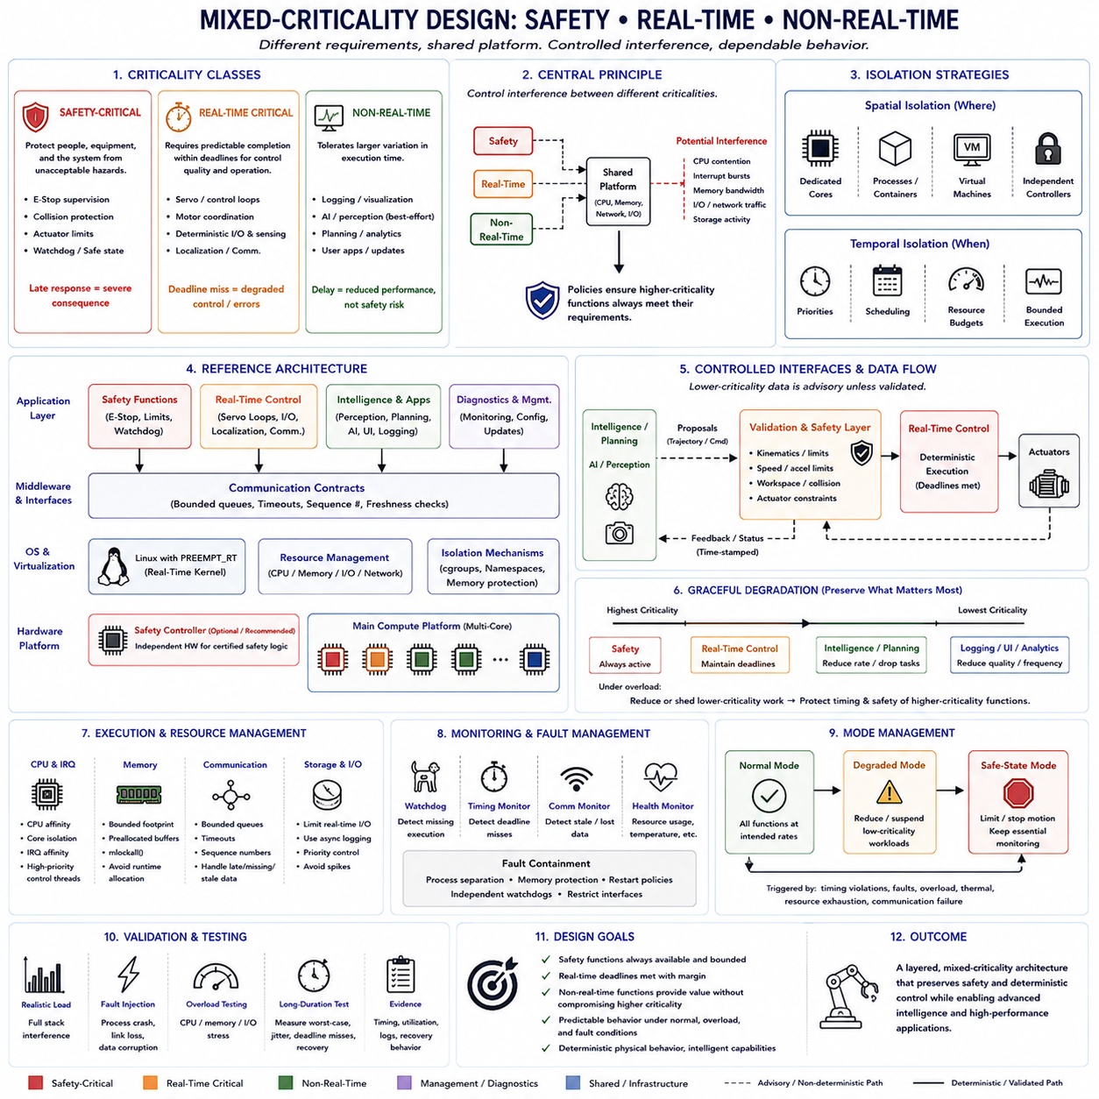
Mixed-criticality design is an architectural approach for systems in which functions with different timing, reliability, and safety requirements share the same computing platform. A robotic controller may simultaneously execute safety monitoring, hard real-time motion control, perception, planning, diagnostics, logging, and user applications. These workloads should not receive identical treatment because the consequences of delay or failure differ substantially across functions.
Criticality describes how strongly system correctness depends on a function operating within its required behavioral and timing limits. A safety shutdown mechanism may have severe consequences if it responds late, while delayed telemetry may merely reduce observability. Mixed-criticality architecture therefore classifies functions according to their operational importance and assigns scheduling, isolation, resource, monitoring, and failure-response policies that correspond to their consequences.
Safety-critical functions protect people, equipment, or the physical system from unacceptable hazards. Examples include emergency-stop supervision, collision protection, actuator limit enforcement, watchdog functions, and safety-state transitions. Their design emphasizes bounded response, independence from noncritical workloads, controlled failure behavior, and evidence that required actions remain available even when other software becomes overloaded or behaves unexpectedly.
Real-time critical functions require predictable completion within defined deadlines because timing directly affects control quality or system operation. Servo loops, motor-control coordination, deterministic sensor acquisition, localization updates, and industrial communication may belong to this category. These functions are not automatically safety-critical, but deadline violations can destabilize control, reduce accuracy, or propagate errors into safety-related parts of the robotic system.
Non-real-time functions usually tolerate greater variation in execution time. Logging, visualization, software updates, analytics, user interfaces, background data processing, and some AI workloads may continue to provide value even when temporarily delayed. Their performance can be optimized for throughput or responsiveness, but they should not consume resources in ways that prevent safety-critical or real-time functions from meeting their timing and availability requirements.
The central mixed-criticality principle is controlled interference. Sharing processors, memory, networks, and operating-system services creates opportunities for one workload to disturb another. A large AI inference task may consume CPU and memory bandwidth, a camera pipeline may generate interrupt bursts, and logging may produce storage activity. Architecture must ensure that these activities cannot unpredictably delay the execution path of higher-criticality functions.
Spatial isolation separates workloads through processors, cores, processes, memory regions, containers, virtual machines, or physically independent controllers. A robot may dedicate a CPU core to deterministic control while perception and planning execute on other cores. Stronger safety boundaries may place emergency or certified safety logic on an independent safety controller so that failure of the main Linux computer cannot disable essential protective behavior.
Temporal isolation controls when and for how long workloads may consume processing resources. Real-time priorities, CPU affinity, bounded execution, periodic scheduling, and resource budgets can prevent lower-criticality software from dominating processor time. Temporal isolation is particularly important when several functions must share a multicore Linux platform because physical separation between processes alone does not guarantee that their execution times will remain independent.
PREEMPT_RT can support the real-time portion of a mixed-criticality Linux architecture by reducing scheduling nondeterminism and making interrupt processing more controllable. High-priority control threads can receive predictable scheduling while lower-priority services operate in the remaining capacity. However, scheduling priority is only one layer of protection. CPU, IRQ, memory, communication, and synchronization interference must also be considered when establishing criticality boundaries.
CPU affinity and core isolation provide useful mechanisms for separating critical execution from best-effort computation. Dedicated real-time cores can host control tasks and selected IRQ threads, while housekeeping cores execute logging, networking, graphical interfaces, AI support services, and operating-system activity. This structure reduces interference and also makes the timing architecture easier to reason about because expected workloads on each core are explicitly defined.
Memory isolation is equally important because separate CPU cores may still share caches, memory controllers, and DRAM bandwidth. Large image processing or AI workloads can interfere with small deterministic control tasks through shared memory infrastructure. Critical software should therefore use bounded memory footprints, preallocated buffers, memory locking where appropriate, and controlled communication structures rather than relying on unrestricted runtime allocation or large shared data structures.
Communication between criticality domains must be carefully constrained. A safety or real-time process should not become unpredictably blocked because a lower-criticality producer holds a lock or fills an unbounded queue. Bounded queues, shared-memory buffers, double buffering, timeouts, sequence counters, and freshness checks can create explicit communication contracts. The interface should define what happens when data is late, missing, invalid, duplicated, or stale.
Data from lower-criticality intelligence functions should generally be treated as advisory unless the architecture explicitly validates it before it influences critical control. Perception, AI inference, or high-level planning may propose trajectories or commands, while a deterministic control or safety layer checks velocity, acceleration, workspace, collision, and actuator constraints. This separation prevents sophisticated but timing-variable computation from directly bypassing essential physical protections.
Graceful degradation is a fundamental mixed-criticality behavior. When computational demand exceeds available resources, the system should preserve the most important functions rather than allowing all workloads to degrade equally. Visualization quality may be reduced, logging frequency lowered, AI processing skipped, or planning rates decreased while safety monitoring and motion-control deadlines continue to be protected. Resource reduction should follow an intentional criticality hierarchy.
Mode transitions provide a structured way to respond to overload or faults. During normal operation, all functions may execute at their intended rates. If timing violations, communication failures, thermal limits, or resource exhaustion are detected, the system can enter a degraded operating mode in which lower-criticality workloads are reduced or suspended. Severe conditions can trigger a safe-state transition in which motion is limited or stopped while essential monitoring remains active.
Watchdogs and runtime monitors provide evidence that critical functions continue to operate correctly. A watchdog can detect missing execution, while timing monitors can identify deadline overruns and communication monitors can detect stale or absent data. Monitoring should itself be designed according to the criticality of the behavior being supervised. A monitor that depends entirely on the failed component may provide little protection against common-mode failure.
Failure containment prevents faults from propagating across criticality boundaries. A perception process that crashes should not corrupt the memory of a motor controller, and a blocked logging service should not prevent a safety task from executing. Process separation, memory protection, restricted interfaces, bounded resource ownership, restart policies, and independent watchdogs can reduce propagation. The stronger the required assurance, the stronger the containment boundary should generally become.
Resource reservations should preserve timing margin rather than maximizing utilization. A processor operating continuously near full capacity may achieve high throughput but leave little protection against transient workloads or execution-time variation. Mixed-criticality systems deliberately reserve computational capacity for important functions and abnormal conditions. From a real-time perspective, unused capacity can represent safety and timing margin rather than wasted computing performance.
Validation must test interactions among criticality classes rather than evaluating each function only in isolation. Safety and control tasks should be measured while perception, AI inference, networking, storage, logging, and user applications create realistic interference. Fault injection and overload testing can examine whether lower-criticality failures remain contained and whether the system performs the intended degradation or safe-state transition when resource assumptions are violated.
Timing evidence should include worst-case latency, jitter, deadline misses, resource utilization, communication delays, and recovery behavior under representative operating conditions. Long-duration testing is important because rare interference may emerge only after extended execution. The objective is to demonstrate that higher-criticality functions retain their required timing envelope even when lower-criticality workloads experience peak demand, faults, or temporary overload.
A practical robotic architecture therefore forms a hierarchy rather than a single uniform software environment. Safety functions occupy the strongest protection boundary, deterministic real-time control receives tightly managed execution resources, and non-real-time intelligence and application functions use the remaining computational capacity. Explicit interfaces connect these domains while monitors, validation, and degradation policies prevent lower-criticality behavior from compromising higher-criticality requirements.
Mixed-criticality design ultimately recognizes that modern robots combine fundamentally different kinds of computation on interconnected hardware. Safety logic requires dependable protection, real-time control requires bounded timing, and perception, AI, logging, and user services often require flexible high-throughput computing. By separating these requirements and controlling their interactions, the architecture can preserve deterministic physical behavior without sacrificing the computational capabilities needed for intelligent robotic systems.

08.09 Real-Time Debugging Tools: Cyclictest, LTTng, Trace Compass
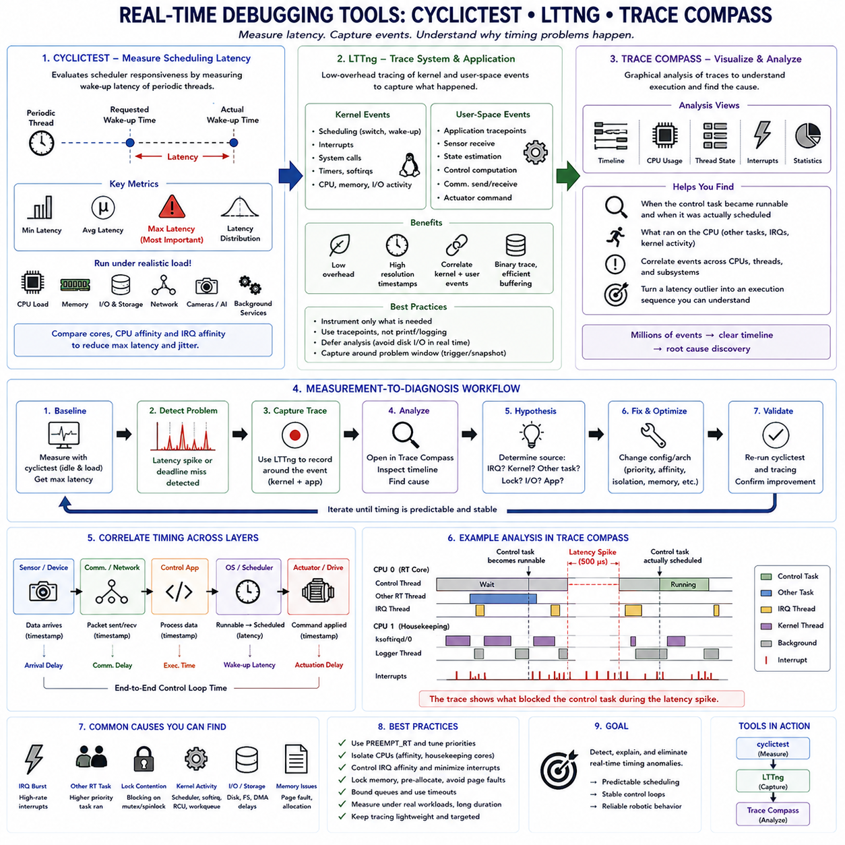
Real-time debugging focuses on finding rare timing violations that may not appear during ordinary functional testing. A robot can execute correctly for millions of cycles and still experience an occasional scheduling delay large enough to violate a control deadline. Tools such as cyclictest, LTTng, and Trace Compass provide complementary views of these problems by measuring latency, recording system events, and reconstructing the execution sequence that produced an abnormal timing event.
Cyclictest is widely used to evaluate scheduling latency in Linux real-time environments. It creates periodic threads that sleep until predetermined wake-up times and measures the difference between the requested wake-up time and the actual time at which each thread resumes execution. This difference provides a practical indication of scheduler responsiveness and helps characterize whether a kernel and system configuration are suitable for deadline-sensitive workloads.
The most important cyclictest result is usually not the average latency but the maximum observed latency. A system may show an excellent average while occasionally producing a large outlier that threatens a hard or firm real-time deadline. Minimum, average, maximum, and latency-distribution information should therefore be considered together. Long-duration measurements are especially valuable because rare interference patterns may emerge only after many millions of scheduling events.
Cyclictest should be executed under realistic system stress rather than only on an idle computer. CPU-intensive workloads, memory pressure, storage operations, network traffic, camera processing, AI inference, and background services can expose interference that remains invisible during simple tests. Comparing idle and loaded measurements helps determine whether the timing architecture maintains predictable scheduling when the complete embedded robotic workload is operating.
CPU affinity is useful when performing cyclictest experiments because latency can differ significantly between processor cores. A core dedicated to real-time execution may produce different results from a housekeeping core handling operating-system services and device interrupts. Repeating measurements with different CPU and IRQ affinity configurations allows engineers to evaluate whether isolation policies actually reduce maximum latency and jitter rather than merely changing average performance.
Cyclictest identifies that a latency problem exists, but it does not always explain why the delay occurred. When a large latency spike is detected, system tracing becomes necessary to reconstruct what happened around the event. The investigation may need to determine which task was running, whether an interrupt occurred, whether a higher-priority thread preempted execution, or whether kernel activity prevented the real-time thread from running when expected.
Linux Tracing Toolkit next generation, commonly known as LTTng, provides low-overhead tracing for Linux systems. It can capture kernel and user-space events while an application is running, producing a detailed temporal record of system behavior. Kernel scheduling, interrupts, system calls, process activity, and application-defined tracepoints can be correlated to understand interactions between the real-time application and the operating system.
Kernel tracing is particularly useful for analyzing scheduler behavior. Events associated with task switches, wake-ups, interrupts, and related kernel activity can reveal the interval between a real-time thread becoming runnable and actually receiving CPU time. If this interval unexpectedly increases, the trace can show what occupied the processor and help distinguish scheduling interference from delays occurring inside the application itself.
User-space tracepoints extend the analysis into the control software. Developers can place trace events around sensor reception, state estimation, control computation, communication, and actuator-command generation. These application events can then be correlated with kernel events. This creates a unified timeline connecting physical-control processing with operating-system behavior and makes it possible to investigate the complete execution path instead of examining isolated functions.
Tracing must be designed carefully because measurement itself can perturb the system. Excessive event generation, synchronous logging, text formatting, or disk writes can alter the latency being investigated. Real-time tracing therefore favors compact binary events, efficient buffering, selective instrumentation, and deferred analysis. Engineers should capture enough information to explain abnormal behavior without turning the tracing mechanism into a new source of timing interference.
Trace Compass provides a graphical environment for analyzing traces collected from Linux and other tracing frameworks. Large traces can contain millions of events that are difficult to interpret manually. Trace Compass organizes this information into timelines, state views, statistics, and analysis perspectives that help engineers understand CPU utilization, thread execution, scheduling transitions, interrupts, and interactions among software components.
A timeline view is particularly valuable for real-time debugging because timing failures are fundamentally temporal events. Engineers can inspect the period surrounding a latency spike and observe which thread occupied a CPU, when the control task became runnable, when it was scheduled, and what interrupt or kernel activity occurred nearby. This transforms a numerical latency outlier into an execution sequence that can be investigated systematically.
The three tools therefore support different stages of the debugging process. Cyclictest answers whether unacceptable scheduling latency exists. LTTng records detailed evidence about system and application execution. Trace Compass helps organize and interpret that evidence. Used together, they form a measurement-to-diagnosis workflow in which latency anomalies are first detected, then captured with sufficient context, and finally analyzed to identify their likely cause.
A useful workflow begins by establishing a baseline on the target hardware and kernel configuration. Cyclictest can measure scheduling behavior before optimization, including maximum latency under both idle and stressed conditions. Engineers can then apply changes such as PREEMPT_RT configuration, CPU isolation, scheduling-priority adjustment, IRQ affinity, memory locking, or service reduction and repeat exactly the same workload to determine whether the timing distribution actually improves.
When an unexplained outlier remains, tracing should focus on the time interval surrounding that event. LTTng can record scheduler and interrupt activity while application tracepoints mark the control cycle. The trace can reveal whether the delay corresponds to an IRQ burst, another real-time task, kernel execution, lock contention, communication processing, or application behavior. Optimization can then target measured evidence rather than assumptions about the source of latency.
Correlation between multiple timing layers is essential. A control loop may appear late because its thread was scheduled late, because sensor data arrived late, because communication was delayed, or because computation took longer than expected. Application timestamps combined with kernel tracing help separate wake-up latency, execution time, communication delay, and blocking time. This decomposition prevents unrelated timing effects from being incorrectly attributed to the scheduler.
Real-time debugging should also examine interrupt behavior. High-rate network, storage, USB, camera, CAN, or other device interrupts can interfere with critical execution. With PREEMPT_RT, many interrupt handlers execute as schedulable threads, allowing their priorities and CPU placement to be analyzed. Traces can reveal whether IRQ activity is concentrated on the real-time core and whether changing IRQ affinity reduces interference without increasing device-to-control latency.
Memory-related events must be considered when timing spikes cannot be explained by scheduling alone. Page faults, runtime allocation, lock contention, and memory pressure can produce delays inside otherwise deterministic code. Memory locking with mlockall(), prefaulting, preallocated buffers, and bounded data structures can remove some of these sources. Measurements should then be repeated to confirm that the change reduces long-tail latency under representative memory pressure.
The same methodology applies to communication-heavy control systems. EtherCAT cycles, TSN traffic, ROS2 communication, or other network events can be marked with application tracepoints and correlated with CPU scheduling. Engineers can determine whether a missed control deadline originated in the network, driver, IRQ path, middleware, application scheduler, or control computation. End-to-end timing analysis is more informative than optimizing each subsystem independently.
Long-duration tracing requires a balance between visibility and data volume. Recording every possible event for many hours can generate enormous traces and make analysis difficult. Selective event sets, rotating buffers, snapshots, triggers, and focused trace sessions can preserve information around abnormal conditions while limiting overhead. The tracing strategy should be designed around the specific timing hypothesis being tested rather than collecting unlimited data without a diagnostic objective.
Real-time debugging is therefore an iterative engineering process. Establish a reproducible workload, measure latency, identify an outlier, collect targeted traces, inspect the execution timeline, form a hypothesis, modify one configuration or architectural element, and repeat the measurement. Maintaining consistent test conditions is essential because simultaneous changes make it difficult to determine which modification actually improved or degraded timing behavior.
The final objective is not simply to produce attractive benchmark numbers. Engineers need evidence that the complete robotic control platform maintains its required timing envelope under realistic CPU, memory, I/O, communication, and application loads. Cyclictest provides quantitative latency evidence, LTTng exposes detailed execution events, and Trace Compass supports temporal diagnosis. Together they provide a practical foundation for finding, explaining, and systematically eliminating real-time timing anomalies.

08.10 Robot Joint Servo Loop Real-Time Implementation Case
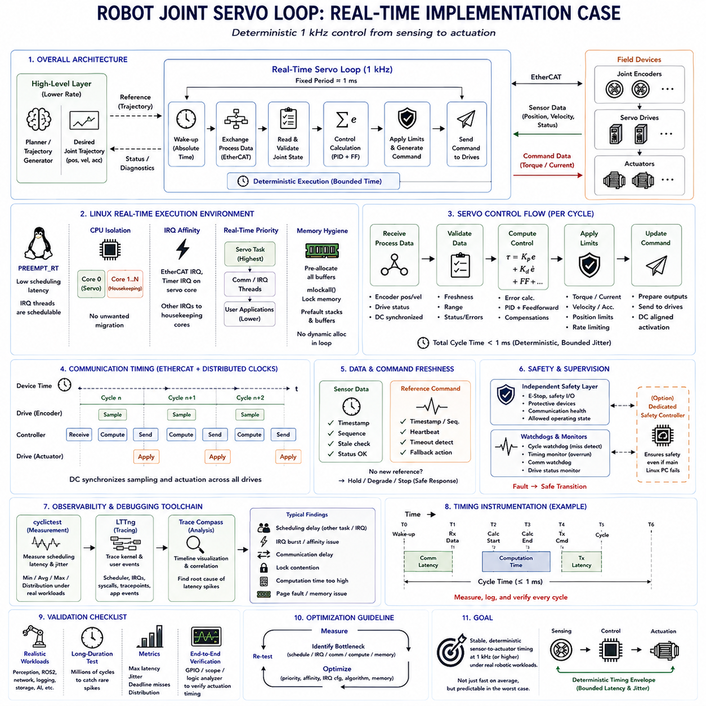
A robot joint servo loop is a closed-loop real-time control mechanism that repeatedly measures joint motion, compares the measured state with a commanded reference, calculates corrective action, and updates the actuator. Unlike high-level planning, servo control operates directly on physical dynamics and must satisfy strict timing constraints. Predictable execution is therefore as important as the mathematical accuracy of the controller itself.
A typical joint control architecture separates trajectory generation from the high-frequency servo loop. A planner or trajectory generator produces desired joint position, velocity, and possibly acceleration references at a moderate rate. The real-time servo task consumes these references and executes at a much higher fixed frequency, maintaining smooth actuator behavior between planning updates while isolating motion control from variable planning computation.
For this implementation case, consider a Linux-based robot controller connected to distributed servo drives through EtherCAT. Joint encoders provide measured position and velocity, while the controller sends torque or current-related commands to each drive. A 1 kHz servo frequency gives the complete control cycle approximately one millisecond, requiring sensing, communication, computation, synchronization, and command delivery to fit within a bounded timing budget.
The periodic task should use a deterministic time base rather than repeatedly sleeping for a relative duration. An absolute wake-up schedule prevents accumulated timing drift because each activation is referenced to the intended cycle timeline. The task wakes at the beginning of each period, exchanges process data, evaluates joint states, calculates control output, prepares the next command, and then waits for the following absolute activation point.
PREEMPT_RT can improve the Linux execution environment by reducing kernel scheduling latency and allowing much interrupt processing to operate as schedulable threads. The servo task should run with an appropriate real-time scheduling policy and priority so that ordinary applications cannot unpredictably delay it. Priority design must also consider EtherCAT, timer, and device IRQ threads that participate in the same end-to-end control path.
CPU isolation further improves predictability by reducing interference from unrelated workloads. A dedicated processor core can execute the servo task and selected communication activity, while housekeeping cores handle logging, graphical interfaces, AI inference, networking, and background operating-system services. CPU affinity prevents unwanted migration, and IRQ affinity controls whether device interrupts execute near the control task or are deliberately moved away from it.
Memory preparation should occur before the robot enters active servo operation. Joint-state arrays, command buffers, communication structures, diagnostic records, and temporary calculation storage should be allocated during initialization. Memory locking with mlockall() can keep required pages resident, while prefaulting stacks and buffers reduces the probability of page faults occurring during the periodic loop. Dynamic allocation should be avoided in the critical execution path.
The EtherCAT communication cycle should be synchronized with the servo execution cycle. At each period, the controller obtains fresh process data containing encoder measurements and drive status, performs the control calculation, and prepares output process data for the actuators. Distributed Clocks can coordinate device timing so that multiple joint drives sample and apply commands with a consistent temporal relationship, which is essential for coordinated multi-axis motion.
The measured joint state must be validated before it is used by the controller. Position and velocity values should be checked for validity, freshness, range, and communication status. Sequence information or timestamps can identify stale measurements, while drive status flags can reveal communication or hardware faults. Invalid input should not silently propagate into the control law because a numerically correct controller can still generate dangerous output from corrupted state information.
The control calculation may use position, velocity, and torque feedback according to the actuator and robot architecture. A common structure combines position error and velocity error with feedforward terms derived from the desired motion. More advanced implementations may include gravity compensation, friction compensation, inverse dynamics, or model-based torque terms. Regardless of algorithm complexity, worst-case execution time must remain comfortably inside the allocated computation budget.
Command generation requires explicit physical limits. Torque, current, velocity, acceleration, and position constraints should be applied before actuator commands are transmitted. Rate limiting can prevent abrupt command changes, while joint limits protect the mechanical workspace. These constraints form an important boundary between high-level references and physical actuation and should execute deterministically within every control cycle rather than depending on slower supervisory software.
Multi-joint robots require coherent updates across all controlled axes. Calculating one joint significantly earlier than another can introduce temporal inconsistency, particularly in coordinated manipulation. A practical implementation reads the complete joint state, computes the relevant control vector, applies limits, and updates output commands as a synchronized set. EtherCAT Distributed Clocks can further align physical command application across distributed drives.
Communication and computation should be arranged as an explicit pipeline. One cycle may receive state data generated at a known device time, compute the corresponding command, and schedule that command for a defined actuator update instant. This structured relationship makes sensor-to-actuator latency easier to analyze. Without explicit phase alignment, apparently fast components can still create inconsistent data age and variable end-to-end response.
Shared information from planning or perception should cross into the servo domain through bounded interfaces. A trajectory process should not hold a mutex required by the high-priority servo task or fill an unlimited command queue. Double buffering, lock-free exchange, bounded queues, or carefully controlled shared memory can transfer references without unpredictable blocking. The servo loop should always have a defined response when no new high-level command is available.
Command freshness is as important as sensor freshness. If the trajectory generator stops updating because of overload or failure, the servo loop should detect that condition rather than indefinitely executing an obsolete command. A timestamp, sequence counter, or heartbeat can identify stale references. Depending on the robot design, the response may hold a safe position, reduce motion, transition to a degraded mode, or request a controlled stop.
Safety supervision should remain logically distinct from ordinary servo computation. The servo controller may enforce local position, velocity, and torque constraints, while an independent safety layer monitors emergency-stop signals, protective devices, communication health, and permitted operating states. Higher assurance requirements may justify a separate safety controller so that failure of the main Linux computer cannot eliminate essential protective functions.
Watchdogs can monitor whether the periodic task continues executing at the required frequency. Each successful cycle can update a heartbeat observed by another component, while internal timing monitors record cycle duration and deadline status. Repeated overruns, missing communication cycles, invalid drive states, or stale data should produce explicit fault transitions. The objective is to detect loss of deterministic behavior before it develops into uncontrolled physical motion.
Timing instrumentation should be incorporated into the implementation from the beginning. Lightweight timestamps can mark cycle wake-up, EtherCAT reception, control calculation start, calculation completion, command transmission, and cycle completion. These measurements allow engineers to separate scheduling latency, communication delay, computation time, and residual timing margin rather than treating the complete loop as one unexplained latency value.
Cyclictest can first characterize the underlying Linux scheduling environment before the servo application is evaluated. Measurements should be performed with the intended PREEMPT_RT configuration, CPU isolation, priorities, and IRQ placement. Testing under CPU, memory, storage, network, and AI workloads helps determine whether the platform provides sufficient scheduling margin before control-specific timing is added to the system.
LTTng can then trace kernel and application events when unexplained timing spikes appear during servo execution. Scheduler switches, wake-ups, IRQ activity, and application tracepoints can reveal whether a late cycle originated from kernel scheduling, another real-time thread, communication processing, lock contention, or the controller itself. Trace Compass can reconstruct these events on a timeline and support systematic root-cause analysis.
Validation should reproduce the complete operating environment rather than testing the servo task only on an idle processor. Perception pipelines, ROS2 nodes, network communication, logging, storage activity, and AI workloads should execute simultaneously when they represent realistic robot operation. Long-duration tests are required because a servo loop running at 1 kHz executes millions of cycles quickly, and rare latency spikes may dominate real-time reliability.
The implementation should be evaluated using maximum latency, jitter, execution-time distribution, deadline misses, communication errors, stale-data events, and actuator response rather than average loop time alone. Hardware measurements using GPIO signals, an oscilloscope, or a logic analyzer can independently verify important software timestamps. This provides stronger evidence that the measured control timing corresponds to actual physical command application.
Optimization should proceed from measured bottlenecks. If scheduling dominates latency, priority and CPU isolation should be investigated. If IRQ activity causes spikes, affinity and interrupt configuration require attention. If computation approaches its budget, algorithms should be optimized or divided appropriately. If page faults or locking appear in traces, memory and synchronization architecture should be redesigned rather than simply increasing processor performance.
A robust robot joint servo implementation ultimately forms a deterministic chain from synchronized sensing to bounded physical actuation. PREEMPT_RT provides a controllable execution environment, CPU and IRQ isolation reduce interference, memory locking removes avoidable runtime uncertainty, EtherCAT supports cyclic multi-axis communication, and timing instrumentation verifies the result. The goal is not merely a 1 kHz nominal rate, but a stable sensor-to-actuator timing envelope that remains valid under realistic robotic workloads.

