Volume 02 Embedded Software Engineering

01. Embedded Software Fundamentals

01.01 Definition of Embedded Systems and Role in Robotics
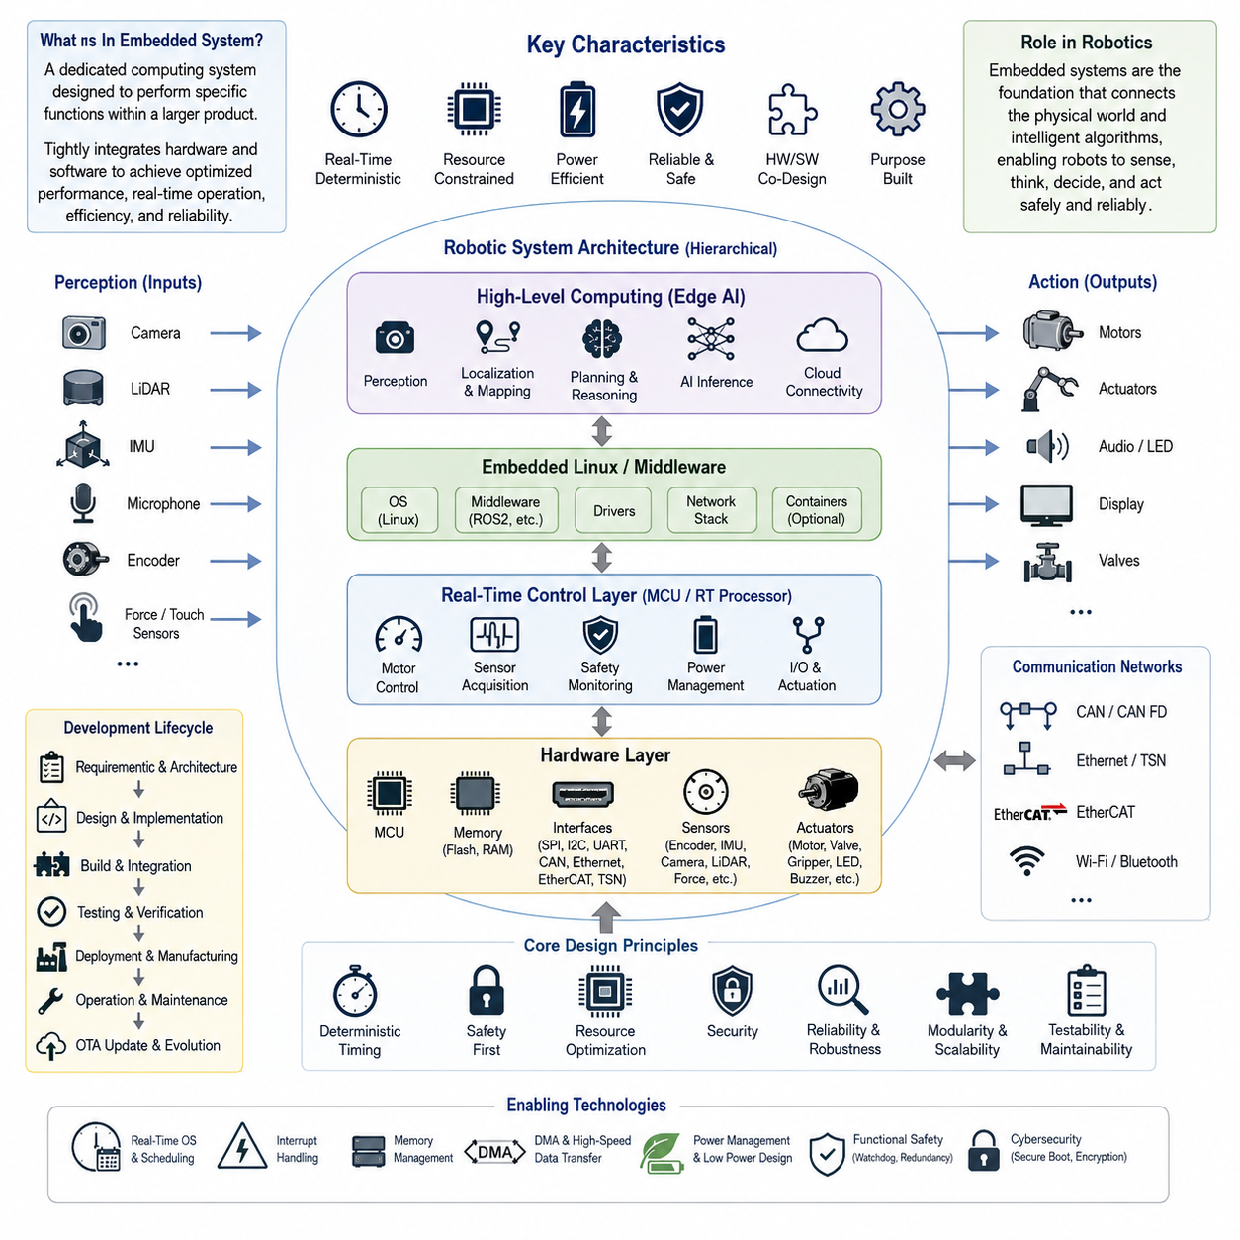
An embedded system is a dedicated computing system designed to perform one or more predefined functions within a larger electronic or mechanical product. Unlike general-purpose computers that execute a wide variety of applications, embedded systems are optimized for specific operational objectives, deterministic timing, energy efficiency, reliability, and hardware integration. They combine hardware and software into a tightly coupled platform where processors, memory, sensors, actuators, communication interfaces, and firmware operate as a unified system. Modern embedded systems are found in consumer electronics, industrial automation, automotive systems, medical devices, aerospace platforms, and increasingly in intelligent robotic systems that require continuous interaction with the physical world.
The defining characteristic of an embedded system is that its software is developed with full awareness of the underlying hardware architecture. Engineers must consider processor capabilities, memory capacity, peripheral interfaces, interrupt latency, power consumption, thermal constraints, and real-time execution requirements during every stage of development. Software is therefore designed not only to implement functional algorithms but also to maximize hardware utilization while maintaining deterministic behavior. This close relationship between software and hardware distinguishes embedded engineering from conventional desktop or cloud software development.
Robotics represents one of the most demanding application domains for embedded systems because robots continuously sense, compute, decide, and act in dynamic environments. Every robotic platform contains numerous embedded controllers responsible for executing low-level operations such as motor control, encoder acquisition, sensor synchronization, battery management, communication, safety monitoring, and actuator coordination. These controllers operate simultaneously with higher-level computing platforms running perception, localization, planning, and artificial intelligence algorithms. Together they form a hierarchical architecture where embedded systems provide the reliable physical foundation upon which intelligent robot behavior is built.
In a modern autonomous robot, embedded systems exist across multiple layers of computation. Microcontrollers typically manage deterministic control loops, safety functions, and hardware interfaces, while embedded processors execute operating systems, middleware, and application software. High-performance edge AI computers perform computationally intensive workloads such as computer vision, simultaneous localization and mapping, large neural network inference, and multimodal reasoning. These heterogeneous computing components communicate through buses and industrial networks including SPI, I2C, UART, CAN, CAN FD, Ethernet, EtherCAT, and Time-Sensitive Networking, enabling coordinated operation across the entire robotic platform.
Real-time responsiveness is one of the most critical requirements for robotic embedded systems. Motion controllers often execute servo loops at frequencies ranging from hundreds of hertz to several kilohertz, leaving only microseconds or milliseconds for sensing, computation, and command generation. Missing timing deadlines can degrade control performance, introduce instability, or even create hazardous operating conditions. Consequently, embedded software emphasizes deterministic execution, interrupt prioritization, predictable scheduling, bounded latency, and efficient resource management rather than maximizing raw computational throughput alone.
Resource constraints fundamentally shape embedded software architecture. Unlike desktop computers equipped with abundant memory and storage, embedded platforms frequently operate with limited Flash memory, SRAM, processor frequency, communication bandwidth, and electrical power. Software engineers therefore optimize memory allocation, reduce computational complexity, minimize unnecessary data movement, and carefully schedule concurrent tasks. Efficient firmware design extends battery life, improves thermal performance, reduces manufacturing cost, and increases long-term system reliability, all of which are essential for commercial robotic products.
Safety and reliability are equally important because embedded systems directly control physical hardware. A software defect may not simply terminate an application but could instead cause unintended robot motion, equipment damage, or injury to nearby operators. Embedded software therefore incorporates watchdog timers, redundancy, fault detection, health monitoring, diagnostic reporting, exception handling, and fail-safe state transitions. Industrial and safety-critical robots frequently follow structured development processes supported by standards that emphasize verification, traceability, defensive programming, and comprehensive validation throughout the product lifecycle.
Communication plays a central role in embedded robotic architectures. Individual controllers rarely operate independently; instead they exchange sensor measurements, control commands, diagnostic information, synchronization signals, and system health data with neighboring modules. Reliable communication protocols ensure consistent timing, low latency, fault tolerance, and interoperability between components produced by different manufacturers. As robotic systems become increasingly distributed, embedded communication infrastructure forms the backbone that connects sensing, control, perception, and cloud-based fleet management into a unified operational ecosystem.
The emergence of Artificial Intelligence has significantly expanded the responsibilities of embedded systems. Traditional firmware primarily executed deterministic algorithms with predefined behaviors, whereas modern embedded platforms increasingly host optimized neural network inference engines, hardware accelerators, and machine learning frameworks. AI-enabled embedded processors perform object detection, semantic segmentation, speech recognition, sensor fusion, predictive maintenance, anomaly detection, and adaptive control directly at the edge. Executing AI locally reduces communication latency, enhances privacy, improves robustness against network failures, and enables robots to react immediately to changing environmental conditions.
Robotic embedded systems are evolving toward heterogeneous computing architectures in which microcontrollers, real-time processors, embedded Linux computers, GPUs, NPUs, DSPs, and dedicated AI accelerators cooperate within a single platform. Time-critical control tasks remain on deterministic controllers, while computationally intensive perception and reasoning algorithms execute on more powerful processors. Middleware and standardized communication frameworks coordinate these heterogeneous resources, allowing robotic developers to balance performance, power consumption, scalability, maintainability, and system complexity without sacrificing deterministic control behavior.
The development lifecycle of embedded software extends well beyond firmware implementation. It includes hardware selection, architecture design, cross-compilation, debugging, hardware abstraction, integration testing, performance profiling, power optimization, security hardening, over-the-air update mechanisms, manufacturing validation, and long-term maintenance. Because robotic products often remain operational for many years, embedded software must support version management, backward compatibility, remote diagnostics, cybersecurity updates, and continuous feature enhancement throughout the entire operational lifetime of the robot.
As robotics advances toward autonomous machines, collaborative robots, humanoids, intelligent mobile platforms, and Physical AI systems, embedded technology will become even more essential. Future embedded systems will integrate real-time control, edge intelligence, functional safety, secure communication, energy-aware computing, and distributed autonomy into unified computing platforms capable of supporting increasingly sophisticated robotic behaviors. Rather than serving merely as low-level controllers, embedded systems are becoming the indispensable computational foundation that bridges physical hardware with intelligent software, enabling robots to perceive, reason, interact, and safely operate in complex real-world environments.

01.02 Embedded vs General SW: Resource Constraints / Realtime
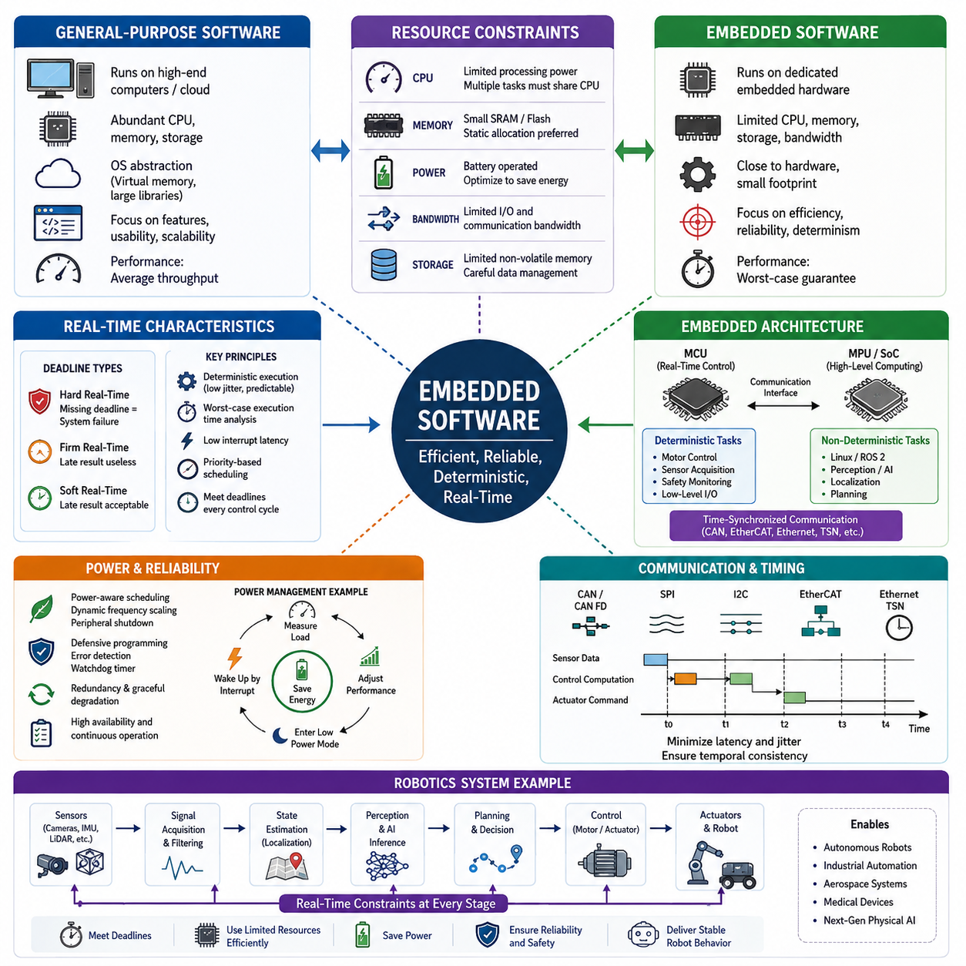
Embedded software differs fundamentally from general-purpose software because it is designed to execute dedicated functions within hardware systems that possess strict limitations in computing resources, power consumption, memory capacity, and execution time. Unlike desktop or cloud applications that operate on relatively abundant hardware, embedded systems are tightly coupled with specific processors, peripherals, and physical devices. Every software component must therefore be designed with awareness of the hardware environment, ensuring that functionality, reliability, and efficiency remain balanced throughout the product lifecycle. This close integration between software and electronics makes embedded engineering a multidisciplinary field that combines computer science, electrical engineering, and real-time control.
General-purpose software typically prioritizes functionality, usability, portability, and scalability across diverse hardware platforms. Modern operating systems provide extensive abstraction layers that isolate applications from hardware details, allowing developers to focus primarily on business logic and user experience. Large memories, multi-core processors, virtual memory, and high-performance storage reduce the impact of inefficient implementations. As a result, software architectures can tolerate dynamic memory allocation, extensive libraries, garbage collection, and variable execution timing without significantly affecting overall system behavior.
Embedded software operates under fundamentally different assumptions. The processor frequency, available SRAM, Flash storage, communication bandwidth, and energy budget are predetermined by the hardware design and cannot easily be expanded after manufacturing. A microcontroller may provide only a few hundred kilobytes of RAM and several megabytes of Flash memory, requiring developers to optimize every variable, function, and communication buffer. Software complexity must therefore be carefully managed so that limited computational resources remain sufficient even under worst-case operating conditions.
Resource constraints extend beyond memory capacity alone. CPU utilization must remain predictable because embedded processors often execute multiple concurrent tasks including sensor acquisition, communication protocols, actuator control, diagnostic monitoring, and safety supervision. Excessive computational load can delay critical control loops and introduce instability into physical systems. Efficient algorithms, lightweight data structures, hardware acceleration, and careful scheduling are therefore essential design considerations rather than optional optimizations.
Memory management represents one of the most important differences between embedded and general software. Desktop operating systems rely heavily on virtual memory, paging, and dynamic allocation, whereas many embedded systems either prohibit or severely restrict dynamic memory usage after initialization. Memory fragmentation, allocation failures, and unpredictable allocation latency may eventually compromise long-term reliability. Consequently, embedded software frequently relies on static allocation, fixed-size memory pools, deterministic buffer management, and compile-time memory planning to guarantee stable operation throughout continuous execution.
Power consumption is another defining characteristic of embedded systems. Battery-powered robots, drones, wearable devices, industrial sensors, and IoT platforms must maximize operating time while maintaining required performance levels. Software directly influences power usage through processor utilization, peripheral activation, communication frequency, memory accesses, and sleep-state transitions. Effective embedded software therefore integrates power-aware scheduling, dynamic frequency scaling, peripheral shutdown strategies, interrupt-driven execution, and efficient communication protocols to extend battery life without sacrificing functionality.
Reliability requirements also distinguish embedded software from conventional applications. Consumer software may recover from occasional crashes through application restarts or operating system recovery mechanisms. In contrast, embedded software controlling industrial robots, medical equipment, vehicles, or aerospace systems may have no opportunity for immediate recovery because failures can directly affect physical safety, equipment integrity, or mission success. Consequently, defensive programming, fault detection, watchdog timers, exception handling, redundancy, and graceful degradation become integral architectural components from the earliest design stages.
Real-time behavior is perhaps the most important characteristic separating embedded software from general-purpose software. Real-time systems are evaluated not only by whether they produce correct results but also by whether those results are delivered within specified timing constraints. Missing a deadline may be equivalent to producing an incorrect result. For example, a motor controller that calculates the correct torque command several milliseconds too late can destabilize an entire robotic platform even though the numerical computation itself is accurate.
Real-time constraints are commonly classified into hard real-time, firm real-time, and soft real-time requirements. Hard real-time systems cannot tolerate missed deadlines because timing failures may produce catastrophic consequences such as equipment damage or safety hazards. Firm real-time systems lose the value of delayed computations, although occasional deadline misses may not immediately endanger the system. Soft real-time systems permit moderate timing variation while maintaining acceptable overall performance, making them suitable for multimedia processing, user interfaces, and certain perception workloads.
Deterministic execution forms the foundation of real-time embedded software. Determinism refers to the ability of a system to produce consistent execution timing under identical operating conditions. Rather than maximizing average performance, embedded developers prioritize minimizing timing variability, execution jitter, interrupt latency, scheduling uncertainty, and communication delays. Worst-case execution time analysis therefore becomes significantly more important than average-case performance benchmarks when validating embedded applications.
Interrupt mechanisms provide rapid responses to external events while minimizing unnecessary processor activity. Instead of continuously polling hardware devices, processors remain available for other tasks until peripherals generate interrupts requiring immediate attention. However, excessive interrupt nesting, lengthy interrupt service routines, or poorly prioritized interrupts can increase latency and reduce system predictability. Consequently, embedded software often performs only minimal processing inside interrupt handlers while delegating more extensive computations to scheduled tasks.
Task scheduling further differentiates embedded software from traditional desktop applications. Bare-metal firmware often relies on super loops, finite state machines, or cooperative scheduling to minimize overhead and maximize determinism. More sophisticated embedded systems employ Real-Time Operating Systems that provide priority-based preemptive scheduling, synchronization primitives, timers, and inter-task communication. Regardless of implementation strategy, scheduling decisions must guarantee that critical control functions always receive sufficient processor time before less important background activities.
Communication latency is equally important in embedded robotics. Sensor measurements, motor commands, safety signals, and diagnostic messages frequently travel through CAN, CAN FD, CAN XL, SPI, I2C, UART, EtherCAT, Ethernet, or Time-Sensitive Networking infrastructures. Each communication interface introduces finite transmission delays, buffering effects, arbitration mechanisms, and synchronization challenges. Embedded software must therefore coordinate communication timing with control cycles so that information remains temporally consistent across distributed controllers.
The increasing adoption of Embedded Linux and heterogeneous computing platforms has expanded embedded software capabilities while introducing additional design complexity. Modern robots often combine microcontrollers responsible for deterministic low-level control with high-performance processors executing Linux, ROS 2, AI inference, perception, localization, and planning algorithms. This hierarchical architecture separates strict real-time functions from computationally intensive workloads, allowing each processor to operate according to its own timing requirements while communicating through carefully designed interfaces.
Artificial intelligence introduces new challenges for embedded resource management. Deep neural networks demand substantial computational throughput, memory bandwidth, and energy consumption, often exceeding the capabilities of traditional microcontrollers. Edge AI platforms such as embedded GPUs and specialized neural processing units enable local inference while maintaining acceptable latency, yet developers must still optimize model size, quantization, batching strategies, and inference scheduling to satisfy both resource limitations and real-time constraints. Efficient integration of AI with deterministic control remains one of the defining engineering challenges of next-generation autonomous systems.
Robotic platforms illustrate the interaction between resource constraints and real-time requirements particularly well. Sensor acquisition, localization, obstacle detection, motion planning, actuator control, battery management, communication, diagnostics, and safety monitoring all execute simultaneously while competing for finite computational resources. Failure to allocate processor time appropriately may increase localization drift, delay obstacle avoidance, reduce control stability, or compromise safety mechanisms. Consequently, embedded robotic software architectures typically partition workloads according to timing criticality, processor capability, and communication latency.
Successful embedded software engineering therefore requires a fundamentally different mindset from conventional software development. Developers must simultaneously optimize functionality, computational efficiency, memory utilization, power consumption, timing predictability, reliability, maintainability, and hardware integration rather than maximizing application features alone. Understanding these tradeoffs enables engineers to design robust embedded platforms capable of supporting increasingly sophisticated autonomous robots, intelligent industrial equipment, medical devices, aerospace electronics, and future Physical AI systems operating safely within strict resource limitations and deterministic real-time constraints.

01.03 Embedded Development Environment: Toolchain, IDE, Debugger
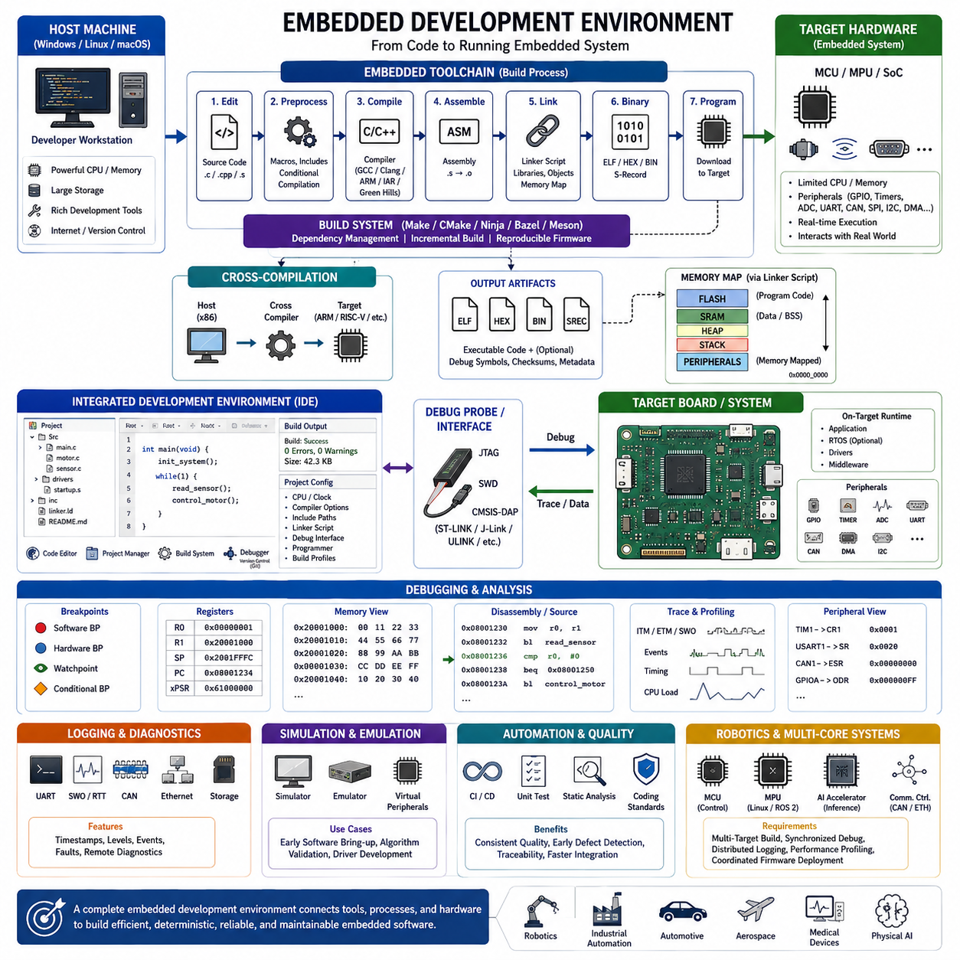
An embedded development environment is a comprehensive ecosystem that enables engineers to design, implement, test, debug, optimize, and maintain software running on dedicated hardware platforms. Unlike general-purpose software development, embedded development targets microcontrollers, processors, and System-on-Chip devices with limited computational resources and direct hardware interaction. The development workflow therefore extends beyond writing source code to include hardware configuration, cross-compilation, firmware generation, flashing, hardware debugging, timing analysis, and system validation. A well-designed development environment improves productivity, software quality, maintainability, and long-term reliability while reducing integration risks throughout the product lifecycle.
The embedded software toolchain consists of multiple tightly integrated components that transform human-readable source code into executable machine instructions. The process typically begins with source code editing, followed by preprocessing, compilation, assembly, linking, binary generation, programming into the target device, execution, and debugging. Each stage contributes to producing deterministic and optimized firmware suitable for the constraints of embedded hardware. Because errors introduced during any stage may propagate throughout the development process, understanding the complete toolchain architecture is essential for diagnosing software failures and improving overall development efficiency.
The compiler is one of the most critical components of the embedded toolchain. Its primary responsibility is translating high-level programming languages such as C and C++ into processor-specific machine code while applying various optimization techniques. Embedded compilers must generate highly efficient executable code because processor speed, Flash memory, and SRAM capacity are often severely limited. Popular compiler families include GNU GCC, LLVM Clang, ARM Compiler, IAR Embedded Workbench Compiler, and Green Hills Compiler. Compiler optimization levels influence execution speed, memory usage, debugging capability, and code predictability, requiring developers to balance performance with maintainability throughout different stages of development.
Before compilation begins, the preprocessor performs macro expansion, conditional compilation, header inclusion, and symbolic replacement. Conditional compilation is particularly valuable in embedded projects because the same firmware often supports multiple hardware revisions, processor families, communication interfaces, or product variants. Compile-time configuration minimizes runtime overhead while allowing a single source code base to serve multiple embedded platforms. Proper use of preprocessing directives improves portability and reduces duplicated source code without sacrificing performance.
Following compilation, the assembler converts processor-specific assembly instructions into relocatable object files. While most embedded applications are primarily written in high-level languages, assembly language remains important for startup code, interrupt entry routines, context switching, bootloaders, hardware initialization, and performance-critical algorithms. Assembly programming provides complete control over processor registers and execution timing, making it indispensable for implementing deterministic low-level functions that cannot tolerate compiler-generated overhead.
The linker combines object files, startup libraries, runtime support packages, middleware components, and application modules into a final executable image. Unlike desktop software development, embedded linking requires precise placement of program sections into Flash memory, SRAM, external memory, or dedicated hardware regions. Linker scripts explicitly define memory maps, interrupt vector locations, stack allocation, heap configuration, initialization data, and peripheral register placement. Careful linker configuration directly affects system stability, startup behavior, and memory utilization.
Binary generation converts the linked executable into formats suitable for programming embedded devices. Depending on the programming tool and processor architecture, firmware may be generated as ELF, HEX, BIN, or Motorola S-record files. These binary formats contain executable instructions together with optional debugging symbols, memory addresses, checksums, and metadata. Production firmware often excludes debugging information to minimize storage requirements, while development builds retain extensive symbolic information for source-level debugging.
Cross-compilation is a defining characteristic of embedded software development. In most projects, software is compiled on a powerful host computer but executed on an entirely different target processor. The host environment may operate on Windows, Linux, or macOS, whereas the target device may use ARM Cortex-M, ARM Cortex-A, RISC-V, PowerPC, or proprietary embedded architectures. Cross-compilers generate executable code specifically optimized for the target instruction set while allowing developers to benefit from the computational resources and development tools available on modern workstations.
Integrated Development Environments provide a unified workspace that combines source code editing, project management, compilation, debugging, version control, build automation, and hardware programming. Modern IDEs significantly improve developer productivity by integrating multiple tools into a consistent graphical interface. Common embedded IDEs include STM32CubeIDE, Keil MDK, IAR Embedded Workbench, MPLAB X, SEGGER Embedded Studio, Eclipse CDT, Visual Studio Code with embedded extensions, and vendor-specific development environments. Although many professional teams increasingly adopt command-line build systems for continuous integration, graphical IDEs remain valuable for debugging and hardware exploration.
Project configuration within an IDE extends beyond compiler settings alone. Developers configure processor architecture, clock frequency, startup files, middleware packages, include directories, compiler optimization levels, linker scripts, debugging interfaces, programming tools, and build profiles. Many modern IDEs automatically generate initialization code for clocks, GPIO, communication peripherals, timers, DMA controllers, and interrupt configurations. This automation reduces repetitive work while maintaining consistency across multiple development teams.
Build systems coordinate the compilation process by determining source file dependencies, incremental compilation requirements, compiler options, linker settings, and output generation. Traditional embedded projects frequently employ Makefiles, whereas modern projects increasingly utilize CMake, Ninja, Bazel, or Meson to improve portability and maintainability. Automated build systems support reproducible firmware generation, simplify multi-platform development, and integrate naturally with continuous integration pipelines used in large-scale embedded software projects.
Debugging represents one of the most important phases of embedded software development because software executes directly on physical hardware interacting with real-world signals. Unlike desktop applications, embedded programs frequently control motors, sensors, communication buses, safety devices, and actuators whose behavior cannot be fully reproduced through simulation. Effective debugging therefore requires visibility into processor execution, memory contents, peripheral registers, communication interfaces, timing behavior, and external electrical signals simultaneously.
Hardware debugging is commonly performed using dedicated interfaces such as JTAG and Serial Wire Debug. These interfaces allow developers to halt processor execution, inspect registers, examine memory, modify variables, set hardware breakpoints, monitor peripheral states, and single-step through source code while the processor remains connected to the target board. Modern debugging probes including ST-LINK, J-Link, CMSIS-DAP, ULINK, and various vendor-specific adapters provide high-speed communication between the host development environment and the embedded processor.
Software breakpoints, hardware breakpoints, watchpoints, and conditional breakpoints each serve different debugging purposes. Software breakpoints temporarily modify program memory to interrupt execution, whereas hardware breakpoints utilize dedicated processor resources without altering Flash contents. Watchpoints automatically halt execution when specified memory locations change, making them particularly valuable for identifying memory corruption, unexpected variable modifications, and synchronization problems in concurrent systems. Conditional breakpoints further improve debugging efficiency by activating only under predefined execution conditions.
Real-time debugging introduces additional challenges because interrupting processor execution may itself change system behavior. Time-critical control loops, communication protocols, and sensor acquisition tasks often depend on uninterrupted execution. Developers therefore complement conventional debugging with non-intrusive techniques such as trace recording, instruction tracing, event logging, serial output, Real-Time Transfer, Embedded Trace Macrocell, Instrumentation Trace Macrocell, and hardware performance counters. These mechanisms provide detailed execution histories without significantly disturbing real-time operation.
Monitoring processor registers and peripheral registers is fundamental for understanding embedded system behavior. Developers routinely inspect general-purpose registers, stack pointers, program counters, interrupt status registers, clock configuration registers, communication controller registers, timer values, DMA states, and GPIO configurations. Register-level debugging often reveals hardware initialization errors, configuration mismatches, synchronization failures, or unexpected interrupt conditions that cannot easily be identified through application-level observation alone.
Memory inspection is equally important because embedded software frequently manipulates memory-mapped peripherals, communication buffers, stacks, heaps, and direct memory access regions. Debuggers allow engineers to visualize memory contents in hexadecimal, binary, decimal, floating-point, or symbolic formats. Memory inspection helps detect stack overflow, buffer overflow, invalid pointer dereferencing, memory corruption, and incorrect peripheral data transfers before such faults propagate into unpredictable system failures.
Logging mechanisms complement interactive debugging by preserving runtime information during long-duration testing. UART output, semihosting, SWO, RTT logging, CAN diagnostics, Ethernet telemetry, and persistent log storage provide continuous visibility into firmware execution without requiring processor interruption. Carefully designed logging frameworks support configurable verbosity levels, timestamp generation, event categorization, fault reporting, and remote diagnostics while minimizing processor overhead and communication bandwidth.
Simulation and emulation environments further improve development efficiency before physical hardware becomes available. Processor simulators execute firmware using software models of processor architectures, allowing developers to verify algorithms, initialization routines, and software logic. Hardware emulators extend this capability by reproducing processor timing and peripheral interactions more accurately. Although simulations cannot completely replace testing on actual hardware, they significantly reduce development time by identifying software defects early in the engineering process.
Modern embedded development increasingly incorporates continuous integration, automated testing, static analysis, code quality verification, and hardware-in-the-loop validation directly into the development environment. Source code repositories automatically trigger compilation, unit testing, static analysis, coding-standard verification, firmware packaging, and deployment to dedicated testing hardware. These automated workflows improve software consistency, accelerate defect detection, and reduce integration risks for large multidisciplinary engineering teams developing complex embedded products.
Robotics and intelligent edge computing systems place even greater demands on embedded development environments because multiple processors frequently execute heterogeneous software stacks simultaneously. A modern autonomous robot may include several microcontrollers responsible for motor control and safety, embedded Linux computers executing ROS 2 middleware, AI accelerators performing neural network inference, and distributed communication controllers connected through CAN, EtherCAT, Ethernet, and Time-Sensitive Networking. Development environments must therefore support multi-target compilation, synchronized debugging, distributed logging, performance profiling, and coordinated firmware deployment across the entire robotic platform.
Ultimately, an embedded development environment is far more than a collection of programming utilities. It forms the technological foundation that connects software engineering, hardware design, system integration, verification, optimization, and long-term maintenance into a unified engineering workflow. Engineers who fully understand the relationships between toolchains, compilers, IDEs, debuggers, build systems, and hardware interfaces are better equipped to develop efficient, deterministic, reliable, and maintainable embedded software capable of supporting next-generation autonomous robots, industrial automation systems, intelligent vehicles, aerospace platforms, medical devices, and future Physical AI applications.

01.04 Cross Compilation and Target Board Deployment
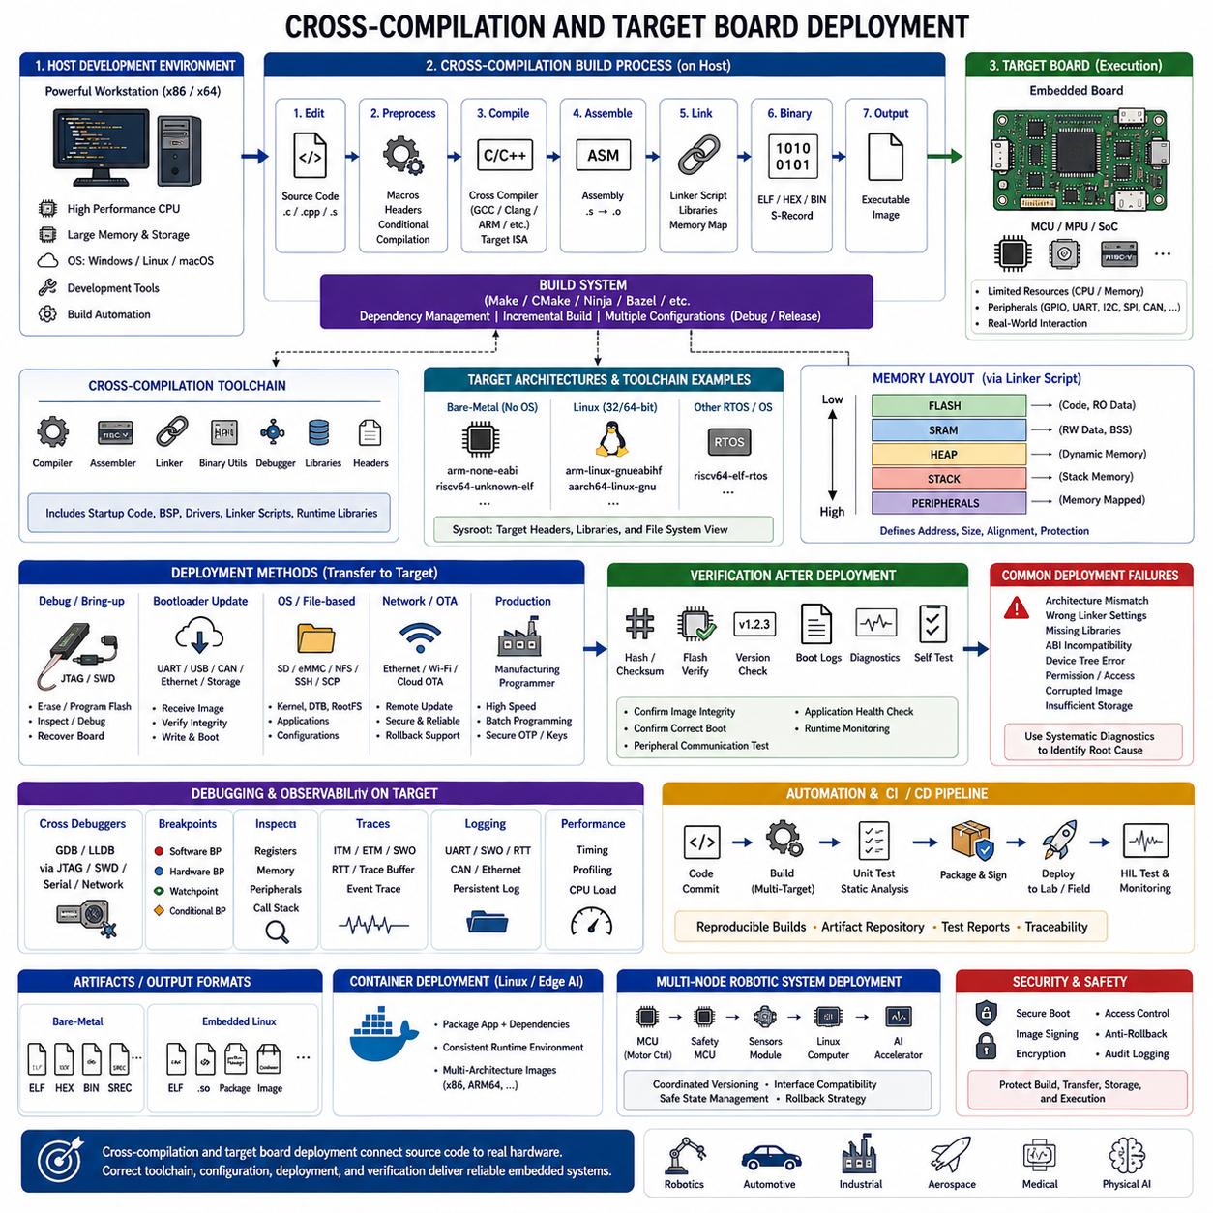
Cross-compilation is the process of building software on one computer architecture so that it can execute on a different target architecture. In embedded development, the host computer usually provides abundant processing power, storage, development tools, and automation capabilities, while the target board uses a resource-constrained processor such as ARM Cortex-M, ARM Cortex-A, RISC-V, or another embedded architecture.
The host and target systems may differ in processor instruction set, operating system, word size, endianness, floating-point support, memory layout, and available libraries. Because of these differences, software compiled with the host computer’s native compiler cannot normally execute on the target board. A dedicated cross-compiler must generate machine instructions that match the target processor and its application binary interface.
A cross-compilation toolchain typically contains a compiler, assembler, linker, binary utilities, debugger, runtime libraries, and target-specific header files. The toolchain may also include startup code, linker scripts, board support packages, device drivers, and system libraries. All components must be mutually compatible so that the generated firmware or executable follows the target platform’s memory and calling conventions.
Toolchain naming often identifies the intended target architecture and runtime environment. Examples include arm-none-eabi for bare-metal ARM systems, aarch64-linux-gnu for 64-bit ARM Linux targets, and riscv64-unknown-elf for bare-metal RISC-V development. These prefixes help developers distinguish cross-compilation tools from native host tools and prevent accidental generation of incompatible binaries.
Bare-metal cross-compilation targets processors without a general-purpose operating system. The generated firmware includes startup routines, interrupt vector tables, hardware initialization, application code, and minimal runtime support. Because no operating system loads or relocates the program, the linker must place every code and data section at exact physical addresses defined by the target device’s memory map.
Embedded Linux cross-compilation follows a different model because the target operating system provides a kernel, process loader, shared libraries, device interfaces, and filesystem services. Applications must be compiled against headers and libraries compatible with the target Linux distribution. A mismatch between the host toolchain’s sysroot and the target root filesystem may cause linking errors or runtime failures after deployment.
The sysroot is a directory structure that represents the target platform’s headers, libraries, and filesystem conventions on the host machine. During compilation and linking, the cross-compiler searches this environment instead of using the host computer’s native libraries. Maintaining an accurate sysroot is essential for generating executables that match the target operating system, library versions, and processor architecture.
Compiler configuration must reflect the exact target processor and hardware capabilities. Options may specify the CPU core, instruction set mode, floating-point unit, hardware floating-point application binary interface, optimization level, alignment rules, and security extensions. Incorrect settings can produce illegal instructions, corrupted function calls, unstable floating-point behavior, or inefficient code that fails only under specific operating conditions.
Linker scripts define how program sections are placed into the target board’s memory regions. They assign interrupt vectors, executable code, read-only constants, initialized data, uninitialized data, stack, heap, and special persistent areas to Flash, SRAM, external memory, or tightly coupled memory. Proper placement improves startup reliability, timing performance, memory protection, and overall resource utilization.
Startup code executes before the application’s main function and prepares the processor for normal operation. It establishes the initial stack pointer, initializes data sections, clears uninitialized memory, configures low-level processor state, and transfers control to the runtime environment. On more complex platforms, early boot software may also initialize clocks, memory controllers, caches, security states, and secondary processor cores.
A board support package provides the software foundation required to operate a specific target board. It may contain clock configuration, pin assignments, peripheral initialization, memory definitions, interrupt mappings, low-level drivers, and operating system adaptation layers. Separating board-specific code from application logic improves portability and allows the same software architecture to support multiple hardware revisions.
The build system coordinates cross-compilation by selecting the correct compiler, target flags, source files, include paths, libraries, linker script, and output format. Make, CMake, Ninja, Bazel, and vendor-specific systems are commonly used. A well-designed build system supports repeatable builds, multiple target configurations, debug and release profiles, dependency tracking, and integration with automated verification pipelines.
CMake cross-compilation commonly relies on a toolchain file that identifies the target system, compiler paths, processor architecture, sysroot, and library search behavior. This approach separates target configuration from the main project description and improves reuse across development machines. It also reduces the risk of unintentionally mixing host libraries with target libraries during configuration and linking.
After linking, the generated executable is converted into a deployment format appropriate for the target board. Bare-metal systems commonly use ELF, HEX, BIN, or S-record files, while embedded Linux systems usually deploy ELF executables, shared libraries, packages, containers, kernel images, device trees, or complete filesystem images. Each artifact serves a different stage of programming, debugging, or production release.
Target board deployment transfers the generated software from the host development environment to the embedded device. Common methods include JTAG, SWD, USB device firmware upgrade, serial bootloaders, removable storage, Ethernet, secure copy, network file systems, over-the-air update services, and manufacturing programmers. The selected method depends on the processor, boot architecture, security policy, and development stage.
During early board bring-up, direct hardware programming interfaces provide the most reliable deployment path. JTAG and SWD probes can erase and program Flash memory, inspect processor state, verify memory contents, and recover boards with damaged application firmware. These interfaces are essential when the bootloader, operating system, network configuration, or higher-level update mechanism is not yet operational.
Bootloaders provide a more flexible deployment mechanism after basic hardware functionality has been established. A bootloader may receive firmware through UART, USB, CAN, Ethernet, or storage media, verify its integrity, write it into application memory, and start execution. Production bootloaders often add cryptographic signature verification, version checking, rollback protection, recovery modes, and dual-partition update support.
Embedded Linux boards frequently use a multi-stage deployment process involving boot firmware, kernel images, device tree files, root filesystems, application binaries, and service configuration. These components may be written to eMMC, SD card, NVMe storage, NAND Flash, or network storage. Deployment automation must preserve version compatibility between the kernel, drivers, libraries, and application software.
Verification after deployment confirms that the transferred image matches the intended build and operates correctly on the target board. Common checks include file hashes, Flash verification, firmware version reporting, boot logs, startup diagnostics, communication tests, peripheral self-tests, and application health monitoring. A successful programming operation does not guarantee that the software is functionally compatible with the hardware.
Remote deployment is widely used when embedded boards are installed inside robots, vehicles, industrial machines, or inaccessible field equipment. Network-based deployment tools can copy binaries, restart services, collect logs, and activate new software versions without physical access. However, remote deployment must include authentication, encryption, integrity checking, interruption recovery, and a safe rollback strategy.
Container-based deployment is increasingly used on embedded Linux and edge AI platforms. Containers package applications with their runtime dependencies, reducing differences between development, testing, and production environments. Nevertheless, containers still depend on the target kernel, processor architecture, device permissions, GPU runtime, and hardware drivers, so cross-built images must be validated on the actual platform.
Multi-architecture container systems allow development teams to build images for x86 hosts, ARM64 edge computers, and other processor families from a shared configuration. Build farms and continuous integration servers can automatically generate, test, sign, and publish target-specific images. This approach improves consistency across robot fleets while maintaining clear separation between architecture-dependent binary layers.
Debugging deployed software requires close coordination between host tools and the target board. Cross-debuggers such as GDB connect through JTAG, SWD, serial stubs, or network servers to inspect target execution. Symbol files must correspond exactly to the deployed binary; otherwise, source lines, variable values, stack traces, and breakpoint locations may be misleading or completely incorrect.
Deployment failures commonly result from architecture mismatches, incorrect linker settings, missing shared libraries, incompatible application binary interfaces, faulty device trees, permission errors, corrupted images, or insufficient storage. Structured diagnostic procedures should examine the build configuration, binary metadata, deployment log, boot sequence, dynamic loader output, kernel messages, and hardware status rather than assuming a single software defect.
Reproducibility is essential for reliable cross-compilation and deployment. The same source revision, toolchain version, configuration, and dependencies should produce an equivalent target image regardless of the developer’s workstation. Containerized build environments, locked dependency versions, artifact repositories, build manifests, and software bills of materials help preserve traceability and support long-term maintenance.
Security must be integrated throughout the cross-compilation and deployment workflow. Toolchains and third-party libraries should come from trusted sources, build servers should protect signing credentials, and deployment artifacts should be signed and verified before execution. Secure boot, encrypted communication, access control, anti-rollback mechanisms, and audit logging reduce the risk of unauthorized firmware modification.
Continuous integration extends the workflow by automatically compiling software for multiple boards whenever source code changes. The pipeline can execute unit tests, static analysis, coding-standard checks, binary size analysis, vulnerability scanning, package generation, digital signing, and deployment to laboratory targets. Hardware-in-the-loop systems can then confirm that the image starts correctly and interacts with real peripherals.
Robotic systems often require coordinated deployment across many heterogeneous computing nodes. Motor controllers, safety microcontrollers, sensor modules, embedded Linux computers, and AI accelerators may each use different toolchains and update formats. A system-level deployment process must manage dependency order, interface compatibility, synchronized versions, rollback behavior, and safe operational states across the complete robot.
For example, a robot’s microcontroller firmware may be cross-compiled as a bare-metal binary and programmed through SWD, while its ARM-based main computer receives Linux applications through secure network deployment. AI inference engines may be generated separately for a GPU accelerator, and communication configuration may be deployed to distributed controllers. All artifacts must remain compatible at the interface level.
A mature deployment architecture clearly separates development builds, test releases, release candidates, and production images. Each artifact should include version identifiers, build metadata, target board information, compatibility requirements, checksums, and release notes. This prevents software intended for one processor, board revision, or product configuration from being installed on an incompatible device.
Ultimately, cross-compilation and target board deployment form the bridge between embedded source code and real-world hardware operation. Success depends on precise control of the toolchain, processor configuration, memory layout, operating environment, deployment channel, and verification process. When these elements are engineered as one traceable workflow, teams can deliver reliable software to robots, vehicles, industrial controllers, medical devices, aerospace platforms, and future Physical AI systems.

01.05 Embedded C Coding Standards: MISRA C / CERT C
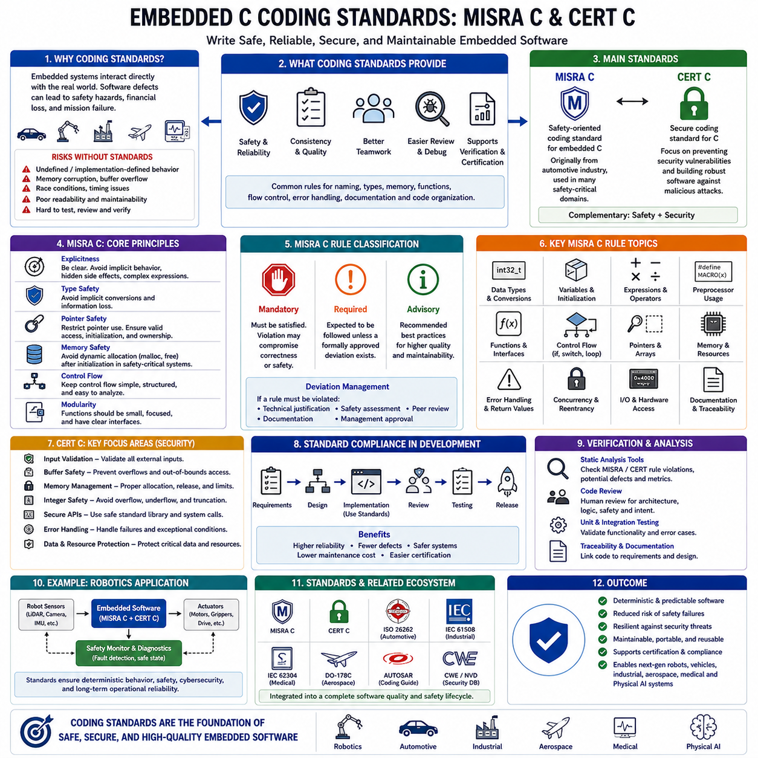
Embedded C is the dominant programming language for resource-constrained embedded systems because it provides direct access to hardware while maintaining high execution efficiency and portability. However, the flexibility of the C language also introduces significant risks, including undefined behavior, implementation-dependent behavior, memory corruption, buffer overflows, race conditions, and unpredictable execution. In safety-critical applications such as automotive electronics, industrial automation, aerospace systems, medical devices, railway control, and autonomous robots, software defects can directly affect human safety and mission success. Consequently, embedded software development relies on well-defined coding standards that restrict unsafe language features and promote deterministic, maintainable, and verifiable software.
Coding standards provide a common set of programming rules that improve software quality throughout the entire development lifecycle. Rather than focusing solely on syntax correctness, coding standards define best practices for naming conventions, variable declarations, memory usage, function design, control structures, type conversions, error handling, documentation, and code organization. Consistent coding practices make software easier to review, debug, test, maintain, and extend while reducing misunderstandings among multidisciplinary engineering teams working on large embedded projects.
Embedded software frequently operates for months or years without interruption while interacting directly with sensors, actuators, communication networks, and safety mechanisms. A seemingly minor programming mistake such as an uninitialized variable, an unintended integer conversion, or an unchecked pointer may remain undetected during laboratory testing yet eventually trigger catastrophic failures in field operation. Coding standards therefore seek to eliminate classes of programming errors before software reaches deployment by defining rules that can be systematically verified through reviews and automated analysis.
MISRA C is one of the most widely adopted coding standards for embedded software development. Originally developed by the Motor Industry Software Reliability Association for automotive electronic systems, MISRA C has evolved into a general-purpose safety-oriented coding standard used across many industries. Although initially designed for automotive control units, its principles are now applied in robotics, aerospace, railway systems, industrial controllers, medical equipment, and other embedded platforms requiring high reliability and deterministic behavior.
The primary objective of MISRA C is not to introduce a new programming language but to define a safe subset of the C language. Many features permitted by the ISO C standard are either restricted or prohibited because they can lead to ambiguous interpretation, compiler-dependent behavior, or hidden software defects. By limiting the use of potentially dangerous language constructs, MISRA C reduces software complexity and improves consistency across development teams and compiler implementations.
MISRA C rules are generally categorized into mandatory rules, required rules, and advisory rules. Mandatory rules must always be satisfied because violating them may fundamentally compromise software correctness or safety. Required rules are expected to be followed unless a formally documented deviation has been approved through engineering review. Advisory rules represent recommended best practices that improve software quality even though occasional deviations may be acceptable under carefully justified circumstances.
One of the fundamental principles of MISRA C is explicitness. Programs should behave exactly as developers intend without relying on compiler assumptions or implicit language behavior. Implicit type conversions, ambiguous operator precedence, hidden side effects, and complex expressions are discouraged because they reduce code readability and increase the likelihood of subtle implementation errors. Software should express engineering intent clearly so that reviewers, static analysis tools, and future maintainers can interpret behavior consistently.
Type safety forms another major component of MISRA C. The C language automatically performs numerous implicit conversions between integer types, floating-point values, signed and unsigned variables, and enumerations. While these conversions simplify general programming, they may unexpectedly alter numerical values or comparison results in embedded systems. MISRA therefore encourages explicit casting only when justified and discourages conversions that may produce information loss, overflow, sign changes, or implementation-dependent behavior.
Pointer management receives extensive attention because incorrect pointer operations remain one of the leading causes of embedded software failures. Invalid pointer dereferencing, pointer arithmetic beyond valid object boundaries, misaligned memory access, aliasing problems, and unintended modification of shared memory can all introduce unpredictable system behavior. MISRA recommends restricting pointer manipulation whenever practical and encourages clear ownership, well-defined memory boundaries, and explicit initialization before pointer usage.
Dynamic memory allocation is another area where MISRA applies significant restrictions. Functions such as malloc(), calloc(), realloc(), and free() may introduce memory fragmentation, allocation failures, unpredictable execution time, and long-term reliability issues. Since many embedded systems operate continuously for extended periods without restarting, memory fragmentation may eventually exhaust available memory even when sufficient total memory remains. Consequently, many safety-critical embedded systems prohibit dynamic allocation after initialization and instead rely on static memory allocation or carefully managed memory pools.
Control flow should remain simple, deterministic, and easy to analyze. Deeply nested conditional statements, multiple exit points, unrestricted goto statements, and excessive recursion make software more difficult to verify and may increase worst-case execution time uncertainty. MISRA therefore encourages structured programming techniques that improve readability while simplifying testing, static analysis, and formal verification activities.
Loop behavior must also be predictable. Infinite loops without explicit termination conditions, complex loop counters, or hidden modifications inside loop bodies reduce software transparency and complicate timing analysis. Embedded software often depends upon deterministic execution schedules, making it essential that loop behavior remains understandable and verifiable under all operating conditions. Clearly defined loop limits also facilitate worst-case execution time analysis required by many real-time systems.
Function design principles emphasize simplicity, modularity, and clear interfaces. Functions should perform well-defined tasks, maintain limited complexity, minimize side effects, and avoid excessive parameter lists. Global variables should be minimized because they increase coupling between software components and complicate reasoning about program state. Instead, developers are encouraged to encapsulate functionality within modules that communicate through clearly documented interfaces.
Preprocessor usage must also be carefully controlled. Although macros provide flexibility and improve code reuse, poorly designed macros may introduce hidden side effects, unexpected operator precedence, multiple evaluations of arguments, and debugging difficulties. MISRA encourages the use of inline functions, typed constants, and strongly structured preprocessing directives whenever they improve clarity without sacrificing efficiency.
The use of compiler-specific extensions requires careful consideration. Embedded compilers often provide proprietary language extensions for hardware access, interrupt declaration, memory placement, or optimization control. While these features may improve performance or simplify hardware interaction, excessive reliance on compiler-specific functionality reduces software portability. Coding standards encourage isolating implementation-specific code within well-defined hardware abstraction layers whenever possible.
Error handling should be explicit and systematic rather than relying on implicit assumptions. Every function should clearly communicate success, failure, or exceptional conditions through documented return values or status mechanisms. Inputs received from sensors, communication interfaces, storage devices, or external systems should be validated before further processing. Defensive programming techniques help detect abnormal conditions early and prevent failures from propagating throughout the system.
Documentation requirements extend beyond comments explaining individual statements. Coding standards encourage meaningful identifiers, self-documenting program structure, interface specifications, design rationale, traceability to system requirements, and documented deviations from established rules. Well-structured documentation enables long-term maintenance, supports certification activities, and facilitates communication between software, hardware, testing, and safety engineering teams.
Static analysis has become an indispensable component of coding-standard compliance. Modern static analysis tools automatically inspect source code for violations of MISRA rules, potential runtime defects, dead code, unreachable branches, data flow anomalies, memory errors, and concurrency issues without executing the software. Automated analysis significantly improves defect detection while reducing the manual effort required for large embedded software projects.
CERT C represents another highly influential secure coding standard for the C programming language. Developed by the CERT Coordination Center, CERT C primarily focuses on preventing security vulnerabilities that may arise from unsafe programming practices. Whereas MISRA emphasizes safety, determinism, portability, and reliability, CERT C concentrates on robustness against malicious attacks, secure resource management, memory protection, input validation, integer safety, and secure handling of external data.
Although MISRA C and CERT C originate from different objectives, they complement each other in many embedded applications. Safety-critical systems increasingly require both functional safety and cybersecurity because connected embedded devices operate within larger industrial networks, cloud infrastructures, and autonomous robotic ecosystems. Applying both standards simultaneously enables software to achieve high reliability while reducing exposure to software vulnerabilities and cyber threats.
Many organizations integrate MISRA C, CERT C, ISO 26262, IEC 61508, IEC 62304, DO-178C, and other industry-specific standards into a unified software development process. Coding standards become part of a broader engineering framework that includes requirements management, architecture design, implementation, code review, static analysis, unit testing, integration testing, system validation, configuration management, and continuous integration. Compliance therefore extends beyond individual programming rules to encompass the entire software quality assurance lifecycle.
Deviation management is another important aspect of coding-standard implementation. Certain hardware-specific requirements or performance constraints may occasionally justify controlled violations of individual rules. Rather than allowing arbitrary exceptions, engineering organizations establish formal deviation procedures requiring technical justification, safety assessment, peer review, documentation, and management approval. This process preserves software integrity while accommodating legitimate engineering constraints.
Code reviews remain essential even when automated static analysis tools are extensively used. Human reviewers evaluate software architecture, algorithm correctness, maintainability, readability, requirement traceability, safety implications, and engineering intent that automated tools cannot fully understand. Combining peer reviews with automated compliance checking provides significantly higher defect detection capability than either technique alone.
Modern embedded software increasingly supports multicore processors, heterogeneous computing platforms, real-time operating systems, and AI accelerators. These technologies introduce additional complexity involving synchronization, shared memory access, task scheduling, cache coherence, and concurrent execution. Coding standards therefore continue evolving to address emerging software risks while preserving deterministic behavior across increasingly sophisticated embedded platforms.
Robotic systems provide an excellent example of why coding standards are indispensable. Autonomous robots simultaneously execute motion control, localization, perception, communication, diagnostics, safety monitoring, and artificial intelligence workloads while interacting continuously with the physical environment. A single software defect may compromise navigation accuracy, actuator stability, collision avoidance, or functional safety. Consistent application of MISRA C, CERT C, rigorous code reviews, and automated verification significantly reduces these risks and improves long-term operational reliability.
Ultimately, embedded C coding standards are not intended to restrict developer creativity but to establish disciplined engineering practices that consistently produce reliable software. By reducing ambiguity, eliminating hazardous language constructs, encouraging defensive programming, and supporting systematic verification, standards such as MISRA C and CERT C enable engineering teams to build maintainable, portable, deterministic, secure, and safety-critical embedded software suitable for next-generation robots, intelligent vehicles, industrial automation systems, aerospace platforms, medical devices, and future Physical AI technologies.

01.06 Embedded C++ Usage Principles and Cautions
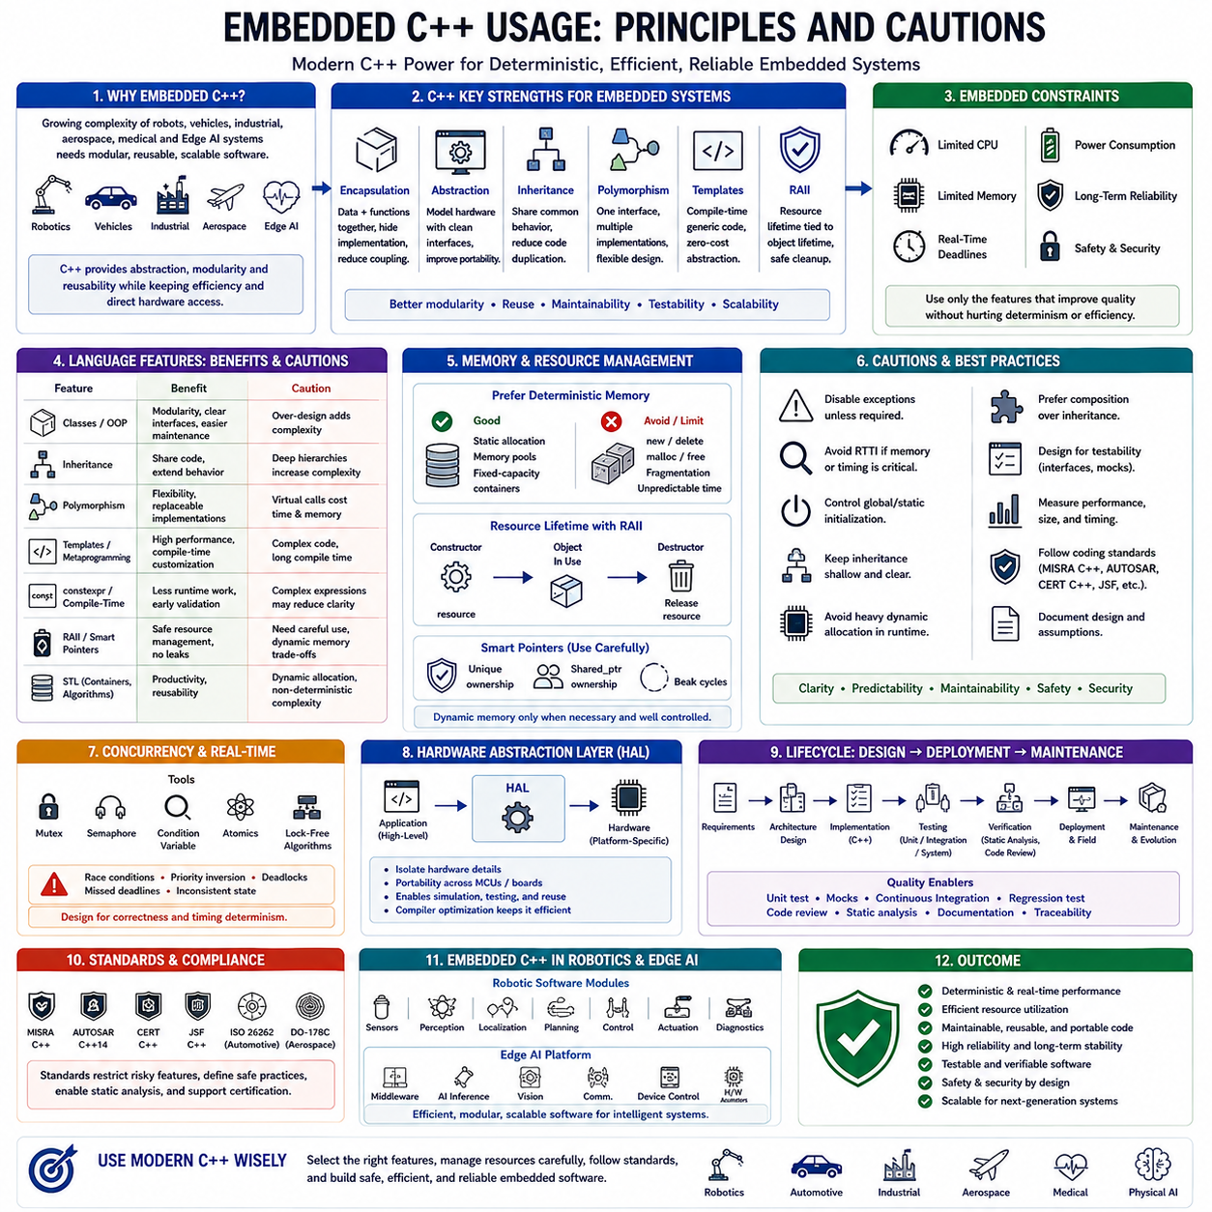
Embedded C++ has become increasingly important in modern embedded software development as embedded processors continue to gain computational capability while software complexity grows significantly. Traditional embedded systems were primarily developed in C because of its simplicity, efficiency, and direct hardware access. However, today's autonomous robots, intelligent vehicles, industrial automation systems, aerospace platforms, medical devices, and edge AI applications often require modular software architectures, reusable components, object-oriented abstraction, and scalable software engineering practices. Embedded C++ provides these capabilities while still allowing developers to maintain deterministic execution and efficient hardware interaction when used appropriately.
Unlike desktop application development, embedded C++ cannot simply utilize every language feature without considering hardware limitations. Embedded systems typically operate under strict constraints involving processor performance, memory capacity, real-time deadlines, power consumption, and long-term reliability. Consequently, successful embedded C++ development is not about maximizing language complexity but rather selecting only those language features that improve software quality without introducing unacceptable runtime overhead or unpredictable behavior.
One of the greatest strengths of C++ is its support for object-oriented programming. Classes provide a natural mechanism for encapsulating data together with the functions that operate upon it, improving software modularity and reducing unintended interactions between components. Encapsulation enables hardware drivers, communication interfaces, sensors, actuators, and control algorithms to expose clean interfaces while hiding implementation details. This separation simplifies maintenance and allows internal implementations to evolve without affecting dependent software modules.
Abstraction further improves software organization by allowing developers to model real hardware components through well-defined interfaces. GPIO controllers, communication peripherals, timers, analog-to-digital converters, motors, cameras, and sensors can all be represented as abstract software objects with consistent programming interfaces. Higher-level application software can therefore interact with hardware through standardized APIs instead of manipulating hardware registers directly throughout the codebase. This approach improves portability when migrating software across different processor families or board revisions.
Inheritance provides a mechanism for sharing common behavior among related software components. Device drivers supporting similar communication protocols, sensor families, or actuator interfaces often contain substantial common functionality. Carefully designed inheritance hierarchies reduce duplicated code while preserving flexibility for hardware-specific implementation details. However, inheritance should remain shallow and well structured because excessively deep class hierarchies increase software complexity, complicate debugging, and reduce code readability.
Polymorphism enables software to interact with multiple implementations through common interfaces. For example, a localization subsystem may access different positioning sensors through the same abstract interface, allowing GPS, LiDAR, visual odometry, or simulated sensors to be exchanged without modifying higher-level application logic. Such flexibility greatly improves software reuse, testing, and simulation capabilities. Nevertheless, developers must carefully evaluate runtime costs associated with virtual function dispatch, especially within high-frequency real-time control loops.
Templates represent one of the most powerful features of modern C++. Unlike runtime polymorphism, template programming performs type specialization during compilation, allowing developers to write highly reusable code without introducing runtime overhead. Template-based libraries can generate efficient implementations optimized for specific processor architectures, numerical types, communication protocols, or hardware configurations. Properly designed templates therefore combine software flexibility with deterministic execution efficiency.
Compile-time programming has become increasingly valuable for embedded systems. Modern C++ features such as constexpr enable mathematical calculations, lookup table generation, configuration validation, and parameter checking to occur entirely during compilation rather than at runtime. This reduces processor workload, eliminates unnecessary initialization code, and improves deterministic execution while simultaneously increasing software correctness through early error detection.
The Resource Acquisition Is Initialization principle provides a disciplined approach to resource management by associating resource lifetime with object lifetime. Memory allocation, file handles, communication channels, mutexes, hardware peripherals, and other resources are automatically acquired during object construction and released during destruction. Although originally developed for desktop software, this principle can improve embedded software reliability by preventing resource leaks and ensuring deterministic cleanup when carefully applied.
Smart pointers improve memory safety by automatically managing object ownership and lifetime. Unique ownership models prevent accidental memory leaks, while shared ownership mechanisms coordinate access to dynamically allocated resources. However, embedded systems often avoid extensive dynamic memory allocation because fragmentation and unpredictable allocation latency conflict with real-time requirements. Consequently, smart pointers should be introduced only after carefully evaluating system constraints and memory management strategies.
Exception handling is among the most controversial C++ features in embedded development. Exceptions improve software readability by separating normal execution paths from error handling logic. However, exception support increases executable size, complicates compiler runtime requirements, and introduces execution paths whose timing may be difficult to predict. Many embedded organizations therefore disable language exceptions entirely and instead implement deterministic error reporting through return values, status objects, or explicit fault management frameworks.
Run-Time Type Information presents similar tradeoffs. Runtime identification of object types enables flexible software architectures but increases executable size and runtime support requirements. Since many embedded systems operate with strict memory limitations and deterministic timing constraints, Run-Time Type Information is frequently disabled unless its benefits clearly outweigh the additional resource consumption.
Dynamic memory allocation remains one of the most carefully controlled aspects of embedded C++ development. Operators such as new and delete provide convenient object creation but may introduce memory fragmentation, allocation failures, unpredictable execution times, and long-term reliability concerns. Many embedded software architectures either prohibit dynamic allocation after system initialization or replace standard allocators with deterministic memory pools specifically designed for real-time applications.
Constructors and destructors provide elegant mechanisms for object initialization and cleanup. Hardware peripherals can automatically configure registers during construction and safely release resources during destruction. Nevertheless, developers must understand object initialization order, especially for global and static objects whose constructors execute before the application's main function. Incorrect initialization dependencies may produce subtle startup failures that are difficult to diagnose.
Static object initialization requires careful engineering because embedded systems frequently initialize hardware before the C++ runtime becomes fully operational. Excessive reliance on global constructors may increase startup complexity and obscure execution order. Many embedded projects therefore restrict global object construction and instead perform explicit initialization within carefully controlled startup sequences.
Namespaces improve software organization by preventing naming conflicts across large embedded projects. Device drivers, middleware libraries, communication stacks, mathematical utilities, diagnostics, robotics frameworks, and application software can coexist without polluting the global namespace. Clear namespace organization also improves code readability and simplifies integration of third-party software components.
The Standard Template Library provides powerful containers, algorithms, and utilities that greatly increase programmer productivity. Containers such as vector, array, queue, map, and optional simplify data management while generic algorithms improve code reuse. Nevertheless, developers must understand the runtime characteristics of each container. Some containers perform dynamic memory allocation or exhibit non-deterministic execution complexity that may be unsuitable for safety-critical real-time applications. Consequently, fixed-capacity containers or embedded-oriented STL implementations are often preferred.
Modern C++ language features introduced in C++11, C++14, C++17, and C++20 provide numerous opportunities for improving embedded software quality. Move semantics reduce unnecessary memory copying, constexpr enables compile-time computation, strongly typed enumerations improve type safety, automatic type deduction reduces programming errors, lambda expressions simplify callback implementation, and standard threading primitives support portable concurrent programming. Each feature should nevertheless be evaluated according to deterministic behavior, compiler maturity, resource consumption, and certification requirements.
Concurrency introduces additional complexity into embedded C++ systems. Multithreaded applications must coordinate shared resources using mutexes, semaphores, condition variables, atomics, and lock-free algorithms. Incorrect synchronization may result in race conditions, priority inversion, deadlocks, or inconsistent system state. Real-time operating systems therefore require disciplined software architecture to guarantee both correctness and timing predictability.
Hardware abstraction layers represent one of the most successful applications of C++ in embedded software engineering. Abstract interfaces isolate application software from processor-specific implementation details, allowing identical high-level software to operate across multiple hardware platforms with only minimal board-specific modifications. Well-designed abstraction layers also improve simulation, automated testing, and long-term maintainability while preserving efficient hardware access through compiler optimization.
Template metaprogramming allows extensive software customization entirely during compilation. Peripheral configuration, communication protocol specialization, mathematical optimization, register mapping, and compile-time validation can all be generated automatically without runtime overhead. Although template metaprogramming significantly increases compiler complexity, it enables highly efficient firmware tailored specifically to each target configuration.
Code readability remains more important than language sophistication. Complex template expressions, deeply nested inheritance hierarchies, excessive operator overloading, and advanced metaprogramming techniques may impress experienced C++ developers but reduce maintainability for multidisciplinary engineering teams responsible for long product lifecycles. Embedded software should prioritize clarity, predictability, and long-term maintainability over language elegance.
Safety-critical embedded systems frequently combine modern C++ practices with coding standards such as MISRA C++, AUTOSAR C++14, JSF C++ Coding Standard, CERT C++, and organizational software guidelines. These standards restrict dangerous language features, define safe programming practices, improve portability, and facilitate static analysis and certification. Compliance becomes increasingly important as embedded software expands into autonomous transportation, industrial robotics, aviation, healthcare, and critical infrastructure.
Testing strategies must account for object-oriented software structures. Unit testing frameworks verify individual classes, dependency injection simplifies component isolation, interface mocking supports hardware-independent testing, and continuous integration automates regression testing across multiple processor architectures. These software engineering techniques significantly improve long-term software quality while reducing integration effort for large embedded development teams.
Embedded C++ is particularly valuable in robotics because robotic software naturally consists of interacting objects representing sensors, actuators, planners, controllers, localization modules, communication interfaces, diagnostics, and artificial intelligence components. Object-oriented architecture enables these modules to evolve independently while maintaining consistent interfaces across increasingly sophisticated robotic platforms. Careful selection of language features allows developers to balance abstraction with deterministic real-time execution.
Modern edge AI platforms further strengthen the role of embedded C++. High-performance processors simultaneously execute robotics middleware, neural network inference, computer vision, communication services, and low-level device control. C++ provides the efficiency required for computationally intensive workloads while supporting modular architectures capable of integrating heterogeneous hardware accelerators, distributed software components, and complex software ecosystems.
Ultimately, successful embedded C++ development requires engineering discipline rather than unrestricted use of language features. The objective is not to maximize object-oriented complexity but to construct software that remains deterministic, efficient, maintainable, portable, testable, and reliable throughout its operational lifetime. When modern C++ principles are combined with careful resource management, coding standards, static analysis, rigorous testing, and sound system architecture, embedded C++ becomes a powerful foundation for next-generation autonomous robots, intelligent vehicles, industrial automation systems, aerospace platforms, medical equipment, and future Physical AI technologies.

01.07 Memory Map: Flash, SRAM, EEPROM, Registers
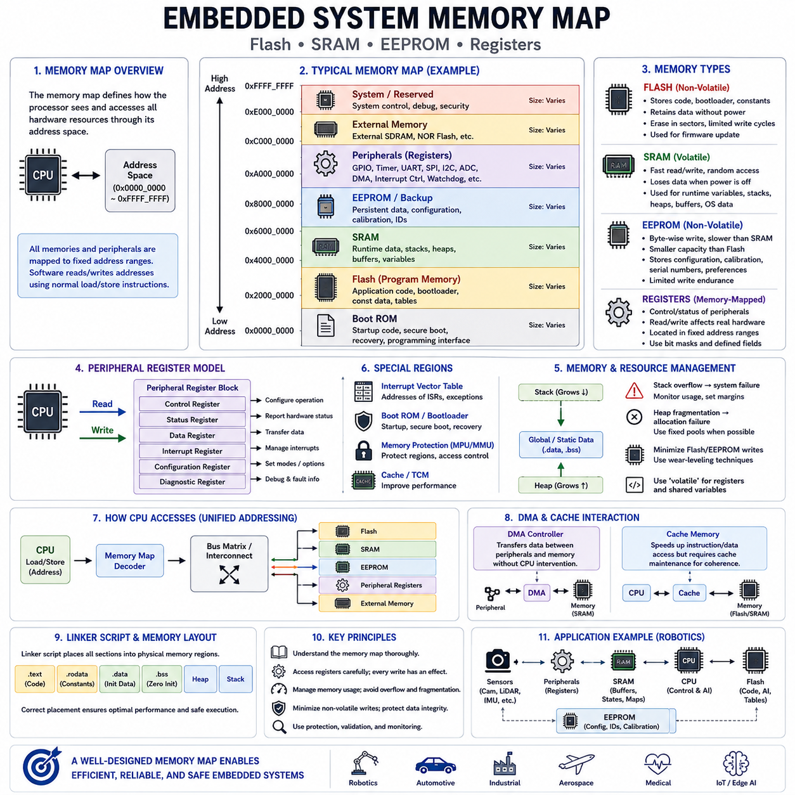
A memory map is one of the most fundamental concepts in embedded system architecture because it defines how a processor views and accesses every hardware resource through its address space. Unlike general-purpose computers, where operating systems provide extensive abstraction, embedded processors frequently access memory and peripheral hardware directly using fixed physical addresses. Program memory, data memory, peripheral registers, boot memory, configuration areas, interrupt vectors, and external devices are all assigned specific address ranges within the processor's unified address space. Understanding the memory map is therefore essential for writing reliable embedded software, debugging hardware interactions, optimizing performance, and designing deterministic real-time systems.
The processor treats memory and peripheral devices as addressable regions that can be accessed through ordinary load and store instructions. When software reads or writes a particular address, the processor automatically routes the operation to the appropriate hardware component according to the memory map. Reading one address may retrieve data from SRAM, another may access Flash memory, while another may immediately control a communication controller, timer, GPIO register, or analog-to-digital converter. This unified addressing model simplifies programming because hardware devices behave similarly to memory from the processor's perspective.
Memory maps vary among processor families, but most embedded microcontrollers contain several common memory regions. Program code typically resides in non-volatile Flash memory, runtime variables occupy SRAM, persistent configuration data may be stored in EEPROM or Flash emulation, and peripheral registers occupy dedicated address ranges reserved for hardware control. Additional regions may include boot ROM, cache controllers, tightly coupled memory, external SDRAM, memory-mapped external Flash, security configuration blocks, and debugging interfaces depending on processor complexity.
Flash memory serves as the primary non-volatile storage location for embedded firmware. Unlike SRAM, Flash retains its contents after power is removed, making it suitable for storing application code, bootloaders, lookup tables, calibration constants, and default configuration parameters. During normal execution, processors fetch instructions directly from Flash or copy selected code into faster memory depending on architectural requirements. Since Flash programming requires erase operations before rewriting, software updates are generally performed through dedicated programming procedures rather than ordinary memory writes.
Flash memory is organized into pages, sectors, or blocks depending on the underlying technology. Individual bytes often cannot be rewritten directly because erase operations affect entire sectors simultaneously. Consequently, firmware update mechanisms must carefully manage erase cycles, temporary storage, integrity verification, and power-loss recovery. Modern embedded systems frequently employ dual-bank Flash architectures, allowing one firmware image to remain operational while another is updated safely in the background before switching execution.
Flash endurance represents another important design consideration. Every erase cycle slightly degrades Flash cells, limiting the total number of reliable rewrite operations. While modern Flash memories often support tens of thousands or hundreds of thousands of erase cycles, continuously rewriting the same storage location eventually causes permanent wear. Embedded software therefore distributes frequently updated data across multiple physical locations using wear-leveling techniques or stores rapidly changing information within SRAM instead of Flash whenever possible.
Static Random Access Memory provides the processor's primary volatile working memory during program execution. Unlike Flash, SRAM loses its contents when power is removed, but it offers significantly faster read and write performance with unrestricted random access. Local variables, global variables, stacks, heaps, communication buffers, sensor measurements, intermediate calculations, task control blocks, and operating system data structures typically reside within SRAM throughout application execution.
SRAM organization directly influences software reliability. Stack memory stores function parameters, local variables, return addresses, and processor context during function calls or interrupt processing. Heap memory supports dynamic allocation when permitted by system design, while global and static variables occupy dedicated data sections initialized during system startup. Careful memory partitioning ensures these regions do not overlap during execution, preventing unpredictable software failures caused by memory corruption.
Stack management is particularly important in embedded software because stack overflow often remains undetected until catastrophic system failure occurs. Deep function call hierarchies, excessive recursion, large local arrays, nested interrupts, and multiple concurrent tasks all increase stack consumption. Developers therefore estimate worst-case stack usage, configure adequate stack sizes, and employ stack monitoring techniques to detect overflow before it compromises system stability.
Heap usage remains controversial in embedded software engineering. Dynamic memory allocation provides flexibility but may introduce fragmentation, allocation failures, unpredictable execution times, and long-term reliability concerns. Safety-critical systems frequently eliminate heap usage entirely after initialization or replace conventional allocators with deterministic fixed-size memory pools that guarantee bounded allocation latency and eliminate fragmentation.
Electrically Erasable Programmable Read-Only Memory occupies an intermediate position between Flash and SRAM. Like Flash, EEPROM preserves information after power loss, but unlike Flash, individual bytes can often be rewritten without erasing entire sectors. EEPROM is therefore well suited for storing calibration values, serial numbers, manufacturing data, device configuration, network addresses, security credentials, and user preferences that change infrequently throughout the product lifetime.
EEPROM capacity is generally much smaller than Flash memory and write operations occur considerably more slowly than ordinary SRAM accesses. Similar to Flash, EEPROM cells possess finite write endurance, making continuous rewriting of identical locations undesirable. Embedded software therefore minimizes unnecessary writes, validates stored data using checksums or cyclic redundancy checks, and often implements wear-leveling strategies for frequently updated configuration parameters.
Many modern microcontrollers no longer contain dedicated EEPROM hardware. Instead, they emulate EEPROM functionality using specially reserved Flash sectors managed through software. Flash-based EEPROM emulation introduces additional complexity because software must erase and rewrite larger memory blocks while preserving previously stored information. Nevertheless, careful firmware design provides behavior functionally equivalent to traditional EEPROM while reducing manufacturing cost and silicon complexity.
Memory-mapped peripheral registers provide the processor's primary interface to hardware devices. Rather than communicating through specialized instructions, embedded processors control peripherals simply by reading and writing predefined memory addresses. General-purpose input/output controllers, timers, communication interfaces, analog converters, pulse-width modulation units, direct memory access controllers, interrupt controllers, watchdog timers, cryptographic accelerators, and clock management hardware all expose programmable registers through dedicated regions of the memory map.
Peripheral registers generally fall into several functional categories. Control registers configure peripheral operation, status registers report current hardware conditions, data registers transfer information between software and hardware, interrupt registers manage event notification, configuration registers define operational modes, and diagnostic registers assist debugging and fault analysis. Understanding the purpose of each register is essential for correctly initializing hardware and diagnosing unexpected system behavior.
Register-level programming requires careful attention because reading or writing hardware registers may produce immediate physical effects. Writing a GPIO output register changes electrical voltage on processor pins, modifying timer registers alters timing behavior, enabling communication controllers activates external interfaces, and acknowledging interrupt registers clears pending hardware events. Unlike ordinary memory, peripheral registers frequently represent active hardware mechanisms rather than passive data storage.
Bit manipulation plays a central role in register programming. Individual bits often enable hardware functions, configure operating modes, select communication speeds, acknowledge interrupts, or indicate error conditions. Embedded software therefore employs bit masks, shift operations, and carefully defined symbolic constants to modify specific register fields without unintentionally affecting neighboring control bits. Hardware reference manuals provide detailed descriptions of every register bit and its associated functionality.
Volatile memory access represents another essential concept in embedded software. Ordinary compiler optimization assumes memory values remain unchanged unless modified directly by program execution. However, peripheral registers may change asynchronously due to external hardware events, interrupt service routines, direct memory access controllers, or communication interfaces. Declaring register pointers and shared variables as volatile informs the compiler that every access must actually read or write physical memory rather than relying upon cached values stored in processor registers.
Interrupt vector tables also occupy fixed locations within the memory map. These tables contain processor addresses corresponding to exception handlers, reset routines, and interrupt service routines. Upon power-up or interrupt occurrence, the processor automatically retrieves the appropriate handler address from the vector table before transferring program execution. Some architectures allow relocation of vector tables into SRAM to support dynamic interrupt management or bootloader architectures.
Boot memory represents another specialized region within many embedded processors. Boot ROM often contains factory-programmed initialization software responsible for processor startup, secure boot verification, recovery procedures, or firmware programming interfaces. Bootloaders stored in Flash cooperate with boot ROM to verify application integrity, authenticate firmware updates, initialize hardware, and safely transfer execution to the primary application after successful startup.
Memory protection mechanisms become increasingly important as embedded systems grow more complex. Memory Protection Units and Memory Management Units divide address space into protected regions with independent read, write, and execute permissions. These mechanisms prevent software components from accidentally corrupting critical memory, improve fault isolation, strengthen cybersecurity, and support multitasking operating systems executing multiple independent software processes.
Direct Memory Access controllers interact extensively with the memory map by transferring data between peripherals and memory without continuous processor involvement. Instead of requiring the CPU to copy every byte manually, DMA engines access SRAM and peripheral registers directly through the system bus. This significantly reduces processor workload while improving communication throughput, sensor acquisition performance, and deterministic execution of time-critical control algorithms.
Cache memory further influences memory-map behavior within high-performance embedded processors. Instruction caches accelerate program execution by storing recently accessed Flash contents, while data caches reduce SRAM access latency. However, caches introduce coherency considerations when processors share memory with DMA controllers or multiple processing cores. Embedded software must therefore explicitly manage cache maintenance operations whenever hardware accesses memory independently of processor execution.
External memory interfaces extend the processor's address space beyond on-chip resources. SDRAM, DDR memory, external NOR Flash, NAND Flash, serial memories, FPGA interfaces, and specialized hardware accelerators may all appear within the processor's memory map. From the programmer's perspective, these external devices behave similarly to internal memory, although access latency, bandwidth, and initialization requirements differ substantially from on-chip resources.
Linker scripts directly implement the memory map within software. They assign executable code, constants, initialized variables, uninitialized variables, stacks, heaps, interrupt vectors, and special application sections into appropriate physical memory regions. Correct linker configuration ensures firmware fits within available Flash and SRAM while satisfying processor startup requirements and maximizing runtime performance.
Memory usage analysis remains an important activity throughout embedded software development. Engineers continuously monitor Flash utilization, SRAM consumption, stack margins, heap usage, peripheral buffer allocation, and linker reports to ensure sufficient resources remain available under worst-case operating conditions. Memory optimization often involves algorithm refinement, data structure redesign, compiler optimization, constant data relocation, and elimination of unnecessary runtime allocations.
Modern robotic systems provide an excellent illustration of comprehensive memory-map utilization. Flash stores firmware, AI inference engines, calibration tables, and bootloaders. SRAM contains localization states, perception buffers, sensor fusion variables, navigation maps, communication queues, and control algorithms. EEPROM preserves robot identification, factory calibration, and configuration settings. Memory-mapped registers configure motors, cameras, LiDAR, inertial sensors, communication networks, and safety hardware. DMA controllers continuously transfer sensor data while processors execute control and planning software, all coordinated through a carefully designed memory architecture.
Ultimately, the embedded memory map provides the structural foundation upon which all software interacts with hardware. Flash, SRAM, EEPROM, peripheral registers, interrupt vectors, boot memory, and external devices each fulfill specialized roles within the processor's address space. Engineers who understand these relationships can design software that is efficient, deterministic, reliable, maintainable, and capable of supporting increasingly sophisticated embedded platforms, autonomous robots, industrial controllers, intelligent vehicles, medical systems, aerospace electronics, and future Physical AI technologies.

01.08 Interrupt and Exception Handling Architecture
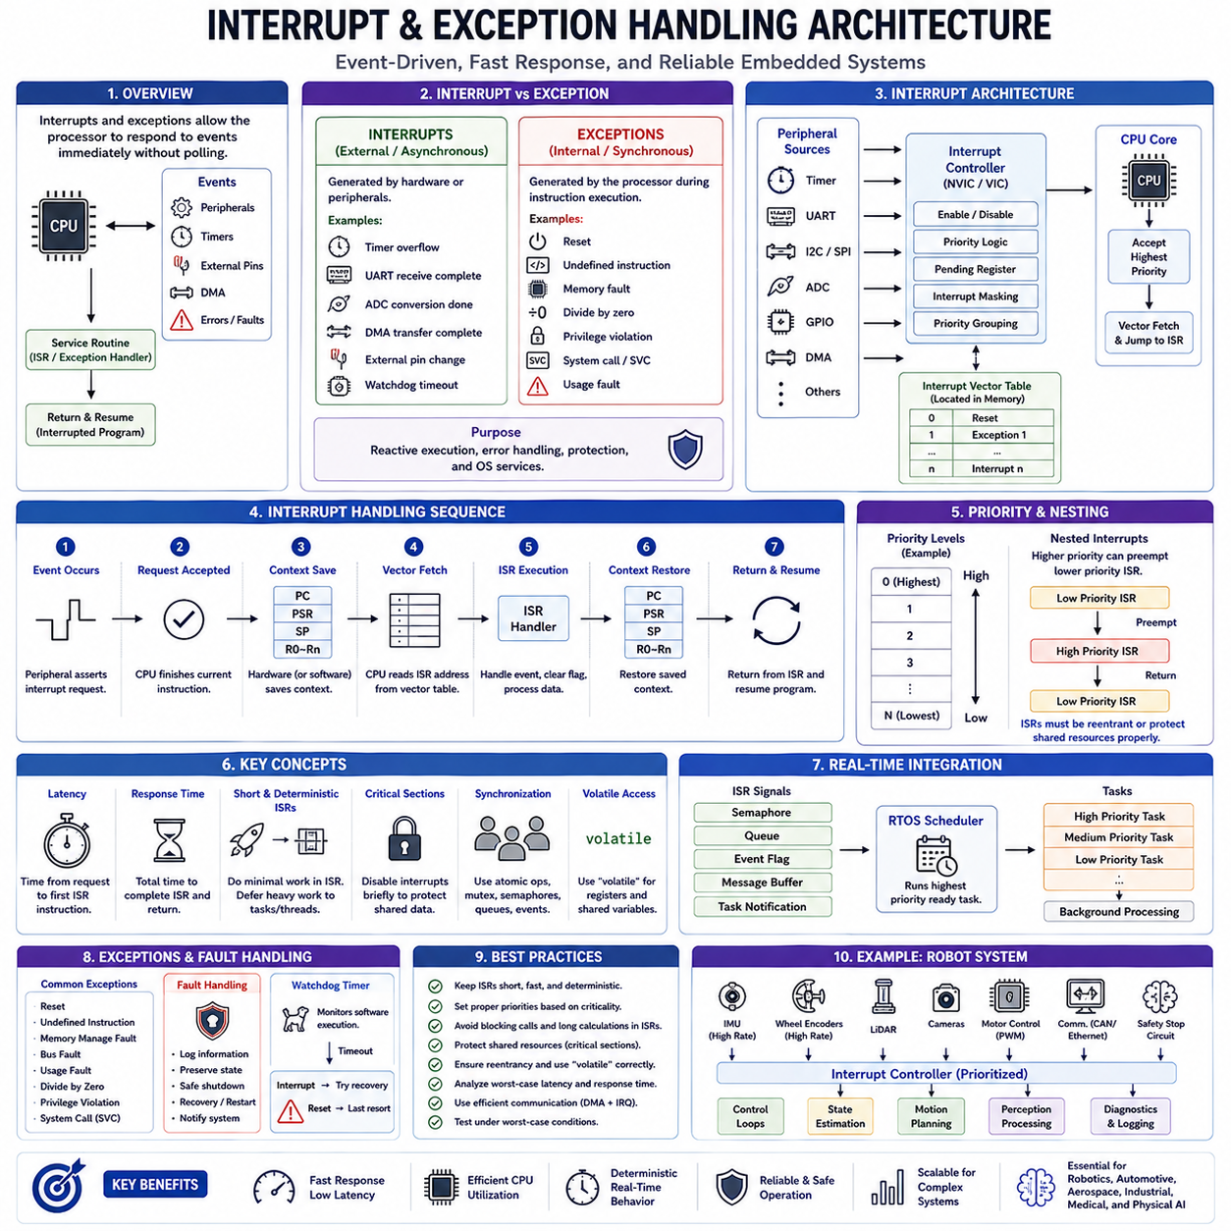
Interrupts and exceptions form the foundation of responsive embedded systems by allowing processors to react immediately to internal and external events without continuously polling hardware devices. Instead of repeatedly checking every peripheral for status changes, the processor executes normal program instructions until an event occurs. When a qualifying event is detected, program execution is temporarily suspended, control is transferred to a predefined service routine, and the interrupted program resumes once the event has been processed. This event-driven execution model significantly improves processor efficiency, reduces latency, conserves energy, and enables deterministic real-time behavior required by modern embedded applications.
Although interrupts and exceptions share similar hardware mechanisms, they represent different categories of processor events. Interrupts are generally generated by external hardware or peripheral modules such as timers, communication interfaces, sensors, analog converters, direct memory access controllers, watchdog timers, or input signals. Exceptions originate internally within the processor due to software execution or processor state changes. Examples include reset events, undefined instructions, memory protection violations, divide-by-zero operations, privilege violations, system calls, and fault conditions detected during instruction execution.
The interrupt architecture allows hardware peripherals to notify the processor whenever immediate software attention is required. Rather than forcing software to monitor every device continuously, peripherals assert interrupt requests when meaningful events occur. Communication controllers generate interrupts after receiving messages, timers signal periodic events, analog converters indicate completed conversions, and external input pins detect signal transitions. This mechanism enables the processor to perform unrelated computations until hardware explicitly requests service, significantly improving overall computational efficiency.
Exceptions provide structured handling of abnormal processor conditions and controlled operating system services. When software executes an illegal instruction, accesses protected memory, performs invalid arithmetic operations, or invokes privileged operating system functions, the processor automatically generates an exception. Unlike interrupts, which usually originate asynchronously from hardware, exceptions often occur synchronously during instruction execution. This distinction allows software to distinguish between external hardware events and execution-related processor conditions while applying appropriate recovery strategies.
Most modern embedded processors implement vectored interrupt architectures. Every interrupt source corresponds to a predefined entry within an interrupt vector table stored at a fixed memory location or relocated into configurable memory. Each vector contains the starting address of an interrupt service routine responsible for handling a specific event. When an interrupt occurs, hardware automatically retrieves the corresponding vector address and transfers execution directly to the appropriate handler without requiring software to identify the interrupt source manually.
The interrupt vector table represents one of the first data structures initialized during processor startup. Reset vectors define initial program entry points, while subsequent vectors correspond to processor exceptions and peripheral interrupt sources. Depending on processor architecture, vector tables may contain hundreds of entries supporting timers, communication controllers, analog peripherals, external interrupts, direct memory access channels, cryptographic accelerators, floating-point units, and debugging facilities. Correct vector table configuration is therefore essential for reliable embedded operation.
The interrupt handling sequence follows a carefully defined hardware procedure. When an interrupt request is accepted, the processor completes the currently executing instruction, saves essential execution context, identifies the highest-priority pending interrupt, loads the corresponding interrupt vector, optionally switches processor privilege level, and begins executing the associated interrupt service routine. After the handler completes, the processor restores the saved execution context and resumes normal program execution exactly where interruption occurred.
Context saving is one of the most critical operations during interrupt processing. The processor preserves information required to resume interrupted execution correctly, including the program counter, processor status register, stack pointer, and general-purpose registers depending on architecture. Some processors perform complete context preservation automatically in hardware, while others save only essential registers, requiring software to preserve additional registers manually within the interrupt service routine. Efficient context management directly influences interrupt latency and overall real-time performance.
Interrupt latency refers to the elapsed time between an interrupt request and execution of the first instruction within its service routine. Low interrupt latency is essential for high-speed control systems, communication protocols, motor control, robotics, aerospace electronics, and industrial automation. Interrupt latency depends upon processor architecture, current instruction execution, context saving overhead, interrupt controller design, cache behavior, memory performance, compiler-generated prologue code, and operating system scheduling policies.
Interrupt response time extends beyond latency by including the complete execution time required to process an interrupt event before normal application execution resumes. Response time therefore includes context saving, interrupt service routine execution, peripheral register access, data processing, context restoration, and return instructions. Real-time system analysis frequently evaluates worst-case interrupt response time to guarantee compliance with strict timing requirements under all operating conditions.
Interrupt service routines should remain short, deterministic, and efficient. Since interrupt handlers temporarily suspend normal application execution, lengthy processing increases overall system latency and delays servicing of other interrupt sources. Best practice recommends performing only essential hardware operations within the interrupt itself while deferring computationally intensive processing to lower-priority background tasks, operating system threads, or event-processing frameworks. This design minimizes interrupt blocking while preserving system responsiveness.
Many embedded processors support nested interrupt architectures allowing higher-priority interrupts to preempt lower-priority interrupt service routines. This capability significantly improves responsiveness for critical hardware events such as emergency shutdown signals, motor protection mechanisms, communication deadlines, or safety monitoring. However, nested interrupts also increase software complexity because interrupt handlers must remain fully reentrant and shared resources require careful synchronization to prevent data corruption.
Interrupt priority management provides deterministic handling of multiple simultaneous events. Hardware interrupt controllers assign programmable priority levels to individual interrupt sources, ensuring that time-critical events receive processor attention before less urgent activities. For example, motor control, safety monitoring, and communication timing may execute at higher priorities than diagnostic reporting or background logging. Proper priority assignment significantly improves predictability within real-time embedded systems.
Priority inversion may occur when lower-priority software indirectly delays higher-priority execution through shared resource dependencies. Real-time operating systems employ mechanisms such as priority inheritance protocols, priority ceiling algorithms, and carefully designed synchronization primitives to minimize such effects. Understanding interactions between interrupt priorities, task priorities, and resource ownership is therefore essential when designing deterministic embedded software architectures.
Interrupt masking temporarily prevents selected interrupt sources from interrupting processor execution. Critical software sections manipulating shared hardware resources, operating system scheduling structures, or atomic data structures often disable interrupts briefly to guarantee data consistency. Nevertheless, interrupt masking should remain as short as possible because excessive masking increases interrupt latency, reduces responsiveness, and may cause hardware events to be delayed or even lost.
Critical sections protect software resources shared between interrupt handlers and ordinary program execution. Since interrupts may occur asynchronously at nearly any instruction boundary, concurrent modification of shared variables, communication buffers, hardware state machines, or operating system structures may produce inconsistent system behavior. Atomic operations, interrupt disabling, mutexes, spinlocks, lock-free algorithms, and memory barriers provide different synchronization mechanisms depending on processor architecture and real-time requirements.
Reentrancy represents another essential property of interrupt-safe software. A reentrant function can safely execute simultaneously from multiple contexts without corrupting shared state. Functions using global variables, static local variables, or non-protected shared resources generally lack reentrancy. Interrupt handlers should therefore either avoid such functions entirely or ensure proper synchronization mechanisms protect all shared data accessed concurrently.
Interrupt-driven communication greatly improves processor efficiency compared with polling approaches. Serial interfaces such as UART, SPI, I2C, CAN, Ethernet, USB, and wireless communication controllers typically generate interrupts when transmitting or receiving data. Rather than repeatedly checking hardware status registers, software processes communication events only when data becomes available, reducing unnecessary processor activity while improving responsiveness and energy efficiency.
Timer interrupts provide the heartbeat for many embedded systems. Periodic timer events drive operating system scheduling, software timers, control algorithms, sensor sampling, communication protocols, diagnostics, watchdog servicing, and periodic maintenance activities. Real-time operating systems frequently depend upon precisely configured timer interrupts to maintain deterministic task scheduling and accurate system time measurement.
Direct Memory Access controllers frequently cooperate with interrupts to maximize data transfer efficiency. DMA engines transfer large data blocks independently of processor execution and generate interrupts only after completing transfers or detecting errors. This combination significantly reduces processor workload while maintaining high communication bandwidth for imaging systems, robotics sensors, audio processing, industrial communication, and artificial intelligence workloads.
Fault exceptions provide structured responses to severe processor errors. Memory management faults, bus faults, usage faults, floating-point exceptions, stack overflows, illegal instructions, and security violations allow embedded software to detect abnormal operating conditions before silent corruption propagates throughout the system. Safety-critical applications often log fault information, preserve diagnostic state, perform controlled shutdown procedures, or restart selected software components following carefully defined recovery strategies.
Watchdog timers complement interrupt and exception architectures by monitoring overall software execution. If software becomes trapped within infinite loops, deadlocks, memory corruption, or unexpected processor states, the watchdog eventually generates either an interrupt or a system reset. Many systems first attempt graceful recovery through watchdog interrupts before escalating to complete processor reset if software fails to recover within predefined timing constraints.
Real-time operating systems integrate interrupts closely with task scheduling mechanisms. Interrupt handlers typically signal semaphores, queues, event flags, message buffers, or task notifications instead of performing extensive application processing directly. The operating system then schedules the highest-priority waiting task capable of completing the required processing. This architecture combines fast interrupt response with efficient task-level software organization.
Modern multicore embedded processors introduce additional interrupt management complexity. Individual processor cores may receive private interrupts, shared peripheral interrupts, interprocessor interrupts, and software-generated synchronization events. Interrupt controllers distribute hardware events among processor cores while preserving priority relationships and minimizing contention. Proper interrupt affinity configuration improves scalability and deterministic execution within heterogeneous multicore systems.
Security architectures increasingly influence interrupt and exception handling. Trusted execution environments, privilege separation, secure interrupt routing, virtualization support, and hardware isolation mechanisms divide interrupt processing between secure and non-secure execution domains. These architectures help protect critical software from unauthorized access while maintaining deterministic handling of safety-related events within connected embedded systems.
Interrupt debugging requires specialized development techniques because asynchronous execution complicates software observation. Developers commonly analyze interrupt latency, execution time, nested interrupt behavior, context switching, stack utilization, race conditions, and timing relationships using hardware trace units, logic analyzers, oscilloscopes, real-time tracing, event logging, processor performance counters, and integrated debugging environments. Such analysis is essential for validating deterministic behavior under worst-case operating conditions.
Coding standards impose numerous restrictions upon interrupt service routine implementation. Interrupt handlers should avoid dynamic memory allocation, excessive recursion, blocking synchronization primitives, lengthy calculations, floating-point operations when unsupported by hardware, and non-reentrant library functions unless specifically validated. Standards such as MISRA C, AUTOSAR, CERT C, and safety certification guidelines provide detailed recommendations for developing predictable interrupt-driven software.
Robotic systems illustrate the importance of sophisticated interrupt architectures. High-frequency motor control loops, inertial measurement units, wheel encoders, LiDAR sensors, cameras, communication networks, emergency stop circuits, battery management systems, safety controllers, and artificial intelligence accelerators all generate asynchronous events requiring deterministic processor response. Carefully engineered interrupt prioritization, minimal interrupt handlers, efficient context management, and coordinated real-time scheduling enable robots to perceive, decide, and act safely within dynamic physical environments.
Ultimately, interrupt and exception handling architecture provides the mechanism through which embedded processors interact with the external world while maintaining deterministic execution. Interrupt controllers, vector tables, context management, priority scheduling, synchronization mechanisms, fault handling, and real-time operating systems work together to ensure that critical events receive immediate attention without compromising overall system stability. A well-designed interrupt architecture enables reliable, responsive, maintainable, and safety-critical embedded software capable of supporting next-generation autonomous robots, intelligent vehicles, industrial automation systems, aerospace electronics, medical devices, and future Physical AI technologies.

01.09 Embedded SW Lifecycle: Dev, Integration, OTA, EOL
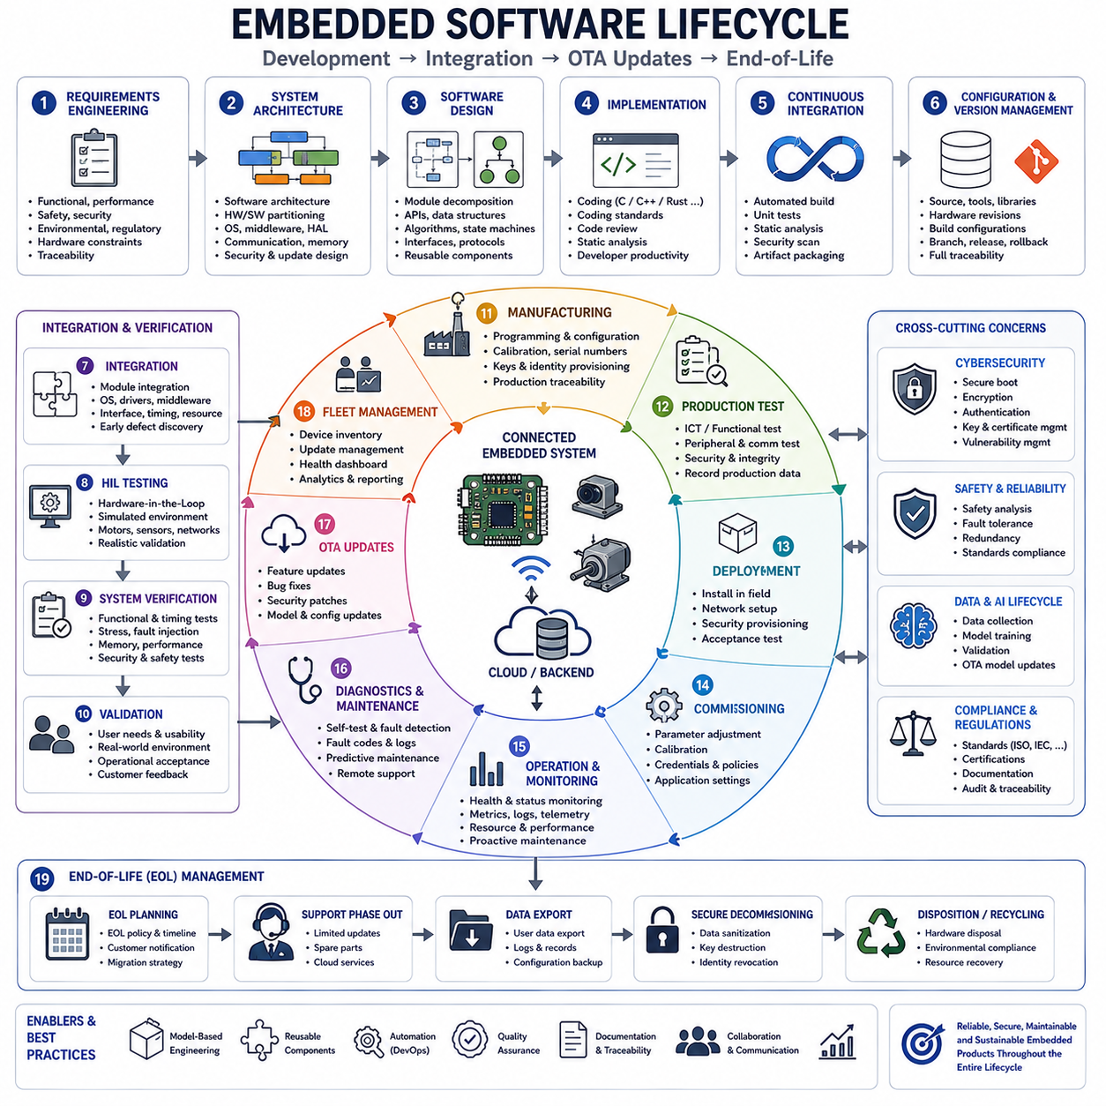
Embedded software development is no longer limited to writing firmware and programming a microcontroller. Modern embedded products remain connected throughout their operational lifetime, continuously receiving new features, security updates, performance improvements, and reliability enhancements. As a result, embedded software must be managed throughout an entire lifecycle that extends from initial concept and architecture design to development, integration, manufacturing, deployment, maintenance, over-the-air updates, and finally end-of-life management. A well-defined lifecycle ensures that embedded systems remain reliable, secure, maintainable, and economically sustainable throughout years or even decades of operation.
The lifecycle begins with system requirements engineering, where functional requirements, performance objectives, timing constraints, safety goals, cybersecurity expectations, environmental conditions, regulatory standards, and hardware limitations are identified. Requirements serve as the foundation for every subsequent engineering activity. In safety-critical industries such as automotive, aerospace, medical devices, industrial automation, railway control, and robotics, complete traceability between requirements, design, implementation, verification, and validation is mandatory to support certification and long-term product maintenance.
System architecture transforms requirements into a structured software and hardware design. Software architects define functional modules, communication interfaces, memory allocation, scheduling strategies, hardware abstraction layers, operating system architecture, middleware, diagnostics, security mechanisms, and update infrastructure. Architectural decisions made during this stage strongly influence scalability, maintainability, portability, and long-term software quality. Since embedded products often remain in service for many years, architecture must accommodate future hardware revisions, feature expansion, and technology evolution without requiring complete redesign.
Detailed software design decomposes the architecture into reusable software components. Developers define APIs, data structures, communication protocols, scheduling behavior, state machines, algorithms, error handling mechanisms, synchronization strategies, and module interfaces. Object-oriented design, component-based architecture, layered software organization, and model-based engineering are increasingly adopted to improve software reuse across multiple embedded product generations while reducing maintenance complexity.
Implementation converts software designs into executable source code using programming languages such as C, Embedded C++, Rust, or specialized domain-specific languages depending on project requirements. Coding standards including MISRA C, MISRA C++, AUTOSAR C++14, CERT C, and organizational software guidelines improve software consistency, portability, maintainability, and safety. Modern development environments integrate version control, automated formatting, static analysis, code review, dependency management, and continuous integration to improve software quality throughout implementation.
Configuration management forms the backbone of modern embedded software development. Every source file, compiler version, library, configuration parameter, hardware revision, calibration dataset, build option, documentation artifact, and release package must remain traceable throughout the entire product lifecycle. Version control systems enable collaborative development while supporting branch management, release tracking, defect correction, feature development, rollback capability, and long-term maintenance across multiple product variants.
Continuous integration has become an essential engineering practice for embedded software. Whenever developers commit source code changes, automated build systems compile firmware, execute static analysis, perform unit testing, generate documentation, validate coding-standard compliance, execute security scanning, and package software artifacts. Automated verification identifies defects immediately after introduction, reducing integration costs while improving software reliability and development productivity.
Static analysis detects potential software defects without executing the program. Modern analysis tools identify memory errors, undefined behavior, coding-standard violations, data-flow anomalies, concurrency problems, unreachable code, initialization errors, resource leaks, security vulnerabilities, and maintainability concerns. Early defect detection significantly reduces correction costs because software problems become increasingly expensive to resolve as development progresses toward production.
Unit testing verifies individual software modules independently of the complete embedded system. Hardware abstraction layers, dependency injection, software simulation, interface mocking, and automated testing frameworks allow developers to validate algorithms before physical hardware becomes available. High unit-test coverage improves software quality while enabling rapid regression testing whenever software modifications occur.
Integration represents one of the most challenging phases of the embedded software lifecycle. Individual software modules must interact correctly with hardware peripherals, operating systems, communication stacks, sensors, actuators, security mechanisms, diagnostics, and external systems. Integration frequently reveals timing problems, resource conflicts, hardware limitations, interface inconsistencies, initialization dependencies, and unexpected interactions that were not visible during isolated module development.
Hardware-in-the-loop testing significantly improves integration quality by executing production software on actual embedded controllers while simulating surrounding physical systems. Motors, sensors, communication networks, power systems, environmental conditions, and external equipment can all be simulated with high accuracy, allowing engineers to evaluate software behavior under realistic operating conditions without exposing expensive prototypes or personnel to unnecessary risks.
System verification confirms that implemented software satisfies engineering specifications. Functional testing, timing verification, communication validation, memory analysis, fault injection, stress testing, environmental testing, cybersecurity evaluation, performance measurement, power analysis, and safety validation collectively establish confidence that the complete embedded system operates correctly under both normal and abnormal conditions.
Validation differs from verification by confirming that the completed product satisfies actual user needs rather than merely complying with technical specifications. Customers evaluate usability, functionality, operational efficiency, maintainability, deployment procedures, diagnostics, update mechanisms, and overall system performance within representative operating environments. Validation ensures that engineering objectives align with real-world application requirements.
Manufacturing introduces additional lifecycle considerations extending beyond software functionality alone. Production programming stations install firmware into embedded controllers, configure manufacturing parameters, assign unique serial numbers, store calibration data, generate cryptographic identities, execute automated functional tests, verify programming integrity, and record production traceability information. Every manufactured device becomes uniquely identifiable throughout its operational lifetime.
Production testing ensures that every manufactured embedded product satisfies quality requirements before shipment. Automated production lines execute electrical verification, communication testing, peripheral validation, memory integrity testing, sensor calibration, safety verification, firmware authentication, and diagnostic self-tests. Manufacturing execution systems record detailed production history for every device, supporting future service, warranty analysis, quality improvement, and regulatory compliance.
Deployment represents the transition from manufacturing into operational environments. Embedded systems may be installed in vehicles, robots, industrial equipment, medical devices, infrastructure, aerospace platforms, or consumer electronics. Installation procedures frequently include network configuration, security provisioning, cloud registration, functional verification, calibration adjustment, software personalization, and operational acceptance testing before products become fully operational.
Commissioning extends deployment by adapting embedded systems to their specific operational environment. Communication parameters, sensor calibration, regional regulations, customer preferences, operational limits, security credentials, cloud connectivity, fleet management configuration, and application-specific settings are adjusted according to installation requirements. Proper commissioning significantly improves long-term reliability while reducing field support requirements.
Operational monitoring has become increasingly important as embedded devices become permanently connected through industrial networks and cloud services. Embedded software continuously reports health status, diagnostic information, fault codes, sensor statistics, performance metrics, communication quality, resource utilization, battery condition, environmental data, and predictive maintenance indicators. Remote monitoring enables proactive maintenance while reducing operational downtime.
Diagnostic frameworks assist maintenance personnel throughout product operation. Self-tests execute during startup and runtime to detect hardware failures, communication faults, memory corruption, software anomalies, timing violations, sensor degradation, actuator malfunctions, cybersecurity incidents, and environmental abnormalities. Diagnostic information supports troubleshooting, predictive maintenance, warranty analysis, fleet management, and continuous product improvement.
Cybersecurity remains an ongoing lifecycle responsibility rather than a one-time development activity. New software vulnerabilities continue to emerge throughout product operation, requiring periodic security assessment, vulnerability analysis, penetration testing, cryptographic updates, authentication improvements, certificate management, intrusion detection, and secure software maintenance. Connected embedded systems therefore require continuous cybersecurity support throughout their operational lifetime.
Over-the-air software updates have fundamentally transformed embedded lifecycle management. Instead of requiring physical service visits, manufacturers can remotely distribute firmware improvements, bug fixes, security patches, feature enhancements, calibration updates, machine learning models, and configuration changes through secure communication networks. OTA technology significantly reduces maintenance cost while extending product functionality long after deployment.
Secure OTA architecture requires multiple protective mechanisms. Firmware packages must be digitally signed, cryptographically verified, version controlled, encrypted when appropriate, and authenticated before installation begins. Secure boot mechanisms verify software integrity during every startup, preventing unauthorized firmware execution. Rollback protection prevents installation of obsolete software containing known vulnerabilities, while secure key management protects update authenticity throughout the product lifecycle.
Reliable OTA implementation must tolerate communication failures, interrupted power supplies, network instability, and incomplete downloads. Modern embedded systems frequently employ dual-bank firmware architectures where one software image remains operational while another receives updates. Only after complete verification does the bootloader switch execution to the new firmware, ensuring uninterrupted recoverability even if update failures occur.
Fleet management has become increasingly important for organizations operating thousands of embedded devices. Centralized management platforms monitor software versions, update progress, hardware inventory, operational health, communication status, geographic distribution, maintenance schedules, diagnostic events, and cybersecurity compliance across entire fleets. Fleet analytics enable data-driven maintenance planning while simplifying software deployment at enterprise scale.
Data collection throughout operation provides valuable feedback for future engineering improvements. Embedded devices generate operational statistics, failure reports, environmental measurements, user behavior patterns, software performance metrics, communication reliability information, energy consumption data, and diagnostic histories. Engineering organizations analyze these datasets to improve algorithms, optimize system architecture, refine predictive maintenance models, and prioritize future software development.
Artificial intelligence increasingly extends the embedded lifecycle beyond conventional software maintenance. Edge devices continuously collect operational data used for retraining machine learning models within cloud infrastructure. Updated models are subsequently validated, optimized, and redistributed through OTA mechanisms, enabling embedded AI systems to improve perception, prediction, diagnostics, anomaly detection, and decision-making capabilities throughout deployment.
Long-term maintenance often represents the largest lifecycle cost for industrial embedded products. Manufacturers must continue supporting multiple hardware revisions, software branches, security patches, regulatory updates, component obsolescence, replacement parts, customer customization, certification maintenance, and compatibility requirements for many years after initial deployment. Well-designed software architecture significantly reduces maintenance effort while extending commercial product viability.
Hardware evolution presents additional lifecycle challenges. Semiconductor manufacturers discontinue processors, memories, sensors, communication controllers, and other components throughout a product's lifetime. Embedded software architectures must therefore support hardware migration with minimal redesign by isolating hardware-specific functionality behind standardized abstraction layers and modular software interfaces.
End-of-life management represents the final phase of the embedded software lifecycle. Manufacturers gradually discontinue software updates, cybersecurity support, hardware production, spare parts, cloud services, and maintenance activities according to published support policies. Customers require advance notification, migration guidance, replacement planning, data export capabilities, secure device decommissioning procedures, and regulatory compliance throughout product retirement.
Secure decommissioning has become increasingly important for connected embedded systems. Sensitive information including cryptographic keys, authentication credentials, proprietary algorithms, personal information, operational histories, and security certificates must be permanently removed before hardware disposal or recycling. Secure erase procedures, cryptographic key destruction, storage sanitization, and identity revocation protect both manufacturers and customers after products reach end of service.
Modern robotic systems demonstrate the complete embedded software lifecycle particularly well. Development begins with system architecture, perception algorithms, motion control, navigation, safety software, diagnostics, and communication infrastructure. Integration combines embedded controllers, sensors, actuators, artificial intelligence, cloud connectivity, and fleet management. Deployment installs robots within operational environments where continuous monitoring, predictive maintenance, OTA software updates, AI model improvements, cybersecurity management, and operational optimization occur throughout years of autonomous service before eventual hardware replacement and secure retirement.
Ultimately, the embedded software lifecycle extends far beyond firmware development. It encompasses requirements engineering, architecture, implementation, integration, verification, manufacturing, deployment, commissioning, monitoring, diagnostics, cybersecurity, over-the-air updates, predictive maintenance, hardware evolution, fleet management, long-term support, and end-of-life planning. Organizations that systematically manage every stage of this lifecycle produce embedded systems that remain reliable, secure, maintainable, adaptable, and economically sustainable throughout decades of operation, providing the technological foundation for autonomous robots, intelligent vehicles, industrial automation, medical systems, aerospace platforms, and future Physical AI ecosystems.

01.10 Robot Embedded System Design Principles Summary
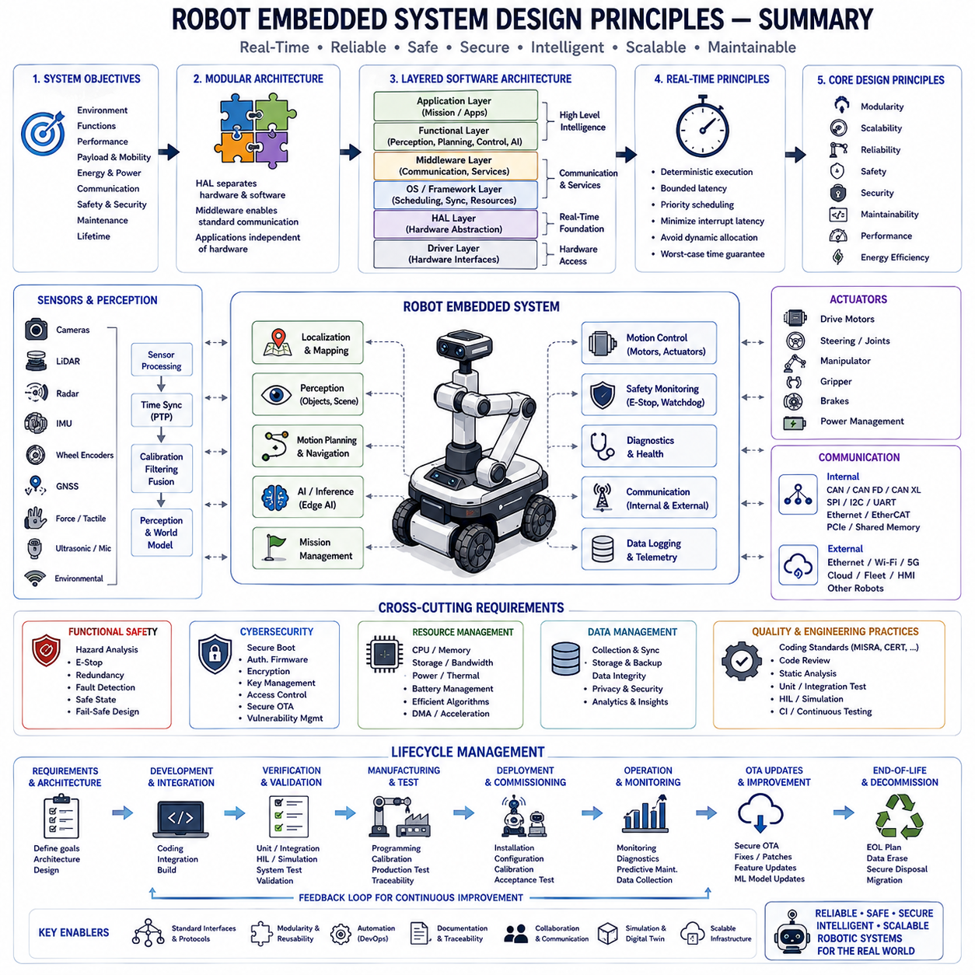
Robotic embedded systems represent one of the most sophisticated forms of modern embedded computing because they integrate real-time control, perception, communication, artificial intelligence, functional safety, cybersecurity, cloud connectivity, and physical interaction within a single coordinated platform. Unlike conventional embedded devices that execute a limited set of predefined functions, robotic systems continuously observe dynamic environments, interpret sensor information, make autonomous decisions, and execute precise physical actions under strict timing constraints. Consequently, robotic embedded software must balance computational efficiency, deterministic behavior, scalability, maintainability, and long-term reliability throughout the entire operational lifetime of the robot.
A successful robotic embedded architecture begins with a clear understanding of system objectives. Engineers must identify the robot's operational environment, functional capabilities, performance expectations, payload limitations, mobility requirements, energy constraints, communication infrastructure, safety objectives, maintenance strategy, and expected service lifetime before selecting hardware or writing software. Well-defined requirements establish measurable engineering targets that guide architecture decisions, hardware selection, software decomposition, verification planning, and lifecycle management while minimizing costly redesign later in development.
System architecture should follow modular engineering principles that separate hardware-dependent functionality from application-level intelligence. Hardware abstraction layers isolate processors, communication peripherals, sensors, actuators, storage devices, and timing resources behind standardized interfaces, allowing software components to remain portable across multiple hardware platforms. Middleware provides standardized communication mechanisms between software modules, while application layers implement perception, planning, localization, control, diagnostics, fleet management, and mission execution independently from low-level hardware implementation.
Layered software architecture significantly improves maintainability and scalability. Low-level drivers directly manage hardware registers and peripheral interfaces. Hardware abstraction layers provide standardized access to these drivers. Operating systems coordinate multitasking, scheduling, synchronization, and resource management. Middleware enables message exchange and service discovery. Functional modules implement localization, mapping, perception, motion planning, navigation, manipulation, communication, and artificial intelligence. User applications coordinate these capabilities according to mission objectives while cloud services provide fleet-level supervision and long-term analytics.
Real-time performance remains one of the defining characteristics of robotic embedded systems. Motion control, motor feedback, sensor acquisition, localization, obstacle avoidance, emergency stop processing, and safety monitoring all require deterministic execution with predictable timing. Software should therefore prioritize bounded execution times, minimize interrupt latency, avoid unnecessary dynamic memory allocation, carefully manage scheduling priorities, and guarantee worst-case response times under all operating conditions. Deterministic behavior provides the foundation for both functional safety and reliable autonomous operation.
Resource management directly influences robotic system performance. Processor utilization, memory consumption, storage capacity, communication bandwidth, electrical power, thermal dissipation, and battery energy must all remain within carefully engineered limits. Efficient algorithms, optimized data structures, hardware acceleration, direct memory access, multicore scheduling, and intelligent workload distribution maximize computational capability while preserving energy efficiency and maintaining real-time responsiveness.
Memory architecture requires disciplined engineering throughout the software lifecycle. Flash memory stores firmware, bootloaders, artificial intelligence inference engines, calibration constants, and configuration tables. SRAM supports runtime execution, sensor buffers, localization states, communication queues, navigation maps, and control variables. Persistent configuration resides within EEPROM or Flash emulation, while peripheral registers expose direct hardware control. Linker configuration, stack management, memory protection, and careful allocation policies ensure deterministic execution without fragmentation or resource exhaustion.
Interrupt architecture forms the nervous system of robotic embedded software. High-priority interrupts process emergency stop circuits, motor control feedback, inertial measurement units, communication deadlines, watchdog timers, and safety events with minimal latency. Lower-priority interrupts handle diagnostics, logging, telemetry, and background communication. Efficient interrupt service routines perform only essential hardware operations while deferring computationally intensive processing to scheduled software tasks, thereby maximizing responsiveness without compromising overall system throughput.
Communication architecture determines how robotic subsystems exchange information. Internal communication may utilize CAN, CAN FD, CAN XL, SPI, I2C, UART, Ethernet, EtherCAT, PCI Express, or shared memory depending on bandwidth and latency requirements. External communication connects robots with cloud platforms, fleet management systems, supervisory controllers, human-machine interfaces, and other robots using Ethernet, Wi-Fi, 5G, industrial fieldbuses, or specialized wireless protocols. Standardized interfaces simplify integration while enabling scalable multi-robot collaboration.
Sensor integration requires synchronized acquisition, timestamp management, calibration, filtering, fusion, and validation. Cameras, LiDAR, radar, inertial measurement units, wheel encoders, GNSS receivers, force sensors, ultrasonic sensors, microphones, and environmental sensors generate complementary information with different update rates, noise characteristics, and communication protocols. Time synchronization technologies such as Precision Time Protocol enable consistent sensor fusion by ensuring that measurements from multiple devices represent the same physical instant.
Localization and mapping form the spatial awareness foundation of autonomous robots. Embedded software continuously estimates robot position by integrating wheel odometry, inertial sensors, GNSS, LiDAR, cameras, radar, landmarks, and environmental maps. Sensor fusion algorithms compensate for individual sensor limitations while maintaining accurate pose estimation despite wheel slip, temporary signal loss, environmental uncertainty, or dynamic obstacles. Reliable localization directly influences navigation accuracy, safety margins, and mission success.
Motion planning transforms high-level objectives into executable trajectories while respecting robot kinematics, dynamics, environmental obstacles, safety zones, energy limitations, and actuator capabilities. Embedded software continuously evaluates alternative trajectories, predicts future robot states, verifies collision-free operation, and generates feasible control commands. Efficient planning algorithms enable autonomous robots to adapt safely to changing environments while maintaining predictable real-time performance.
Motion control converts planned trajectories into precise actuator commands. Closed-loop feedback continuously compares desired motion against measured robot behavior, compensating for disturbances, mechanical variation, environmental changes, and modeling inaccuracies. High-frequency control loops require deterministic scheduling, low interrupt latency, predictable communication timing, and carefully optimized numerical algorithms to achieve stable, accurate, and responsive robot behavior.
Artificial intelligence increasingly complements conventional robotics algorithms without replacing deterministic embedded control. Embedded AI accelerators execute neural network inference for object detection, semantic segmentation, obstacle recognition, anomaly detection, predictive maintenance, speech recognition, and decision support. Traditional control algorithms continue managing hard real-time motor control, safety supervision, communication protocols, and deterministic scheduling, while AI contributes adaptive perception and higher-level reasoning capabilities.
Functional safety must be incorporated throughout robotic system architecture rather than added after implementation. Hazard analysis identifies potential failure modes affecting human safety, equipment protection, environmental impact, and operational reliability. Safety mechanisms include emergency stop systems, redundant sensing, watchdog supervision, fault detection, safe-state transitions, power isolation, braking systems, communication monitoring, and software diagnostics. Layered safety architecture minimizes single points of failure while supporting graceful degradation during abnormal operating conditions.
Cybersecurity has become equally important as functional safety because modern robots operate within interconnected digital infrastructures. Secure boot, authenticated firmware, encrypted communication, hardware root of trust, secure key storage, certificate management, access control, intrusion detection, vulnerability management, and secure OTA updates collectively protect robotic systems from unauthorized modification, malicious software, data theft, and operational disruption throughout their service lifetime.
Software quality depends heavily upon disciplined engineering practices. Coding standards such as MISRA C, MISRA C++, AUTOSAR C++, CERT C, and internal development guidelines improve consistency, readability, portability, and safety. Static analysis identifies potential defects before execution, while peer code reviews, automated formatting, dependency management, and continuous integration establish repeatable engineering processes that improve maintainability and reduce long-term technical debt.
Testing must occur continuously throughout development rather than only after implementation. Unit testing validates individual software modules independently. Integration testing verifies communication among software components. Hardware-in-the-loop simulation evaluates complete control software under realistic physical conditions. System verification confirms compliance with engineering specifications, while validation ensures that the finished robot satisfies actual customer requirements within representative operational environments.
Simulation significantly reduces development cost while accelerating software maturity. Digital twins, physics engines, synthetic sensor generation, virtual environments, and hardware simulation allow engineers to evaluate navigation, perception, motion planning, fault recovery, communication behavior, and safety mechanisms before deploying software onto physical robots. Simulation enables repeatable testing of hazardous or rare scenarios that would otherwise be difficult or expensive to reproduce experimentally.
Lifecycle management extends robotic software far beyond initial deployment. Connected robots continuously report health information, diagnostic events, operational statistics, battery status, environmental conditions, software versions, communication quality, and predictive maintenance indicators. Cloud infrastructure analyzes fleet-wide operational data to identify software improvements, reliability trends, maintenance priorities, cybersecurity vulnerabilities, and artificial intelligence model updates throughout years of field operation.
Over-the-air software updating provides a secure mechanism for distributing firmware improvements, security patches, performance optimizations, calibration updates, configuration changes, and machine learning models without requiring physical maintenance visits. Robust OTA architecture incorporates digital signatures, cryptographic verification, rollback protection, secure boot, dual-bank firmware storage, interrupted-update recovery, and comprehensive audit logging to ensure reliable deployment across large robotic fleets.
Fleet management transforms individual robots into coordinated operational ecosystems. Centralized platforms supervise robot availability, mission assignment, software version control, maintenance scheduling, battery charging, navigation maps, diagnostics, cybersecurity compliance, and performance analytics across hundreds or thousands of deployed systems. Fleet intelligence enables organizations to optimize operational efficiency while reducing maintenance cost and maximizing equipment utilization.
Scalability should remain a primary architectural objective from the earliest design stages. Software developed for a small mobile robot should evolve naturally toward larger autonomous platforms, collaborative robot fleets, industrial automation systems, logistics robots, agricultural equipment, service robots, and intelligent transportation platforms without fundamental architectural redesign. Modular interfaces, standardized communication protocols, reusable software components, and hardware abstraction enable long-term scalability across multiple product generations.
Maintainability determines long-term engineering success as much as initial functionality. Clear software documentation, consistent interfaces, modular implementation, comprehensive testing, traceable requirements, automated deployment, version management, diagnostic capability, logging infrastructure, and structured configuration management collectively reduce maintenance effort while accelerating future feature development. Products designed for maintainability remain commercially valuable far longer than systems optimized solely for initial implementation speed.
Hardware evolution inevitably occurs throughout long-lived robotic platforms. Processors, sensors, communication interfaces, memory technologies, artificial intelligence accelerators, and power electronics continuously improve while existing components eventually become obsolete. Well-designed embedded architectures isolate hardware-specific functionality behind abstraction layers, allowing software migration to newer hardware with minimal modification while preserving application-level functionality and accumulated engineering investment.
Data has become one of the most valuable assets generated by robotic systems. Operational logs, perception datasets, localization histories, navigation performance, fault records, maintenance events, energy consumption, environmental observations, user interactions, and mission outcomes collectively support continuous software improvement, predictive maintenance, digital twin refinement, machine learning retraining, and next-generation product development. Embedded architectures should therefore treat data acquisition, storage, synchronization, security, and lifecycle management as first-class engineering requirements.
Modern robotic embedded systems increasingly integrate cloud computing, edge computing, and onboard processing into a unified computational hierarchy. Hard real-time control remains on embedded processors, perception and artificial intelligence execute on edge accelerators, fleet coordination and large-scale optimization occur within cloud infrastructure, and long-term analytics guide future software evolution. Careful partitioning of computation according to latency, bandwidth, reliability, security, and energy requirements enables efficient utilization of distributed computing resources.
Ultimately, robotic embedded system design is a multidisciplinary engineering discipline integrating electronics, software engineering, control theory, communication systems, artificial intelligence, cybersecurity, safety engineering, systems engineering, and lifecycle management. Successful robotic platforms emerge not from optimizing any single subsystem but from carefully balancing deterministic execution, computational performance, modular architecture, software quality, maintainability, scalability, security, and long-term operational reliability. These design principles provide the engineering foundation upon which future autonomous robots, intelligent industrial systems, collaborative machines, autonomous vehicles, medical robotics, aerospace platforms, and Physical AI ecosystems will continue to evolve.

