Volume 02 Embedded Software Engineering

05. Firmware Architecture

05.01 Firmware Architecture Design Principles: Modularity / Portability
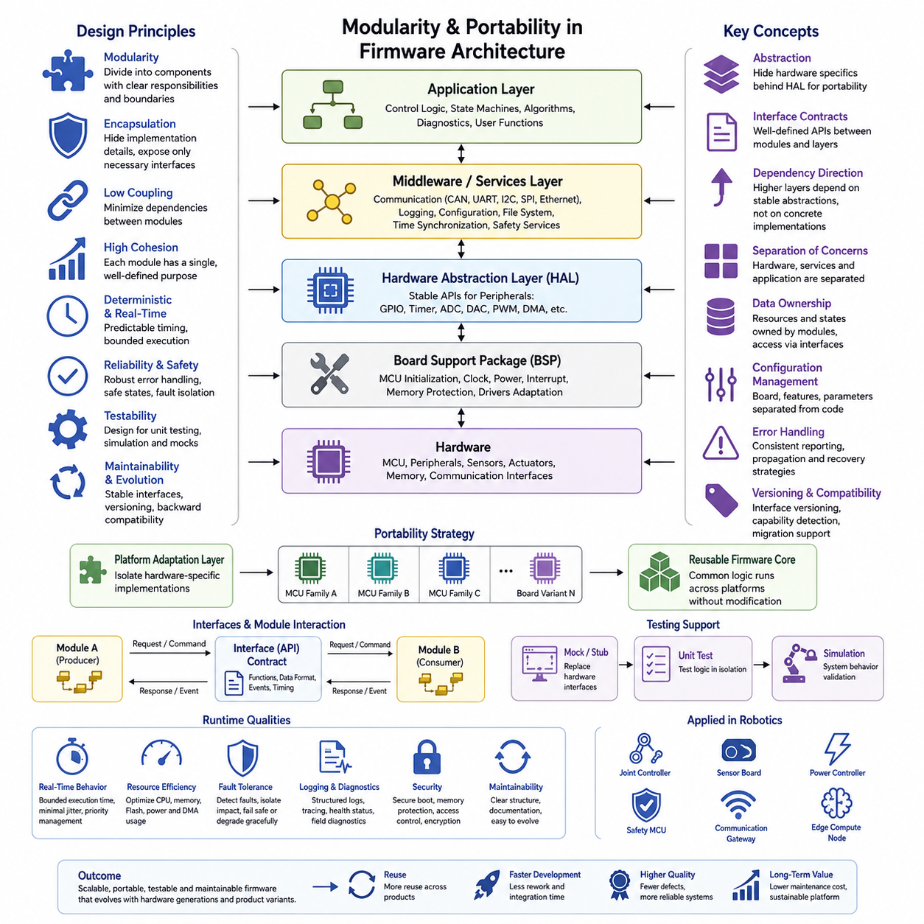
Firmware architecture defines the structural rules that determine how low-level hardware control, reusable services, and application behavior are organized within an embedded system. In robotics, firmware often sits between electrical hardware and higher-level control software, so its architecture must support predictable execution while remaining understandable and maintainable. Modularity and portability are therefore fundamental design principles rather than optional implementation conveniences.
Modularity divides firmware into components with clearly defined responsibilities and interfaces. Instead of allowing application logic to directly manipulate registers, peripherals, communication protocols, and control algorithms throughout the codebase, each responsibility is encapsulated behind an explicit boundary. A well-structured module exposes only the operations required by other components while keeping implementation details private, reducing unintended dependencies and simplifying change.
A useful modular decomposition separates hardware-dependent mechanisms from hardware-independent behavior. Peripheral access, board initialization, clock configuration, interrupt handling, and register operations belong near the hardware boundary, while device services, communication protocols, diagnostics, state management, and control logic occupy progressively higher layers. This organization prepares the architecture for the later distinction among HAL, middleware, and application layers defined within the firmware chapter structure.
The Hardware Abstraction Layer, or HAL, is one of the most important mechanisms for achieving portability. It provides stable software interfaces for GPIO, timers, ADCs, communication peripherals, storage, and other hardware resources while hiding MCU-specific implementation details. Application components should depend primarily on these abstractions rather than directly on vendor registers or peripheral libraries, allowing hardware implementations to change without forcing extensive modification of higher-level firmware.
Portability extends beyond replacing one microcontroller with another. Firmware may need to migrate between board revisions, MCU families, processor architectures, operating environments, or different products within a robot platform. Portable architecture therefore isolates assumptions about memory maps, byte ordering, interrupt controllers, peripheral instances, clock frequencies, DMA channels, and compiler behavior. Platform-specific definitions should be concentrated in controlled adaptation layers instead of being scattered throughout application code.
Interfaces are the contracts connecting modules, and their quality strongly influences architectural stability. Interfaces should communicate intent rather than expose internal representation. A motor-control module, for example, should provide operations such as initialization, command submission, state retrieval, and fault handling rather than allowing external components to manipulate its internal registers or buffers. Small and cohesive interfaces reduce coupling, make dependencies visible, and permit implementations to evolve independently.
Dependency direction is equally important. Higher-level policy should depend on stable abstractions, while hardware-specific implementations satisfy those abstractions from below. When application code directly depends on a particular MCU vendor library, portability becomes expensive because platform assumptions propagate upward. Inverting that dependency through interfaces allows the same control or application logic to operate with different hardware implementations, simulation adapters, or test doubles without redesigning the entire firmware system.
Modularity must also account for embedded resource constraints. Excessive abstraction can introduce memory overhead, additional call paths, larger binaries, or unpredictable execution behavior. Firmware architecture therefore seeks controlled modularity rather than abstraction for its own sake. Interfaces should remain lightweight, memory ownership should be explicit, dynamic allocation should be limited where determinism matters, and performance-critical paths should be designed so that architectural separation does not obscure timing behavior.
Data ownership provides another essential architectural boundary. Shared global state creates hidden coupling because unrelated modules can modify the same information without explicit coordination. Strong firmware architectures assign ownership of buffers, device states, configuration objects, and communication queues to specific components. Other components access those resources through defined interfaces. This makes synchronization requirements visible and reduces race conditions, unintended side effects, and debugging complexity.
Configuration should also be separated from behavioral implementation. Board pin assignments, communication rates, sensor selections, calibration constants, feature switches, and product variants frequently change even when the underlying algorithms remain stable. Keeping configuration in dedicated structures or platform definitions allows a common firmware core to serve multiple hardware variants. This approach reduces source-code branching and helps prevent product-specific modifications from fragmenting a reusable firmware platform.
Modular architecture improves testability because components with explicit dependencies can be evaluated independently. Hardware interfaces can be replaced with mocks or simulated implementations, allowing state machines, protocol handlers, fault logic, and control functions to execute without physical hardware. This architectural property directly supports the firmware chapter's later emphasis on mock environments and unit testing, where separation of hardware dependencies becomes a prerequisite for effective automated verification.
Error handling should follow the same architectural discipline as normal functional behavior. Modules need explicit mechanisms for reporting invalid parameters, timeouts, communication failures, resource exhaustion, hardware faults, and inconsistent states. Errors should propagate across layer boundaries in controlled forms rather than through undocumented global flags. The architecture should distinguish recoverable failures from conditions requiring subsystem reset, degraded operation, or transition to a defined safe state.
Real-time behavior places additional constraints on modular firmware. Components may be logically independent yet still interact through interrupts, periodic tasks, DMA completion events, or shared communication resources. Architectural boundaries should therefore document timing assumptions as well as functional interfaces. Maximum execution time, blocking behavior, interrupt context restrictions, queue capacity, and synchronization rules are part of the effective contract between modules when firmware participates in deterministic robot control.
Portability also depends on minimizing assumptions about the execution environment. Firmware that can operate only because of undocumented initialization order, compiler extensions, implicit memory placement, or a particular startup implementation is difficult to reuse. Platform initialization should establish explicit preconditions, and architecture should clearly separate startup code, runtime services, and application activation. This makes adaptation to bare-metal systems, RTOS-based systems, or different toolchains substantially more manageable.
Versioning becomes increasingly important as modular firmware evolves. Interfaces between bootloaders, application firmware, communication protocols, stored configuration, and external controllers may survive across multiple releases. Architectural design should anticipate compatibility by defining data formats, interface versions, capability identification, and migration behavior. Stable contracts allow modules to evolve independently while preventing a local firmware update from unexpectedly breaking neighboring components or higher-level robot software.
For robotic systems, these principles create a scalable foundation extending from individual actuator controllers to distributed embedded subsystems. A joint controller, sensor board, power controller, or safety MCU can retain hardware-specific implementations while sharing common architectural patterns for diagnostics, communication, configuration, and lifecycle management. This consistency reduces integration effort and supports systematic firmware development across heterogeneous robot hardware rather than treating every embedded controller as an isolated project.
Ultimately, modularity and portability are complementary architectural properties. Modularity establishes boundaries that contain complexity, while portability uses those boundaries to separate reusable behavior from platform-specific mechanisms. Effective firmware architecture balances abstraction with deterministic execution, explicit ownership, stable interfaces, testability, and resource awareness. The result is firmware that can evolve with hardware generations and product variants without repeatedly rebuilding the embedded software foundation from the beginning.

05.02 Bare-Metal Firmware Architecture Design [w/Code]
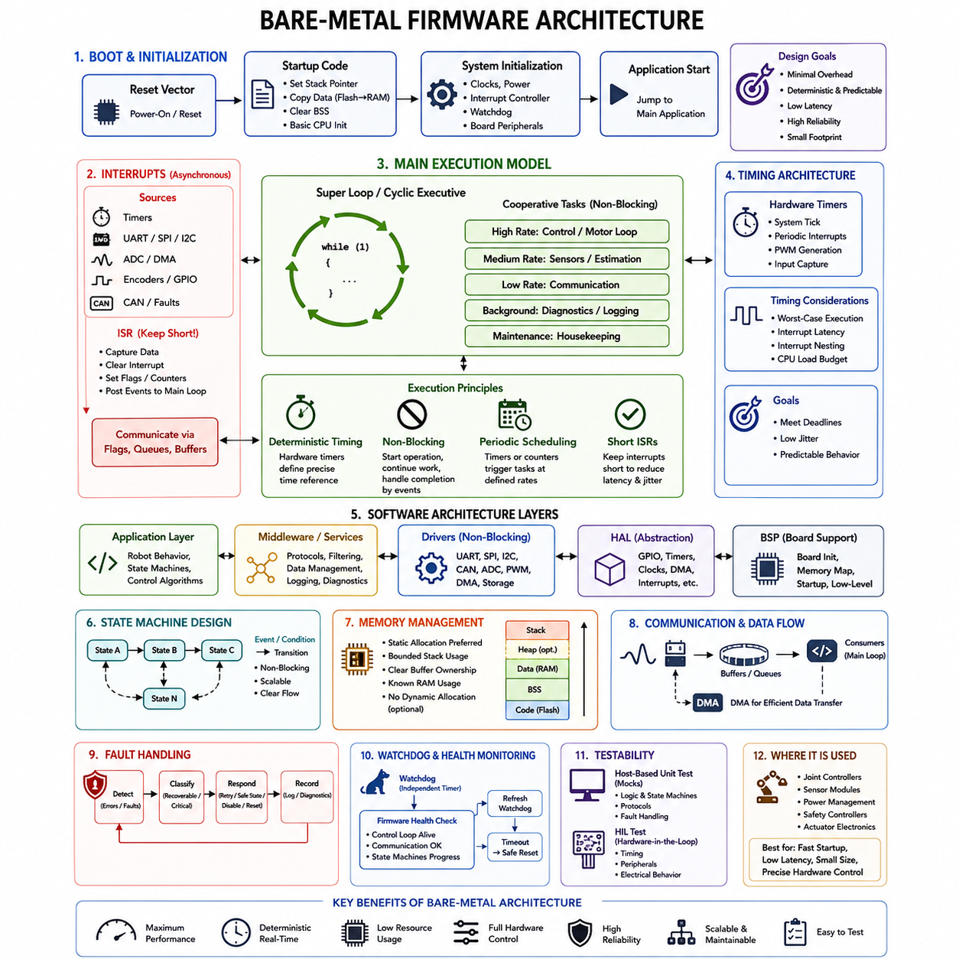
Bare-metal firmware executes directly on a microcontroller or processor without an operating system or real-time operating system managing tasks, memory, or hardware resources. The firmware therefore assumes direct responsibility for processor initialization, peripheral configuration, interrupt handling, timing, communication, and application control. This architecture provides minimal software overhead and highly predictable behavior, but requires disciplined organization to prevent hardware logic and application behavior from becoming tightly coupled.
A typical bare-metal system begins execution at the reset vector after power-on or reset. Startup code establishes the processor environment by configuring the stack pointer, initializing memory regions, copying initialized data from Flash to RAM, clearing uninitialized sections, and preparing essential processor state. System initialization then configures clocks, power domains, interrupt controllers, watchdogs, and board-specific hardware before transferring control to the main firmware application.
The simplest execution architecture uses a super loop, commonly represented by an infinite main loop that repeatedly invokes application functions. Sensor acquisition, communication processing, state updates, actuator commands, diagnostics, and background maintenance may execute sequentially within this loop. Although conceptually simple, the design must ensure that individual operations do not block execution for excessive periods because one slow function can delay every other activity sharing the loop.
A more structured super-loop architecture divides application behavior into cooperative tasks executed at controlled intervals. A high-frequency function may process motor control, while slower functions handle sensor monitoring, communication, diagnostics, or status reporting. Software counters, hardware timers, or periodic timer interrupts can establish these execution rates. This creates a lightweight cyclic executive that provides basic scheduling behavior without introducing a full RTOS task scheduler.
Timing is a fundamental architectural concern because bare-metal firmware has no operating system to guarantee task activation. Hardware timers should establish deterministic time references, while application logic should avoid long blocking delays. Instead of waiting synchronously for a peripheral operation to complete, firmware can initiate the operation, continue executing other work, and later process completion through polling, status flags, interrupts, or state transitions. This preserves responsiveness across the system.
Interrupt Service Routines, or ISRs, provide asynchronous responses to hardware events such as timer expiration, UART reception, ADC conversion completion, encoder transitions, CAN messages, or fault signals. ISRs should normally perform only time-critical work, capture essential information, acknowledge the interrupt source, and communicate the event to foreground processing. Lengthy calculations or blocking operations inside interrupts increase latency and can interfere with higher-priority real-time activities.
Communication between interrupt context and the main execution loop requires carefully controlled shared state. Variables modified by both contexts may require volatile qualification, atomic access, interrupt masking, or other synchronization techniques appropriate to the processor architecture. A common design allows an ISR to set an event flag, update a counter, or place data into a buffer, while the main loop performs the more complex processing associated with that event.
Layering remains valuable even without an operating system. Hardware-specific register operations can be isolated within a Board Support Package and Hardware Abstraction Layer, while device drivers expose higher-level operations for sensors, actuators, communication interfaces, and storage. Middleware components can implement protocols or reusable services, and the application layer can concentrate on robot behavior. This separation prevents the super loop from becoming a collection of unrelated register-level operations.
Peripheral drivers should support non-blocking operation whenever responsiveness is important. UART reception can use interrupts or DMA, ADC sampling can be timer-triggered, and SPI transactions can progress through state-driven operations rather than busy waiting. DMA is particularly useful for moving larger data blocks without continuous processor intervention. These mechanisms allow the CPU to execute control and application logic while hardware peripherals independently perform data transfers.
Finite State Machines, or FSMs, are especially effective in bare-metal architectures because they transform long procedural sequences into incremental state transitions. Initialization, communication protocols, actuator sequencing, calibration, recovery, and device management can each be represented as states responding to events and conditions. Instead of blocking until an entire operation finishes, the firmware advances the operation across repeated loop iterations while preserving system responsiveness.
Memory management should remain explicit and predictable. Static allocation is commonly preferred because RAM requirements can be determined during development and runtime allocation failures are avoided. Stack usage must be carefully bounded, particularly when interrupts can nest or functions contain large local variables. Buffers for communication, sensor acquisition, diagnostics, and control data should have clearly defined ownership and capacity so memory consumption remains understandable throughout system operation.
Bare-metal firmware must also define initialization dependencies explicitly. Drivers should not assume that clocks, GPIO configuration, DMA resources, or communication peripherals have already been prepared unless the architecture guarantees that sequence. A controlled startup procedure typically initializes platform resources first, then device drivers, reusable services, application state, and finally interrupt-driven or periodic operation. Explicit initialization order reduces failures caused by hidden dependencies between components.
Error handling requires architectural planning because there is no operating system supervising failed tasks or processes. Drivers and services should report errors through defined status values, fault structures, or diagnostic events. Recoverable failures may trigger retries or peripheral reinitialization, while serious failures may disable outputs, place actuators into safe conditions, store diagnostic information, or intentionally reset the controller through a watchdog or software-controlled reset mechanism.
Watchdog integration is particularly important in unattended robot controllers. The watchdog should be refreshed only when critical firmware execution is known to be healthy rather than unconditionally from a timer interrupt. A health-monitoring mechanism can verify that essential control loops, communication services, and state machines continue to make progress. If execution stalls or critical conditions become inconsistent, expiration of the watchdog provides a controlled mechanism for restoring the controller.
Deterministic execution requires understanding worst-case behavior rather than relying only on average processing time. Designers should evaluate the execution duration of periodic functions, interrupt latency, interrupt nesting, communication bursts, DMA activity, and shared-resource contention. The combined workload must remain within the available processing budget so that high-priority control operations consistently meet their deadlines even when several hardware events occur close together.
Testing becomes easier when bare-metal architecture separates hardware access from application logic. Register-level implementations can be replaced by mock interfaces on a host computer, enabling state machines, protocol logic, fault handling, and control decisions to be tested independently of the target board. Hardware-in-the-loop testing can then verify timing, interrupts, peripherals, and electrical interactions that cannot be represented accurately in a purely software-based environment.
For robot joint controllers, sensor modules, power-management boards, safety controllers, and compact actuator electronics, bare-metal firmware remains attractive when startup speed, small memory footprint, low latency, and precise hardware control are more important than sophisticated operating-system services. Its effectiveness depends less on the absence of an RTOS than on architectural discipline: explicit timing, short interrupts, non-blocking execution, layered drivers, controlled state, deterministic memory use, and systematic fault handling.
A well-designed bare-metal architecture can therefore provide a compact yet scalable embedded software foundation. The reset and initialization path establishes a known platform state, interrupts capture asynchronous hardware events, cooperative foreground functions execute application behavior, and layered interfaces isolate hardware dependencies. When these elements are combined with deterministic timing, state-machine-based logic, diagnostics, watchdog supervision, and testable modules, bare-metal firmware can reliably support demanding real-time robotic subsystems.

05.03 FSM-Based Firmware Design Patterns [w/Code]
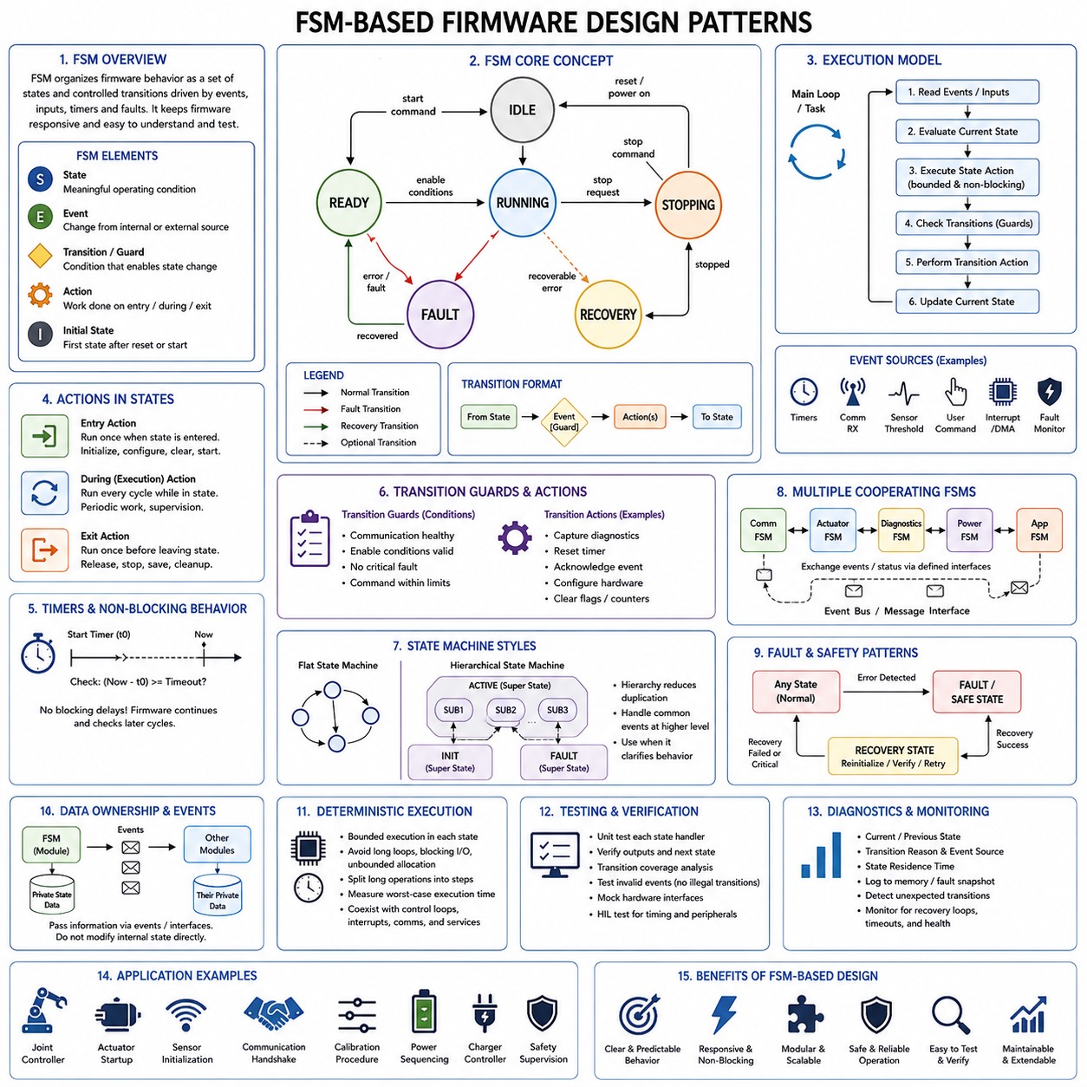
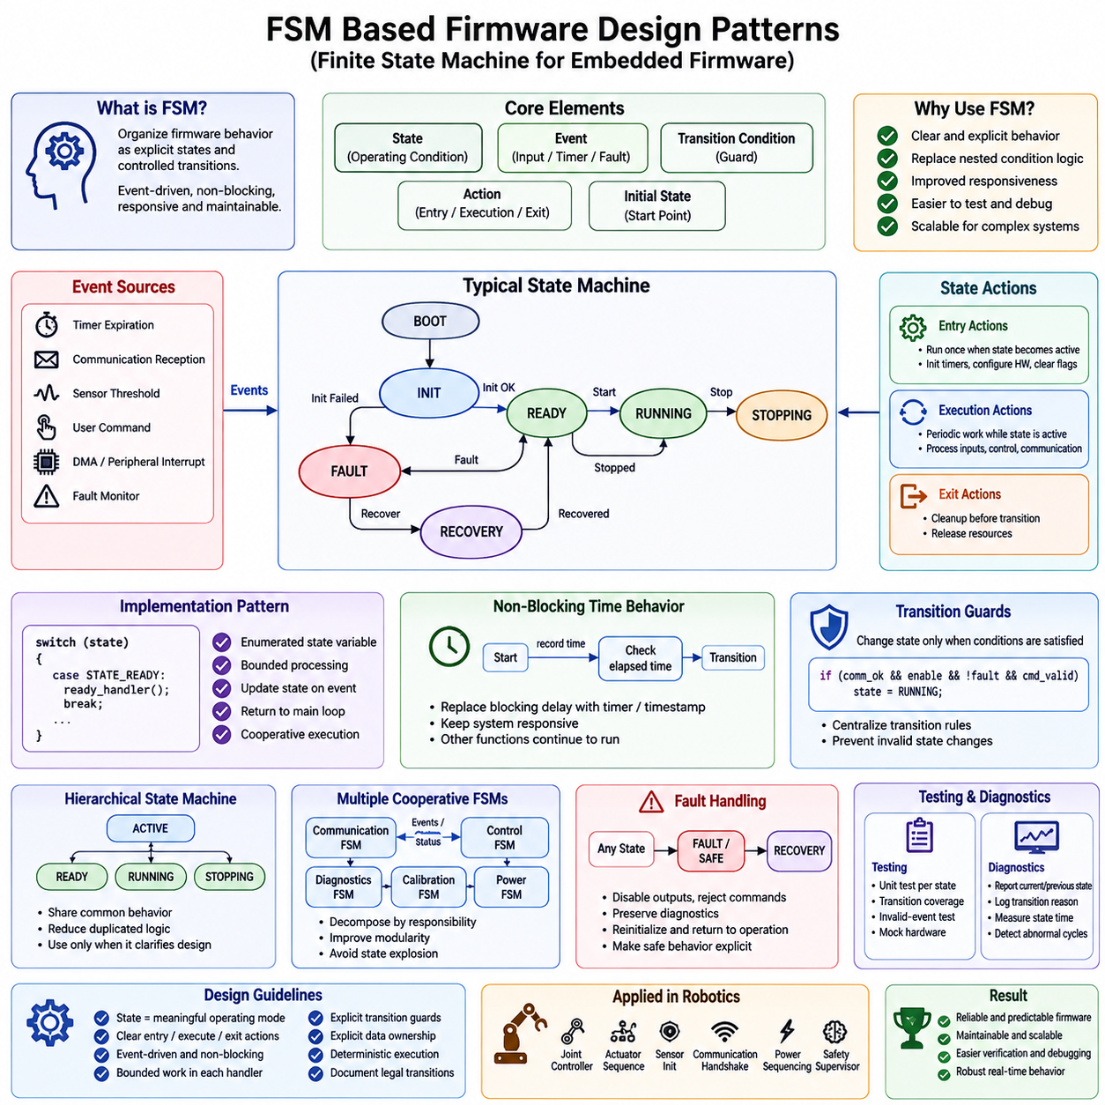
A Finite State Machine, or FSM, provides a disciplined way to organize firmware behavior as a set of explicit operating states and controlled transitions between them. Instead of implementing long procedural sequences with deeply nested conditions, the firmware represents its current operating condition as a state and determines the next action from events, inputs, timers, or faults. This structure is especially effective in embedded controllers that must remain responsive while managing sequential behavior.
An FSM normally consists of states, events, transition conditions, actions, and an initial state. A state represents a meaningful operating condition such as initialization, idle, ready, running, stopping, fault, or recovery. Events describe changes that may influence behavior, while transition conditions determine whether movement from one state to another is permitted. Actions perform the work associated with entering, executing, leaving, or transitioning between states.
State selection should reflect externally meaningful behavior rather than every internal variable combination. If states are too broad, each state accumulates complex conditional logic and loses the advantages of the FSM model. If states are excessively detailed, the transition graph becomes difficult to understand and maintain. Effective firmware design therefore identifies states around distinct operating modes, resource ownership, safety conditions, communication phases, or hardware sequences that require clearly differentiated behavior.
A common implementation pattern uses an enumerated state variable and a dispatch mechanism such as a switch statement. During each execution cycle, the firmware evaluates the current state, performs bounded processing, checks relevant events, and updates the state when a valid transition occurs. The function then returns control to the main loop or scheduler. This repeated execution model avoids blocking behavior and allows multiple firmware functions to progress cooperatively over time.
Entry, execution, and exit actions help separate responsibilities within each state. Entry actions run once when a state becomes active and may initialize timers, configure hardware, clear flags, or issue commands. Execution actions perform periodic work while the state remains active. Exit actions release resources or complete cleanup before transition. Separating these behaviors prevents repeated initialization and makes the lifecycle of each state easier to inspect and test.
Event-driven FSM design improves responsiveness by allowing state transitions to react to asynchronous conditions. Events may originate from timer expiration, communication reception, sensor thresholds, user commands, DMA completion, interrupts, or fault monitors. Interrupt Service Routines should generally capture time-critical information and convert hardware activity into flags, counters, or queued events. The foreground FSM can then process those events without placing complex state logic inside interrupt context.
Timers are particularly important because many firmware sequences depend on time without being allowed to block. Instead of calling a delay function while waiting for hardware stabilization, communication response, motor settling, or retry intervals, the FSM records a timestamp or starts a timer and returns immediately. Later executions compare the elapsed time with the required interval. This converts synchronous waiting into non-blocking temporal behavior while allowing other firmware functions to continue operating.
Transition guards define conditions that must be satisfied before a transition is accepted. A motor controller, for example, may move from READY to RUNNING only when communication is healthy, enable conditions are valid, no critical fault exists, and the requested command is within allowable limits. Guards centralize transition rules and prevent state changes from being scattered throughout unrelated functions, making operational logic easier to review and verify.
Transition actions should remain distinct from continuous state behavior whenever practical. A transition may capture diagnostic information, reset a timer, acknowledge an event, or configure hardware required by the destination state. Keeping these operations explicit reduces hidden side effects. It also allows engineers to determine not only which states are reachable but exactly what happens when the firmware crosses each behavioral boundary.
Hierarchical State Machines can manage complexity when a controller contains related groups of states. Several operational states may share common behavior under an overarching ACTIVE state, while initialization or fault states remain separate. Hierarchy reduces duplicated transition logic and allows common events to be handled at higher levels. However, hierarchy should be introduced only when it clarifies behavior, because excessive nesting can make execution paths difficult to trace in resource-constrained firmware.
Multiple cooperating FSMs are often preferable to one enormous state machine. Communication management, actuator sequencing, diagnostics, calibration, power management, and application control can each have their own state model while exchanging explicit events or status information. This decomposition improves modularity and prevents unrelated concerns from producing a combinatorial explosion of states. Interfaces between FSMs must nevertheless be carefully defined to avoid hidden cyclic dependencies.
Fault handling fits naturally into state-based firmware. Critical errors can trigger transitions from normal operating states into FAULT or SAFE states where outputs are disabled, commands are rejected, and diagnostic information is preserved. Recoverable conditions may transition through a RECOVERY state that reinitializes hardware or verifies system health before returning to operation. Explicit fault states make degraded and safe behavior visible as part of the architecture rather than treating errors as exceptional afterthoughts.
State transition validation is particularly important in safety-related embedded systems. Not every state should be reachable directly from every other state, and invalid transitions should be rejected or reported. A controller may require RUNNING to pass through STOPPING before reaching IDLE, while a critical safety event may be permitted to transition immediately from any operational state to SAFE. Defining legal transitions explicitly reduces unintended operating sequences.
Data ownership should also follow state-machine boundaries. State-specific variables should be contained within the responsible module, while information shared with other components should pass through defined interfaces. Events should carry only the information necessary for processing, and their lifetime should be clearly understood. This approach prevents external modules from changing internal state variables directly and protects the FSM from inconsistent transitions caused by uncontrolled shared data.
FSM execution must remain deterministic when used in real-time firmware. Each state handler should perform bounded work and avoid indefinite loops, blocking communication, uncontrolled dynamic allocation, or unpredictable processing. Long operations should be divided into incremental steps across multiple states or iterations. Worst-case execution time can then be evaluated more easily, allowing the state machine to coexist with control loops, interrupts, communication services, and other periodic firmware activities.
Testing is one of the strongest advantages of explicit FSM architecture. Individual states can be exercised with controlled events and inputs, while tests verify expected outputs and destination states. Transition coverage can determine whether every permitted transition has been executed, and invalid-event tests can verify that prohibited transitions are rejected. Hardware interfaces can be mocked so initialization, timeout, recovery, and fault sequences are evaluated without requiring the physical target system.
Diagnostics can expose the current state, previous state, transition reason, event source, and time spent in each state. Recording this information in logs or fault snapshots significantly improves debugging because engineers can reconstruct the behavioral sequence leading to a failure. Unexpected transitions, repeated recovery cycles, and states that exceed expected residence times can also be detected by runtime monitoring and incorporated into health supervision.
In robotic firmware, FSM patterns are well suited to joint controllers, actuator startup sequences, sensor initialization, communication handshakes, calibration procedures, power sequencing, charging controllers, and safety supervision. A joint controller might progress through BOOT, INIT, CALIBRATION, READY, RUNNING, STOPPING, and FAULT states while responding to commands, sensor feedback, timeouts, and safety events. Such explicit behavior makes interactions between hardware control and system-level requirements understandable.
FSM-based firmware design therefore converts temporal and event-driven behavior into an architecture that can be inspected, tested, and reasoned about systematically. Clear states define operating modes, guarded transitions define legal behavioral changes, events connect asynchronous activity to foreground processing, and non-blocking handlers preserve responsiveness. When combined with modular interfaces, deterministic timing, explicit fault states, diagnostics, and automated transition testing, FSMs provide a scalable foundation for reliable embedded robotic firmware.

05.04 Firmware Components: HAL, Middleware, Application Layer
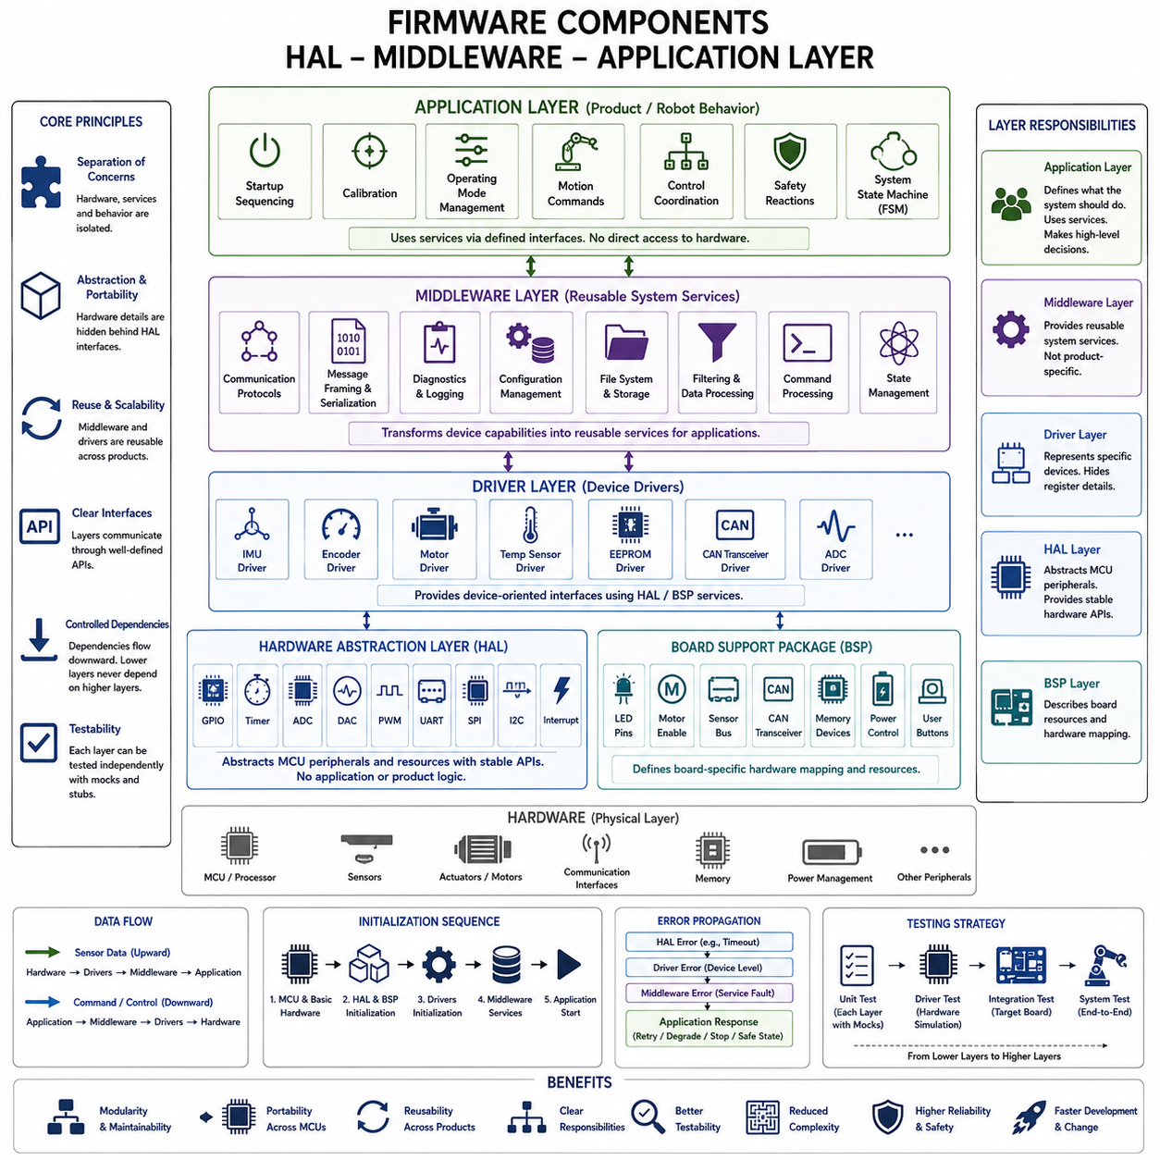
Firmware components are commonly organized into layers so that hardware-dependent mechanisms, reusable system services, and product-specific behavior can evolve with limited impact on one another. A practical embedded architecture places the Hardware Abstraction Layer, or HAL, close to the physical hardware, middleware above hardware-facing services, and the application layer at the top. This separation establishes clear responsibilities and reduces uncontrolled dependencies across the firmware system.
The Hardware Abstraction Layer provides a standardized software boundary between processor-specific hardware and higher-level firmware components. It encapsulates direct access to registers, clocks, GPIO, timers, ADC, DAC, PWM, DMA, communication peripherals, and interrupt-related resources. Instead of allowing application functions to manipulate MCU registers directly, the HAL exposes controlled operations that represent hardware capabilities through stable interfaces.
HAL design improves portability because hardware-specific implementation details remain concentrated near the bottom of the architecture. When a product migrates to another MCU family or a board revision changes peripheral assignments, developers can replace or adapt HAL implementations while preserving much of the middleware and application logic. The effectiveness of this approach depends on preventing vendor-specific definitions, register structures, and device assumptions from leaking through abstraction boundaries.
A Board Support Package, or BSP, frequently complements the HAL by representing characteristics of a particular physical board. While the HAL describes generic peripheral capabilities, the BSP associates those capabilities with concrete hardware resources such as LED pins, motor-enable signals, sensor buses, communication transceivers, memory devices, or power-control lines. This distinction helps separate processor abstraction from product-board configuration and supports reuse across multiple hardware variants.
Device drivers normally build on HAL or BSP services to represent specific physical devices. A driver may configure an IMU, encoder, motor driver, temperature sensor, EEPROM, CAN transceiver, or external ADC without requiring its users to understand the underlying register transactions. The driver converts low-level peripheral operations into device-oriented interfaces such as initialize, configure, read, write, start, stop, reset, and obtain status.
Middleware occupies the architectural region between hardware-oriented components and application behavior. It provides reusable functions that are not tied directly to a single peripheral or product feature. Communication protocols, message framing, serialization, diagnostic services, logging, configuration management, file systems, filtering, command processing, and reusable state-management mechanisms can reside in this layer. Middleware therefore transforms low-level device capabilities into services useful to application logic.
Communication middleware is particularly important in robotic embedded systems because controllers frequently exchange commands and telemetry over CAN, UART, SPI, I2C, Ethernet, EtherCAT, or other interfaces. The hardware driver should manage the physical transfer mechanism, while middleware can handle packet construction, message identification, checksums, protocol states, retries, timeouts, and data interpretation. Separating these responsibilities allows communication policy to evolve independently of peripheral implementation.
Middleware should remain reusable and avoid embedding unnecessary product-specific decisions. A diagnostic service, for example, can provide fault registration, event storage, timestamps, and status retrieval without deciding how a particular robot should react to every fault. Similarly, a configuration service can manage parameters and persistent storage while leaving application logic responsible for interpreting those parameters. This separation preserves cohesion and prevents middleware from gradually becoming hidden application code.
The application layer contains firmware behavior that expresses the purpose of the embedded controller. In a robot joint controller, this may include startup sequencing, calibration, operating-mode management, motion commands, control coordination, safety reactions, and system-level state transitions. Application logic should primarily interact with middleware and abstract device interfaces rather than directly manipulating processor registers, allowing functional behavior to remain understandable independently of hardware details.
Application components can be organized around functions, services, or finite state machines depending on system complexity. An actuator application might contain BOOT, INIT, CALIBRATION, READY, RUNNING, STOPPING, and FAULT states while using lower layers for sensor acquisition, communication, timing, and diagnostics. This keeps the state machine focused on behavioral decisions instead of mixing those decisions with register configuration, packet transmission, or low-level interrupt processing.
Layer boundaries should be enforced through explicit interfaces. Higher layers request capabilities from lower layers without accessing their internal data structures or implementation details. A sensor service might expose measured values and health status rather than its DMA buffers, while a communication service might expose received commands instead of UART registers. Such interfaces establish contracts that define valid operations, data ownership, error reporting, timing assumptions, and lifecycle expectations.
Dependency direction generally flows downward from application behavior toward abstractions provided by lower layers. Hardware-specific modules should not depend on product-level application logic because this creates circular coupling and makes reuse difficult. When lower-level components must report events upward, callbacks, event queues, status interfaces, or message mechanisms can provide controlled inversion of communication without introducing direct knowledge of higher-level implementations.
Data flow deserves separate consideration from dependency direction. Sensor data may physically travel upward from hardware through drivers and middleware to application logic, while actuator commands travel downward toward hardware. This does not require reversing architectural dependencies. Interfaces can allow information to move in both directions while preserving a stable structural rule in which high-level policy depends on lower-level abstractions rather than concrete hardware implementations.
Interrupt processing should also respect component boundaries. HAL or driver code normally handles the immediate hardware-specific interrupt operation, clears the interrupt source, captures essential data, and signals completion or an event. More complex protocol processing or behavioral decisions should occur in middleware or application context. Keeping interrupt handlers short prevents low-level asynchronous execution from becoming tightly coupled with large portions of the firmware architecture.
Error propagation must be defined consistently across layers. HAL functions can report peripheral-level conditions such as timeout or transfer failure, while drivers translate these into device-level errors and middleware may classify them into communication or service faults. The application layer can then determine the appropriate operational response, such as retrying, entering degraded operation, stopping an actuator, or transitioning into a safe state. Each layer adds context without concealing important failure information.
Initialization follows the architectural hierarchy and must respect dependencies among components. Processor clocks, memory, and basic hardware resources are prepared first, followed by HAL and BSP configuration. Device drivers are then initialized before middleware services that depend on those devices, and application components start only after their required services are available. A defined initialization sequence prevents higher layers from attempting to use resources whose lower-level dependencies have not yet reached a valid state.
Testing benefits significantly from layered firmware architecture. Application and middleware components can be tested with mock HAL or driver implementations that simulate sensors, communication channels, timing, and hardware faults. Driver tests can focus on device behavior independently from robot application logic, while target-board integration tests validate the actual HAL and BSP. This decomposition enables failures to be localized and allows much of the firmware to be verified without physical hardware.
Performance-sensitive firmware must balance architectural separation with embedded constraints. Excessively complicated interfaces can increase execution overhead, memory usage, and debugging difficulty, while insufficient separation produces tightly coupled code. Well-designed layers therefore use lightweight APIs, bounded buffers, explicit ownership, predictable execution, and carefully selected abstraction boundaries. Critical control and interrupt paths remain efficient while the overall architecture retains modularity and testability.
In robotic systems, this layered structure can be reused across joint controllers, sensor modules, power controllers, safety MCUs, communication gateways, and other embedded nodes. Different products may require different devices and board configurations while sharing common middleware for diagnostics, configuration, communication, and lifecycle management. Application behavior can then specialize each controller without repeatedly rebuilding the entire hardware-facing software foundation.
HAL, middleware, and the application layer therefore represent different levels of responsibility rather than merely different source-code directories. HAL isolates hardware mechanisms, drivers and BSP components represent concrete devices and boards, middleware provides reusable system capabilities, and the application layer defines controller behavior and operational policy. When these boundaries are supported by stable interfaces, controlled dependencies, explicit data ownership, consistent errors, and systematic testing, they form a scalable firmware architecture for reliable robotic embedded systems.

05.05 Firmware Interface Definition: API Design Principles
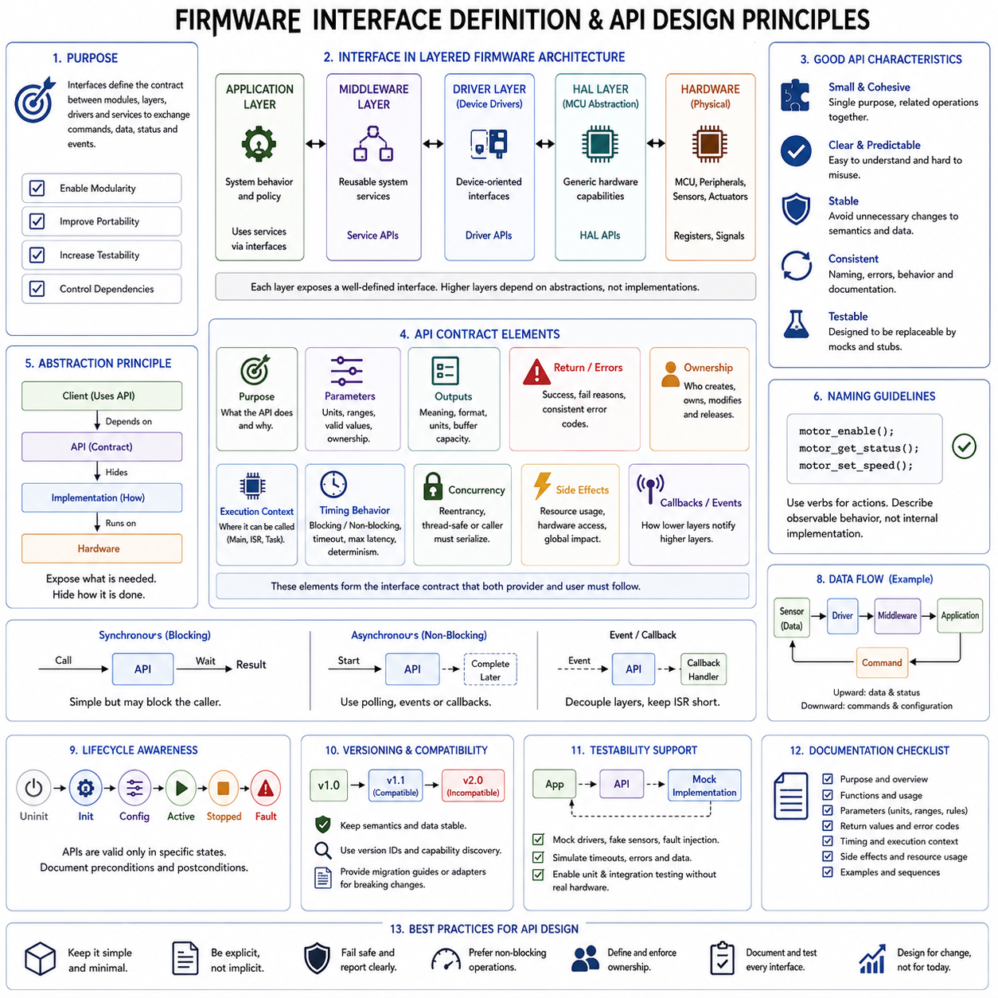
A firmware interface defines the contract through which modules, layers, drivers, and services exchange commands, data, status, and events. Good API design prevents one component from depending on another component’s internal representation, allowing implementations to change while preserving expected behavior. Within layered firmware architecture, these contracts are essential for maintaining modularity, portability, testability, and controlled dependency direction.
An interface should describe what a component provides rather than how that capability is implemented. A motor interface may expose initialization, enable, disable, command, status, and fault operations without revealing PWM registers, timer channels, DMA structures, or internal control variables. This distinction preserves encapsulation and allows application software to express intent using domain-level operations instead of manipulating hardware mechanisms directly.
API boundaries should correspond to architectural responsibilities. HAL APIs represent generic MCU capabilities, device-driver APIs represent physical devices, middleware APIs provide reusable services, and application interfaces coordinate system behavior. Allowing higher layers to bypass these boundaries creates hidden dependencies and weakens portability. A well-defined interface therefore becomes both a programming mechanism and an architectural rule governing which components are permitted to know about one another.
A good firmware API should be small, cohesive, and difficult to misuse. Each operation should have a clear purpose, predictable semantics, and a limited set of responsibilities. Interfaces containing many unrelated functions often indicate that the underlying module owns too many concerns. Conversely, excessively fragmented APIs increase coordination overhead. The objective is to expose the minimum capability necessary for clients while keeping related operations together behind one meaningful abstraction.
Naming strongly influences interface readability. Function, type, parameter, event, and error names should communicate intent consistently across the firmware platform. Operations such as initialize, start, stop, read, write, configure, reset, and get_status should retain predictable meanings. Names should describe observable behavior rather than internal implementation details, because implementation-oriented names make interfaces harder to preserve when the underlying hardware or algorithm changes.
Input parameters form part of the API contract and should have explicit units, ranges, ownership rules, and validity conditions. A velocity command should make clear whether its value represents radians per second, revolutions per minute, or normalized output. Timing values should identify their units, and pointers should define whether NULL is permitted. Ambiguous parameter semantics create integration defects even when the underlying implementation is technically correct.
Output semantics require the same discipline. An API returning sensor data should specify whether the value is raw, calibrated, filtered, timestamped, or converted into engineering units. Status functions should distinguish current operating state from historical fault information. When output buffers are supplied by the caller, the interface should define required capacity and valid data length. Clear semantics prevent different modules from interpreting identical data structures in incompatible ways.
Return values and error codes should communicate operational results consistently. APIs should distinguish success from invalid parameters, unavailable resources, timeout, busy conditions, communication failures, hardware faults, and unsupported operations when these distinctions matter to the caller. Error definitions should remain stable enough for higher layers to implement recovery policies without depending on vendor-specific register flags or undocumented internal states.
Resource ownership is another critical part of interface definition. APIs involving buffers, memory blocks, peripheral handles, DMA transfers, or message objects must establish who creates, modifies, retains, and releases each resource. Unclear ownership produces memory corruption, stale references, duplicated modification, and race conditions. Firmware interfaces should therefore make ownership transfer explicit and minimize shared mutable state wherever deterministic behavior is required.
Execution context must also be documented. Some APIs may be safe from the main loop but prohibited inside an Interrupt Service Routine, while others are specifically designed for interrupt context. An operation may be synchronous, asynchronous, blocking, or non-blocking. Without this information, a logically correct function call can still violate real-time constraints. Context restrictions are therefore part of the interface contract rather than secondary implementation documentation.
Timing semantics become especially important in robotic firmware. An interface may guarantee bounded execution time, initiate an asynchronous transaction, or require completion within a defined timeout. Control APIs may need deterministic activation periods and maximum latency, while diagnostic operations can tolerate slower processing. Explicit timing assumptions help system designers determine whether multiple components can coexist within available CPU and communication budgets.
Non-blocking APIs are generally preferable for operations whose completion time depends on hardware or communication. Instead of waiting until a CAN transaction, SPI transfer, flash write, or sensor conversion finishes, an API can start the operation and report completion through status polling, callbacks, events, or queues. This model preserves responsiveness and integrates naturally with bare-metal super loops, finite state machines, and real-time schedulers.
Callbacks and event interfaces provide controlled communication from lower layers toward higher layers. A driver can report transfer completion or device faults without directly depending on application code. However, callback contracts must specify execution context, permitted operations, data lifetime, and reentrancy expectations. Event queues provide greater decoupling when processing should be deferred, while direct callbacks may be appropriate for short and deterministic notifications.
Reentrancy and concurrency requirements should be explicitly defined when APIs can be called from multiple tasks, interrupt contexts, or processing cores. An interface may be reentrant, internally synchronized, or require serialization by the caller. Hidden assumptions about concurrent access are a common source of intermittent firmware defects. Making synchronization responsibilities part of the contract allows developers to reason about shared peripherals and services systematically.
Configuration interfaces should separate static platform configuration from runtime commands. Pin assignments, peripheral instances, communication rates, buffer capacities, and hardware capabilities may be established during initialization, while operational parameters can change during execution. Separating these categories avoids APIs that permit unsafe reconfiguration at arbitrary times and clarifies which properties remain invariant throughout the component lifecycle.
Lifecycle semantics should define when an interface can legally be used. Components commonly progress through states such as uninitialized, initialized, configured, active, stopped, and faulted. Calling start before initialization or configuration may therefore be invalid. APIs should either prevent such sequences structurally or detect them explicitly. Clear lifecycle rules align interfaces with FSM-based firmware and make illegal operating sequences easier to identify during testing.
Versioning must be considered when interfaces persist across firmware releases or independently developed components. Stable APIs should avoid unnecessary changes to function semantics, data layouts, enumerations, and message formats. When incompatible changes are unavoidable, explicit version identification, capability discovery, migration rules, or compatibility adapters can prevent older components from silently misinterpreting newer interfaces. The surrounding firmware structure explicitly places compatibility strategy immediately after interface definition.
Interface design should support testability from the beginning. Application logic that depends on abstract APIs can be connected to mock drivers, simulated sensors, fake communication services, or fault-injection implementations. Tests can then reproduce timeout, corrupted data, unavailable hardware, and abnormal state sequences without physical devices. Stable interfaces effectively create substitution points where real implementations can be replaced with controlled test doubles.
Documentation should treat an API as a behavioral specification rather than merely a list of function prototypes. Each operation should communicate purpose, inputs, outputs, preconditions, postconditions, errors, timing behavior, ownership, execution context, and side effects where relevant. Interface documentation should also identify assumptions that cannot be expressed directly by the programming language, because those assumptions frequently determine whether integration succeeds or fails.
In robotic firmware, carefully designed interfaces establish stable boundaries among sensor drivers, motor controllers, communication services, diagnostics, safety functions, and application state machines. A higher-level controller can request motion or read health information without understanding register-level mechanisms. This principle scales from a single MCU to distributed robot subsystems because each component exposes capabilities through contracts rather than exposing its internal implementation.
Firmware API design is therefore an architectural discipline centered on explicit contracts. Effective interfaces combine clear semantics, limited responsibilities, controlled ownership, consistent errors, defined timing, lifecycle rules, concurrency expectations, version compatibility, and test substitution points. When these properties are maintained across HAL, drivers, middleware, and application components, firmware can evolve without allowing implementation changes to propagate unpredictably throughout the embedded system.

05.06 Firmware Version Control and Compatibility Strategy
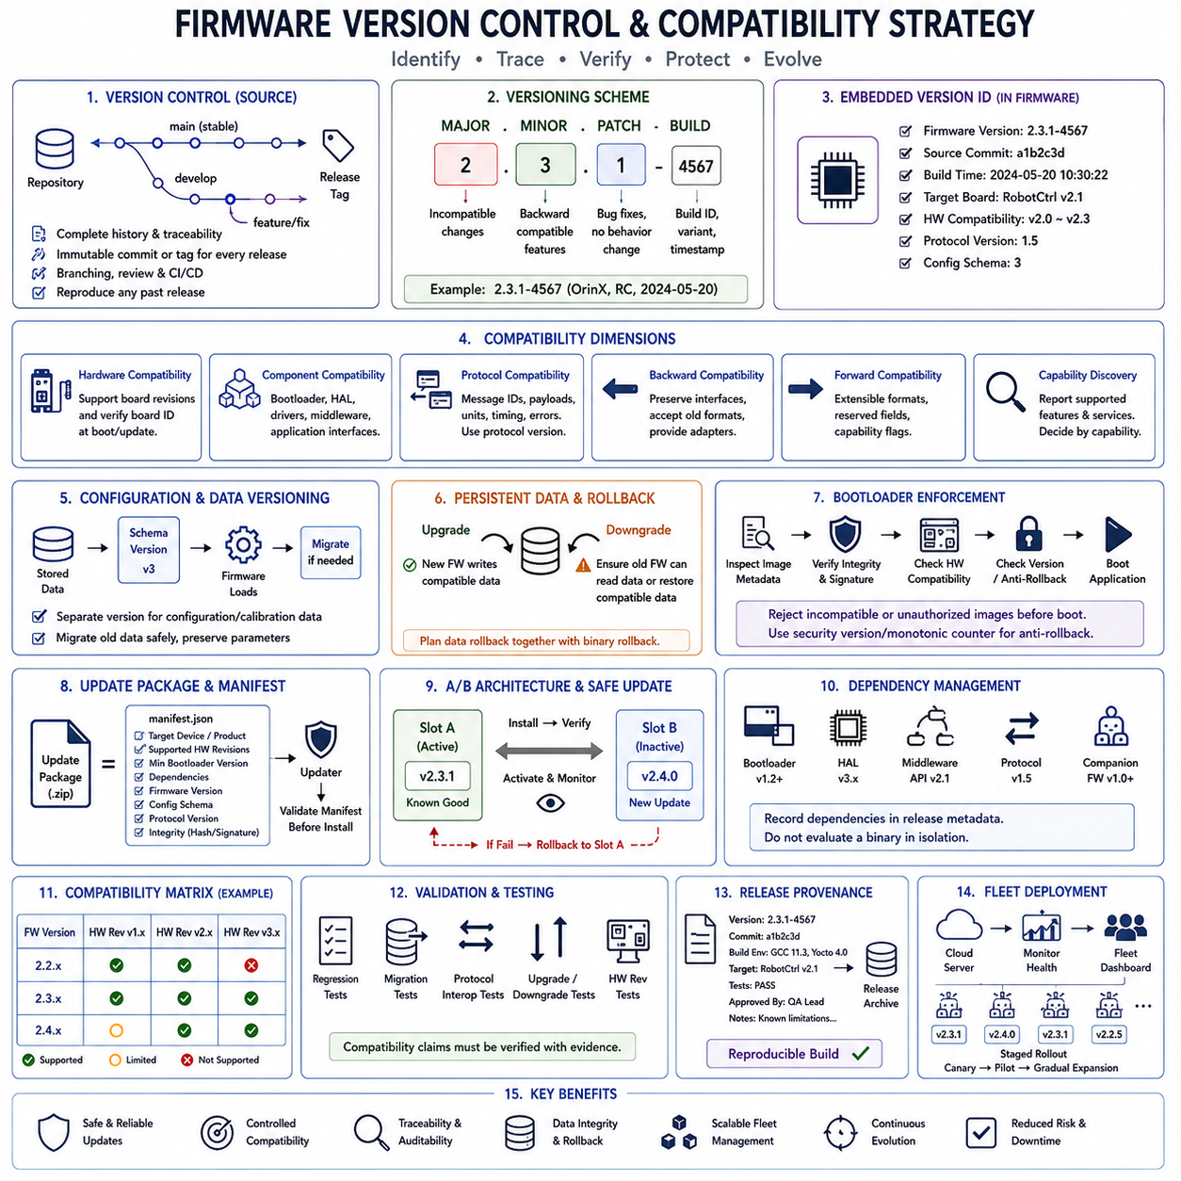
Firmware version control provides a disciplined mechanism for identifying, reproducing, comparing, and maintaining software releases throughout the lifecycle of an embedded product. In robotic systems, firmware may remain deployed for years across controllers with different hardware revisions and operational histories. A version strategy must therefore identify not only source-code evolution but also the exact binary, configuration, interfaces, dependencies, and compatibility assumptions associated with each release.
Source version control should preserve the complete history of firmware changes and provide traceability from a released binary back to the source used to build it. Each production release should correspond to an immutable commit or tag, while development occurs through controlled branches and reviewed changes. This enables engineers to reproduce previous releases, compare modifications, investigate regressions, and maintain multiple supported firmware generations without relying on manually copied source directories.
A firmware version identifier should communicate meaningful compatibility information rather than functioning only as a build label. A common approach distinguishes major, minor, and patch revisions. A major revision can indicate incompatible architectural or interface changes, a minor revision can introduce backward-compatible capabilities, and a patch revision can identify corrections that preserve existing behavior. Additional build metadata may identify development builds, release candidates, hardware variants, or manufacturing configurations.
Version identity should be embedded into the firmware image itself so that a running controller can report exactly which software it contains. Useful metadata may include firmware version, build identifier, source commit, build timestamp, target board, hardware compatibility range, protocol version, and configuration schema version. Diagnostic tools, bootloaders, service software, and higher-level robot controllers can retrieve this information to establish traceability and determine whether interacting components are mutually compatible.
Hardware and firmware compatibility must be explicitly modeled because identical firmware cannot always operate safely on every board revision. Changes in pin assignments, sensors, memory devices, communication transceivers, clock sources, power circuits, or safety signals can invalidate assumptions embedded in older software. Firmware should therefore identify supported hardware revisions and verify board identity during startup or update whenever the platform provides reliable hardware identification.
Compatibility also exists between firmware components. A bootloader may need to understand an application image format, middleware may depend on particular driver capabilities, and an application may expect specific service interfaces. Versioning these boundaries allows compatibility decisions to be made deliberately. Stable interfaces should remain backward compatible when practical, while incompatible changes should require explicit version transitions instead of silently changing previously defined behavior.
Communication protocols require particular attention because robotic controllers frequently evolve independently. Message identifiers, payload layouts, units, enumerations, timing expectations, and error semantics can change between releases. A protocol version should therefore be available independently from the overall firmware version when necessary. Receivers should validate supported protocol versions and reject, translate, or safely degrade unsupported messages rather than interpreting incompatible data as valid commands.
Backward compatibility allows newer firmware to continue operating with components designed for an earlier contract. This can be achieved by preserving existing message fields, maintaining stable API semantics, accepting older configuration formats, or providing translation adapters. Compatibility should not mean preserving every historical behavior indefinitely. The objective is to define a controlled support window so that system evolution remains possible without causing unexpected failures in deployed robots.
Forward compatibility is more difficult because older firmware cannot predict all future features. Interfaces can nevertheless be designed to tolerate extension through reserved fields, explicit lengths, capability flags, optional parameters, or unknown-message handling rules. An older component should ideally ignore unsupported optional information while preserving safe operation. Extensible formats reduce the need for coordinated upgrades across every embedded node whenever a new capability is introduced.
Capability discovery complements version comparison by describing what a component can actually perform. Two devices may report different firmware versions while still supporting the same required interface. A controller can advertise capabilities such as supported control modes, sensor features, diagnostic services, protocol options, or safety functions. Higher-level software can then make compatibility decisions based on required capabilities rather than relying solely on rigid version-number comparisons.
Configuration data requires its own version strategy because firmware updates may change parameter definitions, units, ranges, calibration structures, or persistent-storage layouts. Stored data should include a schema or format version so firmware can determine whether existing information can be loaded directly. When formats change, migration functions can convert older data into the current representation while preserving calibration and product-specific parameters whenever technically safe.
Persistent memory must also handle downgrade scenarios. Newer firmware may write configuration structures that older firmware cannot interpret, making rollback unsafe even if the older binary itself remains available. Designers should therefore consider backward-readable formats, separate versioned storage regions, migration reversibility, or restoration of compatible configuration during rollback. Binary rollback and data rollback must be treated as related parts of the same compatibility strategy.
Bootloaders provide an important enforcement point for firmware compatibility. Before transferring execution, a bootloader can inspect image metadata, target identifiers, version information, image size, integrity data, and hardware compatibility. Secure systems may additionally enforce a security version or monotonic counter so vulnerable historical firmware cannot be reinstalled. Such anti-rollback policy is distinct from ordinary functional rollback and should be designed according to the system's security requirements.
Update packages should contain sufficient metadata for compatibility to be checked before installation. The target device, supported hardware revisions, minimum bootloader version, required configuration schema, dependencies, firmware version, and integrity information can be included in a manifest. An updater should reject an incompatible package before modifying active software. This principle becomes especially important when a robot fleet contains multiple controller generations or product variants.
A/B firmware architectures can improve update resilience by retaining a known working image while installing a new release into an inactive partition. After validation, the system activates the new image and monitors successful startup. If activation fails, the bootloader can return to the previous usable slot. The broader firmware structure treats A/B boot, recovery, OTA rollback, and fleet rollout as dedicated architectural concerns, making version compatibility a prerequisite for safe deployment rather than merely a repository convention.
Dependency management should identify the software assumptions associated with each release. Firmware may depend on bootloader capabilities, HAL revisions, communication protocol versions, calibration formats, external FPGA images, companion-controller firmware, or host-side software. Recording these dependencies in release metadata prevents a binary from being evaluated in isolation when correct operation actually requires a particular combination of components.
Compatibility matrices are useful when multiple hardware and software generations must coexist. A matrix can define which firmware releases are approved for specific board revisions, bootloader versions, protocol versions, or companion controllers. This becomes particularly valuable in robotic fleets where hardware replacement and software deployment do not occur simultaneously. Explicit compatibility information turns upgrade planning from trial-and-error integration into a controlled engineering process.
Release validation should test both intended new functionality and compatibility with supported existing configurations. Regression testing can verify established behavior, while migration tests exercise older persistent data, protocol interoperability, bootloader handover, and upgrade or downgrade paths. Representative hardware revisions should be included whenever hardware differences can affect behavior. Compatibility claims should therefore be supported by verification evidence rather than inferred solely from version numbering.
Production firmware should maintain release provenance. A release record can associate the version with source commit, build environment, compiler and toolchain, target configuration, validation results, known limitations, and approval status. Reproducible builds strengthen this process because engineers can regenerate a binary from recorded inputs and compare it with the deployed artifact. Provenance becomes particularly important when investigating field failures or maintaining long-lived robot platforms.
Fleet operation introduces another dimension because different robots may temporarily run different firmware versions during staged deployment. Management systems should identify the firmware and hardware state of each controller before assigning an update. Canary groups or pilot robots can receive a release first, followed by gradual expansion after monitoring confirms acceptable behavior. The surrounding embedded-software structure explicitly extends these principles into fleet OTA orchestration and staged rollout.
Firmware version control and compatibility strategy therefore connect source management, interface stability, hardware support, persistent data, boot validation, update policy, testing, and fleet operations. A robust system gives every release an unambiguous identity, records its dependencies, verifies compatibility before activation, preserves traceability, and defines controlled migration and rollback behavior. These mechanisms allow embedded robotic platforms to evolve over many hardware and software generations without sacrificing reliability or maintainability.

05.07 Safety-Critical Firmware Design: IEC 61508
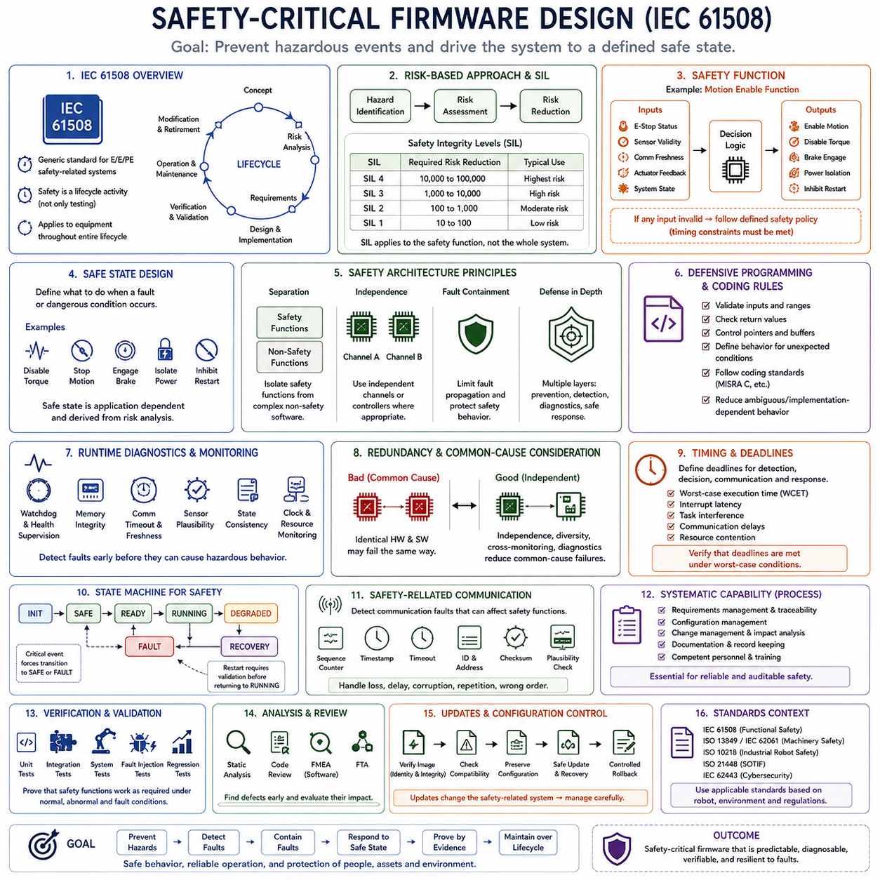
Safety-critical firmware is designed so that software behavior does not allow foreseeable faults to create unacceptable risk. IEC 61508 provides a generic functional-safety framework for electrical, electronic, and programmable electronic safety-related systems and treats safety as a lifecycle activity rather than a final testing step. Within the supplied structure, this firmware topic also serves as a bridge to the later dedicated treatment of safety-critical embedded software.
Functional safety focuses on safety functions that detect hazardous conditions, maintain controlled operation, or move equipment toward a safe state when faults occur. In robotic firmware, these functions may supervise motion permission, actuator enable signals, emergency stopping, communication health, sensor validity, or power conditions. The architecture must distinguish safety-related behavior from ordinary functionality so that failures in noncritical features cannot unpredictably compromise required safety actions.
IEC 61508 uses a risk-based approach in which hazards are identified, risks are evaluated, and necessary risk reduction is assigned to safety functions. Safety Integrity Levels, or SILs, express the required integrity of those safety functions, with SIL 1 through SIL 4 representing increasing levels of required risk reduction. SIL applies to the safety function and its implementation requirements rather than acting as a general performance grade for the complete robot or controller.
Safety requirements should originate from hazard and risk analysis rather than from convenient firmware features. Engineers first determine hazardous events, initiating faults, possible consequences, exposure, and available protective measures. From this analysis, safety requirements define what must be detected, what response is required, how quickly the response must occur, and which safe state must be reached. Firmware architecture then implements these requirements with traceable links back to the identified hazards.
A safety function should have explicit inputs, decision logic, outputs, timing constraints, fault responses, and diagnostic assumptions. For example, a motion-enable function may depend on valid emergency-stop status, sensor health, communication freshness, actuator feedback, and system state. If any required condition becomes invalid, the firmware should transition according to a defined safety policy rather than continuing operation based on stale data or undocumented assumptions.
Safe-state design is fundamental because fault detection has little value unless the system knows how to respond. Depending on the robot and hazard, a safe response may disable torque, stop commanded motion, engage a brake, isolate power, inhibit restart, or enter controlled degraded operation. A safe state is therefore application dependent and must be derived from risk analysis; simply resetting the processor is not automatically equivalent to achieving functional safety.
Safety-critical architecture should minimize unnecessary coupling between safety functions and complex non-safety software. Critical monitoring and shutdown logic can be separated through dedicated modules, protected execution contexts, independent channels, or separate controllers where appropriate. This separation limits fault propagation and makes safety behavior easier to analyze. The broader embedded-software structure reinforces this principle through mixed-criticality design and redundant safety-channel topics.
Defensive programming supports systematic fault containment. Safety-related firmware should validate inputs, check ranges, detect invalid states, verify return values, control pointer and buffer usage, and define behavior for unexpected conditions. Coding rules should reduce ambiguous language behavior and implementation-dependent constructs. The supplied material also connects embedded coding standards with IEC 61508 and emphasizes deterministic software, fault detection, safe-state handling, analysis, and traceability.
Runtime diagnostics are necessary because many dangerous failures cannot be prevented solely through static design. Firmware can supervise execution progress, memory integrity, communication freshness, sensor plausibility, actuator feedback, clock behavior, and internal state consistency. Watchdogs, checksums, memory protection, timeout monitors, redundant calculations, and reasonableness checks provide mechanisms for detecting faults before they propagate into uncontrolled physical behavior.
A watchdog should monitor meaningful execution health rather than merely confirm that some code is still running. Critical tasks or state machines can periodically demonstrate progress, while a health supervisor determines whether all required safety-related activities remain operational. If execution stalls or required health conditions disappear, the watchdog or safety supervisor can initiate the defined recovery or safe-state response instead of allowing a partially functioning controller to continue issuing commands.
Redundancy can reduce dependence on a single failure point, but duplicated components are useful only when common-cause failures are considered. Two channels executing identical software on identical hardware may fail in the same way under the same defect or environmental disturbance. Safety architecture therefore considers independence, diversity, diagnostic coverage, cross-monitoring, and common-cause failure mechanisms when redundant sensors, processors, communication paths, or safety channels are introduced.
Deterministic timing is part of safety behavior because a correct response delivered too late may still be unsafe. Safety requirements should define deadlines for fault detection, decision making, communication supervision, and actuator response. Firmware design must account for worst-case execution time, interrupt latency, task interference, communication delays, and resource contention. Timing verification should demonstrate that required safety actions remain achievable under worst credible operating conditions.
State machines provide a useful mechanism for representing safety-related operating modes explicitly. States such as INIT, SAFE, READY, RUNNING, DEGRADED, FAULT, and RECOVERY can make legal behavior and prohibited transitions visible. Critical events may force transitions directly toward SAFE or FAULT states, while restart may require deliberate validation before returning to operation. Explicit transition rules prevent accidental reactivation after faults and support systematic verification.
Safety-related communication must detect corrupted, delayed, repeated, lost, or incorrectly sequenced information when those failures can affect a safety function. Firmware can use sequence counters, timestamps, timeouts, identifiers, checksums, plausibility checks, and defined communication-loss behavior. The safety argument must consider the complete communication path rather than assuming that a successful low-level transfer automatically means that the received command or status is trustworthy.
Systematic capability is influenced by the development process as well as runtime architecture. Requirements, design decisions, source code, tests, anomalies, changes, and verification evidence should remain controlled and traceable. Configuration management ensures that the firmware being assessed corresponds to known source, toolchain, hardware, and parameter versions. Changes to safety-related software require impact analysis because a seemingly local modification may affect assumptions or evidence elsewhere in the safety case.
Verification should be planned from the safety requirements and performed at multiple levels. Unit testing examines individual safety mechanisms, integration testing evaluates interactions, and system testing verifies complete safety functions on representative hardware. Fault-injection testing is particularly valuable because it intentionally introduces sensor failures, communication loss, corrupted data, timing violations, memory faults, or stalled execution to confirm that detection and safe responses behave as designed.
Static analysis and code review complement dynamic testing by detecting classes of defects that may be difficult to activate during execution tests. Safety-oriented analysis can examine control flow, data flow, initialization, unreachable code, arithmetic behavior, pointer use, complexity, and coding-rule compliance. The larger embedded-software structure explicitly places defensive programming, static analysis, software FMEA and FTA, runtime monitoring, and code-coverage verification within the safety-critical development discipline.
Traceability connects hazards to safety requirements, architecture, implementation, and verification evidence. When a requirement changes, engineers should be able to identify the affected design elements and tests; when a test fails, they should be able to determine which safety requirement is threatened. This bidirectional traceability supports disciplined change management and contributes to an auditable safety case rather than leaving safety knowledge distributed informally among developers.
Firmware updates require special treatment because replacing validated software changes the configuration of a safety-related system. Update mechanisms should verify image identity and integrity, enforce hardware and version compatibility, preserve required configuration, and provide controlled recovery from interrupted or unsuccessful installation. Rollback must also respect safety and security constraints, since restoring an older binary is acceptable only when its software, data, and hardware combination remains valid.
For robotic systems, IEC 61508 provides a generic functional-safety foundation that can coexist with more application-specific standards. The supplied material places it alongside standards such as ISO 13849 and IEC 62061 for machinery-related safety and identifies IEC 61508 as a broader functional-safety framework. The applicable compliance strategy therefore depends on the robot, machinery category, operating environment, safety functions, and regulatory context rather than on firmware technology alone.
Safety-critical firmware design ultimately combines risk-driven requirements, architectural separation, deterministic execution, defensive programming, runtime diagnostics, explicit safe states, controlled development, and evidence-based verification. IEC 61508 frames these activities across the safety lifecycle so that safety is continuously engineered from hazard analysis through implementation, validation, operation, modification, and retirement. Reliable firmware is therefore not merely code that rarely fails, but software whose faults are systematically prevented, detected, contained, and driven toward defined safe behavior.

05.08 Firmware Logging and Diagnostic Infrastructure [w/Code]
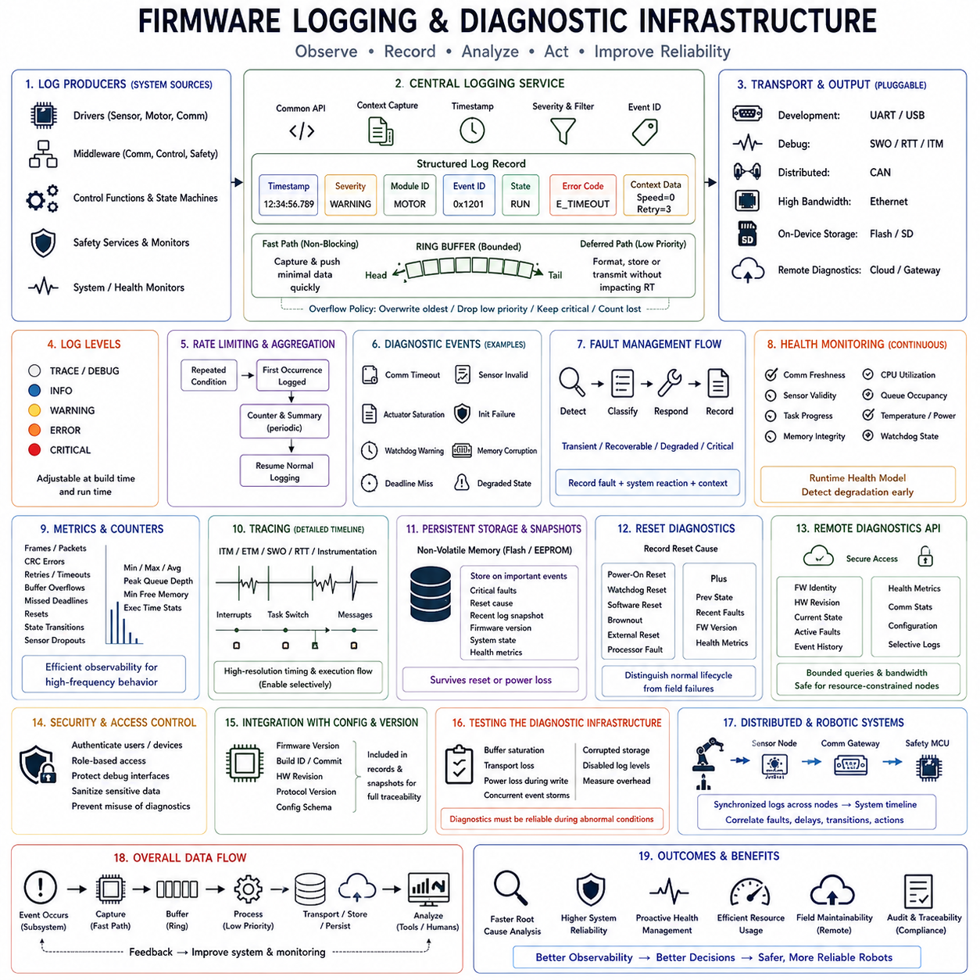
Firmware logging and diagnostic infrastructure provides systematic visibility into the internal behavior of an embedded controller during development, testing, production operation, and field maintenance. Instead of relying on temporary debug prints, a robust architecture records structured events, faults, timing information, state transitions, and health indicators through controlled interfaces. This observability is essential for identifying root causes without disrupting deterministic firmware behavior.
Logging should be treated as a reusable firmware service rather than scattered output statements embedded throughout application code. Drivers, middleware, control functions, state machines, and safety services can submit diagnostic records through a common logging interface. The infrastructure then determines formatting, buffering, filtering, timestamping, storage, and transmission. Centralization creates consistent semantics and allows logging behavior to change without modifying every producer.
A structured log record normally contains more than human-readable text. Useful fields include timestamp, severity, module identifier, event identifier, operating state, error code, and selected contextual values. Event identifiers make records machine-processable, while textual descriptions support engineers during debugging. Structured data also allows automated tools to search, correlate, aggregate, and compare events across many executions or multiple controllers.
Log severity levels provide a mechanism for separating routine information from conditions requiring immediate attention. Typical categories may distinguish trace or debug information, normal informational events, warnings, recoverable errors, and critical faults. The exact naming is less important than consistent semantics. Production firmware can suppress low-value messages while preserving important fault and lifecycle information, reducing CPU, communication, and storage overhead.
Timestamp quality determines whether logs can reconstruct causal sequences accurately. Firmware should use a stable time source appropriate to the required resolution and preserve ordering even when several events occur close together. Distributed robotic systems may additionally require synchronized clocks so records from motor controllers, sensor nodes, safety processors, and higher-level computers can be correlated into one system timeline.
Logging paths must respect real-time constraints. Formatting long strings, waiting for a serial port, writing flash synchronously, or transmitting large diagnostic packets inside a control loop or interrupt handler can create unacceptable latency and jitter. Time-critical code should normally capture compact event information quickly and place it into a bounded buffer. Lower-priority processing can later format, store, or transmit the record without delaying critical execution.
Ring buffers are well suited to firmware logging because they provide bounded memory usage and predictable insertion behavior. Buffer capacity should be selected according to event rates, available RAM, expected diagnostic bursts, and output bandwidth. Overflow behavior must be explicit: the system may overwrite the oldest records, reject new low-priority entries, preserve critical events, or increment a dropped-message counter rather than allowing uncontrolled memory growth.
Rate limiting prevents repetitive conditions from overwhelming the diagnostic infrastructure. A disconnected sensor, failed communication link, or persistent invalid input may otherwise generate thousands of identical records and obscure the original failure. Firmware can record the first occurrence, count repetitions, periodically report summaries, and restore normal logging when the condition clears. This preserves evidence while limiting resource consumption.
Diagnostic events should complement ordinary logs by representing conditions that have operational meaning. Examples include communication timeout, sensor invalidity, actuator saturation, initialization failure, watchdog warning, memory corruption indication, deadline miss, or transition into a degraded state. Such events can be assigned stable identifiers and associated with severity, subsystem, recovery action, and persistent fault information for automated analysis.
Fault management often follows a detect, classify, respond, and record sequence. A module detects an abnormal condition, determines whether it is transient, recoverable, degraded, or critical, performs the defined response, and records enough context for later investigation. Logging should capture both the fault and the system reaction because knowing that an error occurred is insufficient when engineers must determine whether retry, isolation, reset, or safe-state behavior operated correctly.
Health monitoring extends diagnostics beyond individual faults by continuously representing the condition of firmware services and hardware resources. Useful indicators can include communication freshness, sensor validity, task progress, memory integrity, CPU utilization, queue occupancy, temperature, power conditions, watchdog state, and internal state consistency. Together these indicators provide a runtime health model that can detect degradation before a complete functional failure occurs.
Counters and metrics provide efficient observability for high-frequency behavior that would be impractical to log individually. Firmware can maintain counts of received frames, CRC errors, retries, buffer overflows, missed deadlines, resets, rejected commands, sensor dropouts, or state transitions. Maximum latency, minimum free memory, peak queue depth, and execution-time statistics can reveal gradual degradation while requiring much less storage than event-by-event traces.
Tracing provides finer temporal information than conventional logging and is useful for analyzing execution timing, interrupts, task transitions, communication paths, and control-loop behavior. Embedded development environments may expose trace through mechanisms such as ITM, ETM, SWO, or RTT, while other systems use dedicated instrumentation. Trace should be selectively enabled because high-volume instrumentation can consume bandwidth and alter the timing being measured.
Diagnostic transport should be separated from diagnostic generation. The same internal logging service may send records through UART during development, SWO or RTT during debugging, CAN in distributed controllers, Ethernet for high-bandwidth systems, or persistent storage for field retrieval. This separation allows the diagnostic producers to remain unchanged when the deployment environment or available communication interface changes.
Persistent fault storage is important when a controller resets or loses external communication after a failure. Selected critical events, reset causes, fault codes, software version, operating state, and recent contextual records can be retained in nonvolatile memory. A compact fault snapshot can preserve the conditions immediately preceding a reset, watchdog expiration, or emergency shutdown and provide valuable evidence when the robot is inspected later.
Persistent logging must account for flash endurance, write latency, power interruption, and storage corruption. Continuous high-rate writes can rapidly consume write-cycle life, so firmware may aggregate records, use wear-aware storage, reserve dedicated fault regions, or write only selected events persistently. Records should include integrity protection where corruption would make diagnosis misleading, and recovery logic should tolerate incomplete writes caused by unexpected power loss.
Reset diagnostics should preserve the reason a controller restarted. Power-on reset, watchdog reset, software-requested reset, brownout, external reset, and processor fault may require different investigation paths. Capturing reset cause together with previous operating state, recent fault information, firmware version, and selected health metrics helps distinguish expected lifecycle events from recurring field failures that would otherwise appear as unexplained reboots.
Remote diagnostics allow engineers or supervisory systems to inspect controllers without physical debug access. A diagnostic API may expose firmware identity, hardware revision, current state, active faults, historical events, health metrics, communication statistics, and selected configuration information. Remote access should use bounded queries and controlled bandwidth so diagnostic activity cannot starve control traffic or destabilize a resource-constrained embedded node.
Diagnostic interfaces must also consider security and information exposure. Production logs may reveal internal states, addresses, configuration details, or operational information that should not be accessible to unauthorized users. Debug interfaces and diagnostic commands therefore require appropriate access control, and sensitive data should be excluded or protected. Diagnostic capability should improve maintainability without creating an unintended path for manipulating safety-critical behavior.
Logging infrastructure should integrate with firmware version and configuration management. Every important field record should be attributable to the exact software and relevant configuration that generated it. Including firmware version, build identifier, hardware revision, protocol version, and configuration schema in diagnostic snapshots prevents engineers from analyzing an event under incorrect assumptions about the deployed controller implementation.
Testing should verify the diagnostic infrastructure itself. Engineers should exercise buffer saturation, repeated faults, transport loss, corrupted persistent records, unexpected reset, disabled log levels, and simultaneous event generation. Tests should also measure logging overhead under realistic system load. Diagnostics are useful only when they remain dependable during abnormal conditions, which are precisely the situations in which CPU, memory, communication, and storage resources may already be stressed.
In robotic embedded systems, logging and diagnostics connect low-level firmware behavior with system-level observability. Joint controllers, sensor modules, power controllers, communication gateways, and safety MCUs can expose consistent events and health information to higher-level monitoring tools. Distributed logging becomes particularly valuable when synchronized records reveal how a sensor fault, communication delay, state transition, and actuator response propagated across several nodes.
A well-designed diagnostic infrastructure therefore combines structured logging, timestamps, severity levels, bounded buffering, rate limiting, fault records, metrics, tracing, persistent snapshots, and remote retrieval within a resource-aware architecture. Its purpose is not to record everything indiscriminately, but to preserve the information needed to reconstruct behavior and evaluate system health with minimal interference. Effective observability turns difficult field failures into traceable engineering evidence and supports reliable, maintainable robotic firmware.

05.09 Firmware Mock Environment and Unit Testing [w/Code]
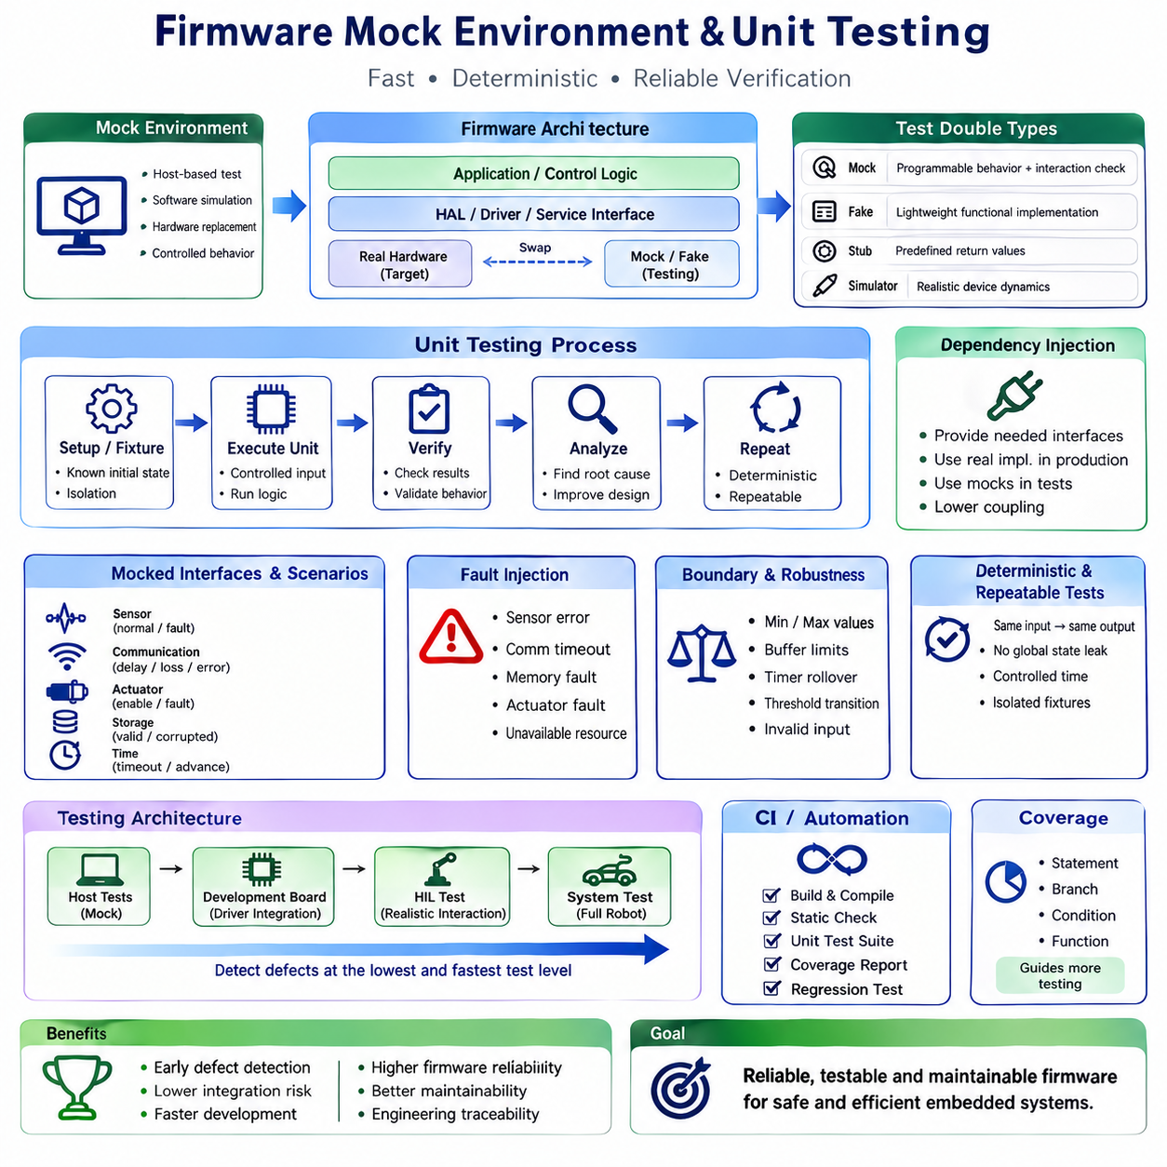
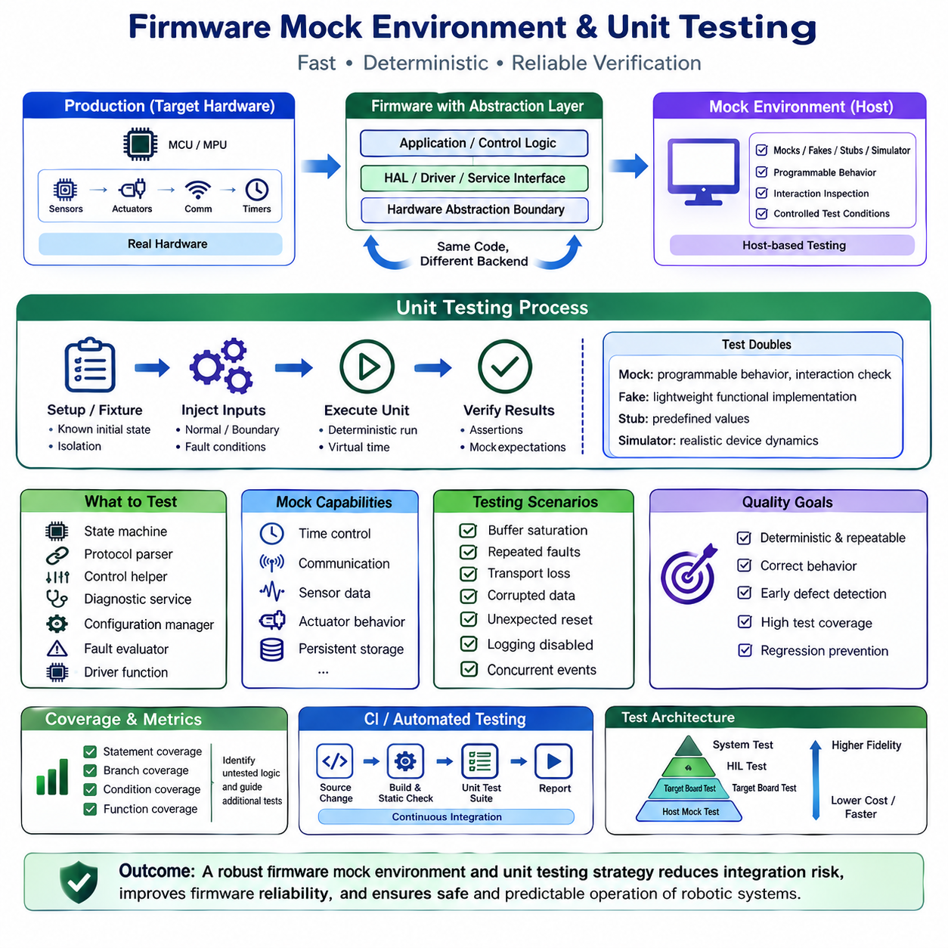
A firmware mock environment provides a controlled software representation of hardware-dependent behavior so embedded code can be tested without requiring the physical target board. Hardware registers, sensors, communication interfaces, timers, memory devices, and actuators are replaced by programmable test substitutes. This approach allows firmware logic to execute on a host computer while preserving the interfaces used by the real embedded implementation.
Mock-based testing depends strongly on architectural separation. Application logic should access hardware through HAL, device-driver, or service interfaces rather than manipulating registers directly throughout the codebase. During production builds, these interfaces connect to real hardware implementations; during host-based tests, they connect to mocks or fakes. The same application component can therefore be exercised under controlled conditions without modifying its functional logic.
A mock represents an interface whose behavior can be programmed and whose interactions can be inspected by the test. A fake provides a lightweight functional implementation, such as an in-memory configuration store replacing external Flash. A stub may return predefined values with minimal behavior, while a simulator attempts to reproduce more realistic device dynamics. Selecting the appropriate test double prevents unnecessary complexity while providing sufficient fidelity for each verification objective.
Unit testing focuses on the smallest practical firmware components in isolation. A unit may be a state machine, protocol parser, control helper, diagnostic service, configuration manager, fault evaluator, or device-independent driver function. Tests provide controlled inputs, execute the unit, and compare observable results with expected behavior. Isolation helps engineers determine whether a failure originates inside the tested component rather than from unrelated hardware or integration effects.
Dependency injection makes test substitution practical by providing a component with the interfaces it requires instead of allowing it to create hidden dependencies internally. A controller can receive abstract sensor, timer, communication, or storage interfaces during initialization. Production code supplies physical implementations, while tests supply mocks. This technique reduces coupling and makes dependencies visible as part of the component's architectural contract.
Hardware abstraction boundaries should expose behavior meaningful to the caller. A timer abstraction might provide current time, elapsed time, and timeout operations rather than exposing processor timer registers. A communication abstraction might provide send, receive, busy, and completion behavior. When interfaces are defined at appropriate abstraction levels, test code can reproduce important conditions without attempting to emulate every detail of the microcontroller.
Time is one of the most valuable dependencies to mock. Real delays make tests slow and nondeterministic, while a virtual clock allows test code to advance time explicitly. Timeout handling, retry intervals, watchdog supervision, communication freshness, debounce logic, and state-machine residence times can then be tested instantly. A test can move simulated time from one boundary to another and verify behavior immediately before, at, and after a deadline.
Sensor mocks allow tests to generate nominal measurements, boundary values, invalid readings, frozen values, discontinuities, noise patterns, or communication failures. Firmware can then be checked for correct filtering, plausibility validation, fault detection, and recovery behavior. For robotic controllers, this enables repeatable testing of encoder faults, IMU anomalies, temperature limits, voltage conditions, and other situations that may be difficult or unsafe to reproduce physically.
Communication mocks can reproduce successful transfers as well as delayed, missing, corrupted, duplicated, or incorrectly ordered messages. Protocol logic can be exercised without connecting multiple physical controllers. Tests may verify message parsing, sequence validation, timeout detection, retry policy, error propagation, and state transitions after communication loss. Deterministic message injection also makes intermittent communication defects easier to reproduce.
Actuator interfaces should normally be mocked so unit tests do not produce physical motion. A mock motor driver can record requested torque, velocity, position, enable, disable, or brake commands and allow the test to verify that the correct action was requested. Fault conditions can also be injected into the actuator interface, allowing application logic to demonstrate safe shutdown, degraded operation, or recovery without energizing real hardware.
Mocking persistent storage enables configuration and lifecycle logic to be tested without consuming Flash write cycles. An in-memory fake can represent valid configuration, erased memory, corrupted records, incompatible schema versions, failed writes, or interrupted updates. Tests can verify initialization defaults, parameter validation, migration, checksum handling, and recovery while executing thousands of scenarios rapidly on a development computer.
State-machine firmware is particularly suitable for unit testing because states and transitions provide explicit observable behavior. A test can initialize an FSM in a known condition, inject an event, execute one processing cycle, and verify the destination state and requested outputs. Sequences such as INIT to READY to RUNNING can be tested alongside prohibited transitions, timeout paths, FAULT entry, RECOVERY behavior, and restart conditions.
Fault injection extends ordinary unit testing by deliberately forcing dependencies to fail. A mock can return a sensor error, communication timeout, invalid CRC, memory failure, actuator fault, or unavailable resource at a precisely selected execution point. The test then verifies whether the component detects the failure, propagates the correct diagnostic information, performs the required fallback action, and avoids unsafe or undefined behavior.
Boundary-value testing is especially important in embedded software because many defects occur around limits. Tests should exercise minimum and maximum commands, buffer capacities, timer rollover, counter limits, threshold transitions, zero values, invalid enumerations, and out-of-range sensor data. Equivalence classes can reduce the total number of cases while still covering representative normal, abnormal, and boundary conditions systematically.
Unit tests should be deterministic and repeatable. The same test with the same inputs should produce the same outputs regardless of execution date, host-machine speed, or test order. Global mutable state, uncontrolled random values, real-time delays, and dependencies on external hardware reduce reproducibility. Test fixtures should establish a known initial condition before each case and restore isolation so one test cannot silently influence another.
Assertions define the expected behavior of the unit under test. They may verify return values, output data, state transitions, generated events, diagnostic codes, function calls, or call ordering. Mock frameworks can additionally verify whether an interface was invoked with expected parameters and whether forbidden operations occurred. Tests should emphasize externally observable behavior rather than depending excessively on private implementation details that may change during refactoring.
Code coverage provides evidence about which portions of firmware have been exercised, but coverage alone does not demonstrate correctness. Statement, branch, condition, and function coverage can identify untested logic and guide additional test development. Safety-related software may require stronger structural coverage objectives, but meaningful tests must still originate from requirements, boundary conditions, failure modes, and expected behavior rather than simply attempting to increase a percentage.
Host-based unit tests should be integrated into automated build and continuous integration workflows whenever possible. Each source change can trigger compilation, static checks, and the unit-test suite before firmware is accepted. Fast execution encourages frequent testing and detects regressions near the point where they are introduced. Test reports can preserve pass/fail results, coverage information, and relevant artifacts for later engineering traceability.
Mock testing cannot replace target-hardware verification because host execution does not reproduce every embedded characteristic. Register behavior, interrupt latency, DMA interaction, memory alignment, compiler differences, electrical timing, peripheral errata, cache effects, and physical sensor dynamics may only appear on the target. Unit testing should therefore form the lower level of a broader verification strategy that progresses toward integration, target-board, hardware-in-the-loop, and system testing.
A practical testing architecture separates tests according to the fidelity required. Pure logic and state behavior can execute rapidly with mocks on the host, driver integration can be verified on development boards, and hardware-in-the-loop testing can validate interactions with realistic sensors and actuators. System tests then evaluate the complete robot behavior. Defects should ideally be detected at the lowest and fastest test level capable of revealing them.
Testability should be considered during firmware design rather than added after implementation. Clear interfaces, limited global state, explicit dependencies, deterministic functions, modular state machines, and separated hardware access naturally create testable components. Architecture designed this way improves production maintainability as well, because the same boundaries that permit mocks also reduce coupling and make firmware changes easier to understand.
Firmware mock environments and unit testing therefore provide a fast, deterministic verification foundation for embedded robotic software. By replacing physical dependencies with controllable test doubles, engineers can exercise normal behavior, timing boundaries, communication failures, corrupted data, hardware faults, and recovery paths repeatedly and safely. Combined with automated execution, fault injection, coverage analysis, target testing, and HIL verification, this approach reduces integration risk and improves firmware reliability.

05.10 Robot Joint Controller Firmware Architecture Case Study
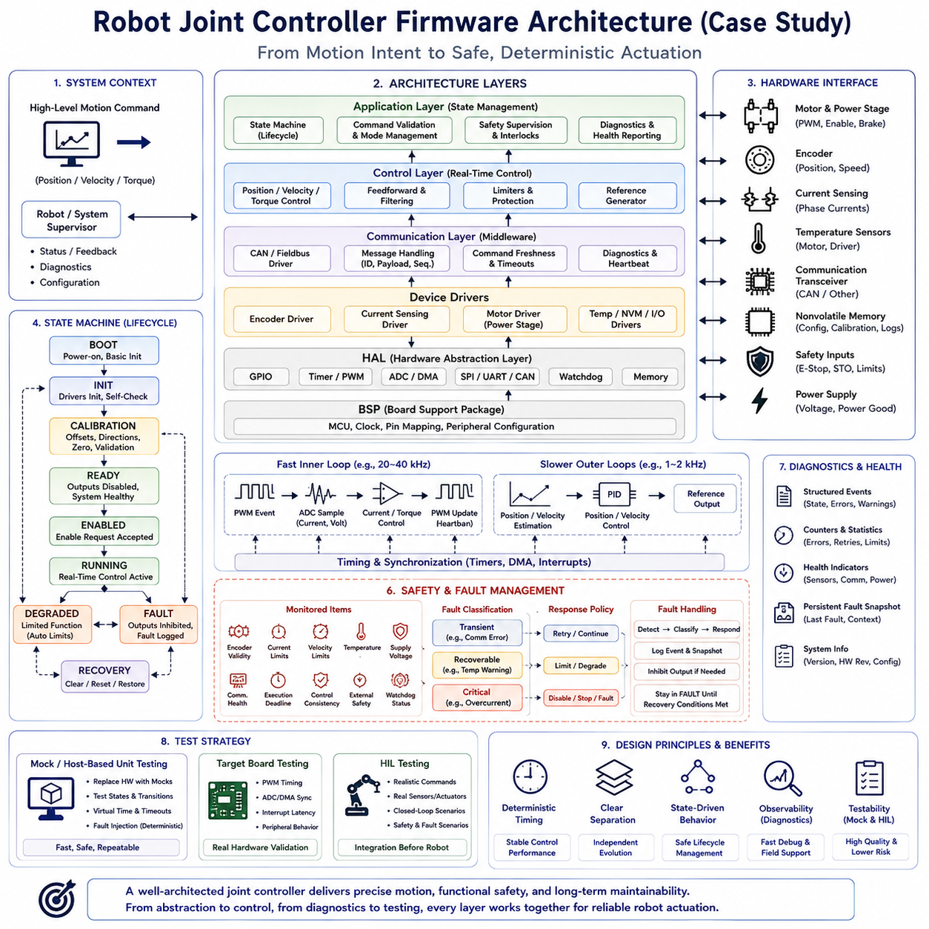
A robot joint controller is a compact example of how firmware architecture translates high-level motion intent into deterministic electrical control of a physical actuator. The controller must coordinate sensing, real-time control, communication, diagnostics, safety supervision, and hardware management within strict timing constraints. A well-structured design separates these responsibilities so that control performance can remain predictable while hardware and software components evolve independently.
At the hardware boundary, the controller typically interacts with a motor power stage, position encoder, current measurement circuitry, temperature sensors, communication transceiver, nonvolatile memory, and safety-related inputs. The microcontroller provides timers, PWM generation, ADC channels, communication peripherals, DMA, interrupts, and watchdog resources. Firmware must convert these processor-level mechanisms into stable services without exposing register-level implementation details throughout the application.
The Hardware Abstraction Layer, or HAL, forms the lowest reusable software boundary. It encapsulates GPIO, timers, PWM, ADC, DMA, SPI, UART, CAN, watchdog, and memory-access mechanisms behind consistent interfaces. A Board Support Package maps these generic capabilities onto the specific joint-controller PCB. This separation allows processor or board revisions to be accommodated primarily within HAL and BSP implementations rather than propagating changes through control and application logic.
Device drivers build on the HAL and BSP to represent concrete joint hardware. An encoder driver provides position and validity information, a current-sensing driver supplies motor-current measurements, and a motor driver controls the power stage through PWM and enable signals. Temperature, nonvolatile memory, and communication devices receive similar abstractions. Each driver converts low-level transactions into device-oriented operations while reporting hardware errors through standardized status interfaces.
The control layer transforms measured joint state and commanded targets into actuator outputs. Depending on the actuator architecture, control may include current or torque control, velocity control, position control, feedforward terms, filtering, and output limiting. Fast inner loops execute at deterministic rates, while slower outer loops provide higher-level regulation. Separating these loops from hardware drivers allows control algorithms to evolve without requiring direct knowledge of timer registers or ADC sequencing.
Sampling and actuation timing must be coordinated carefully because control quality depends on deterministic data acquisition and output updates. PWM events can trigger ADC sampling at defined points in the switching cycle, while DMA transfers move measurements with minimal CPU intervention. Timer-driven control execution ensures that calculations occur at predictable intervals. Interrupt handlers should perform only essential time-critical work and defer complex processing whenever possible.
The application layer coordinates the lifecycle of the joint rather than implementing low-level peripheral mechanisms. A finite state machine can represent states such as BOOT, INIT, CALIBRATION, READY, ENABLED, RUNNING, DEGRADED, FAULT, and RECOVERY. Each state defines which operations are permitted and which transitions are legal. This makes startup, shutdown, fault handling, and reactivation behavior explicit rather than distributing lifecycle decisions across unrelated functions.
During BOOT and INIT, firmware establishes processor resources, initializes HAL and BSP components, starts device drivers, loads configuration, and performs basic self-tests. Sensor communication, encoder validity, memory integrity, power-stage status, and communication availability can be checked before motion is permitted. The controller should not transition toward an enabled state until all mandatory dependencies have reached known and valid conditions.
Calibration establishes the relationship between raw hardware measurements and meaningful joint quantities. Encoder offsets, current-sensor biases, direction conventions, mechanical zero positions, or other actuator-specific parameters may need verification or measurement. Calibration data should be validated before use and stored with integrity protection and format information. Invalid or incompatible calibration must prevent normal motion when safe control depends on those parameters.
In READY, the controller can communicate and report health while keeping actuator output disabled. An explicit enable request can transition the system toward active control only when safety conditions, command validity, sensor health, and power-stage status permit operation. Separating READY from RUNNING prevents communication activity or successful initialization from being interpreted automatically as authorization to energize the actuator.
The RUNNING state coordinates command processing with real-time control execution. Position, velocity, or torque targets may arrive through a communication interface and are validated before becoming active setpoints. Range limits, command freshness, operating mode, acceleration constraints, and safety conditions can be checked before commands reach the control loops. The real-time controller then uses validated targets rather than consuming raw network data directly.
Communication middleware separates network protocol behavior from actuator control. A CAN or other fieldbus driver handles physical frame transfer, while middleware manages message identifiers, payload interpretation, sequence information, timeouts, diagnostics, and command validity. Application logic receives domain-level commands such as requested position, velocity, torque, enable, or stop rather than parsing communication frames inside the control algorithm.
Command freshness is particularly important because a previously valid motion command can become unsafe if communication is lost. Firmware can associate commands with timestamps, counters, or watchdog-style timeout supervision. If new commands do not arrive within the permitted interval, the application transitions according to a defined policy, such as controlled stopping, torque disable, or FAULT entry. Communication success is therefore evaluated as an ongoing condition rather than a one-time connection event.
Safety supervision operates alongside normal control and evaluates whether continued actuator operation remains acceptable. It may monitor encoder validity, current limits, velocity limits, temperature, supply voltage, communication health, execution deadlines, control consistency, and external safety signals. Safety checks should lead to explicitly defined responses rather than merely generating log messages. Critical conditions can override ordinary motion commands and force the joint toward a safe state.
Fault management classifies abnormal conditions according to their operational significance. A transient communication error may permit retry, while persistent sensor invalidity may require degraded operation or shutdown. Overcurrent, invalid position feedback, watchdog expiration, or power-stage faults may require immediate actuator disable. Each fault should have a defined detection condition, diagnostic identifier, response, persistence behavior, and recovery requirement.
The FAULT state provides controlled behavior after a condition makes normal operation unacceptable. Motor output can be inhibited, fault information preserved, and commands rejected until predefined recovery conditions are satisfied. Some faults may clear automatically after a verified transient condition disappears, while others should require an explicit reset or power cycle. Recovery policy must prevent repeated uncontrolled transitions between active operation and faulted states.
Diagnostics provide visibility into the joint controller without interfering with its real-time responsibilities. Structured events can record state transitions, communication failures, sensor errors, current limiting, temperature warnings, resets, and safety interventions. Counters can summarize high-frequency conditions, while persistent fault snapshots preserve critical information across resets. Firmware version, hardware revision, configuration identity, and calibration status should accompany diagnostic information used for field analysis.
The joint controller should expose clear interfaces between application, control, middleware, drivers, and HAL components. Data ownership, execution context, timing assumptions, units, valid ranges, and error semantics should be defined explicitly. Control code should receive normalized or engineering-unit measurements instead of raw register values, while hardware drivers should remain unaware of application states. These boundaries reduce coupling and make individual components independently testable.
A mock environment can replace sensors, timers, communication interfaces, storage, and actuator drivers during host-based unit testing. State-machine behavior can then be tested across initialization, enable, running, fault, and recovery sequences without moving physical hardware. Virtual time allows timeout behavior to be verified instantly, while fault injection can reproduce encoder failure, communication loss, overtemperature, invalid configuration, or actuator faults deterministically.
Target-board testing complements mock testing by validating characteristics that host execution cannot reproduce. PWM timing, ADC synchronization, DMA operation, interrupt latency, encoder interfaces, power-stage behavior, communication timing, and processor-specific effects must be evaluated on actual hardware. Hardware-in-the-loop testing can then exercise realistic commands and sensor responses while preserving controlled conditions before full integration into a robotic mechanism.
The architecture should also support firmware updates and long-term compatibility. The controller can report firmware version, hardware revision, protocol version, and configuration schema so supervisory software can determine compatibility. Bootloader validation, image integrity checks, controlled rollback, and persistent configuration migration become important when many joint controllers are deployed across robots with different manufacturing histories.
A complete robot joint controller firmware architecture therefore forms a chain from hardware abstraction through device drivers, real-time control, communication services, application state management, diagnostics, and safety supervision. Deterministic timing keeps sensing and actuation predictable, explicit interfaces isolate dependencies, and state-driven behavior controls lifecycle and faults. Combined with mock testing and target verification, this architecture provides a scalable foundation for reliable and maintainable robotic actuation.

