Volume 02 Embedded Software Engineering

12. Embedded Case Studies

12.01 Indoor AMR Main Compute Board Embedded SW Design
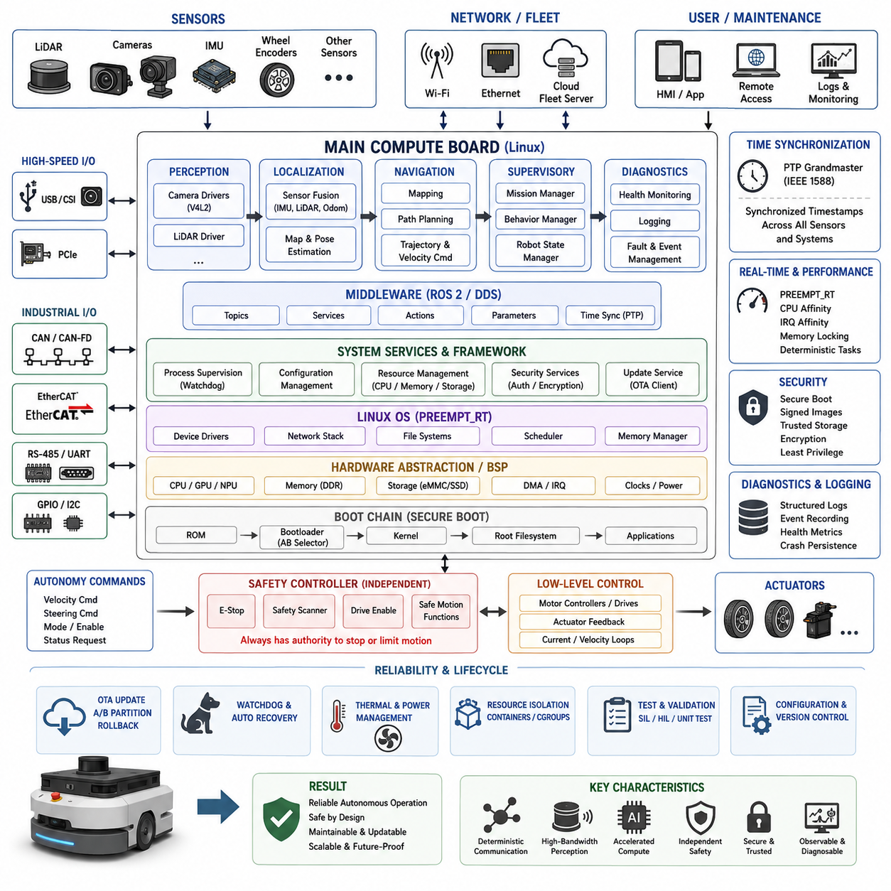
An indoor Autonomous Mobile Robot (AMR) main compute board serves as the embedded computing center that connects perception, localization, navigation, communication, diagnostics, and supervisory control. Unlike a simple motor controller, it must coordinate heterogeneous workloads while maintaining predictable interfaces with safety controllers and low-level actuators. Its software architecture therefore emphasizes clear responsibility boundaries, deterministic data paths, fault containment, and maintainability throughout the robot lifecycle.
A practical main compute platform commonly combines a multicore CPU with hardware acceleration for vision or neural-network inference, high-speed memory, nonvolatile storage, and multiple industrial communication interfaces. Ethernet connects LiDAR, cameras, fleet infrastructure, and service equipment, while CAN, CAN-FD, RS-485, or EtherCAT may connect motor drives and distributed controllers. USB, PCIe, GPIO, UART, and I2C provide additional interfaces for sensors, expansion modules, and board-level management devices.
The embedded software stack should separate hardware-dependent functions from robot applications. Boot firmware initializes the processor, memory, storage, security mechanisms, and essential peripherals before transferring control to the operating system. Linux then provides device management, networking, process isolation, memory management, and system services. Board-support packages and device drivers expose hardware through stable interfaces so that localization, navigation, and perception software remain largely independent of specific board revisions.
Boot behavior is particularly important because an AMR must reach an operational state predictably after power-on, brownout recovery, or watchdog reset. The bootloader should validate software images, identify the active system partition, and support recovery when an update fails. System services should start according to explicit dependencies rather than arbitrary timing assumptions. Hardware initialization, network availability, sensor discovery, middleware startup, localization, navigation, and mission readiness can consequently progress through controlled system states.
Device drivers form the boundary between physical devices and higher-level robot software. Camera drivers may use V4L2, CAN devices can use SocketCAN, and Ethernet sensors generally communicate through vendor protocols or standardized network interfaces. Driver design should avoid unnecessary copies and blocking operations in high-rate paths. DMA, interrupt moderation, asynchronous I/O, bounded queues, and timestamp preservation become important when several cameras, LiDAR streams, encoders, and control messages operate simultaneously.
Time synchronization must be treated as a system-level requirement rather than a sensor-specific feature. Localization and sensor fusion depend on consistent timestamps across LiDAR, cameras, IMUs, wheel encoders, and external positioning sources. The compute board should maintain a clearly defined time domain and distribute or receive synchronization through mechanisms such as PTP when required. Software components should preserve acquisition timestamps instead of replacing them with arbitrary processing times later in the pipeline.
Real-time requirements on the main computer differ from those of dedicated motor-control MCUs. High-frequency current or velocity loops are normally executed closer to the actuator, while the main computer handles localization, trajectory generation, velocity commands, and supervisory logic at lower frequencies. PREEMPT_RT, CPU affinity, IRQ affinity, memory locking, and priority-controlled threads can nevertheless reduce scheduling jitter for critical communication and motion-related processes without forcing every application into a hard real-time model.
The architecture should explicitly separate safety-critical control from computationally intensive autonomy. Emergency-stop circuits, safety scanners, drive-enable signals, and safety-rated motion functions should not depend solely on a complex Linux application remaining healthy. The main computer can request motion and monitor safety status, but independent safety hardware or controllers should retain authority to inhibit hazardous movement. This separation prevents a navigation crash, GPU failure, or operating-system fault from becoming the only barrier against unsafe motion.
Perception workloads place different demands on the board. Camera decoding, object detection, semantic processing, and other AI functions may execute on a GPU, NPU, or dedicated accelerator, while CPU resources remain available for localization, navigation, middleware, networking, and diagnostics. Memory bandwidth must be considered alongside raw compute performance because copying large image tensors between processes can become a bottleneck. Shared memory, zero-copy transport, hardware decoding, and accelerator-aware buffers can substantially reduce unnecessary data movement.
Localization and navigation software require carefully controlled communication with sensors and actuators. LiDAR scans, IMU measurements, wheel odometry, and map information flow toward localization and environmental representation, while planned trajectories and velocity references flow toward drive controllers. Interfaces should define message units, coordinate frames, timestamp semantics, valid ranges, sequence behavior, and timeout handling. These contracts make failures observable and prevent ambiguous assumptions from spreading between software modules.
Process supervision is essential because an indoor AMR may operate continuously without an engineer nearby. Critical services should expose health information including execution state, update rate, communication latency, queue utilization, temperature, memory consumption, and error counters. A supervisory component can detect stalled processes, missing sensor streams, corrupted communication, or excessive resource consumption. Restart policies should distinguish recoverable application faults from conditions requiring controlled robot shutdown or complete system reboot.
Resource isolation prevents one workload from destabilizing the entire robot. CPU affinity and scheduling policies can reserve execution capacity for motion-related tasks, while perception and logging workloads use separate cores where practical. Memory limits, container boundaries, cgroups, and service-level restrictions can prevent runaway applications from exhausting system resources. Storage partitions should similarly separate the operating system, application software, maps, logs, temporary data, and update images so that excessive logging cannot make the root filesystem unusable.
Thermal and power management must be integrated with software because compute performance changes with temperature and available electrical power. Board sensors should monitor processor temperature, accelerator temperature, supply voltage, storage health, and fan operation. Rather than waiting for uncontrolled thermal throttling, the system can reduce noncritical AI workloads, camera processing rates, or background tasks when thermal margins shrink. Persistent abnormal conditions should be reported to robot diagnostics and reflected in operational readiness decisions.
The main compute board should also implement a structured diagnostic framework. Logs need consistent timestamps, severity levels, component identifiers, and fault codes so that failures can be reconstructed after deployment. High-volume sensor data should not be logged indiscriminately; instead, event-triggered recording and bounded ring buffers can preserve data surrounding collisions, localization loss, emergency stops, or unexpected resets. Persistent crash information should survive reboot and remain available for maintenance analysis.
Security begins before normal applications execute. Secure boot can establish trust from immutable hardware or firmware through the bootloader, kernel, and application environment. Signed software packages, protected credentials, restricted administrative interfaces, authenticated communication, and least-privilege services reduce the attack surface. Network interfaces intended for maintenance should not automatically provide unrestricted access to robot control functions, and security credentials should be managed independently from application source code.
OTA capability should be designed into the storage and boot architecture rather than added after deployment. An A/B system layout allows a new image to be written to an inactive partition while the robot continues using the known-good version. After verification, the bootloader can attempt the new system and automatically roll back if health checks fail. Application compatibility, configuration migration, firmware dependencies, and communication protocol versions must also be managed because updating only the Linux image does not guarantee system-level compatibility.
Hardware watchdogs provide another layer of recovery when software supervision itself becomes unavailable. A watchdog should be serviced only when essential system health conditions are satisfied, rather than blindly refreshed by an independent timer thread. If critical execution stops, the watchdog can reset the compute board while the safety controller maintains the robot in a nonhazardous condition. Reset causes, boot counters, and preceding diagnostic information should be retained whenever possible to distinguish software hangs from power or hardware failures.
Development and validation should reproduce the hardware interfaces without requiring a complete robot for every test. Mock drivers, recorded sensor streams, software-in-the-loop environments, and hardware-in-the-loop benches allow navigation and supervisory components to be exercised systematically. Driver-level tests can verify timeout behavior, corrupted frames, disconnections, and high-load conditions, while long-duration tests expose memory leaks, storage growth, thermal problems, race conditions, and timing degradation that short functional tests often miss.
Configuration management becomes increasingly important when one compute-board design supports several AMR variants. Hardware revision, sensor configuration, calibration, network topology, robot identity, and feature options should be represented explicitly rather than embedded as scattered constants. Versioned configuration schemas allow software to detect incompatible parameters during startup. Factory defaults, deployment-specific settings, calibration data, and runtime state should remain logically separated so that software updates do not unintentionally overwrite robot-specific information.
The resulting embedded design is therefore not merely a Linux computer installed inside an AMR. It is a managed execution platform connecting high-bandwidth perception, deterministic robot communication, accelerated computation, safety supervision, diagnostics, security, and lifecycle services. By combining layered hardware abstraction, bounded real-time paths, independent safety authority, resource isolation, secure boot, watchdog recovery, and rollback-capable OTA, the main compute board can support reliable indoor autonomous operation while remaining maintainable as sensors, algorithms, and hardware evolve.

12.02 Outdoor AMR Motor Controller Firmware Case
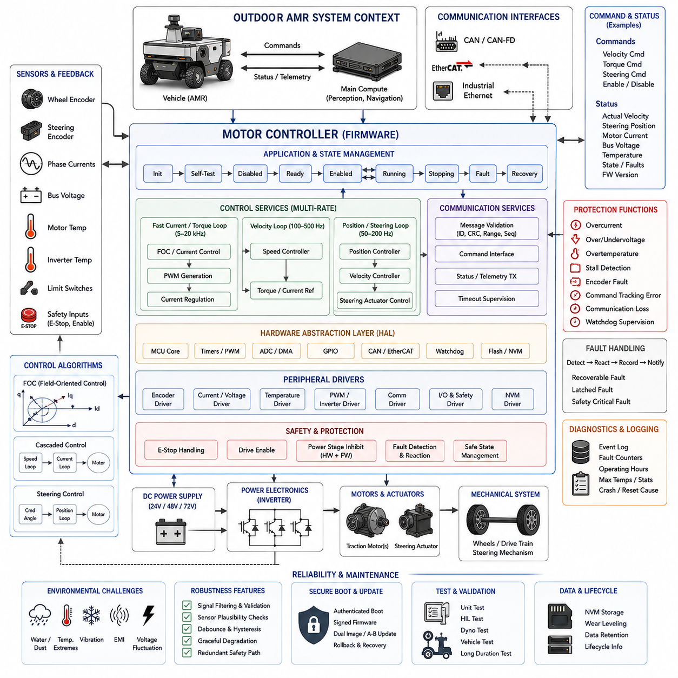
An outdoor Autonomous Mobile Robot (AMR) motor controller is a dedicated embedded subsystem responsible for converting high-level motion commands into deterministic electrical control of traction and steering actuators. Unlike the main compute board, which performs perception and navigation, the motor controller operates close to the physical drivetrain. Its firmware must therefore prioritize predictable timing, rapid fault response, actuator protection, communication integrity, and safe behavior under harsh outdoor operating conditions.
A representative outdoor AMR may use independent traction motors, differential drive, Ackermann steering, or combinations of propulsion and steering actuators depending on vehicle size and mobility requirements. Each motor controller receives velocity, torque, steering, or enable commands from the supervisory computer and converts them into PWM signals or commands for power electronics. Encoder, current, voltage, temperature, and position feedback continuously close the control loops around the physical drivetrain.
The firmware architecture is commonly divided into hardware abstraction, peripheral drivers, control services, communication services, safety supervision, diagnostics, and application-level state management. Hardware-dependent register operations should remain isolated within a Hardware Abstraction Layer (HAL), allowing control algorithms to remain portable across MCU variants. This separation also simplifies unit testing and makes future replacement of gate drivers, encoders, current sensors, or communication transceivers less disruptive.
A high-performance microcontroller such as an ARM Cortex-M class device can provide timers, ADC channels, DMA engines, communication peripherals, watchdogs, and sufficient computational performance for motor control. Hardware timers generate precise PWM waveforms, while synchronized ADC triggering samples motor currents and supply voltages at controlled positions within switching cycles. DMA can transfer repetitive measurements with minimal CPU intervention, reducing interrupt overhead and improving control-loop timing consistency.
Firmware execution should be organized around clearly defined timing domains. Fast current or torque loops may operate at several kilohertz or higher, while velocity control executes at a lower rate and vehicle-level command processing operates more slowly. Diagnostics, temperature monitoring, logging, and communication management can run in background tasks. Separating these rates prevents noncritical activities from introducing excessive jitter into control loops whose timing directly affects motor stability and response.
Interrupt design is consequently central to the implementation. High-priority timer and ADC interrupts should perform only bounded operations required by the control loop, avoiding blocking communication, dynamic memory allocation, or lengthy diagnostic processing. Lower-priority interrupts and scheduled tasks can process CAN messages, update telemetry, and store diagnostic information. Execution-time measurements should confirm that worst-case interrupt latency remains safely below the control-period deadline under maximum system load.
The control pipeline begins with sensor acquisition and signal conditioning. Encoder counts are converted into wheel velocity or steering position, while ADC measurements provide phase current, DC bus voltage, motor temperature, and other electrical quantities. Raw measurements may require calibration, offset correction, scaling, filtering, and plausibility checks before entering the controller. Invalid or physically impossible measurements should be detected explicitly rather than propagated into torque or velocity calculations.
For traction control, the firmware can implement cascaded control loops in which an outer velocity controller generates a torque or current reference and an inner controller regulates actuator current. Depending on the motor and drive architecture, Field-Oriented Control (FOC) may transform measured phase currents into rotating reference coordinates and regulate torque-producing and flux-producing components independently. PWM generation then converts the controller output into switching commands for the inverter power stage.
Steering control requires similar attention to mechanical limits and feedback validity. A steering actuator may use encoder position feedback with position and velocity loops, while firmware enforces maximum steering angle, steering rate, motor current, and mechanical travel boundaries. Limit switches or independent position references can provide additional protection. When commanded and measured steering positions diverge beyond an allowable tolerance, the controller should report a fault rather than continuously increasing actuator effort.
Communication with the main compute system commonly uses CAN, CAN-FD, EtherCAT, or industrial Ethernet depending on vehicle architecture. Command messages should contain clearly defined units, ranges, sequence information, and timeout behavior. The controller must never assume that the last valid command remains safe indefinitely. If new motion commands stop arriving within the configured supervision interval, firmware should transition toward a defined controlled-stop or disabled state according to the system safety concept.
A robust communication layer validates message identifiers, payload lengths, checksums where applicable, command ranges, sequence counters, and communication freshness. Received values should pass through an interface layer before reaching control algorithms so malformed network data cannot directly manipulate hardware. Transmitted status frames can include actual velocity, steering position, motor current, bus voltage, temperature, operating state, fault bits, warning bits, and controller software version for supervisory monitoring.
The controller state machine provides a deterministic framework for managing startup and operation. Typical logical states include initialization, self-test, disabled, ready, enabled, running, controlled stopping, fault, and recovery. Transitions should occur only when explicit conditions are satisfied. For example, motor output must remain disabled until sensor validity, supply voltage, communication status, safety inputs, and internal diagnostics confirm that activation is permissible.
Safety-related inputs require a path that remains effective even when normal application processing fails. Emergency-stop status, drive-enable signals, external safety-controller outputs, and power-stage fault inputs should be monitored using appropriate hardware and firmware mechanisms. Where the safety architecture requires it, power-stage inhibition must not depend exclusively on software. Firmware participates by recognizing the event immediately, suppressing torque commands, recording the cause, and reporting the resulting safe state.
Electrical protection is particularly important for outdoor AMRs because terrain, payload, slopes, wheel obstruction, and impacts can produce severe transient loads. Firmware should supervise overcurrent, overvoltage, undervoltage, motor temperature, inverter temperature, encoder failure, stalled rotor conditions, and excessive command tracking error. Thresholds may include warning and shutdown levels so that performance can be reduced before a condition becomes severe enough to require immediate actuator disablement.
Outdoor environments introduce additional disturbances that should influence firmware design. Wheel slip, vibration, water exposure, large temperature variations, electromagnetic interference, and supply-voltage fluctuations can create noisy measurements or intermittent communication. Filtering must reduce noise without introducing excessive control delay. Sensor plausibility logic should distinguish short disturbances from persistent faults, while repeated abnormal events should accumulate diagnostic evidence that can be examined during maintenance.
Fault handling should distinguish recoverable, latched, and safety-critical conditions. A temporary communication disturbance might allow controlled recovery after valid messages return, whereas severe overcurrent or gate-driver faults may require output shutdown and an explicit reset procedure. Automatic recovery should never create repeated uncontrolled enable-disable cycles. Each fault should therefore define its detection criterion, immediate reaction, persistence behavior, recovery condition, and diagnostic record.
Watchdog supervision provides protection against firmware deadlock or runaway execution. A hardware watchdog should be refreshed only after critical tasks demonstrate successful execution within their expected periods. If the main control loop, communication supervision, or safety monitoring stops progressing, the watchdog eventually resets the MCU. After reset, outputs must remain inactive until initialization and safety checks complete, preventing an uncontrolled restart from immediately producing motor torque.
Nonvolatile diagnostic storage can preserve reset causes, accumulated operating hours, critical fault counters, maximum observed temperatures, overcurrent events, and selected lifecycle information. Flash writes should be controlled to prevent excessive wear, especially when faults occur repeatedly. Important event records can be buffered in RAM and committed only when necessary, while wear-leveling or dedicated storage regions can extend service life for long-running industrial robots.
Bootloader and firmware update design must preserve drivetrain safety during maintenance. Firmware images should be authenticated before execution, and interrupted updates must not leave the controller in an uncontrolled state. Dual-image or recovery-capable boot strategies can preserve a known-good version. Compatibility between motor-controller firmware and the main computer should also be checked because changes in command scaling, message definitions, or state-machine behavior can otherwise produce hazardous integration errors.
Testing should extend beyond nominal motor operation. Unit tests can verify conversion functions, state transitions, saturation logic, fault handling, and communication parsing, while Hardware-in-the-Loop (HIL) testing can emulate encoders, currents, voltages, communication loss, and power-stage faults. Dynamometer and vehicle testing can then evaluate acceleration, braking, steering response, thermal behavior, slope operation, wheel obstruction, emergency stopping, and long-duration reliability under realistic mechanical loads.
The resulting outdoor AMR motor-controller firmware acts as the deterministic bridge between autonomous decision software and physical motion. Its quality depends not only on the control algorithm but also on timing architecture, sensor validation, communication supervision, state management, protection logic, watchdog recovery, secure updating, and systematic diagnostics. When these mechanisms are designed together, the controller can deliver responsive motion while ensuring that communication failures, environmental disturbances, software faults, and electrical abnormalities lead to controlled and diagnosable behavior.

12.03 Mobile Manipulator EtherCAT Master Embedded Design
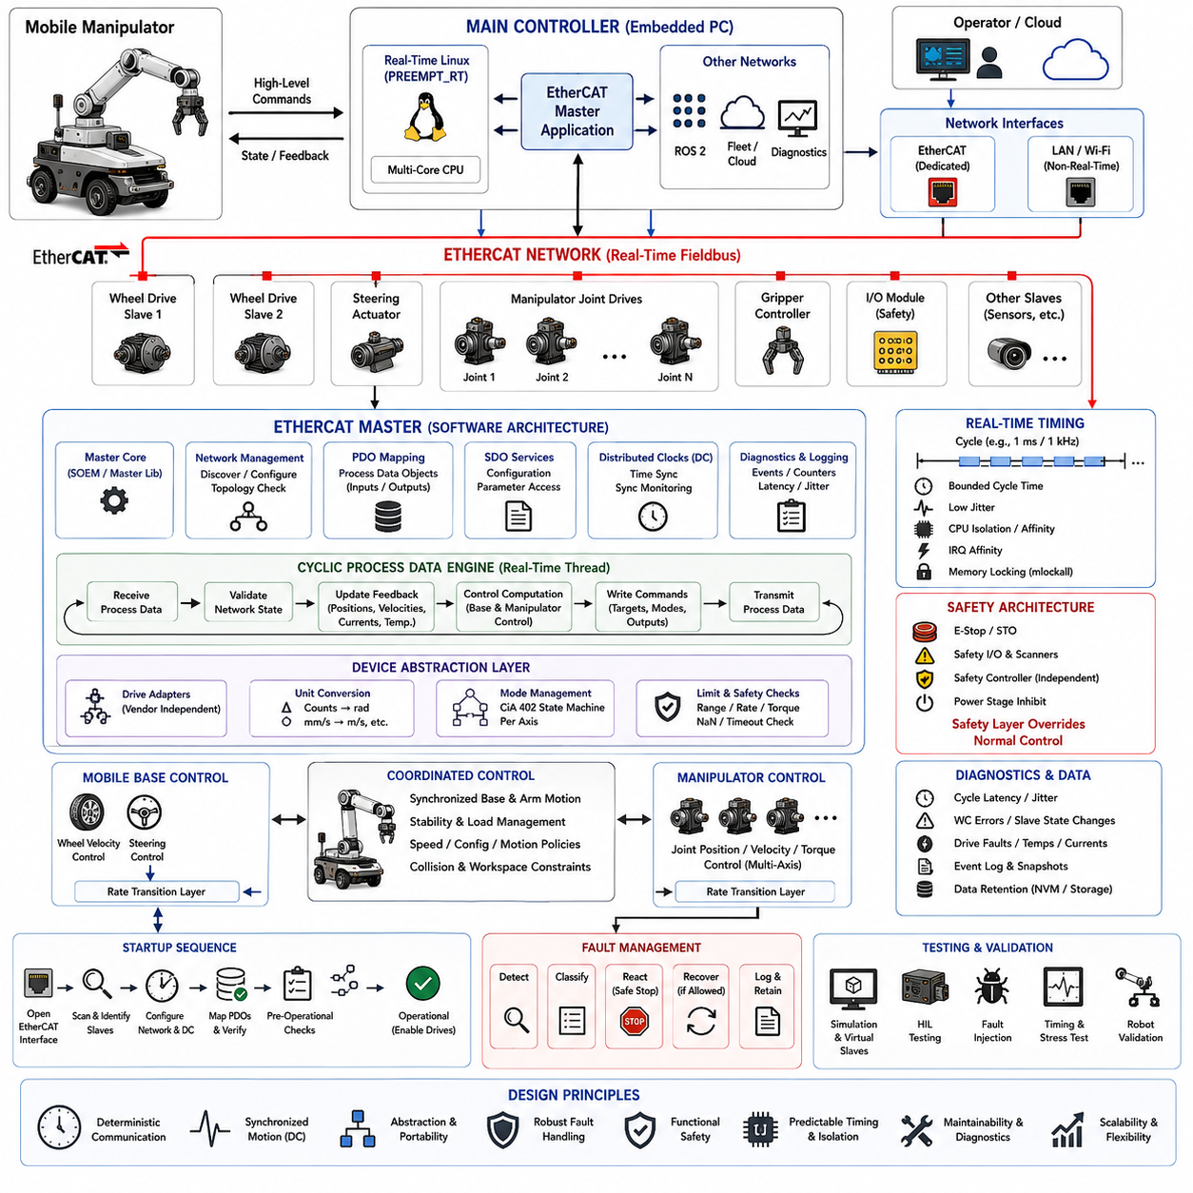
A mobile manipulator combines an autonomous mobile base with a multi-axis robotic arm, creating an embedded control problem that requires coordinated mobility and manipulation. The EtherCAT master becomes the deterministic communication backbone between the main controller and distributed servo drives, I/O modules, grippers, and sensing devices. Its design must provide bounded cycle time, synchronized motion, reliable fault handling, and clear separation between real-time control and higher-level robot intelligence.
The embedded computing platform typically runs Linux with real-time extensions such as PREEMPT_RT on a multicore processor. One or more dedicated Ethernet interfaces are assigned exclusively to the EtherCAT network, while separate interfaces handle ROS 2, fleet communication, diagnostics, and external services. CPU resources, interrupt routing, memory behavior, and network ownership must be planned together because deterministic EtherCAT execution depends on the entire host architecture rather than the protocol stack alone.
A representative EtherCAT topology connects the master to wheel drives, steering actuators, manipulator servo drives, gripper controllers, safety-aware I/O devices, and additional distributed modules in a logical line or branched arrangement. EtherCAT processes frames while they pass through each slave, enabling efficient cyclic exchange across many devices. The resulting architecture allows the mobile base and manipulator to share a synchronized industrial communication domain without requiring independent point-to-point control links for every actuator.
The software architecture should separate the EtherCAT master stack, network configuration, cyclic process-data engine, device abstraction, control interfaces, diagnostics, and application integration. A master library such as SOEM can provide low-level protocol functions, while the surrounding embedded software manages lifecycle, timing, configuration, and fault policy. This separation prevents robot applications from manipulating raw EtherCAT frames and provides stable actuator interfaces even when individual slave devices change.
Startup begins by establishing exclusive ownership of the EtherCAT network interface and discovering the connected slaves. The master identifies each device, checks vendor and product information, configures communication parameters, maps process data, and verifies the expected network topology. Startup should fail safely if required drives are missing, devices appear in unexpected positions, or configuration information differs from the validated machine definition, rather than attempting motion with an uncertain hardware configuration.
Process Data Objects (PDOs) carry cyclic information between the master and slaves. Output PDOs may contain control words, target positions, velocities, torque references, operating modes, and digital outputs, while input PDOs return status words, actual positions, velocities, currents, temperatures, and fault information. PDO layouts should be defined as version-controlled interface contracts because incorrect offsets, sizes, signedness, or scaling can translate directly into incorrect physical actuator commands.
Service Data Objects (SDOs) complement cyclic PDO communication by supporting configuration and parameter access outside the primary real-time data path. SDO operations can configure drive parameters, retrieve device information, or support maintenance functions, but potentially slow mailbox transactions should not interfere with the deterministic cyclic thread. The architecture therefore separates configuration traffic from time-critical process-data exchange and restricts nonessential operations while coordinated motion is active.
The real-time EtherCAT cycle is implemented as a periodic execution loop with a defined period, for example 1 ms for a 1 kHz supervisory servo interface when appropriate for the robot design. During each cycle, the master receives process data, validates network state, updates actuator feedback, executes or exchanges control calculations, writes new commands, and transmits the next frame. Worst-case execution time and jitter must remain comfortably within the selected cycle deadline.
CPU isolation is useful for protecting this periodic loop from unrelated Linux workloads. A dedicated processor core can execute the EtherCAT thread while CPU affinity and IRQ affinity route relevant network interrupts predictably. Memory locking with mlockall prevents page faults after initialization, and real-time scheduling policies give the cyclic thread priority over ordinary applications. Dynamic memory allocation, filesystem access, blocking logging, and unpredictable system calls should be excluded from the critical loop.
Distributed Clocks (DC) provide a key mechanism for synchronizing multiple EtherCAT slaves. Instead of allowing every servo drive to operate from an independent oscillator, distributed clock synchronization establishes a common time reference with tightly controlled phase relationships. This is particularly important for manipulators because coordinated multi-axis motion depends on joints sampling feedback and applying commands at consistent instants. Synchronization quality should therefore be continuously monitored rather than assumed after startup.
The mobile base and manipulator may have different control bandwidths while sharing the same EtherCAT cycle. Wheel velocity or steering commands can be updated according to base-control requirements, while manipulator joints exchange position, velocity, and torque-related data at rates appropriate for servo coordination. A rate-transition layer can connect these actuator domains to higher-level navigation and manipulation software without forcing every algorithm to execute at the EtherCAT network frequency.
Device abstraction prevents higher-level software from depending on vendor-specific register layouts. Each drive adapter can translate standardized robot commands into device-specific PDO representations and convert returned values into consistent engineering units. For example, encoder counts become radians, drive velocity units become radians per second, and current measurements become amperes. This layer can also normalize control modes, fault codes, homing behavior, and enable sequences across heterogeneous servo products.
For manipulator drives using CiA 402-compatible behavior, the embedded software must coordinate the drive state machine carefully. Control words and status words govern transitions through states such as switch-on disabled, ready to switch on, switched on, operation enabled, quick stop, and fault. Motion commands must not be issued simply because network communication exists. Each axis should demonstrate the required operational state before coordinated manipulator motion is permitted.
Command generation must also enforce physical and software limits. Joint position, velocity, acceleration, torque, and following-error limits protect the manipulator from invalid references, while mobile-base commands require equivalent limits for wheel velocity and steering behavior. The EtherCAT layer should reject nonfinite values, impossible ranges, stale commands, and inconsistent operating modes before they reach servo drives. Higher-level software errors should therefore degrade into bounded behavior rather than unrestricted actuator requests.
Communication supervision detects failures that could otherwise propagate rapidly through the robot. The master should monitor working counters, slave states, cycle timing, link status, synchronization error, and command freshness. A mismatch in the expected working counter can indicate that one or more slaves failed to process a frame correctly. Persistent communication anomalies should trigger predefined degradation or stopping behavior instead of allowing the control system to continue with incomplete feedback.
Fault management should distinguish individual-axis faults from failures affecting coordinated motion. A gripper fault may permit the mobile base to remain stationary while diagnostics are performed, whereas loss of a critical arm joint during manipulation may require the complete manipulator to stop. Loss of a wheel drive can require the mobile platform to enter a controlled safe state. Fault policy must therefore reflect mechanical dependencies and system-level hazards rather than treating every EtherCAT error identically.
Safety functions should remain architecturally independent from ordinary EtherCAT motion control where required by the risk assessment. Emergency-stop circuits, Safe Torque Off (STO), safety scanners, protective stops, and safety-rated controllers should retain authority to remove or limit actuator energy even if the EtherCAT master or Linux host fails. The standard EtherCAT master can observe safety status and coordinate application behavior, but normal software communication should not become the sole mechanism protecting people from hazardous motion.
A mobile manipulator introduces an additional coordination challenge because arm movement changes the physical state of the mobile platform. Manipulator extension can shift the center of mass, alter stability margins, enlarge the collision envelope, and change allowable base acceleration. The embedded interface should therefore expose synchronized base and arm states to supervisory control. Motion policies can then restrict base velocity, arm configuration, or simultaneous movement when mechanical stability or operational safety requires it.
Diagnostics should record cycle latency, jitter, missed deadlines, working-counter errors, slave-state transitions, synchronization deviation, drive faults, and communication recovery events. High-frequency data should use bounded buffers rather than synchronous disk writes from the real-time thread. Event-triggered snapshots can preserve process data surrounding a fault, allowing engineers to reconstruct whether the initiating condition originated in a drive, communication network, control algorithm, timing violation, or external safety event.
Recovery behavior must be deterministic. If a slave temporarily leaves its expected operational state, the master may attempt controlled reconfiguration when system policy permits, but automatic recovery must never unexpectedly restore actuator torque. Re-enabling motion should require confirmation of network integrity, valid feedback, appropriate safety state, and compatible application state. Severe or repeated communication failures should transition the robot toward a known safe condition and preserve diagnostic evidence for maintenance.
Testing should combine software simulation, loopback or virtual-slave testing, Hardware-in-the-Loop (HIL), and complete robot validation. Fault injection can deliberately disconnect slaves, delay frames, corrupt configuration, create working-counter mismatches, or force drives into fault states. Timing tests should measure latency distributions and worst-case jitter under CPU, storage, network, and perception workloads, demonstrating that deterministic control remains valid when the mobile manipulator experiences realistic computational stress.
The resulting EtherCAT master is more than an industrial network driver. It forms the deterministic embedded coordination layer between autonomous software and distributed physical actuators, integrating synchronized communication, real-time scheduling, device abstraction, drive state management, fault supervision, and diagnostics. When combined with independent safety mechanisms and carefully defined recovery policies, this architecture enables the mobile base and manipulator to operate as one coordinated robotic system while preserving predictable timing, maintainability, and fault containment.

12.04 Quadruped Joint MCU Firmware Architecture Case
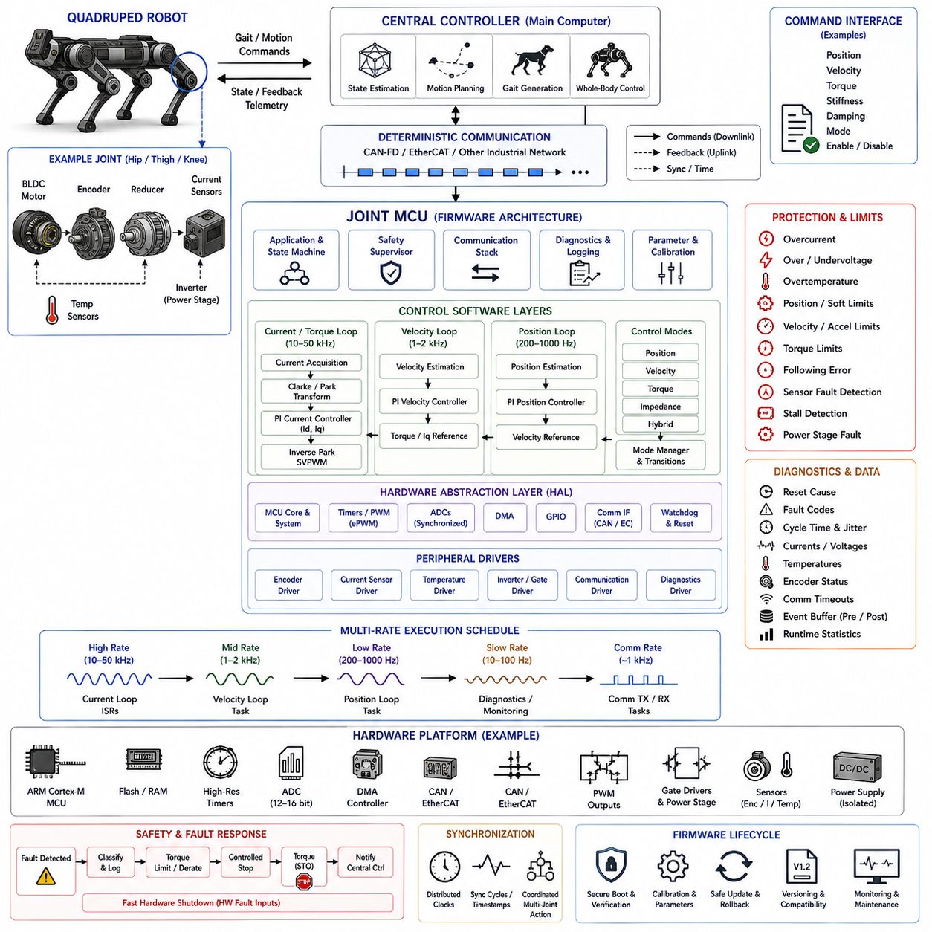
A quadruped robot joint MCU is the lowest embedded control layer that converts coordinated locomotion commands into precise electrical actuation at each leg joint. While the main computer estimates terrain, plans motion, and generates gait targets, the joint controller must execute deterministic servo functions with minimal latency. Its firmware architecture therefore emphasizes high-rate motor control, synchronized sensing, bounded execution time, local protection, robust communication, and predictable transition to safe states.
A typical quadruped contains twelve or more actuated joints distributed across hip, thigh, and knee mechanisms. Each joint may use a brushless permanent-magnet motor, inverter, position encoder, current sensors, temperature sensing, and reduction mechanism. A dedicated MCU may control one actuator or several nearby joints. Distributed controllers reduce wiring complexity and computational load on the main processor while allowing electrical protection and fast servo loops to remain physically close to each motor.
The firmware can be organized into hardware abstraction, peripheral drivers, sensing, motor control, communication, safety supervision, diagnostics, and application state management. Hardware-specific register access belongs inside the Hardware Abstraction Layer (HAL), while control algorithms operate through stable interfaces. This organization makes it possible to change MCU variants, encoder devices, gate drivers, or current-sensing circuits without redesigning the complete joint-control software.
A high-performance ARM Cortex-M MCU can provide advanced timers, synchronized ADCs, DMA, communication peripherals, floating-point processing, watchdogs, and hardware protection resources. PWM timers drive the inverter switching sequence, while ADC conversions are synchronized with PWM timing so phase currents are sampled at electrically meaningful points. DMA transfers repetitive measurements efficiently, allowing the processor to reserve deterministic execution time for current estimation and control calculations.
Joint firmware normally operates through multiple timing domains. The innermost current or torque-control loop may execute at tens of kilohertz, while velocity and position loops operate at lower frequencies. Communication with the robot-level controller may occur around a kilohertz depending on system architecture, whereas diagnostics and thermal monitoring can execute much more slowly. Explicit rate separation prevents maintenance and communication tasks from disturbing the motor-control deadlines.
The interrupt architecture should give the highest priority to time-critical motor-control events. PWM or ADC interrupts trigger current acquisition and control computation, while communication and diagnostic processing execute at lower priorities. Interrupt service routines should avoid blocking operations, filesystem access, dynamic memory allocation, and unpredictable computation. Worst-case execution time must remain below the available control period even when communication traffic and diagnostic activity reach their maximum expected load.
Sensor acquisition begins with rotor position and motor-current measurements. Absolute or incremental encoders provide mechanical position, while current sensors measure phase or inverter current required for torque regulation. Measurements require scaling, offset compensation, calibration, filtering, and validity checking. Position discontinuities, impossible velocity changes, current-sensor saturation, or inconsistent encoder states should be detected before corrupted measurements enter the servo-control calculations.
Field-Oriented Control (FOC) is commonly suitable for high-performance quadruped joints because it enables precise torque production from brushless motors. Rotor electrical angle and phase currents are transformed into rotating reference coordinates, where current components can be regulated independently. Controller outputs are transformed back into voltage commands and converted into PWM duty cycles. The resulting inner loop provides the fast torque response required for dynamic locomotion and disturbance rejection.
Above the current loop, velocity and position controllers translate robot-level joint references into torque-producing commands. The controller may support position, velocity, torque, impedance, or hybrid operating modes depending on locomotion strategy. Impedance control is particularly useful for legged robots because commanded stiffness and damping can regulate how the joint responds to terrain contact. Mode transitions must be explicitly managed to prevent discontinuous torque when locomotion software changes control strategies.
Command interfaces should define position, velocity, torque, stiffness, damping, enable state, and control mode using consistent physical units. Before applying a received command, firmware should check numeric validity, range limits, timestamps or sequence information, and communication freshness. NaN values, excessive torque requests, impossible positions, stale commands, or unsupported operating modes must be rejected locally rather than being transmitted directly to the inverter.
Joint limits provide another layer of protection independent of the higher-level locomotion planner. Firmware can enforce allowable position, velocity, current, torque, temperature, and acceleration boundaries. Soft position limits progressively restrict commands before the mechanical stop is reached, while hard limits trigger stronger protective reactions. These local constraints remain important because a corrupted gait command or software fault on the main computer can otherwise propagate rapidly into physical leg motion.
Communication between joint controllers and the central computer may use CAN-FD, EtherCAT, or another deterministic industrial network. Command packets flow toward the joints while position, velocity, torque, temperature, voltage, operating state, and fault information return to the central controller. The protocol should define scaling, byte order, message identifiers, update rates, sequence behavior, timeout limits, and compatibility versions so every joint interprets commands identically.
Synchronization is critical because locomotion depends on coordinated action across all legs. Joint controllers should share a sufficiently consistent time base or execute commands according to synchronized communication cycles. Without synchronization, small phase differences between joints can distort foot trajectories, contact timing, and force distribution. Timestamped commands, synchronized network cycles, or distributed clock mechanisms can therefore become part of the control architecture for high-performance quadrupeds.
The firmware state machine governs actuator lifecycle behavior. Typical states include boot, initialization, self-test, calibration, disabled, ready, enabled, running, fault, and recovery. Torque output remains inhibited until power conditions, sensor validity, communication status, calibration information, and safety conditions are acceptable. A controller returning from reset should never resume the previous torque command automatically because the mechanical state of the leg may have changed during the interruption.
Quadruped joints experience severe transient loads during foot impact, jumping, slipping, recovery motions, and uneven-terrain traversal. Firmware should continuously supervise overcurrent, bus overvoltage and undervoltage, motor and inverter temperature, encoder failure, excessive velocity, following error, and stalled actuator conditions. Protection thresholds may distinguish warnings, temporary derating, controlled stopping, and immediate power-stage inhibition according to the severity of the detected condition.
Thermal management is especially important because compact joint modules combine motors, reduction mechanisms, electronics, and power stages in limited space. Temperature models can supplement direct sensors to estimate winding or semiconductor heating that is difficult to measure instantaneously. As thermal margins decrease, firmware can reduce allowable continuous torque while preserving short-duration peak capability where safe. This provides graceful performance degradation rather than abrupt thermal shutdown during sustained locomotion.
Fault handling should classify events according to their effect on local and whole-body stability. Some sensor warnings may permit continued operation with reduced capability, while encoder loss or severe inverter faults may require immediate torque removal. Because disabling one leg joint can destabilize the entire robot, the controller should report faults to the central locomotion system with minimal delay. System-level recovery can then coordinate posture stabilization, controlled collapse, or emergency stopping.
A hardware watchdog protects against firmware deadlock, but it should be refreshed only after essential control activities complete successfully. Independent hardware fault inputs from the gate driver or power stage can disable PWM faster than ordinary application software. On reset or severe fault, PWM outputs should enter a predefined inactive condition. Combining MCU supervision with hardware-level shutdown prevents a software failure from leaving uncontrolled switching commands applied to the motor inverter.
Diagnostics should capture information useful for reconstructing difficult locomotion failures. Relevant data include reset cause, fault code, peak current, minimum bus voltage, maximum temperature, encoder anomalies, communication timeouts, and timing overruns. A bounded high-speed event buffer can preserve several control cycles surrounding a critical event. This is valuable when diagnosing intermittent failures that occur only during impacts, high-torque maneuvers, or specific gait transitions.
Nonvolatile memory can store calibration constants, joint identity, hardware revision, firmware version, encoder offsets, protection parameters, and selected lifecycle statistics. Configuration data should include integrity checks and explicit version information so incompatible structures are not silently accepted after firmware changes. Flash writes must be rate-limited because high-frequency diagnostic events can otherwise exhaust endurance long before the mechanical joint reaches its expected service life.
Firmware updates require the same attention to safety as normal motor operation. A bootloader can verify digitally signed images before execution and preserve a recovery image if an update is interrupted. During update mode, motor outputs should remain disabled. Compatibility between joint firmware, communication protocol, and central locomotion software must be controlled because differences in torque scaling, control-mode definitions, or message layouts could create dangerous behavior even when each component operates correctly by itself.
Verification should progress from unit testing and motor simulation to Hardware-in-the-Loop (HIL), actuator dynamometer testing, and complete quadruped experiments. Tests should include sensor faults, communication loss, command saturation, encoder discontinuities, overcurrent events, watchdog resets, thermal derating, and timing overload. Whole-robot testing should then evaluate standing, walking, trotting, impacts, slips, terrain transitions, and emergency conditions while monitoring synchronization and joint-level protection behavior.
The resulting joint MCU firmware is therefore more than a local motor driver. It forms a distributed real-time actuation layer that transforms whole-body locomotion intent into synchronized joint torque while protecting each electromechanical actuator. High-rate FOC, multi-rate servo control, synchronized communication, local command validation, thermal protection, deterministic state management, watchdog supervision, diagnostics, and secure lifecycle mechanisms together provide the foundation for responsive, stable, and fault-aware quadruped locomotion.

12.05 Humanoid Finger Actuator Firmware Case
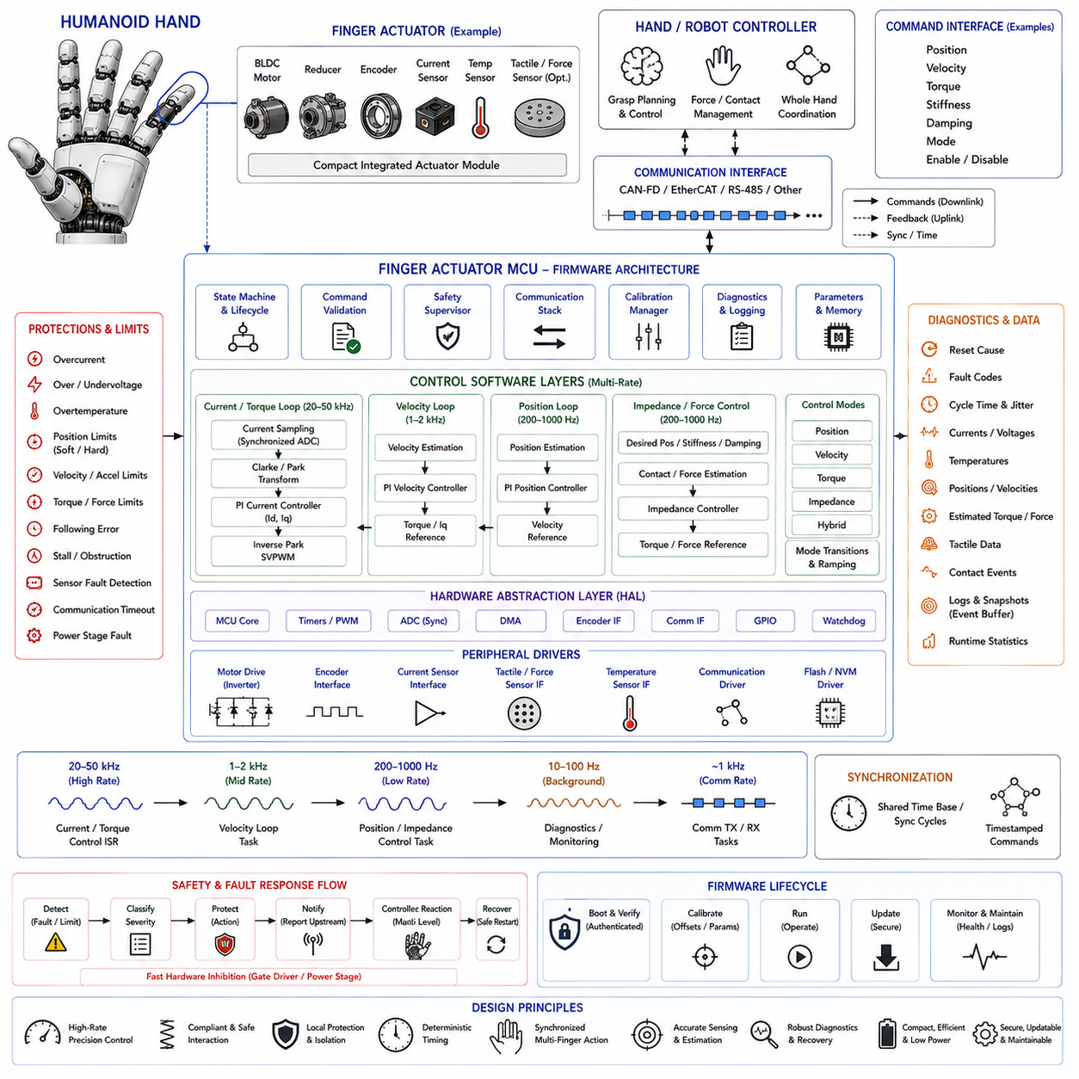
A humanoid finger actuator is a compact embedded mechatronic subsystem that converts hand-level grasp commands into precise joint motion and contact force. Unlike large robot joints, finger actuators operate within severe constraints on volume, mass, heat dissipation, wiring, and available electrical power. Their firmware must therefore combine deterministic motor control, high-resolution sensing, compliant interaction, local protection, communication, calibration, and diagnostics within a tightly integrated control architecture.
A humanoid hand may contain multiple independently controlled fingers with several active or mechanically coupled degrees of freedom. Each actuator can include a miniature BLDC motor, reduction mechanism, position encoder, current sensing, temperature sensing, and compact inverter. Depending on the mechanical architecture, one MCU may control a single joint, several joints within one finger, or a group of actuators distributed throughout the hand while maintaining synchronized command and feedback exchange.
The firmware architecture should separate hardware abstraction, peripheral drivers, sensor acquisition, servo control, communication, safety supervision, calibration, diagnostics, and actuator state management. Hardware-dependent register access remains inside the Hardware Abstraction Layer (HAL), while control algorithms operate through stable interfaces. This separation allows motor, encoder, gate-driver, or MCU revisions to evolve without forcing extensive changes to higher-level grasp and manipulation software.
A suitable MCU provides high-resolution PWM timers, synchronized ADC channels, DMA, encoder interfaces, communication peripherals, watchdogs, and sufficient numerical performance for real-time servo control. PWM timing controls the miniature inverter, while ADC sampling is synchronized to switching events to obtain stable current measurements. DMA transfers repetitive sensor data with low processor overhead, preserving computational time for estimation, control, protection, and communication tasks.
Finger control uses multiple execution rates because electrical and mechanical dynamics occur at different time scales. The current or torque loop may execute at tens of kilohertz, while velocity, position, or impedance loops operate more slowly. Hand-level command communication may run near the kilohertz range, whereas temperature monitoring and noncritical diagnostics execute at lower rates. Explicit scheduling prevents communication or logging activity from disturbing time-critical actuator regulation.
Sensor processing is particularly important because manipulation quality depends on small motion and force variations. Position encoders provide joint or motor angle, current sensors estimate actuator torque, and optional tactile or force sensors provide contact information. Raw measurements require calibration, scaling, filtering, offset compensation, and plausibility checks. Encoder discontinuities, current saturation, implausible velocities, and disconnected sensors must be detected before their values influence control outputs.
Field-Oriented Control (FOC) can provide efficient and smooth torque generation for miniature BLDC actuators. Rotor electrical position and measured phase currents are transformed into rotating reference coordinates, allowing torque-producing current to be regulated accurately. The resulting voltage commands are converted into PWM duty cycles for the inverter. Low torque ripple is especially valuable in humanoid fingers because small oscillations can disturb delicate contact, precision grasping, and tactile interpretation.
Above the current loop, position, velocity, torque, and impedance controllers translate hand-level commands into actuator behavior. Position control supports precise finger configuration, torque control regulates interaction force, and impedance control creates compliant mechanical behavior by combining desired position, stiffness, and damping. Hybrid modes can change these relationships during approach, initial contact, grasp stabilization, object manipulation, and release without requiring the central controller to close every fast servo loop.
Mode transitions must be carefully managed because abrupt changes between position and torque control can produce unexpected finger forces. Firmware should preserve appropriate internal states, limit reference discontinuities, and apply controlled ramping when switching modes. Integrator states may require initialization or reset according to transition direction. The objective is bumpless transfer so that changing the control strategy does not create a sudden actuator impulse at the fingertip.
Command validation provides a local boundary between higher-level manipulation intelligence and physical actuation. Incoming commands can include target position, velocity, torque, stiffness, damping, operating mode, and enable state. Firmware should reject nonfinite values, stale packets, invalid mode combinations, excessive torque, and commands outside calibrated joint limits. Local validation remains necessary even when the hand planner normally generates valid trajectories because communication or software faults can occur upstream.
Mechanical protection must account for the small and relatively fragile structure of humanoid fingers. Firmware can enforce soft position limits before mechanical end stops, restrict velocity and acceleration near joint boundaries, and limit motor current according to actuator capability. Excessive following error may indicate obstruction, linkage damage, or an unexpected object. Rather than continuing to increase motor effort indefinitely, the controller should transition to a bounded force or fault response.
Contact with objects changes the control problem from free-space motion to constrained interaction. A rapid rise in estimated torque, motor current, tactile pressure, or following error can indicate initial contact. Firmware can use this information to reduce closing velocity or transition from position control toward compliant or force-limited behavior. Such local reactions reduce dependence on communication latency and help prevent excessive squeezing before the central manipulation system processes the contact event.
Grip-force regulation requires careful interpretation because motor current is not always identical to fingertip force. Gear friction, tendon transmission, joint geometry, compliance, and mechanical hysteresis can change the relationship between actuator torque and contact force. Calibration models or local estimators can translate electrical measurements into more useful force estimates. When tactile sensors are available, they can supplement actuator-side sensing and improve contact detection and grasp stabilization.
Communication between finger controllers and the hand or robot controller may use CAN-FD, EtherCAT, RS-485, or another deterministic embedded network. Commands flow toward the actuators while position, velocity, estimated torque, current, temperature, tactile information, operating state, and faults return upstream. Protocol definitions should specify physical units, scaling, byte order, update rates, timestamps or sequence counters, timeout behavior, and firmware compatibility to ensure consistent interpretation across all fingers.
Synchronization becomes important when several fingers cooperate during grasping. The thumb and opposing fingers may need to begin closing at coordinated times, while multi-finger manipulation can require synchronized changes in position and force. Controllers should therefore share a consistent time reference or process commands according to synchronized communication cycles. Timestamped references can further ensure that commands generated together are applied coherently across distributed actuator nodes.
The actuator state machine controls startup and lifecycle behavior through states such as boot, initialization, self-test, calibration, disabled, ready, enabled, running, fault, and recovery. Motor torque remains disabled until sensor validity, power conditions, communication status, and calibration information are confirmed. After reset, the actuator should not automatically restore its previous force command because the finger may now be touching a person, object, fixture, or another part of the robot.
Calibration is a fundamental firmware function because compact mechanisms accumulate manufacturing and assembly variations. Encoder zero position, joint range, current-sensor offset, motor electrical alignment, transmission parameters, and force-estimation coefficients may require calibration. Calibration data should be stored with integrity checking and version information in nonvolatile memory. Procedures must also prevent calibration motion from exceeding safe mechanical limits or applying excessive force to an unknown environment.
Thermal protection is challenging because miniature motors and electronics have limited thermal mass and cooling capability. Firmware should monitor motor, inverter, and board temperature while also considering current history when direct winding temperature measurement is unavailable. A thermal estimator can predict internal heating and gradually reduce allowable continuous torque as thermal margins shrink. Short peak forces may remain available within validated limits while sustained grasp force is derated to protect the actuator.
Electrical and mechanical faults require explicit classification and reaction policies. Overcurrent, overvoltage, undervoltage, encoder loss, inverter faults, communication timeout, excessive temperature, stalled motion, and persistent following error should produce defined responses. Some warnings permit reduced operation, whereas severe electrical faults require immediate PWM inhibition. Fault reporting should identify both the initiating condition and the actuator state so the hand controller can coordinate an appropriate whole-hand response.
A hardware watchdog protects against firmware deadlock, while independent gate-driver protection can disable the inverter when electrical faults occur faster than software can react. The watchdog should be refreshed only after critical control and supervision tasks have completed successfully. Following reset, PWM outputs remain inactive until initialization is complete. This prevents a corrupted control task from leaving uncontrolled motor switching or unexpectedly restoring grasp force.
Diagnostics should preserve information needed to understand intermittent manipulation failures. Useful records include reset cause, peak current, maximum temperature, encoder anomalies, communication timeouts, control saturation, following errors, and contact-related events. A bounded high-rate event buffer can capture several control cycles before and after a fault or unexpected contact. Engineers can then distinguish electrical problems from mechanical obstruction, control instability, communication delay, or sensor abnormalities.
Secure firmware lifecycle management is required when many distributed actuators exist inside a humanoid robot. A bootloader can authenticate firmware before execution and maintain a recovery mechanism for interrupted updates. Firmware version, hardware revision, calibration schema, and communication protocol version should be checked for compatibility. Updating one actuator with incompatible scaling or control semantics could otherwise cause asymmetric finger behavior that is difficult to diagnose at the hand level.
Verification should progress from unit tests and motor simulation to Hardware-in-the-Loop (HIL), actuator benches, instrumented finger mechanisms, and complete hand experiments. Tests should cover free motion, contact detection, force limiting, object grasping, mode transitions, sensor faults, communication loss, thermal derating, watchdog recovery, and command saturation. Multi-finger testing should additionally verify synchronized grasping, load sharing, object release, and safe response when one actuator becomes unavailable.
The resulting finger-actuator firmware is not merely a miniature motor driver. It forms a distributed compliant manipulation layer between high-level hand intelligence and physical contact with the environment. High-rate torque control, multi-mode servo behavior, synchronized communication, local contact response, calibration, mechanical and thermal protection, diagnostics, watchdog supervision, and secure firmware management together enable precise yet compliant humanoid grasping while containing faults close to the actuator where they can be detected and controlled most rapidly.

12.06 Cargo UAV Flight Control Computer Embedded SW Case
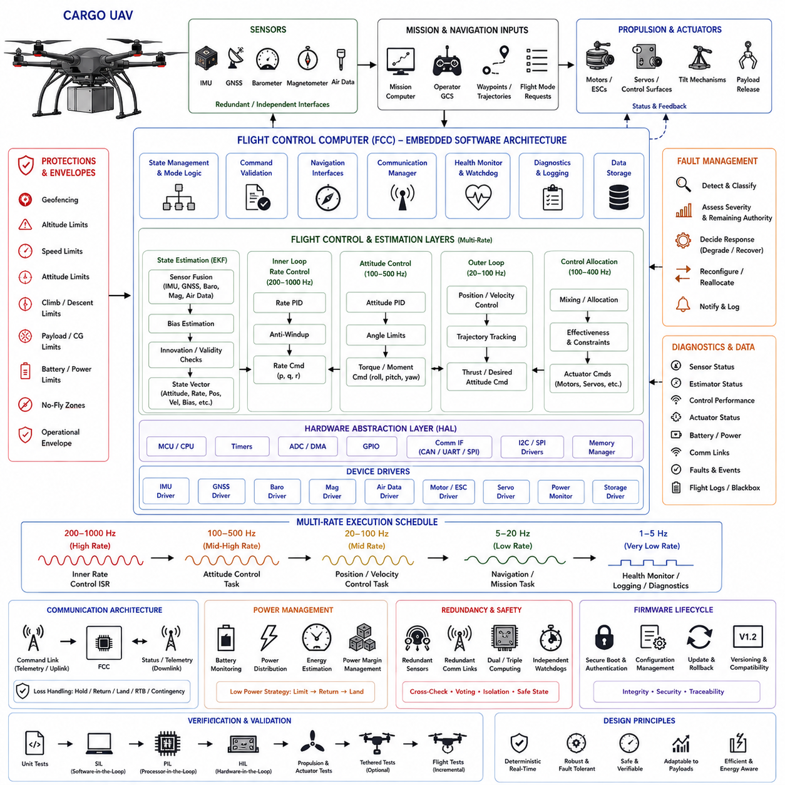
A cargo UAV Flight Control Computer (FCC) is the deterministic embedded core responsible for converting navigation and mission-level objectives into stable aircraft motion. Unlike payload computers that perform perception, mapping, or logistics functions, the FCC directly closes flight-control loops and supervises propulsion and control actuators. Its embedded software must therefore prioritize deterministic timing, sensor integrity, fault containment, actuator authority management, and predictable behavior during abnormal conditions.
Cargo UAVs introduce demanding control requirements because aircraft mass, center of gravity, inertia, aerodynamic response, and propulsion loading can vary substantially with payload configuration. The FCC must maintain stable flight across empty, partially loaded, and maximum-payload conditions while accommodating disturbances such as wind gusts and turbulence. Control parameters, operational envelopes, and protection limits should therefore reflect validated aircraft configurations rather than assuming one fixed dynamic model.
The embedded software architecture can be separated into hardware abstraction, device drivers, sensor acquisition, state estimation, flight control, actuator management, navigation interfaces, health monitoring, diagnostics, and system state management. Hardware-specific functions remain below stable interfaces so flight algorithms are isolated from processor and peripheral details. This modular structure improves verification and allows sensors, communication devices, or computing hardware to evolve without redesigning the complete flight-control application.
An FCC typically integrates a high-performance MCU or safety-oriented processor with timers, ADCs, DMA, communication peripherals, watchdogs, and hardware fault-monitoring resources. Interfaces may connect inertial measurement units, GNSS receivers, barometers, magnetometers, air-data sensors, propulsion controllers, servos, and power-management devices. Critical sensors can use independent communication channels or redundant interfaces so a single peripheral failure does not immediately eliminate essential flight-state information.
Execution is organized into multiple timing domains according to control criticality. Inner angular-rate loops may execute at hundreds of hertz or higher, attitude control operates at a related but potentially lower rate, and position or trajectory control runs more slowly. Navigation, mission communication, health monitoring, and logging can execute at lower rates. Explicit scheduling prevents noncritical functions from delaying flight-control calculations whose timing directly influences aircraft stability.
Sensor acquisition must preserve both timing accuracy and measurement validity. IMU accelerometer and gyroscope samples require precise timestamps, calibration, scaling, bias compensation, filtering, and consistency checking. GNSS, barometer, magnetometer, and optional air-data measurements arrive with different rates and latency characteristics. The FCC should maintain measurement timing explicitly so state estimation combines observations according to when physical measurements occurred rather than merely when software received them.
State estimation fuses heterogeneous sensor information into quantities required by flight control. An Extended Kalman Filter (EKF) or comparable estimator can determine attitude, angular velocity, position, velocity, sensor biases, and other navigation states. Innovation tests and plausibility checks help identify measurements inconsistent with the predicted vehicle state. The estimator should degrade gracefully when individual aiding sources become unreliable instead of immediately allowing corrupted measurements to destabilize control.
The flight-control hierarchy commonly progresses from angular-rate regulation to attitude control and then to velocity, position, or trajectory control. Outer loops generate references for faster inner loops, allowing disturbances to be rejected near the actuator level while navigation objectives evolve more slowly. Saturation and anti-windup mechanisms are important because cargo aircraft may encounter conditions where requested thrust, torque, bank angle, climb rate, or actuator motion exceeds physically available capability.
Multirotor cargo UAVs can use control allocation to convert desired total thrust and body moments into individual motor commands. Other cargo aircraft may combine propulsion motors, control surfaces, tilting mechanisms, or distributed actuators. The allocation layer should understand actuator limits, directionality, effectiveness, and failure conditions. Commands must remain bounded so a high-level controller cannot request physically impossible combinations that create persistent saturation or unstable interactions between control axes.
Actuator interfaces require continuous supervision because propulsion failures can rapidly become flight-critical. The FCC can monitor commanded and measured motor speed, current, voltage, temperature, servo position, and electronic speed controller status where available. Excessive tracking error or missing feedback may indicate a degraded actuator. Fault information should propagate immediately into control allocation and vehicle-level decision logic so remaining control authority can be assessed before selecting a recovery strategy.
Cargo handling changes aircraft dynamics and must be represented explicitly in system operation. Payload mass, mounting position, structural flexibility, and center-of-gravity displacement influence required thrust and control authority. Where payload configuration information is available, the FCC can select validated parameter sets or operational envelopes. Unexpected dynamic behavior can also be detected through estimator residuals or control-performance monitoring, allowing the aircraft to restrict aggressive maneuvering when actual response differs from expected behavior.
Flight modes should be governed by a deterministic state machine rather than scattered application logic. Typical states may include boot, initialization, preflight, standby, armed, takeoff, mission flight, landing, disarmed, degraded operation, and emergency response. Transitions require explicit conditions involving sensor health, navigation validity, power status, actuator readiness, communication state, and safety interlocks. Arming should never occur solely because a remote command requests motor activation.
Command interfaces between mission software and the FCC should define position, velocity, trajectory, heading, flight mode, and mission-related references using controlled units and ranges. Every command requires validation for numeric integrity, freshness, sequence, permitted operating state, and configured flight envelope. Invalid or stale commands must not propagate directly into flight-control loops. The FCC retains final authority to reject commands that violate aircraft-level safety constraints.
Communication loss requires predefined behavior because cargo UAVs may operate beyond continuous high-quality radio coverage. The FCC should distinguish command-link loss from navigation or internal-network failures and apply an appropriate contingency policy. Depending on aircraft capability and mission configuration, responses may include holding position, following a predefined route, returning to a recovery location, performing a controlled landing, or entering another validated contingency mode rather than continuing indefinitely with stale commands.
Geofencing and operational-envelope supervision provide additional boundaries around autonomous navigation. The FCC can enforce altitude, speed, attitude, climb-rate, descent-rate, and geographic restrictions independently of mission-planning software. Envelope protection should be implemented with clear priority relationships so safety constraints can override mission objectives when required. For cargo aircraft, payload-dependent limits may further restrict acceleration, bank angle, or maneuver aggressiveness during heavy-load operations.
Power-system monitoring is essential because propulsion capability depends directly on battery or energy-system condition. The FCC can supervise pack voltage, current, remaining energy estimates, temperature, power-distribution status, and propulsion margin. Energy decisions should consider the power required for safe recovery rather than only the estimated remaining percentage. Low-energy thresholds can progressively restrict mission continuation and eventually trigger return, diversion, or controlled landing according to validated policy.
Fault management should classify failures by severity, persistence, and remaining aircraft capability. A temporary sensor anomaly may permit continued operation using redundant information, whereas loss of essential attitude estimation may require immediate emergency action. Propulsion degradation requires assessment of whether stable flight remains physically achievable. Fault responses should therefore be linked to control authority and navigation confidence rather than using identical reactions for every detected failure.
Redundancy can be applied to sensors, power supplies, communication channels, processors, or complete flight-control lanes depending on aircraft criticality. Redundant information alone does not guarantee safety; the software must detect disagreement, determine which information remains trustworthy, and prevent a faulty channel from contaminating healthy control paths. Cross-monitoring, voting, reasonableness checks, and independent watchdog mechanisms can support fault detection and controlled reconfiguration.
Watchdog supervision protects against deadlock, timing failure, or corrupted execution. Hardware watchdogs should be refreshed only when essential flight-control and monitoring tasks demonstrate correct progress. A separate health supervisor can monitor execution deadlines, stack usage, memory integrity, sensor update rates, and communication activity. Reset behavior must be carefully designed because restarting a controller during flight can be more hazardous than maintaining a degraded but stable control configuration.
Diagnostics and flight logging should capture information required to reconstruct abnormal events without disturbing deterministic execution. Useful data include estimator states, sensor innovations, control references, actuator commands, timing statistics, power measurements, communication status, and fault transitions. High-rate records can use bounded memory buffers and prioritized logging so storage delays never block flight-control tasks. Event-triggered snapshots are especially valuable for investigating short transient failures.
Firmware lifecycle management must preserve both cybersecurity and flight integrity. The boot process can authenticate executable images, verify configuration compatibility, and reject corrupted software before flight operation. Update mechanisms should support rollback or recovery when installation fails. Firmware version, aircraft configuration, sensor calibration, actuator mapping, and control parameters should be treated as a compatible configuration set because an individually valid but mismatched component can compromise vehicle behavior.
Verification should progress from unit and software-in-the-loop testing to processor-in-the-loop, Hardware-in-the-Loop (HIL), propulsion testing, tethered operation where appropriate, and progressively expanded flight envelopes. Fault injection should examine sensor dropout, GNSS degradation, actuator failure, communication loss, processor overload, power anomalies, and estimator divergence. Payload variations, center-of-gravity shifts, wind disturbances, and maximum-load conditions should also be included because they directly affect cargo UAV control margins.
The resulting FCC embedded software forms the trusted real-time boundary between autonomous mission intelligence and the physical aircraft. Sensor fusion, hierarchical flight control, actuator allocation, payload-aware envelope management, deterministic scheduling, redundancy, fault supervision, watchdog protection, secure startup, and systematic verification must operate as one integrated architecture. This allows a cargo UAV to pursue autonomous transport objectives while ensuring that aircraft stability and recoverability remain dominant whenever mission demands conflict with physical or safety constraints.

12.07 High-Reliability OTA Operations: Failure and Recovery
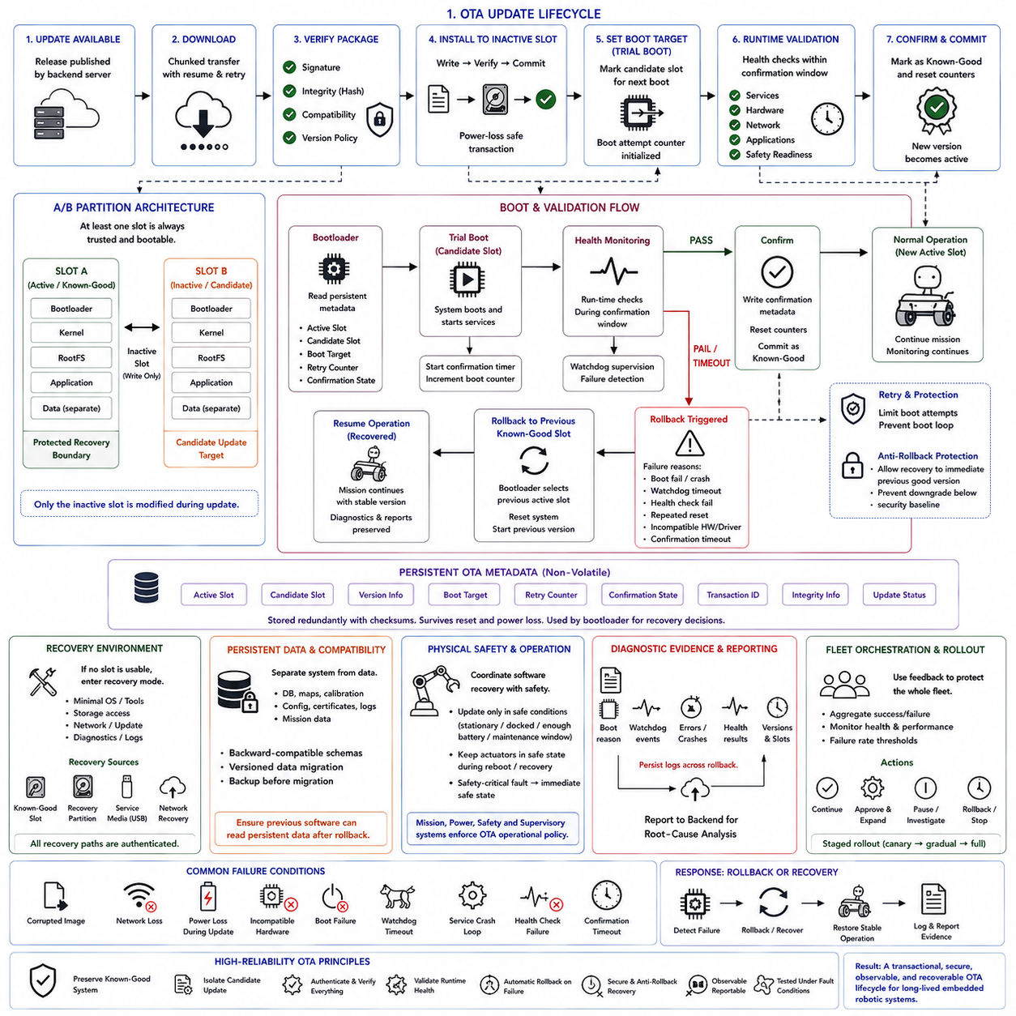
High-reliability Over-the-Air (OTA) operation should be designed as a recoverable transaction rather than a simple remote software installation. The central objective is to preserve at least one trusted, bootable system while a candidate release is downloaded, verified, installed, activated, and validated. If any stage fails, the device must return deterministically to a known-good state without depending on the partially installed software for recovery.
An A/B partition architecture provides the fundamental isolation required for this model. When Slot A is the confirmed active system, a new release is written to inactive Slot B without modifying the running image. Only after installation and integrity verification does the bootloader select Slot B as a candidate for the next boot. Slot A remains protected as the recovery boundary until the candidate has successfully completed runtime validation and is explicitly committed as known-good.
The update lifecycle begins before any flash write occurs. The device receives an update artifact and verifies its digital signature, integrity hash, compatibility metadata, hardware applicability, and permitted software version. An invalid signature, corrupted package, incompatible hardware target, or prohibited version should cause immediate rejection while the current system continues operating. This prevents an untrusted or incompatible artifact from entering the activation path.
Reliable transfer is also important because robotic systems may use intermittent Wi-Fi, LTE, or site networks. Downloads can be chunked, resumed, retried, and validated before installation so temporary network loss does not damage the currently running system. The downloaded artifact should remain separate from the active software until its completeness and integrity have been established. Connectivity failure therefore becomes a delayed update rather than an operational failure of the robot.
Installation should follow a write, verify, and commit discipline. The update agent selects the inactive slot, writes the new system image, verifies the stored content, and only then modifies protected boot metadata to request a trial boot. Power loss during installation must leave the original active slot intact. Redundant metadata, checksums, sequence information, and power-failure-tolerant storage semantics are required so the bootloader can reconstruct the correct state after an interrupted transaction.
Persistent OTA metadata provides continuity across resets and power cycles. Important information includes the current trusted slot, candidate slot, software versions, boot target, retry counter, confirmation state, transaction identifier, integrity information, and update status. This metadata should be compact, protected, checksummed, and stored redundantly where appropriate. Recovery logic must not depend on volatile RAM state because the most important decisions often occur after an unexpected reboot.
Candidate activation begins as a trial rather than an immediate permanent switch. The bootloader selects the new slot, records that the system is under evaluation, and starts or decrements a persistent boot-attempt counter. The operating system and applications must then demonstrate acceptable runtime health within a bounded confirmation interval. Until that confirmation occurs, the previous slot remains the last committed system and retains its role as the automatic rollback destination.
Runtime validation must evaluate actual operational readiness rather than merely successful kernel startup. Health checks can include filesystem mounts, network availability, required services, hardware detection, sensors, middleware, robot applications, localization, controllers, and safety-related readiness. The candidate should be confirmed only when the functions required for the product's validated operating state are available. Boot completion alone is therefore insufficient evidence that an OTA release is healthy.
Watchdog supervision strengthens this validation boundary. During candidate operation, a watchdog can detect hangs, crashes, or unresponsive software while the persistent retry counter tracks repeated unsuccessful boots. Failure to confirm health within the allowed attempts or time interval causes the bootloader to stop retrying the candidate. This prevents an indefinitely repeating boot loop and converts repeated startup failures into a deterministic transition toward rollback or recovery.
Rollback can be triggered by several independent conditions, including boot failure, repeated reset, watchdog expiration, health-check failure, service crash loops, missing hardware, incompatible drivers, or confirmation timeout. When rollback is selected, the bootloader returns to the previous confirmed slot rather than attempting to repair the candidate in place. The candidate can remain marked failed for diagnosis while the robot restores the last software configuration known to have operated successfully.
Persistent application data requires separate treatment because reverting executable software does not automatically revert databases, maps, calibration, configuration, certificates, logs, or mission information. System images should therefore be separated from persistent data, and schema changes must be backward compatible or explicitly versioned. Critical data may require backup before migration so the previous software can still interpret the persistent state after rollback.
Rollback security must balance recoverability with downgrade protection. The system may permit return to an authorized immediate previous known-good version while preventing arbitrary downgrade below the established security baseline. Recovery images and fallback versions must remain authenticated members of the chain of trust. A rollback mechanism that bypasses secure boot or accepts unsigned recovery software would restore availability at the cost of undermining the security architecture.
If neither normal A/B slot can provide a usable system, a dedicated recovery environment can provide a second recovery boundary. This minimal environment may support storage access, networking, image verification, update installation, logging, hardware information, and diagnostics without loading the full application stack. Recovery sources can include a known-good slot, dedicated recovery partition, authenticated service media, network recovery, or controlled service tooling, but all paths must preserve authentication requirements.
Robotic OTA operations must additionally coordinate software recovery with physical safety. Updates, reboots, and rollbacks should consider whether the robot is stationary, docked, sufficiently charged, or within an appropriate maintenance window. Actuators should remain in a safe state during boot and recovery, and safety-critical failure should trigger the required safe condition rather than waiting for software repair. Mission, power, safety, and supervisory systems therefore participate in OTA operational policy.
Failure evidence should survive the recovery process. Persistent diagnostics can record boot reason, watchdog events, errors, crashes, health-check results, software version, active and candidate slot identifiers, and transaction ID. After the device returns to service, this evidence can be reported to the OTA backend for root-cause analysis. Preserving evidence helps distinguish defective software from hardware faults, configuration incompatibility, environmental problems, or isolated device-specific failures.
At fleet scale, recovery information becomes an input to deployment control. The orchestration system can aggregate installation results, boot confirmations, health failures, and rollback rates across devices. If the failure rate exceeds a defined threshold, the rollout should be paused or stopped before additional robots receive the candidate release. Comparing failures across hardware versions, sites, configurations, and device groups helps determine whether the problem is isolated or associated with the release itself.
Staged rollout reduces the operational consequences of defects that escaped laboratory validation. A release can first be deployed to a small canary group, observed under real operating conditions, and expanded only when health and performance remain acceptable. Monitoring may include service health, latency, resource usage, task outcomes, intervention rate, safety indicators, and operational regressions. Deployment policy can then accept and advance, require approval, pause, or roll back according to observed behavior.
Recovery mechanisms themselves require systematic fault-injection testing. Validation should include corrupted images, interrupted writes, power loss during update, repeated boot failures, watchdog resets, health-check timeout, incompatible persistent data, and network loss. A successful test does not merely demonstrate that the previous partition boots; it verifies that required robot functions return, safety conditions remain valid, and the original failure is recorded and reported for later investigation.
Frameworks such as RAUC or Mender can manage artifacts, slots, update states, and bootloader integration, but they do not define the complete reliability policy automatically. The platform designer must still specify health criteria, bootloader semantics, watchdog behavior, safe reboot conditions, persistent-data compatibility, security policy, and fleet-level rollout rules. The OTA framework implements mechanisms, while the product architecture determines what constitutes safe and successful recovery.
The complete high-reliability OTA process therefore forms a closed recovery loop: preserve the known-good system, install the candidate separately, authenticate and verify it, trial boot it, monitor runtime health, and commit it only after successful validation. Any failure before confirmation returns execution to the previous trusted state while retaining diagnostic evidence. This transactional approach transforms OTA from an irreversible software replacement into a controlled, observable, secure, and recoverable lifecycle operation for long-lived embedded robotic systems.

12.08 Embedded Security Breach Case Studies and Lessons
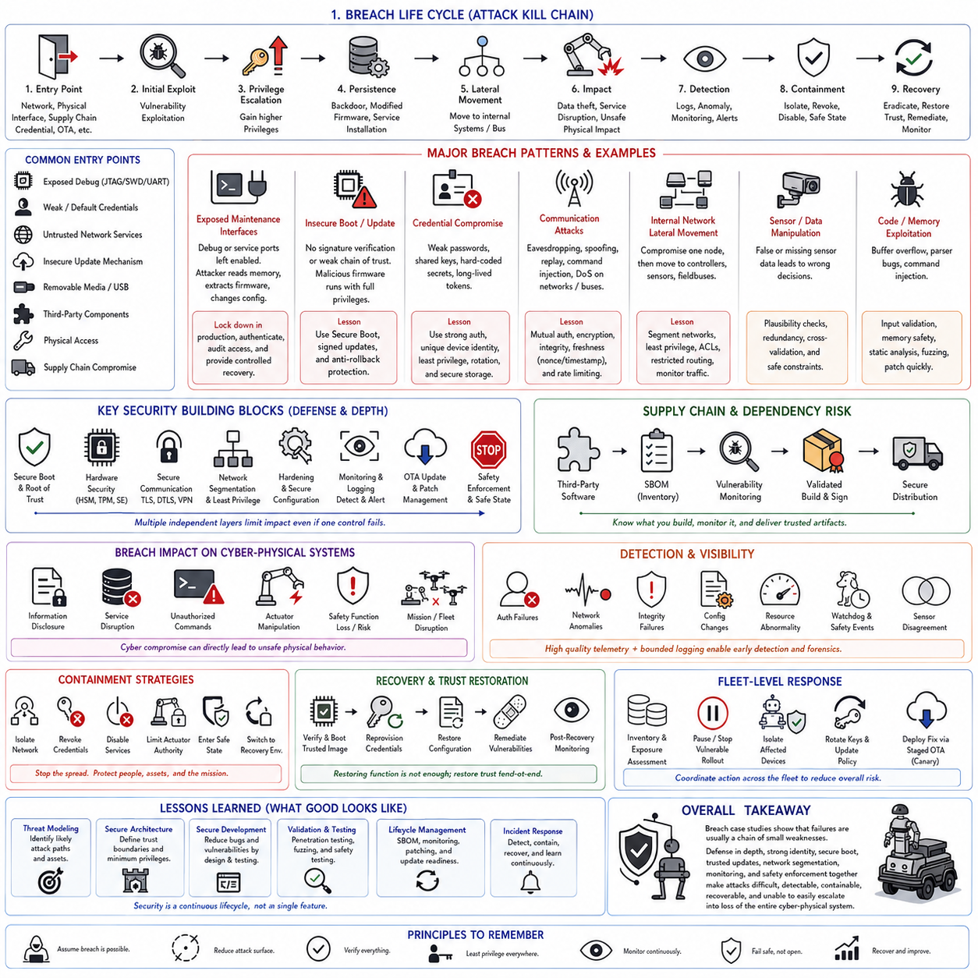
Embedded security breaches are rarely caused by one dramatic cryptographic failure. They usually emerge from combinations of weak credentials, exposed debug interfaces, outdated components, insufficient input validation, insecure update paths, excessive privileges, and poor network isolation. In cyber-physical products, these weaknesses are particularly serious because compromise can progress from information disclosure to unauthorized commands, actuator manipulation, service disruption, or loss of safety-related functions.
A useful breach case study begins with the attack path rather than only the final vulnerability. The sequence can be modeled as entry point, initial exploitation, privilege expansion, persistence, lateral movement, physical or information impact, detection, containment, and recovery. Reconstructing this chain reveals which security boundaries failed and which controls could have interrupted the attack earlier, providing lessons that are more transferable than simply documenting the exploited software defect.
One recurring case involves exposed maintenance interfaces such as JTAG, SWD, UART, USB, consoles, test pads, or removable storage. Development access that remains enabled in production can allow an attacker with physical access to inspect memory, extract firmware, modify configuration, or bypass normal application authentication. The primary lesson is that manufacturing and service interfaces must be treated as security boundaries with explicit production lockdown, authorization, auditability, and controlled recovery procedures.
Firmware extraction can expose additional weaknesses that were previously hidden behind physical packaging. Reverse engineering may reveal hard-coded passwords, API tokens, cryptographic material, undocumented commands, protocol structures, or vulnerable third-party libraries. Obfuscation can increase analysis cost but does not replace key protection. Secrets should therefore be stored in protected hardware or secure storage, while firmware confidentiality should never be assumed to compensate for weak authentication or authorization.
A second breach pattern originates in insecure boot or update mechanisms. If firmware authenticity is not cryptographically verified before execution, modified software can become persistent across resets and may execute with the same authority as legitimate firmware. Secure boot establishes a chain from a hardware Root of Trust through the bootloader to verified firmware, while signed updates and rollback protection extend that trust across the operational lifecycle. Breaking any link weakens the integrity of the complete platform.
OTA compromise illustrates why transport encryption alone is insufficient. Even when an update is downloaded through an encrypted channel, the device must independently authenticate the artifact before installation. Update metadata, target hardware, version policy, and integrity also require validation. A compromised server, stolen credential, replayed package, or corrupted transfer should therefore fail at the device trust boundary rather than automatically becoming executable software.
Credential compromise represents another common breach class. Shared passwords, factory-default credentials, embedded private keys, long-lived tokens, and credentials copied across an entire product fleet create high-impact failure modes. Compromise of one device can become compromise of many if identity is not device-specific. Strong authentication, least privilege, credential rotation, protected key storage, and separation between device, service, operator, and administrative identities reduce this blast radius.
Hardware-backed key protection changes the attacker's objective from simply reading a file to defeating a dedicated trust boundary. A Secure Element, TPM, HSM, or MCU security subsystem can retain private keys internally and perform signing or authentication operations without exposing the key material to normal application memory. This does not eliminate software vulnerabilities, but it can prevent a compromised application from trivially extracting credentials that would otherwise enable impersonation of additional devices.
Communication breaches often exploit missing authentication, encryption, integrity protection, or freshness checking. An attacker able to observe or inject traffic may attempt eavesdropping, spoofing, replay, command modification, or denial of service across Ethernet, Wi-Fi, Bluetooth, cellular links, CAN, UART, EtherCAT, or other interfaces. Secure communication must therefore establish not only confidentiality but also authenticated peers, message integrity, freshness, and appropriate behavior when trust cannot be established.
Replay attacks demonstrate the importance of context beyond encryption. A previously valid actuator, unlock, configuration, or mission command can remain dangerous if the receiver cannot distinguish an old message from a new one. Sequence counters, nonces, timestamps, authenticated session state, and bounded command freshness can make captured traffic unusable later. For physical systems, stale-command rejection should also be integrated with safe-state behavior because simply dropping communication may itself affect robot operation.
Internal robot networks create another important breach pathway. Once an attacker compromises an externally reachable computer, insufficient segmentation can permit lateral movement toward controllers, sensors, fieldbuses, or maintenance services. Fake sensor data or injected actuator commands may then cross from an information-security incident into a physical-control problem. Network segmentation, explicit trust boundaries, authenticated communication, restricted routing, and least-privilege services reduce the ability of one compromised node to control the entire machine.
Sensor manipulation is especially significant for autonomous robots because trustworthy software can still make unsafe decisions when its observations are corrupted. False or missing perception can influence localization, obstacle detection, navigation, manipulation, or flight-state estimation. Security architecture should therefore complement communication protection with plausibility checks, sensor disagreement detection, redundancy where justified, temporal consistency monitoring, and safety constraints that limit physical consequences when perception confidence degrades.
Command injection and memory-corruption vulnerabilities illustrate why secure architecture cannot compensate completely for unsafe implementation. Malformed external input can exploit parsers, protocol handlers, drivers, or application interfaces and potentially alter control flow or data. Defensive implementation requires strict input validation, bounded parsing, memory-safe techniques where feasible, compiler and platform protections, privilege separation, fuzz testing, static analysis, and prompt remediation of known vulnerable dependencies.
Third-party software introduces a supply-chain dimension to embedded breaches. Products may contain operating-system packages, communication stacks, cryptographic libraries, device drivers, middleware, and vendor binary components maintained outside the organization. A vulnerability in one dependency can remain deployed for years if its presence is unknown. Software Bill of Materials (SBOM) management, version tracking, vulnerability monitoring, controlled builds, signed artifacts, and validated update procedures are therefore part of operational security rather than administrative documentation.
Cryptographic libraries provide another instructive lesson: secure primitives do not automatically produce a secure system. Correct TLS depends on key storage, entropy, certificate validation, trust anchors, configuration, debug exposure, update policy, and application error handling. Unused algorithms and protocols should be removed, modern configurations selected, credentials protected with least privilege, and library versions monitored for vulnerabilities. Security emerges from correct integration of the library into the complete platform.
Availability attacks may be less sophisticated than code execution but can still disable an embedded robot. Flooding, interrupt storms, resource exhaustion, storage saturation, excessive logging, or manipulation of watchdog-related behavior can prevent essential software from meeting deadlines. Resource quotas, bounded queues, rate limiting, watchdog supervision, priority separation, storage limits, and graceful degradation help ensure that untrusted traffic cannot consume resources required for deterministic control or safety functions.
A breach affecting a robot must be analyzed differently from compromise of a conventional information system because cyber consequences can propagate into physical behavior. Altered commands may create unsafe motion, communication disruption can break coordination, modified software can change control policy, and manipulated sensors can generate incorrect decisions. Security controls should therefore be combined with runtime safety limits and fail-safe mechanisms so successful cyber exploitation does not automatically imply unrestricted physical authority.
Incident detection requires visibility into behavior that is normally hidden inside embedded devices. Authentication failures, network anomalies, abnormal commands, sensor disagreement, unusual resource consumption, configuration changes, integrity failures, watchdog events, and safety events can provide indicators of compromise. Logs must preserve sufficient timing, identity, version, and event context for reconstruction while remaining bounded so an attacker cannot turn diagnostic logging itself into a resource-exhaustion mechanism.
Containment should prioritize limiting propagation and physical consequences before attempting detailed repair. A compromised robot may need to isolate external communication, revoke credentials, disable affected services, restrict actuator authority, enter a controlled safe state, or switch to a trusted recovery environment. Fleet systems should also determine whether identical credentials, firmware versions, hardware configurations, or vulnerable components exist elsewhere so one detected breach can trigger protective action across potentially exposed devices.
Recovery requires restoration of trust, not merely restoration of functionality. Rebooting a compromised device is insufficient if malicious firmware, stolen credentials, altered configuration, or persistence mechanisms remain. Recovery may require verified boot from trusted software, credential revocation and reprovisioning, configuration restoration, integrity checks, vulnerability remediation, and post-recovery monitoring. Evidence should be preserved whenever possible so the organization can understand the initial access path and prevent recurrence.
Fleet-scale response extends the lesson from individual devices to population risk. Device identity, firmware inventory, SBOM information, security telemetry, update status, and hardware revision allow operators to determine exposure rapidly. A vulnerable release can be paused, affected devices isolated, credentials rotated, and a corrected image deployed through staged OTA procedures. Canary deployment and health monitoring reduce the chance that emergency remediation introduces a second fleet-wide operational failure.
Post-incident analysis should avoid stopping at statements such as “the password was weak” or “the library was vulnerable.” The deeper questions concern why the weakness reached production, why another security layer did not block exploitation, why monitoring did not detect it earlier, and why compromise was able to propagate. Effective lessons therefore produce changes in architecture, development processes, testing, credential management, update capability, monitoring, supplier governance, and operational response rather than only a local software patch.
The recurring lesson across embedded security breaches is defense in depth: assume that individual controls can fail and design the system so another boundary limits the consequence. Secure boot protects software integrity, hardware security protects keys, authenticated communication protects interfaces, segmentation limits lateral movement, hardening reduces attack surface, monitoring improves detection, OTA enables remediation, and independent safety enforcement constrains physical impact. No single mechanism should represent the entire security argument.
A mature embedded security program therefore treats breach case studies as feedback into the complete engineering lifecycle. Threat modeling identifies likely paths, secure architecture creates trust boundaries, implementation practices reduce exploitable defects, penetration testing challenges assumptions, SBOM and vulnerability management track evolving exposure, incident response limits damage, and secure update mechanisms deliver remediation. The objective is not to claim that compromise is impossible, but to make attacks difficult, detectable, contained, recoverable, and unable to escalate easily from one weakness into loss of the entire cyber-physical system.

12.09 Embedded SW Technical Debt Reduction Project
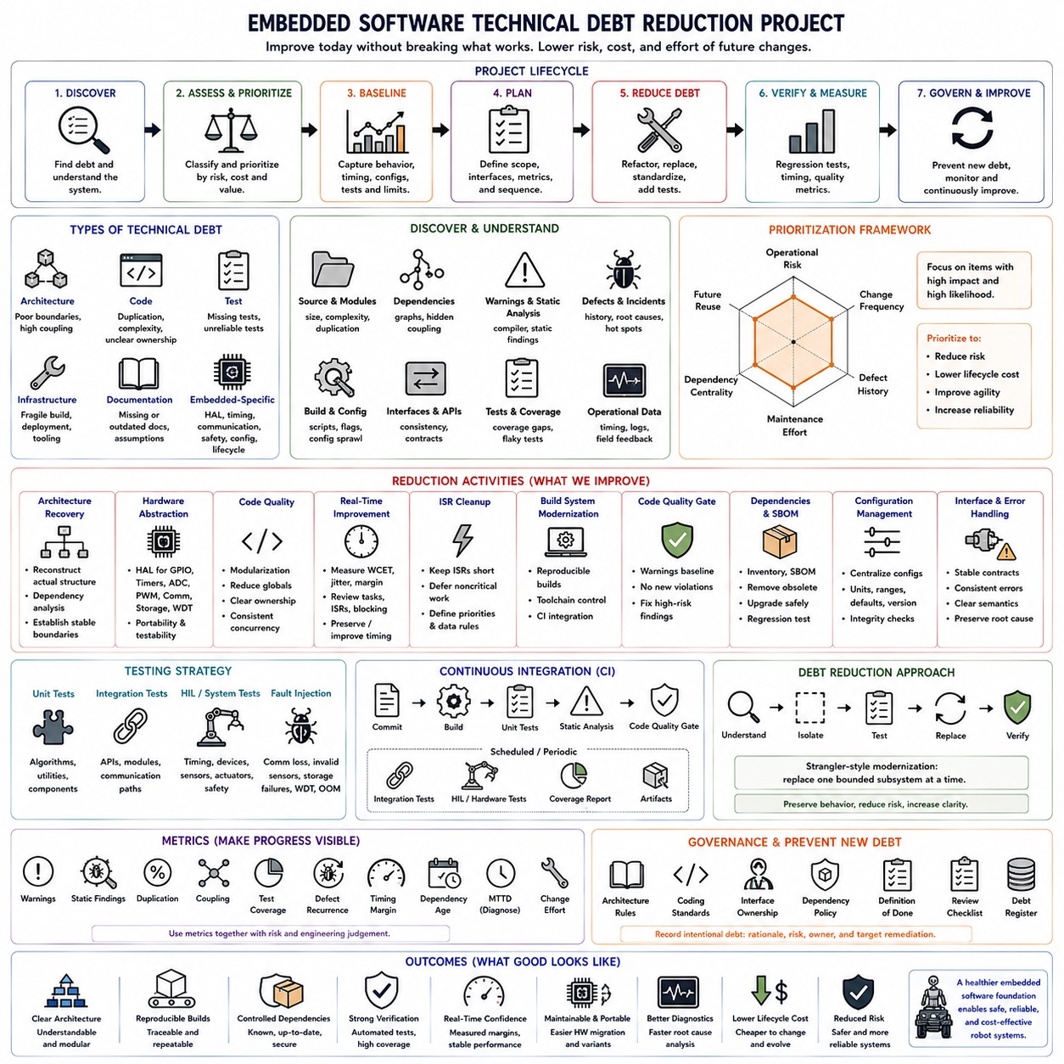
Technical debt in embedded software is the accumulated engineering cost created when short-term implementation choices make future modification, verification, integration, or maintenance increasingly difficult. In robotics and other cyber-physical systems, this debt extends beyond source-code quality because firmware is tightly coupled to hardware, timing, communication, safety, diagnostics, and deployment processes. A reduction project must therefore improve the system without destabilizing validated behavior.
The first phase is technical-debt discovery rather than immediate refactoring. Engineers examine source modules, build scripts, configuration files, drivers, interfaces, tests, warnings, defect history, and operational incidents to identify recurring maintenance problems. Typical evidence includes duplicated code, oversized modules, undocumented dependencies, obsolete APIs, global state, hardware-specific logic scattered across applications, disabled compiler warnings, and fixes repeatedly applied to the same subsystem.
Debt should be classified according to its engineering impact. Architecture debt concerns poor module boundaries and excessive coupling, while code debt includes duplication, complexity, and unclear ownership. Test debt reflects missing or unreliable verification, infrastructure debt includes fragile build and deployment tooling, and documentation debt obscures interfaces or assumptions. Embedded projects additionally accumulate hardware abstraction, timing, communication, safety, configuration, and lifecycle debt.
Not every undesirable implementation should be repaired immediately. A useful prioritization method evaluates operational risk, change frequency, defect history, maintenance effort, dependency centrality, and expected future reuse. Code that is difficult but stable and rarely modified may deserve lower priority than a moderately complex communication module changed every release. Technical debt reduction should therefore optimize engineering risk and lifecycle cost rather than pursue abstract code cleanliness.
Before changing high-risk firmware, the team should establish a behavioral baseline. Existing binaries, hardware revisions, compiler versions, configuration parameters, timing measurements, communication traces, test results, and known limitations should be captured. This creates a reference against which refactored software can be compared. Without such a baseline, engineers may improve internal structure while unknowingly changing externally observable behavior or real-time characteristics.
Characterization testing is particularly useful when legacy code has insufficient unit tests. Instead of initially asserting how the software should behave, these tests record how the existing implementation actually behaves for representative inputs and hardware conditions. The resulting tests become regression barriers during restructuring. Once behavior is understood, requirements can be clarified and tests gradually converted from legacy characterization toward intentional specification-based verification.
Architecture recovery may be necessary when documentation no longer reflects the implementation. Engineers reconstruct actual dependencies among application logic, control algorithms, communication stacks, device drivers, hardware abstraction, operating-system services, and board-specific components. Dependency graphs and interface analysis reveal hidden coupling and circular relationships. The objective is to identify stable boundaries through which legacy modules can be isolated and progressively replaced.
Hardware abstraction is often a high-value target because direct register access and board-specific assumptions frequently spread through mature firmware. Peripheral operations can be moved behind explicit interfaces for GPIO, timers, ADC, PWM, communication, storage, and watchdog functions. Application and control modules then depend on contracts rather than particular devices. This reduces the cost of MCU migration, board revision, simulation, automated testing, and future hardware variants.
Global variables and implicit shared state create another common source of embedded technical debt. They make execution dependencies difficult to understand and can produce race conditions when interrupts, RTOS tasks, and background processing access the same data. Refactoring can introduce explicit ownership, structured state objects, message passing, synchronization rules, and controlled APIs. The goal is not merely fewer globals but predictable data flow and clearly defined concurrency behavior.
Large functions and monolithic tasks should be decomposed according to responsibility while preserving real-time behavior. Sensor acquisition, validation, estimation, control, communication, diagnostics, and state transitions should not become inseparable inside one cyclic routine. Smaller cohesive modules improve testability and reviewability, but decomposition must consider call overhead, memory layout, synchronization, and execution deadlines. Embedded refactoring cannot assume that desktop software restructuring is timing-neutral.
Real-time debt becomes visible when execution timing is based on historical assumptions rather than measured guarantees. The project should identify task periods, interrupt priorities, blocking operations, shared resources, timeout dependencies, and worst-case execution paths. Instrumentation can measure execution time, jitter, deadline margin, queue depth, and CPU utilization. Refactoring should preserve or improve these margins so structural improvement does not introduce subtle timing regressions.
Interrupt service routines frequently accumulate technical debt because functionality is added incrementally to convenient interrupt paths. Excessive computation, logging, protocol parsing, blocking access, or application logic inside interrupts increases latency and complicates scheduling analysis. A reduction project can limit interrupt work to time-critical acquisition and signaling while deferring noncritical processing to scheduled tasks. Interrupt priorities and shared-data rules should then be documented and verified.
Build-system debt can make otherwise maintainable source code difficult to reproduce. Manual library copying, undocumented compiler flags, machine-specific paths, inconsistent toolchains, and uncontrolled generated files create hidden dependencies. The project should move toward reproducible builds with explicit compiler versions, dependency definitions, configuration management, and automated build scripts. A released binary should be traceable to source revision, configuration, toolchain, and build parameters.
Compiler warnings and static-analysis findings provide measurable debt indicators. Rather than accepting thousands of historical warnings, the team can establish a known baseline and prevent new violations while progressively reducing existing ones. High-risk findings involving memory access, integer conversion, uninitialized data, concurrency, undefined behavior, and unchecked return values should receive priority. The long-term objective is to make warnings actionable engineering signals rather than background noise routinely ignored by developers.
Dependency debt requires an inventory of operating-system components, middleware, protocol libraries, cryptographic packages, vendor SDKs, and binary modules. Obsolete dependencies may contain known vulnerabilities or prevent compiler and platform upgrades. Software Bill of Materials (SBOM) information helps identify versions and ownership. Upgrades should be staged and regression-tested because replacing a deeply integrated dependency can alter timing, memory consumption, APIs, or communication behavior.
Configuration debt appears when calibration values, feature flags, communication parameters, safety thresholds, and hardware options are scattered through source files or duplicated across modules. These values should be moved into controlled configuration structures with defined units, ranges, defaults, versions, and integrity checks. Configuration ownership should be explicit so developers can determine which parameters are compile-time constants, manufacturing data, service settings, or runtime-adjustable values.
Interface cleanup is another major reduction activity. Mature embedded systems often contain inconsistent units, ambiguous return codes, undocumented timeout semantics, duplicated message definitions, and APIs exposing internal data structures. Stable interfaces should define ownership, units, valid ranges, error behavior, timing assumptions, and version compatibility. Improving these contracts reduces accidental coupling and allows modules to evolve independently without forcing coordinated modifications throughout the entire firmware.
Error handling should be standardized because legacy systems frequently mix ignored return values, assertions, resets, retries, silent fallback, and global fault flags. The reduction project can define error categories and propagation rules that distinguish recoverable errors, degraded operation, subsystem faults, and safety-critical failures. Diagnostic information should preserve the initiating cause rather than replacing it with generic downstream errors, making field failures easier to reconstruct and correct.
Testing infrastructure is central to sustainable debt reduction. Unit tests can validate algorithms and utility modules, integration tests can exercise interfaces, and Hardware-in-the-Loop (HIL) environments can verify timing and device interactions. Fault injection should test communication loss, invalid sensors, storage failures, watchdog events, and resource exhaustion. Automated regression execution transforms refactoring from a high-risk manual activity into a controlled process with continuously measurable evidence.
Continuous Integration (CI) can enforce the engineering rules established by the project. Each change can trigger compilation, unit tests, static analysis, formatting checks, dependency checks, and selected integration tests. More expensive HIL or hardware regression suites can run at controlled intervals. The objective is not automation for its own sake, but preventing newly introduced debt from replacing the debt being removed while providing rapid feedback when architectural boundaries are violated.
Technical debt should be reduced incrementally rather than through an uncontrolled full rewrite. Large rewrites discard accumulated operational knowledge and often reproduce undocumented behavior only after expensive rediscovery. A safer strategy places interfaces around legacy components, adds tests, replaces one bounded subsystem, validates equivalence, and then proceeds to the next area. This strangler-style modernization preserves working behavior while progressively increasing architectural clarity.
Metrics make progress visible and prevent the project from becoming an indefinite cleanup effort. Useful measures include compiler warnings, static-analysis findings, duplicated code, module coupling, test coverage, build reproducibility, defect recurrence, execution-time margin, dependency age, mean time to diagnose failures, and effort required for common changes. No single metric represents technical debt, so several indicators should be interpreted together with operational risk and engineering experience.
Governance is required after the initial reduction campaign. Architectural rules, coding standards, interface ownership, dependency policies, definition-of-done criteria, review checklists, and debt registers can prevent gradual regression. New shortcuts may still be justified under schedule pressure, but they should be recorded with rationale, risk, owner, and intended remediation point. Explicit debt is manageable; invisible debt silently compounds until routine product changes become expensive and dangerous.
The completed technical-debt reduction project should leave more than cleaner source code. It should produce clearer architecture, reproducible builds, controlled dependencies, measurable timing margins, stronger automated verification, explicit configuration, consistent error handling, improved diagnostics, and documented technical boundaries. The ultimate measure of success is that embedded software becomes safer and cheaper to modify, easier to verify, more portable across hardware generations, and less likely to accumulate hidden risk with every future release.

12.10 Future Embedded SW Platform Integration Roadmap
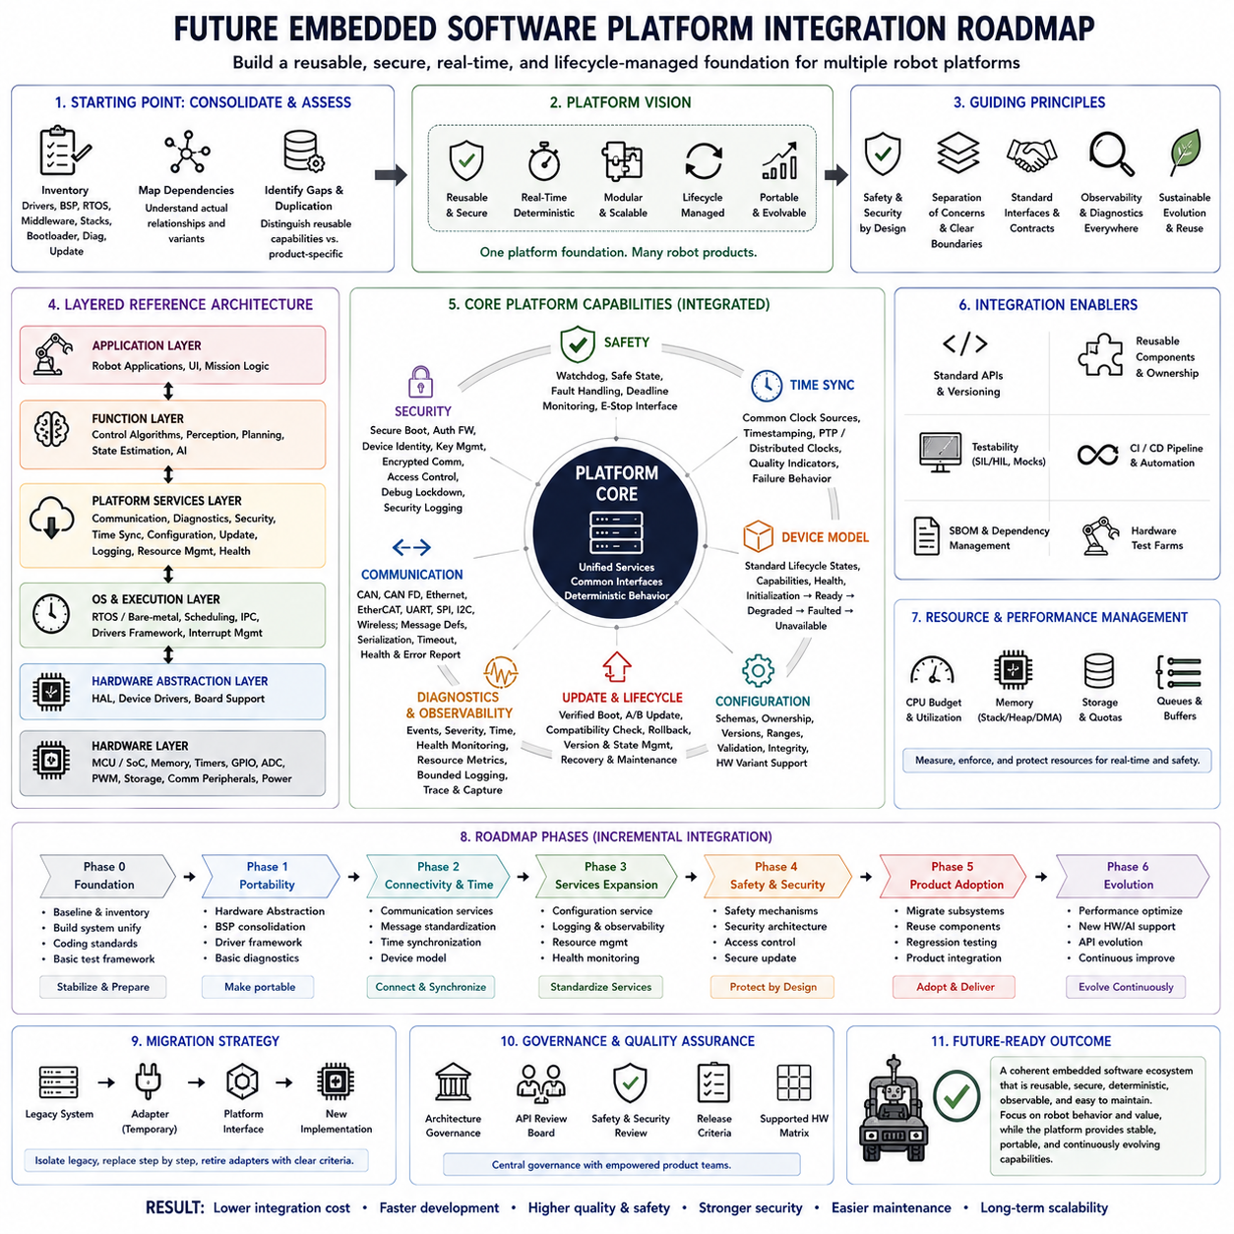
A future embedded software platform should evolve from product-specific firmware into a reusable, layered, and lifecycle-managed foundation that supports multiple robotic platforms without sacrificing deterministic behavior. The roadmap should unify hardware abstraction, real-time execution, communication, safety, security, diagnostics, update management, and application interfaces while preserving clear boundaries between reusable platform services and robot-specific functions.
The starting point is consolidation of the existing embedded software baseline. Legacy drivers, board-support packages, RTOS configurations, middleware, communication stacks, bootloaders, diagnostic modules, and update mechanisms should be inventoried and mapped to their actual dependencies. Duplicate implementations and product-specific variations should be identified so the organization can distinguish genuinely reusable capabilities from hardware constraints and historical implementation differences.
A layered reference architecture provides the structural foundation for integration. At the lowest level, processor, memory, timers, GPIO, ADC, PWM, storage, watchdog, and communication peripherals are represented through controlled hardware interfaces. Above them, operating-system services, device management, communication, diagnostics, security, and lifecycle services form a common platform layer, while control algorithms and robot applications remain separated from hardware-specific implementation details.
Hardware abstraction should gradually become a stable portability boundary rather than a collection of thin wrappers. Interfaces for sensors, actuators, communication devices, storage, timing, power management, and watchdog supervision should define capabilities, ownership, error semantics, and timing expectations. This enables new MCU, SoC, board, or peripheral generations to be integrated by adapting the platform layer instead of repeatedly modifying application and control software.
Real-time execution must remain a first-class architectural property throughout platform modernization. Common scheduling patterns should define periodic control tasks, event-driven processing, interrupt handling, background services, and communication workloads. Task periods, priorities, execution budgets, jitter limits, and synchronization rules should be measurable platform contracts. Integration is successful only when reusable software services preserve the timing guarantees required by physical control functions.
The operating-system strategy should support multiple embedded computing classes while maintaining consistent architectural concepts. Small actuator and sensor controllers may use bare-metal execution or a compact RTOS, while high-performance controllers may require richer real-time operating environments. Rather than forcing every processor onto one operating system, the platform should standardize service interfaces, timing models, communication semantics, diagnostics, and lifecycle behavior across different execution environments.
Communication integration should replace fragmented product-specific protocols with managed interface services. CAN, CAN FD, EtherCAT, Ethernet, UART, SPI, I2C, and wireless links can remain hardware-specific transports while message definitions, serialization, addressing, timeout behavior, health monitoring, and error reporting become standardized. A controlled communication layer reduces duplicated protocol logic and allows robot subsystems to interact through explicit contracts instead of undocumented dependencies.
Time synchronization becomes increasingly important as embedded platforms integrate distributed sensors, actuators, controllers, and high-level computers. The roadmap should establish common clock sources, timestamp semantics, synchronization quality indicators, and failure behavior. Whether the implementation uses hardware timers, PTP, distributed clocks, or another mechanism, software components should interpret time consistently so sensor fusion, control, logging, and distributed diagnostics can reconstruct events correctly.
A common device model can further simplify platform integration. Sensors, actuators, power devices, communication interfaces, and storage resources can expose standardized lifecycle states such as initialization, ready, degraded, faulted, and unavailable. Capability information and health status can be queried through common interfaces. This allows supervisory software to reason about heterogeneous hardware without embedding device-specific fault logic throughout the application architecture.
Configuration management should become a platform service rather than remain distributed across source files. Hardware variants, calibration parameters, communication settings, control limits, feature options, safety thresholds, and manufacturing information require defined schemas, ownership, versions, ranges, and integrity protection. Configuration compatibility should be checked during startup and software updates so an otherwise valid binary cannot operate with an incompatible hardware or parameter set.
Safety integration requires separation between functional software and mechanisms responsible for enforcing critical limits. Platform services can provide watchdog supervision, health monitoring, safe-state interfaces, fault reporting, deadline monitoring, and controlled actuator shutdown. Product-specific safety concepts still determine the required reaction, but common mechanisms reduce duplicated implementation. Safety-related boundaries should remain explicit so application integration cannot silently bypass essential protection functions.
Security should similarly become a platform-wide capability rather than a feature added separately to individual products. Secure boot, authenticated firmware, protected device identity, key storage, encrypted communication, access control, debug lockdown, security logging, and vulnerability management can form a common security architecture. Hardware Roots of Trust and security peripherals should be abstracted through controlled services so applications do not directly manage sensitive cryptographic material.
Boot and firmware lifecycle functions should converge into a standardized platform architecture. Bootloaders should verify software integrity and compatibility, expose consistent recovery semantics, and support controlled A/B or equivalent update strategies where required. The platform should maintain software version, hardware compatibility, update state, rollback information, and diagnostic evidence across resets. This creates a predictable lifecycle from manufacturing provisioning through field updates and long-term maintenance.
Diagnostics and observability should be designed as shared infrastructure. Every subsystem should use consistent event identifiers, severity levels, timestamps, fault states, and diagnostic metadata. Runtime information can include task timing, memory consumption, communication statistics, sensor health, actuator status, resets, watchdog events, and update history. Bounded logging and event-triggered capture should preserve useful evidence without allowing diagnostic activity to interfere with deterministic execution.
Memory and resource management require explicit platform policies because integration tends to increase software size and background processing. Static allocation may remain appropriate for deterministic control components, while controlled dynamic allocation may be acceptable in less critical services. Stack budgets, heap usage, DMA buffers, queue sizes, storage quotas, and CPU budgets should be measured. Platform integration must not allow shared services to consume resources needed by safety- or control-critical functions.
Testing architecture should evolve together with the production architecture. Hardware interfaces that are explicitly abstracted can support mocks, simulators, Software-in-the-Loop environments, and automated unit testing. Communication services can be exercised with virtual peers, while Hardware-in-the-Loop testing validates timing and physical interfaces. Common test APIs and fault-injection mechanisms allow the same platform behaviors to be verified repeatedly across multiple products and hardware variants.
Continuous Integration and Continuous Delivery practices should provide reproducible evidence for every platform change. Automated pipelines can compile supported targets, execute unit and integration tests, run static analysis, generate Software Bill of Materials information, verify configuration schemas, and package signed artifacts. Hardware test farms can extend validation to representative boards. A platform release should therefore represent a verified combination of source, toolchain, dependencies, configuration rules, and test evidence.
Platform APIs require deliberate compatibility management because multiple product teams may depend on them. Interfaces should use explicit versioning and documented deprecation policies rather than changing whenever one product requires a new feature. Backward-compatible extensions should be preferred where practical, while incompatible changes should follow controlled migration plans. Stable interfaces allow hardware, middleware, and applications to evolve at different speeds without creating synchronized redesign across every robot product.
Component reuse should progress from source-code copying toward governed software components. Each reusable module should have an owner, documented interface, supported configurations, dependency definition, verification evidence, version history, and release policy. Consumers should integrate released components rather than private forks whenever possible. This turns reuse into a managed platform capability and prevents common software from fragmenting into incompatible product-specific variants.
The roadmap should introduce platform integration incrementally rather than attempting a single organization-wide rewrite. A practical sequence begins with shared build infrastructure and hardware abstraction, then expands into communication, configuration, diagnostics, security, update services, and common lifecycle management. Existing products can adopt these capabilities subsystem by subsystem while regression testing verifies preserved behavior. Successful patterns can then become mandatory platform standards for new developments.
Migration should distinguish legacy compatibility from permanent architecture. Adapters may temporarily connect old drivers, protocols, configuration formats, or diagnostic systems to the new platform interfaces. These compatibility layers reduce immediate migration risk but should have explicit retirement criteria. Otherwise temporary adapters become another generation of technical debt. Each migration step should therefore define the legacy component being isolated, its replacement path, and the evidence required before removal.
Platform governance becomes increasingly important as reuse expands. Architecture ownership, API review, coding standards, dependency policies, security requirements, safety rules, release criteria, and supported hardware matrices should be managed centrally enough to preserve consistency while allowing product teams to innovate above stable boundaries. Exceptions may be necessary, but they should be documented with technical rationale and a clear decision on whether the variation becomes a supported platform capability.
Long-term evolution should prepare the embedded platform for increasingly distributed and intelligent robotic systems. Edge AI accelerators, heterogeneous processors, advanced sensors, smart actuators, and distributed controllers will increase software interaction across computing domains. The embedded platform should provide deterministic interfaces through which higher-level autonomy, perception, planning, and learning systems can exchange commands and state without directly controlling hardware resources or bypassing real-time and safety constraints.
The final target is not a universal firmware image but a coherent embedded software ecosystem. Common architecture, portable hardware services, deterministic execution, standardized communication, synchronized time, integrated safety and security, controlled configuration, observable runtime behavior, reliable OTA, reusable components, and automated verification should form one platform foundation. Product differentiation can then concentrate on robot behavior and application value while fundamental embedded capabilities remain stable, reusable, secure, and continuously maintainable.

