Volume 02 Embedded Software Engineering

02. Microcontroller Programming

02.01 MCU Architecture Deep Dive: ARM Cortex-M Series
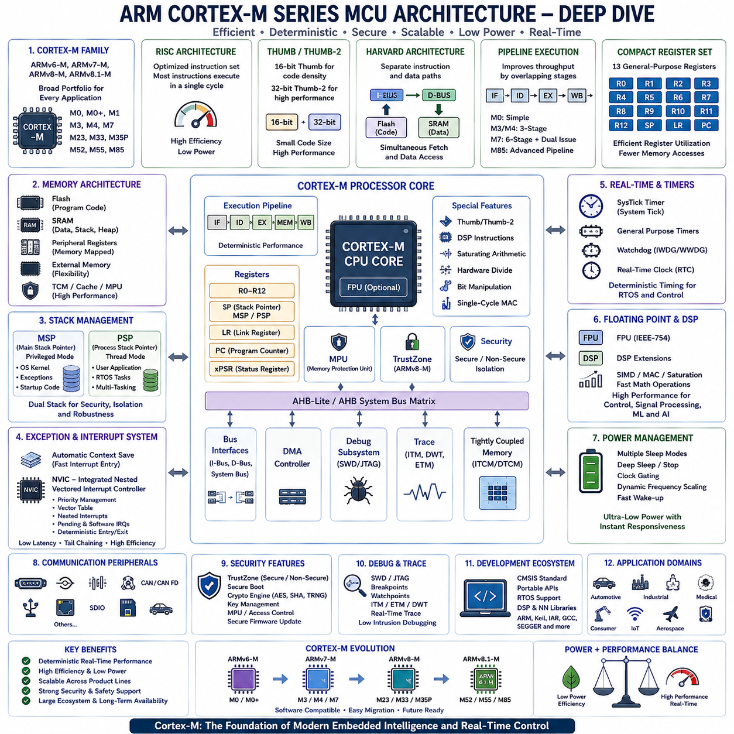
ARM Cortex-M series microcontrollers have become the dominant computing platform for modern embedded systems because they provide an effective balance between computational performance, deterministic real-time behavior, energy efficiency, scalability, and development simplicity. Unlike general-purpose processors designed primarily for desktop or server computing, Cortex-M processors are optimized for deeply embedded applications that require direct hardware control, predictable interrupt response, low power consumption, compact silicon area, and long operational lifetimes. As a result, they are widely deployed in automotive electronics, industrial automation, medical devices, robotics, consumer electronics, aerospace systems, Internet of Things devices, and safety-critical control applications.
The Cortex-M family was developed around the ARMv6-M, ARMv7-M, ARMv8-M, and the latest ARMv8.1-M architectures, each introducing new capabilities while maintaining strong software compatibility across product generations. This architectural continuity enables developers to migrate applications from entry-level microcontrollers to high-performance embedded platforms with relatively small software modifications. The family currently includes Cortex-M0, M0+, M1, M3, M4, M7, M23, M33, M35P, M52, M55, M85, and other specialized implementations, each targeting different combinations of performance, safety, security, artificial intelligence acceleration, and power efficiency.
One of the defining characteristics of Cortex-M processors is their implementation of the Reduced Instruction Set Computer (RISC) philosophy. Instead of supporting thousands of complex instructions, Cortex-M processors execute a carefully optimized instruction set designed for high execution efficiency and simplified hardware implementation. Most instructions execute within a single clock cycle under ideal conditions, allowing deterministic execution timing while reducing processor complexity, silicon cost, and power consumption. This predictable instruction execution forms an essential foundation for real-time embedded software.
The Cortex-M architecture exclusively executes the Thumb and Thumb-2 instruction sets rather than the original 32-bit ARM instruction set. Thumb instructions use compact 16-bit encodings, while Thumb-2 introduces additional 32-bit instructions for improved computational capability without sacrificing code density. The combination significantly reduces firmware size while preserving high processing performance. Smaller executable images reduce Flash memory requirements, lower manufacturing costs, improve instruction cache utilization, and accelerate firmware updates across embedded products.
The processor core follows a Harvard architecture by separating instruction and data pathways. Independent instruction and data buses enable simultaneous instruction fetching and data access, increasing execution throughput compared with traditional Von Neumann architectures. Many implementations further extend this architecture through multiple Advanced High-performance Bus interfaces that independently access Flash memory, SRAM, peripheral devices, debugging resources, and tightly coupled memories. Such parallel memory access substantially improves overall system efficiency during complex embedded workloads.
Pipeline execution enhances processor performance by overlapping multiple instruction processing stages. Entry-level Cortex-M0 processors typically implement relatively simple pipelines, while Cortex-M3 and Cortex-M4 utilize three-stage pipelines. Cortex-M7 introduces a deeper superscalar pipeline capable of dual instruction issue under appropriate conditions, significantly increasing computational throughput. Higher-performance Cortex-M85 processors further extend pipeline optimization while preserving deterministic interrupt response and backward software compatibility.
The register architecture remains intentionally compact to maximize compiler efficiency while minimizing hardware complexity. Thirteen general-purpose registers provide temporary data storage and arithmetic operands, accompanied by dedicated stack pointer, link register, and program counter registers. Special-purpose registers maintain processor state, interrupt masks, execution privilege, exception status, floating-point configuration, and control information. Efficient register allocation significantly reduces memory access frequency, improving execution speed and reducing energy consumption.
Stack management represents a particularly elegant feature of the Cortex-M architecture. Two independent stack pointers support separate operating environments for privileged system software and ordinary application execution. The Main Stack Pointer typically serves operating system kernels, exception handlers, and startup code, while the Process Stack Pointer supports user applications and multitasking environments. This separation improves software isolation, operating system implementation, fault recovery, and overall system robustness.
Exception handling represents one of the most advanced aspects of the Cortex-M architecture. Hardware automatically saves essential processor context whenever exceptions or interrupts occur, dramatically reducing software overhead compared with traditional microcontroller architectures. Automatic context preservation includes program counter, processor status, return address, and selected registers, enabling rapid interrupt response while simplifying interrupt service routine implementation. Hardware-assisted context management significantly reduces interrupt latency while improving deterministic execution.
The Nested Vectored Interrupt Controller forms an integral component of every Cortex-M processor rather than existing as an external peripheral. The NVIC directly manages interrupt prioritization, vector table lookup, nested interrupt execution, pending interrupt management, software-generated interrupts, and deterministic interrupt entry and exit. Hardware acceleration enables exceptionally low interrupt latency while supporting hundreds of interrupt sources depending upon specific processor implementation.
Interrupt prioritization provides deterministic processing of concurrent hardware events. Programmable priority levels ensure that emergency stop systems, motor control feedback, communication deadlines, functional safety monitoring, and other time-critical events immediately preempt lower-priority software activities. Tail chaining further improves efficiency by allowing consecutive interrupt handlers to execute without unnecessary context restoration between interrupts, significantly reducing processor overhead during periods of intensive interrupt activity.
The SysTick timer provides a standardized system timer integrated into every Cortex-M processor. Real-time operating systems commonly employ SysTick to generate periodic scheduling interrupts supporting multitasking, software timers, delay management, time measurement, and operating system services. Standardized timer functionality simplifies portable operating system development while providing deterministic timing behavior across the entire Cortex-M product family.
Memory architecture provides considerable flexibility for embedded system designers. Program code typically resides within Flash memory, while SRAM supports runtime execution, communication buffers, stacks, heaps, operating system objects, and sensor data processing. Peripheral registers occupy dedicated memory-mapped address regions enabling direct hardware control through ordinary load and store instructions. External memories, tightly coupled memories, instruction caches, data caches, and memory protection units further extend architectural flexibility in higher-performance implementations.
Memory Protection Units improve software reliability by partitioning memory into independently protected regions with configurable read, write, and execute permissions. Fault isolation prevents unauthorized software components from corrupting critical operating system structures, communication buffers, safety mechanisms, or security assets. Memory protection significantly improves cybersecurity, software robustness, certification support, and diagnostic capability while enabling secure multitasking environments.
The ARMv8-M architecture introduced TrustZone technology specifically designed for embedded security. TrustZone partitions processor execution into Secure and Non-secure worlds, each maintaining independent software resources, interrupt routing, memory protection, and peripheral access. Security-critical software including cryptographic algorithms, secure boot mechanisms, authentication services, key management, and trusted firmware executes within the Secure domain while ordinary applications operate within the Non-secure environment. Hardware-enforced isolation substantially strengthens cybersecurity throughout connected embedded systems.
Floating-point capability significantly expands computational performance for scientific and control applications. Cortex-M4, Cortex-M7, Cortex-M33, Cortex-M55, Cortex-M85, and selected related processors integrate optional Floating Point Units supporting IEEE-754 arithmetic. Hardware floating-point execution dramatically accelerates digital signal processing, robotics control, sensor fusion, navigation algorithms, Kalman filtering, computer vision preprocessing, and artificial intelligence inference compared with software-emulated floating-point arithmetic.
Digital Signal Processing extensions provide efficient execution of mathematical algorithms frequently required by embedded systems. Single-cycle multiply-accumulate instructions, SIMD operations, saturation arithmetic, bit manipulation instructions, hardware division, and optimized shift operations accelerate motor control, audio processing, image filtering, vibration analysis, communication signal processing, machine learning preprocessing, and industrial control algorithms while minimizing processor utilization.
The Cortex-M55 and Cortex-M85 further extend computational capability through ARM Helium technology, officially known as the M-Profile Vector Extension. Helium introduces vector processing instructions capable of performing identical mathematical operations simultaneously across multiple data elements. Signal processing, neural network inference, image analysis, sensor fusion, robotics perception, and artificial intelligence workloads benefit substantially from vector acceleration while preserving energy-efficient embedded operation.
Power efficiency remains a primary design objective throughout the Cortex-M family. Multiple sleep modes, deep sleep states, clock gating, dynamic frequency scaling, peripheral power management, and rapid wakeup mechanisms minimize energy consumption while preserving immediate responsiveness to interrupts or external events. Battery-powered devices frequently remain in ultra-low-power sleep modes for extended periods before awakening within microseconds to process external events and then returning to sleep.
Clock architecture provides flexible tradeoffs between performance and energy consumption. Internal oscillators support rapid startup with minimal external components, while external crystal oscillators provide highly accurate timing for communication protocols and precision measurement. Phase-locked loops multiply reference frequencies to achieve higher processor clock speeds, and programmable clock trees independently control processor cores, peripheral buses, communication interfaces, timers, analog subsystems, and memory controllers according to application requirements.
Debugging support represents another major strength of the Cortex-M architecture. Hardware debugging components including Serial Wire Debug, Joint Test Action Group interfaces, Flash Patch and Breakpoint units, Data Watchpoint and Trace modules, Instrumentation Trace Macrocell components, and Embedded Trace Macrocell infrastructure provide comprehensive visibility into processor execution without significantly disturbing real-time software behavior. Advanced debugging dramatically shortens software development and fault analysis.
Performance monitoring capabilities enable detailed execution analysis. Cycle counters, event counters, exception statistics, interrupt measurements, cache monitoring, trace systems, and profiling infrastructure allow engineers to identify software bottlenecks, interrupt latency, memory access inefficiencies, synchronization delays, and algorithm optimization opportunities. Accurate performance measurement remains essential for achieving deterministic real-time operation within complex embedded systems.
Modern development ecosystems significantly simplify Cortex-M software engineering. ARM CMSIS standardizes processor initialization, peripheral abstraction, operating system interfaces, debugging support, digital signal processing libraries, neural network libraries, and software portability across semiconductor vendors. Toolchains from ARM, GNU, IAR, Keil, SEGGER, and numerous integrated development environments provide optimized compilers, static analysis, simulation, debugging, profiling, and continuous integration support.
Semiconductor manufacturers extend the standard Cortex-M processor core by integrating application-specific peripherals around the ARM architecture. Analog-to-digital converters, timers, communication interfaces, motor-control accelerators, cryptographic engines, direct memory access controllers, Ethernet controllers, CAN FD interfaces, USB controllers, graphics accelerators, artificial intelligence accelerators, and numerous application-specific peripherals differentiate products while maintaining software compatibility at the processor-core level.
Safety-critical applications frequently employ Cortex-M processors because deterministic execution, standardized architecture, integrated fault handling, memory protection, hardware debugging, and extensive development ecosystem support simplify compliance with functional safety standards such as IEC 61508, ISO 26262, IEC 62304, EN 50128, and DO-178 guidance depending upon application domain. Certified software libraries and development tools further reduce certification effort.
Modern robotic systems extensively utilize Cortex-M processors across distributed embedded architectures. Dedicated motor controllers execute deterministic motion control using Cortex-M4 or Cortex-M7 processors, sensor nodes preprocess camera or inertial measurements, battery management systems supervise energy storage, safety controllers monitor emergency conditions, communication gateways coordinate distributed networks, and higher-performance processors execute localization, diagnostics, and artificial intelligence support. Each controller performs specialized real-time functions while cooperating through deterministic communication networks.
The evolution of Cortex-M processors increasingly supports edge artificial intelligence without sacrificing deterministic embedded control. Machine learning acceleration, vector processing, optimized digital signal processing, floating-point computation, secure execution environments, functional safety mechanisms, and ultra-low-power operation collectively enable intelligent embedded devices capable of perception, prediction, anomaly detection, adaptive control, predictive maintenance, and autonomous decision support directly at the edge. These capabilities reduce cloud dependence while improving privacy, responsiveness, reliability, and operational resilience.
Ultimately, the ARM Cortex-M architecture represents one of the most successful embedded processor families ever developed because it achieves an exceptional balance between simplicity, computational performance, deterministic real-time execution, energy efficiency, scalability, security, software portability, and long-term ecosystem support. Its architectural principles have enabled billions of embedded devices across industrial automation, robotics, automotive electronics, medical systems, aerospace platforms, smart infrastructure, consumer electronics, and Physical AI applications. As embedded intelligence continues expanding toward autonomous machines and intelligent cyber-physical systems, Cortex-M processors will remain fundamental building blocks supporting reliable, secure, efficient, and highly scalable embedded computing architectures.

02.02 STM32 HAL Library Structure and Usage [w/Code]
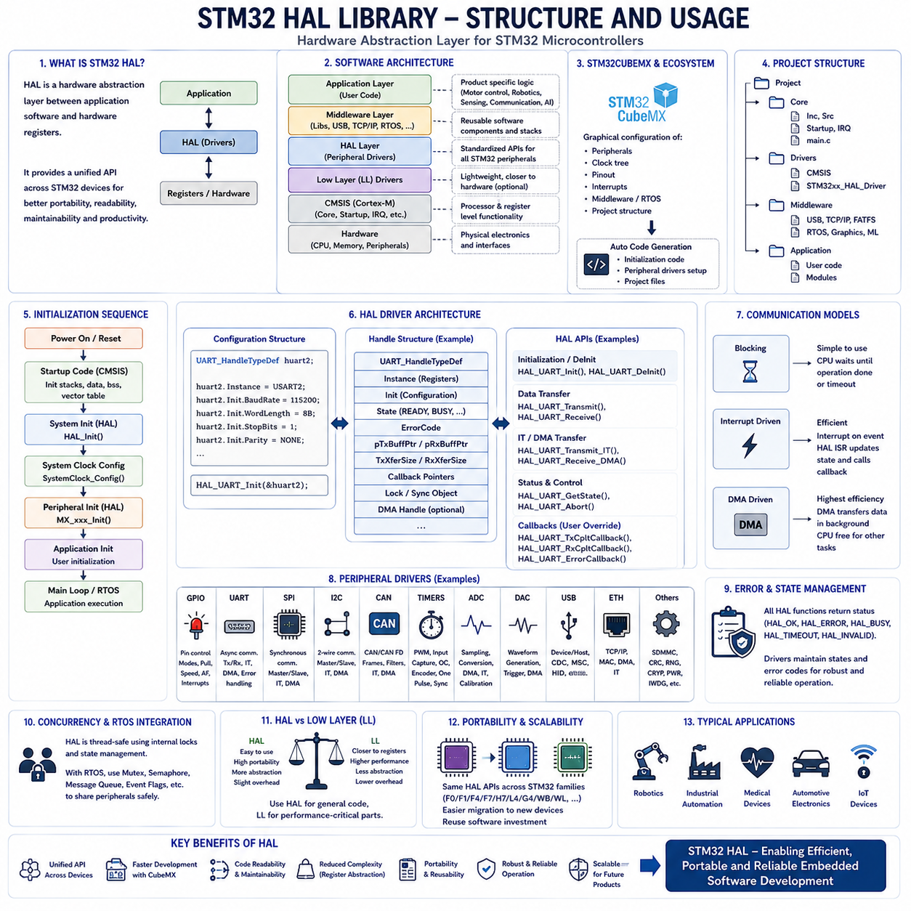
STM32 microcontrollers have become one of the most widely adopted embedded computing platforms because they combine ARM Cortex-M processors with a rich collection of integrated peripherals, comprehensive development tools, and a highly standardized software ecosystem. As STM32 product families expanded to include hundreds of devices with different processors, memories, communication interfaces, analog peripherals, and performance levels, software portability became increasingly important. To address this challenge, STMicroelectronics developed the Hardware Abstraction Layer (HAL), a software framework that provides a unified programming interface across nearly all STM32 devices. Rather than directly manipulating peripheral registers throughout application code, developers interact with standardized HAL Application Programming Interfaces, significantly improving software readability, portability, maintainability, and development productivity.
The STM32 HAL library serves as an abstraction layer positioned between application software and low-level hardware registers. Instead of requiring developers to understand every individual register bit, timing sequence, and hardware-specific configuration, HAL encapsulates these implementation details within standardized driver functions. Application software invokes high-level interfaces to initialize peripherals, configure operating modes, transmit or receive data, control hardware resources, and monitor peripheral status. This abstraction dramatically reduces software complexity while allowing engineers to concentrate on application logic rather than hardware implementation details.
The overall STM32 software architecture consists of several distinct software layers working together in a hierarchical organization. At the highest level, user applications implement product-specific functionality such as motor control, robotics, industrial automation, sensing, communication, or artificial intelligence. Beneath the application layer resides middleware providing reusable software services including USB, TCP/IP networking, file systems, cryptographic libraries, graphics frameworks, machine learning libraries, and real-time operating systems. The HAL layer provides hardware-independent peripheral interfaces, while the Low Layer drivers and CMSIS infrastructure provide direct processor and register-level functionality. At the lowest level reside the processor core, memory system, peripheral hardware, and physical electronic interfaces.
The Cortex Microcontroller Software Interface Standard provides the processor abstraction foundation upon which HAL is built. CMSIS standardizes processor startup code, interrupt vector definitions, register descriptions, compiler compatibility, operating system interfaces, debugging infrastructure, and processor-specific functionality across all ARM Cortex-M devices. HAL builds upon this standardized processor layer while introducing peripheral-specific software interfaces unique to STM32 product families. Consequently, application software benefits from both processor portability through CMSIS and peripheral portability through HAL.
The STM32Cube software ecosystem integrates the HAL library into a complete embedded software development framework. STM32CubeMX automatically generates initialization code, peripheral configuration, clock-tree setup, interrupt configuration, middleware integration, operating system initialization, and project structure. Developers graphically configure hardware resources, after which CubeMX generates corresponding HAL initialization code. This automatic code generation reduces manual configuration effort while minimizing configuration errors during system initialization.
Every STM32Cube project follows a consistent directory structure supporting software organization and long-term maintainability. Core directories typically contain application source files, interrupt handlers, startup code, linker scripts, and processor configuration. Driver directories include CMSIS processor support and HAL peripheral drivers. Middleware directories contain networking stacks, file systems, USB libraries, graphics frameworks, machine learning libraries, and operating system components. User applications generally reside within dedicated application directories that remain largely independent from generated software infrastructure.
Application development usually begins within the main source file where the generated initialization sequence follows a standardized execution order. After processor reset, the startup code initializes memory sections, configures the processor environment, establishes interrupt vectors, initializes the system clock, and transfers execution to the main application. HAL initialization configures the processor core, initializes the SysTick timer, enables peripheral clocks, configures Flash memory latency, and prepares fundamental processor services before individual peripheral initialization functions execute.
Clock configuration represents one of the most important initialization tasks within STM32 systems. Modern STM32 microcontrollers contain multiple oscillators, phase-locked loops, clock domains, peripheral clock generators, and power management mechanisms. STM32CubeMX graphically configures the complete clock tree while automatically generating corresponding HAL initialization functions. Accurate clock configuration ensures proper processor execution, communication timing, analog conversion accuracy, USB functionality, Ethernet synchronization, and real-time operating system scheduling.
Peripheral initialization follows a highly standardized design philosophy throughout the HAL library. Every peripheral driver defines configuration structures containing initialization parameters, operating modes, timing settings, hardware options, interrupt priorities, and communication characteristics. Application software fills these configuration structures before passing them into standardized initialization functions. Once initialized, dedicated HAL interfaces perform transmission, reception, configuration updates, diagnostic monitoring, interrupt handling, and peripheral deinitialization using consistent programming patterns across different peripheral categories.
Handle structures form the central organizational concept of the HAL architecture. Each peripheral instance is represented by a dedicated handle object containing configuration parameters, hardware register addresses, software state variables, transfer status, callback functions, synchronization objects, error codes, and internal driver management information. Rather than directly manipulating hardware resources, application software interacts with peripheral handles through standardized HAL function interfaces. This object-oriented organization simplifies peripheral management while enabling multiple independent peripheral instances within the same embedded application.
State management significantly improves peripheral reliability. Each HAL driver continuously tracks peripheral operating states including reset, ready, busy, timeout, error, abort, and completion conditions. Application software can query peripheral status before initiating new operations, preventing invalid hardware access or conflicting software requests. Explicit state management greatly simplifies debugging while improving software robustness under complex multitasking environments.
Blocking operation represents the simplest HAL communication model. Application software calls transmission or reception functions that remain active until the requested operation completes, encounters an error, or exceeds a specified timeout period. Blocking interfaces simplify software implementation and are appropriate for initialization routines, configuration tasks, diagnostics, and low-frequency communication where processor utilization is not a primary concern.
Interrupt-driven operation improves processor efficiency by allowing application software to perform unrelated computation while hardware peripherals independently execute communication or data acquisition. Once peripheral activity completes, hardware generates interrupts that invoke HAL interrupt service routines, update internal driver state, and execute application callback functions. Interrupt-based programming significantly increases processor utilization while preserving deterministic event handling within real-time embedded systems.
Direct Memory Access integration provides the highest communication efficiency for large data transfers. DMA controllers autonomously transfer information between memory and peripherals without continuous processor involvement. HAL transparently configures DMA channels, synchronization mechanisms, interrupt generation, and transfer completion events while presenting consistent programming interfaces to application software. DMA significantly reduces processor workload during continuous sensor acquisition, communication, graphics processing, audio streaming, and artificial intelligence preprocessing.
Callback mechanisms provide asynchronous communication between HAL drivers and user applications. Default callback functions are implemented as weak symbols that application software overrides when customized behavior is required. Transfer completion, transmission events, reception events, timer expiration, external interrupts, analog conversion completion, communication errors, and fault conditions all invoke corresponding callback interfaces. Callback architecture cleanly separates peripheral drivers from application logic while maintaining modular software organization.
General Purpose Input Output configuration illustrates the consistency of HAL programming. GPIO initialization structures specify pin numbers, operating modes, output characteristics, pull-up or pull-down configuration, alternate functions, output speed, and interrupt configuration. A single standardized initialization function configures the selected hardware registers regardless of processor family or package variation. Similar configuration philosophies extend across UART, SPI, I2C, CAN, ADC, DAC, timers, Ethernet, USB, SDMMC, cryptographic accelerators, and other integrated peripherals.
Communication peripheral drivers share highly consistent programming interfaces. Universal Asynchronous Receiver Transmitter drivers implement transmit, receive, interrupt, DMA, callback, state management, and error handling using standardized function naming conventions. Similar architectural patterns appear throughout Serial Peripheral Interface, Inter-Integrated Circuit, Controller Area Network, Universal Serial Bus, Ethernet, and other communication interfaces. Developers who understand one HAL communication driver can rapidly learn additional peripheral interfaces because common design principles remain consistent throughout the library.
Timer drivers represent one of the most comprehensive HAL subsystems because timers support numerous embedded functions beyond simple time measurement. General-purpose timers generate periodic interrupts, pulse-width modulation signals, input capture measurements, quadrature encoder interfaces, one-pulse generation, synchronized triggering, and advanced motor-control waveforms. HAL organizes these diverse capabilities through modular initialization structures and dedicated software interfaces while maintaining consistent programming methodology.
Analog peripheral drivers simplify complex hardware configuration through structured abstraction. Analog-to-Digital Converter drivers configure sampling time, conversion resolution, triggering sources, conversion sequences, calibration procedures, oversampling, DMA integration, interrupt generation, and continuous conversion modes. Digital-to-Analog Converter interfaces similarly abstract waveform generation, output buffering, triggering mechanisms, and DMA operation while minimizing register-level programming complexity.
Error management constitutes an essential feature of robust HAL software. Nearly every HAL function returns standardized status values indicating successful execution, timeout conditions, invalid parameters, peripheral busy states, communication failures, or hardware errors. Application software should always evaluate return values before proceeding with subsequent operations. Consistent error reporting improves debugging while enabling graceful fault recovery under abnormal operating conditions.
Concurrency management becomes increasingly important when multiple software tasks simultaneously access shared hardware resources. HAL drivers internally employ locking mechanisms, state variables, synchronization flags, and interrupt protection to prevent conflicting peripheral access. When combined with real-time operating systems, additional synchronization primitives including mutexes, semaphores, message queues, and event flags coordinate peripheral sharing among multiple concurrent software tasks.
Although HAL greatly improves software portability and development productivity, abstraction introduces modest execution overhead compared with direct register manipulation. Performance-critical applications including high-frequency motor control, ultra-fast communication processing, precision timing generation, or deterministic control loops occasionally require direct register programming or Low Layer drivers to minimize execution latency. Many industrial embedded systems therefore combine HAL for general software infrastructure with Low Layer drivers for computationally intensive subsystems.
The Low Layer library complements HAL by providing lightweight software interfaces closely corresponding to hardware registers while preserving improved readability compared with direct register manipulation. Low Layer functions execute more efficiently because they minimize software abstraction and reduce function call overhead. Developers frequently employ HAL during initial product development and later migrate selected performance-critical software modules toward Low Layer interfaces after profiling identifies computational bottlenecks.
Code generation should be carefully managed throughout project evolution. STM32CubeMX automatically regenerates initialization software whenever hardware configuration changes. User application logic should therefore remain confined within protected code regions specifically reserved for manual development. Following recommended software organization prevents application code from being accidentally overwritten during future configuration updates while preserving automatic hardware configuration capability.
Software portability represents one of the greatest advantages of the HAL architecture. Application software developed for one STM32 processor family frequently migrates to newer devices requiring only minor hardware configuration changes. Since peripheral interfaces remain largely consistent across product families, organizations can reuse substantial software investments while adopting processors offering greater performance, larger memory capacity, improved security, artificial intelligence acceleration, additional communication interfaces, or enhanced energy efficiency.
Robotic systems demonstrate particularly effective use of the STM32 HAL library. Motor controllers configure timers, pulse-width modulation generators, encoder interfaces, and DMA transfers using standardized HAL drivers. Communication modules exchange CAN FD, UART, SPI, Ethernet, and USB messages through common programming interfaces. Sensor nodes acquire inertial measurements, analog signals, cameras, LiDAR synchronization signals, and external interrupts using reusable initialization structures. Battery management systems, safety controllers, actuator drivers, and communication gateways all benefit from consistent software organization across distributed embedded controllers.
As embedded systems become increasingly connected and intelligent, the HAL architecture continues evolving to support modern software requirements including cybersecurity, secure boot, cryptographic acceleration, machine learning inference, edge artificial intelligence, real-time operating systems, cloud connectivity, and functional safety. Standardized software abstraction enables engineering organizations to focus development effort on innovative product functionality while relying upon thoroughly validated peripheral software infrastructure.
Ultimately, the STM32 HAL library represents far more than a collection of peripheral drivers. It establishes a comprehensive software architecture that standardizes peripheral initialization, communication, interrupt management, DMA integration, callback mechanisms, state management, error handling, and hardware abstraction across the STM32 ecosystem. By combining CMSIS, HAL, STM32Cube tools, middleware, and application software into a unified engineering framework, developers can produce embedded systems that are portable, maintainable, scalable, reliable, and well suited for modern robotics, industrial automation, medical electronics, automotive control, Internet of Things devices, and future Physical AI platforms.

02.03 GPIO, UART, SPI, I2C Driver Implementation [w/Code]
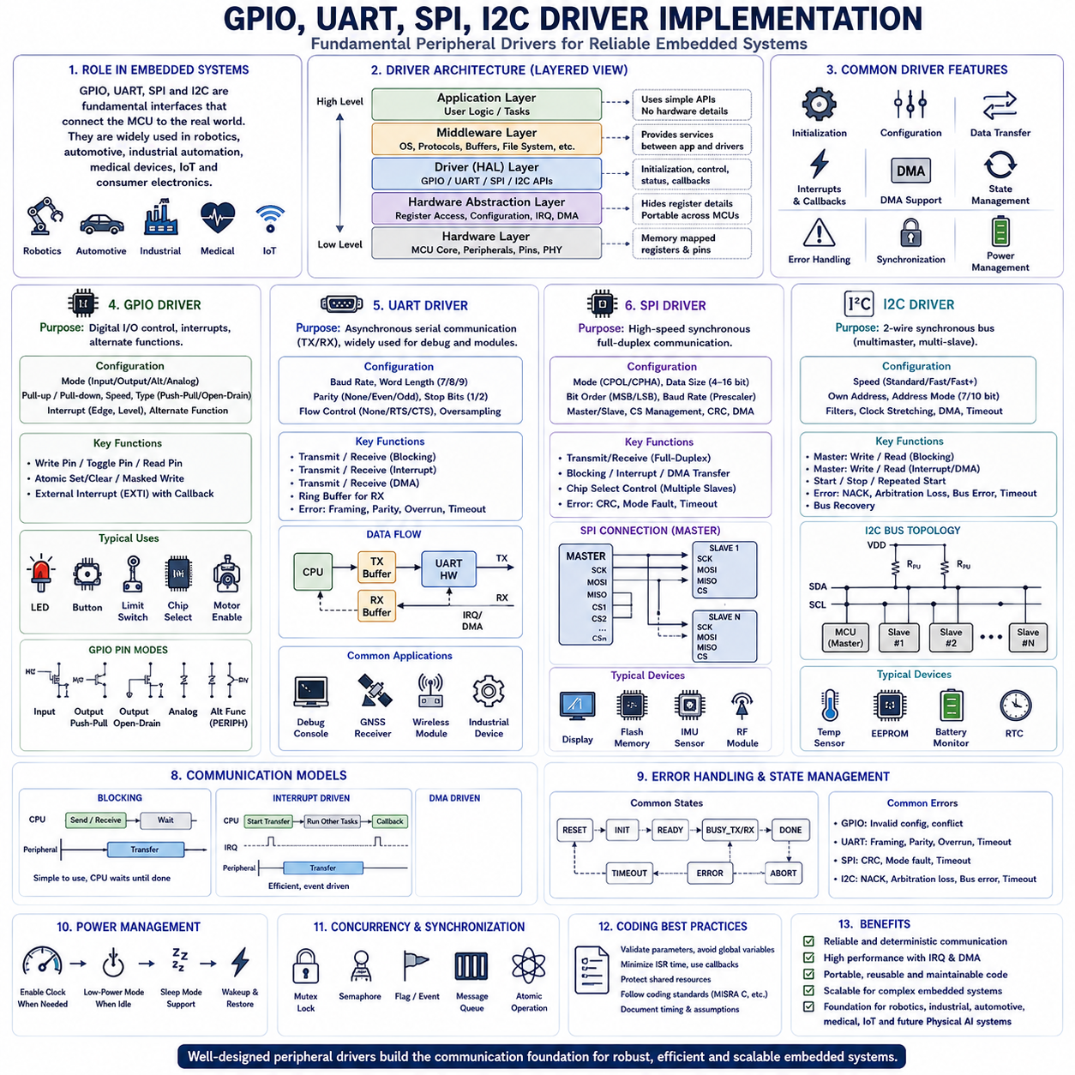
General Purpose Input Output (GPIO), Universal Asynchronous Receiver Transmitter (UART), Serial Peripheral Interface (SPI), and Inter-Integrated Circuit (I²C) represent the fundamental communication and control peripherals of nearly every modern microcontroller. Regardless of whether an embedded system controls an industrial robot, an automotive electronic control unit, a medical device, an Internet of Things sensor, or a consumer electronic product, these peripherals provide the primary interfaces between the processor and the physical world. Effective driver implementation therefore forms one of the most important aspects of embedded software engineering because every higher-level software component ultimately depends upon reliable peripheral communication.
Peripheral drivers provide the software abstraction that separates application logic from hardware-specific implementation details. Instead of allowing application software to manipulate processor registers directly, drivers encapsulate initialization procedures, hardware configuration, communication protocols, interrupt handling, error management, synchronization, and power control within standardized software interfaces. This abstraction improves software portability, readability, maintainability, testing efficiency, and long-term scalability while reducing the complexity of application development across multiple hardware platforms.
Driver architecture typically follows a layered design model. The lowest layer directly accesses memory-mapped peripheral registers responsible for hardware control. Above this level, hardware abstraction interfaces provide standardized functions independent of processor implementation. Middleware components coordinate communication between drivers and operating systems, while application software invokes high-level driver APIs without requiring detailed knowledge of hardware registers or timing sequences. Such separation of responsibilities enables software reuse across multiple processor families and product generations.
GPIO drivers provide the simplest but most frequently used peripheral interface within embedded systems. Every digital input, output, interrupt pin, alternate function, communication interface, status indicator, sensor enable signal, actuator control line, reset circuit, chip-select signal, and diagnostic interface ultimately depends upon GPIO functionality. Although GPIO hardware appears simple, reliable driver implementation requires careful management of electrical characteristics, timing behavior, synchronization, interrupt generation, and hardware configuration throughout system operation.
GPIO initialization begins by enabling the peripheral clock associated with the desired port. Each GPIO pin must then be configured according to its intended function, including input mode, output mode, alternate peripheral function, analog mode, open-drain operation, push-pull output configuration, pull-up or pull-down resistor selection, output speed, and interrupt capability. Modern embedded software encapsulates these configuration parameters within structured initialization objects that simplify driver implementation while improving code readability.
Digital output drivers primarily manipulate output registers controlling external electrical signals. Applications frequently control LEDs, relays, motors, displays, chip-select signals, communication transceivers, power regulators, and external integrated circuits through GPIO outputs. Driver implementations typically provide functions supporting direct output control, bit toggling, masked updates, atomic register access, and synchronized multi-pin operation. Atomic output mechanisms prevent race conditions during concurrent software execution while preserving deterministic hardware behavior.
Digital input drivers acquire external signal states generated by buttons, switches, limit sensors, proximity detectors, optical sensors, magnetic sensors, safety devices, and numerous other external components. Reliable input acquisition frequently requires software debouncing because mechanical contacts naturally generate multiple transitions during switching. Driver implementations often combine timer-based filtering, majority voting, state machines, or configurable debounce intervals to ensure stable input detection under noisy operating conditions.
External interrupt functionality greatly improves processor efficiency by eliminating continuous polling of input signals. GPIO interrupt drivers configure trigger polarity, interrupt masking, priority assignment, callback registration, and interrupt clearing mechanisms while integrating with processor interrupt controllers. Rising edges, falling edges, or both transitions may generate hardware interrupts depending upon application requirements. Interrupt-driven GPIO operation enables rapid response while minimizing processor utilization.
Alternate function configuration transforms ordinary GPIO pins into specialized peripheral interfaces. UART transmit and receive signals, SPI clock and data channels, I²C communication lines, timer outputs, pulse-width modulation signals, Ethernet interfaces, USB connectivity, CAN communication, analog conversion inputs, and many additional hardware functions all share physical processor pins. GPIO drivers therefore manage alternate function multiplexing while ensuring conflict-free peripheral allocation throughout system initialization.
Universal Asynchronous Receiver Transmitter drivers provide serial communication without requiring a shared clock between communicating devices. UART remains one of the most widely deployed embedded communication interfaces because of its simplicity, broad compatibility, low hardware cost, and extensive support across debugging tools, industrial equipment, wireless modules, positioning systems, sensor interfaces, and diagnostic devices. Robust UART driver implementation therefore remains an essential embedded engineering skill.
UART initialization requires configuration of communication parameters including baud rate, word length, parity generation, stop bits, hardware flow control, oversampling mode, transmitter enable, receiver enable, interrupt configuration, and DMA support when required. Accurate baud rate generation depends upon processor clock configuration and peripheral divider calculations. Driver initialization validates parameter consistency before enabling hardware communication to ensure reliable operation across varying system clock frequencies.
UART transmission drivers manage data movement from application software toward communication hardware. Blocking transmission functions remain active until every byte has been physically transmitted or timeout conditions occur. Interrupt-driven transmission allows processors to continue unrelated computation while hardware serializes outgoing data. DMA-based transmission further reduces processor workload by transferring complete communication buffers directly from memory into UART hardware without continuous processor intervention.
UART reception presents additional implementation challenges because incoming data arrives asynchronously without advance processor scheduling. Driver software continuously monitors receive status through polling, interrupts, DMA transfers, circular buffers, or operating system queues depending upon application requirements. Buffer overflow detection, framing error handling, parity verification, noise filtering, timeout management, and synchronization recovery all contribute to robust long-term communication reliability.
Ring buffer implementation represents one of the most common techniques for UART reception. Circular memory structures continuously store incoming bytes regardless of application processing speed. Independent producer and consumer pointers permit interrupt handlers to deposit newly received data while application software simultaneously extracts previously received information without requiring complex synchronization. Ring buffers significantly improve communication robustness during burst traffic while minimizing processor overhead.
Serial Peripheral Interface provides high-speed synchronous communication between processors and peripheral devices using dedicated clock synchronization. Unlike UART, SPI requires a master device generating communication timing while one or more slave devices respond according to synchronized clock edges. SPI commonly connects displays, Flash memories, sensors, analog converters, digital converters, wireless transceivers, inertial measurement units, motor controllers, and numerous integrated circuits requiring reliable medium-to-high-speed communication.
SPI driver initialization configures communication mode, clock polarity, clock phase, frame size, bit ordering, baud rate prescaler, master or slave operation, chip-select management, CRC generation, interrupt support, DMA configuration, and hardware timing parameters. Since SPI communication depends upon precise clock relationships, driver initialization must ensure compatibility between processor timing and external device communication specifications before data exchange begins.
SPI communication always transmits and receives simultaneously because the interface shifts data bidirectionally during every clock cycle. Driver software therefore manages separate transmit and receive buffers even when applications appear to perform only transmission or only reception. Full-duplex operation significantly improves communication efficiency but requires careful buffer synchronization, completion detection, timeout handling, and error management throughout driver implementation.
Chip-select management constitutes another critical SPI driver responsibility. Each slave device requires independent selection signals ensuring that only one peripheral responds during any communication transaction unless specialized multidrop configurations are intentionally employed. Driver implementations automatically assert chip-select signals before transmission begins and release them only after communication completes according to individual device timing requirements. Correct chip-select timing prevents communication corruption while supporting reliable operation across diverse peripheral devices.
DMA integration substantially improves SPI performance during large data transfers including display updates, image acquisition, Flash programming, sensor streaming, and artificial intelligence preprocessing. Rather than transferring individual bytes through processor software, DMA engines autonomously move entire communication buffers while generating interrupts only after transfer completion. Driver software coordinates DMA configuration, synchronization, cache management, timeout monitoring, and completion callbacks while maintaining consistent application programming interfaces.
Inter-Integrated Circuit communication provides a two-wire synchronous serial bus supporting multiple master and slave devices connected simultaneously. SDA transfers bidirectional data while SCL distributes communication timing. Pull-up resistors maintain bus idle levels because both communication lines employ open-drain electrical characteristics allowing multiple devices to share common communication wiring safely. I²C significantly reduces printed circuit board complexity while supporting extensive peripheral expansion using only two communication wires.
I²C driver initialization configures communication speed, addressing mode, timing registers, analog filtering, digital filtering, own device address, dual addressing capability, general call response, clock stretching behavior, interrupt support, DMA integration, and timeout monitoring. Since I²C communication relies upon carefully controlled signal timing, initialization software must compute precise timing parameters based upon processor clock frequency, desired communication speed, and electrical bus characteristics.
Every I²C communication transaction follows a standardized protocol sequence beginning with a START condition generated by the master. The master subsequently transmits slave addressing information followed by read or write direction bits. Slave devices acknowledge successful reception before actual data transfer begins. Communication concludes with a STOP condition releasing the shared communication bus for future transactions. Driver implementations automatically generate these protocol elements while presenting simplified read and write interfaces to application software.
Address management represents an important aspect of I²C driver implementation because numerous slave devices may coexist on the same communication bus. Standard seven-bit addressing supports up to one hundred twenty-eight theoretical device addresses, while extended ten-bit addressing expands addressing capability for larger systems. Driver software validates addressing, detects absent devices through acknowledgment monitoring, resolves communication conflicts, and supports device discovery during system initialization.
I²C communication frequently encounters bus recovery challenges caused by interrupted transfers, electrical disturbances, unexpected processor resets, or malfunctioning peripheral devices. Robust driver implementations detect timeout conditions, perform clock recovery procedures, release blocked communication lines, reset hardware controllers, clear pending status flags, and reinitialize communication hardware before resuming ordinary operation. Effective bus recovery significantly improves long-term system reliability within electrically noisy industrial environments.
Interrupt-driven peripheral drivers maximize processor utilization across GPIO, UART, SPI, and I²C communication. Rather than continuously monitoring hardware status, processors execute application software until communication events generate hardware interrupts. Interrupt service routines update internal driver states, process completed transfers, manage communication buffers, invoke callback functions, and schedule subsequent operations while minimizing interrupt execution time. Deferred processing mechanisms transfer computationally intensive tasks toward background software contexts to preserve deterministic interrupt latency.
DMA operation further extends communication efficiency by allowing peripherals to exchange large data blocks directly with memory independently of processor execution. Driver implementations configure DMA channels, buffer descriptors, transfer lengths, synchronization events, interrupt generation, and completion notification while maintaining transparent application interfaces. DMA proves particularly valuable within robotics, industrial automation, multimedia processing, and edge artificial intelligence where continuous high-bandwidth data movement would otherwise overwhelm processor resources.
Error detection and recovery represent essential responsibilities throughout peripheral driver implementation. GPIO drivers detect invalid configurations, unsupported alternate functions, and electrical conflicts. UART drivers monitor framing errors, parity violations, buffer overruns, break detection, and communication timeouts. SPI drivers identify transfer completion failures, CRC mismatches, mode faults, and synchronization errors. I²C drivers recognize acknowledgment failures, arbitration loss, bus errors, timeout conditions, and unexpected protocol violations. Standardized error reporting enables application software to implement graceful recovery strategies while maintaining long-term operational stability.
Driver software increasingly incorporates explicit state management supporting deterministic multitasking environments. Peripheral states commonly include reset, initialized, ready, busy transmitting, busy receiving, suspended, timeout, aborted, completed, and fault conditions. Application software queries driver states before initiating new operations, preventing conflicting hardware access while simplifying debugging and improving concurrency management within real-time operating systems.
Concurrency becomes particularly important when multiple software tasks share common communication peripherals. Driver implementations utilize mutual exclusion mechanisms, semaphores, synchronization flags, message queues, event notifications, interrupt masking, and atomic operations to coordinate resource ownership. Well-designed synchronization prevents race conditions while maintaining predictable timing behavior across concurrent software execution.
Power management integration has become increasingly important within modern embedded driver architecture. Peripheral drivers enable clocks only when hardware becomes active, transition peripherals into low-power modes during inactivity, coordinate wakeup events, preserve configuration across sleep transitions, and restore communication seamlessly after processor wakeup. Intelligent power-aware driver implementation substantially extends battery operating lifetime without sacrificing application responsiveness.
Coding standards strongly influence professional driver implementation. Driver software typically avoids unnecessary dynamic memory allocation, minimizes global variables, limits interrupt execution time, validates function parameters, performs defensive error checking, isolates hardware dependencies, documents timing assumptions, and follows MISRA C, AUTOSAR, CERT C, or organizational coding guidelines. Such disciplined implementation significantly improves maintainability, safety certification, software portability, and long-term product reliability.
Modern robotic systems illustrate the coordinated operation of these peripheral drivers within complex embedded architectures. GPIO drivers manage emergency stop circuits, motor enable signals, limit switches, LEDs, and sensor power control. UART drivers communicate with GNSS receivers, diagnostic consoles, wireless modules, and industrial equipment. SPI interfaces exchange high-speed data with inertial sensors, external Flash memory, displays, and artificial intelligence accelerators. I²C networks connect environmental sensors, battery management components, power monitors, temperature sensors, and configuration memories. Collectively, these drivers establish the communication foundation supporting perception, localization, navigation, motion control, diagnostics, safety monitoring, and autonomous decision-making throughout advanced robotic platforms.
Ultimately, GPIO, UART, SPI, and I²C drivers represent far more than simple peripheral software modules. They establish standardized communication frameworks that isolate application software from hardware implementation details while providing deterministic timing, robust error handling, efficient interrupt processing, DMA acceleration, concurrency management, power optimization, and long-term maintainability. Well-designed peripheral drivers enable scalable embedded software architectures capable of supporting industrial automation, intelligent vehicles, aerospace electronics, medical equipment, Internet of Things infrastructure, autonomous robots, and the rapidly evolving ecosystem of future Physical AI systems.

02.04 ADC/DAC Driver Design and Sampling Precision [w/Code]
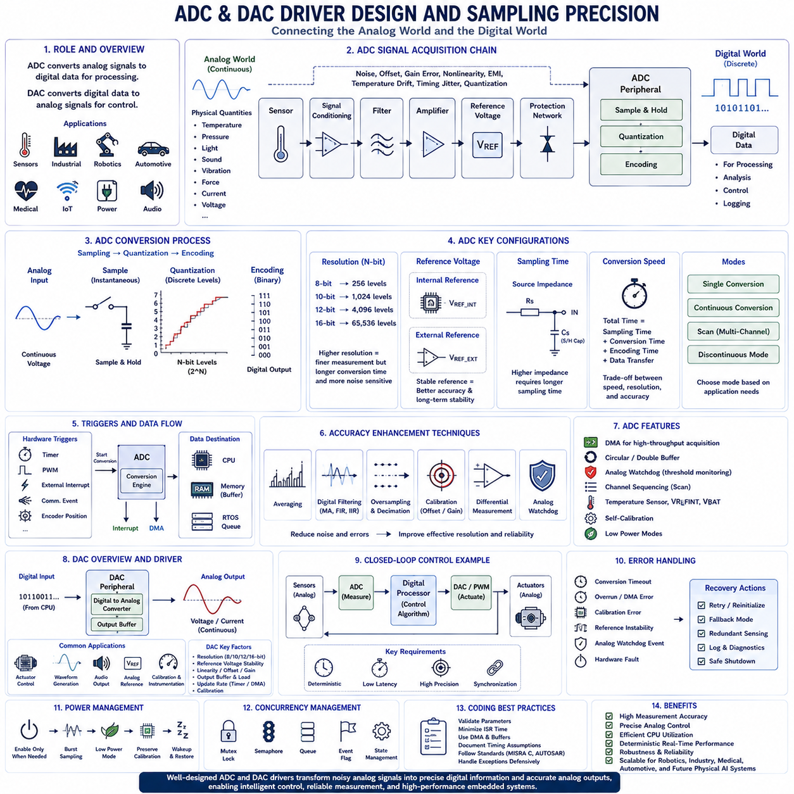
Analog signals dominate the physical world because temperature, pressure, light intensity, sound, vibration, force, current, voltage, magnetic fields, chemical concentration, and countless other physical phenomena vary continuously rather than discretely. Digital microcontrollers, however, operate exclusively on binary information represented by logical zeros and ones. Analog-to-Digital Converters (ADC) and Digital-to-Analog Converters (DAC) therefore serve as the essential interfaces connecting digital embedded systems with the analog environment. ADC peripherals transform continuously varying electrical signals into digital values that processors can analyze, while DAC peripherals convert digital information into precise analog voltages or currents capable of controlling external physical systems. Well-designed ADC and DAC drivers are fundamental components of modern embedded software because they directly influence measurement accuracy, control precision, real-time responsiveness, energy efficiency, and overall system reliability.
ADC driver design begins with understanding the complete analog signal acquisition chain rather than focusing solely on software implementation. The analog front-end consists of sensors, signal conditioning circuits, filters, amplifiers, voltage references, protection networks, sampling capacitors, and conversion hardware before digital software processing even begins. Every stage introduces potential error sources including electrical noise, offset voltage, gain error, nonlinear distortion, temperature drift, quantization uncertainty, electromagnetic interference, and timing jitter. Effective driver software must therefore cooperate closely with hardware design to maximize measurement accuracy while maintaining deterministic sampling behavior throughout the embedded system.
Analog-to-Digital Conversion fundamentally consists of three sequential processes: sampling, quantization, and digital encoding. During sampling, the converter captures the instantaneous analog voltage using an internal sample-and-hold circuit. Quantization maps this continuous voltage into one of a finite number of discrete digital levels determined by converter resolution. Finally, binary encoding represents the selected quantization level as digital data that software can process. Driver implementation must correctly configure timing, resolution, triggering, conversion sequences, and data transfer while recognizing that every conversion inherently introduces finite measurement uncertainty due to quantization.
ADC resolution determines the smallest measurable voltage difference distinguishable by the converter. An N-bit converter provides 2^N discrete quantization levels distributed across the reference voltage range. For example, an 8-bit ADC provides 256 levels, a 10-bit converter provides 1,024 levels, a 12-bit converter provides 4,096 levels, while 16-bit converters support 65,536 discrete measurement values. Higher resolution enables finer voltage discrimination but often requires longer conversion times, improved analog design, cleaner reference voltages, lower electrical noise, and more sophisticated calibration to realize the theoretical precision available from additional digital bits.
Reference voltage stability directly determines conversion accuracy because every digital output value is measured relative to the selected voltage reference. Internal references provide convenient implementation with moderate accuracy, while external precision references significantly improve measurement stability, temperature performance, long-term drift characteristics, and repeatability. Driver software should carefully configure reference selection while considering power consumption, startup time, calibration requirements, and application-specific accuracy objectives. High-performance industrial and medical systems frequently employ dedicated external voltage references with exceptionally low temperature coefficients to maximize measurement consistency over extended operational lifetimes.
Sampling time represents one of the most frequently misunderstood ADC configuration parameters. Before conversion begins, the sample-and-hold capacitor must fully charge to the input signal voltage through the combined impedance of sensors, amplifiers, filters, and analog routing. High source impedance requires longer sampling intervals to achieve accurate voltage acquisition. Insufficient sampling time causes incomplete capacitor charging, introducing systematic measurement errors even when converter resolution appears adequate. Driver initialization therefore selects sampling durations according to source impedance, desired sampling frequency, signal bandwidth, and overall measurement accuracy requirements.
Conversion speed determines how rapidly analog measurements become available for software processing. Total conversion time includes sampling duration, internal quantization time, digital encoding, and result transfer. High-speed control applications including motor control, power electronics, robotics, communication systems, and digital signal processing frequently require hundreds of thousands or even millions of conversions per second. Lower-speed environmental monitoring applications may instead prioritize resolution, stability, and power efficiency over maximum sampling throughput. Driver configuration balances conversion rate against precision, processor workload, and application timing constraints.
Single conversion mode provides the simplest ADC operating model by initiating one conversion upon software request or hardware trigger. After conversion completes, hardware remains idle until another request occurs. Single conversion proves appropriate for configuration measurements, diagnostics, user input acquisition, battery monitoring, calibration procedures, and relatively slow environmental sensing. Blocking, interrupt-driven, or DMA-based software interfaces may all support single conversion depending upon application requirements and processor utilization objectives.
Continuous conversion mode automatically performs repeated measurements without requiring individual software requests. After each conversion completes, hardware immediately begins sampling the next measurement. Continuous acquisition greatly simplifies high-speed signal monitoring while minimizing software overhead. Driver implementations typically combine continuous conversion with DMA transfers, circular memory buffers, interrupt notifications, and real-time operating system synchronization to support efficient long-term data acquisition within robotics, industrial automation, vibration monitoring, and predictive maintenance applications.
Scan conversion mode enables automatic acquisition of multiple analog input channels using programmable conversion sequences. Driver software configures channel ordering, sampling times, trigger sources, DMA operation, interrupt generation, and memory organization before hardware sequentially converts all specified channels without further processor intervention. Multi-channel scanning proves essential for robotics, battery management systems, industrial instrumentation, environmental monitoring, medical electronics, and intelligent sensing platforms requiring synchronized measurement from numerous analog sensors.
Hardware triggering significantly improves sampling determinism by synchronizing conversions with timers, communication events, external interrupts, PWM signals, encoder positions, or other precisely timed hardware sources. Unlike software triggering, which introduces variable execution latency, hardware triggers generate highly repeatable sampling intervals independent of processor workload. Precise timing synchronization becomes particularly important within motor control, digital power conversion, sensor fusion, robotics localization, vibration analysis, and synchronized multi-sensor acquisition.
Interrupt-driven ADC operation allows processors to perform unrelated computation while conversions execute independently. Hardware generates interrupts after conversion completion, threshold detection, analog watchdog events, or sequence completion. Driver interrupt service routines retrieve conversion results, update software state, invoke callback functions, initiate subsequent conversions when appropriate, and notify higher software layers without requiring continuous polling. Interrupt-based acquisition substantially improves processor efficiency while preserving deterministic event handling.
Direct Memory Access integration represents the preferred solution for high-throughput analog acquisition. DMA automatically transfers conversion results directly into memory without processor involvement, dramatically reducing software overhead during continuous sampling. Circular DMA buffers support uninterrupted acquisition by repeatedly overwriting the oldest samples after memory becomes full. Double-buffer techniques permit one memory region to undergo processor analysis while hardware simultaneously fills another buffer, maximizing computational efficiency for digital signal processing, artificial intelligence preprocessing, and real-time analytics.
Calibration plays a critical role in achieving high measurement accuracy. Manufacturing tolerances introduce offset errors, gain variation, capacitor mismatch, comparator imperfections, and reference deviations within every ADC peripheral. Many modern microcontrollers therefore include hardware self-calibration procedures that compensate for internal converter imperfections before ordinary operation begins. Additional application-level calibration further corrects sensor-specific characteristics, analog front-end errors, temperature drift, and installation variation using known reference measurements or stored calibration coefficients.
Noise represents one of the greatest challenges affecting analog measurement quality. Thermal noise, switching regulators, digital communication activity, processor execution, electromagnetic interference, power supply ripple, ground loops, sensor wiring, and external electromagnetic sources all influence measured signals. Driver software frequently employs averaging, moving filters, median filters, finite impulse response filters, infinite impulse response filters, oversampling, decimation, digital smoothing, adaptive filtering, and outlier rejection to improve effective measurement precision without requiring hardware modification.
Oversampling provides an effective method for increasing effective resolution beyond native converter capability. By acquiring multiple measurements and averaging appropriately, random quantization noise decreases while effective signal resolution increases. For every additional effective resolution bit, approximately four times as many independent samples are generally required under suitable noise conditions. Modern microcontrollers increasingly incorporate hardware oversampling engines that automatically accumulate multiple conversions before presenting averaged results to software, simplifying driver implementation while improving measurement quality.
Analog watchdog functionality continuously compares conversion results against programmable threshold values entirely within hardware. Whenever measured signals exceed specified limits, dedicated hardware immediately generates interrupts without requiring continuous processor monitoring of every conversion. Analog watchdogs prove especially valuable for battery voltage supervision, motor current protection, thermal monitoring, pressure limits, safety-critical industrial control, medical equipment, and autonomous robotic systems requiring immediate response to abnormal operating conditions.
Differential conversion capability further improves measurement performance by sampling voltage differences between two input terminals rather than measuring signals relative to ground. Differential acquisition significantly suppresses common-mode interference while improving immunity to electrical noise generated by long sensor cables, industrial environments, high-current switching systems, and distributed instrumentation. Driver software configures differential channel pairing, gain selection, offset correction, calibration procedures, and conversion sequences according to hardware capabilities.
Digital-to-Analog Converters perform the complementary function by transforming digital processor outputs into continuous analog signals. DAC peripherals generate programmable voltages controlling variable-speed drives, actuator references, laboratory instruments, audio systems, waveform generators, analog communication interfaces, industrial controllers, robotics actuators, and calibration equipment. Driver software configures reference selection, output buffering, triggering mechanisms, waveform generation, DMA integration, and calibration while ensuring stable analog output throughout varying operating conditions.
DAC output resolution follows principles analogous to ADC operation. Higher-resolution converters generate finer voltage increments, enabling smoother waveform generation and more precise actuator control. Output accuracy depends not only upon digital resolution but also upon reference voltage stability, output buffer characteristics, linearity, offset error, gain accuracy, temperature variation, and load impedance. Driver software often incorporates calibration procedures compensating for systematic analog output errors before precision operation begins.
Waveform generation represents one of the most common DAC applications. Driver software continuously updates output values according to predefined lookup tables, mathematical functions, communication protocols, or control algorithms. Hardware timers synchronize update frequency while DMA autonomously transfers waveform samples into DAC registers, minimizing processor involvement. Sine waves, square waves, triangular signals, sawtooth waveforms, arbitrary signal synthesis, and analog reference trajectories all become possible through coordinated timer, DMA, and DAC driver operation.
Closed-loop control systems tightly integrate ADC acquisition with DAC output generation. Sensors measure physical system responses through ADC channels while control algorithms calculate corrective actions subsequently transmitted through DAC outputs or pulse-width modulation generators. Deterministic synchronization between measurement acquisition, software computation, and analog output ensures stable control performance within robotics, industrial automation, aerospace systems, medical devices, motor control, and precision instrumentation. Driver software therefore coordinates timing relationships across multiple hardware peripherals while minimizing latency and execution jitter.
Power management increasingly influences analog driver implementation because high-resolution converters consume measurable energy during active operation. Driver software enables analog peripherals only when required, schedules burst acquisition, disables unused channels, enters low-power conversion modes, coordinates wakeup timing, and preserves calibration information across sleep transitions. Intelligent power-aware driver architecture substantially extends battery lifetime within portable measurement devices, wireless sensors, wearable electronics, autonomous robots, and Internet of Things applications.
Error handling forms an essential component of robust analog driver software. Drivers detect conversion timeouts, overrun conditions, DMA synchronization failures, calibration errors, reference instability, invalid configurations, analog watchdog events, hardware faults, and communication failures. Standardized error reporting enables higher software layers to implement graceful recovery, fault diagnostics, redundant sensing, degraded operating modes, or emergency shutdown procedures depending upon application criticality.
Concurrency management becomes increasingly important when multiple software tasks simultaneously access shared analog resources. Driver implementations coordinate ADC channels, DMA controllers, calibration procedures, reference configuration, and DAC outputs using mutual exclusion mechanisms, synchronization primitives, interrupt protection, and explicit peripheral state management. Such coordination prevents conflicting hardware access while maintaining deterministic timing behavior throughout multitasking real-time operating systems.
Coding quality strongly influences long-term reliability of analog drivers. Professional implementations validate all configuration parameters, isolate hardware dependencies, minimize interrupt execution time, avoid unnecessary dynamic memory allocation, document timing assumptions, verify calibration completion, handle exceptional operating conditions defensively, and follow established coding standards including MISRA C, AUTOSAR, and CERT C. Well-structured driver software simplifies verification, maintenance, portability, certification, and long-term product evolution.
Modern robotic systems provide excellent examples of integrated ADC and DAC driver usage. ADC channels continuously monitor battery voltage, motor current, temperature sensors, force sensors, pressure sensors, analog encoders, environmental sensors, and power electronics. DAC outputs generate actuator reference signals, analog control voltages, calibration references, diagnostic outputs, laboratory test signals, and communication interfaces where required. Combined with timers, DMA controllers, interrupt management, digital signal processing, and real-time operating systems, analog drivers establish the measurement and control foundation supporting perception, diagnostics, motion control, energy management, predictive maintenance, and autonomous decision-making.
Ultimately, ADC and DAC driver design extends far beyond simple peripheral initialization. Successful implementation requires comprehensive understanding of analog electronics, sampling theory, quantization, timing synchronization, calibration, signal conditioning, digital filtering, DMA integration, interrupt architecture, power management, concurrency control, error recovery, and software engineering principles. Well-designed analog drivers transform noisy physical signals into precise digital information and accurate analog control outputs, providing the essential interface between embedded intelligence and the continuously varying physical world. These principles remain fundamental to industrial automation, intelligent vehicles, aerospace systems, medical electronics, precision instrumentation, robotics, and the rapidly expanding ecosystem of future Physical AI platforms.

02.05 Timer/PWM Motor Control Signal Generation [w/Code]
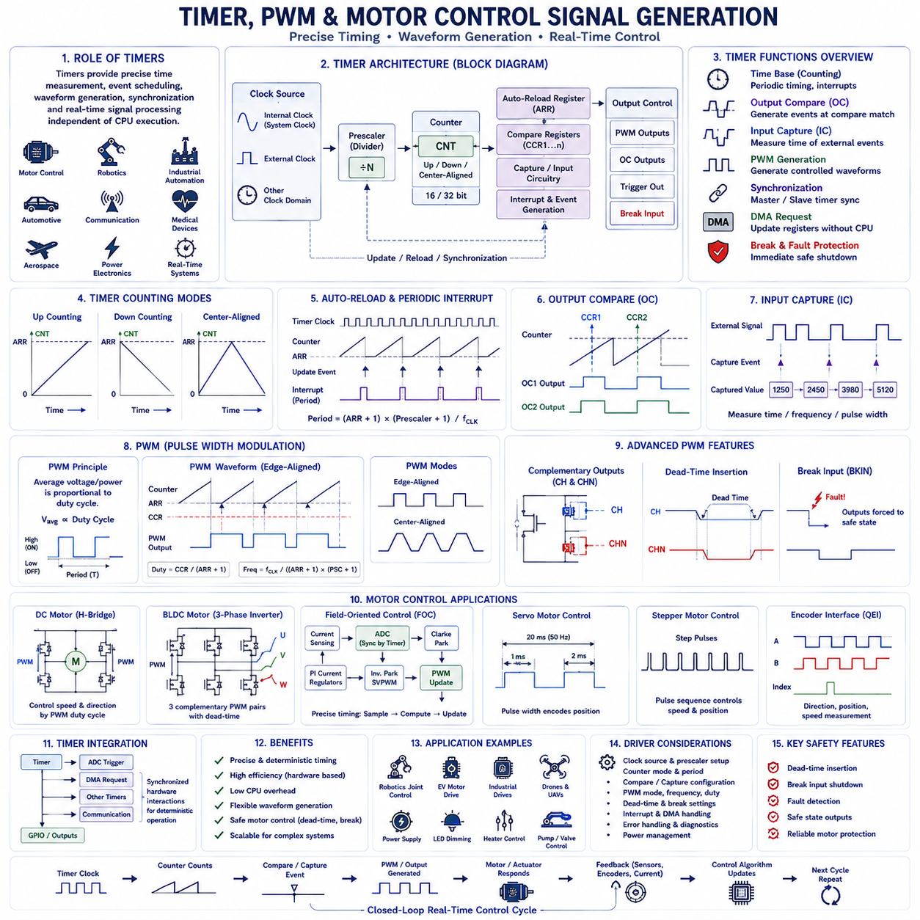
Timer peripherals represent one of the most versatile and indispensable hardware resources in modern embedded systems because they provide precise time measurement, deterministic event scheduling, waveform generation, motion control, communication synchronization, and real-time signal processing. Unlike ordinary software delays that depend on processor execution speed and operating system scheduling, hardware timers operate independently of software execution, ensuring highly accurate timing even when processors execute multiple concurrent tasks. Consequently, timer peripherals form the foundation of motor control, robotics, industrial automation, automotive electronics, communication systems, medical devices, aerospace applications, and nearly every real-time embedded platform requiring predictable temporal behavior.
A hardware timer fundamentally consists of a clock source, prescaler, counter register, auto-reload register, compare registers, capture circuitry, interrupt generation logic, and output control circuitry. The timer receives clock pulses from either the processor clock or an external timing source. A programmable prescaler divides the incoming frequency to achieve the desired timing resolution before incrementing or decrementing the timer counter. Once the counter reaches predefined values, hardware automatically generates interrupts, output transitions, communication triggers, DMA requests, or pulse-width modulation waveforms without requiring continuous processor intervention.
Clock selection represents the first critical design decision during timer configuration. Internal processor clocks provide highly accurate synchronization with software execution, while external clock sources enable measurement of independent physical events or synchronization with external systems. Advanced microcontrollers often support multiple clock domains, allowing timers to operate from high-speed processor clocks, low-power oscillators, external crystal references, or dedicated peripheral clocks. Driver software carefully selects clock sources according to application requirements for timing accuracy, energy efficiency, synchronization, and operating frequency.
The prescaler allows a high-frequency processor clock to be divided into slower timer frequencies appropriate for application timing requirements. For example, a 100 MHz processor clock can be divided to produce timer frequencies ranging from tens of megahertz down to only a few hertz. Higher timer frequencies provide finer timing resolution but shorter maximum timing intervals, while lower frequencies extend measurable durations at the expense of temporal precision. Driver configuration therefore balances timing accuracy against measurement range according to the operational requirements of the embedded application.
The timer counter serves as the primary timing element within every timer peripheral. Depending upon hardware capabilities, counters may increment upward, decrement downward, or operate bidirectionally through center-aligned counting modes. Counter width typically ranges from 16 bits to 32 bits, determining the maximum measurable interval before overflow occurs. Driver software initializes counter values, operating modes, overflow behavior, synchronization mechanisms, and counting direction while ensuring compatibility with the intended application timing requirements.
Auto-reload registers define the maximum counter value before automatic reset or reversal occurs. Once the counter reaches the programmed reload value, hardware immediately restarts the counting cycle while optionally generating interrupts, synchronization events, or waveform transitions. This mechanism enables highly accurate periodic timing without continuous processor supervision. Real-time operating systems, communication scheduling, industrial control loops, and robotics frequently employ periodic timer interrupts generated through auto-reload functionality to establish deterministic software execution intervals.
Output compare functionality enables timers to generate precisely timed output transitions when the counter matches programmable comparison values. Driver software configures comparison registers together with desired output actions including signal assertion, deassertion, toggling, pulse generation, or waveform modification. Output compare operation provides deterministic hardware timing independent of processor execution latency and therefore supports accurate communication protocols, synchronized triggering, industrial automation, robotics coordination, and digital control applications.
Input capture functionality performs the complementary operation by recording timer counter values whenever external signal transitions occur. Instead of generating output events, capture circuitry measures precisely when incoming signals arrive relative to timer operation. Driver software configures capture polarity, filtering, synchronization, interrupt generation, and timestamp acquisition. Input capture enables highly accurate measurement of pulse widths, signal frequencies, rotational velocity, encoder timing, communication characteristics, ultrasonic ranging, and external event timing.
Periodic interrupt generation represents one of the most widely utilized timer functions within embedded software. Rather than executing software delays or polling loops, processors respond to timer-generated interrupts occurring at deterministic intervals. Operating system scheduling, software timers, sensor sampling, communication maintenance, diagnostics, battery management, robotics control, and industrial automation frequently depend upon periodic interrupts generated by dedicated hardware timers. Driver implementation carefully minimizes interrupt execution time while preserving deterministic temporal behavior.
Pulse Width Modulation represents one of the most important timer applications because it enables efficient analog power control using purely digital switching signals. Rather than continuously varying output voltage, PWM repeatedly switches digital outputs between fully enabled and fully disabled states while controlling the percentage of time spent in each state during every switching cycle. The average electrical power delivered to external loads becomes proportional to duty cycle while maintaining exceptionally high power conversion efficiency.
PWM operation depends upon periodic timer counting combined with programmable compare values. During each counting cycle, timer outputs transition when counter values match comparison registers. Adjusting comparison values directly changes output duty cycle without modifying switching frequency. Driver software therefore controls analog-equivalent output power simply by updating compare registers while hardware autonomously generates precisely timed switching waveforms. This architecture enables deterministic motor control, power regulation, lighting control, heating systems, communication modulation, and actuator management.
PWM frequency significantly influences overall system performance. Lower switching frequencies reduce processor overhead and switching losses but may generate audible acoustic noise, mechanical vibration, or visible lighting flicker. Higher frequencies improve output smoothness while increasing switching losses and electromagnetic emissions. Motor controllers frequently employ PWM frequencies between several kilohertz and tens of kilohertz depending upon motor characteristics, power electronics, acoustic requirements, thermal constraints, and electromagnetic compatibility objectives.
Duty cycle determines the proportion of each PWM period during which output signals remain active. Zero percent duty cycle produces continuously disabled outputs, fifty percent duty cycle delivers approximately half the available average power, while one hundred percent duty cycle continuously enables outputs. Intermediate duty cycles provide proportional control over motor torque, rotational velocity, heating power, lighting brightness, valve position, pump flow, actuator force, and numerous other physical quantities. Driver software dynamically adjusts duty cycles according to feedback measurements, control algorithms, operating conditions, and application objectives.
Edge-aligned PWM generates output transitions at fixed timer boundaries before terminating pulses according to programmable comparison values. This approach offers straightforward implementation with efficient hardware utilization. Center-aligned PWM instead symmetrically positions switching transitions around the center of each timing period by counting both upward and downward. Center-aligned operation significantly reduces harmonic distortion, current ripple, electromagnetic interference, torque ripple, and acoustic noise while improving motor control performance within industrial and robotic applications.
Advanced timer peripherals provide complementary PWM outputs specifically designed for half-bridge and full-bridge power converters. Complementary outputs generate opposite switching signals controlling upper and lower power transistors while programmable dead time prevents simultaneous transistor conduction that would otherwise create destructive short circuits. Driver software carefully configures complementary channels, dead-time intervals, fault protection, emergency shutdown, and synchronization according to power electronics safety requirements.
Dead-time insertion represents one of the most critical safety mechanisms within motor control systems. Semiconductor switching devices require finite transition times during switching between conducting and non-conducting states. If complementary transistors simultaneously conduct even briefly, catastrophic shoot-through currents may destroy power electronics almost instantaneously. Hardware dead-time generators automatically delay complementary switching transitions by precisely controlled intervals measured in nanoseconds or microseconds, ensuring safe converter operation independent of processor execution timing.
Break input functionality further enhances motor control safety by immediately disabling PWM outputs whenever hardware fault conditions occur. External fault signals generated by overcurrent detectors, overvoltage protection circuits, emergency stop systems, thermal monitoring, functional safety controllers, or hardware diagnostics directly force PWM outputs into predefined safe states without waiting for processor software response. Driver initialization configures fault polarity, filtering, recovery behavior, output states, and restart procedures according to application-specific safety requirements.
Motor control represents the most demanding timer application because multiple hardware resources must operate with precise synchronization. Brushless DC motors, permanent magnet synchronous motors, induction motors, servo systems, stepper motors, and robotic actuators require tightly coordinated PWM generation, current measurement, encoder acquisition, communication scheduling, protection monitoring, and real-time feedback control. Timer drivers therefore coordinate numerous peripheral interactions while maintaining deterministic timing relationships throughout complex embedded control systems.
DC motor control commonly employs PWM signals to regulate average armature voltage supplied through H-bridge power converters. Driver software computes desired duty cycles according to velocity commands, current feedback, battery voltage, thermal limitations, acceleration profiles, and closed-loop control algorithms. Hardware timers autonomously generate switching waveforms while processors periodically update comparison values according to measured operating conditions and control objectives.
Brushless DC motor controllers require multiple synchronized PWM outputs driving three independent inverter phases. Driver implementations configure complementary switching pairs, center-aligned counting, dead-time insertion, current sampling synchronization, Hall sensor acquisition, encoder feedback, and fault monitoring. Precise timer coordination ensures smooth torque production while minimizing current ripple, switching losses, acoustic emissions, and mechanical vibration throughout motor operation.
Field-Oriented Control algorithms impose particularly demanding timing requirements upon timer peripherals. Current measurements must occur precisely synchronized with PWM switching to minimize measurement distortion caused by switching transients. Timer-generated hardware triggers initiate Analog-to-Digital Converter sampling at carefully selected electrical angles while processors subsequently execute Clarke transformations, Park transformations, current regulators, inverse transformations, and space-vector modulation before updating PWM duty cycles during the next switching period.
Servo motor control employs PWM differently from power conversion applications. Rather than varying duty cycle continuously, servo interfaces encode desired mechanical position through pulse widths repeated at relatively low frequencies. Standard hobby servos typically expect approximately fifty-hertz update rates with pulse widths ranging between approximately one and two milliseconds. Timer drivers therefore generate highly accurate pulse timing while minimizing jitter that would otherwise degrade positioning accuracy and mechanical stability.
Stepper motor drivers utilize timer-generated pulse sequences to determine rotational speed and movement distance. Each output pulse advances the motor by one microstep or full step depending upon driver configuration. Driver software calculates acceleration profiles, deceleration trajectories, velocity limits, jerk constraints, synchronization among multiple axes, and motion planning while hardware timers generate deterministic pulse trains independently of processor workload. Robotics, computer numerical control machinery, additive manufacturing systems, and laboratory automation extensively employ timer-controlled stepper motion.
Quadrature encoder interfaces constitute another specialized timer capability supporting precise position and velocity measurement. Rather than generating timing signals, timers decode two phase-shifted encoder channels directly within hardware while automatically tracking rotational direction, accumulated position, rotational velocity, overflow handling, and index pulse synchronization. Hardware encoder decoding substantially reduces processor workload while providing highly accurate motion feedback for robotics, industrial automation, autonomous vehicles, and precision positioning systems.
Timer synchronization enables multiple independent timer peripherals to operate cooperatively within large embedded systems. Master timers generate synchronization events initiating slave timer operation, PWM generation, analog sampling, communication scheduling, or coordinated actuator control. Hardware synchronization eliminates software timing uncertainty while ensuring deterministic relationships among multiple concurrent timing domains. Complex robotic manipulators, industrial production systems, synchronized power converters, and distributed control architectures frequently depend upon coordinated timer synchronization.
Direct Memory Access integration allows timer peripherals to autonomously update compare registers, waveform tables, pulse sequences, and output patterns without continuous processor intervention. DMA transfers periodically modify timer parameters according to predefined memory tables, enabling waveform synthesis, arbitrary signal generation, communication modulation, LED animation, digital power conversion, and complex actuator trajectories. Driver software configures synchronization events, buffer management, completion interrupts, and memory organization while maintaining transparent application interfaces.
Interrupt management remains essential despite extensive hardware automation because timers frequently notify software regarding overflow events, compare matches, capture completion, synchronization events, break conditions, or communication scheduling. Well-designed interrupt service routines execute rapidly, update software state, initiate subsequent operations, invoke callback functions, and defer computationally intensive processing toward background software contexts. Such interrupt architecture preserves deterministic response while maximizing processor availability for higher-level application logic.
Power management increasingly influences timer driver implementation within battery-powered embedded systems. Driver software selectively enables timer clocks, suspends inactive peripherals, preserves timer configuration during sleep transitions, coordinates wakeup scheduling, and restores deterministic operation following low-power modes. Some ultra-low-power timers continue operating even while primary processor clocks remain disabled, enabling long-duration timing with exceptionally low energy consumption.
Error handling and diagnostic capability significantly improve timer reliability within safety-critical applications. Driver software validates configuration parameters, detects invalid prescaler values, identifies synchronization failures, monitors overflow conditions, verifies DMA completion, reports capture errors, detects communication inconsistencies, and supports graceful recovery following abnormal operating conditions. Comprehensive diagnostics simplify system verification while supporting predictive maintenance, functional safety certification, and long-term operational reliability.
Professional timer driver implementation follows disciplined software engineering principles emphasizing modularity, hardware abstraction, deterministic execution, parameter validation, interrupt minimization, comprehensive documentation, defensive programming, and compliance with standards including MISRA C, AUTOSAR, IEC 61508, and ISO 26262 where appropriate. Such structured implementation improves maintainability, portability, certification readiness, software reuse, verification efficiency, and long-term scalability across multiple embedded platforms.
Modern robotic systems integrate timer peripherals throughout nearly every subsystem. Motor controllers generate synchronized PWM waveforms controlling traction motors, robotic joints, and manipulators. Sensor acquisition synchronizes analog sampling with mechanical motion. Communication scheduling coordinates deterministic industrial networks. Encoder interfaces measure precise mechanical position and velocity. Servo outputs position cameras, grippers, and articulated mechanisms. Safety controllers immediately disable power electronics through hardware break inputs whenever abnormal conditions arise. Together these timer-driven functions establish the deterministic temporal foundation supporting perception, motion planning, closed-loop control, diagnostics, energy management, functional safety, and autonomous operation.
Ultimately, timer peripherals represent far more than simple timekeeping devices. They provide comprehensive hardware infrastructure supporting deterministic scheduling, precision waveform generation, pulse-width modulation, motor control, synchronized sensing, communication timing, encoder acquisition, DMA acceleration, safety protection, power optimization, and real-time coordination throughout embedded systems. Carefully designed timer and PWM driver architectures transform precise digital timing into controlled physical motion, efficient energy conversion, accurate actuator control, and synchronized real-time behavior, making them indispensable building blocks for industrial automation, intelligent transportation, medical equipment, aerospace systems, robotics, and the rapidly advancing ecosystem of future Physical AI platforms.

02.06 DMA Architecture and High-Speed Data Transfer [w/Code]
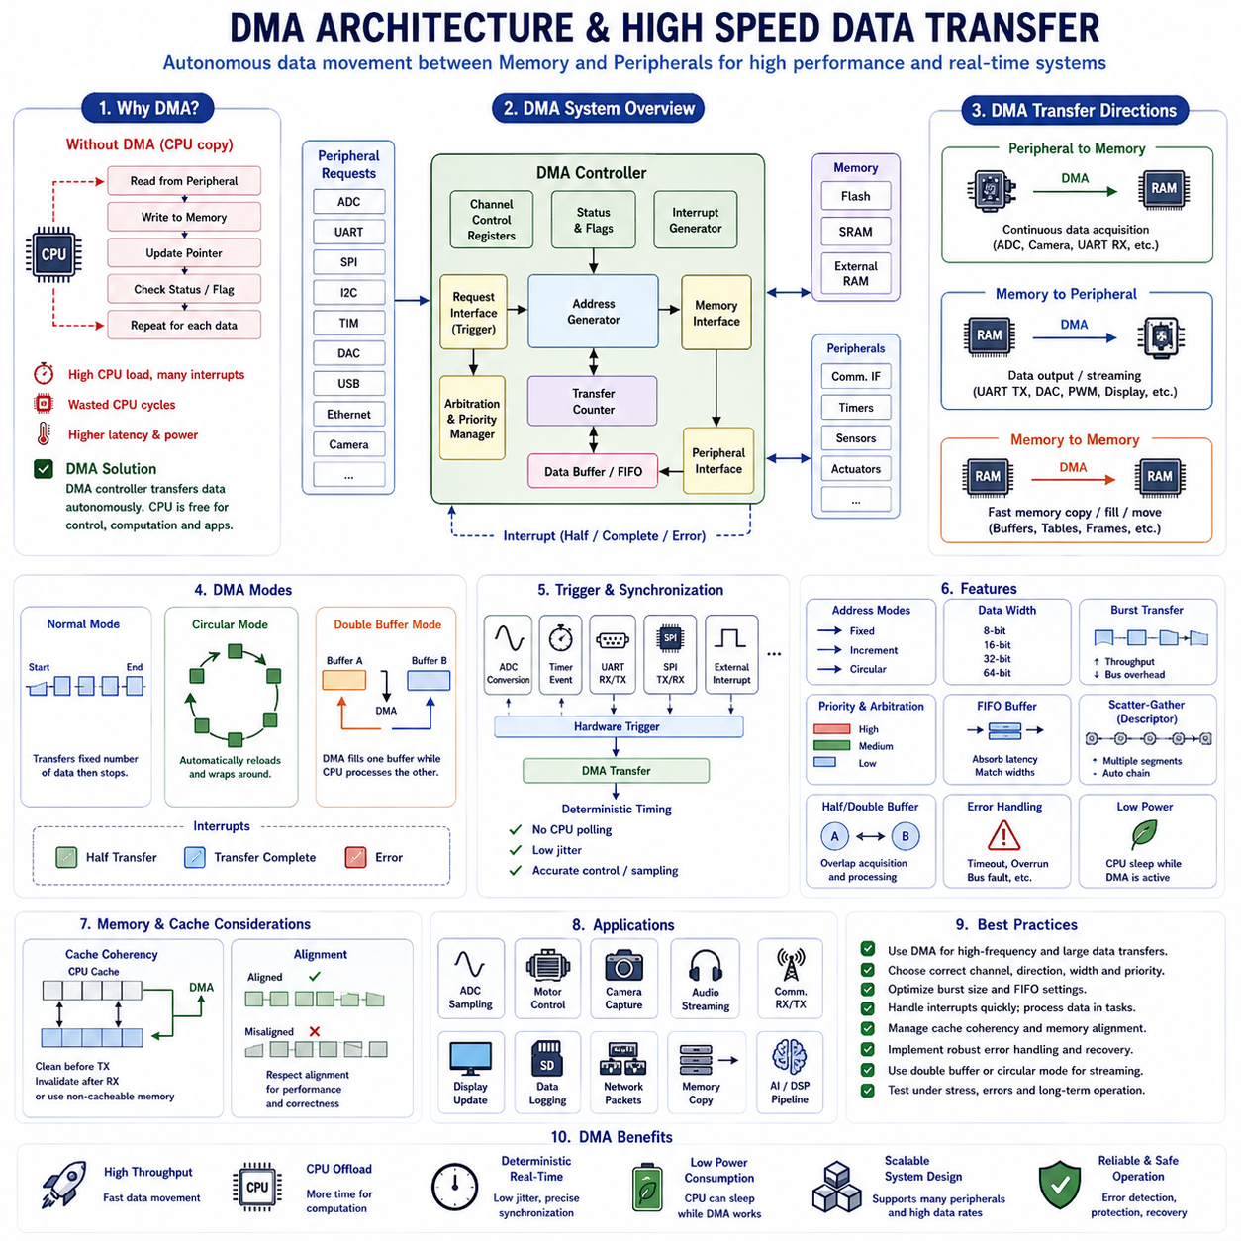
Direct Memory Access (DMA) is a hardware mechanism that transfers data between memory and peripheral devices without requiring the Central Processing Unit (CPU) to execute an instruction for every byte or word. Within microcontroller programming, DMA connects communication, sensing, waveform generation, and memory operations to dedicated transfer hardware, enabling high throughput while preserving processor time for control, diagnostics, communication protocols, and application logic.
Without DMA, the CPU normally reads data from a peripheral register, stores it in memory, updates a pointer, checks status flags, and repeats the sequence for every data element. This processor-driven method is easy to understand but becomes inefficient when ADCs, cameras, communication interfaces, audio devices, or high-rate sensors continuously produce data. Frequent interrupts and copying operations may consume most available execution cycles.
A DMA controller acts as an autonomous data movement engine connected to the system bus. Software configures a source address, destination address, transfer count, data width, transfer direction, address increment behavior, request source, priority, and interrupt options. Once activated, the controller performs the transfer independently and informs software only when a defined event, such as half completion, full completion, or an error, occurs.
The internal DMA architecture normally includes peripheral and memory interfaces, address generators, transfer counters, request synchronization logic, channel arbitration, status registers, and interrupt generation circuits. The address generator determines where each data element is read and written, while the transfer counter tracks remaining data. Arbitration logic resolves simultaneous requests when several channels compete for access to memory or peripheral buses.
Microcontrollers commonly provide several DMA channels or streams that can be associated with ADC, DAC, UART, SPI, I²C, timers, Ethernet, USB, SDMMC, camera interfaces, cryptographic engines, and other hardware modules. Some devices use fixed channel-to-peripheral mappings, while more advanced controllers include request multiplexers that allow flexible routing of peripheral events to available DMA channels.
Peripheral-to-memory transfer is used when hardware continuously generates information that must be stored for later processing. ADC samples, UART receive data, SPI sensor streams, camera pixels, microphone samples, encoder measurements, radar frames, and network packets can be copied directly into SRAM. The CPU can then analyze completed buffers without being interrupted for every individual sample or communication byte.
Memory-to-peripheral transfer supports data generated by software that must be delivered to hardware at a controlled rate. Typical examples include UART transmission, SPI display updates, DAC waveform generation, PWM duty-cycle tables, audio playback, network packet transmission, and motor-control reference sequences. DMA reads the prepared data from memory and supplies the peripheral whenever its hardware request becomes active.
Memory-to-memory operation allows DMA to accelerate buffer copying, memory initialization, frame rearrangement, packet assembly, image preparation, table movement, and other repetitive data operations. Although a CPU can execute these tasks directly, DMA may complete large transfers with lower software overhead. This capability is especially valuable when the processor must simultaneously execute real-time control or computationally intensive algorithms.
Source and destination address modes define how addresses change after each transfer. A peripheral register usually remains at a fixed address, while the memory address increments after each byte, half-word, or word. In memory-to-memory operations, both addresses normally increment. Incorrect increment configuration may repeatedly overwrite one memory location or access invalid addresses, making parameter validation essential.
Transfer width must match the peripheral register and memory data representation. Common choices include 8-bit bytes, 16-bit half-words, and 32-bit words. Some advanced systems additionally support 64-bit transfers or programmable bursts. Mismatched widths may truncate data, introduce alignment faults, waste memory bandwidth, or produce incorrect peripheral behavior, particularly when ADC results or communication frames use specific formats.
Normal DMA mode stops after the programmed number of transfers has completed. It is suitable for finite transactions such as sending a communication packet, reading a sensor register block, copying a frame, or updating a display region. Software receives a completion event, processes the result, and reconfigures or restarts the channel when another transaction becomes necessary.
Circular DMA mode automatically reloads the transfer count and returns the memory pointer to the beginning of the buffer after reaching its end. This mode supports continuous ADC acquisition, UART reception, audio streaming, sensor monitoring, and periodic control data. Because hardware does not stop between cycles, software must process data rapidly enough to avoid losing information when new samples overwrite unprocessed values.
Half-transfer and full-transfer interrupts allow continuous acquisition and processing to overlap. When DMA fills the first half of a buffer, software begins processing that section while the controller continues filling the second half. After the complete buffer is filled, software processes the second section while acquisition returns to the first. This ping-pong pattern reduces latency and supports predictable streaming pipelines.
Double-buffer mode formalizes this approach by providing two independently addressable memory regions. DMA writes into one buffer while the CPU, DSP, or AI accelerator processes the other. Hardware or driver logic then exchanges their roles at transfer boundaries. Double buffering prevents acquisition and processing from accessing the same region simultaneously and is widely used in imaging, audio, robotics, and digital signal processing.
DMA requests are usually generated by hardware events rather than ordinary software timing. An ADC may request transfer after each conversion, UART may request data when its transmit register becomes empty, SPI may request service when receive data becomes available, and a timer may request updates on every compare event. Hardware triggering removes software jitter and preserves precise timing relationships between peripherals and memory.
Timer-triggered DMA is particularly valuable for deterministic signal generation and control. A timer event can initiate movement of waveform values into a DAC, update PWM compare registers, load GPIO output patterns, or schedule communication data. Since the timer and DMA operate independently from task scheduling, output timing remains stable even when the CPU executes interrupts, operating-system services, or complex algorithms.
Channel priority controls how the DMA controller handles simultaneous transfer requests. Safety-related sensing, motor-current acquisition, communication deadlines, or real-time control data may receive high priority, while logging, user-interface updates, or background storage receive lower priority. Priority configuration must be coordinated with system-bus behavior because excessive high-priority traffic may delay CPU memory access or starve lower-priority channels.
Burst transfers improve efficiency by moving several consecutive data elements during one bus ownership period. This reduces arbitration overhead and increases sustained bandwidth for memory, display, camera, Ethernet, storage, and AI-related workloads. However, long bursts can delay other bus masters, including the CPU, so burst length must balance throughput with real-time responsiveness and fair resource sharing.
FIFO support may be included between the source and destination interfaces. A DMA FIFO absorbs differences in transfer width, bus latency, burst size, and peripheral request timing. It can combine smaller peripheral transfers into larger memory bursts or temporarily store data when the destination bus is busy. Driver software must configure FIFO thresholds and error handling according to throughput and latency requirements.
DMA interrupt handling should remain short and deterministic. The interrupt service routine normally identifies the channel, checks completion or error flags, clears the hardware condition, updates driver state, records diagnostics, and notifies a task through a callback, semaphore, event flag, or queue. Large-scale data processing should occur outside the interrupt context to avoid delaying other time-critical interrupts.
Transfer errors may result from invalid addresses, inaccessible memory regions, alignment violations, bus faults, incorrect channel selection, FIFO overflow, synchronization loss, peripheral failure, or memory protection rules. Robust drivers distinguish error types, stop unsafe transfers, preserve diagnostic information, reset affected hardware when necessary, and return the peripheral and DMA channel to a known recoverable state.
Cache coherency becomes critical on high-performance microcontrollers and embedded processors with data caches. CPU-written transmit data may remain in cache instead of reaching physical memory, while DMA-received data may update memory without refreshing cached copies. Drivers must clean cache lines before transmission, invalidate them after reception, use memory barriers, or place DMA buffers in non-cacheable memory regions.
Buffer alignment also affects correctness and performance. DMA buffers should satisfy the alignment requirements of transfer width, cache lines, bus architecture, memory protection, and peripheral hardware. Proper alignment avoids split transactions and access faults while simplifying cache maintenance. Linker scripts or compiler attributes are often used to place DMA buffers in dedicated SRAM sections with predictable addresses.
Memory protection mechanisms can restrict DMA access even when the CPU can reach a particular address. Some processors include bus security controllers, TrustZone attribution, firewalls, or DMA-specific privilege settings. Secure systems must ensure that non-secure DMA channels cannot read cryptographic keys, protected firmware, safety data, or unauthorized memory while still allowing legitimate peripheral transfers.
Scatter-gather DMA processes multiple noncontiguous memory regions through descriptor tables. Each descriptor specifies addresses, transfer size, configuration, and a pointer to the next operation. Hardware follows the chain without requiring software intervention between segments. This capability is useful for network packets, storage blocks, fragmented buffers, image planes, file systems, and complex communication protocols.
Linked-list DMA extends descriptor-based operation by supporting configurable sequences of peripheral, memory, and synchronization actions. Software can prepare a complete acquisition or output pipeline before execution begins. Advanced microcontrollers use linked lists to coordinate multi-channel ADC sampling, camera frames, waveform generation, communication packets, and sensor-processing stages with minimal CPU involvement.
DMA drivers should expose clear state transitions such as reset, ready, busy, half-complete, complete, aborted, timeout, and error. Explicit state management prevents the same channel from being configured by multiple modules simultaneously. In RTOS-based systems, mutexes protect configuration operations, while semaphores, queues, task notifications, and event flags communicate asynchronous completion to waiting software components.
Aborting a DMA operation requires more than merely disabling the channel. The driver may need to stop the peripheral request source, wait for current bus transactions to complete, clear pending flags, reset FIFO state, restore peripheral registers, invalidate partial data, and notify dependent tasks. A carefully designed abort sequence prevents stale requests or incomplete transfers from corrupting subsequent operations.
Power efficiency is a major advantage of DMA. The CPU can execute meaningful computation or enter a sleep state while DMA continues moving data between active peripherals and memory. Communication completion or buffer thresholds can wake the processor only when software attention is necessary. This event-driven architecture reduces instruction execution, interrupt frequency, and energy consumption in battery-powered systems.
Performance analysis should consider more than nominal transfer speed. Engineers must evaluate bus contention, memory latency, cache maintenance cost, interrupt rate, peripheral request frequency, burst size, FIFO behavior, buffer-processing time, and worst-case system load. A DMA channel capable of high peak throughput may still produce missed deadlines if shared-bus arbitration and software processing are not engineered as one system.
In motor control, DMA can transfer timer-triggered ADC current measurements into memory and update PWM compare values at exact control-cycle boundaries. This reduces timing jitter between sensing and actuation. The CPU receives completed sample groups, calculates control outputs, and prepares the next duty-cycle values while DMA and timers maintain deterministic acquisition and waveform-generation timing.
In robotic perception systems, DMA connects cameras, LiDAR interfaces, IMUs, microphones, encoders, and communication controllers to memory buffers. The processor or accelerator analyzes one dataset while hardware acquires the next. This concurrency allows localization, mapping, object recognition, navigation, sensor fusion, and safety monitoring to execute without being overwhelmed by low-level copying operations.
Professional DMA implementation requires clear hardware abstraction, validated configuration, bounded interrupt execution, static or controlled buffer allocation, explicit cache handling, memory protection awareness, comprehensive diagnostics, and documented timing assumptions. Coding standards such as MISRA C, AUTOSAR, and CERT C help prevent unsafe pointer use, uncontrolled shared state, and ambiguous error handling within safety-oriented embedded systems.
Testing should verify finite, circular, half-transfer, double-buffer, peripheral-to-memory, memory-to-peripheral, and memory-to-memory modes under normal and abnormal conditions. Verification must include incorrect alignment, invalid size, simultaneous channel activity, peripheral timeout, buffer overrun, abort handling, cache interaction, priority contention, sleep transitions, and long-duration stress operation to demonstrate reliable behavior.
Ultimately, DMA architecture separates repetitive data movement from intelligent computation. Dedicated transfer hardware manages high-speed communication while the CPU performs control, reasoning, diagnostics, planning, and application processing. When channels, buffers, priorities, triggers, caches, interrupts, protection, and recovery mechanisms are engineered together, DMA provides scalable throughput, deterministic timing, lower energy consumption, and reliable operation for advanced embedded systems, autonomous robots, intelligent vehicles, industrial automation, medical equipment, aerospace electronics, and future Physical AI platforms.

02.07 Low Power Design: Sleep Modes and Wakeup Strategies
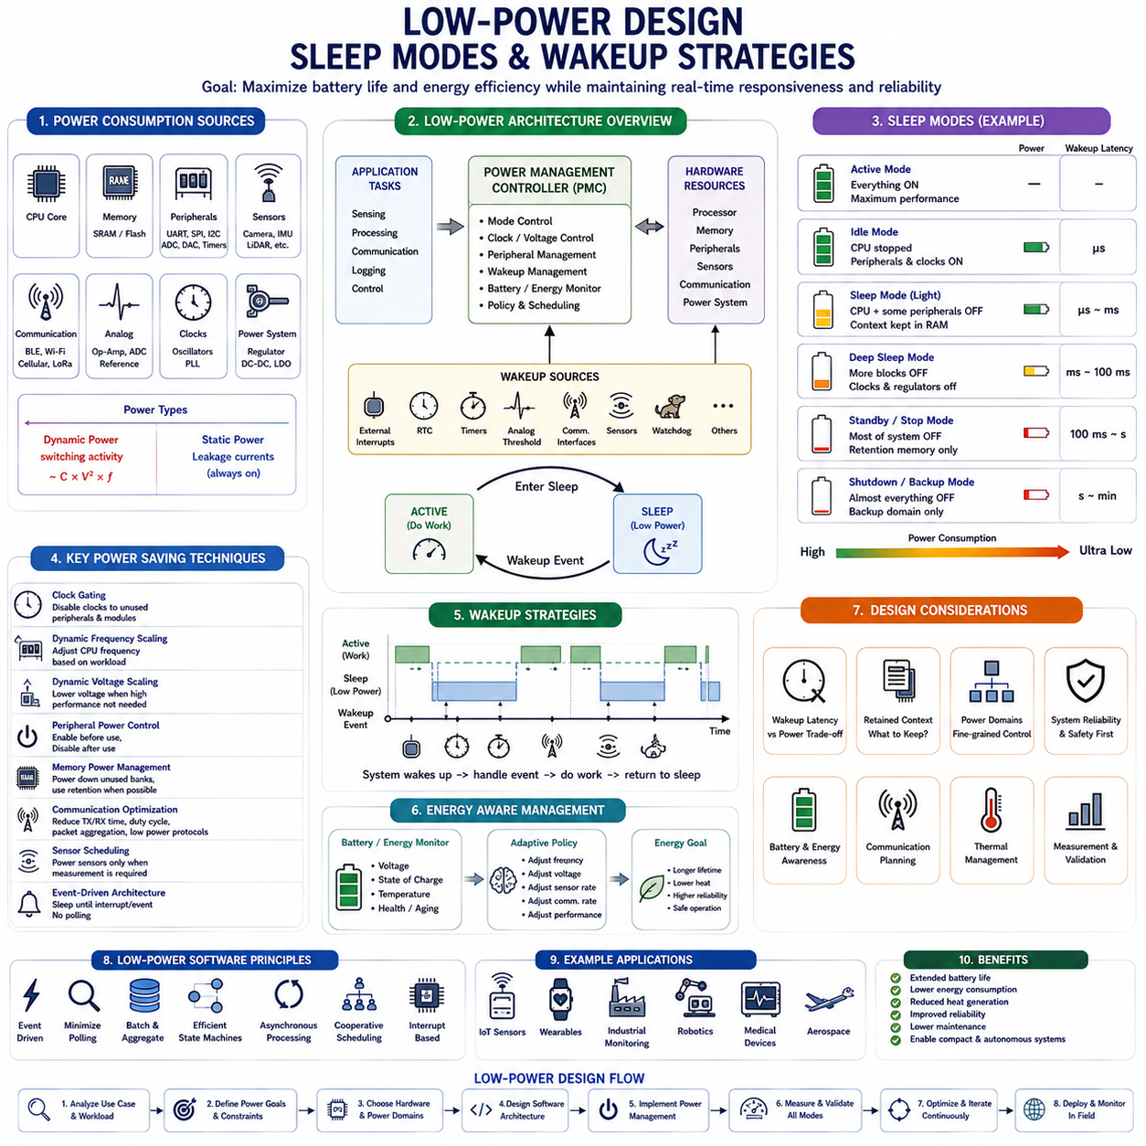
Modern embedded systems increasingly operate from batteries, harvested energy, or strict power budgets, making low-power design one of the most important aspects of embedded software architecture. Unlike desktop computers or servers that typically prioritize computational performance, embedded devices often spend the majority of their operational lifetime waiting for external events while consuming as little energy as possible. Wireless sensor networks, wearable electronics, medical devices, industrial monitoring systems, Internet of Things platforms, autonomous robots, aerospace electronics, and automotive control units all depend on carefully engineered power management strategies to maximize operating lifetime without sacrificing reliability or real-time responsiveness.
Power consumption within an embedded system originates from several hardware components including the processor core, memory, communication interfaces, sensors, analog peripherals, clocks, voltage regulators, external devices, and power conversion circuits. Dynamic power is primarily consumed when transistors switch states during computation, while static power results from leakage currents that continue flowing even when circuits remain inactive. As semiconductor technologies continue shrinking, leakage power becomes an increasingly significant portion of total energy consumption, making hardware shutdown and intelligent sleep management essential design considerations rather than optional optimizations.
A successful low-power architecture begins during the earliest stages of system design rather than being added after software development has finished. Engineers analyze expected operating scenarios, identify active and idle periods, estimate processor utilization, classify peripheral activity, evaluate communication frequency, determine acceptable wakeup latency, and establish battery life targets before implementing application software. This system-level approach allows hardware selection, software architecture, communication scheduling, and power management algorithms to be optimized together instead of independently.
Processor operating states are generally divided into several progressively lower-power modes. During active mode, the processor executes instructions normally while all required clocks remain enabled. Idle mode typically suspends instruction execution while maintaining peripheral clocks so communication and timing functions continue operating. Sleep modes disable progressively more hardware resources while preserving sufficient system context for rapid recovery. Deep sleep, standby, shutdown, or backup modes disable nearly all circuitry except specifically selected wakeup resources, achieving extremely low current consumption at the expense of longer recovery times.
Clock management represents one of the most effective techniques for reducing processor power consumption because switching activity directly depends upon clock frequency. Clock gating selectively disables clocks supplied to unused peripherals, timers, communication modules, cryptographic engines, memory interfaces, and processor subsystems. Rather than powering entire hardware blocks continuously, software enables clocks only when individual peripherals perform useful work. Since disabled circuits no longer receive clock transitions, unnecessary dynamic power consumption is significantly reduced without altering functional behavior.
Dynamic Frequency Scaling adjusts processor operating frequency according to computational demand. During periods requiring intensive digital signal processing, artificial intelligence inference, image processing, or communication, processors may operate at maximum frequency. During monitoring, waiting, logging, or background maintenance, lower frequencies often provide sufficient computational capability while substantially reducing dynamic power consumption. Intelligent frequency management balances application performance against energy efficiency throughout changing operating conditions.
Dynamic Voltage Scaling further extends energy reduction by decreasing processor supply voltage whenever maximum computational performance is unnecessary. Since dynamic power approximately scales with the square of supply voltage, even modest voltage reductions produce substantial energy savings. However, reduced voltage also limits maximum operating frequency and timing margins. Driver software therefore coordinates voltage and frequency transitions carefully to maintain reliable operation under all environmental conditions and computational workloads.
Peripheral power management complements processor sleep operation because communication interfaces, analog converters, sensors, timers, memory controllers, wireless transceivers, and display modules frequently consume considerable energy even while processors remain inactive. Driver software explicitly enables peripheral clocks before operation, performs required communication or measurement tasks, safely disables hardware afterward, and confirms completion before entering sleep. Effective peripheral management often reduces overall system power more significantly than processor optimization alone.
Memory also contributes significantly to embedded power consumption. Static Random Access Memory continuously consumes leakage current while retaining stored information, whereas Flash memory primarily consumes energy during read or programming operations. Some processors partition memory into independently controlled banks allowing unused regions to enter retention or complete shutdown modes. Software allocates frequently accessed data within retained memory while permitting temporary buffers, caches, or unused regions to be powered down during extended idle periods.
Communication interfaces frequently dominate power consumption within wireless embedded systems. Bluetooth Low Energy, Wi-Fi, Zigbee, LoRa, cellular networks, satellite communication, and industrial radio modules consume considerable energy during transmission and reception. Consequently, efficient software minimizes communication frequency, aggregates multiple messages into larger packets, schedules periodic synchronization, compresses transmitted information, and avoids unnecessary network activity whenever possible. Communication planning therefore becomes an integral component of overall power management strategy.
Sensor operation similarly requires careful scheduling because many sensing devices consume substantial energy during measurement despite remaining inactive most of the time. Cameras, LiDAR systems, radar modules, environmental sensors, gas analyzers, inertial measurement units, microphones, ultrasonic sensors, and precision analog circuits may require startup delays before stable operation begins. Driver software activates sensors shortly before required measurements, performs acquisition efficiently, stores results, and immediately returns hardware to low-power states after completion.
Sleep mode selection depends upon application requirements for wakeup latency, retained system context, energy consumption, and available wakeup sources. Light sleep typically preserves processor registers, memory contents, and peripheral configuration while allowing rapid wakeup within microseconds. Deeper sleep modes disable additional hardware resources, requiring partial hardware reinitialization after wakeup but providing significantly lower current consumption. The deepest standby or shutdown modes often reset large portions of the system while retaining only specifically designated backup registers or retention memory.
Wakeup sources determine when processors resume execution from low-power states. External interrupts generated by push buttons, motion detectors, safety sensors, communication interfaces, real-time clocks, timers, analog threshold detectors, watchdog timers, battery management circuits, capacitive touch sensors, or wireless modules commonly trigger wakeup events. Driver software configures polarity, filtering, debounce mechanisms, interrupt priority, and wakeup permissions before entering sleep to ensure reliable system recovery under expected operating conditions.
Real-Time Clock peripherals frequently remain active even while nearly all other processor circuitry has been disabled. Low-frequency crystal oscillators provide highly accurate timekeeping with extremely small energy consumption, allowing software to schedule periodic wakeups after predefined intervals. Environmental monitoring, periodic communication, maintenance tasks, data logging, battery supervision, predictive diagnostics, and synchronized network operation commonly employ RTC-generated wakeup events to balance functionality with energy efficiency.
Timer-based wakeup mechanisms extend periodic scheduling beyond long-duration real-time clocks. Low-power timers continue operating within selected sleep modes and generate interrupts after precisely defined intervals. Software combines timer wakeups with event-driven processing, enabling deterministic sampling frequencies for sensors, communication protocols, motor supervision, diagnostics, or industrial monitoring while avoiding continuous processor activity between scheduled operations.
Interrupt-driven architecture forms the foundation of modern low-power embedded software. Rather than continuously polling hardware status, processors remain asleep until interrupts indicate meaningful external events requiring software attention. This event-driven execution model dramatically reduces unnecessary processor activity while simultaneously improving system responsiveness because hardware immediately notifies software whenever significant changes occur. Well-designed interrupt systems therefore improve both energy efficiency and real-time performance.
Wakeup latency represents the elapsed time between a wakeup event and the moment software resumes useful execution. Latency includes oscillator startup, clock stabilization, voltage regulator activation, memory availability, peripheral initialization, pipeline synchronization, interrupt handling, and software context restoration. Applications involving motor control, industrial safety, autonomous navigation, communication deadlines, or functional safety must carefully evaluate whether selected sleep modes satisfy worst-case timing requirements.
Context preservation significantly influences wakeup complexity. Some processors automatically retain general-purpose registers, stack pointers, peripheral configuration, memory contents, interrupt masks, and processor status during light sleep. Deeper power-saving modes may preserve only backup registers or selected retention memory while requiring complete software initialization after reset. Application software therefore determines which operational state must survive sleep transitions and stores essential information before entering low-power modes.
Power domains partition integrated circuits into independently controlled hardware regions. Processor cores, memories, communication interfaces, analog peripherals, graphics engines, artificial intelligence accelerators, and external buses may each belong to separate voltage domains. Software selectively enables only domains currently required for application execution while disabling inactive regions. Fine-grained power domain management provides substantially greater energy savings than global processor sleep alone.
Modern embedded processors often incorporate hardware power controllers that automate many aspects of low-power operation. Dedicated hardware sequences oscillator shutdown, voltage transitions, clock switching, memory retention, regulator control, and wakeup sequencing without extensive software intervention. Driver software primarily configures operating policies and desired power states while hardware safely performs the detailed transition process according to device-specific timing requirements.
Battery-powered products require additional software awareness of available energy. Battery voltage, charging state, temperature, discharge current, aging characteristics, remaining capacity, and predicted operating lifetime influence power management decisions. Applications may progressively reduce processor frequency, communication rate, display brightness, sensing frequency, or computational complexity as battery capacity decreases while reserving sufficient energy for critical safety functions or orderly system shutdown.
Energy harvesting systems introduce additional complexity because available power continuously changes according to environmental conditions. Solar panels, vibration generators, thermal gradients, radio frequency harvesting, and piezoelectric devices may provide highly variable energy levels. Embedded software therefore dynamically adapts sensing frequency, communication intervals, processor activity, and storage behavior according to harvested energy availability rather than assuming constant battery capacity.
Low-power communication protocols intentionally minimize radio activity because wireless transmission often dominates total energy consumption. Protocols employ duty cycling, synchronized wakeup schedules, beacon intervals, sleep coordination, packet aggregation, adaptive transmission power, acknowledgment optimization, and compressed communication formats to reduce active radio time while maintaining reliable connectivity. Software architecture closely coordinates application scheduling with communication opportunities to avoid unnecessary wakeup events.
Autonomous robotic systems present unique low-power challenges because processors, sensors, actuators, communication systems, localization hardware, and artificial intelligence accelerators consume significant energy simultaneously. Robots dynamically transition between active navigation, perception, waiting, charging, standby monitoring, and maintenance modes. Power management software coordinates processor sleep, sensor scheduling, motor controller activation, wireless communication, battery supervision, and wakeup logic while ensuring immediate response to safety-critical events.
Internet of Things devices often demonstrate the most aggressive application of low-power principles. Many battery-powered sensors remain asleep for more than ninety-nine percent of their operational lifetime, waking only briefly to collect measurements, process data, transmit results, and immediately return to sleep. Achieving multi-year battery lifetime therefore depends more upon minimizing active duration and wakeup frequency than optimizing computational efficiency during active execution.
Power optimization should always be validated through quantitative measurement rather than assumptions. Engineers measure current consumption within every operating mode, characterize wakeup transitions, evaluate battery lifetime under representative workloads, identify unexpected leakage paths, verify peripheral shutdown, monitor communication duty cycles, and compare measured results against design objectives. Accurate measurement frequently reveals hidden energy consumption sources overlooked during software development.
Software architecture strongly influences overall energy efficiency. Event-driven programming, asynchronous communication, deferred processing, batch data handling, cooperative scheduling, efficient state machines, interrupt-based synchronization, and minimal polling all contribute to reduced processor utilization. Well-structured software naturally creates long uninterrupted sleep intervals, whereas poorly organized software frequently wakes processors unnecessarily, dramatically shortening battery lifetime despite using identical hardware.
Reliable wakeup strategies require comprehensive fault handling because wakeup events may occur unexpectedly, simultaneously, or under abnormal environmental conditions. Driver software validates wakeup sources, filters false triggers, prevents repeated oscillation between sleep and active states, restores hardware safely, verifies clock stability, confirms peripheral readiness, and records diagnostic information whenever abnormal wakeup sequences occur. Such defensive design improves long-term reliability in unattended embedded deployments.
Professional low-power software development follows disciplined engineering practices emphasizing deterministic state transitions, explicit peripheral ownership, validated power sequencing, documented wakeup behavior, comprehensive testing, hardware abstraction, modular driver architecture, defensive programming, and compliance with standards such as MISRA C, AUTOSAR, IEC 61508, and ISO 26262 where appropriate. Thorough verification ensures every supported sleep mode, wakeup source, battery condition, communication scenario, and fault condition operates safely throughout the product lifetime.
Ultimately, low-power design extends far beyond simply placing processors into sleep mode. It represents a comprehensive architectural philosophy integrating processor states, clocks, voltage management, peripheral control, communication scheduling, memory retention, battery supervision, wakeup strategies, event-driven software, and application behavior into a unified energy management system. Well-engineered low-power architectures dramatically extend operating lifetime, reduce thermal generation, improve reliability, lower maintenance requirements, and enable advanced embedded systems, autonomous robots, intelligent vehicles, industrial monitoring platforms, medical devices, aerospace electronics, and future Physical AI systems to operate efficiently within demanding real-world energy constraints.

02.08 MCU Security Features: TrustZone / Flash Protection
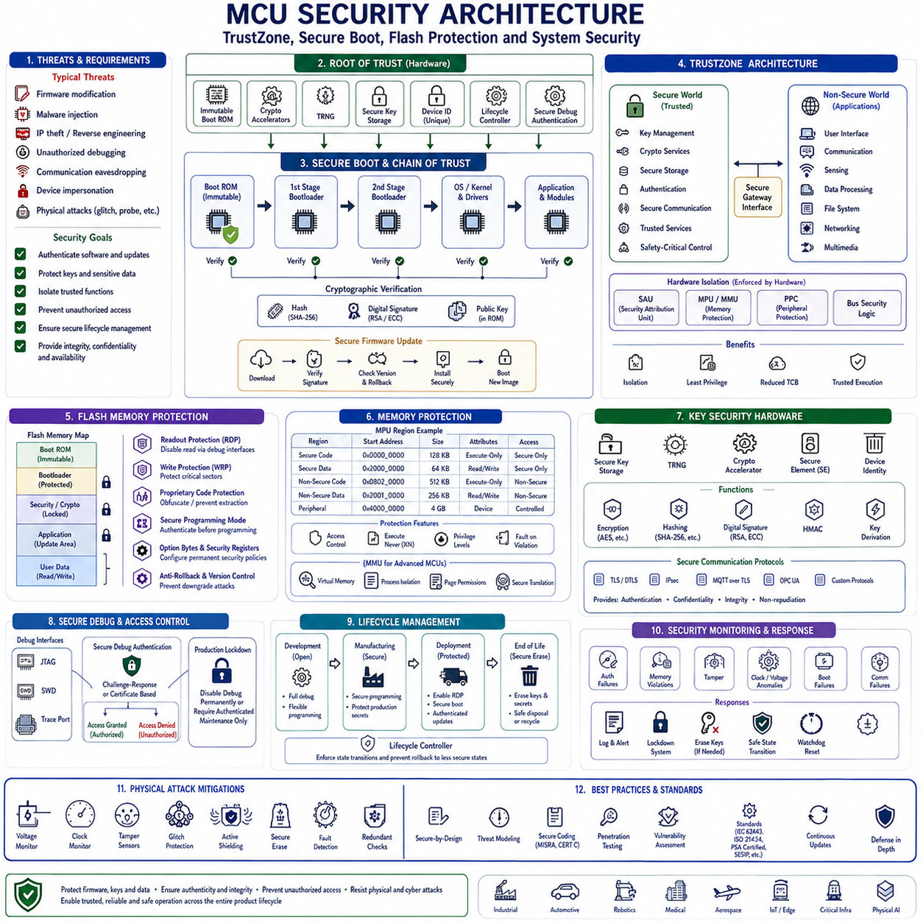
Modern microcontrollers increasingly operate as connected computing platforms rather than isolated embedded devices, making security a fundamental architectural requirement instead of an optional feature. Industrial automation, autonomous robots, automotive electronic control units, medical devices, aerospace systems, Internet of Things products, and intelligent edge computing platforms continuously exchange software updates, communicate over public and private networks, and process sensitive operational data. These systems must defend themselves against unauthorized firmware modification, intellectual property theft, malicious software injection, physical debugging attacks, communication interception, and system impersonation. Consequently, modern MCU security architectures integrate multiple layers of hardware and software protection that establish a trusted execution environment throughout the entire product lifecycle.
Embedded security begins with the concept of the hardware Root of Trust. The Root of Trust is the small collection of immutable hardware resources that establish the initial trust relationship for every software component executed on the processor. Because software itself cannot verify its own authenticity before execution begins, security must originate from hardware mechanisms that remain protected throughout the device lifetime. Typical Root of Trust components include immutable Boot ROM, cryptographic accelerators, hardware random number generators, secure key storage, device identity registers, lifecycle controllers, and secure debug authentication hardware.
Secure Boot represents one of the most important security mechanisms implemented in modern microcontrollers. Rather than executing application firmware immediately after reset, Secure Boot first verifies the authenticity and integrity of the software image using cryptographic techniques. The immutable Boot ROM computes a cryptographic hash of the firmware, verifies its digital signature using trusted public keys stored inside secure hardware, and transfers execution only if verification succeeds. Any modification of firmware contents invalidates the signature and prevents unauthorized code execution, protecting the system against malware injection and firmware tampering.
The cryptographic foundation of Secure Boot relies upon modern public-key cryptography and secure hashing algorithms. Hash functions such as SHA-256 produce fixed-length fingerprints uniquely representing firmware contents, while asymmetric algorithms including RSA and Elliptic Curve Digital Signature Algorithm verify digital signatures without exposing private signing keys. Hardware cryptographic accelerators significantly reduce authentication time while preventing software implementation vulnerabilities and improving resistance against timing attacks and fault injection attempts.
A secure boot chain extends protection beyond the initial firmware image. The Boot ROM authenticates the first-stage bootloader, which subsequently verifies the second-stage bootloader, operating system kernel, middleware, drivers, application software, and optionally downloadable software modules. Every stage verifies the integrity of the next stage before transferring execution, creating a complete Chain of Trust throughout system startup. This hierarchical verification architecture prevents unauthorized software from entering the execution environment even if attackers compromise individual software components.
Secure firmware update mechanisms complement Secure Boot by ensuring that only authenticated software images may replace existing firmware during field operation. Firmware updates distributed through USB, Ethernet, Wi-Fi, Bluetooth, cellular communication, or Over-the-Air delivery undergo signature verification before installation. Version control, rollback protection, compatibility checking, and secure installation procedures prevent attackers from installing outdated vulnerable firmware or unauthorized software images while preserving reliable remote maintenance capability.
TrustZone technology extends hardware security by partitioning processor resources into Secure and Non-Secure execution environments. Originally developed for ARM processors, TrustZone creates hardware-enforced isolation between trusted software responsible for cryptographic operations, secure storage, authentication, and safety-critical control functions, and ordinary application software that manages user interfaces, communication, sensing, or noncritical processing. Hardware prevents unauthorized access across security boundaries regardless of software behavior within either execution domain.
TrustZone operation depends upon hardware attribution mechanisms assigning security attributes to memory regions, peripheral devices, interrupts, communication interfaces, and processor resources. Secure Attribution Units, Memory Protection Controllers, Peripheral Protection Controllers, and bus security logic determine whether individual transactions originate from Secure or Non-Secure software. Unauthorized access attempts generate hardware exceptions before protected information becomes accessible, ensuring deterministic security enforcement independent of application software correctness.
Secure software executing inside the TrustZone Secure World typically performs cryptographic key management, authentication services, secure storage management, random number generation, firmware verification, certificate validation, secure communication establishment, and trusted system services. Non-Secure applications request these services through carefully controlled Secure Gateway interfaces without directly accessing confidential keys or sensitive hardware resources. This architecture minimizes the trusted computing base while simplifying application development.
Flash memory protection mechanisms defend firmware against unauthorized reading, modification, and reverse engineering. Modern microcontrollers commonly provide multiple protection levels including write protection, read protection, proprietary code protection, secure programming modes, and lifecycle-based access restrictions. These hardware controls prevent accidental firmware corruption during software updates while simultaneously protecting intellectual property against unauthorized extraction through debugging interfaces or direct memory access.
Readout Protection disables external debugging tools from reading Flash memory contents after production programming has completed. Development interfaces such as JTAG and Serial Wire Debug remain useful during product development but become potential attack vectors once products enter deployment. Readout Protection permanently or conditionally disables memory extraction through debugging hardware, significantly increasing resistance against firmware cloning, reverse engineering, and unauthorized software duplication.
Write Protection prevents specific Flash memory sectors from accidental or malicious modification during normal operation. Critical bootloaders, calibration parameters, cryptographic libraries, safety functions, and factory configuration data often reside within protected regions. Software updates may modify designated application partitions while permanently preserving immutable security components required for reliable startup and trusted execution.
Option Bytes and security configuration registers define permanent or semi-permanent security policies throughout the product lifecycle. These programmable hardware settings configure debug accessibility, boot source selection, memory protection regions, watchdog behavior, brownout protection, TrustZone partitioning, secure boot activation, and lifecycle transitions. Because many configuration options become irreversible after production programming, careful planning and validation are essential before deployment.
Memory Protection Units provide another important security layer by enforcing software access permissions during runtime. MPU hardware partitions memory into independently protected regions supporting read-only, read-write, execute-only, privileged-only, secure-only, or non-executable attributes. Illegal memory accesses generate hardware exceptions immediately, preventing accidental corruption, unauthorized modification, stack overflow exploitation, buffer overflow attacks, and execution from writable memory regions.
More advanced processors additionally incorporate Memory Management Units supporting virtual memory translation, process isolation, page permissions, secure address translation, and operating system memory protection. Although MMUs primarily appear in application processors rather than small microcontrollers, they provide stronger isolation between software components executing simultaneously under embedded Linux, Android, or real-time operating systems supporting multiple independent processes.
Hardware debug interfaces represent both valuable development tools and significant security risks. JTAG, SWD, boundary scan, trace ports, and embedded debugging hardware allow complete processor inspection during software development. Production systems therefore implement secure debug authentication requiring cryptographic credentials before enabling debugging access. Some systems permanently disable debugging after manufacturing, while others permit authenticated maintenance through manufacturer-issued certificates or challenge-response authentication mechanisms.
Device identity forms the basis of secure authentication between embedded systems and external infrastructure. Modern microcontrollers frequently include immutable unique identifiers programmed during semiconductor manufacturing. These hardware identities support certificate generation, secure communication establishment, device registration, manufacturing traceability, fleet management, cloud authentication, and anti-counterfeit protection without requiring software-generated identifiers vulnerable to modification or duplication.
Hardware security modules and secure key storage mechanisms protect cryptographic secrets throughout device operation. Encryption keys should never appear within application memory where software vulnerabilities could expose them. Dedicated secure storage hardware restricts key visibility while allowing cryptographic accelerators to perform encryption, decryption, hashing, authentication, and digital signature operations internally. Keys remain physically inaccessible even when software executes successfully.
True Random Number Generators provide unpredictable entropy required for cryptographic protocols, session key generation, secure communication, authentication challenges, certificate management, and encryption initialization vectors. Unlike deterministic software pseudo-random generators, hardware TRNGs derive randomness from physical phenomena such as oscillator jitter, thermal noise, avalanche effects, or metastable electronic behavior. High-quality entropy forms an essential prerequisite for every modern cryptographic system.
Cryptographic accelerators substantially improve both performance and security by implementing algorithms directly within dedicated hardware rather than general-purpose software. AES, SHA, RSA, ECC, HMAC, ChaCha20, Poly1305, and authenticated encryption algorithms execute more efficiently while reducing processor workload and minimizing software implementation vulnerabilities. Hardware implementations also simplify certification under industrial, automotive, and governmental security standards.
Secure communication protocols depend upon multiple MCU security features operating together. Device identity establishes trust, random number generators produce cryptographic challenges, secure key storage protects private keys, cryptographic accelerators perform authentication and encryption, TrustZone isolates security services, and Secure Boot guarantees software integrity. Together these hardware mechanisms enable secure implementations of TLS, DTLS, IPsec, Matter, OPC UA, MQTT over TLS, and industrial secure communication protocols.
Physical attacks remain significant concerns for embedded security because attackers may obtain direct access to deployed products. Voltage glitching, clock manipulation, fault injection, electromagnetic interference, side-channel analysis, microprobing, laser attacks, decapsulation, and memory extraction techniques attempt to bypass software protections by manipulating hardware behavior. Security-oriented microcontrollers increasingly incorporate tamper detection circuits, voltage monitors, clock supervision, active shielding, secure erase mechanisms, fault detection, and redundant verification logic to resist sophisticated physical attacks.
Lifecycle management ensures that security policies evolve appropriately from manufacturing through deployment and product retirement. During development, unrestricted debugging and software programming remain necessary. Manufacturing enables secure programming while protecting production secrets. Field deployment activates readout protection, secure boot, authenticated firmware updates, and restricted debugging. End-of-life procedures securely erase confidential information before disposal or recycling. Hardware lifecycle controllers enforce these transitions while preventing unauthorized reversal to less secure operating states.
Security event monitoring allows embedded software to detect abnormal conditions indicating possible attacks or hardware failures. Failed authentication attempts, repeated debug access requests, memory protection violations, secure boot failures, cryptographic errors, tamper detection events, clock anomalies, voltage disturbances, watchdog resets, and communication authentication failures may all generate security logs or initiate protective responses. Continuous monitoring significantly improves both operational security and post-incident forensic analysis.
Automotive, industrial, aerospace, and medical applications frequently combine cybersecurity with functional safety rather than treating them independently. Secure firmware ensures trusted execution, while safety mechanisms ensure predictable operation despite hardware faults or environmental disturbances. Modern embedded architectures therefore coordinate secure boot, TrustZone isolation, memory protection, watchdog supervision, redundancy, diagnostic monitoring, error correction, and safe-state transitions within a unified dependable computing platform.
Professional embedded security development follows secure-by-design principles throughout hardware selection, software architecture, coding, testing, manufacturing, deployment, maintenance, and retirement. Defensive programming, secure coding standards, comprehensive threat modeling, penetration testing, vulnerability assessment, cryptographic validation, secure key management, continuous firmware update capability, and compliance with standards such as IEC 62443, ISO 21434, PSA Certified, SESIP, MISRA C, AUTOSAR, and CERT C collectively establish robust long-term cybersecurity.
Ultimately, MCU security features extend far beyond isolated protection mechanisms such as TrustZone or Flash readout protection. They form an integrated security architecture combining immutable hardware trust anchors, authenticated boot, secure firmware updates, memory isolation, cryptographic acceleration, secure communication, hardware identity, lifecycle management, tamper resistance, runtime monitoring, and protected key storage into a unified defensive framework. Properly engineered MCU security architectures protect intellectual property, maintain software authenticity, preserve confidential information, resist increasingly sophisticated cyberattacks, and establish the trusted foundation required for autonomous robots, connected industrial systems, intelligent vehicles, medical equipment, aerospace electronics, critical infrastructure, and future Physical AI platforms operating within hostile and continuously evolving cybersecurity environments.

02.09 Multi-Core MCU Programming: STM32H7 Dual Core
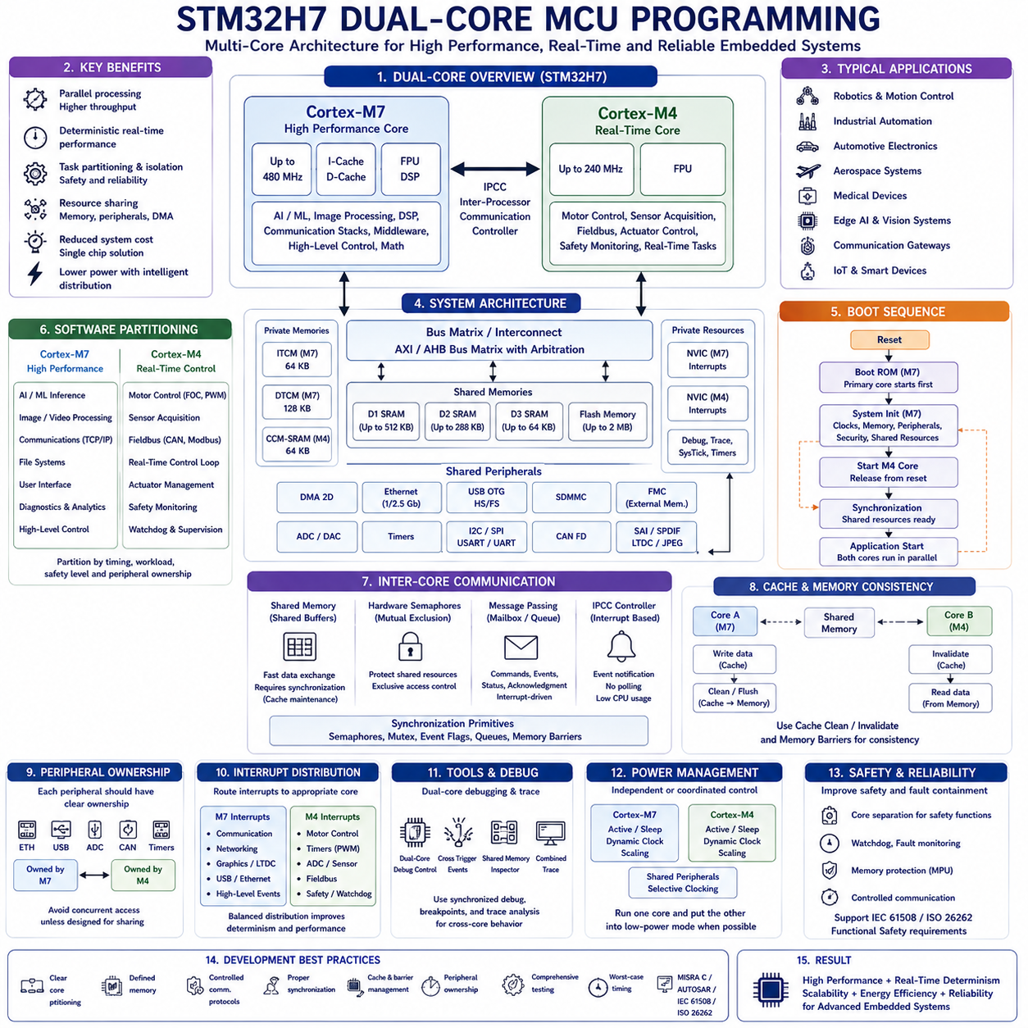
Modern embedded systems increasingly demand higher computational capability while maintaining deterministic real-time behavior, low power consumption, compact hardware size, and functional reliability. As robotic platforms, industrial automation, automotive electronics, aerospace systems, medical devices, and intelligent edge computing continue integrating artificial intelligence, advanced communication, sensor fusion, computer vision, and sophisticated control algorithms, the computational workload often exceeds the capability of traditional single-core microcontrollers. Multi-core microcontrollers address this challenge by integrating multiple processor cores within a single chip, allowing different software tasks to execute concurrently while sharing memory, peripherals, and communication resources. This architecture significantly improves system responsiveness, throughput, and software partitioning without requiring separate processors.
A multi-core microcontroller differs fundamentally from a high-frequency single-core processor. Rather than attempting to execute every software component sequentially on one processor, multiple cores execute independent or cooperative workloads simultaneously. This parallel execution improves overall computational efficiency while reducing scheduling conflicts between time-critical control functions and computationally intensive background processing. Engineers can dedicate specific cores to motor control, communication, artificial intelligence preprocessing, diagnostics, safety monitoring, or user interface management, producing a cleaner and more deterministic software architecture.
The STM32H7 Dual-Core family represents one of the most widely adopted dual-core microcontroller architectures in industrial embedded development. Devices such as the STM32H745, STM32H747, STM32H755, and STM32H757 integrate two ARM Cortex processors within a single microcontroller. The Cortex-M7 core provides high-performance computation with instruction and data caches, floating-point acceleration, and advanced digital signal processing capability, while the Cortex-M4 core offers excellent real-time deterministic execution with lower power consumption. Together they provide a flexible balance between computational performance and predictable embedded control.
The Cortex-M7 processor typically operates at significantly higher frequencies than the Cortex-M4 and serves as the primary application processor. It executes complex algorithms including artificial intelligence inference, image processing, digital signal processing, communication protocol stacks, high-level control logic, mathematical computation, and middleware. Large cache memories, floating-point hardware, branch prediction improvements, and pipeline optimizations allow the Cortex-M7 to achieve substantially greater computational throughput than conventional microcontroller cores while maintaining compatibility with embedded software development tools.
The Cortex-M4 processor complements the Cortex-M7 by focusing on deterministic real-time execution. It frequently handles motor control, sensor acquisition, communication timing, industrial fieldbus interfaces, actuator management, watchdog supervision, safety monitoring, periodic control loops, and interrupt-intensive peripheral management. Since the Cortex-M4 executes a more focused workload, real-time deadlines remain predictable even while the Cortex-M7 performs computationally intensive operations simultaneously.
Although both processor cores reside within the same integrated circuit, they share many hardware resources. Shared SRAM regions, Flash memory, peripheral buses, clock infrastructure, interrupt controllers, communication interfaces, DMA controllers, and system configuration hardware are accessible according to programmable ownership and protection policies. Software architects must therefore design memory allocation, peripheral ownership, synchronization mechanisms, and communication protocols carefully to prevent resource conflicts and maintain deterministic system behavior.
Memory organization forms one of the most important aspects of dual-core software architecture. The STM32H7 family partitions memory into several independent regions connected through high-performance bus matrices. Some memories provide private access with minimal contention, while others are intentionally shared to enable inter-core communication. Engineers often place each core's stack, frequently accessed variables, interrupt vectors, and performance-critical data within dedicated memory regions while reserving shared memory exclusively for controlled information exchange.
The internal bus architecture employs multiple Advanced High-performance Bus and AXI interconnects allowing concurrent access to different memories and peripherals. Arbitration logic manages simultaneous transactions generated by both processors, DMA controllers, Ethernet interfaces, USB controllers, graphics engines, or external memory interfaces. Understanding bus topology helps software developers minimize contention and optimize memory placement for maximum throughput and predictable real-time performance.
Boot management differs significantly from single-core systems because both processors require coordinated startup. After reset, one processor typically begins execution first while the second remains held in reset or standby until explicitly released. The primary processor configures clocks, memory, peripheral initialization, security settings, and shared resources before enabling secondary-core execution. Controlled startup sequencing prevents simultaneous hardware initialization and guarantees consistent system configuration.
Boot synchronization also ensures that shared software resources become available in the correct order. The primary processor may initialize external memory, configure communication peripherals, establish shared buffers, create synchronization objects, validate firmware versions, and complete system diagnostics before signaling the secondary processor that execution may safely continue. Proper initialization sequencing significantly improves system reliability and simplifies software maintenance.
Software partitioning represents one of the most important architectural decisions in multi-core development. Functions should be grouped according to timing requirements, computational complexity, communication frequency, safety classification, and hardware ownership. High-performance computational workloads generally execute on the Cortex-M7, while deterministic real-time control loops remain assigned to the Cortex-M4. Careful partitioning minimizes inter-core communication overhead while maximizing parallel execution efficiency.
Inter-core communication enables processors to exchange commands, status information, sensor measurements, processed results, synchronization events, and diagnostic data. Shared memory provides the simplest communication mechanism because both processors directly access common data structures. However, uncontrolled shared memory access may introduce race conditions, inconsistent data, and unpredictable software behavior. Communication protocols therefore require explicit synchronization and ownership management.
Hardware semaphores provide efficient mutual exclusion mechanisms specifically designed for multi-core processors. Before accessing shared resources, software acquires a hardware semaphore that temporarily grants exclusive ownership. Other processors attempting simultaneous access automatically wait until the semaphore becomes available. Hardware semaphores eliminate many synchronization errors while providing deterministic protection for shared buffers, configuration structures, peripheral registers, and communication queues.
Message passing offers another widely adopted communication model. Instead of allowing unrestricted access to shared variables, processors exchange structured messages through mailboxes, queues, circular buffers, or communication channels. One processor publishes commands or data, while the receiving processor acknowledges successful reception and processes the information independently. Message-based communication improves modularity, reduces synchronization complexity, and simplifies software verification.
Inter-Processor Communication Controller hardware further simplifies communication between processor cores. The IPCC generates interrupts whenever messages become available, eliminating continuous polling of shared memory. Event-driven communication minimizes processor utilization while providing immediate notification of new commands, sensor updates, synchronization events, or completion acknowledgments. Such interrupt-driven messaging forms the basis of many professional multi-core software architectures.
Cache management becomes considerably more important on processors such as the Cortex-M7 that include instruction and data caches. Since shared memory updates performed by one processor may remain temporarily stored inside cache rather than immediately appearing within physical memory, the second processor may observe outdated information. Software must therefore perform cache cleaning, cache invalidation, memory barriers, and explicit synchronization whenever cached shared memory participates in inter-core communication.
Memory consistency requires software to guarantee that all processors observe shared data in the intended order. Memory barrier instructions prevent compilers and processors from reordering critical memory operations. Without proper barriers, one processor may observe partially updated structures, stale flags, or inconsistent synchronization variables. Correct memory ordering becomes particularly important for communication queues, synchronization objects, hardware descriptors, and shared peripheral control structures.
Peripheral ownership should always be explicitly defined. Communication interfaces, ADCs, timers, motor controllers, Ethernet controllers, USB peripherals, graphics engines, external memory interfaces, cryptographic accelerators, and DMA channels should normally be controlled by only one processor unless carefully designed sharing mechanisms exist. Clear ownership prevents simultaneous register modification, unexpected hardware behavior, and difficult-to-diagnose synchronization failures.
Interrupt management also requires careful architectural planning. Each processor possesses its own Nested Vector Interrupt Controller while certain interrupt sources may be routed selectively according to system configuration. High-priority real-time interrupts generally remain assigned to the Cortex-M4, whereas communication, networking, graphics, user interfaces, and computational tasks frequently execute under Cortex-M7 interrupt management. Balanced interrupt distribution improves determinism while reducing unnecessary processor interference.
DMA controllers operate independently from processor execution and frequently interact with both cores. DMA may transfer sensor data into shared memory while one processor performs acquisition and another simultaneously processes completed buffers. Software must coordinate DMA ownership, buffer availability, cache maintenance, synchronization events, and completion notifications carefully to avoid data corruption or inconsistent memory visibility.
Real-Time Operating Systems significantly simplify multi-core application development. Independent RTOS instances may execute simultaneously on each processor, with each scheduler managing tasks assigned exclusively to its local core. Alternatively, lightweight bare-metal software may operate on one processor while an RTOS executes on the other. Task notifications, semaphores, queues, event flags, shared memory, and hardware mailboxes coordinate communication across processor boundaries while preserving deterministic scheduling.
Debugging dual-core applications presents unique challenges because both processors execute concurrently while interacting through shared resources. Professional debugging environments support synchronized processor control, simultaneous breakpoint management, cross-trigger events, shared memory inspection, inter-core trace analysis, and timeline visualization. Developers must consider interactions between processors rather than analyzing each core independently when investigating timing errors, race conditions, communication failures, or unexpected synchronization behavior.
Performance optimization within dual-core systems extends beyond processor frequency. Engineers evaluate processor utilization, memory contention, communication overhead, cache efficiency, DMA activity, interrupt latency, synchronization frequency, bus arbitration delays, and software partitioning quality. Excessive inter-core communication may eliminate the advantages of parallel execution, whereas carefully partitioned workloads often achieve substantial performance improvements with relatively modest synchronization overhead.
Power management becomes more sophisticated because each processor may operate independently. During reduced computational demand, one processor may remain fully active while the second enters low-power mode. Dynamic clock scaling, independent sleep states, selective peripheral activation, and coordinated wakeup strategies allow dual-core microcontrollers to achieve high computational capability while maintaining excellent energy efficiency. Intelligent workload distribution further minimizes unnecessary processor activity throughout changing operational conditions.
Safety-critical applications frequently benefit from processor separation. One core may execute functional safety supervision, watchdog management, fault diagnostics, emergency shutdown procedures, communication monitoring, and redundancy management, while the second executes ordinary application software. Hardware isolation, memory protection, controlled communication interfaces, and independent execution paths improve fault containment and simplify compliance with functional safety standards such as IEC 61508 and ISO 26262.
Robotic systems provide excellent examples of effective dual-core software partitioning. The Cortex-M4 may execute deterministic motor control, encoder acquisition, inertial measurement processing, actuator supervision, safety monitoring, and real-time communication with motor drivers. Simultaneously, the Cortex-M7 performs localization, sensor fusion, trajectory planning, AI inference preprocessing, diagnostics, networking, and communication with higher-level computing platforms. This separation significantly improves responsiveness while preserving deterministic control performance.
Industrial automation similarly benefits from multi-core microcontrollers. One processor maintains precise control loops, fieldbus timing, machine safety supervision, and deterministic input-output processing, while the second processor handles Ethernet communication, Human-Machine Interface management, predictive maintenance algorithms, production analytics, remote diagnostics, cybersecurity monitoring, and cloud connectivity. Independent execution improves scalability while preventing communication workloads from disturbing real-time industrial control.
Reliable multi-core software development requires disciplined engineering practices emphasizing explicit processor ownership, deterministic synchronization, defensive programming, validated communication protocols, modular software architecture, controlled shared memory access, documented resource allocation, comprehensive testing, timing analysis, and compliance with standards such as MISRA C, AUTOSAR, IEC 61508, ISO 26262, and CERT C where applicable. Thorough verification includes startup synchronization, communication robustness, cache coherency, fault recovery, interrupt interaction, and worst-case execution analysis.
Ultimately, multi-core MCU programming represents a transition from sequential embedded software toward coordinated parallel execution. Instead of viewing additional processor cores merely as increased computational capacity, engineers design cooperative software architectures in which independent processors perform specialized tasks while exchanging information through carefully synchronized communication mechanisms. When processor partitioning, memory organization, synchronization, communication, cache management, power control, and safety architecture are engineered as an integrated system, dual-core microcontrollers such as the STM32H7 family provide exceptional computational performance, deterministic real-time behavior, scalability, energy efficiency, and reliability for advanced embedded systems, autonomous robots, industrial automation platforms, intelligent vehicles, medical equipment, aerospace electronics, and future Physical AI applications.

02.10 MCU SW Debugging Techniques: SWD, JTAG, Semihosting
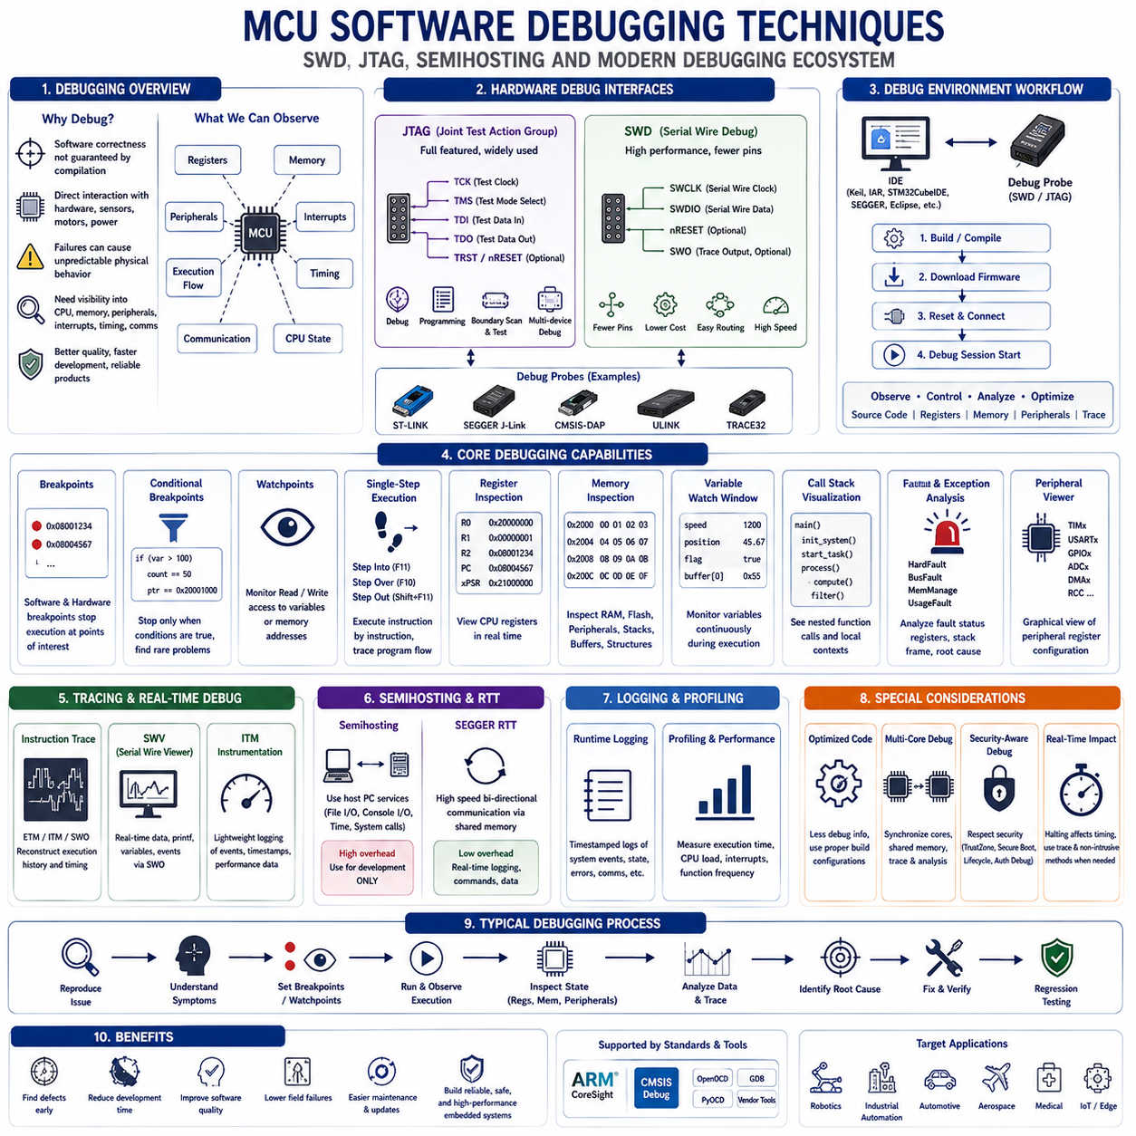
Debugging is one of the most critical activities throughout the entire embedded software development lifecycle because software correctness cannot be guaranteed through compilation alone. Embedded systems directly interact with hardware, external sensors, communication interfaces, power electronics, motors, and real-time control loops where software defects may produce unpredictable physical behavior rather than simple application crashes. Consequently, professional embedded development depends on powerful debugging infrastructures capable of observing processor execution, memory contents, peripheral states, interrupt activity, timing behavior, and communication events while software executes on the target hardware. Modern debugging techniques combine hardware interfaces, integrated development environments, trace technologies, runtime monitoring, and automated diagnostic tools to significantly improve software quality and development efficiency.
Unlike desktop software, embedded applications cannot always rely on operating system services, graphical user interfaces, or console outputs for diagnosing problems. Many embedded systems operate without displays, keyboards, filesystems, or even serial terminals. Furthermore, initialization failures frequently occur before communication interfaces become operational, making traditional software logging impossible. Hardware-assisted debugging therefore becomes essential because engineers require direct visibility into processor registers, memory contents, peripheral configuration, execution flow, and processor state immediately after reset or during fault conditions.
The two most widely adopted hardware debugging interfaces for modern microcontrollers are Joint Test Action Group (JTAG) and Serial Wire Debug (SWD). Both interfaces provide external debugging tools with controlled access to processor registers, memory, breakpoints, execution control, and hardware resources without requiring modifications to application software. Integrated development environments communicate through dedicated debug probes connected to these hardware interfaces, enabling developers to observe and control target execution while maintaining close interaction with the actual embedded hardware.
JTAG originated as an industry-standard boundary scan technology for printed circuit board manufacturing and hardware verification before evolving into a comprehensive processor debugging interface. Standard JTAG implementations employ multiple dedicated signals including Test Clock, Test Mode Select, Test Data Input, Test Data Output, and optional reset signals. Beyond processor debugging, JTAG supports device programming, boundary scan testing, production verification, hardware diagnostics, FPGA configuration, and multi-device debugging across complex embedded systems interconnected through standardized scan chains.
Serial Wire Debug was developed specifically by ARM to provide nearly all essential debugging capabilities while requiring fewer physical connections than traditional JTAG. Instead of multiple dedicated data signals, SWD primarily uses only Serial Wire Clock and Serial Wire Data together with optional reset and trace connections. The reduced pin count lowers hardware complexity, minimizes printed circuit board routing requirements, simplifies connector design, reduces manufacturing cost, and preserves valuable package pins for application peripherals while maintaining excellent debugging functionality.
Modern integrated development environments such as STM32CubeIDE, Keil MDK, IAR Embedded Workbench, SEGGER Embedded Studio, and Eclipse-based toolchains provide seamless integration with SWD and JTAG debugging hardware. Developers initiate debugging sessions directly from the development environment, automatically downloading firmware, resetting processors, configuring debugging hardware, establishing communication with target processors, and presenting comprehensive graphical interfaces for source-level debugging, register inspection, peripheral monitoring, memory visualization, and execution control.
Debug probes function as intelligent communication bridges between development computers and embedded targets. Popular commercial probes include ST-LINK, SEGGER J-Link, CMSIS-DAP compatible probes, ULINK, Lauterbach TRACE32, and vendor-specific debugging hardware. These devices translate high-level debugger commands into low-level SWD or JTAG transactions while managing communication timing, voltage adaptation, target reset sequencing, firmware programming, breakpoint insertion, memory access, and trace data acquisition.
Programming embedded firmware through debugging interfaces represents one of the most common development activities. After software compilation, debugging hardware programs Flash memory through SWD or JTAG without requiring bootloaders or application software support. Verification procedures compare programmed memory contents against compiled binaries to detect programming failures before execution begins. Fast programming algorithms significantly reduce development iteration time during frequent software modification and testing.
Source-level debugging allows developers to observe software behavior directly using original C or C++ source code rather than processor assembly instructions. The debugger correlates executable machine instructions with source code lines generated during compilation using symbolic debugging information. Engineers therefore examine program execution within familiar programming languages while retaining complete visibility into underlying processor state, memory organization, and compiler-generated machine code whenever necessary.
Breakpoints temporarily suspend processor execution when specified program locations become active. Software breakpoints replace executable instructions with special debug instructions stored within program memory, while hardware breakpoints employ dedicated comparator circuits inside the processor to detect instruction fetches without modifying program memory. Hardware breakpoints remain particularly valuable when debugging Flash memory, read-only memory, bootloaders, or security-sensitive firmware regions where software modification is undesirable or impossible.
Conditional breakpoints further enhance debugging efficiency by suspending execution only when specified logical conditions evaluate as true. Rather than stopping every iteration within repetitive loops, debuggers may monitor variable values, memory contents, processor registers, pointer addresses, function parameters, execution counts, or complex logical expressions before interrupting execution. Conditional breakpoints significantly reduce debugging time when investigating intermittent software defects or rare operational conditions.
Watchpoints monitor data rather than program execution. Hardware comparators detect read operations, write operations, or any access to selected memory addresses while automatically suspending processor execution whenever monitored variables change unexpectedly. Watchpoints prove particularly valuable when identifying memory corruption, unintended variable modification, stack overflow, buffer overflow, race conditions, or unexpected peripheral register updates occurring within large software systems.
Single-step execution enables detailed examination of program flow by executing one machine instruction or one source code statement at a time. Developers observe register updates, memory modifications, function calls, stack evolution, and peripheral interactions after every execution step. Step Into enters called functions, Step Over executes complete function calls without entering internal implementation, and Step Out resumes execution until returning from the current function. These controlled execution modes greatly simplify investigation of complex algorithms and initialization sequences.
Register inspection provides direct visibility into processor internal state. General-purpose registers, stack pointers, program counters, status registers, floating-point registers, exception status, interrupt masks, and special control registers become continuously observable during debugging sessions. Understanding processor register contents allows developers to diagnose incorrect program flow, corrupted stack frames, arithmetic errors, interrupt behavior, and processor exceptions that remain invisible through ordinary software logging.
Memory inspection complements register observation by displaying RAM, Flash, peripheral registers, external memory, shared buffers, stack contents, heap allocation, communication structures, DMA descriptors, and application variables. Modern debuggers support multiple visualization formats including hexadecimal, decimal, binary, floating-point, ASCII text, graphical arrays, memory maps, and structured variable representations derived directly from programming language data types.
Variable watch windows continuously display selected software variables throughout program execution. Developers monitor application state, communication buffers, sensor measurements, control parameters, counters, flags, pointers, object members, and mathematical calculations without repeatedly navigating memory regions. Automatic symbolic interpretation significantly improves debugging efficiency while reducing manual address calculations.
Call stack visualization reveals the hierarchy of nested function calls leading to the current execution point. Each stack frame identifies function parameters, local variables, return addresses, and execution context. Call stack analysis rapidly identifies recursive software errors, stack corruption, unexpected execution paths, infinite recursion, exception origins, and interrupt nesting behavior that may otherwise prove difficult to reconstruct manually.
Embedded software frequently encounters hardware exceptions resulting from invalid memory accesses, undefined instructions, divide-by-zero operations, bus faults, memory protection violations, stack overflow, alignment faults, or floating-point errors. Cortex processors provide dedicated fault status registers recording exception causes together with processor state at failure time. Professional debugging therefore includes systematic analysis of HardFault handlers, fault registers, stack frames, exception return values, and memory addresses to accurately determine root causes.
Peripheral register visualization allows engineers to inspect hardware configuration directly during program execution. Rather than manually decoding hexadecimal register values, modern development environments present graphical interpretations of timer configuration, communication interfaces, GPIO states, ADC settings, interrupt controllers, DMA channels, clock systems, watchdog configuration, and power management registers according to processor documentation. Interactive peripheral views significantly simplify hardware verification and driver debugging.
Real-time debugging introduces unique challenges because halting processor execution may disrupt communication protocols, motor control, industrial automation, sensor sampling, or safety-critical timing. Some debugging technologies therefore permit nonintrusive observation while processors continue executing normally. Data trace, event monitoring, performance counters, instrumentation, and hardware trace mechanisms provide valuable runtime visibility without significantly disturbing deterministic application behavior.
Instruction trace technology records processor execution history continuously, allowing developers to reconstruct software behavior preceding faults or unexpected events. Embedded Trace Macrocell, Instrumentation Trace Macrocell, and Serial Wire Output provide hardware-supported execution tracing with minimal runtime overhead. Trace analysis identifies unexpected branches, interrupt timing, execution frequency, software bottlenecks, and complex interactions between concurrent software components that remain difficult to observe using conventional breakpoints.
Serial Wire Viewer extends SWD debugging by transmitting real-time diagnostic information from embedded software to development environments through dedicated trace channels. Unlike conventional serial communication requiring UART peripherals and application software drivers, SWV employs dedicated debugging hardware integrated into Cortex processors. Engineers transmit formatted diagnostic messages, variable updates, event notifications, interrupt statistics, execution timestamps, and performance measurements with minimal processor overhead.
Instrumentation Trace Macrocell provides efficient software instrumentation through lightweight trace message generation. Application software inserts instrumentation macros recording function entry, function exit, execution timing, variable values, communication events, state transitions, or application-specific diagnostics. Hardware automatically forwards these messages through trace interfaces without significantly affecting software timing or requiring conventional communication drivers.
Semihosting enables embedded applications to utilize host computer services during debugging sessions. Instead of implementing complete file systems, console interfaces, or operating system abstractions inside target hardware, embedded software performs standardized software requests intercepted by the debugger. Host computers subsequently provide file access, console output, keyboard input, formatted printing, timing information, or operating system services transparently through debugging connections. Semihosting greatly simplifies application development and software testing while avoiding unnecessary target-side infrastructure.
Despite its convenience, semihosting introduces considerable execution overhead because every semihosting request temporarily suspends target execution while interacting with the debugger. Consequently, semihosting should generally remain limited to software development rather than production firmware. Real-time applications requiring deterministic execution typically replace semihosting with UART logging, SWV tracing, RTT communication, or dedicated diagnostic interfaces before deployment.
SEGGER Real-Time Transfer represents another highly efficient debugging communication technology. RTT exchanges bidirectional information between embedded software and host computers through shared memory accessed over debugging interfaces without stopping processor execution. Compared with semihosting or conventional UART communication, RTT provides substantially higher throughput, lower latency, and minimal processor overhead while supporting formatted diagnostic output, command interfaces, data streaming, and runtime monitoring.
Runtime logging complements hardware debugging by recording software events throughout long-duration execution. Timestamped log messages capture initialization sequences, communication events, sensor measurements, control decisions, diagnostic information, fault conditions, watchdog resets, and system state transitions. Effective logging frameworks employ configurable verbosity levels, circular buffers, asynchronous transmission, event filtering, and efficient formatting to balance diagnostic usefulness against memory consumption and processor utilization.
Performance profiling identifies computational bottlenecks preventing applications from satisfying real-time deadlines. Profiling tools measure function execution frequency, cumulative execution time, interrupt latency, processor utilization, memory access patterns, cache behavior, communication overhead, and task scheduling efficiency. Engineers subsequently optimize critical software regions while preserving functional correctness and deterministic execution behavior.
Debugging optimized software frequently proves more difficult than debugging unoptimized builds because compiler optimizations eliminate variables, reorder instructions, inline functions, and restructure control flow. Professional development therefore employs multiple build configurations balancing optimization against debugging visibility. Development builds prioritize symbolic information and diagnostic clarity, whereas release builds emphasize execution performance, code size reduction, energy efficiency, and production reliability.
Multi-core debugging extends traditional debugging concepts by simultaneously controlling multiple processors executing cooperative software. Modern debugging environments synchronize breakpoints, processor execution, shared memory inspection, communication analysis, trace collection, and timeline visualization across processor boundaries. Developers investigate synchronization failures, cache coherency issues, communication latency, race conditions, and resource contention while maintaining consistent observation of the complete multi-core execution environment.
Security-aware debugging becomes increasingly important as modern microcontrollers implement Secure Boot, TrustZone, memory protection, cryptographic acceleration, secure debug authentication, and lifecycle management. Development environments must respect hardware security boundaries while still providing sufficient diagnostic visibility during authorized development. Production devices frequently disable unrestricted debugging entirely or require authenticated secure debugging procedures that preserve cybersecurity while supporting maintenance and fault analysis.
Professional debugging methodology emphasizes systematic problem isolation rather than random experimentation. Engineers reproduce failures consistently, minimize software complexity, verify assumptions incrementally, inspect processor state objectively, collect trace evidence, analyze timing behavior, validate hardware configuration, review compiler output, examine synchronization mechanisms, and document observed behavior before implementing corrective modifications. Such disciplined debugging significantly reduces development time while improving long-term software quality and maintainability.
Ultimately, MCU software debugging extends far beyond simply inserting breakpoints or observing variables. It represents a comprehensive engineering discipline integrating SWD, JTAG, hardware trace, semihosting, runtime logging, register inspection, memory analysis, peripheral visualization, performance profiling, fault diagnosis, communication monitoring, synchronization analysis, and security-aware development into a unified diagnostic framework. Properly applied debugging techniques dramatically improve software reliability, accelerate development, simplify maintenance, reduce field failures, and enable engineers to construct highly dependable embedded systems, autonomous robots, industrial automation platforms, intelligent vehicles, aerospace electronics, medical equipment, and future Physical AI systems operating within increasingly complex real-world environments.

