Volume 02 Embedded Software Engineering

06. Embedded Linux

06.01 Embedded Linux Distributions: Yocto, Buildroot, Ubuntu Core
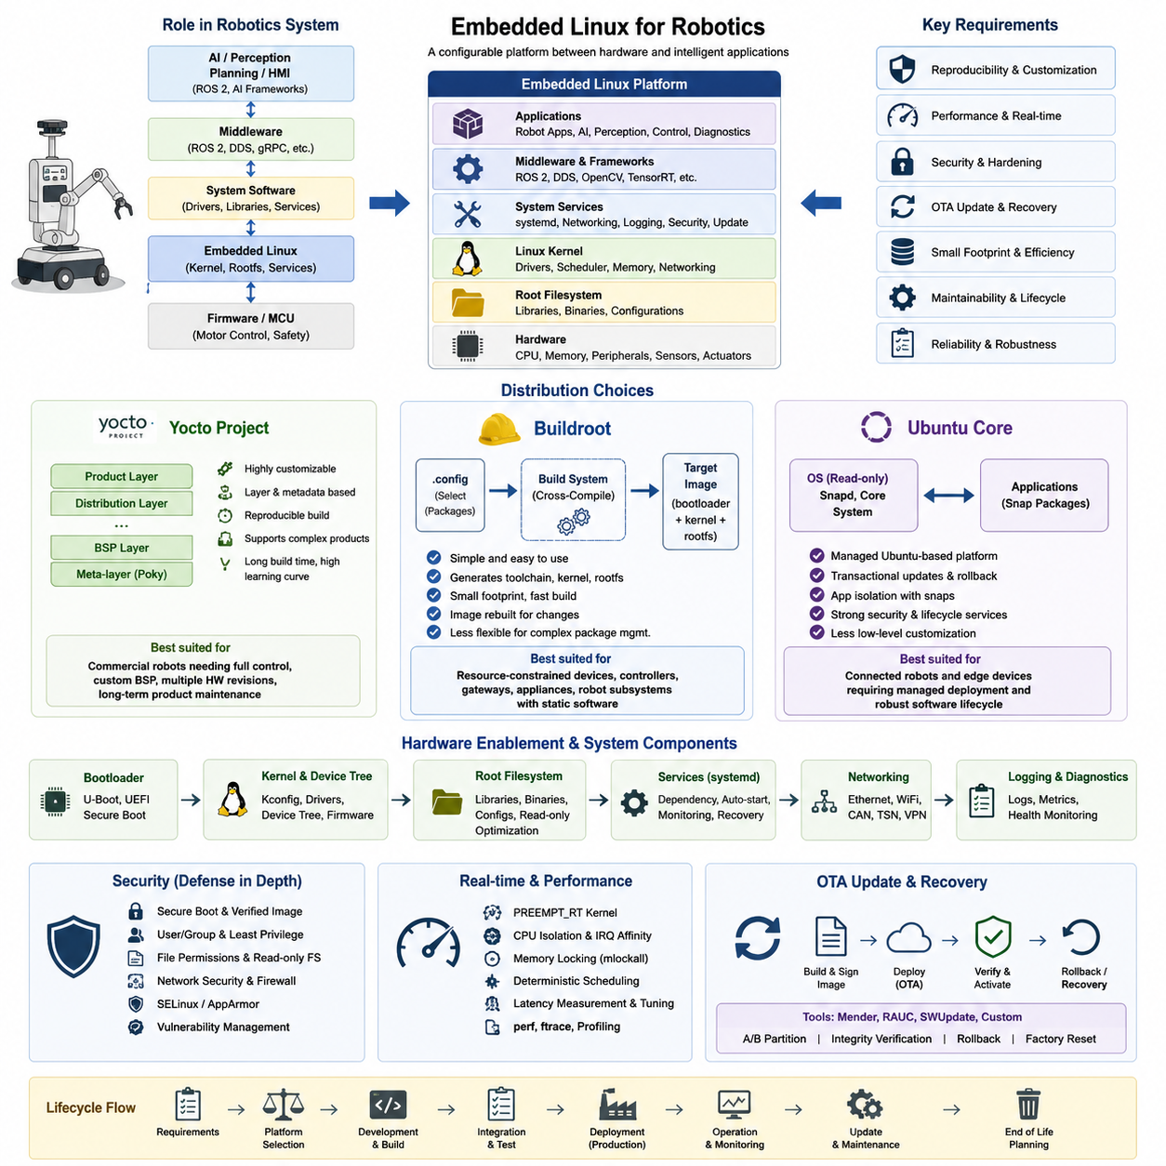
Embedded Linux is not a single operating system but a configurable software platform built around the Linux kernel, a bootloader, system libraries, device management, middleware, and application software. In robotics, the distribution strategy determines how these components are assembled, reproduced, secured, updated, and maintained throughout the product lifecycle.
The choice of an Embedded Linux distribution strongly affects development productivity, image size, boot time, hardware support, security maintenance, and long-term reproducibility. Yocto Project, Buildroot, and Ubuntu Core represent three different approaches: constructing a highly customized product platform, generating a compact embedded system, or adopting a managed Linux environment with stronger application-oriented lifecycle services.
Yocto Project is designed for organizations that need precise control over nearly every component of the Linux software stack. Rather than supplying one fixed distribution, Yocto provides metadata, build tools, recipes, classes, and layers that allow developers to define a reproducible distribution specifically for a target product, processor architecture, board, and application environment.
A typical Yocto-based platform separates hardware-specific Board Support Package information from distribution policies and product-specific software through its layer architecture. Recipes describe where software originates, how it is configured and compiled, which dependencies are required, and how resulting packages are installed. This structure becomes particularly valuable when several robot models share a common software platform.
Yocto's flexibility also introduces significant engineering complexity. Initial configuration, recipe development, dependency resolution, build debugging, layer compatibility, and long build times require specialized knowledge. However, this investment can provide substantial lifecycle advantages for commercial robots that must maintain controlled software configurations across multiple hardware revisions and years of field operation.
Buildroot follows a simpler philosophy. It provides a configuration-driven build system that generates a cross-compilation toolchain, Linux kernel, bootloader, root filesystem, and selected user-space packages. Developers select required components through configuration interfaces and build a complete target image without constructing the extensive metadata and package-management architecture normally associated with Yocto.
This simplicity makes Buildroot attractive for resource-constrained devices, dedicated controllers, gateways, appliances, and robot subsystems where the software image is relatively static. A small number of carefully selected packages can produce a compact root filesystem with low storage and memory requirements. The reduced conceptual overhead can also shorten the path from board bring-up to a functional embedded product.
Buildroot generally treats the target filesystem as an integrated image rather than a conventional distribution assembled and maintained through runtime package management. Consequently, changes are commonly introduced by rebuilding and redeploying the complete firmware image. This model supports deterministic product releases but may become less convenient when complex products require extensive package-level lifecycle management or multiple independently maintained software variants.
Ubuntu Core approaches embedded deployment from another direction. It provides a managed Ubuntu-based environment centered on transactional software packaging and isolation. Instead of requiring engineering teams to construct most operating-system components from source, it emphasizes standardized platform components and independently managed application packages, making it suitable for connected devices requiring systematic deployment and lifecycle management.
For robotics developers already working with Ubuntu ecosystems, this approach can reduce the difference between development and deployed environments. Familiar Linux tools and application frameworks can simplify integration of networking, robotics middleware, diagnostics, and edge services. The tradeoff is that developers surrender some low-level customization and footprint control compared with purpose-built Yocto or Buildroot systems.
Distribution selection should therefore begin with product requirements rather than developer familiarity alone. A small fixed-function embedded controller may benefit from Buildroot, while a sophisticated commercial robot requiring customized BSPs and strict configuration ownership may justify Yocto. A connected edge device emphasizing managed applications and robust software lifecycle mechanisms may favor Ubuntu Core.
Hardware enablement is another major consideration. Embedded Linux must integrate bootloader configuration, kernel drivers, device trees, firmware blobs, graphics or accelerator stacks, and board-specific initialization. Distribution choice influences how these artifacts are organized and maintained, while later kernel Kconfig and Device Tree customization provides the mechanisms for tailoring the operating system to the robot hardware.
Root filesystem design further connects distribution strategy to product behavior. Developers must decide which libraries, shells, diagnostic utilities, services, certificates, configuration files, and application dependencies belong on the target. Removing unnecessary components reduces storage consumption and attack surface, while read-only filesystem strategies can improve resilience against corruption and uncontrolled field modifications.
Service management determines how robot applications are launched and supervised after boot. Embedded Linux systems commonly require deterministic startup ordering for networking, sensor interfaces, middleware, logging, localization, control, and application processes. Distribution architecture must therefore support reliable service dependencies, restart policies, health monitoring, and recovery behavior appropriate to unattended robotic operation.
Security must also be considered at the distribution level rather than added only to individual applications. Package provenance, vulnerability maintenance, user privileges, filesystem permissions, network services, secure boot integration, mandatory access controls, and update authenticity all depend partly on how the operating-system image is constructed and maintained. Long-lived robots require a practical strategy for continuously addressing newly discovered vulnerabilities.
OTA capability further changes the selection criteria because field robots may operate where manual software servicing is expensive or impossible. A production distribution should support controlled image generation, version identification, integrity verification, rollback, and recovery. Frameworks such as Mender and RAUC can complement customized Embedded Linux platforms, while managed environments may provide their own transactional update mechanisms.
Real-time requirements must be evaluated separately from distribution branding. Yocto, Buildroot, or Ubuntu-based systems can all be configured differently depending on kernel options, scheduling policies, CPU isolation, interrupt handling, memory behavior, and PREEMPT_RT requirements. Distribution selection establishes the integration framework, while deterministic robot control ultimately depends on detailed kernel and system-level real-time engineering.
For modern robots, Embedded Linux frequently operates between low-level firmware and higher-level robotics or AI software. MCUs may execute hard real-time motor and safety functions, while Linux computers perform perception, localization, planning, communication, diagnostics, and ROS 2 processing. The selected distribution must therefore provide a stable boundary between hardware-specific embedded components and rapidly evolving application software.
The most appropriate platform is ultimately the one whose lifecycle model matches the robot product. Yocto emphasizes customization, reproducibility, and platform ownership; Buildroot emphasizes simplicity and compact image generation; Ubuntu Core emphasizes managed deployment and application lifecycle capabilities. Understanding these architectural differences allows Embedded Linux to become a deliberate product foundation rather than merely an operating system installed on a robot computer.

06.02 Yocto Project Layer Structure and Recipe Writing [w/Code]
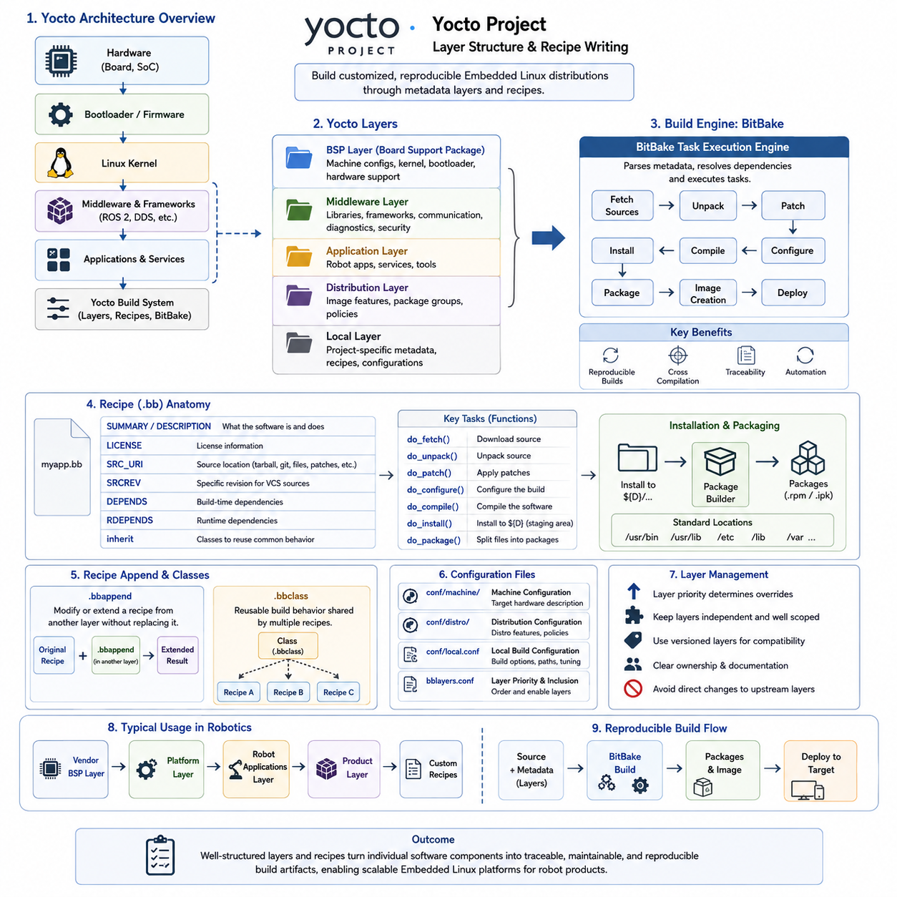
Yocto Project provides a structured framework for building customized Embedded Linux distributions rather than delivering a single predefined operating system. Its architecture organizes hardware support, distribution policies, middleware, applications, and product-specific configuration into reusable metadata layers. This separation helps embedded teams maintain reproducible Linux platforms across multiple boards and robot product variants.
A Yocto build is typically composed of several layers, each containing metadata for a particular responsibility. A Board Support Package layer may define machine configuration, kernel integration, bootloader settings, and hardware-specific components, while separate layers can contain middleware, security policies, robotics applications, or product configuration. Layers allow these concerns to evolve independently while remaining integrated through the build system.
The reference metadata collection known as Poky provides a practical starting environment for Yocto development. It combines the BitBake build engine, OpenEmbedded-Core metadata, reference distribution configuration, and supporting tools. Product teams normally extend this foundation with additional layers instead of directly modifying reference metadata, because separating custom content improves maintainability and simplifies migration between Yocto releases.
BitBake is the task execution engine responsible for interpreting Yocto metadata and constructing the final software image. It analyzes recipes, configuration files, classes, dependencies, and task relationships before executing operations such as fetching source code, configuring packages, compiling software, installing files, generating packages, and assembling the root filesystem. This dependency-driven execution enables repeatable automated builds.
Recipes are central units of Yocto metadata and normally use the `.bb` file extension. A recipe describes how a software component enters the Linux distribution, including its source location, version, license information, dependencies, configuration parameters, compilation procedure, installation behavior, and packaging rules. Recipes therefore provide a declarative bridge between upstream software and the controlled embedded product image.
A recipe commonly identifies source material through `SRC_URI`, which may reference source archives, Git repositories, patches, configuration files, or locally maintained resources. `SRCREV` can select a particular source revision when version-controlled repositories are used. Explicit source versions and checksums improve reproducibility because the build system can retrieve and verify known software inputs instead of relying on uncontrolled development states.
Yocto recipes execute work through tasks such as source fetching, unpacking, patching, configuration, compilation, installation, packaging, and image integration. Standard build classes implement much of this behavior for common build systems, while recipes provide component-specific parameters. Developers should reuse standard tasks and classes whenever possible and customize only the behavior that differs from established build patterns.
Dependencies must distinguish between software required during compilation and software required on the deployed target. Build-time dependencies can be expressed so that BitBake prepares prerequisite components before compilation, while runtime dependencies define packages that must accompany an installed component. Correct dependency modeling prevents accidental reliance on software that happened to exist in a developer's workstation or previous build state.
Installation logic places generated executables, libraries, configuration files, service definitions, firmware, and other resources into a temporary destination that later becomes part of one or more packages. Recipes should install files into standardized filesystem locations rather than directly manipulating the final root filesystem. Yocto's packaging stage can then determine ownership and construct deployable packages in a controlled and traceable manner.
Recipe append files, commonly using the `.bbappend` extension, allow one layer to modify or extend a recipe defined in another layer without copying and rewriting the original recipe. A hardware or product layer can therefore add patches, configuration files, compile options, or installation behavior to an upstream component while preserving separation from the original metadata. This mechanism is important for sustainable product customization.
Classes using the `.bbclass` format provide reusable build behavior shared by multiple recipes. Instead of repeating identical task implementations or configuration logic across components, developers can place common functionality in a class and inherit it where required. This reduces duplication and establishes consistent rules for recurring operations such as package generation, system integration, service handling, or specialized build procedures.
Configuration files complement recipes and layers by defining global build behavior. Machine configuration describes characteristics of the target hardware, while distribution configuration determines policies affecting the operating-system environment. Local build configuration selects options for a particular development environment. Keeping machine, distribution, and application concerns separate prevents product definitions from becoming tightly coupled to individual workstations.
Layer priority and metadata compatibility require careful management as a Yocto platform grows. Multiple layers may provide related recipes, append files, machine definitions, or configuration values, and uncontrolled overrides can make build behavior difficult to understand. Product teams should establish clear ownership boundaries, compatible release versions, naming conventions, and documented dependencies between layers to keep the metadata architecture predictable.
For robotics, a practical layer strategy can separate silicon-vendor BSP metadata from robot-platform software and individual product applications. Common ROS 2 integration, communication middleware, diagnostics, security configuration, hardware abstraction, and deployment services can reside in reusable platform layers, while robot-specific perception, control, navigation, or device configuration can remain in product layers. This supports software reuse across a robot family.
Custom recipes are particularly useful for deploying proprietary robot applications. A recipe can retrieve a controlled application revision, declare required libraries, invoke its build system, install binaries and configuration resources, and package the resulting artifacts into the target image. Combined with service definitions, this approach enables robot processes to be integrated into the operating-system build instead of being manually copied onto production devices.
Reproducibility is one of the strongest reasons for adopting disciplined Yocto metadata. The objective is not merely to compile Linux successfully but to describe the complete software composition sufficiently well that another controlled build environment can regenerate the intended product image. Fixed source revisions, explicit dependencies, versioned layers, configuration management, and automated build infrastructure collectively support this objective.
Yocto layer and recipe design therefore becomes part of the embedded product architecture itself. Well-structured metadata separates hardware enablement from distribution policy and application development, while recipes transform individual software components into traceable build artifacts. When these mechanisms are consistently maintained, teams can scale from initial board bring-up to multiple production robot platforms without losing control of configuration, reproducibility, or lifecycle maintenance.

06.03 Kernel Kconfig and Device Tree Customization [w/Code]
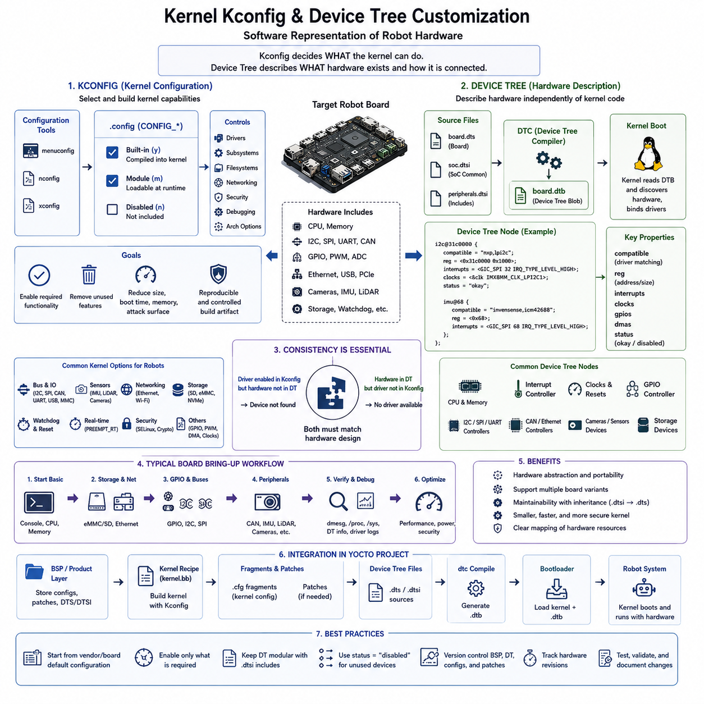
The Linux kernel in an embedded robot must be configured to match the exact processor, memory architecture, peripherals, communication interfaces, security requirements, and runtime behavior of the target hardware. Kernel Kconfig and Device Tree provide two complementary mechanisms for this customization: Kconfig determines which kernel capabilities are built, while Device Tree describes the physical hardware that those capabilities must operate.
Kconfig is the Linux kernel configuration framework used to select features, subsystems, drivers, filesystems, networking functions, debugging facilities, and architecture-specific options. Configuration symbols usually appear as `CONFIG_*` entries in the resulting `.config` file. Depending on the option, a feature can be compiled directly into the kernel, built as a loadable module, or excluded completely from the target system.
Interactive tools such as `menuconfig` provide a structured interface for exploring kernel configuration options and their dependencies. Developers can enable required drivers while removing unnecessary subsystems that increase image size, boot time, memory consumption, or attack surface. Embedded products should treat the resulting kernel configuration as a controlled build artifact rather than relying on manually configured development machines.
Kernel options have dependencies that must be understood before customization. Enabling a sensor driver, network protocol, filesystem, security mechanism, or bus controller may require other kernel subsystems to be enabled first. Kconfig expresses these relationships through dependency and selection rules, helping prevent logically invalid configurations while allowing architecture and platform requirements to influence which options are available.
For production Embedded Linux, teams commonly begin with a vendor or board-specific default configuration and then apply controlled changes for the product. A robot may require CAN, Ethernet, USB, GPIO, I2C, SPI, camera, watchdog, storage, networking, and real-time related functionality while excluding unused consumer-oriented features. Maintaining a minimal configuration reduces unnecessary complexity and makes kernel behavior easier to validate.
Device Tree addresses a different problem by describing hardware independently from most kernel source code. It represents processors, memory regions, buses, interrupt controllers, clocks, GPIO controllers, communication peripherals, sensors, storage devices, and other hardware resources as a hierarchical data structure. This allows one kernel driver implementation to support multiple boards whose physical connections and resource assignments differ.
Device Tree Source files normally use the `.dts` extension, while reusable included fragments commonly use `.dtsi`. The Device Tree Compiler transforms the source representation into a binary Device Tree Blob, usually identified as a `.dtb` file, which is supplied to the kernel during boot. The kernel interprets this hardware description and uses it to discover devices and associate them with appropriate drivers.
A Device Tree node describes a device and its relevant hardware properties. Typical information includes compatible identifiers, register address ranges, interrupt assignments, clocks, GPIO connections, bus addresses, DMA resources, pin configuration, and operational status. The `compatible` property is particularly important because Linux uses it as a key mechanism for matching a hardware node with a driver capable of controlling that device.
Bus-connected devices demonstrate the relationship clearly. An I2C sensor node can be placed beneath the appropriate I2C controller and assigned its slave address, while an SPI device can define chip-select information and operating parameters under an SPI controller. The kernel does not need product-specific application code to discover these physical relationships because they are expressed in the hardware description.
The `status` property is frequently used to enable or disable hardware nodes for a particular board configuration. A common SoC-level `.dtsi` file may describe all controllers available in the processor, while a board-specific `.dts` enables only the peripherals physically connected and required by the product. This inheritance model reduces duplication and supports multiple hardware variants based on the same processor family.
Pin multiplexing and GPIO configuration are also major Device Tree responsibilities. Modern SoCs often allow physical pins to perform several alternative functions, so the board definition must specify whether pins operate as UART, SPI, I2C, CAN, PWM, GPIO, or another interface. Incorrect pin control settings can prevent a correctly configured kernel driver from communicating with the actual hardware.
Kconfig and Device Tree must therefore remain consistent. Enabling a device in Device Tree is insufficient if the corresponding kernel driver has not been compiled, while enabling a driver in Kconfig does not create hardware that has not been described or discovered. Successful board integration requires both the software capability and the hardware description to agree with the electrical design of the target platform.
This relationship is especially important during robot board bring-up. Engineers may first verify serial consoles, storage, Ethernet, and basic GPIO before progressively enabling CAN interfaces, IMUs, LiDAR communication, cameras, motor-control buses, watchdogs, and other peripherals. Kernel logs, driver probe messages, `/proc`, `/sys`, and Device Tree information can then be inspected to determine whether each hardware component has been recognized correctly.
Yocto provides a systematic way to integrate these customizations into an Embedded Linux product build. Kernel configuration fragments, patches, Device Tree sources, and board-specific metadata can be maintained in BSP or product layers rather than modified manually after an image is generated. Recipes and append files can apply these resources during the automated build, keeping hardware enablement reproducible across development and production environments.
Hardware revisions should also be reflected in controlled Device Tree and kernel metadata. If a robot changes an Ethernet PHY, sensor address, GPIO assignment, camera interface, storage device, or peripheral controller, the corresponding software description must evolve with the electrical design. Version-controlled board definitions provide traceability between PCB revisions, BSP releases, kernel versions, and deployed software images.
Customization should avoid enabling every available kernel feature simply because resources permit it. Each unnecessary driver, protocol, filesystem, debugging interface, or legacy subsystem increases code size and potentially expands the security attack surface. Production kernels should include the capabilities required for operation, diagnostics, recovery, and maintenance while deliberately excluding functionality that has no justified product role.
Real-time robot platforms require additional attention because kernel configuration influences scheduling latency and interrupt behavior. PREEMPT_RT support, timer configuration, CPU behavior, interrupt threading, and related facilities may need to be coordinated with later CPU isolation and IRQ affinity strategies. Device Tree can also affect runtime performance through interrupt topology, DMA configuration, clocks, and hardware resource definitions.
Security-oriented configurations similarly combine kernel and hardware description decisions. Kernel options can enable security frameworks, memory protection mechanisms, cryptographic functionality, and restricted interfaces, while Device Tree may describe trusted hardware, secure memory regions, watchdogs, or platform-specific security components. These settings should remain aligned with secure boot, filesystem hardening, and the broader Embedded Linux security architecture.
Kernel Kconfig and Device Tree customization ultimately form the software representation of the robot's computing hardware. Kconfig defines what the Linux kernel is capable of doing, while Device Tree defines what hardware exists and how it is connected. When both are maintained through version-controlled BSP layers and reproducible builds, hardware variants can evolve without sacrificing configuration control, maintainability, or deployment reliability.

06.04 Root Filesystem Optimization: Size Reduction / Read-Only
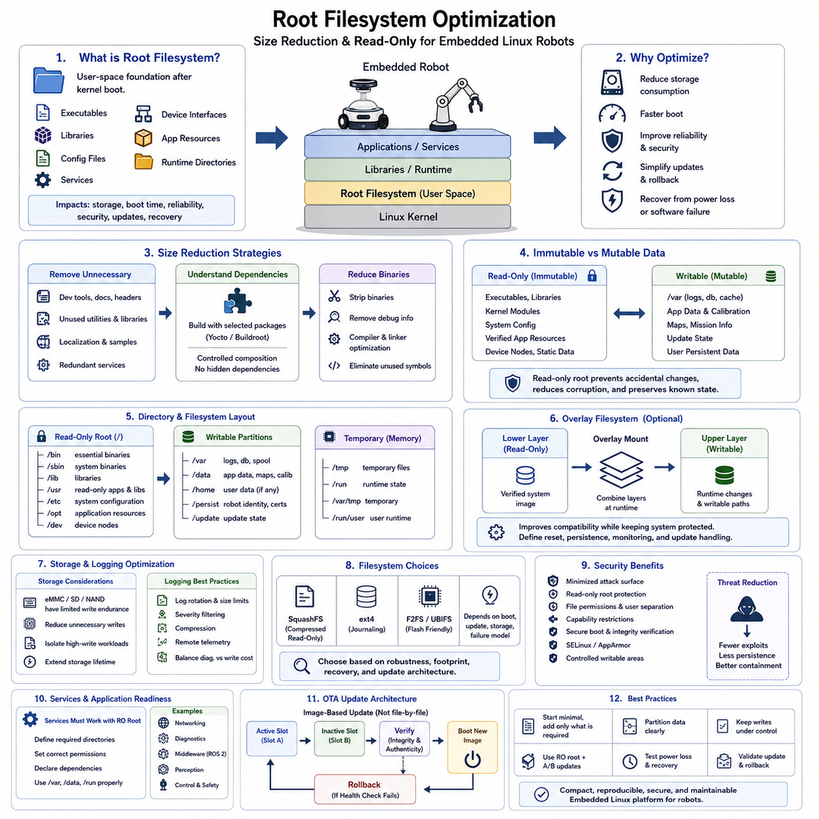
The root filesystem is the user-space foundation of an Embedded Linux system and contains the libraries, executables, configuration files, services, device interfaces, application resources, and runtime directories required after the kernel starts. In a robot, root filesystem design directly affects storage consumption, boot time, reliability, security, update behavior, and the ability to recover from unexpected power loss or software failure.
Unlike a desktop Linux installation, an embedded root filesystem should normally contain only components that serve a defined product function. Development tools, unused command-line utilities, unnecessary libraries, documentation, localization data, sample programs, and redundant services increase image size without improving robot operation. A disciplined package-selection process therefore becomes the first stage of filesystem optimization.
Size reduction begins by understanding dependencies rather than simply deleting files from a completed image. Build systems such as Yocto and Buildroot can generate the root filesystem from explicitly selected packages, allowing unnecessary components to be removed before deployment. This approach produces a controlled software composition and avoids hidden dependencies that can appear when developers manually modify target devices after installation.
Shared libraries require particular attention because a small application may indirectly introduce many additional packages. Removing unused frameworks, optional plugins, debugging libraries, graphical components, scripting environments, and development headers can significantly reduce storage requirements. Where appropriate, compiler and linker optimization can also eliminate unused symbols and reduce binary size without changing application behavior.
Debug information is valuable during development but can consume substantial storage in production images. Symbol tables, unstripped binaries, static libraries, header files, package metadata, test utilities, and source artifacts should be separated from the deployed image unless field diagnostics explicitly require them. Production binaries can be stripped while corresponding debug symbols are retained separately for crash analysis and postmortem debugging.
Filesystem layout should distinguish immutable system content from data that legitimately changes during operation. Executables, libraries, kernel modules, system configuration, and verified application resources can remain stable, while logs, databases, calibration values, downloaded updates, temporary files, and runtime state require writable storage. Separating these categories creates a foundation for reliable read-only root filesystem design.
A read-only root filesystem prevents ordinary applications and services from modifying the operating-system image during runtime. This reduces accidental corruption, uncontrolled configuration drift, and persistent modifications caused by software defects. For autonomous robots operating without continuous human supervision, preserving a known system state can significantly improve repeatability and simplify recovery after crashes or unexpected power interruption.
Read-only operation does not mean that the entire storage device must be immutable. Writable partitions or filesystems can be provided for `/var`, persistent application data, logs, calibration parameters, maps, mission information, and update state. Temporary runtime locations such as `/tmp` and portions of `/run` can use memory-backed filesystems where appropriate, allowing normal Linux services to operate without writing into the protected root image.
The division between persistent and temporary data must be explicitly designed. Robot identity, certificates, calibration parameters, network provisioning, learned configuration, operational databases, and maintenance records may need persistence across reboots. Temporary sockets, process identifiers, caches, intermediate files, and short-lived diagnostic data usually do not. Incorrect classification can either lose essential information or unnecessarily increase persistent writes.
Overlay filesystems provide another strategy when applications expect writable paths even though the underlying root filesystem should remain protected. A read-only lower layer can contain the verified system image while a writable upper layer records runtime changes. This improves compatibility with conventional Linux software, although engineers must define how the writable overlay is reset, preserved, monitored, and handled during software updates.
Storage technology influences optimization decisions as well. eMMC, SD cards, NAND flash, and other embedded storage devices have finite write endurance and can be affected by repeated logging, caching, database transactions, or uncontrolled temporary writes. Reducing unnecessary writes and isolating high-write workloads can improve storage lifetime while also decreasing the probability that filesystem corruption affects the operating system.
Logging therefore requires deliberate design. Unbounded logs can consume writable storage even when the root filesystem itself is protected. Rotation policies, size limits, retention rules, compression, severity filtering, and remote telemetry should be coordinated with diagnostic requirements. Critical robot faults must remain observable, but routine messages should not generate enough persistent writes to threaten long-term reliability.
Filesystem choice also affects robustness and footprint. Depending on the platform, compressed read-only formats can reduce storage consumption, while writable filesystems may be selected for journaling, recovery characteristics, flash behavior, or compatibility. The appropriate choice depends on boot requirements, update architecture, storage hardware, failure modes, and whether the deployed image is expected to change independently of a complete software update.
Security improves when the root filesystem is minimized and protected. Every unnecessary executable, interpreter, service, library, or privileged utility potentially expands the attack surface. Read-only mounting can prevent many unauthorized persistent modifications, while file permissions, user separation, capability restrictions, secure boot, integrity verification, SELinux or AppArmor, and controlled writable areas provide additional layers of protection.
Root filesystem optimization must also consider systemd services and application startup behavior. Services that assume writable directories may fail when the root is mounted read-only unless runtime and persistent paths are prepared correctly. Robot processes should declare their required directories, permissions, dependencies, and storage behavior so that filesystem protection does not conflict with networking, diagnostics, middleware, perception, or control services.
OTA architecture is closely connected to immutable filesystem design. Instead of modifying thousands of files individually on a running robot, an update system can install a complete verified filesystem image into an inactive partition or slot. After integrity and authenticity checks, the system can boot the new image and retain the previous version for rollback if startup validation fails.
An A/B partition strategy is particularly effective for high-reliability robots. Slot A may run the current read-only system while a new image is written to Slot B. The bootloader then selects the updated slot, and health checks determine whether the release is accepted. If the new system fails, the robot can return to the previous known-good image without reconstructing a damaged root filesystem.
Yocto supports these principles by allowing image contents, package selections, filesystem features, configuration files, and deployment artifacts to be defined as build metadata. Product teams can generate minimal images repeatedly rather than manually cleaning general-purpose distributions. Combined with controlled BSP and application layers, this makes filesystem composition traceable and reproducible across hardware and software releases.
Optimization should ultimately be validated on the actual robot rather than judged only by image size. Engineers should measure storage usage, boot behavior, memory consumption, service startup, persistent write rates, recovery from abrupt power loss, update success, rollback operation, and long-duration stability. A smaller image is useful only when all required operational, diagnostic, safety, and maintenance capabilities remain available.
A well-designed root filesystem therefore becomes part of the robot's reliability architecture rather than merely a collection of Linux files. Minimal package composition reduces resource usage and attack surface, separation of mutable data prevents configuration drift, read-only operation protects the deployed system, and image-based updates provide predictable recovery. Together these mechanisms create a compact, reproducible, secure, and maintainable Embedded Linux platform.

06.05 Systemd Service Management: Robot Process Autostart [w/Code]
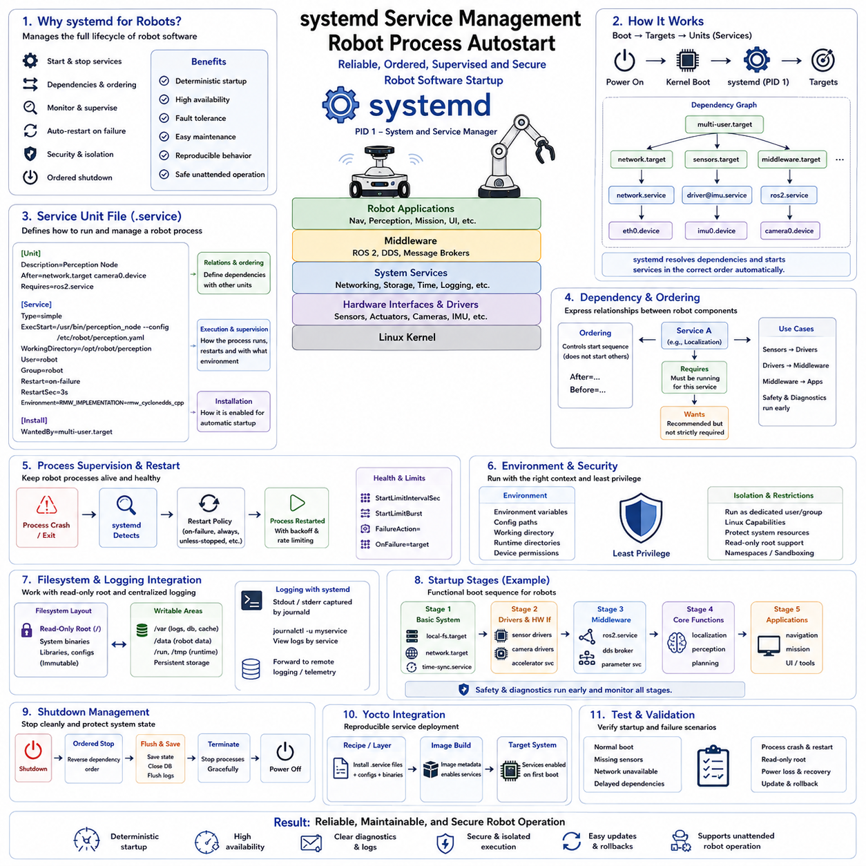
systemd is the primary service and system manager used by many modern Linux distributions, including Embedded Linux platforms deployed in robots. It starts and supervises operating-system services, establishes dependencies between processes, manages startup ordering, monitors process state, and coordinates shutdown. For robots, these capabilities provide a structured mechanism for automatically launching essential software after the operating system boots.
A robotic computer rarely runs only one application. Networking, hardware interfaces, sensor drivers, middleware, localization, perception, navigation, diagnostics, logging, safety supervision, and user applications may all need to start automatically. Starting these programs through shell scripts alone can make ordering and failure handling difficult, whereas systemd represents each managed function as a unit with explicit lifecycle and dependency information.
A service unit is normally described by a file using the `.service` extension. The unit definition specifies information about the service, its relationship with other units, the command used to start the process, execution environment, restart behavior, user privileges, and installation target. Keeping this information in version-controlled configuration allows robot startup behavior to become part of the reproducible Embedded Linux platform.
A service file is commonly divided into `[Unit]`, `[Service]`, and `[Install]` sections. The `[Unit]` section describes the service and defines relationships with other system components. The `[Service]` section determines how the robot process is executed and supervised. The `[Install]` section specifies how the service becomes associated with a target when it is enabled for automatic startup.
Startup dependencies are particularly important in robotic systems because many processes cannot operate independently. A navigation application may require networking and localization, localization may require sensor drivers, and perception may depend on cameras or accelerator services. systemd directives such as `After`, `Before`, `Requires`, and `Wants` allow these relationships to be represented more explicitly than arbitrary startup delays.
Ordering and dependency requirements should not be confused. An `After` relationship controls relative startup order but does not necessarily cause another service to start. Stronger dependency relationships can express that another unit is required for operation, while weaker relationships can request supporting services without making their failure fatal. Correct modeling prevents robot startup from depending on unreliable sleep-based initialization scripts.
Automatic startup is established by enabling a service for an appropriate systemd target. During boot, systemd activates the target and follows the associated dependency graph to start required units. This allows robot applications to become part of normal operating-system initialization rather than requiring an operator to log in and launch processes manually after every power cycle.
Process supervision is another major advantage of systemd. If a robot process terminates unexpectedly, restart policies can determine whether it should be launched again and how quickly retries occur. Appropriate restart behavior improves availability for communication gateways, diagnostics, middleware, and other long-running processes, although repeatedly crashing software should not be hidden behind unlimited restart loops.
Restart strategies must therefore distinguish temporary faults from persistent failures. A process that briefly loses an external dependency may recover successfully after restart, while an application with corrupted configuration or incompatible hardware may fail continuously. Restart delays, rate limits, failure targets, health monitoring, and escalation mechanisms should be designed so that repeated faults remain visible to the robot diagnostic system.
The execution environment of each service should also be explicitly controlled. Robot applications may require environment variables, configuration paths, working directories, runtime directories, device permissions, or middleware-specific settings. Defining these requirements in service configuration reduces dependence on interactive shell profiles and ensures that applications behave consistently whether started automatically, remotely, or during production testing.
Service identity and privileges are important for Embedded Linux security. Robot applications should not automatically run as the root user merely because doing so simplifies development. systemd can launch processes using dedicated users and groups and can apply restrictions to filesystem access, Linux capabilities, devices, namespaces, and other resources. Least-privilege execution limits the impact of application defects or compromised processes.
Filesystem design and service management must be coordinated, especially when a robot uses a read-only root filesystem. Services may require writable locations for logs, sockets, caches, databases, calibration data, or temporary files. These paths should be intentionally mapped to writable persistent storage or memory-backed runtime areas rather than allowing applications to modify protected operating-system directories.
Logging can be integrated with systemd so that output from robot services is collected consistently rather than being scattered across arbitrary files. Centralized service logs simplify startup debugging and failure analysis because engineers can examine process messages together with operating-system events. Production systems should still apply retention, filtering, storage limits, and remote telemetry policies to prevent uncontrolled log growth.
Robot startup should normally progress in functional stages rather than launching every process simultaneously. Basic storage and networking may become available first, followed by hardware interfaces and drivers, middleware, sensing services, localization, perception, planning, and higher-level applications. Safety supervision and diagnostics may need to start earlier so that failures during initialization can be detected and reported.
Hardware availability can complicate autostart because Linux boot completion does not guarantee that every sensor, network interface, removable device, or external controller is operational. Services should rely on meaningful dependencies, device units, readiness checks, or application-level health conditions rather than fixed delays whenever possible. This makes startup more robust when hardware initialization time varies between boots.
For ROS 2 robots, systemd can supervise the processes that establish the runtime environment for robot middleware and applications. Individual nodes, launch processes, hardware interfaces, or grouped robot functions can be managed according to the product architecture. The goal is not necessarily to create one service for every node, but to define manageable failure and lifecycle boundaries appropriate to the deployed robot.
Service grouping also affects recovery behavior. If perception fails, restarting only the affected perception stack may be preferable to restarting navigation, networking, and unrelated diagnostics. Conversely, tightly coupled processes may need coordinated restart because their internal states depend on one another. The systemd service architecture should therefore reflect functional isolation and fault-containment boundaries within the robot software architecture.
Shutdown behavior deserves the same attention as startup. Robots may need to stop motion-related applications, save operational state, close databases, flush logs, disconnect middleware, and terminate hardware communication before power is removed. systemd provides ordered service termination and timeout handling, allowing the Embedded Linux platform to perform a controlled transition instead of abruptly terminating all processes.
Yocto integration makes systemd service configuration reproducible across deployed devices. Robot application recipes can install service unit files together with executables and configuration resources, while image metadata determines which services are enabled in the product. This prevents production startup configuration from depending on manual commands performed after installation and keeps service behavior synchronized with software releases.
Testing should include more than confirming that services start during a normal boot. Engineers should evaluate missing sensors, unavailable networks, delayed dependencies, application crashes, repeated restart conditions, corrupted configuration, read-only filesystem operation, abrupt shutdown, and software updates. Boot logs and service state should provide enough diagnostic evidence to explain why a process started, failed, restarted, or remained inactive.
Well-designed systemd management transforms robot process autostart from a collection of startup scripts into a controlled runtime architecture. Explicit dependencies establish deterministic initialization, supervision improves availability, privilege restrictions strengthen security, structured logging improves diagnostics, and coordinated shutdown protects system state. Combined with reproducible Embedded Linux builds, systemd provides a maintainable foundation for reliable unattended robot operation.

06.06 Embedded Linux Networking: Ethernet, WiFi, CAN
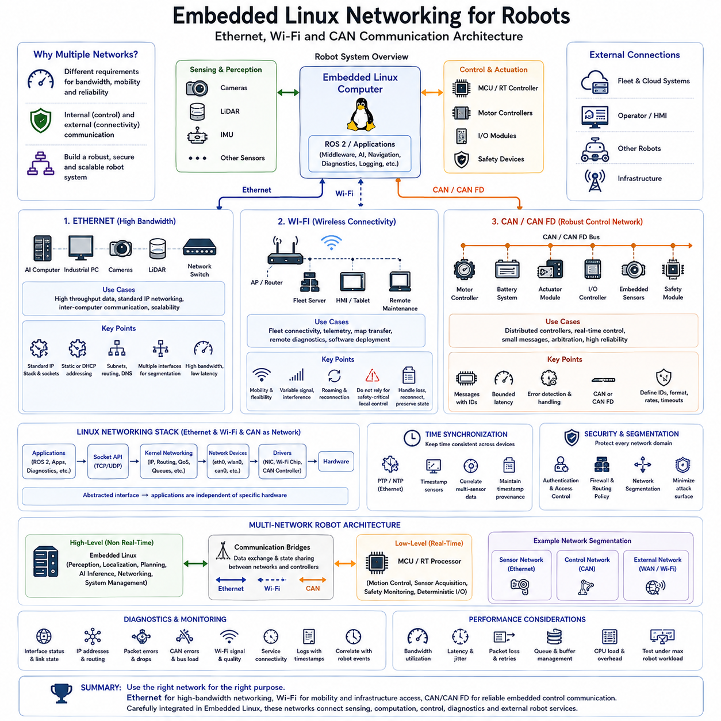
Embedded Linux networking provides the communication foundation that connects robot computers with sensors, controllers, other robots, operator systems, edge servers, and cloud infrastructure. Ethernet, Wi-Fi, and CAN address different communication requirements: Ethernet provides high-bandwidth packet networking, Wi-Fi adds mobile wireless connectivity, and CAN provides robust message-based communication for distributed embedded controllers and real-time-oriented robot subsystems.
A robot communication architecture usually contains both internal and external networks rather than relying on one universal interface. Internal communication may connect Linux computers, MCUs, motor controllers, sensors, and safety devices through CAN, Ethernet, UART, SPI, or related buses, while external communication links the robot with fleet systems, HMIs, other robots, or infrastructure through Ethernet and wireless networks.
Ethernet is commonly used when robots require high throughput, standard IP networking, interoperability, and scalable communication between computing devices. Cameras, LiDAR processing units, industrial PCs, AI computers, and network switches can exchange large amounts of data through Ethernet. Linux exposes these interfaces through its networking subsystem, allowing applications and middleware to use standard sockets rather than interacting directly with physical network hardware.
The Linux networking stack separates applications from Ethernet drivers and hardware. User-space software communicates through socket APIs, while kernel networking components process protocols, routing, packet queues, and network-device operations. Device drivers then connect this software stack to the Ethernet controller or adapter. This layered architecture allows robot applications to remain largely independent of the specific network interface hardware installed on the platform.
IP configuration must be treated as part of the robot product architecture. Interfaces may use static addresses when deterministic identification is important or dynamic configuration when infrastructure provides address assignment. Subnets, gateways, DNS, routing rules, and interface names should be consistently managed so that robot services do not depend on undocumented network settings manually created during development.
Multiple Ethernet interfaces can separate communication domains. A robot may dedicate one network to sensors, another to control or industrial equipment, and another to external fleet connectivity. Such segmentation can reduce unnecessary traffic interaction and create clearer security boundaries. Modern robotics hardware may provide several Ethernet interfaces specifically to support high-bandwidth, deterministic, or isolated communication paths.
Wi-Fi extends the Linux networking model to mobile wireless operation. It is particularly useful for fleet connectivity, telemetry, map transfer, remote diagnostics, operator interfaces, software deployment, and communication with site infrastructure. Because the robot moves through a changing radio environment, however, Wi-Fi must be designed around variable signal quality, interference, roaming behavior, temporary disconnection, and fluctuating latency rather than assuming permanent wired-network characteristics.
Wireless connectivity should therefore not become an uncontrolled dependency for safety-critical local robot behavior. Core motion control, emergency handling, and essential local autonomy should continue operating appropriately when an access point becomes unreachable. Applications using Wi-Fi should tolerate connection loss, reconnect cleanly, preserve important state where necessary, and distinguish temporary communication degradation from failures that require the robot to enter a controlled operational state.
CAN serves a substantially different role from Ethernet and Wi-Fi. It is widely suited to communication among embedded controllers where messages are relatively small but robustness, arbitration, bounded bus behavior, and distributed control are important. Robot platforms can use CAN or CAN FD for motor controllers, battery systems, actuator modules, I/O controllers, embedded sensors, and other devices located close to the physical control layer.
In Embedded Linux, CAN can be integrated through the Linux networking architecture rather than requiring every application to use a proprietary driver interface. This allows CAN interfaces to be treated in a network-oriented manner while preserving the characteristics of CAN frames and identifiers. Applications can then communicate with CAN devices through standardized Linux mechanisms, making diagnostic tools and middleware integration easier to maintain across hardware revisions.
CAN communication requires deliberate definition of identifiers, message formats, update rates, timeouts, error handling, and ownership. A technically functional bus can still become unreliable if several teams independently allocate identifiers or generate excessive periodic traffic. Robot development therefore benefits from a controlled communication specification that defines which controller publishes each message, which components consume it, and how communication failure is detected.
CAN FD extends conventional CAN operation by supporting larger data payloads and higher data-phase rates while retaining the general distributed bus concept. This can be valuable when robot controllers need more information per message or increased throughput without replacing the existing CAN-oriented architecture. Advanced robotics computing platforms increasingly expose multiple CAN FD channels alongside Ethernet, wireless connectivity, and other deterministic interfaces.
Ethernet and CAN frequently coexist because they solve different problems. High-volume perception data and communication between powerful computers are naturally suited to Ethernet, whereas distributed actuator and controller traffic can remain on CAN. An Embedded Linux computer can act as a bridge between these domains, receiving low-level controller information and making selected state available to ROS 2, diagnostics, navigation, logging, or fleet applications.
This multi-network design creates an important architectural boundary between high-level computing and real-time control. Embedded Linux can perform perception, localization, planning, AI inference, networking, and system management, while an MCU or real-time processor performs motor control, sensor acquisition, safety monitoring, and deterministic I/O. Ethernet, CAN, UART, or related mechanisms then provide communication between these computing domains.
Network interface initialization must also be coordinated with system startup. Applications should not assume that an interface is usable merely because the Linux kernel has detected its hardware. Address assignment, wireless association, route installation, time synchronization, or CAN configuration may still be incomplete. systemd dependency relationships and readiness checks can prevent robot applications from starting before their required communication environment is actually available.
Time synchronization becomes increasingly important when networked sensors and computers participate in perception and localization. Camera frames, LiDAR measurements, IMU data, odometry, and distributed computation may need timestamps that can be correlated accurately. Ethernet-based systems can support network time synchronization strategies, while application architecture must preserve timestamp provenance when information crosses CAN, MCU, Linux, and middleware boundaries.
Security should be applied according to the exposure of each network. External Ethernet and Wi-Fi interfaces require authentication, access control, firewall policy, encrypted communication where appropriate, and careful restriction of unnecessary services. Internal networks also require protection because compromised components can provide lateral access to critical robot functions. Network segmentation helps prevent one communication path from automatically exposing every subsystem.
Diagnostics are essential because communication faults often appear intermittently. Engineers should be able to inspect interface state, link status, addresses, routing, packet errors, dropped frames, CAN error conditions, bus utilization, wireless signal behavior, and service connectivity. Logging these conditions together with robot timestamps allows failures to be correlated with perception problems, controller faults, or changes in the physical operating environment.
Performance engineering must consider bandwidth, latency, jitter, CPU overhead, packet loss, and queue behavior rather than only nominal link speed. A high-bandwidth Ethernet link can still perform poorly if several sensors create bursts that overflow queues, while Wi-Fi performance can vary with radio conditions. CAN can become overloaded when message frequencies are poorly designed. Communication capacity should therefore be validated under realistic maximum robot workloads.
Linux provides a common software environment across these different communication technologies. Applications can use standardized networking interfaces while device drivers and protocol-specific components handle the underlying hardware. This abstraction supports portability across ARM, x86, and other Embedded Linux platforms and allows communication interfaces to evolve without requiring every higher-level robot application to be rewritten.
A robust robot network ultimately combines communication technologies according to their physical and timing characteristics rather than selecting a single preferred bus. Ethernet provides scalable high-bandwidth networking, Wi-Fi provides mobility and infrastructure access, and CAN provides reliable embedded-controller communication. Integrated carefully within Embedded Linux, these networks form the communication backbone connecting sensing, computation, control, diagnostics, and external robot services.

06.07 Container-Based Embedded Linux: Docker on Jetson [w/Code]
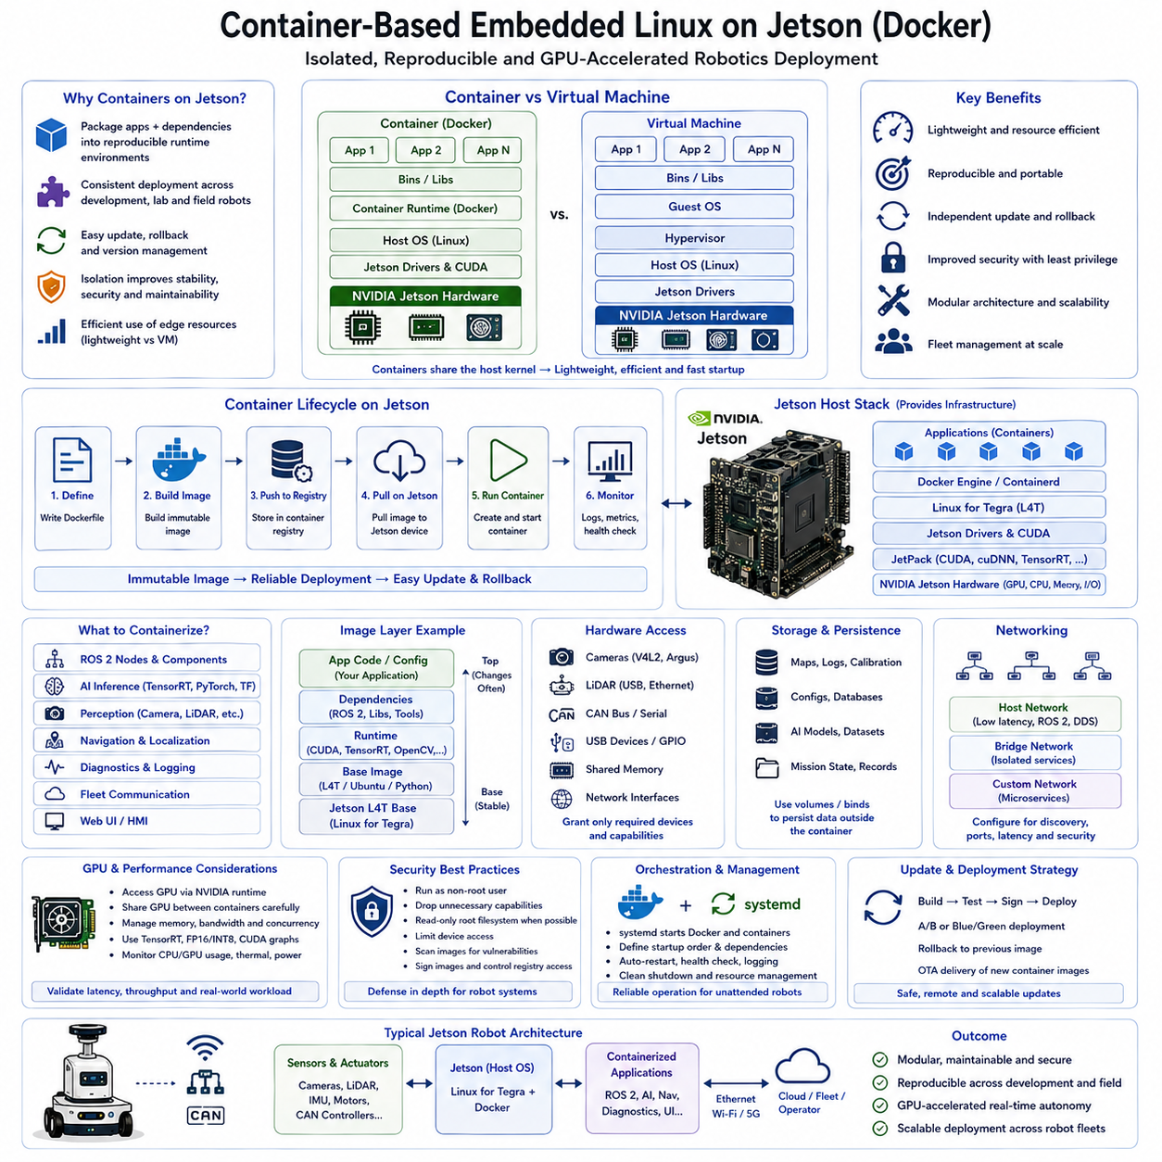
Container-based Embedded Linux provides a deployment model in which robot applications and their dependencies are packaged into isolated, reproducible runtime environments. On NVIDIA Jetson platforms, this approach is especially useful because robotics software commonly combines ROS 2, CUDA runtime components, TensorRT inference engines, AI frameworks, middleware, and application libraries whose versions must remain compatible across development and deployed robots.
A container differs fundamentally from a virtual machine because it normally shares the Linux kernel of the host operating system instead of running a complete guest operating system. Linux namespaces provide isolation for processes, networking, mounts, and other resources, while control groups regulate resource consumption. This architecture keeps containers relatively lightweight and suitable for resource-constrained edge computers where full virtualization would introduce unnecessary overhead.
Docker provides a practical toolchain for constructing, distributing, and executing these containers. Developers describe the application environment through a Dockerfile, build an immutable container image, store that image in a registry, and instantiate it as a running container on the Jetson device. The resulting package can include application binaries, runtime libraries, configuration defaults, middleware components, and supporting tools required by a robot workload.
Container images are constructed as layers, allowing common software components to be reused between related applications. A robotics image may begin with a compatible Linux and Jetson runtime environment, add ROS 2 and application dependencies, install perception or navigation software, and finally copy product-specific configuration. Layer reuse reduces repeated storage and transfer while encouraging teams to separate stable platform dependencies from frequently changing application code.
Jetson container deployment requires particular attention to the relationship between the host operating system and NVIDIA acceleration software. GPU-enabled applications depend on compatible host drivers and platform components, while container runtime integration makes GPU resources available inside the container. Containers therefore isolate much of the user-space software stack, but they do not eliminate compatibility requirements between the container and the underlying Jetson platform.
This distinction is critical for CUDA-based robotics workloads. An application container may package AI frameworks, CUDA-dependent libraries, TensorRT-related components, or inference software, while access to the actual GPU ultimately depends on the Jetson host platform. Container design must therefore be coordinated with the deployed JetPack and Linux for Tegra environment rather than assuming that an arbitrary desktop GPU container can be transferred unchanged to embedded hardware.
Hardware access is another important difference between cloud containers and robot containers. Robotics applications frequently require cameras, LiDAR interfaces, CAN devices, serial ports, GPIO, USB peripherals, shared memory, and network interfaces. Containers must be granted access to the required host devices and resources without unnecessarily exposing the complete hardware platform. This creates a balance between application functionality and isolation.
Networking can be configured according to the communication model of the robot. Containers may use isolated virtual networks for internal services or closer integration with the host network when ROS 2, DDS discovery, multicast communication, sensor streams, or low-latency interfaces require it. Network configuration should be treated as part of the deployed architecture because container boundaries can affect discovery, routing, ports, latency, and service accessibility.
Persistent data must be separated from the container image because containers should generally be replaceable runtime instances rather than permanent storage locations. Robot maps, calibration data, logs, configuration, databases, AI models, mission state, and diagnostic records can be mounted from controlled host directories or persistent volumes. This allows an application container to be replaced without unintentionally destroying operational data.
This separation also improves software update architecture. Instead of modifying libraries and executables directly on a running Jetson, a new container image can be built, tested, versioned, and deployed as a complete artifact. If validation fails, the system can return to a previously approved image. Containerized deployment therefore supports maintainability, software portability, remote update management, and scalable operation across multiple robots.
Version control should extend beyond source code to container definitions and image artifacts. A production robot should be able to identify which application version, base image, middleware release, AI model, configuration, and dependency set are running. Immutable image tags or content digests can provide stronger traceability than continuously changing labels, allowing field failures to be correlated with an exact deployed software composition.
Containers are particularly useful for separating complex robot workloads into functional services. Perception, localization, navigation, AI inference, diagnostics, fleet communication, and user interfaces can be packaged independently when their lifecycle boundaries justify separation. This modular architecture allows one subsystem to be updated or restarted without rebuilding the entire Linux root filesystem or disturbing unrelated robot functions.
However, excessive container fragmentation can create its own complexity. Every additional container introduces configuration, networking, logging, dependency, startup, resource, and version-management requirements. A practical robot architecture should therefore choose container boundaries according to functional ownership, failure isolation, update frequency, resource requirements, and interface stability rather than automatically placing every ROS 2 node in a separate container.
ROS 2 integration is especially relevant because many Jetson robots use distributed publish-subscribe communication. Containerized ROS 2 components must preserve appropriate DDS discovery and data transport behavior across container boundaries. For performance-sensitive perception pipelines, communication architecture may also need shared memory, intra-process communication, zero-copy mechanisms, or GPU-aware data handling to avoid unnecessary serialization and memory movement.
GPU resource management becomes important when several containers execute AI workloads simultaneously. Perception, object detection, segmentation, language models, or other inference services may compete for GPU compute, memory bandwidth, and device memory. Container isolation alone does not guarantee deterministic GPU scheduling, so workload architecture must consider concurrency, memory consumption, inference priorities, power limits, and sustained thermal behavior.
Performance validation should therefore compare containerized execution with the actual timing requirements of the robot. CPU utilization, GPU utilization, memory footprint, startup time, network latency, sensor throughput, inference latency, and storage overhead should be measured under realistic workloads. Containerization provides deployment consistency, but poorly designed resource sharing or communication boundaries can still introduce latency that affects real-time autonomy.
Security is improved when containers are operated with restricted privileges rather than unrestricted host access. Applications should receive only the devices, filesystem paths, Linux capabilities, network access, and user privileges required for their function. Running every robot container as privileged defeats much of the isolation benefit and can allow a compromised application to affect the host operating system or other robot services.
Container images themselves become part of the software supply chain and should therefore be controlled like other production artifacts. Trusted base images, vulnerability scanning, dependency tracking, software bills of materials, image signing, registry access control, and verified deployment can reduce the risk of introducing compromised or obsolete components. Production systems should also define policies for security patches and long-term image maintenance.
Startup and supervision must integrate containers with the Embedded Linux service architecture. systemd or another service manager can start the container runtime and robot containers in a defined order, enforce dependencies, monitor failures, and coordinate shutdown. Sensor interfaces, networking, persistent storage, and GPU services may need to become available before application containers are launched, especially in unattended robot systems.
Containerization complements rather than replaces the underlying Embedded Linux platform. The host still requires a reliable bootloader, kernel, Device Tree, hardware drivers, networking configuration, security policy, filesystem architecture, diagnostics, and OTA strategy. Containers primarily provide an application deployment and isolation layer above this foundation, allowing rapidly evolving robotics and AI software to be managed separately from lower-level platform components.
For Jetson-based robots, this separation creates a useful lifecycle boundary. The host Jetson platform can evolve cautiously around JetPack, drivers, kernel, hardware support, and security, while ROS 2 applications, TensorRT inference services, middleware, and product functions can evolve through independently versioned containers. This model supports reproducible software environments across fleets while preserving access to embedded GPU acceleration.
A successful container-based Embedded Linux architecture therefore combines isolation with deliberate hardware integration. Docker packages applications and dependencies into reproducible artifacts, Jetson provides accelerated edge computing, persistent volumes preserve robot state, controlled device access connects containers to physical hardware, and service management coordinates runtime behavior. Together these mechanisms provide a scalable foundation for maintainable, remotely deployable, GPU-accelerated robotic software.

06.08 Embedded Linux Security Hardening: SELinux / AppArmor
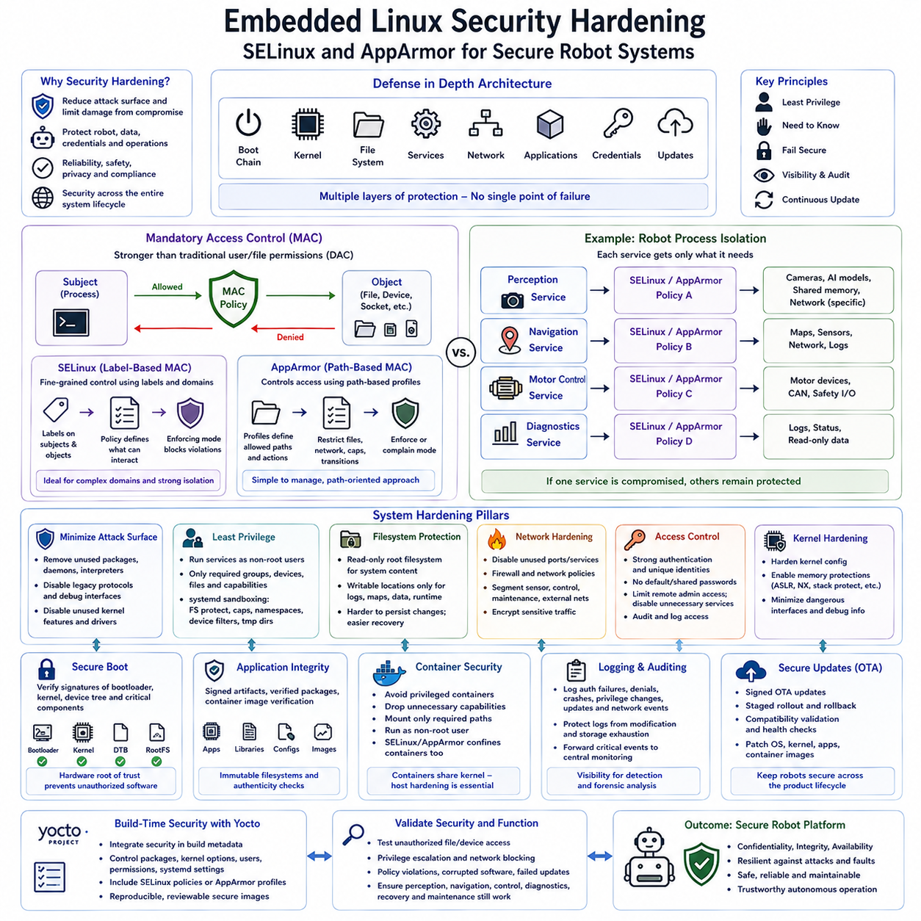
Embedded Linux security hardening reduces the number of ways an attacker, defective application, or compromised service can affect a deployed robot. Security must be designed across the boot chain, kernel, filesystem, services, networking, applications, credentials, and update mechanisms rather than added as a single feature. SELinux and AppArmor strengthen this architecture by enforcing mandatory restrictions beyond conventional Linux user and file permissions.
Traditional Linux security primarily uses discretionary access control, where users, groups, ownership, and permission bits determine access to files and resources. This model remains important, but a process running with excessive privileges can still access more of the system than necessary. Mandatory Access Control, or MAC, introduces centrally defined policies that restrict what processes may access even when ordinary filesystem permissions would otherwise permit the operation.
SELinux implements a powerful label-based Mandatory Access Control framework within the Linux security architecture. Files, processes, sockets, devices, and other objects receive security labels, while policy rules define which labeled subjects may interact with which labeled objects. This allows security decisions to depend on the role and domain of a robot process rather than relying only on the Linux account under which that process executes.
A robot perception service, for example, may need camera devices, AI model files, shared memory, and selected network communication but may not require access to boot configuration, authentication credentials, motor-control devices, or unrelated application data. SELinux policy can confine the perception process to its intended resources. If the service is compromised, the policy can limit the attacker's ability to move beyond that functional boundary.
SELinux commonly operates in enforcing, permissive, or disabled states. Enforcing mode actively blocks operations that violate policy, while permissive mode records policy violations without preventing them and is useful during policy development. Production robots should normally progress from policy observation and refinement toward enforcing operation rather than permanently leaving security controls in a diagnostic-only configuration.
SELinux policy development requires accurate understanding of application behavior. Overly restrictive policies can prevent legitimate robot functions, while excessively broad rules weaken isolation. Engineers should observe access requirements, analyze denial events, define minimal permissions, and repeatedly test normal and abnormal operating conditions. Automatically allowing every denied operation may produce a policy that technically works but provides little meaningful security.
AppArmor provides another Mandatory Access Control approach and generally uses path-oriented profiles to define what applications are permitted to access. A profile can restrict filesystem paths, executable transitions, network operations, capabilities, and other resources associated with a process. Its configuration model can be easier to understand for systems where application boundaries and filesystem paths are clearly structured.
AppArmor profiles can be developed using complain and enforce behavior. Complain mode allows applications to operate while policy violations are logged, helping developers understand required access during integration. Once the profile accurately represents legitimate behavior, enforce mode blocks unauthorized operations. As with SELinux, production security depends on carefully designed profiles rather than merely enabling the framework itself.
SELinux and AppArmor should generally be viewed as alternative policy frameworks rather than security mechanisms that must both be deployed simultaneously. SELinux provides highly expressive label-based control suitable for complex security domains, while AppArmor often provides simpler path-based policy management. The appropriate choice depends on the Linux distribution, build system, organizational expertise, certification requirements, application architecture, and long-term maintenance strategy.
Security hardening begins before MAC policy is applied. Unnecessary packages, interpreters, shells, development tools, debug interfaces, network daemons, legacy protocols, and kernel features should be removed from production images whenever they have no justified operational purpose. Reducing software composition decreases the attack surface and also reduces the number of components that must be patched, configured, monitored, and included in security policy.
Linux services should follow the principle of least privilege. Robot applications should run under dedicated non-root users whenever possible and receive only the groups, devices, files, network access, and Linux capabilities required for their function. systemd can further restrict services through filesystem protection, capability controls, namespace isolation, device restrictions, temporary directories, and other sandboxing mechanisms.
The root filesystem can provide another security boundary when critical system content is mounted read-only. Executables, libraries, configuration, and verified application resources can remain immutable while logs, maps, calibration data, databases, and runtime state are stored in explicitly writable locations. This makes persistent modification more difficult and supports recovery to a known software state after unexpected failures or attempted compromise.
Network hardening is essential because Ethernet, Wi-Fi, fleet connectivity, remote maintenance, and cloud communication create external entry points. Unused ports and services should be disabled, firewall rules should restrict communication paths, administrative interfaces should require authentication, and sensitive traffic should use appropriate encryption. Sensor, control, maintenance, and external communication networks can also be segmented to reduce lateral movement between robot subsystems.
Remote access requires particularly careful control. Production robots should avoid default passwords, shared credentials, unnecessary password-based administrative login, and permanently exposed debugging services. Device-specific identities, protected cryptographic keys, authenticated maintenance channels, restricted administrative privileges, credential rotation, and auditable access mechanisms provide stronger foundations for managing robots deployed outside controlled development environments.
Kernel hardening reduces opportunities for privilege escalation and exploitation below the application layer. Production configurations should remove unused drivers and protocols, restrict dangerous interfaces, enable appropriate memory-protection mechanisms, and minimize debugging functionality that exposes sensitive kernel state. Kernel configuration should be treated as a security-controlled build artifact so that hardening remains reproducible across production releases.
Secure Boot complements operating-system hardening by establishing trust before Linux starts. The boot process can verify cryptographic signatures or integrity metadata for bootloader stages, the kernel, Device Tree, and other critical artifacts. A hardware-backed root of trust can prevent unauthorized software from becoming the foundation of the running system, reducing the value of application-level protections being applied on top of an untrusted platform.
Application integrity must continue after boot. Verified or immutable filesystem strategies, signed application artifacts, container image verification, package authenticity checks, and controlled configuration can help ensure that deployed software matches an approved release. Security metadata should be version controlled together with application software so that policies, binaries, configuration, and platform components remain traceable as one deployed system.
Containerized robot applications still require host-level hardening. Containers share the host Linux kernel and should not be considered equivalent to separate security machines. Containers should avoid unnecessary privileged mode, receive only required devices and capabilities, use controlled filesystem mounts, and run as non-root identities where practical. SELinux or AppArmor can add another confinement layer around container processes and their interaction with host resources.
Robot hardware access makes least-privilege design especially important. A diagnostic application may require CAN monitoring but should not automatically receive unrestricted actuator control. A perception container may require cameras and GPU resources but not access to secure credentials. Separating hardware permissions according to functional responsibility creates containment boundaries between sensing, computation, motion control, diagnostics, fleet communication, and maintenance functions.
Logging and auditing provide visibility into security behavior. Authentication failures, denied policy operations, service crashes, privilege changes, update attempts, administrative access, and abnormal network events should be recorded according to operational requirements. Logs must be protected from uncontrolled modification and storage exhaustion, while critical security events may also be forwarded to an external monitoring or fleet-management system.
Security updates must be designed as part of the product lifecycle rather than treated as exceptional maintenance. Vulnerabilities may be discovered in the kernel, libraries, middleware, container images, drivers, or applications after deployment. Signed OTA updates, controlled rollout, compatibility validation, health checking, and rollback mechanisms allow security patches to reach field robots without sacrificing system availability or software integrity.
Yocto can integrate security configuration directly into reproducible Embedded Linux builds. Package selection, kernel options, users, filesystem permissions, systemd settings, SELinux policies, and other hardening resources can be maintained in controlled metadata and product layers. This prevents security from depending on manual configuration performed after installation and makes differences between development and production images explicit and reviewable.
Hardening must be validated against both security requirements and robot functionality. Engineers should test unauthorized file access, restricted devices, privilege escalation attempts, blocked network paths, policy violations, corrupted software, failed updates, missing credentials, and service compromise scenarios. At the same time, perception, localization, navigation, control, diagnostics, recovery, and maintenance must continue to receive the resources legitimately required for safe operation.
A secure Embedded Linux robot therefore relies on defense in depth rather than one protective mechanism. Minimal software reduces attack surface, least privilege limits authority, SELinux or AppArmor confines processes, read-only filesystems resist persistent modification, network controls reduce exposure, Secure Boot establishes platform trust, and signed updates preserve integrity over the product lifecycle. Together these controls create a hardened foundation for reliable autonomous robot deployment.

06.09 Embedded Linux OTA: Mender / RAUC [w/Code]
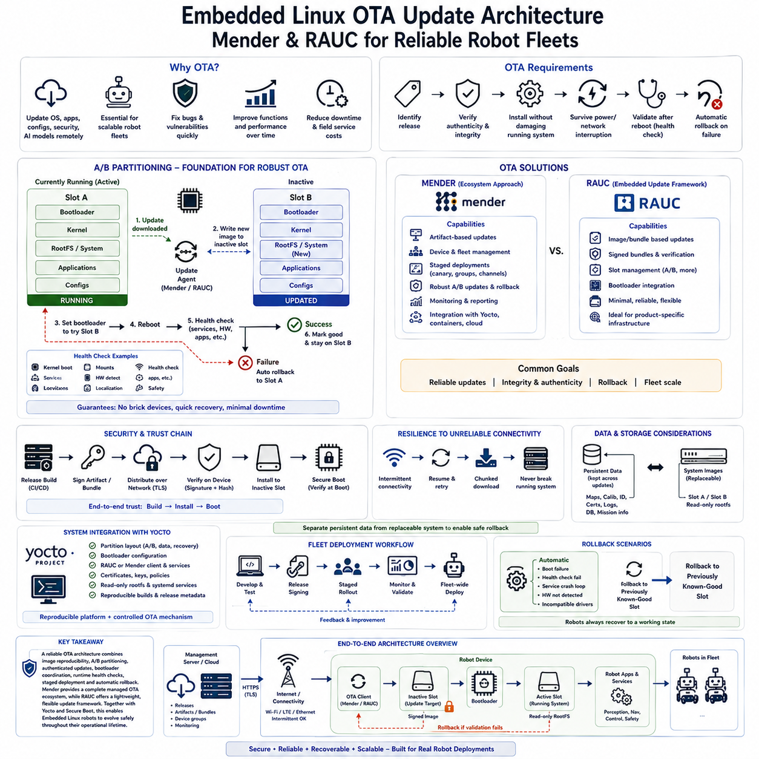
Over-the-Air update architecture allows Embedded Linux robots to receive operating-system, application, configuration, and security updates without requiring technicians to physically access every deployed device. OTA becomes increasingly important as robot fleets scale because software defects, security vulnerabilities, AI models, middleware, and operational functions continue to evolve after deployment. Mender and RAUC provide structured approaches for delivering reliable updates to embedded systems.
An OTA system must do more than transfer new files to a robot. It must identify the intended software release, verify authenticity and integrity, install the update without damaging the currently operational system, survive interrupted power or communication, validate the new software after reboot, and recover automatically when deployment fails. These requirements make OTA part of the platform reliability architecture rather than merely a remote file-copy mechanism.
Image-based updating is particularly suitable for controlled Embedded Linux products. Instead of replacing individual packages and configuration files on a running system, the update process distributes a complete filesystem or system image representing a known software state. This approach reduces configuration drift and makes deployed robots more reproducible because every successfully updated device can boot from essentially the same verified software composition.
A/B partitioning provides one of the strongest foundations for robust OTA operation. Storage contains two system slots, commonly identified as A and B. While the robot operates from Slot A, the updater writes the new system image to inactive Slot B. The running filesystem remains untouched during installation, allowing the robot to preserve a known-good software environment even if downloading or writing the new release fails.
After the inactive slot has been updated, the bootloader is instructed to attempt the new system during the next restart. Boot state and retry information must be maintained so the platform can determine whether the new release becomes operational. If the new image successfully boots and passes required validation, it can be marked as accepted. Otherwise, the boot process can return to the previous known-good slot.
Rollback is essential because successful image transfer does not guarantee successful robot operation. A release may contain incompatible drivers, incorrect configuration, middleware failures, application crashes, or hardware-specific problems. Automatic rollback provides a recovery path when the updated robot cannot reach an acceptable health state, preventing a remote software deployment from permanently disabling a field device.
Health checking connects OTA infrastructure with robot runtime behavior. Validation may confirm that the kernel booted, required filesystems mounted, networking became available, critical systemd services started, hardware interfaces were detected, and essential robot processes reached operational states. More advanced robots may additionally verify localization, sensor availability, safety supervision, communication, or application-specific readiness before committing an update.
Mender provides an OTA ecosystem designed for embedded devices and supports artifact-based software deployment, device management, update control, and rollback-oriented workflows. A Mender artifact can represent a versioned update associated with device compatibility information and deployment metadata. This enables organizations to manage software releases as identifiable deployment objects rather than distributing anonymous filesystem images to robots.
Mender can support robust root filesystem updates using redundant system partitions. The update client receives an artifact, validates it, writes the new image to the inactive partition, modifies boot state, and coordinates the reboot and commit process. If the updated system does not complete the expected confirmation sequence, the boot environment can preserve or restore the previously operational software depending on the configured integration.
For fleet deployments, centralized update management becomes particularly valuable. Robots can be grouped according to product generation, hardware revision, site, customer, operational role, or software channel. A release can first be deployed to development devices or a small canary group before expanding to larger populations. This staged rollout limits the impact of unexpected failures and provides evidence before fleet-wide deployment.
RAUC provides a focused update framework for reliable embedded Linux systems and integrates naturally with image-based and redundant partition designs. It manages signed update bundles and installation targets known as slots. System designers define the relationship between root filesystem slots, boot components, application partitions, or other updateable resources, allowing RAUC to install a controlled bundle according to the platform's storage architecture.
A RAUC bundle packages update content together with metadata and cryptographic verification information. Before installation, the system can authenticate the bundle and verify that it is intended for the target platform. This is important for robots because installing a technically valid but incompatible image onto the wrong hardware revision can be as damaging as installing corrupted software.
RAUC is commonly integrated with a bootloader that can select between redundant boot targets and track boot success. RAUC manages the installation state of slots, while bootloader integration determines which system should be attempted during startup. The exact architecture depends on the hardware platform, bootloader, partition layout, and Embedded Linux distribution, so OTA behavior must be designed together with the boot chain rather than added afterward.
Mender and RAUC therefore overlap in reliable update functionality but emphasize different integration models. Mender can provide a broader device and deployment management ecosystem around OTA workflows, while RAUC is often used as a focused embedded update mechanism integrated into a product-specific infrastructure. Selection should consider fleet-management requirements, backend strategy, storage architecture, security model, and engineering ownership.
Update security begins with authenticity. A robot must distinguish software produced by an authorized release process from arbitrary data received over a network. Signed artifacts or bundles allow the device to verify update provenance before installation. Integrity checks additionally detect corruption during storage or transfer, preventing damaged software from becoming the next bootable system.
Secure Boot and OTA signing should form a continuous chain of trust. OTA verification determines whether an update is authorized for installation, while Secure Boot verifies critical software when the robot starts. When combined correctly, an attacker cannot simply bypass signed OTA mechanisms by replacing boot components or installing an unauthorized kernel through another path. Trust therefore extends from release generation through installation to execution.
OTA systems must also tolerate unreliable connectivity. Mobile robots may move between Wi-Fi access points, lose external communication, enter radio shadows, or operate with limited bandwidth. Downloads should therefore support controlled retries and avoid making the currently running system dependent on continuous connectivity. An interrupted transfer must leave the robot capable of continuing operation or safely resuming the update later.
Persistent application data should normally be separated from replaceable system images. Maps, calibration parameters, robot identity, certificates, mission information, logs, databases, and site-specific configuration may need to survive an operating-system rollback. Clear separation between immutable system software and persistent operational data allows Slot A and Slot B to be replaced without destroying information required by the robot.
Data compatibility nevertheless requires careful planning. A new application may migrate a database or configuration format that an older software version cannot understand after rollback. OTA architecture must therefore consider backward-compatible schemas, migration checkpoints, versioned persistent data, or rollback-aware transformations. System rollback is incomplete if the previous software image boots but cannot interpret the data left by the newer release.
Storage capacity and flash endurance influence partition design. A/B updates require enough space for at least two bootable system images in addition to persistent data and recovery resources. Repeated full-image updates also generate significant writes. Engineers should size eMMC or NVMe storage according to image growth, update frequency, logs, AI models, recovery margins, and expected product lifetime rather than only the initial software footprint.
Yocto can integrate both update architecture and update artifacts into reproducible product builds. Partition layouts, bootloader configuration, filesystem images, update clients, certificates, service definitions, and release metadata can be managed through build layers and recipes. This makes the OTA mechanism part of the controlled platform configuration and reduces differences between laboratory images and software deployed to production robots.
Release automation should connect source control, continuous integration, testing, signing, artifact generation, and deployment approval. A successful source build should not automatically imply permission for fleet deployment. Production pipelines should establish traceability between source revisions, build outputs, test results, signatures, hardware compatibility, release identifiers, and deployment groups so that every field image can be traced to an approved release.
A reliable robot OTA strategy therefore combines image reproducibility, redundant storage, authenticated updates, bootloader coordination, runtime health checking, staged deployment, and automatic rollback. Mender provides a broad framework for managed OTA and fleet-oriented deployment, while RAUC offers a focused mechanism for signed bundle installation and slot management. Integrated with Yocto, Secure Boot, read-only filesystems, and disciplined release engineering, these mechanisms enable Embedded Linux robots to evolve safely throughout their operational lifetime.

06.10 Embedded Linux Performance Profiling: perf / ftrace
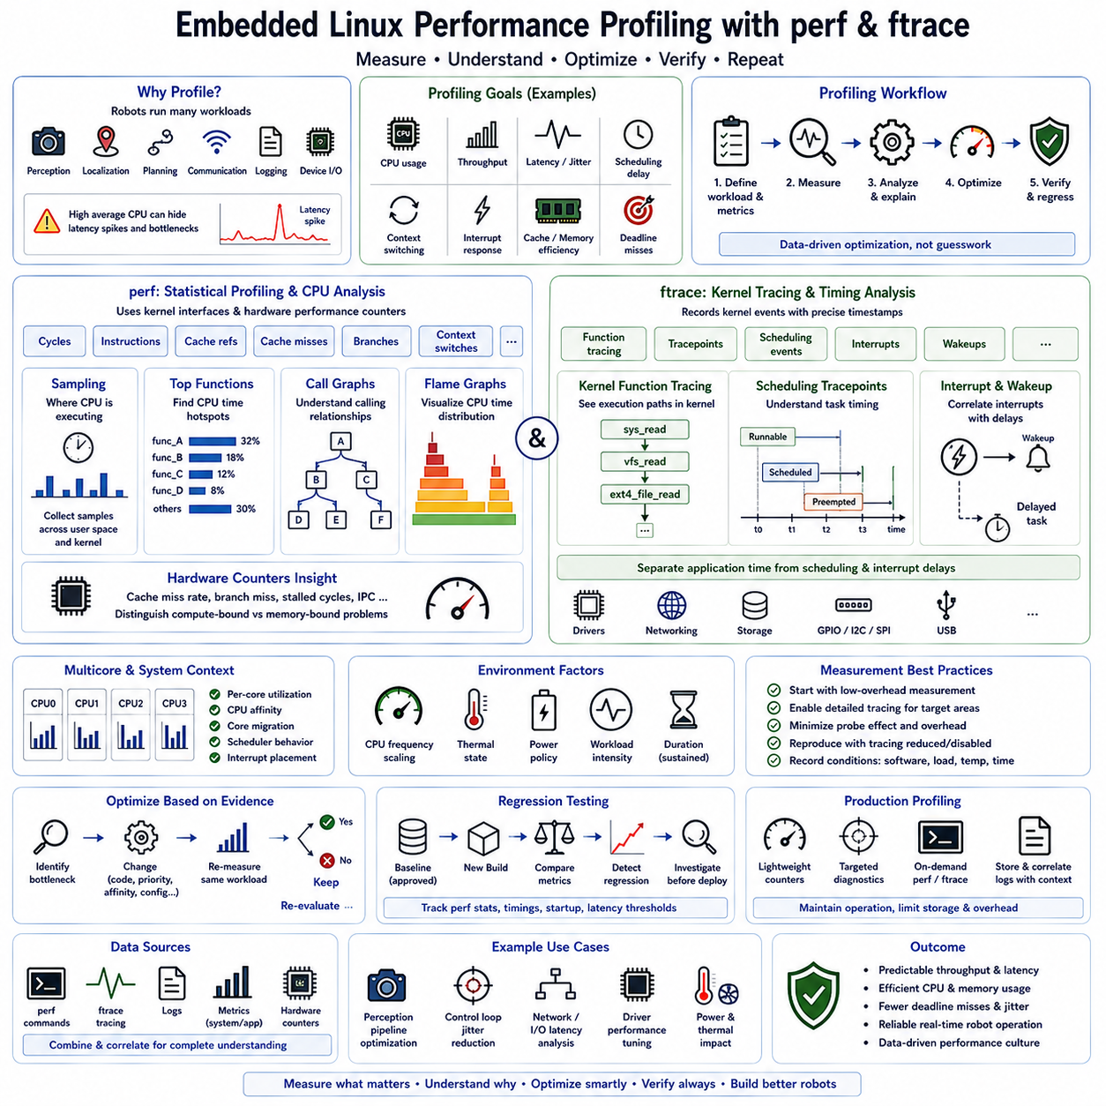
Performance profiling in Embedded Linux is the systematic process of measuring how software, the kernel, and hardware resources behave while a robot is operating. Profiling helps engineers identify CPU bottlenecks, scheduling delays, excessive context switching, cache inefficiency, interrupt activity, and unexpected latency. Tools such as perf and ftrace provide complementary views of system behavior, allowing optimization to be based on measured evidence rather than assumptions.
Robot workloads make performance analysis particularly important because perception, localization, planning, communication, logging, and device handling execute concurrently. A system may show acceptable average CPU utilization while still experiencing short latency spikes that disturb sensor processing or control timing. Profiling therefore examines not only total resource consumption but also when computation occurs, which processes cause delays, and how execution changes under realistic workloads.
The first step in profiling is establishing a repeatable workload and measurable performance objective. Engineers may evaluate camera processing rate, LiDAR pipeline latency, navigation cycle time, CPU utilization, interrupt response, scheduling delay, or application deadline misses. Measurements should be collected under representative operating conditions because an idle development system rarely exposes the contention, thermal behavior, and timing problems that appear during full robot operation.
perf is a Linux performance analysis tool that uses kernel facilities and hardware performance counters to observe application and system execution. It can measure events such as CPU cycles, instructions, cache references, cache misses, branches, context switches, and other processor-specific activities. This makes perf useful for determining where CPU time is consumed and whether inefficient execution is caused by software structure, memory behavior, or processor utilization.
A basic perf analysis can begin with statistical measurements of a process or complete workload. Rather than immediately examining individual functions, engineers can first compare instructions, cycles, cache behavior, and context-switch activity between software versions or operating conditions. These measurements establish a quantitative baseline and help determine whether a performance regression originates from increased computation, memory inefficiency, scheduling activity, or another system-level change.
Sampling provides a deeper view by periodically recording where the processor is executing. perf can collect samples across user-space applications and kernel functions and then summarize which functions consume the most CPU time. This is particularly useful for robotics pipelines containing image processing, point-cloud operations, serialization, middleware communication, AI preprocessing, or repeated memory operations that may dominate computation without being obvious from source-code inspection.
Call graphs extend profiling beyond individual hot functions by showing how expensive functions are reached. A function may appear costly because it is repeatedly invoked through several application paths rather than because one invocation is inherently slow. Examining calling relationships helps developers identify architectural causes such as unnecessary conversions, repeated allocation, duplicated computation, excessive copying, or inefficient abstraction layers.
Flame graphs can provide a compact visual representation of sampled call stacks collected from profiling data. Wider regions represent execution paths consuming larger portions of sampled CPU time, allowing engineers to recognize dominant processing chains quickly. In complex robot applications, this representation can reveal whether computation is concentrated in perception algorithms, middleware serialization, memory management, driver interaction, or kernel networking.
Hardware performance counters add microarchitectural information that ordinary application timers cannot provide. High cache-miss rates, branch misprediction, stalled execution, or poor instructions-per-cycle behavior may indicate that an algorithm is limited by memory access rather than raw arithmetic performance. This distinction matters because optimizing source-level computation may provide little benefit when the actual bottleneck is data layout, memory bandwidth, or cache locality.
ftrace approaches performance investigation from the perspective of kernel tracing. It can record kernel function execution, scheduling events, interrupts, wakeups, and other tracepoints with precise timing relationships. Whereas perf is often used to answer where processing resources are being consumed, ftrace is particularly valuable for understanding when kernel events occur and why a task experiences scheduling or execution latency.
Function tracing can reveal sequences of kernel operations involved in system behavior. Engineers can observe kernel functions associated with drivers, networking, storage, scheduling, or other subsystems and investigate unexpectedly long execution paths. Because tracing every kernel function can generate substantial data and overhead, tracing should normally be restricted to the functions and subsystems relevant to the performance question being investigated.
Tracepoints provide structured instrumentation for important kernel events without requiring unrestricted function tracing. Scheduler tracepoints, for example, can show when tasks become runnable, when they are scheduled, when they are preempted, and when context switches occur. This information is highly valuable when a robot thread occasionally misses its expected processing period even though its own application-level execution time appears acceptable.
Scheduling latency is especially important for real-time-oriented robot software. A control or sensor-processing thread may complete quickly after it starts running but still execute too late because another task, interrupt, or kernel activity delayed its scheduling. ftrace allows engineers to separate application execution time from wakeup and scheduling delay, providing a more accurate explanation of timing failures than measuring only the duration of the application function.
Interrupt and driver behavior can also influence robot timing. High-frequency sensors, Ethernet traffic, CAN interfaces, storage activity, and USB devices may generate interrupts that compete with application processing. Tracing can help correlate interrupt activity with delayed threads or jitter. This allows engineers to determine whether a latency problem originates in application code, kernel scheduling, a device driver, or excessive hardware event activity.
perf and ftrace are therefore complementary rather than competing tools. perf is well suited to statistical CPU profiling, hardware counter analysis, and identifying expensive execution paths, while ftrace provides detailed timing information about kernel functions, scheduling, interrupts, and trace events. A practical investigation may use perf to locate a computational hotspot and then use ftrace to determine whether remaining timing variation originates from kernel or scheduling behavior.
Profiling results must be interpreted in the context of multicore processors. Embedded robot computers commonly distribute perception, middleware, control, and system services across several CPU cores. Overall CPU utilization can hide a single saturated core, migration between cores, or contention between critical and background tasks. Per-core measurements, CPU affinity, scheduler behavior, and interrupt placement should therefore be examined when timing requirements are strict.
Dynamic frequency scaling and thermal management can further complicate measurement. Embedded processors may change CPU frequency according to workload, power policy, and temperature, causing identical software to exhibit different timing characteristics over time. GPU-intensive AI workloads can also affect system power and thermal limits. Profiling should therefore record relevant operating conditions and include sustained tests rather than relying only on short benchmark runs.
Instrumentation itself can influence the system being measured. Detailed tracing generates events, consumes memory, and may increase processing overhead, while high-frequency sampling can perturb timing-sensitive workloads. Engineers should begin with relatively low-overhead measurements and progressively enable more detailed tracing around suspected problem areas. Results should be reproduced with tracing reduced or disabled to confirm that observed behavior is not primarily caused by the measurement mechanism.
Performance optimization should follow measurement rather than intuition. After identifying a bottleneck, engineers can modify algorithms, memory access patterns, thread priorities, CPU affinity, communication paths, driver configuration, or system-service behavior and repeat the same workload. Comparing before-and-after measurements establishes whether the change actually improved throughput or latency and helps prevent optimizations that merely move the bottleneck elsewhere.
Regression testing can extend profiling into the software lifecycle. Selected perf statistics, application timing metrics, startup measurements, and latency thresholds can be recorded for approved releases and compared with later builds. Large changes can then trigger investigation before deployment. This is particularly valuable for Embedded Linux robots because kernel updates, middleware changes, new sensor drivers, or additional AI functions can alter system performance even when application interfaces remain unchanged.
Production profiling requires additional caution because deployed robots must remain operational and tracing data may consume significant storage. Lightweight counters and targeted diagnostics can be retained for field troubleshooting, while detailed perf recordings or ftrace sessions can be activated selectively when necessary. Logs should include software versions, workload conditions, timestamps, and hardware state so that field measurements can be reproduced in engineering environments.
A disciplined Embedded Linux performance workflow therefore moves from observation to localization, explanation, optimization, and verification. System metrics identify symptoms, perf reveals where computation is concentrated, hardware counters expose processor and memory behavior, and ftrace explains kernel timing, scheduling, and interrupt interactions. Together these tools provide the evidence required to build robot platforms with predictable throughput, controlled latency, and reliable real-time-oriented behavior.

