Volume 18 Physical AI Foundation Models

6. Action Tokenization

6.1 Action Representation for Foundation Models Overview
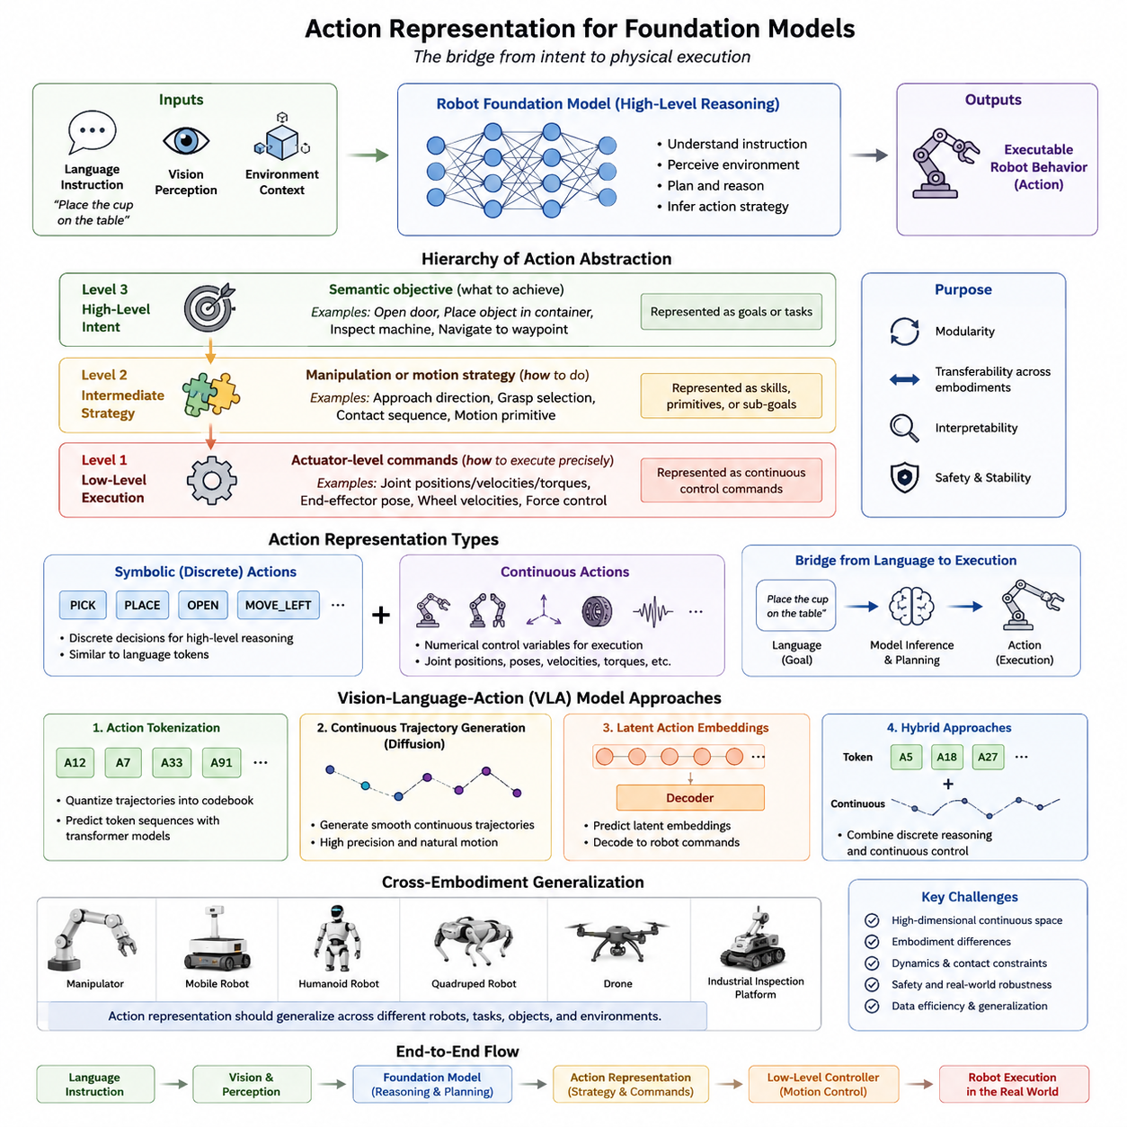
Action representation is one of the most fundamental components of Robot Foundation Models because it defines how an intelligent system expresses decisions as executable physical behavior. While perception determines what the robot observes and language specifies what the robot should accomplish, action representation determines how those objectives are translated into motor commands that interact with the physical world. Every Robot Foundation Model, regardless of its architecture, must ultimately generate actions that can be executed by actuators, whether the robot is a manipulator, an autonomous mobile robot, a humanoid, a quadruped, a drone, or an industrial inspection platform. Consequently, action representation serves as the interface between high-level intelligence and low-level control.
Unlike natural language, where words can be represented as discrete tokens with relatively fixed meanings, robotic actions exist within continuous physical spaces governed by dynamics, kinematics, contact mechanics, and safety constraints. The same semantic goal may require completely different motor trajectories depending on the robot embodiment, object properties, environmental conditions, and task context. Therefore, designing an effective action representation is considerably more challenging than representing text or images. A successful representation must capture both the abstract intent of an action and the precise physical execution required by the robot.
Traditional robotics generally used handcrafted action representations closely coupled to specific hardware. Industrial manipulators commonly employed joint-space trajectories or Cartesian end-effector commands. Mobile robots relied on linear and angular velocity commands. Humanoid robots combined whole-body inverse kinematics with balance controllers. These representations were effective within individual systems but transferred poorly across different robot embodiments because they directly encoded hardware-specific variables. Robot Foundation Models instead seek action representations that support generalization across multiple robots while preserving sufficient information for accurate physical execution.
The emergence of large-scale Robot Foundation Models has shifted action representation toward a more hierarchical perspective. Rather than viewing actions as isolated motor commands, modern systems increasingly interpret actions as structured information connecting semantic reasoning, task planning, motion generation, and physical control. High-level intentions, intermediate manipulation strategies, and low-level actuator commands become distinct layers within a unified action hierarchy. This separation improves transfer learning, modularity, interpretability, and cross-embodiment adaptation.
An action can be interpreted at several levels of abstraction. At the highest level, it represents an objective such as opening a door, placing an object inside a container, inspecting a machine, or navigating to a waypoint. At an intermediate level, the action describes a manipulation strategy including approach direction, grasp selection, contact sequence, or motion primitive. At the lowest level, the action consists of actuator commands including joint positions, joint velocities, joint torques, wheel velocities, motor currents, or force commands. Robot Foundation Models primarily reason at the higher semantic levels while lower control layers ensure physically stable execution.
One important distinction in modern foundation models is between symbolic actions and continuous actions. Symbolic actions represent discrete decisions such as “Pick,” “Place,” “Move Left,” or “Open Drawer.” These actions resemble language tokens and simplify high-level reasoning. However, they cannot directly control physical systems because robots require continuous motor trajectories. Continuous actions instead specify numerical control variables including joint positions, Cartesian poses, gripper openings, velocity vectors, or torque commands. Most practical Robot Foundation Models therefore combine symbolic reasoning with continuous control generation.
Language-conditioned robots naturally introduce another abstraction layer. Human instructions describe desired outcomes rather than exact motor commands. A command such as “place the cup on the table” contains no information regarding arm trajectory, wrist orientation, finger configuration, obstacle avoidance, or motion timing. The Robot Foundation Model must infer these execution details by combining semantic understanding with visual perception, environmental context, and embodiment-specific knowledge. Action representation therefore becomes the bridge connecting language semantics to physical execution.
The development of Vision-Language-Action (VLA) models significantly expanded research into action representations. Unlike conventional vision-language models producing textual responses, VLA systems generate executable robot behavior. Models such as RT-2, OpenVLA, Octo, and GR00T each employ different approaches to representing actions. Some tokenize actions similarly to language, others generate continuous trajectories through diffusion models, and others predict latent action embeddings later decoded into robot commands. These architectural choices strongly influence transfer capability, stability, computational efficiency, and embodiment generalization.
Discrete action tokenization represents one influential research direction. Continuous robot trajectories are quantized into finite codebooks analogous to vocabulary tokens in language models. During training, the model predicts sequences of action tokens instead of continuous numerical values. This approach enables transformers originally designed for language modeling to learn robot behavior using essentially the same autoregressive prediction framework. RT-2 popularized this concept by treating robotic actions as another modality alongside text and images. Although tokenization simplifies multimodal integration, discretization inevitably introduces approximation errors and may limit control precision.
Continuous action representations avoid discretization by directly predicting numerical control values. Diffusion policies, flow-based models, and continuous transformer architectures generate smooth trajectories without requiring action quantization. Such representations preserve physical precision and naturally support high-dimensional control spaces. They are particularly effective for dexterous manipulation, humanoid control, and contact-rich interaction where small numerical differences significantly influence execution quality. However, continuous generation often requires more sophisticated optimization and sampling procedures than discrete token prediction.
Latent action representations provide an intermediate solution between symbolic and continuous control. Rather than predicting raw actuator commands directly, the model learns a compact latent space capturing essential characteristics of robot behavior. Decoder networks subsequently transform latent actions into embodiment-specific motor commands. Latent representations reduce dimensionality while preserving semantic structure, making them attractive for cross-embodiment transfer. Similar manipulation strategies performed by different robots may occupy neighboring regions within the latent action space despite requiring different physical trajectories.
Temporal representation constitutes another major design consideration. Physical actions unfold over time rather than occurring instantaneously. Robot Foundation Models therefore rarely predict only a single control command. Instead, many systems generate action chunks representing short trajectory segments executed sequentially. Predicting multiple future actions simultaneously improves temporal consistency, reduces inference frequency, and allows smoother motion generation. Action chunking has become particularly important in diffusion-based policies and transformer architectures.
Action chunking also reduces computational cost. If the model predicts ten future control steps simultaneously, inference occurs less frequently while maintaining high control bandwidth. Furthermore, chunked prediction allows internal optimization across neighboring actions, producing smoother trajectories than independently predicting each control cycle. The challenge lies in selecting chunk lengths balancing responsiveness against computational efficiency. Very long chunks reduce adaptability, whereas very short chunks increase computational overhead.
Hierarchical action representations naturally complement hierarchical planning architectures. Mission planners generate long-term objectives. Task planners decompose missions into subtasks. Foundation models generate semantic action sequences. Motion planners optimize trajectories. Low-level controllers execute actuator commands. Each layer operates at different temporal and semantic resolutions while exchanging structured action representations. This hierarchy improves scalability because each layer focuses on its appropriate abstraction level rather than solving the entire control problem simultaneously.
Embodiment-specific adaptation remains one of the most difficult challenges in action representation. Different robots possess different numbers of joints, actuator limits, kinematic structures, sensor configurations, and dynamic properties. A seven-degree-of-freedom manipulator, a wheeled mobile robot, a quadruped, and a humanoid cannot share identical motor commands. Foundation models therefore separate embodiment-independent semantic representations from embodiment-dependent action decoders. Shared latent actions are translated into robot-specific commands through lightweight adaptation modules.
Cross-embodiment datasets such as Open X-Embodiment accelerate research in universal action representations. Demonstrations collected from multiple robot platforms expose models to diverse execution strategies corresponding to similar semantic objectives. Rather than memorizing hardware-specific trajectories, models learn invariant manipulation concepts transferable across embodiments. Action representation therefore becomes increasingly independent of any particular robot while remaining compatible with embodiment-specific execution modules.
Coordinate system selection significantly influences action representation quality. Joint-space commands directly control actuators but remain highly embodiment dependent. Cartesian end-effector poses provide greater semantic consistency because reaching a particular spatial location often corresponds to similar manipulation objectives across robots. Object-centric coordinates further improve transfer by expressing actions relative to manipulated objects rather than global reference frames. Future foundation models will likely combine multiple coordinate systems within unified hierarchical representations.
Object-centric action representation has attracted considerable interest because manipulation fundamentally concerns interactions with objects rather than robot joints. Instead of commanding “move joint three by five degrees,” object-centric representations specify intentions such as “approach the mug handle,” “maintain contact with the drawer,” or “rotate the valve clockwise.” These descriptions remain meaningful across different embodiments while leaving embodiment-specific execution to lower control layers.
Affordance-aware action representation further enhances generalization. Affordances describe possible interactions supported by objects. A handle affords pulling, a button affords pressing, a knob affords rotation, and a container affords insertion. Foundation models incorporating affordance information can generate actions based upon functional object properties rather than memorized object identities. Consequently, robots transfer manipulation knowledge more effectively to previously unseen objects exhibiting similar affordances.
Contact-rich manipulation introduces additional complexity because actions depend strongly upon interaction forces rather than solely geometric trajectories. Insertion tasks, polishing, screwing, opening jars, and deformable object manipulation require continuous adaptation based on tactile feedback and force sensing. Purely geometric action representations prove insufficient under such conditions. Future Robot Foundation Models increasingly incorporate force-aware and tactile-aware action representations integrating contact dynamics into motor generation.
Humanoid robots present unique challenges because actions involve coordinated whole-body movement. Walking, balancing, reaching, grasping, bending, and obstacle avoidance interact continuously. Whole-body action representations must coordinate dozens of degrees of freedom while respecting stability constraints. Layered control architectures typically separate locomotion, manipulation, posture regulation, and balance stabilization, with foundation models generating high-level coordinated intentions rather than individual joint torques.
Mobile manipulation similarly requires integrated action representations. Navigation and manipulation cannot be treated independently because base positioning influences arm reachability, manipulation success, and collision avoidance. Foundation models therefore increasingly generate combined navigation-manipulation actions coordinating base movement with arm trajectories. Such integrated representations improve efficiency by planning the entire task jointly rather than sequentially.
Language plays a significant role in shaping action representations. Human instructions specify goals at varying abstraction levels. Commands may describe complete missions, intermediate subtasks, object relationships, spatial constraints, temporal ordering, or safety requirements. Foundation models must transform these linguistic abstractions into executable physical behavior. Consequently, language embeddings often condition latent action representations throughout the generation process.
Visual observations similarly influence action generation continuously. Dynamic environments require constant adaptation because objects move, humans intervene, lighting changes, and unexpected obstacles appear. Closed-loop action representations repeatedly update predicted trajectories using current sensor observations. Unlike open-loop trajectory generation, closed-loop control continuously integrates perception with action execution, substantially improving robustness.
Memory also contributes to action representation. Long-horizon tasks require remembering previous actions, completed subtasks, object states, and mission progress. Foundation models increasingly incorporate recurrent memory, attention mechanisms, or external memory systems allowing future actions to depend upon historical context. Such memory-enhanced representations prove essential for extended autonomous operation.
World models naturally complement action representations by predicting consequences before execution. Candidate actions generated by the foundation model may be evaluated within an internal predictive model estimating future object motion, robot state, collision risk, energy consumption, and task success. The selected action therefore reflects not only immediate feasibility but also anticipated long-term consequences. Action representation thus interacts closely with predictive planning rather than functioning independently.
Safety imposes strict constraints on executable actions. Foundation models may generate semantically reasonable behaviors violating physical limitations. Dedicated safety supervisors therefore validate predicted actions against joint limits, velocity constraints, acceleration limits, workspace boundaries, collision avoidance rules, stability criteria, payload restrictions, and operational policies. Safe action representation requires compatibility with deterministic verification rather than bypassing conventional safety mechanisms.
Action uncertainty represents another emerging research topic. Robots frequently operate under incomplete information, sensor noise, ambiguous instructions, and dynamic environments. Instead of predicting only one deterministic action, future foundation models may estimate probability distributions over possible actions together with associated confidence measures. Low-confidence situations can trigger additional sensing, clarification requests, or conservative fallback behaviors rather than risky execution.
Learning effective action representations requires extensive supervision. Demonstration data provides examples linking observations, language, and successful motor behavior. Simulation generates diverse trajectories difficult to collect physically. Reinforcement learning refines policies through trial and error. Self-supervised predictive learning discovers latent physical structure without explicit labels. Modern Robot Foundation Models increasingly combine all these learning paradigms during different training stages.
Scaling laws also appear within action representation learning. Increasing demonstration diversity generally improves transfer performance more than merely increasing demonstration quantity. Diverse robot embodiments, manipulation styles, object categories, environments, and language instructions enrich latent action representations, enabling broader generalization. Consequently, future research increasingly emphasizes heterogeneous data collection rather than homogeneous dataset expansion.
Evaluation of action representations extends beyond task success alone. Smoothness, stability, energy efficiency, collision avoidance, recovery capability, temporal consistency, embodiment transfer, computational latency, uncertainty calibration, and long-horizon reliability all influence practical deployment. Benchmarking protocols therefore examine not only whether the robot completes tasks but also how effectively, safely, and efficiently those actions are executed.
Industrial deployment introduces additional evaluation criteria. Continuous twenty-four-hour operation, predictive maintenance, communication interruptions, actuator degradation, battery constraints, environmental variability, and human collaboration all influence action quality. Foundation models designed for production environments require representations supporting robust adaptation rather than ideal laboratory performance.
Action representation also affects explainability. High-level semantic actions remain easier for human operators to understand than low-level motor commands. Hierarchical representations therefore improve transparency because planners, operators, and safety supervisors can inspect intermediate decision layers before physical execution. Explainable action generation facilitates debugging, certification, regulatory compliance, and operator trust.
Future research increasingly explores compositional action representations. Rather than learning every manipulation skill independently, foundation models decompose complex behaviors into reusable primitives. Reaching, grasping, rotating, pulling, pushing, aligning, and releasing become composable building blocks assembled dynamically according to task requirements. Such compositionality resembles language, where finite vocabularies generate unlimited expressions through structured combination.
Another promising direction involves integrating symbolic planning with continuous action generation. Symbolic planners efficiently reason about long-horizon task structure, whereas continuous policies excel at physical execution. Hybrid architectures combine symbolic reasoning, latent action representations, world models, and diffusion policies within unified planning frameworks. This integration promises greater scalability, interpretability, and reliability than either paradigm alone.
The emergence of multimodal foundation models further broadens action representation. Future robots will integrate vision, language, sound, touch, force, proprioception, environmental maps, digital twins, and world models into unified action generation. Rather than treating actions as isolated control outputs, foundation models will generate physically grounded behaviors conditioned upon comprehensive multimodal understanding of both current observations and predicted future states.
From the perspective of Physical AI, action representation serves as the central bridge connecting cognition with embodiment. Perception explains what exists in the environment. Language defines desired objectives. World models predict future consequences. Planning determines appropriate strategies. Action representation converts these abstract cognitive processes into executable physical behavior while respecting embodiment constraints, safety requirements, and dynamic interactions. As Robot Foundation Models continue to evolve, increasingly expressive, transferable, hierarchical, and multimodal action representations will become one of the defining technologies enabling general-purpose autonomous robots capable of operating reliably across diverse embodiments, tasks, and real-world environments.

6.2 Continuous Action Discretization Binning Methods [w/Code]
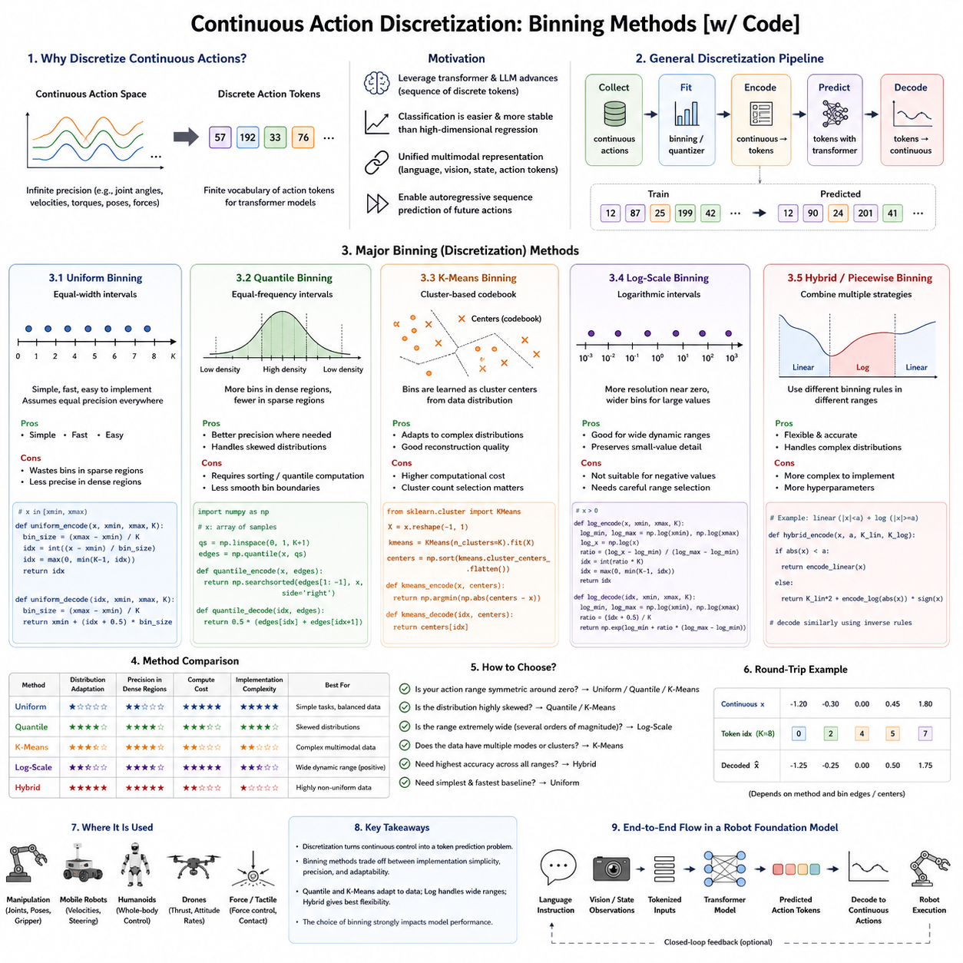
Continuous action generation is one of the defining characteristics of robotic intelligence because robots interact with the physical world through continuous movements rather than discrete symbolic commands. Unlike natural language, where words naturally form a finite vocabulary, robotic actions exist in continuous mathematical spaces involving joint positions, velocities, torques, Cartesian poses, gripper openings, wheel speeds, body orientations, and force commands. Every movement is represented by real-valued variables that theoretically possess infinite precision. This continuous nature enables smooth and precise control but introduces significant challenges for large-scale learning. Modern Robot Foundation Models therefore face an important design question: should actions remain continuous throughout the learning process, or should they be discretized into finite symbolic representations that are easier for transformer architectures to learn?
Continuous action discretization refers to the process of converting real-valued control signals into finite symbolic representations while preserving as much useful information as possible. Instead of directly predicting floating-point actuator commands, the model predicts discrete action tokens selected from a predefined vocabulary. This idea is conceptually similar to language modeling, where continuous human speech is converted into discrete words or tokens before being processed by transformers. By representing actions as discrete symbols, Robot Foundation Models can leverage many of the architectural advances originally developed for large language models, including autoregressive prediction, token embeddings, attention mechanisms, sequence modeling, and large-scale pretraining.
The motivation for action discretization originates from both machine learning and robotics. Transformer architectures were originally designed for sequences of discrete tokens rather than continuous numerical vectors. Although transformers can process continuous inputs through linear projections, predicting high-dimensional continuous outputs directly often leads to optimization instability, slow convergence, and poor uncertainty estimation. Discretization converts regression problems into classification problems, which frequently exhibit more stable optimization behavior. Classification losses such as cross-entropy are generally easier to optimize than high-dimensional continuous regression losses, particularly when training on extremely large datasets.
Another important motivation concerns multimodal learning. Modern Robot Foundation Models simultaneously process language, images, robot states, depth observations, tactile signals, and actions. Representing actions using discrete tokens places them within the same representational framework as textual tokens. Consequently, actions become another modality within a unified sequence model. The transformer no longer distinguishes fundamentally between words, image patches, and action symbols. Instead, every modality becomes a sequence of tokens processed using shared attention mechanisms. This architectural simplicity greatly facilitates multimodal integration.
Discretization also supports autoregressive sequence prediction. Language models generate one token at a time conditioned on previously generated tokens. Robot Foundation Models adopting discrete action representations apply exactly the same principle. Instead of predicting words, they predict sequences of action tokens corresponding to future robot behavior. This unified modeling approach allows robotics to benefit directly from advances in large-scale language modeling without requiring entirely new neural architectures.
The simplest discretization method is uniform binning. In this approach, each continuous variable is divided into equally spaced intervals across its operating range. Every interval corresponds to one discrete action token. For example, a joint angle ranging from minus ninety degrees to plus ninety degrees may be divided into 256 equally sized bins. During preprocessing, every continuous value is assigned to its nearest bin. During inference, predicted bins are converted back into continuous values by selecting the center of the corresponding interval. Uniform binning is straightforward, computationally efficient, and easy to implement. However, it assumes that all regions of the action space require identical precision, which rarely matches real robotic behavior.
Many robotic actions exhibit highly non-uniform distributions. Most joint positions concentrate within relatively small regions, while extreme configurations occur only rarely. Uniform binning therefore allocates many bins to infrequently visited regions while providing insufficient precision where most actions occur. This inefficiency motivates adaptive discretization strategies that distribute bins according to data density rather than geometric distance.
Non-uniform binning allocates more discrete symbols to frequently occurring action regions while assigning fewer bins to rare regions. Quantile-based binning represents one common implementation. Instead of dividing numerical ranges equally, quantile methods divide the empirical action distribution into equally populated intervals. Each bin therefore contains approximately the same number of training samples. High-density regions receive finer resolution, improving reconstruction accuracy without increasing vocabulary size. Quantile binning proves particularly effective when robot demonstrations exhibit strongly skewed action distributions.
Another adaptive strategy employs clustering algorithms. Instead of predefined intervals, clustering methods such as K-means identify representative action centers directly from the data. Every continuous action is assigned to its nearest cluster centroid, and each centroid becomes one discrete token. Unlike uniform or quantile binning, clustering naturally adapts to multidimensional action spaces. Frequently occurring manipulation strategies generate dense clusters, whereas rare behaviors occupy fewer representatives. Cluster-based discretization therefore captures intrinsic action structure more effectively than simple scalar quantization.
Vector Quantized Variational Autoencoders (VQ-VAE) extend this idea further by learning discrete codebooks through neural optimization. Rather than manually defining bins, VQ-VAE learns representative action embeddings minimizing reconstruction error. Continuous actions are encoded into discrete latent codes selected from a learned codebook, and decoder networks reconstruct the original actions. These learned representations preserve semantic similarities while reducing dimensionality. Closely related manipulation behaviors often share neighboring latent codes, improving generalization and compositionality.
Product quantization provides another efficient discretization strategy for high-dimensional action spaces. Instead of discretizing the entire action vector jointly, product quantization decomposes it into smaller subspaces that are quantized independently. Each subspace maintains its own codebook, dramatically reducing overall vocabulary size while preserving expressive capacity. Product quantization becomes particularly attractive for humanoid robots possessing dozens of controlled joints because direct quantization of the full action vector would require prohibitively large vocabularies.
Residual quantization further improves representation accuracy by modeling actions hierarchically. The first quantizer captures coarse behavior, while subsequent quantizers encode progressively smaller residual errors. This multistage process resembles image compression techniques in which coarse approximations are refined iteratively. Residual quantization achieves high precision without requiring exponentially large codebooks, making it attractive for complex manipulation tasks demanding accurate motor control.
Hierarchical discretization extends this principle semantically. Instead of quantizing only numerical values, different abstraction levels receive separate discrete representations. High-level tokens describe semantic objectives such as “grasp,” “push,” or “insert.” Intermediate tokens represent motion primitives including approach direction or contact strategy. Low-level tokens encode actuator commands. Such hierarchical representations align naturally with hierarchical planning architectures and improve interpretability because semantic intentions remain distinguishable from motor execution.
Action tokenization has become particularly influential within Vision-Language-Action models. RT-2 demonstrated that robot actions could be represented as discrete textual-like tokens integrated directly into transformer sequence prediction. Language instructions, visual observations, and action tokens all become elements within one multimodal sequence. During inference, the model autoregressively predicts future action tokens conditioned upon language and perception. This unified representation enables large language model architectures to generate executable robot behavior with minimal architectural modification.
Despite these advantages, discretization inevitably introduces quantization error. Every continuous value is approximated by its nearest discrete representative. The magnitude of this error depends upon bin resolution, data distribution, and reconstruction strategy. Fine discretization reduces approximation error but increases vocabulary size, computational cost, and prediction complexity. Coarse discretization simplifies learning but sacrifices control precision. Selecting appropriate discretization granularity therefore requires balancing accuracy against efficiency.
This tradeoff becomes particularly important for precision manipulation. Tasks such as inserting electrical connectors, tightening screws, performing surgical procedures, or assembling mechanical components often require sub-millimeter positioning accuracy. Excessive quantization error may accumulate over multiple control cycles, producing failed executions despite correct high-level reasoning. Consequently, highly precise applications frequently combine discrete high-level planning with continuous low-level refinement.
Continuous refinement represents one effective hybrid strategy. The transformer first predicts coarse discrete action tokens identifying approximate behavior. Secondary neural networks subsequently refine these predictions into precise continuous commands. Such coarse-to-fine architectures combine stable symbolic prediction with accurate physical execution. The coarse stage captures semantic intent, while refinement networks compensate for quantization error using local continuous optimization.
Diffusion models offer an alternative perspective by avoiding explicit discretization altogether. Instead of selecting discrete bins, diffusion policies iteratively generate continuous action trajectories through stochastic denoising. Because diffusion naturally models complex multimodal distributions, it handles uncertainty and diverse manipulation strategies effectively. However, diffusion inference generally requires multiple iterative refinement steps, increasing computational cost relative to single-pass token prediction.
Flow matching models similarly generate continuous actions while improving computational efficiency compared with diffusion. Rather than reversing stochastic diffusion processes, flow models learn deterministic transformations from simple latent distributions into action space. Flow-based representations preserve continuous precision while reducing inference latency. Recent Physical AI research increasingly investigates flow matching as an alternative to discrete action tokenization.
Action discretization also influences temporal representation. Instead of predicting individual control commands, many Robot Foundation Models discretize short action sequences called action chunks. Each token represents multiple consecutive control cycles. Action chunking reduces inference frequency, improves temporal consistency, and captures higher-level motion patterns extending beyond single actuator updates. RT-1, RT-2, Octo, and several diffusion-based policies all exploit chunked prediction to improve execution smoothness.
Chunk discretization naturally captures reusable motor primitives. Frequently occurring movement segments such as reaching, grasping, lifting, pushing, or retracting become recurring action patterns represented by discrete tokens. Sequence models then compose these primitives into longer behaviors analogously to composing words into sentences. Such compositionality improves data efficiency because learned motor fragments transfer across multiple tasks.
Another important design consideration concerns coordinate systems. Joint-space actions, Cartesian poses, object-relative coordinates, force vectors, and velocity commands each exhibit different statistical properties. Discretization performance depends strongly upon representation choice. Joint-space quantization often transfers poorly across embodiments, whereas object-centric or Cartesian representations provide greater semantic consistency. Consequently, many modern Robot Foundation Models discretize object-relative actions rather than raw actuator signals whenever possible.
Embodiment diversity introduces additional complexity. Robots differ in numbers of joints, actuator ranges, kinematic constraints, and sensing modalities. A universal discrete vocabulary must therefore either accommodate heterogeneous embodiments or employ embodiment-specific decoders. Current research increasingly favors shared latent discrete representations combined with lightweight embodiment adaptation layers translating generic tokens into robot-specific motor commands. Such architectures preserve cross-embodiment transfer while respecting hardware differences.
Language-conditioned action generation further motivates discretization. Human instructions naturally describe symbolic intentions rather than continuous trajectories. A command such as “place the package on the shelf” aligns more closely with symbolic action sequences than numerical joint values. Discrete action tokens therefore create an intermediate semantic representation bridging linguistic reasoning and physical execution. This alignment simplifies multimodal learning because language and actions share similar representational structure.
World models also benefit from discretized actions. Predictive models estimating future environmental evolution require compact action representations suitable for long-horizon simulation. Discrete tokens reduce modeling complexity while enabling efficient rollout over extended planning horizons. Internal simulation can evaluate alternative action sequences before physical execution, supporting imagination-based planning and decision making.
However, excessive discretization may reduce predictive fidelity. Small continuous adjustments often produce significant differences during contact-rich manipulation, balance control, or dynamic locomotion. Predictive world models therefore frequently operate using latent continuous dynamics even when external action interfaces remain discrete. Hybrid architectures combining discrete planning with continuous latent simulation increasingly dominate current research.
Reinforcement learning introduces another perspective on discretization. Classical reinforcement learning algorithms often assume either discrete or continuous action spaces. Discrete methods such as Deep Q-Networks perform efficiently when action vocabularies remain small but scale poorly to high-dimensional robotics. Continuous algorithms such as DDPG, SAC, or TD3 naturally handle motor control but require stable continuous optimization. Robot Foundation Models increasingly combine supervised action token learning with reinforcement learning fine-tuning, exploiting advantages of both paradigms.
Imitation learning similarly benefits from discretization. Expert demonstrations become sequences of symbolic action tokens easily modeled using transformer architectures. Behavioral cloning reduces to sequence prediction rather than continuous regression. Large-scale datasets containing millions of demonstrations therefore become more manageable because learning resembles language modeling over action vocabularies.
Token vocabulary design becomes a critical research problem. Vocabulary size influences expressiveness, computational cost, memory usage, and prediction accuracy. Small vocabularies simplify optimization but reduce precision. Extremely large vocabularies improve reconstruction yet increase model complexity. Adaptive codebooks, hierarchical vocabularies, and dynamic tokenization represent active research directions seeking efficient tradeoffs.
Evaluation of discretization quality extends beyond reconstruction error alone. Successful action representations should preserve task success, trajectory smoothness, temporal consistency, embodiment transfer, robustness, uncertainty estimation, computational efficiency, and long-horizon planning capability. Reconstruction metrics measure numerical fidelity, whereas behavioral evaluation determines practical usefulness. Ultimately, successful robotics depends upon executed behavior rather than representation accuracy in isolation.
Industrial deployment introduces additional constraints. Production robots require deterministic timing, low latency, predictable safety verification, and computational efficiency on embedded hardware. Discrete action representations often simplify real-time implementation because classification inference exhibits stable execution characteristics. Nevertheless, applications requiring extremely fine precision may continue relying upon continuous refinement layers beneath symbolic planning.
Safety verification also benefits from discretized actions. Symbolic action sequences remain easier to inspect, validate, and constrain than arbitrary continuous trajectories. Safety supervisors can reject forbidden action combinations, enforce operational policies, verify mission logic, and monitor semantic consistency before continuous execution occurs. Hierarchical verification therefore improves explainability and regulatory compliance.
Future Robot Foundation Models will likely employ hybrid representations rather than exclusively discrete or continuous actions. High-level reasoning may operate using symbolic action tokens. Mid-level planning may utilize latent action embeddings. Low-level execution may rely upon continuous diffusion or flow-based policies refined through feedback control. Such layered architectures exploit strengths of multiple representations simultaneously while mitigating their individual limitations.
Emerging multimodal foundation models further expand the role of discretization. Actions increasingly interact with language, vision, touch, force sensing, audio, world models, digital twins, and long-term memory. Unified token representations facilitate cross-modal attention and integrated reasoning across these heterogeneous information sources. As multimodal Physical AI systems become more sophisticated, action tokenization will likely evolve into richer semantic representations incorporating temporal, spatial, tactile, and causal information simultaneously.
From the perspective of Physical AI, continuous action discretization is not merely a numerical preprocessing technique. It represents a fundamental bridge connecting symbolic reasoning with physical execution. Binning methods, learned codebooks, latent quantization, hierarchical tokenization, and hybrid continuous-discrete architectures each provide different mechanisms for translating continuous robotic behavior into representations suitable for large-scale foundation model learning. The continuing evolution of these techniques will significantly influence the scalability, transferability, interpretability, and practical deployment of next-generation Robot Foundation Models operating across diverse embodiments, environments, and industrial applications.

6.3 RT-2 Token Action Representation [w/Code]
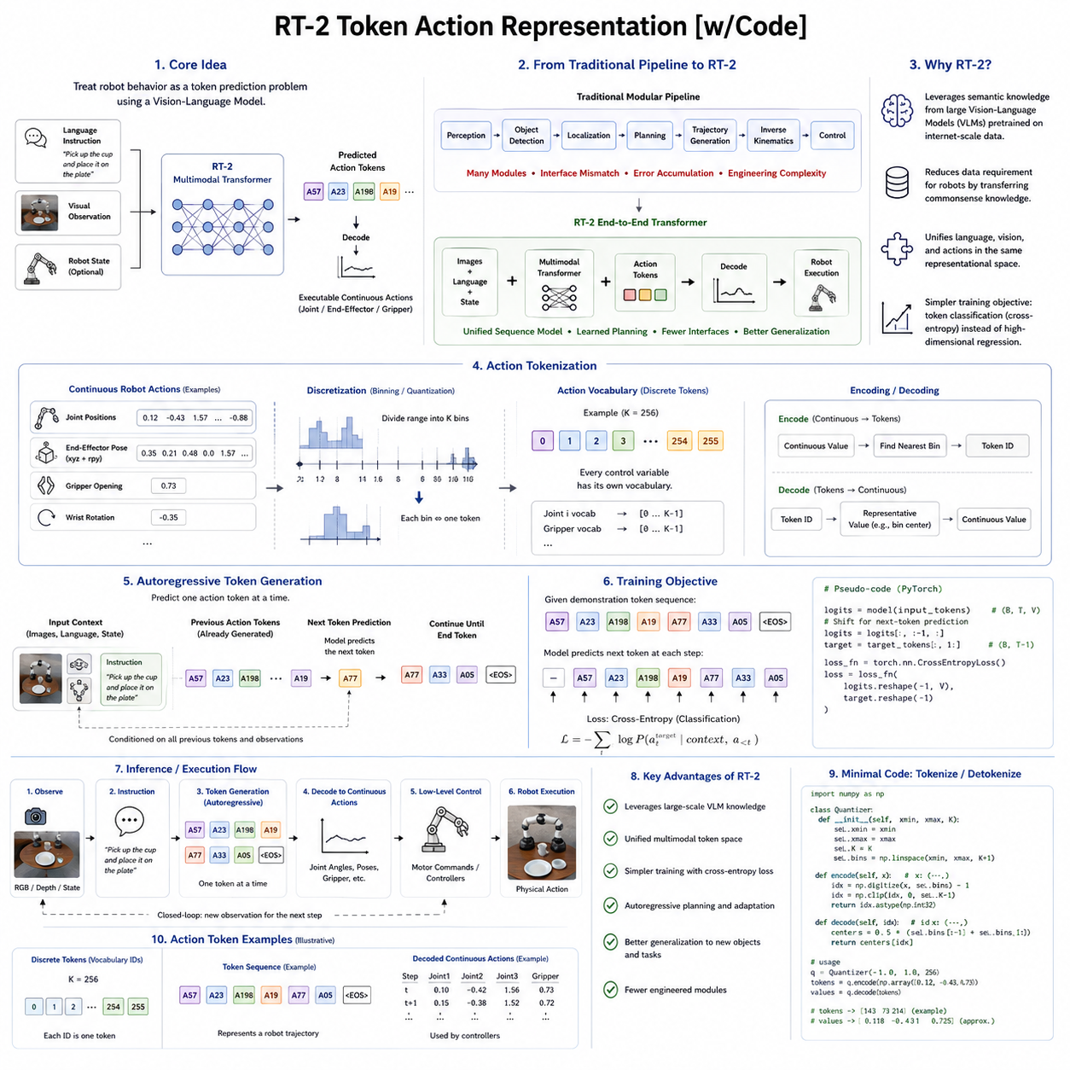
Robot Foundation Models have introduced a new paradigm in robotics by treating robot behavior as a multimodal sequence prediction problem rather than a traditional control problem. Among the most influential developments in this direction is Google's RT-2 (Robotics Transformer 2), which demonstrated that a large Vision-Language Model can directly generate robot actions by representing them as discrete tokens. Instead of viewing robot control as continuous numerical prediction, RT-2 reformulates robot manipulation as a token prediction task analogous to natural language generation. This seemingly simple conceptual shift has profound implications because it allows robotics to leverage the tremendous progress achieved by Large Language Models without fundamentally redesigning transformer architectures. Rather than constructing entirely new robot-specific networks, RT-2 extends multimodal transformer models so that images, language, and physical actions become different forms of tokens processed within a unified sequence model.
Traditional robotic control pipelines typically consist of perception, object detection, localization, planning, trajectory generation, inverse kinematics, motion planning, and low-level control modules operating independently. Every module introduces engineering complexity, interface mismatches, and accumulated errors. RT-2 proposes a fundamentally different philosophy. Instead of explicitly designing separate symbolic planners and motion generators, a transformer directly predicts robot behavior from multimodal observations. Images describe the environment, language specifies the task, and action tokens represent executable robot behavior. The entire decision-making process becomes autoregressive sequence modeling.
The conceptual foundation of RT-2 originates from RT-1, Google's earlier Robotics Transformer architecture. RT-1 successfully demonstrated that transformer models could learn manipulation policies from large collections of robot demonstrations. However, RT-1 remained primarily a robotics-specific architecture trained mainly on robot data. RT-2 expands this concept by incorporating large-scale Vision-Language Models pretrained on internet-scale image-text datasets. The key insight is that semantic knowledge acquired from billions of image-language pairs can substantially improve robotic reasoning even though those datasets contain no direct robot demonstrations.
Vision-Language Models possess extensive knowledge regarding object categories, spatial relationships, human activities, tool usage, materials, affordances, and commonsense reasoning. Humans naturally understand that cups usually contain liquids, drawers can be opened, scissors are used for cutting, and keyboards belong on desks. Traditional robot learning must acquire such knowledge entirely from physical demonstrations, making learning extremely data-intensive. RT-2 instead transfers semantic understanding from pretrained Vision-Language Models into robotic action generation. The challenge becomes connecting semantic reasoning with executable physical behavior.
This connection is established through token-based action representation. Rather than predicting continuous actuator commands directly, RT-2 converts robot actions into discrete textual-like tokens. Joint positions, Cartesian end-effector motions, gripper states, and other control variables are discretized into finite symbolic vocabularies. The transformer therefore predicts action tokens exactly as it predicts language tokens. During inference, these predicted action tokens are decoded back into continuous robot commands suitable for physical execution.
Action tokenization fundamentally changes the learning problem. Continuous control traditionally requires regression over high-dimensional numerical spaces, often leading to optimization difficulties, unstable gradients, and sensitivity to outliers. Token prediction instead converts robot learning into sequence classification. Cross-entropy optimization, widely studied within language modeling, becomes directly applicable to robotics. This architectural unification represents one of RT-2's most significant contributions because it allows decades of language-model optimization research to benefit robot learning.
RT-2 treats actions as another modality within a multimodal transformer. Language tokens, visual embeddings, and action tokens all occupy the same representational space. Attention mechanisms freely connect information across modalities. A language instruction influences action prediction directly, while visual observations provide environmental grounding. Unlike modular robotics pipelines, there is no explicit boundary separating semantic understanding from motor planning. Instead, transformer attention learns these relationships automatically through large-scale training.
The action vocabulary itself is generated through discretization. Continuous control variables are divided into finite bins representing allowable numerical ranges. Each bin corresponds to one symbolic token. During preprocessing, robot demonstrations are converted into token sequences. During inference, predicted tokens are translated back into continuous actuator commands by selecting representative values associated with each token. Although discretization introduces approximation error, sufficiently fine quantization preserves practical control accuracy while dramatically simplifying transformer learning.
Autoregressive generation forms another defining characteristic of RT-2. Rather than predicting an entire trajectory simultaneously, the model predicts one action token conditioned upon previous observations and previously generated actions. This sequential generation closely resembles natural language decoding. Every predicted action influences subsequent predictions through transformer attention, allowing coherent long-horizon behavior to emerge naturally from sequence modeling.
One remarkable consequence of this formulation is the ability to exploit chain-of-thought style reasoning internally. Large Vision-Language Models already learn sophisticated semantic associations between language and images. RT-2 extends these capabilities into robotics by conditioning action generation upon semantic context. Although explicit reasoning traces are not necessarily exposed, the model internally combines perception, language understanding, object knowledge, and action prediction through shared transformer representations.
Internet-scale pretraining significantly enhances robotic generalization. Conventional robot datasets remain relatively small compared with language datasets. Collecting millions of physical robot demonstrations requires expensive hardware, expert supervision, and extensive operational time. In contrast, billions of image-text pairs already exist. RT-2 transfers semantic concepts learned from these internet datasets into robotic manipulation, dramatically reducing the amount of robot-specific knowledge that must be acquired through physical interaction alone.
Semantic transfer manifests in several important ways. The model recognizes previously unseen object categories through visual-language pretraining. It interprets natural language instructions using linguistic knowledge acquired outside robotics. It understands spatial concepts such as inside, behind, above, and next to. It recognizes functional object relationships and common household arrangements. All these capabilities improve robotic decision-making despite originating from non-robotic datasets.
Generalization to unseen objects represents one of RT-2's most important achievements. Traditional imitation learning often memorizes object appearances encountered during training. RT-2 instead reasons about semantic object categories. A robot may manipulate a previously unseen container because it understands the concept of containers rather than memorizing one particular instance. This semantic abstraction substantially improves zero-shot performance across diverse manipulation scenarios.
Natural language understanding similarly expands. Rather than relying upon predefined task identifiers, RT-2 accepts flexible human instructions expressed using ordinary language. Different linguistic formulations describing the same objective often produce consistent robot behavior. The model interprets synonyms, paraphrases, compositional instructions, and contextual descriptions more effectively than earlier robot-specific architectures because of its extensive language pretraining.
Action tokenization also facilitates multimodal attention. Consider the instruction “pick up the smallest blue object and place it inside the red container.” Successful execution requires identifying object colors, estimating relative sizes, understanding spatial relationships, maintaining task memory, and generating appropriate motor commands. Transformer attention naturally integrates these diverse information sources because language tokens, visual tokens, and action tokens coexist within one computational framework.
Despite these advantages, token-based action representation introduces important design challenges. Selecting vocabulary size significantly influences performance. Small vocabularies simplify optimization but reduce control precision. Extremely large vocabularies improve numerical accuracy yet increase computational complexity and prediction difficulty. RT-2 therefore balances expressive capacity against efficient sequence modeling through carefully chosen discretization granularity.
Quantization error represents another unavoidable consequence. Every continuous actuator command must be approximated by its nearest discrete token. Small approximation errors may accumulate over long trajectories, particularly during precision manipulation. Consequently, practical implementations often rely upon downstream feedback controllers compensating for discretization inaccuracies during physical execution.
Temporal representation also requires careful consideration. Individual robot control cycles occur at high frequencies, whereas transformer inference remains computationally expensive. Predicting every actuator update independently would be inefficient. RT-2 therefore predicts temporally meaningful action sequences rather than isolated motor commands. Such temporal abstraction improves computational efficiency while preserving coherent behavior.
Robot embodiment presents another challenge. Different robots possess different kinematic structures, joint counts, actuator limits, and control interfaces. A universal token vocabulary cannot directly represent every possible embodiment. RT-2 primarily focused on manipulation platforms sharing similar action representations. Extending tokenized action prediction across heterogeneous robot embodiments remains an active research direction motivating projects such as Open X-Embodiment and subsequent generalist Robot Foundation Models.
Cross-embodiment learning requires separating semantic actions from embodiment-specific execution. High-level action tokens should describe intentions independent of robot hardware, while embodiment adapters translate these tokens into robot-specific motor commands. Future Robot Foundation Models increasingly adopt this layered approach, allowing semantic reasoning to remain universal while preserving compatibility with diverse robotic platforms.
RT-2 also demonstrates improved compositional reasoning. The model combines previously learned concepts into novel task solutions without explicit retraining. For example, if the model understands “pick up the toy dinosaur” and separately understands “place objects inside containers,” it may successfully execute “place the toy dinosaur inside the red basket” even without observing that exact demonstration during robot training. Such compositionality represents a significant step toward more general robotic intelligence.
Reasoning about unseen combinations similarly benefits from language pretraining. Semantic concepts acquired independently become recombined through transformer attention. This capability resembles compositional generalization observed in large language models and suggests that symbolic reasoning may emerge naturally from sufficiently rich multimodal representations.
RT-2's architecture also illustrates the growing convergence between language models and robotic intelligence. Rather than developing specialized architectures for every application domain, increasingly general multimodal transformers learn reusable representations spanning text, vision, and physical interaction. Robotics thereby becomes another downstream application of large-scale multimodal intelligence rather than an isolated engineering discipline.
Training RT-2 involves multiple stages. Large Vision-Language Models first undergo internet-scale pretraining using image-text datasets. Robot demonstration datasets subsequently fine-tune the model for physical action prediction. During this adaptation stage, action tokens become integrated into the transformer's vocabulary. The model learns associations linking semantic concepts with executable robot behavior while preserving previously acquired visual and linguistic knowledge.
Transfer learning plays a central role throughout this pipeline. Instead of learning perception, language understanding, and commonsense reasoning exclusively from robot demonstrations, RT-2 reuses pretrained representations already optimized through massive internet datasets. Robot-specific learning therefore concentrates primarily on grounding semantic knowledge within physical interaction rather than discovering semantic concepts from scratch.
One notable advantage of tokenized action prediction concerns scalability. Language model scaling laws demonstrate consistent performance improvements with larger models and larger datasets. Because RT-2 formulates robotics using similar sequence prediction principles, comparable scaling behavior becomes possible. Increasing transformer capacity, demonstration diversity, and multimodal pretraining data collectively improve robotic capability without fundamentally changing model architecture.
However, scaling alone cannot solve every robotics problem. Physical interaction introduces contact dynamics, embodiment constraints, safety requirements, latency, actuator limitations, and sensor noise absent from language modeling. Consequently, RT-2 complements rather than replaces traditional robotics engineering. Low-level controllers, safety supervisors, collision avoidance systems, force regulation, and feedback control remain essential components beneath transformer-based action generation.
Safety particularly requires additional deterministic verification. Token prediction alone cannot guarantee physically safe execution. Predicted actions must be validated against joint limits, velocity constraints, collision avoidance rules, workspace boundaries, payload restrictions, and operational safety policies before reaching actuators. RT-2 therefore operates most effectively within layered robotic architectures combining learned intelligence with engineered safety mechanisms.
Another important consideration concerns uncertainty. Language models occasionally generate plausible yet incorrect outputs. Similar behavior in robotics may produce hazardous physical actions. Future token-based Robot Foundation Models increasingly incorporate confidence estimation, uncertainty-aware planning, and verification mechanisms allowing conservative behavior under ambiguous conditions. Rather than blindly executing uncertain actions, robots may request clarification, gather additional observations, or defer execution.
Evaluation of tokenized action representations extends beyond conventional manipulation success rates. Researchers measure zero-shot generalization, semantic understanding, cross-task transfer, robustness to linguistic variation, action consistency, trajectory smoothness, inference latency, token prediction accuracy, and downstream physical performance. Behavioral evaluation ultimately remains more important than token reconstruction accuracy because successful robotics depends upon executed behavior rather than symbolic prediction alone.
RT-2 also influenced subsequent Vision-Language-Action research substantially. OpenVLA explored open-source implementations using similar multimodal principles. Octo investigated scalable robot foundation models across multiple embodiments. NVIDIA GR00T extended multimodal reasoning toward humanoid robotics. Although these systems employ different architectural details, all share the broader objective of integrating language, perception, and action within unified foundation models.
Action tokenization furthermore stimulated research into alternative representations. Diffusion policies generate continuous actions without explicit discretization. Flow matching models improve continuous generation efficiency. Latent action embeddings compress high-dimensional control into compact representations. Hierarchical tokenization separates semantic planning from motor execution. These approaches collectively demonstrate that action representation remains one of the most active research areas within Physical AI.
Industrial deployment presents additional opportunities. Token-based action representation simplifies multimodal integration between inspection, navigation, manipulation, logistics, and maintenance tasks. High-level industrial workflows naturally resemble symbolic action sequences. Future industrial Robot Foundation Models may therefore combine mission planning, language instructions, digital twins, predictive world models, and tokenized robot behavior within unified enterprise-scale Physical AI platforms.
Digital twins further enhance token-based planning by providing predictive simulation environments. Candidate action sequences generated by RT-2 style models can be evaluated within virtual environments before physical execution. Such internal simulation reduces operational risk while improving long-horizon planning and autonomous decision-making. World models therefore complement tokenized action generation by predicting future consequences of candidate action sequences.
Fleet intelligence also benefits from symbolic action representations. Shared token vocabularies facilitate communication among heterogeneous robots operating within common operational environments. Inspection robots, logistics robots, mobile manipulators, and future humanoids may exchange semantic task descriptions while translating them into embodiment-specific motor commands locally. Such architectures naturally support cross-embodiment collaboration.
From the perspective of Physical AI, RT-2's token-based action representation represents far more than a discretization technique. It establishes a unified computational language connecting perception, language understanding, reasoning, planning, and physical execution within one transformer architecture. By treating robot actions as tokens analogous to words, RT-2 enables robotics to inherit powerful capabilities developed for large multimodal foundation models while preserving compatibility with physical control systems. Although challenges remain regarding precision, embodiment diversity, safety, and continuous adaptation, tokenized action representation has fundamentally reshaped how Robot Foundation Models approach intelligent behavior. It serves as one of the foundational ideas driving the convergence of artificial intelligence and robotics toward increasingly capable, general-purpose Physical AI systems operating across diverse tasks, environments, and robot embodiments.

6.4 Action Chunking for Temporal Consistency [w/Code]
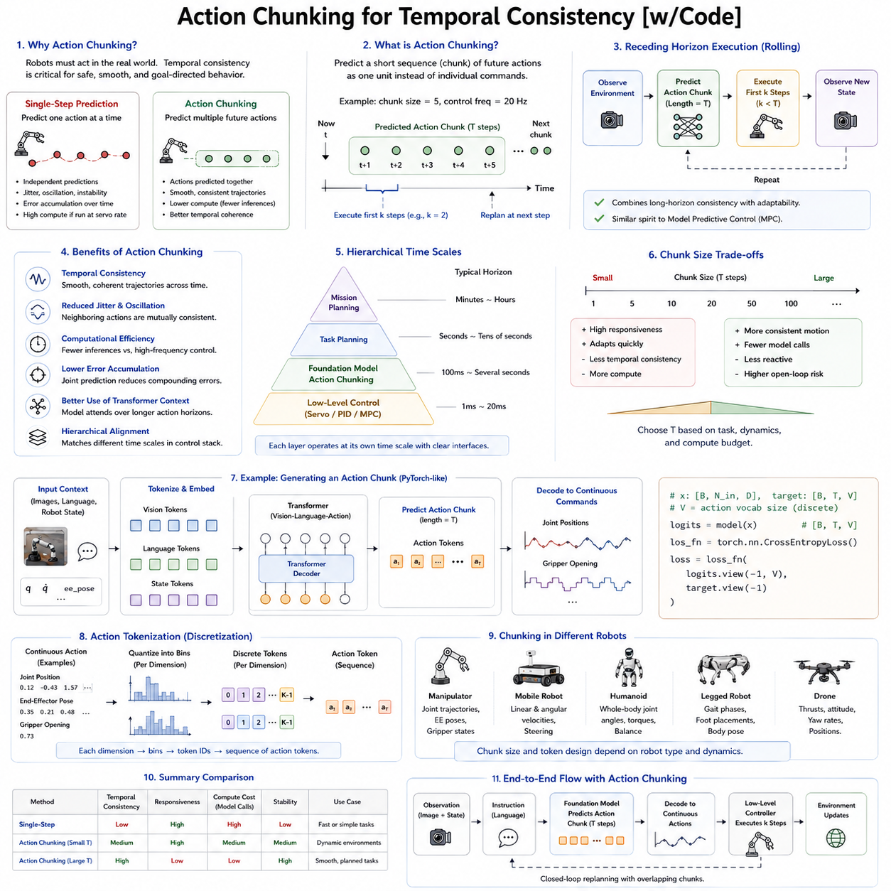
One of the most fundamental differences between robotic intelligence and language intelligence is that robots must continuously interact with the physical world over time. A language model generates one word after another, and although the sequence must be coherent, small inconsistencies rarely produce catastrophic consequences. A robot, however, continuously executes physical actions that directly influence future states of its body and environment. A single unstable motor command may produce oscillations, collisions, failed manipulation, or even unsafe behavior. Consequently, temporal consistency is a fundamental requirement for Robot Foundation Models. The robot must not simply generate individually correct actions; it must generate sequences of actions that remain coherent, smooth, dynamically feasible, and goal-directed over extended periods of execution. Action Chunking has emerged as one of the most effective techniques for achieving this objective.
Action Chunking refers to representing multiple consecutive control commands as a single prediction unit rather than predicting every low-level action independently. Instead of generating one actuator command for every control cycle, the Robot Foundation Model predicts an entire short trajectory segment containing several future actions. This prediction unit is called an action chunk. The chunk may represent a few hundred milliseconds of behavior or several seconds depending on the application, control frequency, and robot embodiment. The concept transforms action generation from isolated decision making into short-horizon behavioral planning.
Traditional robot controllers operate at frequencies ranging from tens to thousands of Hertz. Industrial manipulators often execute servo control at one kilohertz, while autonomous mobile robots may update navigation commands at ten to fifty Hertz. Modern transformer models, however, require substantially greater computational resources than classical controllers. Running a large Vision-Language-Action model at every servo cycle would be computationally impractical. Action Chunking addresses this mismatch by allowing the foundation model to generate multiple future control commands simultaneously while lower-level controllers execute these commands at high frequency.
The motivation for Action Chunking extends beyond computational efficiency. Physical movements naturally possess temporal continuity. Human arm movements, walking motions, grasping actions, and vehicle steering all evolve smoothly over time rather than changing arbitrarily at every instant. Predicting each control signal independently ignores these temporal correlations and often produces jitter, oscillation, or unstable trajectories. Chunked prediction instead encourages neighboring actions to remain mutually consistent because they are generated together as components of one behavioral unit.
Temporal consistency represents a central concept within robot intelligence. Every action changes the future observation available to the robot. A grasping trajectory depends on previous arm motion. Walking stability depends on earlier foot placements. Autonomous driving depends on steering continuity over multiple seconds. Robot Foundation Models therefore require representations that capture dependencies extending beyond individual control cycles. Action Chunking naturally introduces this temporal structure by explicitly modeling short action sequences rather than isolated commands.
One useful analogy compares Action Chunking with natural language. Human communication rarely constructs sentences one completely independent word at a time. Words belong to phrases, phrases form clauses, and clauses compose coherent paragraphs. Similarly, robotic behavior naturally consists of reusable movement segments rather than disconnected motor commands. Reaching toward an object, closing the gripper, lifting the object, transporting it, and placing it each represent coherent behavioral units. Action Chunking captures these units explicitly within the action representation.
Early robotic learning systems commonly predicted only the next control command. Although conceptually simple, single-step prediction accumulates errors rapidly because each prediction depends entirely on previous outputs. Small inaccuracies amplify over time, especially during long manipulation sequences. This phenomenon resembles exposure bias in language generation, where prediction errors compound during autoregressive decoding. Predicting multiple future actions jointly substantially reduces this problem because internal consistency is optimized within each chunk.
Modern Robot Foundation Models therefore increasingly predict fixed-length action sequences. Instead of producing only one joint configuration, the model may predict the next ten, twenty, or even fifty control steps simultaneously. These action chunks overlap in time, and new predictions continuously replace older plans using receding horizon execution. Such rolling prediction maintains responsiveness while preserving temporal coherence.
Receding horizon execution resembles Model Predictive Control (MPC), although learned rather than analytically optimized. The foundation model predicts a future action chunk, executes only the initial portion, observes the updated environment, and then predicts a new chunk conditioned on fresh observations. This repeated replanning process balances long-term consistency with adaptability to changing environments.
Action Chunking also supports hierarchical temporal abstraction. Different control layers naturally operate at different timescales. High-level mission planners reason over minutes or hours. Task planners reason over seconds. Foundation models generate action chunks spanning fractions of seconds. Low-level controllers operate at millisecond frequencies. This hierarchical organization mirrors biological motor control, where strategic planning, movement planning, and muscle activation occur on different temporal scales.
The appropriate chunk length depends strongly upon the application. Manipulation tasks involving delicate contact often require shorter chunks because environmental interactions change rapidly. Mobile robot navigation can tolerate longer chunks because vehicle motion evolves more gradually. Humanoid locomotion typically selects chunk durations matching gait cycles. Drone flight planning often predicts motion several seconds ahead while inner-loop flight controllers stabilize dynamics at much higher frequencies.
Selecting chunk size therefore involves balancing several competing factors. Longer chunks reduce computational cost because inference occurs less frequently. They also improve temporal smoothness by jointly optimizing larger trajectory segments. However, long chunks reduce adaptability because the robot commits to actions further into the future before observing environmental changes. Short chunks increase responsiveness but require more frequent inference and may sacrifice long-range coherence. Practical systems choose chunk durations based on robot dynamics, environmental uncertainty, computational resources, and task complexity.
Action Chunking significantly improves transformer efficiency. Instead of predicting one token for every control cycle, the model predicts one chunk token representing multiple future actions. Sequence length decreases substantially, reducing attention complexity and memory consumption. This improvement becomes increasingly important as Robot Foundation Models scale toward billions of parameters and multimodal processing.
Temporal compression represents another important benefit. Many neighboring motor commands differ only slightly. Encoding each individually wastes representational capacity because adjacent actions exhibit strong redundancy. Chunked representations compress these correlated movements into more compact behavioral descriptions. Such temporal compression resembles video compression, where neighboring frames share substantial information rather than being encoded independently.
Behavioral primitives naturally emerge through Action Chunking. Frequently repeated motion patterns become reusable building blocks. Approaching an object, rotating a wrist, closing a gripper, pushing a drawer, opening a door, or stepping forward each appear repeatedly across numerous tasks. Chunk-based learning captures these recurring temporal structures automatically without requiring manually engineered motion libraries.
The emergence of behavioral primitives closely relates to motor learning in biological systems. Humans do not consciously calculate individual muscle activations during every movement. Instead, higher cognitive processes activate learned movement synergies coordinating multiple muscles simultaneously. Robot Foundation Models similarly learn reusable action chunks representing coordinated motor behaviors rather than isolated actuator commands.
Action Chunking also improves robustness against sensor noise. Individual observations often contain measurement errors, occlusions, lighting variations, or temporary disturbances. Predicting isolated actions directly from noisy observations may produce unstable control. Chunk prediction instead averages information across multiple future steps, reducing sensitivity to transient perception errors while maintaining coherent behavior.
Closed-loop execution remains essential despite chunk prediction. Robots never execute complete chunks blindly. Environmental conditions continuously change because humans move, objects shift, and external disturbances occur. Therefore, foundation models repeatedly generate updated chunks using newly observed sensor information. This continual replanning maintains robustness while preserving temporal consistency.
Action Chunking integrates naturally with Vision-Language-Action architectures. Visual observations provide current environmental state. Language instructions specify task objectives. Action chunks describe future behavior over short time intervals. Transformer attention simultaneously connects all three modalities. Instead of predicting isolated actuator commands, the model reasons about temporally extended behavioral segments grounded in both semantic instructions and environmental observations.
Diffusion Policy architectures have particularly benefited from Action Chunking. Rather than generating one control command, diffusion models denoise complete future trajectories. Joint optimization across entire chunks naturally produces smoother and more physically plausible motion than independently optimizing individual actions. Many state-of-the-art manipulation systems therefore combine diffusion generation with chunk-based trajectory prediction.
Flow-based action generation similarly benefits from chunk representations. Continuous trajectory generation becomes more stable because temporal dependencies remain explicitly represented throughout the learned flow transformation. Instead of modeling instantaneous dynamics independently, flow networks learn coherent evolution across complete behavioral segments.
Latent action representations frequently incorporate Action Chunking as well. Rather than encoding individual motor commands, latent spaces represent temporally extended behaviors. Decoder networks reconstruct detailed continuous trajectories from compact latent chunk embeddings. Such representations significantly reduce dimensionality while preserving essential temporal information.
Action Chunking also complements World Models. Predictive world models estimate future environmental evolution conditioned upon candidate action sequences. Predicting isolated actions limits planning horizon because future predictions require repeatedly invoking the world model. Chunk representations instead evaluate multiple future steps simultaneously, improving planning efficiency and enabling imagination-based decision making over longer horizons.
Model Predictive Control increasingly integrates learned action chunks. Classical MPC optimizes continuous control trajectories analytically using system models. Learned foundation models instead generate candidate chunks directly from experience. Hybrid architectures combine neural chunk generation with classical optimization, exploiting strengths of both approaches. Neural networks propose semantically meaningful behaviors while optimization refines trajectories according to physical constraints.
Action Chunking proves particularly valuable for dexterous manipulation. Fine motor skills require coordinated movement across numerous joints over extended periods. Opening jars, inserting connectors, tying knots, folding cloth, assembling components, and using tools all involve temporally structured behaviors difficult to decompose into independent control steps. Chunk representations naturally preserve these coordination patterns.
Humanoid robotics similarly benefits because whole-body motion exhibits strong temporal dependencies. Walking, balancing, reaching, bending, turning, and recovering from disturbances all require coordinated evolution across multiple body segments. Predicting entire movement fragments rather than isolated joint commands substantially improves stability and naturalness.
Autonomous mobile robots represent another important application domain. Navigation decisions depend upon anticipated future motion rather than instantaneous velocity commands. Chunk prediction enables smoother steering, improved obstacle avoidance, more efficient path following, and reduced oscillatory behavior. Instead of continuously correcting noisy single-step predictions, robots execute coherent motion plans updated periodically through receding horizon inference.
Drone control introduces additional temporal challenges because aerial vehicles exhibit highly coupled dynamics. Abrupt command changes may destabilize flight. Chunk-based trajectory generation naturally limits sudden control discontinuities, improving stability while preserving responsiveness through continual replanning.
Cross-embodiment learning also benefits from Action Chunking. Individual actuator commands vary substantially across robot platforms, whereas higher-level behavioral segments remain more transferable. A reaching motion performed by different manipulators may involve different joint trajectories but similar temporal structure. Shared chunk representations therefore improve generalization across heterogeneous robot embodiments.
Action Chunking supports compositional behavior generation. Complex tasks emerge through sequencing multiple learned chunks. A robot may compose approach, grasp, lift, transport, align, insert, and release chunks into complete assembly procedures. Rather than memorizing every possible task individually, foundation models recombine reusable behavioral modules according to contextual requirements.
Temporal attention mechanisms further enhance chunk prediction. Transformer attention not only connects different modalities but also captures dependencies across previous chunks and future predictions. Long-term context influences short-term movement generation, enabling coherent behavior extending across extended task durations.
Memory systems naturally complement Action Chunking. Long-horizon missions require remembering completed chunks, previous object interactions, environmental changes, and task progress. External memory architectures, recurrent state representations, and attention-based memory allow newly generated chunks to remain consistent with historical behavior. Such integration becomes increasingly important for extended autonomous operation lasting hours rather than seconds.
Action Chunking also influences training efficiency. Sequence prediction over chunks reduces effective sequence length while preserving behavioral richness. Shorter sequences improve transformer scalability because attention complexity grows quadratically with sequence length. Consequently, chunk representations enable larger context windows, richer multimodal integration, and improved computational efficiency simultaneously.
Learning chunk boundaries represents an active research area. Fixed-length chunks provide implementation simplicity but may not align with natural behavioral transitions. Adaptive chunking methods instead learn variable-length behavioral units directly from demonstration data. Meaningful action boundaries emerge automatically around grasp events, contact changes, locomotion phases, or task transitions. Such adaptive segmentation improves representation quality because chunks correspond to semantically coherent motor behaviors.
Self-supervised learning further enhances chunk discovery. Instead of manually labeling action segments, predictive objectives encourage latent representations capturing temporally stable movement patterns. Foundation models learn chunk structures directly from large-scale demonstration datasets without explicit supervision regarding behavioral decomposition.
Evaluation of Action Chunking extends beyond prediction accuracy. Researchers measure trajectory smoothness, temporal consistency, task success, energy efficiency, responsiveness, recovery capability, long-horizon stability, computational latency, embodiment transfer, and robustness against environmental perturbations. Effective chunk representations should improve both behavioral quality and computational scalability simultaneously.
Industrial deployment introduces additional evaluation criteria. Manufacturing robots require deterministic timing, predictable execution, and continuous operation over extended periods. Inspection robots must maintain stable navigation despite changing environments. Logistics robots require smooth motion around human workers. Chunk-based prediction contributes to these objectives by reducing oscillations, improving trajectory consistency, and lowering computational requirements on embedded hardware.
Safety also benefits from temporally coherent action generation. Abrupt command discontinuities increase collision risk and mechanical stress. Chunk prediction naturally constrains neighboring actions to remain mutually compatible, producing smoother actuator commands that are easier for safety supervisors to verify. Predictable temporal evolution also simplifies collision prediction and emergency intervention.
Future Robot Foundation Models will likely employ hierarchical chunk representations operating across multiple temporal scales simultaneously. High-level chunks may represent entire subtasks lasting several seconds. Intermediate chunks describe manipulation phases. Low-level chunks coordinate fine motor execution. Such temporal hierarchies resemble hierarchical planning while preserving continuous adaptation through recurrent replanning.
Integration with World Foundation Models further expands the role of Action Chunking. Internal simulations may evaluate candidate behavioral chunks before physical execution, estimating future task success, collision probability, energy consumption, and environmental evolution. Planning therefore shifts from predicting individual actions toward evaluating coherent behavioral trajectories.
Large-scale multimodal Physical AI systems increasingly integrate Action Chunking with language reasoning, world modeling, digital twins, reinforcement learning, diffusion policies, and cross-embodiment transfer. Rather than serving merely as a computational optimization, chunk-based representation becomes a central abstraction enabling scalable robot intelligence across diverse tasks and embodiments.
From the perspective of Physical AI, Action Chunking represents far more than grouping consecutive control commands. It provides a temporal representation that aligns computational prediction with the natural continuity of physical movement. By treating short behavioral segments as fundamental prediction units, Robot Foundation Models achieve smoother trajectories, greater computational efficiency, improved temporal reasoning, stronger embodiment generalization, and more reliable long-horizon autonomous behavior. As foundation models continue to evolve toward increasingly capable general-purpose robotic intelligence, Action Chunking will remain one of the essential mechanisms connecting high-level reasoning with stable, efficient, and physically consistent real-world execution.

6.5 Diffusion Based Action Generation [w/Code]
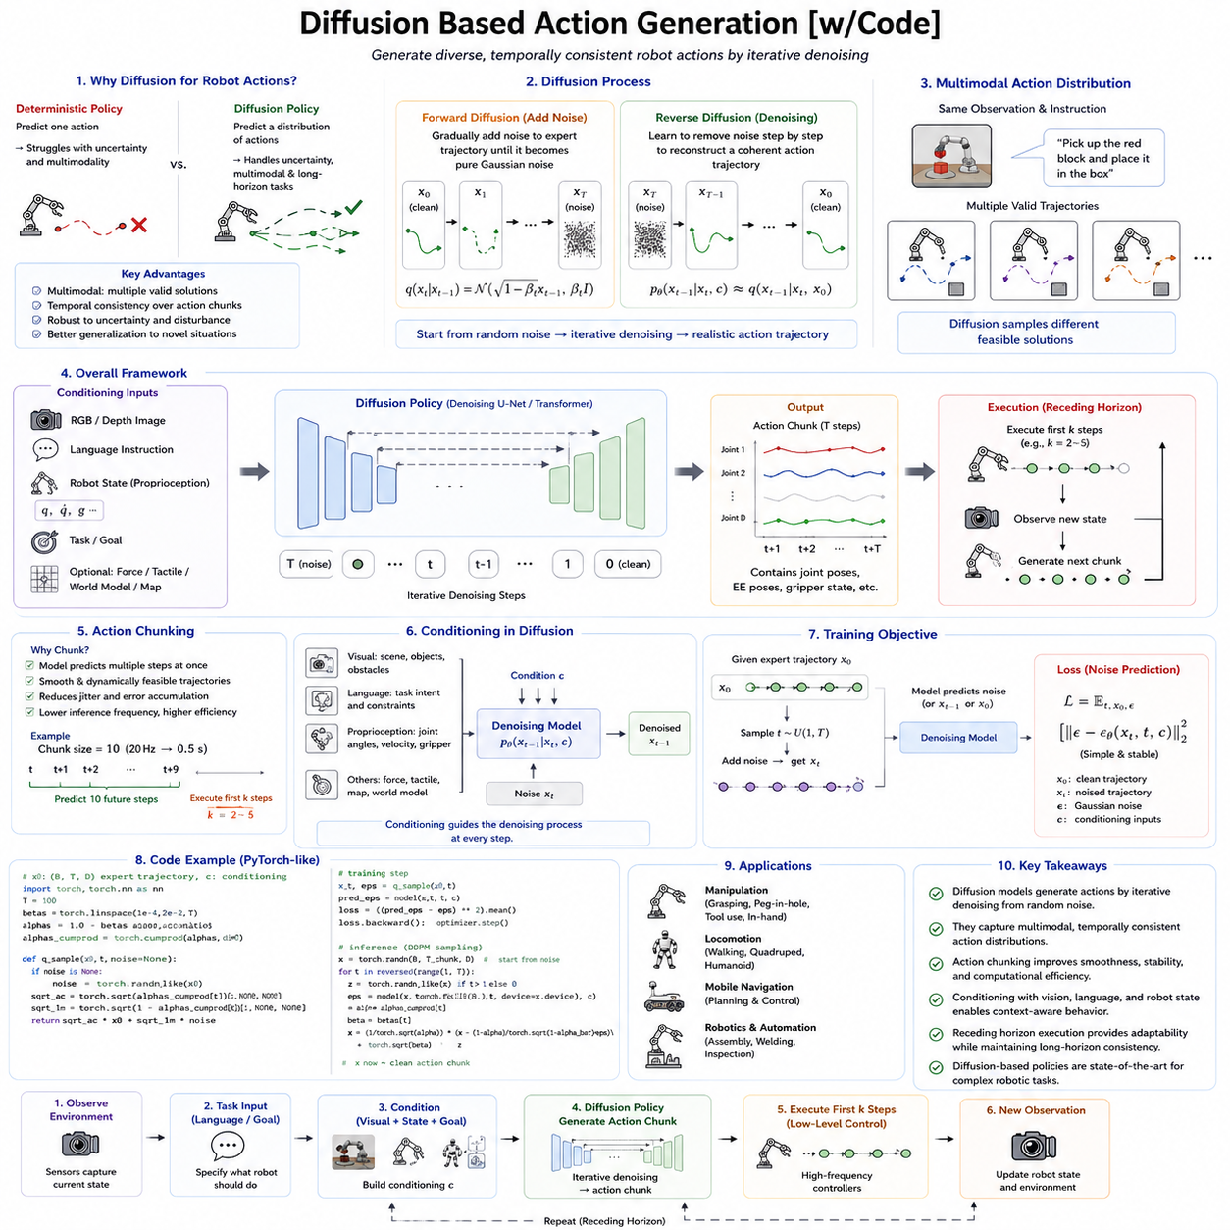
Diffusion-based Action Generation has emerged as one of the most influential approaches for modern Robot Foundation Models because it fundamentally changes how robots generate actions. Traditional robot policies typically predict a single deterministic control command from the current observation. Although effective for relatively simple manipulation tasks, deterministic policies often struggle with uncertainty, multimodal behavior, long-horizon planning, and highly dexterous manipulation. Real-world robotic tasks rarely possess only one correct solution. There are often many equally successful trajectories that differ in approach direction, grasp configuration, motion timing, obstacle avoidance strategy, or force application. Diffusion models provide a natural mechanism for representing this diversity by generating actions through an iterative denoising process that captures the full probability distribution of possible behaviors rather than a single deterministic output.
The origins of diffusion models lie in generative artificial intelligence, where they achieved remarkable success in image synthesis. Models such as DALL·E, Stable Diffusion, and Imagen demonstrated that high-quality images could be generated by gradually removing noise from random samples. The key insight behind diffusion-based robotics is that robot actions can also be viewed as samples drawn from a probability distribution. Instead of generating pixels, the model generates trajectories, joint commands, end-effector poses, gripper states, or complete action sequences. The diffusion process therefore becomes a general framework for producing physically plausible robot behavior conditioned on sensory observations and task objectives.
The mathematical foundation of diffusion models is based on two complementary processes. During training, a forward diffusion process gradually adds random noise to expert action trajectories until the original structure is almost completely destroyed. The model then learns the reverse process, predicting how to remove this noise step by step to reconstruct the original trajectory. During inference, the model begins with pure random noise and repeatedly applies the learned denoising function until a coherent action trajectory emerges. The resulting trajectory is not simply copied from the training data but is synthesized by following the learned probability distribution of successful robot behaviors.
One of the greatest strengths of diffusion-based action generation is its ability to model multimodal action distributions. Many robotic tasks permit several equally valid solutions. A robot reaching toward a cup may approach from the left, the right, or directly from above depending on the surrounding environment. Traditional regression-based policies often average these possibilities, producing unrealistic intermediate trajectories that may collide with obstacles or fail entirely. Diffusion models avoid this averaging problem because they generate complete trajectory samples drawn from the learned distribution rather than estimating only the mean. Every generated trajectory remains internally consistent while representing one realistic solution among many possibilities.
This capability becomes especially important in manipulation tasks involving cluttered environments. Consider a robot retrieving an object from a crowded shelf. Multiple collision-free trajectories may exist depending on the arrangement of surrounding objects. Diffusion policies naturally generate diverse candidate trajectories, allowing downstream planners or safety modules to select the most appropriate option. The policy therefore represents not merely one action but a distribution over physically feasible behaviors.
Diffusion-based policies also improve temporal consistency. Instead of predicting one control command at each time step, many diffusion architectures generate an entire action chunk simultaneously. The complete trajectory segment is optimized jointly during the denoising process, ensuring that neighboring actions remain mutually compatible. Smooth arm motion, stable locomotion, coordinated grasping, and continuous navigation therefore emerge naturally because the optimization considers temporal relationships across the entire chunk rather than isolated control cycles.
The integration of Action Chunking with diffusion models has become one of the defining characteristics of modern robot learning. Each diffusion sample represents a temporally coherent behavioral fragment rather than a single actuator command. During execution, only the initial portion of the generated chunk is performed before a new chunk is generated using updated observations. This receding horizon strategy balances temporal consistency with responsiveness to changing environments.
Conditioning mechanisms are central to diffusion-based action generation. Unlike unconditional image synthesis, robot actions must depend upon current observations, language instructions, robot state, environmental geometry, and task objectives. The diffusion model therefore receives multiple conditioning inputs during every denoising step. Visual observations describe the surrounding environment. Language specifies the desired goal. Robot proprioception provides information regarding joint configuration, velocity, and gripper status. Additional modalities such as force sensing, tactile feedback, world models, or digital twins may also contribute contextual information. The generated trajectory therefore reflects all available multimodal knowledge.
Vision conditioning enables the robot to adapt generated trajectories to the current scene. Objects may move unexpectedly, lighting conditions may change, obstacles may appear, or humans may enter the workspace. The diffusion process continuously incorporates updated visual observations, allowing action generation to remain grounded in the actual physical environment rather than relying on static plans.
Language conditioning expands the flexibility of diffusion policies. Human operators rarely specify exact motion trajectories. Instead, they provide semantic instructions such as “place the red box on the top shelf” or “carefully pick up the fragile glass.” The diffusion model interprets these high-level objectives while generating continuous physical behavior that satisfies the linguistic intent. Different natural language formulations describing similar objectives generally produce similar action distributions because the model learns semantic relationships during multimodal training.
Robot state conditioning ensures physical feasibility. Current joint angles, velocities, gripper configuration, battery status, and dynamic constraints all influence the generated trajectory. Without this information, diffusion models might propose motions that violate actuator limits or begin from impossible initial conditions. State conditioning grounds generated trajectories within the robot's actual embodiment.
Diffusion models are particularly effective for contact-rich manipulation. Tasks such as inserting electrical connectors, tightening screws, opening jars, folding cloth, assembling components, or manipulating deformable objects require highly coordinated force application over time. Small trajectory variations can dramatically influence task success. Because diffusion models optimize complete trajectories rather than isolated commands, they naturally capture these subtle temporal dependencies. This capability has enabled significant advances in dexterous robotic manipulation.
Another important advantage concerns robustness to demonstration diversity. Human demonstrators rarely perform identical trajectories. Differences in speed, style, grasp selection, wrist orientation, and path geometry naturally occur across demonstrations. Regression-based policies often struggle to reconcile such diversity, whereas diffusion models explicitly represent distributions over behaviors. Diverse demonstrations therefore enrich rather than confuse the learned policy.
Diffusion policies also exhibit strong generalization capabilities. During training, the model learns the underlying structure of successful actions rather than memorizing individual trajectories. At inference time, novel action sequences emerge by combining learned motion patterns in previously unseen ways. This compositional generation allows robots to adapt existing skills to unfamiliar environments, object configurations, or task variations without requiring explicit retraining.
The iterative denoising process provides another significant advantage. Each denoising step progressively refines the generated trajectory, correcting inconsistencies introduced during earlier iterations. This gradual optimization resembles human motor planning, where rough movement intentions become increasingly precise before execution. Instead of producing a final trajectory in one forward pass, diffusion models continuously improve candidate actions throughout the generation process.
Despite these strengths, diffusion-based action generation introduces substantial computational requirements. High-quality generation typically requires multiple denoising iterations, often ranging from ten to one hundred refinement steps depending on the algorithm. Each iteration involves neural network evaluation, increasing inference latency compared with deterministic policies. Real-time robotic control therefore requires careful optimization, model compression, or specialized hardware acceleration.
Several techniques have been developed to address this computational challenge. Denoising Diffusion Implicit Models (DDIM) reduce the number of required sampling steps while preserving generation quality. Consistency models learn direct mappings that approximate iterative denoising. Progressive distillation compresses many denoising steps into fewer iterations. Flow matching methods replace stochastic diffusion with deterministic transformations. Together, these approaches substantially reduce inference latency while maintaining most advantages of diffusion-based generation.
Flow matching has recently emerged as a particularly promising alternative. Rather than learning to reverse a stochastic diffusion process, flow models learn deterministic vector fields transforming simple latent distributions into action trajectories. Flow-based generation generally requires fewer inference steps than classical diffusion while preserving continuous trajectory generation. Several next-generation Robot Foundation Models are therefore exploring flow-based policies as computationally efficient successors to diffusion architectures.
Latent diffusion represents another important optimization strategy. Instead of performing diffusion directly in the high-dimensional action space, the model first compresses trajectories into compact latent representations using autoencoders. Diffusion then operates within this lower-dimensional latent space before decoding the final trajectory. Latent diffusion substantially reduces computational cost while preserving essential behavioral structure.
Diffusion models integrate naturally with World Models. Instead of generating actions blindly, candidate trajectories may be evaluated within predictive latent dynamics models before physical execution. World models estimate future object motion, collision risk, energy consumption, task completion probability, and environmental evolution. The robot therefore selects trajectories not merely because they appear plausible but because simulated future outcomes indicate likely success.
This integration supports imagination-based planning. Multiple candidate action trajectories generated by diffusion policies can be simulated internally before selecting one for execution. Such planning combines probabilistic action generation with predictive reasoning, significantly improving long-horizon decision making. Rather than reacting myopically to current observations, robots evaluate future consequences of alternative behaviors.
Reinforcement learning also complements diffusion-based policies. Demonstration data provides initial behavioral distributions, while reinforcement learning further optimizes generated trajectories according to task-specific reward functions. Hybrid approaches combine supervised imitation learning with reinforcement learning fine-tuning, improving both data efficiency and final task performance.
Diffusion policies have demonstrated particularly strong performance in imitation learning benchmarks. Large datasets containing diverse human demonstrations allow the model to learn rich action distributions without requiring explicit reward engineering. Behavioral cloning becomes a generative modeling problem rather than simple regression, improving both robustness and expressiveness.
Safety remains a critical consideration. Diffusion models generate probabilistic trajectories, some of which may violate operational constraints. Safety supervisors therefore evaluate generated trajectories before execution. Joint limits, collision avoidance, force constraints, velocity limits, acceleration bounds, workspace restrictions, and task-specific safety rules filter candidate actions. In industrial settings, diffusion policies typically operate within layered architectures where deterministic safety systems retain final execution authority.
Interpretability presents another challenge. Diffusion models generate trajectories through iterative optimization rather than explicit symbolic reasoning. Understanding why one trajectory was selected instead of another remains difficult. Current research therefore investigates attention visualization, latent space interpretation, trajectory attribution, and confidence estimation to improve explainability.
Uncertainty estimation naturally complements diffusion generation. Because multiple trajectories may be sampled from the learned distribution, agreement among samples provides useful confidence information. Highly consistent trajectories indicate strong certainty, whereas highly diverse samples reveal ambiguity or uncertainty. Robots may respond conservatively under uncertain conditions by requesting additional observations, slowing motion, or seeking human assistance.
Diffusion-based policies have shown remarkable success in bimanual manipulation. Coordinating two robot arms simultaneously requires maintaining complex temporal relationships between multiple manipulators. Independent policy prediction often produces inconsistent coordination. Diffusion models jointly optimize both trajectories, naturally preserving synchronization across both arms throughout task execution.
Humanoid robotics similarly benefits from diffusion generation. Walking, balancing, reaching, and whole-body manipulation require coordinated evolution across dozens of joints. Diffusion models optimize these coupled trajectories simultaneously, improving stability and naturalness. As humanoid Foundation Models continue developing, diffusion-based action generation is expected to play an increasingly important role.
Autonomous mobile robots also gain advantages. Navigation trajectories generated through diffusion tend to exhibit smoother curvature, fewer oscillations, and greater robustness than independently predicted velocity commands. Integrated obstacle avoidance emerges naturally because complete trajectories rather than isolated steering commands are optimized.
Aerial robotics presents additional opportunities. Drone flight involves highly coupled nonlinear dynamics sensitive to abrupt control changes. Diffusion-generated trajectories naturally enforce temporal smoothness while adapting continuously to changing environmental conditions. Predictive world models further enhance flight safety through internal simulation before execution.
Cross-embodiment learning represents another promising direction. Diffusion models operate over continuous trajectory spaces that may be mapped into shared latent representations independent of specific robot hardware. Embodiment-specific decoders subsequently translate these latent trajectories into robot-specific motor commands. Such architectures improve transfer learning across manipulators, mobile robots, humanoids, and quadrupeds.
Multimodal Robot Foundation Models increasingly combine diffusion policies with language, vision, audio, tactile sensing, force feedback, proprioception, and semantic world understanding. Rather than generating isolated motor commands, future systems will synthesize physically grounded behavior conditioned upon comprehensive multimodal context. Every generated trajectory will reflect integrated understanding across multiple sensory modalities.
Industrial deployment further expands the role of diffusion-based action generation. Inspection robots may generate adaptive scanning trajectories based on observed infrastructure conditions. Logistics robots may optimize loading motions under varying package arrangements. Mobile manipulators may generate safe human-aware trajectories in collaborative manufacturing environments. Predictive maintenance robots may adapt inspection behavior dynamically according to equipment state estimated through digital twins.
Digital twins provide particularly valuable conditioning information. Virtual facility models contain infrastructure geometry, historical maintenance records, equipment health, operational schedules, and predictive simulations. Diffusion policies conditioned upon digital twins generate trajectories informed not only by immediate perception but also by long-term operational knowledge. Such integration supports intelligent industrial automation beyond reactive control.
Cloud-edge collaboration also benefits diffusion-based policies. Computationally intensive trajectory generation may occur on edge servers or cloud infrastructure, while low-latency safety control remains onboard. Distilled lightweight diffusion models execute locally during communication interruptions, ensuring operational continuity. Hybrid deployment architectures therefore balance computational capability with real-time responsiveness.
Evaluation of diffusion-based action generation extends beyond trajectory reconstruction. Researchers measure task success, trajectory smoothness, temporal consistency, diversity, robustness, sample efficiency, zero-shot generalization, embodiment transfer, computational latency, safety, energy efficiency, and long-horizon reliability. Industrial applications additionally evaluate continuous operation, fault recovery, maintenance cost reduction, human collaboration quality, and operational scalability.
Future research is expected to integrate diffusion models with increasingly capable World Foundation Models, hierarchical planning systems, symbolic reasoning, reinforcement learning, retrieval-augmented memory, and large multimodal transformers. Rather than treating diffusion as an isolated policy generator, next-generation Physical AI systems will employ diffusion-based action generation as one component within comprehensive cognitive architectures supporting reasoning, prediction, planning, memory, perception, and execution.
From the perspective of Physical AI, diffusion-based action generation represents a fundamental transition from deterministic control toward probabilistic generative behavior. Instead of producing only one predefined response, robots learn complete distributions over successful trajectories, allowing flexible adaptation to uncertainty, environmental variation, embodiment diversity, and task complexity. Through iterative denoising, multimodal conditioning, trajectory optimization, and integration with world models, diffusion policies provide one of the most powerful frameworks currently available for generating smooth, temporally consistent, physically plausible robot behavior. As Robot Foundation Models continue advancing toward increasingly general embodied intelligence, diffusion-based action generation is likely to remain one of the core technologies enabling versatile, robust, and scalable autonomous robotic systems.

6.6 Flow Matching for Action Policy Pi0 [w/Code]
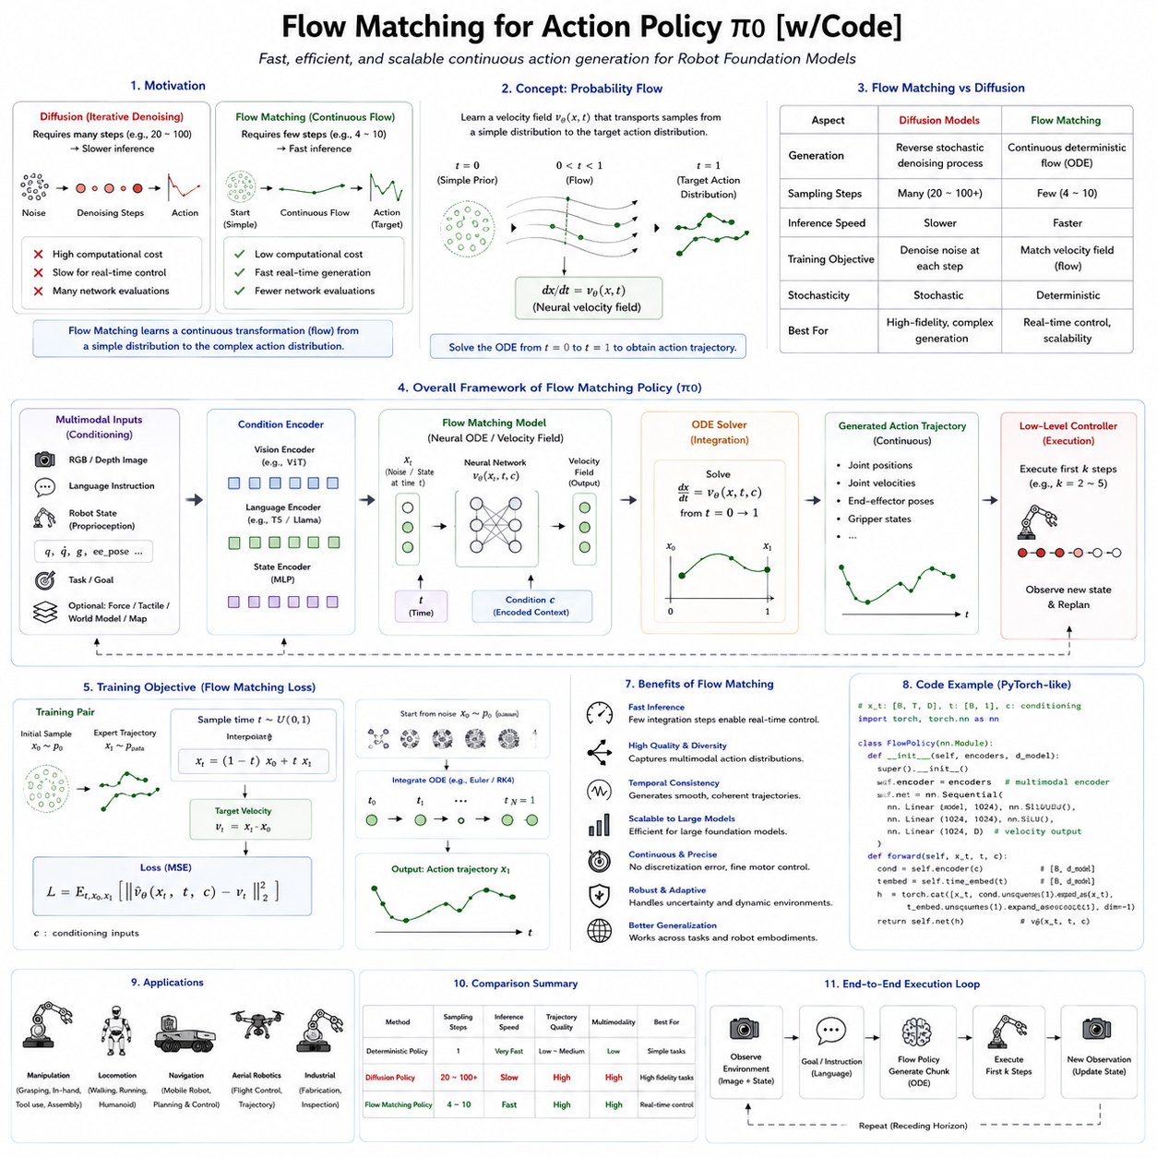
Flow Matching has recently emerged as one of the most promising alternatives to diffusion-based action generation for Robot Foundation Models. While diffusion models have demonstrated remarkable success in producing smooth, multimodal, and robust robot behaviors, they also introduce substantial computational overhead because action generation requires multiple iterative denoising steps. Flow Matching addresses this limitation by learning a direct continuous transformation from simple probability distributions into complex action distributions, dramatically reducing inference time while maintaining the expressive power of generative policies. This capability has attracted considerable attention in Physical AI research, particularly following the introduction of Physical Intelligence's Pi0 model, which employs flow-based action generation to achieve highly capable, real-time robot manipulation.
The emergence of Flow Matching reflects a broader transition in generative artificial intelligence. Early generative models relied on autoregressive prediction, variational autoencoders, or generative adversarial networks. Diffusion models later became dominant because they generated remarkably high-quality images, videos, and robotic trajectories through iterative denoising. However, diffusion sampling often requires dozens or even hundreds of neural network evaluations before producing a final output. Such computational expense is acceptable for offline image generation but becomes problematic for real-time robotic control, where action decisions must often be generated within tens of milliseconds. Flow Matching was developed to preserve the modeling capability of diffusion while significantly improving computational efficiency.
The fundamental idea behind Flow Matching is conceptually elegant. Instead of learning how to remove noise gradually from corrupted samples, the model learns a continuous vector field that transports samples from an initial simple probability distribution toward the target action distribution. One may imagine every action trajectory as a particle moving through a high-dimensional space. The Flow Matching model learns the velocity field governing how each particle should move so that random initial samples gradually evolve into meaningful robot actions. During inference, the robot simply follows this learned flow from the starting distribution to the final action trajectory.
Mathematically, Flow Matching belongs to the broader family of continuous normalizing flows and probability transport methods. Rather than reversing stochastic diffusion processes, it formulates generation as solving an ordinary differential equation describing continuous probability evolution. Neural networks learn the velocity function defining this evolution, allowing deterministic generation of trajectories from random initial states. Because the trajectory follows a continuous flow rather than repeated stochastic denoising, considerably fewer numerical integration steps are required.
One important conceptual distinction separates Flow Matching from diffusion models. Diffusion explicitly introduces stochastic noise during training and subsequently learns how to reverse this corruption process. Flow Matching instead directly learns the optimal transport path connecting two probability distributions. This eliminates the necessity of reconstructing trajectories through repeated denoising. The generated actions therefore emerge through continuous geometric transformation rather than iterative stochastic refinement.
For robot action generation, this distinction has practical consequences. Robot actions are naturally continuous physical quantities involving joint angles, velocities, torques, Cartesian poses, contact forces, and gripper configurations. Flow Matching models these variables directly within continuous action space. Instead of selecting discrete tokens or gradually denoising noisy trajectories, the model continuously deforms an initial latent representation into a physically meaningful action sequence. This formulation aligns naturally with robotic control because physical motion itself evolves continuously over time.
The Pi0 Foundation Model developed by Physical Intelligence represents one of the earliest large-scale demonstrations of this principle. Pi0 combines Vision-Language understanding with flow-based action generation to create a general-purpose manipulation policy capable of controlling multiple robot embodiments. Rather than predicting isolated control commands, Pi0 generates complete continuous action trajectories conditioned upon images, language instructions, and robot state. The use of Flow Matching enables substantially faster inference than diffusion-based policies while preserving smooth and coordinated robot behavior.
A central motivation behind Pi0 is scalability. Foundation Models increasingly integrate billions of parameters, multimodal perception, long-context reasoning, and cross-embodiment generalization. As model size increases, inference efficiency becomes increasingly important. Flow Matching provides an attractive solution because action generation no longer requires dozens of diffusion iterations. Instead, only a relatively small number of integration steps are necessary, making deployment on practical robotic hardware significantly more feasible.
The action representation within Pi0 remains continuous throughout generation. Unlike token-based policies such as RT-2, which discretize actions into symbolic tokens, Pi0 directly models continuous trajectories. Continuous representation avoids quantization error while preserving precise motor control. Fine manipulations involving connector insertion, cloth folding, tool usage, or force-sensitive assembly therefore benefit from greater numerical accuracy.
Flow Matching also naturally supports Action Chunking. Instead of generating one control command at a time, Pi0 predicts temporally extended action segments representing short future behaviors. Each generated chunk contains coordinated joint trajectories evolving consistently across time. During execution, only the initial portion of the chunk is applied before new observations trigger generation of an updated chunk. This receding horizon strategy combines smooth temporal consistency with continuous environmental adaptation.
Conditioning plays a critical role throughout the generation process. Visual observations provide geometric information regarding object positions, obstacles, workspace configuration, and scene context. Language instructions specify semantic objectives using natural communication. Robot proprioception contributes joint positions, velocities, end-effector states, and actuator conditions. Additional sensory modalities such as tactile sensing, force measurements, depth cameras, or digital twins may further enrich contextual understanding. Flow Matching integrates these heterogeneous information sources into one unified generative policy.
Vision conditioning allows the generated flow to adapt continuously to environmental changes. Objects may shift unexpectedly, humans may enter the workspace, lighting conditions may vary, or new obstacles may appear. Because every generated trajectory remains conditioned upon current observations, the resulting behavior remains grounded in real-world perception rather than relying solely upon previously generated plans.
Language conditioning extends flexibility beyond traditional task programming. Human operators rarely specify numerical trajectories. Instead, they communicate semantic intentions such as “carefully place the fragile glass inside the cabinet” or “stack the blue boxes according to size.” The multimodal encoder transforms these instructions into latent semantic representations that guide the continuous action flow toward trajectories satisfying the requested objective.
Robot state conditioning ensures embodiment consistency. Every generated trajectory begins from the robot's actual physical configuration rather than arbitrary initial conditions. Joint limits, current posture, actuator constraints, and motion history all influence the learned flow. Consequently, generated trajectories remain dynamically feasible throughout execution.
One of Flow Matching's greatest strengths lies in computational efficiency. Diffusion policies frequently require twenty to one hundred neural evaluations before generating an action sequence. Flow Matching often achieves comparable generation quality using only several numerical integration steps. Although the exact computational advantage depends upon implementation details, inference latency can be reduced substantially, making Flow Matching particularly attractive for robots operating under strict real-time constraints.
This efficiency becomes especially important for closed-loop robotic control. Robots continuously receive new sensory information while interacting with dynamic environments. If action generation requires excessive computation, environmental changes may invalidate planned trajectories before execution begins. Faster generation enables more frequent replanning, improving responsiveness without sacrificing behavioral quality.
Another significant advantage concerns deterministic generation. Classical diffusion introduces stochastic sampling during inference, potentially producing different trajectories across repeated executions. Flow Matching generally follows deterministic continuous transformations once initial conditions are fixed. This deterministic behavior simplifies debugging, verification, reproducibility, and industrial deployment where predictable operation remains highly desirable.
Flow Matching also exhibits favorable optimization properties. Learning smooth velocity fields often proves numerically stable because supervision occurs directly on continuous vector fields rather than implicitly through iterative denoising objectives. Optimization therefore focuses on matching local motion directions throughout latent space instead of reconstructing complete trajectories after repeated stochastic corruption. Many researchers argue that this direct supervision simplifies learning while improving sample efficiency.
Trajectory smoothness naturally emerges from continuous flow dynamics. Because trajectories evolve according to differentiable vector fields, abrupt discontinuities become less likely than with independently predicted actions. This property aligns well with physical systems where actuator commands should vary gradually to reduce mechanical stress, energy consumption, and instability.
Contact-rich manipulation particularly benefits from continuous trajectory generation. Tasks such as inserting connectors, tightening fasteners, manipulating flexible materials, opening containers, or assembling mechanical components require precise force modulation throughout extended motion sequences. Continuous flows preserve fine-grained motor coordination while maintaining smooth transitions between contact states.
Flow Matching further complements World Models. Candidate trajectories generated by the flow policy may be evaluated within predictive latent dynamics models before physical execution. World Models estimate collision probability, object movement, energy usage, task completion likelihood, and long-term environmental consequences. Planning therefore becomes a combination of generative action synthesis and predictive future evaluation.
This integration enables imagination-based planning. Multiple candidate trajectories may be generated efficiently through Flow Matching and evaluated inside internal simulations. Instead of executing the first available action, the robot selects trajectories predicted to maximize future success. Because Flow Matching generates trajectories rapidly, evaluating numerous hypothetical futures becomes computationally practical.
Reinforcement learning also integrates naturally with Flow Matching. Initial demonstration datasets teach the model the general structure of successful behaviors. Reinforcement learning subsequently refines the velocity field according to task-specific rewards. Such hybrid optimization combines the sample efficiency of imitation learning with the long-term optimization capabilities of reinforcement learning.
Large-scale imitation learning provides another important advantage. Human demonstrations naturally contain variability in speed, wrist orientation, grasp selection, and movement style. Flow Matching learns continuous probability transport across these diverse demonstrations without averaging them into unrealistic intermediate behaviors. The learned flow therefore captures the underlying geometry of successful actions rather than memorizing isolated trajectories.
Cross-embodiment learning represents a major design objective for Pi0. Modern Foundation Models should ideally operate across robotic arms, mobile manipulators, humanoids, quadrupeds, and future robotic platforms. Flow Matching supports this objective by generating trajectories within shared latent action spaces independent of specific hardware. Lightweight embodiment adapters subsequently transform these generic trajectories into platform-specific actuator commands.
Such shared latent representations significantly improve transfer learning. Skills acquired using one robotic platform become more easily transferable to others because the semantic structure of the action remains separated from embodiment-specific motor implementation. Grasping, placing, pushing, opening, inserting, or carrying become abstract behavioral concepts independent of particular kinematic configurations.
Flow Matching also supports hierarchical action generation. High-level planners determine semantic objectives such as grasping an object or opening a drawer. Mid-level flow policies generate coordinated movement trajectories accomplishing these objectives. Low-level controllers execute resulting commands while compensating for actuator dynamics, sensor noise, and external disturbances. This layered organization balances semantic reasoning with precise physical execution.
Memory mechanisms further enhance long-horizon performance. Extended manipulation tasks require remembering previously completed subtasks, object interactions, environmental changes, and task progress. External memory systems, recurrent latent states, and transformer attention enable Flow Matching policies to generate trajectories consistent with historical context over prolonged missions.
Safety remains an essential consideration. Continuous generative models may occasionally produce trajectories violating operational constraints. Therefore, industrial deployments incorporate deterministic safety supervisors evaluating generated trajectories before execution. Joint limits, collision detection, workspace boundaries, force constraints, velocity restrictions, payload limitations, and regulatory requirements remain enforced independently of learned generation policies.
Confidence estimation also becomes important. Although Flow Matching generally produces deterministic trajectories, uncertainty regarding perception or task interpretation still exists. Ensemble methods, Bayesian approximations, or multiple flow evaluations provide confidence estimates allowing conservative behavior under ambiguous conditions. Robots may reduce speed, collect additional observations, or request human assistance whenever uncertainty exceeds acceptable thresholds.
Humanoid robotics presents particularly promising opportunities. Whole-body motion requires coordinated evolution across dozens of joints while maintaining balance, contact stability, and dynamic feasibility. Continuous flow representations naturally capture these coupled dynamics, supporting smooth locomotion, manipulation, and recovery behaviors. Future humanoid Foundation Models will likely employ Flow Matching extensively due to its computational efficiency and continuous action representation.
Autonomous mobile robots similarly benefit. Navigation trajectories generated through continuous flows exhibit smooth steering profiles, reduced oscillation, and improved passenger comfort for autonomous vehicles. Integrated obstacle avoidance emerges naturally because the learned flow continuously adapts trajectories according to environmental geometry.
Aerial robotics offers another application domain. Drone flight requires continuously varying thrust, orientation, and velocity while responding rapidly to disturbances. Flow-generated trajectories preserve smooth control signals without sacrificing responsiveness, improving stability under turbulent environmental conditions.
Industrial robotics may experience particularly significant impact. Assembly robots require millimeter-level precision with deterministic timing. Warehouse robots demand smooth navigation among human workers. Inspection robots must adapt scanning trajectories according to observed infrastructure conditions. Maintenance robots require force-sensitive manipulation across diverse equipment. Flow Matching provides a computationally efficient framework capable of supporting all these applications through one unified generative policy.
Digital Twins further strengthen industrial deployment. Virtual models provide information regarding factory layout, equipment status, maintenance history, production schedules, and predictive simulations. Conditioning Flow Matching policies on Digital Twin information enables trajectories optimized not only for immediate perception but also for broader operational objectives such as production efficiency, maintenance planning, and fleet coordination.
Cloud-edge collaboration represents another practical deployment strategy. Large multimodal encoders and planning modules may execute on edge servers or cloud infrastructure, while lightweight Flow Matching decoders generate trajectories locally with minimal latency. Distilled versions of the model remain onboard for communication outages, ensuring uninterrupted autonomous operation.
Evaluation of Flow Matching policies extends well beyond trajectory reconstruction. Researchers measure task success, temporal consistency, trajectory smoothness, computational latency, sample efficiency, cross-embodiment transfer, zero-shot generalization, robustness to disturbances, safety, energy efficiency, long-horizon stability, and industrial scalability. These metrics collectively determine practical deployment readiness.
Current research directions continue expanding the capabilities of Flow Matching. Integration with retrieval-augmented memory, causal world models, reinforcement learning, symbolic reasoning, semantic planning, multimodal foundation models, and self-improving policies promises increasingly capable Physical AI systems. Rather than serving solely as an action generator, Flow Matching is evolving into one component within comprehensive embodied intelligence architectures supporting perception, reasoning, planning, prediction, memory, and execution.
From the perspective of Physical AI, Flow Matching represents more than a computational optimization over diffusion models. It introduces a new paradigm for continuous action generation based on probability transport rather than stochastic denoising. By learning smooth transformations directly within continuous action space, models such as Pi0 achieve faster inference, improved scalability, precise motor control, and efficient integration with multimodal perception and world modeling. As Robot Foundation Models continue progressing toward general-purpose embodied intelligence capable of operating across diverse environments and robot embodiments, Flow Matching is likely to become one of the foundational technologies enabling practical, scalable, and real-time autonomous robotic systems.

6.7 Hierarchical Action Tokenization High Low Level [w/Code]
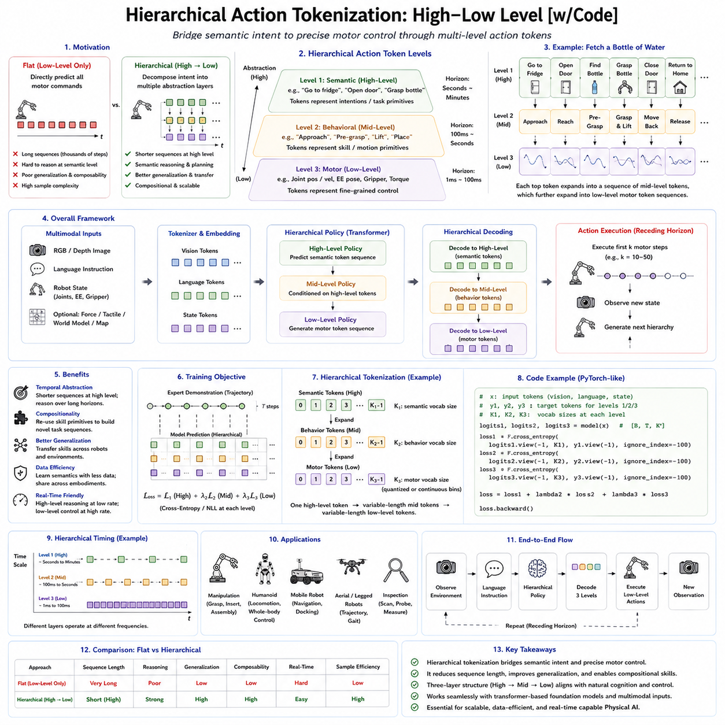
Hierarchical Action Tokenization has become one of the most important research directions in Robot Foundation Models because it addresses a fundamental challenge of embodied intelligence: connecting abstract reasoning with precise physical control. Humans naturally think and act hierarchically. When asked to “bring me a bottle of water,” a person does not consciously compute thousands of muscle activations. Instead, the brain first interprets the semantic goal, decomposes it into subtasks such as walking to the refrigerator, opening the door, locating the bottle, grasping it, closing the door, and returning, and finally translates each subtask into detailed muscle movements. Modern Robot Foundation Models attempt to replicate this hierarchical organization by representing actions at multiple levels of abstraction rather than treating every motor command as an independent prediction.
Early robotic control systems primarily operated at the lowest level of control. Policies directly predicted joint angles, motor torques, Cartesian velocities, or actuator commands from sensor observations. While this approach worked well for narrowly defined tasks, it struggled with long-horizon planning, semantic reasoning, transfer learning, and generalization. High-level task objectives became entangled with low-level motor execution, forcing the learning system to solve planning and control simultaneously. This coupling significantly increased sample complexity and reduced scalability as tasks became more complex.
Hierarchical Action Tokenization separates these responsibilities into multiple layers. High-level tokens represent semantic intentions, task objectives, or behavioral primitives, while low-level tokens describe detailed motor execution. Instead of predicting thousands of actuator commands directly from language and images, the Foundation Model first generates abstract behavioral representations, which are subsequently refined into executable robot actions. This decomposition mirrors hierarchical planning in classical robotics while leveraging the representation power of modern transformer architectures.
The highest layer of the hierarchy typically operates in semantic space. Tokens at this level represent meaningful behavioral concepts such as approach object, grasp object, open drawer, inspect component, insert connector, transport item, or return to home position. These tokens resemble words or phrases in natural language because they encode intention rather than physical movement. One high-level token may correspond to hundreds or even thousands of individual motor commands executed over several seconds.
The intermediate layer introduces behavioral decomposition. High-level semantic intentions are transformed into structured movement plans. Rather than directly commanding motors, intermediate representations describe coordinated behaviors such as reach trajectory, wrist orientation adjustment, pre-grasp positioning, contact establishment, force regulation, or obstacle avoidance. These representations capture task-specific motor organization while remaining largely independent of individual robot hardware.
The lowest layer finally converts intermediate behaviors into continuous control signals. Joint trajectories, Cartesian poses, velocities, torques, gripper commands, balance corrections, and servo references are generated at this level. Real-time feedback controllers then compensate for modeling errors, disturbances, sensor noise, and actuator dynamics. The hierarchical architecture therefore separates semantic reasoning from physical execution while preserving closed-loop stability.
One of the greatest advantages of hierarchical tokenization lies in temporal abstraction. Different reasoning processes naturally operate over different timescales. Mission planning may extend over minutes or hours. Task planning typically spans several seconds. Manipulation behaviors unfold over fractions of seconds. Servo controllers operate every millisecond. Representing all these processes within one flat action space creates enormous computational complexity. Hierarchical tokenization aligns representation granularity with natural temporal organization, allowing each layer to focus on appropriate decision horizons.
Transformer architectures particularly benefit from this decomposition because sequence lengths become significantly shorter at higher abstraction levels. Rather than predicting every control cycle independently, the model predicts compact semantic sequences describing extended behaviors. Lower-level policies subsequently expand these semantic tokens into detailed motion. Reduced sequence length lowers attention complexity while preserving long-horizon reasoning capability.
Action tokenization also supports compositional behavior generation. Individual high-level tokens represent reusable behavioral concepts that may be combined into previously unseen task sequences. A robot that has independently learned approach object, grasp object, and place object can naturally compose these primitives to perform more complex manipulation tasks without explicit retraining. Such compositionality resembles language, where finite vocabularies produce infinitely many meaningful sentences.
This compositional property significantly improves generalization. Traditional behavioral cloning often memorizes complete demonstrations rather than underlying task structure. Hierarchical tokenization instead learns reusable behavioral modules that may be recombined according to new environmental contexts. Zero-shot and few-shot task adaptation therefore become substantially more achievable because existing behavioral vocabulary can express novel task combinations.
Hierarchical tokenization naturally integrates with Vision-Language-Action architectures. Language instructions initially generate semantic action tokens describing desired behavior. Visual perception continuously grounds these semantic intentions within the observed environment. Intermediate planning resolves geometric relationships, object locations, and manipulation strategies. Finally, low-level controllers execute physically feasible movements while maintaining dynamic stability. Every abstraction layer contributes specialized reasoning without overwhelming a single model with all computational responsibilities.
RT-2 introduced one influential form of action tokenization by discretizing continuous actions into symbolic tokens compatible with transformer prediction. However, RT-2 primarily focused on representing low-level actions within a unified multimodal vocabulary. Hierarchical Action Tokenization extends this concept by introducing multiple vocabularies operating at different semantic and temporal scales. Instead of representing only actuator commands, the architecture also tokenizes intentions, subtasks, manipulation phases, and behavioral strategies.
Large Language Models provide another important source of inspiration. Human language naturally exhibits hierarchical structure through words, phrases, sentences, paragraphs, and complete documents. Meaning emerges not only from individual words but also from hierarchical organization across multiple linguistic scales. Robot actions exhibit similar structure. Individual motor commands resemble letters, short movement primitives resemble words, coordinated behaviors resemble sentences, complete tasks resemble paragraphs, and autonomous missions resemble entire documents. Hierarchical tokenization explicitly models these nested structures.
Behavioral primitives occupy a central role within the hierarchy. Many robotic tasks repeatedly reuse movement fragments such as reaching, grasping, rotating, lifting, pushing, pulling, aligning, inserting, or releasing. Instead of learning these behaviors separately for every task, hierarchical tokenization encodes them as reusable intermediate tokens. Complex manipulation emerges through sequencing these learned primitives according to high-level task objectives.
Automatic discovery of behavioral primitives remains an active research area. Rather than manually defining token vocabularies, self-supervised learning methods identify recurring movement patterns directly from large demonstration datasets. Clustering algorithms, contrastive learning, vector quantization, variational autoencoders, and latent action representations all contribute to discovering meaningful behavioral abstractions without explicit human annotation.
Vector Quantized Variational Autoencoders (VQ-VAE) have become particularly influential for learning discrete action vocabularies. Continuous trajectories are encoded into compact latent vectors that are subsequently quantized into discrete tokens selected from a learned codebook. This learned vocabulary often captures meaningful manipulation primitives automatically. Higher-level transformer models then predict token sequences rather than raw motor commands, simplifying long-horizon sequence modeling.
Hierarchical tokenization also complements Action Chunking. Low-level tokens may represent short temporally coherent motion segments instead of individual control cycles. Intermediate tokens coordinate multiple chunks into meaningful manipulation phases. High-level tokens organize complete task sequences. This layered temporal organization improves both computational efficiency and behavioral consistency.
Diffusion policies likewise benefit from hierarchical representations. Rather than generating complete trajectories directly, diffusion models may first generate intermediate behavioral plans before refining them into continuous motion. High-level semantic guidance constrains diffusion sampling toward task-relevant regions of action space, improving generation efficiency while preserving multimodal flexibility.
Flow Matching architectures similarly integrate hierarchical tokenization. Continuous probability transport may occur across multiple abstraction levels simultaneously. Semantic latent variables guide intermediate behavioral flows, which ultimately generate continuous motor trajectories. Such architectures combine efficient continuous generation with structured semantic reasoning.
World Models further strengthen hierarchical action generation. High-level planners evaluate semantic action sequences through imagined future simulations before execution. Intermediate planning layers refine successful strategies into detailed manipulation plans. Low-level execution controllers compensate for physical uncertainty during real-world interaction. Predictive imagination therefore occurs primarily within abstract behavioral space, reducing computational cost compared with simulating every actuator command individually.
Hierarchical representations also improve explainability. Flat control policies often behave as opaque black boxes because reasoning and control remain inseparable. Hierarchical architectures expose intermediate behavioral decisions, allowing observers to inspect generated plans at semantic, behavioral, and motor levels. Engineers may identify whether failures originate from task interpretation, planning, perception, or motor execution. Such transparency significantly facilitates debugging and industrial validation.
Cross-embodiment learning represents another major advantage. High-level behavioral tokens generally remain independent of robot morphology. Concepts such as grasp cup, inspect valve, or open cabinet possess similar semantic meaning across robotic arms, humanoids, quadrupeds, or mobile manipulators. Only lower execution layers require embodiment-specific adaptation. Consequently, hierarchical tokenization separates transferable knowledge from hardware-specific implementation.
This separation dramatically improves scalability. Instead of retraining complete policies for every new robot platform, developers may reuse high-level semantic models while replacing only low-level embodiment adapters. Such modularity reduces training cost, accelerates deployment, and encourages standardization across heterogeneous robotic systems.
Memory systems naturally integrate with hierarchical action representations. Long-duration missions require remembering completed subtasks, environmental changes, object states, human interactions, and operational history. High-level memory primarily stores semantic task progress, whereas low-level memory preserves recent motor context for smooth trajectory continuation. Multi-scale memory therefore complements multi-scale action generation.
Hierarchical tokenization also supports lifelong learning. Newly acquired behavioral skills may be inserted into intermediate vocabularies without retraining complete Foundation Models. High-level planners immediately gain access to these new capabilities because they operate over shared semantic interfaces rather than hardware-specific motor commands. This modular extensibility becomes increasingly valuable as robotic skill libraries continue expanding.
Safety supervision benefits substantially from hierarchical organization. High-level safety rules prevent dangerous mission objectives. Intermediate planning verifies collision-free behavioral strategies. Low-level controllers enforce actuator limits, force constraints, velocity restrictions, and dynamic stability. Layered verification provides significantly stronger safety guarantees than validating only final motor commands.
Human-robot collaboration also becomes more natural. Humans typically communicate through semantic intentions rather than numerical control parameters. Hierarchical tokenization allows natural language instructions to map directly onto high-level behavioral tokens while autonomous execution handles lower-level details. Human operators therefore specify objectives instead of trajectories, reducing cognitive burden while improving operational flexibility.
Industrial automation presents numerous practical applications. Assembly systems may represent manufacturing procedures through semantic task tokens independent of individual robot hardware. Warehouse robots share navigation, loading, unloading, and inspection primitives across heterogeneous fleets. Maintenance robots combine standardized behavioral vocabularies with equipment-specific execution modules. Such abstraction simplifies large-scale deployment while improving interoperability.
Digital Twins further enhance hierarchical reasoning. High-level planners evaluate alternative task sequences within virtual environments before execution. Intermediate planners optimize workspace utilization, scheduling, and resource allocation. Low-level controllers execute validated trajectories in physical facilities. Continuous synchronization between virtual and physical systems supports adaptive industrial intelligence.
Humanoid robotics may ultimately depend heavily upon hierarchical tokenization. Whole-body behaviors involve balancing, locomotion, manipulation, visual attention, communication, and environmental interaction simultaneously. Representing every joint command directly within one model becomes computationally prohibitive. Hierarchical organization distributes reasoning across semantic planning, behavioral coordination, and motor execution, closely resembling biological nervous systems.
Autonomous vehicles similarly exhibit hierarchical structure. Mission planners determine destinations. Route planners select roads. Behavioral planners negotiate traffic interactions. Motion planners generate trajectories. Low-level controllers regulate steering, acceleration, and braking. Hierarchical Action Tokenization provides a unified learning framework capable of representing these layered decision processes within one multimodal architecture.
General Physical AI increasingly requires integration of reasoning, planning, prediction, memory, perception, language understanding, and motor control. Hierarchical tokenization provides the representational infrastructure supporting this integration. Different cognitive functions communicate through shared action abstractions while preserving specialized computation at appropriate levels of detail.
Future research directions include adaptive token hierarchies whose vocabulary evolves automatically through experience. Instead of fixed manually designed abstractions, Foundation Models will continuously discover new behavioral concepts, merge redundant primitives, split overly complex actions, and reorganize hierarchical structure according to operational requirements. Such self-organizing behavioral vocabularies resemble how humans continuously refine skills throughout lifelong learning.
Large-scale multimodal pretraining is expected to further enrich hierarchical action representations. Internet-scale language data provides semantic reasoning. Massive video datasets contribute behavioral understanding. Robot demonstrations supply embodiment-specific execution knowledge. Simulation generates rare corner cases. World Models predict future consequences. Integrating these diverse information sources will produce increasingly powerful hierarchical action vocabularies supporting broad generalization across environments, tasks, and robot embodiments.
Evaluation of Hierarchical Action Tokenization extends beyond action prediction accuracy. Researchers assess semantic consistency, task decomposition quality, compositional generalization, temporal coherence, embodiment transfer, planning efficiency, trajectory smoothness, safety, interpretability, sample efficiency, computational scalability, and long-horizon autonomy. Industrial deployments additionally evaluate maintainability, interoperability, certification readiness, and integration with existing automation infrastructure.
From the perspective of Robot Foundation Models, Hierarchical Action Tokenization represents a fundamental shift from flat motor prediction toward structured embodied reasoning. Rather than treating robotic behavior as one enormous sequence of actuator commands, actions become organized across multiple semantic and temporal levels connecting language, perception, planning, and physical execution. This hierarchical organization dramatically improves scalability, interpretability, generalization, computational efficiency, and cross-embodiment transfer while preserving precise low-level control. As Physical AI continues evolving toward increasingly capable general-purpose robotic intelligence, Hierarchical Action Tokenization is expected to become one of the foundational architectural principles enabling robots to reason abstractly while acting precisely in the real world.

6.8 Action Token Vocabulary Design for Multi Robot [w/Code]
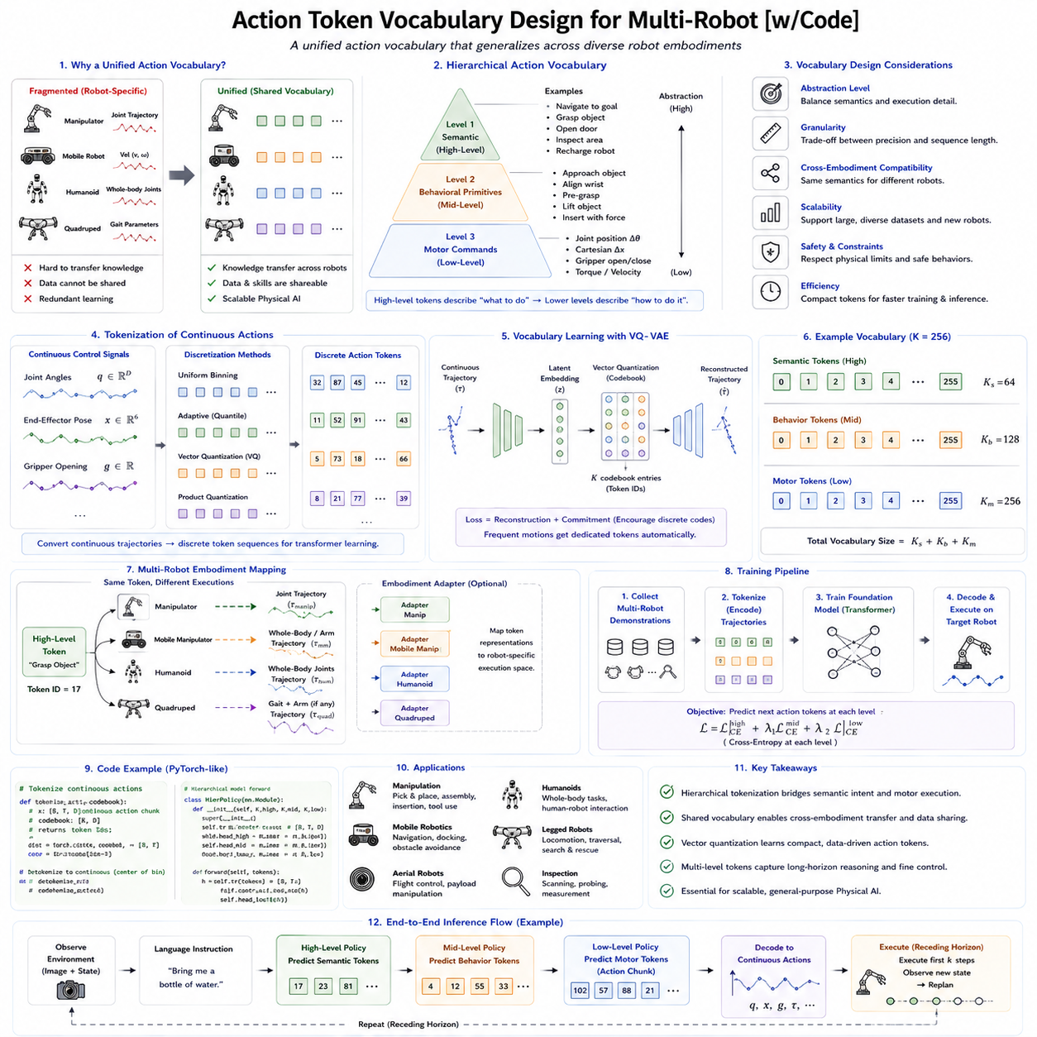
Action Token Vocabulary Design is becoming one of the most important architectural challenges in Robot Foundation Models because it determines how physical actions are represented, learned, transferred, and generalized across different robotic platforms. Just as natural language models depend on carefully designed vocabularies that transform words into tokens, Robot Foundation Models require an action vocabulary capable of representing the enormous diversity of robot behaviors. Unlike language, however, robotic actions are grounded in physics. They involve continuous motion, force interaction, embodiment constraints, temporal evolution, and environmental feedback. Designing an effective Action Token Vocabulary therefore requires balancing semantic abstraction, physical precision, computational efficiency, scalability, and cross-embodiment compatibility.
The need for a generalized action vocabulary arises from the rapid expansion of Physical AI. Early robotic systems were designed for highly specialized applications, with each robot using its own proprietary action representation. Industrial manipulators represented actions as joint trajectories. Autonomous vehicles used steering and throttle commands. Quadruped robots generated gait parameters. Humanoid robots controlled dozens of articulated joints simultaneously. Mobile manipulators combined navigation and manipulation into one integrated controller. These independent representations prevented knowledge transfer between platforms because identical semantic behaviors were encoded in completely different formats. Foundation Models seek to overcome this fragmentation by introducing shared action vocabularies capable of representing multiple robot embodiments through one unified language.
The concept closely resembles multilingual translation. Different human languages use different words and grammar to express similar meanings. A multilingual language model learns shared semantic representations independent of specific languages. Similarly, multiple robot platforms execute different actuator commands while accomplishing identical behavioral objectives. Picking up a cup requires entirely different joint trajectories for a six-axis industrial arm, a dual-arm humanoid, or a mobile manipulator, yet the semantic action remains the same. A well-designed Action Token Vocabulary captures this shared meaning while allowing embodiment-specific execution.
Vocabulary design begins by defining the level of abstraction represented by each token. At the lowest level, tokens may encode individual actuator commands, joint angle increments, Cartesian displacements, or gripper states. These representations preserve maximum physical precision but become highly dependent on robot hardware. A vocabulary based entirely on joint commands cannot easily transfer across robots with different kinematic structures. At the opposite extreme, purely semantic tokens such as “grasp object” or “open door” become highly transferable but omit detailed execution information. Practical Robot Foundation Models therefore employ hierarchical vocabularies combining semantic, behavioral, and motor representations.
Hierarchical Action Tokenization naturally supports vocabulary organization. High-level vocabulary contains semantic task primitives describing intentions such as navigate, inspect, grasp, transport, assemble, recharge, collaborate, avoid obstacle, or dock. Intermediate vocabulary represents reusable behavioral primitives including reach trajectory, wrist alignment, pre-contact positioning, compliant insertion, force adjustment, and recovery motion. Low-level vocabulary finally represents executable motion commands corresponding to robot-specific actuator control. Together these layers bridge abstract reasoning and precise physical execution.
Vocabulary granularity represents one of the most important design choices. Fine-grained vocabularies provide greater precision because each token corresponds to a very small motion increment. However, extremely fine tokenization dramatically increases sequence length, computational cost, and training complexity. Coarse vocabularies reduce computational requirements by representing larger behavioral units but sacrifice fine motor accuracy. Selecting the appropriate granularity therefore requires balancing expressiveness with efficiency according to the intended application.
Continuous robotic actions must generally be transformed into discrete vocabulary entries before transformer-based prediction becomes possible. This discretization process converts continuous trajectories into symbolic action tokens. Uniform binning represents the simplest approach, dividing each continuous control variable into equally spaced intervals. Although straightforward, uniform discretization often wastes vocabulary capacity because robot motions occur nonuniformly throughout action space. Adaptive discretization instead allocates more vocabulary entries to frequently used or high-precision regions while using fewer tokens for rarely visited states.
Vector Quantization has become a widely adopted solution for learning action vocabularies automatically. Rather than manually defining discrete action bins, neural encoders compress continuous trajectories into latent vectors that are subsequently quantized using learned codebooks. Each codebook entry becomes an action token representing a commonly occurring movement pattern. During training, the vocabulary gradually adapts itself to the statistical structure of demonstration data. Frequently repeated behaviors naturally receive dedicated vocabulary entries while redundant representations disappear.
VQ-VAE architectures have proven particularly successful for this purpose. Continuous trajectories are encoded into latent embeddings before nearest-neneighbor quantization assigns them to discrete codebook vectors. The decoder subsequently reconstructs continuous robot motions from these discrete tokens. This learned vocabulary often discovers meaningful manipulation primitives without explicit human supervision, demonstrating that semantic behavioral structure can emerge directly from large-scale robot experience.
Temporal organization also strongly influences vocabulary design. Individual motor commands rarely possess independent meaning. Instead, meaningful behavior emerges through coordinated action sequences extending across time. Action Chunking therefore groups multiple consecutive control commands into one vocabulary token representing a temporally coherent movement fragment. Such chunk tokens improve temporal consistency while reducing sequence length and computational complexity.
Adaptive chunk vocabularies further improve representation efficiency. Rather than using fixed-duration chunks, variable-length behavioral units emerge automatically according to task structure. Grasp completion, object contact, locomotion phase transitions, drawer opening, or insertion completion naturally define chunk boundaries. Dynamic vocabularies therefore align representation with meaningful behavioral events rather than arbitrary time intervals.
Robot morphology introduces another major design consideration. Different robots possess varying numbers of joints, actuator types, workspaces, payload capacities, and dynamic characteristics. A six-degree-of-freedom manipulator differs substantially from a humanoid containing dozens of actuated joints. Mobile robots require navigation control rather than arm manipulation. Quadrupeds coordinate locomotion across four legs. A universal vocabulary cannot simply encode raw actuator commands because embodiment-specific differences would dominate representation learning.
Cross-embodiment vocabularies solve this challenge through abstraction. Semantic action tokens remain independent of hardware configuration. High-level tokens describe objectives rather than execution details. Embodiment-specific decoders subsequently translate these semantic representations into robot-specific motor commands. Consequently, one Foundation Model may generate identical semantic action sequences for different robots while each platform executes physically appropriate motions according to its own kinematics.
Open X-Embodiment has demonstrated the importance of shared action representations across heterogeneous robot datasets. Hundreds of robots contribute demonstrations collected under different hardware configurations, sensing modalities, and control systems. Shared vocabulary design enables these diverse datasets to contribute collectively toward learning generalized manipulation skills. Without common representations, each dataset would remain isolated within its original embodiment.
Action vocabularies must also integrate naturally with Vision-Language-Action architectures. Language tokens describe user intentions. Visual tokens represent environmental observations. Action tokens specify future physical behavior. Ideally these three modalities share compatible latent representation spaces where transformer attention freely exchanges information across modalities. Such unified representation enables semantic reasoning, visual grounding, and physical action generation within one integrated architecture.
RT-2 demonstrated one influential implementation by representing actions as transformer-compatible tokens alongside language. However, future vocabulary designs are expected to become significantly richer. Rather than simply discretizing continuous motor commands, next-generation vocabularies will encode force interaction, uncertainty, compliance, contact state, manipulation phase, temporal intention, and embodiment information simultaneously.
Physical interaction presents unique challenges absent from language processing. Robot actions often involve contact transitions where environmental forces become dominant. Sliding, pushing, grasping, inserting, tightening, cutting, folding, or deforming objects require representing interaction dynamics rather than simple geometric motion. Future action vocabularies therefore increasingly incorporate contact-aware tokens describing force regulation, compliance adjustment, friction interaction, or deformation handling.
Force-sensitive manipulation particularly benefits from enriched vocabulary design. Instead of representing only positional movement, tokens may encode behavioral intentions such as gradually increase gripping force, maintain compliant contact, reduce insertion pressure, or detect surface alignment. Such representations allow Foundation Models to reason about physical interaction at a higher semantic level than raw torque commands.
Navigation robots similarly require specialized vocabulary extensions. High-level navigation tokens may represent follow corridor, avoid pedestrian, enter elevator, approach charging station, cross intersection, or inspect waypoint. Intermediate tokens describe local path adjustments while low-level execution remains platform specific. Shared navigation vocabularies improve transfer learning across autonomous vehicles, warehouse robots, delivery robots, and security patrol systems.
Humanoid robots introduce further complexity because whole-body coordination requires representing posture, balance, locomotion, manipulation, gaze direction, and communication simultaneously. Hierarchical vocabularies therefore become increasingly important as action complexity grows. Semantic task tokens activate coordinated behavioral modules rather than independently controlling dozens of joints.
Diffusion policies interact naturally with action vocabularies. Rather than generating isolated control commands, diffusion models may generate token sequences representing temporally coherent behavioral fragments. Semantic vocabulary constrains diffusion sampling toward physically meaningful action regions, improving both generation quality and computational efficiency.
Flow Matching architectures similarly benefit from structured vocabularies. High-level semantic tokens condition continuous probability flows while embodiment-specific decoders generate detailed motor trajectories. This hybrid representation combines symbolic reasoning with continuous control, reducing computational complexity while preserving physical precision.
World Models further strengthen vocabulary design. Internal simulations evaluate candidate action token sequences before physical execution. Semantic planning occurs primarily within abstract vocabulary space, dramatically reducing computational requirements compared with simulating every actuator command individually. Successful token sequences are subsequently refined into executable trajectories.
Memory systems naturally complement hierarchical vocabularies. Long-duration missions require remembering previous action tokens, completed subtasks, environmental changes, object states, and interaction history. Semantic memory primarily stores high-level task progression while motor memory preserves recent execution context for smooth behavioral continuation.
Retrieval-Augmented Generation introduces another promising direction. Instead of generating every action token from scratch, Foundation Models retrieve previously successful token sequences from large behavioral memory databases. Retrieved experiences are adapted to current environments through transformer reasoning, significantly improving sample efficiency and long-horizon planning.
Vocabulary scalability becomes increasingly important as Foundation Models grow. Language models employ vocabularies containing tens of thousands of tokens. Robot Foundation Models may ultimately require hundreds of thousands of action tokens spanning manipulation, navigation, locomotion, perception, communication, inspection, maintenance, construction, healthcare, logistics, agriculture, and countless future applications. Efficient organization therefore becomes essential.
Dynamic vocabulary evolution represents an active research area. Instead of remaining fixed after training, action vocabularies may continuously reorganize themselves throughout lifelong learning. Frequently used behaviors acquire specialized tokens while obsolete actions disappear. New manipulation skills create additional vocabulary entries. Similar behavioral concepts merge automatically to reduce redundancy. Such adaptive evolution resembles language itself, where vocabulary gradually changes through continuous usage.
Safety considerations strongly influence vocabulary design. Certain behaviors require explicit representation because they trigger specialized safety verification. Emergency stop, safe slowdown, human avoidance, collision recovery, force release, controlled retreat, and system shutdown represent examples of safety-critical action tokens. Dedicated vocabulary entries simplify safety monitoring because supervisory systems recognize hazardous behavioral intentions directly rather than inferring them from low-level actuator commands.
Human-robot interaction similarly benefits from semantic vocabulary design. Humans communicate goals rather than trajectories. Shared semantic tokens enable transparent communication between operators and autonomous systems. Human instructions map directly onto high-level action vocabulary, allowing robots to explain planned behavior using interpretable semantic concepts before execution begins.
Industrial automation provides compelling practical motivation. Manufacturing plants increasingly deploy heterogeneous fleets containing fixed manipulators, autonomous mobile robots, inspection robots, logistics vehicles, collaborative robots, and humanoid assistants. Shared action vocabularies allow these diverse platforms to coordinate tasks, exchange learned skills, and communicate behavioral intentions through standardized representations independent of hardware implementation.
Cloud robotics further amplifies these advantages. Large centralized Foundation Models may continuously learn improved vocabularies using experiences collected across thousands of deployed robots. Updated vocabularies are distributed back to edge devices, allowing continual collective learning while preserving local execution efficiency. Such cloud-edge collaboration supports scalable deployment across global robotic fleets.
Evaluation of Action Token Vocabulary Design extends beyond reconstruction accuracy. Researchers assess semantic consistency, embodiment transfer, task compositionality, temporal coherence, vocabulary efficiency, sample complexity, computational cost, interpretability, scalability, retrieval performance, long-horizon planning capability, safety integration, and industrial deployment readiness. A successful vocabulary should simultaneously support efficient learning, robust execution, broad generalization, and practical engineering deployment.
Future Robot Foundation Models are expected to move toward universal multimodal behavioral languages integrating language, perception, memory, planning, world models, and physical execution within one shared representational framework. Action vocabularies will increasingly function not merely as compressed motor commands but as structured cognitive interfaces connecting symbolic reasoning with embodied interaction. Rather than serving individual robot platforms, these vocabularies will become common behavioral languages shared across heterogeneous robotic ecosystems.
From the perspective of Physical AI, Action Token Vocabulary Design represents far more than selecting discrete symbols for motor control. It defines the representational language through which robots perceive, reason, communicate, plan, learn, and act. Carefully designed hierarchical vocabularies enable efficient multimodal learning, cross-embodiment transfer, scalable Foundation Models, interpretable planning, safe execution, and lifelong skill acquisition. As Physical AI progresses toward increasingly general-purpose autonomous intelligence, Action Token Vocabulary Design will become one of the foundational architectural elements supporting universal robotic cognition across diverse environments, tasks, and robot embodiments.

6.9 Action Tokenization Evaluation Precision Dexterity
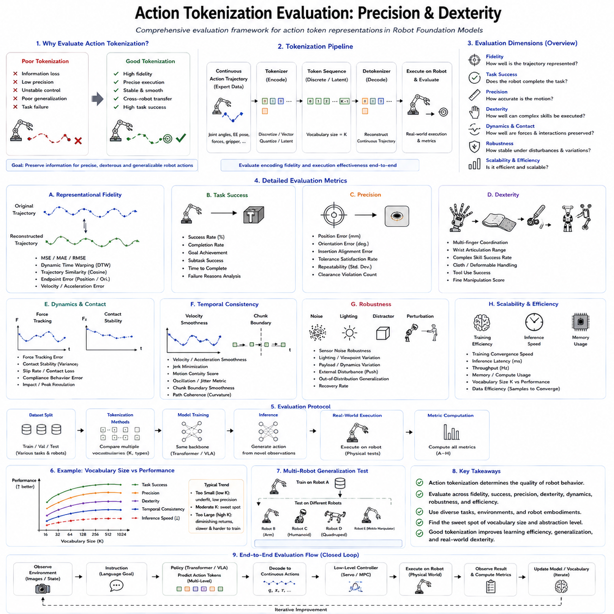
Action Tokenization Evaluation has become an essential component of Robot Foundation Model research because the quality of an action representation directly determines how effectively a robot can perceive, reason, plan, and interact with the physical world. Unlike language tokenization, where evaluation primarily concerns semantic fidelity and linguistic fluency, action tokenization must preserve the physical correctness of movement while supporting efficient learning, cross-embodiment transfer, long-horizon planning, and real-time execution. An action vocabulary that appears compact and computationally efficient may still produce poor manipulation accuracy, unstable control, or degraded generalization. Consequently, evaluating action tokenization requires a comprehensive framework that simultaneously measures representation quality, execution precision, dexterity, robustness, scalability, and computational efficiency.
The motivation for evaluating action tokenization originates from the transition from traditional robotics to Foundation Model-based Physical AI. Classical robotic controllers typically generated continuous joint commands directly through optimization or feedback control. Modern Vision-Language-Action models instead convert continuous actions into discrete or latent representations before generating future behavior using transformer architectures or generative models. This additional representation layer introduces both opportunities and risks. Well-designed tokenization can significantly improve learning efficiency and generalization, while poorly designed vocabularies may discard essential physical information. Evaluation therefore determines whether the chosen representation faithfully preserves the information necessary for successful robot behavior.
The first evaluation objective concerns representational fidelity. An action tokenizer should accurately encode continuous robot trajectories into discrete or latent tokens without losing critical information. After decoding, reconstructed trajectories should closely resemble the original demonstrations. Reconstruction accuracy is commonly measured using Mean Squared Error (MSE), Mean Absolute Error (MAE), Root Mean Squared Error (RMSE), Dynamic Time Warping (DTW), and trajectory similarity metrics. These measurements quantify how well the token vocabulary preserves motion geometry.
However, reconstruction accuracy alone is insufficient because robotics ultimately concerns task execution rather than mathematical similarity. Two trajectories may differ numerically while accomplishing identical manipulation outcomes. Conversely, extremely small trajectory deviations may cause complete task failure during precision assembly. Evaluation must therefore extend beyond numerical reconstruction toward functional behavior assessment.
Task Success Rate represents one of the most important evaluation criteria. The primary purpose of action tokenization is enabling successful robot behavior. If a reconstructed action consistently accomplishes grasping, insertion, navigation, assembly, or inspection tasks despite minor trajectory differences, the representation remains highly effective. Conversely, excellent reconstruction accuracy has limited practical value if execution repeatedly fails under realistic environmental conditions.
Manipulation precision constitutes another fundamental evaluation dimension. Many industrial and service robots operate under millimeter-level tolerances. Connector insertion, electronic assembly, surgical assistance, laboratory automation, and semiconductor manufacturing require extremely precise positioning. Action tokenization must therefore preserve fine spatial detail throughout encoding and decoding. Position error, orientation error, endpoint accuracy, insertion success, alignment precision, and repeatability collectively measure geometric fidelity during execution.
Dexterity evaluation extends beyond positional accuracy toward complex coordinated behavior. Human-like manipulation requires simultaneously controlling multiple joints while adapting continuously to environmental feedback. Tasks such as cloth folding, cable routing, knot tying, tool usage, package handling, or deformable object manipulation require sophisticated temporal coordination. Evaluation therefore considers finger coordination, wrist articulation, contact adaptation, multi-joint synchronization, and continuous force modulation rather than isolated trajectory reconstruction.
Contact-rich manipulation introduces particularly demanding evaluation requirements. Many practical tasks involve transitions between free-space movement and physical interaction. During insertion, polishing, fastening, grinding, or assembly, success depends upon maintaining appropriate contact forces while adapting continuously to local geometry. Action tokenization should preserve these interaction dynamics. Evaluation therefore includes force tracking accuracy, contact stability, compliance behavior, insertion force regulation, friction adaptation, and slip prevention.
Temporal consistency represents another essential criterion. Robot actions naturally evolve over time rather than existing as independent control commands. Action tokenization should preserve smooth temporal progression throughout generated trajectories. Velocity continuity, acceleration smoothness, jerk minimization, motion stability, oscillation suppression, and trajectory coherence all contribute to evaluating temporal quality. Abrupt transitions frequently indicate poor tokenization despite acceptable positional reconstruction.
Action Chunking further influences temporal evaluation. Many modern Robot Foundation Models predict temporally extended action chunks instead of individual control commands. Chunk boundaries should remain behaviorally meaningful while preserving continuity across adjacent segments. Evaluation measures chunk consistency, transition smoothness, planning stability, and cumulative execution accuracy over long action sequences.
Generalization represents one of the defining goals of Foundation Models. Action tokenization should support transferring learned behaviors toward previously unseen environments, objects, tasks, and robot embodiments. Zero-shot evaluation measures performance without additional training. Few-shot evaluation measures adaptation using limited demonstrations. Domain generalization examines robustness across lighting conditions, viewpoints, sensor noise, workspace layouts, and environmental variations. Strong tokenization preserves transferable behavioral structure rather than memorizing demonstrations.
Cross-embodiment evaluation has become increasingly important following the emergence of datasets such as Open X-Embodiment. Shared action vocabularies should support transferring semantic behaviors across robotic arms, mobile manipulators, quadrupeds, humanoids, and future robotic platforms. Evaluation therefore measures transfer efficiency, adaptation speed, policy reuse, embodiment invariance, and hardware independence. A successful vocabulary captures behavioral meaning while allowing embodiment-specific execution.
Semantic consistency forms another major evaluation criterion. High-level action tokens should correspond to meaningful behavioral concepts rather than arbitrary numerical encodings. Human observers should ideally interpret semantic action sequences describing behaviors such as approach object, grasp handle, rotate wrist, insert connector, or place component. Explainable semantic vocabularies improve debugging, human-robot interaction, and industrial verification while supporting symbolic planning and language grounding.
Interpretability therefore extends beyond semantic labels. Researchers increasingly analyze attention maps, latent embeddings, token similarity, behavioral clustering, and hierarchical decomposition to understand internal action representations. Visualization techniques reveal whether similar manipulation behaviors occupy neighboring latent regions and whether learned vocabularies organize themselves according to meaningful behavioral categories.
Vocabulary efficiency constitutes another important consideration. Larger vocabularies increase representational capacity but require more memory, longer training time, and higher computational cost. Extremely small vocabularies reduce complexity but often sacrifice behavioral diversity and precision. Evaluation therefore investigates the tradeoff between vocabulary size, compression ratio, reconstruction quality, computational efficiency, and downstream task performance.
Compression performance provides another quantitative metric. Effective action tokenization compresses long continuous trajectories into compact symbolic representations while preserving execution quality. Compression ratio, information retention, entropy, latent utilization, codebook diversity, and redundancy collectively characterize vocabulary efficiency. Ideally, compressed representations preserve essential behavioral information while eliminating unnecessary redundancy.
Codebook utilization becomes particularly relevant for Vector Quantized Variational Autoencoder (VQ-VAE) architectures. Poorly trained vocabularies often use only a small subset of available codebook entries, reducing representational capacity. Evaluation therefore measures token frequency distribution, codebook occupancy, entropy, dead token percentage, and embedding diversity to ensure efficient utilization of learned vocabulary.
Learning efficiency represents another major evaluation objective. Effective action tokenization should reduce the amount of demonstration data required for successful learning. Researchers therefore compare sample efficiency across different vocabulary designs by measuring task performance under limited data availability. Improved tokenization frequently leads to faster convergence, better generalization, and reduced annotation requirements.
Computational efficiency also deserves careful consideration. Robot Foundation Models increasingly operate under real-time constraints. Encoding, decoding, transformer inference, memory usage, GPU utilization, latency, throughput, and power consumption all contribute to deployment feasibility. Evaluation therefore balances behavioral quality against computational requirements rather than optimizing only accuracy.
Real-time execution imposes strict latency requirements. Mobile robots, autonomous vehicles, humanoids, drones, and industrial manipulators continuously interact with dynamic environments where delayed action generation may cause instability or failure. Action tokenization should therefore minimize encoding overhead while preserving representational quality. End-to-end latency, decoding speed, controller frequency, and responsiveness collectively determine practical applicability.
Robustness evaluation examines resilience against uncertainty. Real-world environments introduce sensor noise, actuator inaccuracies, calibration errors, communication delays, unexpected obstacles, changing illumination, object variation, and mechanical wear. Effective action tokenization should preserve stable behavior despite these disturbances. Evaluation therefore includes noise robustness, disturbance rejection, fault tolerance, recovery capability, and uncertainty adaptation.
Safety evaluation becomes increasingly important as robots operate alongside humans. Tokenized actions should remain compatible with safety verification frameworks. Collision avoidance, force limitation, velocity constraints, workspace boundaries, emergency stopping, and safe recovery behaviors should remain accurately represented throughout tokenization. Safety-critical tasks therefore evaluate not only successful execution but also reliable constraint satisfaction.
Long-horizon evaluation addresses sustained autonomous operation. Foundation Models increasingly perform extended missions involving dozens or hundreds of sequential actions. Small representation errors may accumulate over time, eventually degrading performance. Evaluation therefore measures cumulative trajectory drift, planning consistency, memory utilization, behavioral stability, and long-duration task completion across extended execution horizons.
Memory integration further influences evaluation. Hierarchical tokenization often interacts with recurrent memory, transformer attention, retrieval-augmented generation, and episodic behavioral storage. Effective representations should support efficient retrieval of previously learned behaviors while maintaining coherent long-term reasoning. Retrieval accuracy, memory utilization, behavioral recall, and contextual consistency therefore become additional evaluation dimensions.
World Models introduce predictive evaluation opportunities. Instead of assessing only executed trajectories, internal simulations estimate future consequences of tokenized actions before physical deployment. Prediction accuracy, imagined trajectory consistency, planning reliability, and simulated task success all provide valuable information regarding representation quality. Such evaluation significantly reduces physical experimentation cost while enabling rapid algorithm development.
Diffusion-based action generation introduces additional evaluation metrics. Generated trajectories should exhibit diversity without sacrificing correctness. Researchers therefore measure multimodal coverage, behavioral diversity, sample quality, convergence stability, and planning consistency. Effective tokenization supports expressive generative policies while maintaining physical realism.
Flow Matching architectures similarly require specialized evaluation. Continuous probability transport should generate smooth trajectories with minimal numerical integration steps. Evaluation therefore examines flow smoothness, trajectory continuity, convergence accuracy, computational efficiency, and stability across different robot embodiments. These metrics determine whether flow-based policies preserve behavioral quality while improving inference speed.
Hierarchical Action Tokenization introduces multi-level evaluation. High-level semantic tokens should accurately represent task intentions. Intermediate tokens should preserve behavioral primitives. Low-level tokens should reconstruct precise motor commands. Each layer requires independent evaluation while maintaining consistency across the complete hierarchy. Errors introduced at higher abstraction levels may propagate toward motor execution, making hierarchical validation particularly important.
Human evaluation also contributes valuable insight. Experienced robot operators often identify subtle behavioral differences difficult to capture using numerical metrics alone. Subjective assessments include naturalness, predictability, smoothness, confidence, explainability, collaborative behavior, and perceived intelligence. Human-centered evaluation becomes especially important for collaborative robots operating within shared workspaces.
Industrial deployment introduces additional practical requirements. Manufacturing systems emphasize repeatability, certification, maintenance cost, integration complexity, interoperability, diagnostic capability, fault recovery, and production throughput. Evaluation therefore extends beyond academic benchmarks toward operational reliability under continuous real-world usage.
Cloud robotics presents another evaluation dimension. Shared action vocabularies should support efficient synchronization between centralized Foundation Models and distributed edge robots. Communication bandwidth, vocabulary update efficiency, distributed learning performance, collaborative adaptation, and global knowledge sharing all influence practical scalability across large robotic fleets.
Benchmark datasets continue evolving alongside evaluation methodology. Future benchmarks will likely include heterogeneous robot platforms, multimodal sensing, force interaction, long-horizon manipulation, collaborative robotics, dexterous hand manipulation, humanoid locomotion, autonomous navigation, and industrial maintenance scenarios. Standardized evaluation protocols will enable objective comparison between competing action tokenization strategies.
Future research increasingly focuses on adaptive evaluation frameworks capable of evolving alongside Foundation Models. Rather than relying upon fixed benchmark tasks, evaluation systems may automatically generate increasingly difficult manipulation challenges, novel robot embodiments, unseen object categories, and changing environmental conditions. Such adaptive benchmarking more accurately reflects lifelong learning and continuously improving Physical AI systems.
Ultimately, Action Tokenization Evaluation represents far more than measuring reconstruction accuracy. It assesses whether a representation successfully bridges semantic reasoning, multimodal perception, world modeling, planning, memory, and precise physical execution within one unified Foundation Model architecture. High-quality tokenization should simultaneously preserve precision, dexterity, temporal consistency, computational efficiency, safety, explainability, robustness, and cross-embodiment generalization.
From the perspective of Physical AI, Action Tokenization Evaluation defines the criteria by which embodied intelligence itself can be measured. It determines whether a robot not only reproduces demonstrated trajectories but also understands task structure, transfers knowledge across embodiments, adapts to uncertainty, maintains physical precision, and performs complex manipulation safely and efficiently. As Robot Foundation Models continue advancing toward increasingly capable general-purpose autonomous systems, comprehensive evaluation methodologies for action tokenization will become indispensable for developing reliable, scalable, and truly intelligent robotic platforms capable of operating effectively across diverse real-world environments.

6.10 Action Tokenization for UAV Flight Commands [w/Code]
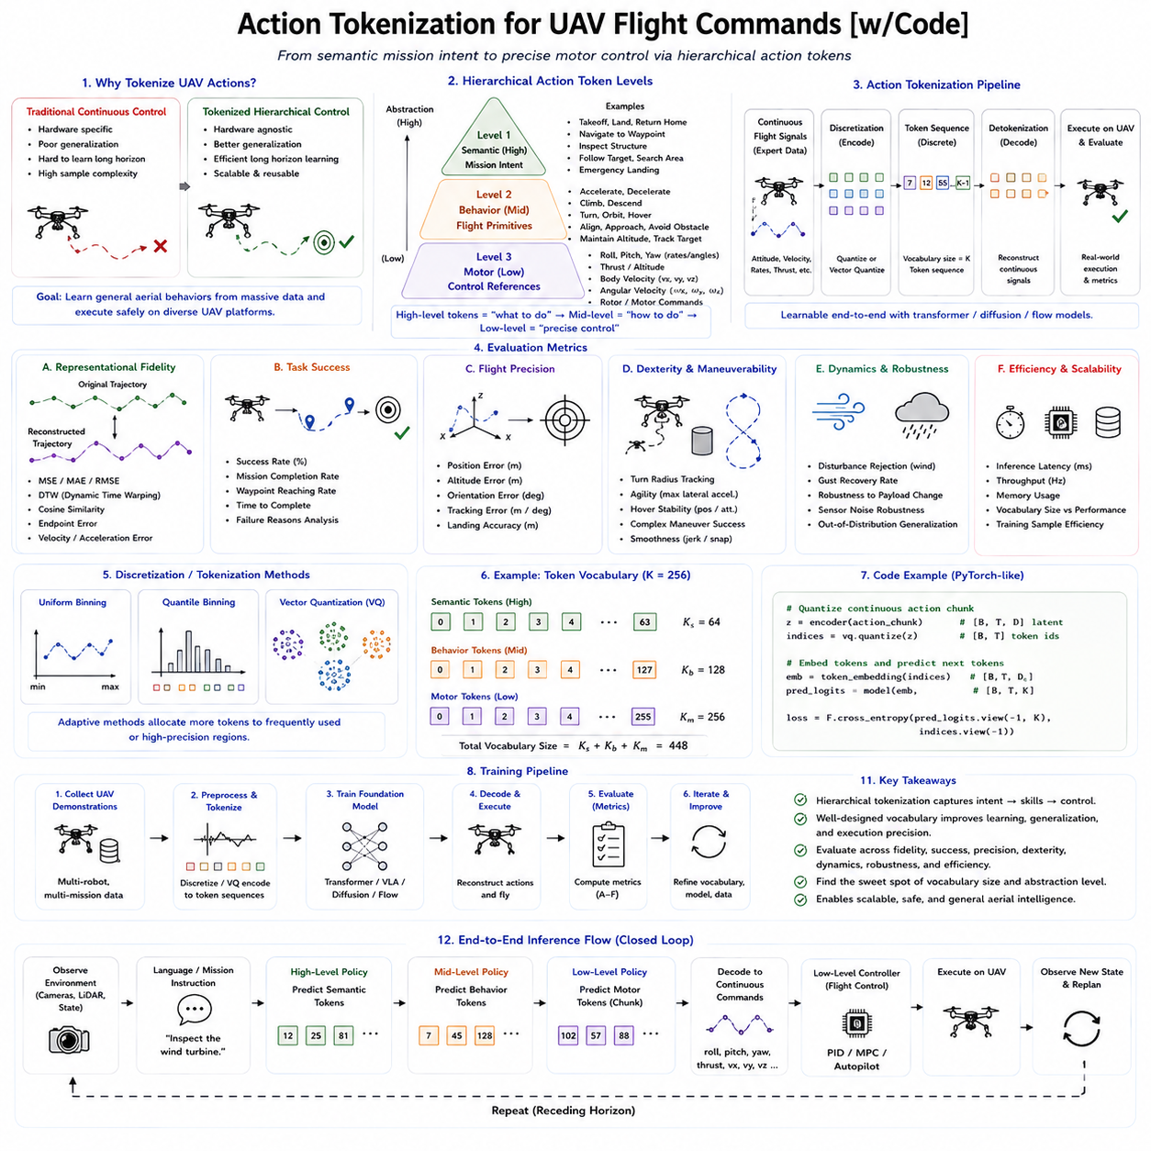
Action Tokenization for UAV Flight Commands represents an emerging research direction that extends Robot Foundation Models beyond manipulation and ground navigation into autonomous aerial intelligence. While Vision-Language-Action models have demonstrated impressive capabilities in robotic manipulation, drones introduce fundamentally different control challenges. Aerial vehicles operate in six degrees of freedom while continuously maintaining dynamic stability in highly coupled nonlinear systems. Every control command directly influences future aerodynamic behavior, making accurate action representation significantly more demanding than in many ground-based robots. Consequently, designing effective action tokenization strategies for UAVs requires integrating flight dynamics, continuous control, semantic mission planning, environmental awareness, and safety constraints into one unified representation suitable for Foundation Models.
Traditional UAV control relies on hierarchical flight control systems composed of multiple nested feedback loops. Low-level controllers stabilize angular velocity, attitude, altitude, and velocity through high-frequency control algorithms. Mid-level planners generate local trajectories and obstacle avoidance behaviors. High-level mission planners determine navigation objectives, inspection routes, surveillance strategies, or delivery schedules. Human pilots naturally communicate using semantic commands such as “fly to waypoint three,” “circle the target,” or “return to home,” while onboard controllers automatically translate these instructions into thousands of motor speed adjustments every second. Action Tokenization provides a computational framework capable of representing this entire hierarchy within a single multimodal learning architecture.
The motivation for action tokenization in UAV Foundation Models originates from the limitations of traditional control representations. Classical autonomous flight systems directly output continuous roll, pitch, yaw, throttle, velocity, or motor commands. Although effective for individual drones performing predefined tasks, these representations generalize poorly across different aircraft platforms, mission objectives, and environmental conditions. Foundation Models instead seek to learn universal aerial behaviors from massive multimodal datasets, requiring action representations that capture semantic flight intentions independently of specific hardware configurations.
Unlike robotic manipulators, aerial vehicles remain dynamically unstable throughout most flight conditions. Quadrotors continuously generate corrective actions simply to remain airborne. Every maneuver involves simultaneous coordination of thrust, orientation, translational velocity, rotational dynamics, and environmental disturbances. Consequently, action tokens cannot represent isolated actuator commands alone. They must preserve dynamic relationships across time while remaining compatible with transformer-based sequence modeling.
Hierarchical Action Tokenization naturally addresses this challenge. High-level flight tokens represent semantic mission objectives such as takeoff, navigate corridor, inspect tower, orbit target, avoid weather, search region, approach landing zone, hover, return home, emergency landing, or dock for charging. These tokens describe behavioral intentions rather than individual control variables. One semantic flight token may correspond to thousands of low-level actuator updates executed over many seconds.
Intermediate flight tokens capture reusable aerial behavior primitives. Examples include accelerate forward, decelerate smoothly, climb gradually, descend safely, rotate toward waypoint, maintain altitude, stabilize under crosswind, avoid obstacle, align with landing pad, perform coordinated turn, transition to hover, or maintain visual tracking. These behaviors remain largely independent of specific UAV hardware while preserving aerodynamic meaning.
Low-level flight tokens finally describe executable control references. These may include desired roll angles, pitch angles, yaw rates, thrust levels, body velocities, acceleration vectors, rotor speed commands, or motor torques depending on platform architecture. Real-time flight controllers subsequently convert these references into actuator-specific motor signals while compensating for disturbances and sensor noise.
Temporal abstraction plays an especially important role in aerial robotics. High-level mission planning operates over minutes or even hours during cargo transportation, infrastructure inspection, or search-and-rescue operations. Local path planning typically spans several seconds. Flight stabilization requires updates every few milliseconds. Representing every control cycle individually would produce prohibitively long sequences for transformer architectures. Hierarchical tokenization compresses these different temporal scales into appropriate abstraction levels, greatly improving computational efficiency.
Action Chunking provides further advantages. Instead of predicting individual motor commands, Foundation Models generate temporally coherent flight segments representing coordinated motion over short time horizons. A chunk may describe an entire coordinated turn, obstacle avoidance maneuver, or controlled landing approach. During execution, only the initial portion of the chunk is applied before new sensor observations trigger replanning. This receding horizon strategy combines smooth trajectory generation with continuous environmental adaptation.
Continuous flight actions generally require discretization before transformer prediction becomes possible. Uniform discretization represents the simplest approach but often wastes vocabulary capacity because flight control variables exhibit highly nonuniform distributions. Hovering occupies a narrow region of action space, while aggressive maneuvers explore much wider ranges. Adaptive discretization therefore allocates more vocabulary entries to frequently occurring flight states while preserving precision where fine control matters most.
Vector Quantization has become an attractive solution for automatically learning UAV action vocabularies. Large collections of expert flight demonstrations are encoded into latent representations before quantization constructs discrete codebooks representing common flight behaviors. Rather than manually designing action primitives, Foundation Models automatically discover recurring maneuver patterns such as stable hovering, coordinated turns, obstacle avoidance, altitude regulation, precision landing, and aggressive acceleration.
VQ-VAE architectures frequently reveal meaningful aerial behaviors without explicit supervision. Codebook entries naturally evolve into reusable flight primitives corresponding to common pilot strategies observed across large demonstration datasets. Transformer policies subsequently generate these learned tokens instead of raw motor commands, improving sequence modeling while preserving behavioral diversity.
Semantic consistency becomes especially important for UAV operations because autonomous aerial systems frequently interact with human operators. Pilots, mission planners, and air traffic controllers communicate using high-level intentions rather than actuator commands. Semantic action vocabularies therefore improve explainability, mission planning, operator supervision, and human-drone collaboration. Commands such as inspect transmission tower or survey agricultural field become directly interpretable within transformer reasoning.
Vision-Language-Action architectures integrate naturally with aerial tokenization. Language instructions specify mission objectives. Visual observations provide environmental context, obstacle information, target identification, and localization cues. Action tokens generate future flight behavior. Shared multimodal representations enable drones to interpret natural language commands while continuously adapting flight trajectories according to real-world perception.
Modern UAV perception extends beyond conventional RGB cameras. Depth sensors, thermal cameras, multispectral imaging, radar, LiDAR, event cameras, inertial measurement units, GPS, barometers, wind sensors, ultrasonic altimeters, and airspeed sensors all contribute complementary environmental information. Effective action tokenization should integrate these heterogeneous sensing modalities into coherent flight behavior generation.
World Models become particularly valuable for autonomous aerial systems because flight planning inherently requires future prediction. Candidate action token sequences may be evaluated within learned latent simulations before execution. World Models estimate future vehicle state, obstacle interaction, weather influence, battery consumption, communication quality, and mission success probability. Internal imagination therefore reduces operational risk while improving planning efficiency.
Weather awareness introduces unique considerations absent from many ground robots. Wind, turbulence, precipitation, temperature variation, atmospheric pressure, visibility, and icing conditions strongly influence flight safety. Future UAV action vocabularies will likely incorporate environmental context directly through weather-conditioned behavioral tokens representing adaptive stabilization, conservative navigation, energy-efficient routing, or emergency avoidance strategies.
Battery management also becomes tightly integrated with action representation. Flight endurance remains one of the principal limitations of UAV systems. High-level tokens may therefore encode energy-aware behaviors such as minimize power consumption, select efficient cruise speed, shorten inspection path, prioritize return flight, or initiate emergency landing due to low battery. Such semantic energy management significantly improves mission reliability.
Cargo UAV applications further expand action vocabulary requirements. Heavy-lift aircraft transporting medical supplies, industrial equipment, humanitarian aid, or commercial freight require coordinated payload handling throughout flight. Action tokens may therefore represent payload stabilization, adaptive center-of-gravity compensation, vibration minimization, precision cargo release, autonomous loading alignment, or coordinated formation transport involving multiple aircraft.
Formation flight introduces another level of complexity. Multi-UAV systems increasingly cooperate during mapping, surveillance, communication relay, search-and-rescue, environmental monitoring, and military reconnaissance. Shared action vocabularies facilitate coordinated behavior through semantic tokens describing maintain formation, expand search pattern, relay communication, exchange observation, avoid teammate, synchronize landing, or distribute coverage. Such representations improve scalability across large autonomous aerial fleets.
Cross-embodiment transfer represents a major objective for UAV Foundation Models. Fixed-wing aircraft, quadrotors, hexacopters, octocopters, tilt-rotors, hybrid VTOL vehicles, cargo drones, and autonomous helicopters all possess different flight dynamics. Nevertheless, semantic behaviors such as inspect pipeline, approach landing zone, follow vehicle, or return home remain largely identical. Shared action vocabularies enable Foundation Models to transfer mission knowledge across diverse aerial platforms while preserving embodiment-specific control.
Diffusion-based action generation has demonstrated promising potential for UAV trajectory synthesis. Instead of generating isolated control commands, diffusion policies generate complete smooth flight trajectories satisfying aerodynamic constraints. Action vocabularies guide diffusion toward physically meaningful maneuver spaces, improving both trajectory quality and planning robustness.
Flow Matching architectures provide additional computational advantages for aerial systems. Real-time autonomous flight demands rapid inference because environmental conditions evolve continuously. Continuous probability transport enables efficient trajectory generation with fewer neural evaluations than diffusion methods. Hierarchical flight tokens condition these continuous flows, combining semantic mission planning with efficient continuous control.
Hierarchical planning significantly enhances long-horizon autonomous missions. High-level planners determine mission objectives, inspection order, delivery schedules, or surveillance priorities. Mid-level planners optimize waypoint sequences, obstacle avoidance, and energy consumption. Low-level controllers maintain flight stability while executing planned trajectories. Hierarchical tokenization provides the representational infrastructure connecting these planning layers within one Foundation Model.
Memory mechanisms become increasingly important during extended UAV operations. Long-range inspections, environmental monitoring, disaster assessment, and logistics missions require remembering previously visited locations, detected anomalies, battery history, communication quality, weather evolution, and mission progress. Hierarchical memory stores semantic mission state separately from low-level flight dynamics, improving long-term consistency while reducing computational complexity.
Retrieval-Augmented Generation further strengthens aerial autonomy. Previously successful flight segments may be retrieved from large-scale behavioral memory databases instead of generating every maneuver from scratch. Historical inspection flights, landing approaches, obstacle avoidance patterns, or emergency recovery behaviors become reusable experiences adapted to current environmental conditions through transformer reasoning.
Safety evaluation occupies a central role throughout UAV action tokenization. Autonomous aerial systems operate within highly regulated airspace while frequently flying over populated regions. Action vocabularies should therefore explicitly represent safety-critical behaviors including emergency hover, collision avoidance, controlled descent, return-to-home, geofence compliance, communication loss recovery, and autonomous contingency landing. Dedicated safety tokens simplify formal verification while improving operational reliability.
Regulatory compliance increasingly influences Foundation Model design. Future autonomous UAV systems must satisfy aviation authorities regarding explainability, predictability, certification, and operational safety. Hierarchical semantic vocabularies improve interpretability because flight intentions become explicitly represented rather than hidden within opaque neural control policies. Such transparency may significantly facilitate certification processes.
Simulation remains indispensable for vocabulary development. Digital Twins of UAV dynamics, weather conditions, urban environments, airports, industrial facilities, forests, mountains, maritime operations, and disaster zones generate enormous quantities of training data impossible to collect safely in reality. Sim-to-real transfer therefore depends strongly upon action vocabularies capable of generalizing across simulated and physical environments.
Evaluation of UAV action tokenization extends beyond conventional reconstruction accuracy. Researchers assess flight stability, trajectory smoothness, waypoint accuracy, obstacle avoidance success, energy efficiency, battery utilization, wind robustness, payload stability, formation coordination, mission completion rate, computational latency, semantic consistency, cross-platform transfer, long-horizon autonomy, and regulatory compliance. Collectively these metrics determine practical deployment readiness.
Future UAV Foundation Models will likely integrate language understanding, multimodal perception, world modeling, hierarchical planning, retrieval-augmented memory, diffusion or flow-based action generation, and adaptive token vocabularies within unified Physical AI architectures. Rather than treating aerial control as isolated motor prediction, these systems will reason about missions, environmental dynamics, energy management, collaborative behavior, and long-term objectives through shared semantic action representations.
From the perspective of Physical AI, Action Tokenization for UAV Flight Commands represents a fundamental transition from conventional flight control toward cognitive aerial autonomy. Carefully designed action vocabularies transform continuous flight dynamics into structured behavioral languages connecting perception, reasoning, planning, prediction, memory, and execution within one scalable Foundation Model. Such representations enable efficient multimodal learning, cross-aircraft generalization, explainable mission planning, safe autonomous flight, and coordinated multi-UAV intelligence. As autonomous cargo drones, aerial inspection systems, disaster-response aircraft, and intelligent flying robots become increasingly widespread, Action Tokenization will serve as one of the foundational technologies enabling truly general-purpose aerial Physical AI across diverse aircraft platforms, missions, and operational environments.

