Volume 18 Physical AI Foundation Models

8. Physical AI Training Pipelines

8.1 Physical AI Training Pipeline Architecture E2E
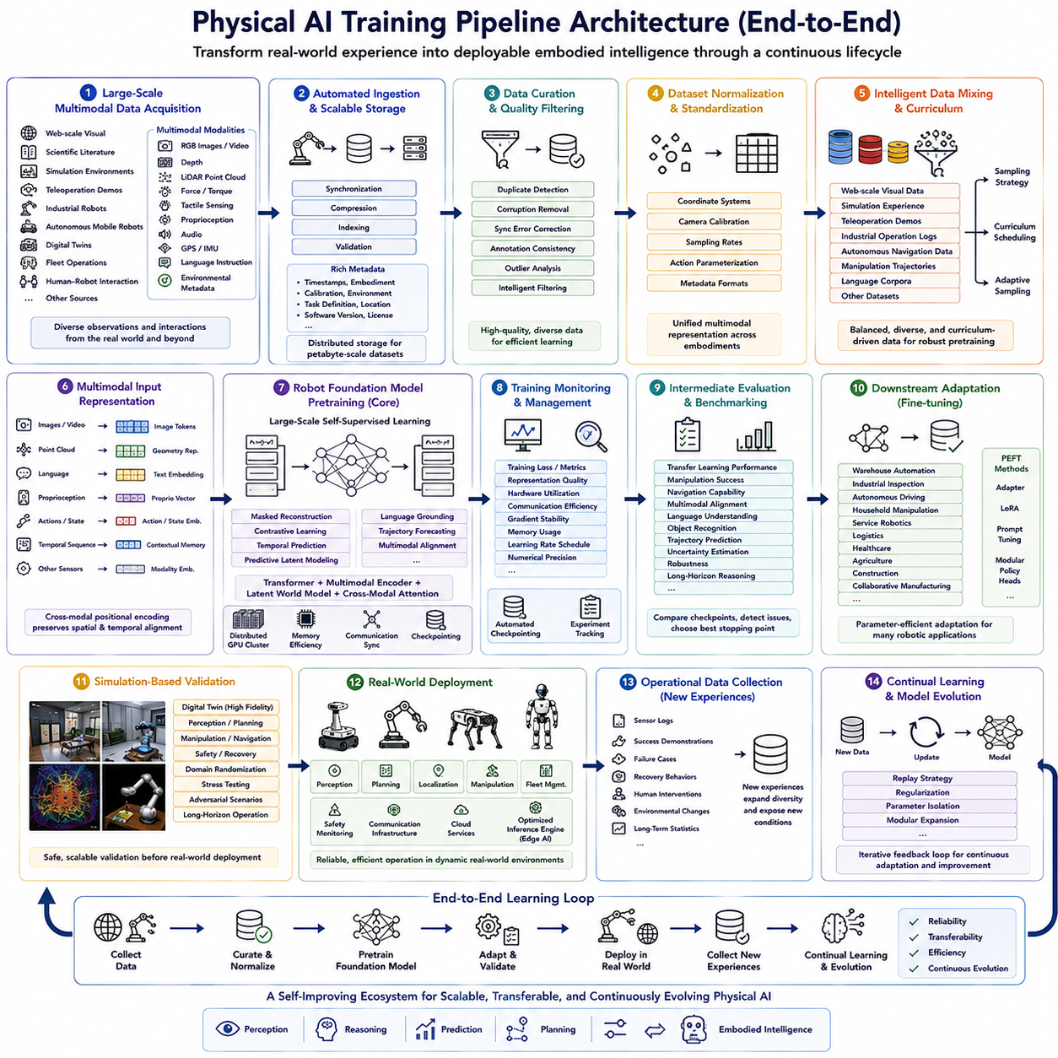
Physical AI training has evolved from isolated machine learning workflows into a comprehensive end-to-end pipeline that continuously transforms heterogeneous real-world experiences into deployable embodied intelligence. Unlike conventional AI systems that primarily learn from static datasets, Physical AI integrates multimodal sensing, simulation, robot interaction, large-scale distributed training, evaluation, deployment, and continual learning into one unified lifecycle. Every stage of the pipeline contributes directly to the capability of Robot Foundation Models, ensuring that perception, reasoning, prediction, planning, and control improve simultaneously as additional robot experience becomes available. Consequently, the overall training pipeline has become one of the most critical architectural foundations supporting scalable embodied intelligence.
The pipeline begins with large-scale multimodal data acquisition, where information is collected from diverse sources including internet-scale visual resources, scientific literature, simulation environments, teleoperation demonstrations, industrial robots, autonomous mobile robots, digital twins, fleet operations, and human-robot interaction. Modern Physical AI systems combine RGB images, videos, depth observations, LiDAR point clouds, force measurements, tactile sensing, proprioception, audio, GPS, IMU, language instructions, and environmental metadata into unified multimodal datasets. The diversity of these observations provides broad physical knowledge while exposing foundation models to countless objects, environments, behaviors, and interaction patterns that cannot be obtained from any single data source.
Once data has been collected, automated ingestion pipelines organize incoming observations into scalable storage infrastructure. Raw sensor streams are synchronized, compressed, indexed, validated, and associated with rich metadata describing timestamps, robot embodiments, calibration parameters, environmental conditions, task definitions, geographic locations, software versions, and licensing information. Distributed storage systems support petabyte-scale datasets while enabling efficient retrieval of specific multimodal sequences during pretraining. Reliable ingestion ensures that future training stages operate upon complete, traceable, and reproducible datasets.
Data curation and quality filtering subsequently transform raw observations into reliable training resources. Duplicate detection removes redundant images and repeated demonstrations, corrupted sensor recordings are discarded, synchronization errors are corrected, annotation consistency is validated, and statistical outliers are examined before entering the training corpus. Intelligent filtering distinguishes valuable rare events from damaged observations while maintaining diversity across tasks, environments, robot platforms, and operational conditions. This stage substantially improves downstream learning efficiency because foundation models benefit more from carefully curated information than simply increasing dataset volume.
Dataset normalization establishes consistent representations across heterogeneous robotic platforms. Different robots frequently employ incompatible coordinate systems, camera calibrations, sampling frequencies, action parameterizations, and metadata formats. Normalization pipelines convert these heterogeneous observations into unified multimodal representations while preserving semantic relationships and temporal consistency. Standardized datasets enable Robot Foundation Models to learn transferable physical knowledge rather than platform-specific implementation details, significantly improving cross-embodiment generalization.
Following normalization, intelligent data mixing determines how different datasets contribute throughout pretraining. Web-scale visual knowledge, simulation experiences, teleoperation demonstrations, industrial operation logs, autonomous navigation data, manipulation trajectories, and language corpora are combined according to carefully designed sampling strategies. Curriculum scheduling gradually introduces increasingly complex observations while adaptive sampling emphasizes informative experiences and underrepresented scenarios. Proper data mixing prevents overfitting to dominant distributions while ensuring balanced learning across multiple robotic capabilities.
The next stage constructs multimodal input representations suitable for foundation model optimization. Visual observations become image tokens, language instructions become semantic embeddings, point clouds become geometric representations, robot states become proprioceptive vectors, temporal sequences become contextual memories, and sensor measurements become modality-specific feature embeddings. Cross-modal positional encoding preserves spatial and temporal correspondence among heterogeneous observations, enabling the model to integrate information originating from multiple sensing modalities simultaneously.
Robot Foundation Model pretraining forms the computational core of the entire pipeline. Large transformer architectures, multimodal encoders, latent world models, and cross-modal attention mechanisms learn generalized representations using self-supervised objectives operating across billions of multimodal observations. Masked reconstruction, contrastive learning, temporal prediction, predictive latent modeling, language grounding, trajectory forecasting, and multimodal alignment jointly optimize semantic understanding, physical reasoning, environmental prediction, and transferable behavioral knowledge. Distributed GPU clusters execute optimization continuously for weeks or months while automatically managing memory efficiency, communication synchronization, checkpointing, and fault tolerance.
During training, continuous monitoring systems evaluate optimization progress in real time. Training loss, validation metrics, representation quality, hardware utilization, communication efficiency, gradient stability, memory consumption, learning rate schedules, and numerical precision are continuously analyzed to identify optimization issues before significant computational resources are wasted. Automated checkpoint management periodically stores recoverable model states while experiment tracking systems maintain complete reproducibility throughout every training iteration.
Intermediate evaluation provides regular assessment of foundation model capability before pretraining has fully completed. Rather than relying exclusively upon optimization loss, evaluation measures transfer learning performance, manipulation success, navigation capability, multimodal alignment, language understanding, object recognition, trajectory prediction, uncertainty estimation, robustness, and long-horizon reasoning. Continuous benchmarking enables researchers to compare intermediate checkpoints while identifying optimal stopping points and diagnosing potential overfitting or representation collapse during large-scale optimization.
After foundation pretraining, downstream adaptation specializes the general-purpose model for specific robotic applications. Fine-tuning may target warehouse automation, industrial inspection, autonomous driving, household manipulation, service robotics, logistics, healthcare, agriculture, construction, or collaborative manufacturing. Parameter-efficient adaptation techniques including adapters, low-rank adaptation, prompt tuning, and modular policy heads significantly reduce computational cost while preserving knowledge acquired during large-scale pretraining. Consequently, one foundation model can efficiently support numerous downstream applications with relatively limited task-specific data.
Simulation-based validation provides a safe environment for verifying robot behavior before deployment into physical systems. Digital twins reproduce sensor configurations, robot kinematics, environmental dynamics, and operational scenarios with high fidelity, allowing researchers to evaluate perception, planning, manipulation, navigation, safety, and recovery behaviors under diverse conditions. Domain randomization, stress testing, adversarial scenarios, and long-horizon autonomous operation reveal weaknesses before real-world deployment while significantly reducing operational risk.
Real-world deployment transfers validated models into physical robotic systems. Optimized inference engines execute foundation models on embedded AI accelerators while integrating perception, planning, localization, manipulation, fleet management, safety monitoring, communication infrastructure, and cloud services. Runtime optimization reduces latency, memory consumption, energy usage, and computational overhead while maintaining reliable decision making under continuously changing environmental conditions. Deployment therefore represents the transition from large-scale offline learning toward practical embodied intelligence operating within real physical environments.
Operational robots continuously generate new experiences that become valuable training resources. Sensor logs, successful demonstrations, failure cases, recovery behaviors, human interventions, environmental changes, and long-term operational statistics are automatically collected during deployment. These newly acquired experiences expand dataset diversity while exposing foundation models to previously unseen conditions unavailable during earlier training. Continuous experience accumulation enables progressively improving robot capability throughout extended deployment lifecycles.
Continual learning closes the end-to-end training loop by integrating newly collected robot experiences back into subsequent pretraining cycles. Rather than periodically rebuilding models entirely from scratch, continual learning updates representations incrementally while preserving previously acquired knowledge through replay strategies, regularization techniques, parameter isolation, or modular expansion. This iterative feedback cycle enables Robot Foundation Models to adapt continuously as environments, hardware platforms, operational requirements, and physical interactions evolve over time.
Ultimately, the Physical AI training pipeline represents a continuously operating ecosystem rather than a sequence of isolated machine learning stages. Large-scale data acquisition, intelligent curation, multimodal representation learning, distributed pretraining, systematic evaluation, downstream adaptation, simulation validation, real-world deployment, operational data collection, and continual learning together create a self-improving architecture capable of progressively expanding embodied intelligence. As Robot Foundation Models continue scaling toward increasingly universal Physical AI systems, robust end-to-end training pipeline architectures will remain the essential infrastructure enabling reliable, transferable, efficient, and continually evolving autonomous robotic intelligence.

8.2 Teleoperation Data Collection System Design [w/Code]
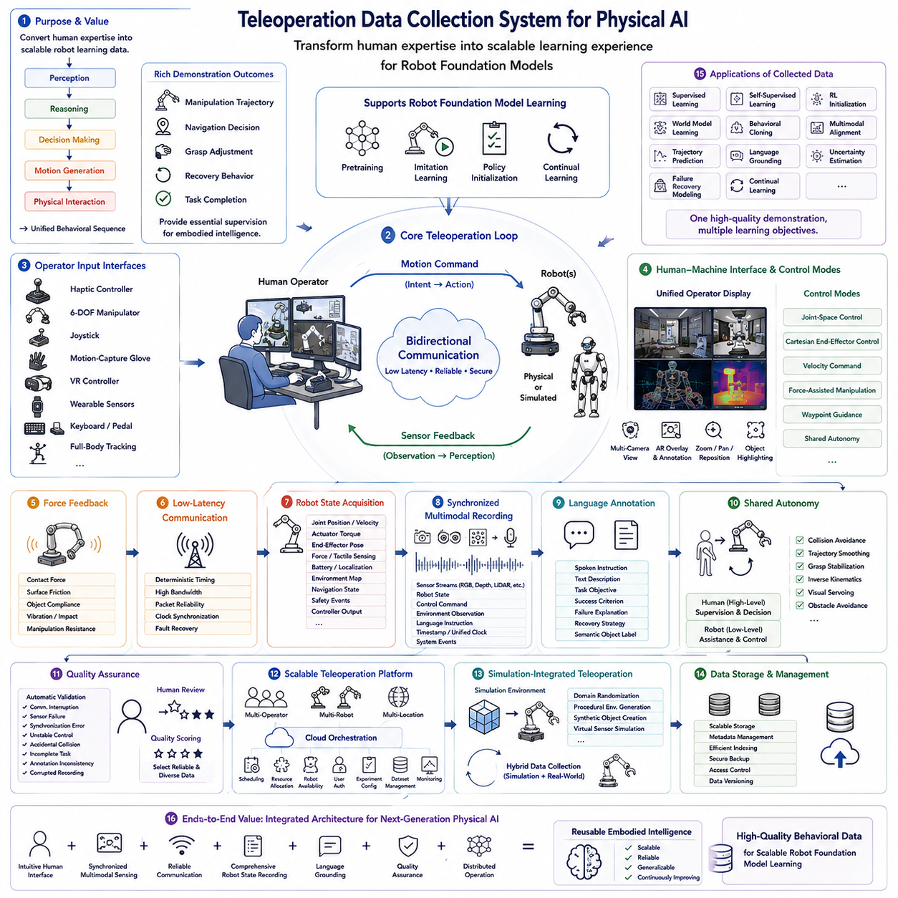
Teleoperation has become one of the most important technologies for collecting high-quality robot training data because it enables human expertise to be directly transformed into scalable learning experiences for Robot Foundation Models. Unlike manually labeled image datasets, teleoperation demonstrations naturally couple perception, reasoning, decision making, motion generation, and physical interaction into coherent behavioral sequences. Every manipulation trajectory, navigation decision, grasp adjustment, recovery behavior, and task completion generated by an expert operator provides valuable supervision for embodied intelligence. Consequently, modern Physical AI systems increasingly rely on large-scale teleoperation platforms to construct multimodal datasets capable of supporting foundation model pretraining, imitation learning, policy initialization, and continual learning across diverse robotic embodiments.
A teleoperation data collection system consists of multiple tightly integrated subsystems connecting the human operator with one or more physical or simulated robots. The operator interacts through input devices such as haptic controllers, six-degree-of-freedom manipulators, joysticks, motion-capture gloves, VR controllers, wearable sensors, keyboards, pedals, or full-body tracking systems. These interfaces continuously capture human intentions while transmitting motion commands to robotic manipulators, mobile platforms, humanoid robots, or other embodied systems. Bidirectional communication simultaneously delivers robot sensory feedback back to the operator, enabling precise closed-loop interaction with the remote environment.
Human-machine interface design directly influences demonstration quality. Ergonomic controllers reduce operator fatigue during long data collection sessions, while intuitive mappings between human motion and robot motion improve behavioral consistency. Modern teleoperation systems frequently support configurable control modes, allowing operators to switch seamlessly between joint-space control, Cartesian end-effector control, velocity commands, force-assisted manipulation, waypoint guidance, or shared autonomy. Such flexibility enables efficient collection of demonstrations spanning both simple repetitive actions and highly dexterous manipulation tasks.
Visual feedback serves as the primary information channel supporting operator situational awareness. Modern teleoperation systems integrate multiple synchronized RGB cameras, stereo vision, depth sensors, wrist-mounted cameras, panoramic cameras, thermal imagers, and three-dimensional reconstruction views into unified operator displays. Multi-camera visualization provides comprehensive environmental awareness while minimizing occlusions during manipulation. Virtual camera repositioning, zoom functions, object highlighting, semantic overlays, and augmented reality annotations further improve operator understanding of complex workspaces during demonstration collection.
Force feedback and haptic interaction substantially improve demonstration realism whenever physical contact occurs. Haptic devices reproduce contact forces, surface friction, object compliance, vibration, impact events, and manipulation resistance experienced by the robot. Rather than relying solely on visual perception, operators naturally adjust grasp strength, insertion force, alignment precision, and contact timing using tactile information. High-fidelity haptic feedback therefore enables collection of manipulation demonstrations that more accurately reflect human physical reasoning and dexterous interaction strategies.
Low-latency communication infrastructure remains essential for high-quality teleoperation. Motion commands, video streams, force feedback, robot states, and synchronization messages must be exchanged continuously with minimal delay to preserve stable closed-loop control. Communication networks therefore prioritize deterministic timing, high bandwidth, packet reliability, clock synchronization, and fault recovery mechanisms. Edge computing further reduces transmission delay by processing sensor fusion, perception, compression, and control algorithms closer to the robotic platform before transmitting summarized information to the remote operator.
Robot state acquisition forms another fundamental component of teleoperation data collection. Every demonstration records joint positions, joint velocities, actuator torques, end-effector poses, force measurements, tactile sensing, battery status, localization estimates, environmental maps, navigation states, safety events, and controller outputs alongside operator commands. This comprehensive system state enables foundation models to learn complete relationships among perception, robot configuration, environmental dynamics, operator intent, and executed physical actions throughout each demonstration sequence.
Synchronized multimodal recording represents one of the defining characteristics of modern teleoperation datasets. Every sensor stream, robot state, control command, environmental observation, language instruction, timestamp, and system event is precisely aligned within a unified temporal reference frame. High-resolution synchronization ensures that visual observations correspond exactly with executed actions, force measurements, and operator decisions. Accurate temporal alignment becomes particularly important for self-supervised learning, multimodal fusion, world modeling, and policy learning where small synchronization errors can substantially degrade representation quality.
Language annotation significantly increases the long-term value of teleoperation demonstrations. Operators may provide spoken instructions, textual descriptions, task objectives, success criteria, failure explanations, recovery strategies, and semantic object labels while performing demonstrations. Automatic speech recognition and language processing systems synchronize these annotations with robot observations and actions, enabling Robot Foundation Models to associate natural language with physical behavior. Such language grounding supports instruction following, semantic planning, explainable decision making, and cross-modal reasoning during downstream deployment.
Shared autonomy further enhances teleoperation efficiency by combining human intelligence with autonomous robotic assistance. Rather than manually controlling every low-level motion, operators supervise high-level objectives while autonomous modules perform collision avoidance, trajectory smoothing, grasp stabilization, inverse kinematics, visual servoing, or obstacle avoidance automatically. Human operators therefore focus primarily upon strategic decision making while repetitive control tasks are delegated to onboard intelligence. This collaboration increases demonstration consistency while reducing operator workload during extended collection campaigns.
Quality assurance mechanisms continuously evaluate demonstration reliability before integrating collected data into foundation model datasets. Automatic validation detects communication interruptions, sensor failures, synchronization errors, unstable control behavior, accidental collisions, incomplete task execution, annotation inconsistencies, and corrupted recordings. Human reviewers subsequently examine uncertain demonstrations while quality scoring systems prioritize successful, informative, and diverse experiences. This validation process ensures that foundation models learn from reliable behavioral examples rather than erroneous or incomplete demonstrations.
Scalable teleoperation platforms support simultaneous data collection from multiple operators and multiple robots distributed across different geographic locations. Cloud-based orchestration coordinates demonstration scheduling, resource allocation, robot availability, user authentication, experiment configuration, dataset management, and continuous monitoring through centralized management systems. Such distributed infrastructure enables collaborative data collection campaigns involving research laboratories, industrial facilities, universities, and commercial robotics organizations operating within one unified data ecosystem.
Simulation-integrated teleoperation substantially expands available training data while reducing operational cost and hardware risk. Operators perform demonstrations within physically realistic simulation environments before transferring learned behaviors to real robotic systems. Domain randomization, procedural environment generation, synthetic object creation, and virtual sensor simulation expose operators to broader task diversity than would be practical using physical robots alone. Hybrid data collection combining simulation and real-world teleoperation therefore provides rich multimodal experiences supporting scalable Robot Foundation Model pretraining.
Collected demonstrations become valuable assets beyond imitation learning alone. Teleoperation datasets support supervised learning, self-supervised representation learning, reinforcement learning initialization, world model training, behavioral cloning, multimodal alignment, trajectory prediction, language grounding, uncertainty estimation, failure recovery modeling, and continual learning. One carefully recorded demonstration therefore contributes simultaneously to numerous learning objectives throughout the Physical AI development pipeline, significantly increasing its long-term research value.
Ultimately, teleoperation data collection system design represents a foundational infrastructure technology supporting next-generation Robot Foundation Models. By integrating intuitive human interfaces, synchronized multimodal sensing, reliable communication, comprehensive robot state recording, language grounding, quality assurance, distributed operation, and scalable dataset management into one unified architecture, teleoperation platforms transform human expertise into reusable embodied intelligence. As Physical AI progresses toward increasingly general autonomous robots capable of learning from diverse multimodal experiences, sophisticated teleoperation systems will remain one of the primary mechanisms for generating the high-quality behavioral data required for scalable robot foundation model training.

8.3 Human Demonstration Data Quality Control [w/Code]
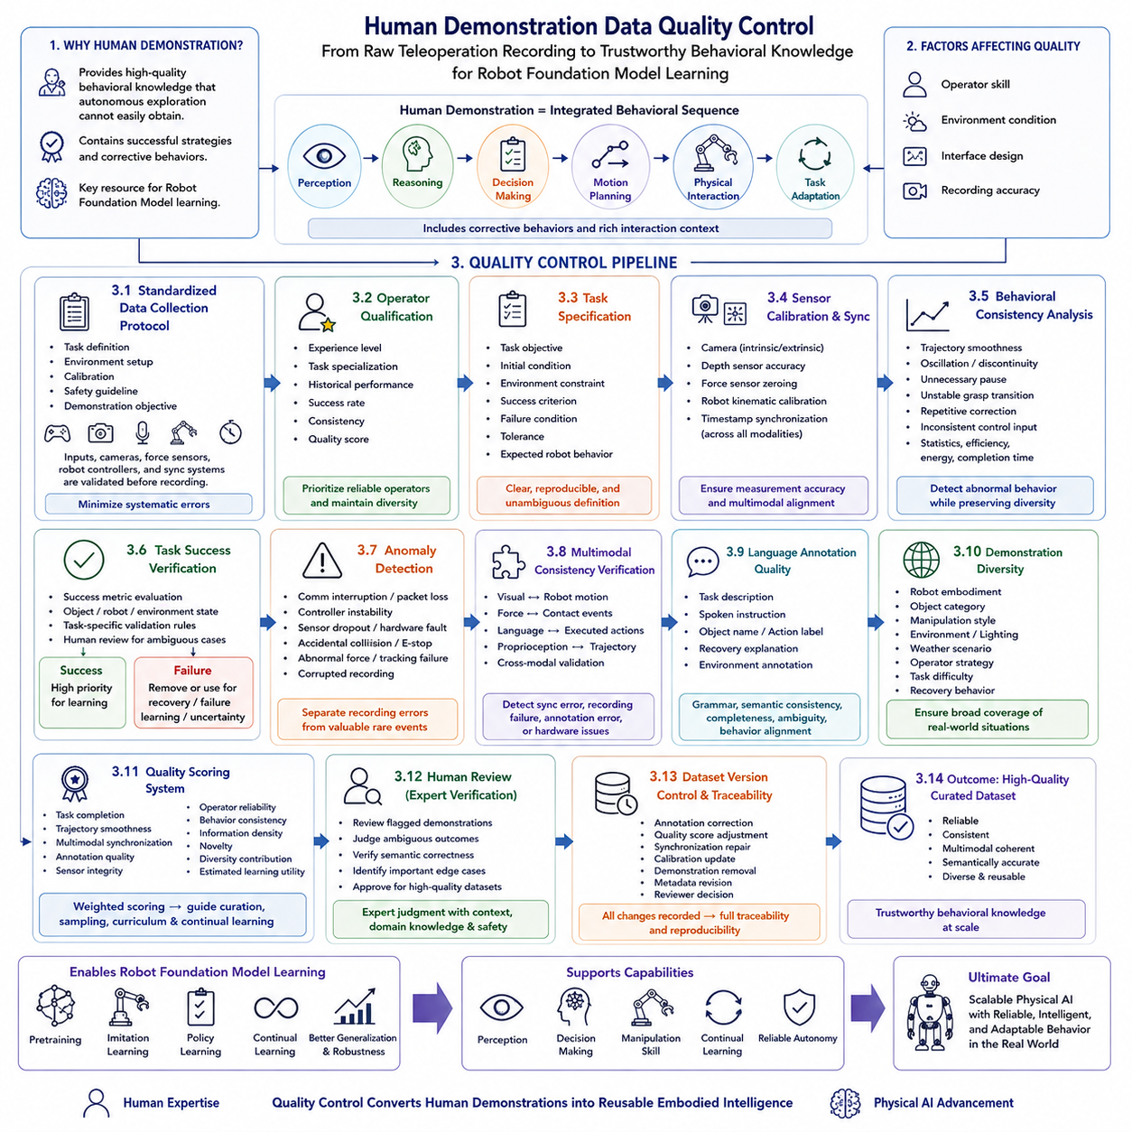
Modern Robot Foundation Models rely heavily on human demonstrations because they provide high-quality behavioral knowledge that is difficult to obtain through autonomous exploration alone. Human operators naturally integrate perception, reasoning, decision making, motion planning, physical interaction, and task adaptation into coherent action sequences while solving real-world problems. These demonstrations capture both successful execution strategies and subtle corrective behaviors that are often absent from automatically generated datasets. However, demonstration quality varies significantly depending on operator skill, environmental conditions, interface design, and recording accuracy. Consequently, Human Demonstration Data Quality Control has become an essential component of Physical AI data engineering, ensuring that only reliable, informative, and reusable demonstrations contribute to large-scale pretraining and downstream policy learning.
Quality control begins before any demonstration is recorded by establishing standardized collection protocols. Operators receive consistent task definitions, environmental preparation procedures, calibration instructions, safety guidelines, and demonstration objectives. Input devices, cameras, force sensors, robot controllers, and synchronization systems are validated before each recording session to minimize systematic errors. Standard operating procedures reduce variation introduced by inconsistent recording practices and ensure that demonstrations collected across different laboratories, operators, and robotic platforms remain sufficiently comparable for large-scale learning.
Operator qualification represents one of the primary determinants of demonstration quality. Experienced operators typically generate smoother trajectories, more efficient manipulation strategies, better recovery behaviors, and higher task completion rates than inexperienced users. Modern teleoperation platforms therefore maintain operator profiles containing experience level, task specialization, historical performance, success rate, demonstration consistency, and quality scores. These metrics allow dataset managers to prioritize demonstrations generated by highly reliable operators while still preserving representative examples from less experienced users for diversity when appropriate.
Task specification must also remain precise and reproducible. Every demonstration should clearly define task objectives, initial conditions, environmental constraints, success criteria, failure conditions, acceptable tolerances, and expected robot behavior. Ambiguous task definitions frequently produce inconsistent demonstrations that confuse learning algorithms by presenting multiple incompatible solutions for the same objective. Well-defined task protocols therefore improve behavioral consistency while allowing foundation models to distinguish between intentional strategy variation and undesirable operator inconsistency.
Sensor calibration directly influences the reliability of recorded demonstrations. Cameras require intrinsic and extrinsic calibration, depth sensors must maintain accurate distance estimation, force sensors require periodic zero-point adjustment, and robot kinematic calibration ensures accurate end-effector positioning. Timestamp synchronization across cameras, robot states, force measurements, tactile sensing, audio streams, and operator commands must remain accurate throughout each recording session. Small calibration or synchronization errors can accumulate into significant inconsistencies that reduce multimodal alignment quality during foundation model training.
Behavioral consistency analysis evaluates whether demonstrations follow coherent and physically reasonable action sequences. Motion trajectories are examined for excessive oscillation, abrupt discontinuities, unnecessary pauses, unstable grasp transitions, repeated corrective motions, and inconsistent control inputs. Statistical trajectory analysis, smoothness metrics, energy consumption, path efficiency, and task completion time help identify demonstrations that deviate substantially from expected operator behavior. While natural behavioral diversity should be preserved, clearly abnormal demonstrations are flagged for further review.
Task success verification distinguishes complete demonstrations from unsuccessful attempts. Completion status is evaluated automatically using predefined success metrics, object states, robot configurations, environmental conditions, and task-specific validation rules. Human reviewers may additionally inspect ambiguous demonstrations requiring semantic interpretation beyond automated evaluation. Successful demonstrations receive higher training priority, whereas unsuccessful attempts may either be discarded or retained separately for learning recovery strategies, failure prediction, or uncertainty estimation.
Anomaly detection algorithms continuously monitor demonstration recordings for unexpected events. Communication interruptions, packet loss, controller instability, sensor dropout, hardware malfunction, accidental collisions, emergency stops, abnormal force peaks, tracking failures, and corrupted recordings are automatically identified using statistical monitoring and machine learning techniques. Rather than immediately discarding every anomalous recording, the quality control system distinguishes between genuine recording failures and valuable rare events that may improve robustness under challenging operating conditions.
Multimodal consistency verification ensures that every sensing modality accurately reflects the same physical interaction. Visual observations should correspond with robot motion, force measurements should align with contact events, language annotations should describe observed actions, and proprioceptive states should remain consistent with executed trajectories. Cross-modal validation detects inconsistencies that often indicate synchronization errors, recording failures, annotation mistakes, or hardware malfunction. Maintaining multimodal coherence significantly improves representation learning during self-supervised pretraining.
Language annotation quality receives dedicated evaluation because semantic descriptions strongly influence language-grounded robot learning. Task descriptions, spoken instructions, object names, action labels, recovery explanations, and environmental annotations are examined for grammatical correctness, semantic consistency, completeness, ambiguity, and alignment with recorded robot behavior. Automatic language models assist reviewers by identifying contradictory descriptions, missing annotations, duplicate labels, and inconsistent terminology while preserving operator-specific contextual information whenever appropriate.
Demonstration diversity represents another critical quality metric. High-quality datasets should not simply contain numerous repetitions of identical tasks performed under nearly identical conditions. Instead, demonstrations should span different robot embodiments, object categories, manipulation styles, environmental layouts, lighting conditions, weather scenarios, operator strategies, task difficulties, and recovery behaviors. Diversity analysis therefore complements quality scoring by encouraging broad coverage of operational situations rather than maximizing demonstration quantity alone.
Quality scoring systems integrate multiple evaluation criteria into comprehensive demonstration rankings. Individual demonstrations are assessed according to task completion, trajectory smoothness, multimodal synchronization, annotation quality, sensor integrity, operator reliability, behavioral consistency, information density, novelty, diversity contribution, and estimated downstream learning utility. Weighted scoring algorithms generate overall quality indices that guide dataset curation, sampling priorities, curriculum learning schedules, and continual learning updates throughout the foundation model training pipeline.
Human review remains indispensable despite increasing automation. Expert reviewers inspect demonstrations flagged by automatic validation systems, resolve ambiguous task outcomes, verify semantic correctness, identify valuable edge cases, and approve demonstrations intended for inclusion in high-quality benchmark datasets. Human expertise ensures that quality control extends beyond statistical validation by incorporating contextual reasoning, domain knowledge, operational experience, and safety considerations that remain difficult to evaluate using fully automated systems.
Dataset version control preserves complete traceability throughout demonstration quality management. Every modification—including annotation correction, quality score adjustment, synchronization repair, calibration update, demonstration removal, metadata revision, or reviewer decision—is permanently recorded within the dataset history. Version management allows researchers to reproduce experiments accurately, compare alternative quality control strategies, evaluate dataset evolution over time, and identify the influence of individual demonstrations on foundation model performance.
Ultimately, Human Demonstration Data Quality Control transforms raw teleoperation recordings into trustworthy behavioral knowledge suitable for large-scale Robot Foundation Model training. Rather than maximizing demonstration quantity alone, modern Physical AI systems emphasize reliability, consistency, multimodal coherence, semantic accuracy, diversity, and long-term reusability. As increasingly capable embodied foundation models continue learning from millions of human demonstrations collected across diverse robotic platforms, sophisticated quality control frameworks will remain fundamental for producing scalable datasets that support robust perception, intelligent decision making, transferable manipulation skills, continual learning, and reliable autonomous behavior across real-world environments.

8.4 Sim and Real Data Mixing Pipeline [w/Code]
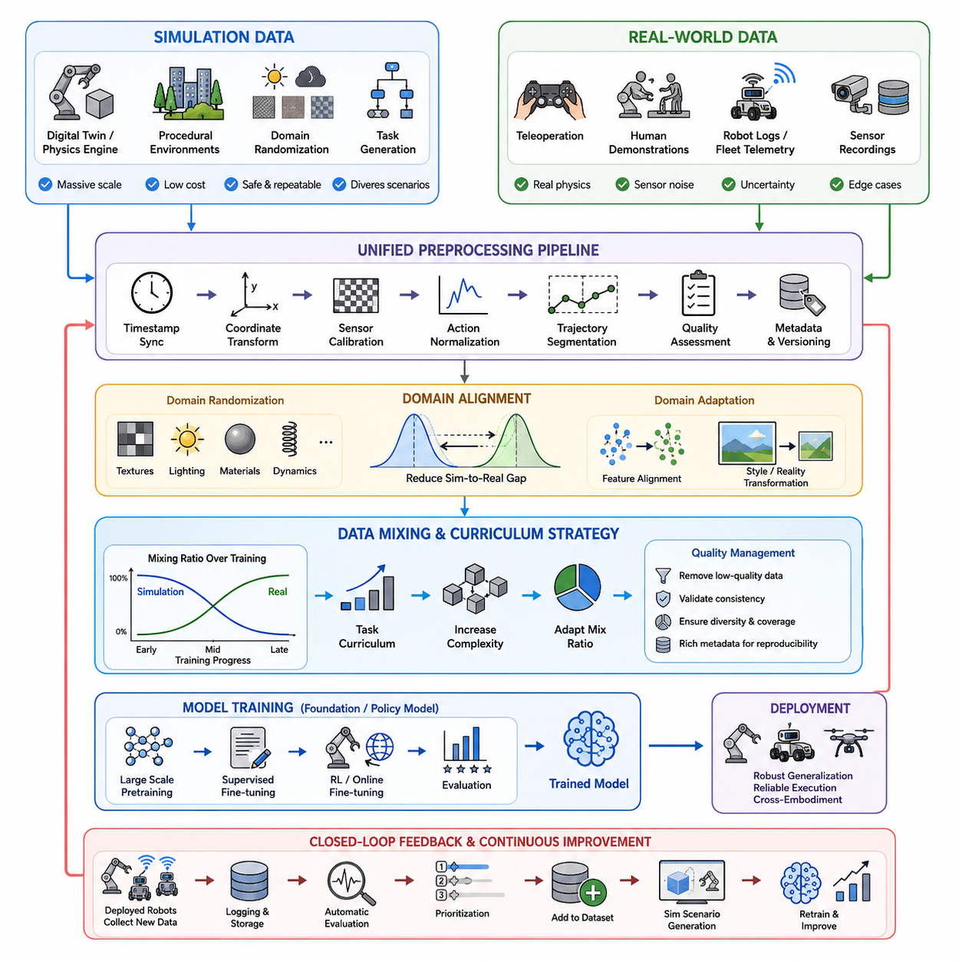
Simulation-generated data and real-world robot data play complementary roles in modern Physical AI training pipelines because each source provides unique advantages and compensates for the limitations of the other. Simulation environments can rapidly generate massive amounts of labeled trajectories under diverse environmental conditions, robot configurations, object arrangements, lighting variations, weather scenarios, and failure cases that are expensive, dangerous, or impossible to reproduce consistently in physical experiments. Real-world data, in contrast, captures sensor noise, actuator imperfections, contact dynamics, environmental uncertainty, human behavior, mechanical wear, and unexpected disturbances that are difficult to model accurately in simulation. An effective training pipeline therefore combines both domains to maximize data diversity while maintaining strong correspondence with physical execution. The objective is not to replace one data source with another, but to create a balanced learning process that enables robust generalization across unseen environments and robot embodiments.
The data mixing pipeline typically begins with large-scale simulation data generation, where digital twins, physics engines, procedural scene generation, synthetic sensors, and automated task generators continuously produce diverse experiences. Simulation data are then validated, filtered, normalized, and converted into standardized dataset formats compatible with downstream learning frameworks. In parallel, real-world datasets are collected through teleoperation systems, autonomous exploration, human demonstrations, industrial robot logs, fleet telemetry, and sensor recordings from deployed robots. Both simulated and real datasets undergo identical preprocessing steps, including timestamp synchronization, coordinate transformation, sensor calibration, action normalization, trajectory segmentation, quality assessment, metadata generation, and version management to ensure that training algorithms receive consistent representations regardless of data origin.
A critical component of the pipeline is domain alignment between simulated and real environments. Without careful alignment, models trained primarily in simulation often experience significant performance degradation when deployed on physical robots because of the well-known simulation-to-reality gap. Domain randomization addresses this challenge by intentionally varying textures, illumination, materials, camera parameters, object positions, friction coefficients, mass distributions, sensor noise, latency, and environmental dynamics during simulation. Domain adaptation techniques further reduce discrepancies by learning invariant feature representations across domains or by translating synthetic observations into realistic visual and physical characteristics. Together, these approaches encourage models to focus on task-relevant information rather than environment-specific artifacts.
The proportion of simulation and real-world data should evolve throughout the training lifecycle instead of remaining fixed. Early-stage foundation model pretraining often benefits from overwhelmingly large quantities of simulated experiences because they provide broad coverage of tasks, motions, and environmental variations at relatively low cost. As training progresses, increasing amounts of high-quality real robot data are introduced to refine perception, manipulation accuracy, motion smoothness, and interaction behaviors under realistic operating conditions. Curriculum learning strategies may gradually increase task complexity while simultaneously adjusting simulation-to-real ratios, allowing the model to acquire general capabilities before specializing in deployment-specific scenarios. This progressive mixing strategy improves sample efficiency while reducing dependence on expensive real-world data collection.
Data quality management remains essential regardless of data origin. Simulation datasets should be evaluated for physical realism, task diversity, collision validity, action consistency, and environment coverage, while real-world datasets require verification of sensor synchronization, annotation accuracy, operator consistency, hardware status, calibration integrity, and execution success. Low-quality trajectories, corrupted sensor streams, duplicated episodes, incomplete demonstrations, or physically implausible actions should be removed before integration into the unified dataset. Metadata describing environmental conditions, robot configurations, software versions, task categories, and collection methods should accompany every sample to enable reproducibility, filtering, and controlled experimentation during training.
Modern Physical AI pipelines increasingly employ automated feedback loops that continuously improve the mixed dataset after deployment. Robots operating in production environments generate new trajectories containing novel situations, edge cases, failures, recovery behaviors, and previously unseen interactions. These experiences are automatically logged, evaluated, prioritized, and incorporated into future training cycles together with newly generated simulation scenarios specifically designed to reproduce observed failures. Such iterative refinement enables continuous reduction of performance gaps between simulated training environments and operational deployment, creating an evolving data ecosystem in which simulation accelerates exploration while real-world experience continually grounds the model in physical reality. This closed-loop Sim-and-Real Data Mixing Pipeline forms a fundamental component of scalable robot foundation model development, supporting robust generalization, efficient learning, reliable deployment, and long-term adaptation across diverse robotic platforms and applications.

8.5 Online RL Fine Tuning Pipeline RLHF for Robots [w/Code]
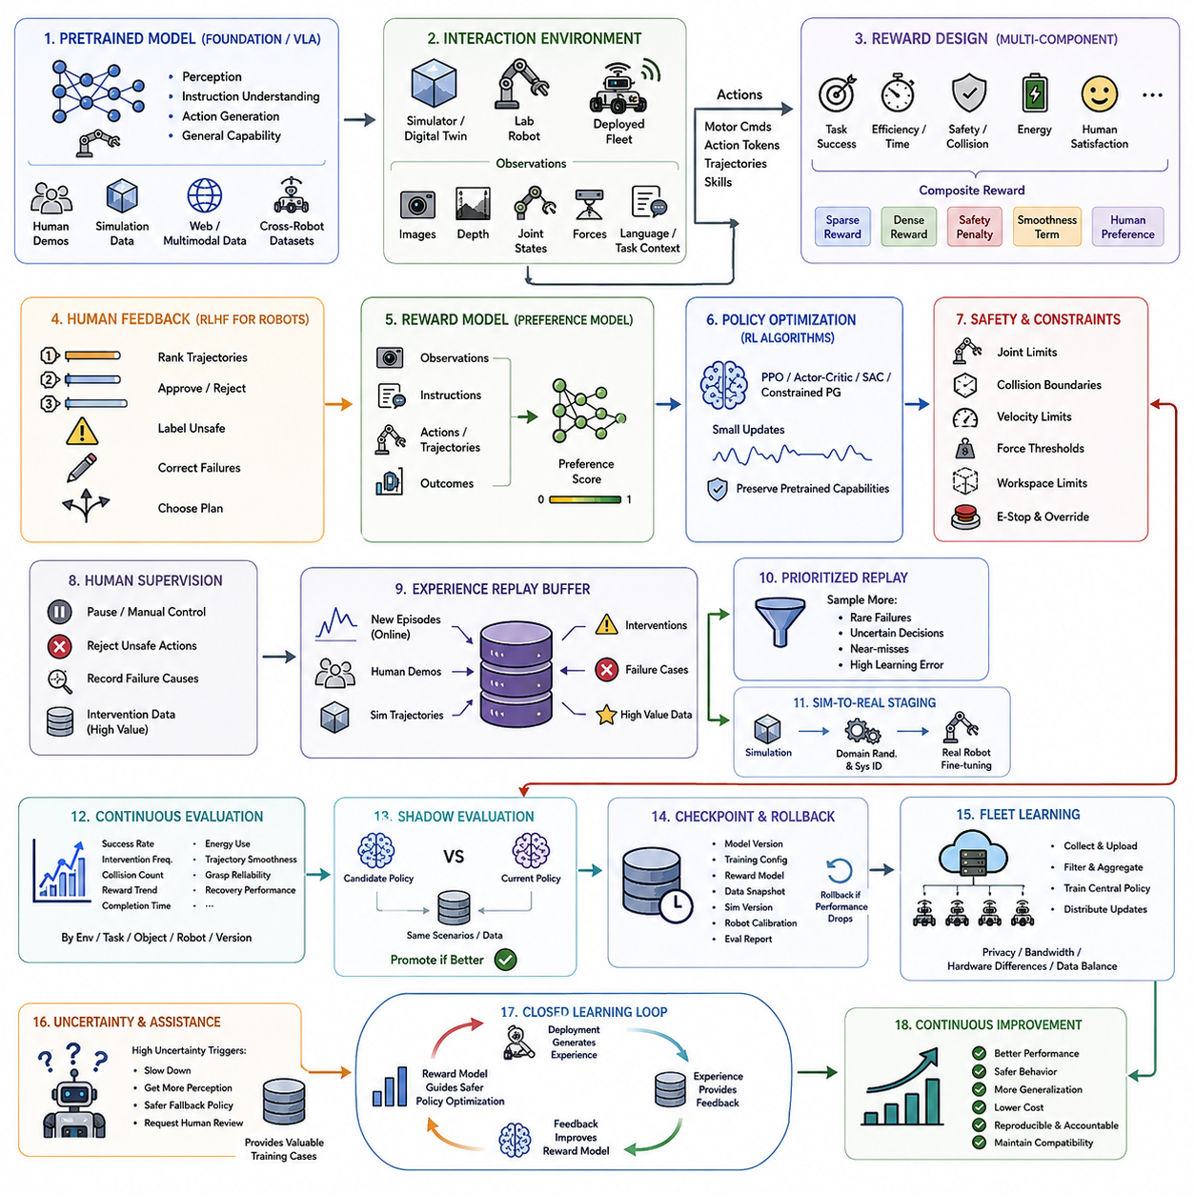
Online reinforcement learning fine-tuning enables a pretrained robot model to improve through direct interaction with physical or simulated environments after its initial supervised training is complete. Instead of relying only on static demonstrations, the robot executes actions, observes outcomes, receives evaluative signals, and updates its policy. This process allows the model to adapt to new objects, workspaces, hardware conditions, and task requirements that were not fully represented in the original dataset.
A typical pipeline begins with a pretrained foundation model or vision-language-action policy that already possesses general perception, instruction understanding, and action-generation capabilities. The model may have been trained using human demonstrations, simulation trajectories, multimodal web data, or cross-robot datasets. Online reinforcement learning then refines this broad capability toward specific operational objectives while preserving the useful representations acquired during large-scale pretraining.
The interaction environment may be a high-fidelity simulator, a digital twin, a laboratory robot, or a deployed fleet operating under controlled safety constraints. At each step, the policy receives observations such as camera images, depth maps, joint states, force measurements, language instructions, and task context. It produces motor commands, action tokens, trajectories, or high-level skills, and the resulting state transition is recorded for evaluation and future learning.
Reward design is one of the most important elements of the pipeline because the policy will optimize whatever signal it receives. Rewards may represent task completion, motion efficiency, grasp stability, collision avoidance, energy consumption, execution time, human satisfaction, or compliance with operational rules. Poorly designed rewards can encourage unsafe shortcuts, unstable behavior, or specification gaming, so reward functions must reflect both performance and physical safety requirements.
For many robot tasks, a single scalar reward is not sufficient to describe successful behavior. The pipeline may therefore combine several components, including sparse success rewards, dense progress rewards, safety penalties, smoothness terms, and human preference scores. These components are normalized and weighted to prevent one objective from dominating the others. The final reward should encourage efficient task execution without sacrificing stability, precision, interpretability, or recoverability.
Human feedback can be incorporated through a robot-specific form of reinforcement learning from human feedback. Operators may rank several trajectories, approve or reject completed actions, identify unsafe behavior, correct failed executions, or choose between alternative motion plans. These preference labels are used to train a reward model that predicts which behaviors humans consider more successful, natural, safe, or appropriate for the intended task.
The reward model receives robot observations, instructions, actions, and trajectory outcomes, then produces a score representing estimated human preference. Training data may consist of pairwise comparisons between successful and unsuccessful episodes, smooth and jerky motions, safe and risky paths, or efficient and wasteful task executions. The quality and diversity of these comparisons directly influence how accurately the reward model represents human intent.
After reward model training, the robot policy can be optimized using algorithms such as proximal policy optimization, actor-critic learning, soft actor-critic, or other constrained policy-gradient methods. The selected algorithm depends on whether actions are continuous, discrete, tokenized, or generated as temporal chunks. Updates are generally kept small to avoid destroying previously learned capabilities and to reduce sudden behavioral changes during physical deployment.
Online learning from real robots requires stronger safety controls than reinforcement learning performed entirely in simulation. The exploration space must be limited by joint constraints, collision boundaries, velocity limits, force thresholds, workspace restrictions, and emergency-stop logic. A separate safety controller may override the learned policy whenever predicted actions violate certified limits or enter states that have not been adequately validated.
Human supervision remains essential during early online fine-tuning. Operators should be able to pause execution, take manual control, reject unsafe actions, and label failure causes. Intervention data are especially valuable because they identify situations where the current policy is uncertain or unreliable. These corrective episodes can be added to a replay buffer and used for supervised recovery training, preference modeling, or additional reinforcement learning updates.
Simulation normally provides the first stage of online reinforcement learning because it allows broad exploration without risking hardware damage. The policy can experience diverse object configurations, disturbances, contact conditions, sensor failures, and task variations at high speed. Domain randomization and system identification are applied to reduce the difference between simulated dynamics and the real robot before the policy is transferred to physical hardware.
Once the policy reaches an acceptable performance threshold in simulation, fine-tuning can continue on the real robot using smaller learning rates and conservative exploration. Real-world updates focus on effects that simulation cannot accurately reproduce, such as friction changes, actuator backlash, camera artifacts, flexible materials, delayed control responses, and mechanical wear. This staged process reduces data collection cost while preserving physical realism.
Experience replay is commonly used to improve data efficiency and stabilize online updates. Newly collected episodes are stored together with earlier demonstrations, simulation trajectories, intervention samples, and high-value failure cases. The training scheduler selects a balanced mixture of recent and historical data so that the policy adapts to new conditions without catastrophically forgetting previously learned skills or becoming over-specialized to a narrow environment.
Prioritized replay gives additional sampling probability to rare failures, uncertain decisions, unsafe near-misses, and episodes that produce large learning errors. However, excessive focus on failures can distort the training distribution and reduce performance on normal tasks. The replay strategy should therefore maintain coverage of successful, routine, difficult, and recovery behaviors while preserving appropriate proportions across robot platforms and task categories.
Policy evaluation must occur continuously rather than only at the end of training. Evaluation metrics may include task success rate, intervention frequency, collision count, reward trend, completion time, energy use, trajectory smoothness, grasp reliability, and recovery performance. Results should be separated by environment, task, object type, robot configuration, and software version to reveal whether improvement in one area causes regression in another.
A shadow evaluation system can compare the newly updated policy with the current production policy before deployment. Both models receive the same recorded observations or simulation scenarios, but only the validated policy controls the robot. The candidate policy is promoted only when it demonstrates statistically meaningful improvement and passes predefined safety, reliability, and regression thresholds across representative benchmark suites.
Checkpointing and rollback mechanisms are necessary because online updates may occasionally reduce performance. Every model version should be linked to its training configuration, reward model, dataset snapshot, simulator version, robot calibration state, and evaluation report. If anomalies appear after deployment, operators must be able to restore the last validated checkpoint and identify exactly which data or optimization step introduced the regression.
Fleet-based learning extends the pipeline by collecting experience from multiple robots operating in different environments. Each robot can upload selected trajectories, failures, interventions, and diagnostic metadata to a central training platform. The central system filters and aggregates these experiences, updates the shared policy, and distributes validated improvements back to the fleet. Privacy, bandwidth, hardware differences, and data imbalance must be managed carefully.
Uncertainty estimation can determine when the robot should continue autonomously and when it should request assistance. High uncertainty may trigger slower motion, additional perception, a safer fallback policy, or human review. These events provide valuable training examples because they reveal gaps in the current model. Over time, repeated learning from uncertain situations can expand the operational domain while maintaining controlled risk.
The complete pipeline forms a closed learning loop in which deployment generates experience, experience produces feedback, feedback improves the reward model, and the reward model guides safer policy optimization. The updated policy is evaluated, validated, versioned, and redeployed only after meeting operational requirements. This structure enables robot systems to improve continuously while preserving safety, reproducibility, accountability, and compatibility with previously learned capabilities.

8.6 Autonomous Data Collection Robot Self Play [w/Code]
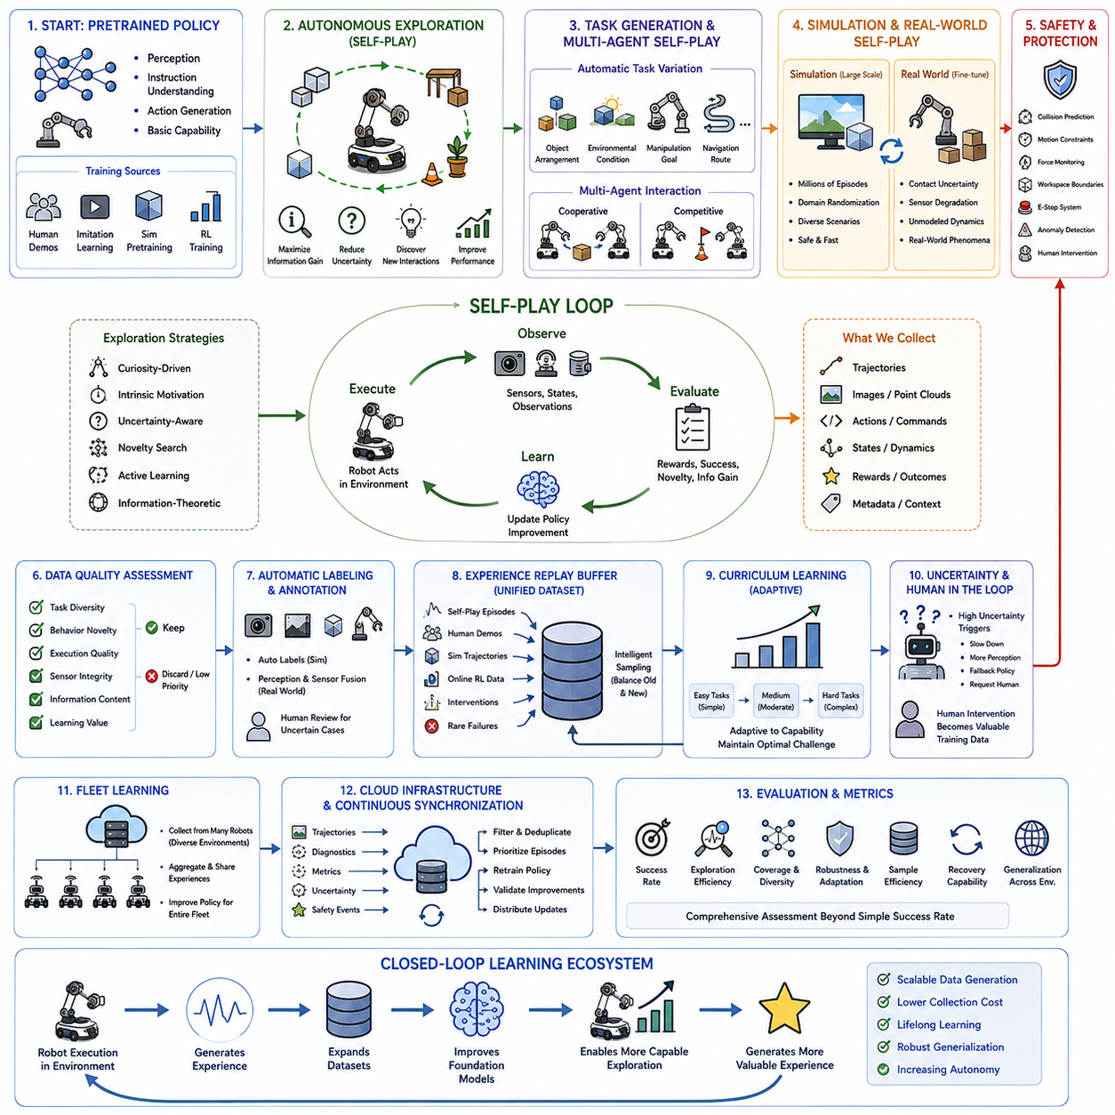
Autonomous data collection through robot self-play is becoming one of the most scalable approaches for training Physical AI systems because it enables robots to continuously generate large amounts of experience without relying exclusively on human demonstrations. Instead of waiting for operators to manually perform tasks, robots autonomously explore environments, interact with objects, attempt different strategies, evaluate outcomes, and accumulate diverse trajectories for future learning. This process dramatically increases data availability while reducing collection cost, allowing foundation models to improve continuously through experience. Self-play transforms deployed robots from passive inference systems into active learning agents that generate valuable training data throughout their operational lifetime.
The self-play pipeline typically begins with a pretrained policy obtained through supervised learning, imitation learning, simulation pretraining, or reinforcement learning. The initial policy provides sufficient capability to perform basic tasks safely while maintaining stable interactions with the environment. Rather than requiring expert-level performance, the policy only needs to achieve enough competence to initiate meaningful exploration. As the robot accumulates additional experience, the policy gradually improves through repeated cycles of autonomous execution, evaluation, and retraining.
Autonomous exploration differs from random behavior because it is guided by learning objectives and operational constraints. The robot actively selects actions that maximize information gain, reduce uncertainty, discover new object interactions, or improve task completion performance. Exploration strategies may include curiosity-driven learning, intrinsic motivation, uncertainty-aware exploration, novelty search, active learning, or information-theoretic objective functions. These methods encourage the robot to encounter situations that provide useful learning signals while avoiding repetitive or uninformative experiences.
Task generation is another important component of self-play systems. Instead of executing a fixed sequence of predefined operations, robots automatically generate new task variations by modifying object arrangements, environmental conditions, manipulation goals, navigation routes, or interaction sequences. Procedural task generation continuously expands the diversity of training experiences and prevents overfitting to a narrow collection of scenarios. As task complexity increases, robots progressively acquire broader behavioral capabilities that generalize across environments and applications.
Multi-agent self-play further enhances data diversity by allowing multiple robots or multiple virtual agents to interact with one another. Cooperative tasks require robots to coordinate transportation, manipulation, communication, or shared decision-making, while competitive scenarios encourage more robust planning, adaptation, and strategy development. These interactions naturally generate complex behaviors that are difficult to design manually and often expose weaknesses that remain hidden during isolated single-robot training.
Simulation provides the ideal environment for large-scale self-play because millions of interactions can be executed rapidly without risking physical hardware. Digital twins, physics simulators, procedural environments, and synthetic sensor models enable robots to explore countless object configurations, disturbances, terrain conditions, weather variations, and failure scenarios. Domain randomization continuously changes visual appearance, physical parameters, sensor characteristics, and environmental dynamics so that learned policies become less dependent on specific simulation settings.
After extensive simulation-based exploration, selected policies and high-value trajectories are transferred to physical robots for additional data collection. Real-world self-play focuses on phenomena that cannot be accurately reproduced in simulation, including contact uncertainty, mechanical wear, sensor degradation, flexible materials, lighting changes, unexpected human behavior, and long-term environmental evolution. The combination of simulation self-play and real-world self-play significantly improves both learning efficiency and deployment robustness.
Safety is a fundamental requirement because autonomous exploration inevitably exposes robots to unfamiliar situations. Every self-play pipeline therefore incorporates multiple protection mechanisms, including collision prediction, motion constraints, force monitoring, workspace boundaries, emergency-stop systems, anomaly detection, and human intervention protocols. Safe exploration algorithms attempt to maximize learning while minimizing hardware damage, environmental disruption, and operational risk. Policies are only allowed to explore within certified safety envelopes that protect both robots and nearby humans.
Continuous data quality assessment ensures that autonomous exploration produces useful rather than redundant experiences. Every trajectory is evaluated according to criteria such as task diversity, behavioral novelty, execution quality, sensor integrity, information content, and learning value. Episodes containing corrupted measurements, repetitive actions, unstable behavior, or invalid state transitions are discarded or assigned lower sampling priority. High-quality trajectories, successful recoveries, rare failures, and informative edge cases receive higher importance during subsequent training cycles.
Automatic labeling and annotation substantially reduce the human effort required for large-scale dataset construction. Simulation environments can generate perfectly synchronized labels for object identities, segmentation masks, depth maps, contact states, force measurements, trajectories, and action sequences. In physical environments, automated perception systems, sensor fusion algorithms, localization systems, and previously trained models assist with annotation while human reviewers validate only uncertain or ambiguous cases. This hybrid labeling strategy maintains scalability without sacrificing dataset reliability.
Experience replay mechanisms continuously integrate newly collected data with historical datasets. Autonomous exploration episodes, human demonstrations, simulation trajectories, online reinforcement learning experiences, intervention records, and rare failure cases are stored in a unified replay buffer. Intelligent sampling algorithms balance old and new experiences so that the model adapts to changing environments while preserving previously acquired knowledge. This process reduces catastrophic forgetting and supports continual learning throughout the robot's operational life.
Curriculum learning naturally emerges during autonomous self-play because the robot initially succeeds only on relatively simple tasks. As competence improves, increasingly difficult environments, longer planning horizons, more complicated object interactions, and stricter performance requirements are introduced automatically. Adaptive curriculum generation ensures that learning difficulty remains appropriately matched to the robot's current capabilities, thereby maintaining efficient learning progress while preventing excessive failure rates.
Uncertainty estimation plays a central role in deciding whether the robot should continue autonomous exploration or request external assistance. High uncertainty may trigger slower execution, additional perception, human supervision, fallback policies, or task termination. Rather than viewing uncertainty as a failure, the pipeline treats these situations as valuable opportunities for acquiring informative data. Human interventions during uncertain situations become particularly important training samples because they demonstrate correct behavior precisely where the policy lacks confidence.
Fleet learning extends autonomous data collection beyond individual robots by allowing experiences gathered across multiple deployments to be aggregated into a centralized training platform. Robots operating in different factories, warehouses, hospitals, construction sites, or outdoor environments collectively contribute diverse experiences that would be impossible for a single platform to obtain. Aggregated datasets substantially increase environmental diversity, task coverage, and operational robustness while accelerating policy improvement across the entire fleet.
Cloud-based infrastructure enables continuous synchronization between deployed robots and centralized learning systems. Robots periodically upload selected trajectories, diagnostic information, performance metrics, uncertainty estimates, and safety events. The central platform filters duplicated experiences, prioritizes informative episodes, retrains updated policies, validates performance improvements, and distributes optimized models back to deployed robots through secure update mechanisms. This continuous synchronization creates an evolving learning ecosystem rather than isolated individual robots.
Evaluation of self-play systems requires more comprehensive metrics than simple task success rates. Researchers measure exploration efficiency, environmental coverage, behavioral diversity, policy robustness, adaptation speed, uncertainty calibration, sample efficiency, intervention frequency, recovery capability, long-term stability, and cross-environment generalization. These metrics collectively determine whether autonomous exploration genuinely expands robot intelligence or merely generates large quantities of redundant experience.
Scalability is one of the primary advantages of autonomous data collection because the amount of generated experience increases approximately in proportion to the number of deployed robots and operating hours. Once reliable self-play infrastructure has been established, every deployed robot effectively becomes an autonomous data generation platform. As fleets expand, the available training data grows continuously without requiring proportional increases in human supervision, making foundation model improvement increasingly efficient over time.
The complete autonomous data collection pipeline forms a closed learning ecosystem in which robot execution generates experience, experience expands datasets, datasets improve foundation models, improved models enable more capable exploration, and more capable exploration generates increasingly valuable experience. This continuous feedback cycle allows Physical AI systems to evolve beyond the limitations of static datasets and human demonstrations, establishing a scalable pathway toward lifelong robot learning, robust generalization, and increasingly autonomous intelligence.

8.7 Training Pipeline Monitoring and Anomaly Alert [w/Code]
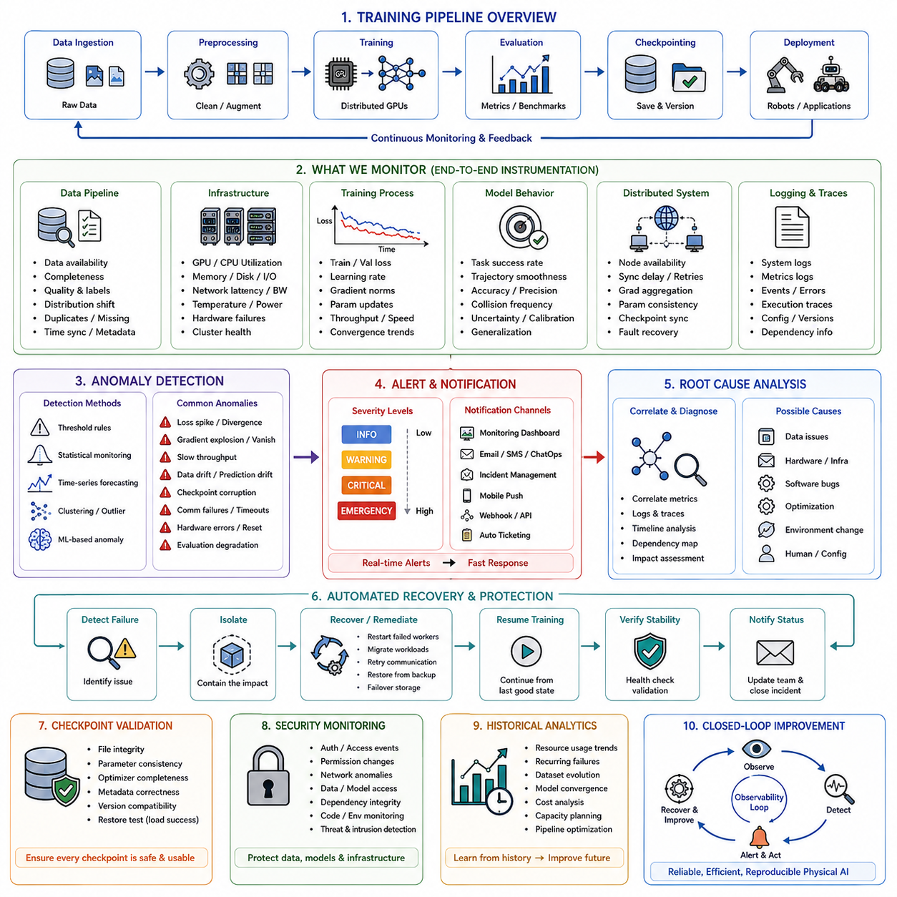
Training pipeline monitoring and anomaly alert systems are essential components of modern Physical AI development because large-scale robot training involves complex interactions among datasets, distributed computing infrastructure, optimization algorithms, hardware accelerators, storage systems, and deployment environments. A failure in any component can significantly reduce model quality, waste computational resources, or produce unreliable robot behavior. Continuous monitoring provides real-time visibility into every stage of the training pipeline, enabling engineers to identify abnormal conditions early, diagnose root causes efficiently, and maintain stable, reproducible model development. Effective monitoring transforms the training process from a passive execution workflow into an actively managed engineering system capable of detecting, reporting, and responding to operational issues before they affect downstream performance.
Monitoring begins with comprehensive instrumentation across the entire training infrastructure. Data ingestion systems, preprocessing pipelines, distributed storage, GPU clusters, communication networks, training frameworks, model checkpoints, evaluation services, and deployment components continuously generate operational metrics. These metrics include hardware utilization, memory consumption, storage throughput, network latency, dataset availability, training speed, optimization statistics, and model performance indicators. Collecting these measurements in real time enables centralized observability platforms to provide a unified operational view of the complete Physical AI training ecosystem.
Data pipeline monitoring focuses on verifying that training data remain consistent, complete, and accessible throughout the learning process. Incoming datasets are continuously inspected for missing files, corrupted samples, duplicated records, incorrect annotations, timestamp inconsistencies, sensor synchronization failures, distribution shifts, and unexpected changes in metadata. Data quality metrics such as class balance, trajectory diversity, modality completeness, environmental coverage, and annotation confidence are tracked continuously. Early detection of data anomalies prevents degraded datasets from propagating into expensive large-scale training jobs.
Infrastructure monitoring supervises the health of computational resources supporting model training. GPU utilization, CPU load, memory allocation, disk throughput, network bandwidth, thermal conditions, power consumption, hardware failures, and communication latency are continuously measured across distributed clusters. Multi-node synchronization performance, parameter server responsiveness, checkpoint storage rates, and communication bottlenecks are also monitored to ensure efficient large-scale parallel training. Infrastructure observability minimizes resource waste while maximizing hardware utilization and training efficiency.
Training process monitoring concentrates on optimization dynamics rather than hardware status alone. The system continuously tracks training loss, validation loss, learning rate schedules, gradient norms, parameter updates, optimizer statistics, batch processing speed, epoch completion times, convergence trends, and numerical stability. Visualization dashboards display these metrics throughout training, allowing researchers to identify optimization problems such as unstable convergence, exploding gradients, vanishing gradients, oscillating losses, or unexpectedly slow learning before irreversible model degradation occurs.
Model behavior monitoring evaluates whether the learned policy continues improving throughout optimization. Intermediate checkpoints are periodically tested on standardized validation datasets, simulation benchmarks, held-out environments, and representative robot tasks. Performance metrics including task success rate, trajectory smoothness, policy consistency, prediction accuracy, collision frequency, manipulation precision, navigation efficiency, uncertainty estimation, and generalization capability are recorded over time. Continuous behavioral evaluation helps distinguish genuine learning progress from superficial optimization improvements.
Distributed training introduces additional monitoring requirements because failures affecting one computing node may influence the entire training process. The monitoring system supervises node availability, synchronization delays, communication retries, parameter consistency, distributed optimizer states, gradient aggregation performance, checkpoint synchronization, and fault recovery mechanisms. Detecting failed workers, stalled communication channels, or inconsistent parameter updates allows distributed jobs to recover gracefully without requiring complete retraining from the beginning.
Anomaly detection combines predefined operational thresholds with intelligent statistical analysis to recognize unusual behavior throughout the pipeline. Simple threshold-based monitoring identifies obvious problems such as excessive memory usage, low GPU utilization, failed data loading, or unavailable storage systems. More advanced methods employ statistical process monitoring, time-series forecasting, clustering, Bayesian inference, or machine learning models to identify subtle deviations that may indicate emerging failures before traditional thresholds are exceeded.
Training anomalies may originate from many different sources. Sudden increases in loss values, unexpected validation degradation, abnormal gradient magnitudes, unstable parameter distributions, unusually slow throughput, checkpoint corruption, repeated communication failures, excessive numerical overflow, inconsistent mixed-precision behavior, or unexplained hardware resets all represent conditions requiring immediate investigation. A comprehensive anomaly detection system classifies these events according to severity, probable origin, affected components, and potential operational impact.
Data drift monitoring plays an increasingly important role for continuously updated Physical AI systems. Newly collected robot experiences may gradually shift environmental characteristics, sensor distributions, object appearances, operational tasks, or user behavior away from the original training distribution. Monitoring systems continuously compare incoming datasets against historical reference distributions using statistical distance measures, embedding similarity, feature histograms, and representation consistency. Significant drift automatically triggers alerts, additional validation, or retraining recommendations before model performance deteriorates in production.
Prediction drift and policy drift monitoring extend anomaly detection beyond input data. Even when datasets remain relatively stable, model outputs may gradually change because of incremental updates, online learning, changing optimization dynamics, or deployment-specific adaptations. Continuous comparison between historical predictions and current model behavior helps identify unexpected policy changes, unstable decision boundaries, degraded confidence calibration, or increasing uncertainty. Detecting behavioral drift is particularly important for safety-critical robotic applications operating in continuously changing environments.
Automated alert systems ensure that critical anomalies receive immediate attention. Alerts may be triggered by predefined thresholds, statistical confidence intervals, predictive maintenance models, or anomaly scoring algorithms. Notification channels include monitoring dashboards, email, messaging systems, incident management platforms, mobile notifications, and automated workflow orchestration services. Alert severity levels distinguish informational events, performance degradation, operational warnings, critical failures, and emergency shutdown conditions, allowing engineering teams to prioritize responses appropriately.
Root cause analysis becomes significantly more efficient when monitoring systems maintain detailed execution traces throughout the training pipeline. Every training run records configuration parameters, dataset versions, software dependencies, hardware allocation, hyperparameter settings, optimization states, infrastructure metrics, system logs, and evaluation results. Correlating anomalies across these multiple information sources enables engineers to identify whether failures originate from data quality, hardware instability, software defects, distributed synchronization, optimization strategies, or environmental changes.
Automated recovery mechanisms reduce downtime by responding intelligently to detected failures. If hardware becomes unavailable, workloads may migrate to alternative computing nodes. Corrupted checkpoints trigger restoration from validated backup versions. Failed workers automatically rejoin distributed training after recovery. Temporary network failures initiate communication retries, while storage failures activate redundant backup systems. These self-healing capabilities improve overall pipeline reliability and reduce the need for continuous manual intervention.
Checkpoint validation represents another important monitoring function. Every saved checkpoint is verified for file integrity, parameter consistency, optimizer completeness, metadata correctness, version compatibility, and successful restoration capability. Validation prevents corrupted checkpoints from becoming the foundation for future training stages or deployment candidates. Regular checkpoint verification also improves disaster recovery readiness by ensuring that every recovery point remains usable throughout long-running training projects.
Security monitoring protects training infrastructure against unauthorized access, malicious modifications, data leakage, and software compromise. Authentication events, permission changes, unusual network activity, dataset modifications, model artifact access, dependency integrity, and execution environments are continuously monitored for suspicious behavior. Security-related anomalies are integrated with operational monitoring to provide a unified view of both system health and infrastructure protection throughout the entire Physical AI development lifecycle.
Historical monitoring records provide valuable insights for long-term optimization of training pipelines. Engineers can analyze resource utilization trends, recurring failures, dataset evolution, infrastructure bottlenecks, model convergence characteristics, and operational costs across many experiments. These historical observations support capacity planning, infrastructure scaling, workflow optimization, predictive maintenance, and continuous improvement of training methodologies, enabling organizations to increase both efficiency and reliability as model complexity grows.
The complete monitoring and anomaly alert architecture establishes a closed operational feedback loop in which continuous observation produces actionable metrics, anomaly detection identifies emerging problems, automated alerts initiate rapid response, recovery mechanisms restore stable execution, and historical analysis guides long-term pipeline optimization. This comprehensive observability framework ensures that Physical AI foundation models are trained efficiently, reproducibly, securely, and reliably while minimizing computational waste, operational risk, and unexpected failures across increasingly large and complex robot learning systems.

8.8 Training Reproducibility Seed Config Versioning [w/Code]
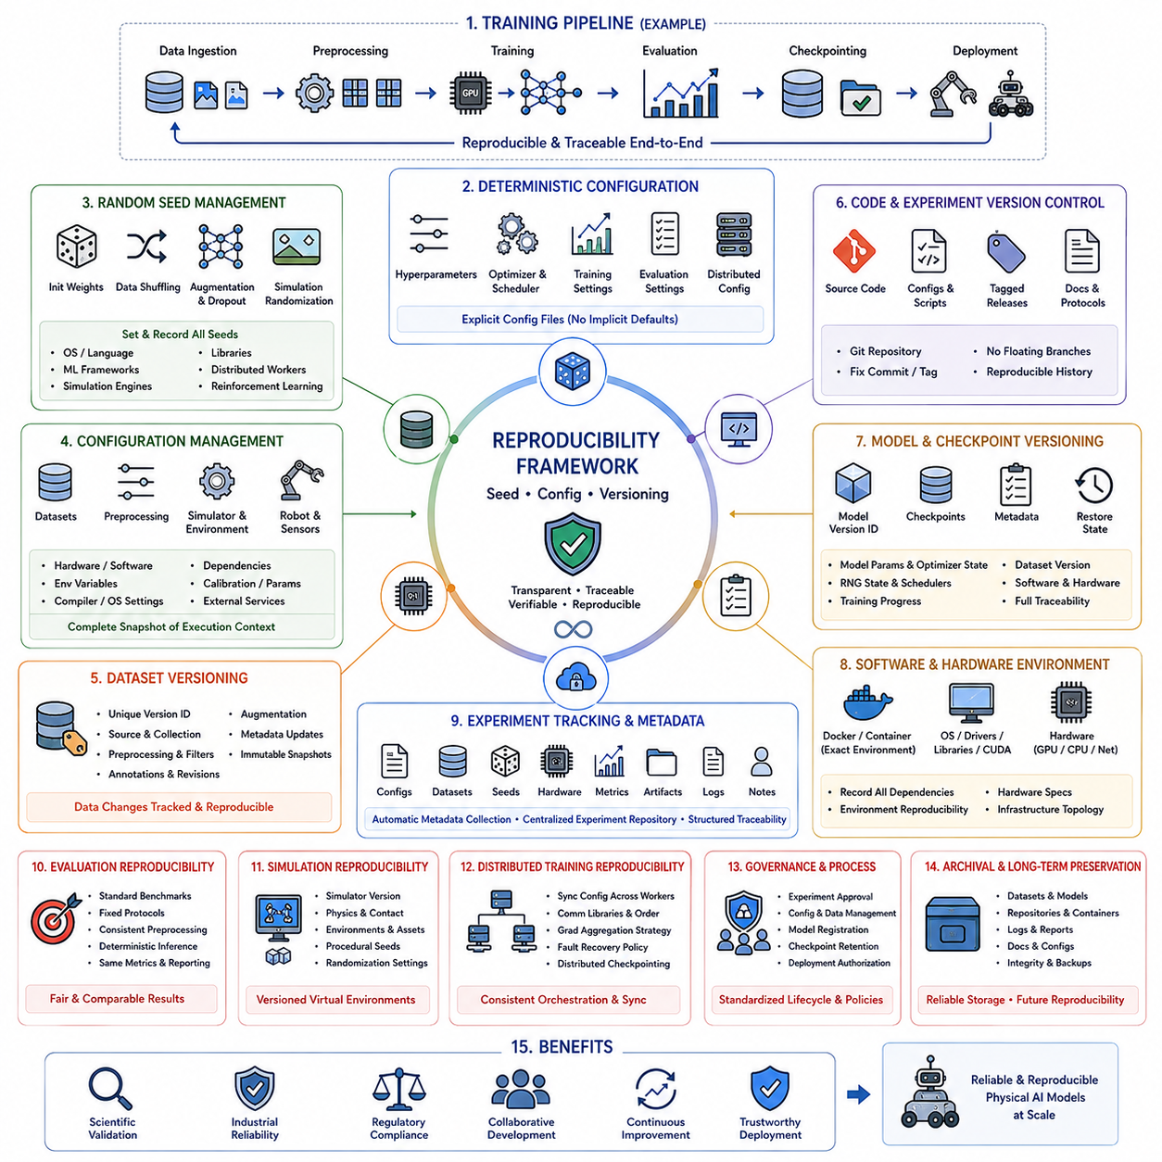
Training reproducibility is a fundamental requirement for modern Physical AI development because robot foundation models are trained through highly complex pipelines involving large-scale datasets, distributed computing, multiple software frameworks, hardware accelerators, and numerous optimization stages. Without reproducibility, the same training procedure may produce inconsistent models, making it difficult to verify experimental results, compare algorithmic improvements, diagnose failures, or certify robot behavior for deployment. Reproducibility ensures that every model can be regenerated under controlled conditions, allowing researchers and engineers to trace model behavior back to specific datasets, configurations, software versions, and hardware environments. This capability is essential for scientific validation, industrial reliability, regulatory compliance, and long-term maintenance of large Physical AI systems.
Reproducibility begins with deterministic experiment configuration. Every training run should define all hyperparameters explicitly, including learning rates, batch sizes, optimizer settings, weight initialization methods, gradient clipping thresholds, scheduler parameters, mixed-precision options, checkpoint intervals, evaluation frequency, and distributed training configurations. Default values should never be assumed because changes introduced by software updates or framework revisions may silently alter experimental behavior. Explicit configuration files provide a complete description of every experiment and eliminate ambiguity during future reproduction.
Random seed management is one of the most important components of reproducible training. Random number generators influence dataset shuffling, weight initialization, data augmentation, sampling strategies, reinforcement learning exploration, dropout operations, simulation randomization, and optimization procedures. Every random generator used by operating systems, programming languages, machine learning frameworks, simulation engines, and distributed workers should be initialized using documented seed values. Recording these seeds enables experiments to reproduce nearly identical computational trajectories whenever deterministic execution is supported.
Despite careful seed control, complete determinism may still be limited by hardware characteristics and parallel computation. GPU kernels, asynchronous execution, floating-point precision, communication ordering, distributed synchronization, and hardware-specific optimization libraries may introduce small numerical differences that gradually accumulate throughout long training processes. Reproducibility strategies therefore distinguish between exact bitwise reproducibility and statistical reproducibility, where repeated experiments produce equivalent performance even if internal numerical values differ slightly.
Configuration management extends beyond hyperparameters to include every component influencing model behavior. Dataset locations, preprocessing pipelines, feature extraction methods, tokenizer versions, sensor calibration parameters, simulator settings, robot hardware configurations, environment variables, compiler options, operating system settings, software dependencies, and external service endpoints should all be recorded. A complete configuration snapshot allows future researchers to recreate not only the training algorithm but the entire execution environment surrounding the experiment.
Version control plays a central role in maintaining reproducibility across evolving development projects. Source code, configuration files, experiment scripts, dataset definitions, evaluation protocols, deployment artifacts, and documentation should all be managed through structured version control systems. Every training run should reference specific repository revisions, tagged releases, or immutable commit identifiers rather than floating development branches. Version-controlled development ensures that historical experiments remain reproducible even after years of subsequent software evolution.
Dataset versioning is equally important because training results depend directly on data content. Every dataset should possess unique version identifiers describing source collections, preprocessing methods, annotation revisions, filtering criteria, augmentation strategies, and metadata updates. Changes affecting only a small fraction of samples may still produce measurable differences in model behavior, particularly for foundation models trained on billions of examples. Immutable dataset snapshots preserve historical training conditions and enable precise comparison across experiments.
Model versioning establishes traceability throughout the entire development lifecycle. Every trained model should receive a unique identifier associated with its training dataset, configuration, software version, hardware environment, random seeds, evaluation results, checkpoint history, and deployment status. Rather than storing model weights alone, comprehensive model packages include metadata describing the complete experimental context. Such traceability simplifies debugging, rollback, certification, deployment management, and long-term maintenance.
Checkpoint versioning provides intermediate recovery points throughout long-running training processes. Each checkpoint records model parameters, optimizer states, learning rate schedules, gradient scaling information, random number generator states, distributed synchronization metadata, and training progress indicators. Checkpoint metadata also identifies the corresponding dataset version, software revision, configuration snapshot, and hardware allocation. Restoring a checkpoint should reproduce not only the model weights but the exact optimization state from which training may continue consistently.
Software environment reproducibility requires precise management of dependencies. Programming language versions, machine learning libraries, CUDA toolkits, GPU drivers, operating system packages, compiler versions, simulation engines, visualization frameworks, and auxiliary utilities should all be documented explicitly. Container technologies such as Docker or similar virtualization systems package complete execution environments, ensuring that experiments remain reproducible even when underlying computing infrastructure evolves significantly over time.
Hardware configuration also influences reproducibility for Physical AI training. GPU architectures, CPU models, accelerator generations, memory capacity, storage systems, network topology, distributed cluster configuration, and specialized hardware libraries may all affect computational behavior. Recording hardware specifications allows researchers to distinguish between algorithmic improvements and hardware-dependent performance differences. Hardware-aware reproducibility is especially important for distributed training involving heterogeneous computing resources.
Experiment tracking systems automatically collect and organize information generated throughout model development. Every experiment records configuration files, software versions, dataset identifiers, random seeds, hardware information, training metrics, evaluation results, checkpoints, execution logs, visualization outputs, and user annotations. Centralized experiment repositories simplify comparison across multiple studies while reducing the possibility of losing important contextual information required for future reproduction.
Automated metadata generation reduces human error during experiment documentation. Rather than requiring researchers to manually record every configuration parameter, the training pipeline automatically captures execution context, software dependencies, hardware specifications, runtime statistics, system environment variables, distributed topology, resource utilization, and timestamp information. Automatically generated metadata improves consistency while ensuring that critical reproducibility information is never omitted inadvertently.
Evaluation reproducibility requires standardized benchmark datasets, fixed evaluation protocols, consistent preprocessing, deterministic inference settings, and identical performance metrics. Evaluation environments should avoid hidden randomness whenever possible, allowing competing models to be compared under equivalent conditions. Statistical confidence intervals, repeated evaluation runs, and standardized reporting formats further improve the reliability and interpretability of published performance comparisons.
Simulation reproducibility requires version-controlled virtual environments because changes to physics engines, contact models, environmental assets, sensor models, terrain generation, or procedural object placement may significantly alter learning outcomes. Every simulation experiment should specify simulator version, physics configuration, environmental parameters, procedural generation seeds, and randomization settings. Maintaining reproducible simulation environments is particularly important for sim-to-real transfer studies where experimental consistency directly influences deployment success.
Distributed training reproducibility requires synchronized configuration across all participating workers. Communication libraries, gradient aggregation strategies, synchronization intervals, parameter update ordering, fault recovery policies, and distributed checkpoint mechanisms should remain consistent throughout every execution. Reproducing distributed experiments requires preserving both local node configurations and the global orchestration strategy coordinating the entire training cluster.
Governance policies strengthen reproducibility by defining standardized procedures for experiment approval, configuration management, dataset release, model registration, checkpoint retention, documentation requirements, and deployment authorization. Organizational reproducibility depends not only on technical mechanisms but also on disciplined engineering processes ensuring that every model follows identical lifecycle management practices. These governance frameworks reduce operational uncertainty while improving collaboration across large multidisciplinary development teams.
Long-term reproducibility also requires careful archival strategies. Historical datasets, software repositories, container images, experiment logs, trained models, evaluation reports, documentation, and configuration snapshots should be preserved using reliable storage systems with integrity verification and redundant backup mechanisms. Future researchers may need to reproduce experiments many years after their original execution, making durable archival infrastructure an essential component of reproducible AI research.
The complete reproducibility framework forms a closed lifecycle management system in which deterministic configuration, controlled randomness, comprehensive versioning, automated metadata collection, standardized evaluation, disciplined governance, and long-term archival collectively ensure that every Physical AI model remains transparent, traceable, verifiable, and reproducible throughout its entire operational lifetime. Such comprehensive reproducibility provides the scientific and engineering foundation required for reliable robot foundation models, large-scale collaborative development, regulatory certification, continuous improvement, and trustworthy deployment across increasingly complex autonomous robotic systems.

8.9 Multi Task Training Pipeline Cross Robot Data [w/Code]
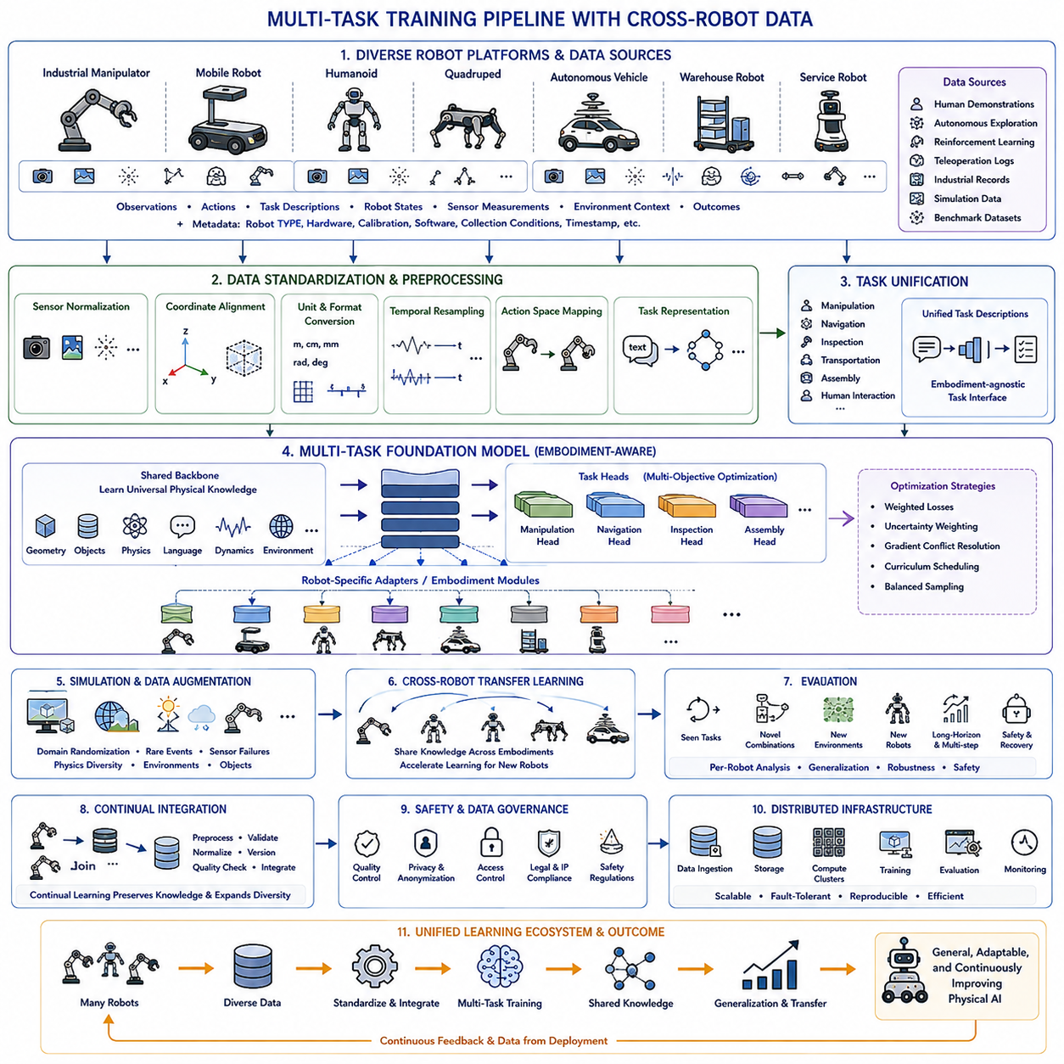
Multi-task training has become one of the defining methodologies for modern Physical AI because robots are expected to perform a wide variety of tasks rather than mastering only a single specialized behavior. Traditional robotic learning often focused on individual tasks such as object grasping, navigation, or assembly, requiring separate models for each capability. In contrast, multi-task learning trains a unified foundation model using diverse experiences collected across many tasks, enabling shared representations that improve knowledge transfer, generalization, and sample efficiency. Instead of learning isolated skills independently, the model develops reusable internal representations that support multiple robotic capabilities simultaneously.
Cross-robot data further extends this concept by integrating experiences collected from different robotic platforms into a unified training pipeline. Industrial manipulators, mobile robots, humanoids, quadrupeds, autonomous vehicles, warehouse robots, and service robots all generate valuable interaction data despite having different embodiments, sensors, actuators, and operational objectives. By combining these heterogeneous datasets, the training pipeline exposes the model to a broader range of physical interactions, environmental conditions, and behavioral strategies than any individual robot could provide. This diversity significantly improves robustness and supports the emergence of generalized robotic intelligence.
The training pipeline begins by collecting datasets from multiple robot platforms operating in simulation and real-world environments. Data sources may include human demonstrations, autonomous exploration, reinforcement learning trajectories, teleoperation logs, industrial production records, fleet operation histories, simulation-generated experiences, and benchmark datasets released by research institutions. Each dataset contains observations, actions, task descriptions, robot states, sensor measurements, environmental context, and execution outcomes. Comprehensive metadata describing robot type, hardware configuration, calibration status, software version, and collection conditions accompany every dataset to maintain traceability throughout the learning process.
Because robots differ substantially in their hardware architectures, data normalization is an essential component of cross-robot learning. Camera images, depth maps, LiDAR scans, force measurements, tactile information, joint positions, actuator commands, localization data, and language instructions must be transformed into standardized representations before entering the shared learning framework. Coordinate systems, measurement units, temporal sampling rates, sensor resolutions, and action formats are converted into common interfaces that enable the foundation model to learn consistent relationships across heterogeneous platforms.
Robot embodiment differences present one of the greatest challenges in multi-robot training. Robots vary in kinematic structures, numbers of joints, actuator types, payload capacities, mobility mechanisms, workspace geometries, sensing modalities, and control frequencies. Rather than forcing all robots into identical action spaces, modern architectures often learn embodiment-aware representations that separate robot-specific characteristics from task-level knowledge. This factorization allows high-level reasoning and planning to transfer across robots while preserving the unique physical constraints of each embodiment.
Task representation also requires careful standardization because identical objectives may be expressed differently across datasets. Manipulation, navigation, inspection, transportation, assembly, object sorting, human interaction, and collaborative operations should be represented using unified task descriptions that remain independent of individual robot implementations. Natural language instructions, semantic task embeddings, structured action specifications, or hierarchical task graphs provide common interfaces through which multiple robot platforms can interpret identical objectives despite differences in physical execution.
Data balancing is critical because some robots or tasks naturally generate much larger datasets than others. Without appropriate balancing strategies, dominant datasets may overwhelm smaller but equally valuable experiences, leading the model to over-specialize toward frequently observed behaviors. Sampling algorithms therefore regulate contributions from different robots, environments, task categories, and difficulty levels to ensure broad coverage throughout optimization. Curriculum scheduling may further adjust these proportions dynamically as training progresses.
Multi-task optimization requires objective functions capable of simultaneously improving diverse robotic capabilities. Individual tasks may emphasize navigation accuracy, manipulation precision, grasp stability, language understanding, obstacle avoidance, energy efficiency, safety, or collaboration. Multi-objective optimization techniques balance these competing requirements using weighted losses, adaptive optimization strategies, uncertainty-based weighting, gradient conflict resolution, or task-specific optimization heads. These approaches encourage shared knowledge while minimizing interference between unrelated tasks.
Parameter sharing forms the foundation of efficient multi-task learning. Lower layers of the model often learn general representations describing geometry, object properties, physical interactions, language semantics, temporal dynamics, and environmental structure. Higher layers gradually specialize toward task-specific reasoning, robot control, or embodiment-dependent execution. Selective parameter sharing enables knowledge transfer without forcing every task to use identical internal representations, thereby improving scalability across increasingly diverse robot populations.
Adapter modules and modular architectures provide additional flexibility for cross-robot learning. A large shared backbone captures universal physical knowledge, while lightweight robot-specific adapters, sensor encoders, action decoders, or embodiment modules customize behavior for individual platforms. Adding a new robot often requires training only these small adaptation components rather than retraining the entire foundation model. This modular design significantly reduces computational cost while preserving accumulated knowledge from previous robots.
Simulation contributes extensive diversity by generating experiences that may be unavailable in physical deployments. Different robot embodiments, terrain conditions, weather scenarios, object arrangements, sensor failures, lighting variations, and rare safety events can be simulated efficiently before transferring selected knowledge to real robots. Domain randomization, system identification, and sim-to-real adaptation minimize discrepancies between virtual and physical environments, allowing simulated experiences to complement rather than replace real-world observations.
Cross-robot transfer learning enables knowledge acquired by one robot to accelerate learning for another. Manipulation strategies learned by industrial arms may improve humanoid dexterity, navigation policies developed for warehouse robots may assist service robots, and locomotion knowledge from quadrupeds may inform exploration strategies for field robots. Although physical embodiments differ substantially, many underlying principles governing perception, planning, interaction, and adaptation remain transferable when represented within sufficiently expressive foundation models.
Evaluation of multi-task models must measure both individual task performance and overall generalization capability. Benchmark suites include previously seen tasks, novel task combinations, unseen environments, new robot embodiments, distribution shifts, long-horizon planning, human interaction, recovery from failures, and multi-step reasoning. Performance should be analyzed across robot categories rather than relying solely on aggregate averages because improvements for one embodiment may conceal regressions affecting another platform.
Continual integration of newly deployed robots enables the training pipeline to evolve over time. As additional platforms join the ecosystem, their experiences are incorporated through standardized preprocessing, validation, normalization, version control, and quality assessment procedures. Existing knowledge is preserved through continual learning techniques while new embodiments expand the diversity of physical interactions represented within the shared foundation model. This incremental growth allows robot intelligence to improve continuously without restarting development from scratch.
Safety and data governance remain essential throughout cross-robot learning. Every dataset must satisfy quality requirements, legal constraints, privacy policies, intellectual property agreements, safety regulations, and organizational governance procedures before entering the centralized repository. Sensitive operational data may require anonymization, access control, encryption, or federated learning approaches that preserve confidentiality while still contributing statistical knowledge to the shared model.
Distributed infrastructure supports efficient processing of extremely large cross-robot datasets. Data ingestion, preprocessing, storage, feature extraction, model optimization, evaluation, checkpoint management, and deployment are executed across distributed computing clusters using scalable storage systems, high-speed communication networks, and hardware accelerators. Pipeline orchestration coordinates these components while monitoring resource utilization, fault recovery, synchronization, reproducibility, and operational reliability throughout every stage of large-scale foundation model training.
The complete multi-task training pipeline establishes a unified learning ecosystem in which diverse robot platforms continuously contribute knowledge to a shared foundation model. Experiences collected across different embodiments, environments, sensors, and operational objectives are standardized, integrated, optimized, validated, and redistributed to improve future robot capabilities. This collaborative learning framework enables increasingly general robotic intelligence by transforming isolated robot experiences into reusable knowledge that benefits the entire ecosystem, providing the foundation for scalable, adaptable, and continually improving Physical AI systems.

8.10 Hills Robotics Physical AI Training Platform Design
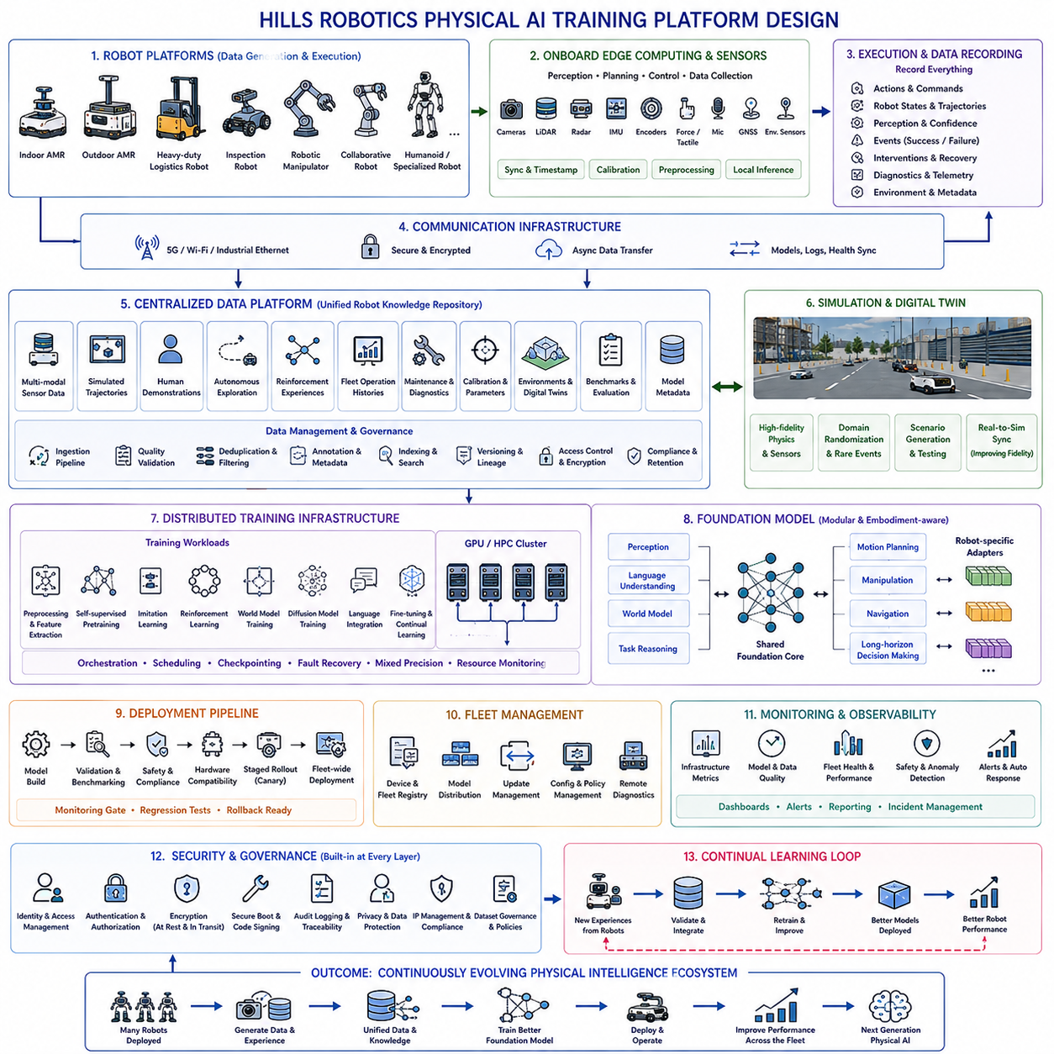
A Physical AI training platform designed for Hills Robotics should provide a unified infrastructure capable of supporting the complete lifecycle of robot foundation model development, from large-scale data acquisition to deployment, continuous learning, fleet optimization, and long-term operational improvement. Rather than treating data collection, simulation, model training, deployment, and robot operation as independent systems, the platform should integrate them into a single closed-loop learning architecture. Every deployed robot becomes both an intelligent execution system and an autonomous data generation node, continuously contributing new experiences that improve future generations of Physical AI models. The platform therefore serves not only as a machine learning infrastructure but also as the central intelligence engine driving the evolution of the entire robotic ecosystem.
The overall architecture should be organized into multiple interconnected layers that cooperate through standardized interfaces and shared data services. These layers include robot hardware, onboard edge computing, sensor acquisition, communication infrastructure, centralized data storage, simulation systems, distributed training infrastructure, foundation model management, deployment services, fleet management, monitoring systems, and continuous improvement pipelines. Although each layer performs specialized functions, they operate as components of a unified architecture in which information flows continuously from physical execution to centralized learning and back to deployed robots.
At the physical layer, multiple robot platforms should participate simultaneously in data generation and model validation. The platform should support indoor autonomous mobile robots, outdoor autonomous mobile robots, heavy-duty logistics robots, autonomous inspection robots, robotic manipulators, collaborative robots, and future humanoid or specialized robotic systems. Despite significant differences in mechanical structures and operational objectives, every platform should expose standardized software interfaces for perception, localization, planning, control, diagnostics, and telemetry. This common abstraction enables diverse robot embodiments to contribute compatible training data to the shared foundation model.
Each robot should incorporate a high-performance onboard computing architecture capable of executing perception, planning, reasoning, and motion control locally while simultaneously collecting synchronized multimodal datasets. Multiple RGB cameras, depth cameras, LiDAR sensors, radar, inertial measurement units, wheel encoders, force sensors, microphones, GNSS receivers, tactile sensors, and environmental sensors generate heterogeneous observations that are synchronized using precise hardware timestamps. Sensor synchronization is essential because accurate temporal alignment significantly improves downstream representation learning, world model training, and multimodal reasoning.
The onboard software stack should organize sensor processing through modular perception pipelines. Raw sensor streams undergo calibration, synchronization, filtering, object detection, semantic segmentation, tracking, localization, mapping, scene understanding, and state estimation before entering higher-level reasoning modules. Intermediate representations rather than raw sensor outputs should be preserved whenever appropriate because compact semantic representations reduce storage requirements while retaining information useful for future foundation model training. Raw data should still be archived selectively for benchmark creation and algorithm verification.
Robot execution generates considerably more information than successful task completion alone. Every mission should record action sequences, control commands, planner outputs, robot states, localization trajectories, perception confidence, uncertainty estimates, collision avoidance decisions, intervention events, operator commands, failure recovery procedures, safety triggers, diagnostic information, and environmental metadata. Recording both successful and unsuccessful executions enables the learning system to understand failure modes, recovery strategies, and uncertainty handling rather than merely imitating optimal demonstrations.
Communication infrastructure should provide reliable synchronization between distributed robots and centralized cloud services. High-bandwidth wireless networks, industrial Ethernet, secure remote communication, and asynchronous data transfer mechanisms allow robots to upload datasets, receive updated foundation models, synchronize operational logs, and report health information without interrupting normal operation. Communication policies should prioritize safety-critical updates while efficiently scheduling large dataset transfers during periods of reduced operational activity.
The centralized data platform forms the foundation of the complete learning ecosystem. Rather than storing isolated datasets, it should maintain an integrated robot knowledge repository containing synchronized multimodal sensor recordings, simulation trajectories, human demonstrations, autonomous exploration episodes, reinforcement learning experiences, fleet operational histories, maintenance records, diagnostic logs, calibration parameters, environment descriptions, digital twin assets, evaluation benchmarks, and model metadata. Comprehensive indexing, version management, and traceability ensure every dataset remains reusable throughout future research and product development.
Data ingestion pipelines automatically validate incoming information before permanent storage. Quality assessment verifies timestamp consistency, sensor synchronization, calibration integrity, annotation completeness, metadata accuracy, trajectory continuity, communication integrity, and legal compliance. Duplicate samples, corrupted recordings, incomplete observations, and inconsistent annotations are automatically filtered or isolated for manual review. Automated validation improves dataset reliability while minimizing engineering effort required for large-scale fleet operation.
Simulation infrastructure should operate as a parallel learning environment tightly integrated with physical robots. High-fidelity digital twins reproduce robot kinematics, sensor behavior, environmental geometry, physical interactions, lighting conditions, weather effects, terrain characteristics, and dynamic obstacles. Simulation generates large volumes of safely collected experience covering rare events, dangerous situations, hardware failures, environmental disturbances, and task variations that cannot be economically reproduced in physical deployments. Continuous synchronization between real-world observations and simulation parameters gradually improves simulator fidelity over time.
The training infrastructure should support large-scale distributed optimization across GPU clusters while remaining flexible enough to accommodate rapidly evolving foundation model architectures. Distributed preprocessing, feature extraction, multimodal tokenization, self-supervised pretraining, imitation learning, reinforcement learning, world model optimization, diffusion model training, language integration, continual learning, and fine-tuning should operate within a unified orchestration framework. Efficient workload scheduling, automatic checkpointing, fault recovery, mixed-precision computation, and resource monitoring maximize computational efficiency while maintaining reproducibility.
The foundation model itself should adopt a modular architecture capable of integrating perception, language understanding, world modeling, task reasoning, motion planning, manipulation, navigation, and long-horizon decision making. Shared representations learned through large-scale multimodal training provide transferable physical knowledge across different robot embodiments and operational domains. Robot-specific adaptation modules enable individual platforms to exploit this shared intelligence while respecting their unique kinematic structures, sensing capabilities, and control constraints.
World models should occupy a central role within the training platform because they enable robots to predict future environmental states before executing physical actions. Learned latent dynamics support planning, imagination, counterfactual reasoning, uncertainty estimation, policy evaluation, and autonomous exploration without requiring exhaustive real-world experimentation. Combining foundation models with scalable world models significantly improves sample efficiency, safety, planning capability, and generalization across previously unseen environments.
Deployment infrastructure should support controlled model distribution across the complete robot fleet. Every released model undergoes automated validation, simulation benchmarking, regression testing, safety verification, hardware compatibility assessment, and staged rollout before large-scale deployment. Canary deployment strategies initially expose updated models to limited robot populations, allowing operational performance to be evaluated under realistic conditions before organization-wide distribution. Rollback mechanisms remain available whenever unexpected behavior is detected after deployment.
Continuous monitoring ensures operational transparency throughout the entire platform lifecycle. Infrastructure metrics, training statistics, model quality indicators, deployment health, communication status, resource utilization, safety events, anomaly detection, prediction confidence, and fleet performance are collected continuously into centralized observability dashboards. Automated alert systems identify abnormal conditions, initiate recovery procedures, and notify engineering teams before operational failures significantly affect production environments.
Security and governance should be incorporated into every architectural layer rather than treated as independent subsystems. Identity management, authentication, authorization, encrypted communication, secure boot, software signing, access control, audit logging, regulatory compliance, privacy protection, intellectual property management, and dataset governance collectively ensure trustworthy operation throughout the platform lifecycle. Every dataset, experiment, model, deployment, and operational event should remain fully traceable for certification, debugging, and long-term maintenance.
The platform should support continual learning by allowing newly collected operational experiences to improve future generations of foundation models without interrupting deployed services. Carefully validated robot experiences are integrated into centralized datasets, balanced against historical knowledge, evaluated for quality, and incorporated into subsequent training cycles. Continual learning mechanisms preserve existing capabilities while expanding behavioral diversity, enabling robots to adapt gradually to changing environments, new customer requirements, evolving hardware configurations, and emerging operational challenges.
The Hills Robotics Physical AI training platform should ultimately function as a continuously evolving intelligence ecosystem rather than a conventional machine learning pipeline. Every deployed robot contributes experience, every experience enriches the centralized knowledge base, every training cycle improves the shared foundation model, and every improved model enhances future robot performance across the entire fleet. This closed-loop architecture establishes a scalable infrastructure capable of supporting next-generation autonomous mobile robots, intelligent manipulation systems, inspection robots, logistics platforms, collaborative industrial robots, and future general-purpose Physical AI systems while providing the technological foundation for lifelong learning, large-scale deployment, and continuously improving robotic intelligence.

