Volume 18 Physical AI Foundation Models

10. Fine Tuning and Adaptation

10.1 Fine Tuning Strategy Full Head Only LoRA Prompt
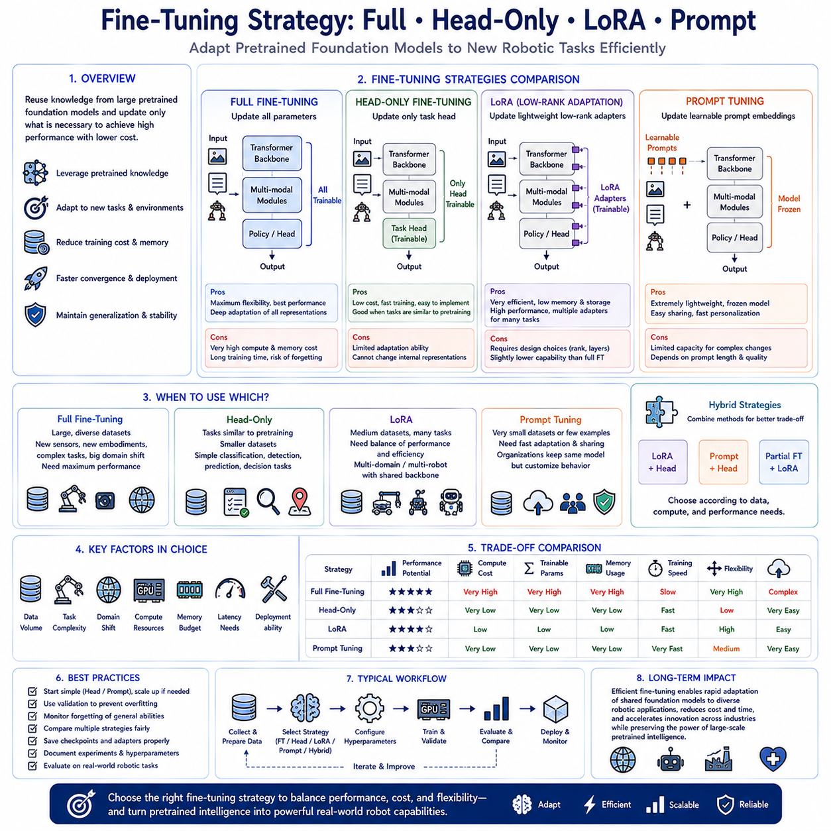
Modern Physical AI systems increasingly rely on efficient fine-tuning strategies to adapt large pretrained foundation models to new robotic tasks, environments, hardware platforms, and industrial applications. Training an entire foundation model from scratch requires enormous computational resources, massive multimodal datasets, and extensive engineering effort that are beyond the capabilities of most research laboratories and commercial organizations. Fine-tuning addresses this challenge by reusing the knowledge already learned during large-scale pretraining while updating only selected portions of the model to acquire new capabilities. Depending on available computational resources, dataset size, deployment requirements, and expected performance, organizations may choose among full model fine-tuning, head-only adaptation, Low-Rank Adaptation (LoRA), prompt tuning, or combinations of multiple parameter-efficient adaptation techniques. Selecting the appropriate fine-tuning strategy directly influences training cost, memory consumption, convergence speed, deployment flexibility, and long-term maintainability.
Full model fine-tuning updates every trainable parameter within the pretrained foundation model during optimization. This approach allows complete adaptation of the internal feature representations, attention mechanisms, multimodal fusion layers, reasoning modules, and policy generation components to the target application. Because every layer participates in optimization, the model possesses maximum flexibility to learn new visual concepts, manipulation strategies, language understanding, sequential reasoning, and environment-specific behaviors. Full fine-tuning generally achieves the highest possible task performance when sufficient training data and computational resources are available, particularly when the target domain differs substantially from the original pretraining distribution.
The primary advantage of full fine-tuning lies in its unrestricted learning capacity. Models can modify low-level visual representations, intermediate semantic features, high-level reasoning structures, and action generation policies simultaneously, allowing deep adaptation throughout the network hierarchy. Industrial robotics applications involving novel sensors, unique robot embodiments, specialized manipulation tasks, or unfamiliar environmental conditions frequently benefit from complete parameter optimization because domain-specific information may influence nearly every stage of the perception-to-action pipeline. Large multimodal foundation models trained through comprehensive fine-tuning often exhibit superior accuracy, robustness, and long-term generalization compared with more constrained adaptation strategies.
Despite its advantages, full fine-tuning imposes substantial computational demands. Updating billions of model parameters requires multiple high-memory GPUs, distributed optimization infrastructure, large storage capacity for optimizer states and checkpoints, extensive training time, and carefully tuned optimization schedules. Catastrophic forgetting may also occur when aggressive optimization causes the model to lose valuable capabilities acquired during pretraining while specializing toward a narrower downstream task. Consequently, organizations must balance adaptation performance against computational cost, memory availability, engineering complexity, and preservation of previously learned general knowledge.
Head-only fine-tuning represents one of the simplest adaptation strategies by freezing the pretrained backbone while optimizing only the task-specific prediction head. The backbone continues extracting generic multimodal representations learned during pretraining, whereas newly initialized output layers learn mappings from these representations to target actions, classifications, regression outputs, or policy predictions. Because only a relatively small number of parameters require optimization, head-only fine-tuning significantly reduces memory consumption, computational cost, convergence time, and overfitting risk. This strategy is particularly effective when downstream tasks closely resemble capabilities already represented within the pretrained foundation model.
Head-only adaptation performs especially well for applications requiring modest domain specialization without fundamental changes to learned representations. Object classification, defect detection, manipulation success prediction, anomaly recognition, quality inspection, navigation waypoint selection, or simple robotic decision-making tasks often benefit from efficient head optimization because pretrained feature extractors already encode highly informative visual and semantic representations. Small industrial datasets also favor head-only fine-tuning because limited trainable parameters reduce the likelihood of memorizing training examples while preserving strong generalization inherited from large-scale pretraining.
However, head-only fine-tuning cannot modify internal feature representations when pretrained knowledge becomes insufficient for new applications. If robots encounter entirely new sensing modalities, significantly different manipulation dynamics, unfamiliar object categories, complex physical interactions, or radically different operational environments, frozen backbone representations may prevent effective adaptation regardless of output head optimization. Consequently, organizations should carefully evaluate whether downstream tasks primarily require new decision boundaries or fundamentally different internal representations before selecting head-only adaptation.
Low-Rank Adaptation, commonly known as LoRA, has emerged as one of the most influential parameter-efficient fine-tuning techniques for large foundation models. Rather than updating every pretrained parameter directly, LoRA inserts small trainable low-rank matrices into selected neural network layers while leaving original model weights unchanged. During optimization, only these lightweight adapter matrices receive gradient updates, dramatically reducing trainable parameter count while preserving nearly all pretrained knowledge. After training, LoRA adapters may remain separate from the original model or merge into base weights for simplified deployment depending upon operational requirements.
The fundamental principle underlying LoRA exploits the observation that many downstream adaptations require only low-dimensional modifications to existing parameter spaces. Instead of learning entirely new weight matrices containing millions of parameters, LoRA approximates necessary updates through compact low-rank decompositions capturing dominant adaptation directions. This mathematical formulation significantly decreases GPU memory usage, optimizer storage, communication overhead during distributed training, and checkpoint size without substantially degrading downstream performance. Consequently, organizations can efficiently fine-tune very large robot foundation models using comparatively modest computational infrastructure.
LoRA offers substantial operational flexibility because multiple task-specific adapters may coexist with a single pretrained backbone. Separate adapters can specialize the same foundation model for warehouse logistics, industrial inspection, agricultural robotics, healthcare assistance, laboratory automation, household manipulation, autonomous navigation, or collaborative manufacturing without duplicating complete model weights. Runtime systems dynamically load appropriate adapters according to deployment context, allowing efficient multitask operation while minimizing storage requirements and simplifying model management across diverse robotic applications.
Several LoRA design choices influence adaptation quality. Engineers select insertion layers, adapter rank, scaling coefficients, initialization strategies, target attention modules, feed-forward layers, optimization schedules, and regularization techniques according to available computational resources and task complexity. Higher adapter ranks generally improve adaptation flexibility while increasing computational cost, whereas lower ranks prioritize efficiency but may restrict representational capacity. Careful hyperparameter selection therefore balances adaptation quality against training efficiency for individual deployment scenarios.
Prompt tuning provides an alternative parameter-efficient adaptation strategy by optimizing learnable prompt embeddings rather than modifying model weights directly. Additional trainable vectors are inserted into input sequences, conditioning pretrained transformers toward specific tasks without altering internal parameters. During optimization, only these prompt embeddings receive updates while the entire pretrained model remains frozen. Prompt tuning dramatically reduces trainable parameter count and preserves complete compatibility with original foundation model weights, enabling extremely lightweight adaptation suitable for organizations possessing limited computational resources.
Soft prompt tuning extends this concept by learning continuous embedding vectors rather than manually designed textual prompts. Unlike handcrafted language instructions, optimized prompt embeddings capture latent task-specific information through gradient-based optimization, enabling more expressive conditioning of transformer representations. Vision-language-action foundation models similarly employ learnable multimodal prompts influencing visual perception, language grounding, action generation, or cross-modal attention without modifying underlying transformer architectures. These approaches provide efficient adaptation while maintaining excellent scalability across numerous robotic applications.
Prompt-based adaptation proves particularly valuable when multiple organizations share identical pretrained foundation models but require customized behavior for proprietary tasks. Each organization stores only compact prompt parameters describing its specialized operational requirements while relying upon common pretrained weights distributed across all deployments. This architecture simplifies model maintenance, accelerates software updates, reduces storage requirements, and enables efficient personalization without exposing proprietary training data or modifying shared foundation model parameters.
Hybrid fine-tuning strategies increasingly combine multiple adaptation techniques within unified training pipelines. Organizations may optimize task heads together with LoRA adapters, combine prompt tuning with lightweight classifier updates, or selectively fine-tune only higher transformer layers while freezing lower perception modules. Such hybrid approaches exploit complementary strengths of individual methods, achieving better adaptation than any single strategy while maintaining acceptable computational efficiency. Selecting appropriate hybrid configurations depends upon dataset scale, task complexity, hardware resources, deployment constraints, and desired inference performance.
Fine-tuning strategy selection depends strongly upon available data volume. Large, diverse multimodal datasets generally support full model optimization because sufficient examples prevent severe overfitting while enabling comprehensive representation learning. Medium-scale datasets frequently favor LoRA or partial fine-tuning because parameter-efficient adaptation preserves pretrained knowledge while incorporating task-specific specialization. Small datasets often perform best with head-only optimization or prompt tuning because limited trainable parameters reduce memorization risk while exploiting broad representations acquired during foundation model pretraining.
Hardware resources likewise influence strategy selection. Organizations operating multi-node GPU clusters equipped with large accelerator memory can perform distributed full fine-tuning of billion-parameter models efficiently. Smaller research laboratories possessing limited GPU memory frequently prefer LoRA, prompt tuning, or head-only optimization because these techniques substantially reduce computational requirements while preserving competitive downstream performance. Efficient adaptation methods therefore democratize foundation model development by enabling high-quality customization without requiring hyperscale computing infrastructure.
Evaluation should compare multiple fine-tuning strategies using identical datasets, training procedures, evaluation metrics, computational budgets, and deployment requirements. Model accuracy, generalization capability, inference latency, memory consumption, training duration, energy efficiency, catastrophic forgetting, checkpoint size, deployment complexity, and maintainability collectively determine practical suitability for industrial Physical AI applications. Organizations should avoid selecting strategies solely according to benchmark accuracy because operational constraints often dominate real-world deployment decisions.
The long-term significance of fine-tuning strategies extends beyond computational efficiency because they define how rapidly pretrained robot foundation models can acquire new capabilities while preserving previously learned knowledge. Full fine-tuning, head-only adaptation, LoRA, prompt tuning, and hybrid parameter-efficient approaches each occupy important positions within the modern Physical AI development ecosystem. As robot foundation models continue expanding in scale, multimodal capability, and deployment diversity, efficient fine-tuning methodologies will remain fundamental technologies enabling organizations to adapt shared pretrained intelligence into specialized robotic systems that satisfy increasingly diverse industrial, commercial, and scientific applications without repeatedly training massive models from the beginning.

10.2 LoRA Low Rank Adaptation for Robot Models [w/Code]
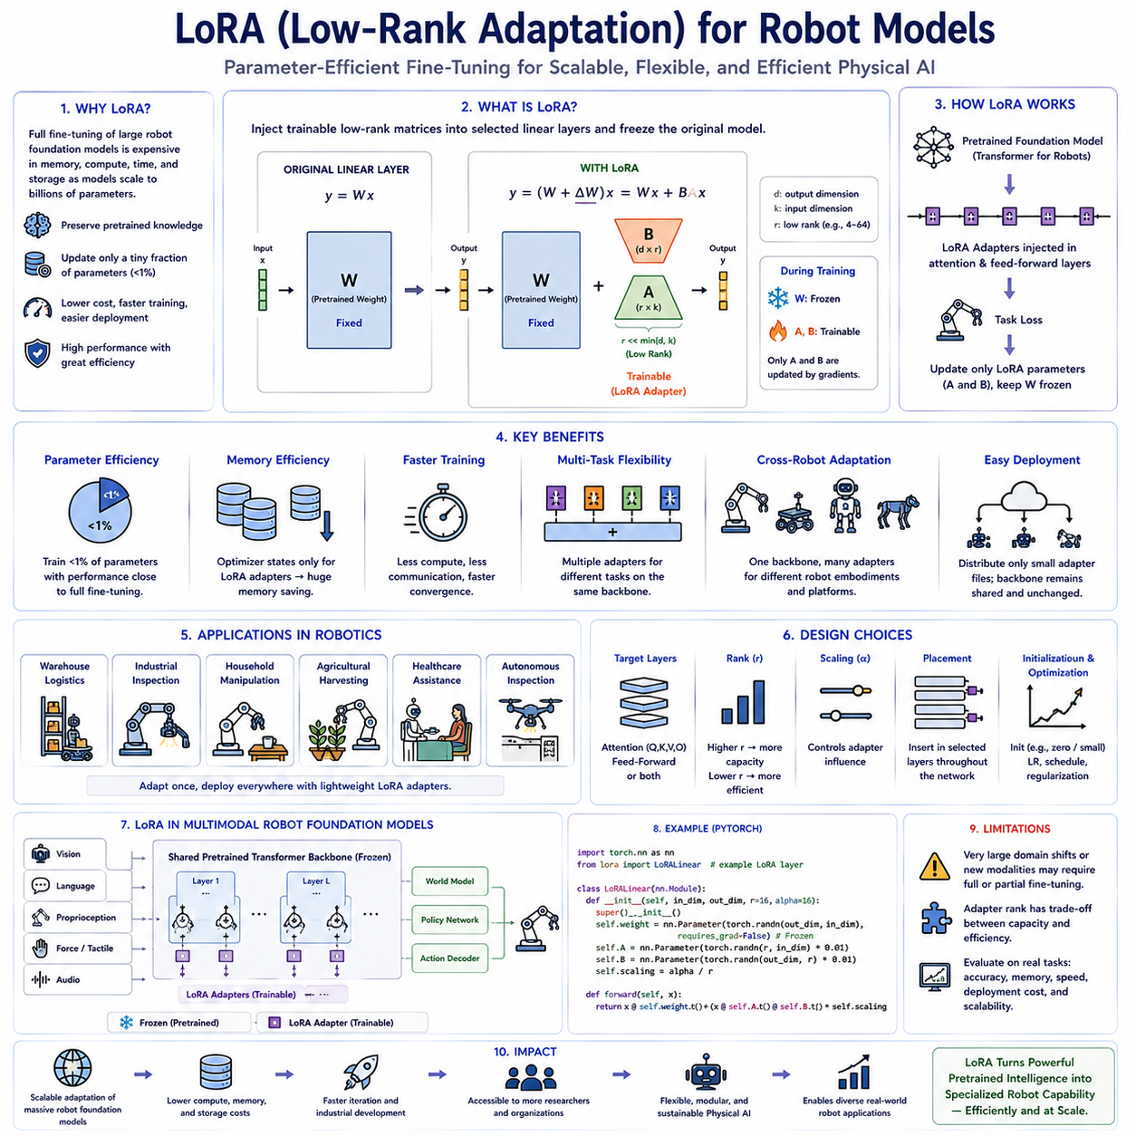
Large robot foundation models have transformed modern Physical AI by providing powerful pretrained representations that can be adapted efficiently to new robotic platforms, industrial tasks, and operational environments. However, directly fine-tuning every parameter of these increasingly large models often requires enormous GPU memory, extensive computational infrastructure, long optimization time, and substantial storage for optimizer states and checkpoints. As foundation models continue expanding from hundreds of millions to tens of billions of parameters, full fine-tuning becomes impractical for many organizations. Low-Rank Adaptation, commonly known as LoRA, addresses this challenge by enabling parameter-efficient fine-tuning that updates only a very small fraction of model parameters while preserving nearly all pretrained knowledge. This approach significantly reduces computational requirements without sacrificing most of the performance obtained through conventional full-model optimization.
The central idea behind LoRA is that many downstream adaptation tasks require only relatively small modifications to the original pretrained parameter space. Instead of replacing or updating every weight matrix within a transformer network, LoRA inserts lightweight trainable matrices into selected linear transformation layers while freezing the original model parameters. During optimization, only these newly introduced matrices receive gradient updates, whereas the pretrained backbone remains completely unchanged. Because the trainable matrices possess intentionally low rank, they introduce only a small number of additional parameters while still capturing the dominant directions required for task-specific adaptation. This mathematical formulation allows efficient learning while maintaining compatibility with the original foundation model.
Transformer architectures contain numerous large matrix multiplications within attention mechanisms and feed-forward layers. These matrices often contain millions of parameters that are expensive to optimize during conventional fine-tuning. LoRA decomposes the desired parameter update into two much smaller matrices whose product approximates the full adaptation. Instead of directly learning a large weight correction, the model learns compact low-rank representations capable of expressing the most significant task-dependent changes. Since only the adapter matrices require optimization, GPU memory usage decreases substantially while training speed improves due to reduced computational overhead associated with gradient storage and optimizer updates.
One of the greatest advantages of LoRA is its exceptional parameter efficiency. In many practical applications, less than one percent of the original model parameters require training while achieving performance close to that of full fine-tuning. Organizations can therefore adapt billion-parameter robot foundation models using hardware configurations that would otherwise be insufficient for complete model optimization. Smaller GPU clusters, single high-memory accelerators, or even workstation-class systems become capable of supporting sophisticated robot model adaptation, making advanced Physical AI development accessible to a much broader range of research groups and industrial organizations.
Memory efficiency represents another major benefit of LoRA. Since the pretrained foundation model remains frozen, optimizer states exist only for the lightweight adapter parameters rather than the complete neural network. Gradient memory, optimizer memory, checkpoint storage, and communication bandwidth required for distributed training decrease dramatically. These reductions enable larger batch sizes, longer sequence lengths, higher image resolutions, additional multimodal inputs, or multiple concurrent experiments within the same hardware budget. Efficient memory utilization becomes increasingly valuable as multimodal robot foundation models incorporate high-resolution vision, language reasoning, force sensing, audio perception, and temporal sequence modeling simultaneously.
Training speed also improves significantly under LoRA-based optimization. Fewer trainable parameters reduce computational workload during both forward and backward propagation while minimizing optimizer update operations. Distributed synchronization across multiple GPUs transfers only adapter gradients instead of complete model gradients, reducing communication latency during large-scale training. Faster convergence allows researchers to iterate more rapidly through hyperparameter exploration, architecture refinement, dataset validation, and deployment testing. Industrial development cycles therefore shorten substantially because model customization requires fewer computational resources and less engineering time.
LoRA provides remarkable flexibility for multitask robotics because multiple adapter sets can coexist alongside a single pretrained backbone. One adapter may specialize a robot foundation model for warehouse logistics, another for industrial inspection, another for household manipulation, another for agricultural harvesting, and another for healthcare assistance. The underlying pretrained model remains identical across all applications while only lightweight adapter parameters change according to deployment requirements. Runtime systems dynamically load the appropriate adapter based on the current robotic mission, enabling efficient task switching without maintaining multiple copies of extremely large foundation models.
Cross-robot adaptation represents another valuable application of LoRA within Physical AI. A common robot foundation model may support manipulators, mobile robots, humanoids, quadrupeds, service robots, warehouse platforms, or autonomous inspection systems by assigning embodiment-specific adapters to each robot category. Visual perception, language understanding, reasoning capability, and multimodal representations remain largely shared while adapters learn hardware-specific action generation, control dynamics, kinematic constraints, sensor calibration differences, and embodiment-dependent behaviors. Such modular adaptation substantially simplifies large-scale deployment across heterogeneous robotic fleets.
LoRA performs particularly well when adapting pretrained robot foundation models using relatively limited task-specific datasets. Because only a small number of parameters receive updates, the risk of severe overfitting decreases compared with full fine-tuning. The pretrained backbone preserves broad representations learned from massive multimodal datasets while adapters encode specialized knowledge associated with new industrial environments, manipulation tasks, operational procedures, or customer-specific workflows. This balance between preserving general intelligence and learning domain-specific expertise makes LoRA highly attractive for industrial robotics where collecting millions of labeled demonstrations is often impractical.
Several design decisions influence LoRA performance. Engineers must determine which transformer layers should receive adapters, appropriate low-rank dimensions, scaling coefficients, initialization methods, target modules within attention or feed-forward networks, learning rates, optimization schedules, regularization strategies, and adapter placement frequency throughout the network hierarchy. Higher adapter ranks generally improve representational capacity but increase computational cost, whereas lower ranks emphasize efficiency while potentially limiting adaptation flexibility. Hyperparameter selection therefore depends upon task complexity, available hardware resources, dataset diversity, and desired deployment performance.
Attention modules frequently receive LoRA adapters because attention mechanisms play central roles in multimodal reasoning, long-horizon planning, language grounding, and contextual representation learning. Applying LoRA within query, key, value, or output projection matrices allows adaptation of information flow throughout transformer computations without modifying the original pretrained attention parameters. Feed-forward networks may also receive adapters when downstream tasks require stronger semantic specialization. Selecting appropriate insertion points significantly influences adaptation quality while balancing computational efficiency against representational flexibility.
Modern robot foundation models increasingly integrate multiple sensing modalities including RGB images, depth observations, force measurements, joint positions, proprioception, language commands, audio signals, tactile sensing, and environmental state estimation. LoRA naturally supports multimodal adaptation because separate adapter modules may specialize different sensory pathways without disturbing shared multimodal representations. Vision encoders, language transformers, multimodal fusion blocks, world model components, policy networks, and action decoders can each receive independently optimized adapters depending upon application requirements. This modular structure enables precise adaptation of specific subsystems while preserving stable interaction among remaining pretrained components.
Industrial deployment benefits substantially from LoRA because lightweight adapters simplify model distribution and lifecycle management. Instead of transferring complete multi-gigabyte foundation models whenever task updates occur, organizations distribute only compact adapter files while retaining identical pretrained backbones across all deployment sites. New customer requirements, process improvements, additional robot skills, or localized operational adjustments become deployable through small adapter updates requiring minimal storage, network bandwidth, and installation time. Version control likewise becomes easier because adapter revisions remain separate from the stable pretrained model.
Research reproducibility also improves under LoRA-based development. Experimental comparisons may share identical pretrained foundation models while differing only in adapter parameters, training datasets, optimization settings, or deployment objectives. Smaller checkpoint files accelerate experiment sharing, collaborative benchmarking, peer review, and public model release. Academic researchers benefit from reduced storage requirements while industrial organizations gain more efficient internal model management across multiple product lines and development teams.
LoRA integrates naturally with complementary parameter-efficient adaptation techniques. Prompt tuning, prefix tuning, lightweight classification heads, partial layer fine-tuning, adapter fusion, continual learning methods, reinforcement learning optimization, and retrieval-augmented reasoning may all combine with LoRA to create highly flexible adaptation pipelines. Such hybrid architectures allow organizations to balance computational efficiency, model flexibility, adaptation quality, and deployment complexity according to application-specific engineering requirements rather than relying upon a single universal optimization strategy.
Although LoRA provides outstanding efficiency, it does possess practical limitations. Extremely large domain shifts, radically different robot embodiments, entirely new sensing modalities, or tasks requiring fundamental representational changes may exceed the expressive capacity of low-rank adapters. In such situations, partial or full model fine-tuning may become necessary to achieve maximum performance. Engineers should therefore evaluate adaptation quality, computational cost, deployment efficiency, and long-term maintainability together when selecting between LoRA and alternative fine-tuning strategies.
Evaluation of LoRA should extend beyond benchmark accuracy alone. Organizations should compare memory consumption, GPU utilization, training duration, convergence stability, inference latency, checkpoint size, deployment simplicity, catastrophic forgetting resistance, multitask scalability, adapter management complexity, cross-domain generalization, and long-term maintenance cost. These practical engineering metrics frequently determine whether LoRA delivers meaningful advantages within real industrial Physical AI systems rather than only within controlled research benchmarks.
The long-term significance of Low-Rank Adaptation extends far beyond reducing computational cost because it fundamentally changes how robot foundation models are customized, distributed, maintained, and deployed. By separating shared pretrained intelligence from lightweight task-specific adaptation modules, LoRA enables scalable development of specialized robotic capabilities while preserving common multimodal knowledge acquired through large-scale pretraining. As robot foundation models continue increasing in size, capability, and industrial adoption, parameter-efficient adaptation methods such as LoRA will remain foundational technologies supporting flexible, economical, and sustainable Physical AI deployment across increasingly diverse robotic platforms and real-world applications.

10.3 QLoRA Quantized LoRA for Memory Efficient FT [w/Code]
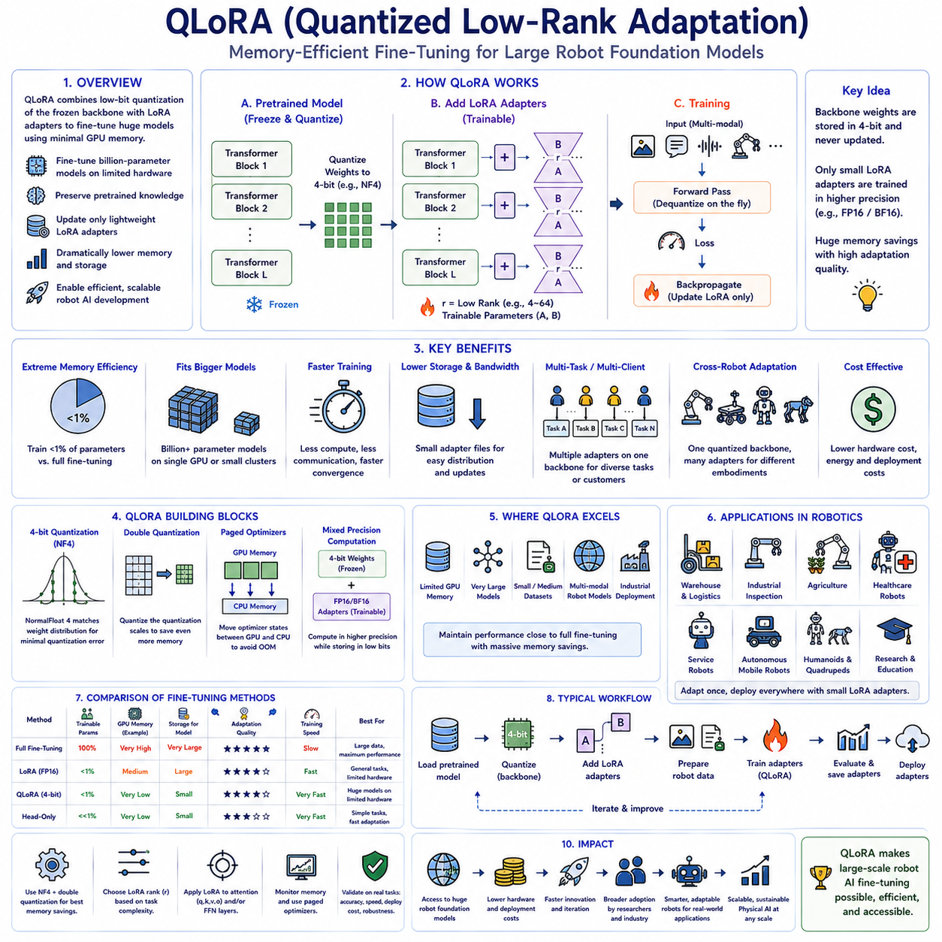
Quantized Low-Rank Adaptation, commonly known as QLoRA, extends the advantages of Low-Rank Adaptation by combining parameter-efficient fine-tuning with low-bit quantization techniques, enabling extremely large foundation models to be trained using dramatically reduced GPU memory. While standard LoRA already minimizes the number of trainable parameters by freezing the original model and optimizing only lightweight low-rank adapters, the frozen backbone still occupies substantial memory because it is typically stored using 16-bit floating-point precision. QLoRA addresses this remaining limitation by storing pretrained model weights in low-bit quantized formats, most commonly 4-bit representations, while keeping LoRA adapters trainable in higher precision. This combination enables organizations to fine-tune billion-parameter robot foundation models using hardware that would otherwise be insufficient for conventional LoRA or full fine-tuning, greatly expanding access to advanced Physical AI development.
The fundamental concept of QLoRA is based on separating inference precision from training precision. The original pretrained model remains frozen and is compressed into low-bit numerical representations that require significantly less memory than traditional floating-point formats. During optimization, quantized weights are efficiently reconstructed into higher numerical precision for computation while gradients are applied only to the trainable LoRA adapters. The quantized backbone itself never receives parameter updates, allowing the optimization process to preserve pretrained knowledge while avoiding the enormous memory cost associated with storing gradients and optimizer states for billions of frozen parameters. This architecture maintains excellent adaptation capability while dramatically reducing hardware requirements.
Quantization reduces the number of bits required to represent each numerical weight within a neural network. Traditional deep learning models commonly store parameters using FP32 or FP16 floating-point representations requiring thirty-two or sixteen bits per value. QLoRA instead stores frozen pretrained parameters using four-bit integer-like numerical representations while preserving computational accuracy through carefully designed quantization algorithms. Reducing parameter precision by approximately four times compared with FP16 substantially decreases GPU memory consumption, enabling much larger models to fit within limited accelerator memory without significantly degrading downstream adaptation performance.
One of the most important innovations supporting QLoRA is NormalFloat 4, commonly abbreviated as NF4. Unlike simple uniform quantization methods that assign equal numerical spacing between quantization levels, NF4 is specifically designed to approximate the statistical distribution typically observed within pretrained neural network weights. Because model parameters often follow approximately normal distributions centered around zero, NF4 allocates quantization levels more efficiently where numerical precision matters most. This statistically informed representation minimizes quantization error while preserving nearly the same adaptation quality achieved by higher precision parameter storage. As a result, NF4 has become one of the preferred numerical formats for memory-efficient foundation model fine-tuning.
Double quantization further improves memory efficiency by compressing not only the pretrained model parameters but also the scaling constants required during quantization. Conventional quantization methods store additional floating-point values describing numerical ranges for reconstructing quantized parameters. QLoRA applies secondary quantization to these scaling factors, reducing memory consumption even further without introducing significant computational overhead. Although each individual optimization appears relatively small, cumulative savings become substantial when applied across billions of parameters distributed throughout large transformer architectures. These optimizations collectively enable efficient fine-tuning of models previously considered impractical on commodity hardware.
Paged optimizers represent another important component within practical QLoRA implementations. During optimization, temporary memory spikes occasionally occur due to gradient computation, optimizer state management, or activation storage. Paged optimization techniques intelligently move less frequently accessed optimizer information between GPU memory and host memory, preventing sudden out-of-memory failures while maintaining acceptable computational performance. This dynamic memory management allows organizations to train larger robot foundation models on limited hardware resources without requiring expensive high-memory accelerator configurations. Efficient paging becomes particularly valuable when adapting multimodal Physical AI models incorporating vision, language, force sensing, and temporal reasoning simultaneously.
The combination of quantization and LoRA creates remarkable parameter efficiency. Only lightweight adapter matrices receive gradient updates while the quantized pretrained backbone remains fixed throughout optimization. Since optimizer states exist exclusively for adapter parameters, total GPU memory consumption decreases dramatically compared with full fine-tuning. Organizations can therefore adapt models containing billions of parameters using single workstation GPUs, compact edge servers, or modest research clusters that would otherwise lack sufficient memory capacity. This democratization of large-scale model adaptation enables a wider range of universities, startups, and industrial robotics companies to develop advanced Physical AI solutions without hyperscale computing infrastructure.
QLoRA is particularly attractive for robotics because robot foundation models increasingly integrate multiple high-dimensional sensing modalities including RGB cameras, depth sensors, LiDAR observations, force measurements, joint encoders, tactile sensing, proprioceptive feedback, language instructions, environmental maps, and temporal state histories. Storing these increasingly large multimodal transformer architectures entirely in floating-point precision rapidly exceeds available GPU memory during adaptation. Quantizing the frozen backbone while updating only LoRA adapters allows organizations to preserve rich multimodal reasoning capability without sacrificing practical deployability. Consequently, sophisticated robot models become trainable even within relatively constrained industrial computing environments.
Industrial robotics applications frequently require rapid adaptation to customer-specific manufacturing processes, warehouse layouts, inspection procedures, logistics workflows, agricultural environments, healthcare protocols, or service robot behaviors. QLoRA enables organizations to maintain a shared pretrained robot foundation model while distributing only compact task-specific LoRA adapters for individual deployments. Customers receive specialized adaptation modules without transferring enormous foundation model checkpoints, reducing network bandwidth, storage requirements, software update complexity, and deployment time. Such modular deployment strategies significantly simplify lifecycle management across geographically distributed robotic fleets.
Cross-robot adaptation also benefits from QLoRA. A single quantized robot foundation model may support manipulators, autonomous mobile robots, quadrupeds, humanoids, warehouse robots, agricultural platforms, and industrial inspection systems through embodiment-specific LoRA adapters. General multimodal perception, language understanding, reasoning capability, and world knowledge remain shared across all robots while each adapter captures embodiment-specific kinematics, control dynamics, actuator behavior, calibration parameters, and task execution policies. This modular structure minimizes storage requirements while supporting diverse robotic embodiments through efficient specialization.
Training speed under QLoRA remains highly competitive despite operating on quantized parameters. Since frozen weights never require gradient computation or optimizer updates, computational effort concentrates primarily on lightweight adapter matrices. Quantized weight reconstruction introduces only modest overhead relative to the substantial memory savings achieved. Modern GPU architectures efficiently support mixed-precision arithmetic, allowing QLoRA implementations to maintain practical training throughput while dramatically increasing model scale within fixed hardware constraints. Faster experimentation enables engineers to evaluate multiple datasets, hyperparameter configurations, robot embodiments, and deployment strategies more efficiently.
Several implementation decisions influence QLoRA performance. Engineers must select quantization formats, adapter rank, target transformer layers, scaling coefficients, learning rates, optimizer configuration, batch size, gradient accumulation schedules, checkpoint frequency, activation precision, and regularization strategies according to available hardware resources and downstream task complexity. Higher adapter ranks generally improve adaptation flexibility at the cost of additional trainable parameters, whereas lower ranks prioritize efficiency while reducing representational capacity. Appropriate hyperparameter selection balances memory savings, computational efficiency, adaptation quality, and deployment practicality.
QLoRA integrates naturally with existing transformer architectures because quantization primarily affects parameter storage rather than computational graph structure. Vision encoders, language models, multimodal fusion modules, world models, planning networks, action decoders, and policy transformers can all adopt quantized frozen backbones while receiving trainable LoRA adapters where adaptation is required. This modular compatibility simplifies integration into existing Physical AI training pipelines without requiring extensive architectural redesign. Organizations can therefore upgrade memory efficiency while preserving established development workflows and deployment infrastructure.
Model checkpoint management becomes substantially more efficient under QLoRA. Instead of storing complete copies of enormous pretrained models for every experimental variation, organizations preserve one shared quantized foundation model together with numerous lightweight LoRA adapter checkpoints representing different tasks, customers, robot embodiments, or deployment environments. Storage requirements decrease dramatically while version management becomes simpler because only small adaptation modules change between experiments. Collaborative research also benefits because adapter files can be exchanged rapidly without transferring multi-gigabyte foundation model weights repeatedly.
Evaluation of QLoRA should consider practical engineering metrics in addition to prediction accuracy. Memory consumption, GPU utilization, training throughput, convergence stability, inference latency, storage efficiency, checkpoint size, deployment simplicity, catastrophic forgetting resistance, adapter scalability, energy efficiency, and long-term maintenance cost all influence real-world suitability. Organizations should compare QLoRA with standard LoRA, head-only adaptation, partial fine-tuning, and full fine-tuning under identical experimental conditions to identify the most appropriate strategy for specific robotic applications rather than relying solely on benchmark performance.
Although QLoRA delivers outstanding memory efficiency, certain limitations remain. Quantization inevitably introduces small numerical approximation errors that may accumulate during highly specialized adaptation tasks. Extremely sensitive scientific applications, substantial domain shifts, entirely new sensing modalities, or tasks demanding extensive representational modification may occasionally benefit from higher precision optimization or selective full fine-tuning. Engineers should therefore evaluate memory savings together with adaptation quality, computational cost, deployment constraints, and long-term maintainability before selecting QLoRA as the preferred optimization strategy.
The long-term significance of Quantized Low-Rank Adaptation extends beyond reducing GPU memory requirements because it fundamentally expands access to large-scale robot foundation model adaptation. By combining intelligent quantization with parameter-efficient fine-tuning, QLoRA enables sophisticated multimodal Physical AI systems to be customized using affordable computing infrastructure while preserving nearly all pretrained knowledge. As robot foundation models continue increasing in size, multimodal capability, and industrial deployment, QLoRA will remain a foundational technology supporting scalable, economical, and sustainable development of intelligent robotic systems capable of rapid specialization across diverse real-world environments, applications, and autonomous operational domains.

10.4 Prompt Tuning and Prefix Tuning for Robots [w/Code]
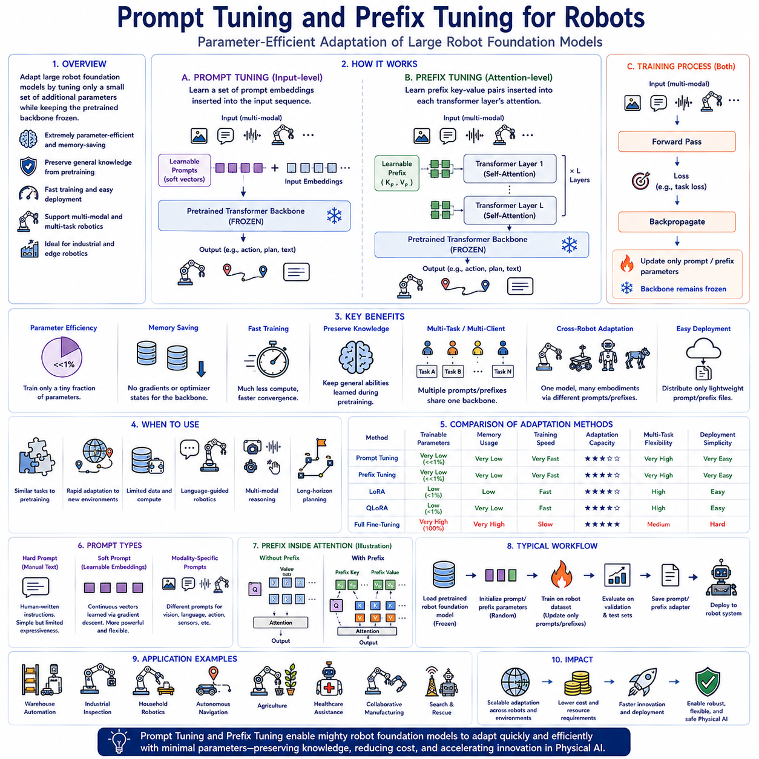
Prompt Tuning and Prefix Tuning have emerged as highly efficient parameter adaptation techniques that enable large robot foundation models to acquire new capabilities without modifying the original pretrained model weights. Unlike conventional fine-tuning methods that update millions or billions of neural network parameters, these approaches optimize only a very small set of additional learnable parameters while keeping the pretrained backbone completely frozen. This dramatically reduces computational cost, memory consumption, storage requirements, and optimization complexity while preserving the general knowledge acquired during large-scale pretraining. As robot foundation models continue increasing in size and complexity, parameter-efficient adaptation methods such as Prompt Tuning and Prefix Tuning have become increasingly important for practical Physical AI deployment across diverse robotic platforms and industrial applications.
The fundamental motivation behind Prompt Tuning is based on the observation that large pretrained transformer models already possess extensive visual, linguistic, reasoning, and decision-making knowledge learned from enormous multimodal datasets. Rather than modifying the internal representations themselves, Prompt Tuning attempts to guide the pretrained model toward new tasks by optimizing only a small number of trainable prompt embeddings inserted into the input sequence. These learned prompts influence how the frozen transformer interprets incoming observations, effectively steering existing knowledge toward specialized robotic applications without altering the original model parameters.
Traditional prompts consist of manually designed natural language instructions intended to influence model behavior during inference. While handcrafted prompts remain useful for general language models, they often lack sufficient expressive power for complex robotic tasks involving multimodal perception, long-horizon planning, manipulation, navigation, and physical interaction. Prompt Tuning replaces manually written instructions with continuous trainable embedding vectors optimized directly through gradient descent. These learned prompts occupy the same embedding space as ordinary input tokens while encoding task-specific knowledge that cannot easily be expressed through natural language alone.
Soft Prompt Tuning extends this concept further by treating prompt vectors as fully learnable continuous parameters independent of human-readable text. Instead of constructing prompts from discrete vocabulary tokens, optimization directly adjusts embedding values according to downstream task objectives. This allows learned prompts to encode highly abstract representations capturing subtle multimodal relationships, robot control strategies, environmental context, sensor calibration characteristics, and task-specific behavioral preferences. Because these optimized embeddings need not correspond to actual language, they provide considerably greater representational flexibility than manually engineered prompts while requiring only a tiny fraction of trainable parameters.
Prompt Tuning provides exceptional parameter efficiency because only the prompt embeddings require optimization. The pretrained transformer backbone remains completely frozen throughout training, eliminating gradient computation and optimizer state storage for billions of original parameters. Memory consumption therefore decreases dramatically compared with full fine-tuning while preserving compatibility with existing pretrained model checkpoints. Organizations can efficiently customize very large robot foundation models even when computational resources remain limited, making Prompt Tuning particularly attractive for industrial deployment, academic research, and edge robotics applications.
Prompt-based adaptation performs particularly well when downstream robotic tasks closely resemble capabilities already represented within the pretrained foundation model. Robots performing warehouse logistics, industrial inspection, household manipulation, service assistance, autonomous navigation, agricultural harvesting, or collaborative manufacturing often require only modest specialization rather than complete representational restructuring. Learned prompts effectively activate appropriate internal knowledge already contained within the pretrained model while requiring minimal computational effort for adaptation. This preserves robust generalization inherited from large-scale pretraining while enabling efficient customization for individual deployment environments.
Prompt Tuning naturally supports multimodal robot foundation models integrating vision, language, proprioception, force sensing, tactile information, depth perception, environmental maps, and temporal observations. Separate prompt embeddings may specialize different sensory modalities while maintaining shared multimodal reasoning across the frozen transformer backbone. Vision prompts can emphasize object recognition, language prompts may improve instruction following, action prompts can influence policy generation, and multimodal prompts may strengthen cross-modal alignment between sensory observations and robot actions. Such modular specialization enables flexible adaptation without disturbing stable interactions among existing pretrained representations.
Prefix Tuning represents a closely related but conceptually distinct parameter-efficient adaptation strategy. Rather than inserting trainable prompt embeddings only at the model input, Prefix Tuning introduces learned continuous vectors directly into the internal attention mechanisms throughout multiple transformer layers. These learned prefixes function as additional key-value memory representations that influence attention computation without modifying original model parameters. Since attention mechanisms govern information flow across transformer architectures, Prefix Tuning provides deeper control over internal reasoning while maintaining computational efficiency comparable to Prompt Tuning.
Within transformer attention modules, queries attend to keys and retrieve corresponding values to generate contextual representations. Prefix Tuning augments these attention computations by adding trainable prefix key-value pairs before ordinary input tokens participate in attention. During optimization, only these prefix representations receive gradient updates while the pretrained attention matrices remain frozen. The prefixes effectively provide additional contextual memory that guides transformer reasoning toward downstream robotic objectives without altering the pretrained network itself. This mechanism allows adaptation to influence every transformer layer rather than only the initial input representation.
Because Prefix Tuning operates throughout multiple transformer layers, it frequently exhibits greater adaptation capacity than shallow Prompt Tuning while still requiring only a small number of trainable parameters. Long-horizon robotic planning, sequential manipulation, multimodal reasoning, language-grounded navigation, and complex decision-making tasks often benefit from deeper contextual influence provided by internal attention prefixes. By modifying information flow across the network hierarchy, Prefix Tuning enables richer task-specific adaptation while preserving nearly all pretrained model knowledge.
Prompt Tuning and Prefix Tuning both support efficient multitask robotics. Multiple independent prompt or prefix parameter sets may coexist alongside a single pretrained robot foundation model. Individual adapters specialize the same backbone for warehouse automation, autonomous inspection, agricultural robotics, healthcare assistance, collaborative manufacturing, household service, laboratory automation, or search-and-rescue operations. Runtime systems dynamically activate appropriate prompt or prefix parameters according to deployment context while sharing identical pretrained model weights across all applications. This architecture minimizes storage requirements while greatly simplifying deployment across diverse robotic fleets.
Cross-robot adaptation similarly benefits from prompt-based parameter-efficient learning. A common multimodal robot foundation model may support humanoids, manipulators, quadrupeds, autonomous mobile robots, industrial inspection platforms, and collaborative robots through embodiment-specific prompt or prefix modules. Shared visual understanding, language grounding, world knowledge, and reasoning remain common across all robot categories while lightweight prompt parameters encode embodiment-dependent motion characteristics, actuator behavior, kinematic constraints, calibration information, and task execution strategies. This modular design enables efficient specialization without duplicating enormous pretrained models.
Industrial deployment becomes considerably more manageable because prompt or prefix checkpoints remain extremely compact compared with complete foundation model weights. Organizations distribute only lightweight prompt parameter files whenever customer requirements evolve, manufacturing procedures change, inspection workflows expand, or robotic capabilities improve. Existing pretrained foundation models remain unchanged across deployment sites, reducing software maintenance complexity, storage overhead, network bandwidth consumption, validation effort, and update time. Efficient version management further supports continuous deployment across geographically distributed industrial robot fleets.
Prompt-based adaptation also provides significant advantages for continual learning. New robotic skills can often be introduced by training additional prompt modules while preserving previously optimized prompts for earlier tasks. Instead of repeatedly modifying a shared model through sequential fine-tuning, organizations accumulate libraries of specialized prompt configurations representing diverse operational capabilities. Robots dynamically select or combine appropriate prompts according to current objectives, enabling scalable lifelong learning while minimizing catastrophic forgetting commonly associated with repeated parameter updates.
Several implementation choices influence adaptation quality. Engineers determine prompt length, embedding dimensionality, initialization strategy, insertion location, optimization schedule, learning rate, batch size, regularization methods, and whether prompts remain task-specific or become partially shared across multiple applications. Prefix Tuning similarly requires decisions regarding transformer layers receiving prefixes, prefix dimensionality, attention integration strategy, and computational tradeoffs between adaptation flexibility and efficiency. Appropriate hyperparameter selection depends upon task complexity, available training data, computational resources, and desired deployment performance.
Evaluation should compare Prompt Tuning, Prefix Tuning, LoRA, QLoRA, head-only adaptation, partial fine-tuning, and full fine-tuning under identical experimental conditions. Prediction accuracy, memory consumption, training speed, inference latency, storage efficiency, catastrophic forgetting resistance, multitask scalability, deployment simplicity, maintenance cost, and cross-domain generalization collectively determine practical suitability. Benchmark accuracy alone rarely captures operational considerations that dominate real industrial Physical AI systems deployed continuously across diverse environments.
Although Prompt Tuning and Prefix Tuning provide remarkable efficiency, certain limitations remain. Extremely large domain shifts, fundamentally new sensing modalities, radically different robot embodiments, or tasks requiring deep representational restructuring may exceed the adaptation capacity provided by lightweight prompt parameters alone. In such situations, LoRA, partial fine-tuning, or full model optimization may produce superior performance despite increased computational cost. Engineers should therefore evaluate adaptation quality, computational efficiency, deployment constraints, maintainability, and expected operational lifetime together when selecting parameter-efficient adaptation strategies.
The long-term significance of Prompt Tuning and Prefix Tuning extends beyond reducing training cost because these methods fundamentally redefine how large robot foundation models are customized for diverse real-world applications. By preserving shared pretrained intelligence while introducing lightweight task-specific adaptation modules, they enable scalable, flexible, and economical deployment of sophisticated Physical AI systems across heterogeneous robots, industrial environments, and autonomous operational domains. As multimodal robot foundation models continue expanding in capability and scale, Prompt Tuning and Prefix Tuning will remain foundational technologies supporting rapid specialization, efficient knowledge reuse, continual learning, and sustainable development of intelligent robotic systems without repeatedly retraining massive neural networks from the beginning.

10.5 Domain Adaptation from Sim to Real Fine Tuning [w/Code]
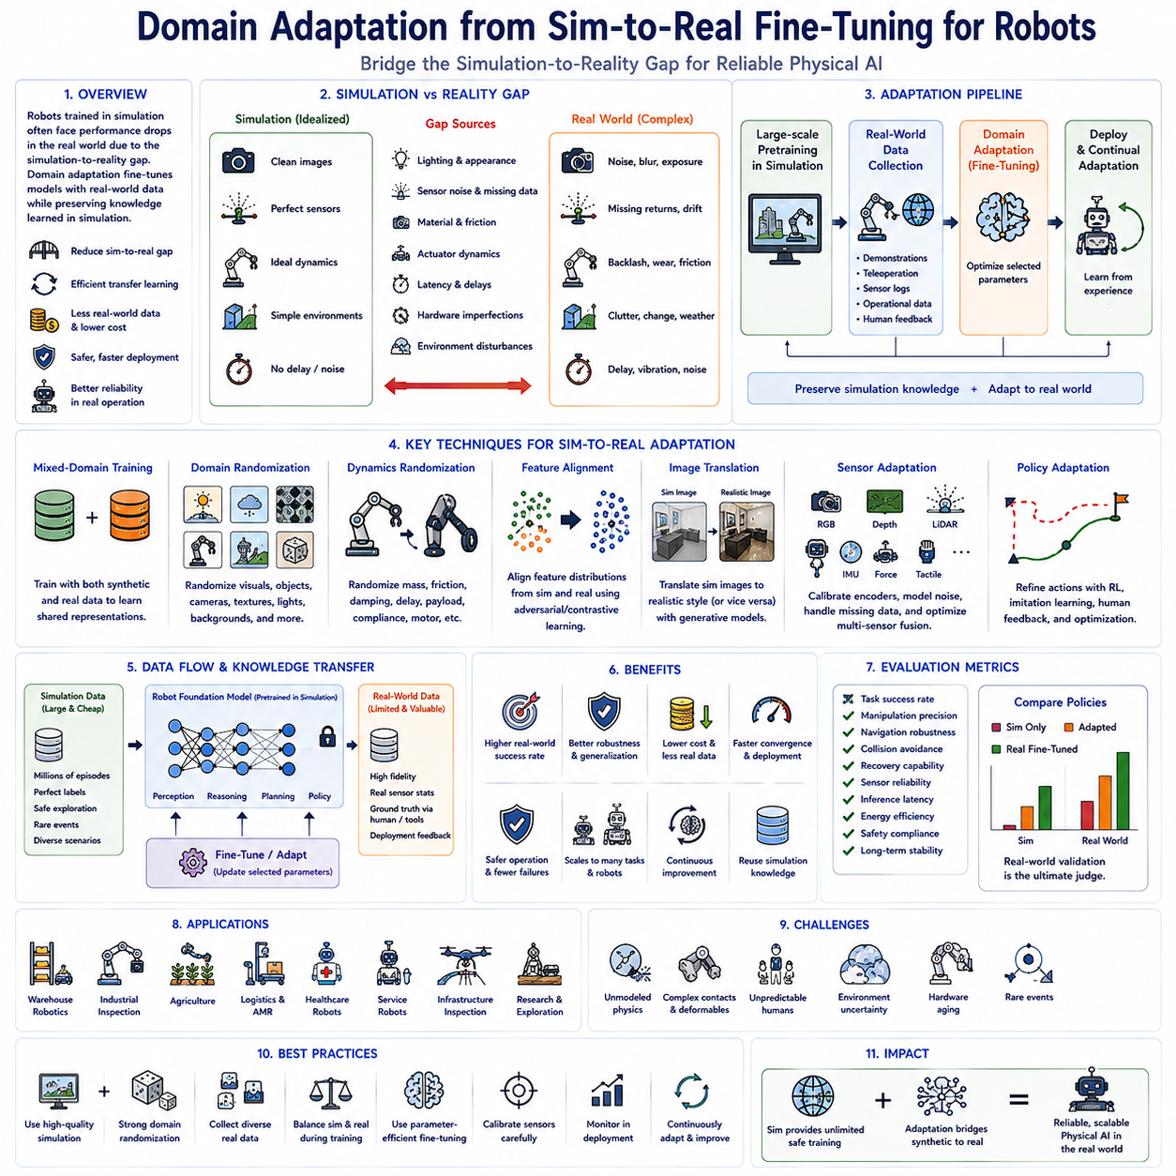
Domain adaptation has become one of the most critical technologies in modern Physical AI because robots trained entirely in simulation often experience significant performance degradation when deployed in the real world. Although simulation environments provide unlimited training data, perfectly synchronized labels, accelerated experimentation, and safe exploration of dangerous scenarios, they cannot fully reproduce the complexity of physical reality. Differences in lighting conditions, sensor noise, material properties, object appearance, actuator dynamics, friction coefficients, environmental disturbances, communication delays, and hardware imperfections create a phenomenon commonly known as the simulation-to-reality gap. Domain adaptation seeks to minimize this discrepancy by enabling robot foundation models trained primarily in simulation to transfer their knowledge effectively into real operational environments through systematic fine-tuning and adaptation.
The simulation-to-reality gap originates from multiple sources across perception, dynamics, sensing, control, and environmental interaction. Simulated cameras typically generate cleaner images with perfectly modeled optics, while real cameras introduce lens distortion, motion blur, exposure variation, sensor noise, compression artifacts, and changing illumination. Simulated LiDAR systems produce ideal point clouds, whereas real sensors suffer from missing returns, reflective surfaces, atmospheric interference, vibration, and calibration drift. Robot actuators behave deterministically in simulation but exhibit backlash, wear, thermal effects, manufacturing tolerances, communication latency, and nonlinear friction in physical systems. These cumulative differences cause policies learned entirely in simulation to perform less reliably when transferred directly to real robots.
Domain adaptation addresses these challenges by gradually aligning feature representations, policy behavior, and control strategies between simulated and real environments. Rather than discarding pretrained simulation models, adaptation techniques preserve valuable knowledge acquired during large-scale simulation while modifying only those components required to accommodate real-world observations. Fine-tuning therefore represents an efficient transfer learning strategy that significantly reduces the quantity of expensive real-world training data required for successful deployment. Instead of learning robotic skills from the beginning, robots refine existing knowledge to account for physical differences encountered during actual operation.
Simulation remains an indispensable training platform because it enables rapid generation of massive multimodal datasets under highly controlled conditions. Millions of robot trajectories, manipulation attempts, navigation episodes, failure cases, collision scenarios, and environmental variations can be produced automatically without risking hardware damage or human safety. Simulation also allows perfect annotation of object poses, semantic labels, depth maps, force interactions, occupancy maps, and state trajectories that would otherwise require extensive manual labeling in physical environments. Consequently, simulation provides the foundation upon which subsequent domain adaptation builds increasingly realistic robot intelligence.
Fine-tuning using real-world data typically begins after large-scale pretraining has been completed within simulation. The pretrained robot foundation model already possesses general visual perception, multimodal reasoning, navigation capability, manipulation strategies, planning behavior, and policy generation learned from simulated experiences. Real-world demonstrations, teleoperation trajectories, sensor recordings, operational logs, and deployment feedback are subsequently introduced to refine these representations. Since much of the underlying knowledge remains valid across domains, only moderate parameter adaptation is generally required, greatly reducing computational cost while accelerating convergence.
One widely adopted strategy combines simulation and real-world data throughout the fine-tuning process rather than relying exclusively upon either source. Mixed-domain training exposes the model simultaneously to synthetic and physical observations, encouraging shared feature representations that generalize across both environments. Simulation continues providing diverse rare events and extensive coverage, whereas real-world data anchors the learned representations to actual sensor characteristics and environmental behavior. Carefully balancing synthetic and physical samples prevents catastrophic forgetting of broadly useful simulation knowledge while ensuring successful adaptation to deployment conditions.
Domain randomization represents another powerful technique supporting simulation-to-real transfer. Instead of attempting to construct perfectly realistic simulators, developers intentionally randomize textures, lighting, object colors, camera positions, sensor noise, physical properties, weather conditions, backgrounds, and environmental layouts throughout simulation. By continuously exposing robot policies to highly diverse synthetic environments, models learn invariant representations that become less sensitive to specific simulation details. When deployed in the real world, physical observations naturally appear as one variation among many encountered during randomized simulation, substantially improving transfer performance.
Dynamics randomization extends this concept beyond perception into robot control. Physical parameters such as mass, inertia, joint damping, actuator delay, friction coefficients, wheel slip, payload variation, compliance, and motor efficiency vary randomly throughout simulated training. Robot policies therefore become robust against uncertainty in mechanical behavior rather than depending upon perfectly accurate physical models. Since real robotic systems inevitably differ slightly from theoretical simulations, dynamics randomization significantly improves control stability and adaptation during deployment without requiring exact identification of every hardware parameter.
Feature-level domain adaptation attempts to learn internal representations that remain consistent across simulated and real observations. Neural networks are optimized so that intermediate feature embeddings extracted from synthetic images closely resemble embeddings generated from corresponding real images despite substantial visual differences. Domain-invariant representations allow downstream planning and control modules to operate consistently regardless of data origin. Adversarial learning, contrastive representation learning, feature alignment objectives, and distribution matching techniques frequently support this process by encouraging shared latent spaces spanning both simulation and reality.
Image translation techniques further reduce perceptual differences between synthetic and real environments. Generative models transform simulated images into realistic visual appearances or convert real observations into synthetic style while preserving semantic content. Photorealistic rendering, neural style transfer, generative adversarial networks, diffusion models, and image-to-image translation frameworks enable robot perception models to experience more realistic training data without requiring manual collection of enormous real-world datasets. These techniques improve visual robustness while maintaining precise simulation annotations unavailable within physical environments.
Sensor adaptation plays an essential role because multimodal robot foundation models increasingly integrate RGB cameras, depth sensors, LiDAR, radar, inertial measurements, tactile sensing, force sensors, microphones, joint encoders, GPS receivers, and environmental state estimation. Each sensing modality exhibits unique statistical differences between simulation and reality. Fine-tuning therefore adjusts sensor encoders individually while preserving shared multimodal reasoning throughout the robot foundation model. Calibration refinement, temporal synchronization, noise modeling, missing data handling, and sensor fusion optimization collectively improve real-world perception without requiring complete model retraining.
Policy adaptation focuses directly on robot behavior rather than only perceptual representations. Even when visual perception transfers successfully, action generation may require refinement due to actuator limitations, control latency, mechanical flexibility, safety constraints, or changing operational objectives. Reinforcement learning, imitation learning, offline reinforcement learning, human feedback, trajectory optimization, and policy regularization may all contribute to behavioral fine-tuning using limited real-world interaction. Such adaptation improves execution reliability while preserving the high-level planning capability learned during simulation.
Human demonstrations provide particularly valuable adaptation signals during simulation-to-real transfer. Expert teleoperation, kinesthetic teaching, corrective interventions, shared autonomy, and human feedback expose robots to realistic manipulation strategies impossible to capture fully through simulation alone. Fine-tuning with these demonstrations enables robot foundation models to incorporate practical operational knowledge including safety awareness, ergonomic motion, environment-specific handling techniques, failure recovery, and human collaboration behaviors. Combining simulated exploration with expert demonstrations frequently accelerates adaptation while improving deployment safety.
Continual adaptation allows deployed robots to improve continuously after initial fine-tuning. Rather than ending optimization following deployment, operational experience, mission logs, successful executions, failure cases, maintenance records, and environmental changes become additional learning resources supporting periodic model updates. Continuous adaptation enables robot foundation models to accommodate changing factory layouts, evolving warehouse inventories, seasonal agricultural conditions, equipment aging, sensor recalibration, and new operational procedures without requiring complete retraining. Careful replay strategies preserve previously learned capabilities while integrating newly acquired knowledge.
Evaluation of domain adaptation extends beyond simulation benchmark accuracy. Performance should be measured using real-world task success rate, manipulation precision, navigation robustness, collision avoidance, recovery capability, sensor reliability, inference latency, energy efficiency, safety compliance, and long-term operational stability across diverse deployment environments. Statistical comparisons between purely simulated policies and progressively adapted models quantify transfer effectiveness while identifying remaining performance gaps requiring further refinement. Real-world validation ultimately determines practical success because simulation metrics alone cannot fully predict deployment performance.
Several engineering considerations influence successful simulation-to-real adaptation. Dataset diversity, simulation fidelity, domain randomization strength, real-world data quantity, adaptation schedule, optimizer selection, parameter-efficient fine-tuning strategy, sensor calibration quality, hardware consistency, evaluation methodology, and deployment monitoring collectively determine transfer effectiveness. Organizations should treat simulation and reality as complementary rather than competing sources of robotic knowledge, leveraging the strengths of both throughout development and deployment.
Despite remarkable progress, simulation-to-real adaptation remains an active research challenge because no simulator perfectly captures every aspect of physical reality. Complex contact dynamics, deformable materials, unpredictable human behavior, environmental uncertainty, hardware degradation, and rare operational events continue limiting complete transfer. Future robot foundation models will increasingly integrate world models, continual learning, self-supervised adaptation, online reinforcement learning, uncertainty estimation, and autonomous data collection to reduce dependence upon manual fine-tuning while improving robustness across changing environments.
The long-term significance of domain adaptation extends far beyond improving transfer accuracy because it fundamentally enables scalable development of intelligent Physical AI systems. Simulation provides virtually unlimited safe training opportunities, while fine-tuning bridges accumulated synthetic knowledge into practical robotic deployment. As robot foundation models continue expanding in multimodal capability, reasoning ability, and autonomous decision-making, domain adaptation from simulation to reality will remain one of the foundational technologies enabling efficient, economical, safe, and reliable deployment of advanced robotic intelligence across manufacturing, logistics, agriculture, healthcare, service robotics, infrastructure inspection, scientific exploration, and countless future real-world applications.

10.6 Task Specific Fine Tuning Data Requirements [w/Code]
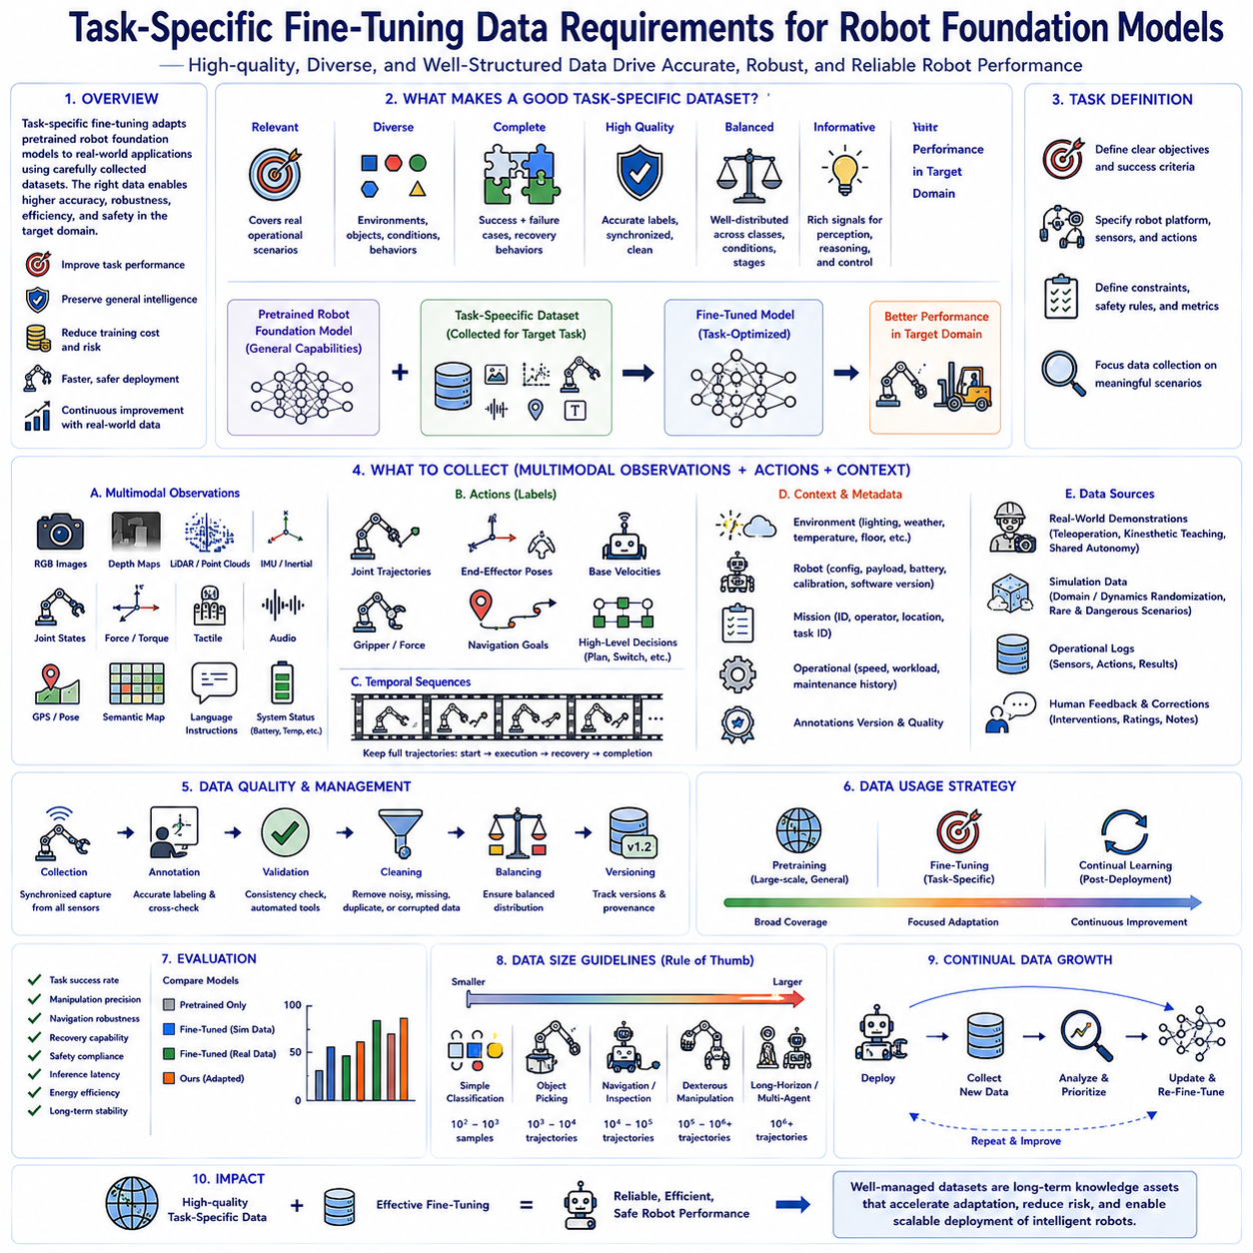
Task-specific fine-tuning plays a fundamental role in modern Physical AI because pretrained robot foundation models are designed to provide broad general capabilities rather than optimal performance for every individual application. Large-scale pretraining enables robots to acquire universal knowledge from diverse multimodal datasets, including visual perception, language understanding, manipulation strategies, navigation skills, reasoning, and decision-making. However, industrial deployment almost always requires adaptation to specific operational environments, hardware configurations, customer workflows, safety regulations, sensor characteristics, and task objectives. Task-specific fine-tuning bridges this gap by refining pretrained knowledge using carefully collected application-specific datasets, allowing robots to achieve higher accuracy, robustness, efficiency, and reliability within their intended deployment domains while preserving the general intelligence learned during pretraining.
The quality of a fine-tuned robot model depends far more on the quality and diversity of training data than on the sheer quantity of collected samples. Although increasing dataset size generally improves model performance, poorly curated or biased datasets often limit generalization regardless of scale. Effective task-specific datasets should represent realistic operating conditions, include both successful and unsuccessful executions, capture natural environmental variability, and reflect the full range of situations expected during deployment. Well-designed datasets expose robot foundation models to representative sensory inputs, decision points, action sequences, environmental changes, and recovery behaviors that collectively define successful task execution.
Defining clear task boundaries represents the first step in constructing an effective fine-tuning dataset. Engineers must specify exactly what capability the robot should acquire, which environmental assumptions remain valid, what sensors are available, what actions are permitted, and how success should be evaluated. Tasks may include object picking, warehouse navigation, pallet transportation, industrial inspection, autonomous charging, collaborative assembly, agricultural harvesting, healthcare assistance, service interaction, or infrastructure maintenance. Clearly defined objectives allow data collection to focus on meaningful operational scenarios rather than generating unnecessary observations that contribute little to downstream learning.
Every task-specific dataset should include comprehensive multimodal observations describing the robot, the environment, and the ongoing task. Modern robot foundation models commonly process synchronized RGB images, depth maps, LiDAR scans, force measurements, joint positions, proprioceptive states, tactile sensing, inertial measurements, GPS coordinates, semantic maps, environmental metadata, language instructions, temporal histories, and system status information. Collecting synchronized multimodal data enables the model to learn rich cross-modal relationships that improve perception, planning, reasoning, and action generation under diverse operating conditions. Consistent sensor synchronization and timestamp accuracy are therefore essential for reliable model adaptation.
High-quality action labels represent another critical dataset requirement. Every observation sequence should be paired with corresponding robot actions describing desired behavior throughout task execution. Depending on the learning framework, actions may include joint trajectories, end-effector poses, mobile robot velocities, steering commands, manipulation forces, gripper states, navigation goals, waypoint sequences, motion primitives, or high-level planning decisions. Precise action labeling enables supervised learning, imitation learning, reinforcement learning initialization, behavior cloning, and policy refinement while reducing ambiguity during optimization. Label consistency directly influences policy accuracy and deployment reliability.
Temporal continuity is particularly important because robotic behavior depends strongly on sequential context rather than isolated observations. Single images rarely provide sufficient information for predicting future actions, especially during manipulation, navigation, obstacle avoidance, or collaborative interaction. Fine-tuning datasets should therefore preserve complete trajectories containing continuous observation-action sequences spanning task initiation, execution, completion, interruption, recovery, and termination. Long temporal windows allow robot foundation models to learn dynamic relationships, delayed consequences, motion dependencies, and long-horizon planning strategies that cannot be inferred from individual frames alone.
Task diversity substantially improves model robustness. Rather than repeatedly demonstrating identical procedures, datasets should intentionally include multiple object categories, lighting conditions, weather situations, workspace layouts, camera viewpoints, robot speeds, payload variations, environmental disturbances, obstacle configurations, operator behaviors, and execution styles. Such diversity prevents models from memorizing narrow scenarios while encouraging generalized decision-making applicable across realistic deployment environments. Balanced variation enables robots to remain reliable despite naturally occurring changes encountered during long-term operation.
Failure examples are equally valuable as successful demonstrations. Industrial robots inevitably encounter dropped objects, failed grasps, blocked paths, sensor degradation, communication interruptions, actuator limitations, localization drift, unexpected obstacles, and changing environmental conditions. Fine-tuning datasets should intentionally capture these situations together with appropriate recovery actions, corrective behaviors, safety responses, and operator interventions. Learning from both success and failure enables robot foundation models to recognize abnormal situations, recover autonomously, request assistance when necessary, and maintain safe operation under uncertain conditions.
Human demonstrations remain one of the richest sources of task-specific data. Expert teleoperation, kinesthetic teaching, shared autonomy, remote supervision, and manual guidance allow experienced operators to demonstrate optimal manipulation strategies, efficient navigation behavior, safe interaction patterns, and environment-specific operational knowledge. Human demonstrations naturally encode practical expertise that may be difficult to specify through explicit programming. Fine-tuning robot foundation models using expert demonstrations significantly accelerates skill acquisition while reducing the exploration cost associated with purely autonomous learning methods.
Simulation-generated data complements human demonstrations by providing virtually unlimited examples covering rare situations, dangerous scenarios, extreme environmental conditions, and large-scale parameter variation. Simulation supports automatic annotation of object poses, semantic labels, force interactions, collision events, depth maps, occupancy grids, and system states that would require extensive manual labeling in physical environments. Combining synthetic and real-world datasets allows robot foundation models to leverage broad simulation coverage while refining behavior using realistic operational experience through domain adaptation and selective fine-tuning.
Balanced dataset composition is essential for avoiding undesirable learning bias. If one object category, environment, operator, weather condition, robot speed, or task outcome dominates the dataset, the resulting model may perform well only under those specific conditions while generalizing poorly elsewhere. Engineers should analyze dataset distributions to ensure adequate representation across classes, environments, sensor conditions, temporal stages, and operational scenarios. Statistical balancing improves robustness while reducing unexpected deployment failures caused by insufficient exposure to important situations during training.
Accurate annotation quality directly determines downstream model performance. Object identities, semantic segmentation masks, bounding boxes, keypoints, robot states, force measurements, language descriptions, task boundaries, temporal synchronization, and action labels should all remain internally consistent throughout the dataset. Annotation errors introduce conflicting supervision signals that slow convergence, reduce prediction accuracy, and complicate model evaluation. Automated validation tools, consistency checking, cross-review procedures, and quality assurance pipelines therefore become indispensable components of large-scale robot dataset construction.
Metadata provides valuable contextual information extending beyond raw sensor observations. Environmental temperature, humidity, lighting conditions, floor material, payload weight, battery state, robot configuration, software version, calibration status, operator identity, mission identifier, facility location, weather conditions, and maintenance history may all influence robot behavior during deployment. Recording such metadata enables conditional learning, failure analysis, domain adaptation, dataset filtering, experiment reproducibility, and future continual learning. Rich metadata also simplifies root-cause investigation when unexpected behavior appears during operational deployment.
Data quality management should include systematic filtering of corrupted, incomplete, duplicated, inconsistent, or low-information samples before fine-tuning begins. Sensor synchronization failures, missing observations, communication errors, invalid annotations, extreme measurement noise, hardware malfunctions, and incomplete trajectories should be detected automatically whenever possible. High-quality datasets consistently outperform significantly larger but poorly curated collections because optimization depends upon reliable supervisory information rather than raw sample count alone.
Task-specific fine-tuning datasets should evolve continuously after deployment rather than remaining static. Operational logs, newly observed environmental conditions, rare failure events, customer feedback, operator corrections, maintenance records, software updates, and changing production requirements all generate valuable new learning opportunities. Incrementally expanding datasets through continual collection enables robot foundation models to improve steadily while adapting to evolving operational environments. Active learning strategies further prioritize collection of the most informative new samples, maximizing adaptation efficiency while minimizing labeling effort.
Evaluation datasets should remain separate from training datasets to ensure unbiased measurement of generalization performance. Validation data should represent realistic deployment conditions while including scenarios not encountered during optimization. Performance metrics may include task success rate, trajectory accuracy, manipulation precision, navigation robustness, recovery capability, safety compliance, inference latency, energy efficiency, and long-term operational stability. Careful separation of training, validation, and testing data prevents overfitting while providing trustworthy estimates of real-world deployment capability.
Several engineering factors influence the required dataset size for successful fine-tuning. Task complexity, sensor diversity, environmental variability, robot embodiment, action dimensionality, desired accuracy, foundation model capability, parameter-efficient adaptation method, simulation availability, and deployment risk collectively determine data requirements. Simple classification tasks may require relatively modest datasets, whereas dexterous manipulation, long-horizon planning, collaborative robotics, and multimodal reasoning often demand substantially larger collections. Dataset planning should therefore be driven by task characteristics rather than fixed numerical sample targets.
The long-term significance of task-specific fine-tuning data extends beyond supporting individual model optimization because high-quality datasets become reusable organizational knowledge assets. Carefully curated multimodal datasets preserve operational expertise, customer experience, environmental diversity, safety procedures, and accumulated robotic behavior that continue providing value across multiple generations of robot foundation models. As Physical AI systems become increasingly capable and autonomous, organizations possessing comprehensive, high-quality task-specific datasets will gain substantial advantages in adaptation speed, deployment reliability, continual learning, and scalable development of intelligent robotic systems across diverse industries and real-world applications.

10.7 Catastrophic Forgetting Prevention EWC Replay [w/Code]
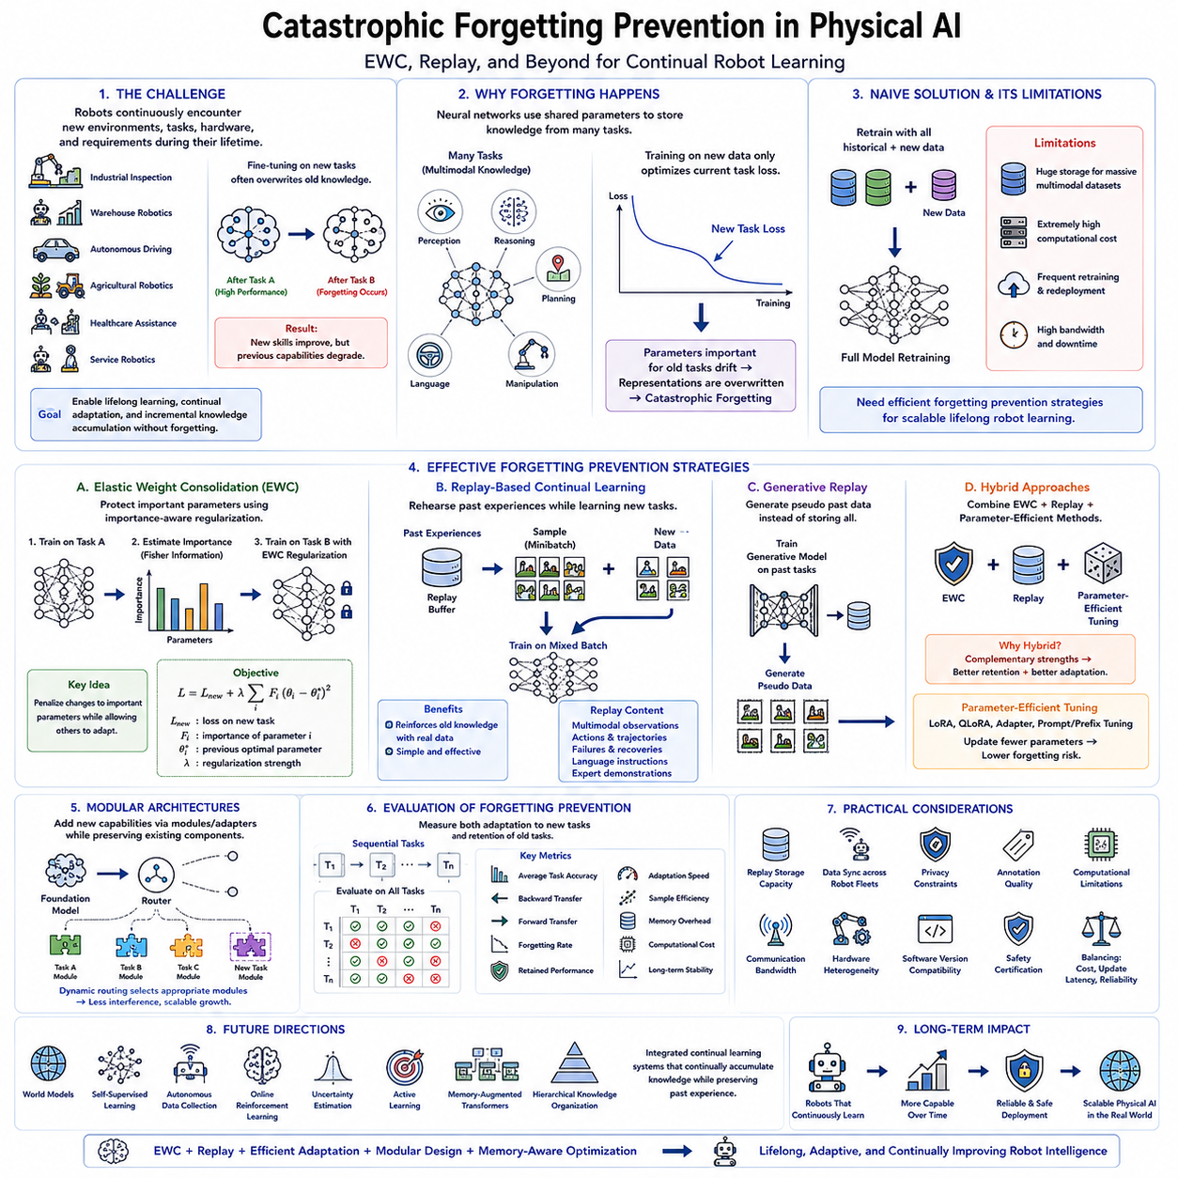
Catastrophic forgetting represents one of the most significant challenges in continual learning for Physical AI because robot foundation models frequently require adaptation to new environments, tasks, hardware platforms, and operational requirements throughout their deployment lifetime. During conventional fine-tuning, neural networks optimize parameters primarily for newly introduced tasks, often overwriting representations that previously supported older capabilities. As a result, robots may improve performance on recently learned behaviors while simultaneously degrading their ability to perform tasks mastered during earlier training stages. Preventing catastrophic forgetting is therefore essential for developing intelligent robotic systems capable of lifelong learning, continual adaptation, and incremental knowledge accumulation without repeatedly retraining from the beginning.
The underlying cause of catastrophic forgetting arises from the shared parameter structure of deep neural networks. A single set of model weights simultaneously represents knowledge acquired from numerous perception, reasoning, planning, navigation, manipulation, and language tasks. When optimization updates these shared parameters using only new training data, gradient descent naturally prioritizes minimizing current task loss without explicitly preserving knowledge required for previous tasks. Parameters important for earlier capabilities may therefore drift toward values optimized exclusively for the newest objective, gradually erasing previously learned representations despite the absence of intentional forgetting mechanisms.
Robot foundation models face particularly severe catastrophic forgetting because deployed robots continually encounter changing operational conditions. Industrial inspection systems receive updated inspection procedures, warehouse robots learn new inventory layouts, autonomous vehicles adapt to revised traffic regulations, agricultural robots experience seasonal crop variations, healthcare assistants incorporate new treatment protocols, and service robots expand their interaction capabilities. Each adaptation introduces new training objectives while risking degradation of previously reliable behaviors. Without forgetting prevention mechanisms, continual improvement eventually becomes unsustainable because every new capability potentially weakens existing functionality.
One straightforward solution involves periodically retraining the complete foundation model using all historical datasets together with newly collected data. Although this approach largely avoids catastrophic forgetting, it rapidly becomes computationally impractical as robot experience accumulates over months or years. Storing enormous multimodal datasets, repeatedly executing large-scale optimization, and redistributing updated foundation models across robot fleets require substantial computational resources, storage capacity, network bandwidth, and operational downtime. Consequently, efficient forgetting prevention strategies have become essential for scalable lifelong robot learning.
Elastic Weight Consolidation, commonly abbreviated as EWC, represents one of the earliest and most influential continual learning algorithms designed specifically to preserve previously acquired knowledge during sequential learning. Rather than treating every neural network parameter equally, EWC estimates which parameters contributed most significantly to earlier tasks and selectively discourages substantial modification of those important weights during future optimization. Parameters determined to have little influence upon previous capabilities remain relatively free to adapt toward new objectives, allowing continual learning while preserving critical knowledge accumulated from earlier experiences.
The central insight behind EWC originates from Bayesian learning principles. After completing training on an initial task, the optimized parameter configuration represents a probability distribution reflecting accumulated knowledge. Instead of allowing unrestricted movement away from this solution during subsequent fine-tuning, EWC introduces a regularization term penalizing changes to parameters deemed highly important for previous performance. The optimization objective therefore balances two competing goals simultaneously: improving performance on the new task while maintaining parameter values necessary for preserving previously learned capabilities. This compromise substantially reduces catastrophic forgetting without completely preventing useful adaptation.
Estimating parameter importance forms the foundation of EWC. The algorithm commonly employs the Fisher Information Matrix to approximate how sensitive model performance remains to changes in individual parameters. Parameters producing large performance degradation when perturbed receive high importance scores, whereas parameters exerting relatively little influence receive lower importance estimates. During later fine-tuning, optimization penalizes modifications according to these importance values rather than applying identical constraints across all parameters. This selective protection enables efficient reuse of less critical network capacity while preserving essential knowledge encoded within highly influential weights.
Although the complete Fisher Information Matrix becomes computationally expensive for modern robot foundation models containing billions of parameters, practical implementations typically approximate only its diagonal elements. This diagonal approximation significantly reduces computational complexity while still capturing useful estimates of parameter importance. Consequently, EWC remains feasible even for relatively large transformer-based robot foundation models where full second-order optimization would otherwise become prohibitively expensive. Modern continual learning frameworks frequently incorporate such approximations to balance effectiveness with computational efficiency.
Replay-based continual learning provides another powerful strategy for preventing catastrophic forgetting. Instead of relying solely upon parameter regularization, replay methods periodically expose the model to representative examples drawn from previously encountered tasks while learning new ones. By simultaneously optimizing both historical and newly collected data, the network continually refreshes earlier knowledge rather than allowing previous representations to disappear. Replay therefore transforms sequential learning into a partially interleaved optimization process that naturally reinforces older capabilities while integrating new experiences.
Experience replay stores carefully selected observations from earlier robot deployments inside a replay buffer. During subsequent fine-tuning, each optimization batch contains both newly collected experiences and randomly sampled historical observations. This balanced exposure prevents optimization from focusing exclusively upon recent tasks while preserving diverse operational knowledge accumulated throughout deployment history. Replay buffers commonly include multimodal sensor observations, language instructions, action trajectories, environmental metadata, failure cases, recovery behaviors, and expert demonstrations representing broad operational diversity rather than merely maximizing sample quantity.
Selecting representative replay samples significantly influences continual learning performance. Random sampling provides simplicity but may inadequately preserve rare operational situations or safety-critical behaviors. More sophisticated replay strategies prioritize informative experiences according to novelty, uncertainty, prediction error, temporal diversity, task coverage, or safety importance. Representative replay datasets therefore maximize retained knowledge while minimizing storage requirements. Intelligent sample selection becomes increasingly valuable as long-term robot deployments accumulate enormous operational histories exceeding practical storage capacity.
Generative replay eliminates the need to store large historical datasets explicitly. Instead of preserving raw sensor observations, the system trains generative models capable of synthesizing representative examples from previous tasks whenever continual learning occurs. Diffusion models, variational autoencoders, generative adversarial networks, and world models may all generate realistic replay experiences supporting continual adaptation. Generative replay substantially reduces storage requirements while preserving diverse historical knowledge, although maintaining high synthesis quality remains an active research challenge for multimodal robotic applications.
Hybrid continual learning approaches frequently combine EWC and replay mechanisms to exploit complementary advantages. Parameter regularization protects highly important knowledge embedded within model weights, whereas replay continually reinforces previous representations using representative historical observations. Together these methods generally outperform either approach independently, particularly within complex robot foundation models supporting multimodal perception, long-horizon planning, language understanding, manipulation, and autonomous navigation simultaneously. Hybrid strategies therefore represent practical solutions for real-world continual robot learning.
Parameter-efficient fine-tuning techniques further contribute to forgetting prevention by reducing the extent of parameter modification during adaptation. Methods including LoRA, QLoRA, prompt tuning, prefix tuning, adapter layers, and head-only fine-tuning introduce lightweight task-specific parameters while preserving most pretrained backbone weights unchanged. Since fewer shared parameters receive updates, opportunities for catastrophic forgetting naturally decrease. Combining parameter-efficient adaptation with replay or EWC often produces highly stable continual learning behavior suitable for industrial robot deployment.
Modular architectures provide another complementary strategy. Instead of forcing every capability into one shared parameter space, robots may maintain separate task adapters, policy modules, perception components, or embodiment-specific representations connected through a common foundation model. Newly acquired skills are implemented within additional modules while preserving earlier components intact. Dynamic routing mechanisms activate appropriate modules according to operational context, reducing interference among unrelated capabilities while supporting scalable lifelong expansion.
Evaluation of forgetting prevention requires measuring both adaptation and retention simultaneously. After sequentially learning multiple tasks, robot foundation models should be evaluated on all previously encountered capabilities rather than only the newest objective. Common metrics include average task accuracy, backward transfer, forward transfer, forgetting rate, retained performance, adaptation speed, sample efficiency, memory overhead, computational cost, and long-term deployment stability. Comprehensive evaluation ensures continual learning methods genuinely accumulate knowledge rather than simply replacing older capabilities with newer ones.
Practical deployment introduces additional engineering considerations beyond algorithmic design. Replay storage capacity, synchronization across distributed robot fleets, privacy constraints, annotation quality, computational limitations, communication bandwidth, hardware heterogeneity, software version compatibility, and safety certification all influence continual learning system design. Industrial deployments frequently require balancing forgetting prevention effectiveness against storage cost, update frequency, latency, and operational reliability. Consequently, engineering decisions remain as important as algorithm selection when building scalable lifelong Physical AI systems.
Future robot foundation models will likely integrate continual learning directly into their core architecture rather than treating forgetting prevention as an external optimization technique. World models, self-supervised representation learning, autonomous data collection, online reinforcement learning, uncertainty estimation, active learning, memory-augmented transformers, and hierarchical knowledge organization may collectively support continuous knowledge accumulation without significant degradation of previously acquired capabilities. Such systems will progressively refine their understanding throughout years of deployment while preserving accumulated operational experience across changing environments and evolving task requirements.
The long-term significance of catastrophic forgetting prevention extends far beyond maintaining benchmark accuracy because it fundamentally determines whether intelligent robots can learn continuously throughout their operational lifetime. Techniques such as Elastic Weight Consolidation, replay-based continual learning, parameter-efficient adaptation, modular architectures, and memory-aware optimization collectively enable robot foundation models to accumulate knowledge rather than repeatedly replacing it. As Physical AI systems become increasingly autonomous and operate across diverse real-world environments for extended periods, preventing catastrophic forgetting will remain one of the foundational technologies supporting scalable, reliable, adaptive, and continually improving robotic intelligence.

10.8 Few Shot Adaptation to New Robot Platform [w/Code]
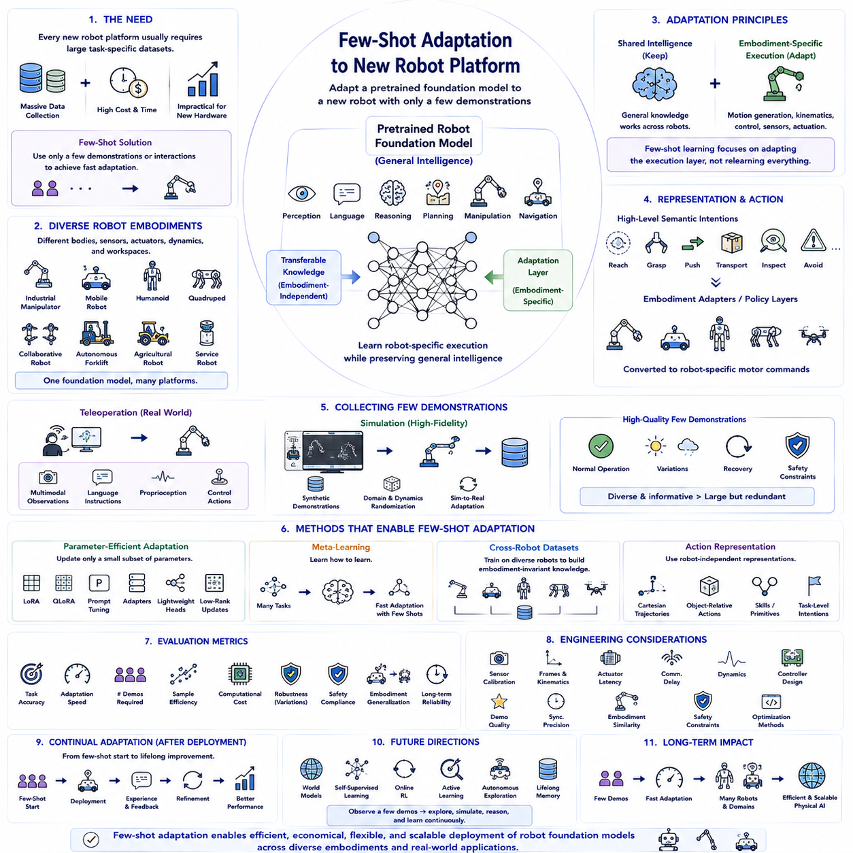
Few-shot adaptation has emerged as one of the most important capabilities for modern Physical AI because deploying robot foundation models across diverse robotic platforms would otherwise require collecting massive task-specific datasets for every new robot. Traditional robot learning often demands thousands or even millions of demonstrations before achieving reliable performance, making adaptation expensive, time-consuming, and impractical whenever new hardware is introduced. Few-shot adaptation seeks to overcome this limitation by enabling a pretrained robot foundation model to acquire useful behaviors for an unfamiliar robot platform using only a very small number of demonstrations or interaction episodes. Instead of learning every capability from the beginning, the robot transfers previously acquired knowledge and rapidly specializes it for the new embodiment, sensors, actuators, and operational environment.
The motivation behind few-shot adaptation originates from the increasing diversity of robot embodiments deployed across real-world industries. Manufacturing robots, warehouse mobile platforms, humanoids, quadrupeds, collaborative manipulators, autonomous forklifts, agricultural robots, healthcare assistants, inspection systems, and service robots all possess different mechanical structures, sensor configurations, actuator dynamics, control frequencies, payload capacities, and workspace geometries. Although these robots share many high-level reasoning and perception capabilities, their physical execution differs substantially. Building completely independent models for every embodiment would be computationally inefficient and economically unsustainable. Few-shot adaptation enables organizations to reuse one powerful robot foundation model while efficiently customizing it for many hardware platforms.
Robot foundation models provide an ideal starting point because large-scale pretraining has already captured broad knowledge regarding visual perception, language understanding, manipulation principles, navigation strategies, object relationships, physical reasoning, spatial representations, and sequential decision-making. Most of this knowledge remains valid regardless of the specific robot embodiment. When adapting to a new platform, only embodiment-dependent components such as motion generation, inverse kinematics, low-level control behavior, actuator characteristics, and sensor calibration require substantial adjustment. Consequently, few-shot learning focuses primarily on modifying robot-specific execution while preserving universal cognitive knowledge accumulated during large-scale pretraining.
Embodiment differences represent one of the greatest challenges during adaptation. Two robots may observe identical environments and receive identical language instructions while possessing completely different joint structures, degrees of freedom, gripper mechanisms, locomotion systems, sensor placements, and reachable workspaces. A humanoid may manipulate objects using dexterous hands, whereas an industrial manipulator uses rigid end effectors. A wheeled mobile robot navigates differently from a quadruped, while an aerial drone obeys entirely different motion dynamics. Few-shot adaptation therefore requires separating transferable task knowledge from embodiment-specific motor behavior so that common intelligence can generalize despite physical differences.
Learning embodiment-independent representations has become an active research direction supporting cross-platform adaptation. Instead of encoding robot-specific joint trajectories directly, modern robot foundation models increasingly represent actions using higher-level semantic intentions such as reaching, grasping, pushing, transporting, inspecting, avoiding, or following. Individual robots subsequently translate these abstract behavioral representations into platform-specific motor commands through dedicated policy layers or embodiment adapters. Such hierarchical representations greatly simplify few-shot adaptation because only the translation layer requires retraining while the shared reasoning system remains largely unchanged.
High-quality demonstrations become especially valuable when only limited adaptation data are available. Every demonstration should maximize informational value by exposing the robot to representative situations spanning normal operation, environmental variation, recovery behavior, and safety constraints. Rather than collecting redundant trajectories, engineers should intentionally capture diverse manipulation strategies, navigation paths, object configurations, interaction styles, and environmental conditions. Carefully selected demonstrations often provide substantially greater adaptation benefit than significantly larger collections containing repetitive behaviors with limited informational diversity.
Teleoperation provides one of the most practical mechanisms for collecting few-shot adaptation data. Human operators remotely control the new robot while executing representative tasks, allowing synchronized recording of multimodal observations, language instructions, proprioceptive states, environmental context, and corresponding control actions. Since only relatively few demonstrations are required, teleoperation sessions remain manageable even for newly developed robotic platforms. Modern teleoperation systems frequently integrate virtual reality interfaces, force feedback devices, motion capture systems, shared autonomy, and interactive correction mechanisms to maximize demonstration quality while minimizing operator workload.
Simulation also contributes significantly to few-shot adaptation. Before collecting expensive physical demonstrations, developers often adapt foundation models within high-fidelity simulators configured specifically for the new robot embodiment. Synthetic demonstrations covering numerous environmental variations, object arrangements, motion trajectories, and recovery behaviors provide valuable initialization before real-world fine-tuning begins. Domain randomization, dynamics randomization, and simulation-to-real adaptation further improve transfer efficiency by exposing the robot to diverse conditions before deployment on physical hardware. Consequently, only limited real-world demonstrations may be required to bridge the remaining simulation gap.
Parameter-efficient adaptation techniques significantly reduce computational requirements during few-shot learning. Methods including LoRA, QLoRA, prompt tuning, prefix tuning, adapter modules, lightweight policy heads, and low-rank parameter updates modify only a small subset of network parameters while preserving the majority of pretrained foundation weights. Since relatively few parameters require optimization, stable adaptation becomes possible even when only limited demonstrations are available. Parameter-efficient methods also reduce memory consumption, accelerate optimization, simplify deployment, and minimize catastrophic forgetting of previously acquired capabilities.
Meta-learning provides another promising approach for few-shot robot adaptation. During pretraining, the robot foundation model intentionally experiences numerous diverse learning tasks designed to improve its ability to learn new tasks rapidly. Instead of optimizing only task performance, meta-learning optimizes learning efficiency itself. Consequently, when encountering an unfamiliar robot embodiment, only a handful of demonstrations may suffice because the model has already learned general adaptation strategies applicable across many previous learning experiences. This capability closely resembles how humans quickly acquire new motor skills after accumulating extensive prior experience.
Cross-robot datasets substantially improve few-shot adaptation performance because they expose foundation models to diverse embodiments before deployment. Large-scale datasets integrating demonstrations from industrial manipulators, mobile robots, humanoids, quadrupeds, aerial vehicles, collaborative robots, and service platforms encourage the development of embodiment-invariant representations. Learning common behavioral abstractions across multiple robot types enables stronger transfer whenever an entirely new embodiment appears. Projects such as Open X-Embodiment illustrate how broad cross-platform data collection supports increasingly general robot intelligence capable of efficient adaptation.
Action representation plays an essential role during adaptation. Direct joint-space commands often transfer poorly across robots with different kinematic structures, whereas Cartesian end-effector trajectories, object-relative actions, semantic skills, motion primitives, or task-level intentions frequently generalize more effectively. Designing robot-independent action representations therefore reduces the amount of embodiment-specific retraining required during few-shot adaptation. Hierarchical policy architectures commonly separate high-level planning from low-level motor execution, improving both transfer efficiency and long-term maintainability.
Evaluation of few-shot adaptation extends beyond measuring final task accuracy alone. Researchers also evaluate adaptation speed, required demonstration count, sample efficiency, computational cost, energy consumption, robustness under environmental variation, safety compliance, embodiment generalization, and long-term operational reliability. True few-shot capability should enable successful deployment after only a limited number of demonstrations while maintaining stable performance across realistic operational scenarios. Comprehensive evaluation therefore measures both adaptation quality and adaptation efficiency simultaneously.
Several engineering factors determine practical adaptation performance. Sensor calibration accuracy, coordinate frame consistency, actuator latency, communication delay, robot dynamics, environmental diversity, demonstration quality, synchronization precision, embodiment similarity, controller architecture, safety constraints, and parameter-efficient optimization methods collectively influence adaptation success. Careful system integration often contributes as much to successful deployment as the learning algorithm itself. Engineering discipline therefore remains essential even when highly capable robot foundation models are available.
Safety becomes increasingly important when adapting to unfamiliar robotic platforms. Newly adapted policies should initially operate under conservative constraints including limited speed, restricted force output, supervised execution, collision monitoring, workspace boundaries, emergency stopping mechanisms, and uncertainty-aware decision making. Confidence estimation enables robots to recognize unfamiliar situations requiring human intervention rather than attempting unreliable autonomous execution. Progressive deployment gradually expands operational capability as additional experience validates policy reliability under increasingly diverse real-world conditions.
Continual adaptation naturally extends few-shot learning after deployment. Initial demonstrations establish baseline capability, while operational experience continuously refines performance through additional observations, corrective interventions, failure recovery, maintenance records, environmental variation, and user feedback. Rather than representing separate learning paradigms, few-shot adaptation and continual learning complement one another by enabling rapid initial deployment followed by progressive long-term improvement throughout the robot's operational lifetime. Efficient knowledge accumulation ultimately transforms isolated demonstrations into increasingly comprehensive robotic expertise.
The future of few-shot adaptation will likely integrate robot foundation models, world models, self-supervised representation learning, multimodal reasoning, online reinforcement learning, active learning, autonomous exploration, and lifelong memory into unified learning systems. Future robots may observe only a handful of demonstrations before autonomously refining their skills through simulation, prediction, interaction, and self-generated experience. Such systems will progressively reduce dependence upon extensive manual data collection while accelerating deployment across increasingly diverse robotic embodiments and application domains.
The long-term significance of few-shot adaptation extends beyond reducing data collection costs because it fundamentally enables scalable deployment of robot foundation models across heterogeneous Physical AI platforms. Organizations will no longer need to construct completely independent learning systems for every new robot design. Instead, a common foundation model can accumulate broad robotic intelligence while rapidly specializing to individual embodiments through only limited demonstrations. As Physical AI continues expanding into manufacturing, logistics, agriculture, healthcare, construction, inspection, transportation, household assistance, and scientific exploration, few-shot adaptation will remain one of the foundational technologies enabling efficient, economical, flexible, and highly scalable robot intelligence across the next generation of autonomous systems.

10.9 Fine Tuning Evaluation and Regression Testing [w/Code]
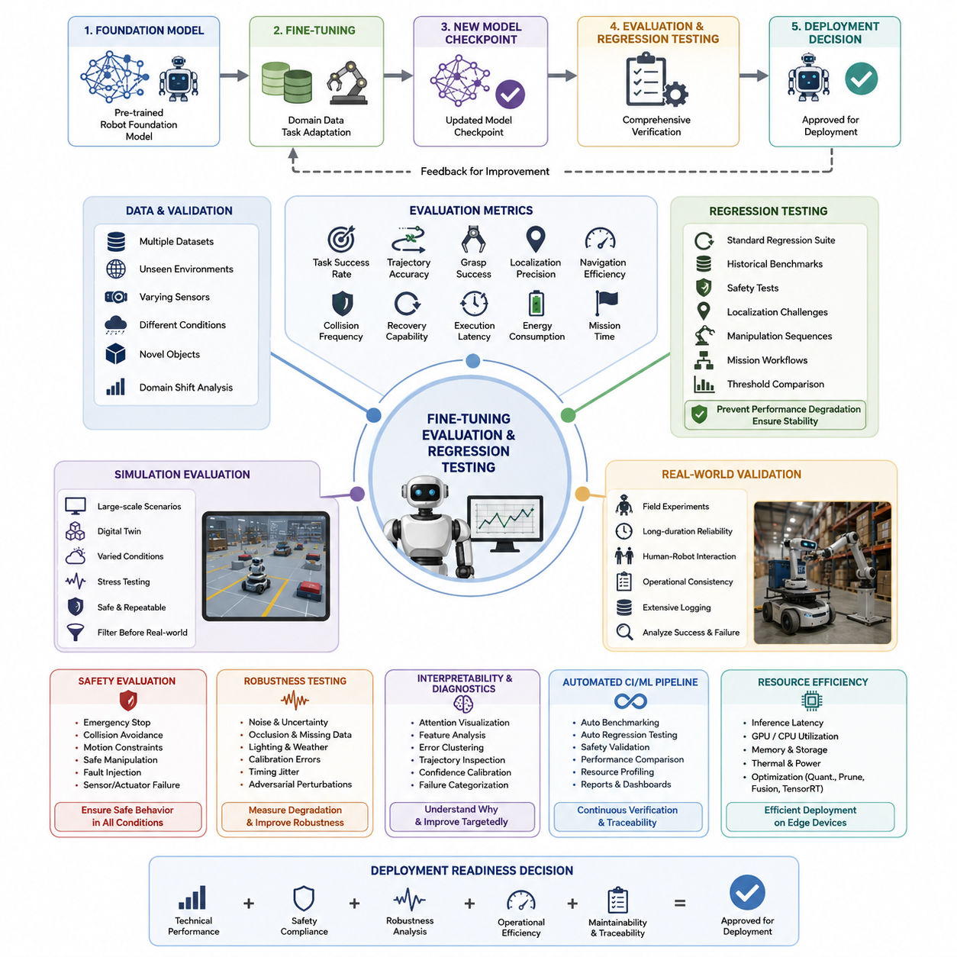
Fine-tuning evaluation and regression testing are essential stages that verify whether an adapted robot foundation model has genuinely improved its capabilities without sacrificing previously acquired knowledge. Fine-tuning often produces significant gains for specialized tasks such as industrial inspection, warehouse logistics, service robotics, agricultural automation, or humanoid manipulation. However, performance improvements on one task may unintentionally reduce robustness, generalization, safety, or efficiency in other situations. A systematic evaluation framework therefore measures task-specific improvements while simultaneously validating overall system stability across diverse operational conditions. The objective is not merely to maximize benchmark scores but to ensure that every model update produces measurable, reliable, and deployable improvements for real robotic systems.
Evaluation begins by defining quantitative performance metrics that accurately reflect operational objectives. Task completion rate, trajectory accuracy, object grasp success, localization precision, navigation efficiency, collision frequency, recovery capability, execution latency, energy consumption, and mission completion time are commonly measured together. These metrics are collected under standardized testing protocols so that different model versions can be compared objectively. Confidence intervals, statistical significance tests, repeated trials, and uncertainty estimation help distinguish genuine performance improvements from random variation. Carefully designed evaluation metrics allow development teams to identify strengths, weaknesses, and hidden trade-offs before deployment.
Fine-tuned models should be validated across multiple datasets rather than relying exclusively on the training distribution. Independent validation datasets, unseen environments, different sensor configurations, changing weather conditions, varying illumination, dynamic obstacles, and novel object categories expose weaknesses that may remain hidden during training. Cross-domain evaluation determines whether learned representations transfer effectively to new scenarios while preserving reliable behavior. Domain shift analysis further identifies conditions where adaptation performance begins to degrade, allowing engineers to introduce additional data collection, simulation, or targeted fine-tuning strategies before field deployment.
Simulation-based evaluation provides a safe and highly repeatable environment for large-scale testing. Thousands of navigation episodes, manipulation tasks, multi-agent interactions, recovery scenarios, and safety-critical events can be executed automatically under controlled conditions. Digital twins enable parameter variation across terrain properties, lighting conditions, sensor noise, actuator uncertainty, payload changes, and environmental complexity. Stress testing under extreme situations allows researchers to observe model behavior beyond normal operating ranges while minimizing hardware risks. Simulation therefore serves as an efficient filtering stage before expensive physical validation begins.
Real-world validation complements simulation by exposing practical challenges that virtual environments cannot fully reproduce. Mechanical wear, imperfect calibration, sensor degradation, wireless communication delays, unexpected human behavior, environmental clutter, and hardware limitations frequently introduce uncertainties absent from simulation. Field experiments evaluate long-duration reliability, operational consistency, and human-robot interaction quality under realistic working conditions. Extensive logging captures perception outputs, planning decisions, actuator commands, and environmental observations, enabling detailed post-mission analysis that explains both successful and unsuccessful executions.
Regression testing ensures that new model versions do not unintentionally degrade previously validated capabilities. Every new checkpoint is evaluated against a standardized regression suite containing representative tasks accumulated throughout the development lifecycle. Historical benchmark datasets, previously solved scenarios, safety tests, localization challenges, manipulation sequences, and mission-level workflows are executed automatically after each training iteration. If a newly fine-tuned model performs worse than an approved baseline beyond predefined thresholds, deployment is blocked until the regression is understood and corrected. This continuous verification process prevents gradual quality degradation across multiple development cycles.
Catastrophic forgetting represents one of the most significant risks during fine-tuning, particularly when adapting foundation models to highly specialized robotic domains. Models may improve dramatically on new tasks while losing competence in previously mastered behaviors. Regression testing therefore monitors both newly acquired capabilities and long-established competencies simultaneously. Replay datasets, continual learning strategies, regularization techniques, knowledge distillation, and parameter-efficient adaptation methods help preserve earlier knowledge while incorporating new information. Continuous monitoring ensures that specialization does not compromise the broad generalization expected from foundation models.
Safety evaluation receives special attention because robots directly interact with humans, equipment, and physical environments. Emergency stopping behavior, collision avoidance, obstacle prediction, motion constraint compliance, safe manipulation forces, perception reliability, and recovery from sensor failures are evaluated under both normal and abnormal conditions. Fault injection techniques deliberately introduce sensor failures, communication interruptions, actuator errors, corrupted inputs, and unexpected environmental changes to verify that safety mechanisms remain effective. Robust safety validation increases confidence that autonomous systems will behave predictably even when operating under uncertain or degraded conditions.
Robustness testing investigates how well fine-tuned models tolerate noise, uncertainty, and unexpected disturbances. Synthetic sensor noise, partial occlusions, missing observations, lighting fluctuations, weather effects, calibration errors, timing jitter, and adversarial perturbations are systematically introduced into evaluation pipelines. Performance degradation curves reveal the operational limits of perception, planning, and control components. Engineers use these analyses to strengthen weak modules, improve redundancy, optimize sensor fusion, and design adaptive recovery strategies that maintain acceptable performance even under difficult operating conditions.
Interpretability and diagnostic analysis help developers understand why evaluation results change after fine-tuning. Attention visualization, feature embedding analysis, activation comparisons, trajectory inspection, error clustering, confidence calibration, and failure categorization provide valuable insights into model behavior. Instead of relying solely on aggregate performance metrics, engineers examine representative successes and failures to identify systematic weaknesses. This detailed understanding supports targeted improvements, reduces debugging time, and enables more informed decisions regarding architecture modifications, data augmentation, or additional training objectives.
Continuous integration and automated machine learning pipelines further strengthen evaluation consistency by integrating testing directly into the development workflow. Every model checkpoint automatically triggers benchmark execution, regression testing, safety validation, performance comparison, resource profiling, and report generation. Version control systems maintain complete traceability between datasets, training configurations, model parameters, evaluation metrics, and deployment decisions. Automated dashboards summarize performance trends across successive model versions, allowing development teams to detect gradual improvements or emerging regressions throughout long-term projects.
Resource efficiency is evaluated alongside predictive performance because deployment often occurs on edge computing platforms with strict computational limitations. Inference latency, GPU utilization, CPU load, memory consumption, storage requirements, thermal behavior, and energy efficiency are measured across representative hardware configurations. Optimization techniques such as quantization, pruning, operator fusion, TensorRT acceleration, and efficient runtime scheduling are validated to ensure that computational improvements do not reduce prediction quality or system stability. Balanced optimization enables practical deployment without compromising operational reliability.
Evaluation results ultimately support deployment readiness decisions by combining technical performance, safety compliance, robustness analysis, operational efficiency, and long-term maintainability into a unified assessment framework. Organizations typically establish predefined acceptance criteria that models must satisfy before production deployment. Comprehensive documentation records evaluation procedures, regression histories, benchmark outcomes, identified limitations, corrective actions, and deployment approvals, providing complete traceability throughout the model lifecycle. Fine-tuning evaluation and regression testing therefore function as the final quality assurance process that transforms continuously evolving foundation models into trustworthy robotic intelligence capable of reliable operation in complex real-world environments.

10.10 Hills Robotics Fine Tuning Pipeline Architecture
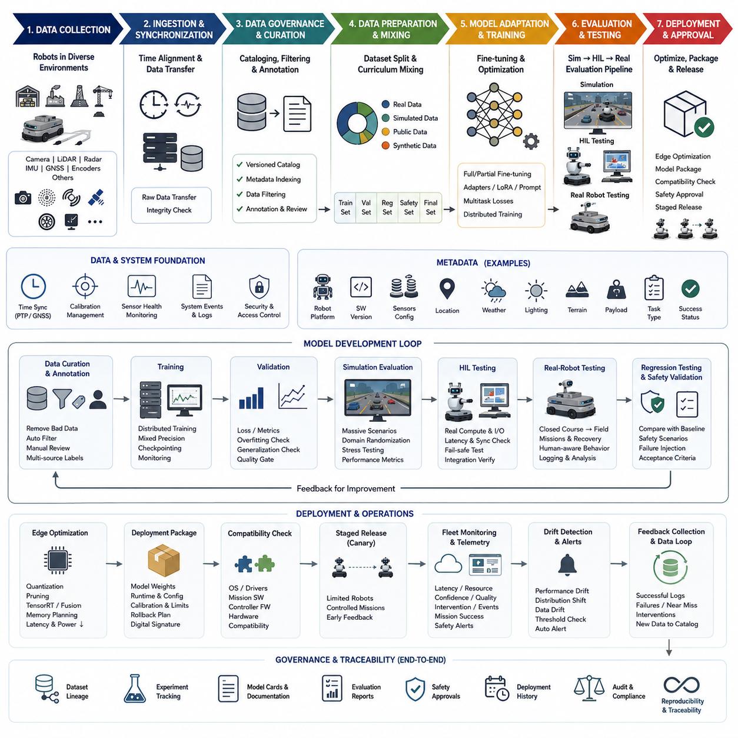
The Hills Robotics fine-tuning pipeline architecture is designed to transform a general-purpose robot foundation model into a reliable intelligence layer for indoor and outdoor autonomous mobile robots. The pipeline connects data collection, dataset governance, model adaptation, simulation validation, hardware-in-the-loop testing, edge optimization, deployment approval, and continuous monitoring within one traceable lifecycle.
The architecture begins with data acquisition from Hills Robotics platforms operating in warehouses, factories, logistics facilities, outdoor roads, construction environments, and controlled test sites. Cameras, LiDAR, radar, ultrasonic sensors, GNSS, IMU, wheel encoders, motor controllers, battery systems, and mission software generate synchronized observations that represent both robot behavior and environmental conditions.
A time-synchronization layer aligns multimodal data using hardware timestamps, Precision Time Protocol, GNSS time references, and trigger signals. Accurate alignment is essential because perception errors may originate from timing differences rather than model weaknesses. The pipeline therefore preserves raw timestamps, synchronization offsets, calibration versions, sensor health information, and communication latency together with every recorded mission.
The ingestion layer transfers recorded data from robot storage to local workstations, network-attached storage, and centralized training infrastructure. Large sensor streams are divided into mission-level packages containing raw observations, robot states, operator commands, system events, and environmental metadata. Integrity checks verify file completeness, timestamp continuity, checksum consistency, and compatibility with the expected data schema.
Dataset governance is implemented through a version-controlled data catalog. Each mission is indexed by robot platform, software version, sensor configuration, location, weather, lighting, terrain, payload, operator, task type, and success status. This metadata allows engineers to construct balanced training mixtures and prevents hidden duplication, uncontrolled data leakage, or accidental use of outdated calibration data.
The data curation stage removes corrupted records, long periods of inactivity, duplicated sequences, invalid sensor packets, and missions affected by unresolved hardware faults. Automated filters identify abnormal frame rates, missing LiDAR scans, unstable GNSS signals, excessive vibration, wheel-slip events, and inconsistent actuator feedback. Human reviewers then inspect representative samples and confirm whether unusual behavior should be excluded or preserved as a valuable failure case.
Annotation combines automated labeling, simulation-derived ground truth, existing detector outputs, operator feedback, and manual verification. Depending on the target model, labels may include object classes, free space, traversability, localization references, trajectories, control actions, collision risks, mission states, manipulation targets, and recovery decisions. Every annotation is connected to its source, confidence level, reviewer status, and revision history.
The pipeline separates data into training, validation, regression, safety, and final acceptance sets. Separation is performed at the mission, location, time, and robot level to prevent nearly identical sequences from appearing in multiple partitions. Rare hazards, difficult weather, sensor failures, emergency stops, and recovery situations are intentionally reserved for robustness testing rather than being absorbed entirely into the training distribution.
A data-mixing controller defines the proportion of real-world, simulated, public, and synthetically generated samples used during fine-tuning. Hills Robotics can increase the weight of platform-specific data while preserving broad capabilities learned from general robot datasets. Curriculum scheduling introduces common operating conditions first and gradually increases the frequency of difficult terrain, dynamic obstacles, incomplete observations, and long-horizon missions.
The model adaptation layer supports full fine-tuning, partial layer unfreezing, adapter modules, low-rank adaptation, prompt tuning, and other parameter-efficient methods. The selected strategy depends on available GPU memory, training cost, dataset size, and the risk of catastrophic forgetting. Safety-critical perception and control components may use conservative adaptation settings, while task-specific heads can be updated more aggressively.
Training objectives are configured according to the deployed capability. Perception models may optimize detection, segmentation, depth, tracking, and uncertainty losses. Navigation models may combine imitation learning, trajectory prediction, collision penalties, progress rewards, and smoothness constraints. Vision-language-action models may optimize action-token prediction, language grounding, temporal consistency, and successful completion of multi-step robot missions.
Distributed training infrastructure manages GPU allocation, mixed-precision computation, gradient accumulation, checkpointing, and recovery from interrupted jobs. Experiment configurations are stored with dataset versions, model weights, hyperparameters, random seeds, software dependencies, and hardware information. This ensures that every result can be reproduced and compared without relying on undocumented manual settings.
During training, monitoring services collect loss curves, validation metrics, gradient statistics, GPU utilization, memory consumption, data-loading speed, and checkpoint quality. Abnormal training behavior such as divergence, overfitting, unstable gradients, class imbalance, or decreasing generalization triggers alerts. Poor checkpoints are automatically rejected, while promising candidates proceed to structured evaluation.
Simulation evaluation is the first major validation gate. Fine-tuned models are tested across digital environments that reproduce Hills Robotics missions, sensor layouts, vehicle dynamics, payload configurations, and navigation constraints. Thousands of scenarios can vary illumination, surface friction, obstacle density, localization drift, communication delay, sensor noise, and pedestrian behavior without placing physical equipment at risk.
Hardware-in-the-loop testing connects the candidate model to real robot computers, controllers, and communication interfaces while some environmental or motion elements remain simulated. This stage verifies inference timing, message compatibility, synchronization, actuator command limits, fail-safe transitions, and computational stability. It also identifies integration problems that cannot be detected through offline dataset evaluation alone.
Real-robot testing proceeds through controlled laboratory trials, closed test areas, and representative operational environments. The model must demonstrate reliable localization, obstacle avoidance, path following, docking, mission execution, recovery, and human-aware behavior under realistic disturbances. All commands and decisions are logged so that engineers can reconstruct the exact sequence leading to success, delay, intervention, or failure.
Regression testing compares every candidate against the currently approved production model. Historical missions, previously solved edge cases, safety scenarios, localization challenges, and performance benchmarks are replayed automatically. Deployment is blocked when improvements in one area cause unacceptable degradation in another, even when the average score appears higher than the existing baseline.
Safety validation operates independently from general performance evaluation. Emergency stopping, speed limitation, restricted-zone compliance, collision avoidance, actuator fault handling, communication loss, sensor degradation, and manual takeover are tested under predefined acceptance criteria. The machine-learning model is never treated as the only safety mechanism, and deterministic safety controllers retain authority over hazardous motion.
Diagnostic tools support failure analysis by comparing input observations, intermediate features, confidence estimates, planned trajectories, control outputs, and final mission outcomes. Engineers can cluster recurring errors by environment, object type, sensor condition, or software version. These findings guide targeted data collection and reduce the need for broad, expensive retraining when a narrow correction is sufficient.
Before deployment, model optimization converts the approved checkpoint into a runtime suitable for Hills Robotics edge computers. Quantization, pruning, TensorRT compilation, operator fusion, memory planning, and batch-size tuning reduce latency and power consumption. The optimized model is re-evaluated because numerical compression can alter confidence values, rare-class performance, or safety margins even when average accuracy remains stable.
The deployment package includes model weights, runtime libraries, configuration files, calibration references, supported hardware definitions, safety limits, rollback instructions, and a digital signature. Version compatibility is checked against the robot operating system, mission software, sensor drivers, and controller firmware. Only approved combinations are allowed to enter field operation.
A staged release strategy limits initial deployment to selected robots and controlled missions. Canary robots provide early operational evidence before the model is distributed across the wider fleet. Telemetry services track inference latency, resource consumption, confidence distributions, intervention frequency, mission success, localization quality, and safety events while respecting data retention and security policies.
Continuous monitoring detects changes between the training environment and actual operations. New facilities, seasonal weather, altered floor conditions, different payloads, sensor aging, and software updates can gradually reduce performance. Drift indicators identify these changes and trigger additional review, data collection, or fine-tuning when operational metrics move beyond accepted thresholds.
Feedback from deployed robots returns to the data catalog as structured learning material. Successful missions improve coverage of normal operation, while failures, near misses, manual interventions, and recovery attempts receive higher review priority. This closed loop enables Hills Robotics to convert field experience into progressively stronger models without losing traceability between observed problems and corrective updates.
The complete architecture is governed by model cards, dataset documentation, experiment records, evaluation reports, safety approvals, and deployment histories. Every production model can therefore be traced back to its source data, training configuration, validation evidence, optimization procedure, and release decision. This traceability supports technical debugging, quality assurance, customer reporting, and future compliance requirements.
By integrating data engineering, model adaptation, simulation, physical testing, safety control, edge deployment, and fleet feedback, the Hills Robotics fine-tuning pipeline creates a repeatable path from raw robot experience to dependable autonomous behavior. The architecture allows specialized capabilities to evolve continuously while maintaining operational stability, computational efficiency, and confidence across different robot platforms and real-world environments.

