Volume 18 Physical AI Foundation Models

12. Foundation Model Case Studies

12.1 Mobile Manipulator RT-2 Style VLA Deployment Case
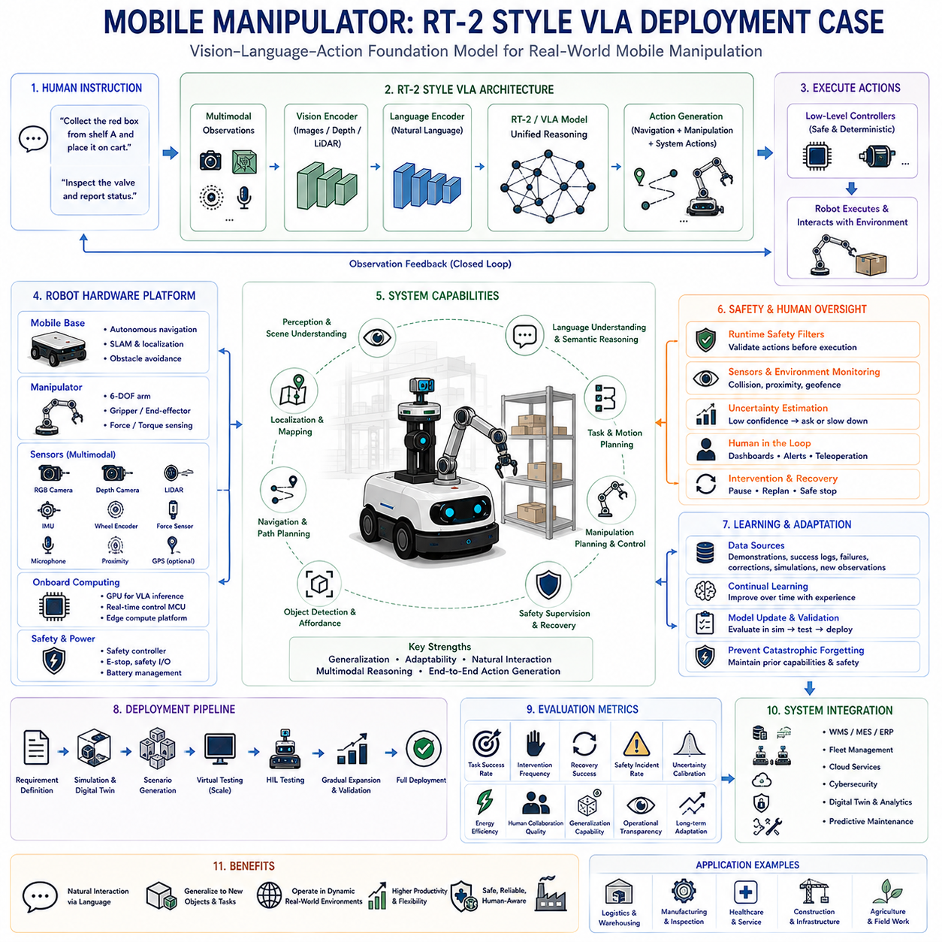
Vision-Language-Action models have transformed autonomous robotics by enabling a single foundation model to connect visual perception, natural language understanding, semantic reasoning, and robot control within one unified architecture. Rather than relying upon multiple independently engineered perception, planning, and control modules, a VLA system directly predicts robot actions from multimodal observations and human instructions. RT-2 demonstrated that internet-scale vision-language knowledge can significantly improve robotic reasoning and generalization, making it an influential reference architecture for modern mobile manipulator deployment.
A mobile manipulator combines an autonomous mobile robot with one or more robotic manipulators, creating a system capable of navigating complex environments while physically interacting with surrounding objects. Unlike stationary industrial robots operating inside predefined work cells, mobile manipulators continuously perceive changing environments, localize themselves, avoid obstacles, plan navigation paths, identify target objects, manipulate them safely, and recover from unexpected situations. These capabilities make them highly suitable for logistics, warehouse automation, healthcare, manufacturing, construction, inspection, agriculture, and service robotics.
Deploying an RT-2-style VLA architecture begins with defining operational objectives rather than selecting machine learning models. Engineers first identify target applications, expected environments, task complexity, manipulation requirements, navigation constraints, safety objectives, available computing resources, communication infrastructure, and acceptable operational risks. These high-level system requirements determine the overall architecture while preventing unnecessary model complexity that exceeds actual deployment needs.
The hardware architecture generally consists of a mobile base, robotic manipulator, multimodal sensor suite, onboard computing platform, communication interfaces, power management system, and safety supervision hardware. The mobile platform provides autonomous navigation, while the robotic arm performs manipulation tasks. RGB cameras, depth sensors, LiDAR, IMUs, wheel encoders, force sensors, microphones, GPS when appropriate, and proximity sensors collectively provide the multimodal observations required by the VLA model.
The onboard computing platform executes perception, reasoning, planning, and control with strict real-time constraints. Edge computing devices equipped with high-performance GPUs frequently host the VLA inference engine while lower-level motor controllers execute deterministic motion control independently. Separating high-level semantic reasoning from real-time control improves safety, latency, computational efficiency, and fault isolation without sacrificing intelligent decision making.
Sensor synchronization plays a critical role because multimodal reasoning requires temporally consistent observations across multiple sensing modalities. Cameras, LiDAR, depth sensors, inertial measurements, wheel odometry, and robot joint states should be synchronized through precise timestamp alignment before entering the perception pipeline. Accurate synchronization enables reliable world modeling while reducing inconsistencies introduced by asynchronous sensor measurements.
The perception pipeline transforms raw sensor observations into structured semantic representations suitable for foundation model reasoning. Object detection, semantic segmentation, depth estimation, scene understanding, human detection, free-space estimation, grasp candidate generation, localization, and environmental mapping collectively describe the robot's surroundings. Rather than operating as isolated perception modules, these representations provide contextual information supporting integrated vision-language reasoning.
Natural language instructions become another primary input to the VLA architecture. Human operators specify objectives using conversational commands rather than predefined programming interfaces. Instructions such as collecting packages, organizing shelves, delivering equipment, inspecting machinery, assisting personnel, or retrieving specified objects become semantic goals interpreted jointly with visual observations. The model reasons about both environmental context and linguistic intent before generating executable actions.
Semantic reasoning extends beyond direct object recognition by incorporating broad knowledge acquired during foundation model pretraining. Internet-scale image-language datasets enable robots to recognize unfamiliar objects, infer object affordances, understand contextual relationships, predict likely object locations, interpret human intentions, and generalize beyond explicitly trained robotic demonstrations. This transfer of general knowledge significantly expands operational flexibility compared with conventional task-specific robotics.
The world model continuously integrates observations collected throughout robot operation into an evolving representation of the surrounding environment. Static structures, dynamic obstacles, human motion, object locations, navigable space, manipulation opportunities, and environmental uncertainty become unified within a continuously updated internal state. The VLA model reasons over this evolving world representation when selecting future actions instead of relying solely upon instantaneous sensor observations.
Task planning emerges directly from multimodal reasoning rather than handcrafted symbolic workflows. After understanding environmental observations and human intent, the VLA architecture predicts intermediate objectives, navigation goals, manipulation sequences, safety constraints, and recovery behaviors that collectively maximize successful task completion. Although explicit symbolic planners may still complement deployment, foundation models increasingly perform high-level planning implicitly through learned reasoning.
Navigation planning operates simultaneously with manipulation planning because mobile manipulators continuously alternate between movement and physical interaction. The system predicts collision-free trajectories toward target locations while preserving sufficient workspace accessibility for subsequent manipulation. Dynamic obstacle avoidance, localization uncertainty, battery constraints, traffic management, and safety margins remain integrated within overall mission planning instead of being optimized independently.
Manipulation planning requires accurate estimation of object pose, grasp configuration, reachability, collision avoidance, force control, and execution sequencing. The VLA model predicts grasp strategies conditioned upon visual observations, language instructions, object properties, environmental context, and accumulated task history. Rather than selecting predefined grasp templates, learned manipulation policies adapt continuously to changing operational conditions.
Action generation represents the defining characteristic of VLA architectures because perception and reasoning directly produce executable robot actions. High-level semantic representations become navigation commands, manipulator trajectories, gripper operations, camera positioning, sensor activation, and communication requests. Intermediate symbolic translation layers become significantly simplified compared with traditional robotics software stacks, reducing engineering complexity while increasing behavioral flexibility.
Low-level motion control remains independent from foundation model reasoning despite high-level action generation. Deterministic controllers enforce velocity limits, joint constraints, collision avoidance, actuator protection, emergency stopping, force limitations, and motion smoothness. This layered architecture ensures that learned policies cannot directly violate fundamental safety constraints even if unexpected model predictions occur.
Safety supervision continuously monitors every stage of autonomous execution. Runtime safety filters verify predicted actions before execution while emergency stopping systems, collision detection, geofencing, human proximity monitoring, uncertainty estimation, and operational constraint verification independently supervise robot behavior. Safety mechanisms therefore remain separate from learned intelligence while providing redundant protection against unexpected failures.
Human oversight remains essential throughout deployment because autonomous reasoning inevitably encounters unfamiliar environments and ambiguous objectives. Operators monitor mission progress through visual dashboards, natural language explanations, confidence estimation, intervention interfaces, and remote teleoperation capabilities. The robot requests clarification whenever uncertainty exceeds acceptable operational thresholds, preserving both safety and collaborative human-robot interaction.
Continuous learning enables deployed robots to improve gradually through operational experience without requiring complete retraining after every new task. Human demonstrations, successful execution histories, failure cases, corrective interventions, simulation experience, and new environmental observations become valuable learning resources supporting future adaptation. Carefully controlled continual learning allows deployment performance to improve while minimizing catastrophic forgetting of previously acquired capabilities.
Simulation provides a critical deployment stage before physical operation begins. High-fidelity digital twins reproduce environmental layouts, dynamic obstacles, manipulation tasks, communication latency, sensor noise, lighting variation, weather conditions, and rare operational failures. Thousands of virtual missions validate navigation, manipulation, reasoning, safety supervision, and recovery behavior before real-world deployment, substantially reducing operational risk.
Field deployment proceeds incrementally through controlled operational expansion rather than immediate full-scale autonomy. Initial deployment often restricts operating speed, workspace complexity, task diversity, payload weight, and environmental variability while collecting extensive performance data. As validation evidence accumulates, operational boundaries gradually expand toward fully autonomous production environments with increasing confidence.
Evaluation metrics extend beyond traditional navigation accuracy or manipulation success rates. Task completion reliability, intervention frequency, recovery success, uncertainty calibration, energy efficiency, human collaboration quality, semantic reasoning accuracy, object generalization capability, safety incident rate, operational transparency, and long-term adaptation collectively characterize deployment effectiveness. Balanced evaluation across technical performance, operational safety, and human trust provides a realistic assessment of practical system capability.
Industrial deployment also requires integration with warehouse management systems, manufacturing execution systems, enterprise resource planning platforms, fleet management software, cloud services, cybersecurity infrastructure, digital twins, predictive maintenance systems, and operational analytics. RT-2-style architectures therefore function not as isolated robot controllers but as intelligent components within broader industrial automation ecosystems.
Future mobile manipulators will likely integrate larger foundation models, richer world models, multimodal memory systems, continual learning, collaborative multi-robot reasoning, predictive simulation, uncertainty-aware planning, explainable artificial intelligence, and cloud-edge hybrid computing. These developments will progressively transform robots from specialized automation machines into adaptable physical intelligence capable of understanding natural language, interpreting complex environments, learning from experience, and executing increasingly sophisticated manipulation tasks across diverse operational domains.
Ultimately, the deployment of an RT-2-style Vision-Language-Action architecture demonstrates a fundamental transition in robotics engineering. Instead of constructing independent perception, planning, reasoning, and control modules connected through manually engineered interfaces, modern Physical AI increasingly relies upon unified foundation models that directly transform multimodal observations and human intentions into intelligent actions. Combined with layered safety supervision, deterministic control, continual learning, and comprehensive system validation, this deployment paradigm establishes a scalable foundation for trustworthy mobile manipulation across real-world industrial and service applications.

12.2 Quadruped Foundation Model for Terrain Navigation Case
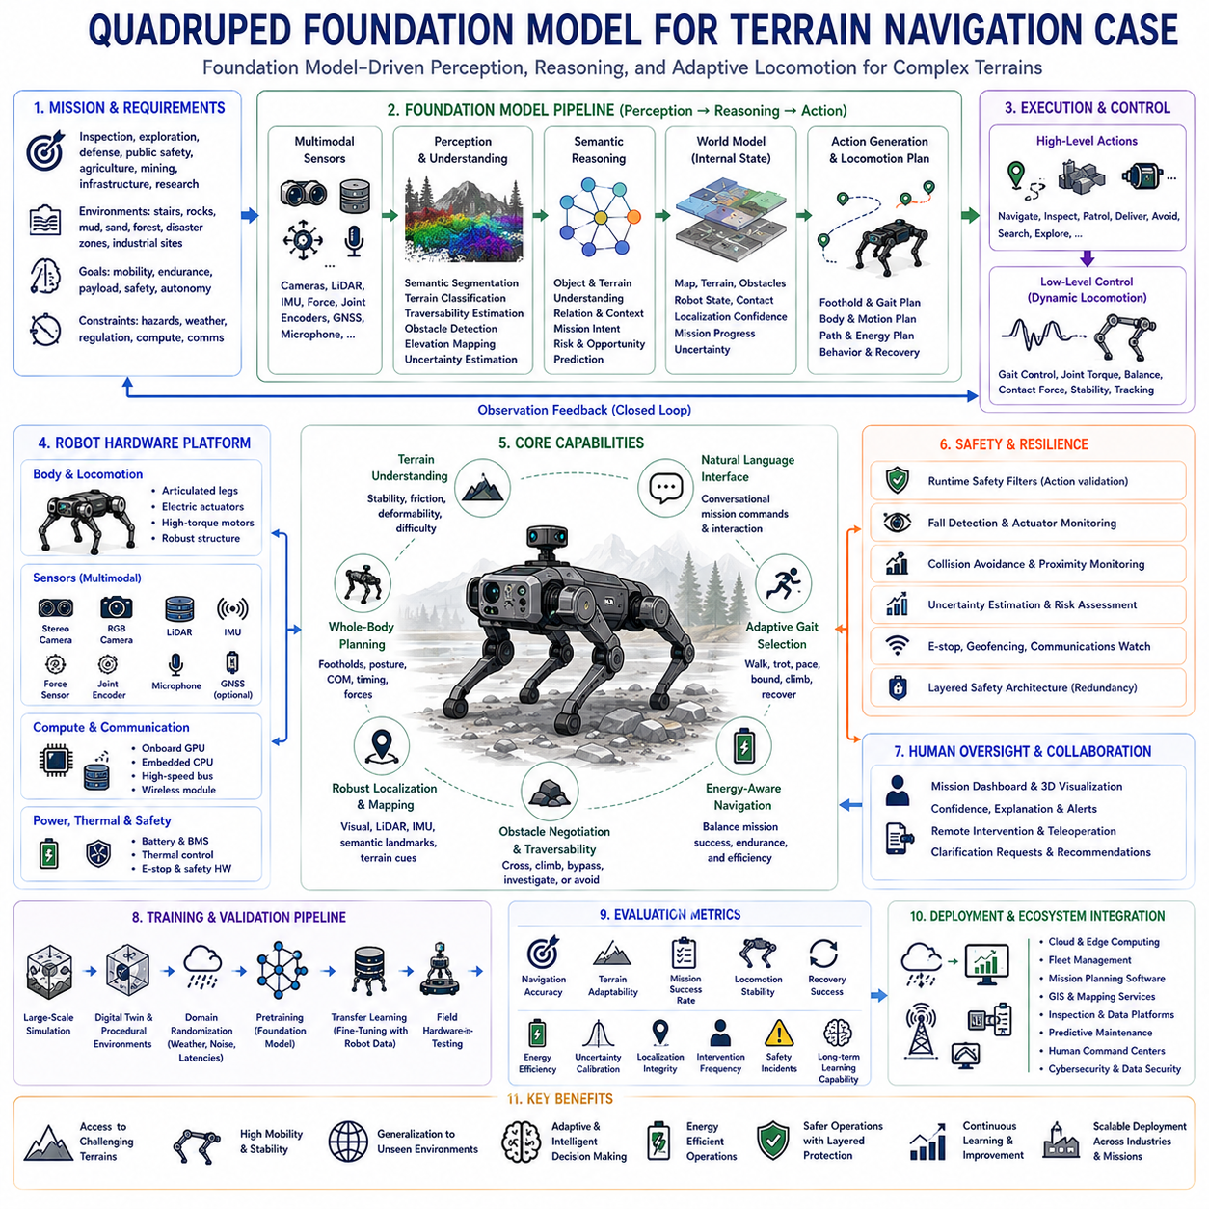
Quadruped robots have emerged as one of the most versatile Physical AI platforms because their four-legged locomotion enables stable movement across terrains that remain inaccessible to conventional wheeled or tracked robots. Their ability to traverse stairs, rocks, mud, sand, forests, construction sites, disaster areas, industrial facilities, and uneven natural environments makes them valuable for inspection, exploration, defense, public safety, agriculture, mining, infrastructure maintenance, and scientific research. As robotic intelligence advances beyond handcrafted control algorithms, foundation models are becoming increasingly important for enabling adaptive perception, reasoning, navigation, and decision making across diverse terrain conditions.
Traditional quadruped navigation systems typically consist of separate perception, localization, mapping, planning, locomotion, and control modules connected through manually engineered interfaces. Although modular architectures provide flexibility and deterministic behavior, they often struggle to generalize beyond conditions explicitly represented during development. Foundation models introduce a different paradigm by integrating multimodal perception, semantic reasoning, environmental understanding, and action generation within unified architectures capable of transferring knowledge across numerous operating environments.
Deploying a foundation model for quadruped terrain navigation begins by defining operational missions rather than selecting artificial intelligence architectures. Engineers identify expected environments, mobility objectives, payload requirements, operational endurance, communication infrastructure, environmental hazards, weather conditions, safety constraints, regulatory requirements, available computing resources, and expected levels of autonomy. These system-level objectives establish the design boundaries governing every subsequent hardware, software, and learning component throughout deployment.
The robotic hardware platform forms the physical foundation supporting autonomous intelligence. Typical quadruped systems integrate articulated legs, electric actuators, high-bandwidth motor controllers, force sensors, joint encoders, inertial measurement units, stereo cameras, RGB cameras, depth sensors, LiDAR, microphones, GNSS receivers when available, wireless communication modules, onboard GPUs, embedded processors, battery management systems, thermal control, and emergency safety mechanisms. These components collectively provide the sensing and actuation capabilities required for intelligent mobility.
Reliable sensor synchronization becomes particularly important because locomotion decisions depend upon precise temporal alignment between visual observations, inertial measurements, joint states, force sensing, terrain contact information, and environmental perception. Even small synchronization errors may accumulate into localization drift, unstable gait generation, inaccurate terrain estimation, or delayed obstacle avoidance. Accurate timestamp management therefore represents a fundamental engineering requirement supporting trustworthy autonomous navigation.
The perception pipeline continuously transforms multimodal sensor observations into structured environmental understanding. Semantic segmentation, terrain classification, traversability estimation, obstacle detection, free-space analysis, elevation mapping, object recognition, human detection, weather assessment, and environmental uncertainty estimation collectively describe the surrounding world. Rather than producing isolated perception outputs, these representations provide contextual knowledge supporting integrated reasoning throughout autonomous navigation.
Foundation models extend perception beyond recognizing individual objects by interpreting semantic relationships across entire environments. Instead of merely identifying rocks, stairs, vegetation, puddles, or debris independently, the model reasons about how these environmental features collectively influence mobility, stability, safety, mission efficiency, and potential future hazards. This higher-level environmental understanding enables robots to anticipate navigation challenges before encountering them physically.
Natural language interfaces introduce additional flexibility by allowing human operators to specify complex navigation objectives conversationally. Commands such as inspect damaged pipelines, avoid unstable ground, search collapsed structures, patrol designated regions, deliver emergency supplies, or prioritize energy-efficient routes become semantic mission descriptions rather than manually programmed navigation sequences. Foundation models interpret these instructions jointly with environmental observations before generating autonomous behavior.
The internal world model continuously integrates observations collected throughout robot operation into an evolving representation of surrounding terrain and mission context. Static structures, dynamic obstacles, surface properties, elevation changes, weather effects, traversability estimates, localization confidence, mission progress, and uncertainty become unified within a continuously updated environmental model. Future navigation decisions therefore depend not only upon current observations but also upon accumulated operational experience throughout the mission.
Terrain understanding represents one of the defining advantages of foundation-model-based navigation. Rather than classifying terrain using predefined categories alone, foundation models learn continuous semantic representations describing stability, friction, deformability, obstacle complexity, expected energy expenditure, and locomotion difficulty. Similar terrain conditions encountered during pretraining contribute transferable knowledge that improves navigation within previously unseen environments.
Locomotion planning combines semantic reasoning with dynamic robot stability. Instead of generating only geometric paths, the navigation system predicts foothold placement, gait transitions, body posture adaptation, center-of-mass movement, step timing, contact force distribution, and energy-efficient motion sequences appropriate for surrounding terrain. Navigation therefore becomes an integrated whole-body planning problem rather than simple route optimization.
Adaptive gait selection enables quadruped robots to modify locomotion strategies continuously according to changing environmental conditions. Walking, trotting, pacing, bounding, climbing, cautious stepping, obstacle negotiation, slope traversal, and recovery behaviors emerge dynamically according to terrain characteristics rather than remaining fixed throughout an entire mission. Foundation models assist gait selection by reasoning over semantic environmental context rather than relying exclusively upon handcrafted threshold rules.
Energy-aware navigation significantly influences long-duration field operations because battery capacity remains limited. Foundation models estimate terrain difficulty, expected power consumption, mission priorities, environmental uncertainty, and alternative routes before selecting energy-efficient trajectories. Rather than minimizing travel distance alone, autonomous navigation balances mission success, operational endurance, safety margins, and resource utilization simultaneously.
Obstacle negotiation extends beyond simple collision avoidance. Fallen trees, loose rocks, debris fields, collapsed structures, water crossings, unstable soil, narrow passages, moving humans, vehicles, and temporary construction barriers require adaptive decision making rather than deterministic obstacle rejection. Foundation models evaluate whether obstacles should be crossed, avoided, climbed, bypassed, or investigated according to mission objectives and operational risk.
Localization remains challenging because outdoor and disaster environments frequently contain degraded GNSS availability, dynamic terrain, sparse visual features, smoke, dust, darkness, or structural collapse. Foundation models integrate visual odometry, inertial navigation, terrain recognition, semantic landmarks, LiDAR observations, and prior environmental knowledge to improve localization robustness despite uncertain sensing conditions. Multiple complementary information sources reduce dependence upon any individual localization technology.
Safety supervision operates independently from learned navigation policies to guarantee fundamental operational constraints. Runtime safety filters evaluate predicted actions before execution while fall detection, actuator monitoring, thermal protection, communication supervision, emergency stopping, uncertainty estimation, collision prevention, and human proximity monitoring provide redundant protection throughout autonomous operation. Layered safety architecture prevents unsafe behavior even when learned models encounter unfamiliar conditions.
Human oversight remains important despite increasing autonomous capability. Operators supervise missions through visual interfaces, semantic maps, confidence estimates, natural language summaries, remote intervention tools, and teleoperation functions whenever necessary. Foundation models support collaboration by explaining navigation decisions, identifying uncertainty sources, requesting clarification, and recommending alternative mission strategies instead of operating as completely opaque autonomous systems.
Simulation provides extensive opportunities for training and validation before real-world deployment. Large-scale terrain generation, digital twins, procedural environment creation, weather simulation, sensor noise modeling, dynamic obstacle generation, communication latency, actuator degradation, and rare failure scenarios collectively expose foundation models to diverse experiences that would be impractical or dangerous to reproduce exclusively through physical experiments.
Transfer learning bridges simulation and real-world deployment by adapting pretrained foundation models using relatively small quantities of robot-specific operational data. Instead of training navigation intelligence entirely from scratch, organizations fine-tune existing representations using local terrain observations, hardware characteristics, environmental conditions, and mission requirements. This significantly reduces data collection costs while accelerating deployment across new robotic platforms.
Evaluation metrics extend beyond conventional navigation accuracy by measuring terrain adaptability, mission completion reliability, locomotion stability, recovery success, energy efficiency, uncertainty calibration, localization integrity, environmental generalization, operator intervention frequency, safety incidents, operational transparency, and long-term learning capability. Comprehensive evaluation reflects practical deployment performance rather than isolated laboratory benchmarks.
Real-world deployment frequently integrates quadruped robots into broader operational ecosystems including cloud computing platforms, digital twins, fleet management systems, mission planning software, geographic information systems, inspection databases, predictive maintenance platforms, communication infrastructure, and human command centers. Foundation models therefore operate within collaborative intelligent systems rather than isolated robotic platforms.
Future quadruped navigation will increasingly combine foundation models, world models, reinforcement learning, multimodal memory, continual learning, cloud-edge collaboration, uncertainty-aware planning, explainable artificial intelligence, collaborative multi-robot coordination, and predictive simulation into unified Physical AI architectures. These integrated systems will progressively enable robots to understand complex environments, reason about long-term mission objectives, learn continuously from operational experience, and adapt safely to rapidly changing real-world conditions.
Ultimately, deploying foundation models for quadruped terrain navigation represents a significant transition from manually engineered robotic intelligence toward generalized Physical AI capable of understanding and interacting with natural environments through unified multimodal reasoning. By integrating semantic perception, world modeling, adaptive locomotion, safety supervision, continual learning, and human collaboration within a single deployment architecture, quadruped robots become increasingly capable of performing complex field operations safely, efficiently, and autonomously across diverse environments that have historically remained beyond the reach of conventional robotic systems.

12.3 Humanoid GR00T Style Foundation Model Case
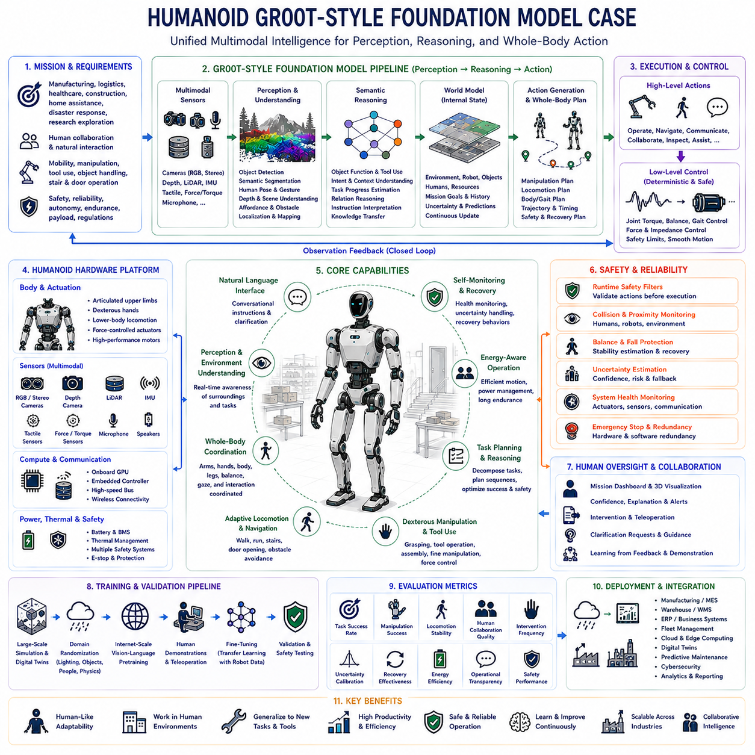
Humanoid robots represent one of the most ambitious embodiments of Physical AI because they combine human-like morphology with advanced perception, reasoning, manipulation, locomotion, and decision-making capabilities. Unlike industrial robots designed for narrowly defined repetitive operations, humanoid systems are expected to function within environments originally created for humans without requiring extensive infrastructure modification. Their ability to operate tools, manipulate common objects, navigate stairs, open doors, communicate naturally, and collaborate with people makes them promising platforms for manufacturing, logistics, healthcare, construction, domestic assistance, disaster response, and scientific exploration. Foundation models inspired by architectures such as NVIDIA GR00T demonstrate how large-scale multimodal intelligence can become the cognitive core enabling these highly adaptable robotic systems.
Traditional humanoid control architectures separate perception, localization, planning, manipulation, locomotion, task scheduling, and language processing into independently developed software modules. Although this modular engineering approach offers deterministic behavior and relatively straightforward debugging, it often struggles to generalize across unfamiliar environments or previously unseen tasks. GR00T-style foundation models introduce a unified learning paradigm in which multimodal perception, semantic reasoning, world understanding, language comprehension, and action generation emerge from a shared representation learned from extremely diverse datasets collected across simulated environments, real robots, internet-scale vision-language resources, and human demonstrations.
Successful deployment begins with defining operational missions instead of selecting machine learning architectures. Engineers first identify expected workplace environments, task diversity, manipulation requirements, mobility expectations, human interaction frequency, safety objectives, computational resources, communication infrastructure, battery endurance, payload capacity, operational regulations, and long-term deployment goals. These system-level requirements determine hardware selection, software architecture, model capacity, sensor configuration, and deployment strategy while ensuring that engineering complexity remains proportional to practical operational needs.
The humanoid hardware platform provides the physical embodiment through which foundation model intelligence interacts with the surrounding world. Typical systems integrate articulated upper limbs, dexterous hands, lower-body locomotion mechanisms, force-controlled actuators, joint encoders, inertial measurement units, stereo cameras, RGB cameras, depth sensors, LiDAR when appropriate, tactile sensing, force-torque sensors, microphones, speakers, wireless communication systems, onboard GPUs, embedded controllers, battery management systems, thermal regulation, and multiple independent safety mechanisms. Together these components provide rich multimodal observations together with precise physical interaction capabilities.
Reliable synchronization across sensing modalities represents a fundamental engineering requirement because humanoid decision making depends upon temporally consistent visual observations, joint states, tactile feedback, inertial measurements, force sensing, language input, and environmental context. Accurate timestamp alignment enables coherent world understanding while reducing inconsistencies caused by asynchronous sensor acquisition. High-quality synchronization becomes particularly important during complex whole-body manipulation where multiple sensor streams continuously influence dynamic control decisions.
The perception pipeline transforms raw multimodal observations into structured semantic understanding of both surrounding environments and ongoing tasks. Object detection, semantic segmentation, human pose estimation, gesture recognition, scene understanding, depth estimation, object affordance prediction, obstacle detection, free-space estimation, localization, and environmental mapping collectively describe operational context. Rather than functioning as isolated perception algorithms, these representations become integrated inputs supporting unified reasoning throughout the foundation model.
Language understanding allows human operators to communicate naturally using conversational instructions instead of predefined command interfaces. Requests such as organize these components, inspect this equipment, assemble the requested product, prepare the workstation, assist the technician, or transport these materials become semantic objectives interpreted jointly with visual observations and environmental context. Natural language therefore becomes a flexible interface connecting human intentions with autonomous robotic behavior.
Foundation models extend perception through semantic reasoning acquired during large-scale multimodal pretraining. Instead of recognizing only explicitly trained objects, humanoid robots infer object functionality, predict human intentions, understand contextual relationships, recognize unfamiliar tools, estimate task progression, interpret ambiguous instructions, and transfer knowledge across domains without requiring extensive task-specific programming. This broad knowledge transfer substantially increases operational adaptability compared with conventional robot software architectures.
The internal world model continuously integrates observations collected throughout operation into an evolving representation describing the robot, surrounding environment, ongoing task, human collaborators, available resources, and mission objectives. Static structures, dynamic obstacles, manipulated objects, human movement, workspace organization, environmental uncertainty, historical observations, and predicted future states become unified within a continuously updated internal representation. Future reasoning therefore depends upon accumulated contextual knowledge rather than isolated instantaneous observations.
Task planning emerges from integrated multimodal reasoning rather than manually engineered symbolic workflows. After interpreting environmental observations and human intentions, the foundation model predicts intermediate objectives, manipulation sequences, navigation goals, safety constraints, collaboration strategies, and recovery procedures that collectively maximize successful task completion. Explicit symbolic planning may continue supporting deployment, but foundation models increasingly perform high-level reasoning directly through learned internal representations.
Whole-body coordination represents one of the defining characteristics of humanoid intelligence because manipulation and locomotion occur simultaneously rather than independently. Arm trajectories, hand configuration, body posture, center-of-mass movement, balance control, foot placement, visual attention, force regulation, and obstacle avoidance remain tightly coupled throughout execution. Foundation models coordinate these multiple degrees of freedom by reasoning over complete body state instead of optimizing isolated subsystems individually.
Dexterous manipulation requires coordinated control of perception, grasp planning, tactile feedback, force regulation, object stability, collision avoidance, and task sequencing. Humanoid foundation models predict manipulation strategies conditioned upon visual observations, object geometry, semantic understanding, language instructions, historical experience, and environmental context. Instead of selecting predefined motion primitives, learned manipulation policies continuously adapt to variations encountered during real-world interaction.
Locomotion planning extends beyond simple navigation by incorporating balance maintenance, terrain adaptation, obstacle negotiation, stair climbing, narrow passage traversal, turning, body stabilization, and coordinated manipulation while walking. Whole-body mobility allows humanoid robots to access workspaces specifically designed for humans without requiring dedicated robotic infrastructure. Foundation models improve locomotion by reasoning about environmental semantics together with physical stability constraints.
Action generation directly transforms multimodal reasoning into executable whole-body behavior. High-level semantic representations become arm trajectories, hand movements, walking commands, gaze direction, body posture adjustments, communication responses, manipulation actions, and collaborative behaviors. Traditional software pipelines requiring numerous intermediate symbolic translation layers become substantially simplified because the foundation model predicts integrated behavioral policies spanning perception through action.
Despite increasingly capable foundation models, deterministic low-level control remains essential for guaranteeing safe physical execution. Joint torque limits, actuator protection, balance controllers, emergency stopping, collision avoidance, force limitations, motion smoothness, thermal protection, and velocity constraints operate independently from learned reasoning. Layered control architecture therefore combines adaptive intelligence with predictable physical safety throughout operation.
Safety supervision continuously evaluates every predicted action before execution. Runtime safety filters verify manipulation feasibility, collision risk, human proximity, balance stability, environmental hazards, actuator integrity, localization confidence, communication health, and operational constraints. Independent monitoring systems ensure that unexpected model outputs cannot directly produce unsafe physical behavior even under unfamiliar operating conditions.
Human oversight remains an essential component of deployment because humanoid robots frequently collaborate directly with people. Operators supervise execution through multimodal dashboards, semantic world visualization, confidence estimation, natural language explanations, intervention interfaces, and teleoperation capabilities. Whenever uncertainty exceeds predefined thresholds, the robot requests clarification, additional observations, or human approval before continuing autonomous operation.
Continual learning enables deployed humanoid robots to improve progressively from operational experience without retraining complete foundation models after every new task. Human demonstrations, corrective interventions, successful execution histories, simulation experience, failure analysis, environmental adaptation, and newly collected multimodal observations provide valuable learning resources supporting continual capability expansion while minimizing catastrophic forgetting of previously acquired knowledge.
Simulation provides an indispensable development environment because safely collecting sufficient humanoid training data entirely through physical experimentation remains impractical. Large-scale digital twins reproduce factories, warehouses, homes, hospitals, offices, disaster environments, and industrial facilities while introducing randomized lighting, object arrangements, human behavior, sensor noise, communication latency, actuator degradation, and rare failure scenarios. Foundation models acquire broad operational experience before transitioning into physical deployment.
Transfer learning significantly accelerates deployment by adapting pretrained foundation models using relatively limited robot-specific datasets. Instead of training perception, reasoning, manipulation, and language capabilities independently, organizations fine-tune unified multimodal representations using local operational data reflecting specific hardware characteristics, workplace environments, task requirements, and organizational workflows. This substantially reduces development cost while improving scalability across multiple humanoid platforms.
Evaluation metrics extend beyond manipulation accuracy or navigation performance by measuring task completion reliability, human collaboration quality, semantic reasoning capability, language understanding, manipulation success, locomotion stability, uncertainty calibration, recovery effectiveness, intervention frequency, operational transparency, energy efficiency, long-term adaptation, and overall safety performance. Balanced multidimensional evaluation provides a realistic assessment of practical deployment readiness rather than emphasizing isolated benchmark scores.
Industrial deployment requires seamless integration with manufacturing execution systems, warehouse management systems, enterprise resource planning platforms, fleet management software, cloud computing infrastructure, cybersecurity services, digital twins, predictive maintenance platforms, quality management systems, and operational analytics. Humanoid foundation models therefore function as intelligent participants within larger industrial ecosystems instead of isolated robotic devices.
Future GR00T-style humanoid foundation models will increasingly integrate larger multimodal architectures, world models, long-term memory, continual learning, collaborative multi-robot reasoning, uncertainty-aware planning, explainable artificial intelligence, cloud-edge hybrid computing, predictive simulation, and autonomous skill acquisition. These advances will progressively enable robots to understand complex environments, acquire new capabilities through experience, communicate naturally with humans, and safely perform increasingly sophisticated physical tasks across diverse industries.
Ultimately, GR00T-style foundation model deployment represents a major transition from manually engineered humanoid control systems toward unified Physical AI capable of integrating perception, language, reasoning, planning, locomotion, manipulation, memory, and collaboration within a single multimodal intelligence architecture. Combined with deterministic safety mechanisms, layered control, continual learning, comprehensive validation, and human oversight, this deployment paradigm establishes a scalable foundation for trustworthy humanoid robotics capable of operating safely, intelligently, and adaptively throughout real-world industrial and human-centered environments.

12.4 Cargo UAV World Model Flight Planning Case
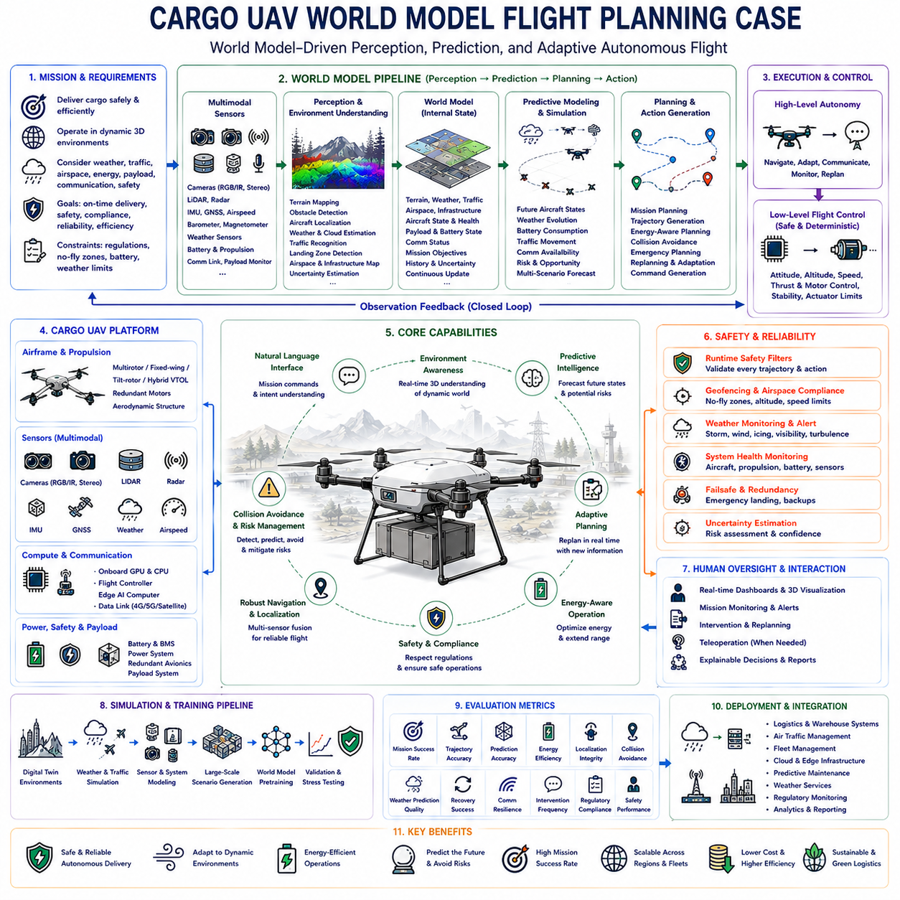
Cargo unmanned aerial vehicles represent one of the most demanding applications of Physical AI because autonomous flight requires continuous perception, prediction, decision making, and control while operating within highly dynamic three-dimensional environments. Unlike ground robots that interact primarily with relatively structured surfaces, cargo UAVs must simultaneously consider terrain elevation, weather conditions, air traffic, restricted airspace, communication availability, battery limitations, payload dynamics, emergency landing opportunities, and rapidly changing atmospheric conditions. As cargo transportation expands toward larger autonomous aircraft, world models are becoming essential cognitive components that enable intelligent flight planning beyond conventional waypoint navigation.
Traditional autonomous flight systems generally separate perception, localization, mapping, trajectory planning, collision avoidance, mission management, and flight control into independent software modules. Although this modular architecture provides deterministic behavior and regulatory transparency, it often struggles to generalize across unfamiliar environments or rapidly changing operational conditions. World-model-based foundation architectures introduce a unified reasoning framework in which multimodal observations, environmental understanding, predictive simulation, and action planning are integrated into continuously evolving internal representations supporting adaptive autonomous flight.
Successful deployment begins by defining operational objectives before selecting artificial intelligence models. Engineers first identify aircraft class, payload capacity, mission duration, cruising altitude, operational range, communication infrastructure, weather tolerance, regulatory restrictions, airspace classification, safety requirements, navigation accuracy, available computational resources, and expected autonomy level. These system-level requirements determine both hardware architecture and world model capability while ensuring that deployment remains aligned with practical operational constraints.
The cargo UAV platform integrates aerodynamic structures, propulsion systems, flight control computers, onboard GPUs, embedded processors, battery management systems, power distribution units, communication equipment, redundant avionics, environmental sensors, safety mechanisms, and payload management systems. Depending upon aircraft size, propulsion may consist of multirotor configurations, fixed-wing systems, tilt-rotor architectures, or hybrid vertical takeoff and landing platforms. Every hardware component contributes observations that collectively support intelligent flight planning throughout mission execution.
Multimodal sensing provides comprehensive situational awareness during autonomous operation. RGB cameras, infrared cameras, stereo vision systems, LiDAR, radar, inertial measurement units, GNSS receivers, airspeed sensors, barometers, magnetometers, weather sensors, propulsion diagnostics, battery monitoring systems, communication quality indicators, and payload monitoring collectively describe both internal aircraft state and surrounding environmental conditions. Sensor synchronization remains essential because predictive reasoning depends upon temporally consistent observations across every sensing modality.
The perception pipeline continuously transforms raw observations into structured environmental understanding. Terrain mapping, obstacle detection, aircraft localization, weather estimation, cloud identification, air traffic recognition, landing zone detection, infrastructure mapping, environmental uncertainty estimation, and semantic scene understanding collectively describe the operational environment. These representations provide meaningful contextual information rather than isolated sensor measurements, allowing subsequent reasoning modules to understand both immediate conditions and broader mission context.
Natural language interfaces enable human operators to communicate high-level mission objectives without manually programming every navigation detail. Commands such as deliver medical supplies to the designated clinic, avoid severe weather systems, prioritize energy efficiency, maintain communication coverage, inspect remote infrastructure during transit, or reroute around restricted airspace become semantic mission descriptions interpreted jointly with environmental observations. Language therefore becomes another information source supporting intelligent flight planning.
The world model functions as the central cognitive representation integrating every available source of information throughout flight. Static terrain, dynamic weather systems, moving aircraft, restricted airspace, communication infrastructure, emergency landing locations, payload condition, battery state, mission objectives, historical observations, environmental uncertainty, and predicted future events become unified within a continuously updated internal model. Autonomous reasoning therefore extends far beyond instantaneous perception by incorporating accumulated operational knowledge and predictive simulation.
Predictive environmental modeling represents one of the defining advantages of world-model-based flight planning. Instead of merely reacting to currently observed conditions, the system continuously predicts future aircraft states, weather evolution, battery consumption, traffic movement, communication availability, payload stability, and environmental changes across multiple possible future trajectories. Anticipating future conditions enables proactive decision making rather than reactive emergency responses after hazards have already developed.
Mission planning becomes a dynamic optimization process integrating operational objectives, environmental conditions, safety constraints, energy consumption, payload priorities, regulatory compliance, and expected uncertainty. Rather than following predetermined waypoint sequences, the world model continuously updates mission strategies according to newly observed information while preserving overall mission intent. Adaptive planning substantially improves robustness within unpredictable operational environments.
Trajectory generation extends beyond shortest-path optimization by considering aircraft performance limitations, aerodynamic efficiency, weather forecasts, obstacle avoidance, no-fly zones, communication reliability, emergency landing accessibility, payload stability, and battery reserve margins simultaneously. Every predicted flight path is evaluated according to multiple competing objectives before selecting the safest and most efficient trajectory consistent with mission requirements.
Weather understanding plays a particularly important role because atmospheric conditions directly influence aerodynamic performance and operational safety. Wind fields, turbulence, precipitation, icing conditions, visibility, temperature gradients, thunderstorms, cloud development, and localized microclimate effects become integrated into world model reasoning rather than remaining isolated weather observations. Predictive weather reasoning enables autonomous aircraft to avoid hazardous atmospheric regions before encountering dangerous conditions.
Energy-aware flight planning continuously estimates battery consumption throughout every candidate mission trajectory. Payload weight, wind resistance, altitude changes, maneuver intensity, propulsion efficiency, reserve requirements, emergency contingencies, and alternative landing opportunities all influence predicted energy expenditure. World models therefore optimize flight according to total mission feasibility rather than minimizing travel distance alone.
Collision avoidance extends beyond detecting nearby obstacles by predicting future interactions among multiple dynamic agents. Other aircraft, birds, drones, helicopters, tall structures, construction cranes, communication towers, and unexpected airborne objects become components within predictive environmental simulation. The world model evaluates alternative avoidance maneuvers while preserving mission objectives and maintaining regulatory compliance throughout autonomous flight.
Localization combines multiple complementary information sources because GNSS alone cannot always provide sufficient reliability. Visual odometry, inertial navigation, terrain matching, map alignment, radar observations, LiDAR localization, semantic landmarks, communication-based positioning, and historical environmental knowledge collectively improve navigation robustness under degraded satellite reception or challenging environmental conditions. Redundant localization significantly increases operational reliability.
Safety supervision operates independently from learned reasoning to guarantee compliance with fundamental aviation constraints. Runtime safety filters verify every predicted trajectory while geofencing, altitude limitations, speed restrictions, aircraft health monitoring, redundancy management, emergency landing planning, communication supervision, propulsion diagnostics, uncertainty estimation, and regulatory constraint verification continuously protect flight operations. Layered safety architecture ensures that adaptive intelligence cannot violate essential operational safety requirements.
Human oversight remains indispensable for cargo aviation despite increasing autonomous capability. Operators monitor missions through real-time dashboards, three-dimensional world visualization, weather forecasts, confidence estimation, explainable decision summaries, fleet management systems, intervention interfaces, and emergency teleoperation capabilities whenever required. The aircraft requests operator confirmation whenever predicted uncertainty exceeds acceptable operational thresholds or regulatory requirements mandate human authorization.
Simulation forms an essential stage of world model development because safely exposing physical aircraft to every hazardous scenario remains impractical. High-fidelity digital twins reproduce terrain, airports, weather systems, communication failures, propulsion degradation, sensor noise, emergency conditions, traffic density, infrastructure, and rare environmental events. Millions of simulated flight hours expose foundation models to operational experiences that would be prohibitively expensive or unsafe to reproduce entirely through physical testing.
Transfer learning accelerates deployment by adapting pretrained world models using relatively limited aircraft-specific operational data. Instead of constructing complete predictive models independently for every aircraft platform, organizations fine-tune shared representations using local weather patterns, propulsion characteristics, payload behavior, regional terrain, operational procedures, and regulatory environments. Knowledge transfer substantially reduces engineering cost while improving scalability across diverse cargo UAV platforms.
Evaluation extends beyond conventional flight accuracy metrics by measuring mission completion reliability, predictive accuracy, localization integrity, weather prediction quality, uncertainty calibration, collision avoidance effectiveness, emergency recovery success, energy efficiency, communication resilience, regulatory compliance, operational transparency, human intervention frequency, and long-term adaptive performance. Comprehensive evaluation provides realistic understanding of operational readiness rather than isolated subsystem performance.
Industrial deployment integrates cargo UAVs into broader logistics ecosystems including warehouse management systems, air traffic management infrastructure, enterprise resource planning platforms, cloud computing services, fleet management systems, predictive maintenance platforms, weather forecasting services, digital twins, communication infrastructure, regulatory monitoring systems, and operational analytics. World-model-based flight planning therefore functions as one intelligent component within large-scale autonomous logistics networks.
Future cargo UAV systems will increasingly integrate foundation models, world models, reinforcement learning, multimodal memory, continual learning, collaborative multi-aircraft coordination, cloud-edge hybrid intelligence, uncertainty-aware reasoning, explainable artificial intelligence, autonomous mission negotiation, and predictive digital twins into unified aviation intelligence architectures. These technologies will progressively enable cargo aircraft to reason about complex operational environments, learn continuously from accumulated experience, coordinate intelligently with other autonomous systems, and safely execute increasingly sophisticated logistics missions with minimal human intervention.
Ultimately, world-model-based cargo UAV flight planning represents a fundamental transition from reactive autonomous navigation toward predictive Physical AI capable of understanding, simulating, and reasoning about the future before executing physical actions. By integrating multimodal perception, semantic environmental understanding, predictive world modeling, adaptive planning, layered safety supervision, continual learning, human oversight, and comprehensive system validation within a unified deployment architecture, cargo UAVs become increasingly capable of delivering reliable, scalable, and trustworthy autonomous air transportation across complex real-world environments.

12.5 Cross Robot Foundation Model Transfer Case
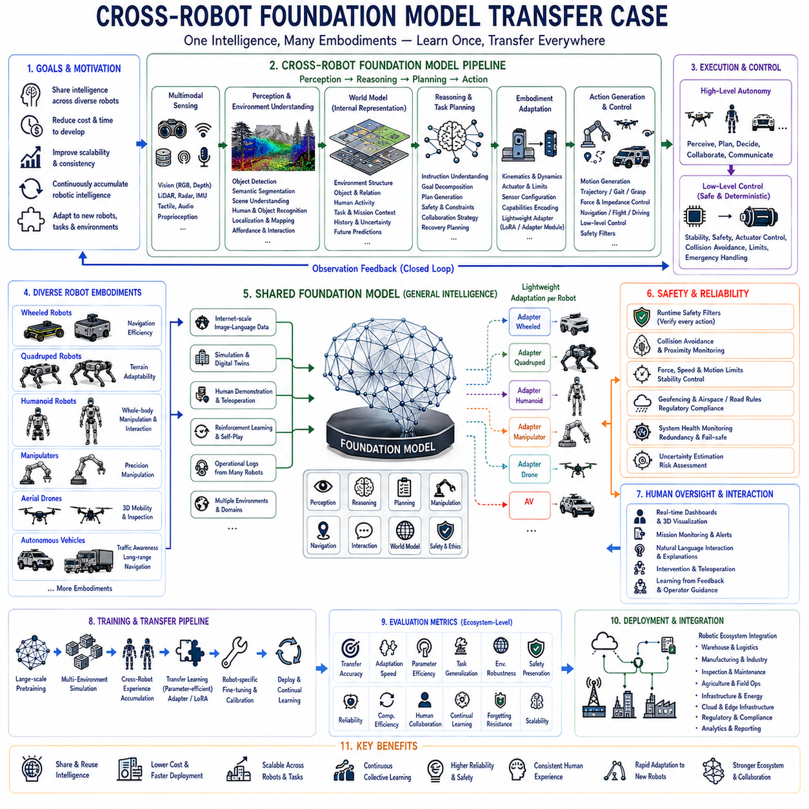
Cross-robot foundation model transfer represents one of the most significant advances in Physical AI because it enables knowledge acquired by one robotic platform to be efficiently adapted to entirely different robots with minimal additional training. Instead of developing independent artificial intelligence systems for every robot type, organizations increasingly rely on shared foundation models that capture general perception, reasoning, planning, manipulation, navigation, and interaction capabilities. This transfer paradigm dramatically reduces development cost, accelerates deployment, improves scalability, and enables continuous accumulation of robotic intelligence across diverse hardware platforms operating in different environments.
Traditional robotics has typically relied upon task-specific software stacks tightly coupled to individual hardware configurations. Manipulation algorithms, navigation systems, perception pipelines, and control architectures were frequently customized for particular sensors, actuators, kinematic structures, computing platforms, and operational environments. While these specialized systems often achieved excellent performance within narrowly defined applications, transferring capabilities between wheeled robots, quadrupeds, humanoids, manipulators, drones, or autonomous vehicles required extensive redevelopment. Foundation models fundamentally change this engineering paradigm by separating high-level intelligence from platform-specific execution.
The deployment process begins by defining common capabilities that should remain transferable across robotic platforms. Engineers identify perception objectives, semantic reasoning requirements, language understanding, world modeling, task planning, safety constraints, manipulation objectives, navigation behaviors, collaboration strategies, and human interaction requirements independently from individual robot hardware. This abstraction establishes a platform-agnostic intelligence layer capable of supporting multiple embodiments through appropriate adaptation interfaces.
A shared foundation model typically learns from extremely diverse multimodal datasets collected across internet-scale image-language resources, simulation environments, digital twins, human demonstrations, teleoperation sessions, reinforcement learning, operational robot logs, and multiple physical platforms. Exposure to heterogeneous observations enables the model to acquire generalized representations describing objects, environments, human behavior, physical interactions, task structures, semantic relationships, and decision-making strategies applicable across numerous robotic systems.
Platform-specific embodiment introduces substantial variation despite shared high-level intelligence. Wheeled mobile robots emphasize navigation efficiency, quadrupeds prioritize terrain adaptability, humanoids integrate locomotion with dexterous manipulation, stationary manipulators maximize precision, aerial drones optimize three-dimensional mobility, and autonomous vehicles balance traffic awareness with long-range navigation. Cross-robot transfer therefore requires adaptation mechanisms translating common semantic reasoning into hardware-specific motion generation while preserving shared cognitive knowledge.
The perception pipeline remains one of the most transferable components because visual understanding often depends more upon environmental semantics than hardware configuration. Object detection, semantic segmentation, depth estimation, affordance recognition, scene understanding, human recognition, obstacle identification, localization, and environmental mapping can frequently be shared across diverse robotic embodiments despite differences in sensor placement or camera configuration. Transfer learning allows these representations to adapt efficiently using relatively limited robot-specific calibration data.
Natural language understanding provides another highly transferable capability because human instructions remain largely independent of robot morphology. Commands such as inspect this equipment, deliver these supplies, organize these components, follow this person, avoid hazardous areas, or search this environment represent semantic objectives rather than platform-specific control sequences. Shared language models therefore interpret operator intent consistently while downstream adaptation modules translate semantic goals into embodiment-specific action plans.
World models further improve transferability by maintaining abstract representations describing environmental structure, object relationships, human activity, mission context, uncertainty, and future predictions independently from any individual robot body. Rather than encoding detailed actuator commands, the world model captures conceptual understanding of surrounding environments that remains useful whether the executing platform consists of wheels, legs, manipulators, aerial propulsion, or articulated humanoid limbs.
Task planning becomes increasingly platform independent as foundation models separate semantic objectives from physical execution. High-level reasoning predicts task decomposition, intermediate goals, sequencing strategies, collaboration requirements, safety constraints, and recovery procedures before embodiment-specific controllers generate executable motion. Multiple robot types therefore solve equivalent operational problems while employing different locomotion and manipulation strategies appropriate for their physical capabilities.
Embodiment adaptation bridges abstract intelligence and physical execution through dedicated adaptation layers. Kinematic differences, actuator characteristics, joint limits, mobility constraints, payload capacity, sensor placement, force capabilities, balance requirements, and dynamic behavior become encoded within lightweight robot-specific modules rather than requiring complete retraining of the shared foundation model. Parameter-efficient adaptation significantly reduces computational cost while preserving generalized knowledge.
Motion generation remains platform dependent despite shared cognitive reasoning. Wheeled robots generate navigation trajectories, quadrupeds predict foothold placement and gait transitions, humanoids coordinate whole-body movement, manipulators compute grasp trajectories, drones optimize flight paths, and autonomous vehicles plan road trajectories. Although execution differs substantially, every platform benefits from common semantic understanding, environmental reasoning, and mission planning learned within the shared foundation architecture.
Simulation provides an ideal environment for cross-robot transfer because multiple robotic embodiments can interact with identical virtual environments under controlled conditions. Digital twins reproduce factories, warehouses, cities, disaster zones, homes, hospitals, agricultural fields, and industrial infrastructure while exposing wheeled robots, quadrupeds, humanoids, manipulators, drones, and autonomous vehicles to equivalent operational scenarios. Shared simulation experience significantly strengthens transferable representations before physical deployment begins.
Transfer learning strategies typically combine shared pretraining with platform-specific fine-tuning. Rather than optimizing every parameter independently for each robot, organizations freeze large portions of the foundation model while adapting relatively small parameter subsets through techniques such as adapter modules, low-rank adaptation, prompt tuning, or lightweight embodiment encoders. These parameter-efficient methods dramatically reduce training cost while maintaining strong generalization capability.
Continual learning enables cross-robot knowledge accumulation throughout operational deployment. Successful experiences collected by one robot platform become valuable training resources benefiting other robotic embodiments after appropriate adaptation. Improvements achieved by warehouse robots, inspection drones, industrial manipulators, humanoids, or quadrupeds therefore propagate throughout an entire robotic ecosystem rather than remaining isolated within individual products. Shared learning substantially accelerates collective intelligence growth.
Safety supervision remains platform specific despite shared intelligence because physical risk depends strongly upon embodiment characteristics. Collision avoidance, force limitation, emergency stopping, stability control, geofencing, velocity restrictions, aviation regulations, industrial safety standards, and human proximity monitoring differ considerably across robotic systems. Shared cognitive reasoning therefore operates above independent deterministic safety architectures guaranteeing compliance with platform-specific operational constraints.
Human interaction also benefits from shared multimodal intelligence because users generally expect consistent communication regardless of robot embodiment. Natural language dialogue, semantic explanations, confidence estimation, clarification requests, collaborative planning, task reporting, and operator guidance remain largely transferable across diverse platforms. Consistent interaction improves usability while reducing training requirements for human operators supervising heterogeneous robot fleets.
Evaluation extends beyond individual robot performance by measuring knowledge transfer efficiency across multiple embodiments. Transfer accuracy, adaptation speed, parameter efficiency, task generalization, environmental robustness, safety preservation, operational reliability, computational efficiency, human collaboration quality, continual learning performance, catastrophic forgetting resistance, and long-term scalability collectively characterize the effectiveness of cross-robot foundation model deployment. Comprehensive evaluation reflects ecosystem-level intelligence rather than isolated benchmark performance.
Industrial deployment increasingly integrates heterogeneous robotic platforms operating cooperatively within shared digital ecosystems. Warehouse mobile robots transport materials, manipulators perform assembly, quadrupeds inspect hazardous environments, humanoids support human workers, drones monitor infrastructure, and autonomous vehicles manage logistics. Shared foundation models enable these diverse embodiments to exchange knowledge, coordinate missions, understand common semantic representations, and continuously improve collective operational capability.
Cloud-edge hybrid computing further strengthens cross-platform deployment by allowing computationally intensive foundation models to operate collaboratively with lightweight edge adaptation modules. Shared cloud infrastructure continuously aggregates operational experience from multiple robots while local edge systems perform latency-critical perception, control, and safety supervision. This distributed intelligence architecture balances scalability, computational efficiency, communication reliability, and real-time responsiveness throughout large robotic fleets.
Future cross-robot transfer will increasingly integrate foundation models, world models, multimodal memory, continual learning, reinforcement learning, explainable artificial intelligence, uncertainty-aware reasoning, collaborative multi-robot planning, autonomous skill composition, and lifelong knowledge accumulation into unified Physical AI ecosystems. Rather than treating each robot as an isolated intelligent machine, organizations will develop continuously evolving collective intelligence capable of adapting seamlessly across new embodiments, tasks, environments, and operational requirements.
Ultimately, cross-robot foundation model transfer represents a fundamental transition from hardware-specific robotic software toward generalized Physical AI capable of sharing knowledge across fundamentally different embodiments. By separating semantic intelligence from physical execution while integrating multimodal perception, language understanding, world modeling, adaptive planning, parameter-efficient transfer learning, layered safety supervision, continual learning, and collaborative deployment, organizations establish scalable robotic ecosystems in which every deployed platform contributes to continuously expanding collective intelligence that benefits all future robotic systems.

12.6 Open Source VLA Fine Tuning Production Case
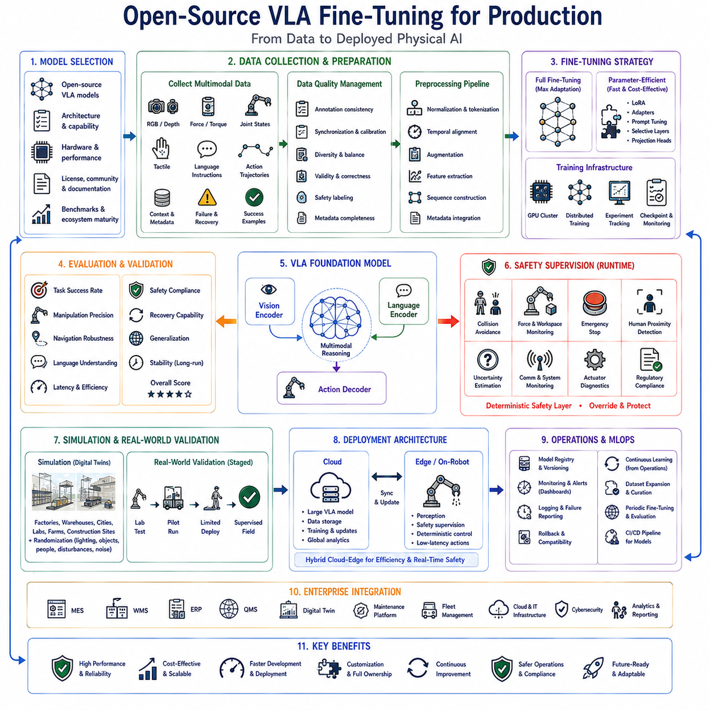
Open-source Vision-Language-Action models are becoming one of the most practical foundations for deploying Physical AI because they provide powerful multimodal reasoning capabilities while allowing organizations to customize models according to their own robotic platforms, operational environments, safety requirements, and proprietary workflows. Unlike closed commercial systems, open-source VLA models offer transparency, architectural flexibility, community-driven improvements, and full ownership of fine-tuned models. These advantages make them particularly attractive for manufacturing, logistics, service robotics, autonomous inspection, warehouse automation, agricultural robotics, healthcare systems, and intelligent industrial automation where long-term maintainability and deployment flexibility are essential.
Successful production deployment begins by selecting an appropriate open-source foundation model rather than immediately collecting task-specific datasets. Organizations evaluate model architecture, parameter size, multimodal capabilities, supported hardware accelerators, inference efficiency, licensing conditions, community activity, documentation quality, benchmark performance, training framework compatibility, and long-term ecosystem maturity. Model selection significantly influences future scalability, deployment cost, maintenance complexity, and adaptation efficiency throughout the entire production lifecycle.
Production requirements define the engineering objectives guiding every subsequent development activity. Engineers identify robot platforms, operational environments, manipulation complexity, navigation requirements, perception challenges, safety objectives, expected task diversity, latency constraints, computational resources, communication infrastructure, regulatory obligations, and expected operational lifetime. These system-level requirements determine fine-tuning strategy, infrastructure architecture, validation methodology, and deployment policies before implementation begins.
High-quality datasets represent the most valuable resource during production fine-tuning. Organizations collect multimodal demonstrations consisting of synchronized RGB images, depth observations, force sensing, joint states, tactile information, language instructions, action trajectories, environmental context, operational metadata, failure examples, recovery demonstrations, and successful task executions. Dataset diversity generally contributes more to production robustness than simply increasing dataset volume because broad operational coverage improves generalization across unseen conditions.
Data quality management remains essential because production models inherit both strengths and weaknesses from their training data. Engineers verify annotation consistency, temporal synchronization, sensor calibration, demonstration quality, class balance, environmental diversity, action validity, language correctness, safety labeling, and metadata completeness before training begins. Comprehensive dataset validation substantially reduces future deployment failures caused by hidden data quality problems.
Data preprocessing transforms heterogeneous operational logs into standardized training representations compatible with the selected VLA architecture. Image normalization, tokenization, trajectory alignment, temporal segmentation, sensor synchronization, action discretization, language formatting, augmentation, feature extraction, sequence construction, and metadata integration establish consistent multimodal inputs supporting stable optimization during fine-tuning. Reproducible preprocessing pipelines also simplify future dataset expansion.
Fine-tuning strategy depends upon available computational resources, dataset size, production objectives, and acceptable deployment cost. Full-parameter optimization provides maximum adaptation capability but requires substantial computing infrastructure. Parameter-efficient methods such as Low-Rank Adaptation, adapter modules, prompt tuning, selective layer optimization, or lightweight projection heads significantly reduce computational requirements while preserving most pretrained knowledge. Production systems frequently favor parameter-efficient approaches because they accelerate experimentation and reduce maintenance complexity.
Distributed training infrastructure enables organizations to optimize increasingly large VLA models efficiently. GPU clusters, high-speed storage, dataset versioning systems, experiment tracking platforms, checkpoint management, automatic fault recovery, distributed optimization algorithms, mixed precision training, gradient accumulation, and monitoring dashboards collectively support reliable large-scale model development. Robust infrastructure improves engineering productivity while minimizing downtime during extended training processes.
Hyperparameter optimization significantly influences production performance despite using identical datasets and model architectures. Learning rate schedules, batch size, optimizer configuration, weight decay, gradient clipping, sequence length, curriculum learning strategies, warmup schedules, checkpoint intervals, and early stopping criteria collectively determine optimization stability. Systematic experimentation supported by reproducible experiment tracking allows organizations to identify reliable configurations appropriate for production deployment.
Evaluation extends beyond conventional benchmark accuracy because production success depends upon operational reliability rather than isolated laboratory metrics. Engineers evaluate task completion rate, manipulation precision, navigation robustness, semantic reasoning quality, language understanding, inference latency, computational efficiency, uncertainty calibration, safety compliance, recovery capability, environmental generalization, and long-duration operational stability. Comprehensive evaluation provides realistic assessment of production readiness.
Regression testing verifies that newly fine-tuned models preserve previously acquired capabilities while improving target tasks. Historical benchmark suites, standardized operational scenarios, simulation environments, edge cases, safety evaluations, performance baselines, latency measurements, memory utilization, and compatibility testing collectively identify unintended behavioral degradation introduced during optimization. Continuous regression testing therefore protects long-term model reliability throughout repeated production updates.
Simulation provides an efficient environment for validating model behavior before physical deployment. Digital twins reproduce factories, warehouses, logistics centers, laboratories, hospitals, agricultural environments, construction sites, and industrial facilities while introducing randomized lighting, object placement, human activity, environmental disturbances, communication failures, and sensor noise. Broad simulation exposure substantially improves operational robustness while reducing expensive physical testing requirements.
Real-world validation remains indispensable because simulation cannot perfectly reproduce every operational condition. Engineers conduct progressively expanding deployment trials beginning with controlled laboratory experiments before advancing toward pilot production, limited operational deployment, supervised field operation, and finally full autonomous production environments. Staged validation significantly reduces deployment risk while enabling systematic collection of additional operational data supporting continual model improvement.
Safety supervision operates independently from learned VLA reasoning to guarantee deterministic operational constraints. Runtime safety filters continuously evaluate predicted actions while collision avoidance, workspace monitoring, force limitations, emergency stopping, human proximity detection, communication supervision, actuator diagnostics, uncertainty estimation, cybersecurity monitoring, and regulatory verification collectively protect physical operation. Layered safety architecture ensures trustworthy deployment despite adaptive learned behavior.
Human oversight remains essential throughout production because operators continue supervising robotic systems even as autonomy increases. Interactive dashboards, semantic visualization, confidence estimation, natural language explanations, intervention interfaces, teleoperation capabilities, operational logging, failure reporting, and maintenance analytics provide comprehensive operational transparency supporting rapid diagnosis whenever unexpected behavior occurs. Human expertise therefore complements autonomous intelligence instead of being completely eliminated.
Model version management becomes increasingly important as organizations continuously improve deployed systems. Version-controlled datasets, reproducible preprocessing pipelines, experiment tracking, model registries, deployment manifests, rollback capability, compatibility testing, performance history, approval workflows, and release documentation collectively establish reliable machine learning operations throughout long-term production maintenance. Comprehensive version control simplifies auditing while accelerating future upgrades.
Continuous learning enables production systems to improve progressively from operational experience collected after deployment. Successful task executions, operator corrections, rare failure scenarios, environmental changes, newly introduced products, hardware modifications, customer feedback, and evolving operational requirements generate valuable training resources supporting periodic fine-tuning. Organizations therefore transform production operation itself into an ongoing source of knowledge expansion.
Cloud-edge hybrid deployment balances computational efficiency with real-time responsiveness. Large VLA foundation models may operate partially within cloud infrastructure while lightweight adaptation modules, perception pipelines, safety supervision, and deterministic control execute locally on embedded edge computers. Distributed architecture minimizes latency for safety-critical functions while preserving access to large-scale reasoning capabilities unavailable on resource-constrained robotic hardware.
Industrial deployment integrates fine-tuned VLA models into broader enterprise ecosystems including manufacturing execution systems, warehouse management systems, enterprise resource planning platforms, quality management systems, digital twins, predictive maintenance platforms, fleet management software, cloud computing infrastructure, cybersecurity services, operational analytics, and continuous integration pipelines. Successful production deployment therefore depends upon complete system integration rather than model performance alone.
Future production systems will increasingly combine open-source VLA models, world models, multimodal memory, continual learning, reinforcement learning, explainable artificial intelligence, uncertainty-aware planning, collaborative multi-robot learning, autonomous skill composition, parameter-efficient adaptation, and cloud-native machine learning operations into unified Physical AI production platforms. These integrated architectures will continuously expand robotic capability while reducing engineering effort required for deployment across new robotic platforms and industrial applications.
Ultimately, open-source Vision-Language-Action fine-tuning for production represents a transition from isolated research demonstrations toward scalable industrial Physical AI capable of supporting long-term deployment, continual improvement, and organization-specific customization. By integrating high-quality datasets, parameter-efficient optimization, comprehensive validation, layered safety supervision, robust MLOps infrastructure, continual learning, cloud-edge deployment, and enterprise-wide system integration within a unified production architecture, organizations establish trustworthy robotic intelligence that evolves continuously while remaining reliable, maintainable, and economically scalable throughout its operational lifetime.

12.7 Physical AI Safety Incident Analysis Case
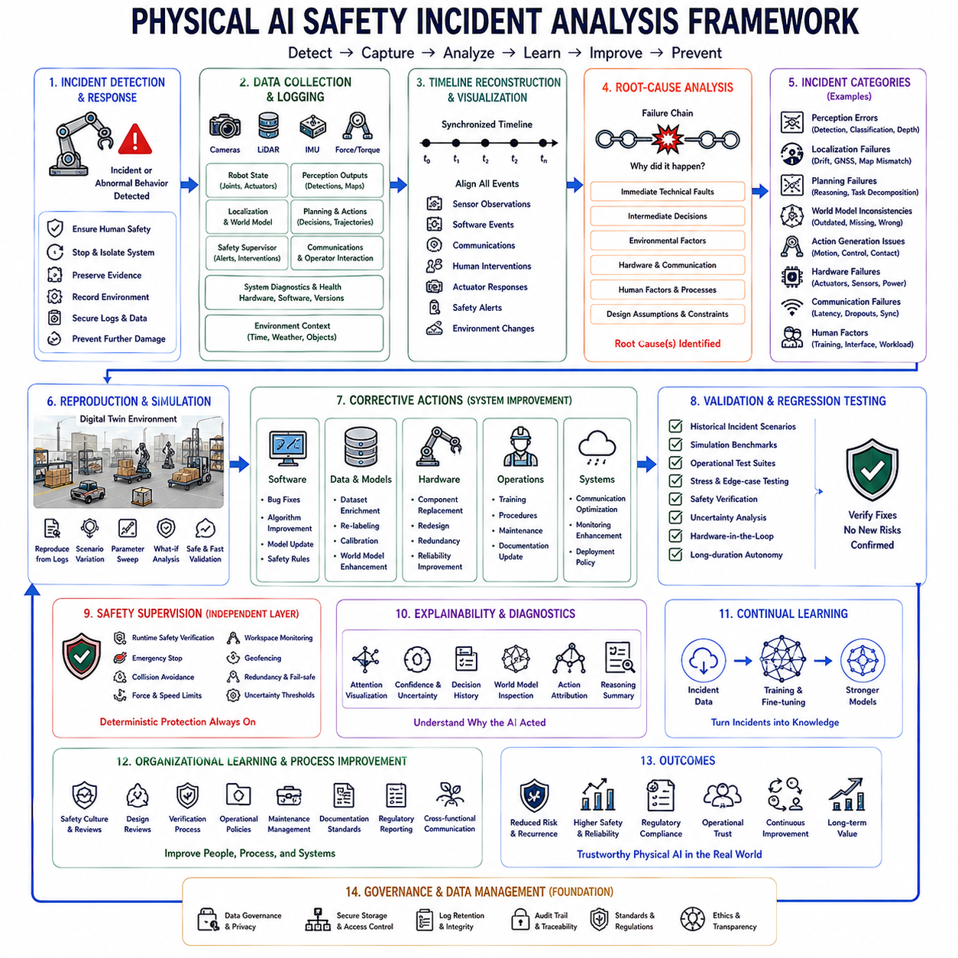
Physical AI systems operate directly within the real world where every perception error, reasoning mistake, software defect, hardware malfunction, communication failure, or unexpected environmental condition may produce consequences extending beyond computational failure into physical safety incidents. Unlike conventional software systems whose failures often remain confined to digital environments, intelligent robots interact continuously with people, infrastructure, machinery, vehicles, and valuable assets. Consequently, systematic safety incident analysis becomes a fundamental engineering discipline supporting trustworthy deployment, regulatory compliance, continual learning, and long-term operational reliability throughout the complete lifecycle of Physical AI systems.
Safety incident analysis begins by recognizing that incidents rarely result from a single isolated failure. Instead, they typically emerge through complex interactions among perception uncertainty, localization errors, environmental changes, planning mistakes, actuator behavior, software architecture, operator decisions, communication latency, sensor degradation, hardware faults, maintenance deficiencies, and organizational processes. Comprehensive investigation therefore examines complete system interactions rather than attributing responsibility exclusively to individual components.
Effective incident analysis starts immediately after abnormal behavior is detected. The highest priority is ensuring human safety by stopping hazardous operations, isolating affected systems, preserving operational evidence, recording environmental conditions, securing communication logs, protecting sensor data, documenting hardware status, and preventing additional damage. Accurate evidence preservation significantly improves the quality of subsequent engineering analysis while supporting regulatory reporting and legal accountability when required.
Comprehensive operational logging provides the primary information source supporting root-cause investigation. Modern Physical AI systems continuously record synchronized sensor observations, perception outputs, localization estimates, world model updates, planning decisions, actuator commands, safety supervisor interventions, communication traffic, operator interactions, diagnostic information, hardware status, software versions, and environmental context. High-quality logging transforms isolated incidents into reproducible engineering problems rather than anecdotal observations.
Timeline reconstruction organizes collected evidence into a precise chronological sequence describing system behavior before, during, and after the incident. Sensor observations, software events, communication messages, human interventions, actuator responses, safety alerts, localization updates, environmental changes, and mission execution become aligned through accurate timestamps. Temporal reconstruction frequently reveals subtle causal relationships that remain invisible when individual events are examined independently.
Root-cause analysis extends beyond identifying the final observable failure by tracing every contributing factor throughout the operational chain. Immediate technical faults, intermediate software decisions, environmental influences, organizational procedures, maintenance history, operator actions, hardware limitations, and design assumptions collectively explain why unsafe behavior became possible. Effective investigation therefore distinguishes symptoms from underlying engineering deficiencies requiring permanent correction.
Perception-related incidents frequently originate from sensor occlusion, illumination changes, weather effects, reflective surfaces, dynamic obstacles, environmental ambiguity, calibration drift, synchronization errors, or insufficient training data. Misclassification, missed detections, inaccurate depth estimation, semantic misunderstanding, and uncertainty underestimation may propagate through subsequent planning and control systems, eventually producing hazardous physical actions. Perception analysis therefore examines both algorithmic outputs and original sensor observations simultaneously.
Localization failures represent another common incident category because inaccurate position estimates directly influence navigation, manipulation, and collision avoidance. GNSS degradation, visual odometry drift, map inconsistencies, inertial sensor errors, environmental changes, feature scarcity, synchronization problems, and accumulated estimation uncertainty may progressively degrade situational awareness before reaching catastrophic operational thresholds. Investigators evaluate every localization subsystem together rather than isolating individual algorithms.
Planning failures occur when high-level reasoning generates unsafe or inefficient actions despite receiving apparently valid environmental information. Incomplete world models, incorrect task decomposition, optimistic assumptions, inadequate constraint handling, insufficient uncertainty awareness, or unexpected environmental interactions may produce inappropriate navigation routes, manipulation sequences, or collaborative behaviors. Planning analysis therefore investigates internal reasoning processes together with environmental context and operational objectives.
World model inconsistencies increasingly represent important investigation targets because predictive reasoning depends upon accurate internal representations describing both current and future environmental states. Missing obstacles, outdated environmental information, incorrect object relationships, inaccurate human activity predictions, stale semantic maps, or inconsistent uncertainty estimates may cause planning modules to reason about environments that no longer correspond to physical reality. Maintaining synchronized world models therefore becomes essential for reliable autonomous operation.
Action generation incidents frequently involve inappropriate translation of high-level reasoning into executable robot behavior. Motion generation, trajectory optimization, grasp planning, gait selection, force regulation, velocity control, timing synchronization, or actuator coordination may introduce unsafe physical actions despite otherwise correct mission reasoning. Investigators evaluate embodiment adaptation, control architecture, and physical execution independently from higher-level artificial intelligence reasoning.
Hardware failures contribute directly and indirectly to numerous operational incidents. Actuator degradation, battery abnormalities, thermal overload, power instability, sensor malfunction, communication hardware failure, mechanical wear, structural fatigue, connector damage, or embedded controller faults frequently interact with software behavior in unexpected ways. Effective analysis therefore combines electrical, mechanical, software, and systems engineering expertise rather than treating hardware and artificial intelligence independently.
Communication failures become increasingly significant as Physical AI systems integrate cloud computing, fleet coordination, remote supervision, digital twins, and distributed intelligence. Network latency, bandwidth limitations, synchronization loss, packet corruption, authentication failures, cloud service interruptions, or wireless interference may influence perception updates, world model synchronization, operator communication, or collaborative decision making. Communication analysis therefore evaluates complete distributed system behavior rather than isolated network performance.
Human factors remain essential throughout incident investigation because operators, maintenance personnel, supervisors, system designers, and organizational procedures collectively influence operational safety. Inadequate training, ambiguous interfaces, excessive workload, delayed interventions, incorrect maintenance, insufficient documentation, procedural violations, communication misunderstandings, or unrealistic operational expectations may substantially increase accident probability despite technically capable autonomous systems. Human-centered analysis therefore complements technical investigation.
Simulation enables systematic reproduction of many incidents under controlled experimental conditions. Digital twins reconstruct environmental geometry, sensor observations, weather conditions, communication behavior, hardware characteristics, and mission execution using operational logs collected before the incident. Engineers evaluate alternative scenarios, parameter variations, recovery strategies, and software modifications without exposing people or equipment to unnecessary physical risk. Reproducible simulation substantially accelerates engineering validation.
Corrective action extends beyond repairing individual defects by strengthening complete system resilience. Software patches, dataset improvements, sensor recalibration, controller modification, world model enhancement, safety rule refinement, operator training, maintenance procedure revision, hardware redesign, communication optimization, documentation updates, and deployment policy modifications collectively reduce recurrence probability. Effective incident response therefore emphasizes systemic improvement rather than isolated bug fixing.
Regression testing validates every corrective modification before redeployment. Historical incident scenarios, simulation benchmarks, operational test suites, stress testing, edge-case evaluation, safety verification, uncertainty analysis, hardware-in-the-loop testing, environmental variation, and long-duration autonomous operation collectively confirm that corrective actions eliminate identified hazards without introducing new unintended failures elsewhere within the system. Continuous regression testing preserves accumulated operational reliability.
Safety supervisors represent independent deterministic protection layers operating above learned artificial intelligence. Runtime safety verification, emergency stopping, collision avoidance, force limitation, speed regulation, workspace monitoring, geofencing, thermal protection, redundancy management, communication supervision, and uncertainty thresholds continuously constrain autonomous behavior regardless of underlying model predictions. Incident investigations carefully evaluate whether these independent protection mechanisms functioned correctly during hazardous situations.
Explainability significantly improves incident analysis because transparent reasoning allows engineers to understand why artificial intelligence generated specific decisions. Attention visualization, confidence estimation, uncertainty representation, semantic reasoning summaries, action attribution, decision histories, world model inspection, and intermediate prediction analysis provide valuable diagnostic information unavailable from opaque black-box systems. Improved interpretability accelerates both debugging and regulatory compliance.
Continual learning transforms operational incidents into valuable engineering knowledge. Carefully curated incident datasets, failure demonstrations, recovery examples, operator interventions, environmental anomalies, and newly identified edge cases become incorporated into future training processes. Rather than representing isolated operational failures, incidents become opportunities to strengthen perception, reasoning, planning, safety supervision, and overall system robustness across future deployments.
Organizational learning extends beyond technical improvements by refining engineering processes, safety culture, design reviews, deployment procedures, verification methodology, operational policies, maintenance scheduling, documentation standards, regulatory reporting, and cross-functional communication. Mature Physical AI organizations continuously improve institutional knowledge through structured post-incident reviews rather than relying solely upon technical modifications.
Future Physical AI incident analysis will increasingly integrate foundation models, world models, explainable artificial intelligence, uncertainty-aware reasoning, digital twins, predictive simulation, automated log analysis, causal inference, continual learning, collaborative robotics, cloud-edge analytics, and autonomous safety validation into unified safety engineering platforms. These integrated systems will progressively detect emerging risks earlier, explain failures more effectively, accelerate root-cause identification, and continuously improve operational safety throughout increasingly complex autonomous robotic ecosystems.
Ultimately, Physical AI safety incident analysis represents far more than post-accident investigation. It establishes a continuous engineering feedback loop connecting operational experience, system understanding, corrective action, validation, organizational learning, and future deployment improvements. By integrating comprehensive operational logging, root-cause investigation, simulation, deterministic safety supervision, explainable reasoning, continual learning, and enterprise-wide safety governance within a unified analytical framework, organizations create increasingly trustworthy autonomous robotic systems capable of operating safely, transparently, and reliably throughout diverse real-world environments.

12.8 Foundation Model Inference Edge Optimization Case
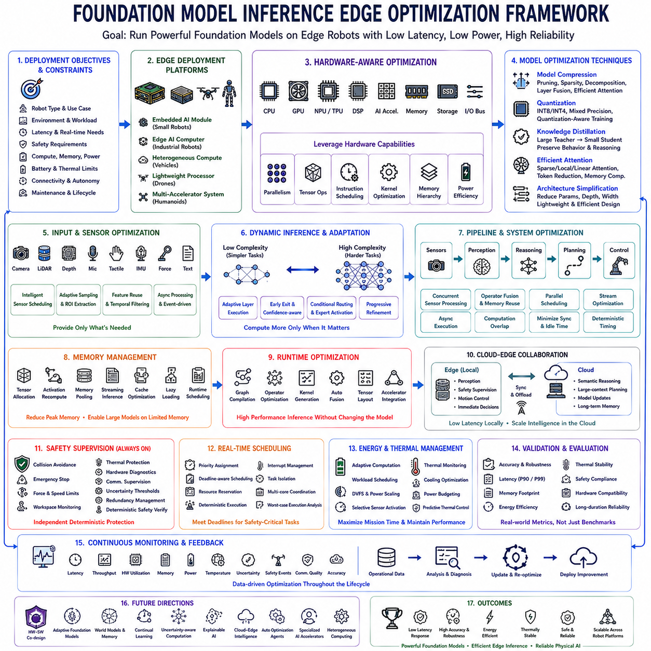
Foundation models have dramatically expanded the capabilities of Physical AI by enabling unified perception, language understanding, reasoning, planning, and action generation within a single multimodal architecture. However, the computational requirements of large foundation models often exceed the resources available on embedded robotic hardware. Real-world deployment therefore depends not only on model intelligence but also on efficient inference optimization that enables reliable execution within strict constraints on latency, memory, power consumption, thermal limits, and hardware availability. Edge optimization has consequently become a critical engineering discipline for transforming research-grade foundation models into practical autonomous robotic systems.
The optimization process begins by defining deployment objectives rather than selecting optimization algorithms. Engineers first identify robot type, operational environment, response-time requirements, safety constraints, computational resources, battery capacity, thermal limitations, communication infrastructure, expected autonomy level, workload characteristics, and long-term maintenance requirements. These system-level constraints determine acceptable inference latency, memory footprint, energy consumption, model accuracy, and optimization strategy before implementation begins.
Edge deployment platforms vary significantly depending on application requirements. Small mobile robots may rely on embedded AI modules, industrial manipulators often integrate high-performance edge computers, autonomous vehicles require redundant heterogeneous computing architectures, drones emphasize lightweight energy-efficient processors, while humanoid robots frequently combine multiple heterogeneous accelerators. Platform selection therefore influences every subsequent optimization decision because computational capability directly determines achievable model complexity.
Hardware-aware model optimization begins by analyzing available processing resources including CPUs, GPUs, NPUs, TPUs, DSPs, dedicated AI accelerators, memory bandwidth, cache hierarchy, storage performance, and communication buses. Rather than treating hardware as a passive execution environment, modern optimization strategies exploit hardware-specific parallelism, tensor operations, instruction scheduling, and accelerator capabilities to maximize inference throughput while minimizing latency and power consumption.
Model compression represents one of the most effective approaches for improving inference efficiency. Parameter pruning, structured sparsity, weight sharing, tensor decomposition, layer fusion, architecture simplification, and efficient attention mechanisms collectively reduce computational complexity without significantly degrading prediction quality. Successful compression requires careful balance between model size reduction and preservation of essential reasoning capability required for autonomous robotic decision making.
Quantization further improves deployment efficiency by representing neural network parameters using reduced numerical precision. Floating-point computations are progressively replaced by lower-precision integer or mixed-precision arithmetic compatible with hardware acceleration. Modern quantization-aware optimization maintains competitive model accuracy while substantially reducing memory requirements, computational cost, inference latency, and energy consumption, making large multimodal models increasingly practical for embedded robotic systems.
Knowledge distillation transfers capabilities from large teacher models into smaller student architectures optimized specifically for edge deployment. Instead of reproducing every parameter, compact student models learn behavioral characteristics, semantic representations, reasoning strategies, intermediate feature relationships, and prediction distributions generated by substantially larger foundation models. Distillation therefore preserves much of the original intelligence while dramatically reducing computational requirements appropriate for embedded hardware.
Efficient attention mechanisms address one of the largest computational bottlenecks within transformer-based foundation models. Sparse attention, local attention, hierarchical attention, linear attention approximations, token reduction, adaptive computation, memory compression, and sequence optimization reduce quadratic computational complexity while maintaining effective multimodal reasoning performance. Attention optimization becomes increasingly important as robotic foundation models process high-resolution visual observations together with lengthy contextual information.
Multimodal input optimization minimizes redundant computation before inference begins. Cameras, depth sensors, LiDAR, microphones, tactile sensors, inertial measurements, force sensing, and language inputs frequently produce far more information than necessary for every decision. Intelligent sensor scheduling, adaptive sampling, region-of-interest extraction, feature reuse, asynchronous processing, temporal filtering, and event-driven computation significantly reduce processing requirements while preserving essential environmental understanding.
Dynamic inference enables computational resources to adapt continuously according to operational complexity. Simple navigation through familiar environments requires substantially less computation than dexterous manipulation, human collaboration, or complex reasoning under uncertainty. Adaptive layer execution, early prediction termination, confidence-aware computation, conditional routing, selective expert activation, and progressive refinement allocate computational effort only where additional reasoning meaningfully improves operational performance.
Pipeline optimization reorganizes perception, reasoning, planning, and control into efficient execution graphs minimizing unnecessary synchronization and idle hardware utilization. Concurrent sensor processing, asynchronous execution, operator fusion, memory reuse, parallel scheduling, stream optimization, and computation overlap collectively improve end-to-end throughput while maintaining deterministic timing required for safety-critical robotic applications. Careful pipeline engineering frequently produces larger performance improvements than isolated algorithmic optimization.
Memory management becomes increasingly important as foundation models exceed available embedded memory capacity. Efficient tensor allocation, activation recomputation, memory pooling, streaming inference, cache optimization, parameter sharing, lazy loading, and runtime memory scheduling collectively minimize peak memory consumption without sacrificing computational correctness. Predictable memory behavior significantly improves long-duration operational stability throughout continuous autonomous deployment.
Runtime optimization frameworks translate trained neural networks into hardware-efficient executable representations. Graph compilation, operator optimization, hardware-specific kernel generation, execution scheduling, automatic fusion, tensor layout optimization, and accelerator integration collectively improve inference performance without modifying original model functionality. Production deployment therefore depends heavily upon mature runtime infrastructure in addition to model architecture itself.
Cloud-edge collaborative inference balances local responsiveness with large-scale computational capability. Latency-sensitive perception, safety supervision, motion control, and immediate decision making execute locally, while computationally intensive semantic reasoning, large-context planning, model updating, and long-term memory management may operate through cloud infrastructure whenever communication reliability permits. Hybrid deployment provides scalability while preserving autonomous operation during temporary network disruption.
Safety supervision always remains independent from optimized foundation model inference. Collision avoidance, emergency stopping, workspace monitoring, force limitation, velocity regulation, thermal protection, hardware diagnostics, communication supervision, redundancy management, uncertainty thresholds, and deterministic safety verification continue operating regardless of optimization strategy. Performance optimization therefore never compromises fundamental operational safety or regulatory compliance.
Real-time scheduling guarantees predictable execution despite varying computational workloads. Priority assignment, deadline-aware scheduling, resource reservation, deterministic execution policies, interrupt management, task isolation, multicore coordination, and worst-case execution analysis collectively ensure that perception, planning, and safety-critical control satisfy strict timing constraints throughout autonomous operation. Deterministic scheduling becomes particularly important for robots interacting directly with humans.
Thermal management significantly influences sustained edge inference performance because prolonged high computational utilization frequently produces thermal throttling reducing processing speed unexpectedly. Dynamic frequency scaling, workload balancing, adaptive model selection, power budgeting, cooling optimization, hardware monitoring, and predictive thermal control maintain stable computational performance throughout extended deployment. Thermal engineering therefore directly influences both reliability and available inference capacity.
Energy-aware optimization becomes essential for battery-powered autonomous robots. Every additional inference operation influences mission duration, operational range, charging frequency, payload capability, and long-term system availability. Adaptive computation, workload scheduling, accelerator utilization, dynamic voltage scaling, selective sensor activation, intelligent sleep management, and power-aware model execution collectively maximize operational efficiency without unnecessarily sacrificing autonomous capability.
Validation extends beyond benchmark inference speed because practical deployment requires simultaneously satisfying accuracy, robustness, latency, memory consumption, energy efficiency, thermal stability, safety compliance, communication resilience, hardware compatibility, and long-duration operational reliability. Comprehensive evaluation ensures optimized models continue satisfying real-world engineering requirements rather than merely improving isolated computational metrics.
Continuous monitoring remains essential after deployment because operational environments evolve over time. Runtime performance statistics, latency measurements, hardware utilization, thermal behavior, energy consumption, uncertainty estimation, communication quality, safety events, memory usage, and inference accuracy collectively provide valuable operational feedback supporting future optimization and predictive maintenance. Production optimization therefore continues throughout the operational lifecycle rather than ending after initial deployment.
Future edge optimization will increasingly integrate hardware-software co-design, adaptive foundation models, world models, multimodal memory, continual learning, uncertainty-aware computation, explainable artificial intelligence, collaborative cloud-edge intelligence, autonomous optimization agents, specialized AI accelerators, and heterogeneous computing architectures into unified deployment ecosystems. These technologies will progressively enable increasingly capable foundation models to execute efficiently within compact robotic platforms while maintaining high levels of autonomy and safety.
Ultimately, foundation model inference edge optimization represents the essential bridge connecting advanced multimodal artificial intelligence with practical autonomous robotic deployment. By integrating hardware-aware optimization, model compression, quantization, knowledge distillation, efficient attention, adaptive inference, runtime optimization, cloud-edge collaboration, deterministic safety supervision, real-time scheduling, energy management, and continuous operational monitoring within a unified engineering architecture, organizations can deploy powerful Physical AI systems that remain intelligent, responsive, reliable, energy-efficient, and scalable across diverse real-world robotic platforms.

12.9 Foundation Model ROI Analysis for Robot Fleets
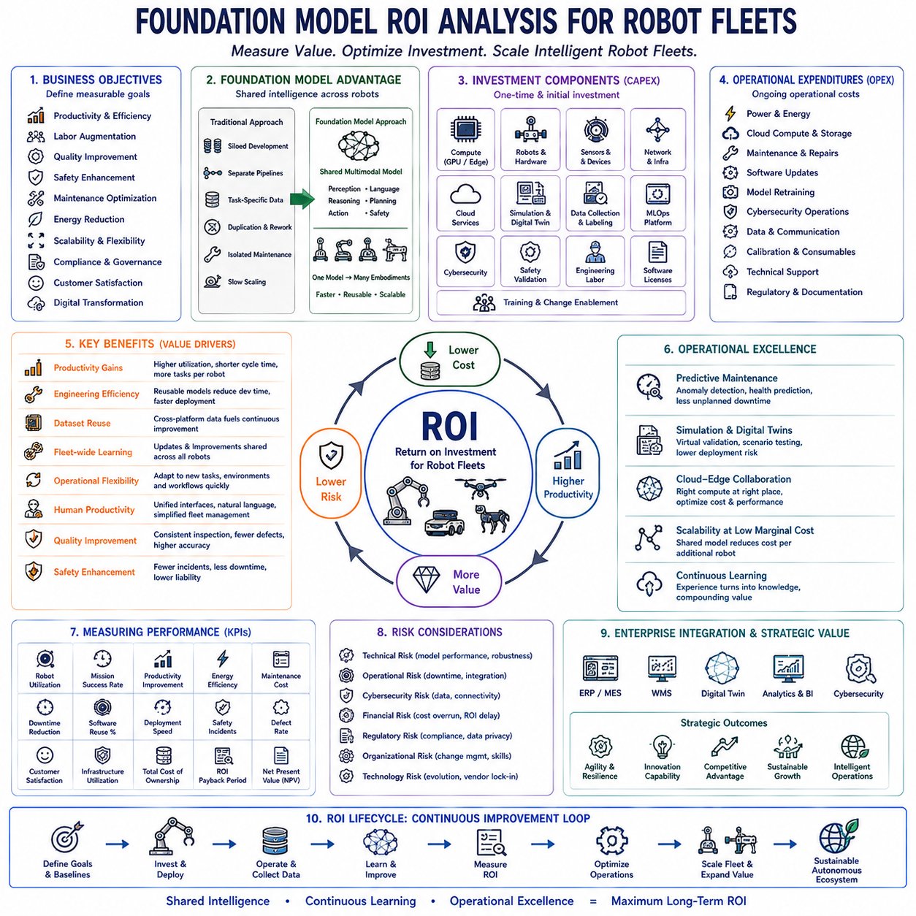
Foundation models are transforming autonomous robotics by enabling robot fleets to share generalized perception, language understanding, reasoning, planning, and decision-making capabilities across diverse operational environments. Unlike traditional task-specific software that requires independent development for each robot platform, foundation models establish reusable intelligence that can be continuously adapted to new missions, hardware configurations, and operational requirements. As organizations expand robotic deployments across manufacturing, logistics, healthcare, agriculture, inspection, mining, construction, and service industries, evaluating return on investment becomes increasingly important for justifying large-scale adoption and guiding long-term technology strategy.
Return on investment analysis begins by defining measurable business objectives before considering model architecture or implementation technology. Organizations identify productivity targets, operational efficiency improvements, labor augmentation goals, quality enhancement, safety objectives, maintenance optimization, energy reduction, scalability requirements, regulatory compliance expectations, customer satisfaction, and long-term digital transformation strategies. These business drivers establish quantitative benchmarks against which foundation model deployment can be objectively evaluated throughout its operational lifecycle.
Traditional robotic systems often require separate software development, independent perception pipelines, application-specific datasets, duplicated engineering effort, repeated integration, and isolated maintenance processes for every robot category. Foundation models fundamentally change this economic structure by introducing shared intelligence that supports multiple robotic embodiments through common multimodal representations. Shared development substantially reduces engineering duplication while accelerating deployment across heterogeneous robot fleets operating under different physical constraints.
Initial investment typically includes computing infrastructure, GPU servers, edge computers, robotic hardware, sensors, networking equipment, cloud services, simulation environments, digital twins, data collection systems, labeling infrastructure, MLOps platforms, cybersecurity, safety validation, engineering labor, software licensing, and workforce training. Comprehensive ROI analysis therefore evaluates complete system acquisition costs rather than considering only model development expenses or hardware procurement.
Operational expenditures continue throughout deployment and frequently exceed initial implementation costs over long operational periods. Electricity consumption, cloud computing resources, hardware maintenance, software updates, model retraining, cybersecurity management, storage expansion, communication infrastructure, calibration, preventive maintenance, replacement components, regulatory documentation, and technical support collectively determine total cost of ownership. Long-term financial analysis therefore requires continuous monitoring rather than one-time capital expenditure calculations.
Productivity improvements represent one of the most visible financial benefits associated with foundation model deployment. Intelligent perception, adaptive planning, natural language interaction, autonomous decision making, continual learning, collaborative operation, and generalized task execution enable robots to perform broader mission portfolios with reduced engineering customization. Higher robot utilization directly increases asset productivity while decreasing operational idle time across large fleet deployments.
Engineering efficiency improves substantially because reusable foundation models eliminate repeated algorithm development for every new application. Once perception, reasoning, navigation, manipulation, language understanding, and planning capabilities become standardized, engineering teams primarily adapt embodiment interfaces rather than rebuilding complete artificial intelligence systems. Reduced software complexity accelerates product development while lowering engineering costs throughout successive deployment projects.
Dataset reuse significantly contributes to long-term economic value because multimodal operational data collected by one robot frequently benefits multiple platforms. Warehouse robots, industrial manipulators, mobile inspection systems, quadrupeds, autonomous vehicles, drones, and humanoids collectively generate valuable perception, language, action, and environmental knowledge supporting continual improvement of shared foundation models. Cross-platform knowledge accumulation dramatically increases data return compared with isolated robot-specific learning systems.
Fleet-wide learning provides another major economic advantage because improvements discovered by individual robots become immediately transferable across the entire robotic ecosystem. Software updates, improved perception models, refined planning strategies, optimized manipulation skills, enhanced safety policies, and new operational capabilities propagate rapidly without requiring complete redevelopment for every deployed platform. Shared intelligence therefore scales much more efficiently than conventional application-specific robotics.
Operational flexibility increases significantly because generalized foundation models support changing production requirements without extensive software redesign. New products, modified workflows, relocated facilities, evolving customer requirements, environmental variation, additional sensors, upgraded hardware, or expanded operational missions frequently require only limited adaptation rather than complete system redevelopment. Flexible deployment substantially reduces future engineering investment while extending useful system lifetime.
Human productivity also improves because operators interact with generalized multimodal interfaces instead of managing multiple specialized robotic systems independently. Natural language supervision, unified fleet management, semantic mission planning, intelligent diagnostics, automated reporting, collaborative scheduling, and explainable decision support reduce operational complexity while enabling smaller engineering teams to supervise increasingly large autonomous robot fleets.
Quality improvements generate substantial financial value beyond direct labor savings. Foundation models improve inspection consistency, anomaly detection, process repeatability, defect identification, measurement accuracy, task standardization, documentation quality, and operational traceability across diverse industrial environments. Reduced product defects, improved regulatory compliance, and higher customer satisfaction contribute indirectly but significantly to long-term organizational profitability.
Safety improvements frequently produce the highest long-term economic impact despite being difficult to quantify directly. Enhanced perception, uncertainty estimation, predictive planning, collision avoidance, human awareness, continuous monitoring, autonomous recovery, layered safety supervision, and explainable reasoning reduce accident probability while minimizing operational disruption, equipment damage, regulatory penalties, insurance costs, and reputational risk. Comprehensive ROI analysis therefore incorporates both measurable financial savings and avoided operational losses.
Predictive maintenance supported by foundation models improves equipment utilization while reducing unexpected downtime. Intelligent diagnostics, anomaly prediction, sensor fusion, operational trend analysis, maintenance scheduling, component health estimation, and automated reporting enable organizations to transition from reactive maintenance toward predictive maintenance strategies. Improved equipment availability increases productive operating time while reducing maintenance expenditure across large robotic fleets.
Simulation and digital twins reduce deployment cost by identifying operational issues before physical implementation begins. Virtual validation, synthetic data generation, scenario testing, safety evaluation, performance optimization, operator training, and infrastructure planning collectively reduce expensive physical experimentation while accelerating deployment readiness. Investment in high-quality simulation environments therefore generates long-term financial returns throughout repeated deployment cycles.
Cloud-edge collaborative architectures optimize infrastructure utilization by balancing centralized computational resources with distributed edge intelligence. Large foundation models, continual learning infrastructure, long-term data management, and enterprise analytics operate within cloud environments while latency-sensitive perception, motion control, and safety supervision remain localized. Efficient resource allocation minimizes redundant infrastructure investment while maintaining operational performance.
Scalability represents one of the strongest financial justifications for adopting foundation models. As robot fleets expand from dozens to hundreds or thousands of autonomous systems, traditional software development costs grow approximately linearly with deployment size. Shared foundation models, however, distribute development investment across the entire robotic ecosystem, progressively reducing marginal deployment cost for each additional robot introduced into production.
Risk analysis remains essential because foundation model deployment introduces technical, financial, operational, cybersecurity, regulatory, organizational, and technological uncertainties. Model maintenance requirements, evolving hardware platforms, changing regulations, cybersecurity threats, communication dependencies, workforce adaptation, vendor ecosystems, and technology maturity influence long-term economic outcomes. Balanced ROI evaluation therefore considers both anticipated benefits and associated deployment risks.
Performance measurement requires carefully selected operational metrics supporting continuous financial evaluation. Robot utilization, mission completion rate, productivity improvement, energy efficiency, maintenance cost, downtime reduction, software reuse, deployment speed, engineering effort, safety incidents, defect rate, customer satisfaction, and infrastructure utilization collectively provide quantitative indicators demonstrating long-term return on investment throughout operational deployment.
Continual learning further improves investment efficiency because deployed systems continuously accumulate operational knowledge instead of remaining functionally static. New environmental observations, human interactions, operational failures, successful task demonstrations, maintenance records, and fleet-wide experiences become valuable assets supporting future model improvements. Knowledge therefore becomes an appreciating organizational resource rather than a fixed engineering deliverable.
Enterprise-wide digital transformation increasingly positions foundation models as strategic infrastructure rather than isolated artificial intelligence components. Integration with enterprise resource planning, manufacturing execution systems, warehouse management platforms, digital twins, predictive maintenance, cybersecurity infrastructure, cloud computing, operational analytics, and business intelligence establishes unified data ecosystems supporting continuous optimization across entire industrial organizations.
Future economic analysis will increasingly incorporate autonomous multi-robot collaboration, world models, multimodal memory, adaptive reasoning, continual learning, cloud-edge intelligence, explainable artificial intelligence, specialized AI accelerators, autonomous optimization, and foundation model ecosystems into integrated financial planning. Organizations will evaluate not only immediate operational efficiency but also long-term knowledge accumulation, strategic flexibility, innovation capability, and competitive advantage generated through continuously evolving Physical AI infrastructure.
Ultimately, return on investment analysis for foundation model deployment extends far beyond comparing implementation cost with short-term productivity gains. By integrating infrastructure investment, engineering efficiency, dataset reuse, fleet-wide learning, operational flexibility, predictive maintenance, cloud-edge computing, safety improvement, continual learning, digital transformation, and long-term organizational scalability within a unified financial framework, enterprises establish sustainable autonomous robotic ecosystems whose cumulative economic value increases continuously as operational knowledge expands across increasingly intelligent robot fleets.

12.10 Future Physical AI Foundation Model Roadmap
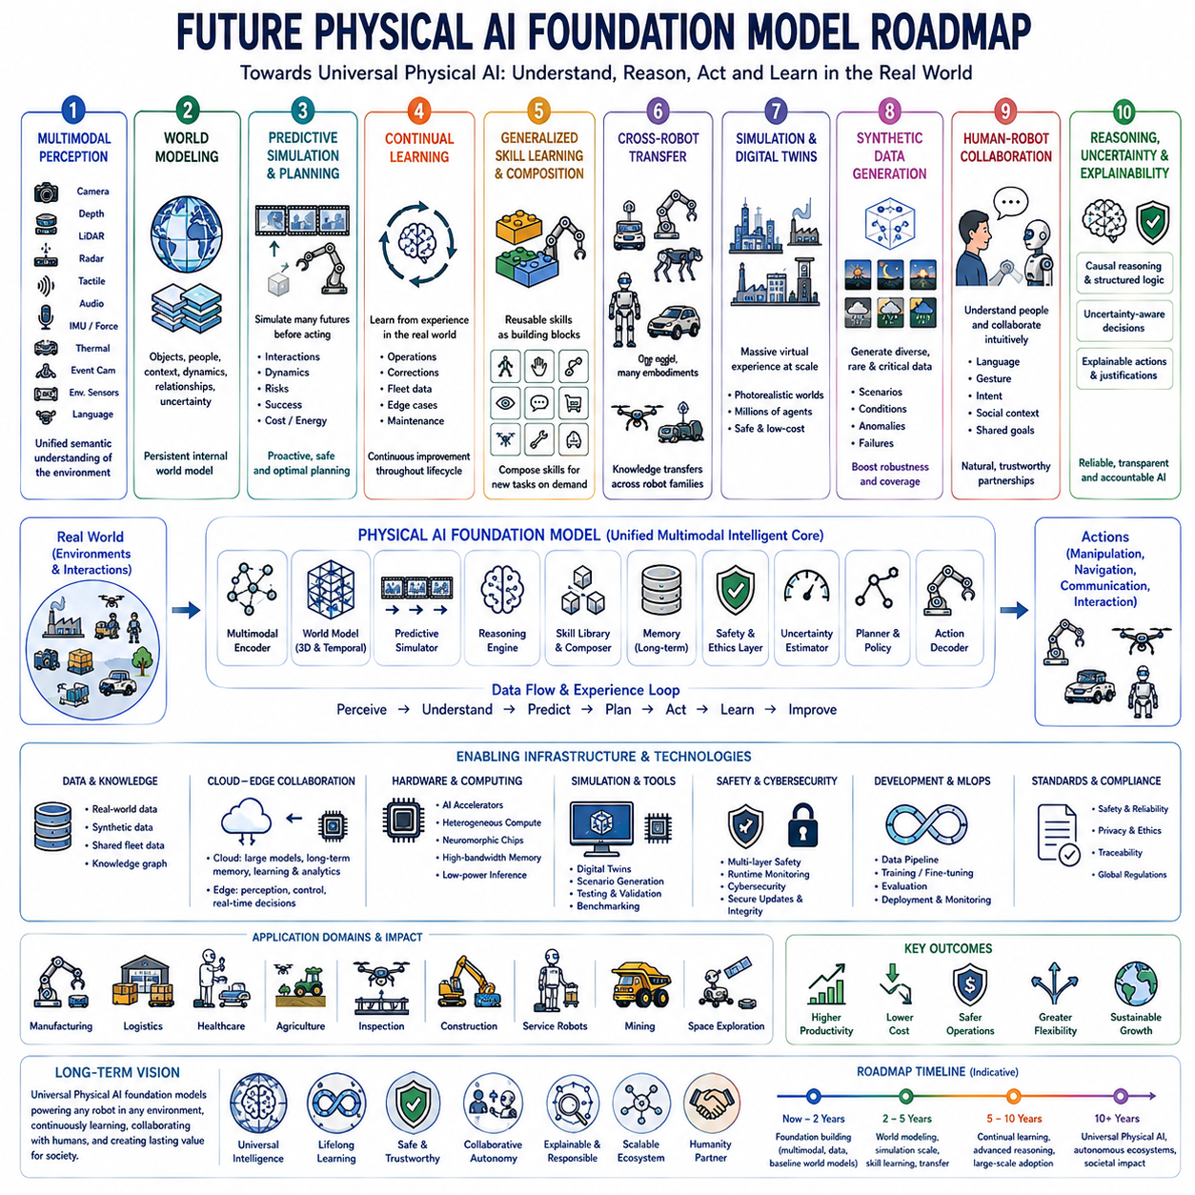
The future evolution of Physical AI foundation models represents a convergence of artificial intelligence, robotics, embodied cognition, large-scale multimodal learning, world modeling, and autonomous decision-making into unified intelligent systems capable of understanding, reasoning, and interacting with the physical world. Unlike conventional task-specific robotic software, future foundation models will continuously accumulate knowledge from diverse environments, transfer skills across heterogeneous robotic platforms, and adapt autonomously to new tasks with minimal human supervision. This transformation will fundamentally redefine how intelligent machines are developed, deployed, maintained, and improved throughout their operational lifecycles.
The first stage of this roadmap focuses on expanding multimodal perception beyond traditional vision-language integration. Future models will simultaneously process RGB imagery, depth sensing, LiDAR, radar, tactile sensing, force feedback, proprioception, audio, thermal imaging, event cameras, environmental sensors, and natural language into unified semantic representations. Rich multimodal understanding will significantly improve environmental awareness while reducing ambiguity caused by individual sensor limitations.
The second stage emphasizes the evolution from perception-centered intelligence toward comprehensive world modeling. Future foundation models will no longer react only to current observations but will maintain continuously updated internal world models describing objects, people, environmental dynamics, physical relationships, semantic context, uncertainty, and future predictions. Persistent world understanding will allow robots to anticipate environmental changes before they occur instead of merely responding after changes become observable.
World models will progressively incorporate predictive simulation capabilities that enable robots to evaluate alternative future outcomes before executing physical actions. Internal simulation engines will estimate object interactions, human behavior, robot dynamics, environmental evolution, collision probability, energy consumption, mission success, and safety risks under multiple hypothetical scenarios. Planning will therefore become increasingly proactive rather than reactive, reducing operational uncertainty while improving decision quality.
Foundation models will evolve from static pretrained networks into continually learning systems that improve throughout deployment. Operational experiences, successful task demonstrations, human corrections, maintenance records, environmental variations, fleet-wide observations, and newly discovered edge cases will become valuable learning resources supporting periodic model refinement. Rather than separating training from deployment, future Physical AI systems will establish continuous learning loops integrating real-world operational experience directly into model evolution.
Generalized skill learning will replace isolated task programming as robots acquire reusable behavioral primitives applicable across diverse applications. Navigation, grasping, manipulation, inspection, communication, collaboration, transportation, assembly, exploration, and maintenance skills will become modular capabilities that can be composed dynamically according to mission requirements. Skill composition will dramatically reduce engineering effort while increasing operational flexibility throughout heterogeneous robotic ecosystems.
Cross-robot transfer learning will become increasingly efficient as common foundation models support mobile robots, industrial manipulators, quadrupeds, humanoids, autonomous vehicles, drones, underwater robots, agricultural machinery, medical robots, and space exploration systems. Knowledge acquired within one embodiment will transfer naturally to others through shared semantic representations and unified action abstractions, enabling collaborative improvement across previously isolated robotic domains.
Large-scale simulation environments and digital twins will become primary knowledge generation platforms before physical deployment. Millions of autonomous agents will interact continuously within photorealistic virtual environments reproducing factories, warehouses, cities, hospitals, construction sites, forests, agricultural fields, disaster zones, and extraterrestrial environments. Massive simulation-generated experience will substantially accelerate foundation model development while reducing physical experimentation cost and deployment risk.
Synthetic data generation will mature into an essential component of future Physical AI development. Generative world models will automatically produce realistic sensor observations, environmental variations, rare failure scenarios, safety-critical events, human interactions, weather conditions, and operational anomalies unavailable within limited physical datasets. High-quality synthetic experience will complement real-world observations while improving robustness against rare operational conditions.
Human-robot collaboration will evolve from command-based interaction toward natural cooperative intelligence. Foundation models will understand conversational language, gestures, facial expressions, intentions, emotional context, collaborative objectives, organizational policies, and social conventions simultaneously. Shared situational awareness will enable humans and robots to coordinate complex missions through intuitive communication rather than explicit low-level programming.
Reasoning capability will continue advancing beyond pattern recognition toward structured causal understanding. Future models will infer physical causality, temporal dependencies, mechanical relationships, safety implications, operational constraints, resource optimization, and long-term mission consequences using explicit reasoning mechanisms integrated with deep neural representations. Causal reasoning will substantially improve explainability, planning quality, and autonomous decision reliability.
Uncertainty-aware intelligence will become a standard architectural component rather than an optional enhancement. Future foundation models will continuously estimate confidence across perception, localization, planning, manipulation, prediction, communication, and reasoning processes. Decision-making policies will adapt automatically according to quantified uncertainty, selecting conservative behaviors whenever operational confidence becomes insufficient for safe autonomous execution.
Explainable artificial intelligence will become deeply integrated into Physical AI systems rather than existing as external analysis tools. Robots will generate natural language explanations, semantic reasoning summaries, confidence visualization, action justifications, alternative plan comparisons, causal graphs, and operational diagnostics supporting both engineering validation and human trust. Transparent reasoning will become essential for certification, regulation, and collaborative human supervision.
Safety architecture will transition toward multilayer intelligent supervision combining deterministic safety verification with adaptive learning-based reasoning. Runtime monitoring, predictive hazard analysis, behavioral verification, autonomous anomaly detection, formal safety constraints, uncertainty thresholds, emergency intervention policies, and continuous risk assessment will operate cooperatively to maintain safe autonomous behavior despite increasing model complexity.
Foundation models will increasingly integrate cybersecurity awareness throughout their reasoning architecture. Secure communication, authentication, privacy protection, adversarial robustness, anomaly detection, secure software updates, model integrity verification, trusted execution, encrypted collaboration, and cyber-physical threat assessment will become intrinsic capabilities rather than external security layers. Cyber resilience will become indispensable as robotic systems connect across large distributed infrastructures.
Cloud-edge collaborative intelligence will mature into highly adaptive computational ecosystems. Large reasoning models, long-term memory, continual learning infrastructure, global knowledge sharing, and strategic planning will execute within cloud environments, while latency-sensitive perception, safety supervision, motion control, and immediate decision making remain localized on embedded robotic platforms. Dynamic workload allocation will maximize computational efficiency while preserving autonomous operation during communication disruptions.
Hardware evolution will increasingly co-design artificial intelligence architectures with specialized robotic processors. Dedicated AI accelerators, heterogeneous computing platforms, neuromorphic processors, high-bandwidth memory, low-power inference engines, event-driven computing, optical interconnects, and advanced sensor integration will enable increasingly capable foundation models to execute efficiently within compact autonomous robots operating under strict power and thermal constraints.
Enterprise integration will extend foundation models beyond individual robots into complete organizational intelligence systems. Manufacturing execution systems, warehouse management, digital twins, predictive maintenance, enterprise resource planning, quality assurance, fleet management, operational analytics, supply chain optimization, cybersecurity infrastructure, and business intelligence platforms will share semantic knowledge through unified multimodal representations. Organizations will increasingly optimize entire operational ecosystems rather than isolated robotic assets.
Regulatory frameworks will evolve alongside technological capability, requiring foundation models to satisfy explainability, traceability, safety verification, cybersecurity, privacy, reliability, fairness, environmental responsibility, and continuous monitoring requirements throughout operational deployment. Compliance engineering will become an integrated design discipline rather than a post-development certification activity, supporting trustworthy deployment across international markets.
Economic models surrounding Physical AI will shift from hardware-centered purchasing toward continuously improving intelligence platforms. Organizations will invest not only in robotic equipment but also in evolving foundation models, shared operational knowledge, simulation infrastructure, synthetic data generation, continual learning services, cloud-edge intelligence, and autonomous software ecosystems. Knowledge accumulation will become a primary source of competitive advantage and long-term organizational value.
Ultimately, the long-term roadmap envisions universal Physical AI foundation models capable of understanding the physical world with human-level semantic richness while operating across nearly every robotic embodiment. Unified perception, world modeling, predictive reasoning, continual learning, transferable skills, collaborative intelligence, explainable decision-making, adaptive safety supervision, cloud-edge computation, and enterprise-scale knowledge integration will converge into comprehensive intelligent ecosystems. These systems will progressively transform autonomous robots from specialized programmable machines into continuously learning physical partners capable of safely assisting humanity across industrial, commercial, scientific, healthcare, domestic, and exploration environments while continuously expanding their knowledge, capability, and societal value through lifelong interaction with the real world.

