Volume 25. Testing Validation and Benchmarking

Chapter 07. Safety and Reliability Testing

07.01. Safety Testing Strategy IEC 61508 ISO 26262
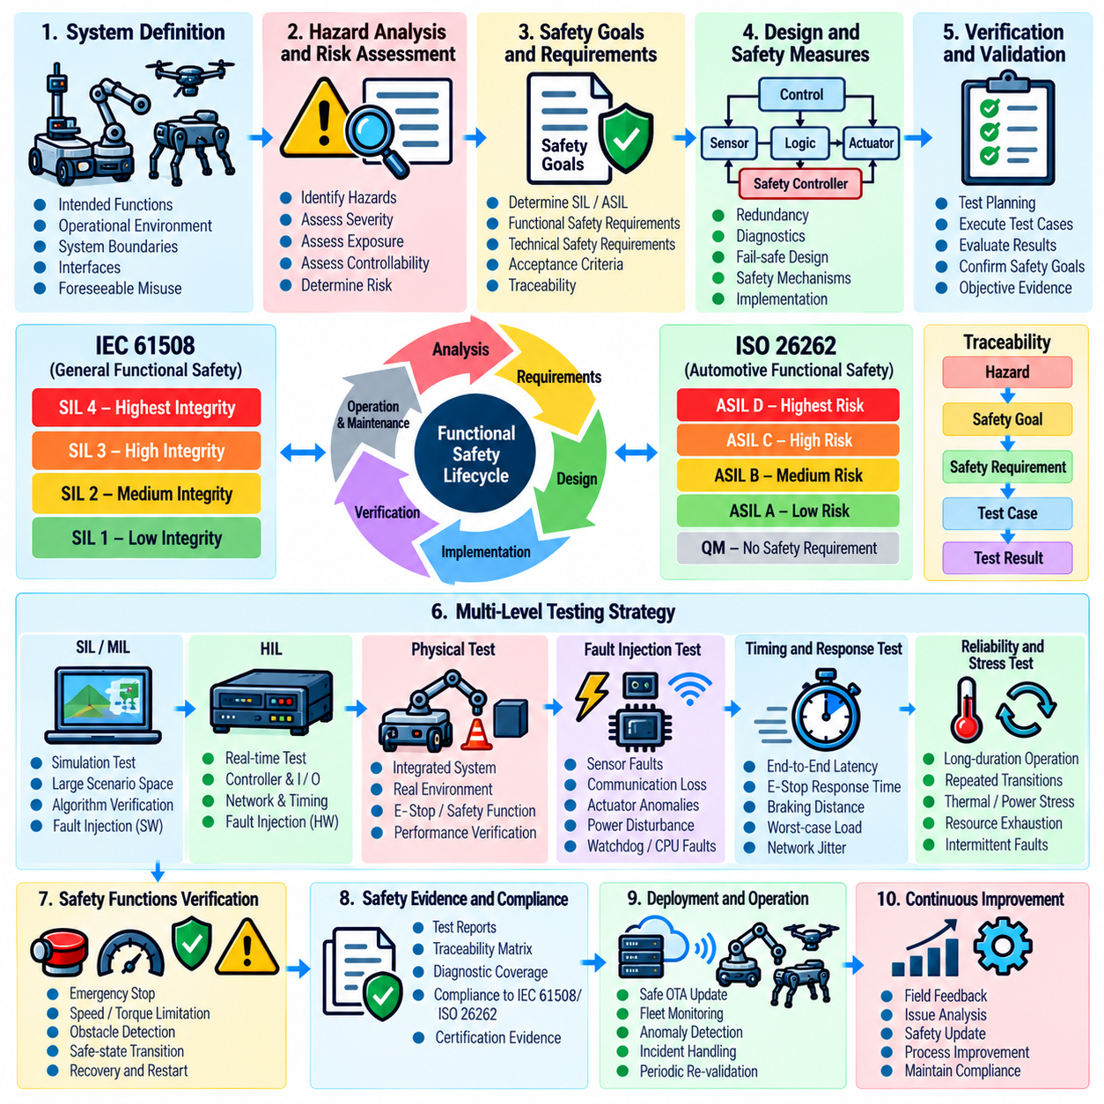
A safety testing strategy for robotic systems begins by treating functional safety as a lifecycle activity rather than a final-stage inspection. IEC 61508 provides a general framework for safety-related electrical, electronic, and programmable electronic systems, while ISO 26262 adapts comparable lifecycle principles to road vehicles. For robotics, these frameworks provide useful methods for connecting hazards, safety requirements, implementation controls, verification activities, and objective evidence throughout development.
The strategy should begin with system boundaries, intended functions, operating environments, foreseeable misuse, interfaces, and safety-related assumptions. Hazard analysis identifies situations in which failures could cause injury, equipment damage, or loss of controlled operation. Risk assessment then determines the required level of risk reduction. Safety goals are converted into measurable requirements so that each protective function can later be verified through analysis, simulation, hardware testing, and system-level testing.
IEC 61508 organizes functional safety around the concept of Safety Integrity Levels, commonly expressed as SIL 1 through SIL 4. The required integrity level influences architectural constraints, systematic development practices, diagnostic coverage, verification rigor, and evidence expectations. A robot safety program should therefore avoid treating SIL merely as a numerical reliability target. Testing must demonstrate both resistance to random hardware failures and adequate control of systematic faults introduced through requirements, design, software, integration, or maintenance.
ISO 26262 uses a risk-oriented automotive framework in which hazardous events are analyzed according to factors such as severity, exposure, and controllability, leading to Automotive Safety Integrity Levels. Although ASIL classifications should not be directly substituted for IEC 61508 SIL classifications, the underlying engineering discipline is valuable for mobile and autonomous robotic platforms. Safety goals, functional safety requirements, technical safety requirements, verification measures, and confirmation activities should remain traceable across the complete development lifecycle.
A practical robot safety test architecture should maintain bidirectional traceability from hazards to safety requirements and from requirements to executable test cases. Each safety requirement should define its verification method, expected response, acceptance criteria, required instrumentation, environmental conditions, and evidence format. Requirements concerning emergency stopping, torque limitation, speed limitation, obstacle detection, communication supervision, actuator shutdown, or degraded operation therefore become explicit and repeatable verification targets rather than informal demonstrations.
Testing should be distributed across multiple abstraction levels because no single environment can expose every relevant safety failure. Model-in-the-loop and software-in-the-loop testing can explore large scenario spaces efficiently, while hardware-in-the-loop testing verifies timing, communication, controller behavior, and hardware interfaces under realistic conditions. Physical system tests then confirm that integrated sensors, computers, networks, drives, brakes, actuators, and mechanical structures produce the required safety response under representative operating conditions.
Fault injection is especially important because many safety mechanisms remain inactive during normal operation. Tests should deliberately introduce sensor loss, corrupted measurements, communication delays, network interruption, processor faults, actuator anomalies, power disturbances, watchdog expiration, and inconsistent state information. The objective is not simply to observe whether the robot reports an error, but to verify fault detection latency, diagnostic coverage, transition behavior, containment, safe-state achievement, recovery logic, and prevention of hazardous unintended motion.
Timing must be treated as a safety property whenever a protective function depends on rapid reaction. An emergency-stop chain, for example, should be evaluated from initiation of the safety event through detection, communication, controller response, drive reaction, torque removal, and final mechanical stopping. Measuring only software callback latency is insufficient. The acceptance criterion should address the complete end-to-end response and account for worst-case computational load, network jitter, actuator dynamics, payload, velocity, surface conditions, and braking performance.
Safety testing should also distinguish prevention, detection, mitigation, and recovery mechanisms. Redundant sensing may prevent a single sensor fault from causing hazardous behavior, while plausibility checking can detect disagreement between channels. A safety controller may mitigate the resulting risk by limiting speed or disabling torque, and controlled recovery procedures may subsequently restore operation. Test cases should verify these layers independently and in combination, including scenarios where multiple protection mechanisms interact or fail sequentially.
Reliability evidence supports functional safety by establishing whether components and subsystems behave consistently over their intended mission profile. Failure-rate assumptions, diagnostic mechanisms, redundancy architectures, watchdogs, communication supervision, memory protection, power monitoring, and thermal protection should be tested under representative workloads. Long-duration operation and repeated transition testing can reveal intermittent faults, resource exhaustion, thermal degradation, timing drift, connector problems, and software states that short nominal tests may never expose.
Software safety verification requires more than functional correctness. The test strategy should address requirements coverage, interface behavior, defensive programming, numerical limits, concurrency, scheduling, memory handling, state-machine transitions, initialization, shutdown, restart, and fault recovery. Static analysis, unit testing, integration testing, structural coverage, robustness testing, and system testing provide complementary evidence. Greater safety criticality generally requires stronger independence, traceability, review discipline, and verification rigor.
Autonomous and AI-enabled robots introduce additional uncertainty because perception and learned policies may behave differently outside their training distribution. Conventional functional-safety mechanisms should therefore establish deterministic safety envelopes around probabilistic components whenever practical. Tests should examine low-confidence perception, contradictory sensors, unexpected objects, degraded visibility, unusual geometry, localization uncertainty, and unsafe AI commands. Independent monitors should verify that AI behavior cannot bypass established motion, workspace, force, speed, or shutdown constraints.
Configuration control is essential because safety evidence is meaningful only for a known system configuration. Every safety test result should be associated with software versions, model versions, firmware, calibration data, hardware revisions, safety parameters, test equipment, environmental conditions, and requirement baselines. Changes to safety-related components should trigger impact analysis so that affected tests can be selected for regression rather than assuming that previously collected evidence remains valid after modification.
The final strategy should produce an auditable safety case rather than a collection of disconnected test reports. Hazard records, safety requirements, architecture decisions, verification results, fault-injection evidence, coverage measurements, anomaly reports, corrective actions, and residual-risk assessments should form a traceable evidence chain. Within the broader testing structure, this establishes the foundation for subsequent safety-function procedures, fault injection, reliability assessment, functional-safety checklists, integrity-level evidence, and automated safety regression testing. Volume_25_Testing_Validation_an…

07.02. Safety Function Test Procedure STO SLS SS1 [w/Code]
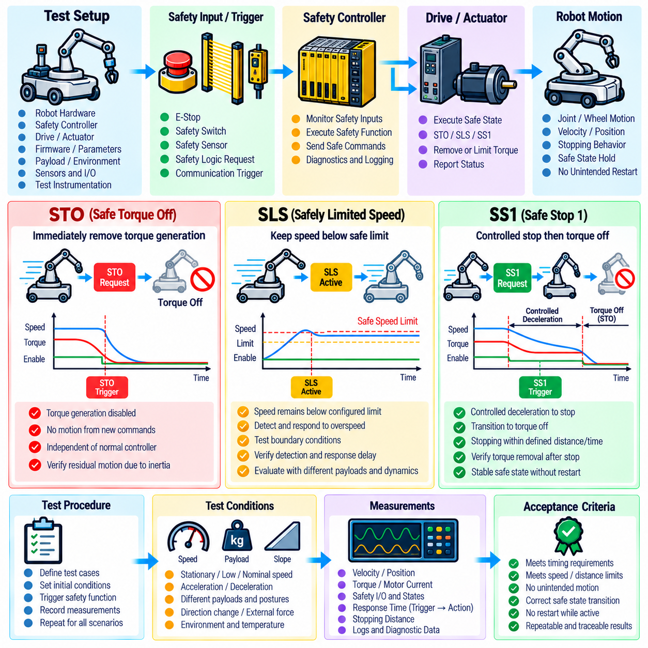
The safety function test procedure for Safe Torque Off (STO), Safely Limited Speed (SLS), and Safe Stop 1 (SS1) verifies that a robot can prevent or terminate hazardous motion according to predefined safety requirements. These functions should be tested as parts of an integrated safety chain that includes sensors, safety controllers, communication interfaces, servo drives, actuators, brakes, and mechanical motion. Each test must define initial conditions, trigger conditions, expected transitions, timing limits, acceptance criteria, and evidence to be recorded. Volume_25_Testing_Validation_an…
Before functional testing begins, the test configuration must be controlled and documented. The robot hardware revision, safety controller firmware, drive firmware, safety parameters, software version, payload, battery or power condition, communication configuration, and calibration state should be recorded. Safety inputs and outputs must be mapped to their physical and logical channels so that measured responses can be associated with the exact safety path being evaluated. Test instrumentation should have sufficient sampling rate and timestamp accuracy for response-time analysis.
STO testing verifies that hazardous torque-producing energy is prevented from reaching the motor when the safety function is demanded. The robot should first be placed in representative operating states such as stationary enabled, low-speed motion, nominal-speed motion, acceleration, deceleration, and loaded operation. The STO request is then activated while motor command, drive status, wheel or joint velocity, current, torque-related signals, and safety-controller states are recorded. The expected result is removal of torque generation capability without an unintended restart.
An STO test should distinguish commanded zero torque from genuine safety-related torque inhibition. Simply observing that a velocity command becomes zero does not demonstrate STO operation because the normal motion controller may still retain authority over the drive. Evidence should confirm that the safety path forces the drive into the defined torque-off condition independently of ordinary motion commands. Attempts to issue new velocity, position, or torque commands while STO remains active should not restore actuator torque or initiate hazardous movement.
STO response testing must also evaluate the physical consequences of removing torque. STO itself does not necessarily provide controlled deceleration, so a mobile robot, manipulator, humanoid joint, or other mechanism may continue moving because of inertia, gravity, external forces, or stored mechanical energy. Tests should therefore measure residual motion and stopping behavior under representative speed, payload, slope, posture, and load conditions. Where mechanical brakes or additional stopping functions are required, their interaction with STO must be verified separately.
SLS testing verifies that robot motion remains below a specified safety-related speed limit whenever the function is active. The procedure should establish the configured safe-speed threshold and determine how actual velocity is independently measured. Tests should cover operation below the limit, approach toward the threshold, intentional commands above the threshold, sudden acceleration, direction changes, varying payloads, and realistic control disturbances. Both the monitored speed and the safety system response should be captured using synchronized measurements.
The central SLS criterion is not merely whether the normal controller attempts to respect the speed limit, but whether the safety mechanism detects and responds to excessive speed according to the specified safety behavior. The test should intentionally request motion beyond the permitted threshold and verify detection of the violation. Measurements should determine the maximum observed speed, detection delay, response delay, duration of any overspeed condition, and resulting transition to limited motion or another defined safe state.
Boundary testing is particularly important for SLS because filtering, quantization, encoder resolution, sampling intervals, communication latency, and speed-estimation algorithms can affect threshold detection. Repeated tests should exercise values slightly below, at, and above the configured limit. Acceleration through the boundary should also be varied so that both slow threshold crossings and rapid overspeed events are evaluated. Acceptance criteria should account for explicitly defined tolerances rather than relying on visual observation of robot speed.
SS1 testing verifies a controlled stopping sequence followed by activation of a safe torque-off state. Unlike immediate STO activation, SS1 allows the drive or motion controller to perform controlled deceleration before torque-producing capability is removed. The test should therefore evaluate the complete sequence from the initial safety request through deceleration, stopping, transition to torque-off, and final stationary condition. Position, velocity, acceleration, drive state, safety state, brake status, and relevant command signals should be recorded throughout the sequence.
The SS1 procedure should be executed from representative combinations of velocity, payload, direction, slope, manipulator configuration, and operating mode. A safety request is introduced while the robot is moving, and the measured trajectory is compared with the expected deceleration behavior. Testing should determine whether stopping remains controlled, whether the robot exceeds permitted motion boundaries, whether torque removal occurs at the correct stage, and whether the final safe state remains stable after the stopping sequence has completed.
Timing verification is essential for all three safety functions. Measurements should identify the interval between safety input activation and safety-controller recognition, the communication delay to the drive, the drive reaction time, the onset of deceleration or torque inhibition, and the time required to reach the final safe condition. For SS1, the controlled-stop interval and subsequent STO transition must be evaluated separately. Repeated measurements should be used to identify worst-case behavior rather than accepting a single successful response.
Fault injection should be incorporated into STO, SLS, and SS1 testing because nominal tests cannot demonstrate behavior when components of the safety chain malfunction. Representative cases include loss of one redundant safety channel, encoder inconsistency, communication interruption, stale velocity information, safety-controller restart, drive communication failure, and disagreement between commanded and measured motion. The expected reaction should be defined before testing so that each injected fault can be evaluated against a deterministic pass/fail criterion.
Reset and restart behavior must receive the same attention as activation of the safety function. After STO or an SS1-to-STO transition, clearing the initiating condition should not automatically produce unexpected motion. The test should verify the required reset sequence, acknowledgement logic, drive re-enablement, brake release, command validation, and transition back to operational control. For SLS, tests should similarly confirm how the system exits speed-limited operation and whether unrestricted motion can resume only when all specified safety conditions are satisfied.
Regression testing should repeat critical STO, SLS, and SS1 scenarios whenever safety-related software, firmware, drive parameters, controller configuration, hardware interfaces, or motion-control logic changes. Automated acquisition can compare response time, stopping distance, maximum speed, safety-state transitions, and fault reactions against approved baselines. This converts individual safety demonstrations into reproducible verification procedures and supports the chapter's broader progression toward fault injection, functional-safety verification, integrity-level evidence, and automated safety regression. Volume_25_Testing_Validation_an…

07.03. E Stop Response Time Test Automation [w/Code]
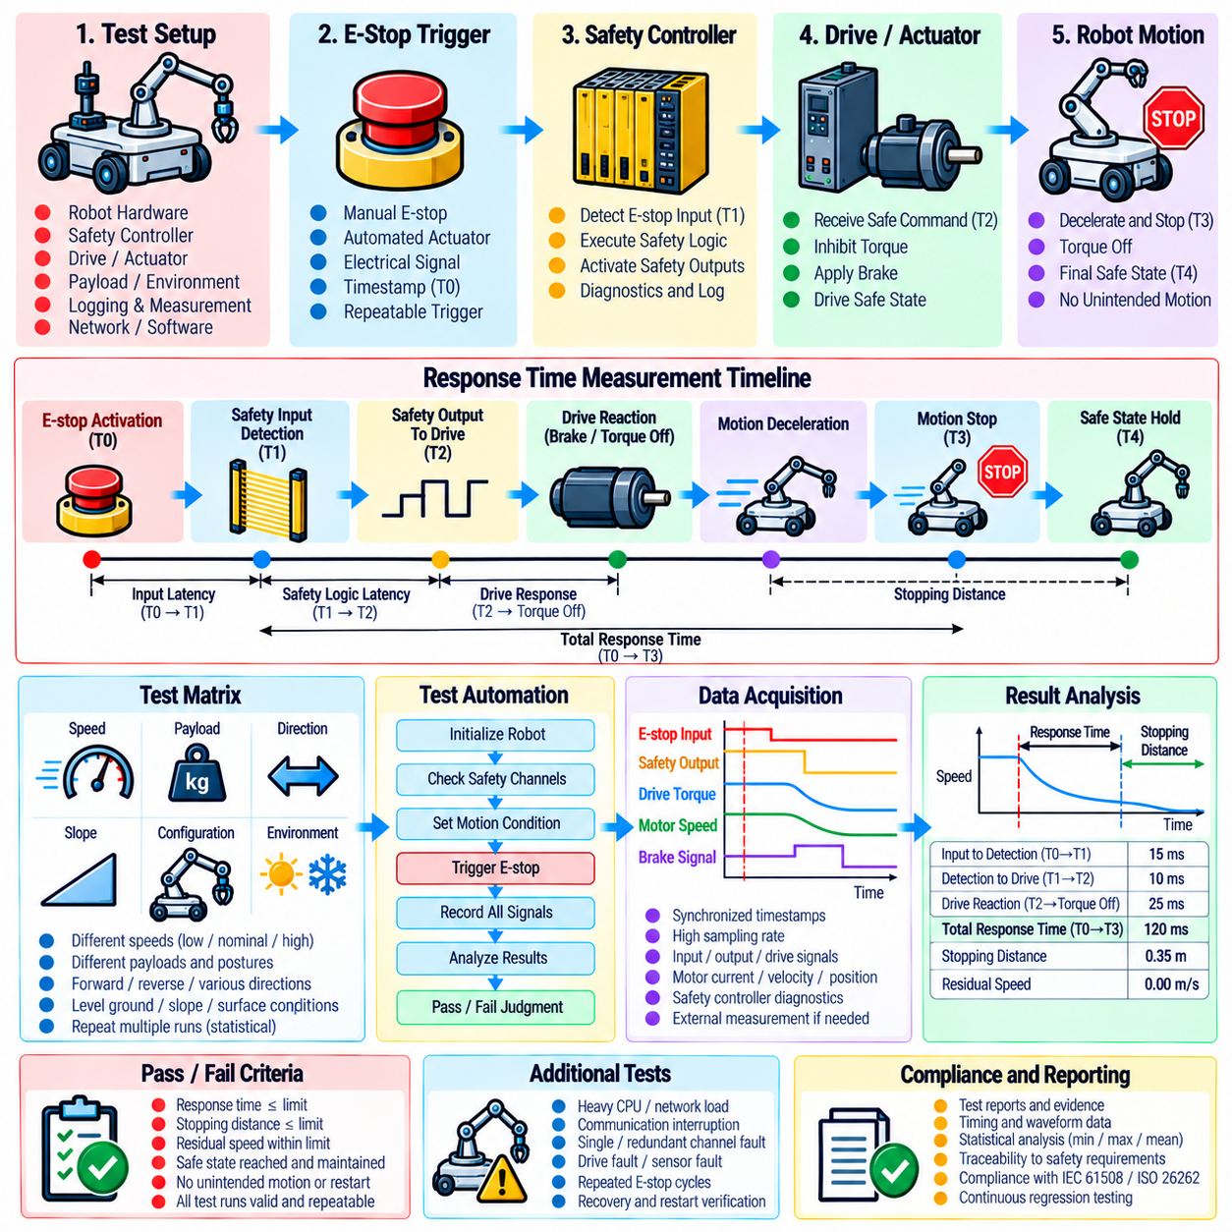
Emergency-stop response-time test automation establishes a repeatable method for measuring how quickly a robot transitions from an emergency-stop request to the required safe condition. The test must evaluate the complete safety chain rather than only software execution time. Relevant stages include physical E-stop activation, safety input detection, safety-controller processing, communication to drives, braking or torque removal, and the final cessation of hazardous motion.
The automated procedure begins with a controlled test configuration. Robot hardware, safety-controller firmware, drive firmware, motion software, safety parameters, payload, battery or supply condition, brake configuration, and network settings should be recorded before execution. Measurement devices must use synchronized timestamps so that events observed at different points of the safety chain can be reconstructed accurately and compared across repeated test runs.
A response-time measurement should define a common event timeline. The initial reference event is the transition of the emergency-stop input from its normal state to its demanded state. Subsequent timestamps identify safety-controller recognition, safety-output transition, drive reaction, initiation of deceleration, torque inhibition, brake engagement where applicable, and final motion termination. These timestamps allow both component-level latency and complete end-to-end response time to be calculated automatically.
Instrumentation should capture signals at a sampling rate appropriate to the required timing resolution. Safety input and output states, drive status words, motor current, torque-related values, wheel or joint velocity, commanded velocity, encoder data, brake signals, and safety-controller diagnostics may be recorded simultaneously. When software logs alone cannot provide independent timing evidence, external measurement equipment should be used to establish an objective reference for physical input activation and actual mechanical motion.
Automation should execute the same E-stop scenario repeatedly under controlled initial conditions. Each run initializes the robot, verifies that required safety channels are healthy, commands the selected motion condition, waits until predefined steady-state criteria are satisfied, triggers or detects the emergency-stop event, records the response, and determines whether the final safe condition has been achieved. Invalid runs caused by incomplete initialization or instrumentation failure should be identified separately rather than counted as successful tests.
The test matrix should represent the operating conditions that can influence stopping performance. Measurements should include different commanded speeds, payloads, directions of travel, actuator configurations, battery or supply conditions, and representative surface conditions where relevant. For manipulators or humanoid systems, joint configuration and gravitational loading may significantly affect stopping behavior. Mobile robots should additionally consider vehicle mass, wheel traction, slope, and direction because these factors can alter stopping distance.
Response time and stopping distance should be treated as related but distinct safety metrics. A short electronic reaction time does not guarantee a short physical stopping distance because mechanical deceleration depends on velocity, mass, braking capability, traction, actuator dynamics, and environmental conditions. Automated analysis should therefore calculate the interval from E-stop activation to the start of safety action, the total time until motion termination, and the distance or angular displacement traveled during the stopping process.
Pass and fail criteria must originate from defined safety requirements rather than from comparison with typical test results. The automation framework should compare measured values against maximum permitted response time, stopping time, stopping distance, residual velocity, and any applicable state-transition requirements. A run should fail if any safety limit is exceeded, if the required safe state is not reached, or if recorded evidence is incomplete enough that compliance cannot be demonstrated objectively.
Statistical repetition is necessary because response time may vary with scheduling, communication jitter, controller load, network traffic, sensor sampling, drive-cycle timing, and other asynchronous processes. Automated testing should perform sufficient repetitions to reveal variation instead of reporting only an average value. Minimum, maximum, mean, percentile, and dispersion statistics can characterize observed behavior, while the worst measured result should receive particular attention when assessing compliance with a safety timing limit.
Stress conditions should be introduced to determine whether emergency-stop performance remains acceptable when the robot is heavily loaded computationally or operationally. The system can be exercised while perception pipelines, logging, networking, navigation, AI inference, or other non-safety workloads are active. Safety-related execution should remain sufficiently isolated and deterministic so that increased application workload does not cause unacceptable delay in detection, communication, drive response, or physical stopping.
Fault-oriented testing extends automation beyond nominal E-stop activation. Tests may introduce communication interruption, delayed messages, loss of a redundant channel, drive faults, safety-controller diagnostics, encoder inconsistencies, or abnormal application behavior before the emergency-stop request. The objective is to verify that failures elsewhere in the system do not prevent the emergency-stop path from reaching its specified safe state within the required response envelope.
The procedure should also verify behavior after motion has stopped. Maintaining the emergency-stop condition must prevent an unintended restart even if normal motion commands continue to be transmitted. Releasing the physical E-stop should not itself initiate motion. Where a manual reset or acknowledgement is required, automation should confirm that the robot remains inhibited until the prescribed reset sequence is completed and that re-enablement occurs only after all safety conditions have returned to valid states.
Automated analysis should generate traceable evidence for every execution. Each result should retain the test-case identifier, requirement reference, system configuration, timestamped signal data, calculated response intervals, stopping distance, acceptance limits, pass/fail result, and detected anomalies. Raw data should remain available so that a failed result can be reconstructed and independently reviewed instead of relying only on a summarized test report.
Integration with continuous integration and hardware-in-the-loop environments allows the E-stop test to become part of safety regression testing rather than a one-time qualification activity. Changes to safety software, drive firmware, communication configuration, braking parameters, motion-control logic, or relevant hardware can trigger selected response-time tests automatically. Results can then be compared with approved baselines to detect timing degradation before a modified configuration is released for field operation.
A mature E-stop automation framework ultimately provides evidence that emergency stopping is deterministic, repeatable, measurable, and resistant to system variation. Its purpose is not merely to demonstrate that pressing an emergency-stop device eventually stops the robot, but to prove that the complete physical system reaches the defined safe condition within specified limits across relevant operating states. This evidence complements the chapter's STO, SLS, SS1, fault-injection, reliability, and functional-safety verification activities. Volume_25_Testing_Validation_an…

07.04. Fault Injection Test HW SW Sensor Actuator [w/Code]
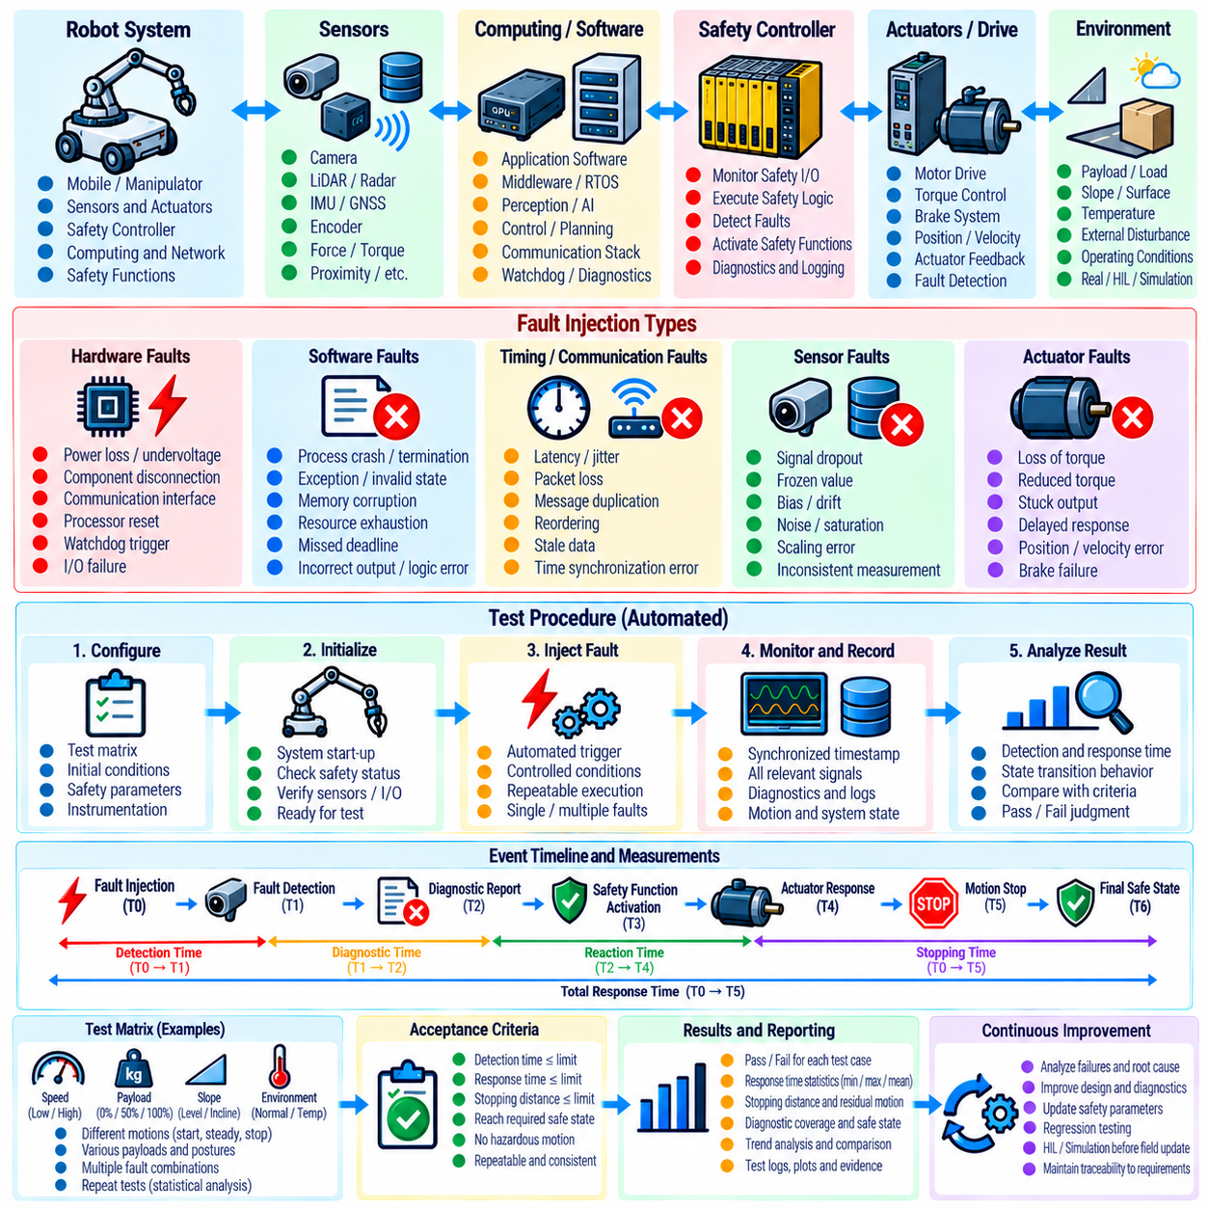
Fault injection testing evaluates whether a robotic system can detect, contain, and safely respond to failures that may occur in hardware, software, sensors, actuators, and communication paths. Unlike nominal functional testing, the objective is to deliberately introduce abnormal conditions and observe whether safety mechanisms behave as specified. The procedure should connect each injected fault to a defined failure hypothesis, expected diagnostic response, required safe state, timing constraint, and objective pass/fail criterion. Volume_25_Testing_Validation_an…
A fault injection campaign should begin with a structured fault model derived from system architecture, hazard analysis, FMEA, safety requirements, and known component failure modes. Faults should be classified according to their origin, duration, observability, and potential safety consequence. Permanent, transient, intermittent, single-point, and combined faults may require different test methods. The selected set should represent credible failures rather than arbitrary disturbances that have no relationship to system risk.
Hardware fault injection examines failures in computing modules, power systems, communication interfaces, safety controllers, drives, wiring, and supporting electronics. Representative tests can introduce power interruption, undervoltage, communication loss, disconnected channels, corrupted interfaces, processor resets, watchdog events, or unavailable peripherals. Injection equipment should avoid creating uncontrolled physical hazards, while measurements should determine whether the system detects the fault and transitions to the required degraded or safe condition.
Software fault injection targets abnormal internal states that may not be reproduced through physical hardware manipulation. Tests can emulate process termination, delayed execution, missed deadlines, invalid state transitions, corrupted messages, resource exhaustion, unavailable services, or unexpected return values. The purpose is to verify that supervision mechanisms, exception handling, watchdogs, lifecycle management, and recovery logic prevent a local software failure from propagating into hazardous robot behavior.
Timing faults deserve particular attention in distributed robot software. A message may remain syntactically valid while arriving too late to represent the current physical state. Fault injection should therefore introduce latency, jitter, packet loss, duplication, reordering, and stale data into selected communication paths. The system should identify information that exceeds its permitted age or timing assumptions and avoid using outdated state estimates or commands when they could produce unsafe motion.
Sensor fault injection verifies robustness against incorrect or unavailable observations. Camera, LiDAR, radar, IMU, GNSS, encoder, force, torque, proximity, and other sensor channels can be subjected to dropout, frozen values, bias, drift, noise, saturation, scaling errors, timestamp errors, or physically inconsistent measurements. The test should determine whether plausibility checks, redundancy, confidence monitoring, sensor fusion, and diagnostic logic correctly identify or tolerate the abnormal condition.
Sensor testing should distinguish complete failure from plausible but misleading information. A disconnected sensor is often easier to detect than a sensor that continues producing valid-format measurements with a slowly increasing bias. Tests should therefore include subtle faults that remain within normal communication formats while violating physical consistency. Cross-sensor comparison, temporal consistency checks, kinematic constraints, and environmental models can then be evaluated as mechanisms for detecting latent or deceptive sensor failures.
Actuator fault injection evaluates whether commanded motion and actual physical response remain safely supervised. Representative faults include loss of torque, reduced torque, delayed response, stuck output, unexpected motion, brake failure, position tracking error, velocity deviation, and disagreement between command and feedback. For mobile robots and manipulators, the procedure should determine whether the controller recognizes degraded actuation and whether the remaining system can stop, limit motion, isolate the failed actuator, or enter another defined safe state.
Fault injection into safety-related actuators requires strict control because intentionally disturbing brakes, drives, or torque-producing devices can create real hazardous motion. Tests should begin in simulation or HIL where practical and progress to physical hardware only when appropriate safeguards are established. Physical tests should define restricted operating zones, reduced initial energy, suitable payload conditions, independent emergency stopping, instrumentation, and clear abort criteria before the fault is introduced.
Combined faults are important when the safety architecture relies on redundancy or diagnostic assumptions. A single sensor failure may be tolerated, while simultaneous loss of a redundant sensor and its communication path may require immediate stopping. Testing should therefore examine selected dependent and multiple-fault combinations where justified by the safety analysis. The goal is not exhaustive enumeration of every possible combination, but verification of assumptions concerning independence, redundancy, diagnostic coverage, and fault containment.
For every injected fault, the event sequence should be captured from fault activation to final system response. Important measurements include fault injection time, detection time, diagnostic reporting time, safety-function activation, motion response, isolation time, and achievement of the final safe or degraded state. These timestamps allow calculation of fault detection latency and fault reaction time, making it possible to determine whether diagnostic mechanisms operate within their specified safety timing requirements.
Pass/fail evaluation should consider more than whether an error message appears. A successful test requires the correct fault to be detected within the required interval, the specified diagnostic state to be entered, hazardous commands to be inhibited where necessary, and the required safe or degraded behavior to be achieved. Undetected faults, incorrect classification, excessive detection latency, unsafe fallback behavior, uncontrolled restart, or loss of required diagnostic evidence should be treated as failures requiring investigation.
Recovery testing should follow fault detection because returning from a fault can itself introduce risk. After the injected condition is removed, the robot should not automatically resume hazardous motion unless automatic recovery is explicitly permitted by the safety design. Tests should verify reset requirements, state reinitialization, sensor validation, actuator readiness, localization consistency, command freshness, and operator acknowledgement where applicable before normal operation is restored.
Automation makes fault injection reproducible and suitable for regression testing. A test framework can initialize the robot, establish nominal conditions, activate a predefined fault at a controlled time, collect synchronized telemetry, evaluate diagnostic and safety responses, restore the environment, and generate a result automatically. Each execution should preserve the injected fault definition, software and hardware configuration, raw signals, calculated timing metrics, expected response, actual response, and final pass/fail decision.
A mature fault injection program converts assumptions about fault tolerance into measurable evidence. Hardware, software, sensor, and actuator failures are deliberately exercised so that diagnostic coverage, redundancy, degradation strategies, stopping functions, and recovery mechanisms can be validated before comparable failures occur in field operation. Within the safety and reliability testing structure, these results provide direct input to reliability assessment, functional-safety verification, safety-integrity evidence, and automated regression activities.

07.05. Reliability Test MTBF MTTF Estimation [w/Code]
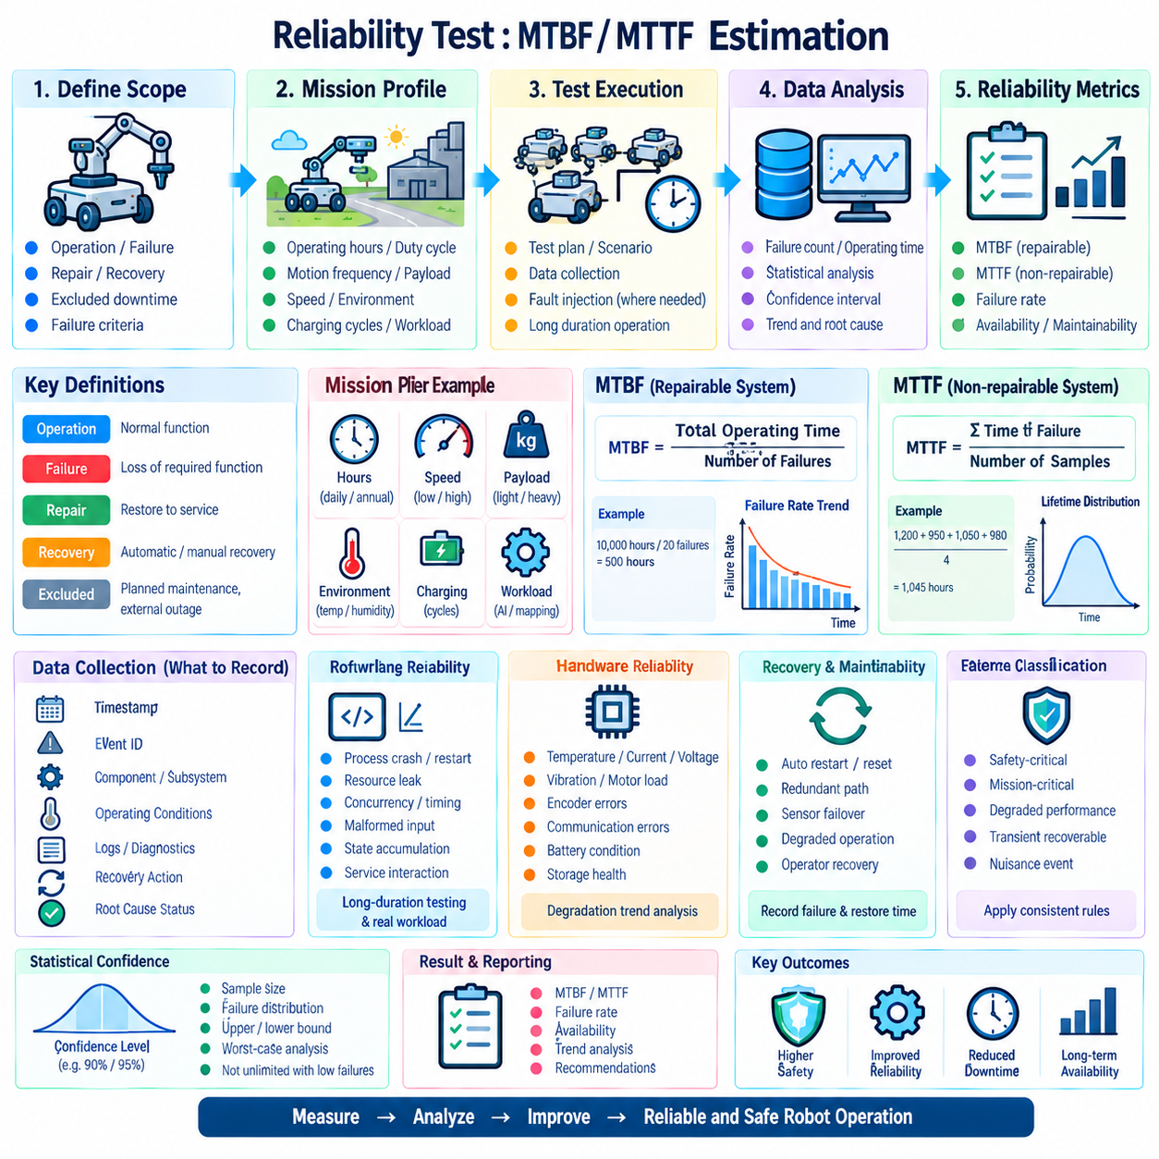
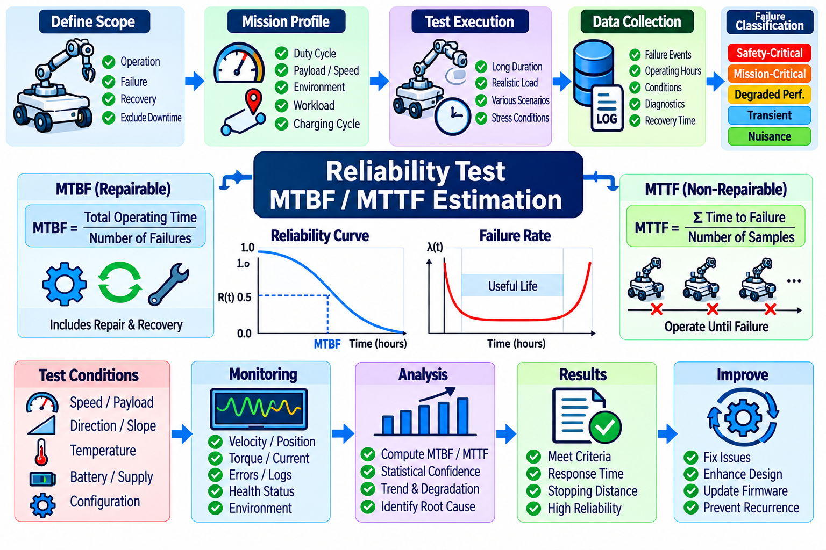
Reliability testing determines whether a robotic system can perform its required functions consistently for the intended operating duration and mission profile. Within safety and reliability testing, Mean Time Between Failures (MTBF) and Mean Time To Failure (MTTF) provide quantitative indicators for characterizing failure behavior. MTBF is generally applied to repairable systems, while MTTF is commonly used for non-repairable items or components whose useful operating life ends when failure occurs. Volume_25_Testing_Validation_an…
A reliability test should begin by defining what constitutes operation, failure, repair, recovery, and excluded downtime. Without consistent definitions, accumulated operating hours and failure counts cannot produce meaningful reliability estimates. A robot failure may include complete loss of mission capability, unsafe shutdown, actuator malfunction, persistent localization loss, unrecoverable software failure, or another condition defined by system requirements. Planned maintenance and external infrastructure outages should be classified separately when appropriate.
The mission profile establishes the conditions under which reliability evidence is valid. It should describe operating hours, duty cycle, motion frequency, payload, speed, environmental conditions, charging cycles, computational workload, communication usage, actuator utilization, and expected standby periods. Reliability measured during light laboratory operation cannot automatically represent continuous industrial deployment. Test conditions should therefore reproduce the stresses and usage patterns expected during actual service as closely as practical.
MTBF for a repairable system can be estimated from accumulated operating time divided by the number of relevant failures during the observation period. If several equivalent robots participate in testing, their valid operating hours can be accumulated when configurations and operating conditions are sufficiently comparable. The resulting value represents an estimate rather than a guaranteed interval between failures, and interpretation should consider the amount of exposure, failure distribution, confidence level, and maturity of the tested configuration.
MTTF estimation applies similar observation principles to non-repairable components or items evaluated until failure. Multiple samples should be operated under controlled conditions, and their time-to-failure values recorded. Depending on the component and failure mechanism, analysis may use arithmetic estimates or an appropriate lifetime distribution. Motors, bearings, batteries, electronic modules, sensors, connectors, and other robot components can exhibit different aging mechanisms, so a single statistical model should not be assumed automatically.
Reliability data collection must preserve the distinction between failure events and symptoms. A navigation process crash, for example, may be a visible symptom caused by memory exhaustion, corrupted input data, communication loss, or an underlying hardware problem. Each event should therefore receive a unique identifier and retain timestamps, system configuration, operating conditions, diagnostic logs, affected subsystem, observed consequence, recovery action, and root-cause status. This prevents repeated manifestations of one underlying problem from being incorrectly interpreted.
Software reliability requires special treatment because software does not physically wear out in the same manner as mechanical components. Failures may instead depend on rare execution paths, resource leakage, concurrency, timing, malformed inputs, state accumulation, or interactions between services. Long-duration testing should therefore exercise realistic workloads, repeated lifecycle transitions, communication disturbances, logging, AI inference, map updates, mission changes, and recovery sequences to expose defects that short functional tests may not reveal.
Hardware reliability testing should monitor parameters that can reveal progressive degradation before complete failure occurs. Temperature, current, voltage, vibration, motor load, encoder errors, communication error counts, battery condition, storage health, and thermal throttling can provide useful precursors. Correlating these measurements with operating hours and failure events helps distinguish random failures from wear-related mechanisms and can support preventive maintenance or condition-based maintenance strategies.
Reliability testing should also examine system recovery because repairable robots may experience faults without requiring physical replacement of hardware. Automatic process restart, controller reset, redundant communication paths, sensor failover, degraded operation, and operator-assisted recovery can reduce service interruption. The test program should record both failure occurrence and restoration time so that reliability results can later be combined with maintainability measurements when evaluating operational availability.
Failure classification should separate safety-critical failures, mission-critical failures, degraded-performance events, transient recoverable faults, and nuisance events according to defined project rules. A high MTBF calculated by ignoring repeated degraded states may provide a misleading representation of field performance. Conversely, treating every diagnostic warning as a system failure may underestimate reliability. Classification rules should therefore be established before data analysis and applied consistently across test campaigns.
Statistical confidence becomes important when few failures are observed. A long test with zero or one failure does not establish unlimited reliability; it only provides evidence within the accumulated exposure and selected statistical assumptions. Reliability reports should therefore state operating time, sample size, number and type of failures, estimation method, and confidence assumptions together with the reported MTBF or MTTF. Point estimates without their underlying test exposure can create unjustified confidence in system maturity.
Reliability growth testing can track whether corrective engineering actions improve system performance over successive development iterations. Failures discovered during endurance testing are analyzed, root causes are corrected, and the modified configuration is tested again. Trends in failure frequency, accumulated operating time, recurring failure modes, and subsystem contribution can then reveal whether reliability is genuinely improving or whether faults are merely shifting between components.
Automated reliability testing can continuously execute missions while collecting telemetry and detecting failure conditions. A test controller may schedule navigation, manipulation, charging, startup, shutdown, communication, or other representative cycles while a monitoring system records health indicators and operational state. Automated event detection should preserve raw evidence and allow human review because incorrect automatic classification of a failure can significantly distort MTBF and MTTF estimates.
Configuration management is essential because reliability statistics from materially different system versions should not be combined without justification. Hardware revisions, firmware, operating-system versions, robot software, AI models, calibration parameters, safety settings, and mechanical changes can alter failure behavior. Reliability evidence should therefore identify the exact configuration under test, and major modifications should trigger a new baseline or a documented analysis explaining how historical data remains applicable.
MTBF and MTTF ultimately serve as evidence for engineering decisions rather than isolated performance numbers. Their value comes from connecting operating exposure, failure mechanisms, statistical uncertainty, corrective actions, and field requirements into a traceable reliability assessment. Within the chapter structure, these results establish a quantitative basis for accelerated life testing, environmental stress screening, functional-safety verification, safety-integrity evidence, and regression testing that follow the reliability evaluation process.

07.06. Accelerated Life Test ALT for Robot HW SW
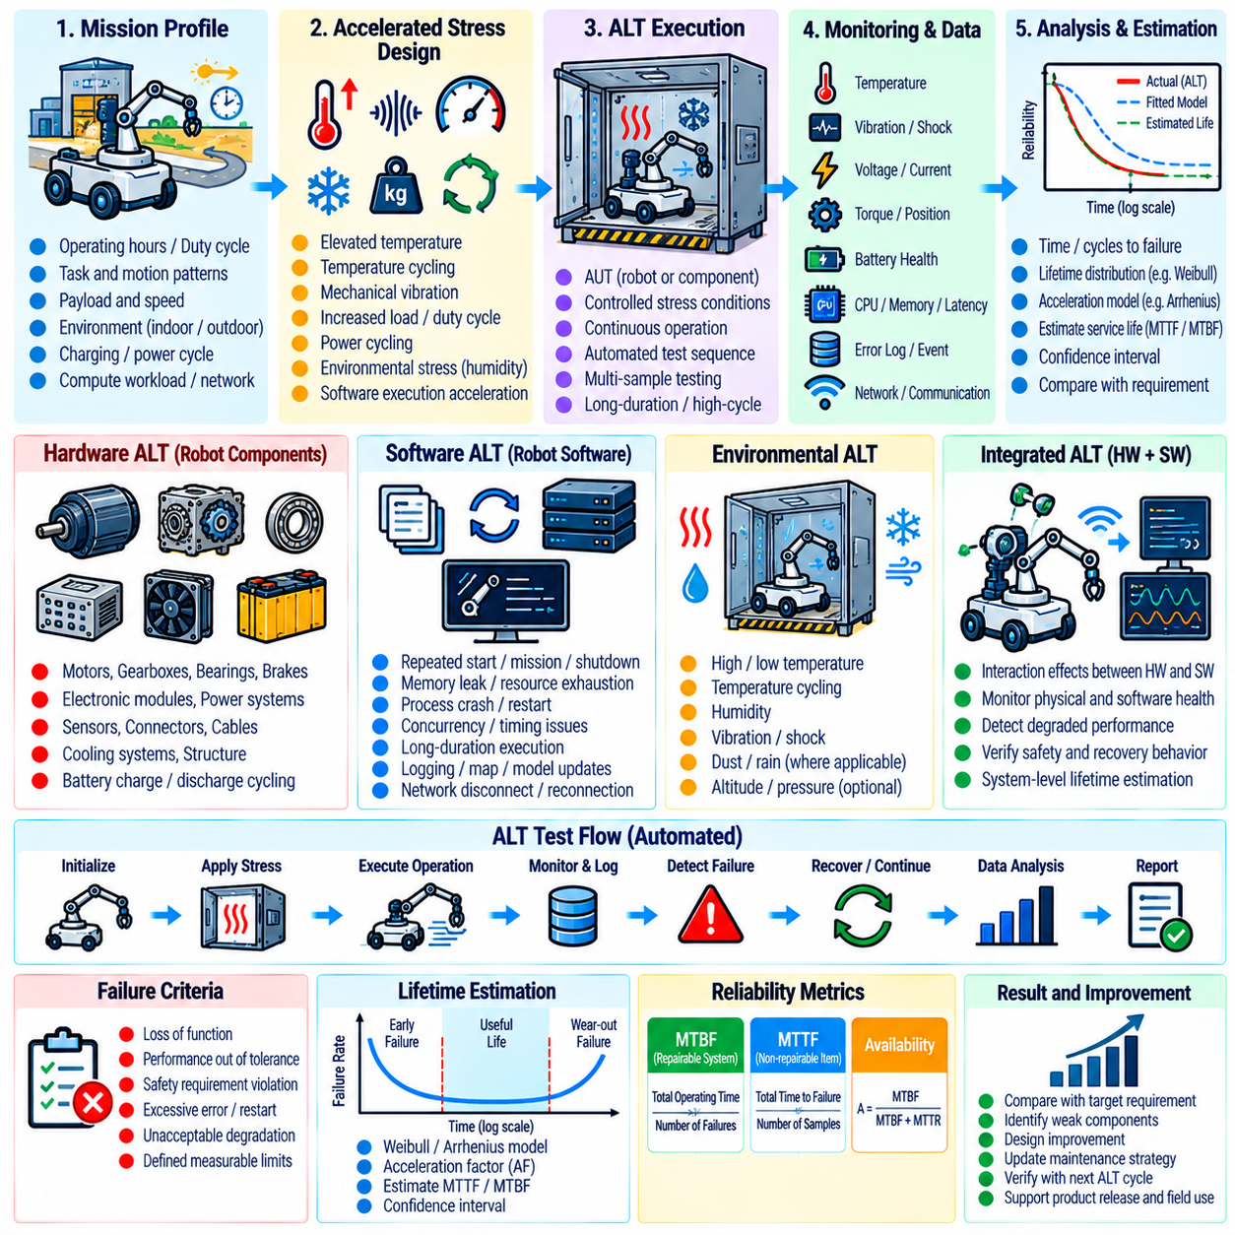
Accelerated Life Testing (ALT) evaluates whether robot hardware and software can maintain required performance over an intended service life by exposing the system to controlled stresses that accelerate relevant degradation or failure mechanisms. The objective is not simply to make components fail quickly, but to reproduce credible aging processes in less calendar time and use the resulting evidence to estimate durability, identify weak points, and support reliability improvement. Volume_25_Testing_Validation_an…
An ALT program should begin with the intended robot mission profile and the failure mechanisms expected under normal operation. Duty cycle, operating hours, payload, actuator utilization, charging frequency, thermal conditions, vibration, humidity, computational workload, communication activity, and repeated startup or shutdown cycles should be characterized. Acceleration conditions are then selected so that the test increases degradation rates without introducing unrealistic failure mechanisms that would not occur in actual service.
Hardware ALT commonly applies elevated temperature, increased mechanical cycling, higher duty cycle, vibration, repeated power cycling, intensified actuator loading, or accelerated battery charge and discharge patterns. Motors, bearings, gearboxes, brakes, connectors, electronic modules, cooling systems, sensors, and power components may respond differently to each stress. The selected stress therefore needs a physical relationship to the failure mechanism being investigated rather than being chosen solely because it shortens test duration.
Stress levels must remain within a range where the resulting failures are representative of field aging. Excessive temperature can melt materials that would never reach such conditions in service, while excessive mechanical loading can create fractures unrelated to normal fatigue. Such failures may reveal structural margins but should not automatically be used for life prediction. ALT planning should distinguish accelerated aging from destructive overstress testing and document the engineering rationale for each applied condition.
Thermal acceleration is particularly relevant to robot electronics, batteries, computing modules, power converters, and embedded controllers. Elevated temperature can accelerate mechanisms such as chemical aging, insulation degradation, and some electronic failure processes. Temperature cycling can additionally expose expansion mismatch, solder fatigue, connector problems, and intermittent contacts. Measurements should include component temperature rather than relying only on chamber temperature because internal self-heating may significantly alter actual stress.
Mechanical life testing should reproduce repeated motions and load cycles representative of real robot operation. Drive wheels, steering assemblies, joints, gearboxes, manipulators, grippers, suspension elements, brakes, and cable chains may require thousands or millions of cycles. Automated rigs or robot programs can repeatedly execute defined trajectories while monitoring torque, current, vibration, backlash, position error, temperature, and cycle count to identify progressive degradation before complete functional failure occurs.
Robot software also benefits from accelerated life concepts even though software does not physically wear out. Long-duration execution can compress months of operational state transitions into shorter continuous campaigns and reveal memory leaks, resource exhaustion, counter overflow, log growth, timing drift, stale state, synchronization problems, or rare concurrency failures. The acceleration mechanism is increased execution frequency and operational cycling rather than physical aging, so software results should be interpreted separately from hardware lifetime models.
A software ALT campaign can repeatedly execute startup, mission loading, navigation, manipulation, charging, communication loss, reconnection, process restart, map switching, model loading, shutdown, and recovery sequences. AI-enabled systems should also exercise repeated inference, data buffering, logging, model transitions, and sensor-stream interruptions. Monitoring should track memory, storage, processor and accelerator utilization, latency, queue depth, thread health, error counts, and service availability throughout the campaign.
Combined hardware and software ALT is valuable because many robot failures emerge only through interactions between physical degradation and control behavior. Increasing gearbox friction may raise motor current and temperature, which can trigger controller limits or change motion tracking. A degraded battery may alter voltage stability and computing behavior under peak load. Integrated testing should therefore monitor both physical health indicators and software responses to determine whether degradation is detected, tolerated, or amplified by system-level control.
ALT requires explicit failure criteria before testing begins. Failure may be defined as complete loss of function, inability to satisfy a safety requirement, performance outside an allowed tolerance, excessive backlash, unacceptable localization error, actuator tracking degradation, repeated software restart, thermal shutdown, or another measurable limit. Defining these criteria prevents test duration and failure classification from being adjusted after results are observed and supports consistent comparison among samples and system versions.
Time-to-failure or cycles-to-failure should be recorded together with the applied stress history. When multiple samples are tested, the resulting distribution can support lifetime estimation if the acceleration model and statistical assumptions are appropriate for the observed failure mechanism. Extrapolation from accelerated conditions to normal service should be performed cautiously because different stresses may follow different acceleration relationships. The selected model should therefore be justified by engineering evidence rather than applied automatically.
Intermediate inspections are important because a component may degrade progressively long before reaching the formal failure threshold. Scheduled checkpoints can measure backlash, bearing condition, brake performance, battery capacity, sensor accuracy, insulation condition, connector resistance, thermal behavior, and other health indicators. Trends across these measurements help identify degradation trajectories and may provide earlier engineering insight than waiting for complete failure at the end of the test.
When a failure occurs, root-cause analysis should determine whether it represents the intended accelerated mechanism, an unrelated test-fixture problem, manufacturing variation, software defect, or an unrealistic overstress condition. Failed components should retain their configuration, operating history, logs, and environmental records for investigation. Corrective design changes can then be introduced and retested, allowing ALT to support reliability growth rather than functioning only as a qualification gate.
Automation is essential for long-duration accelerated testing because continuous manual supervision is impractical. A test controller can schedule stress cycles, command robot motions, collect synchronized telemetry, detect threshold violations, place the system into a safe state, and resume permitted sequences after recovery. Automated monitoring should preserve raw data and generate alerts for abnormal trends while maintaining safeguards that prevent a test-induced failure from creating uncontrolled hazardous motion.
ALT results should remain traceable to hardware revisions, software and firmware versions, AI models, safety parameters, test fixtures, environmental conditions, applied stresses, sample identities, and calibration records. This configuration control is necessary because even small design changes can alter dominant failure mechanisms. Within the broader safety and reliability program, accelerated life evidence complements MTBF and MTTF estimation and provides a foundation for environmental stress screening, functional-safety verification, and reliability-focused regression testing.

07.07. Environmental Stress Screening ESS Protocol
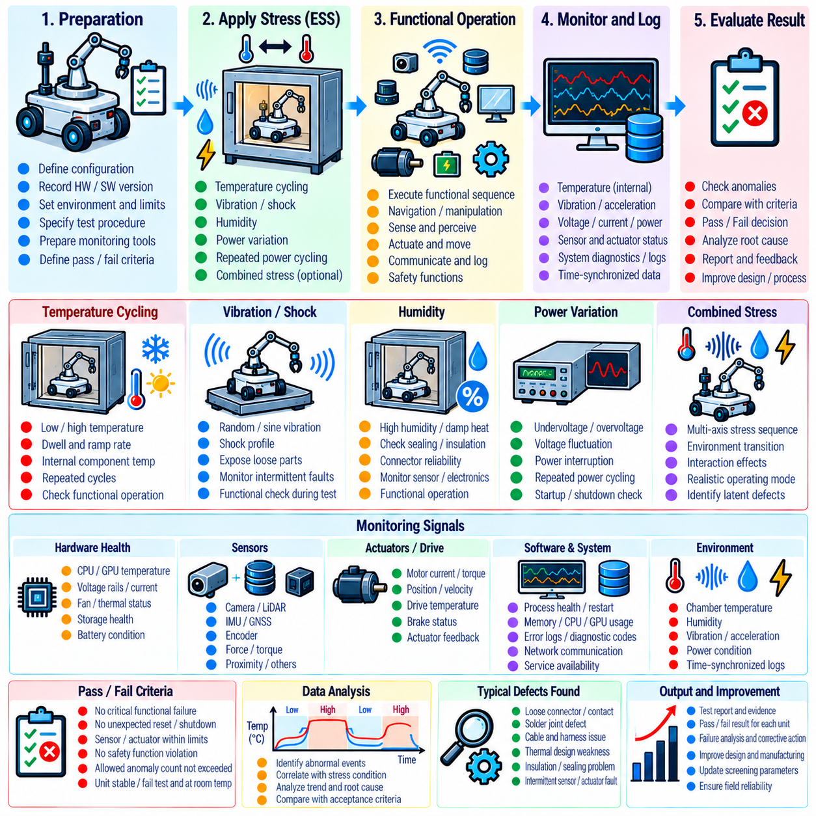
Environmental Stress Screening (ESS) is a controlled process used to expose latent manufacturing, assembly, integration, and workmanship defects before a robot enters extended validation or field deployment. Unlike accelerated life testing, ESS is primarily intended to reveal existing weaknesses rather than estimate service life. The protocol applies environmental stresses while continuously or periodically checking whether hardware, embedded software, communication, sensing, actuation, and safety functions remain operational. Volume_25_Testing_Validation_an…
An ESS protocol should begin with the robot configuration, intended operating environment, component limitations, and known failure sensitivities. Screening conditions must be strong enough to expose marginal connections, assembly defects, thermal weaknesses, or intermittent faults without consuming a significant portion of useful product life. Hardware revision, firmware, software, calibration, safety parameters, test equipment, environmental limits, and acceptance criteria should be frozen and recorded before screening begins.
Temperature cycling is one of the most effective ESS methods because repeated expansion and contraction can expose weak solder joints, connectors, cable terminations, printed circuit assemblies, seals, and mechanical interfaces. The robot or subsystem is repeatedly transitioned between defined low and high temperatures while critical functions are monitored. Temperature ramp rate, dwell duration, number of cycles, stabilization criteria, and component temperature should be specified so that screening remains repeatable across units.
Thermal monitoring should include internal components rather than relying solely on environmental chamber measurements. Edge computers, GPUs, motor drives, batteries, power converters, safety controllers, and enclosed electronics can experience temperatures significantly different from ambient conditions because of self-heating and airflow restrictions. Sensors placed at representative thermal locations help determine whether functional anomalies correlate with actual component temperature, thermal gradients, or transitions between heating and cooling phases.
Vibration screening is used to expose loose fasteners, marginal connectors, cracked joints, cable problems, mounting weaknesses, and intermittent electrical contacts. The vibration profile should reflect the robot platform and intended transportation or operating environment. Mobile robots, quadrupeds, manipulators, and UAVs can experience substantially different vibration spectra. Functional monitoring during vibration is valuable because intermittent failures may disappear immediately after the mechanical excitation stops.
Where appropriate, ESS can include humidity, power variation, repeated power cycling, or combined environmental stresses. Humidity may reveal insulation, sealing, contamination, or connector vulnerabilities, while controlled supply variation can expose marginal power distribution and reset behavior. Repeated power cycles can identify startup sequencing problems and intermittent initialization failures. Combined stresses should be introduced cautiously because interactions may produce failure mechanisms that are difficult to interpret or are not representative of intended operation.
Screening should monitor the robot at functional and diagnostic levels. Relevant observations may include processor health, communication error counts, sensor availability, actuator feedback, motor current, voltage rails, temperature, storage status, network connectivity, safety-controller state, encoder consistency, and application service health. Periodic functional sequences can exercise navigation, actuation, sensing, braking, communication, and safety functions while the environmental stress remains active.
Intermittent faults deserve particular attention because ESS frequently reveals failures that are difficult to reproduce under normal laboratory conditions. A connector may open only during vibration, a solder joint may fail near a particular temperature transition, or a processor may reset only when high computational load coincides with elevated temperature. High-resolution timestamped logging should therefore preserve environmental conditions and system events on a common timeline so that short-duration anomalies can later be correlated with the applied stress.
The ESS protocol should define explicit screening limits and product limits separately. Screening limits establish the controlled stresses applied during ESS, while product limits define the conditions within which the robot is required to operate or survive. Screening conditions should be justified so that they expose workmanship defects without becoming uncontrolled overstress tests. Exceeding component ratings without engineering justification can damage otherwise acceptable units and invalidate conclusions about production quality.
Pass and fail criteria should cover both permanent and temporary anomalies. A unit should not automatically pass merely because it operates normally after returning to room temperature. Resets, communication dropouts, sensor errors, safety faults, unexpected state transitions, actuator deviations, data corruption, or thermal protection events observed during screening may indicate latent defects. Acceptance rules should specify which events are prohibited, which require investigation, and which may be tolerated under defined conditions.
When a failure is detected, the screening process should preserve the failure state whenever practical before resetting or repairing the system. Logs, environmental measurements, diagnostic states, error codes, physical configuration, and the exact stress phase should be captured. Root-cause analysis can then determine whether the event resulted from manufacturing variation, assembly workmanship, component weakness, design margin, software behavior, test equipment, or an inappropriate screening profile.
Corrective actions should be followed by confirmation testing under the same or appropriately revised ESS conditions. If repeated failures occur across multiple units, the issue may indicate a systematic design or production problem rather than an isolated defective component. Trends should therefore be analyzed by subsystem, hardware revision, supplier lot, manufacturing process, environmental condition, and failure mode where sufficient data exists. ESS can consequently support both product verification and manufacturing quality improvement.
Automation improves ESS repeatability because environmental chambers, vibration equipment, power controllers, robot software, and data acquisition systems can be coordinated through predefined test sequences. The automation framework can apply stress profiles, execute functional checks, monitor health thresholds, capture anomalies, and place the system into a safe condition when required. Automated execution also reduces variation introduced by manual operation during long screening campaigns.
Safety controls are essential because environmental stress can degrade sensing, communication, actuation, or computing while the robot is energized. Physical motion should be constrained appropriately, and independent emergency stopping or power isolation should remain available. Tests involving actuators should define restricted workspaces, reduced-energy conditions where practical, thermal limits, abort thresholds, and procedures for handling battery, electrical, or mechanical abnormalities during screening.
ESS results should remain traceable to individual units, hardware and software configurations, calibration records, environmental profiles, instrumentation, test dates, observed anomalies, repairs, and final disposition. This evidence demonstrates that environmental robustness has been evaluated systematically rather than through informal exposure testing. Within the chapter structure, ESS complements MTBF, MTTF, and accelerated life testing and provides additional evidence for functional-safety verification, safety-integrity assessment, and automated safety regression activities.

07.08. Functional Safety Verification Checklist [w/Code]
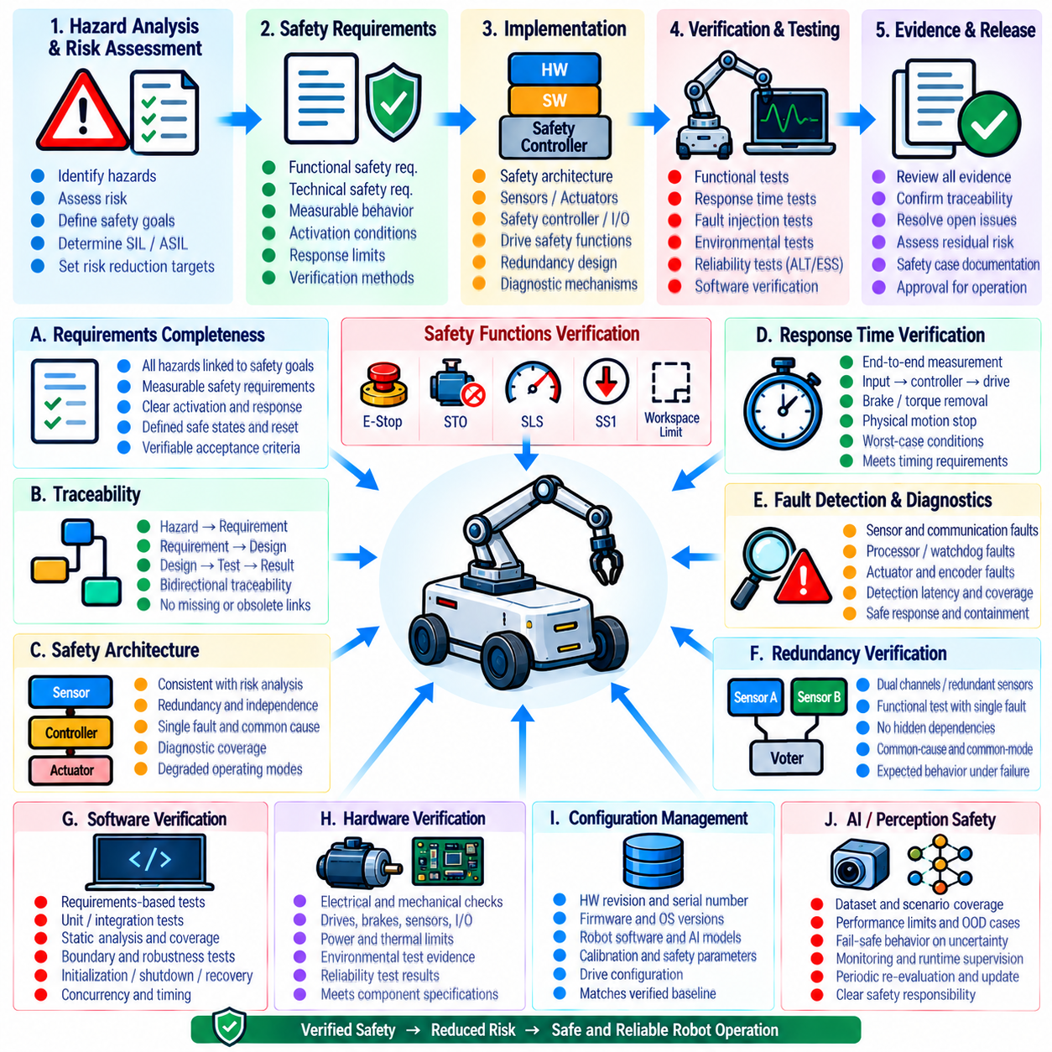
Functional safety verification uses a structured checklist to confirm that safety requirements have been implemented, tested, traced, and supported by sufficient evidence before a robot is approved for operation. The checklist should not function as a simple administrative sign-off. It should connect hazard analysis, safety requirements, architecture, implementation, verification results, configuration records, anomalies, and residual risks into a reviewable chain of evidence across the safety lifecycle. Volume_25_Testing_Validation_an…
The first verification area concerns the completeness of safety requirements. Every identified hazardous condition should be linked to one or more safety goals and corresponding functional or technical safety requirements. Requirements should define measurable behavior, activation conditions, response limits, safe states, fault reactions, reset conditions, and verification methods. Ambiguous requirements such as “stop safely” should be replaced by criteria that can be objectively measured during testing.
Traceability should be verified in both directions. Reviewers should be able to navigate from a hazard to its safety requirement, implementation element, verification method, test case, result, and final evidence record. The reverse path should also be available so that every safety mechanism can be justified by an identified requirement or risk-control objective. Missing, duplicated, obsolete, or unverified links should be treated as verification findings rather than documentation inconveniences.
The safety architecture should be checked against the assumptions established during hazard and risk analysis. Safety controllers, emergency-stop circuits, drive safety functions, brakes, redundant sensors, watchdogs, communication supervision, power isolation, and independent monitoring mechanisms should be identified. The checklist should verify whether single failures, common-cause vulnerabilities, dependencies, diagnostic mechanisms, and degraded operating modes have been considered where they are relevant to the required safety integrity.
Safety functions such as Safe Torque Off (STO), Safely Limited Speed (SLS), Safe Stop 1 (SS1), emergency stopping, protective stopping, speed supervision, workspace limitation, and torque or force limitation should have explicit verification evidence when applicable. Each function should be tested under defined initial conditions and representative operating states. Activation behavior, response time, final safe state, reset logic, restart prevention, and interactions with other safety functions should be included in the verification record.
Response-time verification should confirm that the complete physical safety chain satisfies its allocated timing requirements. Measurement should begin at the initiating safety event and include input detection, safety-controller processing, communication, drive reaction, braking or torque removal, and physical motion termination as applicable. Software callback timing alone is insufficient when the safety requirement concerns the robot's actual movement. Worst-case operating conditions and repeated measurements should be considered.
Fault detection and diagnostic coverage should be reviewed using evidence from fault injection testing. Sensor dropout, corrupted measurements, communication interruption, processor restart, watchdog activation, actuator deviation, encoder disagreement, power anomalies, and other relevant faults should produce the specified diagnostic and safety responses. Verification should determine whether faults are detected within required timing limits and whether fault propagation is contained before hazardous system behavior can develop.
Redundancy should be verified functionally rather than accepted solely from architectural diagrams. If a safety mechanism depends on dual channels, redundant sensors, independent processors, duplicated communication paths, or multiple power domains, tests should demonstrate the intended behavior when one element fails. The checklist should also examine whether apparently redundant elements share hidden dependencies that could create common-cause or common-mode failures.
Software verification evidence should demonstrate that safety-related software has been reviewed and tested according to its assigned criticality. Requirements-based tests, unit tests, integration tests, static analysis, interface verification, boundary testing, robustness testing, and relevant structural coverage should be reviewed where applicable. Initialization, shutdown, restart, timing, concurrency, memory handling, invalid inputs, exception handling, and state-machine transitions should receive explicit attention when they can influence safety behavior.
Hardware verification should confirm that safety-related electrical and mechanical components operate within their specified limits. Power distribution, drives, brakes, contactors, sensors, encoders, safety I/O, wiring, connectors, thermal protection, and mechanical stopping mechanisms should be examined as applicable. Evidence from endurance testing, accelerated life testing, and environmental stress screening can support confidence that safety functions remain available under relevant operational and environmental conditions.
Configuration management is a fundamental checklist item because verification evidence applies only to a known system baseline. Hardware revisions, firmware, operating-system versions, robot software, AI models, calibration files, safety parameters, drive configuration, and mechanical modifications should be identified. The verified configuration should match the configuration intended for release, and unresolved differences should trigger impact analysis and appropriate regression testing.
For robots containing AI or probabilistic perception, the checklist should verify that learned components cannot bypass deterministic safety constraints. Low-confidence perception, sensor disagreement, localization uncertainty, unexpected objects, invalid AI commands, and out-of-distribution conditions should be considered where relevant. Independent safety monitors, motion limits, force limits, protected spaces, or fallback states should remain effective even when the AI component produces an incorrect or uncertain result.
Anomaly management should confirm that failures discovered during verification are formally recorded, classified, investigated, and resolved or explicitly accepted. A test campaign should not be considered complete merely because most test cases pass. Open anomalies should be assessed for safety impact, affected requirements, recurrence risk, workaround validity, and regression implications. Corrective actions should be linked to retest evidence demonstrating that the original problem has been adequately addressed.
The checklist should verify that reset, recovery, and restart behavior cannot create a new hazardous condition. Clearing an emergency stop, restoring communication, restarting a controller, reconnecting a sensor, or recovering from degraded operation should not automatically initiate dangerous movement unless explicitly permitted by the safety concept. Required operator acknowledgement, state validation, command freshness, actuator readiness, and safety-condition checks should be confirmed before normal operation resumes.
Final verification should review whether the complete evidence package supports the claimed safety performance. Requirements, test procedures, raw measurements, pass/fail records, fault-injection results, response-time measurements, reliability evidence, environmental tests, anomaly resolutions, configuration records, and residual-risk assessments should be internally consistent and traceable. Missing evidence should remain visible as an open verification item rather than being implicitly assumed to be satisfied.
A completed functional safety verification checklist therefore represents a controlled engineering decision that the implemented robot configuration satisfies its defined safety requirements with adequate objective evidence. Within the chapter sequence, it consolidates results from safety-function testing, E-stop measurement, fault injection, reliability testing, accelerated life testing, and ESS, creating the evidence foundation required for subsequent safety integrity level achievement and automated safety regression testing.

07.09. Safety Integrity Level Achievement Evidence
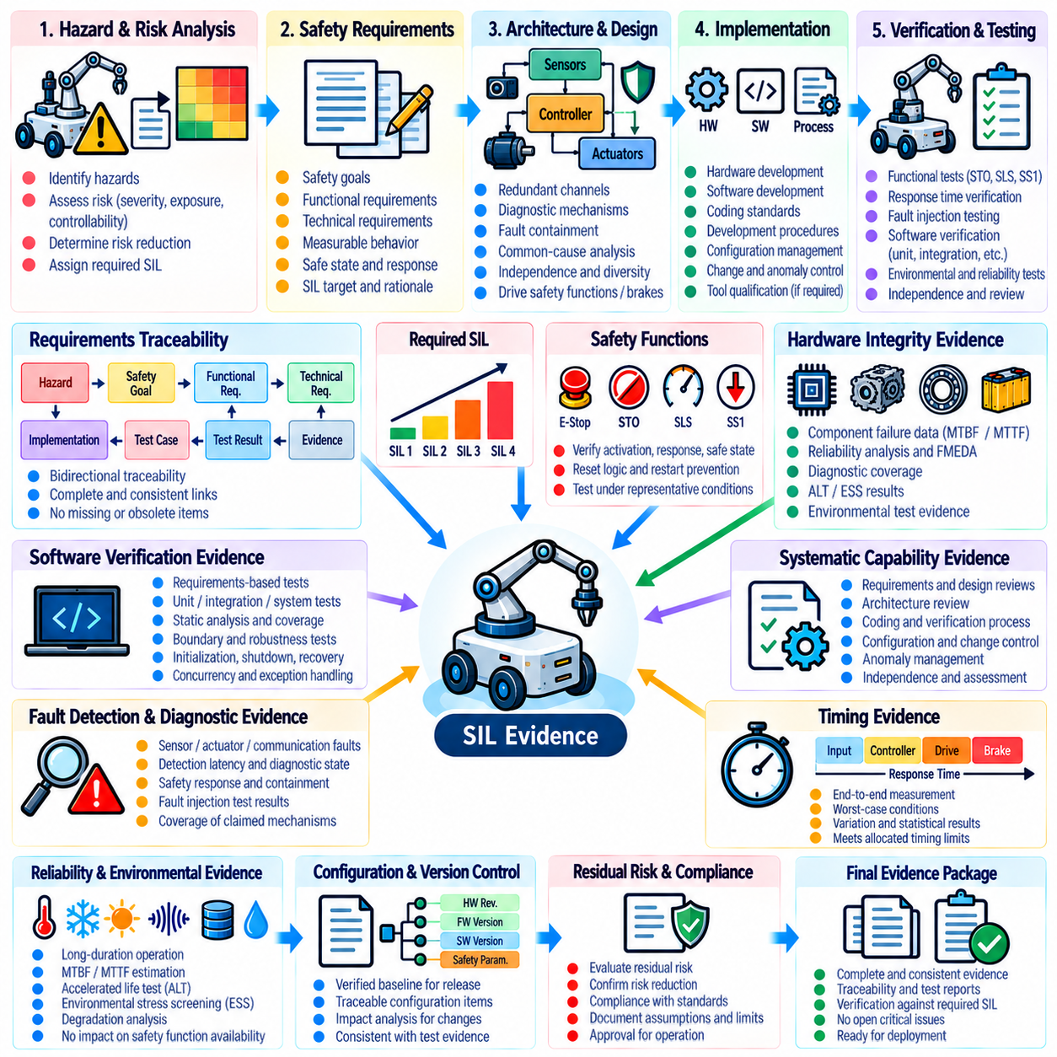
Safety Integrity Level achievement evidence demonstrates that a safety-related system satisfies the integrity requirements assigned through hazard and risk analysis. For robotic systems, the evidence must show more than successful operation of individual safety functions. It should establish a traceable relationship among hazards, safety requirements, architecture, hardware reliability, systematic development measures, verification results, fault responses, configuration control, and unresolved residual risk.
The required Safety Integrity Level (SIL) should originate from a documented risk assessment rather than being selected as a desired product attribute. Each safety function should have a clearly defined safety objective, operating mode, demand condition, safe state, response requirement, and integrity target. Evidence should preserve the reasoning used to assign the target so that reviewers can understand how risk reduction requirements were translated into engineering and verification obligations.
Requirements traceability forms the backbone of SIL evidence. Safety goals should be decomposed into functional and technical safety requirements and allocated to specific hardware, software, communication, sensing, actuation, or mechanical elements. Every requirement should identify its implementation and verification evidence. Bidirectional traceability should allow reviewers to move from the original hazard to the final test result and from any safety mechanism back to the requirement that justifies its existence.
Hardware integrity evidence should address failure behavior of components participating in safety functions. Failure-rate assumptions, component reliability data, architectural redundancy, diagnostic mechanisms, fault containment, and relevant failure-mode analyses should be documented. Where quantitative calculations are required, assumptions and source data should remain visible. Reliability claims should be supported by evidence such as operating history, MTBF or MTTF analysis, accelerated life testing, and environmental stress screening where applicable.
Architectural evidence should demonstrate that the safety-related design can tolerate or detect faults according to its integrity requirements. Redundant channels, safety controllers, monitored communication, drive safety functions, brakes, watchdogs, power isolation, and independent sensing should be evaluated as complete safety paths. Review should consider single-point failures, dependent failures, common-cause failures, diagnostic coverage, and whether hidden shared resources can invalidate an assumption of independence.
Systematic capability is equally important because high hardware reliability cannot compensate for uncontrolled errors introduced during specification, design, implementation, or modification. Evidence should therefore include development procedures, requirements reviews, architecture reviews, coding practices, verification independence, configuration management, change control, anomaly management, and appropriate tool controls. The rigor of these activities should correspond to the criticality and integrity objectives assigned to the safety-related functions.
Software evidence should demonstrate that safety-related logic has been verified against its requirements. Unit, integration, system, robustness, boundary, timing, and fault-response testing should be included as appropriate, together with static analysis and relevant coverage evidence. Initialization, shutdown, restart, state transitions, concurrency, invalid inputs, memory behavior, watchdog handling, communication loss, and exception paths deserve particular attention because systematic software faults can remain hidden during nominal operation.
Safety-function evidence should include direct verification of functions such as Safe Torque Off (STO), Safely Limited Speed (SLS), Safe Stop 1 (SS1), emergency stopping, protective stopping, speed supervision, workspace limitation, and other applicable protective functions. Records should identify initial conditions, trigger events, measured response, final safe state, acceptance limits, reset behavior, and restart prevention. Representative payload, speed, operating mode, and environmental conditions should be included where they affect performance.
Timing evidence should demonstrate that safety functions react within their allocated response limits under representative and worst-case conditions. The complete path from safety-event initiation through sensing, safety-controller processing, communication, drive response, braking or torque removal, and physical motion termination should be measured where applicable. Repeated tests should characterize variation and ensure that computational load, communication jitter, or asynchronous execution does not invalidate the required timing margin.
Fault-injection evidence provides direct confirmation that diagnostic and fault-reaction assumptions operate as designed. Tests should exercise relevant hardware, software, sensor, actuator, power, and communication failures and record detection latency, diagnostic state, containment behavior, safety-function activation, and final system condition. Particular attention should be given to faults used in quantitative safety arguments because claimed diagnostic coverage should correspond to mechanisms that have been objectively demonstrated.
Reliability and environmental evidence should show that safety-related functions remain available throughout relevant operating conditions rather than only in a nominal laboratory state. Long-duration operation, MTBF and MTTF evaluation, accelerated life testing, temperature cycling, vibration screening, and other justified environmental tests can reveal degradation mechanisms that threaten safety integrity. Failures discovered during these campaigns should be linked to root-cause analysis, corrective action, and confirmation testing.
Verification independence and review records provide evidence that safety conclusions were not based solely on the judgement of the implementation team. Depending on the required integrity and project framework, selected requirements, architecture decisions, test procedures, results, anomalies, and safety arguments may require independent review or confirmation. Review records should identify the evaluated baseline, findings, dispositions, responsible roles, and evidence supporting closure of each significant issue.
Configuration evidence must demonstrate that all safety claims apply to the exact robot configuration intended for release. Hardware revisions, safety-controller firmware, drive firmware, operating system, robot software, AI models, calibration files, safety parameters, wiring, sensors, actuators, and mechanical changes should be controlled. Any difference between the tested baseline and release baseline should undergo impact analysis, with affected safety evidence repeated or otherwise justified before approval.
Anomaly and residual-risk records should remain visible in the SIL evidence package. Open defects, test deviations, waived requirements, unexplained intermittent events, or incomplete verification activities should not disappear through summary reporting. Each item should be evaluated for safety impact and either resolved with objective evidence or formally dispositioned through the applicable safety process. Residual risks should be explicitly documented together with assumptions, operational constraints, and required mitigations.
The final SIL achievement package should integrate the safety plan, hazard analysis, safety requirements, architecture evidence, quantitative reliability analysis, software and hardware verification, safety-function tests, fault-injection results, environmental and life-test evidence, configuration records, anomaly closure, and independent review results. Internal consistency is essential: assumptions used in one safety argument should agree with the configuration, measurements, and verification evidence used elsewhere.
SIL achievement is therefore not established by a certificate, calculation, test result, or checklist in isolation. It emerges from a coherent body of objective evidence showing that the required risk reduction has been systematically designed, implemented, verified, maintained, and traced to a controlled robot configuration. Within the chapter structure, this evidence consolidates the preceding safety and reliability activities and establishes the basis for automated safety testing and regression control. Volume_25_Testing_Validation_an…

07.10. Safety Testing Automation Regression Suite [w/Code]
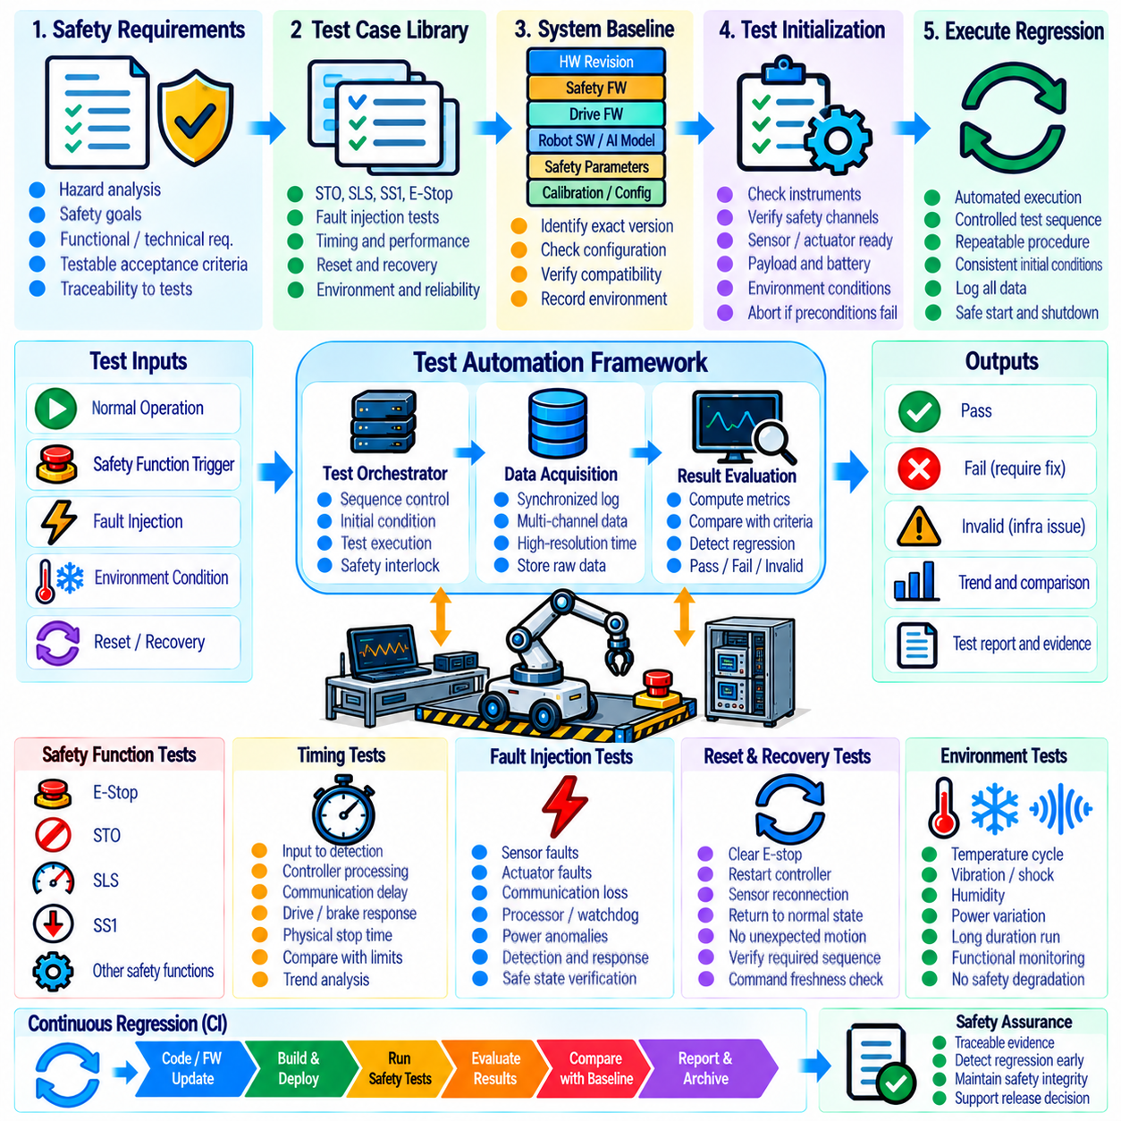
A safety testing automation regression suite provides a repeatable mechanism for verifying that software, firmware, hardware, configuration, and AI-related changes do not degrade previously validated robot safety behavior. The suite converts critical safety tests into controlled executable procedures that can be rerun throughout development. Its purpose is to detect unintended changes in safety functions, timing, fault handling, stopping behavior, diagnostics, and recovery before a modified system reaches field operation.
The regression suite should be derived directly from approved safety requirements, hazard analysis, functional safety verification, and previously validated test procedures. Each automated test should retain traceability to the safety requirement or risk-control objective that justifies its execution. Tests for Safe Torque Off (STO), Safely Limited Speed (SLS), Safe Stop 1 (SS1), emergency stopping, fault detection, restart prevention, and other applicable safety mechanisms should preserve their defined acceptance criteria.
Automation architecture should separate test orchestration from the safety functions being evaluated. A test controller may configure initial conditions, command representative robot behavior, activate test stimuli, collect synchronized measurements, evaluate results, and restore the system after execution. The automation framework itself must not modify or bypass the safety path in a manner that invalidates the test. Independent observation should be retained wherever the safety claim depends on physical motion or hardware response.
Every regression execution should begin by identifying the exact system baseline. Hardware revision, safety-controller firmware, drive firmware, operating system, robot software, AI model, safety parameters, calibration data, network configuration, and relevant mechanical configuration should be captured automatically where possible. The suite should reject or clearly flag executions performed on unknown or inconsistent configurations because results from an uncontrolled baseline cannot provide reliable safety evidence.
Test initialization should verify that instrumentation, safety channels, sensors, actuators, communication links, clocks, and data acquisition systems are ready before hazardous motion is permitted. Preconditions such as payload, battery state, operating mode, localization validity, brake state, and environmental assumptions should also be checked when relevant. If required preconditions are not satisfied, the test should terminate as invalid rather than incorrectly reporting either a pass or a safety failure.
Safety-function regression tests should reproduce the validated activation and response sequences for STO, SLS, SS1, emergency stopping, protective stopping, and other implemented functions. Automation should verify trigger recognition, state transitions, torque inhibition, speed limitation, controlled deceleration, final safe state, reset logic, and prevention of unintended restart. Representative speed, payload, direction, operating mode, and actuator conditions should be included where they materially influence the safety response.
Timing regression is essential because a functional behavior can remain logically correct while becoming too slow to satisfy a safety requirement. Automated measurements should capture safety-input detection, controller processing, communication delay, drive response, braking or torque removal, and physical motion termination where applicable. Results should be compared with both absolute acceptance limits and approved historical baselines so that gradual timing degradation can be detected before the formal safety limit is exceeded.
Fault-injection regression should automatically exercise selected hardware, software, sensor, actuator, power, and communication failures. Examples include sensor dropout, frozen measurements, communication interruption, stale data, watchdog activation, processor restart, encoder disagreement, actuator tracking deviation, and loss of redundant channels. Each test should confirm detection latency, diagnostic classification, containment behavior, activation of the required safety response, and achievement of the specified safe or degraded state.
Regression testing should also verify reset and recovery paths because changes in initialization or state-management logic can create hazards even when fault detection remains correct. Clearing an emergency stop, restoring communication, restarting a controller, reconnecting a sensor, or recovering from degraded operation should not cause unexpected movement. Automation should confirm required acknowledgement, command freshness, actuator readiness, safety-condition validation, and the correct sequence for returning to normal operation.
The suite should distinguish test failure from test infrastructure failure. A safety requirement violation, excessive stopping time, incorrect state transition, or failed fault response represents a product failure. Missing telemetry, unavailable instrumentation, failed test setup, synchronization loss, or automation-controller malfunction represents an invalid or infrastructure-related execution. Maintaining this distinction prevents unreliable test equipment from being interpreted as evidence of either product compliance or product failure.
Data acquisition should preserve sufficient information to reconstruct every significant result. Timestamped safety inputs, controller states, drive states, commands, velocities, positions, currents, brake signals, diagnostic events, injected faults, and environmental conditions should be captured as applicable. Raw data should be retained together with derived metrics such as response time, stopping time, stopping distance, maximum overspeed, detection latency, and fault-reaction time so that automated conclusions can be independently reviewed.
Regression results should be evaluated against version-controlled acceptance criteria. A test should not silently adopt new thresholds simply because system behavior changes after an update. Modifications to safety limits, tolerances, timing budgets, or expected state transitions should require documented engineering approval and traceability to revised safety requirements. This prevents regression automation from normalizing degraded behavior and preserves continuity of the original safety argument.
Continuous integration can trigger selected safety tests whenever relevant software, firmware, configuration, or model changes occur. Tests that require only simulation or HIL can execute frequently, while physical robot tests may be scheduled according to risk, equipment availability, and change impact. A layered strategy allows rapid tests to detect obvious regressions early and reserves longer physical safety campaigns for changes that affect motion, drives, sensors, braking, safety controllers, or hardware interfaces.
Not every modification requires execution of the complete safety suite. Change-impact analysis can identify affected safety requirements, components, interfaces, and hazards and select the corresponding regression subset. However, periodic execution of the full approved suite remains important for detecting unexpected interactions between subsystems. The selection logic itself should be controlled so that optimization of test duration does not gradually remove necessary safety coverage.
Failed regression tests should automatically create a traceable investigation record containing the system baseline, test identifier, requirement reference, measurements, expected behavior, actual behavior, and relevant logs. Corrective changes should be followed by targeted retesting and, when necessary, broader regression because a local fix may influence other safety functions. A failure should not be considered closed until objective evidence demonstrates that the affected requirement is again satisfied.
A mature safety regression suite becomes part of the robot's continuing safety evidence rather than merely a development convenience. By repeatedly verifying safety functions, response timing, fault tolerance, diagnostics, recovery, configuration, and physical stopping behavior, it protects previously established safety integrity against uncontrolled change. Within the chapter structure, it consolidates the evidence generated by safety-function testing, fault injection, reliability evaluation, functional safety verification, and Safety Integrity Level achievement into a continuously executable verification process.

