Volume 26. Industrial Robot Applications

Chapter 04. Outdoor Security Robot Applications

04.01. Outdoor Security Robot Mission Profile and Scope
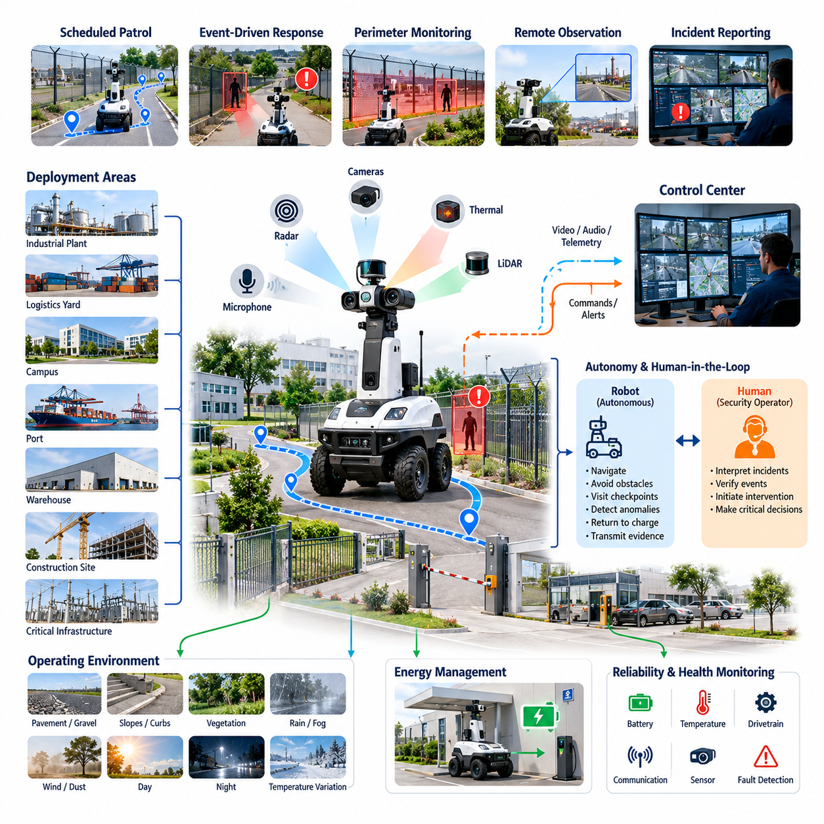
Outdoor security robots are autonomous or semi-autonomous mobile platforms designed to extend security operations across large, exposed, and continuously changing environments. Their mission is not simply to replace stationary cameras or human guards, but to provide mobile sensing, persistent observation, rapid verification, and structured data collection. Typical deployment areas include industrial plants, logistics yards, campuses, ports, energy facilities, warehouses, construction sites, and critical infrastructure.
A security robot mission profile defines what the robot must accomplish, where it operates, how long it must remain available, and how it interacts with human operators and security systems. The profile normally combines scheduled patrol, event-driven inspection, perimeter monitoring, anomaly verification, remote observation, and incident reporting. These activities establish operational requirements for mobility, perception, communications, autonomy, energy management, reliability, and environmental protection.
Scheduled patrol is one of the fundamental mission modes. The robot follows predefined or dynamically generated routes through checkpoints, fence lines, building exteriors, parking areas, storage zones, or other security-sensitive locations. At each checkpoint, it may capture visible images, thermal measurements, video, audio, or environmental observations. Patrol execution should record position, time, sensor status, detected events, and route completion so that every mission can be reconstructed later.
Event-driven response complements routine patrol. When a fixed camera, access-control system, fence sensor, security analytics platform, or human operator reports an abnormal condition, the robot can be dispatched to the affected location. Mobile deployment allows sensors to approach the event and observe it from different viewpoints. The robot therefore acts as a remote verification platform that helps operators distinguish genuine incidents from false alarms before personnel are sent into the area.
Perimeter security missions require continuous awareness of people, vehicles, objects, and activities near restricted boundaries. Cameras, thermal sensors, LiDAR, radar, microphones, and other sensors can contribute complementary observations. Perception software may detect unauthorized entry, loitering, unusual motion, abandoned objects, vehicles entering restricted zones, or unexpected activity. Detection alone is insufficient; observations must be associated with location, time, confidence, and mission context before an alert becomes operationally useful.
Outdoor security robots operate under conditions that are substantially more variable than indoor service robots. Pavement, gravel, slopes, curbs, drainage structures, vegetation, puddles, shadows, dust, rain, fog, wind, and changing illumination can affect navigation and perception simultaneously. The mission scope must therefore specify terrain limits, weather limits, temperature ranges, allowable slopes, obstacle dimensions, visibility conditions, and degraded operating modes rather than assuming that nominal autonomous navigation will always remain available.
Day and night operation introduces another important mission requirement. Visible-light cameras can provide detailed appearance information during favorable illumination, while thermal imaging can improve observation in darkness and support detection based on heat signatures. Security systems may combine these modalities instead of treating either sensor as universally sufficient. Sensor selection, field of view, mounting position, illumination support, image quality, and perception confidence should consequently be derived from the actual surveillance environment.
The autonomy scope must clearly define which decisions belong to the robot and which remain under human authority. A robot may autonomously navigate, avoid obstacles, visit checkpoints, detect candidate anomalies, return to charge, and transmit evidence, while security personnel retain responsibility for interpreting critical incidents and initiating physical intervention. This separation creates a practical human-in-the-loop model in which automation increases coverage and persistence without giving the mobile platform unnecessary authority.
Communication is central to this operating model because a security robot is usually part of a larger security infrastructure rather than an isolated machine. The platform may exchange video, voice, telemetry, alarms, maps, mission commands, and diagnostic information with a control center. Two-way communication can also allow an operator to observe a situation remotely or communicate with a person near the robot. The chapter structure therefore treats communication, reporting, and fleet-level incident response as integral parts of the security application.
Mission planning must also consider the relationship between patrol coverage and available energy. A robot that can navigate accurately but repeatedly interrupts patrol because of charging requirements may provide inadequate security coverage. Route length, patrol frequency, sensor power consumption, communication load, terrain resistance, battery state, charging time, and reserve energy should be evaluated together. Continuous operation may require automated charging, overlapping robot assignments, or fleet-level scheduling that preserves coverage while individual robots recharge.
Reliability requirements are particularly demanding because security missions often extend beyond normal working hours. The robot may be expected to operate at night, during weekends, or in areas with limited personnel presence. Fault detection should therefore cover localization degradation, sensor failure, communication loss, low battery, blocked routes, excessive temperature, drivetrain faults, and compute failures. Safe fallback behaviors may include stopping, returning to a designated location, requesting assistance, or switching to a reduced-capability operating mode.
The physical mission boundary must be defined as carefully as the software functionality. Geofences can prevent the robot from entering public roads, hazardous machinery zones, restricted pedestrian areas, steep terrain, or locations outside authorized surveillance regions. Speed limits may vary by zone, time, visibility, or proximity to people. Emergency stopping, remote intervention, obstacle avoidance, controlled recovery, and safe-state behavior form essential constraints around autonomous patrol rather than optional features added after deployment.
Security data management is another major element of mission scope because mobile robots can continuously collect identifiable images, video, audio, location records, and behavioral observations. Operators should define what information is collected, why it is required, how long it is retained, who can access it, and how it is protected. Privacy requirements should influence camera orientation, recording policies, access control, encryption, audit logging, retention rules, and data deletion mechanisms throughout the system lifecycle.
A practical deployment also requires explicit performance indicators. Patrol completion rate, checkpoint coverage, anomaly detection rate, false alarm rate, response time, localization availability, communication availability, autonomous operating time, intervention frequency, charging utilization, mission failure rate, and mean time between failures can reveal whether the robot is delivering operational value. These metrics should be evaluated under representative weather, lighting, traffic, terrain, and communication conditions rather than only in controlled demonstrations.
The overall mission scope is therefore broader than autonomous movement with surveillance sensors. An outdoor security robot is a coordinated physical security platform integrating patrol execution, perception, anomaly detection, communications, incident response, environmental robustness, privacy protection, and continuous operation. This framing also provides the foundation for the subsequent application topics of autonomous patrol, AI-based intrusion detection, abnormal-event reporting, thermal perception, two-way communication, fleet dispatch, reliability, privacy, and 24/7 operation.

04.02. Autonomous Patrol Route Planning and Execution [w/Code]
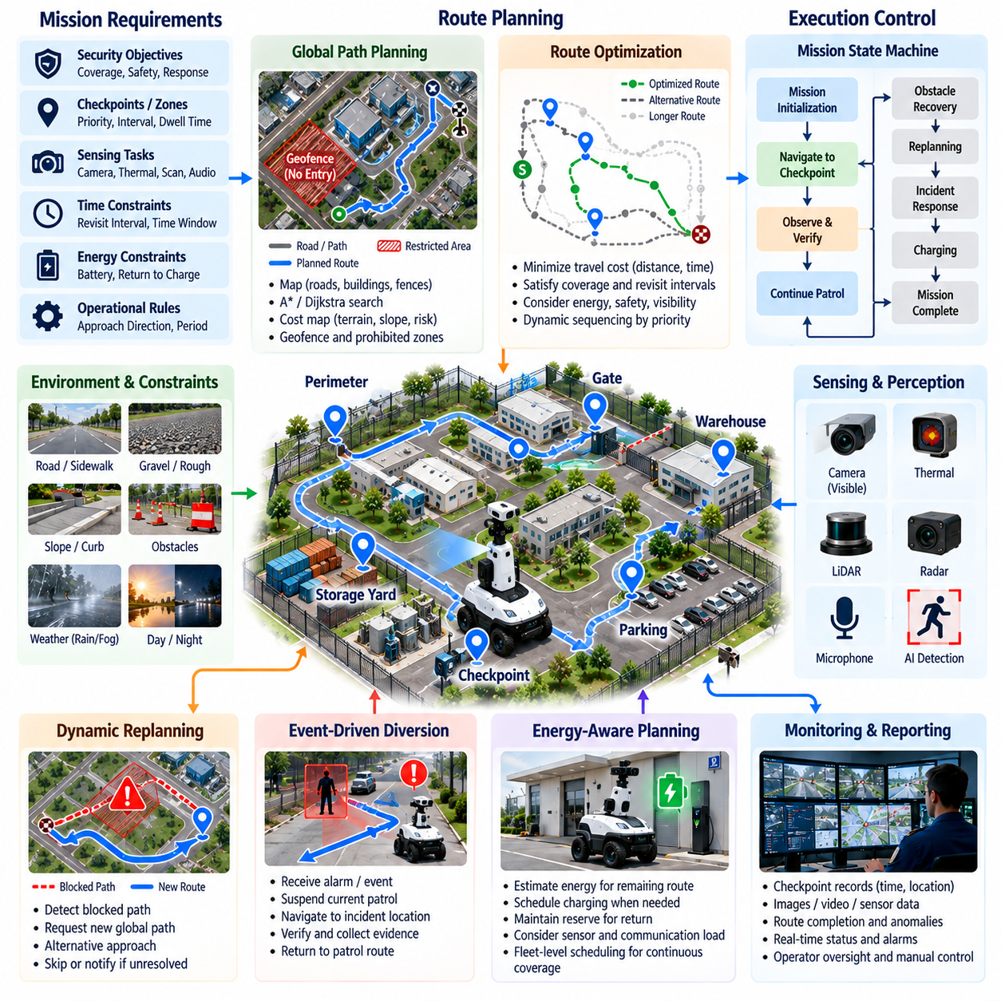
Autonomous patrol route planning transforms security objectives into executable robot motion across an outdoor site. Unlike ordinary point-to-point navigation, patrol planning must repeatedly cover security-sensitive areas while satisfying timing, safety, energy, and observation requirements. The robot therefore manages not only where it travels, but also which checkpoints it visits, how frequently they are inspected, and what sensing actions are performed at each location.
A patrol mission can be represented as a collection of checkpoints, patrol zones, connecting paths, observation tasks, and operational constraints. Checkpoints may correspond to gates, fences, equipment areas, building entrances, parking zones, storage yards, or other locations requiring periodic inspection. Each checkpoint can contain attributes such as priority, required arrival interval, dwell time, camera orientation, sensing task, allowable approach direction, and permitted operating period.
The route planner converts these mission requirements into an ordered sequence that can be executed efficiently. A simple patrol may follow a fixed cyclic route, while a larger facility may require dynamic sequencing based on priority, elapsed time since the previous inspection, travel cost, battery state, or current security conditions. Route optimization therefore resembles a constrained routing problem in which minimizing distance is only one objective among coverage, response readiness, safety, and inspection quality.
Global path planning determines feasible paths between patrol locations using a map of the operating environment. The planner must consider roads, sidewalks, open yards, restricted areas, fences, buildings, slopes, charging stations, and other persistent features. Graph-based methods such as Dijkstra or A* can search connected route networks, while cost maps can represent traversal difficulty and risk. Geofenced regions can be assigned extremely high or prohibited costs to prevent unauthorized entry.
Outdoor environments require the route representation to include more than geometric distance. A short path across rough terrain, a steep slope, a congested pedestrian zone, or an unreliable communication area may be less desirable than a longer but safer route. Navigation costs can therefore incorporate terrain traversability, slope, surface condition, expected traffic, visibility, localization quality, communication coverage, and security priority. This produces routes that better reflect operational risk rather than distance alone.
Local planning handles conditions that cannot be completely predicted during global route generation. People, vehicles, temporary barriers, construction materials, parked equipment, vegetation, and other obstacles may appear along an otherwise valid patrol path. The local planner continuously evaluates sensor observations and generates collision-free motion while attempting to preserve progress toward the current checkpoint. Speed and clearance can be adjusted according to obstacle density and uncertainty.
Patrol execution is typically controlled by a mission state machine or behavior-based task manager. States may include mission initialization, navigation to checkpoint, observation, checkpoint verification, route continuation, obstacle recovery, charging, incident response, and mission completion. Transitions occur according to navigation results, sensor events, timers, battery conditions, operator commands, or detected anomalies. This structure separates high-level security objectives from lower-level motion control and navigation behavior.
Checkpoint arrival should be verified rather than assumed from a navigation command alone. The robot can evaluate localization position, distance to the target, heading, velocity, and sensor readiness before declaring the checkpoint reached. Once validated, it performs the assigned observation action, such as rotating a camera, capturing images, recording thermal data, scanning a fence line, or waiting for a specified duration. The resulting evidence can be associated with checkpoint identity and timestamp.
A robust patrol system must manage blocked paths without terminating the entire mission. When an obstacle persists beyond a configured period, the robot may retry local navigation, request a new global path, approach the checkpoint from another direction, temporarily skip the location, or notify the control center. Recovery policies should distinguish transient obstacles from persistent route failures so that repeated unsuccessful attempts do not waste energy or leave other security zones unobserved.
Dynamic replanning becomes especially important when the security context changes during patrol. A newly detected event can temporarily override the scheduled route and create a high-priority destination. The robot may suspend its current patrol, navigate toward the incident, collect additional observations, transmit evidence, and then resume the interrupted route. The planner must retain mission state so that emergency diversions do not cause checkpoints to be unintentionally omitted after incident handling.
Time is another critical planning dimension. Some locations may require inspection every few minutes, while others need only occasional observation. Route scheduling can therefore use maximum revisit intervals, time windows, checkpoint deadlines, or priority-weighted lateness. If the robot falls behind schedule because of obstacles or incidents, the planner can reorder remaining checkpoints according to operational importance instead of blindly continuing the original sequence.
Energy-aware planning prevents a patrol mission from consuming more battery capacity than the robot can safely support. The mission manager estimates energy required for remaining travel, sensing, communication, and return to a charging station. When available energy approaches a defined reserve threshold, the robot can shorten the route, defer low-priority checkpoints, or initiate charging. Charging decisions should preserve sufficient reserve energy for localization uncertainty, detours, and unexpected recovery actions.
Patrol planning can also coordinate multiple robots. A fleet manager may partition a large facility into patrol sectors, assign checkpoints according to robot position and capability, and redistribute tasks when a robot charges or becomes unavailable. Overlapping coverage can be maintained for critical areas while unnecessary duplication is reduced elsewhere. Dynamic allocation also enables the nearest suitable robot to interrupt its patrol and respond to a newly reported security incident.
Mission monitoring provides operators with continuous visibility into patrol execution. The system can report the current robot position, active route, next checkpoint, completed checkpoints, delayed tasks, battery state, navigation status, detected obstacles, and mission exceptions. Historical mission records allow operators to compare planned and actual routes, identify repeatedly blocked locations, analyze missed inspections, and determine whether patrol policies should be modified for changing site conditions.
Safety constraints always take precedence over patrol efficiency. Route execution must respect geofences, speed limits, minimum obstacle clearances, restricted zones, emergency-stop conditions, and environmental operating limits. If localization confidence becomes insufficient or a required safety sensor fails, the robot should not continue merely to satisfy a patrol schedule. Instead, the mission manager transitions to a defined degraded or safe state and reports the reason to the supervisory system.
Reliable autonomous patrol is ultimately a closed operational loop connecting mission definition, route optimization, navigation, checkpoint verification, sensing, exception handling, and mission reporting. Successful execution is measured not simply by whether the robot traveled through the facility, but by whether required areas were observed at the correct frequency and quality while maintaining safety and availability. This framework provides the navigation foundation for intrusion detection, abnormal-event reporting, incident response, and continuous outdoor security operation.

04.03. Perimeter Intrusion Detection AI Vision [w/Code]
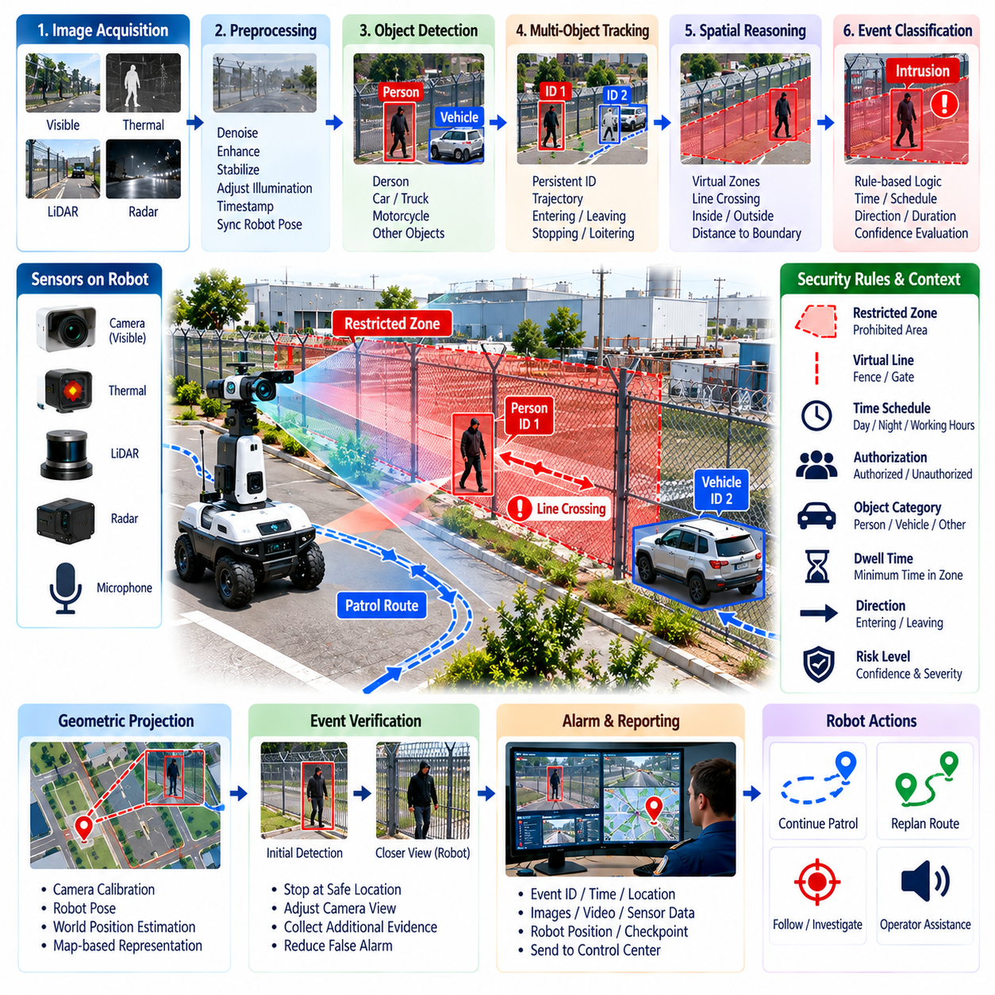
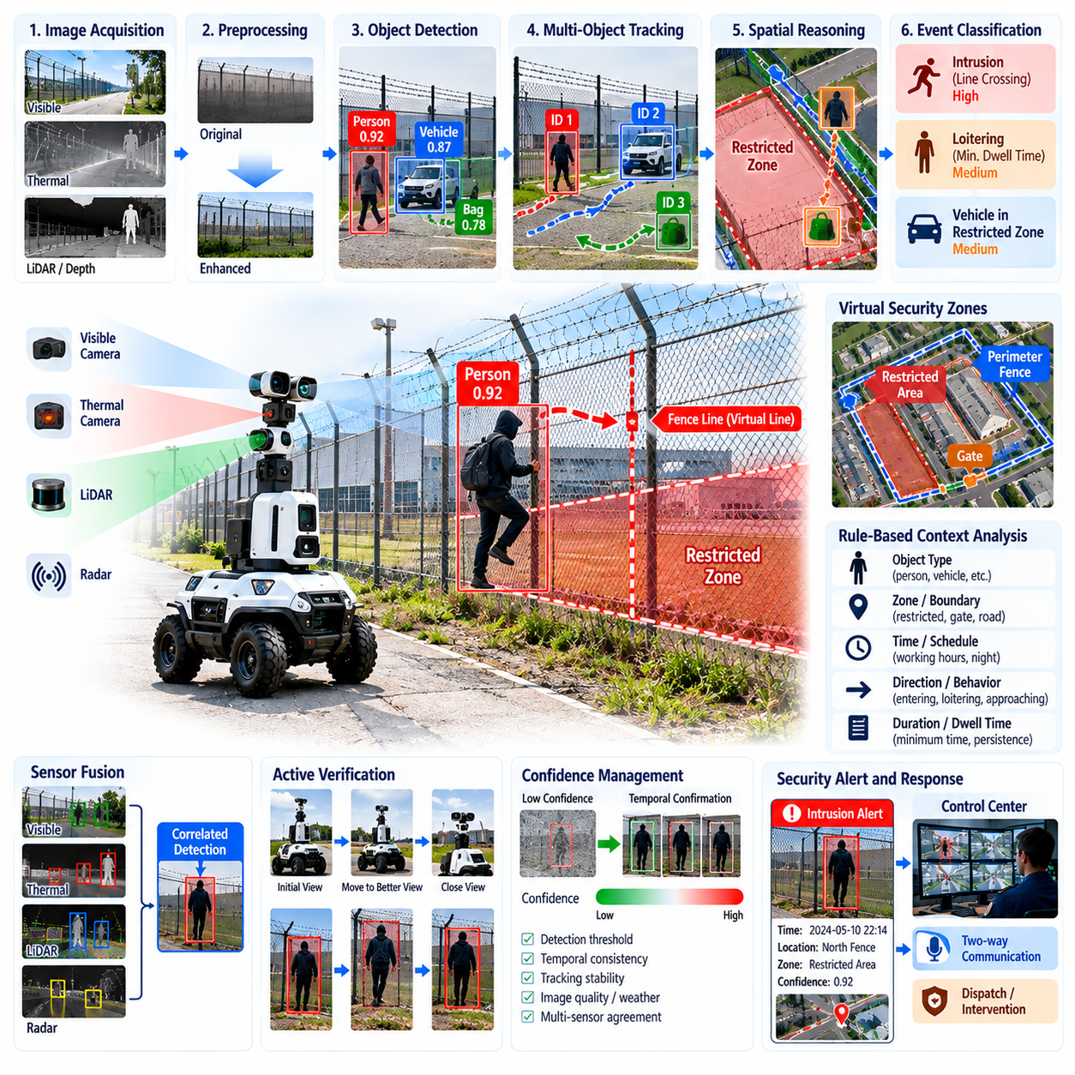
Perimeter intrusion detection using AI vision extends the outdoor security robot from a mobile observation platform into an active threat-detection system. During patrol, cameras continuously observe fences, gates, restricted zones, equipment areas, and open boundaries while vision models identify people, vehicles, and relevant objects. The objective is to recognize potentially unauthorized activity early and provide operators with sufficient visual evidence for rapid verification and response.
The perception pipeline typically begins with image acquisition, preprocessing, object detection, tracking, spatial reasoning, and event classification. Images from visible-light or other imaging sensors are timestamped and associated with robot position and orientation. Preprocessing may compensate for exposure, noise, vibration, or changing illumination before inference. Detection results are then transformed from individual image observations into persistent objects and security events that can be evaluated over time.
Object detection provides the basic semantic information required for intrusion analysis. A detector can identify classes such as person, car, truck, motorcycle, or other site-specific objects and return bounding boxes with confidence values. However, detecting a person does not automatically indicate an intrusion. The security system must combine the detected object class with its position, movement, time, authorization context, and relationship to protected areas before generating an operational alarm.
Restricted areas can be represented as virtual security zones associated with the robot map or camera image. A polygon may define a prohibited region, while a virtual line can represent a fence, gate, or access boundary. After detecting an object, the system estimates whether its representative point or spatial footprint lies inside a protected zone. Line-crossing logic can additionally determine whether a tracked object has moved from an authorized side of a boundary into a restricted side.
Multi-object tracking is important because security events develop over time rather than within a single frame. A tracker assigns a persistent identifier to each detected person or vehicle and estimates its trajectory across consecutive observations. This allows the system to distinguish entering, leaving, passing nearby, stopping, or repeatedly approaching a boundary. Tracking also reduces duplicate alarms because multiple detections belonging to the same physical object can be treated as one continuing event.
Temporal reasoning helps distinguish genuine intrusion behavior from short-lived detection noise. A system may require an object to remain inside a restricted zone for several frames or exceed a minimum dwell time before raising an alert. Similarly, line crossing can be confirmed only when a tracked trajectory clearly moves across both sides of the boundary. These temporal conditions suppress alarms caused by uncertain bounding boxes, partial occlusion, image noise, or momentary detector errors.
Security rules can combine object category, zone, direction, schedule, and duration. For example, a person entering a maintenance area during authorized working hours may not represent the same risk as a person entering the same area at night. A vehicle traveling along an approved road can be ignored while the same vehicle entering a pedestrian-only zone generates an event. Rule-based context therefore converts generic AI detections into site-specific security interpretations.
Confidence management is necessary because AI vision models operate probabilistically. A single detection with marginal confidence should not always trigger a high-severity alarm. Systems can apply class-specific thresholds, temporal confirmation, tracker consistency, or secondary verification before escalating an event. Confidence may also be influenced by image quality, distance, object size, weather, illumination, and occlusion so that uncertain observations are handled differently from clear detections.
A mobile robot introduces perception challenges that differ from fixed surveillance cameras. Camera position, heading, vibration, background, and viewing distance continuously change as the robot moves. Apparent motion caused by robot movement can complicate conventional motion detection, while turns may temporarily change the visible security zone. Robot localization and camera pose should therefore be associated with visual observations so that detected objects can be interpreted relative to the physical site rather than only image coordinates.
Geometric projection can connect image detections with the robot navigation map. Using camera calibration, robot pose, depth information, or supporting sensors, the system can estimate the approximate world position of an observed object. This allows intrusion events to be represented as georeferenced security information. An operator can then receive not only an image containing a detected person but also the robot location, estimated event location, affected security zone, and corresponding patrol checkpoint.
Sensor fusion can improve reliability when vision alone becomes uncertain. LiDAR may provide range and geometric structure, radar can support detection under difficult visibility, and thermal imaging can improve observation in darkness. The system can correlate detections from multiple sensors according to position and time. Agreement between modalities may increase event confidence, while disagreement can cause the system to request additional observation instead of immediately issuing a high-priority alarm.
Active verification is a major advantage of a mobile security robot. When a possible intrusion is detected, the robot can stop at a safe location, orient its camera, adjust its viewpoint, or move to another observation position. Additional images or video can then be collected before escalation. This transforms perception from passive detection into an observe–verify–report process and can reduce false alarms caused by poor viewpoints, temporary occlusion, or ambiguous objects.
An intrusion event should contain more information than a simple alarm flag. A useful event record may include event type, object class, tracking identifier, detection confidence, zone identifier, robot pose, estimated target position, timestamp, representative image, video segment, and current mission state. This structured evidence allows the control center to review what happened and enables later analysis of detection performance, response effectiveness, and recurring activity around specific locations.
False-positive control is essential for practical deployment. Shadows, reflections, vegetation, animals, rain, headlights, partially visible objects, unusual clothing, and distant pedestrians can challenge perception models. Threshold tuning alone is rarely sufficient. Combining object detection, tracking, spatial rules, temporal persistence, multimodal sensing, and active verification provides a stronger approach because several independent conditions must support the intrusion hypothesis before a critical alert is generated.
False negatives are equally important because missed intrusions directly reduce security coverage. Evaluation should therefore measure precision and recall together with event-level detection rate, false alarms per operating hour, detection latency, tracking continuity, and performance across distance and environmental conditions. Test scenarios should include daylight, darkness, backlighting, rain, partial occlusion, multiple people, moving vehicles, and different approach directions to expose weaknesses hidden by ordinary image benchmarks.
The complete AI vision system forms a closed perception and security reasoning loop connecting sensing, detection, tracking, spatial interpretation, temporal validation, event generation, and operator verification. Its purpose is not merely to recognize objects but to determine whether observed behavior violates the security policy of the physical environment. When integrated with autonomous patrol, reporting, thermal perception, and incident response, perimeter intrusion detection becomes a central intelligence function of the outdoor security robot.

04.04. Abnormal Event Alert and Reporting SW [w/Code]
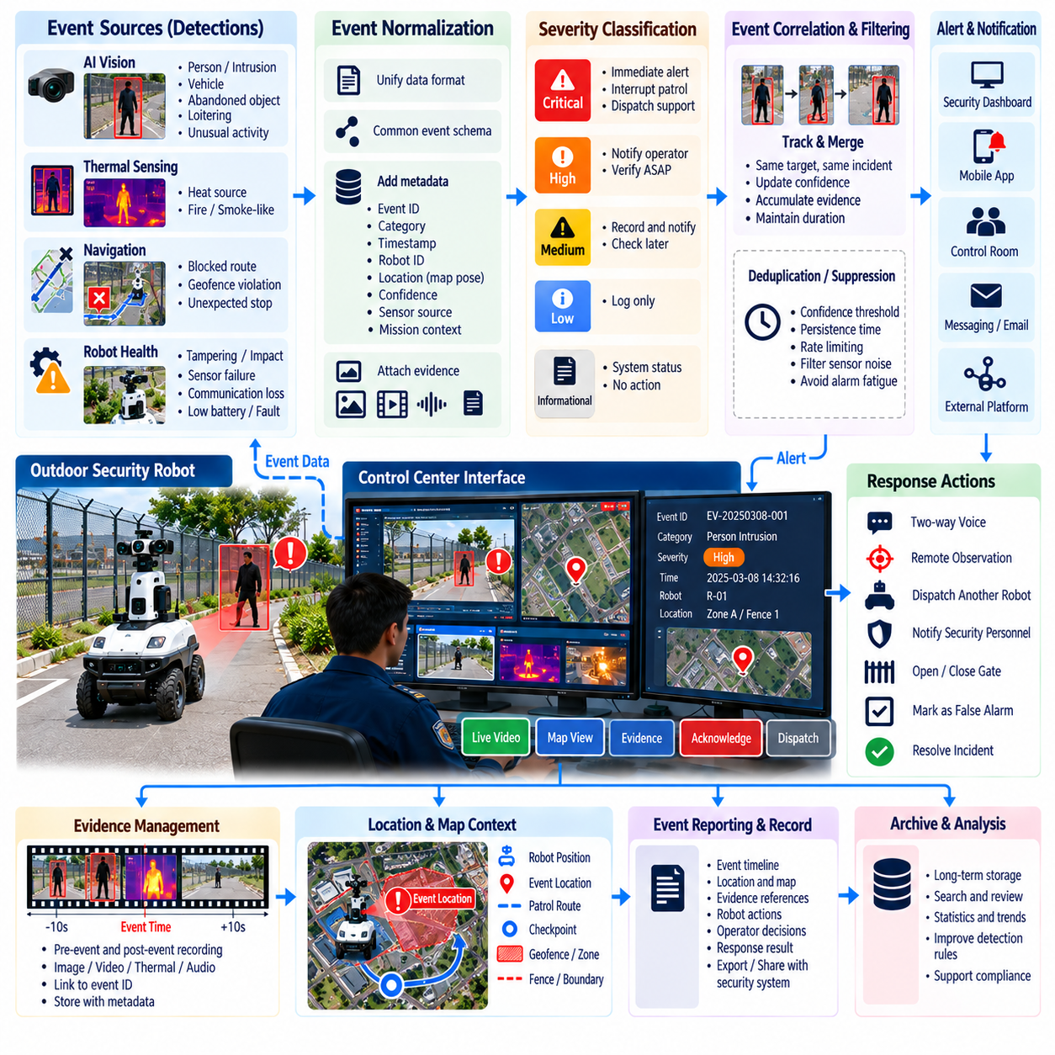
Abnormal event alert and reporting software converts observations from an outdoor security robot into actionable security information. Detection alone is insufficient because operators need to understand what occurred, where it occurred, when it happened, how reliable the observation is, and what response may be required. The software therefore connects perception, navigation, mission status, communications, evidence management, and human supervision into a structured event-processing workflow.
An abnormal event can originate from multiple robot subsystems. AI vision may detect an intrusion, loitering person, abandoned object, unauthorized vehicle, smoke-like appearance, or unusual activity, while thermal sensing may identify an unexpected heat source. Navigation software can report blocked routes or geofence violations, and hardware monitoring may detect tampering, impact, sensor failure, communication degradation, or other conditions that affect security operations.
The event-processing pipeline begins by converting heterogeneous detections into a common event representation. Each event should contain a unique identifier, event category, severity, timestamp, robot identity, robot pose, estimated event location, confidence value, sensor source, and mission context. Images, video clips, thermal frames, audio, or other evidence can be attached to the same record so that downstream systems process a consistent security object rather than unrelated sensor messages.
Event normalization is important because different perception modules may describe similar situations using different data formats. A vision model may produce bounding boxes and class confidence, while a thermal module reports temperature regions and navigation software reports coordinates or fault codes. The event manager translates these outputs into a shared schema. This abstraction allows alert logic and reporting services to operate independently of the specific algorithms or sensors that generated the original observation.
Severity classification determines how urgently an event should be handled. Informational events may simply be recorded, while low-priority anomalies can be queued for later review. Higher-severity events may immediately notify an operator, interrupt a patrol mission, or dispatch another robot for verification. Severity can be calculated from event type, confidence, protected-zone priority, time of day, persistence, target behavior, and proximity to critical assets rather than using a single fixed threshold.
Event correlation prevents the control center from being overwhelmed by repeated alerts describing the same physical incident. A person remaining near a restricted fence may generate detections across hundreds of video frames, but the event manager should associate these observations with one continuing incident. Correlation can use tracking identifiers, spatial distance, event category, and temporal proximity to merge related observations while updating confidence, duration, evidence, and target position.
Deduplication and suppression policies further reduce unnecessary alarms. Events with low confidence may require persistence for several seconds before notification, while repeated warnings from the same location can be rate-limited. Temporary sensor noise or short communication interruptions may be recorded without immediately escalating them. These policies must be carefully designed because excessive suppression can hide real incidents, whereas insufficient filtering produces alarm fatigue and reduces operator trust.
When an event satisfies escalation criteria, the alert service selects appropriate notification channels according to severity and operational policy. Alerts may be delivered to a security dashboard, mobile application, control-room workstation, messaging infrastructure, or external security management platform. Critical events should include concise information that allows rapid assessment, such as event category, location, robot identifier, detection confidence, timestamp, representative image, and current event status.
Reliable alert delivery requires acknowledgment and retry mechanisms. Sending a network message does not guarantee that an operator or external system received and processed it. The software can therefore maintain states such as generated, transmitted, delivered, acknowledged, assigned, resolved, and closed. If acknowledgment is not received within a configured interval, the system may retry delivery, use another communication channel, or escalate the event to another responsible operator.
Evidence capture should preserve information surrounding the event rather than recording only the instant at which an alarm was generated. A circular video buffer can retain several seconds of observations before detection and continue recording afterward. This pre-event and post-event context helps operators understand how the situation developed. Evidence should be linked to the event identifier so that images, video, thermal observations, robot telemetry, and mission logs can later be reviewed together.
Location information significantly improves the usefulness of an alert. The report can include the robot pose, patrol zone, checkpoint, geofence identifier, and estimated target coordinates when available. A control-room interface can use this information to place the incident on a site map and determine which cameras, guards, gates, or other robots are nearby. Spatial context also enables automatic routing of incidents to teams responsible for particular areas of a large facility.
The reporting subsystem creates a durable record of both the abnormal event and the actions taken in response. A report may include detection time, notification time, acknowledgment time, event severity, evidence references, robot actions, operator decisions, dispatched resources, resolution status, and closing comments. Maintaining this lifecycle history supports incident investigation, operational auditing, performance evaluation, and later improvement of security rules and AI models.
Human operators should remain able to classify and update events after reviewing evidence. An alert may be confirmed as a genuine intrusion, marked as a false positive, downgraded, escalated, assigned to another operator, or closed after investigation. These decisions should be stored as part of the event history rather than overwriting the original machine prediction. Preserving both AI output and human judgment creates valuable labeled operational data for future analysis.
Integration with autonomous patrol allows abnormal-event handling to influence robot behavior. When an event is generated, the mission manager may pause the current route and command the robot to maintain observation, move to a safer viewpoint, approach within a permitted distance, or return to normal patrol after verification. Another robot can also be dispatched when additional viewpoints or sensors are required, linking event management directly with fleet-level incident response.
Communication failures must be considered because outdoor security robots may operate in areas with unstable wireless coverage. If the central server cannot be reached, the robot should retain important events and evidence locally using a store-and-forward mechanism. Critical information can be prioritized over routine telemetry when bandwidth is limited. After connectivity is restored, queued records can be synchronized while preserving their original timestamps and event sequence.
Security and privacy controls are required because incident reports may contain sensitive video, audio, location information, and identifiable individuals. Event records should be protected through authenticated access, encrypted communication, authorization policies, audit logging, and controlled retention. Evidence integrity is also important; timestamps, event identifiers, hashes, or other mechanisms can help demonstrate that stored records correspond to the information captured during the original incident.
Operational metrics allow the alerting system itself to be evaluated. Useful measures include events per patrol hour, false-alert rate, average detection-to-notification latency, acknowledgment time, resolution time, percentage of unacknowledged alerts, communication retry frequency, and event closure rate. Comparing these metrics by location, event category, environmental condition, and robot can reveal weak detection zones, ineffective escalation policies, or recurring operational problems.
Abnormal event alert and reporting software ultimately forms the bridge between autonomous robot perception and human security operations. Its value depends not on producing the largest number of alarms, but on delivering reliable, contextualized, traceable, and prioritized information at the correct time. By combining event normalization, correlation, severity assessment, evidence capture, notification, acknowledgment, reporting, and mission integration, the system turns raw robot observations into manageable security incidents.

04.05. Night Vision Thermal Perception Integration [w/Code]
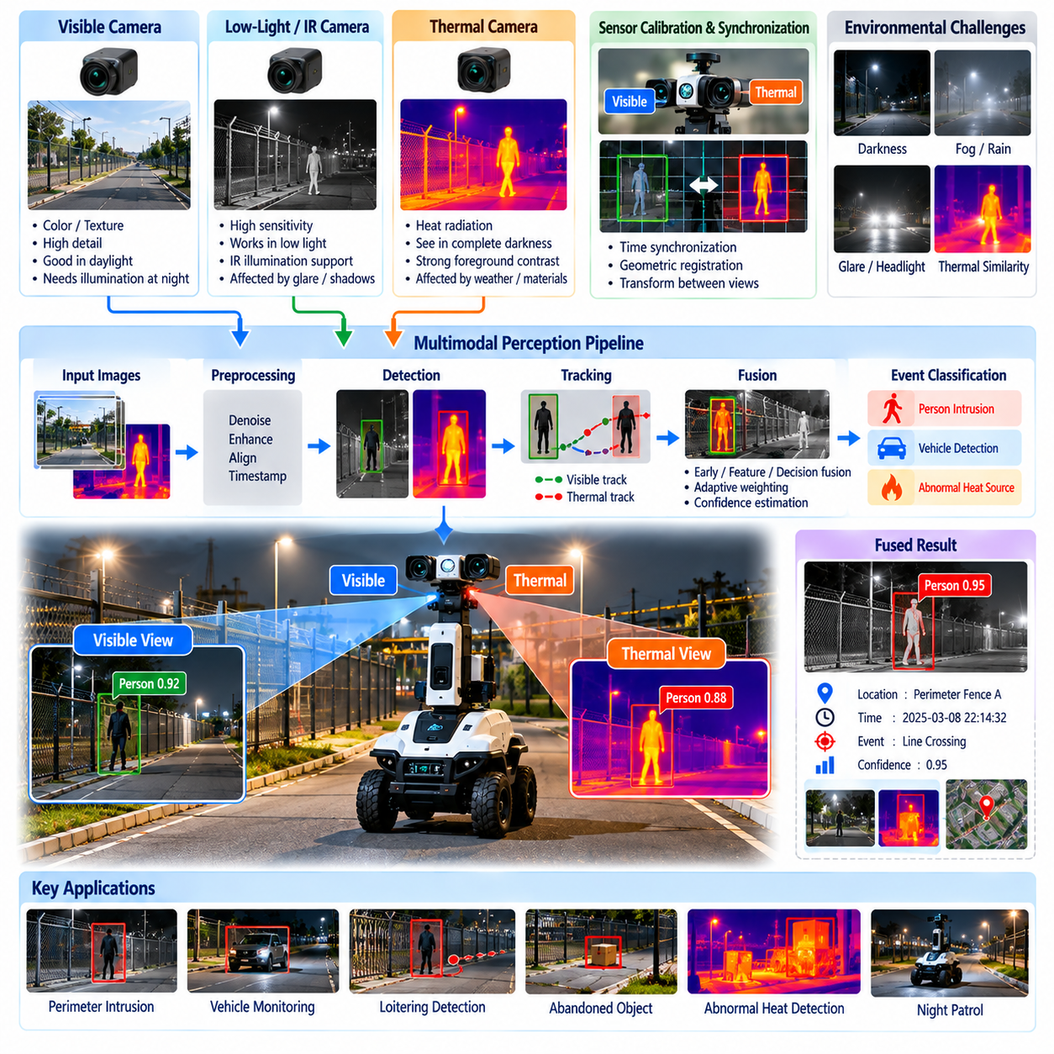
Night vision and thermal perception extend outdoor security robot operation beyond the limitations of ordinary visible-light cameras. Security patrols often continue through darkness, poorly illuminated areas, shadows, fog, or rapidly changing lighting conditions. A robust perception system therefore combines complementary sensing modalities so that people, vehicles, animals, equipment, and abnormal heat sources can remain observable when conventional RGB imagery becomes unreliable.
Visible-light cameras provide detailed appearance, color, texture, signage, and object information when sufficient illumination is available. At night, their performance depends heavily on ambient light, artificial lighting, exposure settings, and sensor sensitivity. Low-light cameras can improve sensitivity, while infrared illumination may provide additional visibility. However, headlights, reflections, deep shadows, glare, and sudden transitions between bright and dark regions can still reduce image quality and detection reliability.
Thermal cameras measure infrared radiation associated with surface temperature rather than relying on reflected visible light. Warm people, operating vehicles, electrical equipment, and other heat-producing objects may therefore remain detectable in darkness. Thermal imagery can provide strong foreground-background contrast under suitable conditions, making it particularly valuable for perimeter monitoring, nighttime patrol, and initial detection of targets that are difficult to recognize using visible imagery alone.
Thermal sensing is not equivalent to perfect night vision. Apparent temperature differences vary with weather, material properties, solar heating, wind, rain, and time of day. Warm pavement or machinery can create backgrounds with temperatures similar to a human body, while rain may reduce thermal contrast. Glass and other materials also interact differently with long-wave infrared radiation. The perception software must therefore treat thermal observations as another uncertain sensing modality rather than absolute evidence.
A multimodal security robot can operate visible and thermal cameras simultaneously and associate their observations in time. Accurate timestamps are necessary because the robot and targets may both be moving. When cameras have different positions, fields of view, resolutions, and frame rates, calibration is required to determine their geometric relationship. Synchronization and calibration allow observations from both sensors to describe the same physical target with sufficient consistency for downstream fusion.
Sensor registration maps corresponding information between visible and thermal images. Calibration estimates intrinsic parameters for each camera and the extrinsic transformation between them. With these parameters, detections or image coordinates from one modality can be projected toward the other, although differences in viewpoint and depth can introduce alignment errors. Registration quality should therefore be validated across the expected operating distance rather than only using nearby calibration targets.
Fusion can occur at several stages of the perception pipeline. Early fusion combines aligned sensor data before feature extraction, while feature-level fusion combines representations learned independently from visible and thermal inputs. Decision-level fusion allows separate detectors to generate candidate objects and then combines their outputs according to position, class, confidence, and time. Decision-level approaches can be practical because each sensing pipeline can continue operating when the other becomes degraded.
Adaptive fusion can change the contribution of each modality according to environmental conditions. During daylight, visible imagery may provide richer object appearance and identification information. In darkness, thermal sensing may receive greater weight for target detection. The system can estimate image brightness, contrast, sensor noise, thermal contrast, weather conditions, or detection consistency and use these indicators to adjust confidence instead of assuming that one fixed fusion policy is optimal throughout the entire patrol.
Object detection models used with thermal imagery must account for the different visual characteristics of infrared data. Models trained only on ordinary RGB datasets may not transfer directly because thermal images contain different textures, intensity distributions, and object boundaries. Thermal-specific or multimodal training data can improve performance. Dataset design should represent the target deployment environment, including different temperatures, seasons, distances, viewing angles, backgrounds, and human appearances.
Tracking provides an important connection between visible and thermal detections over time. Once a person or vehicle has been detected, a multi-object tracker can maintain an identity as sensor quality changes during robot movement. A target initially detected by the visible camera may later enter a dark area where thermal sensing becomes dominant. Cross-modal tracking can preserve continuity and prevent the same target from being incorrectly reported as multiple independent security events.
Thermal perception can support more than intrusion detection. Abnormal heat signatures may indicate overheating machinery, electrical faults, recently operated vehicles, hot surfaces, or other conditions relevant to industrial security and safety. The robot can associate thermal observations with patrol checkpoints and compare them with expected conditions. However, temperature interpretation requires suitable calibration and context because apparent thermal intensity does not automatically provide an accurate physical temperature measurement.
The robot can actively modify its observation behavior when multimodal perception produces an uncertain result. It may stop, rotate its sensor head, reduce vibration, approach within a permitted distance, or observe the target from another viewpoint. Additional visible and thermal frames can then be collected and evaluated. This active perception strategy is particularly useful at night because a target that is ambiguous from one viewpoint may become much easier to classify after the robot changes position.
Nighttime navigation and nighttime security perception should also be coordinated. A robot may navigate using LiDAR, radar, GNSS, inertial sensing, or other sensors that do not depend strongly on visible illumination while cameras perform security observation. Perception quality can nevertheless influence mission behavior. If visibility becomes severely degraded, the mission manager may reduce speed, increase observation time, modify checkpoint positions, or classify certain surveillance tasks as temporarily degraded.
Environmental monitoring can help the system interpret sensor reliability. Ambient temperature, humidity, precipitation, illumination level, lens contamination, and sensor temperature may influence image quality. A health-monitoring process can detect blocked lenses, excessive noise, loss of thermal calibration, frozen frames, or unavailable camera streams. The robot should report such degradation because continuing a patrol with failed perception may create the appearance of coverage without actually providing effective surveillance.
Event generation should preserve the contribution of each sensing modality. An intrusion report may include a visible image, thermal frame, object class, tracking identifier, confidence values from individual detectors, fused confidence, robot position, and event timestamp. Operators can then inspect both forms of evidence rather than receiving only the final AI decision. Maintaining modality-specific information also supports later diagnosis of false alarms and missed detections under difficult nighttime conditions.
Performance evaluation must reflect realistic night operation rather than relying only on daytime benchmarks. Tests should cover twilight, complete darkness, artificial lighting, headlights, shadows, warm backgrounds, cold weather, rain, fog, partial occlusion, and targets at different distances. Metrics can include detection precision, recall, false alarms per hour, detection range, tracking continuity, fusion improvement, inference latency, and performance degradation when one sensor becomes unavailable.
Night vision and thermal perception integration ultimately provides sensing redundancy and complementary environmental awareness for continuous outdoor security operation. Visible imagery contributes detailed appearance information, while thermal sensing provides an alternative observation channel when illumination is inadequate. Through synchronization, calibration, multimodal fusion, tracking, confidence management, active verification, and sensor health monitoring, the robot can maintain more reliable perception across the changing conditions encountered during 24/7 security patrols.

04.06. Two Way Voice and Video Communication [w/Code]
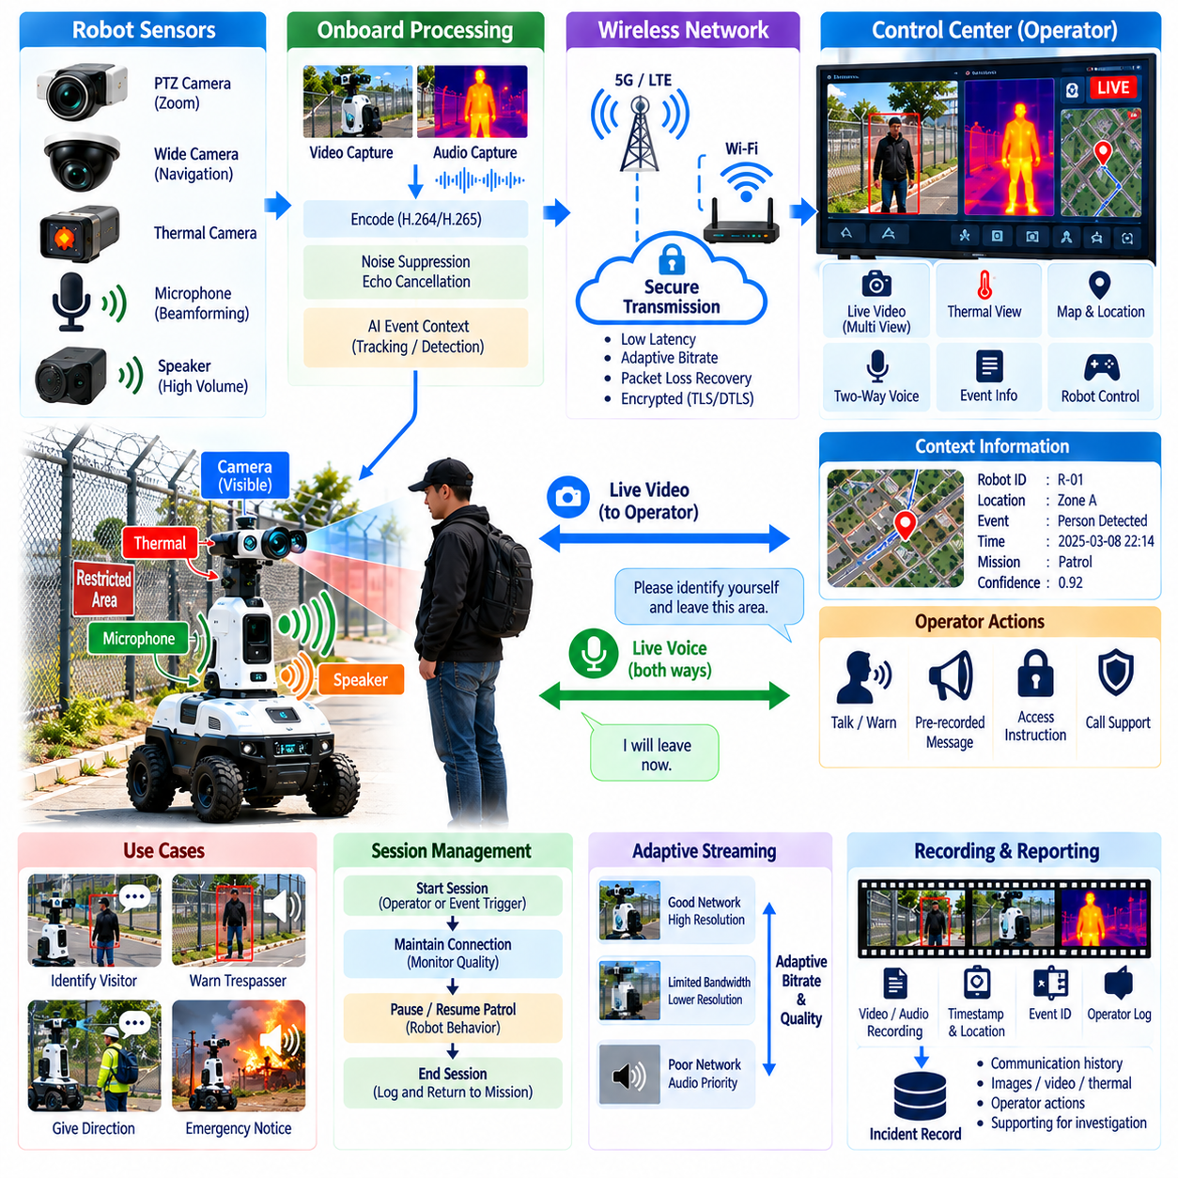
Two-way voice and video communication transforms an outdoor security robot from an autonomous sensing platform into a mobile communication endpoint between remote security personnel and people in the field. When the robot encounters a visitor, worker, suspicious individual, or emergency situation, an operator can establish real-time audio and visual communication without physically traveling to the location. This capability extends remote supervision into direct human interaction.
The communication architecture typically connects cameras, microphones, speakers, onboard computing, wireless networking, and a remote control center. Video captured by the robot is encoded and transmitted to an operator interface, while microphone signals provide environmental audio or speech. In the opposite direction, the operator’s voice is transmitted to the robot and reproduced through onboard speakers, creating an interactive communication channel between the control room and the robot’s physical location.
Audio communication must remain intelligible in challenging outdoor environments. Wind, vehicle engines, industrial machinery, rain, echoes, and robot drivetrain noise can significantly reduce speech quality. Signal-processing functions such as noise suppression, acoustic echo cancellation, automatic gain control, and microphone beamforming can improve intelligibility. Microphone and speaker placement should also minimize mechanical vibration and feedback generated by the robot itself.
Video communication provides the operator with situational awareness that voice alone cannot deliver. The video stream may include a wide-angle navigation camera, a pan-tilt-zoom security camera, thermal imagery, or other views available on the robot. Operators can use these streams to identify the person being addressed, inspect surrounding conditions, verify access credentials, observe gestures, or determine whether additional security personnel should be dispatched.
Interactive communication imposes stricter latency requirements than ordinary surveillance recording. Large delays make conversations unnatural and can cause operators and field personnel to speak over one another. The communication system should therefore control capture, encoding, transmission, decoding, and playback latency while maintaining acceptable media quality. Low-latency operation is especially important when the operator is giving safety instructions or responding to a rapidly developing incident.
Network conditions in outdoor facilities can vary considerably as the robot moves between buildings, yards, fences, parking areas, and remote sections of a site. Wi-Fi, private LTE or 5G, and other wireless networks may provide different levels of bandwidth and coverage. Communication software should monitor packet loss, delay, jitter, signal quality, and available throughput so that media transmission can adapt to changing connectivity without unnecessarily terminating the session.
Adaptive bitrate and resolution control can maintain communication when bandwidth decreases. Instead of attempting to transmit a high-resolution video stream until the connection fails, the system can reduce frame rate, image resolution, or encoding bitrate while preserving the audio channel. Because spoken instructions may remain operationally useful even when video quality becomes poor, the system can prioritize voice traffic and critical control messages over nonessential high-bandwidth data.
Session management controls how communication is established, maintained, and terminated. A remote operator may initiate a call to a selected robot, or the robot may request operator assistance after detecting an abnormal event. The software should maintain session identifiers, participant information, connection state, media status, and timestamps. Clear state management prevents multiple operators from unintentionally issuing conflicting voice commands or attempting to control the same communication channel.
Two-way communication should be integrated with the robot’s autonomous mission logic. When an operator begins interacting with a person, the robot may pause its patrol, stop at a safe distance, orient its camera toward the target, and maintain a stable observation pose. After the communication session ends, the mission manager can resume the interrupted route, continue incident monitoring, or execute another command depending on the outcome of the interaction.
Remote operators may use the robot to deliver warnings, instructions, or access-related messages. For example, an operator can ask an unknown person to identify themselves, instruct someone to leave a restricted area, provide directions to an authorized visitor, or communicate emergency evacuation information. Pre-recorded or text-to-speech messages can supplement live voice communication when standardized announcements must be delivered consistently across repeated situations.
The communication interface should provide operators with sufficient context before they begin speaking. Robot identity, location, current mission, event category, live video, target tracking information, and recent alert history can be displayed together. This prevents the operator from entering a conversation without understanding why the robot initiated contact. Contextual information is particularly important when one control center supervises multiple robots distributed across a large industrial or logistics facility.
Video and audio recording can support incident investigation when permitted by operational policy and applicable privacy requirements. Communication records can be associated with the same event identifier used by the abnormal-event reporting system. Relevant timestamps, robot location, operator identity, session duration, and evidence references can then become part of the incident history. Recording policies should define when capture begins, how long information is retained, and who is authorized to access it.
Authentication and authorization are critical because the communication channel allows remote users to observe the environment and speak through a physical robot. Only approved operators should be able to initiate sessions, access camera streams, activate microphones, or use robot speakers. User identities, roles, permissions, and session actions should be logged. Strong access control reduces the risk that compromised accounts could transform a security robot into an unauthorized surveillance or communication device.
Media streams should also be protected while they travel across wireless and backend networks. Encryption can prevent unauthorized interception of video, audio, and session-control messages, while authenticated signaling helps ensure that commands originate from trusted systems. Communication services should be separated appropriately from safety-critical robot control so that failures or attacks affecting media functions do not directly compromise navigation, emergency stopping, or other essential safety mechanisms.
Failure handling is important because communication sessions may be interrupted by coverage loss, server faults, software errors, or robot movement. The system should detect broken media streams and inform the operator rather than silently presenting frozen video or missing audio. Automatic reconnection can be attempted within defined limits. If communication cannot be restored, the robot can preserve the incident state, continue local observation, and follow a predefined autonomous fallback policy.
Multiple robots introduce additional communication-management requirements. A control center may receive simultaneous requests from several robots while only a limited number of operators are available. Sessions can therefore be prioritized according to incident severity, location, waiting time, and security policy. High-risk events may preempt routine interactions, while lower-priority communication requests remain queued until an operator becomes available. This connects media communication with fleet-level resource management.
Performance evaluation should measure communication quality under realistic operating conditions. Important indicators include end-to-end audio and video latency, packet loss, connection setup time, reconnection time, audio intelligibility, video frame rate, bitrate adaptation behavior, session completion rate, and coverage-related failure frequency. Testing should include stationary and moving robots, network handovers, weak-signal regions, noisy environments, nighttime operation, and concurrent fleet communications.
Two-way voice and video communication ultimately provides the human interaction layer of the outdoor security robot system. Autonomous perception can detect and classify events, but many security situations require conversation, judgment, instruction, and negotiation by a human operator. By integrating low-latency media streaming, adaptive networking, session management, mission coordination, security controls, evidence recording, and failure recovery, the robot becomes a mobile extension of the remote security control center.

04.07. Fleet Dispatch and Incident Response Integration [w/Code]
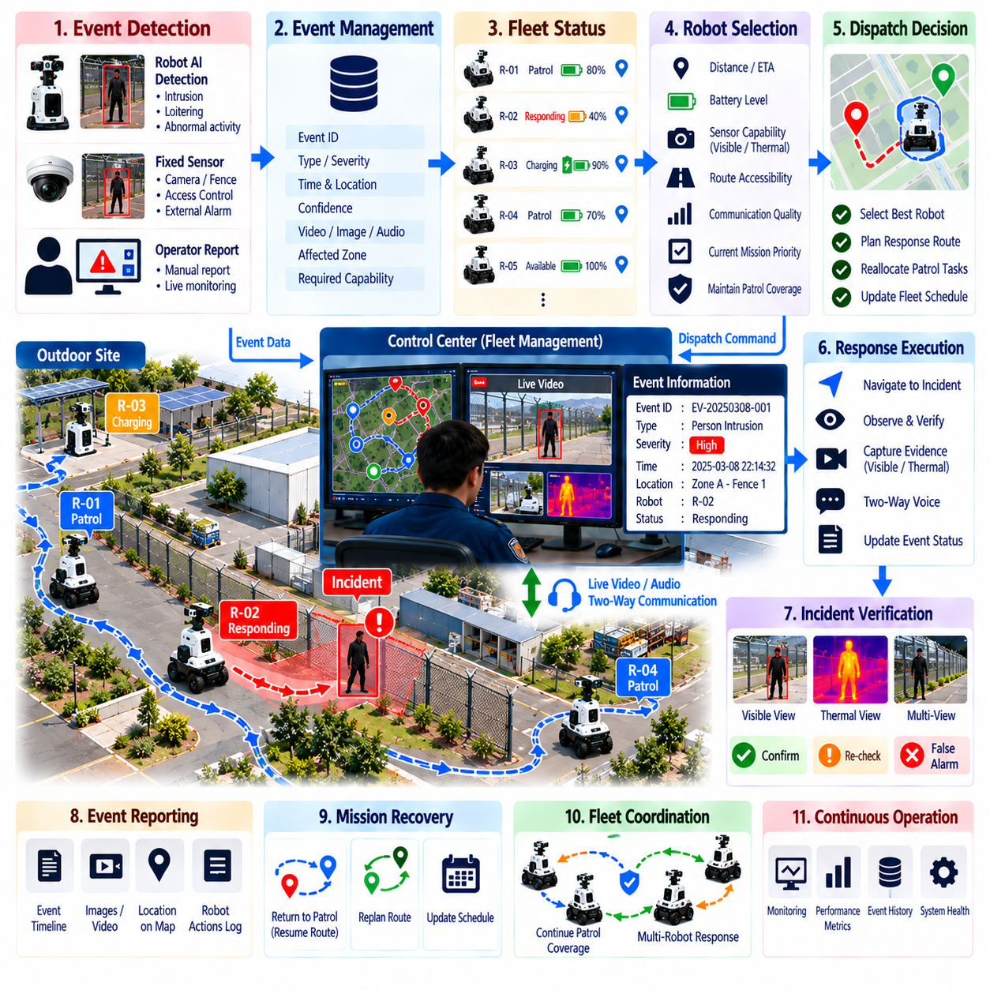
Fleet dispatch and incident response integration coordinates multiple outdoor security robots as a shared operational resource rather than treating each robot as an independent patrol unit. When an abnormal event occurs, the system determines which robot or combination of robots can respond effectively while maintaining essential patrol coverage. This coordination connects event management, fleet status, mission planning, communications, operator supervision, and security response into one operational process.
A fleet management system continuously maintains the operational state of every robot. Relevant information includes position, current mission, patrol route, battery level, charging status, sensor availability, communication quality, payload capability, health condition, and whether the robot is already responding to another incident. This shared state provides the information required to select an appropriate responder instead of simply dispatching the geographically closest robot.
Incident dispatch begins when an event is created by a robot, fixed security sensor, control-center operator, or external security platform. The event manager provides the fleet system with incident type, severity, location, timestamp, confidence, affected security zone, and required sensing capabilities. These attributes are converted into a response task that can be evaluated against the current availability and capabilities of the robot fleet.
Robot selection can be formulated as a task-allocation problem. Distance to the incident is important, but it is not the only criterion. Estimated travel time, remaining battery, route accessibility, sensor configuration, communication coverage, current mission priority, and future patrol obligations can also influence assignment. A thermal-camera-equipped robot, for example, may be preferred for a nighttime incident even when another robot is physically closer.
Dispatch decisions should consider the operational cost of removing a robot from its current patrol. Redirecting the only robot monitoring a high-priority perimeter may create a new security gap. The fleet manager can therefore compare incident urgency with patrol coverage requirements and determine whether another robot should respond, whether an existing patrol should be temporarily delayed, or whether multiple missions must be rescheduled to preserve minimum surveillance coverage.
Once a robot is assigned, its current mission can be interrupted through controlled mission preemption. The mission manager records the patrol state, checkpoint progress, and remaining route before switching to the incident-response task. This allows the robot to return to the interrupted patrol after the incident is resolved. Priority rules are necessary so that low-severity events do not repeatedly interrupt critical missions while high-severity incidents receive immediate attention.
Incident navigation differs from routine patrol because the robot may need to approach an uncertain or potentially dangerous situation. The response route should respect geofences, traffic restrictions, terrain limitations, and safe approach distances. Rather than navigating directly to the event coordinates, the robot can move to a predefined observation position that provides useful sensor coverage while maintaining physical separation from people, vehicles, hazardous equipment, or other risks.
After arriving, the robot can perform an incident verification procedure. Cameras may be oriented toward the target, thermal sensing activated, video streaming increased, or additional observations collected from different viewpoints. The robot can remain stationary to improve image stability or reposition when occlusion prevents confirmation. Verification results are sent to the event manager so that the original alert can be confirmed, downgraded, escalated, or classified as a false alarm.
Multiple robots can be dispatched when one viewpoint or sensor configuration is insufficient. One robot may maintain visual observation while another approaches from a different direction or provides thermal sensing. Coordinated positioning can reduce blind spots and improve target tracking across a large area. Multi-robot response should nevertheless avoid unnecessary congestion, conflicting paths, or excessive concentration of fleet resources around a single event.
Fleet-level tracking becomes useful when a person or vehicle moves beyond the observation range of the responding robot. The system can predict the target direction and transfer observation responsibility to another robot located near the expected path. Event identifiers and target information should remain consistent during this handoff so that the control center sees one continuing incident rather than a sequence of unrelated detections generated by different robots.
Human operators remain responsible for decisions that require security judgment or physical intervention. The fleet system can recommend a robot, calculate response routes, and automatically initiate predefined low-risk actions, but operators should be able to approve, modify, cancel, or escalate assignments according to operational policy. Live video, robot position, incident evidence, response status, and available fleet resources provide the context needed for effective supervision.
Integration with two-way communication allows a responding robot to become a mobile contact point at the incident location. A remote operator can observe the scene, speak to a person through the robot, issue warnings, request identification, or provide safety instructions. The outcome of the conversation can influence the incident state and subsequent fleet actions. The robot may continue observation, return to patrol, request another robot, or remain until human security personnel arrive.
The fleet system should also integrate with external incident-response resources when available. Security guards, fixed cameras, access-control systems, gates, alarms, or facility management platforms may contribute to the same response workflow. Robot-generated location and evidence can help human teams understand the situation before arrival, while external systems can provide access status or additional sensor information that changes the robot’s response strategy.
Communication reliability is essential during fleet dispatch because assignment, navigation, video, and event updates depend on network connectivity. If a responding robot temporarily loses connection, it should not immediately abandon the incident or continue indefinitely without supervision. A predefined fallback policy can determine whether the robot holds position, returns to a safe point, continues local observation, or attempts to reconnect while preserving event data for later synchronization.
Incident resolution should trigger an orderly recovery of fleet operations. Once the event is closed, robots assigned to the response can return to their previous patrols, move to charging stations, or accept newly prioritized tasks. The fleet manager should reconsider coverage because the response may have delayed checkpoints or consumed significant battery capacity. Dynamic rescheduling restores the patrol plan while accounting for the operational effects of the completed incident.
Every dispatch and response action should be recorded for later analysis. The incident history can contain event creation time, dispatch decision, selected robot, estimated and actual arrival times, route changes, observations, operator actions, communication sessions, resolution status, and mission recovery. These records provide traceability and allow organizations to evaluate whether dispatch policies produce fast and effective responses without unnecessarily reducing routine security coverage.
Performance metrics should evaluate both response speed and overall fleet effectiveness. Useful measures include dispatch latency, travel time to incidents, verification time, total resolution time, percentage of incidents successfully reached, patrol coverage lost during response, battery consumed per incident, reassignment frequency, and robot utilization. Simulation and field tests can expose situations in which locally optimal dispatch decisions create poor fleet-wide security performance.
Fleet dispatch and incident response integration ultimately creates a closed operational loop from detection to coordinated action. An event is detected, classified, assigned, investigated, communicated, resolved, and incorporated back into fleet scheduling. By combining task allocation, mission preemption, safe navigation, multimodal verification, operator supervision, multi-robot coordination, and post-incident recovery, outdoor security robots can function as a coordinated security fleet rather than isolated autonomous machines.

04.08. Outdoor Robot Weather and Reliability Design
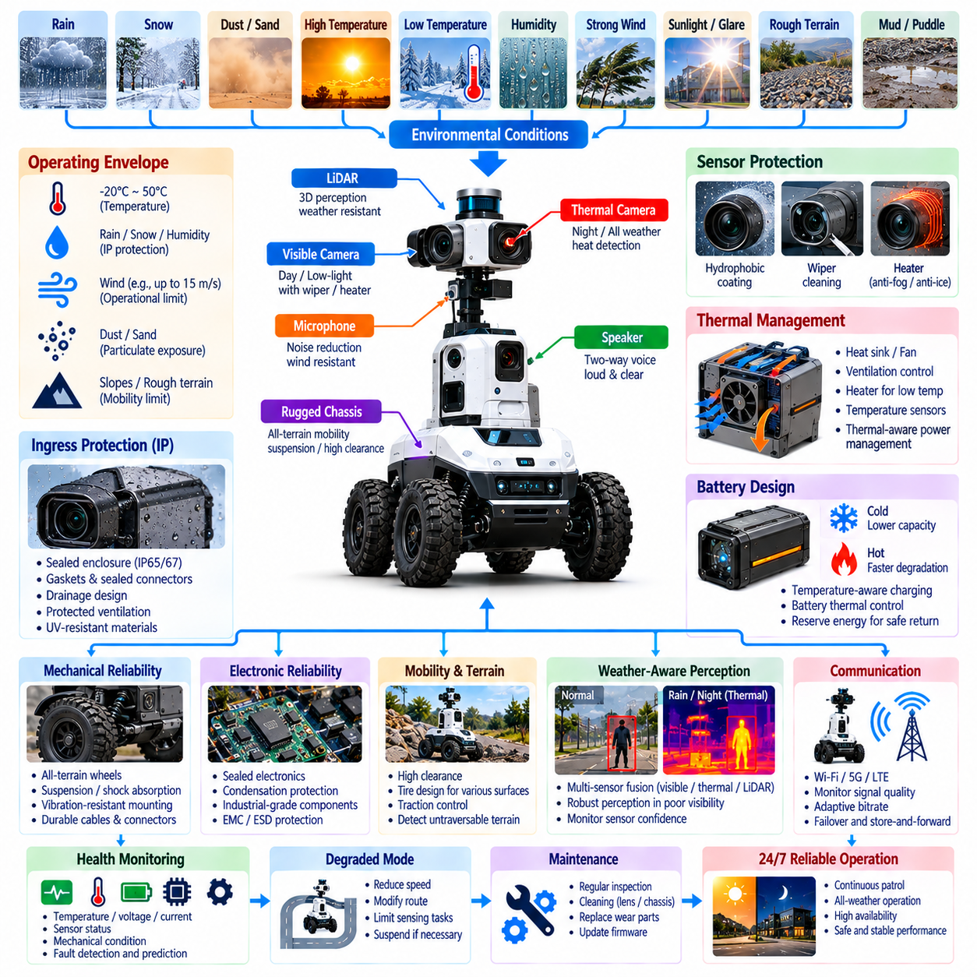
Outdoor security robots must operate reliably in environmental conditions that are substantially more variable than those encountered by indoor mobile robots. Rain, dust, wind, sunlight, temperature extremes, moisture, uneven terrain, and seasonal changes can simultaneously affect mechanical components, electronics, sensors, batteries, communications, and autonomous navigation. Weather and reliability design must therefore be treated as a system-level engineering requirement rather than an enclosure problem alone.
Environmental requirements should be defined from the intended operational site before hardware design is finalized. Expected minimum and maximum temperatures, rainfall intensity, humidity, dust exposure, wind conditions, solar radiation, puddle depth, surface contamination, and seasonal weather patterns establish the robot’s operating envelope. Designers should also distinguish normal operating conditions from degraded conditions and environmental limits beyond which autonomous operation must be suspended.
Ingress protection is essential because water and particulate contamination can damage electronics, connectors, motors, sensors, and battery systems. Mechanical enclosures require appropriate sealing around panels, cable entries, joints, buttons, charging interfaces, and maintenance access points. Gaskets, sealed connectors, drainage paths, and protected ventilation can reduce ingress risk, but sealing strategies must also consider heat dissipation and pressure changes inside the enclosure.
Rain affects more than enclosure integrity because it can directly degrade perception. Water droplets on camera windows may distort images, while wet surfaces create reflections that challenge vision algorithms. LiDAR returns can be affected by airborne water, and heavy precipitation can reduce useful sensing range. Sensor covers may therefore use hydrophobic surfaces, protective hoods, heating, air flow, or cleaning mechanisms while perception software monitors whether environmental contamination is reducing sensor confidence.
Dust and debris create similar long-term reliability problems. Fine particles can accumulate on lenses, cooling surfaces, seals, mechanical joints, and charging contacts. Industrial yards may additionally expose robots to sand, metallic particles, mud, or material generated by vehicle traffic. Mechanical protection should be combined with inspection and cleaning procedures because even well-sealed equipment can gradually lose performance when contamination accumulates over extended 24/7 operation.
Temperature management influences almost every subsystem. High ambient temperatures and direct sunlight can increase internal enclosure temperature beyond electronic component limits, while low temperatures can reduce battery output and alter mechanical properties. Thermal design may combine passive conduction, heat sinks, controlled ventilation, fans, heaters, and temperature-aware power management. Temperature sensors should monitor critical components so that software can detect thermal stress before permanent damage occurs.
Battery behavior requires particular attention because available energy, charging efficiency, and allowable current vary with temperature. Cold conditions may reduce usable capacity and increase the energy required for propulsion, while excessive heat can accelerate degradation and trigger protection mechanisms. The mission manager should therefore interpret battery state together with temperature and expected travel requirements rather than relying only on a simple percentage indicator when deciding whether a patrol can safely continue.
Solar radiation can heat the enclosure and also create difficult optical conditions. Direct sunlight, glare, strong shadows, and rapid transitions between illuminated and shaded areas may reduce camera performance. Materials and coatings should tolerate ultraviolet exposure without excessive degradation, discoloration, or embrittlement. Perception systems can use exposure control, high-dynamic-range imaging, thermal sensing, and confidence monitoring to maintain useful observations across changing outdoor illumination.
Wind introduces both mechanical and sensing effects. Strong gusts can influence stability, especially for tall robots or platforms carrying elevated sensor masts, and may increase the load on actuators. Wind also creates vegetation motion, airborne debris, microphone noise, and rapidly changing environmental conditions that affect security perception. Operational limits should define wind conditions under which normal patrol is allowed and conditions requiring reduced speed, sheltered waiting, or mission suspension.
Mobility reliability depends strongly on terrain and surface conditions. Outdoor patrol routes may contain asphalt, concrete, gravel, slopes, expansion joints, drainage channels, small curbs, mud, leaves, snow, or standing water. Wheel size, tire design, suspension, ground clearance, traction, and drivetrain torque should reflect these conditions. Navigation software should recognize terrain that exceeds safe traversability limits rather than forcing the robot to follow a nominal route regardless of surface condition.
Mechanical reliability requires consideration of continuous vibration, shock, repeated acceleration, and long operating cycles. Bearings, gearboxes, wheels, suspension components, sensor mounts, and cable assemblies experience repeated loading during patrol. Fasteners can loosen and connectors can fatigue if mechanical design does not account for vibration. Reliability engineering should therefore include component derating, structural analysis, vibration-resistant mounting, cable strain relief, and inspection of predictable wear items.
Electronic reliability depends on more than protecting circuits from direct water exposure. Condensation can form when temperature changes cause moist air inside an enclosure to reach the dew point. Corrosion may then develop gradually on connectors and circuit assemblies even without visible water ingress. Moisture management, conformal protection where appropriate, corrosion-resistant materials, controlled ventilation, and environmental monitoring can reduce failures caused by long-term exposure.
Fault detection should be built into the robot rather than depending exclusively on periodic human inspection. Health monitoring can track motor current, wheel behavior, battery temperature, internal humidity, processor temperature, communication quality, sensor availability, storage status, and charging performance. Deviations from normal operating patterns can indicate degradation before complete failure. These observations can support preventive maintenance and reduce unexpected downtime during security operations.
Reliability design should also define how the robot behaves after faults occur. Failure of a noncritical sensor may permit continued operation in a degraded mode, while loss of localization, braking capability, critical perception, or battery safety may require an immediate safe stop. The system should distinguish recoverable faults from safety-critical failures and provide clear diagnostic information to the control center. Autonomous recovery must never conceal a persistent fault that requires maintenance.
Redundancy can improve availability when selected carefully. Multiple sensing modalities can preserve environmental awareness when one sensor becomes unreliable, while redundant communication paths can maintain contact during network degradation. However, duplicating every component increases cost, weight, power consumption, and complexity. Reliability engineering should identify functions whose failure would terminate the mission or create unacceptable risk and apply redundancy where it provides meaningful system-level benefit.
Charging infrastructure must be designed for the same outdoor reliability requirements as the robot. Charging contacts, docking markers, communication interfaces, and station electronics may be exposed to water, dust, temperature variation, and contamination. The robot should verify successful docking and charging rather than assuming that physical arrival at the station restored energy. Failed charging attempts should trigger retry, alternate-station selection, or operator notification before battery reserve becomes critical.
Maintenance planning connects reliability design with actual long-term availability. Components such as tires, seals, cleaning mechanisms, fans, batteries, and protective windows have different wear and replacement intervals. Maintenance software can use operating hours, traveled distance, charging cycles, fault history, and environmental exposure to schedule inspection. Condition-based maintenance can be more effective than waiting for failure, particularly when a security fleet is expected to provide continuous patrol coverage.
Environmental and reliability validation should reproduce realistic combinations of stress rather than testing each factor only in isolation. Temperature cycling, water exposure, dust, vibration, prolonged operation, charging cycles, sensor contamination, and degraded communication should be evaluated together with autonomous missions. Field testing across different seasons is also important because laboratory tests may not reproduce every interaction among weather, terrain, perception, mobility, and human operations.
Outdoor robot weather and reliability design ultimately determines whether autonomous security capability remains available when environmental conditions become difficult. A robot that performs well only in favorable weather cannot provide dependable 24/7 security coverage. By combining environmental protection, thermal management, robust mobility, sensor protection, health monitoring, fault handling, maintainability, redundancy, and realistic validation, the system can sustain safe and predictable operation throughout its intended service life.

04.09. Security Robot Data Privacy GDPR Compliance
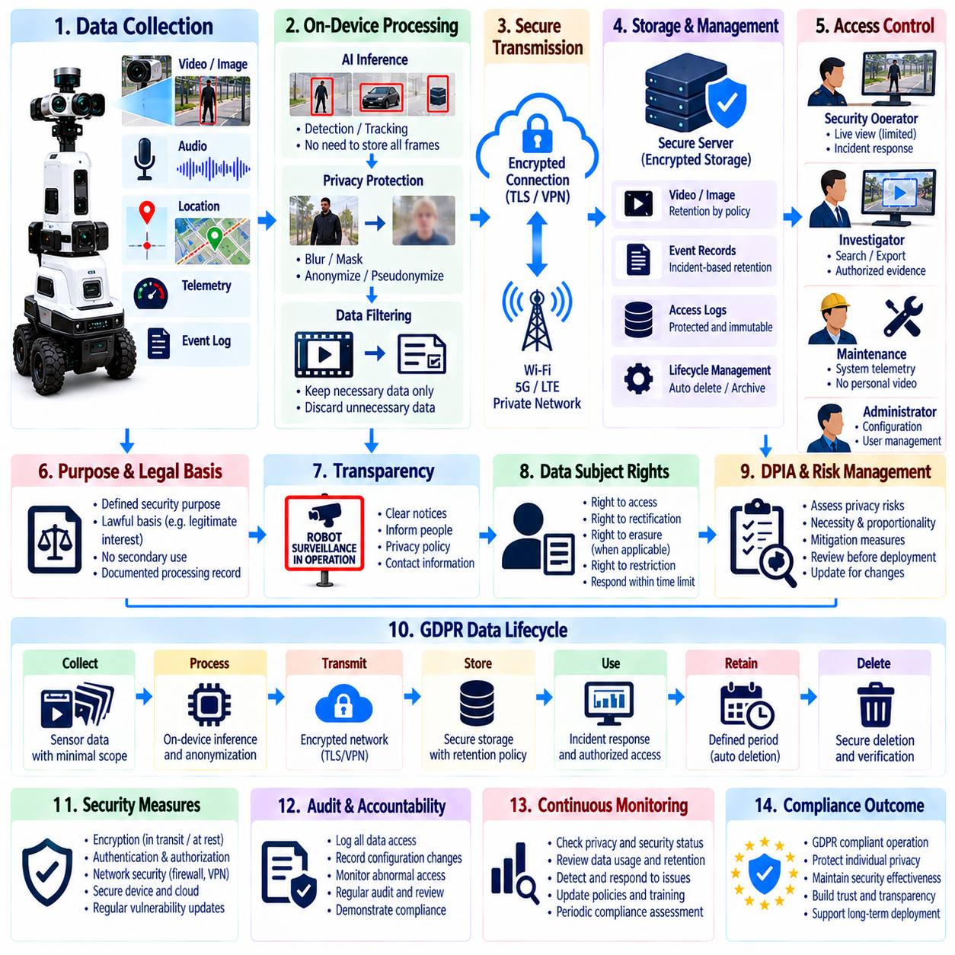
Outdoor security robots continuously observe physical environments and may collect video, images, audio, location information, timestamps, access events, and other data associated with identifiable people. Privacy must therefore be considered throughout system design rather than added after deployment. When robots operate where the General Data Protection Regulation applies, data processing should be designed around lawful purpose, transparency, proportionality, security, accountability, and protection of individual rights.
The first step is to understand what information the robot collects and why it is required. Navigation sensor data may contain little personal information, while security video can capture faces, clothing, vehicle registration information, behavior, and movement patterns. Microphones may record conversations, and event logs can connect observations with locations and times. A data inventory helps distinguish operational telemetry from personal data and supports appropriate controls for each category.
Purpose limitation requires collected information to be used for defined security objectives rather than unrestricted secondary purposes. Video gathered for perimeter intrusion detection, for example, should not automatically become a general employee-monitoring dataset. Each processing activity should have a documented purpose, responsible organization, expected data categories, processing location, retention period, recipients, and applicable legal basis. This creates a traceable relationship between robot functionality and data processing.
Data minimization reduces privacy risk by limiting collection to information that is necessary for the intended task. A robot performing autonomous navigation may not need to retain every camera frame, and routine patrol footage may not require long-term storage when no security event occurs. Sensor resolution, field of view, recording duration, sampling frequency, and retention policy can be configured according to operational need rather than maximizing data collection simply because storage is available.
Privacy by design integrates protection mechanisms into the architecture from the beginning. Processing can be performed locally on the robot when raw data does not need to leave the device. AI inference may convert camera frames into temporary object detections while discarding unnecessary imagery. Where appropriate, masking, blurring, cropping, pseudonymization, or extraction of non-identifying metadata can reduce exposure while still supporting security functions such as intrusion detection and patrol verification.
Privacy by default complements this approach by ensuring that the normal system configuration uses the least intrusive settings compatible with the security mission. Continuous audio recording, unrestricted remote camera access, excessive retention, or broad sharing should not automatically be enabled when they are unnecessary. More intrusive functions can require explicit authorization, defined operational conditions, or event-triggered activation so that exceptional capabilities do not become routine surveillance practices.
Transparency is especially important because a mobile robot can observe people from changing positions. Individuals should be able to understand that robotic surveillance is operating, the general purposes of processing, the responsible organization, and where additional privacy information can be obtained. Appropriate notices, signage, policies, and operator procedures can support this requirement. The visibility of the robot itself should not be treated as sufficient explanation of how collected data is processed.
A Data Protection Impact Assessment can be important when robotic surveillance is likely to create elevated privacy risks, particularly when systematic monitoring, new technologies, large areas, or vulnerable individuals are involved. The assessment identifies processing operations, necessity, proportionality, risks to individuals, and measures used to reduce those risks. Conducting this analysis before deployment can influence camera placement, recording policies, retention periods, access controls, and operational procedures.
Retention management determines how long security data remains available. Different information may require different lifetimes. Routine footage without an incident may be deleted quickly, while evidence associated with a confirmed security event may need longer retention according to organizational policy and legal requirements. Automated lifecycle rules can delete or archive information when retention periods expire, reducing dependence on manual cleanup and preventing indefinite accumulation of historical surveillance data.
Access control should follow the principle of least privilege. Robot operators may need live video for incident response but may not require unrestricted access to historical recordings. Investigators may need specific evidence, while maintenance personnel may require technical telemetry without personal video. Role-based permissions, strong authentication, session controls, and authorization checks can separate these responsibilities and reduce unnecessary exposure of sensitive information.
Audit logging supports accountability by recording who accessed data, what actions were performed, when access occurred, and which records were affected. Important actions can include viewing live streams, retrieving recordings, exporting evidence, changing retention settings, or modifying privacy configurations. Logs should themselves be protected against unauthorized modification. Regular review can reveal inappropriate access patterns and provide evidence that privacy and security procedures are being followed.
Encryption protects information both during transmission and while stored. Video, audio, incident reports, and robot telemetry may travel through wireless networks, edge servers, control centers, or cloud services. Secure communication protocols and authenticated endpoints reduce interception and manipulation risks. Stored information should also receive appropriate protection, while encryption keys and credentials require controlled lifecycle management so that encryption does not depend on poorly protected secrets.
Data integrity and availability are also important because privacy protection is part of broader information security. Altered evidence can lead to incorrect conclusions, while unavailable records can prevent investigation or fulfillment of legitimate data requests. Backup, integrity verification, secure timestamps, controlled replication, and recovery procedures should be designed according to the importance of the information. Security controls should protect confidentiality without making operationally necessary data unusable.
Data subject rights must be considered in the system architecture and organizational workflow. Depending on the applicable circumstances, individuals may have rights relating to access, correction, erasure, restriction, objection, or information about processing. Robotic video systems can make these requests technically difficult because identifying relevant footage may require location and time information. Data indexing and controlled retrieval mechanisms can help authorized privacy personnel respond without exposing unrelated individuals.
Third-party services require careful governance when robot data is processed outside the operating organization. Cloud storage, video analytics, fleet platforms, communications services, and maintenance providers may receive or process information generated by the robot. Responsibilities should be defined through appropriate agreements and technical controls. Organizations should understand where data is processed, who can access it, how long it is retained, and whether international transfers introduce additional requirements.
Security incidents involving personal data require preparation before they occur. Unauthorized access, stolen credentials, exposed storage, compromised robots, or accidental data sharing can create privacy breaches. Monitoring and incident-response procedures should identify affected systems and information, contain the exposure, preserve evidence, evaluate impact, and support required organizational or regulatory actions. Privacy breach response should therefore be integrated with the broader cybersecurity incident process.
AI-based security functions introduce additional governance concerns because automated models can produce false detections, biased outcomes, or uncertain classifications. A person should not be treated as a security threat merely because an algorithm generated a low-confidence result. Confidence management, human verification, documented escalation rules, and performance testing can reduce inappropriate decisions. Training and evaluation data should also be governed carefully when they contain images or other personal information.
Compliance must continue after deployment rather than being treated as a one-time certification activity. Software updates, new sensors, changed patrol routes, expanded camera coverage, additional AI functions, cloud migration, or new data-sharing relationships can alter privacy risk. Change management should therefore include privacy review, security assessment, configuration verification, and documentation updates whenever system capabilities or processing purposes materially change.
Security robot data privacy and GDPR compliance ultimately require coordination among robotics engineering, cybersecurity, security operations, privacy governance, and organizational policy. The objective is not to eliminate data collection that is necessary for legitimate security functions, but to ensure that collection and processing remain purposeful, proportionate, protected, transparent, and accountable. Integrating these principles into the robot lifecycle enables autonomous security operations while reducing unnecessary privacy risk.

04.10. Outdoor Security Robot 24/7 Operation Case
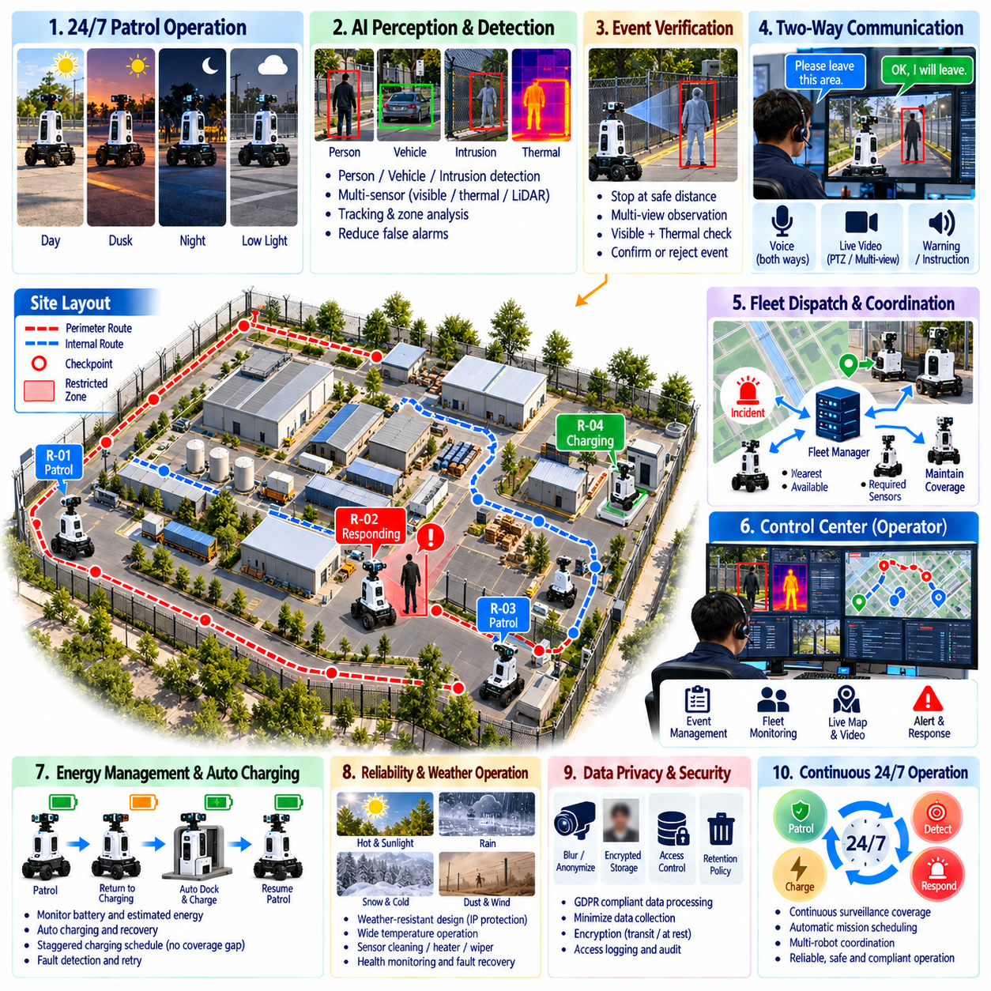
A 24/7 outdoor security robot deployment demonstrates how autonomous patrol, AI perception, communications, fleet management, charging, reliability engineering, and human supervision operate as one continuous security service. The objective is not simply to keep a robot moving throughout the day, but to maintain dependable surveillance coverage across changing shifts, weather, illumination, network conditions, battery states, and security events without creating unacceptable operational gaps.
A representative deployment can involve an industrial facility with perimeter fences, vehicle gates, warehouses, outdoor storage areas, parking zones, utility equipment, and restricted infrastructure. Patrol routes are divided into security zones and checkpoints according to risk and required inspection frequency. Higher-priority areas receive shorter revisit intervals, while lower-risk sections are scheduled less frequently so that available robot time is allocated according to operational importance.
Before each patrol cycle, the mission manager evaluates robot health, battery state, sensor availability, communication quality, localization confidence, and route conditions. A robot that does not satisfy minimum operational requirements should not begin an ordinary mission merely to preserve the schedule. Instead, the fleet system can assign another available robot, modify the route, or notify an operator that expected security coverage has been reduced.
During routine operation, the robot follows scheduled patrol routes while continuously performing navigation and security perception. Visible cameras, thermal sensors, and other available sensing systems observe fences, gates, roads, buildings, and equipment areas. The robot records checkpoint completion, relevant observations, system health, and mission progress while AI perception searches for people, vehicles, intrusions, abnormal activity, or other events defined by site security policy.
Daytime operation benefits from strong visible-light imagery but introduces challenges such as glare, shadows, vehicle traffic, workers, and changing site activity. Security logic must distinguish normal authorized movement from suspicious behavior so that routine operations do not produce excessive alarms. Context such as zone permissions, time schedules, movement direction, object tracking, and persistence can convert generic object detections into operationally meaningful security events.
At night, the sensing strategy changes as visible illumination decreases. Low-light cameras, infrared illumination, and thermal perception can maintain observation of people, vehicles, and selected equipment. The robot may reduce speed or increase observation time at important checkpoints when perception becomes more difficult. Multimodal sensing provides redundancy so that the loss of useful information from one camera does not automatically eliminate nighttime surveillance capability.
When the robot detects a possible perimeter intrusion, the event is not immediately treated as a confirmed security breach. Object detection, tracking, virtual-zone logic, temporal confirmation, and confidence evaluation are used to validate the observation. The robot can stop at a safe position and collect additional visible or thermal evidence. This active verification step reduces false alarms while providing the control center with better information for human assessment.
A confirmed or sufficiently high-confidence event enters the abnormal-event management workflow. The event record includes time, location, robot identity, event category, confidence, relevant images or video, and current mission context. The alert system assigns severity and notifies the appropriate operator. Repeated detections associated with the same tracked target are correlated into one continuing incident rather than generating a new independent alarm for every video frame.
The responding operator can establish two-way voice and video communication through the robot when interaction is appropriate. Live video provides situational awareness while the robot speaker allows the operator to issue warnings, request identification, provide instructions, or communicate safety information. The robot becomes a mobile presence at the incident location while the human operator retains responsibility for decisions requiring contextual judgment or escalation.
If additional observation is necessary, the fleet manager can dispatch another robot without losing awareness of existing patrol obligations. Robot selection considers distance, estimated arrival time, battery level, sensor capability, route accessibility, and current mission priority. A thermal-equipped robot may be selected for nighttime verification, while another robot can temporarily cover a patrol area left unattended by the responding unit. Fleet coordination therefore balances incident response with continued surveillance.
Energy management is fundamental to continuous operation because individual robots cannot patrol indefinitely. Battery state is monitored together with expected route energy, environmental conditions, and reserve requirements. Before energy reaches a critical level, the robot returns to a charging station and verifies successful docking and charging. Another robot can assume patrol responsibility during this period, allowing fleet-level security coverage to continue even though individual units alternate between operation and charging.
Charging schedules should avoid creating simultaneous coverage gaps. The fleet manager can stagger charging periods according to battery state, patrol demand, incident probability, and available charging stations. If a robot fails to dock or charging does not begin correctly, the system should detect the failure and attempt recovery before reserve energy becomes insufficient. Charging is therefore managed as part of mission scheduling rather than as an independent maintenance activity.
Weather conditions can change the operational strategy throughout the day. Rain may reduce camera and LiDAR performance, high temperatures may increase thermal load, cold weather may reduce battery capacity, and strong wind may affect stability or audio quality. Environmental measurements and sensor-health indicators allow the mission manager to reduce speed, increase safety margins, modify sensing behavior, reroute patrols, or suspend specific missions when operating conditions exceed defined limits.
Communication coverage also varies as robots move across large outdoor facilities. The system monitors bandwidth, latency, packet loss, and connection state while prioritizing critical alarms and control information. Temporary loss of central connectivity should not erase event information or leave the robot without defined behavior. Store-and-forward mechanisms preserve evidence locally, while fallback policies determine whether the robot continues observation, waits safely, returns, or attempts reconnection.
Continuous operation depends on predictive and preventive maintenance as much as autonomy. Motor current, battery temperature, wheel behavior, internal humidity, processor temperature, sensor availability, charging performance, and fault history can reveal gradual degradation. Maintenance can then be scheduled before complete failure occurs. A fleet with one robot temporarily unavailable for service should redistribute missions according to remaining capacity instead of allowing hidden coverage gaps.
Shift changes in the human security team should not interrupt robotic surveillance. Event state, active incidents, robots under manual supervision, degraded equipment, patrol exceptions, and unresolved maintenance conditions should remain available through the control system. Structured digital records reduce dependence on verbal handover and provide incoming operators with a consistent operational picture of what occurred during previous hours and what conditions still require attention.
Privacy and cybersecurity requirements remain active throughout continuous operation. Video and audio collection should follow defined purposes, retention rules, and access permissions, while communications and stored evidence require appropriate protection. Operator access, evidence retrieval, configuration changes, and incident actions should be logged. Continuous availability must not be achieved by weakening authentication, privacy safeguards, or security controls during unattended nighttime periods.
Operational performance should be evaluated over complete days and weeks rather than only during short demonstrations. Important indicators include patrol completion rate, checkpoint revisit compliance, security coverage, false alarms, missed events, incident response time, robot availability, charging success, communication interruptions, maintenance downtime, and operator intervention frequency. Long-duration measurements reveal recurring problems that may not appear during controlled acceptance tests.
The 24/7 operation case ultimately demonstrates that dependable robotic security is a system capability rather than the performance of a single autonomous machine. Continuous coverage emerges from coordinated patrol planning, AI perception, event verification, human supervision, fleet dispatch, charging, weather adaptation, communication recovery, maintenance, privacy, and cybersecurity. When these functions operate as one closed operational cycle, outdoor security robots can provide persistent and measurable support to human security teams across day and night operations.

