Volume 26. Industrial Robot Applications

Chapter 05. GPR and Infrastructure Inspection

05.01. GPR Robot System Overview and Workflow
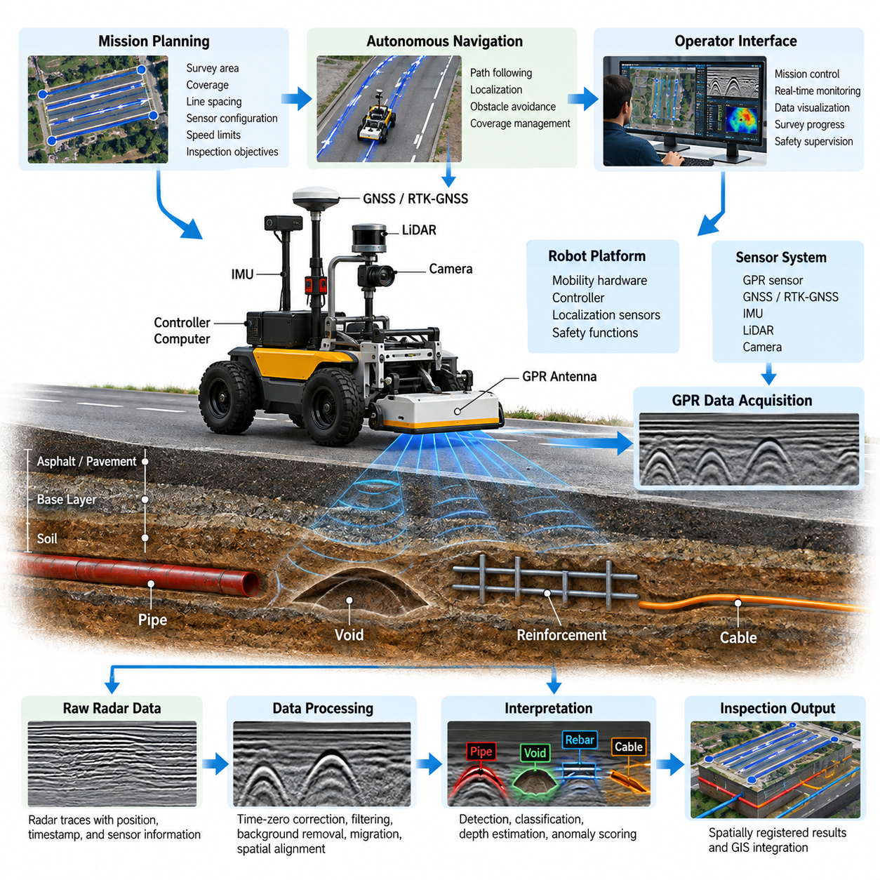
Ground-penetrating radar (GPR) inspection robots combine autonomous mobility, subsurface sensing, positioning, and data-processing functions into a unified infrastructure inspection platform. Unlike conventional inspection vehicles that primarily observe visible surfaces, a GPR robot investigates structures beneath roads, bridge decks, floors, and other accessible surfaces. The robotic platform provides controlled sensor motion while the radar subsystem continuously measures electromagnetic reflections from underground or embedded features.
The overall system is organized around several interacting layers: the mobile robot, GPR sensor, localization subsystem, navigation software, data-acquisition pipeline, inspection-processing software, and operator interface. This architecture reflects the broader robotics software organization in which navigation, perception, sensor management, data architecture, and application software cooperate through modular interfaces. The inspection application therefore acts as an orchestration layer connecting robot autonomy with specialized nondestructive sensing functions. 08_Robotics_Software_Tree
A typical GPR sensor transmits short electromagnetic pulses or frequency-modulated signals toward the inspected medium and measures reflected energy produced by changes in electromagnetic properties. Boundaries between pavement layers, reinforcement bars, buried pipes, cables, voids, moisture regions, or different soil materials may generate recognizable reflections. The robot does not directly observe these objects; instead, it collects radar measurements whose spatial and temporal patterns must later be interpreted to infer subsurface structure.
The robotic mobility platform provides a repeatable spatial trajectory for this sensing process. Wheel encoders, inertial sensors, GNSS or RTK-GNSS outdoors, LiDAR, cameras, and SLAM-based localization can be combined according to the inspection environment. Accurate localization is particularly important because every radar measurement must ultimately be associated with a physical position. The inspection result is therefore not simply a radar image but a spatially registered representation of subsurface observations.
Before an inspection mission begins, the operator defines the survey area, required coverage, lane or grid spacing, sensor configuration, speed limits, and inspection objectives. Existing maps, GIS information, engineering drawings, or known utility records may also be imported. The mission planner transforms these requirements into executable survey trajectories. Depending on the site, the robot may follow parallel lines, grids, road lanes, bridge sections, corridors, or manually defined inspection boundaries.
During mission initialization, the robot verifies the operational state of mobility hardware, radar electronics, localization sensors, storage devices, communication links, and safety functions. Sensor timestamps and coordinate frames must be synchronized so that radar measurements can later be correlated with robot poses. Calibration may also establish antenna height, sensor offset relative to the robot reference frame, wheel odometry parameters, localization alignment, and radar acquisition settings appropriate for the expected inspection depth.
Once the survey begins, autonomous navigation and radar acquisition operate as synchronized processes. The navigation subsystem commands the robot along the planned path while continuously estimating position and orientation. At the same time, the GPR subsystem acquires radar traces at controlled spatial or temporal intervals. Robot pose, velocity, radar parameters, timestamps, diagnostic states, and environmental information can be recorded together, producing a traceable dataset for subsequent processing and analysis.
Maintaining stable motion is important because irregular speed, excessive vibration, wheel slip, or abrupt steering can degrade spatial sampling consistency. The motion controller therefore attempts to maintain survey velocity and trajectory accuracy while the mission manager monitors localization confidence and radar acquisition status. When an obstacle appears, the system must determine whether local avoidance is compatible with inspection coverage or whether the affected section should be interrupted, replanned, and surveyed again.
Coverage management distinguishes inspection robots from ordinary autonomous navigation systems. Reaching a destination is insufficient; the robot must verify that the required surface has been scanned with appropriate spacing and measurement density. Survey software tracks completed and uncompleted segments and can identify gaps caused by obstacles, localization loss, sensor faults, or emergency stops. Missing regions can then be scheduled for recovery passes before the inspection mission is considered complete.
Raw radar measurements require a processing pipeline before meaningful subsurface features can be extracted. Typical processing stages may include time-zero correction, background removal, filtering, gain compensation, noise suppression, migration, and spatial alignment. Individual radar traces form profiles such as B-scans, while repeated parallel passes can be combined into larger two-dimensional or three-dimensional representations. Processing parameters must remain linked to the original data so results can be reproduced or reprocessed.
Interpretation converts processed radar responses into engineering information. Characteristic hyperbolic reflections may indicate compact buried objects, while continuous responses can represent material boundaries or structural layers. Automated algorithms can assist with detection, segmentation, classification, depth estimation, and anomaly scoring. AI-based interpretation may further identify patterns associated with utilities, reinforcement, voids, delamination, deterioration, or other subsurface conditions, but confidence information should accompany automated findings.
The system workflow therefore separates measurement from interpretation. Raw sensor data should be retained even when real-time detection is available, because improved algorithms or revised engineering assumptions may require later reprocessing. Processed radar products, detected anomalies, robot trajectories, localization confidence, and inspection metadata can be stored as related but distinguishable data products. This preserves evidence provenance and makes the inspection result auditable throughout its lifecycle.
Georeferencing connects radar interpretation with infrastructure management. Detected objects and anomalies can be transformed from the radar or robot coordinate frame into site, map, or geographic coordinates. These results can then be associated with road sections, bridge components, utility corridors, or asset identifiers. The chapter structure explicitly extends this workflow toward autonomous survey planning, AI-based utility interpretation, bridge and road inspection, pipeline inspection, GIS integration, and field deployment. Volume_26_Industrial_Robot_Appl…
The operator interface provides mission supervision rather than requiring continuous manual driving. It can display robot position, planned and completed survey paths, localization status, sensor health, radar acquisition progress, storage capacity, communication quality, and detected anomalies. Operators may pause or resume surveys, modify mission boundaries, mark regions for rescanning, or assume manual control when required. Remote supervision also allows inspection personnel to remain outside hazardous traffic or construction areas.
Safety management operates independently from the inspection objective. Emergency stops, obstacle detection, speed limits, geofencing, communication-loss behavior, fault monitoring, and safe-stop states prevent the sensing mission from overriding fundamental robot safety. Infrastructure sites can contain vehicles, workers, uneven surfaces, excavations, restricted zones, and electromagnetic interference. Consequently, the mission manager must treat safety events as state transitions that can suspend acquisition and preserve enough context for controlled recovery.
System reliability also depends on continuous health monitoring. The robot should detect loss of radar communication, insufficient storage, degraded localization, abnormal motion, sensor overheating, timestamp errors, power limitations, or inconsistent measurement rates. Instead of silently continuing a compromised survey, the system can flag affected data, stop the mission, or schedule the corresponding region for reacquisition. This prevents technically complete trajectories from being mistaken for valid inspection coverage.
At mission completion, the system verifies survey coverage and data integrity before generating inspection products. Radar profiles, subsurface maps, anomaly locations, estimated depths, confidence values, trajectory records, and diagnostic logs can be assembled into an inspection package. Engineering review may then validate automated interpretations and convert selected findings into maintenance or investigation actions. The resulting information can also be exported to GIS, asset-management, or infrastructure digital-twin environments.
The complete workflow can therefore be understood as a closed information chain: mission definition leads to survey planning, robot localization and autonomous motion enable controlled sensing, synchronized acquisition produces spatially referenced GPR measurements, signal processing transforms measurements into interpretable representations, and detection or AI interpretation produces infrastructure findings. Data management, safety supervision, and operator oversight support every stage rather than functioning as isolated downstream activities.
A well-designed GPR robot ultimately transforms subsurface inspection from a manually positioned sensing task into a repeatable robotic measurement process. Its principal value is not autonomy alone, but the integration of controlled mobility, precise localization, consistent sensor acquisition, systematic coverage, automated processing, and spatial data management. This integrated workflow establishes the foundation for the later chapter topics covering GPR acquisition software, subsurface detection, autonomous survey planning, AI interpretation, infrastructure inspection applications, GIS integration, and field operation.

05.02. GPR Sensor Integration and Data Acquisition SW [w/Code]
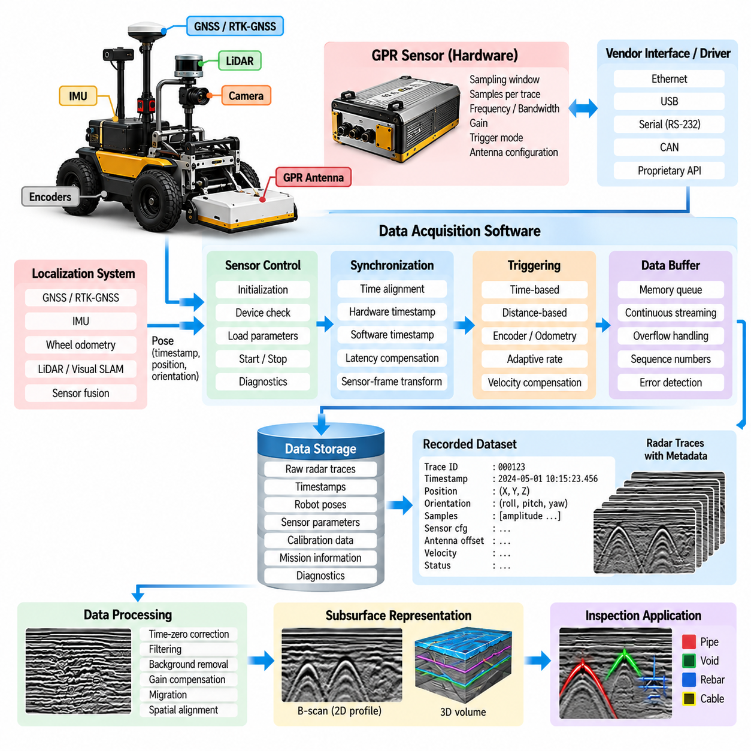
Ground-penetrating radar sensor integration requires the robotic platform and radar instrument to operate as a synchronized measurement system rather than as independent devices. The data-acquisition software provides the interface between the GPR hardware, robot localization, motion control, storage, and inspection applications. Its primary responsibility is to capture radar measurements reliably while preserving the spatial, temporal, and configuration information required for later subsurface analysis.
A typical integration architecture separates the vendor-specific radar interface from the rest of the robot software. The GPR may communicate through Ethernet, USB, serial communication, CAN, or a proprietary hardware interface, while a dedicated device driver or adapter converts these commands and measurements into a standardized internal representation. This abstraction prevents higher-level inspection software from depending directly on a particular radar manufacturer or communication protocol.
The acquisition software normally manages radar initialization before measurement begins. It establishes communication with the sensor, verifies device identity and firmware state, loads acquisition parameters, checks antenna configuration, and confirms that valid radar traces can be received. Parameters may include sampling window, number of samples per trace, pulse repetition settings, frequency characteristics, gain, triggering mode, and other sensor-specific options supported by the selected GPR equipment.
A radar trace represents reflected electromagnetic energy sampled over propagation time. Each trace must therefore contain not only amplitude samples but also metadata describing how the measurement was produced. The acquisition layer should associate trace identifiers, timestamps, sensor configuration, antenna information, measurement sequence numbers, and diagnostic states with the samples. Preserving this metadata is essential because later processing depends on knowing the conditions under which the original signal was acquired.
Robotic GPR inspection additionally requires every radar measurement to be associated with robot position and orientation. The software can receive localization estimates from wheel odometry, IMU, GNSS or RTK-GNSS, LiDAR localization, visual localization, or fused SLAM systems. A sensor transform defines the position and orientation of the GPR antenna relative to the robot base, allowing measurements to be transformed from the sensor coordinate frame into the robot, map, or geographic coordinate frame.
Time synchronization is one of the most important integration requirements. Radar measurements, robot poses, encoder readings, IMU measurements, and navigation events may originate from devices with different clocks and update rates. The software must maintain a consistent timestamping strategy so that each radar trace can be matched with an appropriate robot pose. Hardware timestamps are preferable when available, while software timestamps require careful management of communication and processing latency.
Spatial triggering can improve measurement consistency when robot velocity changes during a survey. Instead of recording radar traces only at fixed time intervals, the acquisition system can trigger measurements according to traveled distance derived from a wheel encoder or localization estimate. For example, the system may request a measurement after a specified displacement. This approach produces approximately uniform spatial sampling even when the robot accelerates, decelerates, or temporarily reduces speed.
Time-based acquisition remains useful when the GPR sensor operates continuously at a predefined trace rate. In this configuration, the robot software records each incoming trace and interpolates or associates the corresponding pose using synchronized localization data. The relationship between robot velocity, radar trace rate, and required spatial resolution must be considered carefully. Excessive speed can produce sparse spatial sampling, whereas unnecessarily high acquisition rates increase processing and storage requirements.
The acquisition pipeline should be designed for continuous streaming rather than assuming that every radar measurement can immediately be written to permanent storage. Incoming traces can first enter a bounded memory buffer, where acquisition and storage operations are decoupled. A dedicated writer process or thread then transfers buffered measurements to disk. This architecture reduces the possibility that temporary storage latency will interrupt radar communication or cause measurement loss during continuous inspection.
Buffer management requires explicit overflow behavior. If processing or storage becomes slower than the incoming radar stream, the software should detect the condition instead of silently discarding measurements. Depending on system requirements, it may reduce robot speed, pause the survey, generate a fault, or mark missing traces in the dataset. Sequence numbers make dropped or duplicated measurements detectable and allow the integrity of the acquired radar stream to be evaluated after the mission.
Data storage should preserve both raw radar information and the contextual information necessary to reconstruct the inspection. Raw traces may be stored in a vendor-neutral binary format, structured dataset, or converted representation while retaining the original measurements when practical. Pose data, timestamps, calibration parameters, mission identifiers, radar settings, robot velocity, coordinate transforms, and sensor diagnostics should remain logically associated with the corresponding radar records.
For large infrastructure surveys, storage throughput and capacity become operational constraints. Continuous high-resolution radar acquisition can generate substantial datasets, particularly when multiple antennas or channels are used. The acquisition software should monitor available storage and estimated remaining recording time. Chunked files can limit the impact of corruption and simplify later processing, while asynchronous writing and suitable compression can improve storage efficiency without blocking the real-time acquisition path.
Calibration connects the physical sensor installation with software interpretation. The system should record antenna position, orientation, height, channel arrangement, and relevant sensor-specific calibration values. Mechanical changes to the antenna mount can invalidate previous transformations even when the radar electronics remain unchanged. Configuration versioning therefore allows every inspection dataset to identify precisely which robot geometry, sensor configuration, and calibration state were active during acquisition.
The software must also coordinate GPR operation with robot mission states. Radar recording should begin only when the inspection system enters an authorized acquisition state and should stop or pause during selected transitions such as emergency stops, localization failures, manual repositioning, or non-survey navigation. This state-aware acquisition prevents unrelated robot movement from being mixed with valid inspection measurements and simplifies identification of usable survey segments during later processing.
Quality monitoring can operate concurrently with data acquisition without replacing detailed offline processing. The software may calculate basic indicators such as signal amplitude range, saturation, noise level, trace continuity, acquisition frequency, antenna communication status, and spatial sampling interval. These indicators provide immediate feedback about measurement quality and can identify disconnected sensors, abnormal signals, excessive vehicle speed, or other conditions that could compromise the survey.
Diagnostic monitoring should cover the complete acquisition chain rather than only the radar device. Communication timeout, malformed packets, timestamp discontinuity, sequence gaps, localization loss, encoder faults, storage errors, excessive buffer occupancy, and sensor temperature can all affect inspection validity. Each event should be logged with sufficient context to determine which radar measurements were affected and whether the corresponding survey region requires reacquisition.
A robust implementation uses explicit fault and recovery states. Temporary communication interruptions may permit automatic reconnection, while repeated sensor failures can force the robot into a controlled stop. After recovery, the acquisition system should avoid silently joining discontinuous measurements as though no interruption occurred. Recording segment boundaries, fault events, restart timestamps, and configuration changes creates a transparent history of the inspection and supports reliable downstream analysis.
Integration with robotic middleware can expose radar acquisition through modular interfaces. A sensor driver publishes raw measurements and diagnostics, localization components provide robot poses, and the inspection application coordinates acquisition through services, actions, or lifecycle states. Such separation allows navigation, sensing, processing, visualization, and storage components to evolve independently while maintaining well-defined data contracts between subsystems.
The broader industrial inspection structure places this acquisition layer directly between the GPR robot overview and later subsurface processing, autonomous survey planning, AI-based utility interpretation, bridge and road inspection, pipeline inspection, GIS integration, and safety functions. The acquisition software therefore serves as the measurement foundation on which the subsequent inspection workflow depends.
At mission completion, the acquisition system should finalize files safely, flush remaining buffers, calculate integrity statistics, and store a mission manifest describing the collected dataset. The manifest can summarize radar channels, trace counts, recording segments, time ranges, coordinate references, calibration versions, detected data gaps, and relevant fault events. These records allow downstream software to determine whether the dataset is complete before computationally expensive processing begins.
Well-designed GPR data-acquisition software ultimately transforms a stream of radar samples into trustworthy robotic inspection evidence. Reliable hardware communication alone is insufficient; measurements must be synchronized, spatially referenced, calibrated, monitored, stored, and linked to robot operating states. By preserving this chain from physical sensing to structured data, the integration layer enables reproducible signal processing, automated subsurface detection, geospatial mapping, and defensible infrastructure inspection results.

05.03. GPR Data Processing and Subsurface Detection [w/Code]
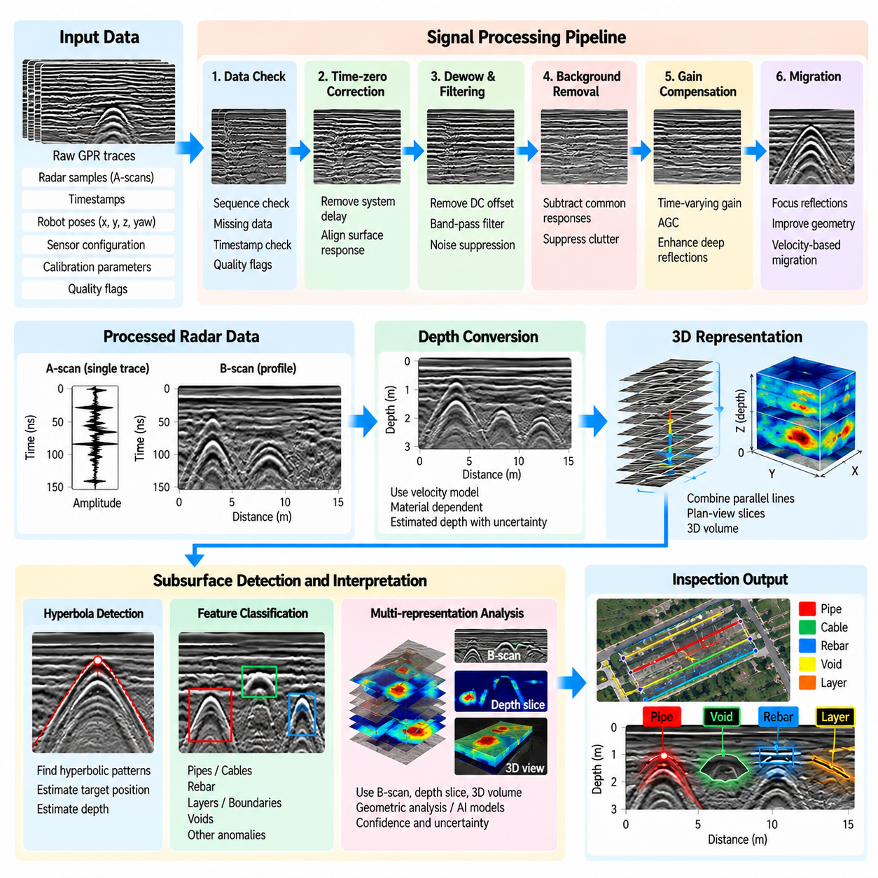
Ground-penetrating radar data processing transforms raw electromagnetic measurements into interpretable representations of subsurface structures. The processing pipeline begins after synchronized radar traces, robot poses, calibration parameters, and acquisition metadata have been collected. Its purpose is to suppress measurement artifacts, enhance meaningful reflections, estimate spatial relationships, and produce reliable inputs for detecting buried utilities, structural components, voids, and other subsurface anomalies.
A raw GPR trace contains signal amplitude as a function of propagation time and normally includes both useful reflections and unwanted components. Direct antenna coupling, system ringing, environmental interference, background responses, attenuation, and random noise can obscure weak targets. Processing therefore should not be treated merely as visualization enhancement. Each operation modifies the evidence available for interpretation and must preserve sufficient metadata to reproduce the processing sequence.
The first stage commonly performs data integrity checks before signal transformation begins. Software verifies trace sequence continuity, timestamp consistency, expected sample counts, sensor configuration, spatial coordinates, and acquisition intervals. Missing or corrupted traces can be marked rather than silently interpolated. Quality flags generated during acquisition should also remain associated with the data so that later detection algorithms can distinguish poor measurements from genuine subsurface anomalies.
Time-zero correction aligns the effective beginning of radar propagation across traces. Electronic delays, antenna characteristics, triggering differences, and system configuration may shift the apparent location of the surface response. If these offsets are not corrected, estimated target depths and layer boundaries can become inconsistent. The processing software identifies or estimates a reference position and shifts traces into a common temporal coordinate while recording the applied correction.
Low-frequency baseline variations and direct-current components can be removed through dewow or similar preprocessing operations. Frequency-domain or time-domain filtering can then suppress signal components outside the useful radar bandwidth. Filter selection requires care because aggressive filtering may eliminate weak target responses together with noise. Processing parameters should therefore be configurable according to antenna frequency, inspected material, expected target dimensions, and required penetration depth.
Background removal is especially useful when strong responses remain nearly constant across consecutive radar traces. Averaging or estimating the common component and subtracting it can suppress antenna coupling and horizontally persistent clutter, making localized objects easier to observe. However, continuous structural features may also resemble background energy. The algorithm must therefore be selected according to whether the inspection objective emphasizes discrete utilities, continuous layers, reinforcement patterns, or deterioration zones.
Radar signals normally attenuate as they propagate through the inspected medium, causing deeper reflections to appear weaker than shallow ones. Gain compensation increases selected portions of the signal to improve visibility across depth. Time-varying gain, automatic gain control, or other compensation methods may be applied, but gain does not recover information that was never measured. Excessive amplification can also strengthen noise and create misleading features, so original amplitudes should remain accessible.
Individual processed traces are arranged according to robot motion to construct radar profiles. Consecutive A-scans form a B-scan in which one axis represents survey distance and the other represents propagation time or estimated depth. Parallel survey lines can subsequently be combined into plan-view representations or three-dimensional radar volumes. Accurate robot localization and spatial sampling are therefore essential because geometric errors in the trajectory propagate directly into the reconstructed subsurface representation.
Conversion from propagation time to depth requires an estimate of electromagnetic wave velocity within the material. This velocity depends strongly on dielectric properties and can vary among soil, asphalt, concrete, aggregate, and moisture conditions. Software may use assumed material parameters, calibration targets, hyperbola fitting, or other field-derived estimates. Depth values should consequently be associated with the velocity model used rather than presented as measurements independent of material assumptions.
Compact buried objects such as pipes and cables often produce characteristic hyperbolic patterns in B-scan imagery. The shape occurs because the antenna detects the target from multiple positions while approaching and moving away from it. Detection software can exploit this geometry using template matching, curve fitting, image-processing techniques, or learned models. The estimated hyperbola apex can provide a target position, while its curvature can contribute to depth or propagation-velocity estimation.
Migration attempts to reposition distributed radar energy toward the physical location of the reflecting object. Hyperbolic responses from compact targets can be focused, while dipping interfaces and complex structures can become geometrically easier to interpret. Migration quality depends on an appropriate propagation-velocity model and accurate spatial sampling. Incorrect assumptions may distort rather than improve the result, making parameter traceability important when migrated data are used for engineering decisions.
Subsurface detection can operate on several representations rather than relying on a single processed image. Algorithms may analyze individual traces, B-scans, depth slices, three-dimensional volumes, extracted features, or combinations of these inputs. Classical signal-processing and computer-vision methods remain useful for strong geometric patterns, while machine-learning approaches can learn more complex relationships. Detection confidence should account for both algorithmic evidence and measurement quality.
A practical detector separates candidate generation from engineering interpretation. Signal peaks, hyperbolic structures, discontinuities, layer changes, or localized high-energy regions can first be identified as candidates. Subsequent processing estimates their position, depth, dimensions, continuity, and confidence before assigning possible semantic meaning. This separation reduces the risk of converting every unusual radar response directly into a claimed pipe, cable, void, reinforcement bar, or structural defect.
Three-dimensional surveys provide additional evidence by comparing detections across neighboring scan lines. A buried pipe that produces separate hyperbolic responses in multiple B-scans may form a continuous linear feature after spatial registration. Software can associate these detections using geometric consistency and localization information. Repeated observations increase confidence and allow the system to estimate utility direction, extent, and relationship with other subsurface structures.
Robotic inspection makes georeferencing an integral part of the processing pipeline. Every detected feature can be transformed from radar sample coordinates into the sensor frame, robot frame, local map frame, and ultimately a geographic or infrastructure coordinate system. Localization uncertainty, antenna offset, depth uncertainty, and processing assumptions should accompany this transformation. The result becomes a spatial inspection object rather than merely a feature visible in a radar image.
Processing software should retain multiple data levels instead of overwriting raw measurements with the latest processed result. Raw traces, corrected traces, filtered data, migrated products, detection candidates, confirmed objects, and associated metadata can be stored as linked artifacts. A processing manifest records algorithm versions and parameters. This provenance allows engineers to reproduce findings, compare processing methods, and reprocess historical surveys when improved algorithms become available.
Automated quality control can identify conditions that reduce detection reliability. Excessive noise, saturated traces, inconsistent sampling distance, localization discontinuities, weak coupling, unexpected signal loss, or large gaps between survey lines can trigger warnings. Detection confidence can then be reduced in affected regions, or the system can request another survey pass. This links data processing with autonomous coverage management rather than treating analysis as an isolated offline activity.
Real-time processing and offline processing serve different purposes. Lightweight preprocessing and candidate detection can run onboard the robot to provide immediate feedback and identify regions requiring rescanning. More computationally demanding migration, three-dimensional reconstruction, multi-pass fusion, and advanced detection can execute after the mission on edge or server resources. Both paths should use compatible data definitions so that field observations remain traceable to final results.
The chapter structure places this processing stage between GPR sensor acquisition and subsequent autonomous survey planning, AI-based utility interpretation, bridge and road inspection, pipeline inspection, GIS integration, and inspection safety. This position reflects its role as the transformation layer that converts synchronized measurements into spatial subsurface evidence suitable for higher-level inspection applications.
A robust GPR processing system ultimately combines signal conditioning, geometric reconstruction, localization, target detection, uncertainty management, and data provenance. The objective is not simply to produce visually clear radar images, but to generate repeatable and spatially defensible evidence about hidden infrastructure. When processing assumptions and confidence are preserved together with detections, robotic GPR can support systematic mapping, automated interpretation, maintenance planning, and long-term infrastructure assessment.

05.04. Autonomous GPR Survey Path Planning [w/Code]
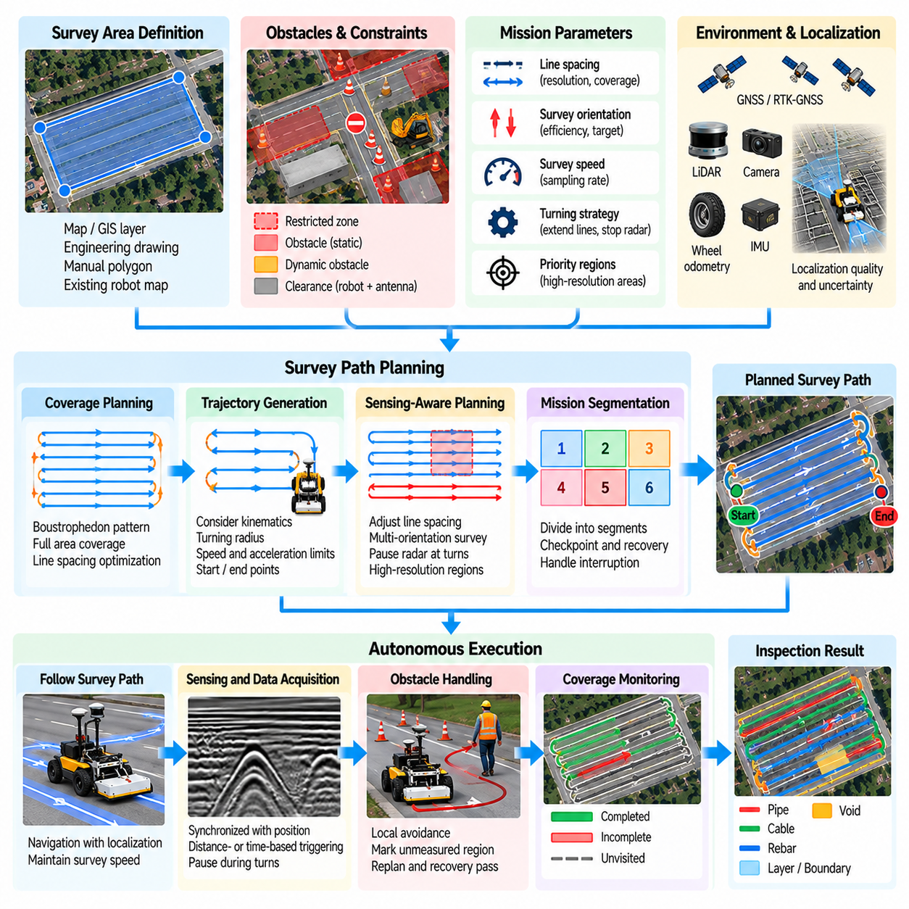
Autonomous GPR survey path planning transforms an infrastructure inspection area into a sequence of robot trajectories that provides systematic radar coverage. Unlike ordinary navigation, where the primary objective is reaching a destination safely, a GPR survey must ensure that measurements are collected across the required surface with controlled spacing, orientation, speed, and overlap. The planner therefore optimizes both robot motion and sensing quality as parts of the same inspection mission.
The planning process begins with a survey region defined from a map, GIS layer, engineering drawing, manually selected polygon, or previously generated robot map. The region may represent a road section, bridge deck, pavement area, utility corridor, industrial floor, or other accessible infrastructure. Boundaries are converted into a coordinate frame compatible with robot localization so that planned radar measurements can later be georeferenced to the inspected asset.
Before generating scan paths, the planner identifies areas that cannot or should not be traversed. Fixed structures, barriers, curbs, excavations, equipment, traffic zones, steep slopes, and safety exclusion regions can be represented as obstacles or restricted polygons. Additional clearance is normally applied according to robot dimensions and antenna geometry. This converts the physical inspection environment into a navigable survey region suitable for coverage planning.
Coverage path planning differs fundamentally from point-to-point route planning. The robot must pass sufficiently close to every required portion of the survey area rather than simply finding the shortest route between two locations. A common strategy decomposes the region into parallel survey lines arranged in a back-and-forth or boustrophedon pattern. The spacing between lines is selected according to the radar footprint, target dimensions, required resolution, and intended three-dimensional reconstruction quality.
Survey orientation can significantly affect both mission efficiency and radar interpretation. The planner may align scan lines with the longest dimension of the inspection region to reduce turning, or orient them relative to expected underground objects. For example, scanning across the expected direction of a buried linear utility can produce stronger and more recognizable cross-sectional signatures. Multiple survey orientations may be scheduled when higher confidence or three-dimensional characterization is required.
Path spacing represents a direct connection between sensing requirements and robot motion. Wide spacing reduces survey time but can leave subsurface features insufficiently sampled, while narrow spacing increases coverage density, mission duration, storage requirements, and energy consumption. The planner should therefore derive spacing from the inspection objective rather than treating it as an arbitrary navigation parameter. High-resolution regions can also use denser trajectories than low-priority areas.
Turning behavior requires special consideration because GPR sensing is most reliable during controlled, predictable motion. Tight turns can change antenna orientation, increase wheel slip, disturb localization, and produce irregular spatial sampling. The planner can extend survey lines beyond the inspection boundary when space permits, allowing the robot to complete turns outside the primary measurement region. Radar acquisition may be paused during turns and resumed after the robot stabilizes on the next scan line.
Robot kinematic constraints must be incorporated into trajectory generation. Differential-drive, skid-steer, Ackermann-steered, and omnidirectional platforms have different minimum turning radii and motion capabilities. A geometrically valid coverage pattern may therefore be physically impossible for a particular inspection robot. The planner converts ideal scan lines into feasible trajectories while respecting steering limits, velocity limits, acceleration constraints, robot footprint, and antenna placement.
Survey speed is also a sensing parameter. The maximum allowable velocity depends on radar trace rate and required spatial sampling distance. If the robot moves too quickly, consecutive measurements may become too widely separated to support reliable detection or reconstruction. The planner can therefore calculate velocity limits from acquisition requirements and request slower motion in high-resolution regions. Motion control and radar acquisition become coordinated components of the same planning problem.
Localization quality can influence where and how the robot surveys. Outdoor road inspections may use GNSS or RTK-GNSS, while bridge decks, tunnels, indoor structures, or GNSS-denied areas may depend on LiDAR, cameras, wheel odometry, landmarks, or SLAM. The planner can avoid regions with known localization difficulties or reduce speed where pose uncertainty increases. Survey results should retain localization confidence because positional uncertainty directly affects mapped subsurface detections.
The mission planner divides long inspections into manageable survey segments. Each segment can contain entry motion, radar acquisition lines, transitions, turning maneuvers, and an exit condition. Segmenting the mission simplifies recovery from interruption and allows progress to be checkpointed. If the robot stops because of an obstacle, sensor fault, communication failure, or low battery, completed segments remain recorded while incomplete sections can be scheduled again.
Dynamic obstacles require coordination between local navigation and coverage planning. A conventional navigation system may simply drive around a pedestrian, vehicle, or temporary barrier, but such a deviation can create an unmeasured region in a GPR survey. The system must distinguish safe obstacle avoidance from valid inspection coverage. When the robot leaves a planned scan line, the affected portion can be marked incomplete and automatically inserted into a later recovery trajectory.
Coverage tracking continuously compares the planned survey with the trajectory actually executed by the robot. A line should not be considered complete merely because the robot reached its endpoint. The software can evaluate positional deviation, measurement availability, sampling interval, localization confidence, and radar health along the path. Only portions satisfying inspection-quality criteria are marked as successfully covered, creating a measurement-aware coverage map rather than a simple navigation history.
Adaptive replanning allows the mission to respond to information discovered during inspection. Preliminary radar processing may identify an unusual reflection, suspected utility, void, or structurally important region. The planner can generate additional passes with reduced line spacing, different orientations, or slower velocity around the candidate. This creates a closed-loop inspection process in which sensor observations influence subsequent robot motion instead of waiting for the entire mission to finish.
Energy management becomes important during large-area surveys because dense coverage can require long travel distances. The planner can estimate path length, mission duration, computational load, and expected battery consumption before execution. Charging or battery replacement can be incorporated between survey segments when necessary. Mission partitioning should minimize unnecessary transit while ensuring that the robot retains sufficient energy to reach a safe location if inspection is interrupted.
Safety constraints have higher priority than coverage efficiency. Geofences, traffic boundaries, minimum obstacle clearances, maximum slopes, prohibited surfaces, worker zones, and emergency-stop conditions constrain the path that may be executed. If a required inspection area cannot be reached safely, the planner should report it as inaccessible rather than forcing coverage. The resulting mission record can distinguish physically uninspected regions from areas missed because of sensing or navigation failures.
For repeated infrastructure inspection, previously executed trajectories can be reused as reference paths. Following similar scan lines across multiple inspection dates improves spatial correspondence between historical datasets and supports change detection. The planner can register an earlier survey to the current map and regenerate feasible paths while preserving measurement locations as closely as practical. This repeatability is valuable for monitoring progressive deterioration or changes around buried infrastructure.
The planning system should maintain explicit relationships between planned paths, executed trajectories, and acquired radar data. Each survey line can have an identifier associated with expected geometry, actual robot poses, radar trace ranges, quality statistics, and completion state. These relationships allow later processing software to determine exactly where each B-scan or three-dimensional radar volume originated and make it possible to reconstruct the inspection mission from stored records.
A modular robotic implementation separates global coverage generation from local trajectory execution. The coverage planner determines where measurements are required, while the navigation subsystem converts survey lines into collision-free robot motion. The mission manager coordinates radar acquisition, localization, safety states, and recovery behavior. This separation allows conventional autonomous navigation capabilities to be reused while adding the measurement-specific logic required for GPR inspection.
Within the infrastructure inspection workflow, autonomous survey planning connects GPR data acquisition and subsurface processing with later AI interpretation, bridge and road inspection, pipeline inspection, GIS integration, and field safety functions. The chapter structure places autonomous GPR survey planning directly after GPR sensor integration and data processing, emphasizing that sensing, interpretation, and robot motion must operate as a coordinated inspection system.
A successful autonomous GPR planner therefore optimizes more than travel distance. It must balance coverage completeness, radar sampling density, trajectory accuracy, robot kinematics, localization confidence, obstacle avoidance, safety, energy, and mission duration. By continuously comparing intended measurements with measurements actually acquired, the system can detect coverage gaps and generate recovery or adaptive scans, transforming autonomous navigation into a repeatable infrastructure measurement process.

05.05. GPR AI Interpretation Utility Detection [w/Code]
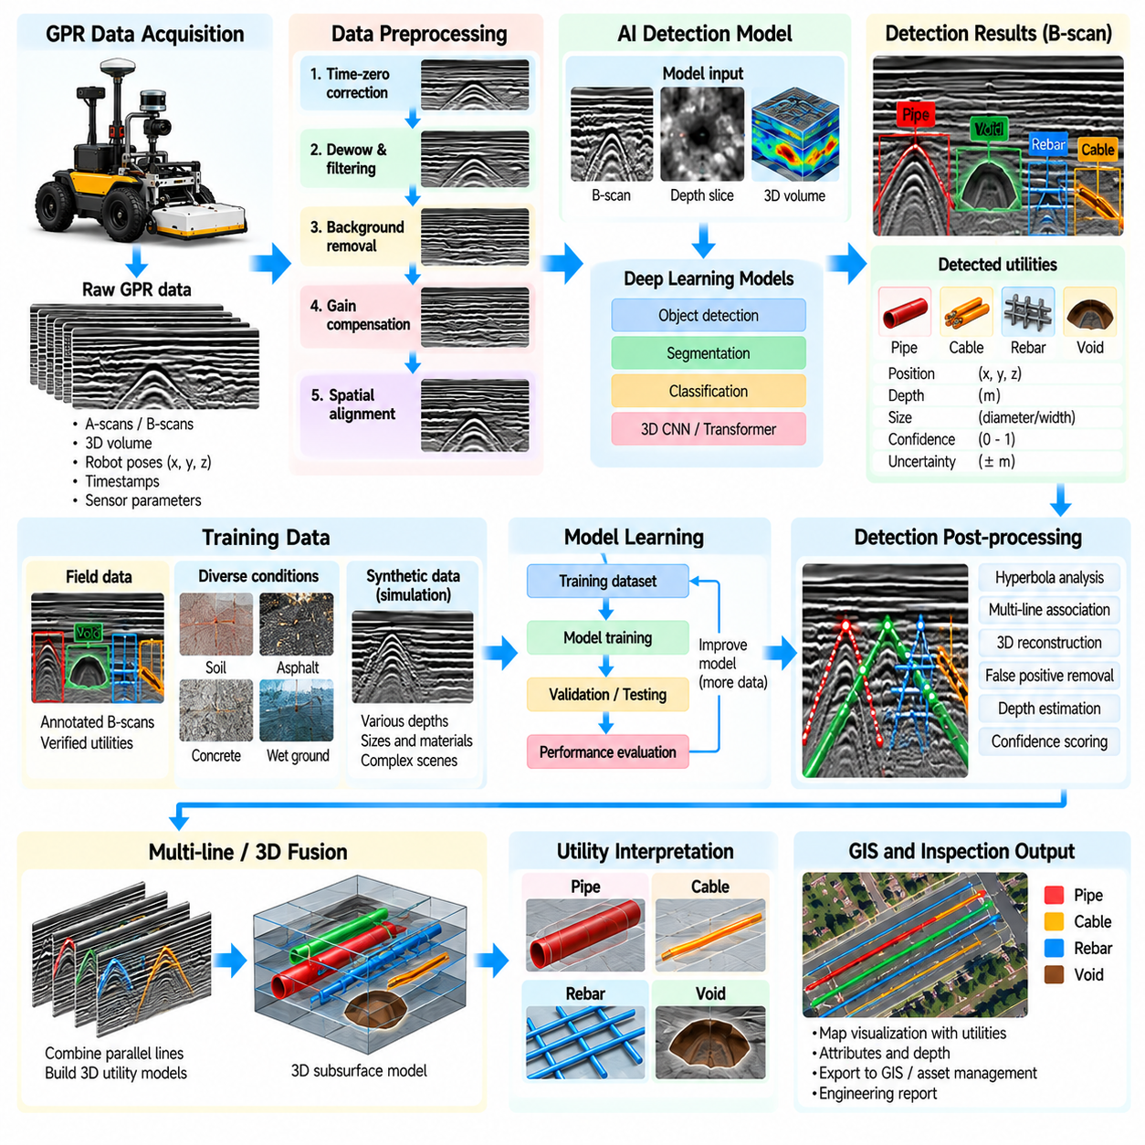
Artificial intelligence extends GPR interpretation from signal visualization toward automated recognition of buried infrastructure. After preprocessing, spatial registration, and geometric reconstruction, AI models can analyze radar traces, B-scans, depth slices, or three-dimensional volumes to identify patterns associated with pipes, cables, conduits, drainage structures, and other utilities. The objective is to convert radar responses into structured detection results while retaining confidence and spatial uncertainty.
Utility detection is difficult because GPR does not directly measure the semantic identity of an underground object. It measures electromagnetic reflections produced by contrasts in material properties. Similar radar signatures may originate from utilities, rocks, reinforcement, construction joints, moisture boundaries, or clutter. AI interpretation therefore operates as probabilistic inference, combining signal appearance, geometry, spatial continuity, acquisition quality, and contextual information rather than treating every strong reflection as a confirmed utility.
For many buried cylindrical objects, the characteristic hyperbolic response visible in a B-scan provides an important detection cue. Traditional algorithms can search for hyperbola-like curves, while machine-learning models can learn variations caused by target depth, diameter, orientation, soil condition, antenna frequency, and survey geometry. AI becomes particularly useful when responses are incomplete, overlapping, noisy, or distorted enough that fixed geometric templates cannot reliably describe them.
A practical AI pipeline begins by converting processed GPR measurements into standardized model inputs. Signal amplitudes can be normalized, resized, windowed, or transformed into image-like representations while preserving spatial scale. B-scans may be divided into overlapping patches for detection, while three-dimensional surveys can generate depth slices or local volumes. The transformation must retain relationships between model coordinates and original radar coordinates so that detections can later be mapped back into physical space.
Supervised learning requires annotated examples describing known underground targets. Labels may identify bounding boxes, segmentation masks, hyperbola centers, target classes, depths, or utility trajectories. High-quality annotation is difficult because the true underground configuration is often unknown until excavation or another verification method is available. Training datasets should therefore distinguish confirmed ground truth from uncertain field interpretation to avoid teaching the model that expert guesses are equivalent to physically verified targets.
Training data should represent the diversity expected in deployment. Radar signatures vary with soil composition, moisture, pavement structure, concrete condition, antenna frequency, target material, burial depth, target diameter, robot velocity, and sensor orientation. A model trained only on clean measurements from one test site can perform poorly in different environments. Dataset design should therefore include multiple sites, acquisition conditions, sensor configurations, and target types whenever possible.
Synthetic data can supplement scarce field measurements. Electromagnetic simulation can generate radar responses for controlled combinations of target geometry, depth, material, and surrounding medium. Simulated datasets provide precise labels and can expose models to rare configurations that are difficult to collect experimentally. However, simulation-to-reality differences must be considered because real measurements contain antenna effects, heterogeneous materials, localization errors, environmental noise, and construction complexity that simplified models may not reproduce.
Different AI architectures can support different stages of interpretation. Classification models can determine whether a candidate region contains a likely utility response, object detectors can localize targets within B-scans, and segmentation networks can identify response regions at pixel level. Sequence or transformer-based models can analyze relationships across traces, while three-dimensional networks can process volumetric surveys. The architecture should be selected according to the required output rather than simply choosing the most complex available model.
Candidate-based detection can reduce computational requirements and false alarms. Conventional signal processing first identifies strong reflections, hyperbolic structures, or other suspicious regions, and an AI model subsequently evaluates these candidates. An alternative end-to-end approach allows a neural network to learn detection directly from larger radar representations. Hybrid systems are often attractive for robotic inspection because physically meaningful preprocessing can constrain the search space while AI handles complex classification and ambiguity.
A single B-scan detection provides limited evidence about a buried utility. When parallel survey lines are available, detections from neighboring scans can be associated according to position, depth, orientation, and appearance. A pipe or cable should normally form a spatially coherent structure rather than a collection of unrelated points. Multi-line fusion therefore allows AI interpretation to estimate utility trajectories, reject isolated false positives, and increase confidence through repeated observations.
Depth estimation can be integrated with utility detection, but it remains dependent on electromagnetic propagation velocity. An AI model may estimate hyperbola geometry or directly regress target depth, yet its output can still be biased if dielectric conditions differ from those represented during training. A robust system should retain both the predicted depth and the assumptions or uncertainty associated with the material model. AI prediction should not conceal the physical dependencies of GPR measurement.
Utility classification is generally more uncertain than utility localization. Radar responses may provide clues about geometry and electromagnetic properties, but distinguishing electrical cables, communication lines, water pipes, gas pipes, or other services solely from GPR can be unreliable. Classification models should therefore report probabilities or broad categories when evidence is insufficient. External information such as utility records, GIS layers, surface features, and known construction layouts can provide additional contextual evidence.
Confidence estimation is essential for operational use. A detection score from a neural network should not automatically be interpreted as engineering certainty. Confidence can incorporate model probability, signal quality, localization accuracy, agreement across multiple scan lines, consistency with expected geometry, and similarity to the training distribution. Regions containing unfamiliar radar patterns can be flagged as uncertain rather than forcing the model to assign a confident known class.
Uncertainty can also control autonomous robot behavior. If onboard AI detects a possible utility with insufficient confidence, the mission planner can request additional scans across the region using smaller line spacing, slower velocity, or a different orientation. New measurements can then be fused with the original evidence. This creates active inspection, where AI does not merely analyze completed data but influences subsequent sensing actions to reduce ambiguity before the robot leaves the site.
False-positive and false-negative errors have different operational consequences. Excessive false positives can create unnecessary excavation, engineering review, and maintenance work, while false negatives may leave critical buried infrastructure undocumented. Detection thresholds should therefore reflect the inspection objective and risk level. Performance evaluation should include precision, recall, localization error, depth error, and object-level detection rather than relying only on generic image-classification accuracy.
Model validation should separate training environments from evaluation environments whenever possible. Testing random radar patches from the same survey used for training can produce unrealistically optimistic results because neighboring measurements are strongly correlated. More meaningful evaluation holds out complete sites, survey sessions, or environmental conditions. This site-level validation better measures whether the AI system can generalize to infrastructure that was not represented during model development.
Human review remains important for high-consequence interpretations. The software can present detected utilities together with the supporting B-scan, depth slice, estimated trajectory, confidence, and relevant quality indicators. Engineers can accept, reject, modify, or mark detections for additional investigation. These decisions can be stored as structured feedback, creating a mechanism for dataset improvement and future model retraining without discarding the original automated prediction.
Georeferencing converts AI output into information usable by infrastructure management systems. Detected targets are transformed from model coordinates into radar, robot, map, and geographic coordinates using the acquisition trajectory and sensor calibration. Multiple detections can then be assembled into utility objects containing estimated position, depth, direction, extent, class probability, confidence, and provenance. These objects can subsequently be exported to GIS or asset-management applications.
Deployment on inspection robots requires attention to computational resources and latency. Lightweight models can perform preliminary candidate detection on an onboard GPU or edge processor, while larger models and three-dimensional fusion may execute after the mission. Model version, preprocessing configuration, calibration state, and inference parameters should be stored with every result. This traceability ensures that later users can determine exactly how an automated interpretation was produced.
Within the GPR inspection workflow, AI utility interpretation builds directly on sensor integration, radar processing, and autonomous survey planning. Its outputs support later bridge and road inspection, pipeline inspection, GIS integration, and field decision making. The value of AI is therefore not simply automatic pattern recognition, but the conversion of spatially registered radar evidence into structured hypotheses that can participate in a larger robotic infrastructure inspection system.
A dependable GPR AI system combines learned models with signal processing, physical measurement knowledge, spatial consistency, uncertainty estimation, and human verification. It should distinguish observation from interpretation and prediction from confirmed ground truth. When these boundaries are preserved, AI can reduce manual review effort, prioritize suspicious regions, guide adaptive rescanning, reconstruct probable utility trajectories, and make large-scale robotic GPR surveys more consistent and operationally useful.

05.06. Bridge and Road Inspection AMR SW [w/Code]
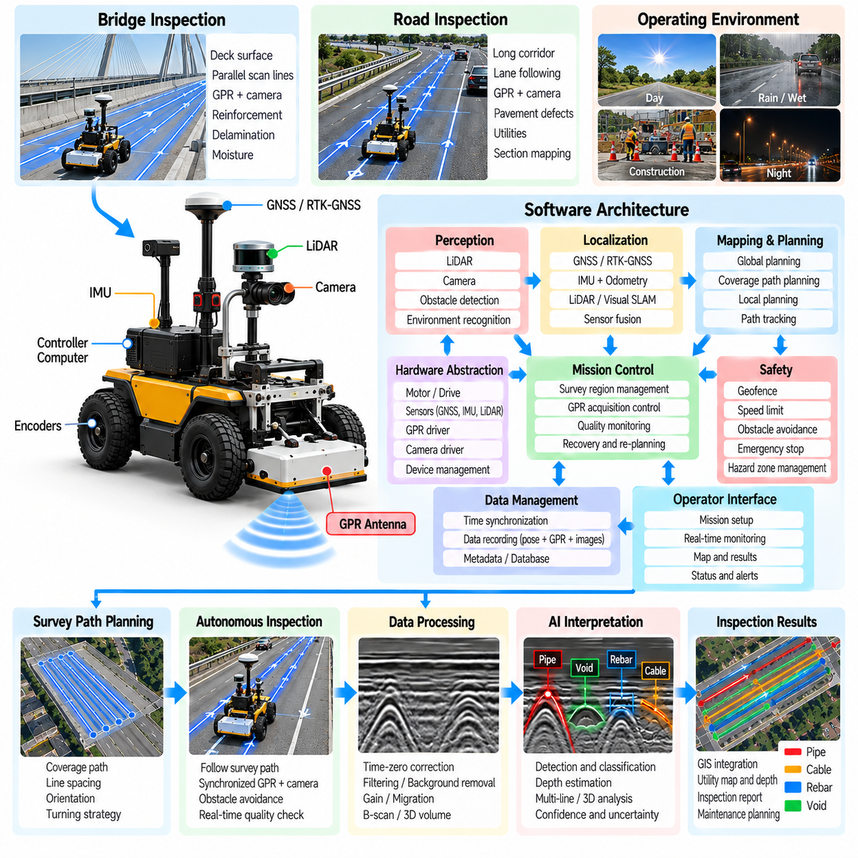
Bridge and road inspection AMR software integrates autonomous mobility, subsurface sensing, surface inspection, localization, mission management, and infrastructure data processing into a field-ready robotic system. Unlike warehouse AMRs operating in structured indoor environments, inspection robots must traverse large outdoor surfaces with changing pavement conditions, traffic constraints, weather exposure, GNSS variability, and irregular obstacles while maintaining consistent measurement quality.
The software architecture is typically divided into hardware abstraction, localization, perception, navigation, inspection sensing, mission control, safety, data management, and operator-interface layers. Hardware drivers isolate wheel encoders, motor controllers, IMUs, GNSS receivers, LiDAR, cameras, GPR sensors, and auxiliary instruments from higher-level applications. This modular structure allows inspection sensors or mobile platforms to change without redesigning the complete software stack.
Localization provides the spatial reference required to associate every inspection measurement with infrastructure coordinates. Outdoor road surveys can combine GNSS or RTK-GNSS with wheel odometry and IMU measurements, while bridge structures may create multipath, partial satellite visibility, or signal degradation. LiDAR or visual localization can supplement satellite positioning, and sensor fusion maintains a continuous robot pose estimate when individual localization sources temporarily become unreliable.
The navigation subsystem converts inspection missions into executable robot trajectories. Global planning determines how the AMR moves between survey regions, while local planning handles nearby obstacles, temporary barriers, workers, vehicles, and unexpected surface conditions. Inspection motion differs from ordinary autonomous driving because the robot must follow predefined scan lines accurately. Cross-track error, heading deviation, velocity variation, and missed path segments directly influence measurement quality.
Bridge deck inspection commonly requires systematic coverage rather than destination-oriented navigation. The mission software divides the deck into parallel lanes or survey cells and generates repeated passes with defined spacing and orientation. GPR measurements can investigate reinforcement, layer boundaries, moisture-related changes, delamination indicators, or subsurface anomalies. Other sensors can be synchronized with the same trajectory to create complementary surface and subsurface inspection records.
Road inspection missions may extend over longer linear corridors and therefore require different planning behavior. The AMR can follow road geometry while maintaining a specified offset from curbs, lane boundaries, or reference trajectories. Survey segments can be divided according to distance, pavement section, intersection, or asset identifier. Long missions benefit from checkpointing so that completed sections remain valid when the robot must stop for traffic, charging, communication loss, or environmental conditions.
GPR acquisition software is coordinated with robot motion rather than operating as an independent recorder. Radar traces are timestamped and associated with robot poses, survey-line identifiers, velocity, sensor configuration, and quality information. The mission controller can enable recording only within valid inspection sections and pause acquisition during turns, obstacle avoidance, manual repositioning, or transit. This prevents unrelated movement from contaminating the inspection dataset.
Surface sensing can complement GPR by providing information that electromagnetic subsurface measurements cannot directly describe. Cameras may document cracks, potholes, joints, markings, corrosion-related surface evidence, or visible deterioration, while LiDAR can measure surface geometry and structural features. When these observations share a common coordinate system, the software can relate visible defects to subsurface responses and create a richer representation of infrastructure condition.
Inspection quality monitoring operates continuously during autonomous execution. The system can evaluate radar trace availability, spatial sampling interval, antenna communication, robot velocity, trajectory deviation, localization uncertainty, camera status, and storage performance. If quality falls below defined limits, the affected path is marked incomplete rather than automatically accepted. The mission manager can then schedule a recovery pass so that navigation completion and inspection completion remain distinct concepts.
Bridge and road environments contain dynamic hazards that require explicit safety behavior. Pedestrians, maintenance workers, moving vehicles, construction equipment, temporary barriers, drop-offs, damaged pavement, and restricted traffic areas may appear during operation. Perception and local navigation provide obstacle detection and avoidance, while safety functions impose speed limits, geofences, emergency stops, minimum clearances, and controlled-stop behavior when safe autonomous continuation cannot be guaranteed.
Obstacle avoidance must preserve inspection coverage. If the AMR leaves a survey line to move around a temporary object, the software records the deviation and identifies the resulting measurement gap. Once the obstacle disappears or another safe approach becomes available, the mission planner can generate a short recovery trajectory through the missing region. This measurement-aware behavior prevents successful obstacle avoidance from being incorrectly interpreted as successful infrastructure inspection.
Weather and surface conditions can influence both mobility and sensing. Rain, standing water, dust, strong illumination changes, wet pavement, temperature, and reduced tire traction may affect cameras, LiDAR, GPR responses, localization, and vehicle control. Environmental states should therefore be recorded with the inspection mission when available. The software can reduce speed, adjust operational limits, suspend selected sensing operations, or terminate the mission when conditions exceed validated operating boundaries.
Data management must handle the large and heterogeneous datasets generated by infrastructure inspection. Radar traces, images, point clouds, localization trajectories, mission events, sensor diagnostics, and processed detections should share consistent timestamps and spatial references. Data can be organized by project, asset, survey date, segment, and scan line. A mission manifest preserves calibration versions, sensor configurations, coordinate systems, software versions, and quality events required for later reconstruction.
Processing may occur partly onboard and partly after the mission. Lightweight algorithms can detect missing radar data, excessive trajectory error, obvious surface defects, or candidate subsurface anomalies in real time. More computationally demanding GPR migration, three-dimensional reconstruction, AI interpretation, image analysis, and multi-sensor fusion can run later on edge or server systems. The same identifiers should connect onboard observations with final engineering products.
Repeated inspections are particularly valuable for bridges and roads because deterioration develops over time. The software can store previous survey trajectories and use them as references for later missions, allowing the AMR to reproduce similar measurement paths. Spatial registration between inspection dates supports comparison of radar responses, surface defects, and detected anomalies. Consistent acquisition geometry improves the reliability of change detection and long-term condition monitoring.
Infrastructure assets require results to be expressed in engineering coordinates rather than only robot coordinates. Detected anomalies can be associated with bridge stationing, deck regions, road chainage, lanes, GIS coordinates, or asset identifiers. Coordinate transformations connect sensor observations with maps and maintenance databases. Each reported defect or anomaly can retain links to the original measurements, processing results, location uncertainty, and inspection confidence supporting the finding.
Operator software provides supervision without requiring continuous manual driving. A field interface can display robot position, planned and completed survey lines, sensor health, remaining mission coverage, battery state, communication status, and detected faults. Operators may pause, resume, cancel, or authorize recovery operations. Manual control can be available for deployment and exceptional situations while preserving clear boundaries between autonomous survey data and manually acquired measurements.
Fault management is essential because infrastructure missions may occur far from convenient recovery locations. The software monitors localization loss, motor faults, sensor disconnection, storage exhaustion, excessive temperature, communication interruption, and battery state. Recoverable faults may trigger controlled retries or mission pauses, while critical failures produce a safe stop. Checkpointed mission state allows inspection to continue later without unnecessarily repeating successfully validated survey regions.
The bridge and road inspection AMR forms a practical application layer above GPR acquisition, data processing, autonomous survey planning, and AI interpretation. These earlier functions provide synchronized sensing, subsurface reconstruction, coverage control, and automated detection, while the application software combines them with field navigation, safety, asset coordinates, operator workflows, and inspection records required for real infrastructure operations.
A mature inspection AMR therefore measures success by more than autonomous driving distance. It must demonstrate that required infrastructure regions were safely reached, valid sensor data were collected at sufficient spatial quality, measurement gaps were identified, results were correctly georeferenced, and the complete inspection remains traceable. This integration transforms an autonomous mobile robot from a sensor carrier into a repeatable bridge and road condition-assessment platform.

05.07. Pipeline Inspection Robot SW Architecture [w/Code]
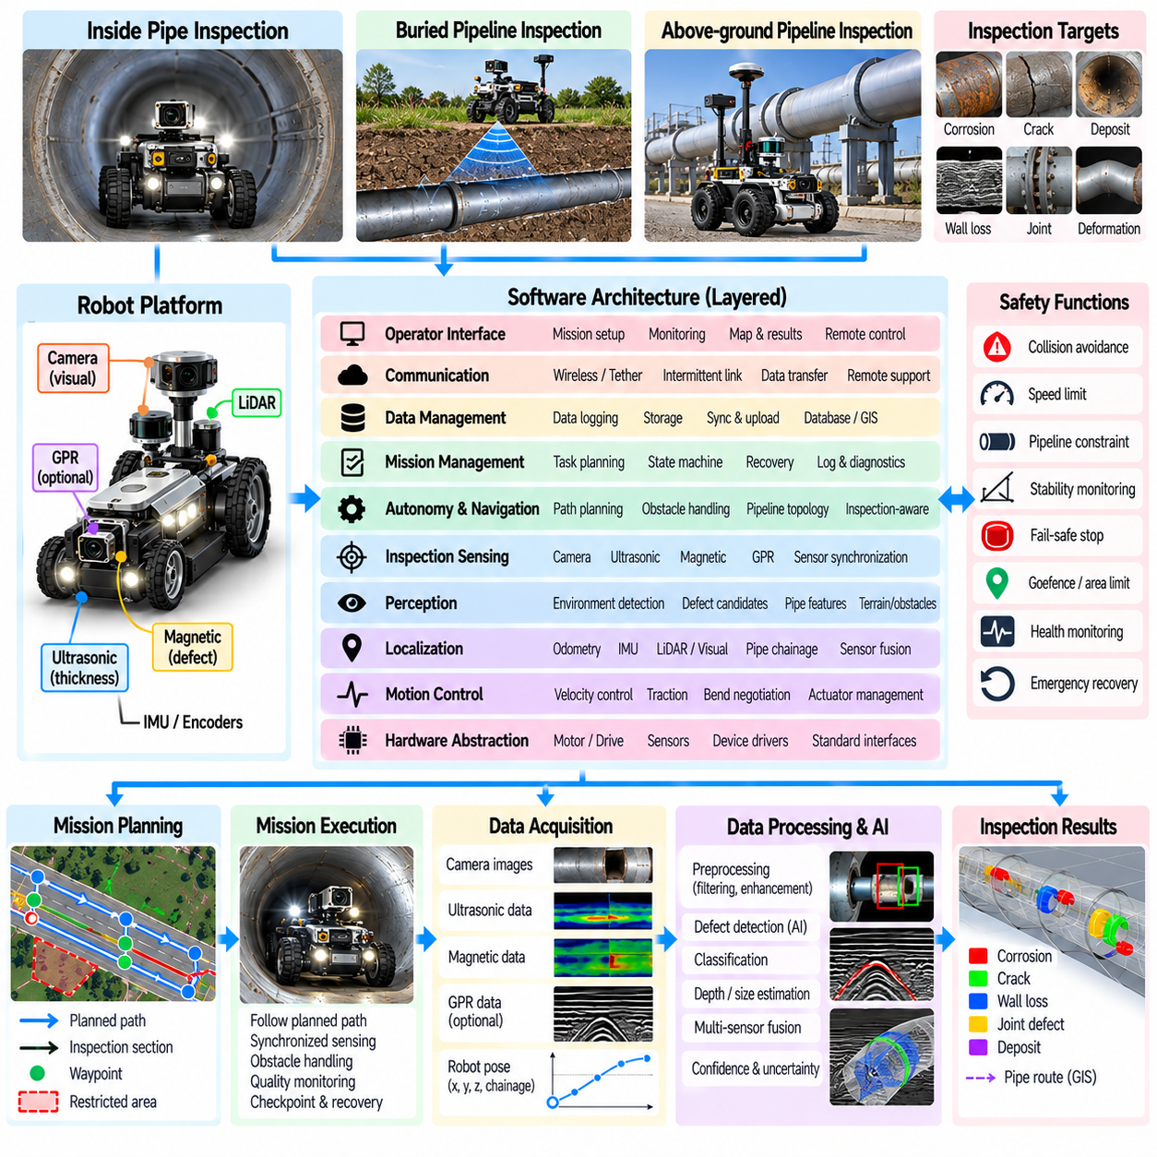
Pipeline inspection robot software architecture must support mobility, sensing, localization, mission execution, communication, safety, and defect assessment within environments that are often inaccessible to people. Depending on the application, the robot may travel inside a pipe, along an external pipeline corridor, or across facilities containing connected pipe assets. The software must therefore separate reusable robotic functions from inspection modules that depend on pipe geometry, sensor type, and operating environment.
A layered architecture commonly includes hardware abstraction, real-time motion control, localization, perception, inspection sensing, autonomy, mission management, data management, communication, safety, and operator interfaces. Hardware abstraction isolates motors, encoders, IMUs, cameras, LiDAR, GPR, ultrasonic sensors, magnetic sensors, and other instruments from higher software layers. Standardized interfaces make it possible to replace individual sensors or vehicle components without redesigning the complete inspection application.
The motion-control layer translates commanded velocity or trajectory targets into actuator commands while monitoring wheel speed, motor current, traction, and mechanical limits. Pipe environments can impose strong geometric constraints, including narrow diameters, bends, joints, slopes, and irregular surfaces. Control software must maintain stable movement without excessive slip or oscillation because unstable motion reduces both localization accuracy and the spatial consistency of inspection measurements.
Localization is challenging because underground or enclosed pipelines frequently prevent reliable GNSS reception. Wheel odometry and IMU measurements can provide continuous relative motion estimates but accumulate drift over long distances. Cameras, LiDAR, structural landmarks, pipe joints, known bends, or other recognizable features can provide additional corrections. Sensor fusion combines these sources into a pose estimate while retaining uncertainty so that inspection results are not reported with unrealistic positional precision.
For long linear pipelines, position may be represented not only in Cartesian coordinates but also as distance along the pipe centerline. This representation allows inspection events to be associated with chainage, pipe segment identifiers, joints, valves, branches, or other known assets. Where an external geographic reference is available, the software can connect local robot coordinates with GIS coordinates. Maintaining both representations simplifies engineering interpretation and later maintenance operations.
Perception software identifies environmental conditions relevant to safe motion and inspection. Cameras or ranging sensors can detect obstructions, deformation, debris, standing liquid, unexpected branches, severe surface irregularities, or restricted passages. For external inspection robots, perception additionally handles terrain, vegetation, structures, vehicles, and workers. The perception output is used by navigation and safety functions rather than being treated only as recorded inspection imagery.
Inspection sensing depends on the defect mechanisms and pipe material being evaluated. Visual cameras can identify visible corrosion, cracking, deposits, coating damage, and joint conditions, while ultrasonic or magnetic methods may provide information about wall thickness or material loss. GPR can contribute to selected buried-pipeline applications by detecting pipe location or surrounding subsurface conditions. The software architecture should support multiple sensor modalities without assuming that one sensor can identify every defect type.
Sensor synchronization is essential for converting inspection measurements into spatial evidence. Each image, radar trace, ultrasonic measurement, point cloud, or diagnostic sample should be associated with a timestamp and robot pose or pipeline position. Calibration defines the spatial relationship between sensors and the robot body. Without consistent timing and calibration, a detected anomaly may be correctly identified by the sensor but incorrectly assigned to a physical location on the pipeline.
The mission-management layer coordinates robot motion and inspection sensing as a state-driven workflow. Typical states can include initialization, self-test, deployment, transit, inspection, obstacle handling, recovery, return, and shutdown. Sensor recording is activated only in appropriate states, while transitions are logged with timestamps and positions. This prevents deployment motion or recovery maneuvers from being mixed unintentionally with valid inspection data.
Autonomous navigation must respect the physical topology of the pipeline. Inside a pipe, the robot may primarily follow the available passage but still needs decisions for speed control, branches, obstacles, bends, and turnaround conditions. External pipeline robots may require conventional path planning along a mapped corridor. In both cases, navigation should be inspection-aware so that successful movement is not considered complete unless required measurements were acquired at acceptable quality.
Communication architecture must account for severe connectivity limitations. Metallic pipes, underground structures, long distances, and complex facilities can reduce wireless reliability or eliminate continuous communication entirely. The robot should therefore tolerate intermittent links and continue validated portions of a mission autonomously when permitted. Critical commands and status messages require priority, while large inspection datasets can be buffered locally and transferred when sufficient bandwidth becomes available.
Local data storage is particularly important for high-resolution inspection. Images, video, GPR measurements, ultrasonic data, point clouds, localization estimates, and system diagnostics can generate large datasets. A structured recording system associates these streams with mission identifiers, pipeline segments, timestamps, calibration versions, and robot states. Chunked storage and integrity checks reduce the impact of file corruption and make interrupted missions easier to reconstruct.
Health monitoring continuously evaluates the robot as well as its inspection instruments. Battery state, motor temperature, current consumption, storage capacity, communication quality, sensor status, localization uncertainty, and computational load can indicate developing problems. Trends such as increasing drive current may reveal mechanical resistance before complete immobilization occurs. Health information should therefore participate in mission decisions instead of appearing only in post-mission diagnostic logs.
Fault management is especially important when physical recovery is difficult. A pipeline robot that fails deep inside a confined asset can create significant operational cost. Software should classify faults according to severity and determine whether to retry, reduce capability, stop inspection, return, or enter a safe state. Recovery decisions must consider remaining energy, estimated distance to an access point, communication availability, localization confidence, and the robot's mechanical condition.
Energy-aware autonomy prevents inspection goals from consuming the reserve needed for safe recovery. The mission manager can estimate remaining range using battery state, traveled distance, terrain or pipe resistance, sensor power demand, and historical consumption. A return threshold should include uncertainty rather than assuming ideal energy use. When the estimated recovery margin becomes insufficient, the robot should terminate further inspection and begin an appropriate return or retrieval procedure.
Safety software operates independently from normal mission objectives wherever practical. Limits on speed, motor current, temperature, tilt, obstacle proximity, communication loss, and other hazardous states can trigger protective behavior. External pipeline inspection additionally requires geofencing and interaction rules for people, vehicles, and industrial equipment. Safety events must be preserved in the mission record because they can explain missing data or unusual robot trajectories.
Defect-processing software transforms raw measurements into inspection candidates. Classical signal processing, computer vision, geometric analysis, or AI models can identify corrosion-like regions, cracks, deformation, material loss, anomalous subsurface responses, or other sensor-specific features. Candidate detections should retain links to their source measurements and processing configuration. Confidence and uncertainty are important because automated detection does not necessarily constitute confirmed engineering diagnosis.
Multi-sensor fusion can improve defect interpretation when different instruments observe complementary properties. A visual anomaly can be compared with geometric deformation, wall-thickness measurements, or other nondestructive inspection data at the same pipeline position. Fusion requires accurate spatial registration and should preserve disagreements rather than forcing all sensors into a single conclusion. Conflicting evidence can itself indicate that additional inspection or human review is necessary.
Operator software provides mission preparation and supervision while minimizing the need for continuous teleoperation. The interface can display robot state, pipeline position, sensor health, inspection progress, energy margin, communication status, and detected anomalies. Operators can authorize mission transitions, request return, annotate observations, or assume manual control when communication and system design permit. Autonomous and manually controlled segments should remain identifiable in the recorded dataset.
Post-mission processing reconstructs the inspection from synchronized robot and sensor records. Measurements can be organized according to pipeline segment, chainage, asset identifier, or geographic coordinates and then compared with previous inspections. Detected anomalies can be linked to images, sensor signals, estimated dimensions, confidence, and processing history. This traceability allows engineers to move from a reported defect back to the original evidence supporting the result.
Repeated pipeline inspection benefits from consistent spatial referencing. Previous anomaly locations and survey records can guide subsequent missions so that the robot intentionally reacquires measurements around known areas of concern. Changes in defect dimensions, signal characteristics, or surrounding conditions can then be evaluated over time. The software therefore supports not only one-time detection but also longitudinal condition monitoring and maintenance planning.
The pipeline inspection robot forms another application layer above sensor integration, signal processing, autonomous survey planning, and AI interpretation. Its software architecture combines these capabilities with constrained mobility, communication-loss tolerance, energy-aware recovery, pipeline-specific coordinates, fault management, and engineering data organization. A robust implementation transforms the robot from a remotely operated sensor carrier into a traceable autonomous platform for systematic pipeline condition assessment.
Inspection data management provides the information backbone that connects robotic sensing with engineering decisions. GPR traces, images, point clouds, localization trajectories, detected anomalies, robot states, and mission events must remain associated with the physical infrastructure that was inspected. GIS integration extends this relationship into geographic space, allowing measurements and interpreted results to be managed together with roads, bridges, pipelines, utilities, and other infrastructure assets.
A useful data architecture separates raw measurements, processed products, interpreted inspection objects, and asset-level records. Raw data preserve the original sensor evidence, while processed data contain filtering, reconstruction, registration, or AI outputs. Inspection objects describe detected utilities, defects, voids, structural features, or other anomalies. Asset records connect these findings to infrastructure identifiers, locations, inspection dates, maintenance history, and engineering context.
Every inspection mission should have a unique identifier that links robot operations with recorded datasets. Mission metadata can describe the project, inspected asset, robot platform, sensors, operators, software versions, calibration states, coordinate references, start and end times, and environmental conditions. Survey segments and scan lines can receive additional identifiers so that individual measurements remain traceable through processing, interpretation, reporting, and later reanalysis.
Time synchronization provides the first major relationship among heterogeneous sensor streams. Radar traces, camera frames, LiDAR scans, IMU measurements, GNSS observations, odometry, robot states, and diagnostic events may arrive at different frequencies. Consistent timestamps allow these records to be aligned during processing. The original acquisition time should remain preserved even when data are later transformed, resampled, fused, or exported into engineering applications.
Spatial referencing provides the second major relationship. Measurements may initially exist in sensor coordinates and then be transformed through robot, local-map, project, and geographic coordinate frames. Calibration defines sensor-to-robot transformations, while localization determines the robot pose within the environment. GIS integration requires these transformations to remain explicit so that a detected feature can be traced from its map position back to the exact sensor measurements that generated it.
Coordinate reference systems must be managed carefully because infrastructure organizations may use geographic coordinates, projected map coordinates, local construction grids, bridge stationing, road chainage, or pipeline-specific references. A dataset should identify its coordinate reference system rather than assuming that numerical coordinates are self-explanatory. Transformation parameters and reference definitions should be stored so that inspection results can be exchanged without introducing hidden positional errors.
Georeferencing converts robotic detections into spatial infrastructure objects. A buried utility detected in a GPR survey can be represented by a point, line, or three-dimensional geometry containing estimated depth, orientation, extent, confidence, and uncertainty. Road defects can be linked to lane and chainage, while bridge anomalies can be associated with deck regions or structural elements. Pipeline findings can similarly reference pipe segments, joints, valves, or centerline distance.
GIS layers provide contextual information that can improve inspection interpretation. Existing utility maps, road centerlines, bridge boundaries, parcel information, drainage networks, pipeline routes, construction drawings, and previous inspection results can be displayed with new robotic measurements. Spatial comparison can reveal whether a detected feature agrees with an existing record, represents a possible undocumented asset, or occurs near a known area requiring engineering attention.
The relationship between GIS records and robotic observations should preserve uncertainty. A detected underground feature may have uncertainty in horizontal position, depth, classification, and spatial extent. Localization error, sensor calibration error, propagation assumptions, and AI confidence can all contribute to the final result. GIS visualization should therefore avoid presenting every detection as an exact surveyed object when the underlying evidence supports only an estimated position or probable classification.
Large inspection datasets require storage policies that balance accessibility, performance, and preservation. High-volume raw radar data, imagery, video, and point clouds may be stored in optimized files or object storage, while searchable metadata and interpreted results can reside in databases. The database can reference the larger files rather than embedding every measurement directly. This separation supports scalable storage while allowing engineers to search by asset, location, date, anomaly type, or mission.
Spatial databases can provide efficient management of geographically referenced inspection results. Points, lines, polygons, trajectories, and three-dimensional attributes can be queried according to location and relationship with infrastructure assets. An engineer may retrieve all anomalies within a road section, compare detections around a pipeline segment, or identify inspection regions that have not been surveyed recently. Spatial indexing becomes increasingly important as repeated robotic missions accumulate large historical datasets.
Data provenance records how each result was produced. A processed radar volume should identify the source mission, raw measurements, calibration version, processing algorithms, and parameters used to generate it. An AI detection should additionally record model version, preprocessing configuration, inference settings, and confidence. Provenance makes it possible to reproduce results, compare algorithms, audit automated interpretations, and reprocess historical data when improved methods become available.
Version management is necessary because inspection results can change after engineering review or algorithm updates. An automatically detected anomaly may later be confirmed, rejected, reclassified, or assigned a different geometry. Rather than overwriting the previous result, the system can preserve revisions and their authorship or processing source. This history distinguishes original machine predictions from later human interpretation and maintains a defensible record of how the final assessment evolved.
Data quality indicators should accompany inspection records. Completeness, localization accuracy, sensor status, spatial sampling density, signal quality, trajectory deviation, and environmental conditions can influence whether a dataset is suitable for a particular engineering purpose. Quality metadata allows downstream users to filter unreliable regions or understand why confidence differs across an inspection area. Missing data should be represented explicitly rather than appearing as normal inspected space.
Repeated inspections make temporal data management important. Measurements collected at different dates can be spatially registered to the same asset and compared over time. A bridge defect, road anomaly, buried utility region, or pipeline condition can therefore be represented as a time series of observations rather than isolated reports. Consistent asset identifiers and spatial references enable change detection and support analysis of deterioration, movement, repair effectiveness, or newly appearing anomalies.
Integration with asset-management systems extends GIS beyond visualization. Inspection findings can be associated with maintenance records, work orders, risk classifications, repair histories, and asset condition scores. A robotic detection does not necessarily become an immediate maintenance action, but it can create evidence for engineering review. Once validated, the finding can participate in established infrastructure management workflows without requiring manual re-entry of its location and supporting measurements.
Interoperability requires well-defined exchange formats and interfaces. GIS applications may consume vector features, raster products, spatial databases, web services, or structured files, while engineering systems may require asset-specific schemas. The robotic inspection platform should maintain an internal canonical representation and convert it into required external formats. This reduces dependence on one GIS vendor and prevents sensor-processing software from being tightly coupled to downstream applications.
Access control and data integrity become important when inspection information describes critical infrastructure. Users may require different permissions for viewing raw measurements, editing interpretations, approving findings, or exporting asset data. Audit records can document important modifications and approvals. Integrity checks can verify that files have not been corrupted or unintentionally altered, while controlled backups protect long-term inspection evidence from hardware failure or accidental deletion.
Field operations may occur without reliable network connectivity, so data management should support disconnected workflows. The robot or field computer can maintain a local mission package containing sensor data, maps, metadata, and preliminary detections. When communication becomes available, synchronized transfer can upload new records to central storage while preserving identifiers and provenance. Partial transfers should be detectable so that incomplete datasets are not mistaken for complete inspections.
Visualization should connect geographic context with the original inspection evidence. Selecting a mapped anomaly can open its associated B-scan, image, point cloud, processed result, AI confidence, or engineering note. Conversely, selecting a feature in sensor data can highlight its geographic location. This bidirectional linkage helps engineers verify automated findings and prevents GIS symbols from becoming detached from the measurements that support them.
Within the infrastructure inspection workflow, data management and GIS integration consolidate outputs from GPR acquisition, subsurface processing, autonomous survey planning, AI utility interpretation, bridge and road inspection, and pipeline inspection. They transform individual robotic missions into persistent infrastructure knowledge that can be searched, compared, reviewed, and reused across inspection cycles.
A mature inspection information system therefore preserves more than final maps. It maintains raw evidence, processing history, coordinate transformations, uncertainty, quality, human review, and relationships to physical assets. By combining robotic inspection records with GIS and asset-management information, infrastructure organizations can move from isolated sensor surveys toward traceable spatial databases that support long-term condition monitoring, maintenance planning, and evidence-based engineering decisions.

05.08. Inspection Data Management and GIS Integration [w/Code]
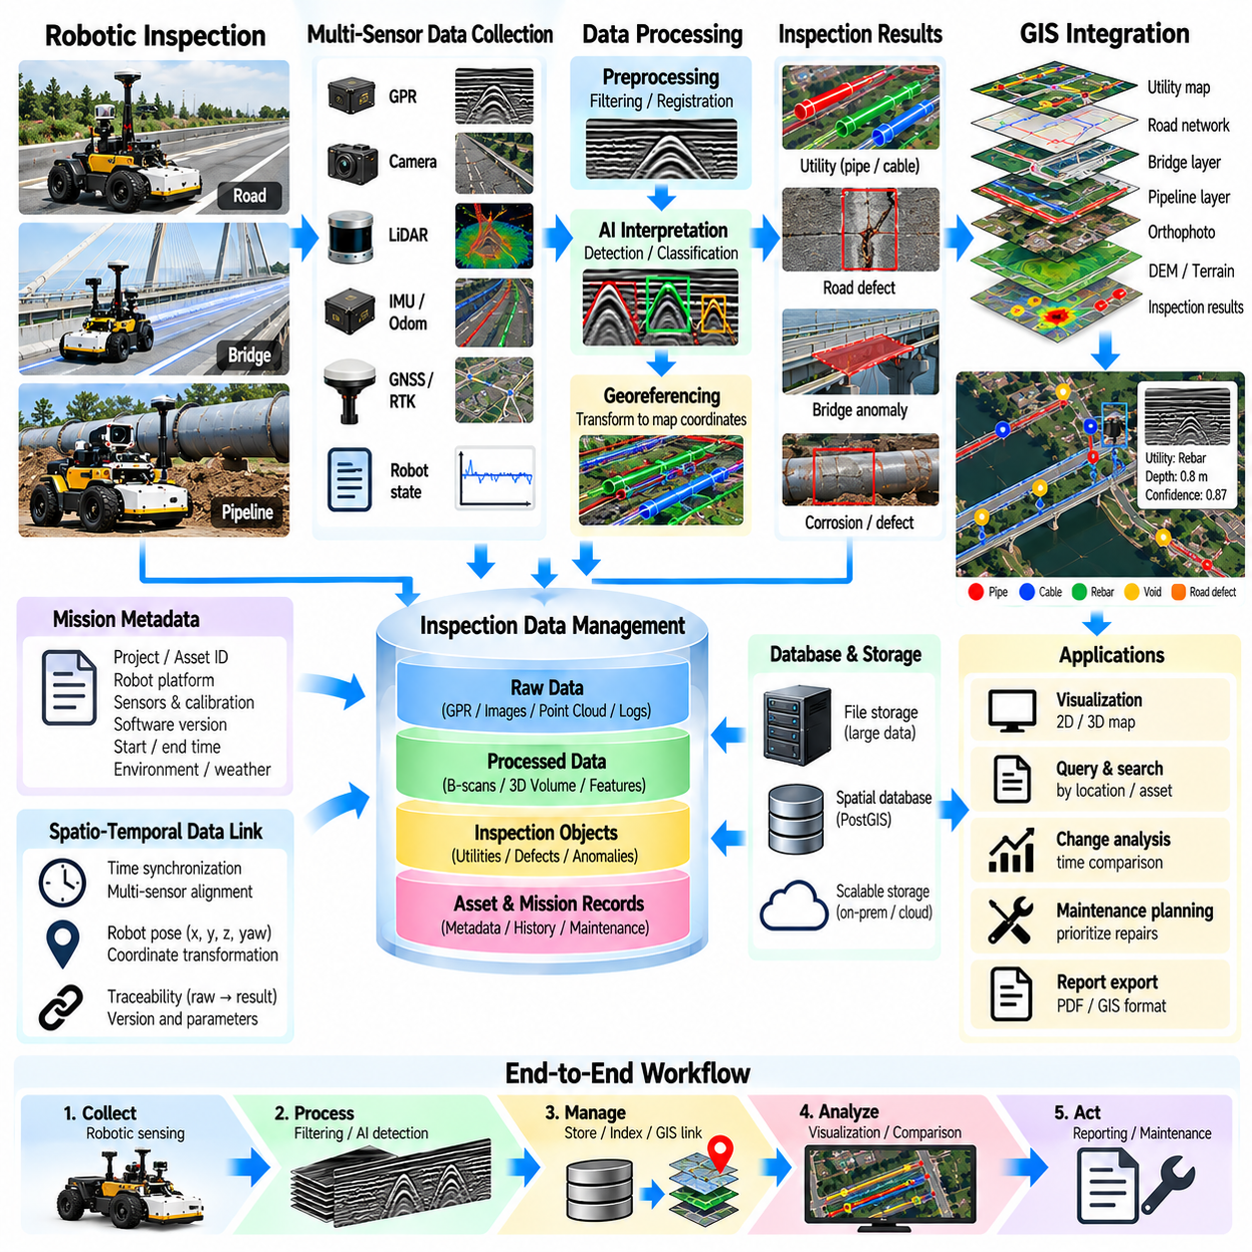
Inspection data management provides the information backbone that connects robotic sensing with engineering decisions. GPR traces, images, point clouds, localization trajectories, detected anomalies, robot states, and mission events must remain associated with the physical infrastructure that was inspected. GIS integration extends this relationship into geographic space, allowing measurements and interpreted results to be managed together with roads, bridges, pipelines, utilities, and other infrastructure assets.
A useful data architecture separates raw measurements, processed products, interpreted inspection objects, and asset-level records. Raw data preserve the original sensor evidence, while processed data contain filtering, reconstruction, registration, or AI outputs. Inspection objects describe detected utilities, defects, voids, structural features, or other anomalies. Asset records connect these findings to infrastructure identifiers, locations, inspection dates, maintenance history, and engineering context.
Every inspection mission should have a unique identifier that links robot operations with recorded datasets. Mission metadata can describe the project, inspected asset, robot platform, sensors, operators, software versions, calibration states, coordinate references, start and end times, and environmental conditions. Survey segments and scan lines can receive additional identifiers so that individual measurements remain traceable through processing, interpretation, reporting, and later reanalysis.
Time synchronization provides the first major relationship among heterogeneous sensor streams. Radar traces, camera frames, LiDAR scans, IMU measurements, GNSS observations, odometry, robot states, and diagnostic events may arrive at different frequencies. Consistent timestamps allow these records to be aligned during processing. The original acquisition time should remain preserved even when data are later transformed, resampled, fused, or exported into engineering applications.
Spatial referencing provides the second major relationship. Measurements may initially exist in sensor coordinates and then be transformed through robot, local-map, project, and geographic coordinate frames. Calibration defines sensor-to-robot transformations, while localization determines the robot pose within the environment. GIS integration requires these transformations to remain explicit so that a detected feature can be traced from its map position back to the exact sensor measurements that generated it.
Coordinate reference systems must be managed carefully because infrastructure organizations may use geographic coordinates, projected map coordinates, local construction grids, bridge stationing, road chainage, or pipeline-specific references. A dataset should identify its coordinate reference system rather than assuming that numerical coordinates are self-explanatory. Transformation parameters and reference definitions should be stored so that inspection results can be exchanged without introducing hidden positional errors.
Georeferencing converts robotic detections into spatial infrastructure objects. A buried utility detected in a GPR survey can be represented by a point, line, or three-dimensional geometry containing estimated depth, orientation, extent, confidence, and uncertainty. Road defects can be linked to lane and chainage, while bridge anomalies can be associated with deck regions or structural elements. Pipeline findings can similarly reference pipe segments, joints, valves, or centerline distance.
GIS layers provide contextual information that can improve inspection interpretation. Existing utility maps, road centerlines, bridge boundaries, parcel information, drainage networks, pipeline routes, construction drawings, and previous inspection results can be displayed with new robotic measurements. Spatial comparison can reveal whether a detected feature agrees with an existing record, represents a possible undocumented asset, or occurs near a known area requiring engineering attention.
The relationship between GIS records and robotic observations should preserve uncertainty. A detected underground feature may have uncertainty in horizontal position, depth, classification, and spatial extent. Localization error, sensor calibration error, propagation assumptions, and AI confidence can all contribute to the final result. GIS visualization should therefore avoid presenting every detection as an exact surveyed object when the underlying evidence supports only an estimated position or probable classification.
Large inspection datasets require storage policies that balance accessibility, performance, and preservation. High-volume raw radar data, imagery, video, and point clouds may be stored in optimized files or object storage, while searchable metadata and interpreted results can reside in databases. The database can reference the larger files rather than embedding every measurement directly. This separation supports scalable storage while allowing engineers to search by asset, location, date, anomaly type, or mission.
Spatial databases can provide efficient management of geographically referenced inspection results. Points, lines, polygons, trajectories, and three-dimensional attributes can be queried according to location and relationship with infrastructure assets. An engineer may retrieve all anomalies within a road section, compare detections around a pipeline segment, or identify inspection regions that have not been surveyed recently. Spatial indexing becomes increasingly important as repeated robotic missions accumulate large historical datasets.
Data provenance records how each result was produced. A processed radar volume should identify the source mission, raw measurements, calibration version, processing algorithms, and parameters used to generate it. An AI detection should additionally record model version, preprocessing configuration, inference settings, and confidence. Provenance makes it possible to reproduce results, compare algorithms, audit automated interpretations, and reprocess historical data when improved methods become available.
Version management is necessary because inspection results can change after engineering review or algorithm updates. An automatically detected anomaly may later be confirmed, rejected, reclassified, or assigned a different geometry. Rather than overwriting the previous result, the system can preserve revisions and their authorship or processing source. This history distinguishes original machine predictions from later human interpretation and maintains a defensible record of how the final assessment evolved.
Data quality indicators should accompany inspection records. Completeness, localization accuracy, sensor status, spatial sampling density, signal quality, trajectory deviation, and environmental conditions can influence whether a dataset is suitable for a particular engineering purpose. Quality metadata allows downstream users to filter unreliable regions or understand why confidence differs across an inspection area. Missing data should be represented explicitly rather than appearing as normal inspected space.
Repeated inspections make temporal data management important. Measurements collected at different dates can be spatially registered to the same asset and compared over time. A bridge defect, road anomaly, buried utility region, or pipeline condition can therefore be represented as a time series of observations rather than isolated reports. Consistent asset identifiers and spatial references enable change detection and support analysis of deterioration, movement, repair effectiveness, or newly appearing anomalies.
Integration with asset-management systems extends GIS beyond visualization. Inspection findings can be associated with maintenance records, work orders, risk classifications, repair histories, and asset condition scores. A robotic detection does not necessarily become an immediate maintenance action, but it can create evidence for engineering review. Once validated, the finding can participate in established infrastructure management workflows without requiring manual re-entry of its location and supporting measurements.
Interoperability requires well-defined exchange formats and interfaces. GIS applications may consume vector features, raster products, spatial databases, web services, or structured files, while engineering systems may require asset-specific schemas. The robotic inspection platform should maintain an internal canonical representation and convert it into required external formats. This reduces dependence on one GIS vendor and prevents sensor-processing software from being tightly coupled to downstream applications.
Access control and data integrity become important when inspection information describes critical infrastructure. Users may require different permissions for viewing raw measurements, editing interpretations, approving findings, or exporting asset data. Audit records can document important modifications and approvals. Integrity checks can verify that files have not been corrupted or unintentionally altered, while controlled backups protect long-term inspection evidence from hardware failure or accidental deletion.
Field operations may occur without reliable network connectivity, so data management should support disconnected workflows. The robot or field computer can maintain a local mission package containing sensor data, maps, metadata, and preliminary detections. When communication becomes available, synchronized transfer can upload new records to central storage while preserving identifiers and provenance. Partial transfers should be detectable so that incomplete datasets are not mistaken for complete inspections.
Visualization should connect geographic context with the original inspection evidence. Selecting a mapped anomaly can open its associated B-scan, image, point cloud, processed result, AI confidence, or engineering note. Conversely, selecting a feature in sensor data can highlight its geographic location. This bidirectional linkage helps engineers verify automated findings and prevents GIS symbols from becoming detached from the measurements that support them.
Within the infrastructure inspection workflow, data management and GIS integration consolidate outputs from GPR acquisition, subsurface processing, autonomous survey planning, AI utility interpretation, bridge and road inspection, and pipeline inspection. They transform individual robotic missions into persistent infrastructure knowledge that can be searched, compared, reviewed, and reused across inspection cycles.
A mature inspection information system therefore preserves more than final maps. It maintains raw evidence, processing history, coordinate transformations, uncertainty, quality, human review, and relationships to physical assets. By combining robotic inspection records with GIS and asset-management information, infrastructure organizations can move from isolated sensor surveys toward traceable spatial databases that support long-term condition monitoring, maintenance planning, and evidence-based engineering decisions.

05.09. Inspection Robot Safety and Hazard Zone [w/Code]
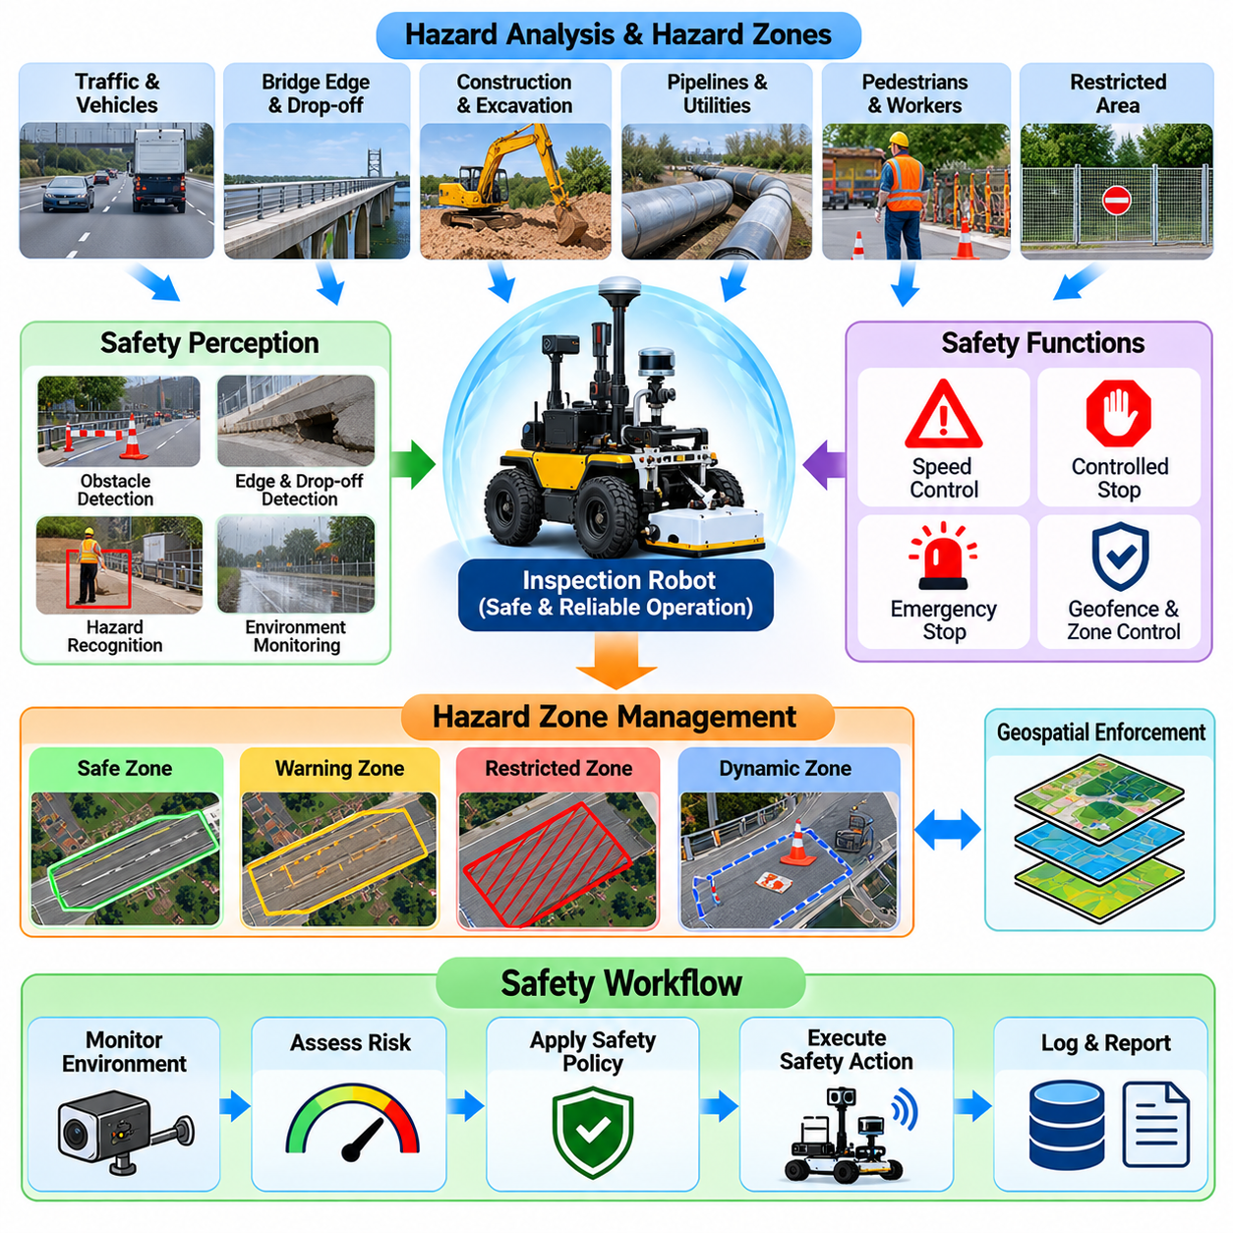
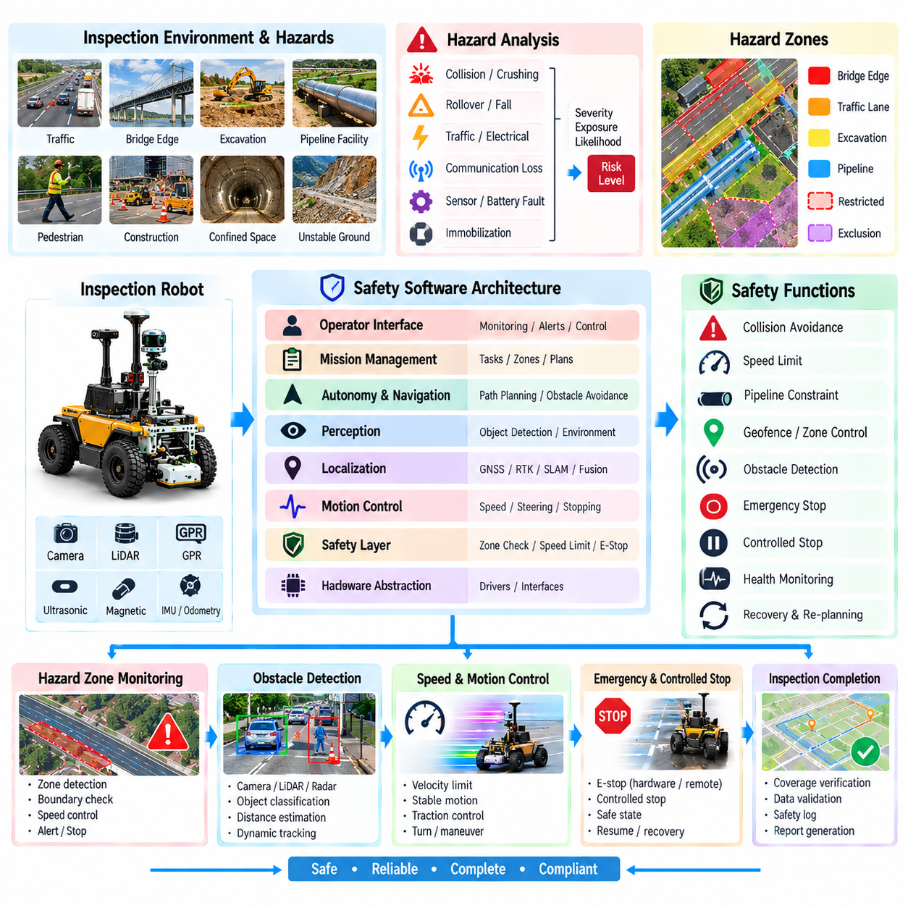
Inspection robot safety must be designed as a system-level property rather than added after autonomous navigation and sensing have been implemented. Infrastructure inspection robots may operate near traffic, bridge edges, excavation zones, pipelines, construction equipment, pedestrians, confined spaces, or unstable surfaces. Safety software must therefore coordinate perception, motion control, mission logic, communications, hardware protection, and operator supervision throughout the complete inspection lifecycle.
Hazard analysis begins by identifying possible sources of harm associated with the robot, environment, inspection equipment, and operational procedure. Hazards may include collision, crushing, unintended motion, rollover, falling from an elevated structure, entering traffic, electrical exposure, loss of communication, sensor failure, battery faults, or becoming immobilized in a restricted location. Each hazard can be evaluated according to severity, exposure, and likelihood to determine appropriate risk-reduction measures.
A hazard zone represents an area where robot operation requires specific restrictions or protective behavior. Zones can describe bridge edges, active traffic lanes, excavation boundaries, railway areas, high-voltage equipment, pipeline facilities, pedestrian workspaces, unstable ground, or prohibited infrastructure regions. The safety system associates each zone with operational rules such as maximum velocity, required clearance, permitted direction, sensor requirements, or complete exclusion from autonomous entry.
Geofencing provides a software mechanism for enforcing spatial safety boundaries. Geographic or local-map polygons can define allowed operating regions, restricted regions, and conditional-access areas. The robot continuously compares its estimated pose with these boundaries and predicts whether its current motion could cross them. Because localization contains uncertainty, safety margins should extend beyond the nominal boundary rather than assuming that the estimated robot position is perfectly accurate.
Localization quality is therefore directly connected to safety. A robot cannot reliably enforce a hazard boundary if it does not know its position with sufficient confidence. The safety layer should monitor localization uncertainty, GNSS or RTK status, odometry consistency, map matching, and other available indicators. When uncertainty exceeds the level required for the current zone, the robot can reduce speed, increase clearance, request operator intervention, or perform a controlled stop.
Obstacle detection protects people, vehicles, equipment, and the robot itself. LiDAR, cameras, radar, ultrasonic sensors, bumpers, or other proximity devices may provide overlapping detection capabilities. Safety-related perception should consider sensor range, blind regions, environmental degradation, and detection latency. The required stopping distance must account for robot velocity, control delay, braking performance, surface traction, and uncertainty rather than relying only on instantaneous obstacle distance.
Dynamic safety zones can change according to robot velocity and operational context. At low speed, a small protective region may provide adequate stopping distance, while faster motion requires a larger region. Different zones can be established in the forward, lateral, and rear directions according to vehicle geometry and motion. When an object enters a warning region the robot may reduce speed, while entry into a protective region can trigger an immediate controlled or emergency stop.
Inspection robots operating near bridge edges, curbs, pits, trenches, or elevated structures require protection against drop-off hazards. Forward-facing obstacle sensors may not detect the absence of supporting ground, so downward-looking ranging sensors, cameras, map constraints, or dedicated edge detectors can be required. Detection logic should distinguish traversable surface changes from dangerous discontinuities and apply conservative behavior when terrain classification is uncertain.
Speed management is one of the most effective software safety controls. Maximum velocity can vary according to environment, localization quality, obstacle density, sensing mode, surface condition, and proximity to hazardous regions. Inspection operations often benefit from relatively low speeds because measurement quality also depends on controlled motion. The mission planner should therefore treat safety speed limits as hard constraints rather than optimization preferences that can be violated to improve productivity.
Emergency stop functionality provides a direct mechanism for terminating hazardous motion. Physical emergency-stop devices, remote operator commands, safety controllers, or onboard fault detection may initiate the stop depending on the system design. Emergency stopping should place actuators into a defined safe condition and prevent unintended automatic restart. Recovery should require an explicit procedure confirming that the original hazard has been removed or adequately controlled.
A controlled stop differs from an emergency stop because it allows the robot to decelerate normally while maintaining stability and system awareness. Communication degradation, temporary localization uncertainty, blocked paths, or inspection sensor faults may justify a controlled stop without immediately removing actuator power. Distinguishing stop categories allows the robot to respond proportionally while ensuring that safety-critical conditions always receive priority over mission completion.
Safety supervision should remain logically separated from ordinary autonomy wherever practical. Navigation software may request motion toward a waypoint, but a supervisory safety layer evaluates whether the command satisfies current speed, zone, obstacle, localization, and system-health constraints. Unsafe commands can be limited or rejected before reaching low-level control. This architecture prevents a planning error or application-software fault from directly commanding unrestricted hazardous motion.
System health monitoring contributes to safety by detecting internal failures before they produce dangerous behavior. Motor temperature, current, battery voltage, brake status, steering response, sensor communication, computational load, storage capacity, and network condition can be monitored continuously. Inconsistent actuator feedback or unexpected current may indicate mechanical obstruction or drivetrain failure. Safety responses can range from degraded operation to immediate stopping according to fault severity.
Communication loss requires predefined behavior rather than improvised recovery. Some missions may permit continued autonomous operation inside a validated region, while others require the robot to stop or return when supervision is lost. The decision depends on environmental risk, autonomy capability, mission type, and recovery options. The communication policy should specify timeout thresholds and clearly distinguish loss of telemetry from loss of safety-critical command channels.
Human interaction requires special attention because infrastructure inspection frequently occurs in shared work areas. Workers may approach the robot to examine equipment, cross its route, or unintentionally enter an active survey zone. Visual indicators, audible warnings, predictable motion, low-speed modes, and clearly defined operating boundaries help communicate robot state. The system should avoid relying exclusively on workers understanding autonomous navigation behavior.
Traffic-adjacent inspection introduces additional hazards because road vehicles may move faster than the robot can avoid them. Route planning should respect lane closures, barriers, approved work zones, and traffic-management procedures rather than assuming onboard perception alone can guarantee safety. The robot can monitor nearby traffic and remain inside protected areas, but operational controls and physical separation may still be required for high-risk road environments.
Confined-space and pipeline operations introduce different safety concerns. Communication may be weak, access points limited, and physical robot recovery difficult. Energy reserves, thermal state, traction, obstruction detection, and return distance therefore become safety variables. Mission software should maintain sufficient recovery margin and terminate further inspection before the remaining energy or mechanical condition makes retrieval unreliable.
Environmental conditions can modify hazard severity. Rain, ice, standing water, dust, darkness, strong sunlight, high temperature, or reduced traction may degrade sensing and braking performance. The safety system can use environmental observations or operator-defined conditions to change speed limits and operating boundaries. When conditions exceed the validated operational envelope, suspending the mission is safer than attempting to compensate with unverified autonomous behavior.
Hazard-zone configuration should be stored as part of the mission record. Maps, geofences, speed limits, exclusion areas, safety parameters, and relevant configuration versions should be traceable to the inspection that used them. Safety events such as emergency stops, boundary violations, localization degradation, obstacle interventions, and operator overrides should also be timestamped and associated with robot position for later review.
Safety validation requires more than demonstrating successful nominal missions. Testing should include sensor loss, localization degradation, communication interruption, obstacle appearance, boundary approach, actuator faults, low battery, emergency stopping, and other foreseeable abnormal conditions. Simulation and controlled field testing can expose the software to hazardous scenarios without unnecessarily creating real risk. Acceptance criteria should define expected safe behavior for each tested condition.
Within the infrastructure inspection architecture, safety constrains every other subsystem rather than functioning as an isolated module. Survey planning must respect hazard zones, navigation must obey safe-motion limits, sensing must provide sufficient environmental awareness, data management must record safety events, and operator interfaces must communicate system state. These relationships make safety an architectural property of the complete robotic inspection workflow.
A dependable inspection robot therefore treats hazard awareness as a continuous process from mission preparation through deployment, autonomous inspection, recovery, and shutdown. Safe operation depends on combining hazard maps, geofencing, localization confidence, obstacle detection, speed control, system-health monitoring, emergency functions, and human supervision. The objective is not merely to prevent collisions, but to ensure that inspection remains within explicitly defined and verifiable operational risk boundaries.

05.10. Infrastructure Inspection Robot Field Case
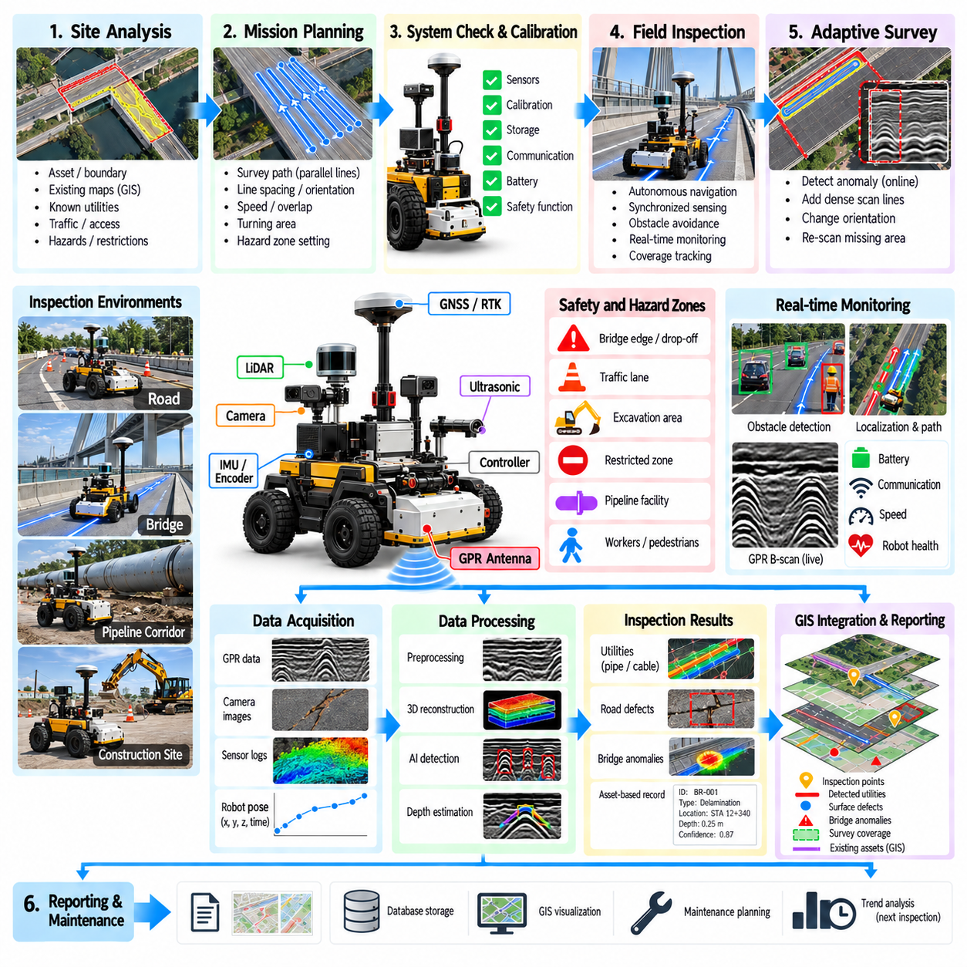
A field case for an infrastructure inspection robot demonstrates how sensing, autonomous mobility, data processing, safety, and engineering interpretation operate as one integrated workflow. The objective is not merely to prove that a robot can move across an infrastructure site, but to verify that it can repeatedly collect spatially valid inspection evidence under realistic environmental and operational constraints while maintaining traceability from mission planning to final assessment.
A representative field deployment begins with site characterization. Engineers identify the inspection asset, expected deterioration mechanisms, survey boundaries, access points, traffic conditions, surface characteristics, known utilities, restricted areas, and potential hazards. Existing drawings, GIS records, previous inspection reports, and maintenance history can be reviewed before deployment. These inputs establish both the inspection objectives and the operational constraints that the robotic system must satisfy.
Mission preparation converts engineering requirements into robot-executable survey plans. For a bridge deck or road section, the inspection region can be represented as a polygon divided into parallel survey lines with defined spacing. For a buried utility or pipeline corridor, the mission may use transverse and longitudinal passes. Path orientation, sampling density, robot velocity, turning areas, and required overlap are selected according to sensor characteristics and the spatial resolution required by the inspection objective.
Before autonomous operation begins, the robot performs initialization and system checks. Motor controllers, wheel encoders, IMU, GNSS or RTK-GNSS, cameras, LiDAR, GPR equipment, communication links, storage devices, and safety functions are verified. Sensor calibration and coordinate transformations are loaded with identifiable versions. The mission software also confirms sufficient battery capacity and storage resources before allowing the robot to enter the active inspection state.
A short calibration or reference run can be performed before the primary survey. The operator verifies localization quality, trajectory tracking, GPR triggering, image acquisition, timestamp synchronization, and data recording. Known surface or subsurface features can provide useful reference observations when available. Detecting configuration problems at this stage prevents an apparently successful autonomous mission from producing unusable inspection data that is discovered only after leaving the site.
During autonomous inspection, the AMR follows the planned survey lines while maintaining the velocity required for measurement quality. GPR traces are synchronized with robot position, and cameras or other sensors record complementary information. Navigation software controls cross-track error and heading while local perception detects temporary obstacles. The mission manager distinguishes valid inspection motion from turns, repositioning, obstacle avoidance, and transit between survey regions.
Field conditions rarely match the original plan perfectly. Workers, vehicles, equipment, debris, temporary barriers, wet surfaces, or inaccessible areas may interrupt a survey line. The robot can stop, wait, or execute a validated avoidance maneuver according to safety policy. Any deviation that creates a measurement gap is recorded explicitly. Once the obstruction is removed or a safe route becomes available, the planner can generate a recovery pass through the incomplete inspection region.
Localization performance is monitored throughout the mission because spatial accuracy determines the engineering value of the measurements. RTK-GNSS may provide high-quality outdoor positioning, but bridges, nearby structures, vegetation, or other environmental conditions can degrade satellite measurements. Odometry, IMU, LiDAR, or visual information can maintain continuity. The software records localization uncertainty so that later anomaly positions are reported with appropriate spatial confidence.
Inspection quality is evaluated separately from navigation success. The robot may physically traverse a survey line while radar communication fails, spatial sampling becomes too sparse, trajectory deviation exceeds limits, or localization quality becomes unacceptable. Such a line should not automatically be marked complete. Quality-control logic identifies the affected interval and requests reacquisition when practical, ensuring that mission progress represents valid measurements rather than distance traveled.
Preliminary processing can occur onboard while the field mission continues. GPR software may perform time-zero correction, filtering, background removal, gain adjustment, or simple candidate detection. Camera processing may identify visible surface defects, while trajectory analysis checks coverage quality. These preliminary results are not necessarily final engineering conclusions, but they can reveal suspicious regions requiring denser scanning or additional measurements before the robot leaves the site.
An adaptive field workflow can use preliminary interpretation to modify the survey. If a possible buried utility, void, structural anomaly, or ambiguous radar response is detected, the robot can perform additional passes with smaller line spacing or a different orientation. Repeated observations provide stronger spatial evidence than a single scan. This closes the loop between sensing and planning and demonstrates an important advantage of autonomous inspection over fixed manual data collection.
Safety supervision remains active independently of inspection productivity. Hazard zones, bridge edges, traffic boundaries, restricted regions, obstacle distances, speed limits, localization confidence, and robot health are continuously evaluated. A safety constraint can override the planned survey trajectory at any time. Emergency or controlled stops are recorded with their positions and causes so that resulting measurement gaps can later be distinguished from ordinary sensor or processing failures.
At the end of each survey segment, the system verifies coverage and data integrity before declaring completion. Recorded files can be checked for expected size, timestamps, sensor availability, trajectory association, and storage integrity. Missing or corrupted intervals are identified while the robot is still available for reacquisition. This field-level validation reduces the risk of discovering critical gaps only after equipment and traffic-control resources have been removed from the site.
After the mission, raw measurements are transferred into the inspection data-management workflow without losing their original identifiers. Radar traces, images, point clouds, trajectories, diagnostics, mission events, safety records, calibration information, and configuration versions remain associated with the same mission. Processing creates derived products while preserving links to the raw evidence, allowing later users to reconstruct how each reported result was generated.
Detailed GPR processing can transform synchronized radar measurements into B-scans, depth representations, spatially registered slices, or three-dimensional survey volumes. Filtering, gain compensation, migration, velocity assumptions, and depth conversion are documented as processing provenance. Candidate subsurface features can then be analyzed using geometric methods, AI models, or expert interpretation. Automated results retain confidence and uncertainty instead of being treated immediately as confirmed infrastructure objects.
Multi-sensor interpretation provides additional context for field findings. A subsurface radar anomaly can be compared with surface imagery, LiDAR geometry, known utility records, construction drawings, or previous inspection results. Agreement among independent sources can increase confidence, while disagreement identifies areas requiring further review. The system preserves both supporting and conflicting evidence so that the final engineering interpretation does not hide uncertainty present in the field measurements.
Georeferencing converts interpreted findings into infrastructure coordinates. Buried features can be represented as estimated utility trajectories with depth and confidence, road anomalies can be associated with lanes and chainage, and bridge findings can be connected to deck regions or structural elements. GIS integration allows these results to be viewed together with existing asset records while retaining links from each mapped feature to its original sensor evidence.
Engineering review forms the final interpretation stage of the field case. Specialists examine automated detections together with radar views, images, spatial context, data-quality indicators, uncertainty, and historical information. A finding can be accepted, rejected, modified, or marked for additional investigation. The review decision is stored without deleting the original machine output, preserving a traceable distinction between automated interpretation and validated engineering assessment.
Field performance should be evaluated using inspection-oriented metrics rather than autonomous-navigation metrics alone. Useful measures include valid coverage ratio, trajectory accuracy, localization uncertainty, sensor-data completeness, spatial sampling consistency, reacquisition frequency, anomaly localization error, inspection duration, intervention frequency, and safety events. Detection precision and recall can be evaluated when verified ground truth is available, but field datasets should not imply certainty where physical verification does not exist.
Operational lessons from a field case often reveal integration problems that individual subsystem tests cannot expose. Sensor cables may loosen under vibration, GNSS performance may vary across the site, storage bandwidth may become limiting, turning behavior may disturb GPR acquisition, or safety interventions may create unexpected coverage gaps. Recording these interactions provides evidence for improving mechanical design, software architecture, mission procedures, and subsequent validation tests.
Repeated deployment provides an even stronger demonstration of infrastructure inspection capability. The robot can return to the same asset using previous trajectories and spatial references, reacquire comparable measurements, and evaluate changes over time. Consistent survey geometry improves comparison of radar responses and surface conditions. Historical inspection records can therefore evolve from isolated datasets into a spatial and temporal representation of infrastructure condition.
The complete field case integrates the major functions of the GPR and infrastructure inspection workflow: sensor acquisition, radar processing, autonomous survey planning, AI interpretation, bridge and road inspection, pipeline-oriented inspection concepts, GIS data management, and hazard-zone safety. Success is achieved when the robot produces reproducible, spatially referenced, quality-controlled, and traceable evidence that engineers can use for infrastructure assessment rather than merely demonstrating autonomous movement in the field.

