Volume 26. Industrial Robot Applications

Chapter 06. CAD2SCAN and Construction Scanning

06.01. CAD2SCAN Concept Design to As Built Comparison
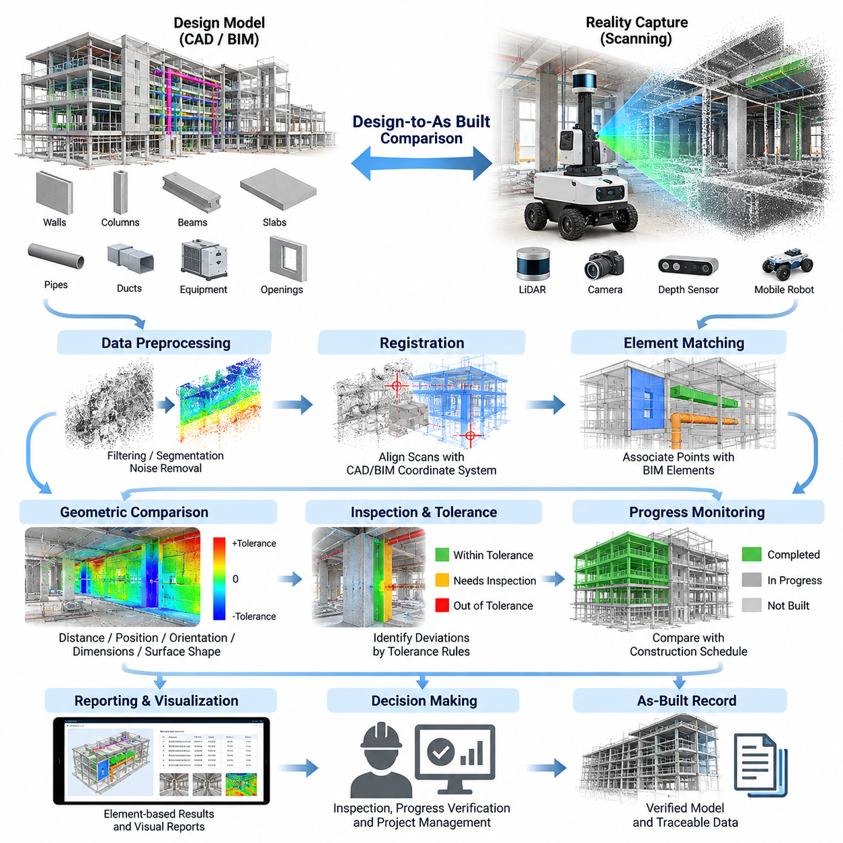
CAD2SCAN is a construction verification methodology that connects digital design information with the physical state of a built environment. In this workflow, CAD or Building Information Modeling (BIM) data represents the intended geometry, while three-dimensional scanning captures the actual geometry produced on site. The resulting comparison creates a measurable relationship between design intent and as-built conditions throughout construction.
The concept is particularly valuable because conventional construction inspection often depends on manual measurements, visual observations, photographs, and periodic surveying. These methods can identify major problems but may overlook distributed geometric deviations across large structures. CAD2SCAN converts the construction site into spatial data that can be systematically compared with the reference design, enabling more comprehensive and repeatable verification.
A typical CAD2SCAN workflow begins with a digital reference model containing structural, architectural, or mechanical geometry. Relevant objects such as walls, columns, slabs, beams, pipes, ducts, equipment foundations, and openings are extracted from the model. Coordinate systems, model units, reference points, and construction tolerances must be defined carefully because these parameters determine whether subsequent geometric comparisons are meaningful.
The as-built representation is normally obtained through terrestrial LiDAR, mobile laser scanning, depth cameras, photogrammetry, or robot-mounted three-dimensional sensors. Each acquisition method produces observations of visible surfaces from one or more viewpoints. Multiple scans are combined into a common coordinate frame to form a point cloud representing the physical construction state, including geometric details that may differ from the original design.
Robotic scanning extends this process by allowing repeated data acquisition with consistent trajectories and sensor configurations. An autonomous mobile robot can travel through corridors, floors, rooms, or partially completed construction zones while collecting LiDAR and image data. Repeated scanning missions make it possible to compare not only design versus reality but also the evolution of the construction site across different dates and project milestones.
Before design-to-as-built comparison can occur, the scanned point cloud must be aligned with the CAD or BIM coordinate system. Registration may use surveyed control points, GNSS or RTK references in suitable outdoor environments, fiducial markers, SLAM trajectories, geometric features, or iterative alignment algorithms. Registration accuracy is critical because alignment error can be incorrectly interpreted as construction deviation when the two datasets are compared.
Once registration is established, geometric correspondence can be evaluated between design surfaces and measured points. A simple approach calculates the shortest distance from each observed point to the expected CAD or BIM surface. More advanced methods associate scanned regions with individual BIM elements and evaluate position, orientation, dimensions, surface shape, and completeness. The resulting deviation field provides a quantitative description of how closely construction matches design.
Deviation values can be represented using tolerance bands that distinguish acceptable geometry from conditions requiring inspection. For example, measurements within a specified tolerance may be considered compliant, while larger positive or negative deviations can indicate displacement, excessive material, missing material, incorrect alignment, or installation error. Tolerances should be defined according to the component, construction stage, measurement uncertainty, and applicable engineering requirements.
CAD2SCAN can also support progress monitoring by determining whether designed elements are present in the scanned environment. If a BIM model contains the expected construction sequence, observed geometry can be associated with scheduled components to estimate completion status. This transforms scanning from a dimensional inspection technique into a broader construction intelligence mechanism capable of supporting progress verification and evidence-based project management.
The comparison process must distinguish true construction differences from sensing artifacts. Occlusion is common because equipment, temporary structures, stored materials, workers, vehicles, and unfinished components can block sensor visibility. Reflective surfaces, glass, dust, rain, poor lighting for cameras, and long sensing distances can further reduce measurement quality. Reliable CAD2SCAN systems therefore track data confidence and coverage in addition to geometric deviation.
Data preprocessing is another essential stage. Raw scans may contain noise, duplicate observations, moving objects, outliers, and unnecessary environmental information. Filtering, downsampling, ground or structural segmentation, normal estimation, and region extraction can simplify the point cloud before comparison. However, preprocessing must preserve the geometric features required for inspection, because excessive filtering can remove small but significant construction deviations.
Semantic information from BIM provides an important advantage over purely geometric comparison. Instead of reporting an anonymous cluster of points as being several centimeters away from a reference surface, the system can associate that deviation with a specific wall, beam, pipe, or equipment foundation. This connection enables inspection results to be organized according to building elements, locations, work packages, responsible disciplines, and construction schedules.
A practical CAD2SCAN software pipeline therefore combines several robotics and construction-data technologies. Sensor acquisition produces point clouds and images, localization determines the scanner trajectory, registration establishes a shared reference frame, BIM processing extracts design geometry, and comparison algorithms calculate deviations. A reporting layer then converts numerical results into information that engineers, contractors, inspectors, and project managers can interpret and act upon.
Autonomous robots are especially useful when scanning must be repeated frequently. Manual scanning can require technicians to reposition instruments and revisit numerous locations, whereas a robot can execute predefined or adaptively generated scan missions. The robot can also record its trajectory and sensor poses, improving repeatability between inspection sessions. This supports systematic comparison of the same construction areas as work progresses.
Construction environments nevertheless present difficult navigation conditions. The robot may encounter uneven floors, temporary barriers, narrow passages, ramps, changing layouts, moving workers, construction machinery, dust, and areas without reliable GNSS coverage. Consequently, CAD2SCAN robotics requires robust localization, obstacle avoidance, map updating, mission recovery, and safety mechanisms so that scanning operations remain reliable as the site changes.
Design revisions introduce another important consideration. The reference model used for comparison must correspond to the approved design version applicable when the scan was captured. Comparing current construction against an outdated CAD or BIM model can generate large numbers of false deviations. CAD2SCAN systems should therefore maintain model versions, scan timestamps, coordinate references, processing parameters, and comparison results as traceable project records.
Measurement uncertainty should also be treated explicitly. Scanner accuracy, localization drift, registration residuals, surface properties, point density, and environmental conditions all contribute to uncertainty in the final deviation estimate. A detected difference should not automatically be classified as a construction defect unless it exceeds the combined uncertainty and the specified engineering tolerance. This prevents the system from producing misleading precision.
At the project level, CAD2SCAN creates a digital feedback loop between design, construction, and verification. Design information defines what should exist, robotic or stationary scanning observes what actually exists, comparison algorithms identify differences, and engineering teams determine whether corrective action is required. After correction or continued construction, the environment can be scanned again, producing a continuously updated record of physical progress.
The resulting as-built information can ultimately support commissioning, facility management, renovation, and digital twin applications. Instead of ending with a design model that may no longer accurately represent the completed facility, the project can maintain a geometrically verified digital representation linked to physical observations. CAD2SCAN therefore provides a foundation for automated construction inspection and for maintaining trustworthy connections between digital models and real infrastructure.
Within the broader construction scanning workflow, this concept establishes the foundation for subsequent capabilities such as robotic 3D scanning architecture, autonomous scan-path planning, point-cloud registration, BIM-to-point-cloud deviation analysis, AI-based change detection, scan-data management, construction-site navigation, and automated reporting. These functions form the technical progression defined for the CAD2SCAN chapter.

06.02. 3D Scanning Robot SW Architecture [w/Code]
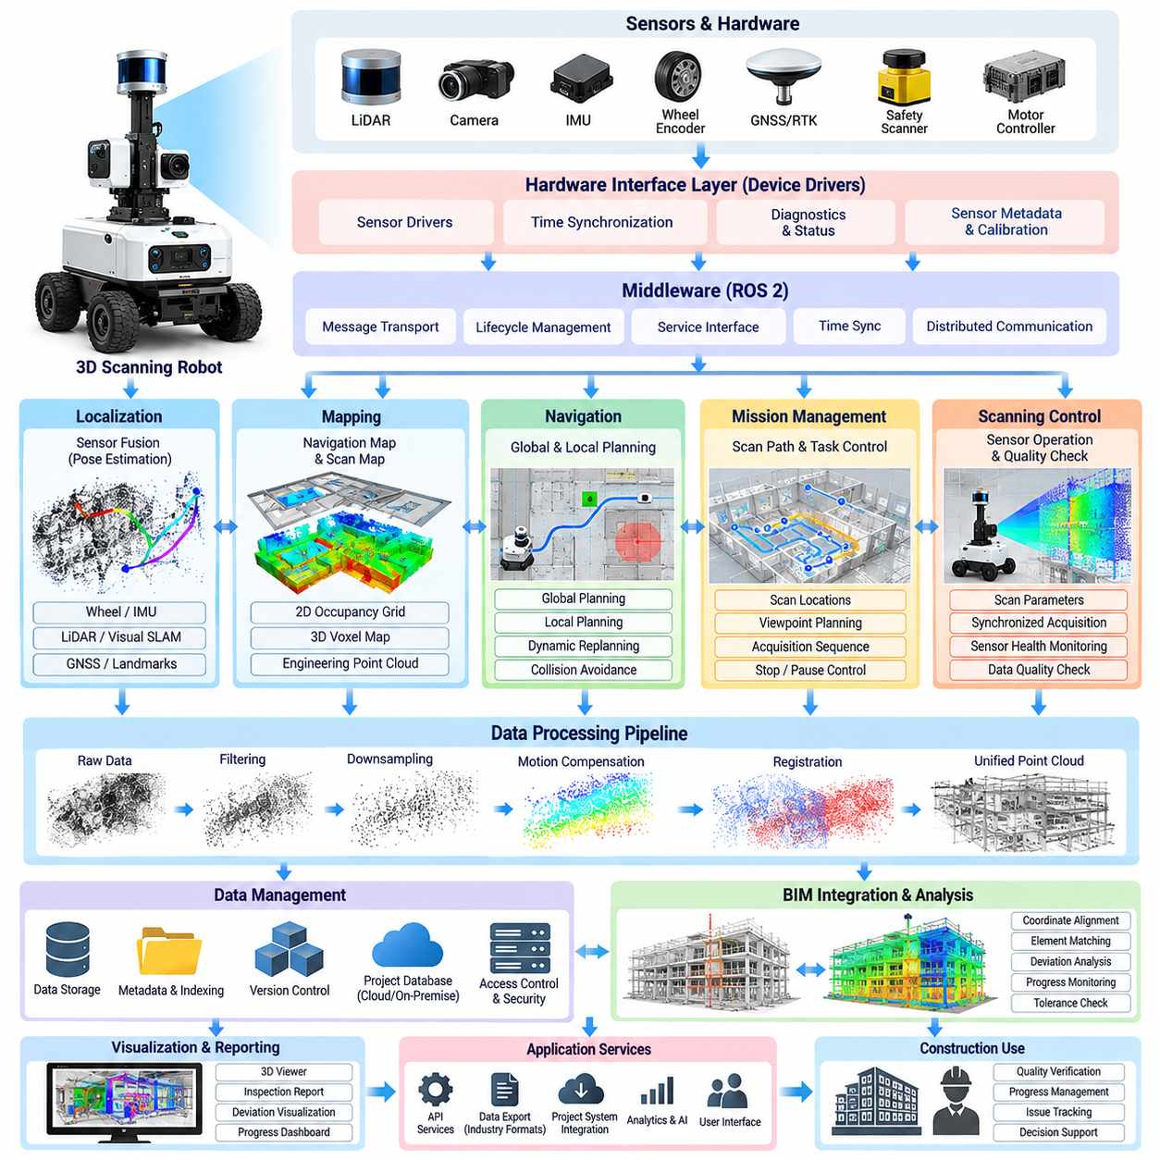
A 3D scanning robot software architecture integrates autonomous mobility, localization, sensor control, spatial data acquisition, point-cloud processing, and construction information management into a coordinated robotic system. Its primary objective is to move a scanning platform through a construction environment while continuously producing geometrically consistent data that can later be compared with CAD or BIM models for inspection and verification.
The architecture is commonly organized as a layered system in which hardware interfaces are separated from perception, localization, navigation, scanning, data processing, and application services. This separation allows individual sensors or algorithms to be replaced without redesigning the entire platform. Middleware such as ROS 2 can provide message transport, lifecycle management, service interfaces, time synchronization, and distributed communication between these software components.
At the hardware interface layer, device drivers connect the software stack to LiDAR scanners, RGB or depth cameras, inertial measurement units, wheel encoders, GNSS receivers, motor controllers, safety scanners, and other instruments. Each driver converts vendor-specific measurements into standardized internal messages while preserving timestamps, calibration parameters, diagnostic states, and sensor metadata required by downstream processing.
Time synchronization is particularly important because a scanning robot collects spatial information while moving. LiDAR measurements, camera frames, IMU observations, wheel odometry, and robot poses must correspond to consistent points in time. Hardware triggering, Precision Time Protocol, synchronized clocks, or software timestamp correction can be used to reduce temporal offsets that would otherwise produce distorted point clouds and inaccurate geometric reconstruction.
A coordinate-frame management subsystem defines the spatial relationship among the robot base, sensors, odometry frame, local map, construction coordinate system, and BIM reference frame. Static transformations represent calibrated sensor mounting positions, while dynamic transformations describe robot motion. Maintaining a consistent transformation tree enables every captured point to be transformed from its original sensor frame into a common project coordinate system.
The localization layer estimates the six-degree-of-freedom pose of the scanning platform during data acquisition. Depending on the environment, the robot may combine wheel odometry, IMU measurements, LiDAR SLAM, visual SLAM, GNSS/RTK, surveyed landmarks, or fiducial references. Sensor fusion reduces dependence on any single source and provides a more stable trajectory when the construction site contains repetitive geometry or rapidly changing surroundings.
Mapping software constructs a representation of the environment for both robot navigation and scan management. Navigation maps may use two-dimensional occupancy grids, three-dimensional voxel maps, elevation maps, or local obstacle representations, while inspection data can retain much denser point clouds. Separating navigation-oriented maps from engineering-quality scan products prevents high-resolution scanning data from unnecessarily increasing real-time navigation computation.
The navigation subsystem converts scanning missions into safe robot motion. Global planning determines routes between inspection regions, while local planning generates collision-free commands according to nearby obstacles and platform constraints. Construction environments require continuous replanning because workers, vehicles, temporary barriers, stored materials, and partially completed structures can change the traversable space between successive scanning missions.
A mission-management layer coordinates navigation and scanning activities at a higher level. Instead of simply commanding the robot to reach a destination, the mission defines scan locations, observation orientations, sensor configurations, required coverage, stopping conditions, and acquisition sequences. The mission manager can pause navigation for stationary scanning or coordinate continuous acquisition when sensors are capable of collecting reliable measurements while the robot is moving.
The scanning subsystem controls sensor operating modes and determines when engineering-quality observations should be recorded. It may configure scan frequency, angular resolution, camera exposure, depth range, field of view, or acquisition duration according to the target structure. Sensor health and acquisition quality are monitored during each operation so that incomplete or corrupted scans can be identified before the robot leaves an inspection region.
Raw sensor data passes into a preprocessing pipeline that removes measurements unsuitable for geometric reconstruction. Point-cloud filtering can reject range outliers, low-confidence returns, moving objects, or points outside the region of interest. Downsampling reduces computational load while preserving important geometry, and motion compensation can correct distortions caused by platform movement during acquisition. The original measurements should still be retained when traceability is required.
Registration software combines scans collected from different robot poses into a consistent three-dimensional representation. Initial alignment can be obtained from the localization trajectory, surveyed references, or known sensor poses, after which geometric algorithms refine the transformation. Techniques such as Iterative Closest Point can minimize residual differences between overlapping point clouds, although registration quality must be monitored to prevent alignment errors from accumulating.
The resulting point clouds require a structured data-management layer because construction scanning can generate large datasets. Each scan should be associated with its timestamp, robot trajectory, sensor calibration, coordinate frame, mission identifier, project location, processing version, and quality indicators. Spatial indexing, compression, tiled storage, and hierarchical point-cloud formats can improve retrieval efficiency when projects contain repeated scans of large buildings or infrastructure.
A BIM integration service connects robotic observations with the digital construction model. The service imports relevant geometry and semantic information from CAD or BIM sources, transforms the design into the same coordinate reference used by scanning, and exposes individual building elements to downstream analysis. This enables point-cloud regions to be associated with walls, columns, slabs, beams, pipes, ducts, openings, and other modeled components.
The analysis layer uses registered observations to support design-to-as-built comparison. It can calculate point-to-surface distances, estimate dimensional deviations, detect missing or newly constructed geometry, and evaluate whether measured elements fall within specified tolerances. Results should include confidence information derived from scan coverage, sensor accuracy, localization uncertainty, and registration quality rather than reporting geometric differences as perfectly precise measurements.
Construction-site operation also requires a dedicated safety architecture. Emergency-stop inputs, safety LiDAR, bumper signals, speed limits, restricted zones, communication watchdogs, and motion-controller states should be monitored independently from the high-level scanning application. A failure in mapping, perception, network communication, or scan processing must not prevent the robot from entering a defined safe state when hazardous conditions are detected.
Fault management allows the robot to continue useful operation when recoverable problems occur. The system can detect localization degradation, blocked routes, sensor disconnection, insufficient scan coverage, storage limitations, or failed registration and then initiate appropriate recovery behavior. Depending on severity, the robot may retry acquisition, reposition itself, select another route, return to a known localization point, or request assistance from a remote operator.
System observability is essential for field deployment because failures often involve interactions among multiple subsystems. Structured logs, sensor diagnostics, localization confidence, CPU and GPU utilization, network status, storage capacity, navigation events, and mission states should be recorded with synchronized timestamps. These records allow engineers to reconstruct what occurred during a scan mission and distinguish robot failures from sensing or environmental problems.
A distributed implementation may divide computation between the robot, an edge workstation, and centralized project infrastructure. Real-time localization, obstacle avoidance, safety supervision, and basic scan validation should remain close to the robot, while computationally expensive registration, BIM comparison, change detection, and report generation can execute on edge or server resources. This separation reduces onboard computational requirements while preserving autonomous operation.
Reliable interfaces between these layers transform the scanning robot from a mobile sensor carrier into an integrated construction inspection platform. Navigation determines where the robot can safely travel, mission management determines what must be observed, scanning captures the physical environment, localization establishes where observations were made, and processing converts measurements into registered spatial information that can be connected with engineering models.
Within the CAD2SCAN workflow, this software architecture provides the operational foundation for autonomous scan-path planning, point-cloud registration and ICP alignment, BIM-to-point-cloud deviation analysis, progress monitoring, scan-data management, construction-site safety, and automated report generation. These capabilities form the subsequent technical sequence of the construction scanning chapter and build upon a common robotic data pipeline.

06.03. Autonomous Scan Path Planning for Structures [w/Code]
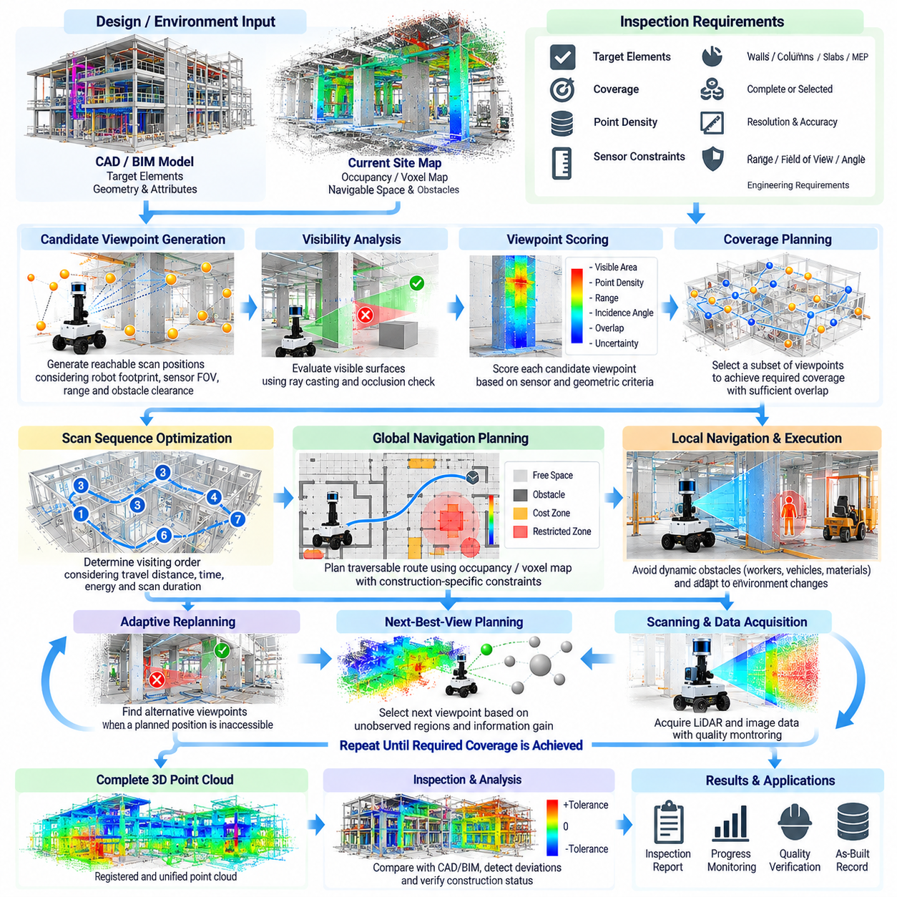
Autonomous scan path planning determines where a mobile scanning robot should travel and where its sensors should observe a structure to obtain sufficient three-dimensional coverage. Unlike ordinary navigation, which primarily seeks a collision-free route between locations, scan planning must consider visibility, sensor range, viewing angle, point density, localization quality, and inspection requirements while minimizing unnecessary travel and acquisition time.
The planning problem begins with a representation of the structure and its surrounding accessible space. CAD or BIM geometry can provide expected walls, columns, slabs, beams, equipment, and other construction elements, while an occupancy or voxel map represents the environment currently observed by the robot. Combining design information with live mapping allows the planner to distinguish inspection targets from obstacles and navigable regions.
Inspection requirements define what constitutes a successful scan mission. Some tasks may require complete surface coverage, while others focus on selected structural elements or areas where construction deviations are likely to occur. The planner can assign different priorities, required point densities, maximum sensing distances, and acceptable incidence angles to individual targets according to their engineering importance and expected measurement accuracy.
Candidate viewpoints are generated around the surfaces that must be inspected. Each viewpoint represents a possible robot position and sensor orientation from which part of the structure can be observed. Candidate generation must respect the robot footprint, minimum obstacle clearance, scanner height, sensor field of view, sensing range, and platform kinematics so that theoretically useful observations are also physically reachable.
Visibility analysis estimates which portions of a target can actually be measured from each candidate viewpoint. Ray casting or geometric intersection tests can determine whether walls, columns, temporary objects, or other structures block the line of sight between the sensor and target surfaces. This step is essential because construction sites contain frequent occlusions that can make a geometrically nearby scanning position ineffective.
Sensor characteristics influence viewpoint quality as strongly as geometric visibility. Measurements acquired near the sensor's effective range and at favorable incidence angles generally provide better geometric information than distant or grazing observations. A viewpoint scoring function can therefore combine visible surface area, expected point density, range, incidence angle, overlap with neighboring scans, and estimated measurement uncertainty into a common utility value.
Coverage planning selects a set of viewpoints that collectively observe the required structure. Because many candidate viewpoints may contain overlapping information, visiting every possible position would waste time and energy. The planner attempts to identify a smaller subset that satisfies the required coverage while preserving sufficient overlap for point-cloud registration. This creates a tradeoff between inspection completeness and operational efficiency.
Scan overlap is particularly important when multiple observations must be registered into a common point cloud. Adjacent scans should contain enough shared geometric features to support reliable alignment. A route optimized only for maximum new coverage may create isolated observations with weak correspondence, so scan planning should explicitly preserve geometric overlap or ensure that localization accuracy is sufficient to connect successive acquisitions.
After viewpoints are selected, the system determines the order in which they should be visited. This can be formulated as a route optimization problem in which travel distance, estimated traversal time, turning cost, energy consumption, and scan duration contribute to the objective. The shortest geometric sequence is not always optimal because some routes may cross unsafe areas, narrow passages, slopes, or regions with heavy construction traffic.
The global navigation planner converts the ordered scan locations into traversable routes through the site. An occupancy grid, voxel map, or other spatial representation identifies free and occupied regions, while cost maps assign additional penalties near obstacles or hazardous zones. Construction-specific constraints can prevent the robot from entering unfinished floors, restricted work zones, unstable surfaces, or areas reserved for workers and machinery.
Local planning handles environmental changes that were not represented when the scan mission was generated. Workers, vehicles, material pallets, cables, tools, and temporary barriers may suddenly obstruct the planned route or scanning position. The robot must avoid these obstacles while attempting to preserve the original inspection objective, rather than treating every deviation from the predefined route as a mission failure.
When a selected viewpoint becomes inaccessible, adaptive replanning can search for an alternative observation pose that provides similar target visibility. The replacement viewpoint should maintain the required sensor range, viewing geometry, and coverage while remaining reachable under current conditions. This capability is particularly important in construction because the physical environment can change significantly between mission planning and execution.
Next-best-view planning provides a more dynamic approach when the environment or structure is only partially known. Instead of calculating the entire mission in advance, the robot analyzes the current three-dimensional map after each acquisition and selects the next viewpoint expected to reveal the most useful unobserved geometry. The process repeats until coverage requirements are satisfied or additional observations provide insufficient information gain.
Information gain can be estimated from unknown voxels, unobserved target surfaces, expected reduction in geometric uncertainty, or improvement in registration confidence. A useful next viewpoint should provide substantial new information without requiring excessive travel or introducing unacceptable risk. Balancing information gain against movement cost enables the robot to explore complex structures efficiently while maintaining an inspection-oriented mission objective.
Localization quality must also influence path planning. Long featureless corridors, repetitive columns, open spaces, glass surfaces, and rapidly changing construction areas can reduce SLAM reliability. The planner can favor routes containing stable geometric features or known landmarks and periodically return to well-localized regions. This reduces accumulated pose error and improves the geometric consistency of scans collected across large structures.
For stationary high-resolution scanning, the robot must stop at a stable pose before acquisition begins. The motion controller verifies that linear and angular velocities are sufficiently small, the platform is not vibrating excessively, and the sensor has reached the required operating state. After acquisition and basic quality verification, the mission manager releases the robot to continue toward the next scanning location.
Continuous mobile scanning uses a different planning strategy because measurements are collected along the trajectory rather than only at discrete viewpoints. Robot velocity becomes part of the sensing configuration because excessive speed can reduce point density or increase motion distortion. The planner may therefore adjust velocity according to target complexity, sensor sampling frequency, required resolution, turning motion, and expected localization quality.
Scan quality should be evaluated during mission execution rather than only after the robot returns. Coverage maps can record which target surfaces have been observed and whether the measurements satisfy required density, range, and viewing conditions. If the quality falls below specified thresholds, the planner can schedule additional viewpoints immediately, reducing the need for a separate manual rescan mission.
Large structures may require hierarchical planning. At the highest level, the building can be divided into floors, rooms, corridors, structural zones, or work packages. A regional planner determines the order of these areas, while local planners generate detailed viewpoints and routes inside each region. This decomposition reduces computational complexity and allows inspection priorities to follow construction schedules or project management requirements.
Energy and mission duration impose additional constraints on autonomous scanning. The planner must estimate travel energy, scanning time, computational load, and remaining battery capacity while ensuring that the robot can reach a charging or recovery location. For extensive construction sites, a large inspection mission can be divided into several sorties while maintaining consistent coverage records and coordinate references across sessions.
Safety constraints must remain dominant over coverage optimization. Planned viewpoints and routes should respect robot clearance, stopping distance, floor boundaries, restricted zones, maximum slopes, and other platform limitations. Dynamic safety sensors can override planned motion whenever hazardous conditions are detected. A scan is valuable only when it can be acquired without exposing workers, equipment, or the robotic platform to unacceptable risk.
Mission results provide feedback for subsequent planning cycles. Successfully observed surfaces are marked as covered, failed viewpoints are recorded, inaccessible regions remain pending, and newly discovered obstacles update the environmental map. This creates a closed-loop planning process in which the scanning strategy evolves according to actual field conditions instead of relying exclusively on the original CAD or BIM representation.
Within the CAD2SCAN workflow, autonomous scan path planning connects robotic navigation directly with engineering inspection objectives. It determines not simply how the robot reaches a location, but where observations should be made to produce useful geometric evidence. The resulting scans provide the structured spatial data required for subsequent point-cloud registration, ICP alignment, BIM deviation analysis, progress monitoring, and automated reporting.

06.04. Point Cloud Registration and ICP Alignment [w/Code]
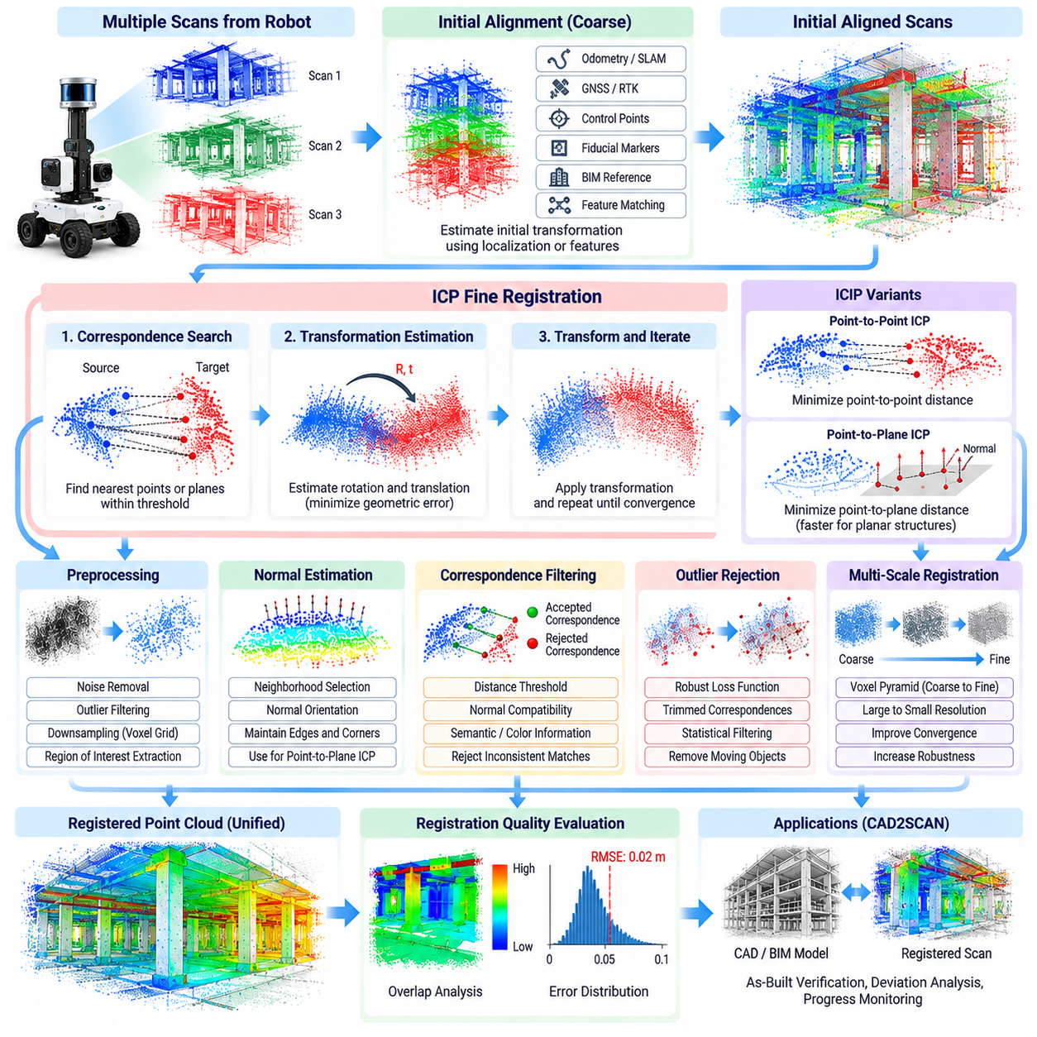
Point-cloud registration is the process of transforming multiple three-dimensional scans into a common coordinate system so that they form a geometrically consistent representation of a construction environment. In CAD2SCAN applications, registration connects observations captured from different robot poses and prepares the resulting point cloud for comparison with CAD or BIM geometry. Accurate alignment is therefore fundamental to reliable as-built verification.
Each scan is initially expressed in the local coordinate frame of the sensor at the moment of acquisition. As a mobile robot moves through a building, the scanner continuously changes position and orientation, causing identical structural surfaces to appear in different coordinate systems. Registration estimates the rigid transformations required to express these observations within a shared map, project, or BIM reference frame.
A rigid three-dimensional transformation consists of rotation and translation. For every point in a source cloud, the registration algorithm estimates a transformation that places the point at the corresponding location in a target cloud. Construction scanning generally assumes that walls, columns, slabs, and other structural objects remain rigid, although temporary objects and moving equipment must be excluded because they violate this assumption.
Registration is commonly performed in multiple stages rather than relying on a single optimization. An initial transformation provides a coarse estimate of the relative pose between two scans, after which a fine-registration algorithm refines the alignment. The initial estimate can originate from robot odometry, LiDAR SLAM, visual-inertial localization, surveyed control points, GNSS/RTK, fiducial markers, BIM references, or previously registered scans.
Coarse alignment is important because local registration algorithms normally converge only when the initial transformation is reasonably close to the correct solution. If two scans begin with a large translational or rotational difference, the optimizer may associate unrelated surfaces and converge to an incorrect alignment. Reliable robot localization can therefore significantly reduce the search space and improve the robustness of subsequent geometric registration.
Feature-based registration can provide an initial alignment when an accurate pose estimate is unavailable. Geometric keypoints and local descriptors are extracted from both point clouds, candidate correspondences are established, and robust estimation methods reject inconsistent matches. Construction environments can make this difficult because repeated columns, parallel walls, similar rooms, and planar surfaces often create geometrically ambiguous correspondences.
Iterative Closest Point, commonly called ICP, is one of the fundamental algorithms for fine point-cloud registration. Starting from an initial pose estimate, ICP repeatedly identifies corresponding points or surfaces between two overlapping clouds, estimates the transformation that reduces their geometric difference, applies that transformation, and repeats the process until a convergence condition is reached.
The simplest point-to-point ICP minimizes distances between corresponding three-dimensional points. For each source point, a nearby target point is selected as its correspondence, and the rigid transformation minimizing the accumulated squared distance is estimated. This formulation is conceptually simple and useful for many datasets, but convergence can become slow or unstable when the point clouds contain noise, uneven sampling, or large planar regions.
Point-to-plane ICP uses surface orientation information in addition to point position. Surface normals are estimated for the target cloud, and the optimization minimizes the distance from each transformed source point to the tangent plane associated with its correspondence. In environments dominated by walls, floors, ceilings, and other planar construction surfaces, point-to-plane alignment can converge more efficiently than basic point-to-point ICP.
Correspondence selection strongly affects registration accuracy. Nearest-neighbor search is commonly accelerated with spatial structures such as k-d trees or voxel indices, but the closest point is not necessarily a correct match. Maximum correspondence distance, normal compatibility, surface type, color information, or semantic labels can be used to reject implausible associations before transformation estimation.
Outlier rejection is essential in construction scanning because two scans rarely observe exactly the same environment. Workers may move through the scene, equipment can change position, and some structural surfaces may appear in only one scan because of occlusion. Robust loss functions, trimmed correspondences, distance thresholds, and statistical filtering reduce the influence of these inconsistent measurements on the estimated transformation.
Downsampling can substantially improve computational efficiency before ICP processing. A voxel-grid filter replaces dense groups of nearby points with a smaller spatial representation while preserving the dominant geometry. Coarser point clouds can first be used to correct larger pose errors, followed by progressively finer resolutions. This multi-scale registration strategy often improves both convergence speed and robustness.
Normal estimation requires careful neighborhood selection when point-to-plane methods are used. A neighborhood that is too small can produce unstable normals because of measurement noise, while an excessively large neighborhood can smooth edges and corners that provide useful alignment constraints. Sensor resolution, point density, surface curvature, and expected construction geometry should therefore influence normal-estimation parameters.
The overlap ratio between scans is another critical factor. ICP requires sufficient common geometry to estimate a meaningful transformation. Autonomous scan-path planning should therefore create neighboring observations with adequate overlap and distinctive structural features. If successive scans contain only small common regions or repetitive planar geometry, registration can become underconstrained even when each individual scan has high measurement accuracy.
Registration quality can be evaluated using residual errors, correspondence counts, overlap ratios, transformation magnitude, and convergence behavior. A low numerical residual alone does not guarantee a correct solution because an incorrect alignment between repetitive surfaces can also produce a small error. Quality evaluation should therefore combine geometric metrics with localization estimates, structural context, and consistency with neighboring scans.
Pairwise registration aligns one scan directly with another, but large construction projects usually require many scans collected across rooms, floors, or repeated missions. Sequentially chaining pairwise transformations can accumulate drift because every small alignment error propagates through the scan sequence. Global registration methods are therefore required to maintain geometric consistency over large spatial areas.
Pose-graph optimization represents scan poses as nodes and relative registration constraints as edges. Consecutive scans create local constraints, while loop closures connect locations that the robot observes again later. Optimizing the complete graph distributes registration errors across the trajectory instead of allowing them to accumulate sequentially. Surveyed control points or known BIM references can additionally anchor the solution to the project coordinate system.
Loop closure is especially valuable when a scanning robot travels through corridors, around building cores, or across multiple connected rooms and eventually returns to a previously observed region. Detecting the repeated location introduces a long-range geometric constraint that can correct accumulated drift. Incorrect loop closures, however, can deform the entire reconstruction, so candidate closures require robust geometric verification.
Construction projects also require registration between scans captured on different dates. The environment may have changed substantially because new walls, equipment, pipes, or temporary structures have appeared. Temporal registration should rely on stable structural geometry or surveyed references rather than assuming that every observed surface remains unchanged. This enables repeated scanning missions to share a consistent coordinate system for progress monitoring.
After local and global registration, the reconstructed point cloud must be transformed into the CAD or BIM reference frame. Control points, surveyed coordinates, known structural features, or manually verified correspondences can establish this final relationship. Once the scan and design share the same coordinate system, geometric differences can be interpreted as potential as-built deviations rather than coordinate-frame inconsistencies.
Uncertainty in registration must be considered when interpreting small deviations. Scanner noise, localization drift, correspondence errors, calibration uncertainty, insufficient overlap, and unfavorable geometry all contribute to transformation uncertainty. A measured displacement close to the expected registration error should not automatically be classified as a construction defect. Inspection thresholds should account for both measurement uncertainty and engineering tolerance.
A practical registration pipeline should preserve intermediate transformations, parameter settings, quality metrics, rejected correspondences, software versions, and coordinate references. These records support reproducibility and allow engineers to determine whether an apparent construction deviation originated from the physical structure or from data processing. Registration is therefore not merely a geometric operation but part of the traceable inspection evidence.
Within the CAD2SCAN workflow, point-cloud registration and ICP alignment provide the geometric bridge between autonomous scanning and BIM-based deviation analysis. Reliable registration converts many locally captured observations into a coherent as-built spatial model, while project-frame alignment connects that model to design intent. The resulting registered data supports BIM-to-point-cloud deviation analysis, progress monitoring, data management, and automated reporting in subsequent stages.

06.05. BIM to Point Cloud Deviation Analysis [w/Code]
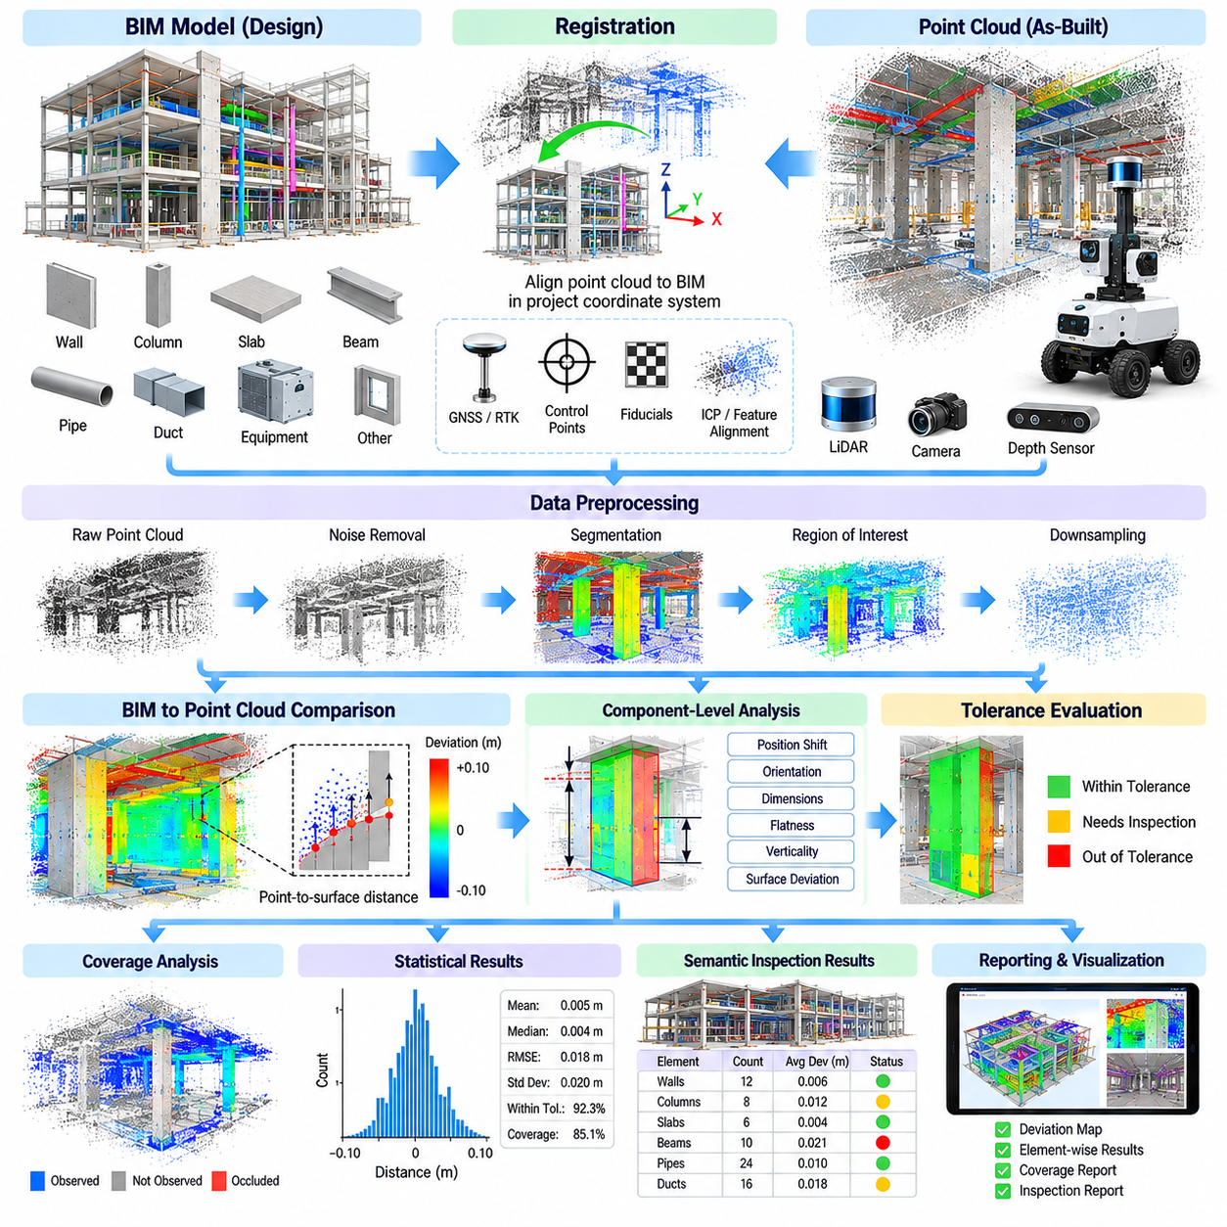
BIM-to-point-cloud deviation analysis evaluates how closely the physical geometry captured from a construction site matches the geometry defined in a Building Information Model. After scan data has been registered to the project coordinate system, measured three-dimensional points can be compared directly with designed surfaces and components. The resulting deviations provide quantitative evidence for identifying construction errors, dimensional differences, and installation problems.
The analysis depends on accurate alignment between the BIM model and the registered as-built point cloud. Even a small coordinate transformation error can appear as a systematic construction deviation across many components. Before geometric inspection begins, the system should therefore verify control points, registration residuals, coordinate conventions, model units, and reference elevations to ensure that observed differences originate from construction rather than alignment errors.
BIM geometry must be converted into a representation suitable for spatial comparison. Parametric objects such as walls, slabs, columns, beams, pipes, ducts, and equipment can be transformed into polygon meshes, surfaces, or other geometric primitives. Semantic identifiers should remain associated with these representations so that measured deviations can later be linked back to specific BIM elements rather than reported only as anonymous spatial errors.
The point cloud also requires preprocessing before deviation calculation. Noise, isolated points, moving workers, vehicles, temporary materials, and measurements outside the inspection region can create misleading differences. Filtering and segmentation reduce these effects, while spatial cropping selects the portion of the scan associated with the BIM element under evaluation. Point density may also be normalized to prevent heavily sampled areas from dominating statistical results.
A fundamental comparison method calculates the shortest distance from each measured point to the corresponding BIM surface. Small distances indicate that the observed geometry closely follows the design, while larger distances indicate potential displacement or shape differences. Signed distances can additionally distinguish measurements located outside the expected surface from those located inside it, providing information about the direction of deviation.
Point-to-surface distance alone does not always identify the engineering meaning of a difference. A wall may have the correct shape but be translated from its intended location, while a column may be correctly positioned but rotated slightly. Component-level analysis can therefore estimate translation, orientation, dimensions, surface flatness, verticality, and other geometric properties so that deviations correspond more directly to construction inspection requirements.
Tolerance management converts geometric measurements into engineering decisions. Each BIM object or object class can be assigned allowable positional, angular, or dimensional tolerances according to project specifications and construction standards. Measurements inside the tolerance range can be classified as acceptable, while larger deviations can be marked for review. Different tolerances may be required for structural concrete, architectural finishes, mechanical systems, and precision equipment.
Deviation maps provide a spatial representation of comparison results across surfaces. Instead of reporting only a single average error, the system associates local distance values with different regions of the observed geometry. This makes it possible to identify patterns such as a tilted wall, uneven slab, displaced beam, bowed surface, or locally incorrect installation. Statistical summaries can then complement the spatial distribution rather than replacing it.
Robust statistics are important because construction point clouds contain incomplete and imperfect observations. Mean deviation can be strongly influenced by outliers, so median values, percentiles, standard deviation, root-mean-square error, and maximum deviations may be reported together. The percentage of observed points within tolerance is also useful because it expresses compliance over the measured surface instead of relying on a single representative value.
Coverage must be distinguished from compliance. If only a small portion of a BIM element is visible in the point cloud, the observed region may satisfy tolerance even though the remainder of the element has not been verified. The system should therefore calculate scan coverage or observability for each component and avoid interpreting unobserved geometry as compliant. Low-coverage components can be scheduled for additional robotic scanning.
Occlusion is a major source of incomplete comparison data. Temporary scaffolding, stored materials, construction machinery, neighboring components, and workers can block surfaces from the scanner. BIM geometry itself can be used to estimate expected visibility from known scanner poses, while actual point density reveals whether observations were successfully acquired. This information helps separate missing construction from geometry that was simply not visible.
Semantic BIM information allows deviation analysis to operate at the component level. Points can be associated with a wall identifier, column number, slab region, pipe segment, duct section, or equipment object. Inspection results can then inherit BIM metadata such as floor, room, discipline, system, work package, or responsible contractor. This transforms raw geometric differences into structured construction quality information.
Association between measured points and BIM objects becomes difficult when neighboring elements are close together. A point near the intersection of a wall and slab, for example, may be geometrically close to both surfaces. Semantic segmentation, surface normals, spatial boundaries, expected visibility, and object topology can supplement nearest-distance matching to reduce incorrect assignments and improve the reliability of element-level statistics.
Deviation analysis can also identify missing and unexpected geometry. A BIM element expected to be present but lacking sufficient supporting scan observations may represent unfinished construction, an occluded object, or a missing installation. Conversely, persistent point-cloud geometry that cannot be explained by the BIM model may indicate temporary construction, an undocumented object, a design revision, or work performed differently from the reference model.
The distinction between construction deviation and design revision is operationally important. If the BIM model is outdated, correctly constructed geometry may appear incorrect when compared with an obsolete design. The analysis pipeline should therefore associate each scan with the applicable BIM revision, acquisition date, construction phase, and comparison configuration. Model version control becomes part of measurement traceability rather than merely document management.
Measurement uncertainty should accompany deviation values. Scanner accuracy, range, incidence angle, surface reflectivity, localization uncertainty, and point-cloud registration error all affect the confidence of the final comparison. A measured deviation only slightly larger than a nominal tolerance may not provide sufficient evidence of a defect when uncertainty is significant. Confidence-aware classification reduces false alarms and misleading precision.
Structural geometry can be analyzed using fitted primitives when direct point-wise comparison is too sensitive to measurement noise. Planes can be fitted to walls and slabs, lines or axes to beams and pipes, and cylindrical models to columns or conduits. The parameters of these fitted shapes can then be compared with BIM geometry to estimate offsets, angular differences, diameter errors, flatness, or verticality more robustly.
Large construction projects require efficient spatial processing because both BIM models and point clouds may contain millions of geometric entities. Spatial indexing structures can quickly identify candidate model surfaces near each point, while tiled or hierarchical processing divides the building into manageable regions. Parallel CPU or GPU computation can further accelerate distance calculations when frequent robotic scanning produces repeated large-scale comparisons.
Repeated scans extend deviation analysis from static quality inspection to temporal construction monitoring. Results from different dates can reveal whether a previously detected deviation was corrected, whether newly installed components match the design, or whether geometry changed unexpectedly. By maintaining the same BIM reference and project coordinate system, the system can build a historical record of measured construction states.
Quality-control workflows should preserve the evidence supporting each detected issue. A deviation record can reference the BIM element, measured point-cloud region, scan timestamp, sensor source, registration quality, tolerance rule, statistical result, and processing version. Engineers can then review the original spatial evidence before accepting or rejecting an automatically generated finding, maintaining human oversight over construction decisions.
The output of deviation analysis should support practical field action rather than remain only as a dense numerical dataset. Detected issues can be organized by severity, location, component, discipline, and confidence. Results may be linked to BIM-based coordination or inspection workflows so that responsible teams can locate the affected structure, investigate the cause, perform corrective work, and verify the result during a subsequent scan.
Within the CAD2SCAN workflow, BIM-to-point-cloud deviation analysis transforms registered three-dimensional measurements into engineering information about construction conformity. It connects geometric sensing with component-level quality assessment and establishes the data foundation for progress monitoring, scan-data management, and automated reporting. Together with autonomous scanning and registration, it forms the central design-to-as-built verification process of the construction scanning system.

06.06. Progress Monitoring AI Change Detection [w/Code]
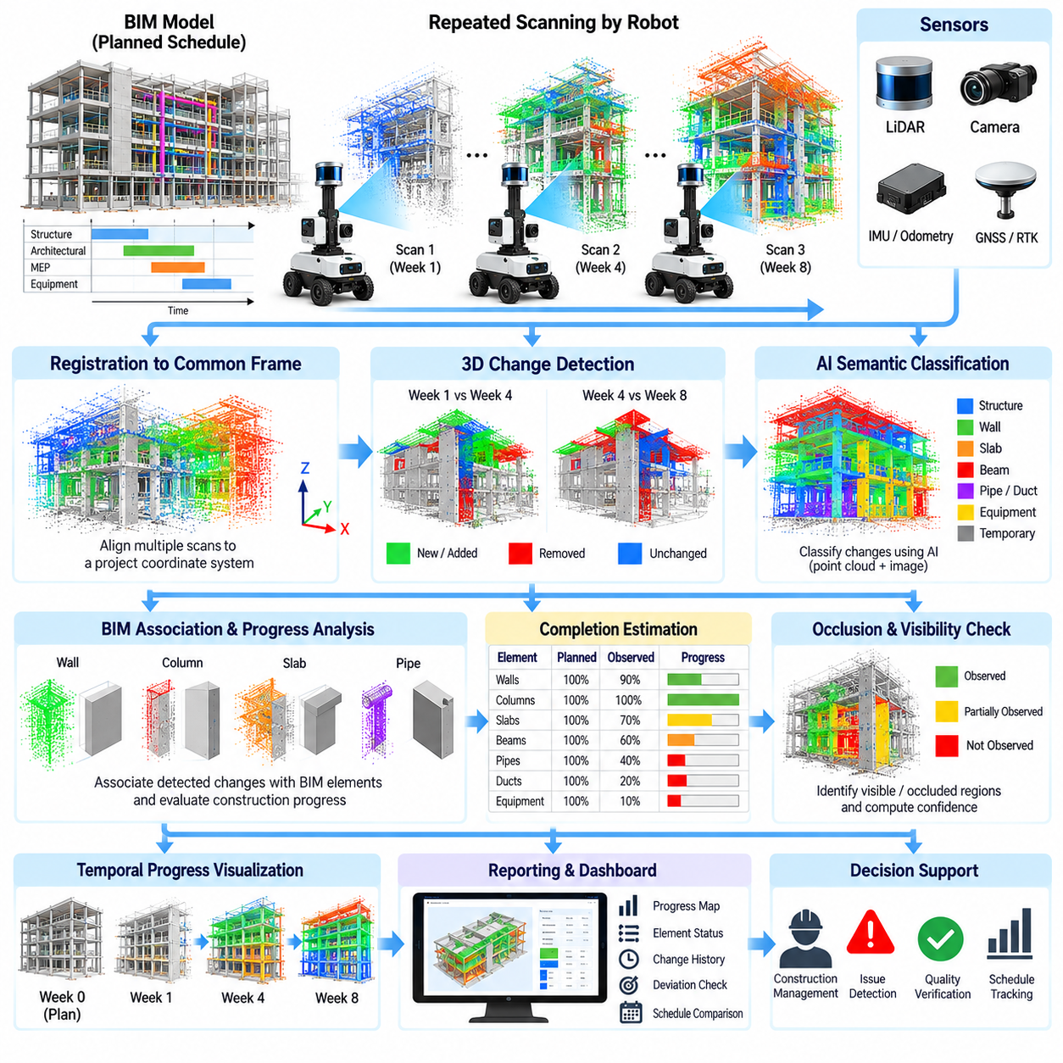
Construction progress monitoring uses repeated observations of a site to determine how physical work evolves over time and whether actual execution follows the planned schedule. In a CAD2SCAN system, autonomous robots can repeatedly capture point clouds and images from comparable locations. These observations create a temporal record of the as-built environment that can be analyzed against BIM geometry, previous scans, and expected construction states.
Traditional progress assessment often depends on manual site walks, photographs, contractor reports, and percentage estimates entered by project personnel. These methods remain useful but can be subjective and difficult to reproduce. Robotic scanning introduces measurable geometric evidence by recording which components are physically present, how much of each element has been constructed, and how the observed state changes between inspection dates.
Reliable temporal analysis requires scans from different missions to share a consistent coordinate system. Each new point cloud should be registered to stable project references or a common BIM frame before change detection begins. Otherwise, small localization or registration errors may appear as physical movement. Stable structural surfaces and surveyed control points can provide long-term references even when temporary construction conditions change significantly.
Change detection compares spatial observations collected at different times and identifies regions where geometry has appeared, disappeared, or changed. Newly observed surfaces may represent completed construction, delivered equipment, temporary materials, or unexpected objects. Disappearing geometry may correspond to removed formwork, relocated equipment, demolished elements, or previous occlusions. Interpretation therefore requires more than geometric differencing alone.
A basic three-dimensional change detector measures distances between points or surfaces in two registered scans. Regions whose differences remain below a selected threshold can be treated as unchanged, while larger differences become change candidates. Voxel occupancy comparison provides another representation by identifying cells that transition between empty, occupied, and unknown states. These methods provide useful geometric evidence but do not automatically explain the meaning of a detected change.
BIM provides the semantic context required to convert spatial change into construction progress. Instead of asking only whether geometry has changed, the system can determine whether a planned wall, column, beam, slab, pipe, duct, or equipment component has become observable at its expected location. Each detected geometric region can be associated with BIM element identifiers, construction zones, work packages, disciplines, and scheduled activities.
Component completion cannot always be determined from simple presence or absence. A wall may be partially constructed, a pipe run may be incomplete, or only one portion of a slab may be visible. Coverage-based metrics can estimate how much of the expected BIM geometry is supported by observed points. Surface coverage, occupied volume, geometric completeness, and confidence values can therefore provide more informative progress estimates than a binary installed/not-installed classification.
Artificial intelligence can improve change interpretation when geometric rules are insufficient. Learned models can classify point-cloud regions, image observations, or fused multimodal features into construction-related categories. Semantic segmentation can distinguish structural components from workers, machinery, stored materials, and temporary objects, reducing the probability that ordinary site activity is incorrectly interpreted as permanent construction progress.
Three-dimensional neural networks can operate on points, voxels, sparse tensors, or projected representations of the scanned environment. Depending on available training data, a model may perform semantic segmentation, object detection, instance recognition, or direct change classification. For large construction scenes, sparse representations are particularly useful because most of the surrounding three-dimensional volume contains no measured geometry and should not consume unnecessary computation.
Image information can complement point-cloud analysis when geometric evidence alone is ambiguous. RGB images may reveal material appearance, component boundaries, labels, surface finishes, or construction states that are difficult to infer from geometry. When cameras and LiDAR are calibrated, visual features can be projected into the same spatial reference, enabling multimodal analysis that combines geometric structure with visual semantics.
Temporal AI models can analyze sequences rather than treating each scan independently. Features from multiple inspection dates can be compared to determine whether an observed component is newly installed, unchanged, removed, or progressively completed. Temporal consistency also helps reject short-lived objects because a material pallet or vehicle that appears in one scan and disappears later should not normally be interpreted as permanent project progress.
Occlusion remains one of the most difficult problems in automated progress monitoring. Failure to observe a BIM element does not necessarily mean that the element is missing. It may be hidden behind temporary materials, equipment, scaffolding, or another completed component. Visibility analysis based on sensor poses, BIM geometry, and ray tracing can identify regions that should have been observable and separate them from areas where no reliable progress conclusion can be made.
Confidence estimation should accompany automated progress decisions. Confidence can depend on scan coverage, point density, sensor range, incidence angle, registration quality, semantic classification probability, temporal consistency, and visibility. A component supported by dense observations from multiple viewpoints can receive high confidence, while a partially occluded element observed at poor geometry should remain uncertain rather than being forced into a definitive completion state.
Progress states can be mapped to project schedules when BIM elements are associated with planned activities. A component detected as completed can update the evidence associated with its construction task, while missing expected geometry can indicate potential delay. This does not mean that geometric completion alone proves contractual completion, because inspections, testing, documentation, and commissioning may also be required before an activity is formally accepted.
Schedule comparison becomes more useful when actual physical progress is evaluated against a time-dependent expected model. The system can determine which components were planned to exist by the scan date and compare that expected state with observed geometry. Elements completed earlier than planned, on schedule, late, or not yet verifiable can then be distinguished, allowing spatial sensing data to support project-control decisions.
Change detection should also identify unexpected modifications after installation. A component that was previously verified but later moves, disappears, or changes shape may indicate rework, damage, temporary removal, or a design modification. Maintaining temporal histories at the BIM-element level allows the system to distinguish normal construction progression from reversals and unusual state transitions that require investigation.
False change detection can result from sensor noise, registration drift, different viewing angles, changing point density, reflective surfaces, or incomplete observations. Robust processing should therefore use spatial thresholds, neighborhood consistency, repeated observations, and uncertainty models rather than classifying isolated differences as meaningful events. Multi-date confirmation can further reduce false alarms caused by transient site conditions.
Progress analysis should preserve the provenance of each conclusion. For every BIM element, the system can record the source scans, acquisition dates, robot poses, coverage measurements, change-detection results, AI model version, classification confidence, and applicable BIM revision. Such traceability allows project personnel to review why an element was classified as completed, incomplete, changed, or uncertain.
Human review remains important for high-impact findings. Automated systems can prioritize components with significant schedule deviations, unexpected geometry, low confidence, or suspected rework and present the supporting spatial evidence to engineers. Human decisions can then confirm, reject, or modify machine-generated assessments. Reviewed outcomes can also become labeled data for improving future AI models and project-specific decision rules.
Repeated robotic missions create a closed-loop monitoring process. The current scan updates the known construction state, uncertain regions generate requests for additional observations, and the next autonomous mission can prioritize those locations. This connects progress analytics with scan-path planning so that sensing resources are directed toward areas where additional information has the greatest value for project management.
At project scale, progress information can be aggregated from individual BIM elements to rooms, floors, zones, disciplines, work packages, or milestones. The aggregation should preserve confidence and observability so that incomplete sensing is not mistaken for incomplete construction. Spatial dashboards and reports can then summarize progress while retaining links to the detailed geometric evidence underlying each higher-level indicator.
Within the CAD2SCAN workflow, AI-based change detection transforms repeated registered scans into temporal knowledge about construction execution. BIM supplies the expected structure and semantics, robotic scanning provides objective field observations, and temporal analysis identifies how the physical site evolves. The resulting information supports progress monitoring, deviation investigation, rescan planning, data management, and automated construction reporting in subsequent stages.

06.07. Scan Data Management and BIM Integration [w/Code]
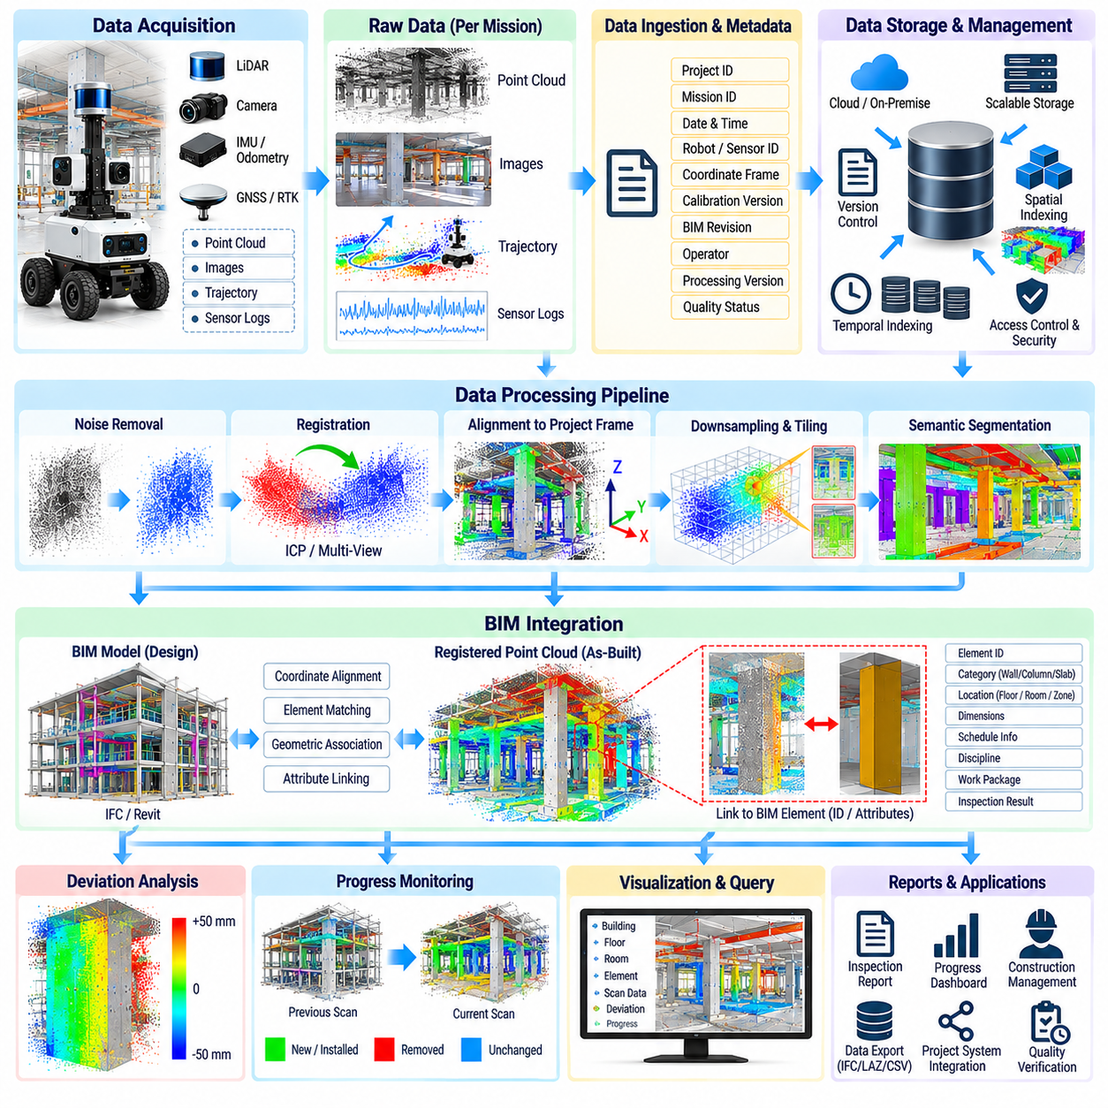
Scan data management provides the information infrastructure required to transform large collections of robotic measurements into persistent construction records. A CAD2SCAN platform may generate point clouds, images, trajectories, localization states, calibration files, quality metrics, and analysis results during every mission. These datasets must remain organized and traceable so that engineers can reliably connect field observations with BIM elements and project decisions.
Raw sensor data should be preserved separately from processed products whenever practical. Original LiDAR measurements, camera images, IMU data, robot trajectories, and sensor timestamps provide the evidence from which later results are derived. Processed point clouds, registered maps, deviation results, semantic labels, and reports can then be regenerated when algorithms, calibration parameters, or engineering requirements change without losing the original measurement record.
Metadata is essential for making scan datasets understandable beyond the mission in which they were collected. Each dataset can include project identifier, robot and sensor identifiers, acquisition date, mission identifier, coordinate frame, calibration version, BIM revision, operator information, processing software version, and quality status. Consistent metadata enables automated search, filtering, comparison, and long-term interpretation of construction measurements.
Coordinate-system information must be treated as managed data rather than an undocumented assumption. Raw scans may originate in sensor frames, robot frames, SLAM maps, surveyed site coordinates, or global reference systems. The transformations connecting these frames should be stored with their source, timestamp, accuracy, and version. This prevents valid geometry from becoming unusable because the spatial reference required to interpret it has been lost.
Point clouds can become extremely large when autonomous robots repeatedly scan buildings at high resolution. Efficient storage therefore requires suitable data structures, compression, spatial partitioning, and multiple levels of detail. Dense source data can be retained for engineering verification, while downsampled or tiled representations support rapid visualization and interactive analysis without repeatedly loading an entire project-scale point cloud.
Spatial indexing allows applications to retrieve only the data associated with a requested region. A building can be divided by floor, zone, room, grid cell, voxel hierarchy, or BIM component boundary. When an engineer investigates a specific column or pipe section, the system can load nearby measurements rather than searching every point in the project. This becomes increasingly important as repeated missions accumulate months or years of scan history.
Temporal indexing is equally important because construction scanning records an evolving environment. Data should be searchable by acquisition date, construction phase, mission, BIM revision, and processing state. Maintaining separate observations for different dates allows the system to reconstruct historical site conditions, perform change detection, verify corrective work, and distinguish current geometry from obsolete measurements.
Data provenance records how each derived product was created. A registered point cloud should reference its source scans, registration transformations, processing parameters, software version, and quality metrics. A deviation result should additionally identify the BIM model and tolerance configuration used for comparison. Provenance allows engineers to reproduce an analysis and determine why results changed after a software or model update.
BIM integration connects geometric measurements with the semantic structure of the construction project. BIM elements contain identities and attributes describing walls, columns, slabs, beams, pipes, ducts, equipment, spaces, systems, and other objects. By associating scan regions and analysis results with these element identifiers, CAD2SCAN converts point-cloud geometry into information that can participate directly in construction management workflows.
The connection between BIM and scan data requires a reliable spatial transformation. The BIM model and registered point cloud must share compatible origins, axes, units, orientation, and elevation references. Survey control, known structural features, or verified transformations can establish this relationship. The transformation should be versioned because project coordinate definitions or imported model configurations may change during a long construction program.
BIM model versions must be managed together with scan versions. A scan acquired on a particular date should normally be analyzed against the design revision applicable at that time. If the current BIM model is later revised, historical comparisons should not silently inherit the new geometry. Preserving the relationship between scan date and BIM revision prevents design changes from being incorrectly interpreted as construction errors.
Element-level linking provides a practical bridge between geometric and semantic information. A group of measured points can be associated with a specific BIM globally unique identifier or equivalent project identifier. Registration quality, coverage, deviation statistics, progress state, confidence, and inspection status can then be stored as attributes or linked records associated with that element without modifying the original sensor measurements.
Open and interoperable data formats are valuable when information must move between robotic software, BIM platforms, engineering tools, and project databases. Point-cloud formats may store coordinates, intensity, color, normals, classifications, and timestamps, while BIM exchange mechanisms preserve object geometry and semantics. Integration software should translate between representations without discarding the metadata needed for engineering traceability.
An application programming interface can expose scan and BIM information to other project systems. Services may provide access to missions, point-cloud regions, BIM elements, deviation results, progress states, and quality metrics. Instead of copying entire datasets between applications, project tools can request only the information required for visualization, inspection, reporting, or analytics, reducing duplication and synchronization problems.
A common data model simplifies relationships among robots, scans, spatial regions, BIM components, processing results, and project activities. The model can represent which robot collected a dataset, which coordinate transformation was applied, which BIM elements were observed, and which analysis generated a finding. Explicit relationships make CAD2SCAN information suitable for database queries and automated downstream processing.
Large projects benefit from separating object storage from searchable metadata. High-volume point clouds, images, and raw sensor files can reside in scalable file or object storage, while a database maintains mission records, BIM identifiers, timestamps, spatial indices, processing states, and result references. This architecture allows applications to discover relevant information quickly without placing massive binary datasets directly inside transactional databases.
Edge and cloud resources can divide the data-management workload. The robot or nearby edge computer can perform initial validation, temporary buffering, compression, and selected preprocessing immediately after acquisition. Larger datasets can then be transferred to project servers or cloud infrastructure for long-term storage, global registration, BIM comparison, AI analysis, and collaborative access according to project connectivity and security requirements.
Reliable transfer mechanisms are necessary because construction sites may have unstable wireless connectivity. Scan data should not be considered safely uploaded until integrity checks confirm successful transfer. Interrupted uploads can resume from known states, while local buffering prevents data loss during network outages. Checksums, dataset identifiers, and transfer logs help ensure that files stored centrally are identical to those produced by the scanning system.
Access control and cybersecurity become important when scan data contains detailed information about buildings, infrastructure, equipment, or restricted project areas. Users and software services should receive only the permissions required for their roles. Authentication, authorization, encryption, audit logs, backup policies, and retention rules should therefore be integrated into the data architecture rather than added only after deployment.
Quality status should travel with the data throughout its lifecycle. A scan can be marked according to coverage, localization confidence, registration quality, sensor health, or processing completeness. Downstream applications should be able to distinguish verified engineering data from preliminary or low-confidence observations. This prevents uncertain measurements from being unintentionally used as authoritative evidence in BIM comparison or reporting.
Lifecycle management determines how long different data products should be retained and when they can be archived or regenerated. Raw measurements may require long-term preservation for traceability, while temporary intermediate products can sometimes be recreated from source data. Retention policies should consider contractual requirements, storage cost, future reprocessing needs, commissioning, facility management, and potential digital-twin applications.
Integrated scan and BIM repositories also support collaboration. Designers, contractors, inspectors, and project managers can reference the same spatial evidence while viewing it through discipline-specific applications. A detected deviation can remain linked to its BIM component, supporting point cloud, scan date, and analysis result as it moves through review and corrective-action workflows. This reduces ambiguity caused by disconnected screenshots and manually exchanged files.
Within the CAD2SCAN workflow, scan data management and BIM integration create the persistent information layer connecting robotic acquisition with engineering use. Well-managed coordinates, metadata, versions, provenance, spatial indices, and semantic links allow measurements to remain meaningful throughout the project lifecycle. This foundation enables reliable progress monitoring, safety-aware field operation, automated reporting, historical analysis, and future reuse of construction scan data.

06.08. Construction Site AMR Safety and Navigation [w/Code]
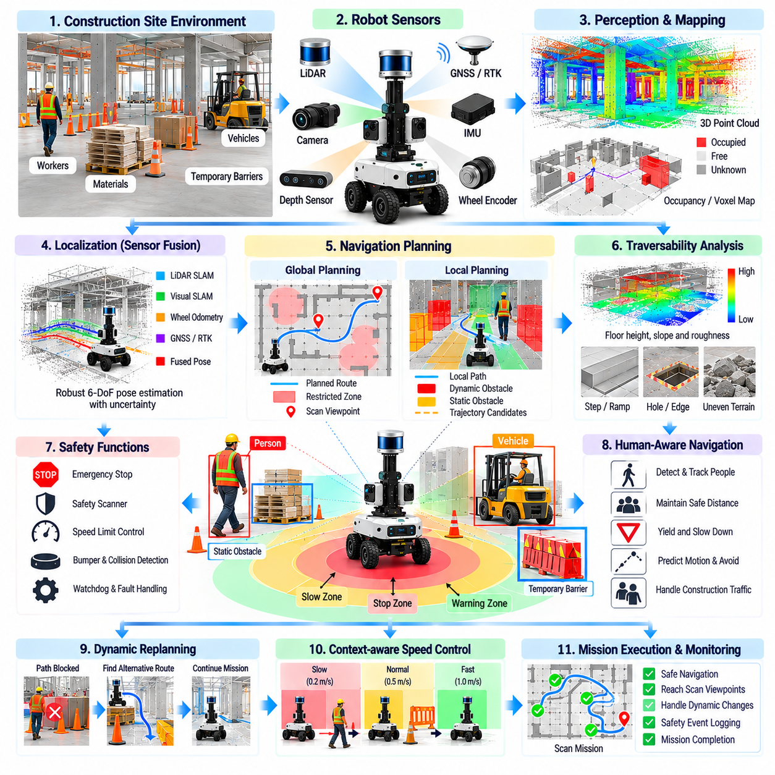
Construction-site AMRs operate in environments that are substantially less structured than warehouses or factories. Floors may be unfinished, pathways can change daily, materials occupy temporary locations, and workers and heavy equipment move unpredictably. A scanning AMR must therefore combine autonomous navigation with safety mechanisms that continuously evaluate whether planned motion remains acceptable under current site conditions.
Navigation begins with an environmental representation suitable for robot motion. LiDAR, depth cameras, wheel encoders, IMUs, and other sensors can generate occupancy grids, voxel maps, elevation maps, or local obstacle representations. Unlike a static facility map, the construction map should support frequent updates because walls, temporary barriers, stored materials, openings, and accessible corridors may change as construction progresses.
Localization must remain reliable despite these environmental changes. LiDAR SLAM, visual-inertial methods, wheel odometry, GNSS/RTK in suitable outdoor areas, and surveyed landmarks can contribute complementary pose information. Sensor fusion reduces dependence on any single source, while localization confidence should be monitored so that the AMR can slow down, stop, or request recovery when its estimated pose becomes unreliable.
Construction environments frequently contain repetitive or weak geometric features that challenge localization. Long corridors, unfinished concrete surfaces, repeated columns, glass, dust, and changing objects can reduce feature quality. The navigation system should recognize localization degradation and avoid continuing normal autonomous operation when accumulated uncertainty could cause the robot to enter an incorrect corridor, scan location, or restricted region.
Global path planning determines a route from the current robot pose to a scan location while considering the known site layout. The planner can use occupancy and cost maps to avoid permanent structures, restricted areas, hazardous zones, and regions with insufficient clearance. For CAD2SCAN missions, the route should also support efficient access to viewpoints selected by the autonomous scan-path planner rather than optimizing transportation alone.
Local navigation continuously modifies robot motion in response to nearby obstacles and environmental changes. Workers, carts, forklifts, construction vehicles, pallets, cables, tools, and temporary barriers may appear after the global route has been planned. Local planners use current sensor observations to adjust velocity and trajectory while preserving safe clearance and attempting to make progress toward the assigned scan destination.
Traversability analysis is especially important on unfinished construction surfaces. A region that appears empty in a two-dimensional occupancy map may still be unsafe because of steps, holes, steep ramps, debris, floor edges, or uneven terrain. Three-dimensional sensing and elevation analysis can estimate surface height, slope, roughness, and discontinuities so that the robot distinguishes geometrically free space from physically traversable space.
Negative obstacles require particular attention because they may not generate the same sensor response as ordinary objects. Stair openings, floor edges, pits, trenches, and incomplete slabs can create severe hazards for a mobile robot. Downward-looking sensors, depth cameras, 3D LiDAR, dedicated edge detectors, or mapped exclusion zones can provide additional protection where conventional horizontal obstacle detection is insufficient.
Safety should be implemented independently of high-level mission logic wherever practical. Emergency stops, safety-rated scanners, bumpers, motor-controller limits, watchdogs, and protective stop functions can prevent motion even if navigation or application software fails. The scanning mission should never be able to override fundamental protective mechanisms merely to reach a desired observation location or complete a scheduled inspection.
Protective zones can vary according to robot speed and operating context. At higher speeds the system requires greater stopping distance, while movement near workers, narrow passages, or scanning equipment may require lower speed limits. Dynamic safety fields can expand or contract around the robot according to velocity and direction, allowing efficient movement in open areas while maintaining conservative behavior in constrained environments.
Human-aware navigation is essential because construction sites are shared workspaces rather than robot-only environments. The AMR should detect nearby people, predict short-term movement when possible, and avoid trajectories that pass uncomfortably close to workers. Conservative yielding behavior is generally preferable to assuming that a worker will move out of the robot's path, particularly when visibility, noise, or site activity reduces mutual awareness.
Heavy construction equipment creates different risks from pedestrians. Forklifts, excavators, lifts, trucks, and material-handling machines may have large blind spots and complex motion patterns. The AMR should maintain larger separation distances from such equipment and may need to avoid designated traffic zones entirely. Site maps can encode vehicle lanes, crossing points, restricted periods, and one-way travel rules when these constraints are known.
Speed management should reflect both geometric and semantic risk. Open corridors with high localization confidence may permit normal travel speed, while crowded areas, blind corners, ramps, narrow passages, or low-confidence localization should trigger slower motion. Context-dependent speed policies provide a practical connection between perception, navigation uncertainty, site rules, and the physical stopping capability of the AMR.
Dynamic replanning is necessary when the planned route becomes blocked. The navigation system can first search for a safe local detour and, if none exists, request a new global path. When a scan viewpoint itself becomes inaccessible, mission management can coordinate with scan-path planning to select an alternative viewpoint. The robot should distinguish temporary blockage from persistent inaccessibility so that it does not repeatedly attempt an unsafe route.
Recovery behaviors should be designed conservatively for construction environments. Standard actions such as rotating in place or backing away may be inappropriate near floor edges, workers, or narrow passages. Recovery should consider local free space, safety zones, recent sensor history, and localization confidence. If a safe autonomous recovery cannot be established, the robot should enter a controlled stopped state rather than attempting increasingly aggressive maneuvers.
Navigation maps should distinguish temporary obstacles from persistent changes when possible. A pallet encountered during one mission may disappear later, while a newly constructed wall may represent a permanent modification to the environment. Repeated observations and temporal map management can help determine whether an obstacle should influence only immediate local planning or update the longer-term map used by future scanning missions.
BIM and construction planning information can supplement sensor-based navigation. Known walls, rooms, floor boundaries, work zones, and planned structural changes provide useful prior information, while live sensing determines the current traversable state. The robot should not treat BIM geometry as unquestionable ground truth because the physical site may differ from the design or may be incomplete at the time of operation.
Mission-level safety also includes energy, communications, and system health. The AMR should track battery state, sensor status, computing load, storage capacity, network availability, and actuator faults while executing scanning tasks. A mission should be interrupted or shortened when the remaining resources are insufficient to complete the work and return to a designated safe location with an appropriate reserve.
Communication loss should not immediately create unsafe behavior. Essential obstacle avoidance, protective stopping, and low-level motion control should continue locally without dependence on a remote server. Depending on the operating policy, prolonged communication loss may cause the AMR to stop safely, return to a known location, or wait for connectivity. Remote connectivity should enhance supervision without becoming a single point of safety failure.
Safety events and navigation decisions should be recorded for later analysis. Logs can include protective stops, emergency-stop activation, obstacle encounters, localization degradation, route replanning, inaccessible viewpoints, speed reductions, and recovery attempts. Combined with timestamps and robot poses, these records support incident investigation, navigation improvement, and verification that the system operated according to defined safety policies.
Deployment should include systematic validation under representative construction conditions. Navigation tests can examine narrow passages, dynamic pedestrians, temporary obstacles, ramps, low-feature areas, changing layouts, communication loss, localization failure, and emergency stopping. Testing should verify not only whether the AMR reaches its destination but also whether it transitions to a safe state when assumptions required for autonomous operation are violated.
Within the CAD2SCAN workflow, construction-site AMR safety and navigation provide the operational foundation that allows autonomous scanning to occur in a changing human workspace. Reliable localization and planning deliver the robot to useful scan viewpoints, while traversability analysis and independent protective mechanisms constrain unsafe motion. Together, these capabilities enable repeatable field acquisition without separating inspection performance from worker and robot safety.

06.09. CAD2SCAN Report Generation Automation [w/Code]
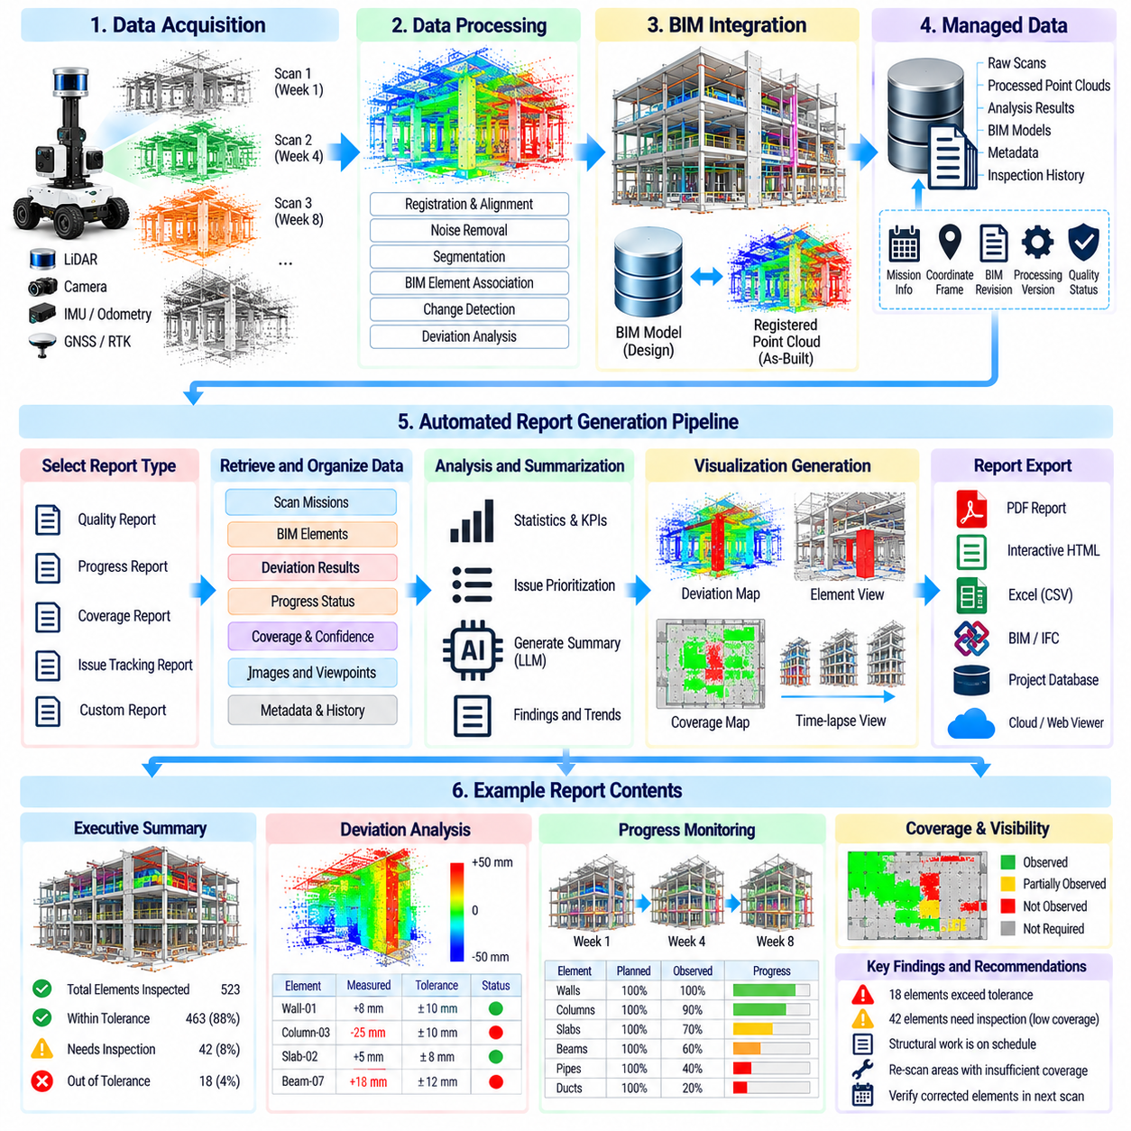
CAD2SCAN report generation automation transforms robotic scanning results into structured engineering documents that can be reviewed, distributed, and archived without manually assembling every measurement. The reporting pipeline connects scan missions, registered point clouds, BIM comparisons, deviation analysis, progress monitoring, and system metadata so that field measurements become understandable evidence for construction quality and project management.
Automated reporting begins with clearly defined report objectives. A quality-control report may emphasize geometric deviations and tolerance violations, while a progress report focuses on installed components and schedule status. Other reports may document scan coverage, inaccessible areas, navigation events, or measurement confidence. A common reporting framework can support these purposes while selecting information appropriate to each audience.
The report generator should obtain information from managed CAD2SCAN data rather than manually copied files whenever possible. Mission identifiers, acquisition dates, robot and sensor information, coordinate references, BIM revisions, registration results, coverage statistics, deviation measurements, and progress states can be retrieved through standardized data interfaces. This reduces transcription errors and maintains consistency between analysis results and published reports.
Traceability is fundamental to automated engineering reporting. Every reported finding should remain connected to the measurement and processing history that produced it. A deviation record can reference its source scan, robot mission, acquisition timestamp, registration transformation, BIM element, tolerance rule, processing software version, and confidence value. This evidence chain allows engineers to investigate a result instead of treating the generated report as an isolated document.
BIM element identifiers provide a natural structure for organizing inspection results. Findings can be grouped by building, floor, zone, room, discipline, work package, or individual component. A report can identify a wall, column, beam, slab, pipe, duct, or equipment object and associate it with measured deviations, scan coverage, progress state, and inspection status. Semantic organization makes large datasets easier to interpret than point-cloud coordinates alone.
Deviation reporting should present both measured values and the engineering rules used to interpret them. Positional offsets, angular differences, dimensional errors, flatness, verticality, or surface-distance statistics can be compared with defined tolerances. The report should indicate whether a result is within tolerance, outside tolerance, or uncertain rather than presenting numerical measurements without the acceptance criteria required to understand them.
Measurement uncertainty should be visible when it materially affects a finding. Scanner accuracy, localization quality, registration residuals, point density, incidence angle, and observation coverage can influence confidence in a reported deviation. If the measured difference is close to the tolerance threshold, the report should preserve this uncertainty instead of presenting an artificially precise pass-or-fail conclusion that exceeds the reliability of the underlying data.
Coverage reporting prevents unobserved regions from being mistaken for verified construction. For each BIM component or inspection area, the system can report the proportion of geometry that was adequately observed. Elements with insufficient coverage can be classified as not verified or requiring additional scanning. This distinction is particularly important when scaffolding, stored materials, equipment, or neighboring structures block the robot's view.
Progress reports can summarize construction state using repeated scan observations and BIM-linked change detection. Components may be classified as observed, partially complete, completed, changed, missing, or uncertain according to project-specific rules. When schedule information is available, actual observed states can be compared with expected states for the inspection date, helping project personnel identify potential delays or unexpected progress.
Temporal reporting can show how findings evolve between scanning missions. A deviation detected during an earlier inspection may later disappear after corrective work, while a previously incomplete component may become fully observed. Maintaining links between related findings allows reports to distinguish newly detected issues, unresolved issues, corrected issues, and recurring problems rather than presenting every inspection as an unrelated snapshot.
Automated issue prioritization helps engineers focus on results that require attention. Findings can be ranked according to deviation magnitude, tolerance exceedance, component importance, schedule impact, confidence, or persistence across multiple scans. Priority rules should remain configurable because the significance of a geometric difference depends on project requirements and the function of the affected construction element.
Report generation can include machine-generated summaries derived from structured analysis results. The system can describe how many elements were inspected, how many exceeded tolerance, which regions had insufficient coverage, and which work packages showed potential schedule discrepancies. Such summaries should be generated from verified data fields so that natural-language descriptions remain consistent with the underlying quantitative evidence.
AI can assist with classification and summarization, but generated statements should remain grounded in measurable results. A language model may convert structured findings into readable engineering descriptions, group related observations, or prepare draft explanations for reviewers. However, it should not invent causes for deviations or claim construction defects when the available scan evidence only demonstrates geometric differences or uncertainty.
Report templates provide consistency across repeated robotic inspections. Standard sections can contain project information, mission metadata, scan quality, registration quality, coverage, deviation findings, progress status, unresolved issues, and conclusions. Templates can be configured for different project stakeholders while retaining a common underlying data model and traceability structure across all generated outputs.
Visual references may be associated with report records even when the core report is generated from numerical data. A finding can reference the relevant point-cloud region, BIM element, scan location, or captured image so that an engineer can inspect the supporting evidence in an external viewer. Maintaining these references is preferable to relying solely on static screenshots because the original spatial data remains available for detailed investigation.
Report automation should support review and approval rather than automatically treating every machine-generated result as final. Draft reports can be routed to engineers who confirm findings, modify classifications, add comments, or reject false detections. Approval status, reviewer identity, review time, and modifications can then become part of the report history, creating an auditable workflow for construction inspection.
Version control is necessary because scan processing, BIM models, tolerance configurations, and findings can change. A regenerated report should identify the exact data and software versions used to produce it. If a BIM revision or improved registration changes a deviation result, the system should preserve the earlier report and create a new version rather than silently replacing historical evidence.
Report generation can be triggered automatically after predefined workflow events. Completion of a robotic scan mission may initiate data validation, registration, BIM comparison, deviation analysis, progress analysis, and report preparation. Quality gates can prevent report publication when registration fails, coverage is insufficient, required metadata is missing, or processing remains incomplete, ensuring that automation does not bypass essential validation.
Notifications and project-system integration can distribute approved findings to the appropriate stakeholders. High-priority deviations may create inspection tasks, while progress results can update project dashboards or coordination systems. Integration should transfer structured identifiers and evidence references together with human-readable descriptions so that downstream systems retain the connection to the original CAD2SCAN measurements.
Automated reporting also supports statistical analysis across many missions. Repeated records can reveal frequently failing component types, areas with persistent scan-coverage problems, recurring registration difficulties, or work packages associated with repeated deviations. These trends can help improve construction processes, robotic scan planning, tolerance configuration, and quality-control strategies beyond the individual inspection event.
Security and access control should apply to generated reports as well as raw scan data. Reports may contain detailed building geometry, construction status, quality issues, equipment information, or restricted site locations. Distribution rules, user permissions, audit logs, retention policies, and controlled export mechanisms help ensure that automation improves information flow without unintentionally exposing sensitive project information.
Long-term archiving should preserve both the human-readable report and the structured evidence required to reproduce its conclusions. Future project teams may need to verify why a component was accepted, investigate a later defect, support commissioning, or compare construction records with facility conditions. Maintaining links to scans, BIM revisions, processing configurations, and approval history increases the long-term value of CAD2SCAN documentation.
Within the CAD2SCAN workflow, automated report generation is the final translation layer between robotic perception and actionable engineering communication. It converts registered scans, BIM-linked deviations, progress states, quality metrics, and traceable metadata into consistent project records. By combining automation with confidence information, version control, and human approval, the system can accelerate reporting while preserving the evidence required for responsible construction decisions.

06.10. Construction Scanning Robot Field Case
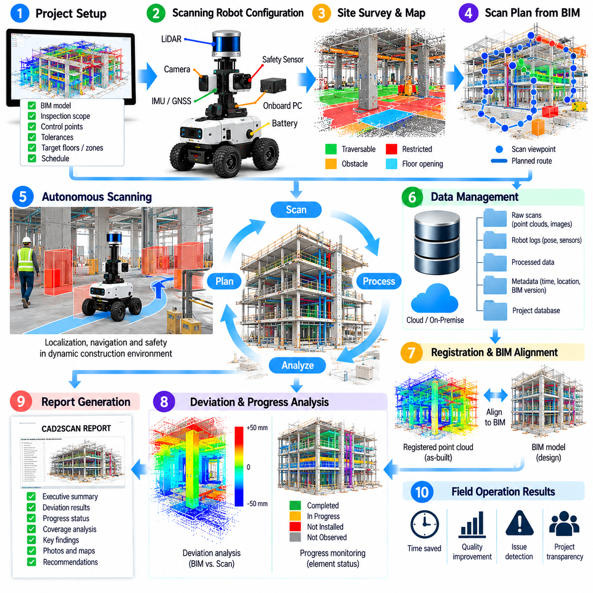
A construction scanning robot field deployment demonstrates how CAD2SCAN functions become an integrated operational workflow rather than isolated algorithms. The field system combines an AMR, LiDAR, cameras, localization sensors, onboard computing, safety devices, and BIM-connected software. Its objective is to repeatedly capture the evolving construction environment and convert physical observations into traceable engineering information.
Before deployment, the project team defines the inspection scope and establishes the relationship between the digital design and physical site. Relevant BIM models, coordinate references, survey control points, target floors, inspection zones, and tolerance requirements are prepared. Scan objectives may include structural verification, installation progress, dimensional inspection, or collection of evidence for later construction-quality review.
The robotic platform is configured according to site conditions. A mobile base carries the primary 3D scanner together with cameras, IMU, wheel encoders, safety sensors, and computing hardware. Sensor mounting positions are calibrated relative to the robot coordinate frame so that measurements can be transformed consistently. Battery capacity, storage, network connectivity, and scanner operating range are also verified before field operation.
An initial site survey identifies traversable corridors, ramps, narrow passages, floor openings, restricted areas, material-storage zones, and regions shared with workers or vehicles. These observations are used to create or validate navigation maps and safety constraints. Because construction layouts change frequently, the initial map is treated as a starting reference rather than a permanent representation of the physical environment.
The BIM model provides prior information about expected geometry and inspection targets. Walls, columns, slabs, beams, mechanical systems, rooms, and other relevant elements can be associated with spatial regions requiring observation. The system then converts inspection requirements into candidate scan viewpoints while considering sensor range, field of view, expected occlusion, robot clearance, and required point density.
The mission planner organizes selected viewpoints into an executable route. Travel distance, scan duration, overlap between neighboring observations, localization reliability, and safety restrictions influence the sequence. High-resolution stationary scans may require the robot to stop and stabilize at each viewpoint, while continuous scanning missions coordinate robot velocity with sensor acquisition to control point density and motion distortion.
During autonomous travel, the AMR continuously localizes itself and monitors nearby obstacles. Workers, temporary barriers, pallets, equipment, cables, and construction vehicles can invalidate the originally planned route. Local navigation modifies the trajectory when safe alternatives exist, while global replanning is used when a larger route change is necessary. Unsafe or inaccessible areas are recorded rather than forcing the robot to complete every planned viewpoint.
Safety functions operate throughout the mission independently of the inspection objective. Protective scanners, emergency stops, speed limits, bumpers, watchdogs, and restricted zones constrain robot motion. Additional attention is required around floor edges, openings, ramps, and heavy equipment. If localization confidence or sensor health falls below an acceptable level, the system can stop or suspend autonomous operation instead of continuing with uncertain state information.
At each scan location, the system records not only the geometric measurements but also the context required to interpret them. Robot pose, sensor timestamps, calibration version, mission identifier, coordinate frame, scan parameters, and quality indicators accompany the point cloud and images. This metadata becomes essential when measurements from multiple viewpoints and different inspection dates are later combined.
Field data quality is evaluated as early as possible. The robot can check sensor availability, point density, expected coverage, motion effects, localization confidence, and storage status before leaving an inspection region. Detecting an incomplete scan immediately allows the mission planner to repeat an observation or select an alternative viewpoint, reducing the cost of discovering missing evidence after the robot has left the site.
Individual scans are transformed into a common coordinate system and registered to create a consistent site representation. Robot localization provides an initial alignment, while geometric registration refines the relationship between overlapping observations. Stable structural surfaces and surveyed references can constrain the solution. Registration residuals and overlap statistics are recorded so that downstream analysis can distinguish reliable alignment from uncertain results.
The registered point cloud is then aligned with the BIM coordinate system. Survey control, known reference geometry, or previously verified transformations establish the connection between measured and designed space. Before automated comparison, the field team verifies units, axes, elevation, orientation, and BIM revision. A coordinate error at this stage could produce widespread false deviations even when the physical construction is correct.
BIM-to-point-cloud analysis evaluates the observed geometry against expected components. Surface distances, positional offsets, angular differences, dimensional measurements, flatness, or verticality can be calculated according to the element type. Results are associated with BIM identifiers and applicable tolerance rules, allowing engineers to identify which components appear compliant, which exceed limits, and which require further investigation.
The field case also demonstrates the importance of separating deviation from insufficient observation. Scaffolding, stored materials, neighboring components, and temporary equipment may prevent the scanner from seeing part of an element. Visibility and coverage analysis identify these regions so that the system can classify them as unverified rather than defective. Additional scan viewpoints can then be scheduled when the missing evidence is important.
When the site is scanned repeatedly, temporal comparison provides construction-progress information. Newly observed geometry can indicate installed components, while increased coverage of an existing BIM element may indicate continued construction. The system compares current scans with earlier observations and expected BIM states, allowing progress information to be associated with floors, zones, components, work packages, or planned activities.
AI-based analysis can assist in distinguishing permanent construction from temporary site activity. Semantic segmentation or object recognition can identify workers, vehicles, equipment, stored materials, and structural components within sensor data. Temporal consistency further reduces false progress events because an object that appears briefly and disappears during later scans is less likely to represent completed permanent construction.
A practical field deployment inevitably encounters failures and exceptions. Routes may become blocked, localization may degrade, scan viewpoints may be inaccessible, network connectivity may disappear, or registration may fail because of insufficient overlap. Rather than hiding these conditions, the system records them as mission outcomes and applies defined recovery procedures such as replanning, rescanning, returning to a known pose, or requesting operator review.
Data collected during the mission is transferred into the project information infrastructure with integrity checks and traceable identifiers. Raw scans are retained separately from registered and analyzed products, while metadata links each result to its source mission. BIM revision, processing parameters, software versions, quality metrics, and approval status are preserved so that engineering findings can later be reproduced or reprocessed.
Automated reporting converts the analyzed field data into information suitable for project personnel. Reports can summarize scanned areas, coverage, registration quality, deviations, progress states, uncertain findings, and locations requiring rescanning. High-priority results remain connected to their BIM components and source measurements so that engineers can move from a report-level finding back to the underlying spatial evidence.
Human review remains an important stage of the field workflow. Engineers examine significant tolerance violations, uncertain measurements, unexpected geometry, and potential schedule discrepancies before formal acceptance or corrective action. Reviewer decisions can confirm, modify, or reject automated findings. These decisions become part of the inspection history and can improve project-specific analysis rules and future AI models.
Repeated deployment creates a closed-loop inspection process. Findings from one mission influence the next mission by identifying poorly observed regions, unresolved deviations, changing access conditions, and components requiring confirmation. The robot can prioritize these locations during later scans, allowing sensing resources to focus on areas where additional information has the greatest engineering value.
Operational performance should also be evaluated independently from geometric inspection accuracy. Useful metrics include mission completion rate, autonomous travel distance, intervention frequency, inaccessible viewpoint rate, scan coverage, localization failures, protective stops, data-transfer success, processing time, and report turnaround. These measurements reveal whether the complete robotic workflow is practical for repeated construction-site operation.
The field case illustrates that successful CAD2SCAN deployment depends on integration across robotics, sensing, BIM, data management, safety, analysis, and human decision-making. Accurate scanning alone is insufficient if the robot cannot safely reach viewpoints or if results cannot be traced to project information. An integrated workflow transforms repeated robotic observations into reliable evidence for construction verification, progress monitoring, corrective action, and long-term digital records.

