EVALUATION REPORT

Maintenance

21 respondents • 3 first-time attendees (14%)

[ DEMONSTRATION REPORT — SYNTHETIC DATA ONLY ]

Question 2: Top Safety Topics
Respondents selected up to four safety topics they want to hear about at future meetings. Topics ranked by total selections.
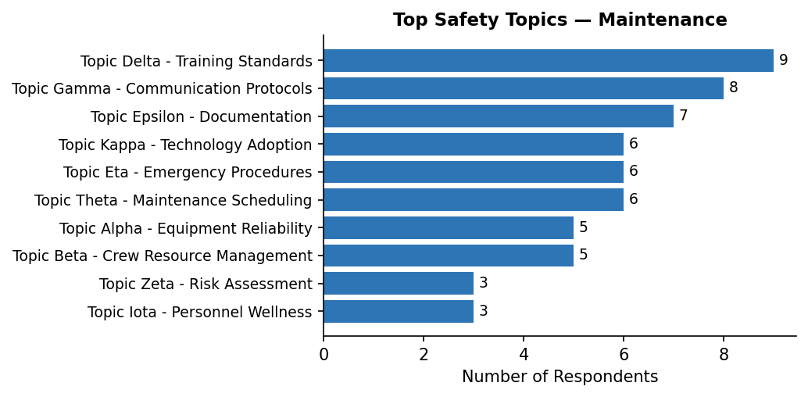

Question 3: Safety Concern
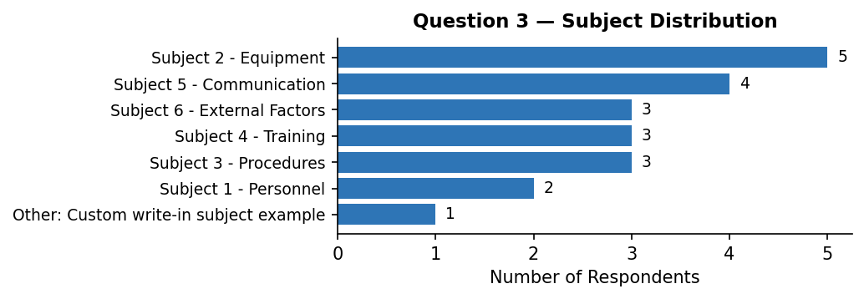

Topics chosen within each subject:
Other: Custom write-in subject example
Other: Software glitch in console | 1
Subject 1 - Personnel
Workload distribution | 1
Other | 1
Subject 2 - Equipment
Spare parts availability | 1
Other | 1
Sensor reliability | 1
Software updates | 1
Other: Pilot fatigue concern | 1
Subject 3 - Procedures
Documentation gaps | 1
Checklists | 1
Other: Pilot fatigue concern | 1
Subject 4 - Training
Initial training quality | 2
Cross-training | 1
Subject 5 - Communication
Reporting channels | 2
Other: Communication delay | 1
Other: Pilot fatigue concern | 1
Subject 6 - External Factors
Regulatory changes | 2
Supply chain issues | 1

3b. Further Comments
Communication
[Communication / Inter-team]  Topic: Regulatory changes  Communication between teams could be significantly improved. | [Communication / Inter-team]  Topic: Sensor reliability  Cross-team meetings have been very productive when they occur.
[Communication / Inter-team]  Topic: Regulatory changes  Communication between teams could be significantly improved. | [Communication / Inter-team]  Topic: Reporting channels  Cross-team meetings have been very productive when they occur.
[Communication / Inter-team]  Topic: Workload distribution  Cross-team meetings have been very productive when they occur. | [Communication / Reporting]  Topic: Other  Reporting channels are unclear for non-routine observations.

Equipment
[Equipment / Hardware]  Topic: Initial training quality  Equipment failures have caused minor delays but no safety incidents recently. | [Equipment / Software]  Topic: Initial training quality  New software rollout went smoothly but training was minimal.

External
[External / Supply Chain]  Topic: Software updates  Spare parts inventory is sometimes insufficient for routine maintenance. | [External / Weather]  Topic: Checklists  Weather-related disruptions have been higher than usual this quarter.
[External / Weather]
Topic: Supply chain issues
Weather-related disruptions have been higher than usual this quarter.

Personnel
[Personnel / Fatigue]  Topic: Spare parts availability  We have noticed increased issues related to fatigue among night shift staff. | [Personnel / Workload]  Topic: Other: Pilot fatigue concern  Staffing shortages are creating additional workload pressure.
[Personnel / Workload]
Topic: Cross-training
Staffing shortages are creating additional workload pressure.

Procedures
[Procedures / Documentation]  Topic: Other  Documentation is sometimes unclear and leads to inconsistent practices. | [Procedures / Documentation]  Topic: Other: Pilot fatigue concern  Documentation is sometimes unclear and leads to inconsistent practices.
[Procedures / Documentation]  Topic: Other: Communication delay  Documentation is sometimes unclear and leads to inconsistent practices. | [Procedures / Documentation]  Topic: Documentation gaps  Some checklists are outdated and reference old equipment.

Uncategorized
[Uncategorized / —]  Topic: Reporting channels  We need better tools for tracking maintenance schedules. | [Uncategorized / —]  Topic: Other: Pilot fatigue concern  We need better tools for tracking maintenance schedules.
[Uncategorized / —]
Topic: Other: Software glitch in console
We need better tools for tracking maintenance schedules.

Question 4: Safety Concern
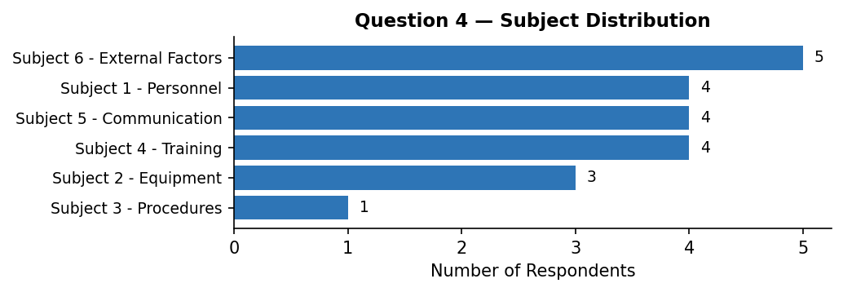

Topics chosen within each subject:
Subject 1 - Personnel
Workload distribution | 2
Other: Training simulator availability | 1
Experience levels | 1
Subject 2 - Equipment
Software updates | 1
Spare parts availability | 1
Aging hardware | 1
Subject 3 - Procedures
Process compliance | 1
Subject 4 - Training
Simulator availability | 3
Cross-training | 1
Subject 5 - Communication
Language barriers | 2
Other: Software glitch in console | 1
Other: Communication delay | 1
Subject 6 - External Factors
Supply chain issues | 2
Public perception | 1
Regulatory changes | 1
Weather impacts | 1

4b. Further Comments
Communication
[Communication / Inter-team]  Topic: Software updates  Communication between teams could be significantly improved. | [Communication / Inter-team]  Topic: Aging hardware  Cross-team meetings have been very productive when they occur.
[Communication / Inter-team]  Topic: Workload distribution  Communication between teams could be significantly improved. | [Communication / Inter-team]  Topic: Other: Communication delay  Cross-team meetings have been very productive when they occur.
[Communication / Inter-team]  Topic: Supply chain issues  Communication between teams could be significantly improved. | [Communication / Inter-team]  Topic: Simulator availability  Cross-team meetings have been very productive when they occur.
[Communication / Inter-team]  Topic: Cross-training  Communication between teams could be significantly improved. | [Communication / Inter-team]  Topic: Weather impacts  Cross-team meetings have been very productive when they occur.

External
[External / Supply Chain]  Topic: Other: Software glitch in console  Spare parts inventory is sometimes insufficient for routine maintenance. | [External / Weather]  Topic: Language barriers  Weather-related disruptions have been higher than usual this quarter.
[External / Supply Chain]  Topic: Other: Training simulator availability  Spare parts inventory is sometimes insufficient for routine maintenance. | [External / Weather]  Topic: Language barriers  Weather-related disruptions have been higher than usual this quarter.

Personnel
[Personnel / Experience]
Topic: Simulator availability
Onboarding for new staff takes longer than expected.

Procedures
[Procedures / Documentation]  Topic: Workload distribution  Some checklists are outdated and reference old equipment. | [Procedures / Documentation]  Topic: Process compliance  Some checklists are outdated and reference old equipment.

Uncategorized
[Uncategorized / —]
Topic: Simulator availability
We need better tools for tracking maintenance schedules.

Question 5: Safety Concern
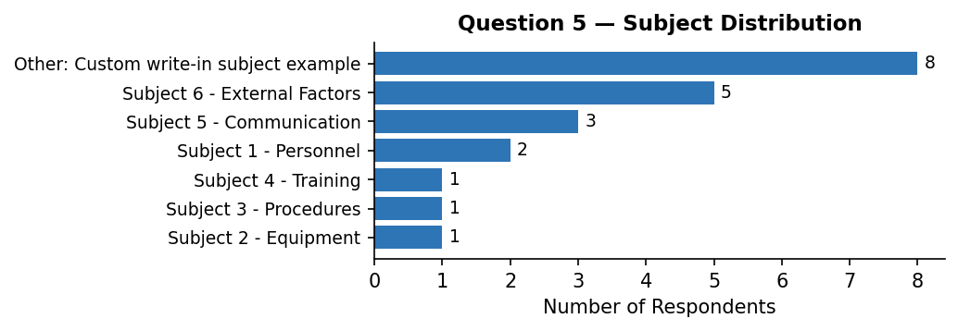

Topics chosen within each subject:
Other: Custom write-in subject example
Other: Training simulator availability | 3
Other | 2
Other: Pilot fatigue concern | 1
Other: Software glitch in console | 1
Other: Communication delay | 1
Subject 1 - Personnel
Fatigue management | 1
Other: Software glitch in console | 1
Subject 2 - Equipment
Other: Software glitch in console | 1
Subject 3 - Procedures
Standard operating procedures | 1
Subject 4 - Training
Simulator availability | 1
Subject 5 - Communication
Reporting channels | 2
Inter-team communication | 1
Subject 6 - External Factors
Supply chain issues | 2
Public perception | 2
Other | 1

5b. Further Comments
Communication
[Communication / Inter-team]  Topic: Other: Software glitch in console  Communication between teams could be significantly improved. | [Communication / Inter-team]  Topic: Inter-team communication  Cross-team meetings have been very productive when they occur.
[Communication / Inter-team]
Topic: Reporting channels
Cross-team meetings have been very productive when they occur.

Equipment
[Equipment / Hardware]  Topic: Other: Training simulator availability  Equipment failures have caused minor delays but no safety incidents recently. | [Equipment / Hardware]  Topic: Other  Equipment failures have caused minor delays but no safety incidents recently.

External
[External / Supply Chain]  Topic: Other: Software glitch in console  Spare parts inventory is sometimes insufficient for routine maintenance. | [External / Weather]  Topic: Fatigue management  Weather-related disruptions have been higher than usual this quarter.
[External / Supply Chain]  Topic: Supply chain issues  Spare parts inventory is sometimes insufficient for routine maintenance. | [External / Weather]  Topic: Other: Software glitch in console  Weather-related disruptions have been higher than usual this quarter.
[External / Weather]  Topic: Other: Training simulator availability  Weather-related disruptions have been higher than usual this quarter. | [External / Weather]  Topic: Reporting channels  Weather-related disruptions have been higher than usual this quarter.

Personnel
[Personnel / Experience]  Topic: Standard operating procedures  Onboarding for new staff takes longer than expected. | [Personnel / Fatigue]  Topic: Other: Training simulator availability  We have noticed increased issues related to fatigue among night shift staff.
[Personnel / Experience]  Topic: Other  Onboarding for new staff takes longer than expected. | [Personnel / Workload]  Topic: Simulator availability  Workload during peak periods is unsustainable without changes.

Procedures
[Procedures / Compliance]
Topic: Other
Training programs need to be updated to reflect new procedures.

Uncategorized
[Uncategorized / —]
Topic: Public perception
We need better tools for tracking maintenance schedules.

Question 6: How can we evolve to make this more valuable?
Equipment
[Equipment / Software]  Focus more on practical applications and less on theory. | [Equipment / Software]  Focus more on practical applications and less on theory.

Event Feedback
[Event Feedback / Content]  The presentation slides could be made available in advance. | [Event Feedback / Format]  More time for networking would be valuable.
[Event Feedback / Format]  Add more interactive sessions to break up the day. | [Event Feedback / Format]  Smaller breakout groups would encourage more participation.
[Event Feedback / Format]  Add more interactive sessions to break up the day. | [Event Feedback / Format]  Smaller breakout groups would encourage more participation.
[Event Feedback / Format]  Add more interactive sessions to break up the day. | [Event Feedback / Format]  Smaller breakout groups would encourage more participation.
[Event Feedback / Format]  Consider hybrid attendance options for those who can't travel. | [Event Feedback / Format]  Smaller breakout groups would encourage more participation.
[Event Feedback / Format]  More time for networking would be valuable. | [Event Feedback / Format]  Smaller breakout groups would encourage more participation.

Question 7: Challenges or emerging risks over the next 3 years
Equipment
[Equipment / Software]  Adoption of new technology without adequate training. | [Equipment / Software]  Adoption of new technology without adequate training.
[Equipment / Software]  Adoption of new technology without adequate training. | [Equipment / Software]  Adoption of new technology without adequate training.

External
[External / Regulation]  Increasing regulatory complexity. | [External / Weather]  Supply chain disruptions affecting maintenance.
[External / Regulation]  Increasing regulatory complexity. | [External / Weather]  Supply chain disruptions affecting maintenance.
[External / Regulation]  Increasing regulatory complexity. | [External / Weather]  Supply chain disruptions affecting maintenance.
[External / Weather]
Supply chain disruptions affecting maintenance.

Personnel
[Personnel / Experience]  Aging workforce and knowledge transfer challenges. | [Personnel / Staffing]  Continued staffing pressures and turnover.
[Personnel / Experience]  Aging workforce and knowledge transfer challenges. | [Personnel / Staffing]  Continued staffing pressures and turnover.
[Personnel / Staffing]
Continued staffing pressures and turnover.

Uncategorized
[Uncategorized / —]  Changes in passenger volume and patterns. | [Uncategorized / —]  Changes in passenger volume and patterns.

Question 8: General feedback
Event Feedback
[Event Feedback / Content]  More diverse perspectives in the panels would help. | [Event Feedback / Logistics]  The venue could be improved.
[Event Feedback / Content]  More diverse perspectives in the panels would help. | [Event Feedback / Logistics]  The venue could be improved.
[Event Feedback / Logistics]  Logistics were smoothly handled. | [Event Feedback / Logistics]  The venue could be improved.
[Event Feedback / Logistics]  Logistics were smoothly handled. | [Event Feedback / Logistics]  The venue could be improved.
[Event Feedback / Logistics]  Logistics were smoothly handled. | [Event Feedback / Logistics]  The venue could be improved.
[Event Feedback / Logistics]
The catering was excellent.

Uncategorized
[Uncategorized / —]  Great event overall, looking forward to next year. | [Uncategorized / —]  Great event overall, looking forward to next year.
[Uncategorized / —]
Great event overall, looking forward to next year.

Appendix: Quick Statistics
Total respondents: 21
First-time attendees: 3 (14%)
Q2 total topic selections: 58
⚠ 10 comment(s) could not be auto-categorized and need manual review. Search for [Uncategorized / —] tags in this document.

