EVALUATION REPORT

Operations - Track A

21 respondents • 6 first-time attendees (29%)

[ DEMONSTRATION REPORT — SYNTHETIC DATA ONLY ]

Question 2: Top Safety Topics
Respondents selected up to four safety topics they want to hear about at future meetings. Topics ranked by total selections.
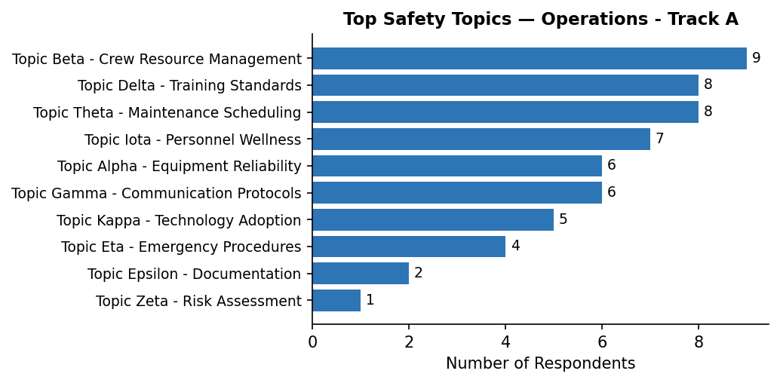

Question 3: Safety Concern
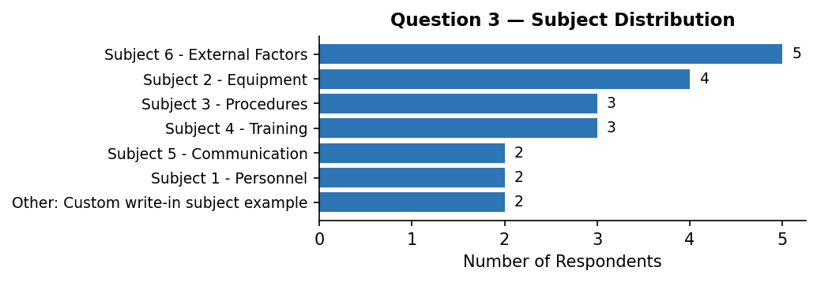

Topics chosen within each subject:
Other: Custom write-in subject example
Other | 1
Other: Communication delay | 1
Subject 1 - Personnel
Experience levels | 1
Workload distribution | 1
Subject 2 - Equipment
Spare parts availability | 2
Aging hardware | 1
Sensor reliability | 1
Subject 3 - Procedures
Standard operating procedures | 2
Process compliance | 1
Subject 4 - Training
Simulator availability | 2
Initial training quality | 1
Subject 5 - Communication
Reporting channels | 1
Inter-team communication | 1
Subject 6 - External Factors
Public perception | 2
Regulatory changes | 1
Other: Communication delay | 1
Other: Training simulator availability | 1

3b. Further Comments
Communication
[Communication / Inter-team]  Topic: Experience levels  Communication between teams could be significantly improved. | [Communication / Reporting]  Topic: Spare parts availability  Reporting channels are unclear for non-routine observations.
[Communication / Inter-team]
Topic: Other: Communication delay
Cross-team meetings have been very productive when they occur.

Equipment
[Equipment / Hardware]  Topic: Other  Equipment failures have caused minor delays but no safety incidents recently. | [Equipment / Software]  Topic: Other: Communication delay  New software rollout went smoothly but training was minimal.

External
[External / Supply Chain]  Topic: Regulatory changes  Spare parts inventory is sometimes insufficient for routine maintenance. | [External / Supply Chain]  Topic: Aging hardware  Spare parts inventory is sometimes insufficient for routine maintenance.
[External / Supply Chain]
Topic: Simulator availability
Spare parts inventory is sometimes insufficient for routine maintenance.

Personnel
[Personnel / Fatigue]  Topic: Process compliance  We have noticed increased issues related to fatigue among night shift staff. | [Personnel / Workload]  Topic: Inter-team communication  Staffing shortages are creating additional workload pressure.
[Personnel / Fatigue]
Topic: Sensor reliability
We have noticed increased issues related to fatigue among night shift staff.

Procedures
[Procedures / Documentation]  Topic: Public perception  Documentation is sometimes unclear and leads to inconsistent practices. | [Procedures / Documentation]  Topic: Other: Training simulator availability  Documentation is sometimes unclear and leads to inconsistent practices.
[Procedures / Documentation]  Topic: Public perception  Documentation is sometimes unclear and leads to inconsistent practices. | [Procedures / Documentation]  Topic: Initial training quality  Some checklists are outdated and reference old equipment.

Question 4: Safety Concern
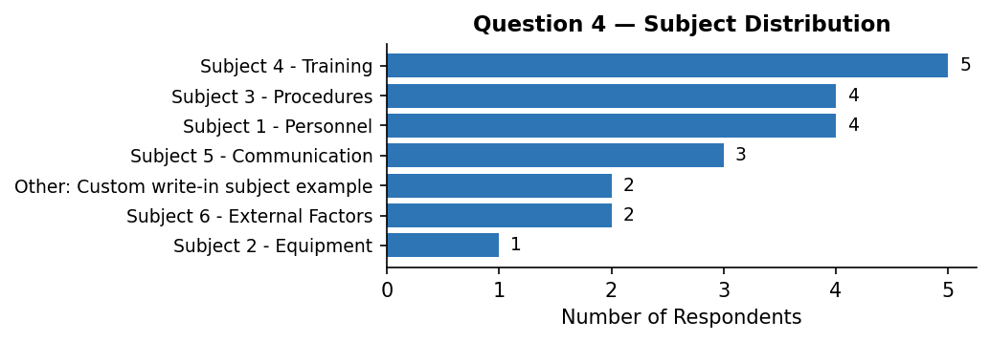

Topics chosen within each subject:
Other: Custom write-in subject example
Other: Software glitch in console | 2
Subject 1 - Personnel
Staffing levels | 2
Other: Software glitch in console | 1
Fatigue management | 1
Subject 2 - Equipment
Other: Pilot fatigue concern | 1
Subject 3 - Procedures
Documentation gaps | 1
Other: Training simulator availability | 1
Checklists | 1
Other | 1
Subject 4 - Training
Recurrent training frequency | 2
Cross-training | 2
Other: Training simulator availability | 1
Subject 5 - Communication
Inter-team communication | 1
Information dissemination | 1
Other: Communication delay | 1
Subject 6 - External Factors
Other: Software glitch in console | 1
Supply chain issues | 1

4b. Further Comments
Communication
[Communication / Inter-team]  Topic: Information dissemination  Communication between teams could be significantly improved. | [Communication / Reporting]  Topic: Inter-team communication  Reporting channels are unclear for non-routine observations.
[Communication / Inter-team]
Topic: Staffing levels
Cross-team meetings have been very productive when they occur.

Equipment
[Equipment / Hardware]  Topic: Cross-training  Equipment failures have caused minor delays but no safety incidents recently. | [Equipment / Hardware]  Topic: Staffing levels  Equipment failures have caused minor delays but no safety incidents recently.
[Equipment / Hardware]  Topic: Other  Equipment failures have caused minor delays but no safety incidents recently. | [Equipment / Software]  Topic: Other: Software glitch in console  New software rollout went smoothly but training was minimal.

External
[External / Weather]  Topic: Other: Training simulator availability  Weather-related disruptions have been higher than usual this quarter. | [External / Weather]  Topic: Other: Pilot fatigue concern  Weather-related disruptions have been higher than usual this quarter.
[External / Weather]  Topic: Checklists  Weather-related disruptions have been higher than usual this quarter. | [External / Weather]  Topic: Cross-training  Weather-related disruptions have been higher than usual this quarter.

Personnel
[Personnel / Workload]
Topic: Recurrent training frequency
Workload during peak periods is unsustainable without changes.

Procedures
[Procedures / Compliance]  Topic: Other: Software glitch in console  Training programs need to be updated to reflect new procedures. | [Procedures / Documentation]  Topic: Other: Communication delay  Some checklists are outdated and reference old equipment.
[Procedures / Compliance]
Topic: Other: Software glitch in console
Training programs need to be updated to reflect new procedures.

Uncategorized
[Uncategorized / —]
Topic: Documentation gaps
We need better tools for tracking maintenance schedules.

Question 5: Safety Concern
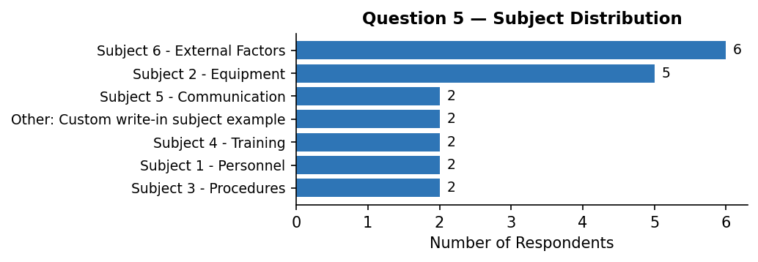

Topics chosen within each subject:
Other: Custom write-in subject example
Other | 1
Other: Pilot fatigue concern | 1
Subject 1 - Personnel
Fatigue management | 1
Workload distribution | 1
Subject 2 - Equipment
Aging hardware | 2
Spare parts availability | 2
Sensor reliability | 1
Subject 3 - Procedures
Checklists | 1
Documentation gaps | 1
Subject 4 - Training
Other | 1
Initial training quality | 1
Subject 5 - Communication
Information dissemination | 1
Other | 1
Subject 6 - External Factors
Supply chain issues | 3
Other: Training simulator availability | 1
Public perception | 1
Weather impacts | 1

5b. Further Comments
Communication
[Communication / Inter-team]  Topic: Aging hardware  Communication between teams could be significantly improved. | [Communication / Reporting]  Topic: Spare parts availability  Reporting channels are unclear for non-routine observations.
[Communication / Inter-team]
Topic: Workload distribution
Cross-team meetings have been very productive when they occur.

Equipment
[Equipment / Software]  Topic: Sensor reliability  New software rollout went smoothly but training was minimal. | [Equipment / Software]  Topic: Weather impacts  New software rollout went smoothly but training was minimal.

External
[External / Supply Chain]  Topic: Other  Spare parts inventory is sometimes insufficient for routine maintenance. | [External / Weather]  Topic: Aging hardware  Weather-related disruptions have been higher than usual this quarter.
[External / Supply Chain]  Topic: Supply chain issues  Spare parts inventory is sometimes insufficient for routine maintenance. | [External / Weather]  Topic: Fatigue management  Weather-related disruptions have been higher than usual this quarter.
[External / Weather]  Topic: Other: Pilot fatigue concern  Weather-related disruptions have been higher than usual this quarter. | [External / Weather]  Topic: Initial training quality  Weather-related disruptions have been higher than usual this quarter.

Personnel
[Personnel / Experience]  Topic: Documentation gaps  Onboarding for new staff takes longer than expected. | [Personnel / Workload]  Topic: Other  Workload during peak periods is unsustainable without changes.
[Personnel / Fatigue]  Topic: Information dissemination  We have noticed increased issues related to fatigue among night shift staff. | [Personnel / Workload]  Topic: Other  Workload during peak periods is unsustainable without changes.

Uncategorized
[Uncategorized / —]
Topic: Public perception
We need better tools for tracking maintenance schedules.

Question 6: How can we evolve to make this more valuable?
Equipment
[Equipment / Software]
Focus more on practical applications and less on theory.

Event Feedback
[Event Feedback / Content]  The presentation slides could be made available in advance. | [Event Feedback / Format]  More time for networking would be valuable.
[Event Feedback / Format]  Add more interactive sessions to break up the day. | [Event Feedback / Format]  More time for networking would be valuable.
[Event Feedback / Format]  Add more interactive sessions to break up the day. | [Event Feedback / Format]  Smaller breakout groups would encourage more participation.
[Event Feedback / Format]  Add more interactive sessions to break up the day. | [Event Feedback / Format]  Smaller breakout groups would encourage more participation.
[Event Feedback / Format]  Consider hybrid attendance options for those who can't travel. | [Event Feedback / Format]  Smaller breakout groups would encourage more participation.
[Event Feedback / Format]  More time for networking would be valuable. | [Event Feedback / Format]  Smaller breakout groups would encourage more participation.
[Event Feedback / Format]
More time for networking would be valuable.

Question 7: Challenges or emerging risks over the next 3 years
Equipment
[Equipment / Software]  Adoption of new technology without adequate training. | [Equipment / Software]  Adoption of new technology without adequate training.
[Equipment / Software]
Adoption of new technology without adequate training.

External
[External / Regulation]  Increasing regulatory complexity. | [External / Weather]  Supply chain disruptions affecting maintenance.
[External / Regulation]
Increasing regulatory complexity.

Personnel
[Personnel / Experience]  Aging workforce and knowledge transfer challenges. | [Personnel / Staffing]  Continued staffing pressures and turnover.
[Personnel / Experience]  Aging workforce and knowledge transfer challenges. | [Personnel / Staffing]  Continued staffing pressures and turnover.
[Personnel / Staffing]  Continued staffing pressures and turnover. | [Personnel / Staffing]  Continued staffing pressures and turnover.

Question 8: General feedback
Event Feedback
[Event Feedback / Content]  More diverse perspectives in the panels would help. | [Event Feedback / Logistics]  The catering was excellent.
[Event Feedback / Logistics]  Logistics were smoothly handled. | [Event Feedback / Logistics]  The catering was excellent.
[Event Feedback / Logistics]  Logistics were smoothly handled. | [Event Feedback / Logistics]  The catering was excellent.
[Event Feedback / Logistics]  Logistics were smoothly handled. | [Event Feedback / Logistics]  The venue could be improved.
[Event Feedback / Logistics]  Some sessions ran long; tighter scheduling would help. | [Event Feedback / Logistics]  The venue could be improved.
[Event Feedback / Logistics]  Some sessions ran long; tighter scheduling would help. | [Event Feedback / Logistics]  The venue could be improved.
[Event Feedback / Logistics]  The catering was excellent. | [Event Feedback / Logistics]  The venue could be improved.
[Event Feedback / Logistics]
The catering was excellent.

Appendix: Quick Statistics
Total respondents: 21
First-time attendees: 6 (29%)
Q2 total topic selections: 56
⚠ 2 comment(s) could not be auto-categorized and need manual review. Search for [Uncategorized / —] tags in this document.

