EVALUATION REPORT

Operations - Track B

18 respondents • 5 first-time attendees (28%)

[ DEMONSTRATION REPORT — SYNTHETIC DATA ONLY ]

Question 2: Top Safety Topics
Respondents selected up to four safety topics they want to hear about at future meetings. Topics ranked by total selections.
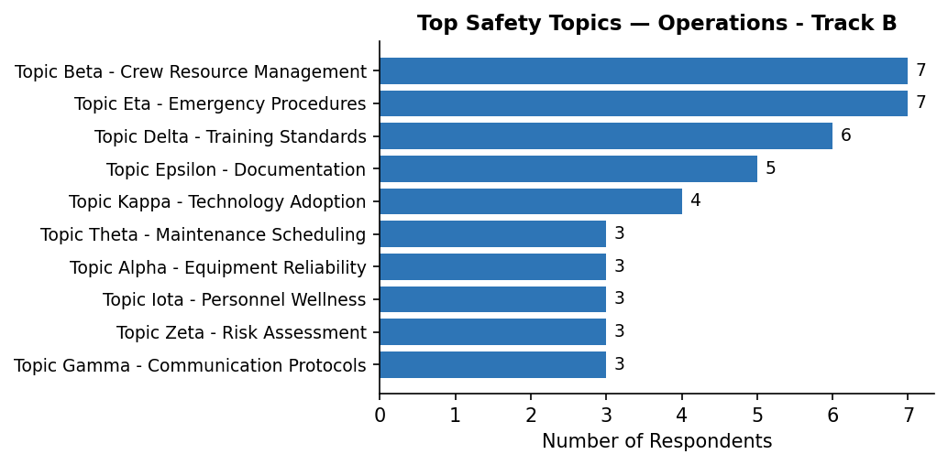

Question 3: Safety Concern
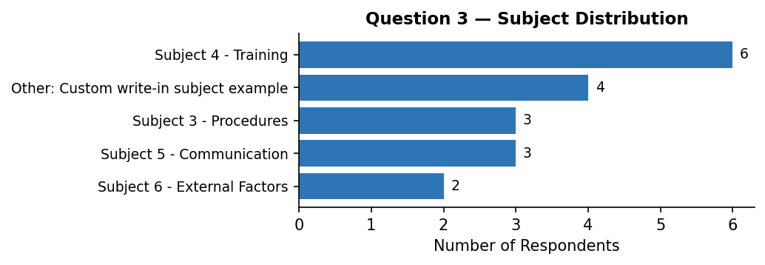

Topics chosen within each subject:
Other: Custom write-in subject example
Other: Communication delay | 2
Other: Training simulator availability | 1
Other: Pilot fatigue concern | 1
Subject 3 - Procedures
Process compliance | 1
Documentation gaps | 1
Other: Communication delay | 1
Subject 4 - Training
Recurrent training frequency | 3
Simulator availability | 1
Initial training quality | 1
Other | 1
Subject 5 - Communication
Reporting channels | 2
Other: Pilot fatigue concern | 1
Subject 6 - External Factors
Other: Training simulator availability | 1
Public perception | 1

3b. Further Comments
Communication
[Communication / Inter-team]  Topic: Simulator availability  Communication between teams could be significantly improved. | [Communication / Inter-team]  Topic: Other: Pilot fatigue concern  Communication between teams could be significantly improved.

External
[External / Weather]
Topic: Documentation gaps
Weather-related disruptions have been higher than usual this quarter.

Personnel
[Personnel / Experience]  Topic: Other: Communication delay  Onboarding for new staff takes longer than expected. | [Personnel / Workload]  Topic: Recurrent training frequency  Workload during peak periods is unsustainable without changes.
[Personnel / Experience]
Topic: Other
Onboarding for new staff takes longer than expected.

Procedures
[Procedures / Compliance]  Topic: Other: Training simulator availability  Training programs need to be updated to reflect new procedures. | [Procedures / Documentation]  Topic: Other: Training simulator availability  Documentation is sometimes unclear and leads to inconsistent practices.
[Procedures / Compliance]  Topic: Reporting channels  Training programs need to be updated to reflect new procedures. | [Procedures / Documentation]  Topic: Public perception  Documentation is sometimes unclear and leads to inconsistent practices.
[Procedures / Compliance]  Topic: Other: Communication delay  Training programs need to be updated to reflect new procedures. | [Procedures / Documentation]  Topic: Reporting channels  Documentation is sometimes unclear and leads to inconsistent practices.
[Procedures / Documentation]  Topic: Process compliance  Documentation is sometimes unclear and leads to inconsistent practices. | [Procedures / Documentation]  Topic: Other: Pilot fatigue concern  Some checklists are outdated and reference old equipment.

Uncategorized
[Uncategorized / —]  Topic: Recurrent training frequency  We need better tools for tracking maintenance schedules. | [Uncategorized / —]  Topic: Recurrent training frequency  We need better tools for tracking maintenance schedules.

Question 4: Safety Concern
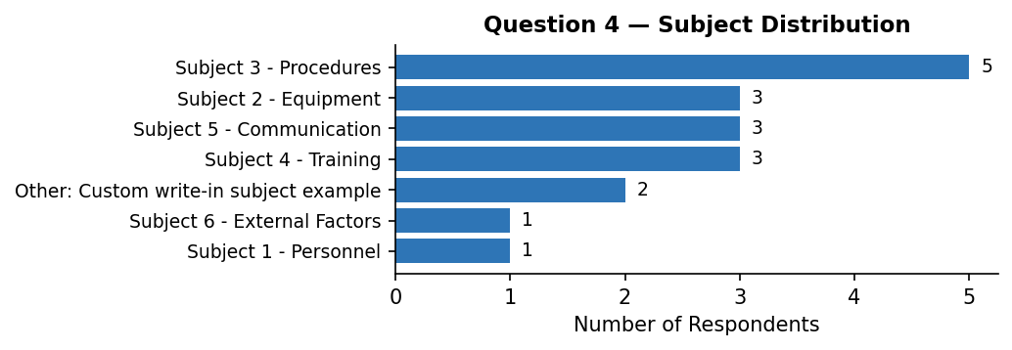

Topics chosen within each subject:
Other: Custom write-in subject example
Other: Pilot fatigue concern | 1
Other | 1
Subject 1 - Personnel
Staffing levels | 1
Subject 2 - Equipment
Software updates | 1
Aging hardware | 1
Spare parts availability | 1
Subject 3 - Procedures
Process compliance | 2
Other: Training simulator availability | 1
Checklists | 1
Documentation gaps | 1
Subject 4 - Training
Cross-training | 2
Initial training quality | 1
Subject 5 - Communication
Other: Pilot fatigue concern | 1
Other: Training simulator availability | 1
Other: Communication delay | 1
Subject 6 - External Factors
Supply chain issues | 1

4b. Further Comments
Communication
[Communication / Inter-team]  Topic: Other  Communication between teams could be significantly improved. | [Communication / Reporting]  Topic: Other: Training simulator availability  Reporting channels are unclear for non-routine observations.
[Communication / Inter-team]
Topic: Initial training quality
Cross-team meetings have been very productive when they occur.

Equipment
[Equipment / Software]  Topic: Software updates  New software rollout went smoothly but training was minimal. | [Equipment / Software]  Topic: Aging hardware  New software rollout went smoothly but training was minimal.
[Equipment / Software]
Topic: Other: Training simulator availability
New software rollout went smoothly but training was minimal.

External
[External / Weather]
Topic: Staffing levels
Weather-related disruptions have been higher than usual this quarter.

Personnel
[Personnel / Experience]  Topic: Other: Communication delay  Onboarding for new staff takes longer than expected. | [Personnel / Workload]  Topic: Other: Pilot fatigue concern  Staffing shortages are creating additional workload pressure.
[Personnel / Fatigue]  Topic: Cross-training  We have noticed increased issues related to fatigue among night shift staff. | [Personnel / Workload]  Topic: Supply chain issues  Workload during peak periods is unsustainable without changes.
[Personnel / Fatigue]
Topic: Documentation gaps
We have noticed increased issues related to fatigue among night shift staff.

Procedures
[Procedures / Compliance]  Topic: Cross-training  Training programs need to be updated to reflect new procedures. | [Procedures / Documentation]  Topic: Other: Pilot fatigue concern  Some checklists are outdated and reference old equipment.
[Procedures / Compliance]  Topic: Checklists  Training programs need to be updated to reflect new procedures. | [Procedures / Documentation]  Topic: Process compliance  Some checklists are outdated and reference old equipment.

Question 5: Safety Concern
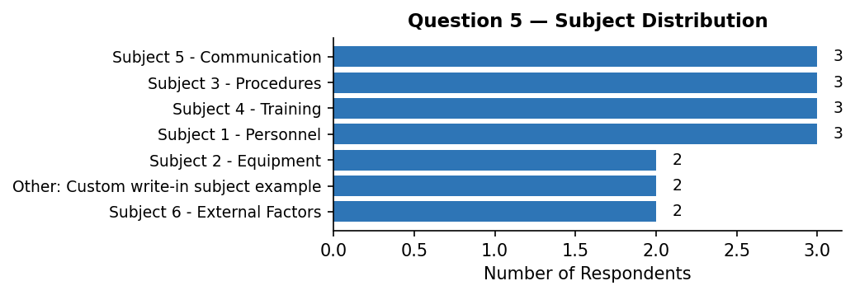

Topics chosen within each subject:
Other: Custom write-in subject example
Other: Software glitch in console | 1
Other: Pilot fatigue concern | 1
Subject 1 - Personnel
Experience levels | 1
Workload distribution | 1
Other: Software glitch in console | 1
Subject 2 - Equipment
Sensor reliability | 2
Subject 3 - Procedures
Standard operating procedures | 2
Process compliance | 1
Subject 4 - Training
Simulator availability | 2
Initial training quality | 1
Subject 5 - Communication
Language barriers | 1
Reporting channels | 1
Inter-team communication | 1
Subject 6 - External Factors
Weather impacts | 1
Other: Training simulator availability | 1

5b. Further Comments
Communication
[Communication / Inter-team]  Topic: Other: Software glitch in console  Cross-team meetings have been very productive when they occur. | [Communication / Reporting]  Topic: Simulator availability  Reporting channels are unclear for non-routine observations.
[Communication / Inter-team]
Topic: Workload distribution
Cross-team meetings have been very productive when they occur.

Equipment
[Equipment / Hardware]
Topic: Weather impacts
Equipment failures have caused minor delays but no safety incidents recently.

Personnel
[Personnel / Fatigue]  Topic: Standard operating procedures  We have noticed increased issues related to fatigue among night shift staff. | [Personnel / Workload]  Topic: Standard operating procedures  Staffing shortages are creating additional workload pressure.

Procedures
[Procedures / Compliance]  Topic: Other: Software glitch in console  Training programs need to be updated to reflect new procedures. | [Procedures / Documentation]  Topic: Sensor reliability  Some checklists are outdated and reference old equipment.
[Procedures / Documentation]  Topic: Language barriers  Documentation is sometimes unclear and leads to inconsistent practices. | [Procedures / Documentation]  Topic: Process compliance  Some checklists are outdated and reference old equipment.
[Procedures / Documentation]  Topic: Inter-team communication  Documentation is sometimes unclear and leads to inconsistent practices. | [Procedures / Documentation]  Topic: Experience levels  Some checklists are outdated and reference old equipment.
[Procedures / Documentation]  Topic: Initial training quality  Documentation is sometimes unclear and leads to inconsistent practices. | [Procedures / Documentation]  Topic: Other: Training simulator availability  Some checklists are outdated and reference old equipment.

Uncategorized
[Uncategorized / —]  Topic: Simulator availability  We need better tools for tracking maintenance schedules. | [Uncategorized / —]  Topic: Other: Pilot fatigue concern  We need better tools for tracking maintenance schedules.

Question 6: How can we evolve to make this more valuable?
Equipment
[Equipment / Software]  Focus more on practical applications and less on theory. | [Equipment / Software]  Focus more on practical applications and less on theory.

Event Feedback
[Event Feedback / Content]  The presentation slides could be made available in advance. | [Event Feedback / Format]  Consider hybrid attendance options for those who can't travel.
[Event Feedback / Content]  The presentation slides could be made available in advance. | [Event Feedback / Format]  Consider hybrid attendance options for those who can't travel.
[Event Feedback / Format]  Add more interactive sessions to break up the day. | [Event Feedback / Format]  More time for networking would be valuable.
[Event Feedback / Format]  Add more interactive sessions to break up the day. | [Event Feedback / Format]  Smaller breakout groups would encourage more participation.
[Event Feedback / Format]  Consider hybrid attendance options for those who can't travel. | [Event Feedback / Format]  Smaller breakout groups would encourage more participation.

Question 7: Challenges or emerging risks over the next 3 years
Equipment
[Equipment / Software]  Adoption of new technology without adequate training. | [Equipment / Software]  Adoption of new technology without adequate training.

External
[External / Regulation]  Increasing regulatory complexity. | [External / Weather]  Supply chain disruptions affecting maintenance.
[External / Regulation]  Increasing regulatory complexity. | [External / Weather]  Supply chain disruptions affecting maintenance.
[External / Weather]  Supply chain disruptions affecting maintenance. | [External / Weather]  Supply chain disruptions affecting maintenance.

Personnel
[Personnel / Experience]  Aging workforce and knowledge transfer challenges. | [Personnel / Experience]  Aging workforce and knowledge transfer challenges.
[Personnel / Experience]
Aging workforce and knowledge transfer challenges.

Question 8: General feedback
Event Feedback
[Event Feedback / Content]  More diverse perspectives in the panels would help. | [Event Feedback / Logistics]  The catering was excellent.
[Event Feedback / Content]  More diverse perspectives in the panels would help. | [Event Feedback / Logistics]  The catering was excellent.
[Event Feedback / Logistics]  Logistics were smoothly handled. | [Event Feedback / Logistics]  The venue could be improved.
[Event Feedback / Logistics]  Logistics were smoothly handled. | [Event Feedback / Logistics]  The venue could be improved.
[Event Feedback / Logistics]  Some sessions ran long; tighter scheduling would help. | [Event Feedback / Logistics]  The venue could be improved.
[Event Feedback / Logistics]  Some sessions ran long; tighter scheduling would help. | [Event Feedback / Logistics]  The venue could be improved.
[Event Feedback / Logistics]  Some sessions ran long; tighter scheduling would help. | [Event Feedback / Logistics]  The venue could be improved.

Uncategorized
[Uncategorized / —]  Great event overall, looking forward to next year. | [Uncategorized / —]  Great event overall, looking forward to next year.
[Uncategorized / —]
Great event overall, looking forward to next year.

Appendix: Quick Statistics
Total respondents: 18
First-time attendees: 5 (28%)
Q2 total topic selections: 44
⚠ 7 comment(s) could not be auto-categorized and need manual review. Search for [Uncategorized / —] tags in this document.

