Developing Soft and Parallel Programming Skills Using Project-Based Learning

Project Report

Fall-2018

Submitted By PAJ_VR

Prashant Vemulapalli, Anthony Davis, Jaiana Butler, Vincent Lee, Ryan Barret

**Planning and Scheduling**

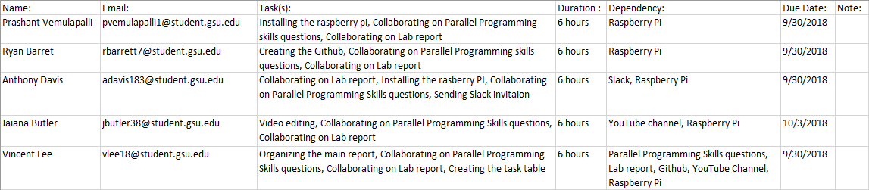

**Parallel Programming Skills**

*Identifying the components on the raspberry PI B+*

The raspberry pi has nine components: Display, power, ethernet controller, ethernet port, camera, CPU/RAM, HDMI, two USB ports, and a 3.5 audio jack.

*How many cores does the Raspberry Pi’s B+ CPU have?*

The Raspberry Pi B+ has four cores.

*List four main differences between X86 (CISC) and ARM Raspberry PI (RISC).*

The x86 has an instruction set that is composed of more complex operations, and may take

more cycles to execute, while the ARM Raspberry pi uses an instruction set composed of

simpler instructions that reduce the amount of cycles needed to execute them.

ARM uses a load/store memory model in which arithmetic operations such as add, or sub are

executed exclusively in registers while the x86 uses the register/memory model that doesn’t

have these restrictions.

The x86 uses little endian while the ARM is bi-endian, meaning it can use either little endian or

big endian, depending on the situation.

Because the ARM uses RISC, it can also utilize pipelining more effectively than x86, due to it being able to execute most instructions in one clock cycle, so it can use a pipeline composed of single instructions segments to complete a task.

*What is the difference between sequential and parallel computation and identify the*

*practical significance of each?*

In parallel computation, processes/threads are executed simultaneously, while in sequential

computation, processes are executed one by one. The practical significance of parallel

computation is that tasks can be executed in a shorter amount of time, and the practical significance of sequential computation is that may have a lower cost compared to parallel

computation.

*Identify the basic form of data and task parallelism in computational problems.*

Examples of data and task parallelism are application creating threads for doing parallel

processing where each thread is responsible for preforming a different operation, or a cl-

ient server assigning some tasks the job of making requests and others the jobs of servic-

ing requests.

*Explain the differences between processes and threads.*

A process is an abstraction of a program that does not share memory with other processes. A

process can be decomposed into smaller individual process called threads, and these threads

can share memory with other threads.

*What is OpenMP and what is OpenMP pragmas?*

OpenMP is an API to write multi-threaded processes in parallel processing. OpenMP pragmas are

compiler directives that allow for the generation of threaded code.

*What applications benefit from multi-core (list four)?*

Database servers, web servers, compilers, and multimedia applications.

*Why Multicore? (why not single core, list four)*

Heat and speed issues with single core, higher clock frequency in multicore compared to single-core, many newer applications use multiple cores, multi core allowing for multithreading, and a general trend towards multicore in recent times.

**Parallel Programming Basics**

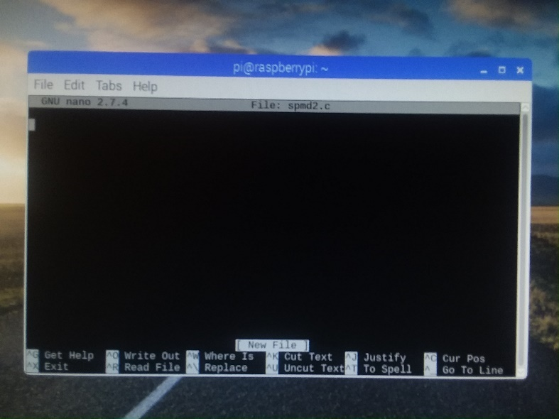

Explanation: The code “**nano spmd2.c**” was used to open the nano editor and begin writing the spmd2.c code.

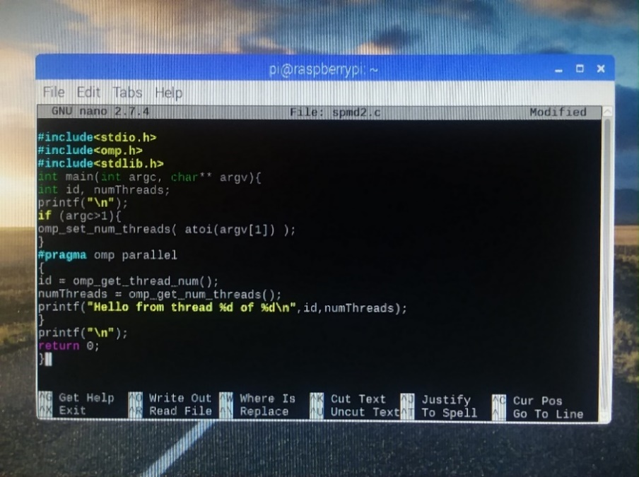

Explanation: The spmd2.c code is then written in the nano editor.

Observation(s): The code appears to be including some sort of libraries, similar to how impor-

ting libraries are used in java. The “**id**” and “**numThreads**” also seem to be returning what thr-

ead number and id the printf in line 14 will print.

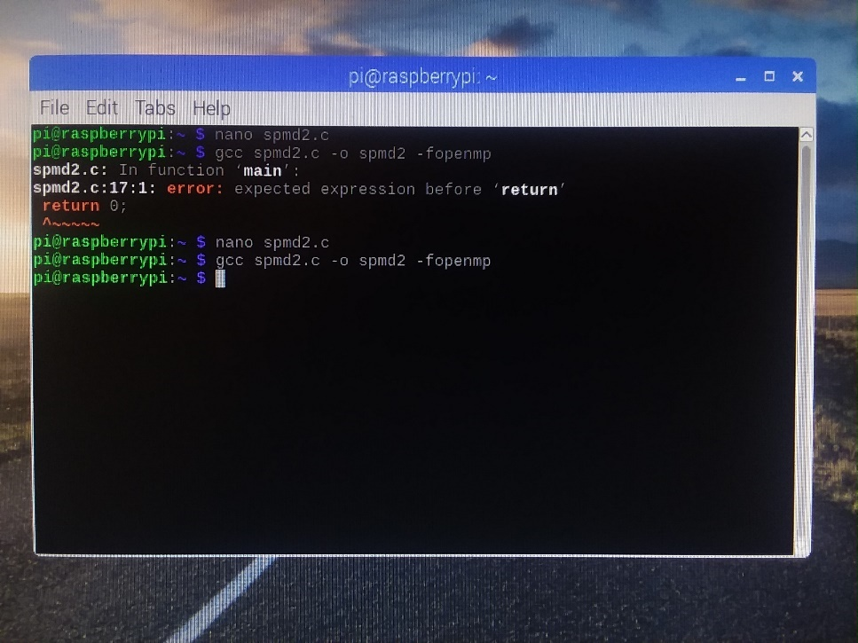

Explanation: The executable for the spmd2.c program is created using the code “**gcc spmd2.c -o -fopenmp**”.

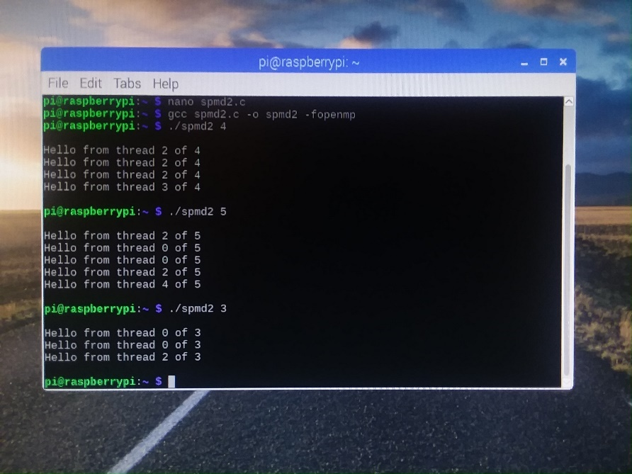

Explanation: Multiple values in place of 4 are tried for the spmd2.c program, and there are repeating thread ids in the result.

Observation(s): After more testing, it appears that the threads with an id of 0 occur whenever the number of threads to fork is less than or greater than 4, while a thread with an id of 0 will never occur if the number of threads to fork is 4.

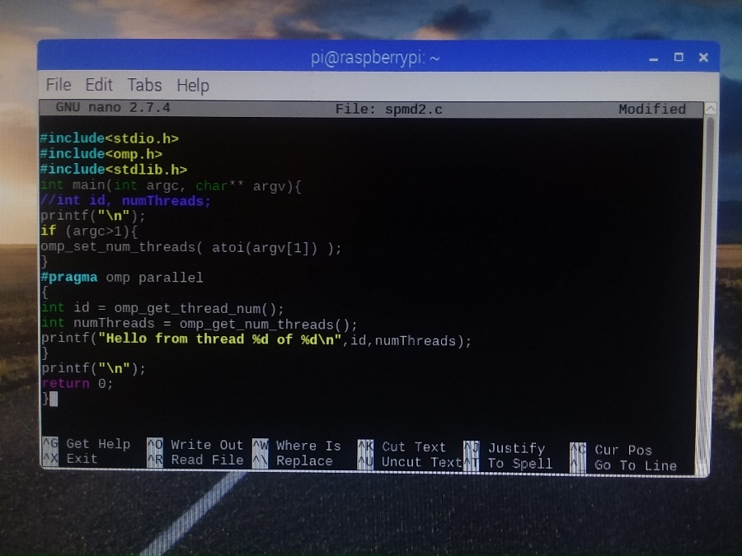

Explanation: The incorrect code is corrected by using “**nano spmd2.c**” then commenting out line 5 by adding “**//**” then placing “**int**” at the beginning of lines 12 and 13.

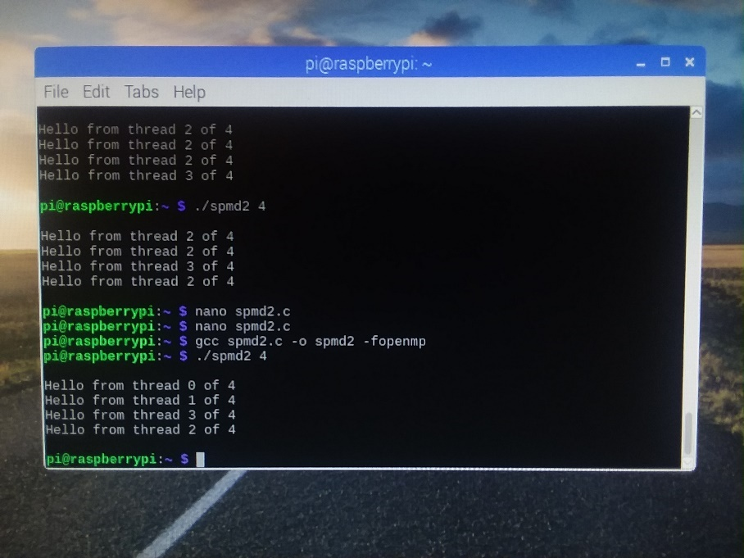

Explanation: After saving the changes in nano and exiting, “**gcc spmd2.c -o -fopenmp**” is used again to compile the corrected code, and **“./spmd2 4**” is used to execute the code, and this time there are no repeated thread ids in the result. The code is successful.

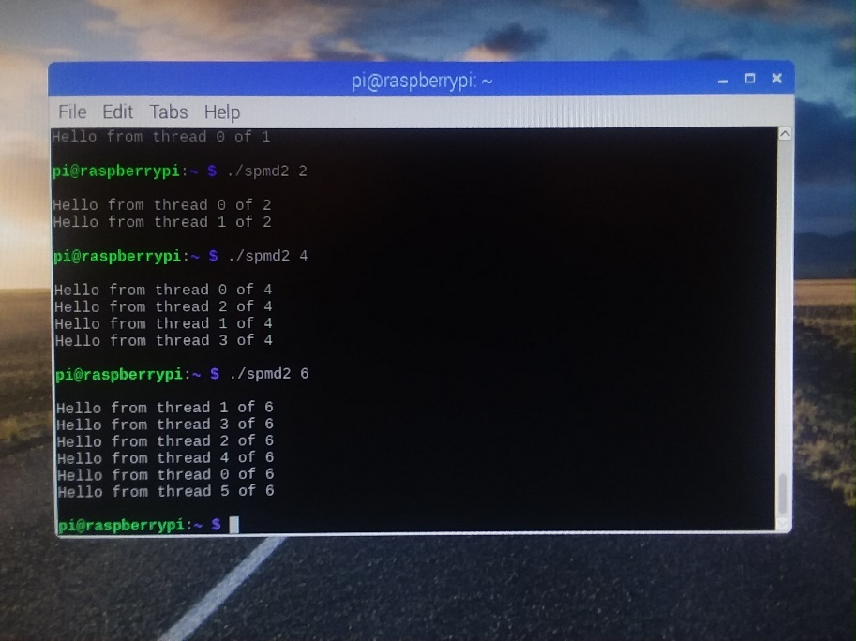

Explanation: The code is then tested again for other values, and there are also no repeating thread ids for numbers of threads greater than or less then 4.

Observation(s): Now that the code is correct, a thread with id 0 will appear for any number of threads, including 4.

**Appendix**

Video: https://youtu.be/drT0E6N0-2M

Slack: pajvr.slack.com

Github: https://github.com/PAJVR/Project_2

Github project page screenshot:

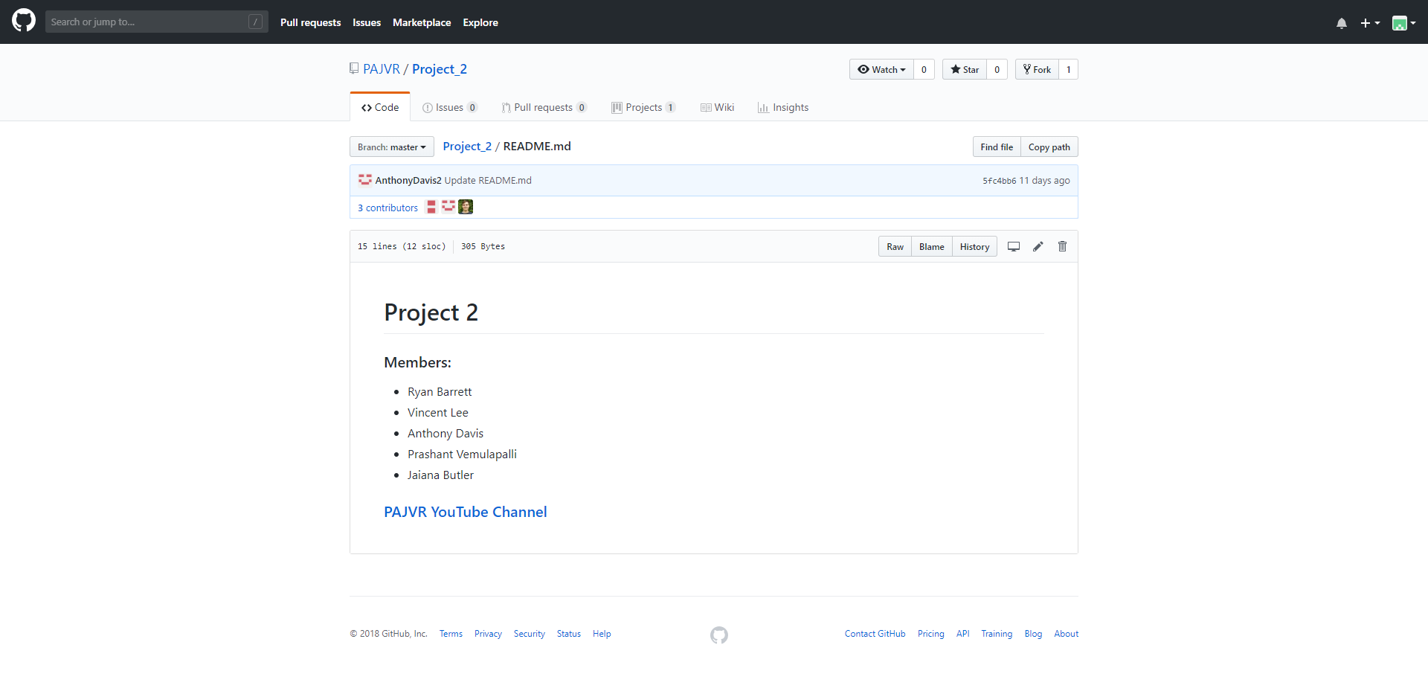

Github readme page screenshot:

