МІНІСТЕРСТВО ОСВІТИ ТА НАУКИ УКРАЇНИ НАЦІОНАЛЬНИЙ УНІВЕРСИТЕТ “ЛЬВІВСЬКА ПОЛІТЕХНІКА” Н-Н ІНСТИТУТ ПІДПРИЄМНИЦТВА ТА ПЕРСПЕКТИВНИХ ТЕХНОЛОГІЙ

Звіт
До виконаної лабораторної роботи №3
З дисципліни «Розроблення та адміністрування баз даних»

Виконав: Мальцев Кирило
Прийняла: Машевська М.В.

Львів 2021

1. Таблиці Представлення


CREATE VIEW MinCountOfVacancy AS
SELECT MIN(result.vacancy_count)
FROM (SELECT COUNT(job_position) AS vacancy_count FROM Vacancy GROUP BY company_Name) AS result;

CREATE VIEW VacancyInfo AS
SELECT VR.company_Name as company_name, VR.job_position, VR.month_salary, VR.Age, Sex, Education.degree, Education.specialization FROM (SELECT company_Name, job_position, month_salary, Age, Sex, Vacancy.id AS VRid FROM Vacancy
JOIN Requirements ON Vacancy.id_requirements = Requirements.id) AS VR
JOIN Education ON VRid = Education.id;
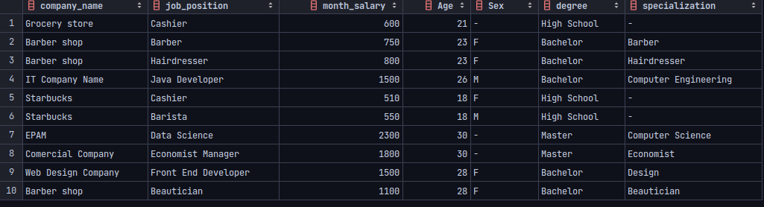
CREATE VIEW HighEducationCount AS
SELECT degree, COUNT(degree) AS CountOfVacancies FROM Education
WHERE degree IN ('Master', 'Bachelor')
GROUP BY degree;

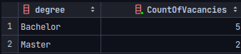

2. Тригери
DROP TRIGGER IF EXISTS riseWorkExp;
CREATE TRIGGER riseWorkExp
AFTER UPDATE ON AdditionalRequirements
FOR EACH ROW
BEGIN
UPDATE Vacancy
SET Vacancy.month_salary = Vacancy.month_salary + (NEW.work_experience - OLD.work_experience) * 100
WHERE NEW.id = Vacancy.id;
END;
DROP TRIGGER IF EXISTS insertInfo;
CREATE TRIGGER insertInfo
BEFORE INSERT ON AdditionalRequirements
FOR EACH ROW
BEGIN
INSERT INTO Requirements
VALUE (NEW.id_requirements, 18, '-');
END;
3. Функції
DELIMITER $$
CREATE FUNCTION maxVacancy()
RETURNS INT
DETERMINISTIC
BEGIN
DECLARE max_Vacancy INT;
SET max_Vacancy = (
SELECT MAX(VcN.Vacancies)
FROM (
SELECT COUNT(company_Name) as Vacancies, company_Name
FROM Vacancy as res
GROUP BY company_Name
HAVING Vacancies = (
SELECT MAX(result.vacancy_count)
FROM (
SELECT COUNT(job_position) AS vacancy_count
FROM Vacancy
GROUP BY company_Name) AS result
)
) as VcN
);
RETURN max_Vacancy;
end $$



4. Процедури
DROP PROCEDURE IF EXISTS getCompanyByVacancy;
DELIMITER //
CREATE PROCEDURE getCompanyByVacancy(IN jp VARCHAR(45))
BEGIN
SELECT * FROM Vacancy
WHERE job_position = jp;
END //
DELIMITER ;

