**DOCUMENTATION**

**HOW TO RUN THE APPLICATION?**

* Create a database named cms in your xampp server, and import the cms.zip in this database.
* Now your database has been created.
* Start xampp, and initialize apache and mysql from xampp- control.
* Also, save the project folder inside C:\xampp\htdocs .
* To run this application on your browser, enter the url: localhost/Educational_blog_website
* You will be sent into the home page. Here you can view the post , search by tags and you can see the categorizations of the blogs from topics sidebar. Also, upcoming evets of the college will be shown here.
* Only admin can login inside the admin panel. So we have created a user named ‘abc’ with password ‘123’. Enter this in the admin login to visit admin panel.
* Inside admin panel you’ll first visit dashboard.
* Inside admin panel, you can create blogs, approve the comments , create events, and add new users.

**FUNCTIONALITIES**

**USER FUNCTIONALITIES**

* **Admin Login**

Here, the admin enters the name and password. The password is encrypted for security. Only the admins (in our case, teachers ) can access the admin page.

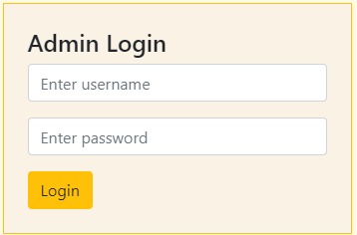

* **Search by tags**

If the viewer wants to search the blog site for blogs of a certain topic, this is the place. All blogs have tags which identify the blogs and provide its topic coverage. Here, the viewer can view blogs of his/her personal interest by searching.

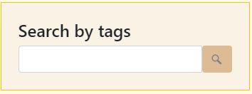

* **Categorization of blogs through topics**

Here, list of topics covered by the various blogs is presented at a glance. The viewer can select any topic of his/her choice, and it will lead him/her to the blogs of that certain category.

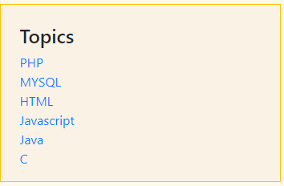

* **Upcoming events**

Upcoming events being organized by various clubs are presented here. Once the event has passed its due date, it is removed from this space. It is a one stop place for viewers of the institution to see all the upcoming events in one glance.

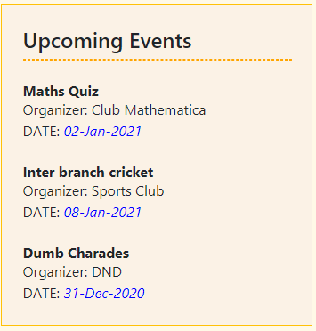

* **Newsletter**

The viewer has the option to subscribe to the newsletter of the institution, wherein important updates will be mailed to the user via mail.

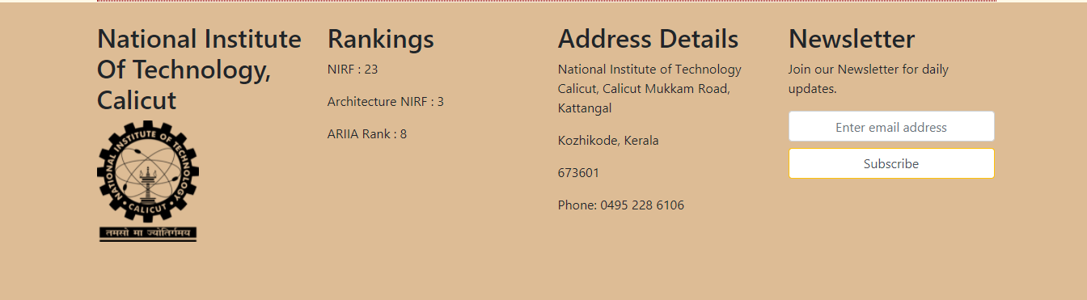

* **Read More**

All blogs are shown in a reverse chronological manner, and a preview of the blog is presented. If the viewer finds it interesting, he/she has the option to click on read more, which will open up the entire blog, and provide the user with the option to comment.

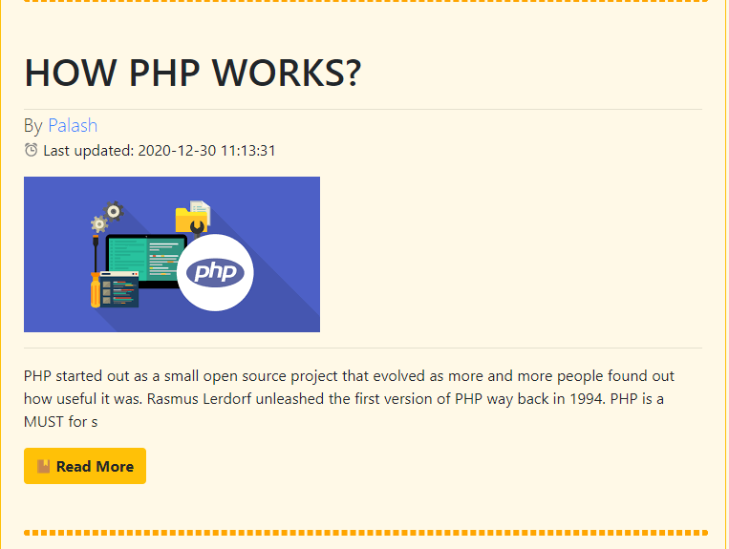

* **Comments**

A viewer has the option to comment and discuss in the comment section of each blog. The comment has to be accompanied by user name and user email. After posting the comment, it is sent to the admin to decide whether the comment should be posted or needs to be deleted.

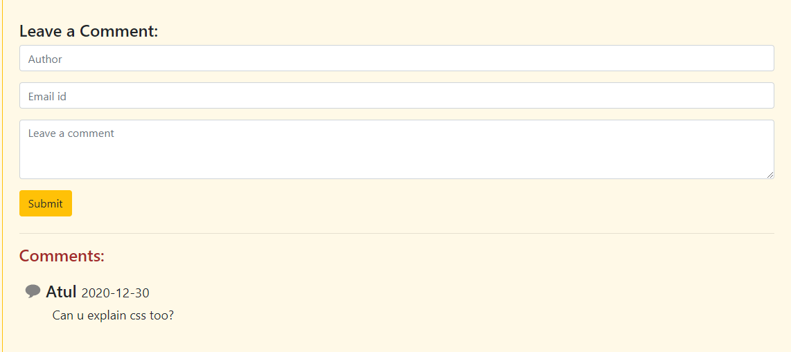

* **About Us**

About us section in the home page provides details about our institution, its vision, information about the people in authority, among other things.





* **Clubs**

This section provides information about all the clubs in our institution, and provides us with an option to contact the club.

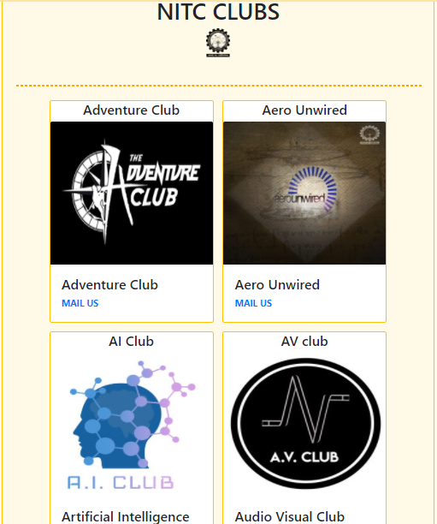

* **Contact Us**

This section provides us with the important contact details of the institute.

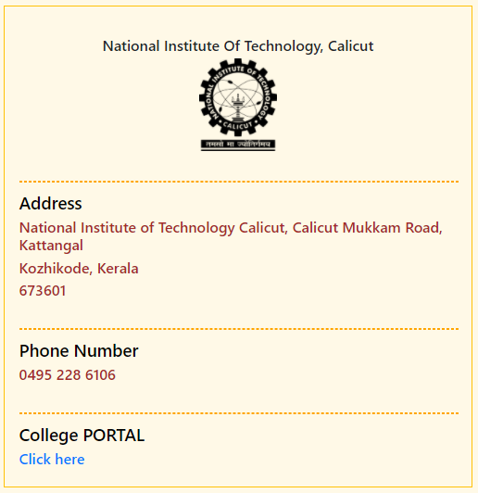

**ADMIN FUNCTIONALITIES**

* **Dashboard**

This is the first page shown to admin after admin login. This dashboard provides the admin with the vital stats of the engagement of the various posts. This includes ‘comments done’, ‘post count’, and ‘categories covered’.

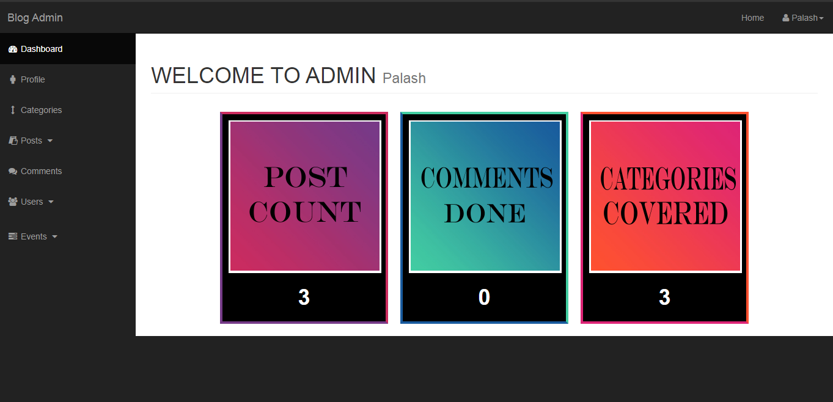

* **Profile**

This section provides the admin with his/her profile, and important data regarding the admin.

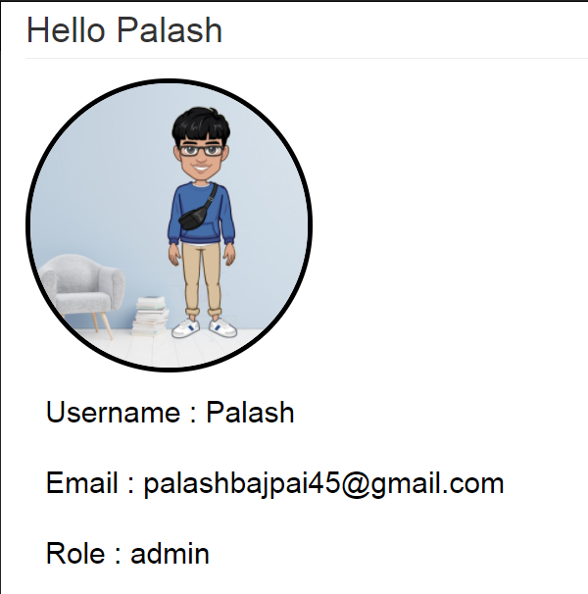

* **Categories**

The categories section help in performing CRUD operation on categories table . This categories are used in making posts.

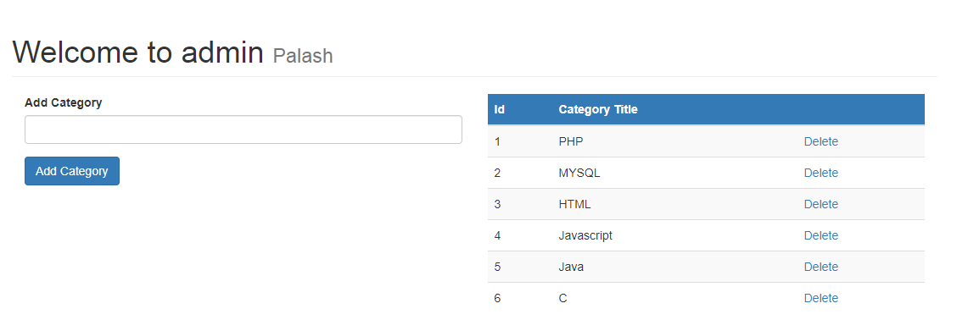

* **Posts**

This section consists of 2 sections, create post and view all posts made by the admin who is logged in this admin panel.

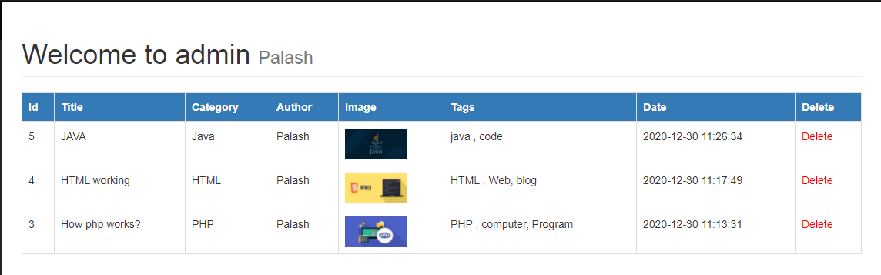

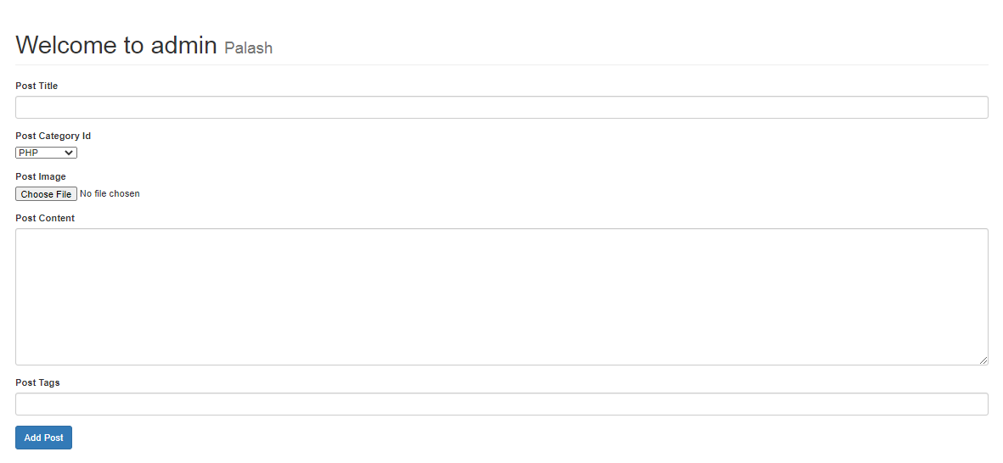

* **Comments**

This section help to see all comments made on your posts and also to approve them . Comments approved by the admin are only visible on posts.

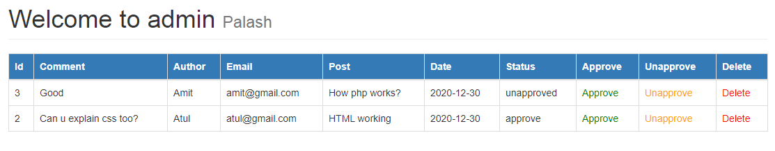

* **Users**

Here we can view all users and also change privilege of user from admin to viewer. Also here we have form to add up new users,

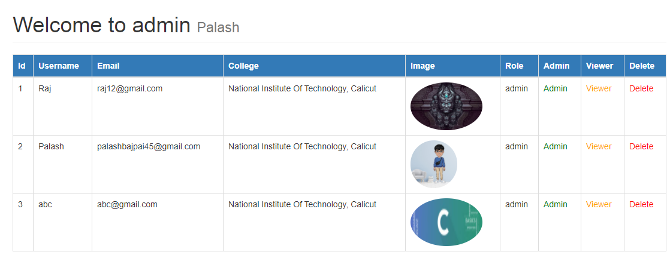

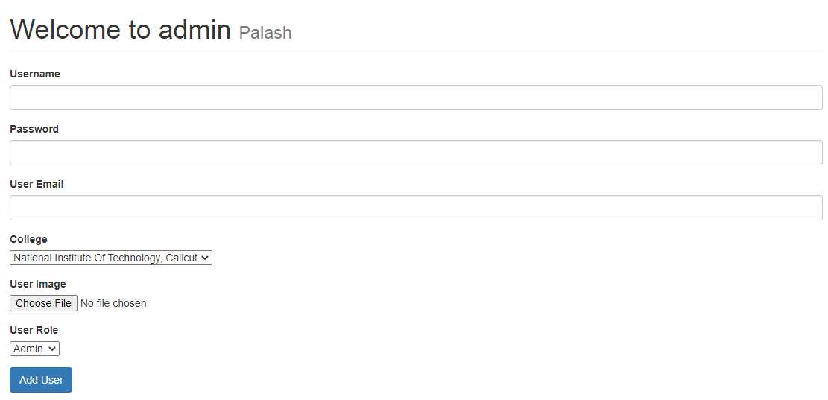

* **Events**

Here club representative who is also admin can add up events on the blog site. Events which are to be held in future are only shown on home page.

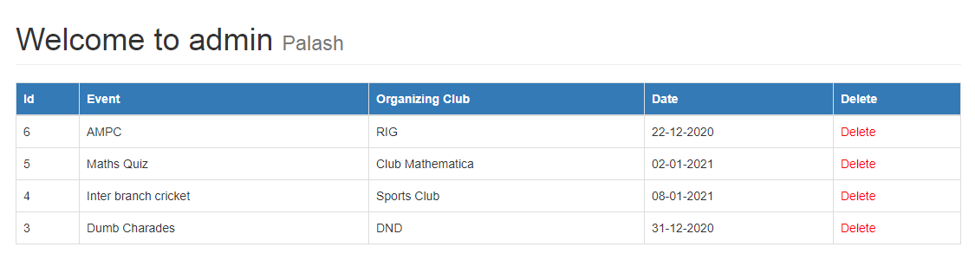

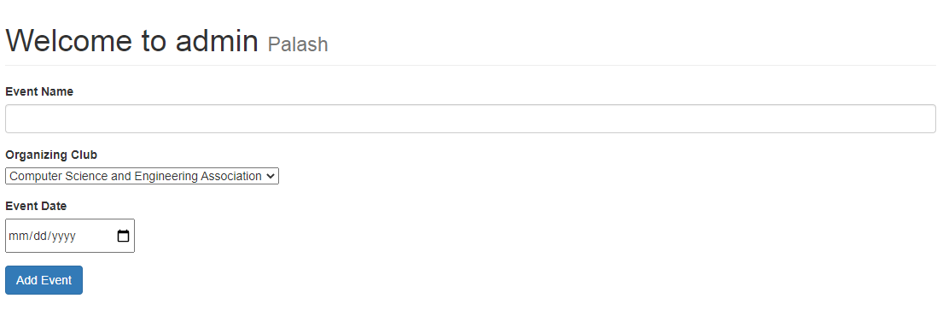

**FEATURES**

* **EVENTS**

Full event management stack provided to the admin. Provision provided for user to be notified about upcoming events.

* **NEWSLETTER**

User has the option to subscribe to the institution newsletter, where important updates will be mailed directly to the user.

* **USER EXPERIENCE**

Smooth, simple and a personalized manner of presentation to the user.

* **ADMIN PRIVILEGE**

Admin provided with features like adding, editing and deleting posts and comments, and tracking the post engagements.

* **SECURITY**

Passwords are secured and encrypted. Important credentials are encrypted in the database. No scope for sql injection.

* **CATEGORIZATION**

All posts are categorized by the topics they pertain to. This enables users to search and view blogs related to the topics of their personal choice.