**RESUME**

**PAWAN KUMAR**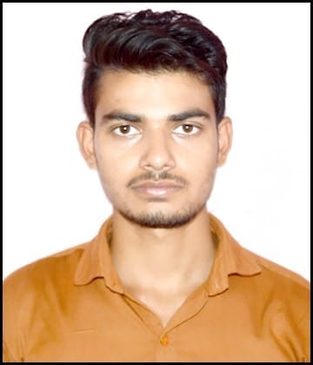

**ADD-VILL**-ANTPURI, **POST** -KUSHMARA,

**DISST**-MAINPURI,UP

**MOB**-8808745300

[Email-palpawan611@gmail.com](mailto:Email-palpawan611@gmail.com)

**CAREER OBJECTIVE:** -

To obtain a position that will allow me to utilize my technical skills, experience and willingness to learn in making an organization successful.

**EDUCATION QUALIFICATION: -**

|  |  |  |  |  |
| --- | --- | --- | --- | --- |
| **S.NO** | **CLASS** | **INSTITUTE** | **BOARD/UNIVERSITY** | **PASSING YEAR** |
| **1** | **POST-GRADUATION** | **ITM UNIVERSITY** | **ITM UNIVERSITY** | **2024** |
| 2 | GRADUATION | SUBHARTI UNIVERSITY | SUBHARTI UNIVERSITY | 2022 |
| 3 | INTERMEDIATE | N COL OF SCI GAISINGHPUR FARRUKHABAD | UP BOARD | 2017 |
| 4 | HIGH SCHOOL | ARMY PUBLIC SCHOOL, (ROORKEE) | CBSE BOARD | 2015 |

**SKILLS**

BASIC KNOWLEDGE OF PROGRAMING LANGUAGE

PYTHON,JAVA SCRIP ,JAVA,SQL,DSA,AI TOOLS

WORD PAD, POWER POINT, EXEL

**MAJOR PROJECT;**

Real-time chat app with push notification java project idea

RF-BASED REMOTE CONTROLED DEVICE

**HOBBIES: -**

Playing chess, football, travelling, gardening

**DECELERATION**

I hereby declare and affirm that the above information is true and correct to the best of my knowledge and belief.

**DATE**

**PLACE (SIGNATURE)**