OJT Productivity Process Manual

1) PMS Login →Organization Tree → HR → HR → HR

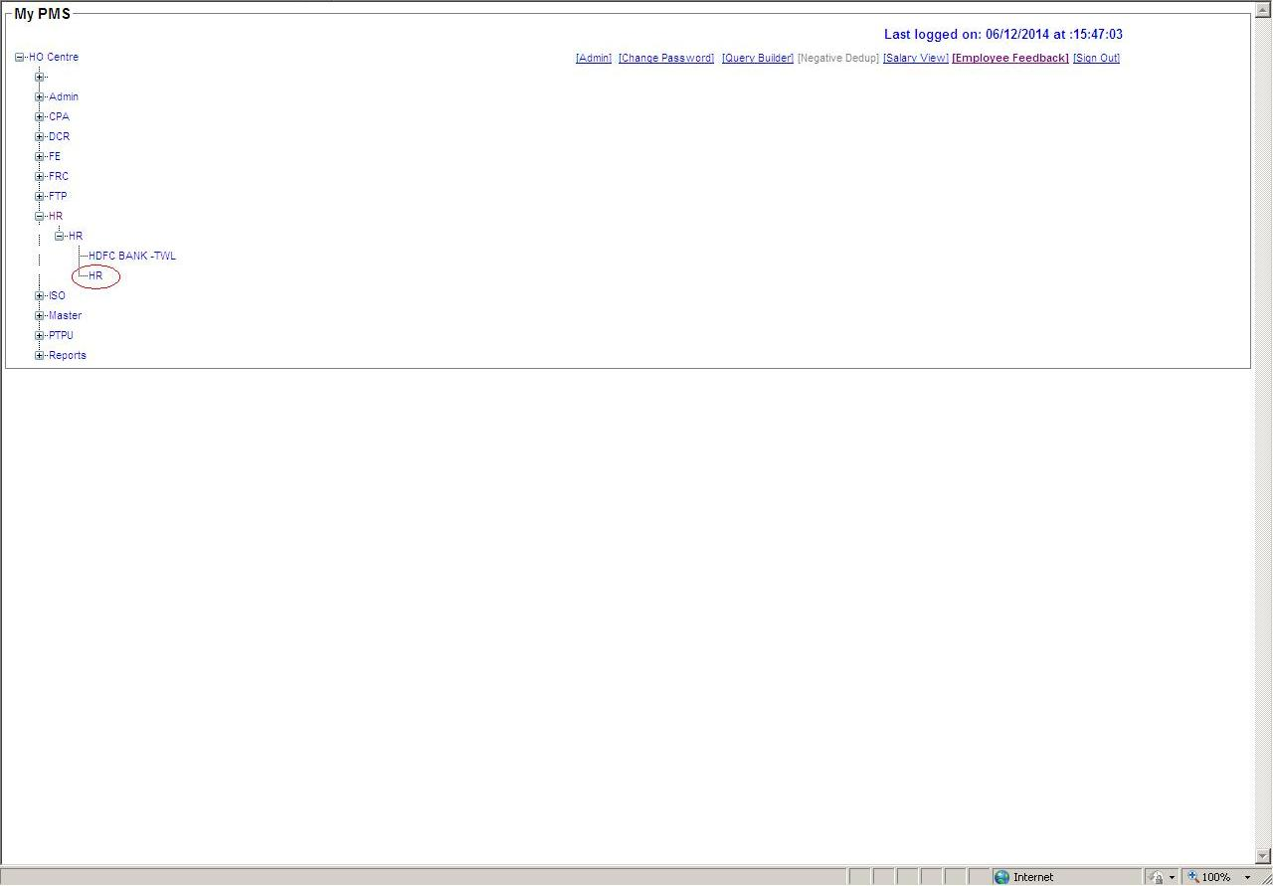
2) HR → Productivity.

Select “Productivity” option to Add/Update OJT records.

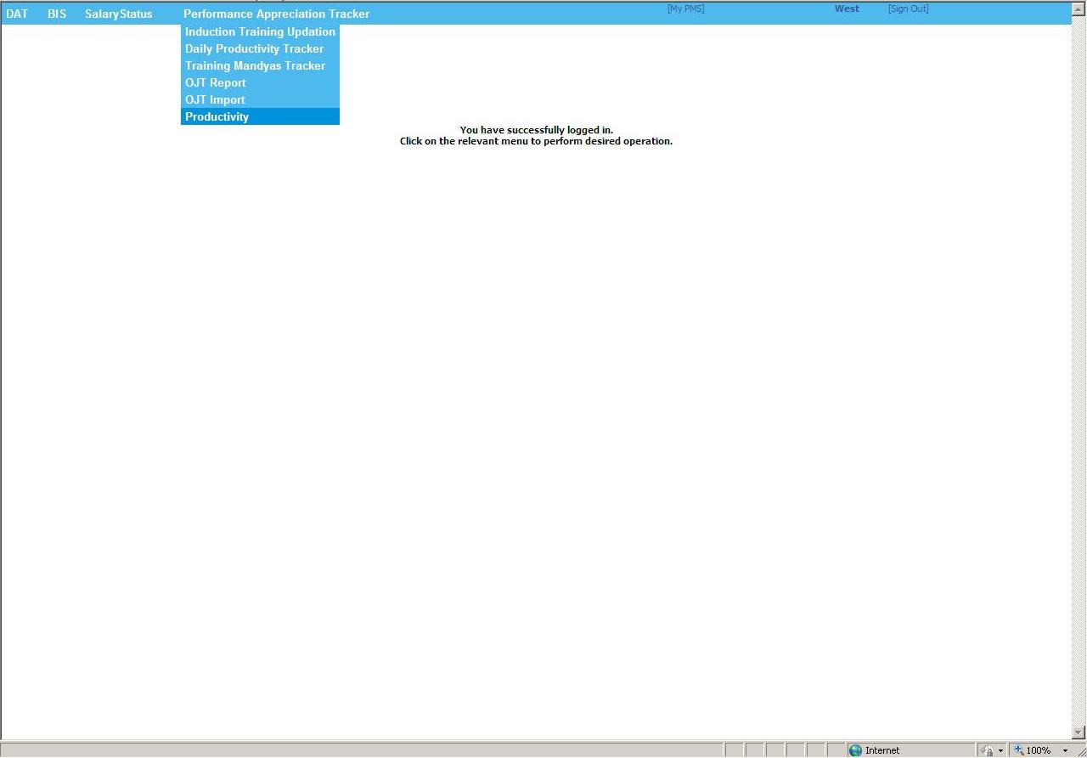
3) Select particular option shown in below image.

- Select “New Entry in OJT” to ADD new OJT records in PMS.
- Select “Update Entry in OJT” to UPDATE OJT records in PMS.

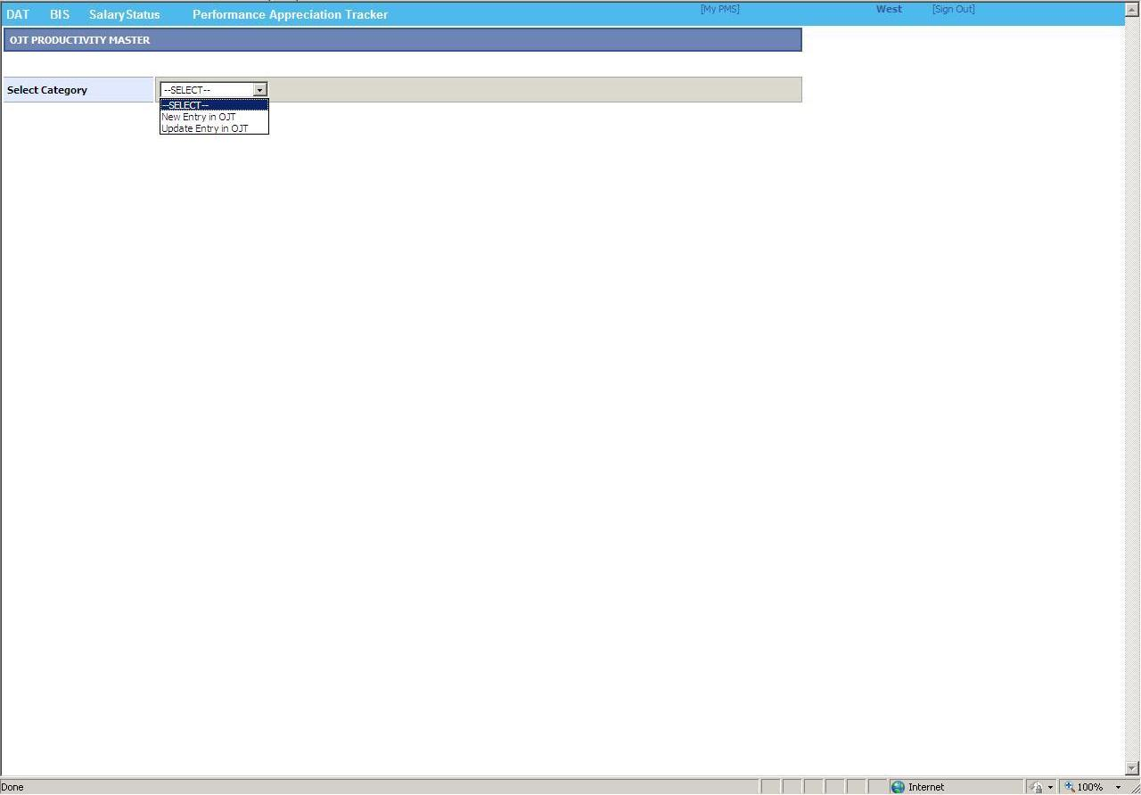
4) Select Category → “New Entry in OJT”

Search Employee details to ADD new OJT record by
- Selecting “Cluster Name” from which the Employee belongs to.
- Entering “Employee Code” of that particular employee.

After fetching the entire Employee details click on “EDIT” link button as shown below to ADD his/her
- Updating Authority.
- Minimum Productivity.

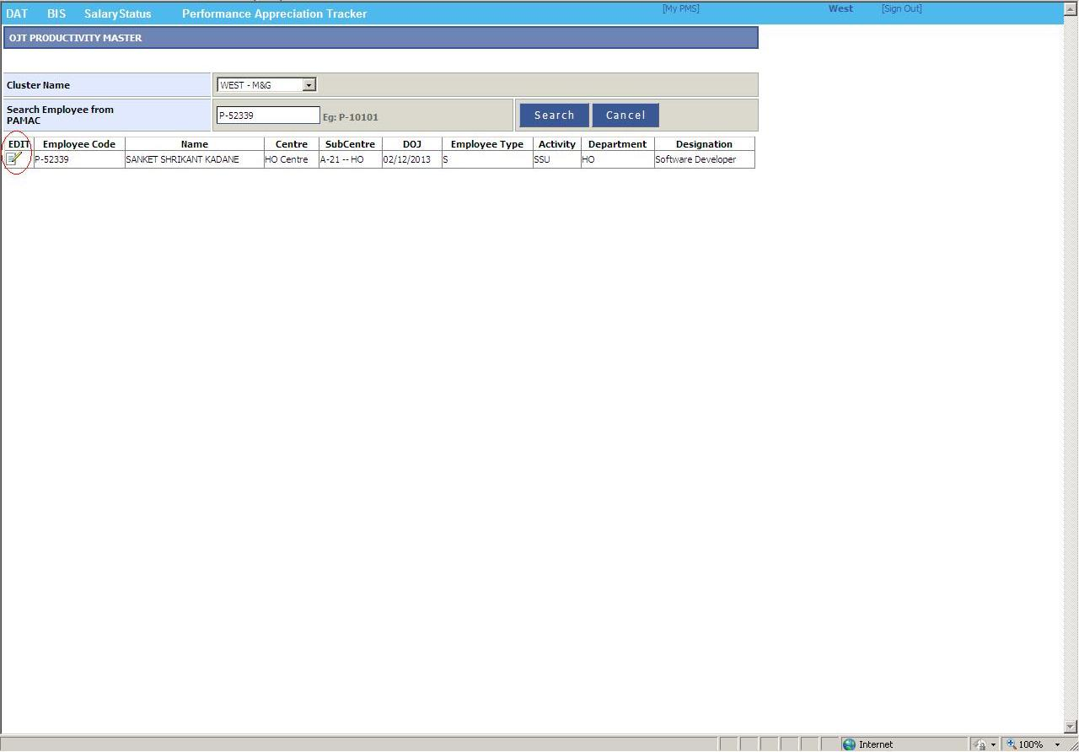
5) Select Category → “Update Entry in OJT”

Search Employee details to UPDATE the OJT record by
- Selecting “Cluster Name” from which the Employee belongs to.
- Entering “Employee Code” of that particular employee.

After fetching the entire Employee details click on “EDIT” link button as shown below to UPDATE his/her
- Updating Authority.
- Minimum Productivity.

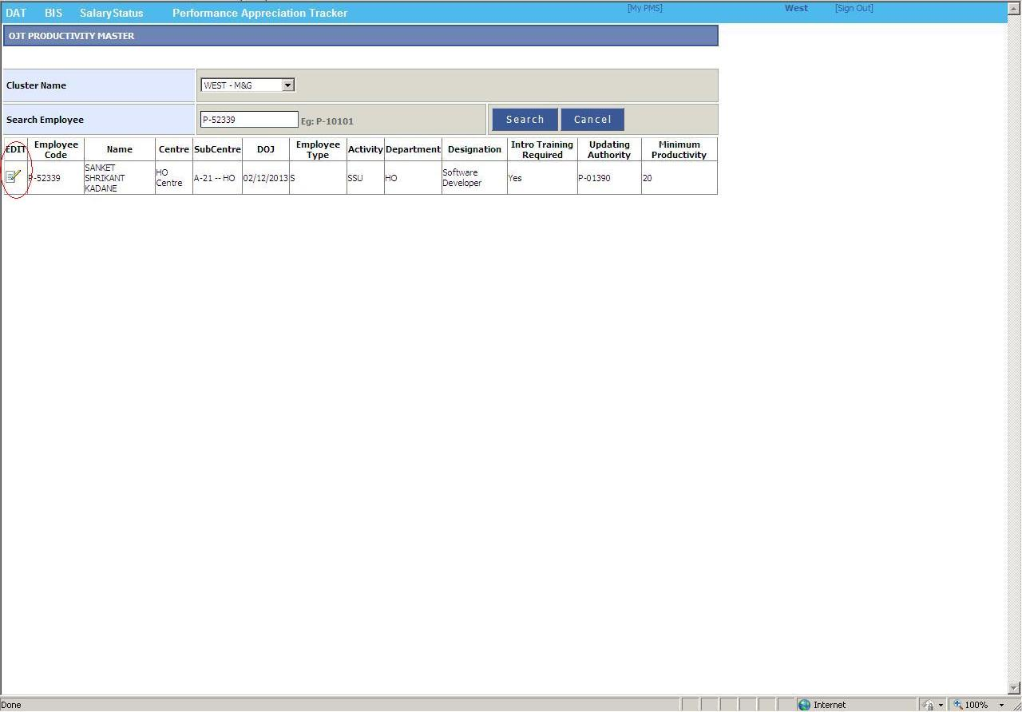
6) Click on “SAVE” button to ADD/UPDATE OJT record.

NOTE:

- “Updating Authority” must be Employee Code who will update daily productivity for the particular employee.
- “Minimum Productivity” must be an Integer Number.

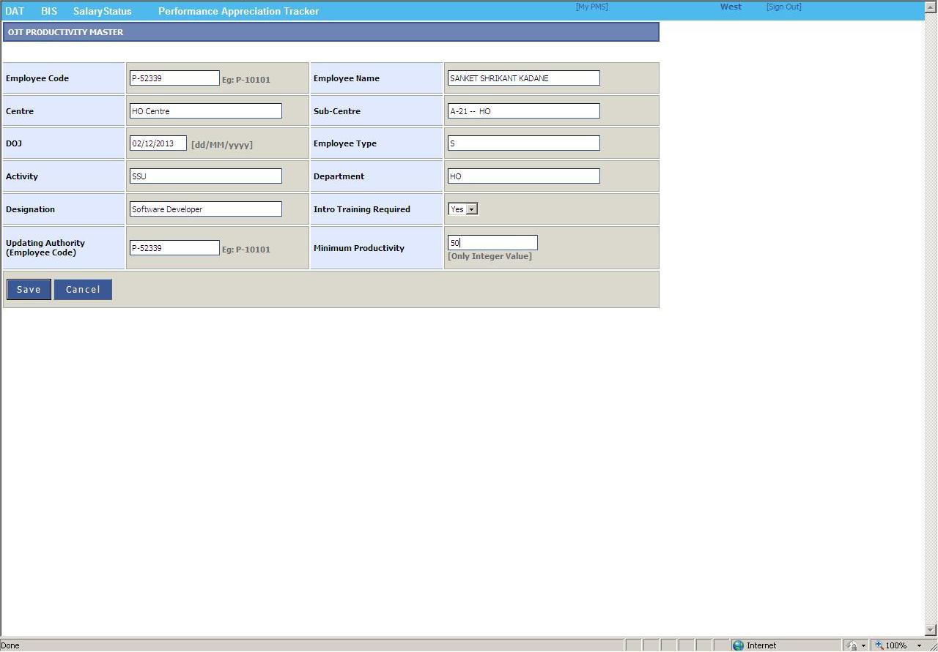
7) Print message will be visible after Adding/Updating OJT records as shown below.

