OJT Productivity

1) PMS Login →Organization Tree → HR → HR → HR

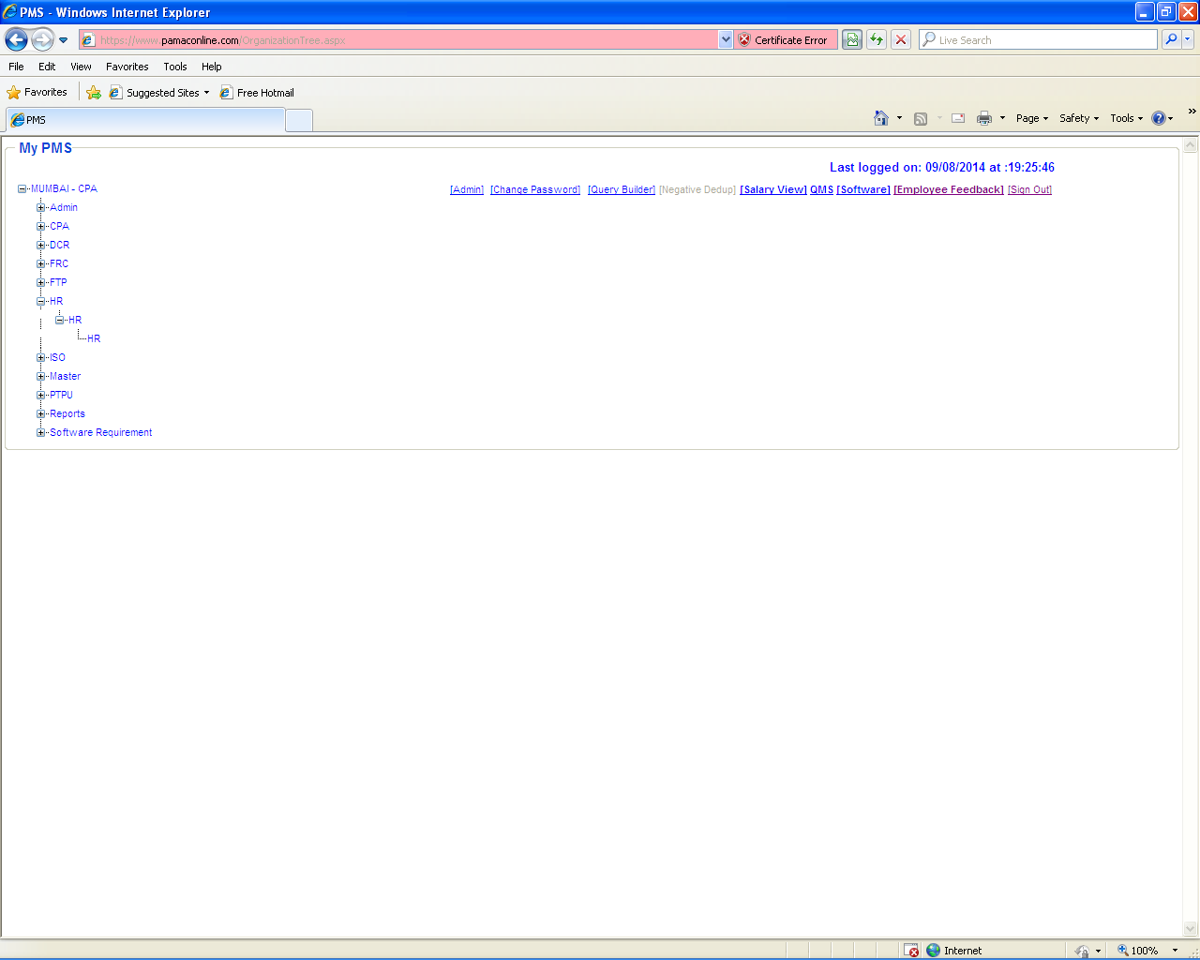
2) HR → Productivity.

Select “Productivity” option to Update/Remove OJT record.

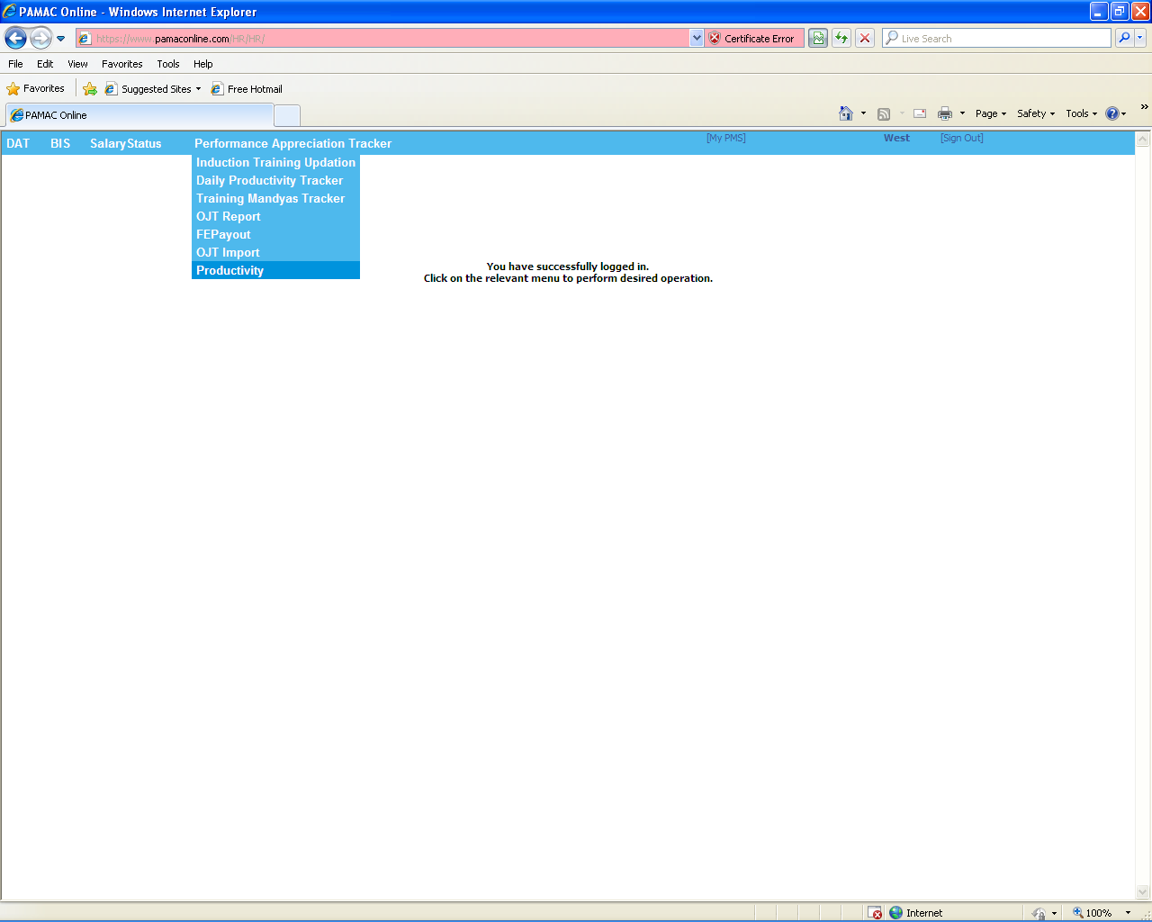
3) Select “Update Entry in OJT” to Remove OJT record in PMS.

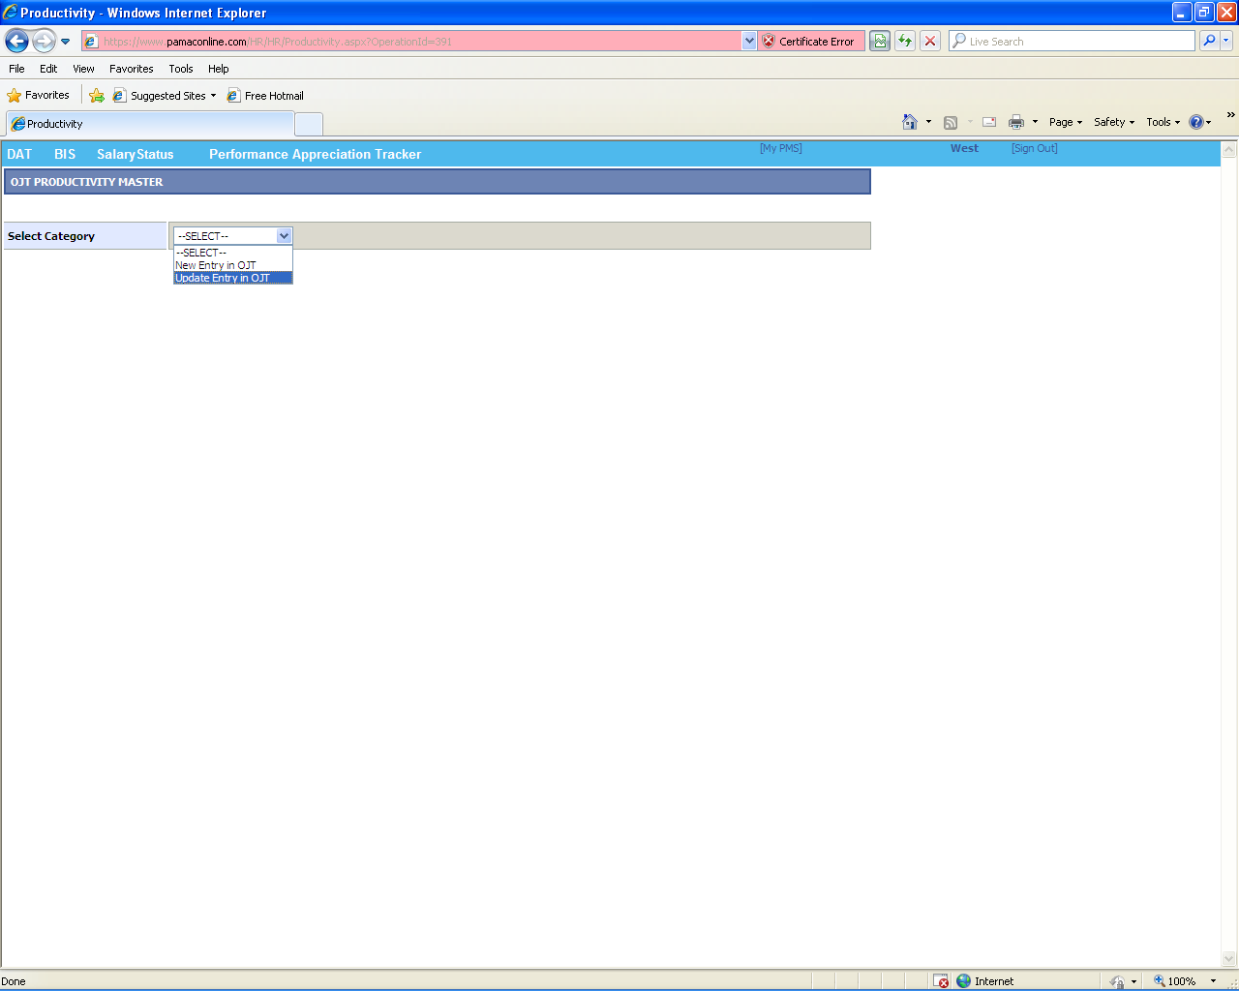
4) Select Category → “Update Entry in OJT”

Search Employee details to REMOVE the OJT record by
- Selecting “Cluster Name” from which the Employee belongs to.
- Entering “Employee Code” of that particular employee.

After fetching the entire Employee details click on “EDIT” link button as shown below to REMOVE OJT record(s).

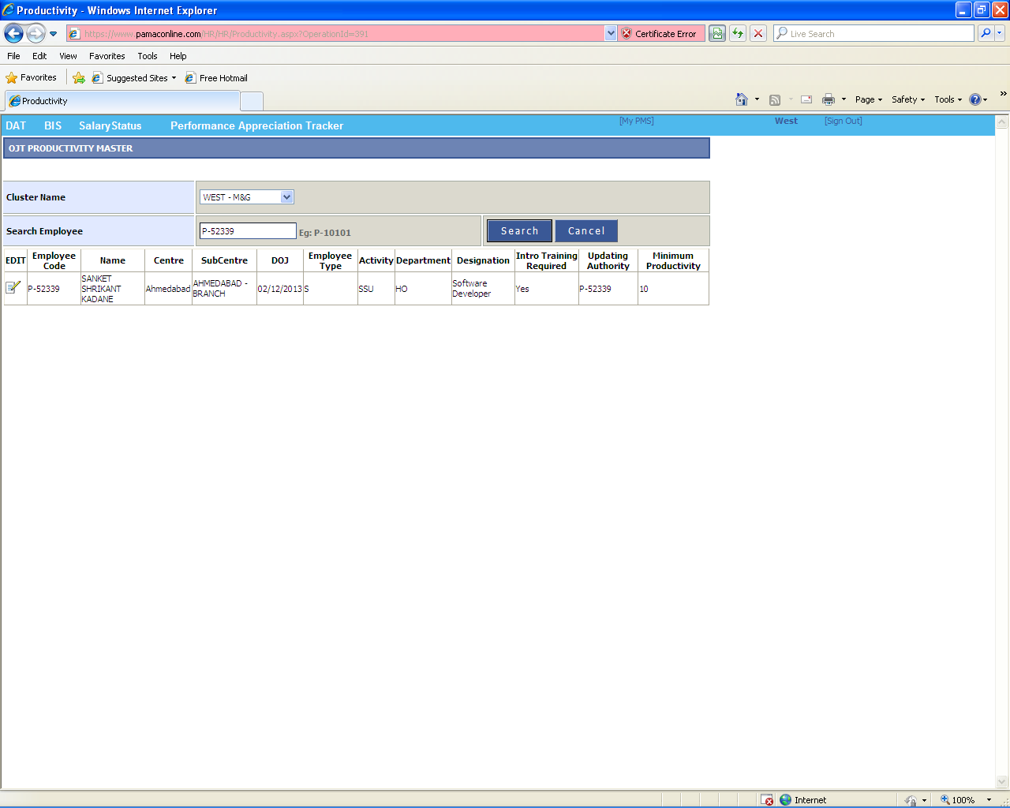
5) Click on “REMOVE” button to Delete OJT record for that particular employee as shown in below images.

NOTE:

- “Updating Authority” must be BLANK or NULL.
- “Minimum Productivity” must be BLANK or NULL.
- “Remark” must be the Reason why we need to Remove OJT record for the particular employee.

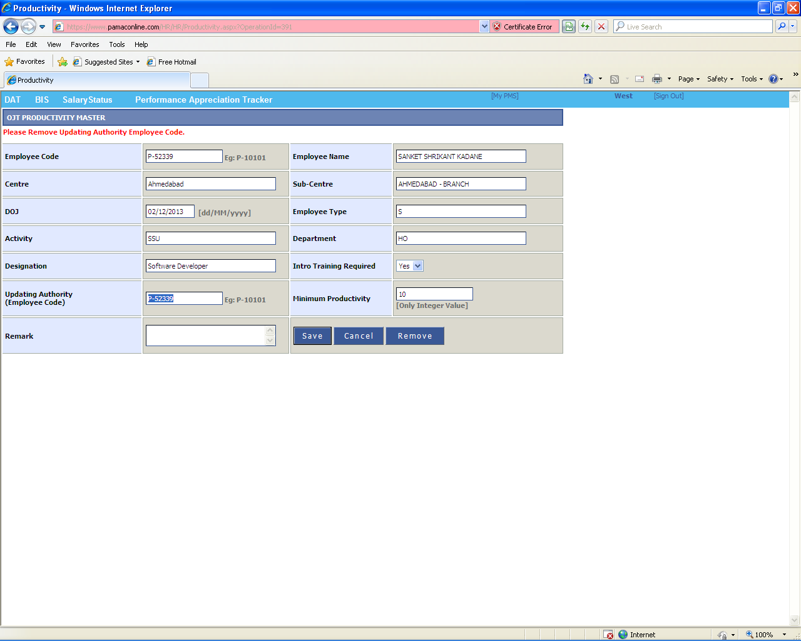

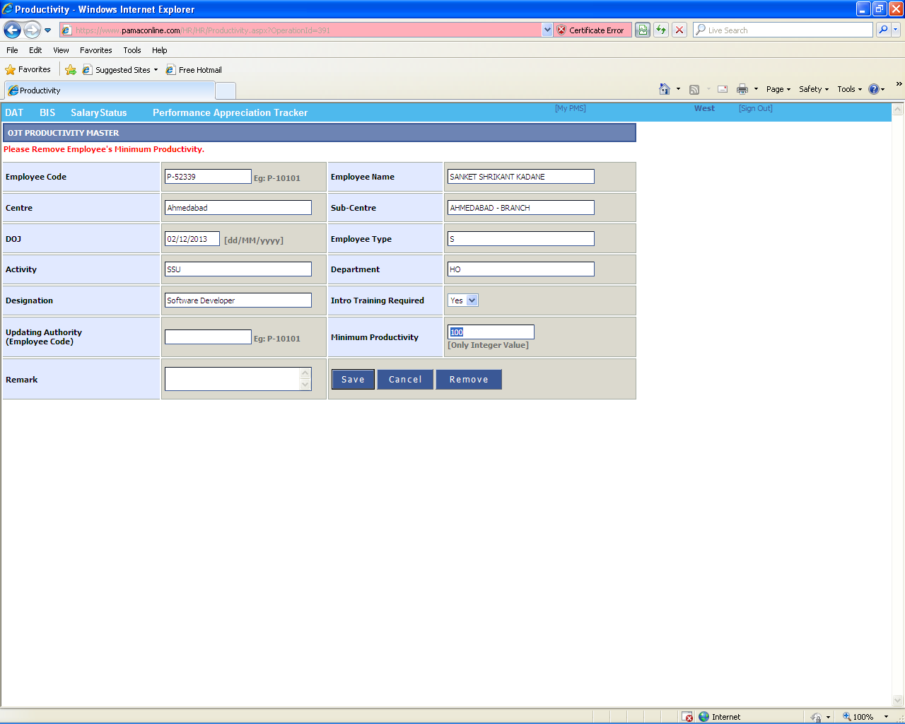

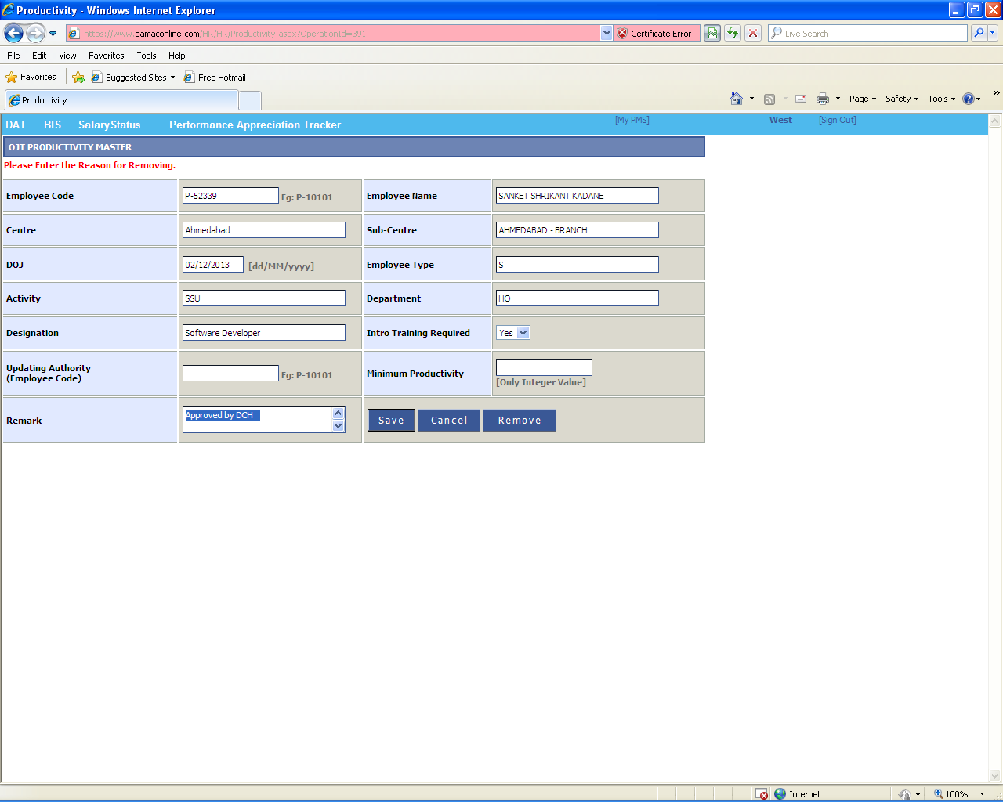
6) Print message will be visible after REMOVING the particular OJT record as shown below.

