Query Management System (QMS) Process Manual

PMS Login -> Admin -> QMS -> Select QMS.

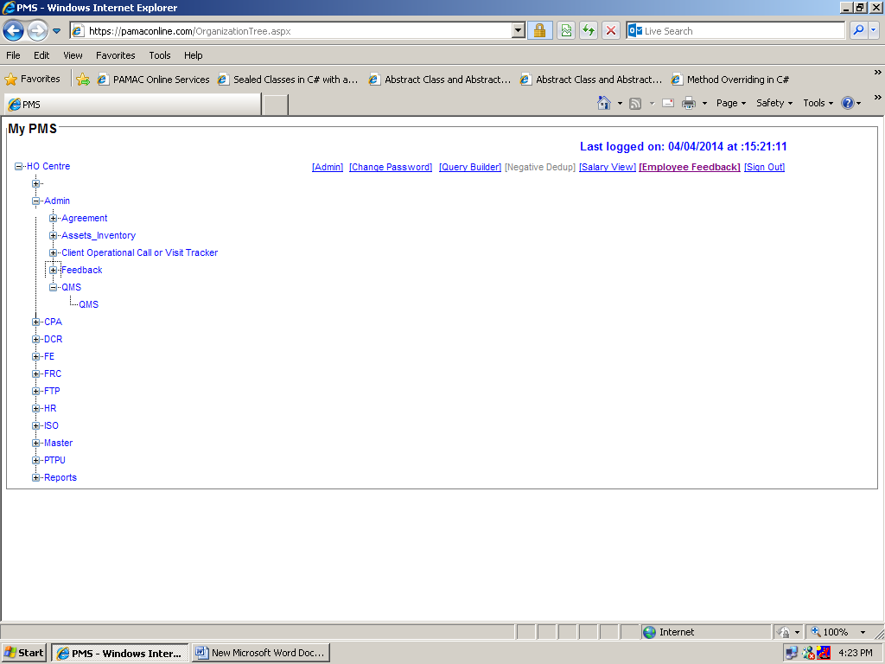

In QMS HR Support menu is having three sub menus:

- Ticket Request
- Ticket Assignment
- Reports

Ticket Request:-

Select “Ticket Request” option to add new Request/Query.

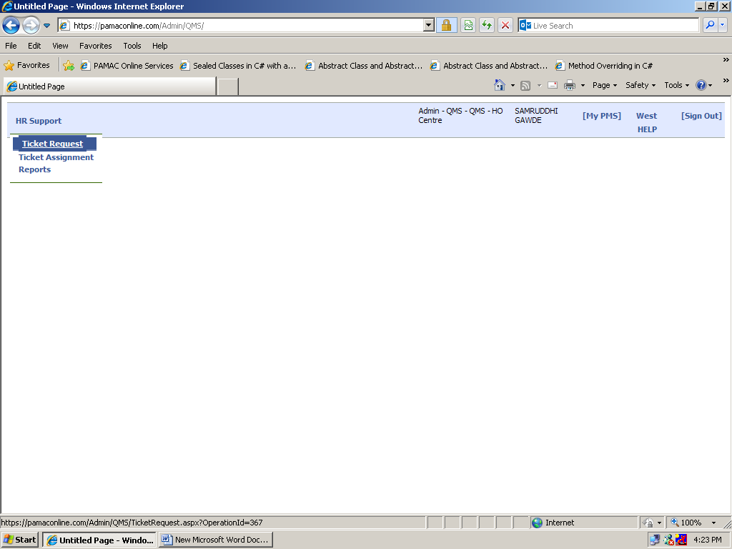

Select and Fill all the necessary options shown in below image.

- Department of The Employee: Select particular Department from which user belong to.
- Concern Department: Select Concern Department to whom user’s query belongs to.
- Query Type: Select particular query.
- Assign To: It will automatically reflect the User from Concern Department.
- Comments: Write comment to explain the exact query problem.
- Attachment: Attach file (if any).

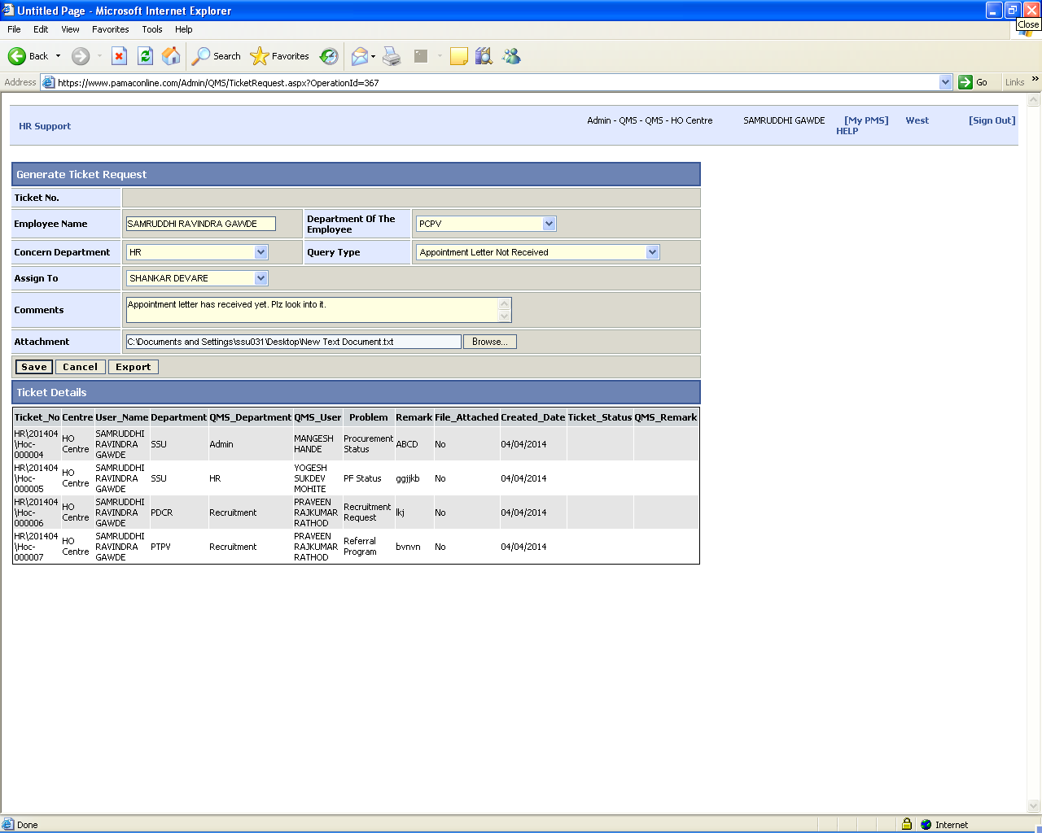

Ticket Assignment:-

Ticket Assignment is a mandatory stage, here QMS user need to assign ticket either to him/her or any other respective user.
QMS User needs to update the status (open, pending, close) of every ticket in this stage.

Select “Ticket Assignment” option to search the Request/Query generated by User(s).

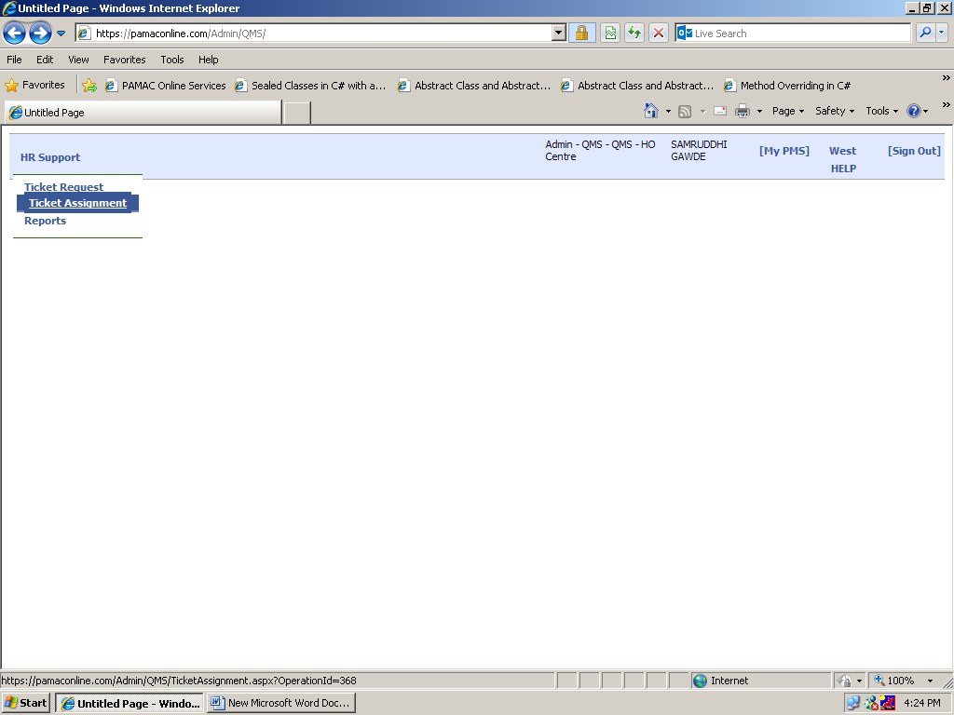

Search the record by selecting particular option(s) as shown in below image.

Ticket No.: Search the record by Ticket No.
Department: Search the record by Department of the user.
Request By: Search the record by Name of the user.
Centre: Search the record by particular centre.
Problem Type: Search the record by particular problem type.
Assigned By: Search the record who has assigned the Ticket request to concern person.
Request From & Request To: Search the record between particular dates.
Assigned To: Search the record to whom the ticket request has assign.

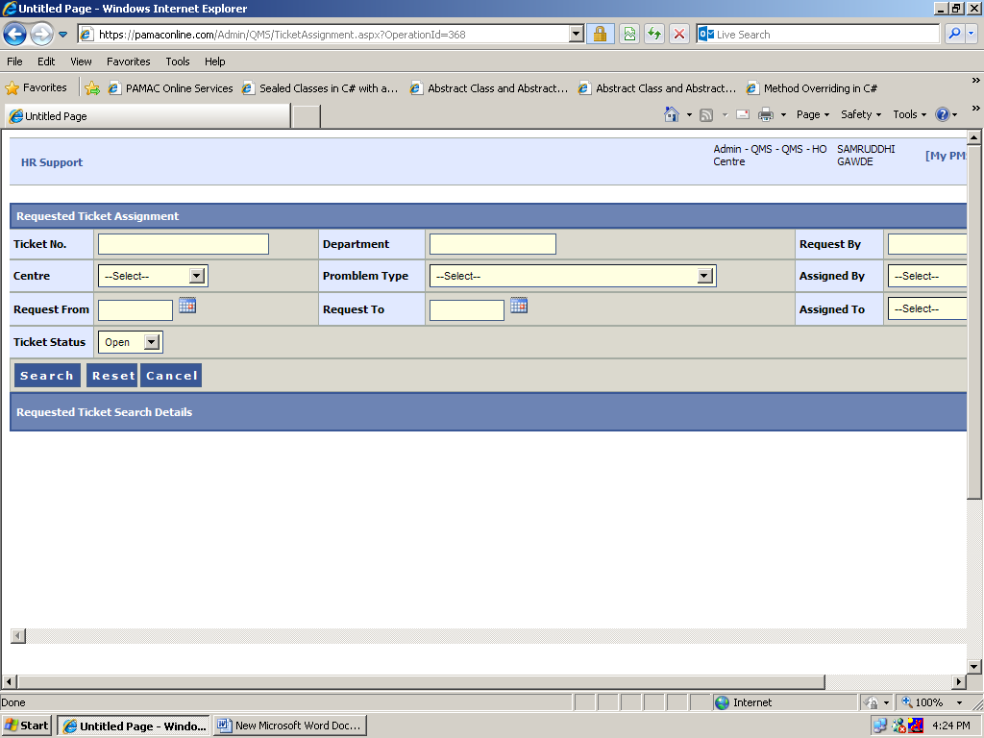

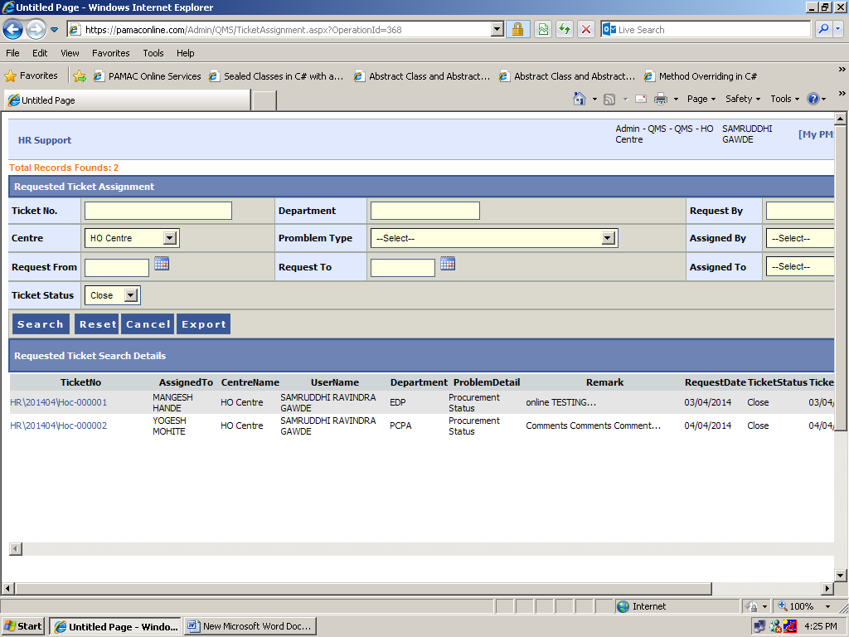

Click on “Ticket No” from grid view to Assign / Reassign the Ticket request.

“Ticket Detail Info” window will display all the record who has requested the query.

“Ticket Status Updated” window will display all the updated details for the concern ticket request.

- Assigned To: Select concern person to whom query need to assign.
- Ticket Status: Select Ticket Status (Open/Pending/Close).
- Update Remark: Write updated remark.

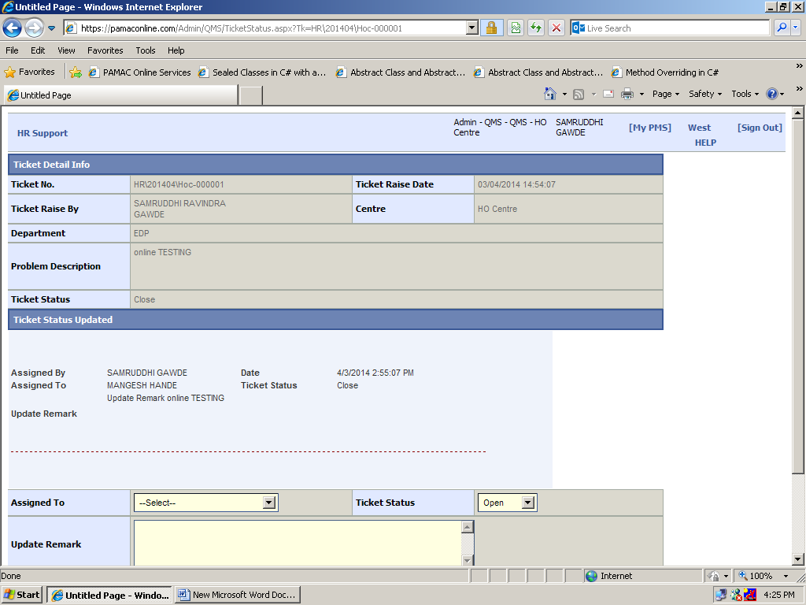

Reports:-

Select “Reports” option to search the Request/Query generated by User(s) has completed in given TAT hours or not.

From Date & To Date: Select the date range to search the record.

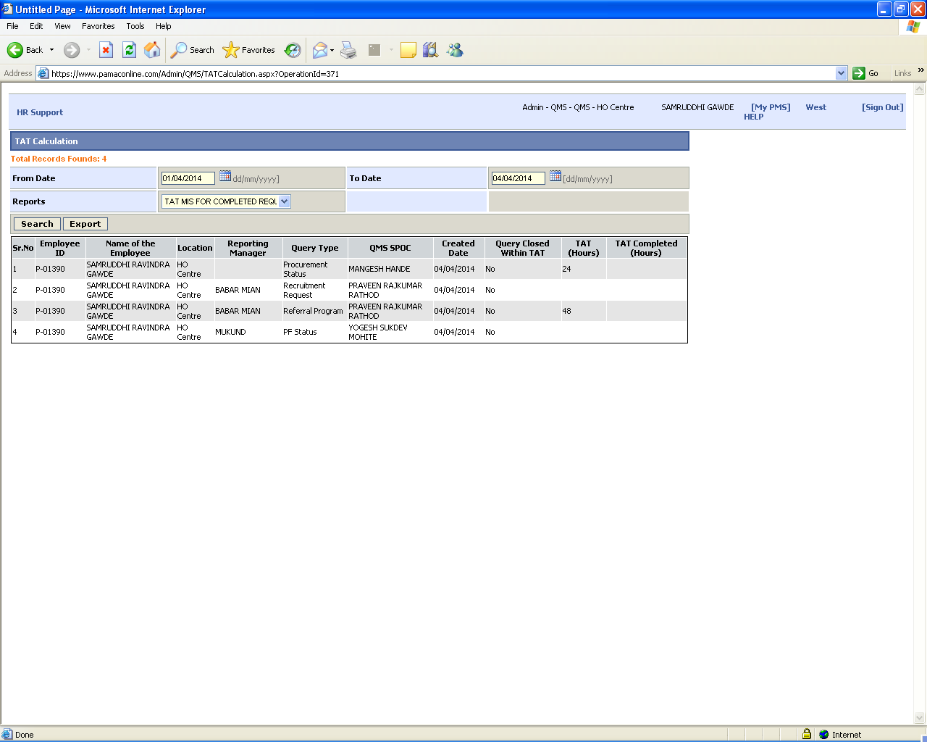

Click “Export” button to Open/Save the TAT report.

