

A User’s Introduction to 

Tutorial version 1.5.0

October 2024

Contents
PAMGuard Overview 3
Tutorial Learning Outcomes 4
Exercise 1. Tutorial Installation 5
St Andrews University Classroom PC’s 5
Personal Computers 5
1.1. Install data and configuration files 5
1.2. Install PAMGuard 5
Exercise 2. PAMGuard familiarisation 5
Ex 2.1 Launching PAMGuard 5
Ex 2.2 PAMGuard GUI overview 6
Ex 2.3 Using the map 7
Ex 2.4 Setting up a sound source 8
Exercise 3. Running the Click Detector 10
Ex 3.1 Tracking clicks manually 11
Ex 3.2 Tracking clicks automatically 12
Exercise 4. Adding a Spectrogram Display 14
Ex 4.1 Changing the scales 17
Ex 4.2 Add plug in displays to the spectrogram 18
Exercise 5. Detecting Whistles 19
Ex 5.1 Configure PAMGuard 19
Ex 5.2 Configure the FFT 20
Ex 5.3 Viewing whistle detections 23
Exercise 6. Mysticete Detection 25
Ex 6.1 Energy Sum Detector 25
Ex 6.2 Spectrogram Correlation Detector 27
Ex 6.3 Ishmael Matched Filter detector. 28
Ex 6.4 Compare the three detectors 29
Ex 6.5 Set up the detectors for different species 29
Exercise 7. Use the Whistle and Moan Detector to detect Baleen whale calls. 30
Exercise 8. Advanced display features 30
Ex 8.1 Adding further displays to Spectrogram Panels 30
Ex 8.2 Adding a Radar Display to the User Display panel 31
Exercise 9. Detection during seismic source operation 32
Ex 9.1 Loading the sound file 32
Ex 9.2 Adjusting click detection parameters 33
Exercise 10. Don’t stop now! 35

PAMGuard Overview
Many marine activities involve underwater sound emissions. These may be a by-product of the activity (e.g. piling or explosives), or a tool (e.g. air guns used for seismic surveys in oil and gas exploration, or military/commercial sonar). To mitigate against harm to marine mammals, observers are often employed to visually scan the sea surface for the presence of animals. In the event of a sighting, procedures such as suspension/delay of activities may be implemented to avoid harm.
Visual observations play a vital role, but marine mammals are difficult to spot on the sea surface, especially when weather and light conditions are poor. However, many marine mammals produce loud and distinctive vocalisations, which can often be detected more reliably than visual cues. For these species, passive acoustic monitoring (PAM) offers an effective means of detection. Furthermore, the creatures do not need to be on the surface to be detected.
A basic PAM system consists of a number of hydrophone elements (analogous to microphones in air, but used for underwater sound) arranged to form an array, hydrophone signal conditioning/amplification, a signal acquisition device (e.g. a sound card) and a computer running PAM software. Sounds in the water are converted by the hydrophones into electrical signals which are conditioned appropriately and converted into digital signals for processing by the PAM software.
The PAMGuard project was set up to provide a standard software infrastructure for acoustic detection, localisation and classification for mitigation against harm to marine mammals, and for research into their abundance, distribution and behaviour.
PAMGuard is open-source Passive Acoustic Modelling (PAM) software based on a platform-independent (e.g. Windows or Linux), flexible, modular architecture.
This architecture makes it relatively straightforward to incorporate new modules as they are developed to include additional detection, localisation, classification and sound visualisation functionalities. The software offers a versatile software/hardware interface to enable flexibility in the configuration of in-sea equipment (number of hydrophones, sensitivities, spacing and geometry).
PAMGuard is a sophisticated software package that can be used by the expert user to set up industry/research PAM infrastructure. It can also be configured for operational use by MMO PAM operators. Central to the software design is a flexible core architecture which allows the integration of a range of additional plug-ins. For more information on PAM and PAMGuard please visit www.PAMGuard.org.
This tutorial provides an introduction to PAMGuard from a user’s perspective. This involves exercises in setting up and running the software with a variety of configurations of plug-in modules.
The latest PAMGuard release contains over 38 different plug in modules. A complete list of these is available on the PAMGuard web site at http://www.PAMGuard.org/modules.shtml

Tutorial Learning Outcomes
The purpose of this tutorial is to provide a basic overview of how to use PAMGuard, including adding and configuring plug-in modules.
The main learning outcomes are:
- Loading and running PAMGuard configurations
- Navigating the Graphical User Interface (GUI)
- Basic Map familiarisation
- Running and configuring a Click Detector module
- Adding and configuring User Display panels
- Adding, configuring and running a Whistle Detector
- Using “Ishmael” modules for Energy Sum, Spectrogram Correlation and Matched Filter detectors.
- Overlaying detector graphics on display panels
- Adding and configuring FFT Engines
- Using spectrogram and radar displays to view detection information
These learning outcomes can be achieved through a series of exercises that now follow.
The exercises can be seen as a guide, so you’re encouraged to experiment with PAMGuard as you work through each one.

- Tutorial Installation
During these tutorial examples, we assume you are running PAMGuard on a Windows machine.
In the exercises you will play back sound from a file rather than receive it in through a sound card. PAMGuard will operate in exactly the same way as it would if the sound were coming in through the sound card. If a sound playback module is included in the PAMGuard configuration, then analysis will be in real time. If a sound playback module is not included, then PAMGuard will process data as fast as possible.

St Andrews University Classroom PC’s
PAMGuard is available on the Classroom PC’s through APPS Anywhere. Before starting PAMGuard you’ll need to move some folders from the read only L drive to either your personal Home Drive (H:) or Windows (K:). Performance seems slightly better if copied onto K:
On L: find the folder L:\Biology\BL5210\PAM Practical_171103
This contains three sub folders: TutorialMaps, TutorialSoundFiles and PAMGuardTutorialHome. The Maps and sound files can remain on the L drive. However you should copy the PAMGuardTutorialHome folder to your Home (H:) or Windows (K:) drive. This is because the L drive is read only, and PAMGuard will need write access in order to modify files in the PAMGuardTutorialHome folder.

Personal Computers

Install data and configuration files
Download the training wav files from https://doi.org/10.5281/zenodo.13851130
Download the configuration files from the PAMGuard web site.
The configuration files will be accessing the downloaded wav files. In principle, the downloaded files can be anywhere on your computer. However, when setting up the exercises, the files were in the folder C:\PamguardTutorial\webTutorialDataset. If you put your files in the same folder, then the tutorials will work “out of the box”. Otherwise, for each exercise, you will have to go into the sound acquisition settings and re-select the correct file, wherever you’ve stored it on your system.

Install PAMGuard
The examples in this tutorial will work with the latest PAMGuard Version 2.02.13 or higher.
- PAMGuard familiarisation
- Launching PAMGuard
Launch PAMGuard from Apps Anywhere (or your Windows Start menu on a personal PC). The first thing to appear will be a splash screen giving version and license information and a tip of the day. Make the tip go away and wait for the splash screen to disappear and you will be left with a dialog like the one below.

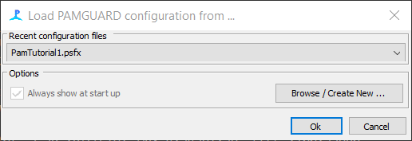
Figure 1. PAMGuard configuration dialog

This dialog allows the user to choose from a selection of PAMGuard configuration files which were either installed with PAMGuard, you created yourself, or were provided by someone else.
Recently used configurations can be selected from the drop down list. If the file you want is not available in the list, press the browse button and find the configuration file on your computer. For this tutorial, press Browse and navigate to where you’ve put the PAMGuardTutorialHomeDrive folder on H:. Select PAMTutorial1.
When OK is clicked, the dialog will disappear and the PAMGuard application will launch. During the launch, the following dialog might appear.

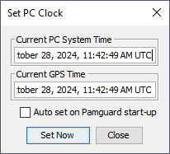
Figure 2. Set PC Clock Dialog

You should ignore this dialog for this tutorial. After a few seconds it will disappear. In real operation this would synchronise your PC clock with the time provided by the GPS system. (Note, that in recent Windows versions, this functionality may not be available due to security constraints).
- PAMGuard GUI overview
Once launched, the PAMGuard Graphical User Interface (GUI) will look like Figure 3.

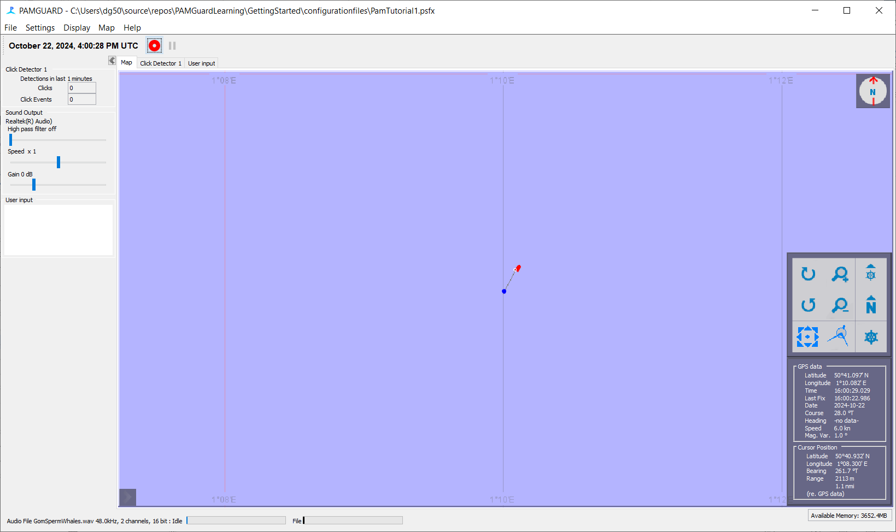
Figure 3. PAMGuard Graphical User Interface

The GUI is subdivided as described in the following table.

Menu bar | This provides access to many PAMGuard settings and controls, as well as access to the help system. PAMGuard has a dynamic menu bar system, whereby the menu items change according to the current view and settings.
Clock display | Shows the current time.
Side panel | The side panel gives quick access to information and controls for currently active modules.
Tab panel | Tab panels provide access to the main visual interfaces of many of the PAMGuard modules. In this example the map tab panel is shown, which consists of a map, compass and some GPS data etc.
Status bar | This bar provides information on the current status of PAMGuard, e.g. whether it is running or idle

Spend some time investigating the user interface.

- Using the map
At this point, PAMGuard should be running with the “PamTutorial1.psfx” configuration. The configuration file name is always shown in the title bar of the PAMGuard display. If this is not “PamTutorial1.psfx”, exit and restart PAMGuard with the correct configuration file.
In the tutorial configurations, the GPS data are simulated and the “vessel” icon will appear on and move over the map display. If you cannot see this, make sure you have selected the map tab panel by clicking on its tab and click on the “centre map on ship” map control button (see table below). GPS data are simulated for demonstration purposes.
Experiment with the map controls, which have functions as described below:
 | Centre map on vessel | This control pans the map such that the vessel which supplies PAMGuard’s GPS feed is represented in the centre of the display by the icon.
 | Zoom out/in | These controls allow the user to zoom in and out of the map view. These functions can also be achieved using the mouse wheel.
   | Measure/Pan | These controls allow the user to either measure by dragging the mouse across the display or to ‘pan’ or drag the display to view a different region.
 | Ship/North orientation | These controls set the map’s orientation to ship’s heading and North, respectively.
 | Rotate map | These controls allow the user to rotate the map to a desired arbitrary orientation.

Move the mouse cursor around the map and note that the Latitude and Longitude of the cursor position is provided and in addition, the range from the mouse cursor to the host vessel. This is useful for range estimation.
Note the information panel at the lower right hand corner of the map. This shows useful information such as the position of the vessel which is supplied by the GPS feed to PAMGUARD.
- Setting up a sound source
First of all you will need a source of sound. PAMGuard modules can acquire sound data in a number of ways, e.g. sound can be acquired directly from the system sound card, from some other digital acquisition device or sound files can be loaded and “re-played”.
If you’ve put the PamguardTutorial folder on your C drive, or your ‘home’ folder, and are running the example configuration files (e.g.PamTutorial1.psfx) then the sound source will already be configured for you. If however you’ve put the tutorial files somewhere else on your computer, you’ll have to go through these next stages in order to find the correct files.
To load a sound file, your configuration must contain a ‘Sound Acquisition’ module. Go to the settings dialog for the sound acquisition module (Figure 4). You will find this in the Detection->Sound Acquisition menu. In ‘Data Source Type’ select ‘Audio File’. Select the file of choice (AIF or WAV format) either using the ‘Select File’ button or selecting a recent file from the drop down list. The sample rate and number of channels will be read automatically from the file. If you have calibration information you can also enter it here, but this is not required for any of the exercises in this tutorial.

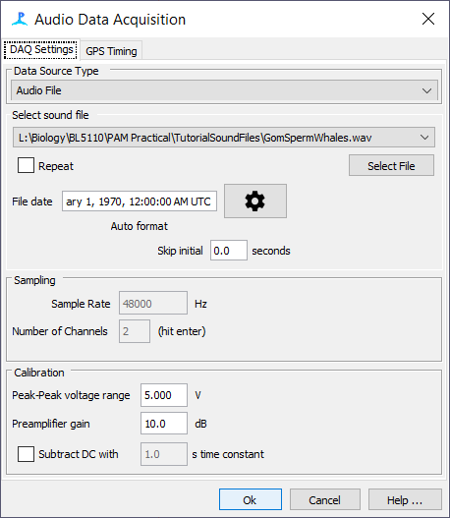
Figure 4: Sound acquisition configuration dialog.

- Running the Click Detector
The loaded configuration already has a Click Detector plug-in added. Clicking on the Click Detector module’s tab (Click Detector 1) will bring forward the main Click Detector interface panel (Figure 5).

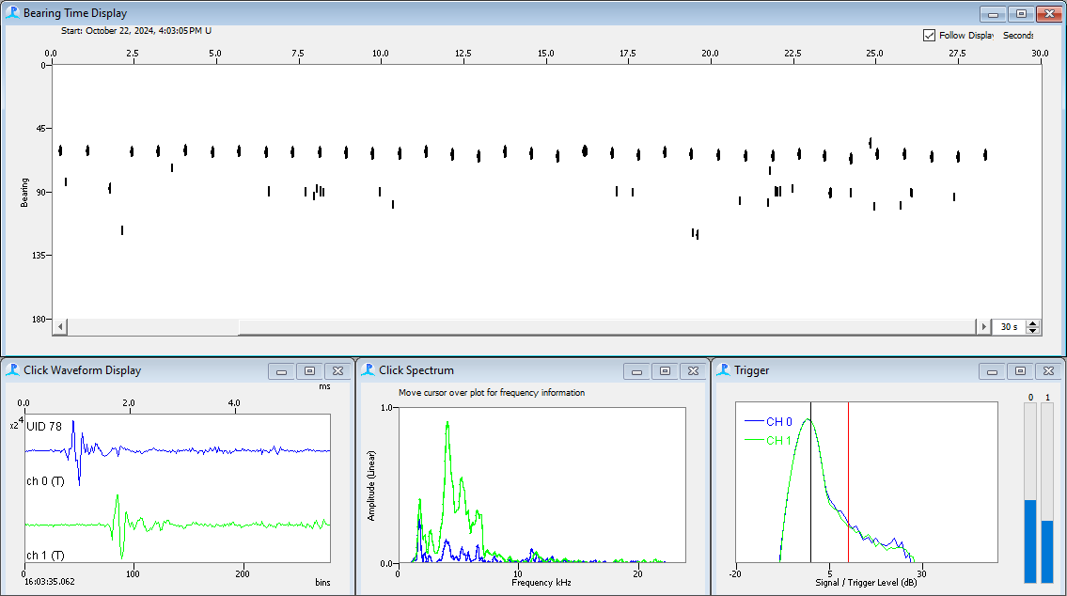
Figure 5. Click Detector Tab Panel

The panel has four main components:

Bearing/Time  display | Each detected click is shown as a circle or ellipse on the scrolling display. The toolbar at the top of the display can be used to select the type of vertical axis - bearing, amplitude or inter click interval.
Click waveform  display | The waveform of each detected click appears on the display as it is detected.
Click spectrum | The power spectrum of each click is displayed as it is detected.
Trigger display | The trigger window shows the amplitude of the signal on each channel as a decaying histogram. The vertical red line represents the trigger threshold set in the detection parameters dialog (cross reference). Level meters for each channel are also shown on the right hand side of the trigger window.

You can change the duration of the bearing/time display using the arrows in the bottom right corner of the displays scroll bar.
Start detection by selecting Detection ⇒ Start from the main menu. You are now running PAMGuard.

- Tracking clicks manually
The bearing time display scrolls with time and detected clicks are displayed as ellipses. As clicks appear on the bearing time display, the Click Detector’s side panel display (Figure 6) updates the number of clicks detected in the last 1 minute.

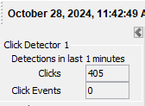  Figure 6. Click Detector side panel display | 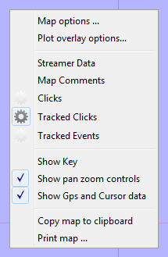  Figure 7. Map Panel drop-down menu

To track detected clicks manually, select a click in the Bearing Time display by right-clicking on it (in fact you can right click anywhere, which will pause the display, then release the mouse over the click you want to track). A pop-up menu should then appear where you can select an id or colour for the whale you are tracking. This will draw a cross on that click to confirm its status as being tracked. Next, click on the map panel tab to bring forward the map display. Using the right mouse button (or for Macs, hold the ctrl key and click) click on the map display to bring up the map detection drawing options. This provides a selectable list of items which are suitable for drawing on the map. An example is shown here:
Make sure that “Tracked Clicks” is selected. This will draw the bearing lines for that click on the map panel, as indicated in Figure 8:

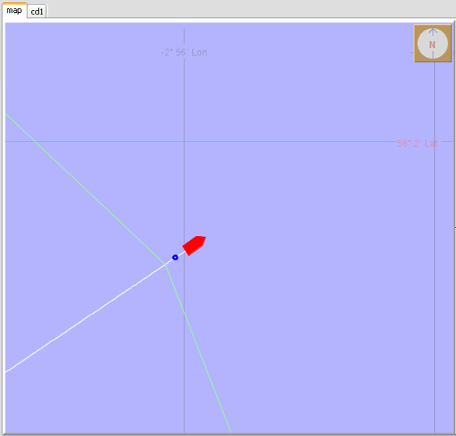
Figure 8. Tracked click bearing lines plotting on the map panel

- Tracking clicks automatically
The Click Detector can automatically detect sequences of clicks on a consistent bearing with a consistent inter click interval. Clicks that satisfy these constraints are referred to as Click Trains.
To enable this feature, select the Click Detector tab panel. Then select Click Detection ⇒ Click Train Identification… from the menu bar. This will bring up the following dialog:

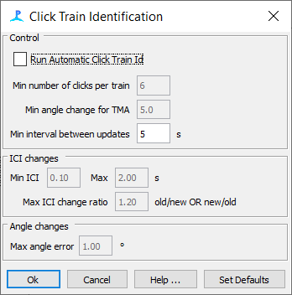

Figure 9. Click Train Identification Dialog

Click on the Run Click Train Id check box and select OK.
Note that access to the same dialog is also possible by selecting
Detection ⇒ “Click Detector Name” ⇒ Click Train Identification
from the main menu – where “Click Detector Name” is the name given to the particular Click Detector module running. For this exercise this will be “Click Detector 1”.
Now look at the Bearing Time display. Identified click trains are indicated by coloured ellipses, as in the Figure 10.

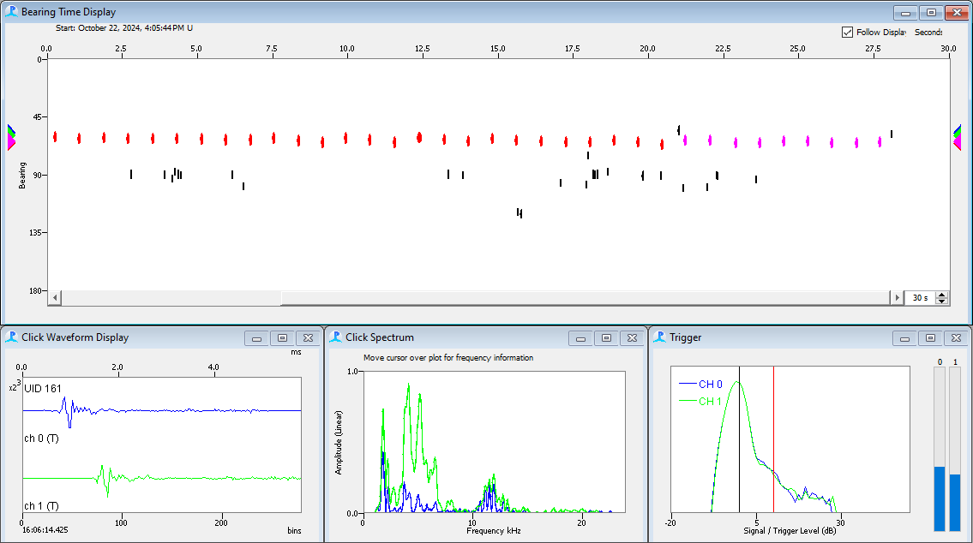
Figure 10. Click trains plotted on the bearing time display
Now switch to the map view.
Position the mouse somewhere on the blue map area and press the right mouse button to display the drop-down detector selection box and make sure that “Click Trains” is selected.
If a click train reaches sufficient length and the bearing change is adequate, target motion analysis automatically calculates a range and bearing to the sound source. The first and last bearing lines associated with this click train sequence are also automatically displayed on the map. An example is shown in Figure 11.

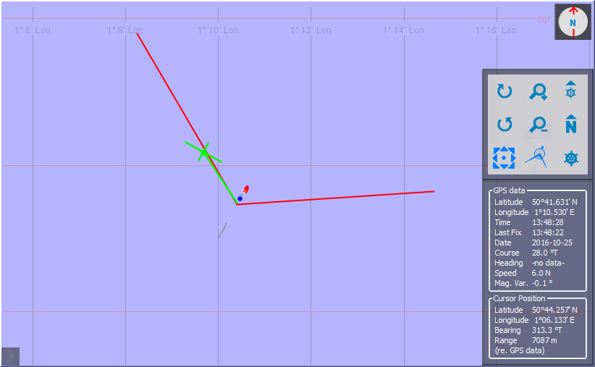
Figure 11. Click Train range estimates drawn on the map

Note that the lines terminate at the point of bisection, indicating the range estimate. Now hover the mouse cursor over this point and observe the Vessel-cursor range and bearing on the map information panel.
Take some time to experiment with the Click Detector and map views.
Try the program with the file “SpermSurvey.wav”, a recording made in the course of a real seismic survey from a survey vessel of Australia.
Select Detection ⇒ Stop from the main menu to stop the detector.
Think about the advantages and disadvantages of automatic detection compared to manual detection of click trains and other events.

- Adding a Spectrogram Display
Detections can be viewed in a number of PAMGuard graphics modules. For this exercise you will firstly use a Spectrogram Display. Spectrogram Displays are placed on a generic User Display panel, so first of all you have to add a User Display panel to PAMGuard. To add the new User Display panel, you will now use the Data Model display. Select File ⇒ Show data model… from the main menu. This will open the Data Model display window.

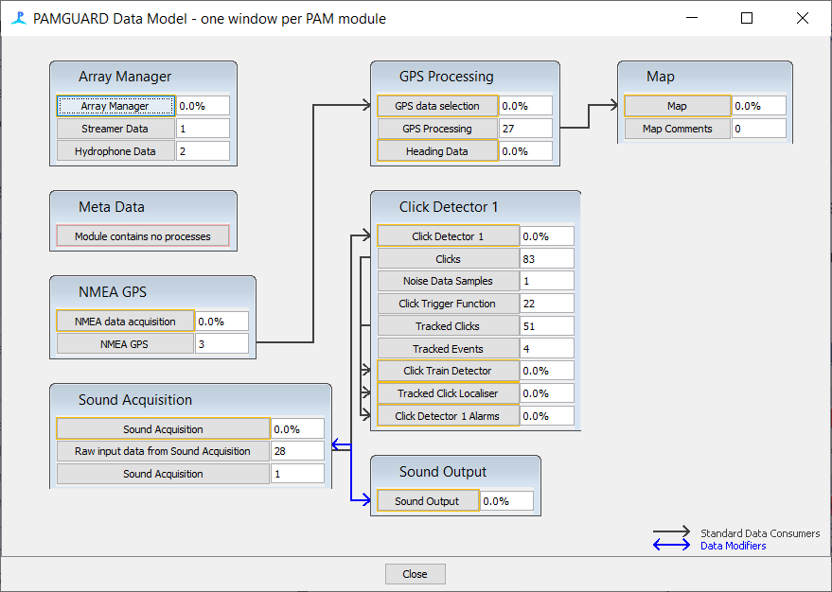
Figure 12. The PAMGuard Data Model window

Place your cursor anywhere on an empty space on the data model display area and, clicking the right mouse button, select Add Modules… ⇒Display⇒ User Display from the drop-down menus. Enter “User Display 1” as the name of your panel in the new module dialog and click OK. Note that the User Display module does not appear as part of the data model. This is because the user display cannot receive or produce data, and acts merely as a canvas for other displays. Click Close at the bottom of the Data Model display window.
Before adding the spectrogram display, you need to add a module to calculate FFT’s, which are the data to be displayed on the spectrogram. Go to the menu File ⇒ Add Modules ⇒ Sound Processing ⇒ FFT (Spectrogram) Engine. A dialog will appear asking what you want to call it. Leave it at the default value and say OK.
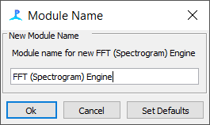
Once you’ve done this, go to the Settings ⇒ FFT (Spectrogram) engine settings … to open the FFT dialog.
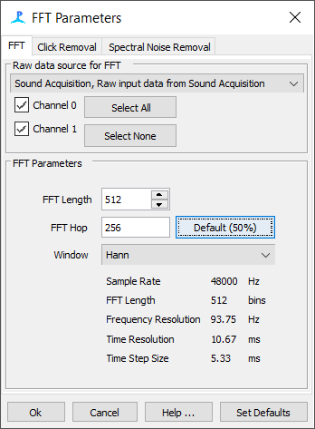
Change the FFT length to 512 points and press the ‘Default’ button to set the FFT hop to 256.

To add the Spectrogram Display to the new User Display panel, select the User Display tab on the tab panel selector. Notice the main menu items change as you select the various tabs. Select User Display ⇒ New Spectrogram… from the main menu.

Click Ok to create the FFT module and Ok again to set the module name (or enter a different one).
The Spectrogram configuration dialog will then appear:
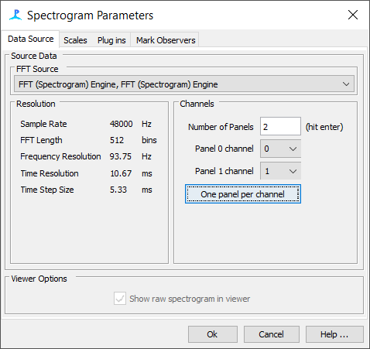
Figure 13. Spectrogram configuration dialog.
Enter “2” in the number of panels box. Hit the Enter key on the keyboard to confirm the value and select channel 0 and 1 from the two channel selection drop-down lists. Click OK and the new Spectrogram Display will appear on the User Display 1 panel. The FFT Engine will appear in the model view (Figure 12) connected to the sound acquisition module.
Start the detectors again and you will see a spectrogram scrolling across the screen. Sperm whale clicks will appear as vertical lines along the display. You may wish to experiment with different FFT lengths and other parameters in the FFT Engine configuration dialog. The spectrogram configuration dialog shown in Figure 13 can be accessed by right clicking anywhere on the spectrogram display and selecting ‘Settings’.
- Changing the scales
To change spectrogram time, frequency and amplitude scales, go back to the dialog (right click and chose “Settings …”) and go to the “Scales” tab.
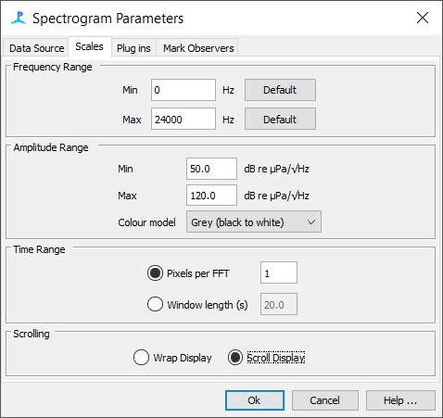
By default, the displayed frequency range will be from 0Hz to half the sample rate (refer back to the lectures and remember that we can only process sound data at frequencies up to half the sample rate of the data, so if the sample rate is 48kHz, we can process sounds up to 24 kHz).
The amplitude range required to get a reasonable resolution on the amplitude (colour) scale will depend on the hydrophone sensitivity and the amount of noise in the system. If you set the values too high or too low, then you may end up with a completely black or completely white display since many of the values to be displayed will be outside the range you have specified. You can change the display colours – but while the coloured spectrogram might look nice, it will be harder to see the detections which are drawn on top of the display once we start to add detection data in later exercises.
By default, it’s best to use a single pixel of the display for each FFT slice in time. For a 512 point FFT and a 48kHz sample rate, this generally means less than 10s of data per screen. Increasing the time range beyond this will force the software to compress the spectrogram image and short transient sounds may no longer be visible.
You can chose to scroll or wrap the spectrogram. Scrolling looks better, but if you’re using a module which requires you to mark or select parts of the spectrogram with the mouse, then it’s almost impossible to mark the right bit when it’s scrolling, so the wrapping option is easier to use.
- Add plug in displays to the spectrogram
Many PAMGuard modules have plug in displays which attach to the bottom of the spectrogram displays. Right click on the spectrogram to access the spectrogram configuration dialog. Go to the ‘Plug ins’ Tab (Figure 14) and select one or two of the available plug in displays. Start detection and you will see additional display units at the bottom of the spectrogram display. Some plug ins have additional options which can be accessed by right clicking on specific plug in panels.
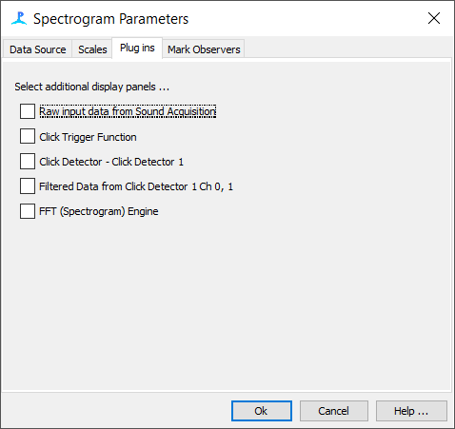
Figure 14. Spectrogram plug ins configuration.
- Detecting Whistles
PAMGuard contains two different detectors that can be used to detect Whistles – tonal calls from a variety of Odontocete species. The first is called simply the “Whistle Detector” and the second the “Whistle and Moan Detector”. The Whistle and Moan detector is a lot better than the older Whistle detector at detecting calls, so you should always use that one. We’ve left the older module in though, just in case anyone has it set up perfectly for a particular purpose and doesn’t want to change it.
As its name implies, the Whistle and Moan detector can be used to detect both odontocete whistles, which are generally at frequencies of between a couple of kHz and the low 10’s of kHz and also low frequency moans from baleen whales.

- Configure PAMGuard
Start from the settings file used for click detection ‘PamTutorial1.psfx’. The module will already have the click detector in it, but that’s OK – PAMGuard can run multiple detectors at the same time.
First, ensure that Detection mode is not active (Detection ⇒ Stop).
Load the sound file “whistles.wav“ (See exercise 1.4).
Next, we will add a Whistle and Moan Detector module to PAMGuard. Select File ⇒ Add Modules…⇒ Whistle and Moan Detector from the main menu. The following dialog will appear if an FFT module is not already included in the configuration:

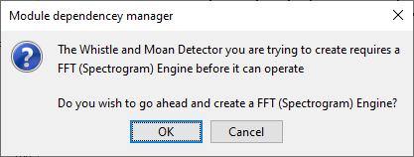
Figure 15. FFT Engine creation dialog

- Configure the FFT
Whistle detector modules require spectrogram data to work. FFT modules provide spectrogram data and PAMGuard knows at this point that no FFT data producing modules are present. PAMGuard therefore asks if you would like to make one. Click Yes. A new dialog will appear asking you to name the FFT Engine module.

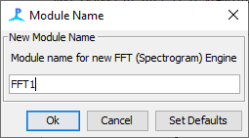
Figure 16. Naming the FFT Engine module

In this dialog, enter FFT1 as the name for the new FFT Engine and click OK.
It will then ask the name of the new Whistle and Moan detector:
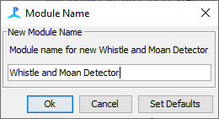
Click OK (or change the name if you want to !).

Configure the FFT module
Next you need to configure the FFT module so that it’s providing exactly the right type of data to the Whistle and Moan Detector. It need to be set up quite carefully for the Whislte and Moan detector to operate correctly.
From the Detection menu, select FFT1 Settings and the following dialog will appear:
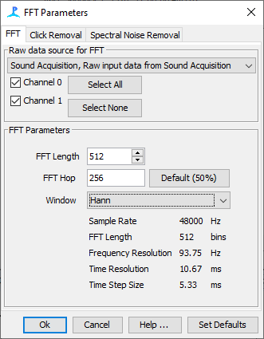
On the first tab, make sure that it’s connected to the correct sound source (Raw input data from Sound Acquisition), that both channels are selected and that the FFT length is set to 512 points and the FFT hop to 256 points (when you adjust the FFT length and hop, note how the Freqeuncy and Time resolution values change !).
Next, you need to set up some noise reduction methods, which operate on the Spectrogram data before it can be used to detect the sounds. On the other two tabs, select everything !
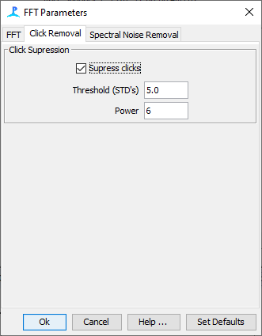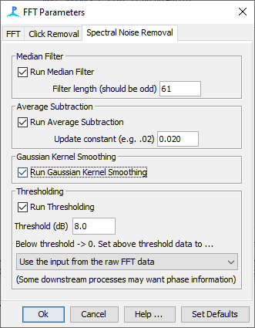

Once you’ve done this, you can close this FFT dialog and proceed to setting up the Whistle Moan detector itself.
From the Detection menu, select Detection > Whistle and Moan Detector.
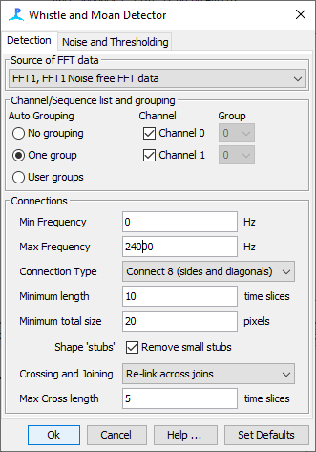
There are several things you’ll need to change on this dialog.
First set the source of FFT data to be “FFT1 Noise free FFT data.
Select one channel group, and include both channels in that group (for more on channel grouping and how channel groups are used to measure bearings to detected sounds, see the help file).
Set the Max frequency to 24000Hz (24kHz).
And click Ok to save the configuration.

Now that you have changed the PAMGuard model configuration, click
File ⇒ Save configuration as… and save the configuration as “clickAndWhistleDetectors.psfx”. Close down PAMGuard (File ⇒ Exit) and re-launch the application. Choose “clickAndWhistleDetectors.psfx” from the Load PAMGuard configuration from… dialog and click OK.
Note: This closing down operation is not necessary for PAMGUARD to operate with the new configuration – it’s just to give you practice!
- Viewing whistle detections

You’ve probably already got a Spectrogram display from Exercise 4. If not, go back to Exercise 4 and add one now.
Start detection Detection ⇒ Start and the two spectrogram panels will show the spectrogram data in real time.

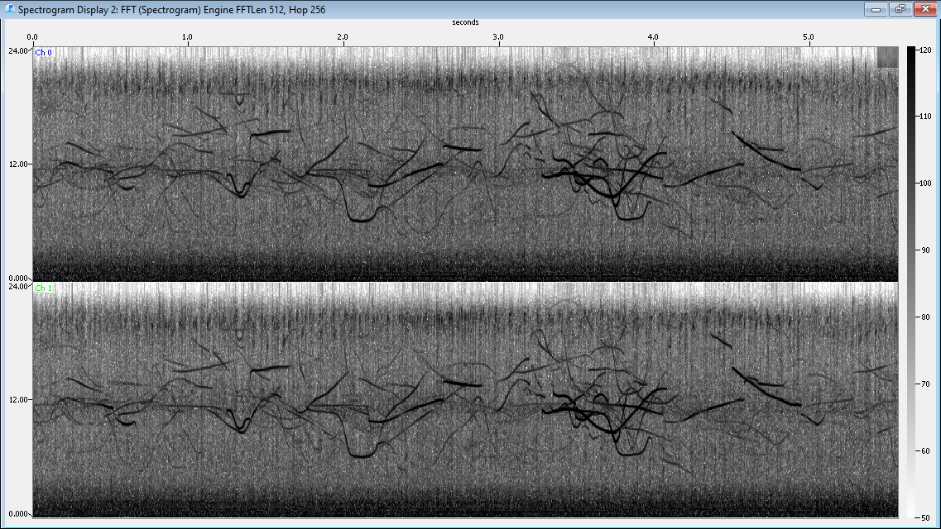
Figure 22. A Spectrogram panel display
To view the whistle contours on the display, right click anywhere on the spectrogram and select “Whistle and Moan Detector Connected Regions”.
Run the detector and you should get something looking like this:
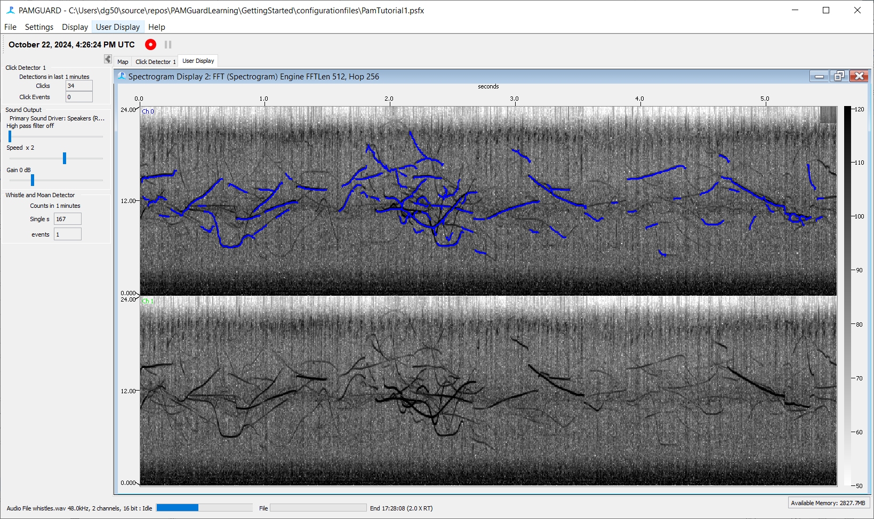
- Mysticete Detection
This set of exercises will demonstrate three different detectors which have been ported to PAMGuard from Dave Mellingers Ishmael software.
- Energy sum
- Spectrogram Correlation
- Matched Filtering
The energy sum detector takes a spectrogram and sums the energy in a given frequency band. It’s sensitive to any sounds in that frequency band and would not, for example, be able to tell the difference between an upsweep and a downsweep. Energy sum detectors are extremely simple, but are good for making a first pass through a data set, highlighting areas that deserve closer scrutiny. (Low Processor Gain)
Spectrogram correlation also uses the output of a spectrogram, but rather than simply adding the energy in a given frequency band, the spectrogram ‘image’ is convolved with (multiplied by) a spectrogram image of a sample sound. The closer the match of the image to the sample sound, the higher the detector output. Spectrogram correlation detectors should be able to tell the difference between an upsweep and a downsweep. (Moderate Processor Gain)
A matched filter uses the raw data, which is convolved by a template of a sample sound. The better the match of the sample sound, the higher the detector output. Matched filters are in fact the optimal solution for the detection of a known signal in random (Gaussian noise). However, if the template is not an exact match, they perform poorly. (High processor gain).
To start this series of exercises, exit PAMGuard, then restart it and load up the configuration file PamTutorial2.psfx. This contains a basic configuration containing a sound acquisition module (which will read the sound files), FFT Engine and a spectrogram display. During the exercises you will add the three detectors and then run them on a variety of sounds.
All exercises start by using the file Blue Whale-Atlantic.wav file. This should be reposautomatically loaded when you start the PamTutorial2.psfx configuration. PAMGuard can analyse this low frequency sample file extremely quickly. To slow it down, so that you can see what’s going on on the screen, a playback module has been included in the configuration which plays the sounds at several times real time for the 100Hz sample file.
- Energy Sum Detector
From the File/Add Modules/Detectors… menu, add an Ishmael energy Sum detector. From the Detection settings menu, configure the module as shown in Figure 17.
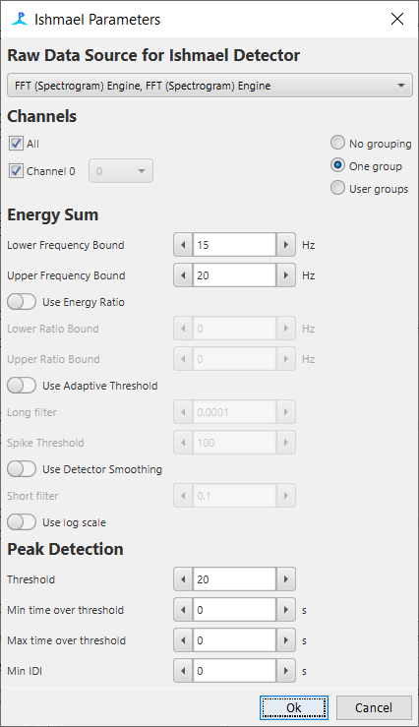
Figure 17. Energy sum configuration dialog.
From the spectrogram plug-in options (right click on the spectrogram display), select the ‘Ishmael energy Sum Graphics’ and start detection. You should see the detector output displayed below the spectrogram as shown in Figure 18.
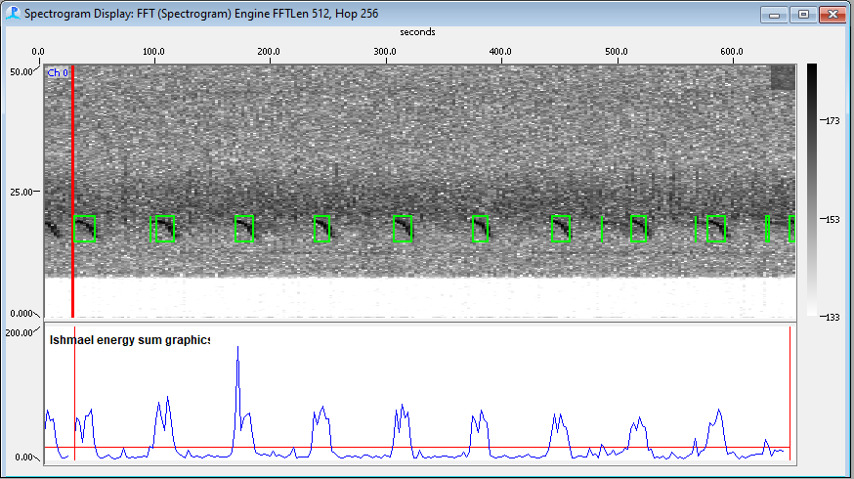
Figure 18. Blue whale calls and Ishmael Energy sum detector output.

- Spectrogram Correlation Detector
From the File/Add Modules/Detectors… menu, add an Ishmael Spectrogram Correlation detector. From the settings menu, configure the module as shown in Figure 19.
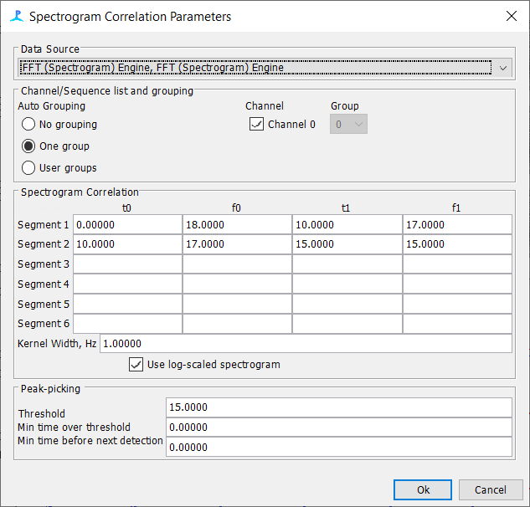
Figure 19. Spectrogram Correlation configuration dialog.
Select the appropriate plug in for the spectrogram display and run the detector again (Figure 20).
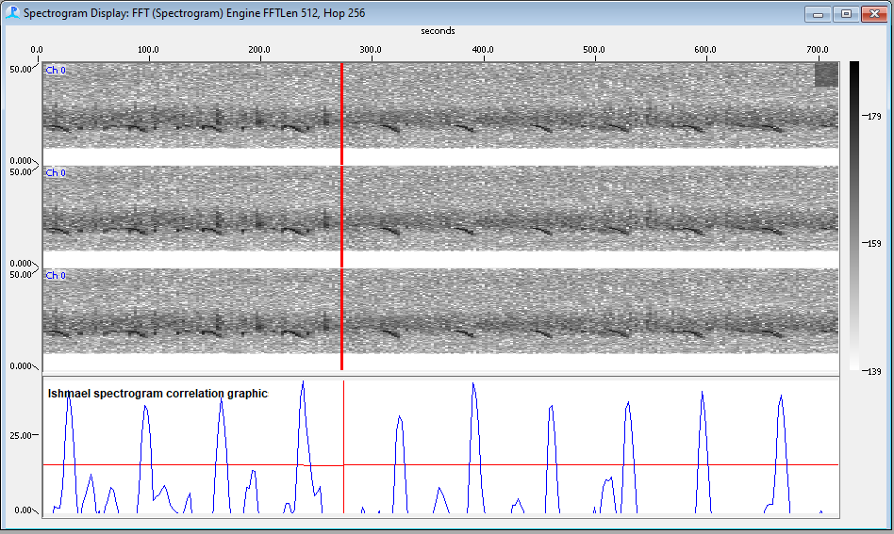
Figure 20. Blue whale calls and Ishmael Spectrogram Correlation detector output.

- Ishmael Matched Filter detector.
From the File/Add Modules/Detectors… menu, add an Ishmael Matched Filtering detector. From the settings menu, configure the module as shown in Figure 21. Note that the name of the kernel sound file is blueTemplate.wav and is included with the tutorial dataset.
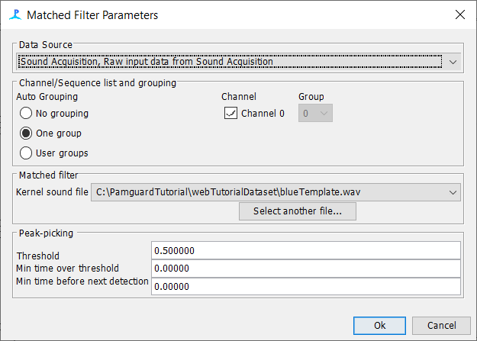
Figure 21. Matched Filter configuration dialog.
Select the appropriate plug in for the spectrogram display and run the detector again (Figure 22). The output of the detector is a number varying between 0 and 1. Note that the peak detector output corresponding to the second call reaches this value. This is because the template for the matched filter was taken from this second call, to the match is perfect !

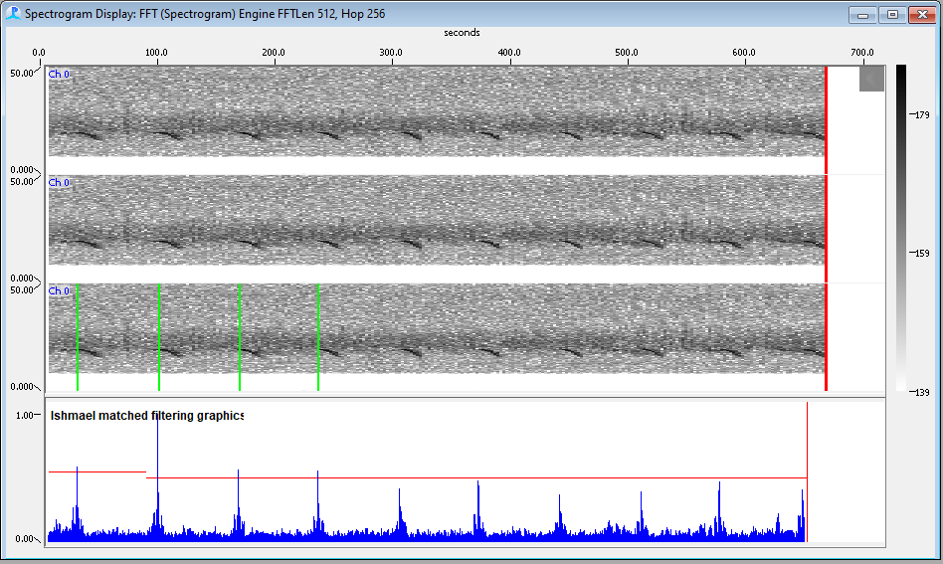
Figure 22. whale calls and Ishmael Matched Filter detector output

- Compare the three detectors
You should easily be able to run all three detectors simultaneously and display the plug ins for each at the bottom of the spectrogram. Which detector is best ? The answer is that it’s impossible to say unless you test them with multiple sound files containing both blue whale calls and a variety of noise sources, count the number of false detections and the number of missed detections for varying detection thresholds and create ROC curves for the three detectors.
- Set up the detectors for different species
Try the detectors with some of the other blue whale and humpback sound files. Try to reconfigure the energy sum and spectrogram correlation detectors for some of the other sounds files. You will be able to test the matched filter on other sound files, but will not be able to reconfigure it since the creation of a suitable template file is beyond the scope of this tutorial.
Try to configure energy sum and spectrogram correlation detectors for some of the sperm whale and whistle files in the tutorial dataset.

- Use the Whistle and Moan Detector to detect Baleen whale calls.
Go back to one of the configurations you were using to detect Baleen whale sounds with the Ishmael detectors and try to set up the Whistle and Moan detector to find these sounds as well.
- Advanced display features
There are more display types available in PAMGuard which will be explored here.
- Adding further displays to Spectrogram Panels
It is often useful to view multiple data and detection types simultaneously. For example, various detector modules active in PAMGuard can draw detections on the Spectrogram panels. While detection is running, right-click over a spectrogram panel and choose “Clicks”. Detected clicks will now be plotted on the panel as red circles on the top of the plot.
In addition, plots can be added to the bottom of the Spectrogram panel. Right-click over the spectrogram display and choose Settings… from the menu. Now click on the Plug-in tab. Select additional plug-in display panels by clicking on the check boxes for Raw input data from Sound1 and Click Detector ⇒ Click Detector 1. Click OK.

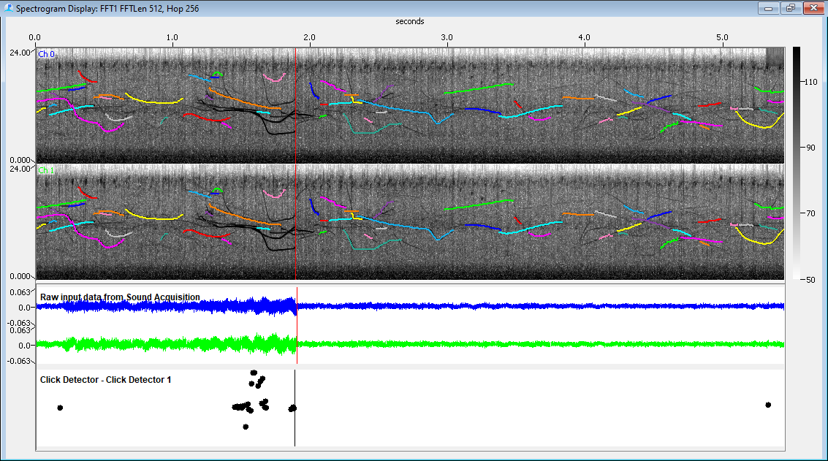

Figure 24. Raw data and Click Detector plugin panels added to a spectrogram display

As illustrated in the figure above, the raw sound waveforms are plotted and also a compact version of the Click Detector display is shown.
- Adding a Radar Display to the User Display panel
We will now add a “Radar” type display to the User Display. Radar display windows can be used to display range, amplitude and bearing information to detected sounds. To add the Radar Display to the User Display panel User Display 1, select the User Display 1 tab on the tab panel selector. Select User Display ⇒ New Radar display… from the main menu.
Since many detectors, particularly those using simple linear hydrophones, produce ambiguous bearing information, it is possible to display either the full display or only one half of the display. We will display a half display called RD1, so type in the name and select Right half only from the Style option drop-down list. Once the Radar Display is on User Display 1, select, User Display ⇒ Arrange Windows… ⇒ Tile Vertical from the main menu. The display should look something like Figure 25.

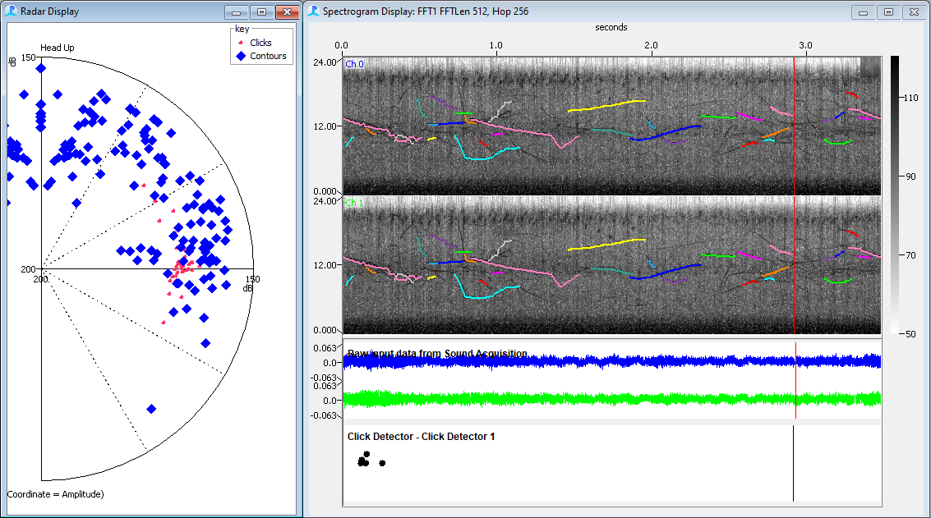
Figure 25. A Radar display added to the User Display Panel
Right-click over RD1 and choose Settings… ⇒ Detectors. From the Detectors tab, select the Show Detector Data settings as indicated in Figure .

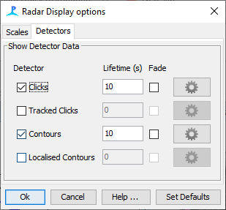
Figure 26. Detector selection and lifetime settings for Radar Display
Click OK. This will set the radar plot to display Clicks, Tracked Clicks and Whistle detections for 1, 20 and 1 seconds respectively. Experiment with the plot settings and, when you have finished, select Detection ⇒ Stop from the main menu in preparation for the next exercise.
- Detection during seismic source operation
- Loading the sound file
First load the sound file “spermWhalesPlusSeismic.wav”.
This is a recording of sperm whale vocalisations taken during an active seismic survey. The presence of a significant sound source, such as firing air guns has implications for the operation of detection algorithms.
You will notice an artefact on the central axis (indicting no time delay between channels). This is noise picked up after the seismic pulse which has been gated out.
Here we will investigate changing the Click Detector settings in an effort to reduce the adverse effects of the unwanted noise.
Select Detection ⇒ Click Detector 1 ⇒ Detection Parameters… from the main menu. Click on the Set defaults button to restore the detectors settings to their default values. Start Detection (Detection ⇒ Start) and observe the Click Detector tab panel displays. You should see something like this:

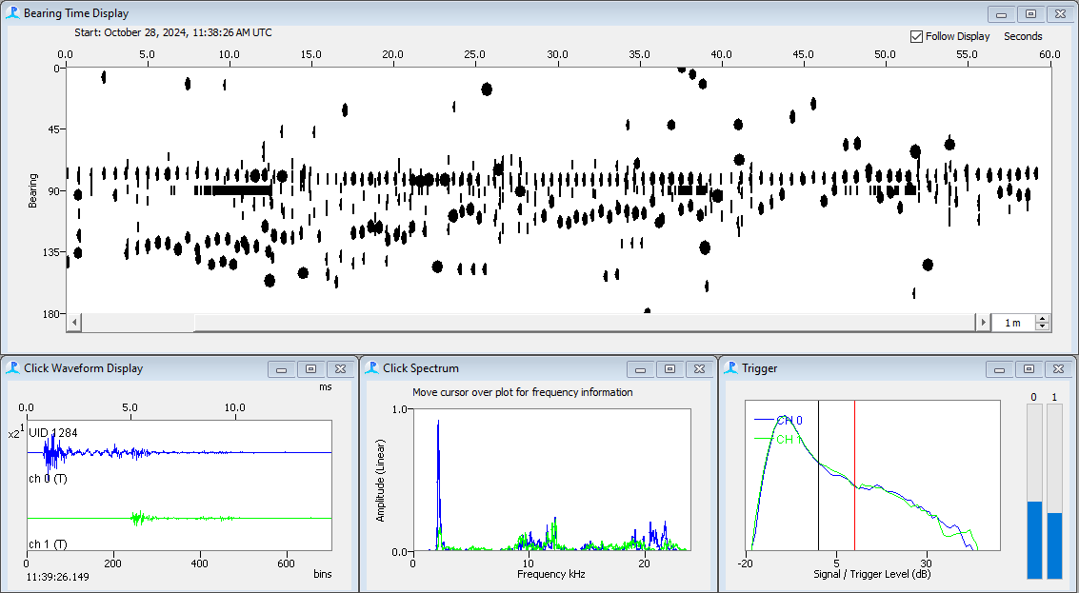
Figure 23. Click Detector display example for noisy seismic data

Notice the rapid click detections associated with the electrical noise on the 90° bearing.
- Adjusting click detection parameters
Right click on the Click Detector Bearing Time Display and select ‘Amplitude/Time’ This changes the Y-axis of the plot to represent the amplitude of detected clicks. Notice that the rapid clicks consistently appear at lower amplitude to the majority of the rest of the click detections (Figure 24). If all of the clicks appear at the top of the display, you may need to adjust your computer’s mixer settings to reduce the amplitude of the captured sound. You can also adjust the amplitude scaling of the display by right clicking and invoking the settings dialog.
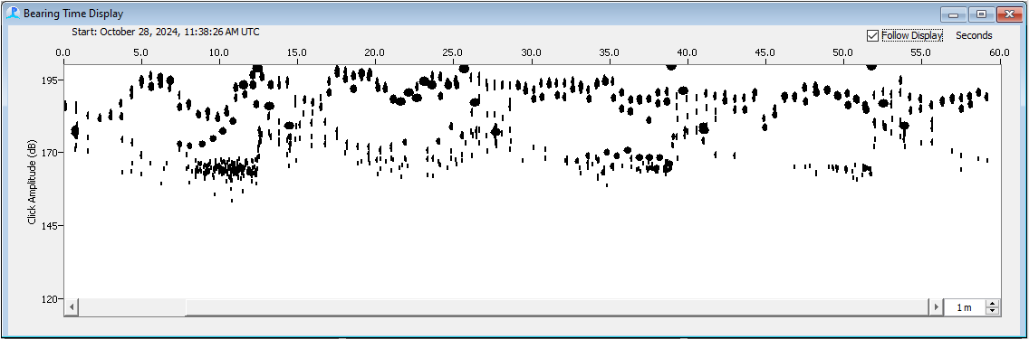
Figure 24. Plotting click amplitude versus time

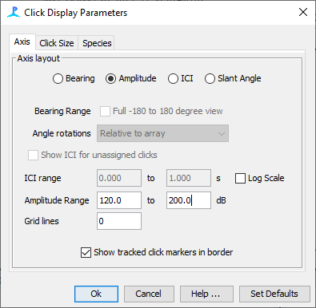
Figure 25. Adjusting the amplitude scaling for the Click Detector Amplitude display

We will now adjust the click trigger threshold such that the Click Detector will not trigger for these lower amplitude clicks. Again select Detection ⇒ Click Detector 1 ⇒ Detection Parameters… from the main menu. This time, increase the Threshold setting above the default setting of 10.0 dB. This will increase the level above the measured background which must be exceeded by clicks to become detection candidates.
Click OK and observe the Click Detector display. Wait for the algorithm to settle down with the new settings (up to 10 seconds).
If your setting is too high, then genuine clicks may not be exceeding the threshold and the click display will look rather sparse. If the setting is too low, you will still be seeing the interference clicks. Experiment with this setting until you are happy with the results.

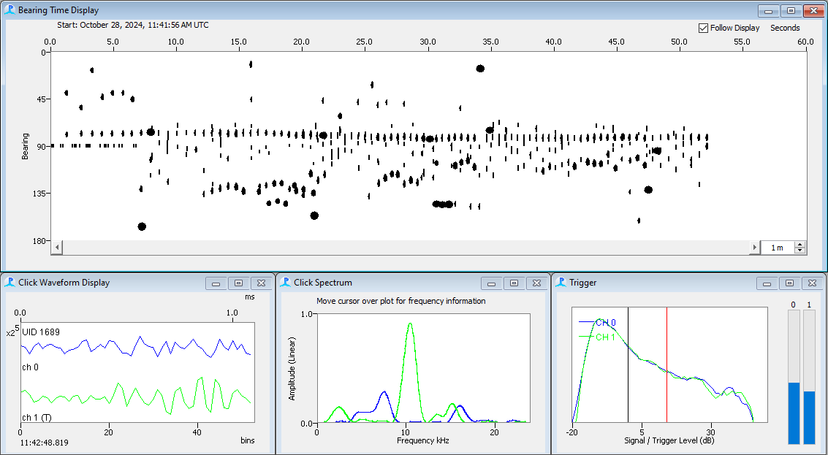

Figure 30. Results of adjusting Click Detector trigger threshold

- Don’t stop now!
This tutorial has given you a brief introduction to setting up and using PAMGuard. There are more PAMGuard plug-ins and features for you to try out.
Here’s some ideas to get you going:
- Set up a Sound Recorder module and trigger recordings from click trains.
- Use a decimator to provide lower sample rate data to a second spectrogram.
- Display smoothed spectral data on a spectrogram.
Try these out with the other example sound data files.
The PAMGuard developers are keen to know what you think of the software, so any comments (good or bad!) are very welcome. Also, if you think this tutorial can be improved in any way, please let us know at feedback@PAMGuard.org.

Thanks for taking the time to do this tutorial. Hopefully you’ve enjoyed this and learned some more about PAMGuard. You can contact us and keep up with PAMGuard news through visiting www.PAMGuard.org.

