TEAM CODEX
Multi-Patient Vital Signs and Triage Alert Engine
Project Documentation
Track 2 – Group 2 | Built in MATLAB

Team Members
Team Member | Role
Peter Onah Apeh | Team Lead
Mercy Akinola | Member
Paul Terna | Member
Ismail Wildan | Member

Submitted by Team CodeX

1. Project Overview
The Multi-Patient Vital Signs and Triage Alert Engine is a MATLAB-based monitoring tool that simulates the tracking of critical vital signs — Heart Rate (HR), Systolic Blood Pressure (SBP), and Body Temperature — for multiple patients over a series of time intervals. The system automatically screens each reading against clinically defined safe ranges, logs an alert whenever a patient's vitals fall outside those ranges, and produces a visual dashboard that plots each vital sign over time alongside the safe zone boundaries.
The goal of the project is to demonstrate how a simple rule-based triage algorithm, combined with clear data visualization, can help quickly flag patients whose vitals require urgent clinical attention — a foundational concept behind real-world patient monitoring and early-warning systems used in hospitals.

2. Objectives
- Represent multiple patients' vital signs (HR, SBP, Temperature) across several time intervals in a single, structured MATLAB data array.
- Build a reusable function that scans the data, applies medically-informed threshold rules, and flags abnormal readings as “critical incidents.”
- Count and report the total number of critical incidents (alerts) logged during a monitoring session.
- Visualize each vital sign for all patients on a single dashboard, with safe-zone reference lines for quick interpretation.

3. Tools & Technologies
- MATLAB (Online, via MATLAB Drive) – core development and execution environment.
- MATLAB scripting (.m files) – main script and a custom user-defined function.
- Built-in MATLAB plotting functions (subplot, plot, yline) – for dashboard-style visualization.

4. Project Structure
The project consists of two MATLAB files, stored in the folder Track_2_Team_CodeX_Group_2:
- main_track2.m – the entry-point script. It builds the sample patient dataset, calls the triage function, and generates the visualization dashboard.
- triageMonitor.m – a custom function that receives the vitals data, checks every reading against the safe-zone thresholds, prints an alert message for each abnormal reading, and returns the total alert count.

5. How It Was Done — Methodology

5.1 Data Representation
All patient vitals are stored in a single 3-dimensional numeric array, vitalsData, of size [numPatients × numVitals × numTimeSteps] — in this project, 2 patients × 3 vitals × 5 time steps. The first row along the second dimension holds HR, the second holds SBP, and the third holds Temperature. This structure allows any number of patients, vitals, or time steps to be added without changing the underlying logic.
For this demonstration run, two patients were used:
- Patient 1 – a “normal” case, with all HR, SBP and Temperature readings staying inside the safe zones across all 5 time steps.
- Patient 2 – an “abnormal” case, deliberately seeded with out-of-range readings at specific time steps to test that the alert engine correctly detects and logs them.

5.2 The Triage Algorithm (triageMonitor.m)
The triageMonitor function takes the 3-D vitals array as its only input and returns alertCount, the total number of critical incidents detected. Internally, it works as follows:
- Reads the array dimensions to determine the number of patients and the number of time steps.
- Loops through every patient, and for each patient, loops through every time step.
- At each time step, extracts that patient's HR, SBP, and Temperature reading.
- Checks the reading against the safe-zone thresholds shown in the table below. If any one of HR, SBP, or Temperature falls outside its safe range, the reading is flagged as abnormal.
- On a flagged reading, the function increments the running alert counter and prints a formatted message to the Command Window identifying the patient, the time step, and the exact HR/SBP/Temperature values that triggered the alert.
- After scanning all patients and time steps, the function returns the final alert count to the calling script.
The thresholds used to define a “safe” reading, exactly as implemented in the code, are:
Vital Sign | Safe Zone | Triggers an ALERT when
Heart Rate (HR) | 50 - 120 bpm | < 50 or > 120 bpm
Systolic Blood Pressure (SBP) | 90 - 140 mmHg | < 90 or > 140 mmHg
Body Temperature | 36.0 - 38.5 °C | < 36.0 or > 38.5 °C

5.3 Main Script Flow (main_track2.m)
- Clears the workspace and command window (clc, clear, close all) for a clean run.
- Initializes the vitalsData array and populates it with hand-crafted sample readings for Patient 1 (normal) and Patient 2 (abnormal).
- Calls totalAlerts = triageMonitor(vitalsData) to run the triage engine and capture the total number of alerts.
- Prints the total number of critical incidents logged to the Command Window.
- Builds a time vector (1 to 5) and opens a new figure with a blue background.
- Uses a 3-row subplot layout to plot Heart Rate, Systolic Blood Pressure, and Body Temperature for both patients on separate stacked charts, each annotated with dotted green “Safe Zone” reference lines marking the lower and upper safe bounds.

6. Sample Run — Input Data & Results

6.1 Sample Dataset
The dataset used to test the engine is summarized below (values as entered in main_track2.m):
- Patient 1 (Normal): HR = [90, 115, 57, 79, 109] bpm; SBP = [115, 119, 117, 116, 115] mmHg; Temp = [36.6, 36.9, 36.4, 37.0, 37.1] °C — all readings remain within the safe zones, so no alerts are raised for this patient.
- Patient 2 (Abnormal): HR = [69, 32, 129, 78, 80] bpm; SBP = [121, 88, 152, 110, 118] mmHg; Temp = [40.9, 38.4, 36.0, 37.2, 34.0] °C — deliberately includes out-of-range values at several time steps.

6.2 Alert Log — Patient 2
Running triageMonitor on this dataset produces the following per-time-step evaluation for Patient 2 (Patient 1 produced zero alerts):
Time Step | HR (bpm) | SBP (mmHg) | Temp (°C) | Abnormal Reading(s) | Alert Logged?
1 | 69 | 121 | 40.9 | Temp > 38.5 °C | YES
2 | 32 | 88 | 38.4 | HR < 50; SBP < 90 | YES
3 | 129 | 152 | 36.0 | HR > 120; SBP > 140 | YES
4 | 78 | 110 | 37.2 | None — all within range | no
5 | 80 | 118 | 34.0 | Temp < 36.0 °C | YES

Command Window output produced by the run:
ALERT: Patient 2 at Time 1 | HR: 69, SBP: 121, Temp: 40.9
ALERT: Patient 2 at Time 2 | HR: 32, SBP: 88, Temp: 38.4
ALERT: Patient 2 at Time 3 | HR: 129, SBP: 152, Temp: 36.0
ALERT: Patient 2 at Time 5 | HR: 80, SBP: 118, Temp: 34.0
Total Critical Incidents Logged: 4
This matches the engine's output exactly: 4 critical incidents were detected and logged out of the 10 total readings (2 patients × 5 time steps) — all 4 coming from Patient 2, confirming the alert logic correctly distinguishes normal from abnormal readings.

6.3 Visualization Dashboard
The script produces a single figure with three stacked subplots — Heart Rate, Systolic Blood Pressure, and Body Temperature — each showing both patients over the 5 time steps, with dotted green lines marking the safe-zone boundaries for that vital sign:
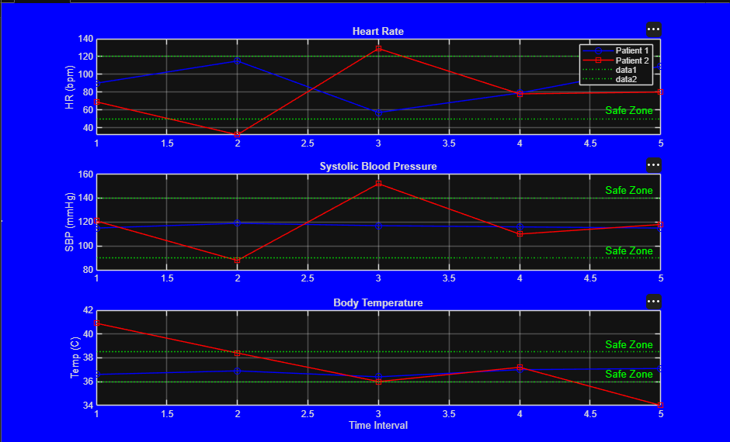
Patient 1 (blue circles) stays within all three safe zones throughout. Patient 2 (red squares) visibly breaches the safe zone on the Heart Rate chart around time steps 2–3, on the Blood Pressure chart around time steps 2–3, and on the Temperature chart at the start (time 1) and the end (time 5) of the monitoring window — visually confirming the same incidents captured in the alert log.

7. How to Run the Project
- Open MATLAB (Online or Desktop) and navigate to the project folder Track_2_Team_CodeX_Group_2.
- Ensure both main_track2.m and triageMonitor.m are in the same folder / on the MATLAB path.
- Open main_track2.m and click Run (or press F5).
- The Command Window will display each ALERT message as it is detected, followed by the total count of critical incidents.
- A figure window will open automatically showing the three-panel vitals dashboard for visual inspection.

8. Conclusion & Possible Extensions
This project demonstrates a compact but complete pipeline for patient monitoring: structured data storage, rule-based anomaly detection, automated alert logging, and clear visual reporting — all built using core MATLAB without any external toolboxes. The modular design (a standalone triageMonitor function) means the dataset can easily be scaled to more patients, more vitals, or more time steps without changing the detection logic.
Team CodeX identified the following as natural next steps for future iterations:
- Reading vitals from a live or file-based data source (e.g. CSV, sensor feed) instead of hand-coded sample values.
- Adding a severity scale (e.g. mild / moderate / critical) rather than a single binary alert.
- Exporting the alert log to a table or spreadsheet for record-keeping.
- Adding more vital signs (e.g. oxygen saturation, respiratory rate) to the monitoring matrix.

Appendix A — Full Source Code: main_track2.m
clc;
clear;
close all;
% Creating Sample Dataset
vitalsData = zeros(2, 3, 5);
% Patient 1(Normal)
vitalsData(1, 1, :) = [90, 115, 57, 79, 109]; % hr normal
vitalsData(1, 2, :) = [115, 119, 117, 116, 115]; % sbp normal
vitalsData(1, 3, :) = [36.6, 36.9, 36.4, 37.0, 37.1]; % temp normal
% Patient 2(Abnormal)
vitalsData(2, 1, :) = [69, 32, 129, 78, 80]; % hr ab at 2,3
vitalsData(2, 2, :) = [121, 88, 152, 110, 118]; % sbp ab at 2,3
vitalsData(2, 3, :) = [40.9, 38.4, 36.0, 37.2, 34.0]; % temp ab at 1,5
% Calling Function
totalAlerts = triageMonitor(vitalsData);
fprintf('\n Total Critical Incidents Logged: %d\n', totalAlerts);
% Visualization
time = 1:5;
figure('color','b');
% Heart Rate Quadrant
subplot(3, 1, 1);
plot(time, squeeze(vitalsData(1, 1, :)), '-bo', 'DisplayName', 'Patient 1'); hold on;
plot(time, squeeze(vitalsData(2, 1, :)), '-rs', 'DisplayName', 'Patient 2');
yline([50, 120], ':g', 'Safe Zone');
ylabel('HR (bpm)'); title('Heart Rate'); grid on; legend;
% Systolic Blood Pressure Quadrant
subplot(3, 1, 2);
plot(time, squeeze(vitalsData(1, 2, :)), '-bo', 'DisplayName', 'Patient 1'); hold on;
plot(time, squeeze(vitalsData(2, 2, :)), '-rs', 'DisplayName', 'Patient 2');
yline([90, 140], ':g', 'Safe Zone');
ylabel('SBP (mmHg)'); title('Systolic Blood Pressure'); grid on;
% Body Temperature Quadrant
subplot(3, 1, 3);
plot(time, squeeze(vitalsData(1, 3, :)), '-bo', 'DisplayName', 'Patient 1'); hold on;
plot(time, squeeze(vitalsData(2, 3, :)), '-rs', 'DisplayName', 'Patient 2');
yline([36.0, 38.5], ':g', 'Safe Zone');
xlabel('Time Interval'); ylabel('Temp (C)'); title('Body Temperature'); grid on;

Appendix B — Full Source Code: triageMonitor.m
function alertCount = triageMonitor(vitalsMatrix)
[numPatients, ~, numSteps] = size(vitalsMatrix);
alertCount = 0;
for p = 1:numPatients
for t = 1:numSteps
hr = vitalsMatrix(p, 1, t);
sbp = vitalsMatrix(p, 2, t);
temp = vitalsMatrix(p, 3, t);
if (hr < 50 || hr > 120) || (sbp < 90 || sbp > 140) || (temp < 36.0 || temp > 38.5)
alertCount = alertCount + 1;
fprintf('ALERT: Patient %d at Time %d | HR: %d, SBP: %d, Temp: %.1f\n', p, t, hr, sbp, temp);
end
end
end
end

