PRACTICAL – 1
Aim:- Write a c-program to demonstrate call by value and call by reference.
Code:-
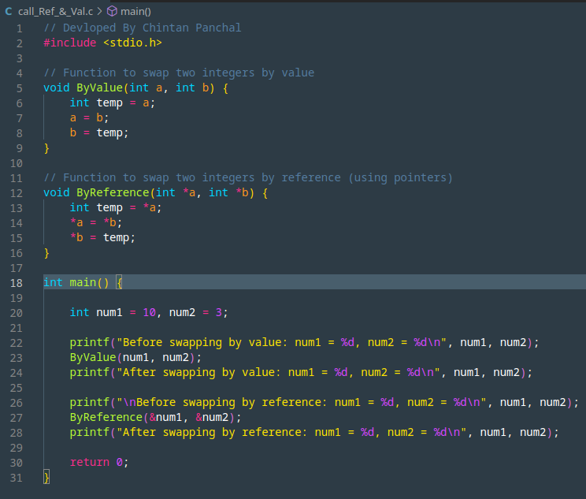
Output:-
