Aim :-Write a java Program to Perform Arithematic Operations Like Add, Subtract, Multiply, Divide.
Code:-
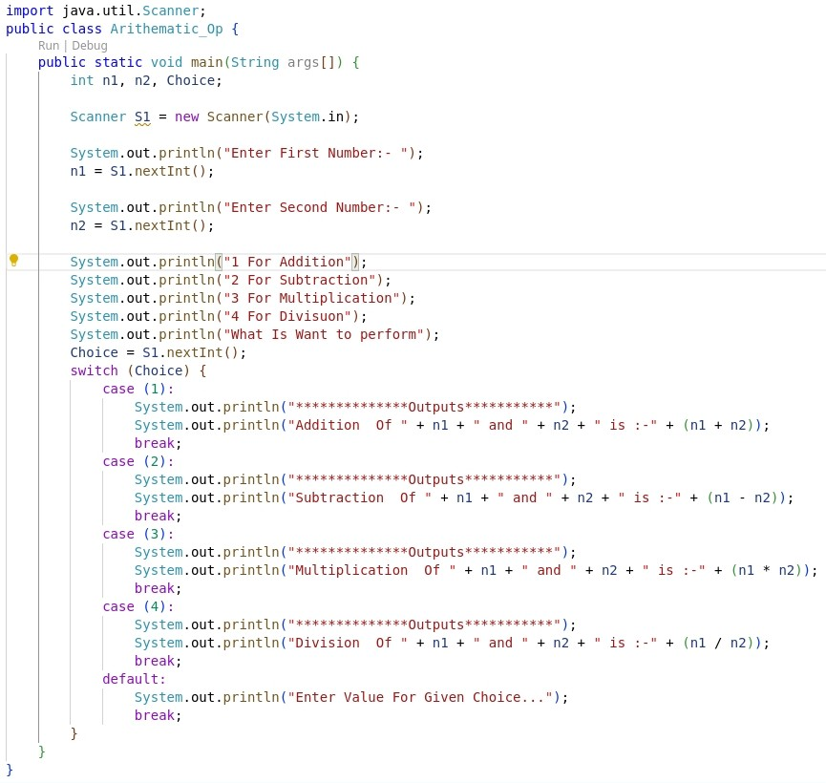
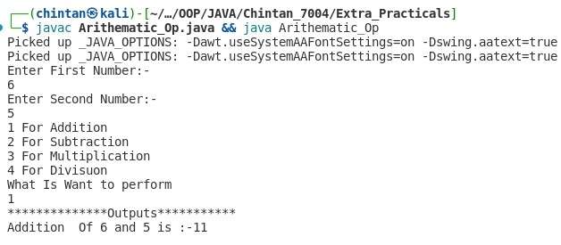
Output:-

