 ANMAYA TECHNOLOGIES PVT.LTD
DETAILED PROJET DOCUMENTATION

PROJECT TITLE
FPGA-Based Smart Parking Management System with Real-Time Web Interface

Submitted by
PANCHAMI
SATHVI

Project Overview
The FPGA-Based Smart Parking System is designed to provide an efficient and automated solution for managing parking spaces. The project uses an Artix-7 FPGA as the main controller, which communicates with a Python Flask web application through UART (Universal Asynchronous Receiver Transmitter). The system allows users to monitor and control parking slots in real time using a web browser.
When a parking slot is selected from the web dashboard, the command is sent to the FPGA through UART. The FPGA updates the parking slot status, controls the corresponding LED, operates the servo motor to simulate the parking gate, and activates the buzzer for notifications. The updated parking status is then transmitted back to the web application, which displays the current occupancy, parking duration, and vehicle activity log. This project demonstrates the integration of FPGA hardware with software to build a real-time smart parking management system.

Design and Architecture
The system is divided into three major sections: FPGA Hardware, Python Flask Server, and the Web Dashboard.
The FPGA acts as the central controller of the system. It receives commands from the PC through the UART receiver, processes the parking slot information, updates the LEDs, controls the servo motor and buzzer, and sends the latest parking status back through the UART transmitter.
The Python Flask application acts as a communication bridge between the FPGA and the web dashboard. It automatically detects the serial port, exchanges data with the FPGA using UART, and transfers real-time information to the browser using Socket.IO.
The Web Dashboard provides a user-friendly interface where users can monitor parking slot availability, view parking duration, maintain vehicle logs, and control parking slots with a single click.

Architecture Flow
Web Dashboard
│
Socket.IO
│
Flask Application
│
UART Communication
│
Artix-7 FPGA
│
├── LEDs
├── Servo Motor
└── Buzzer

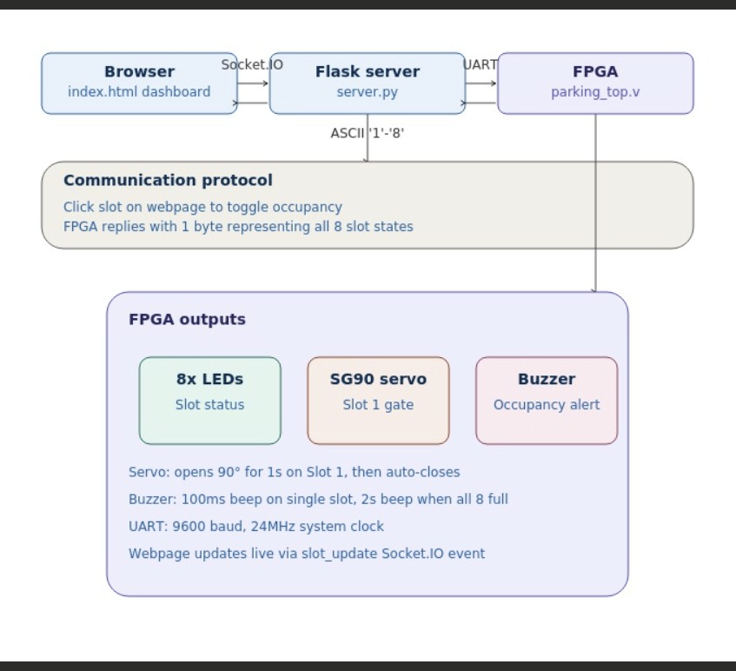

Implementation Approach
The implementation begins by designing the UART communication modules (uart_rx.v and uart_tx.v) to establish reliable serial communication between the FPGA and the computer. The main controller (parking_top.v) is then developed to process incoming commands, update parking slot status, and control the connected hardware.
A separate servo controller generates PWM signals to automatically open and close the parking gate whenever a vehicle enters a parking slot. A buzzer module is also implemented to provide audio alerts for vehicle entry and when all parking spaces become occupied.
On the software side, a Python Flask application is developed to handle serial communication and provide a real-time connection with the web dashboard using Socket.IO. Finally, an interactive HTML, CSS, and JavaScript dashboard is created to display parking availability, vehicle logs, parking duration, and connection status. The complete system is tested by programming the FPGA and communicating with the web application through UART.

Module Descriptions
parking_top.v
This is the top-level module of the project. It receives UART commands from the computer, updates the parking slot register, controls the LEDs, servo motor, and buzzer, and transmits the updated parking slot information back to the web application.
uart_rx.v
This module acts as the UART receiver. It receives serial data transmitted from the PC at 9600 baud and converts it into parallel data that can be processed by the FPGA. Once a complete byte is received, it generates an rx_done signal.
uart_tx.v
This module is responsible for transmitting parking slot information from the FPGA to the PC. It converts parallel data into serial UART format and sends the updated slot status whenever a parking change occurs.
servo_ctrl.v
The servo controller generates PWM signals required to operate the servo motor. When a vehicle enters a parking slot, the servo rotates to approximately 90° to simulate opening the gate and automatically returns to its initial position after a short delay.
app.py
This Python Flask application manages communication between the FPGA and the web dashboard. It automatically detects the connected serial port, sends parking commands to the FPGA, receives slot status updates, and forwards the data to the browser using Socket.IO.
index.html
This file provides the graphical user interface of the smart parking system. It displays the parking slots, occupancy status, available spaces, parking duration, vehicle logs, and connection status. The dashboard updates automatically whenever new data is received from the FPGA

Build, Run, and Testing Instructions
Build the FPGA Design
- Open Vivado Design Suite and create a new project.
- Add the Verilog source files (parking_top.v, uart_rx.v, uart_tx.v, and servo_ctrl.v) to the project.
- Add the corresponding XDC constraints file for the FPGA board.
- Run Synthesis and verify that there are no design errors.
- Run Implementation and generate the Bitstream.
- Connect the FPGA board to the computer and program it with the generated bitstream.

Run the Web Application
1. Install the required Python libraries using:
pip install flask flask-socketio pyserial
2. Open the project folder in a terminal or command prompt.
3. Start the Flask server by running:
python app.py
4. Open a web browser and navigate to:
http://127.0.0.1:5000
The Smart Parking dashboard will be displayed.

Testing Procedure
- Click any parking slot on the web dashboard and verify that the corresponding LED changes state on the FPGA.
- Observe that the servo motor opens and closes automatically when a vehicle enters a parking slot.
- Confirm that the buzzer sounds for a short duration during vehicle entry and for a longer duration when all parking slots become occupied.
- Verify that the parking slot status, vehicle log, and parking duration are updated in real time on the web dashboard.
- Disconnect and reconnect the FPGA to ensure that the Flask application automatically detects the serial port and restores communication.

