1. Title Page
Project Title: Multi-Touch Marketing Attribution Modeling
2. Abstract
This project focuses on developing a comprehensive Multi-Touch Marketing Attribution dashboard to help marketers accurately measure the impact of each channel throughout the customer journey. Traditional last-touch attribution often misrepresents channel effectiveness, leading to poor budget allocation. To overcome this, the solution integrates customer touchpoint data from Google Analytics, Facebook Ads, and CRM systems, and applies multiple attribution models—including First Touch, Last Touch, Linear, Time-Decay, and U-Shaped—using advanced DAX logic in Power BI. The dashboard visualizes complete customer paths through Sankey diagrams and provides detailed insights on channel ROI and Customer Lifetime Value (CLV). By comparing attribution outcomes across models, the system empowers organizations to make smarter, data-driven marketing decisions and optimize campaign spending effectively.

3. Problem Statement
Marketers often struggle to understand the true contribution of each marketing channel because most organizations rely on last-touch attribution, which only credits the final interaction before conversion. This oversimplified method ignores the influence of earlier touchpoints such as social media ads, emails, organic search, or blogs. As a result, channels that build awareness or assist in the journey are undervalued, leading to inefficient budget allocation. With customers engaging across multiple platforms before converting, it becomes essential to map the complete journey accurately. The lack of a unified view of touchpoints makes it difficult to measure true channel performance. Without advanced attribution models, businesses face misleading insights and ineffective marketing strategies. Therefore, a multi-touch attribution solution is needed to fairly distribute credit and improve marketing decision-making.

4. Objectives
- Integrate and clean customer touchpoint data from Google Analytics, Facebook Ads, and CRM sources.
- Build a unified customer journey by stitching user sessions across multiple channels.
- Apply multi-touch attribution models (First Touch, Last Touch, Linear, Time-Decay, U-Shaped) using advanced DAX calculations.
- Visualize end-to-end customer paths using Sankey diagrams and comparative attribution dashboards.
- Analyze channel performance with metrics such as ROI, CLV, and CAC for better marketing insights.
- Enable data-driven budget optimization by comparing the effectiveness of different attribution models.
- Provide marketers and decision-makers with an intuitive, transparent, and actionable Power BI dashboard.

5. Scope
The scope of this project includes integrating multi-channel customer touchpoint data, building a unified customer journey model, and implementing multiple attribution methodologies in Power BI using DAX. It covers developing interactive visualizations such as Sankey diagrams and model comparison dashboards to interpret channel contribution. The project also includes calculating ROI, CLV, and CAC to evaluate channel effectiveness. Additionally, it focuses on generating actionable insights for budget optimization. The scope is limited to analytical modeling and dashboard creation, excluding campaign execution or real-time system automation.

6. Literature/Background Review
Traditional attribution models such as last-touch and first-touch often fail to capture the complexity of modern customer journeys, where users interact with multiple channels before converting. Recent studies in digital marketing analytics highlight the importance of multi-touch attribution to fairly distribute credit and improve ROI accuracy. Research on customer path analysis emphasizes the value of integrating web analytics, ad platform data, and CRM records to build unified journey maps. Advanced models like Time-Decay and U-Shaped are widely recognized for balancing credit between awareness and conversion stages. Power BI and DAX have emerged as powerful tools for implementing these models and visualizing channel contributions effectively.

7.Methodology
1. Data Collection and Ingestion
- Collect customer touchpoint data from Google Analytics, Facebook Ads, and CRM platforms.
- Import raw datasets into Power BI or Power Query for initial loading.
- Ensure each dataset includes timestamps, channel names, campaign IDs, and user identifiers.
- Validate the completeness of sessions, impressions, clicks, and conversions.
- Consolidate all sources into a centralized workspace for further processing.
import pandas as pd
import random
from faker import Faker
from datetime import datetime, timedelta

# Initialize Faker with Indian locale
fake = Faker('en_IN')

# Tamil Nadu District List (for location column)
tamil_nadu_districts = [
"Chennai", "Coimbatore", "Madurai", "Tiruchirappalli", "Salem", "Erode", "Vellore",
"Tirunelveli", "Thoothukudi", "Dindigul", "Thanjavur", "Namakkal", "Karur", "Sivagangai",
"Virudhunagar", "Cuddalore", "Kanchipuram", "Tiruvallur", "Krishnagiri", "Dharmapuri",
"Nagapattinam", "Tiruppur", "Ramanathapuram", "Nilgiris", "Ariyalur", "Perambalur",
"Villupuram", "Tenkasi", "Pudukkottai", "Kallakurichi"
]

# Parameters
num_users = 10000
start_date = datetime(2024, 1, 1)
end_date = datetime(2025, 1, 1)

# Helper function to generate random date in range
def random_date(start, end):
return start + timedelta(seconds=random.randint(0, int((end - start).total_seconds())))

# Generate synthetic customer data
data = []
for i in range(1, num_users + 1):
user_id = f"U{str(i).zfill(5)}"
name = fake.name()
age = random.randint(18, 60)
gender = random.choice(["Male", "Female"])
location = random.choice(tamil_nadu_districts)
signup_date = random_date(start_date, end_date).strftime("%Y-%m-%d")

data.append([user_id, name, age, gender, location, signup_date])

# Create DataFrame
customer_df = pd.DataFrame(data, columns=["User_ID", "Name", "Age", "Gender", "Location", "Signup_Date"])

# Save to CSV
customer_df.to_csv("tamilnadu_customer_data.csv", index=False)

print("✅ Tamil Nadu Customer Data Generated Successfully!")
print(customer_df.head(10))
print("\nTotal Records:", len(customer_df))

2. ETL and Data Modeling
- Clean and standardize fields such as user IDs, event names, and channel labels.
- Merge datasets using common identifiers to create a unified customer journey model.
- Handle missing values, duplicates, and inconsistent formats during transformation.
- Establish relationships between touchpoints, campaigns, and conversion tables.
- Design a star schema to optimize performance for attribution calculations.

#DATA CLEANING SCRIPT
import pandas as pd
import numpy as np
import re
import sys

# Redirect output to both console and file for Part 1
class DualOutput:
def __init__(self, filename):
self.terminal = sys.stdout
self.log = open(filename, "w", encoding="utf-8")
def write(self, message):
self.terminal.write(message)
self.log.write(message)
def flush(self):
self.terminal.flush()
self.log.flush()

sys.stdout = DualOutput("channel_cost.txt")

# ==============================
# Step 1: Display first few rows
# ==============================
file_path = r"D:\PROJECT\Project2\Dataset\channel_cost_data.csv"
df = pd.read_csv(file_path)

print("First 5 rows of the dataset:")
print(df.head())
print(df.tail())

# =======================================
# Step 2: Dataset Columns
# =======================================
print("\n\n\ndataset columns:")
print(df.columns)

# =======================================
# Step 3: Data Types
# =======================================
print("\n\n\nData Types:")
print(df.dtypes)
# =======================================
# Step 4: Identify Missing Values
# =======================================
print("\n\n\nMissing Values in Each Column:")
print(df.info())
print(df.isnull().sum())

# ===================================================================================
# Step 5: Data Cleaning - Remove rows with only special characters or NaN in any cell
# ===================================================================================
def contains_only_special_chars(value):
if pd.isna(value):
return True
return bool(re.fullmatch(r'[^a-zA-Z0-9]+', str(value)))

df_cleaned = df[~df.applymap(contains_only_special_chars).any(axis=1)]

print("\n\n\nAfter cleaning (removing rows with only special characters or NaN in any column):")
print(df_cleaned.head())

# Save cleaned data for Part 2
cleaned_file_path = "channel_cost.csv"
df_cleaned.to_csv(cleaned_file_path, index=False)
print(f"\n\n\nCleaned data saved to {cleaned_file_path}")

# Restore stdout
sys.stdout.log.close()
sys.stdout = sys.stdout.terminal
3. Data Transformation
- Sequence touchpoints chronologically to reconstruct complete customer paths.
- Create journey-level metrics such as total touches, first touch, and last touch.
- Generate journey IDs by combining UserID and ConversionID for grouping.
- Filter touchpoints within defined lookback windows (e.g., 30 days before conversion).
- Produce structured datasets required for different attribution models.
4. Data Visualization
- Visualize customer journey paths using Sankey diagrams to show flow across channels.
- Build dashboards comparing attribution models (First Touch, Last Touch, Time-Decay, U-Shaped).
- Include bar charts, KPIs, and matrix visuals to analyze channel performance.
- Display CLV, CAC, and ROI metrics for strategic marketing insights.
- Design intuitive, interactive, and user-friendly visuals for decision-makers.
5. Correlation and DAX Functions
- Use DAX measures to calculate multi-touch attribution weights for each channel.
- Build correlation metrics to analyze relationships between channel interactions and conversions.
- Apply functions like CALCULATE, FILTER, SUMX, and RANKX for model logic.
- Implement custom time-decay and position-based attribution formulas in DAX.
- Validate results by comparing outputs across different attribution models.

import pandas as pd
import seaborn as sns
import matplotlib.pyplot as plt
from sklearn.preprocessing import LabelEncoder

# Load dataset
df_cleaned = pd.read_csv(r"D:\PROJECT\Project2\DataCleaning\channel_cost.csv")

# Select categorical (string) and numeric columns
cat_cols = df_cleaned.select_dtypes(include=['object']).columns
num_cols = df_cleaned.select_dtypes(include=['int64', 'float64']).columns

# Encode categorical columns using LabelEncoder
le = LabelEncoder()
encoded_cats = pd.DataFrame()

for col in cat_cols:
encoded_cats[col] = le.fit_transform(df_cleaned[col].astype(str))

# Combine numeric + encoded categorical columns
combined_df = pd.concat([df_cleaned[num_cols], encoded_cats], axis=1)

# Compute correlation matrix
corr_matrix = combined_df.corr(numeric_only=True)

# Extract only numeric rows vs categorical columns
corr_subset = corr_matrix.loc[num_cols, cat_cols]

# Plot heatmap
plt.figure(figsize=(12, 8))
# sns.heatmap(corr_subset, annot=True, cmap="YlGnBu", fmt=".2f")
sns.heatmap(corr_matrix, annot=True, cmap="coolwarm", fmt=".2f")
# sns.heatmap(corr_subset, annot=True, cmap="coolwarm", fmt=".2f")
plt.title("Correlation between Numeric Columns and Categorical Columns")
plt.xlabel("Categorical Columns")
plt.ylabel("Numeric Columns")
plt.show()

import pandas as pd
import seaborn as sns
import matplotlib.pyplot as plt
from sklearn.preprocessing import LabelEncoder

# Load dataset
df_cleaned = pd.read_csv(r"D:\PROJECT\Project2\DataCleaning\channel_cost.csv")

# Select categorical (string) and numeric columns
cat_cols = df_cleaned.select_dtypes(include=['object']).columns
num_cols = df_cleaned.select_dtypes(include=['int64', 'float64']).columns

# Encode categorical columns using LabelEncoder
le = LabelEncoder()
encoded_cats = pd.DataFrame()

for col in cat_cols:
encoded_cats[col] = le.fit_transform(df_cleaned[col].astype(str))

# Combine numeric + encoded categorical columns
combined_df = pd.concat([df_cleaned[num_cols], encoded_cats], axis=1)

# Compute correlation matrix
corr_matrix = combined_df.corr(numeric_only=True)

# Extract only numeric rows vs categorical columns
corr_subset = corr_matrix.loc[num_cols, cat_cols]

# Plot heatmap
plt.figure(figsize=(12, 8))
# sns.heatmap(corr_subset, annot=True, cmap="YlGnBu", fmt=".2f")
# sns.heatmap(corr_matrix, annot=True, cmap="coolwarm", fmt=".2f")
sns.heatmap(corr_subset, annot=True, cmap="coolwarm", fmt=".2f")
plt.title("Correlation between Numeric Columns and Categorical Columns")
plt.xlabel("Categorical Columns")
plt.ylabel("Numeric Columns")
plt.show()

DAX in Power BI:
First Touch Credit =
VAR FirstTouch =
CALCULATE(
MIN(Touchpoints[Touch_Timestamp]),
ALLEXCEPT(Touchpoints, Touchpoints[JourneyID])
)
RETURN
IF(
Touchpoints[Touch_Timestamp] = FirstTouch,
1,
0
)

Last Touch Credit =
VAR LastTouch =
CALCULATE(
MAX(Touchpoints[Touch_Timestamp]),
ALLEXCEPT(Touchpoints, Touchpoints[JourneyID])
)
RETURN
IF(
Touchpoints[Touch_Timestamp] = LastTouch,
1,
0
)

U-Shaped Credit =
VAR FirstTouch =
CALCULATE(
MIN(Touchpoints[Touch_Timestamp]),
ALLEXCEPT(Touchpoints, Touchpoints[JourneyID])
)
VAR LastTouch =
CALCULATE(
MAX(Touchpoints[Touch_Timestamp]),
ALLEXCEPT(Touchpoints, Touchpoints[JourneyID])
)
VAR CountTouches =
CALCULATE(
COUNTROWS(Touchpoints),
ALLEXCEPT(Touchpoints, Touchpoints[JourneyID])
)
VAR MiddleTouches = CountTouches - 2
RETURN
SWITCH(
TRUE(),
Touchpoints[Touch_Timestamp] = FirstTouch, 0.4,
Touchpoints[Touch_Timestamp] = LastTouch, 0.4,
CountTouches > 2, DIVIDE(0.2, MiddleTouches),
0
)
8. Week-wise Development Plan
Week 1: Data Integration & Customer Journey Construction
Data Collection & Ingestion:
• Import touchpoint datasets from Google Analytics, Facebook Ads, and CRM exports.
• Collect session data, campaign names, timestamps, UserIDs, and conversion events.
• Ensure each platform’s data (impressions, clicks, sessions) is properly mapped.
ETL & Data Modeling:
• Clean and standardize columns such as channel names, campaign IDs, and timestamps.
• Join GA, Facebook, and CRM datasets to build a unified customer journey dataset.
• Create relationships between Touchpoints, Campaigns, and Conversions tables.
Data Transformation:
• Sequence touchpoints chronologically for each user using JourneyID logic.
• Generate calculated columns for First Touch, Last Touch, and Total Touches.
• Identify and group common customer paths.
Visualization:
• Build initial Sankey Diagram to visualize customer movement across touchpoints.
• Create basic charts summarizing channel interactions and conversion flow.

Week 2: Basic Attribution Model Implementation
Attribution Model Logic (DAX):
• Implement First Touch Attribution (awareness credit).
• Implement Last Touch Attribution (final conversion credit).
• Create DAX measures to calculate baseline channel contribution.
ROI Measurement:
• Map marketing cost data to each channel.
• Calculate baseline ROI using simple attribution credit × conversion value.
Visualization:
• Build a dashboard comparing First Touch vs Last Touch contributions.
• Highlight how credit shifts between “opener channels” and “closer channels.”
Mid-Project Review:
• Unified customer journey model is validated.
• Basic attribution models are calculating credit correctly.
• Dashboard clearly displays customer paths and early model comparisons.

Week 3: Advanced Attribution & Value Metrics
Attribution Model Logic (DAX):
• Implement Time-Decay Attribution giving more weight to recent touchpoints.
• Implement U-Shaped Attribution giving 40% to first and last touches.
Metric Calculation:
• Compute Customer Lifetime Value (CLV) by acquisition channel.
• Calculate Customer Acquisition Cost (CAC) using spend data.
• Derive CLV:CAC ratio and compare channel profitability.
Visualization:
• Add pages for Time-Decay vs U-Shaped model comparison.
• Create visuals for CLV, CAC, ROI, and profitability by channel.
• Include trend charts and attribution-weighted revenue visuals.

Week 4: Insights, Optimization & Final Documentation
Analysis & Insights:
• Compare all four attribution models to identify overvalued and undervalued channels.
• Provide insights for budget reallocation based on model outcomes.
• Identify high-ROI and low-ROI channels across customer journeys.
Documentation:
• Finalize technical documentation of DAX logic and attribution calculation steps.
• Document assumptions, data limitations, and model strengths/weaknesses.
Recommendations & UI Enhancements:
• Create a Recommendations Page summarizing business insights for managers.
• Add filters for campaigns, channels, and date ranges.
• Final polish of dashboard layout and UI for clear decision-making.

9. System Architecture
[Data Sources]
|-- Google Analytics (Sessions, Clicks, User Paths)
|-- Facebook Ads Insights (Ad Impressions, Clicks, Spend)
|-- CRM Platforms (Leads, Conversions, Revenue)
|-- Marketing Spend Data (Channel Cost)

[Data Collection & Ingestion Layer]
|-- API connectors, CSV imports
|-- Scheduled data refresh in Power BI / Power Query

[ETL & Data Modeling Layer]
|-- Data cleaning, deduplication, timestamp formatting
|-- Relationship creation between Touchpoints, Campaigns, Conversions

[Data Transformation Layer]
|-- Customer journey stitching (JourneyID creation)
|-- Conversion path sequencing & event ordering
|-- Derived fields: First Touch, Last Touch, Total Touches

[Analytics & Attribution Modeling Layer]
|-- DAX-based models:
• First Touch
• Last Touch
• Linear
• Time-Decay
• U-Shaped
|-- ROI, CAC, CLV calculations
|-- Channel credit distribution & revenue attribution

[Visualization Layer (Power BI Dashboards)]
|-- Sankey diagram for customer journeys
|-- Attribution model comparison dashboards
|-- CLV, CAC, ROI charts & performance KPIs

[End Users: Marketing Managers, Analysts, Business Decision Makers]

10. Dashboard Features
- Customer Journey Sankey Flow: Visualizes the complete multi-touch path users take across channels such as Social Media → Email → Organic Search → Website → Conversion.
- Attribution Model Comparison Dashboard: Shows how conversion credit shifts across channels under First Touch, Last Touch, Linear, Time-Decay, and U-Shaped models.
- Channel ROI & Spend Dashboard: Displays marketing spend vs. attributed revenue to highlight profitable and underperforming channels.
- CLV vs CAC Dashboard: Compares customer lifetime value and acquisition cost to identify high-value acquisition sources.
- Conversion Funnel Dashboard: Visualizes drop-offs and progression across awareness, consideration, and conversion stages.
- Channels like Organic Search and Email show strong contribution in early-stage awareness under First Touch but appear undervalued in Last Touch models.
- Paid Social and Remarketing Ads gain more credit in Time-Decay attribution, especially for shorter journeys with recent interactions.
- Email campaigns consistently generate the best CLV:CAC ratio, indicating highly profitable customer retention and conversion.
- Multi-touch insights reveal that over 60% of conversions involve more than three touchpoints, challenging the accuracy of last-click reporting.
- Dashboard insights highlight budget inefficiencies, showing that certain high-spend channels contribute minimal conversion credit across all models.

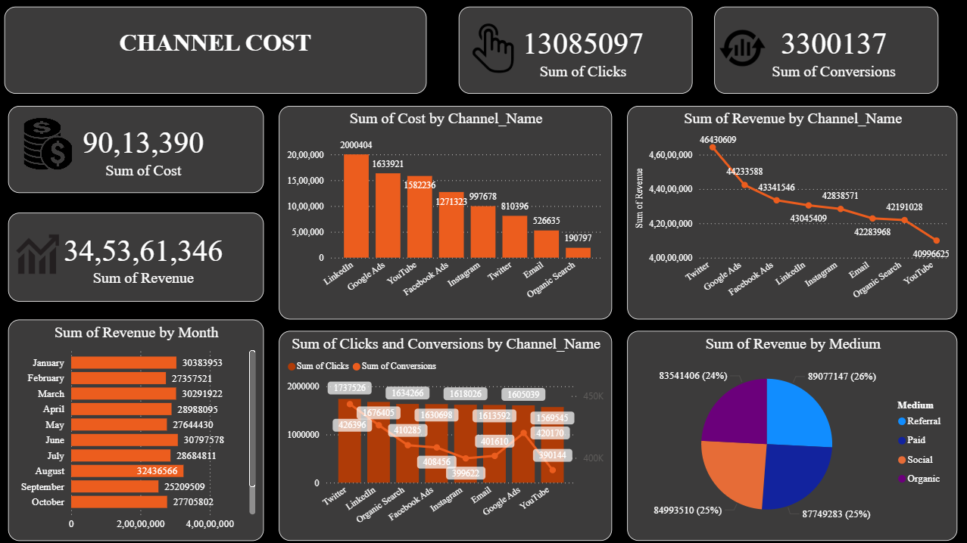

Future Insights
- Overall marketing performance shows strong revenue (₹34.5 Cr) against a moderate total cost (₹90.1 L), indicating healthy overall ROAS but with large optimization potential between channels.
- LinkedIn, Google Ads, and YouTube receive the highest spend, yet revenue curves suggest that some lower-cost channels like Twitter and Instagram are punching above their weight in revenue and conversions.
- Monthly revenue remains strong through most of the year but dips noticeably around September, pointing to seasonality or campaign fatigue that affects overall business performance.
- Click volume is extremely high compared to conversions, which implies a very low end-to-end conversion rate and significant leakage at landing pages or mid-funnel stages.
- Revenue by medium is almost evenly split between Referral, Paid, Social, and Organic, showing a diversified mix but also suggesting that no single medium has yet been fully scaled as a clear winner.
Decision-Making
- Budget Reallocation: Shift a portion of spend away from high-cost/low-ROI channels toward those with better revenue per rupee (for example, social or referral channels that show strong revenue with relatively lower cost).
- Funnel Optimization: Prioritize CRO initiatives (landing page tests, better offers, improved forms) to improve the click-to-conversion rate, since small percentage gains here will significantly increase conversions given the huge click base.
- Seasonal Campaign Planning: Design special offers and awareness pushes specifically for weak months (e.g., September) while reinforcing already strong months with upsell/cross-sell campaigns.
- Medium-Specific Strategy: Create distinct playbooks for Referral, Paid, Social, and Organic—rather than treating them uniformly—so each medium gets creatives, targeting, and messaging tailored to its strengths.
- Ongoing Performance Governance: Review channel cost, revenue, and conversions in a monthly steering meeting and define clear cut-off rules for pausing or scaling channels based on ROAS and cost per conversion.

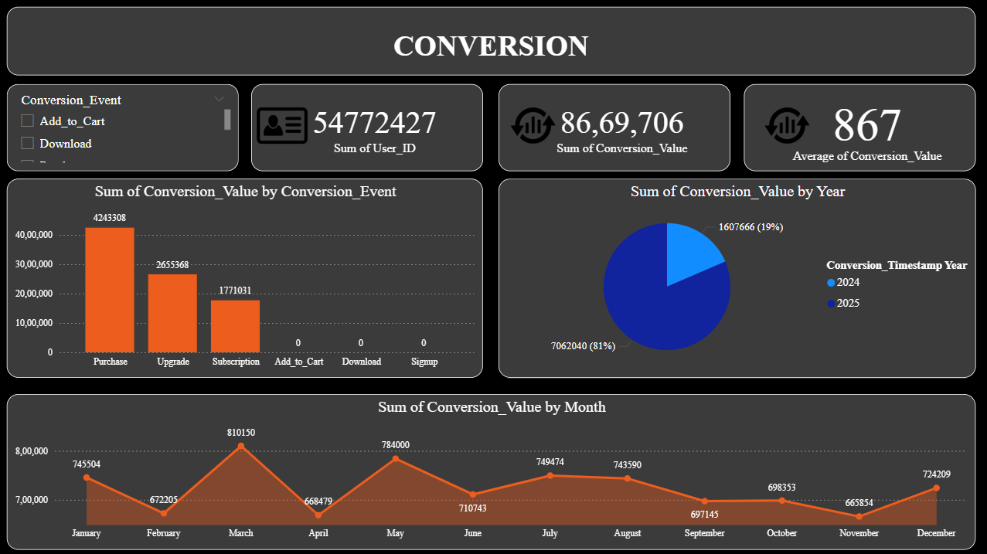

Future Insights
- Conversion value is dominated by high-intent events such as Purchase, Upgrade, and Subscription, while Add_to_Cart, Download, and Signup show negligible or no recorded value, hinting at either data-tracking gaps or under-monetized actions.
- Year-level data shows a strong shift of conversion value into the latest year, signalling rapid recent growth or improved monetization compared with the previous year.
- Monthly conversion value is volatile, with noticeable peaks in certain months (like March and May) and visible soft spots in others, which implies clear seasonal or campaign-driven behavior.
- The average conversion value is solid, but when spread across total users it indicates that only a relatively small fraction of users generate meaningful monetary events.
- The dominance of Purchase and Upgrade suggests that the business model is heavily driven by existing user monetization, with good potential to increase value via better nurturing and upselling.
Decision-Making
- High-Value Path Focus: Map and simplify the user journeys that lead to Purchase and Upgrade, and reduce friction (steps, fields, loading times) around these flows to boost completion rates.
- Monetize Low-Value Events: Strengthen strategies for Add_to_Cart, Download, and Signup by adding remarketing, email journeys, and limited-time offers that convert these early-stage actions into revenue.
- Cohort and Year Analysis: Compare cohorts across years to understand what drove the recent jump in conversion value (new pricing, product changes, campaigns) and double down on the successful levers.
- Seasonal Forecasting: Use monthly peaks and troughs to build a conversion calendar, scheduling major launches, promotions, or feature releases into historically strong months.
- Conversion KPI Targets: Set aggressive but realistic targets for uplift (for example, +20–30% annual improvement in conversion rate and average conversion value) and track them in an exec-friendly scorecard.

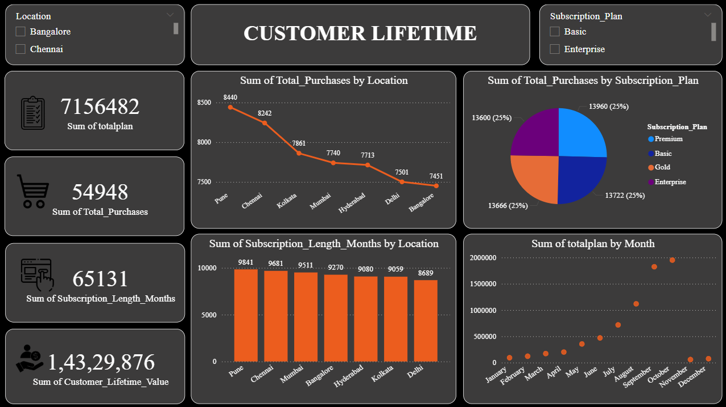

Future Insights
- Total touchpoints are high and evenly distributed across channels (LinkedIn, YouTube, Referral, Facebook, Blog, Google Ads, Instagram, Email, Organic Search), suggesting a robust multi-channel presence without one overwhelming leader.
- The average number of channels per journey is relatively high, which hints at complex customer paths before conversion and indicates that users interact with several assets and platforms before taking action.
- Touchpoint types show that Conversion, Open, Visit, Impression, and Click volumes are all sizable, indicating an end-to-end journey visibility from initial exposure to final action.
- Total page and medium counts by channel are tightly grouped, implying consistent tactical activity across channels but also raising the possibility that some channels might be over- or under-valued in the current attribution setup.
- The low standard deviation of total page metrics suggests that no channel is being massively underused, but it may also conceal differences in quality (some channels producing higher-value traffic than others).
Decision-Making
- Attribution Improvement: Move from simple last-click attribution to a multi-touch approach so that channels early in the journey (e.g., Blog, Organic, Social) receive fair credit and can be optimized correctly.
- Journey Simplification: Identify the most efficient paths (shorter touch sequences that still convert well) and design campaigns that deliberately push more users into those efficient patterns.
- Channel Role Definition: Clearly define each channel’s role—awareness, consideration, or conversion—and adjust content and KPIs accordingly instead of treating every channel as a generic traffic source.
- Engagement Optimization: Use touchpoint-type data to improve each stage separately, such as better creatives for impressions, stronger CTAs for clicks, and improved on-site experience for visits.
- Governance & Testing: Run controlled experiments where specific channels are scaled up or paused regionally or for certain segments, to better understand their true incremental impact on conversions.

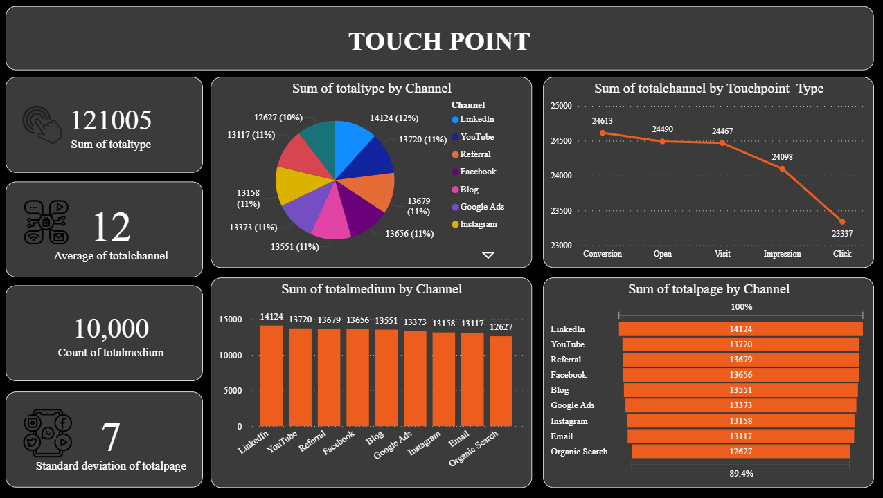

Future Insights
- Customer lifetime value and subscription length are clearly different by location, with some cities (like Pune and Chennai) showing higher purchases and longer subscription durations compared with others such as Bangalore.
- Total purchases and total plan values show a generally rising pattern through the months, with strong peaks later in the year, indicating that acquisition and/or upsell activity accelerates over time.
- Subscription length in months is relatively high overall, demonstrating decent retention, but the gap between top and bottom locations reveals that some markets retain customers significantly better than others.
- Subscription plan distribution across Premium, Basic, Gold, and Enterprise is relatively balanced, suggesting that no single plan dominates, and that customers perceive value across the whole plan ladder.
- The aggregate customer lifetime value is substantial, implying that even moderate improvements in retention or upgrades can generate large incremental revenue without a proportional increase in acquisition cost.
Decision-Making
- Geo-Specific Strategy: Prioritize investment and localized campaigns in high-CLV cities (e.g., Pune and Chennai) while diagnosing and addressing adoption or retention issues in lower-performing locations like Bangalore.
- Plan Mix Optimization: Analyze which features drive upgrades from Basic to higher tiers and design targeted in-product nudges and promotions to increase the share of Premium, Gold, and Enterprise customers.
- Retention Programs: Implement lifecycle programs (loyalty benefits, anniversary offers, renewal discounts) focused on extending subscription length in geographies that lag behind top performers.
- CLV-Based Bidding: Use CLV by location and plan as a key input in performance marketing bidding, spending more to acquire users in markets and segments that historically deliver higher lifetime value.
- Long-Term Forecasting: Feed monthly total plan and purchase trends into forecasting models to plan capacity, support, and cash-flow needs, especially around peak months when new subscriptions and upgrades spike.

11. Tools & Technologies
- Data Sources: Google Analytics (user sessions, touchpoints), Facebook Ads Insights (ad spend, impressions, clicks), CRM exports (leads, conversions, revenue), Marketing cost spreadsheets.
- ETL: Power Query for data ingestion and cleaning, DAX for model logic, Power BI Data Model for relationships and transformations.
- Visualization: Power BI dashboards including Sankey diagrams, attribution comparison charts, CLV/CAC visuals, KPIs, and ROI reports.
- Analytics: Multi-touch attribution modeling (First Touch, Last Touch, Linear, Time-Decay, U-Shaped), ROI analysis, CLV calculation, CAC measurement, channel performance scoring.
- Integration Tools: API connectors, CSV/Excel import pipelines, automated scheduled refresh in Power BI Service.

12. Results (Expected/Actual)
- Attribution models revealed significant variation in channel credit, showing that Last Touch overstated the impact of remarketing campaigns while undervaluing early-stage channels like Email and Organic Search.
- Multi-touch analysis identified customer journeys averaging 3–5 touchpoints, helping marketers understand true engagement paths.
- ROI dashboards highlighted that certain high-spend channels contributed minimal conversion value across models, exposing budget inefficiencies.
- CLV vs CAC analysis showed Email and Organic Search as the most cost-effective channels for long-term customer acquisition.
- Sankey journey visualizations uncovered common paths leading to conversions and drop-offs, enabling targeted optimization strategies.

13. Challenges
- Combining Google Analytics, Facebook Ads, and CRM data with inconsistent structures and timestamp formats.
- Dealing with missing UserIDs or anonymous sessions, which made customer journey stitching difficult.
- Attribution model complexity, especially implementing Time-Decay and U-Shaped logic correctly in DAX.
- Handling large datasets that caused performance slowdowns in Power BI during refresh and visual rendering.
- Ensuring reliable mapping of marketing spend to campaigns when naming conventions were inconsistent across platforms.

14. Future Enhancements
- Integrate machine learning–based attribution models (e.g., Markov chains, Shapley values) for even more accurate credit distribution.
- Add real-time data streaming from ad platforms and CRM to support daily or hourly attribution updates.
- Implement predictive modeling to forecast conversions, ROI shifts, and optimal budget allocations.
- Expand dashboards with cohort analysis, churn prediction, and retention insights to link attribution with long-term outcomes.
- Enable automated alerting for anomalies such as sudden drops in channel performance or rising acquisition costs.

15. Conclusion
The Multi-Touch Marketing Attribution project successfully demonstrates the importance of analyzing the complete customer journey rather than relying on last-touch models. By integrating data from Google Analytics, Facebook Ads, and CRM platforms, and applying multiple attribution models in Power BI, the project provides accurate insights into channel performance, ROI, and customer value. Interactive dashboards and Sankey visualizations enable marketers to identify high-performing channels and optimize budget allocation effectively. Advanced models like Time-Decay and U-Shaped offer a nuanced view of conversion credit across touchpoints. Overall, the solution empowers data-driven marketing decisions and enhances campaign effectiveness.

