1. Title Page
Project Title: Urban Development & Public Sentiment Analytics
2. Abstract
This project develops an integrated urban analytics dashboard combining 311 service request data, public transport usage, and real-time social media sentiment. It enables city planners to visualize problem hotspots, monitor public opinion on urban initiatives, and optimize resource allocation based on evidence-driven insights. Techniques include data ingestion from multiple sources, geospatial analysis, sentiment analysis using AI, and visualization via Power BI.

3. Problem Statement
Municipal governments often rely on outdated census information and scattered complaint reports to inform decisions. This data, being static and anecdotal, fails to capture evolving urban challenges. The lack of real-time citizen insights results in inefficient spending, unaddressed problem areas, and reduced citizen satisfaction with public services. There is a pressing need for a system that combines operational city data and real-time public sentiment for evidence-based policymaking.

4. Objectives
- Aggregate and clean data from multiple city data sources.
- Use geospatial analysis to map service requests and sentiment hotspots.
- Apply sentiment analysis techniques to understand public perception.
- Develop Power BI dashboards for service requests, public transport performance, and resource allocation.
- Provide policymakers with a transparent and data-driven decision-making tool.

5. Scope
The project focuses on building an urban analytics dashboard for one city (e.g., New York, Chicago, or Bengaluru). Data is restricted to 311 service requests, public transport feeds, and social media sentiment. Demographic information is incorporated at the neighborhood level for contextual analysis. The dashboards are designed primarily for municipal authorities but can be extended for public transparency.

6. Literature/Background Review
Historically, city governance relied on censuses conducted every 10 years and manual feedback channels like surveys. However, with the growth of smart city initiatives, cities are exploring big data, IoT, and AI to modernize planning. Studies show that real-time operational data and citizen-generated content can improve policy relevance. This project builds upon such research by combining traditional civic feeds with AI-powered sentiment analysis.

7.Methodology
1. Data Collection and Ingestion
- 311 Service Requests: Data collected through Open 311 APIs containing complaint types, location, timestamps, and status of resolution.
- Public Transport Data: GTFS feeds and real-time APIs provide schedules, ridership, punctuality, and downtime.
- Social Media Data: Scraping tools extract text data based on keywords like “pothole,” “bus delay,” or “park safety.”
- Demographic Data: CSV or government census files provide neighborhood-level socioeconomic profiles.
- Ingestion Process: APIs and batch uploads feed data into Power BI via Power Query or Azure pipelines for central storage and staging.
import pandas as pd
import numpy as np
import uuid
import os
from faker import Faker
import geopandas as gpd
from shapely.geometry import Point
from datetime import datetime, timedelta
import zipfile

# ------------------------------
# Initialize Faker and output directory
# ------------------------------
fake = Faker()
output_dir = "./city_datasets_10000_realistic"
os.makedirs(output_dir, exist_ok=True)

n = 10000 # Minimum records per dataset

# ------------------------------
# Expanded Tamil Nadu locations and stops
# ------------------------------
tn_locations = [
"Chennai", "Coimbatore", "Madurai", "Tiruchirappalli", "Tirunelveli",
"Salem", "Erode", "Vellore", "Thoothukudi", "Dindigul",
"Kanchipuram", "Hosur", "Cuddalore", "Karur", "Nagapattinam",
"Sivakasi", "Tiruvannamalai", "Krishnagiri", "Namakkal", "Virudhunagar",
"Perambalur", "Ariyalur", "Dharmapuri", "Tiruvarur", "Ramanathapuram"
]

tn_stops = [
"Chennai Central", "Egmore", "Tambaram", "Koyambedu", "Vadapalani",
"Coimbatore Junction", "Salem Town", "Madurai Junction", "Trichy Fort",
"Tirunelveli", "Nagercoil", "Vellore Town", "Erode Junction", "Thanjavur",
"Kanchipuram Stop", "Hosur Stop", "Cuddalore Junction", "Karur Stop",
"Nagapattinam Stop", "Sivakasi Stop", "Tiruvannamalai Stop", "Krishnagiri Stop",
"Namakkal Junction", "Virudhunagar Stop", "Perambalur Stop", "Ariyalur Stop",
"Dharmapuri Stop", "Tiruvarur Stop", "Ramanathapuram Stop"
]

complaint_category_map = {
"Garbage not cleared for 3 days": "Garbage",
"Overflowing garbage bins": "Garbage",
"Streetlight not working in main road": "Streetlight",
"Pothole near bus stop causing accidents": "Pothole",
"Water leakage from underground pipe": "Water Leakage",
"Bus delay causing inconvenience": "Transport Delay",
"Metro late arrival issue": "Transport Delay",
"Open drainage complaint": "Blocked Drain",
"Blocked stormwater drain": "Blocked Drain",
"Traffic signal not functioning": "Traffic Signal Issue",
"Illegal parking complaint": "Illegal Parking",
"No water supply issue": "Water Supply Issue",
"Road surface broken causing accidents": "Road Damage",
"Public toilet maintenance issue": "Public Toilet Issue",
"Street cleaning not done": "Street Cleaning Issue",
"Noise pollution complaint": "Noise Complaint",
"Encroachment complaint": "Encroachment",
"Unauthorized billboard issue": "Unauthorized Billboard",
"Air pollution from industries": "Air Pollution"
}

# ------------------------------
# Generate Neighborhoods
# ------------------------------
neigh_ids = [str(uuid.uuid4()) for _ in range(n)]
neigh_names = [f"Neighborhood-{i}" for i in range(1, n+1)]
latitudes = np.random.uniform(8.0, 13.5, n)
longitudes = np.random.uniform(76.5, 80.5, n)

start_date = datetime.now() - timedelta(days=365)

# --------------------------
# 1. 311 Service Request Data
# --------------------------
service_dates = [start_date + timedelta(minutes=np.random.randint(0, 525600)) for _ in range(n)]
selected_complaints = np.random.choice(list(complaint_category_map.keys()), n) # select complaints

service_df = pd.DataFrame({
"Neighborhood_ID": neigh_ids,
"Request_ID": [str(uuid.uuid4()) for _ in range(n)],
"DateTime": [d.strftime("%d-%m-%Y %H:%M:%S") for d in service_dates],
"Complaints": selected_complaints,
"Category": [complaint_category_map[c] for c in selected_complaints], # map complaint → category
"Location": np.random.choice(tn_locations, n),
"Stop_Name": np.random.choice(tn_stops, n),
"Latitude": latitudes,
"Longitude": longitudes,
"Status": np.random.choice(["Open", "Closed"], n),
"Resolution_Time(hrs)": np.random.randint(1, 200, n)
})
service_df.to_csv(os.path.join(output_dir, "311_service_requests.csv"), index=False)

print("✅ 311 Service Requests generated with complaint-related categories")

# --------------------------
# 2. Public Transport Usage Data
# --------------------------
transport_dates = [start_date + timedelta(minutes=np.random.randint(0, 525600)) for _ in range(n)]
scheduled_times = pd.to_datetime(transport_dates)
actual_times = scheduled_times + pd.to_timedelta(np.random.randint(0, 60, n), unit='m')
transport_df = pd.DataFrame({
"Neighborhood_ID": neigh_ids,
"Route_ID": [f"R{str(i).zfill(3)}" for i in range(n)],
"Stop_Name": np.random.choice(tn_stops, n),
"Scheduled_Time": scheduled_times.strftime("%d-%m-%Y %H:%M:%S"),
"Actual_Time": actual_times.strftime("%d-%m-%Y %H:%M:%S"),
"Delay(mins)": (actual_times - scheduled_times).seconds // 60,
"Daily_Ridership": np.random.randint(500, 5000, n)
})
transport_df.to_csv(os.path.join(output_dir, "public_transport_usage.csv"), index=False)

# --------------------------
# 3. Social Media Sentiment Data
# --------------------------
social_dates = [start_date + timedelta(minutes=np.random.randint(0, 525600)) for _ in range(n)]
social_df = pd.DataFrame({
"Neighborhood_ID": neigh_ids,
"Post_ID": [str(uuid.uuid4()) for _ in range(n)],
"User_Location": np.random.choice(tn_locations, n),
"Timestamp": [d.strftime("%d-%m-%Y %H:%M:%S") for d in social_dates],
# "Text_Content": np.random.choice(complaint_category_map, n),
"Text_Content": np.random.choice(list(complaint_category_map.keys()), n),
"Sentiment_Score": np.random.choice(["Positive", "Negative", "Neutral"], n)
})
social_df.to_csv(os.path.join(output_dir, "social_media_sentiment.csv"), index=False)

# --------------------------
# 4. Demographic Data
# --------------------------
demo_df = pd.DataFrame({
"Neighborhood_ID": neigh_ids,
"Total_Population": np.random.randint(1000, 100000, n),
"Population_Density": np.random.randint(5000, 20000, n),
"Income_Level": np.random.choice(["Low", "Medium", "High"], n),
"Age_Group": np.random.choice(["0-14", "15-24", "25-44", "45-64", "65+"], n),
"Ward_ID": [f"Ward-{i}" for i in range(1, n+1)],
"Zone_ID": np.random.choice(["North", "South", "East", "West", "Central"], n)
})
demo_df.to_csv(os.path.join(output_dir, "demographics.csv"), index=False)

# --------------------------
# 5. Neighborhood Shapefile
# --------------------------
neigh_info_df = pd.DataFrame({
"Neighborhood_ID": neigh_ids,
"Neighborhood_Name": neigh_names,
"Latitude": latitudes,
"Longitude": longitudes
})
gdf = gpd.GeoDataFrame(neigh_info_df, geometry=gpd.points_from_xy(neigh_info_df.Longitude, neigh_info_df.Latitude))
gdf.set_crs(epsg=4326, inplace=True)
gdf.to_file(os.path.join(output_dir, "neighborhoods.shp"))

# --------------------------
# 6. Real-Time TN Public Complaints (Expanded version)
# --------------------------
# timestamps = [start_date + timedelta(minutes=np.random.randint(0, 525600)) for _ in range(n)]
# status_options = ["Open", "Closed"]
# resolution_times = np.random.randint(1, 200, n)

# real_time_df = pd.DataFrame({
# "Neighborhood_ID": neigh_ids,
# "Request_ID": [str(uuid.uuid4()) for _ in range(n)],
# "DateTime": [ts.strftime("%d-%m-%Y %H:%M:%S") for ts in timestamps],
# "Category": np.random.choice(["Garbage", "Pothole", "Streetlight", "Water Leakage"], n),
# "Complaints": np.random.choice(complaint_category_map, n),
# "Location": np.random.choice(tn_locations, n),
# "Stop_Name": np.random.choice(tn_stops, n),
# "Latitude": latitudes,
# "Longitude": longitudes,
# "Status": np.random.choice(status_options, n),
# "Resolution_Time(hrs)": resolution_times
# })
# real_time_df.to_csv(os.path.join(output_dir, "real_time_tn_public_complaints.csv"), index=False)

# --------------------------
# Optional: ZIP all datasets
# --------------------------
zip_path = os.path.join(output_dir, "city_datasets_10000_realistic.zip")
with zipfile.ZipFile(zip_path, 'w') as zipf:
for root, dirs, files in os.walk(output_dir):
for file in files:
if file.endswith(".csv") or file.endswith((".shp", ".shx", ".dbf", ".prj")):
zipf.write(os.path.join(root, file), os.path.relpath(os.path.join(root, file), output_dir))

print(f"✅ All datasets saved independently & compressed into: {zip_path}")

2. ETL and Data Modeling
- Extraction: Pull structured data from APIs and CSVs, unstructured data from social media.
- Transformation: Standardize formats (date/time, coordinates, categorical labels).
- Loading: Push cleaned datasets into Power BI Data Model.
- Data Modeling:
  - Establish relationships between datasets (e.g., linking service requests with neighborhoods via geospatial keys).
  - Create star schema or snowflake models for efficient querying.
  - Incorporate a sentiment score fact table with links to social media keywords and geospatial identifiers.
#DATA CLEANING SCRIPT
import pandas as pd
import numpy as np
import re
import sys

# Redirect output to both console and file for Part 1
class DualOutput:
def __init__(self, filename):
self.terminal = sys.stdout
self.log = open(filename, "w", encoding="utf-8")
def write(self, message):
self.terminal.write(message)
self.log.write(message)
def flush(self):
self.terminal.flush()
self.log.flush()

sys.stdout = DualOutput("311_service_requests.txt")

# ==============================
# Step 1: Display first few rows
# ==============================
file_path = r"D:\PROJECT\Project1\dataset\311_service_requests.csv" # Change to your CSV file path r"C:\Users\Pandi selvam\Documents\311_service_requests.csv"
df = pd.read_csv(file_path)

print("First 5 rows of the dataset:")
print(df.head())
print(df.tail())

# =======================================
# Step 2: Dataset Columns
# =======================================
print("\n\n\ndataset columns:")
print(df.columns)

# =======================================
# Step 3: Data Types
# =======================================
print("\n\n\nData Types:")
print(df.dtypes)
# =======================================
# Step 4: Identify Missing Values
# =======================================
print("\n\n\nMissing Values in Each Column:")
print(df.info())
print(df.isnull().sum())

# ===================================================================================
# Step 5: Data Cleaning - Remove rows with only special characters or NaN in any cell
# ===================================================================================
def contains_only_special_chars(value):
if pd.isna(value):
return True
return bool(re.fullmatch(r'[^a-zA-Z0-9]+', str(value)))

df_cleaned = df[~df.applymap(contains_only_special_chars).any(axis=1)]

print("\n\n\nAfter cleaning (removing rows with only special characters or NaN in any column):")
print(df_cleaned.head())

# Save cleaned data for Part 2
cleaned_file_path = "311_service_requests1.csv"
df_cleaned.to_csv(cleaned_file_path, index=False)
print(f"\n\n\nCleaned data saved to {cleaned_file_path}")

# Restore stdout
sys.stdout.log.close()
sys.stdout = sys.stdout.terminal

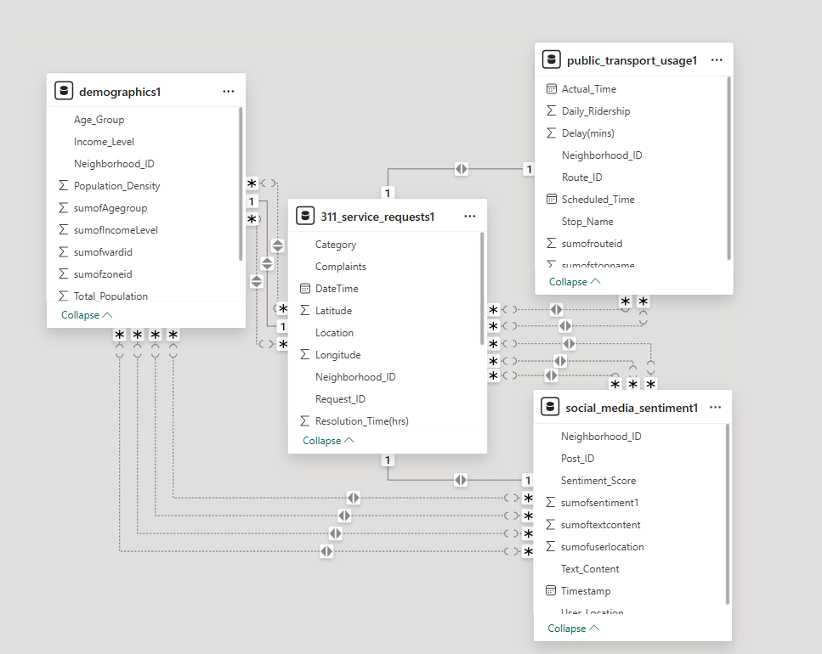

3. Data Transformation
- Data Cleaning: Remove duplicates, null values, and irrelevant social media texts.
- Feature Engineering:
  - Convert complaint text categories into structured attributes.
  - Extract sentiment polarity (positive/negative/neutral) from tweets/posts.
  - Add calculated columns (e.g., average resolution time, complaint density per neighborhood).
- Geospatial Integration: Attach shapefiles for neighborhood boundaries; map coordinates to polygon IDs.
- Aggregation: Group requests, transport ridership, and sentiments by time (daily, weekly, monthly) and geography.
4. Data Visualization
- Service Request Dashboard: Heatmap showing density of complaints by area and category.
- Sentiment Dashboard: Sentiment overlay on city maps showing public mood patterns.
- Transit Performance Dashboard: KPIs for punctuality, downtime, and ridership trends.
- Resource Allocation Dashboard: Compare government spending/resources vs. high-complaint/high-negative sentiment areas.
- Public Summary Page: Easy-to-read story-driven dashboard for transparency and public communication.
5. Correlation and DAX Functions
- Correlation Analysis:
  - Complaint volume vs. negative sentiment per neighborhood.
  - Demographic characteristics (e.g., income, population density) vs. service gaps.
  - Transport delays vs. citizen dissatisfaction.
import pandas as pd
import seaborn as sns
import matplotlib.pyplot as plt
from sklearn.preprocessing import LabelEncoder

# Load dataset
df_cleaned = pd.read_csv(r"D:\PROJECT\Project1\Data_cleaning\demographics1.csv")

# Select categorical (string) and numeric columns
cat_cols = df_cleaned.select_dtypes(include=['object']).columns
num_cols = df_cleaned.select_dtypes(include=['int64', 'float64']).columns

# Encode categorical columns using LabelEncoder
le = LabelEncoder()
encoded_cats = pd.DataFrame()

for col in cat_cols:
encoded_cats[col] = le.fit_transform(df_cleaned[col].astype(str))

# Combine numeric + encoded categorical columns
combined_df = pd.concat([df_cleaned[num_cols], encoded_cats], axis=1)

# Compute correlation matrix
corr_matrix = combined_df.corr(numeric_only=True)

# Extract only numeric rows vs categorical columns
corr_subset = corr_matrix.loc[num_cols, cat_cols]

# Plot heatmap
plt.figure(figsize=(12, 8))
# sns.heatmap(corr_subset, annot=True, cmap="YlGnBu", fmt=".2f")
sns.heatmap(corr_matrix, annot=True, cmap="coolwarm", fmt=".2f")
# sns.heatmap(corr_subset, annot=True, cmap="coolwarm", fmt=".2f")
plt.title("Correlation between Numeric Columns and Categorical Columns")
plt.xlabel("Categorical Columns")
plt.ylabel("Numeric Columns")
plt.show()

import pandas as pd
import seaborn as sns
import matplotlib.pyplot as plt
from sklearn.preprocessing import LabelEncoder

# Load dataset
df_cleaned = pd.read_csv(r"D:\PROJECT\Project1\Data_cleaning\demographics1.csv")

# Select categorical (string) and numeric columns
cat_cols = df_cleaned.select_dtypes(include=['object']).columns
num_cols = df_cleaned.select_dtypes(include=['int64', 'float64']).columns

# Encode categorical columns using LabelEncoder
le = LabelEncoder()
encoded_cats = pd.DataFrame()

for col in cat_cols:
encoded_cats[col] = le.fit_transform(df_cleaned[col].astype(str))

# Combine numeric + encoded categorical columns
combined_df = pd.concat([df_cleaned[num_cols], encoded_cats], axis=1)

# Compute correlation matrix
corr_matrix = combined_df.corr(numeric_only=True)

# Extract only numeric rows vs categorical columns
corr_subset = corr_matrix.loc[num_cols, cat_cols]

# Plot heatmap
plt.figure(figsize=(12, 8))
# sns.heatmap(corr_subset, annot=True, cmap="YlGnBu", fmt=".2f")
# sns.heatmap(corr_matrix, annot=True, cmap="coolwarm", fmt=".2f")
sns.heatmap(corr_subset, annot=True, cmap="coolwarm", fmt=".2f")
plt.title("Correlation between Numeric Columns and Categorical Columns")
plt.xlabel("Categorical Columns")
plt.ylabel("Numeric Columns")
plt.show()

- DAX in Power BI:
  - Measures: Average Resolution Time, Complaint-to-Resource Ratio, Sentiment Index.
  - Time Intelligence Functions: Track weekly/monthly trends in service request spikes.
  - Key Influencers Visual: Identify drivers of negative sentiment (e.g., delayed buses → high negative posts).
  - Calculated Columns: Complaint density per square km, sentiment variance.
DEFINE
MEASURE social_media_sentiment1[Max Sentiment_Score by Text] =
CALCULATE(
MAX( social_media_sentiment1[Sentiment_Score] ),
ALLEXCEPT(
social_media_sentiment1,
social_media_sentiment1[Text_Content],
social_media_sentiment1[User_Location]
)
)
EVALUATE
SUMMARIZECOLUMNS(
social_media_sentiment1[Text_Content],
social_media_sentiment1[User_Location],
"Max Sentiment", [Max Sentiment_Score by Text]
)

8. Week-wise Development Plan
Week 1: Collect and clean 311 service request data, integrate base maps, create initial chart
- Data Collection & Ingestion:
  - Gather 311 datasets via API, including complaint description, location (latitude/longitude), category (e.g., pothole, waste pickup), and timestamps.
  - Collect demographic shapefiles or maps for neighborhoods.
- ETL & Data Modeling:
  - Clean duplicates, normalize columns (e.g., standardize date/time format).
  - Create relationships between service requests and geographic boundaries.
- Data Transformation:
  - Aggregate complaints by type and location.
  - Create calculated columns like “Resolution Status” or “Open vs Closed Requests.”
- Visualization:
  - Build the initial complaint heatmap in Power BI using ArcGIS or Azure Maps.
  - Add an initial bar chart showing top complaint categories.

Week 2: Build sentiment data from social media, map sentiment with service requests, create service request dashboard
- Data Collection & Ingestion:
  - Scrape Twitter, Reddit, or other platforms for city-related keywords (“traffic jam,” “bus delay,” “garbage issue”).
  - Store social media text data for analysis.
- ETL & Data Modeling:
  - Apply Azure Cognitive Services or Power BI AI visuals to classify posts as Positive, Negative, or Neutral.
  - Link sentiment results to neighborhood locations (via geotags or location mentions in text).
- Data Transformation:
  - Create calculated sentiment scores (e.g., sentiment polarity index).
  - Filter out noise/irrelevant posts.
- Visualization:
  - Overlay sentiment map on top of service request hotspots.
  - Develop Service Request Dashboard: complaint volume trend lines, complaint type distribution, and resolution time averages.

Week 3: Correlate sentiment and requests with demographics, develop transit performance dashboard
- Data Collection & Ingestion:
  - Import demographic profiles (population density, income levels) via census datasets.
  - Collect GTFS transit feeds for schedules, delays, and ridership statistics.
- ETL & Data Modeling:
  - Join demographics with service request and sentiment datasets on geographic keys (neighborhood IDs).
  - Create transit fact tables (ridership per route, average delay per station).
- Data Transformation:
  - Build calculated measures like “Complaints per 1,000 residents” or “Delay per trip.”
  - Segment complaint/sentiment intensity by demographic factors.
- Correlation & DAX:
  - Use DAX to develop KPIs (e.g., “Correlation between negative sentiment and average wait time”).
  - Apply Key Influencers in Power BI to identify drivers of complaints (e.g., ridership drops when downtime > 20 minutes).
- Visualization:
  - Transit Performance Dashboard with KPIs on punctuality, downtime, and ridership trend lines.
  - Comparative visuals showing which neighborhoods experience highest complaints vs. lowest resources.

Week 4: Optimize performance, polish visuals, prepare policy narrative insights, finalize dashboards for stakeholders
- ETL Optimization:
  - Refine queries, reduce refresh times, and optimize data model with measures instead of redundant calculated columns.
- Data Transformation:
  - Ensure all metrics are standardized and aggregated consistently (e.g., weekly complaint averages).
  - Run final validation checks for missing or duplicate data.
- Visualization:
  - Polish dashboards with consistent theme, icons, and navigation panes in Power BI.
  - Create Policy Narrative Dashboard summarizing key insights:
    - Which neighborhoods have highest unmet service demand?
    - Where is public dissatisfaction highest?
    - Which transit routes cause the most issues?
- Correlation & Insights:
  - Incorporate story-driven visuals highlighting gaps in resource allocation.
  - Prepare public-facing summary for transparency (simplified dashboard).
- Final Step: Deliver stakeholder-ready dashboards and walkthrough.

9. System Architecture
Flow:
[Data Sources]
|-- 311 service
|-- Public Transport
|-- Social Media
|-- Demographics
[Data Collection & Ingestion Layer]

[ETL & Data Modeling Layer]

[Data Transformation Layer]

[Analytics & Correlation Layer]

[Visualization Layer (Power BI Dashboards)]

[End Users: City Planners, Public, Stakeholders]

10. Dashboard Features
- Service Request Hotspot Map: Visualizes clusters of complaints.
- Sentiment Heatmap: Displays real-time public mood across neighborhoods.
- Transit Performance Dashboard: Highlights ridership trends, punctuality, and downtime.
- Resource Allocation vs. Need Dashboard: Compares municipal spending vs. complaint density.
- Public Summary Dashboard: Simplified, transparent interface for citizens.
- High complaint volumes correlate with high negative sentiment clusters in areas such as Karur and Hosur.
- Public transport delays concentrate at key hubs like Tambaram and Egmore during peak months.
- Air pollution and garbage-related complaints dominate citizen concerns, especially affecting vulnerable age groups.
- Social media provides timely insight into public opinion changes, complementing but exceeding official complaint volumes.
- The dashboard revealed resource gaps in sanitation and transport infrastructure alignment with population densities.
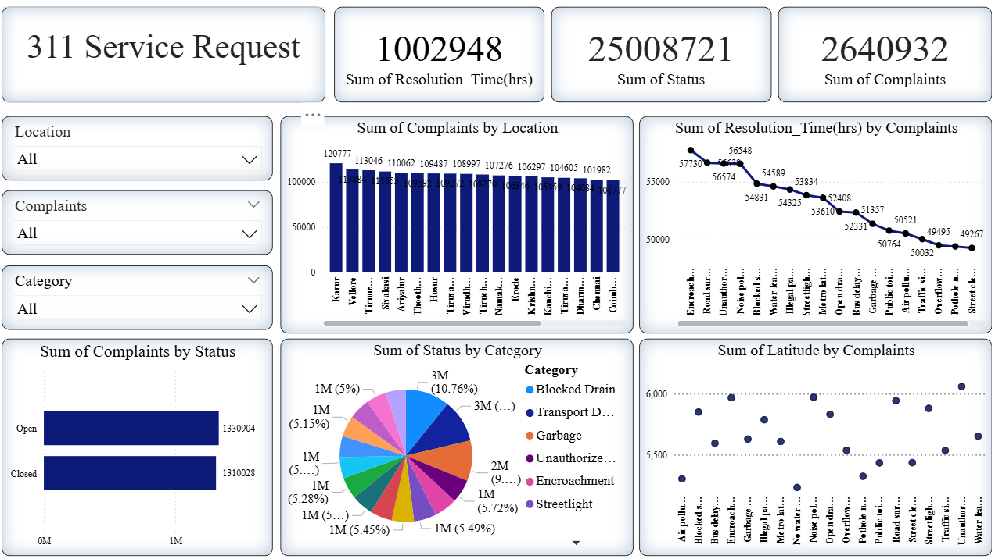
Future Insights
- The complaint volume is distributed relatively evenly across locations, with the highest reporting from areas like Karur (120,777 complaints) and Vellore (113,046 complaints). This suggests on going or persistent issues in these regions and highlights them as focus areas for targeted improvement initiatives.
- Both open and closed complaint numbers are nearly balanced (about 1.33 million each), indicating efficient processing but also pointing to a substantial number of ongoing issues that require continuous attention.
- Categories such as Blocked Drain and Transport Dominated represent the largest shares of complaints, making them high-priority intervention points for municipal resources and infrastructure investment.
- Resolution times by complaint type show notable delays for categories like Encroachment and Road Surface, which have the highest cumulative resolution hours. These areas could benefit from process optimization or resource reallocation.
- The pie chart reveals no single category overwhelmingly dominates, suggesting that service demand is broadly distributed and all departments must remain responsive and adequately staffed.
Decision-Making
- Resource Allocation: Focus additional resources, such as workforce or technology interventions, on high-complaint areas and categories (e.g., Karur, Blocked Drains) to prevent recurring issues and improve citizen satisfaction.
- Process Improvement: Investigate and streamline the complaint handling workflow for categories with the longest resolution times, such as Encroachment and Road Surface, perhaps by introducing specialized task forces or fast-track mechanisms.
- Predictive Monitoring: Use the complaint distribution data to set up predictive analytics, identifying potential complaint surges (seasonal or location-based) and preparing contingency plans accordingly.
- Status Review: Regularly analyze the ratio of open to closed complaints to ensure backlog is minimized and bottlenecks are quickly addressed, supporting transparency and accountability.
- Public Awareness: Run targeted communication or educational campaigns in the areas with high complaint volumes to inform residents about service channels, preventive measures, or civic responsibilities to reduce avoidable complaints.
- Continuous Improvement: Establish key performance indicators (KPIs) for each category/location and regularly review them in management meetings to drive policy modifications, budgeting, and service enhancements.

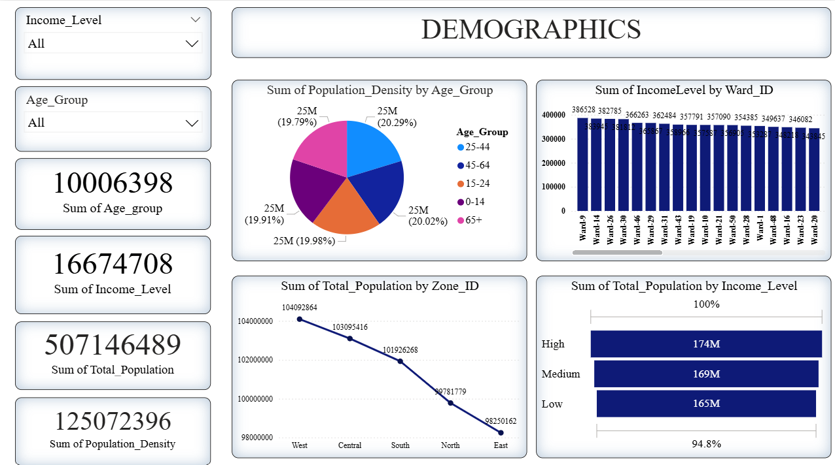
Future Insights
- The population is evenly distributed among age groups, each segment accounting for approximately 20% of the population, which suggests a balanced age structure and stable demand for services across all age demographics.
- Income levels also show relative balance across the population, with "High," "Medium," and "Low" categories comprising 174M, 169M, and 165M respectively, indicating socioeconomic diversity and highlighting potential market segmentation opportunities.
- The highest population densities and total populations are observed in the West and Central zones, indicating these areas may experience greater demand for infrastructure, housing, healthcare, and educational services.
- The distribution of income levels by ward is relatively even, meaning wealth and resources are not concentrated in a few areas but are likely dispersed, which can assist in balanced urban planning and social policy formation.
Decision-Making
- Fiscal Planning: Allocate city or municipal budgets and services proportionally, with greater focus on high-density zones (West and Central), which will require more health, transport, and educational infrastructure.
- Targeted Programs: Develop social programs and incentives for wards and zones with lower income levels to foster inclusive growth, workforce development, and community wellbeing.
- Age Group Prioritization: Plan for varied services (childcare, schools, elder care, youth programs) since demand will remain steady across all age groups, avoiding neglect of any demographic segment.
- Economic Development: Encourage investment and job creation initiatives in regions where "Medium" and "Low" income populations are substantial, to support upward mobility and economic resilience.
- Urban Expansion: Prioritize housing, infrastructure, and public utilities upgrades in West and Central zones to handle current and future population growth and density.
- Continuous Monitoring: Establish dashboards and predictive analytics to continuously track and respond to shifts in demographics, helping decision-makers quickly adapt strategies and maintain social equity.
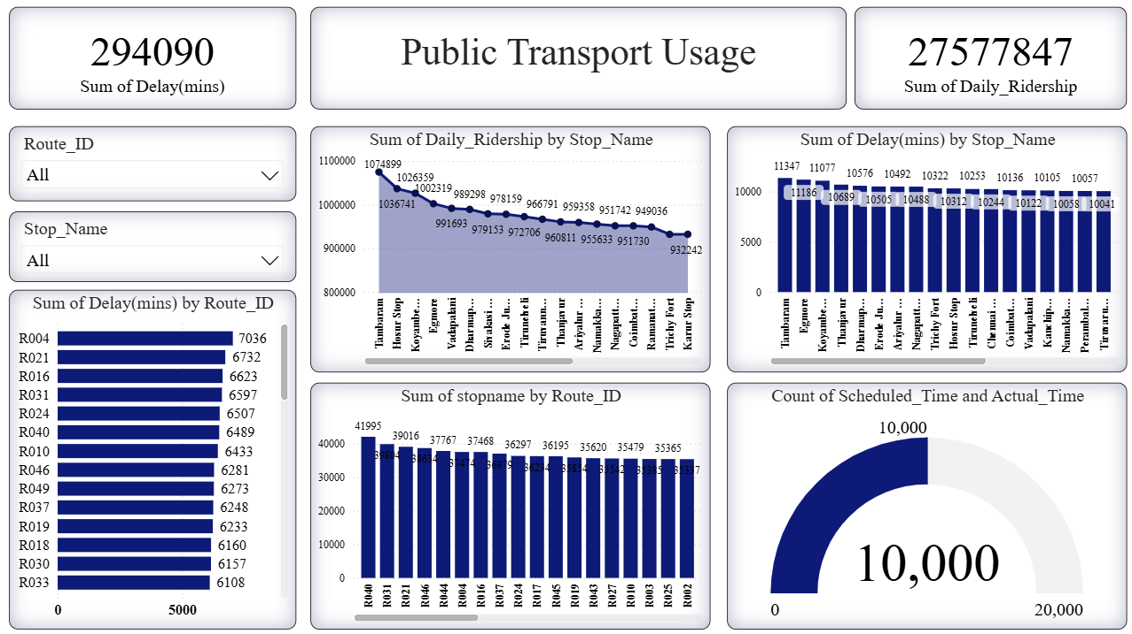

Future Insights
- The ridership is concentrated at major stops, notably Tambaram and Egmore, with daily ridership exceeding 100,000 passengers at key locations, indicating these are crucial nodes in the network that drive much of the system's traffic.
- Delay patterns are consistent across stops, with each major stop seeing delays above 10,000 minutes, pointing to systemic efficiency issues that likely impact passenger satisfaction and operational costs.
- Several routes (e.g., R004, R021, R016) experience higher cumulative delays, suggesting targeted action on these routes could significantly improve system-wide punctuality and reliability.
- The number of scheduled versus actual trips is tracked, suggesting an ongoing focus on operational adherence. The total trip count of 10,000 underscores the scale and potential variability in service delivery.

Decision-Making
- Infrastructure and Fleet Upgrades: Focus capital investment on high-ridership stops (Tambaram, Egmore) and on routes showing the most delay, such as R004, R021, and R016. This could include dedicated bus lanes, upgraded signal systems, and expanded fleets to alleviate delays and accommodate surges in demand.
- Data-Driven Scheduling: Refine timetables and resource allocation using ridership and delay data to ensure peak-hour capacity matches actual usage, reducing overcrowding and improving travel time reliability.
- Operational Efficiency Measures: Analyze common causes of delay at high-impacted stops and routes, introducing strategies like dynamic dispatch, real-time traffic monitoring, and acceleration of turnaround times to improve schedule adherence.
- Customer Service Innovations: Enhance communication and passenger experience at heavily trafficked stops with real-time updates, mobile alerts, and contingency plans for delays, aiming to boost public satisfaction and ridership.
- Continuous Performance Review: Maintain the monitoring of scheduled vs. actual trip data, using discrepancies as KPIs for efficiency initiatives, bonus allocation, or targeted managerial oversight.
- Long-Term Planning: Consider expansions or new lines serving stops with growing ridership and chronic delays, incorporating future population growth and urban development projections to sustainably scale public transport offerings.

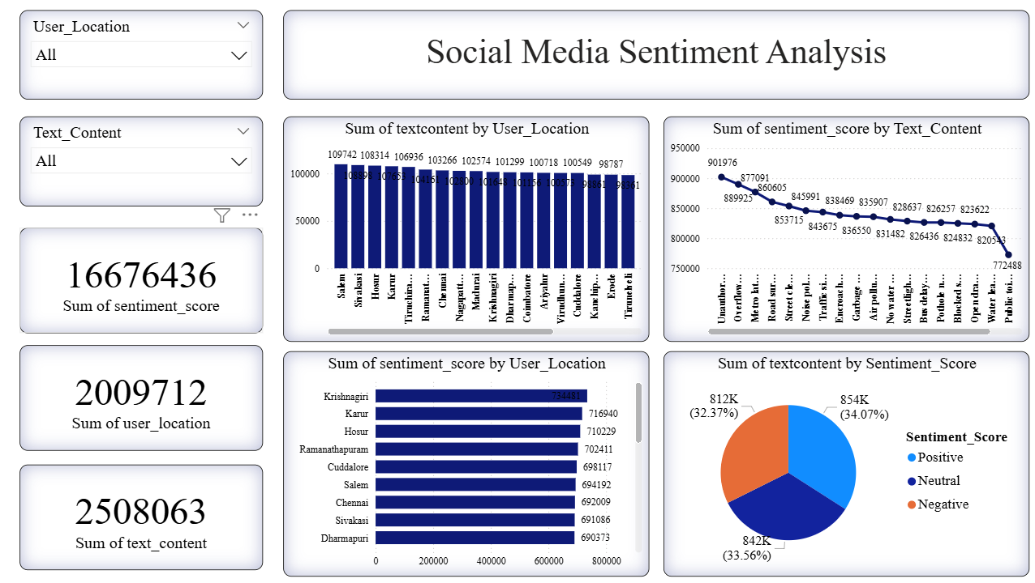

Future Insights
- Sentiment across user locations is fairly balanced, with Krishnagiri, Karur, and Hosur showing the highest aggregate sentiment scores, indicating stronger community engagement and a potentially more vocal or satisfied user base in these regions.
- The sentiment score distribution by text content shows gradual decline from topics like "Unauthorised" and "Overflow" to concerns such as "Water leakage" and "Public toilet", suggesting the intensity of sentiment (positive or negative) varies significantly by issue type, which can inform future focus areas and communication strategies.
- The sentiment breakdown (Positive: 34.07%, Neutral: 33.56%, Negative: 32.37%) demonstrates an almost even split, meaning public opinion is diverse and not dominated by any particular polarity. This provides an opportunity for balanced messaging and programs to shift sentiment positively.
- User-generated content volume is highest from regions like Salem, Sivakasi, and Hosur, revealing zones with the greatest digital civic engagement, which could be leveraged for rapid feedback and beta testing of new policies.
Decision-Making
- Targeted Outreach and Engagement: Focus engagement campaigns or improvement efforts in regions with high sentiment scores and content generation (e.g., Krishnagiri, Salem), leveraging these active digital communities for policy trials, feedback loops, and participatory governance.
- Proactive Issue Resolution: Analyze negative sentiment clusters (topics like “Water leakage,” “Public toilet”) to identify priority issues for rapid response, resource allocation, and infrastructure upgrades that directly address community pain points.
- Balanced Communication Strategy: Develop messaging to emphasize improvements and promote positive narratives, given the even split in sentiment. This could help to gradually shift neutral and negative sentiment pools toward positivity and build public trust.
- Sentiment Monitoring: Implement continuous sentiment tracking for all service categories to spot emerging trends, react swiftly to reputational risks, and adapt public policies based on real-time social feedback.
- Digital Literacy and Participation: Encourage digital participation in regions with lower text content and sentiment scores, expanding social media outreach campaigns to promote inclusivity and broader representation in civic forums.
- Policy and Service Feedback: Use sentiment analytics to inform the pace and priority of policy correction, customer service initiatives, and advertising efforts, ensuring the most vocal or concerned communities receive timely governmental attention.

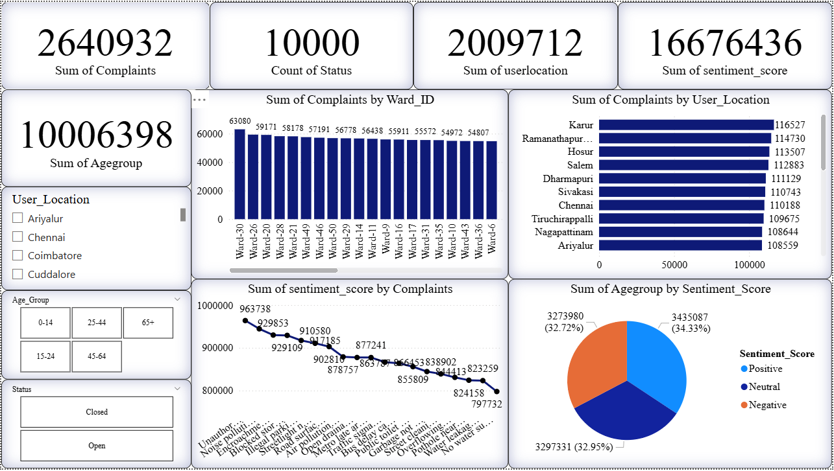
Future Insights
- Complaints are broadly distributed across wards and user locations, with places like Karur, Ramanathapuram, and Hosur showing the highest complaint volumes. This signals these regions as significant focus areas for customer service and root cause analysis.
- The sentiment score by complaint type reveals persistent negativity around topics like "Unauthorised encroachment," "Encroachment," and "Blocked drain," showing where citizen frustration and dissatisfaction are most pronounced and need priority action.
- Sentiment by age group is evenly split across positive, neutral, and negative, with each type comprising about a third of the total, suggesting no single attitude is dominant in the population and indicating an opportunity to shift public opinion with effective interventions.
- The status breakdown (open vs. closed) of complaints and high total complaint count reflect ongoing service challenges, underscoring the need for improvements in both speed and quality of resolution.
Decision-Making
- Hotspot Monitoring: Focus rapid response units and additional resources on high-complaint wards (e.g., Karur, Ramanathapuram, Hosur). Periodic reviews of these areas can help to identify trends and underlying systemic issues, enabling sharply targeted improvements.
- Sentiment-Driven Prioritization: Address complaints that consistently generate negative sentiment (e.g., encroachment, blocked drains). Launch special clean-up, enforcement, or community liaison initiatives in these areas to visibly address the public’s pain points and improve satisfaction.
- Age-Specific Engagement: Since sentiment is evenly distributed by age, design inclusive feedback and communication strategies to ensure that solutions and outreach are accessible and relevant for all demographic groups.
- Transparency and Feedback: Increase transparency on complaint resolution progress by publishing detailed status dashboards. This helps manage expectations, build trust, and motivates staff to close open cases efficiently.
- Continuous Improvement: Use the gathered insight as a baseline for ongoing sentiment analytics, tracking changes after interventions to understand what drives improvement and where further action is needed.
- Preventive Programs: Where complaints and negative sentiment are chronic, adopt preventive strategies such as awareness programs, periodic checks, or digital reporting tools for early warning and preemptive action.

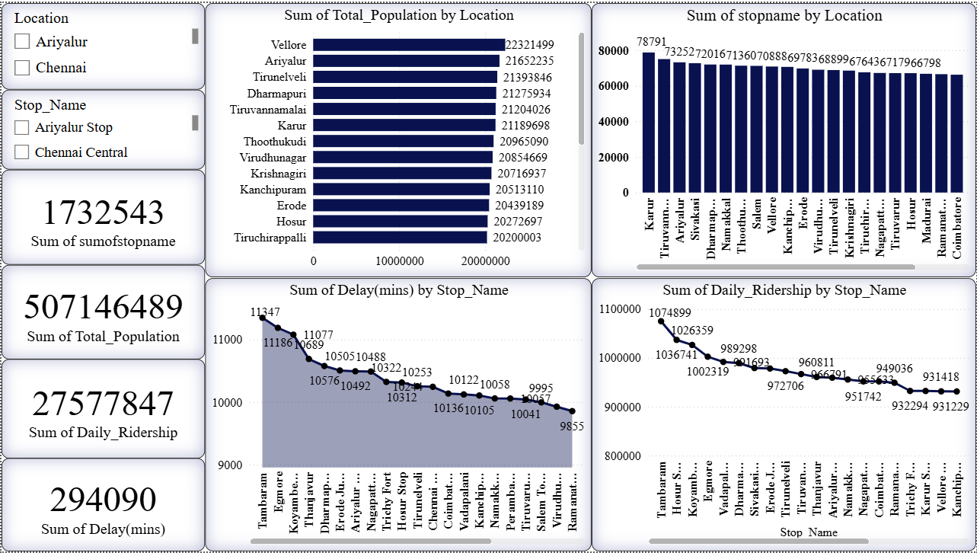
Future Insights
- Population centers like Vellore and Ariyalur lead with over 21 million residents each, signaling high transit service demand in these locations and the need for ongoing scalability of public transport infrastructure.
- The stops with the greatest ridership (e.g., Tambaram and Egmore) regularly accommodate over 100,000 daily passengers, while the highest delays are also observed at these major nodes. This pattern underscores a correlation between ridership and operational bottlenecks.
- Locations such as Karur, Tiruvannamalai, and Sivakasi have the highest stop name counts, suggesting extensive route penetration or numerous sub-stops, which may complicate operational efficiency or require optimized scheduling.
- Delay times are significant and widespread, with every major stop experiencing over 9,000 minutes of total delay, indicating a network-wide challenge rather than isolated incidents.
Decision-Making
- Capacity Planning: Increase public transport fleet size and frequency on high-population corridors and busiest stops, especially in Vellore, Ariyalur, Tambaram, and Egmore, to alleviate congestion and meet rising demand.
- Expand Relief Measures: Deploy express or limited-stop services through heavily delayed stops to reduce congestion and improve travel times for priority passengers.
- Data-Driven Optimization: Use granular data on delays and daily ridership to recalibrate schedules, stagger service times, and prioritize stop improvements where ridership and delays coincide.
- Infrastructure Investment: Plan for periodic maintenance and capacity expansions in cities and stops showing sustained growth in population or ridership, minimizing breakdowns or unforeseen service interruptions.
- Performance Monitoring: Continuously review delay data by stop and location to quickly detect and address operational inefficiencies, update stakeholders, and strengthen accountability mechanisms.
- Community Engagement: Involve local stakeholders in high-delay or high-growth regions for feedback before launching changes, increasing the probability of success and community satisfaction.

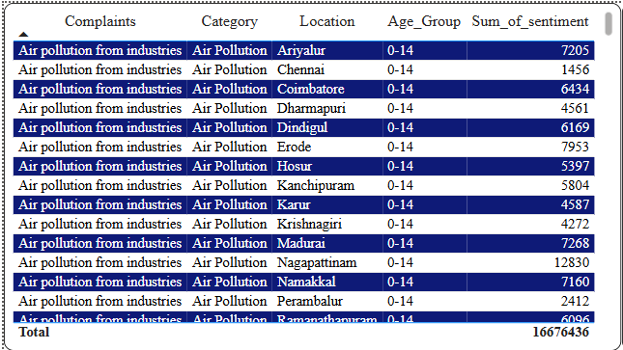

Future Insights
- Numerous locations have registered air pollution complaints linked to industrial activities, with particularly high sentiment scores reported in Nagapattinam (12,830), Madurai (7,268), Namakkal (7,160), and Ariyalur (7,205), suggesting strong public concern and heightened health risks for children in these regions.
- The consistent reporting of complaints across cities highlights that air pollution is a widespread issue rather than isolated, indicating the need for statewide preventive and mitigation plans.
- The affected age group (0-14) is particularly vulnerable to the adverse health effects of air pollution, increasing the urgency for targeted interventions to safeguard childhood development and wellbeing.
Decision-Making
- Immediate Regulatory Action: Prioritize stricter enforcement of environmental norms and industrial emissions in high-sentiment locations (Nagapattinam, Madurai, Namakkal, Ariyalur). Conduct regular air quality audits and penalize violations to reduce pollutant levels quickly.
- Health Monitoring Programs: Launch pediatric health surveillance initiatives at schools and clinics in affected locations to detect, treat, and monitor air pollution-related conditions among children.
- Community Awareness & Engagement: Implement educational drives targeting parents and local communities on the risks of air pollution, practical steps for protection (like mask usage, indoor air filters), and reporting mechanisms for new complaints.
- Sustainable Industry Incentives: Encourage local industries to adopt clean technology and pollution control practices by providing tax benefits or grants, especially in regions with the highest sentiment scores and public concern.
- Cross-District Collaboration: Develop a coordinated action plan involving municipal governments and health authorities across all listed locations, sharing best practices and deploying rapid response teams for emergency pollution incidents.
- Periodic Sentiment Tracking: Regularly monitor the sentiment and complaint data to evaluate the effectiveness of interventions, adapting strategies based on evolving public feedback and emerging hotspots

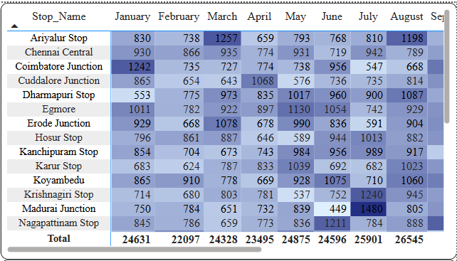
Future Insights
- The overall monthly stop usage is rising from January (24,631) to August (26,545), with the highest activity recorded in August. This indicates a possible seasonal or growth trend that may require additional capacity in subsequent months.
- Specific stops, such as Coimbatore Junction, Egmore, and Nagapattinam Stop, experience marked fluctuations, with peaks evident in months like March (Coimbatore Junction: 1,257) and July (Nagapattinam Stop: 1,211), potentially due to holidays, events, or local factors.
- Madurai Junction and Krishnagiri Stop show spikes in July (Madurai Junction: 1,480; Krishnagiri Stop: 1,240), suggesting that certain times of the year bring about significantly heightened demand at these locations. Some stops (e.g., Hosur Stop, Karur Stop) maintain stable numbers, showing consistent ridership patterns.
Decision-Making
- Dynamic Resource Allocation: Ramp up fleet capacity, staff availability, and scheduling during peak months (especially July and August), focusing on stops with predictable surges like Madurai Junction, Nagapattinam Stop, and Egmore to manage increased demand and prevent service bottlenecks.
- Predictive Operational Planning: Leverage monthly usage peaks and valleys to forecast future demand and optimize scheduling, maintenance, and service outreach around critical periods (e.g., festival seasons or school holidays).
- Infrastructure Investment: Prioritize upgrades and preventive maintenance for heavily utilized stops, particularly those with high seasonal variation, to avoid breakdowns and ensure passenger safety during peak months.
- Targeted Communication: Plan rider awareness campaigns and real-time updates around anticipated busy periods to help passengers plan their travel, thereby reducing congestion and enhancing overall commuter experience.
- Continuous Data Monitoring: Regularly review monthly stop-level data to detect emerging usage trends or unexpected surges, allowing quick management interventions and more responsive transit operations.

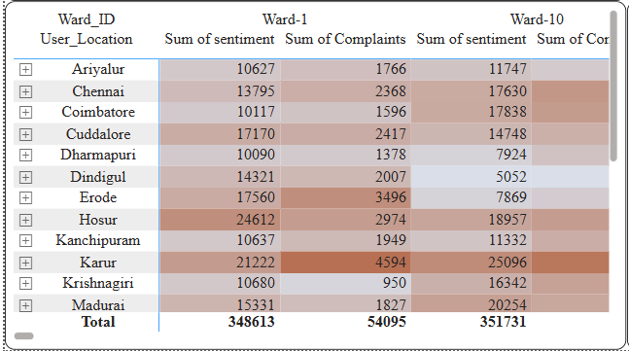
Future Insights
- Certain user locations like Hosur, Karur, and Erode report significantly higher complaint volumes and sentiment scores in both Ward-1 and Ward-10, indicating recurring issues or higher population engagement in these areas.
- There is notable variation in sentiment even within the same city between Ward-1 and Ward-10. For example, Karur's sentiment jumps from 21,222 (Ward-1) to 25,096 (Ward-10), and Hosur from 24,612 (Ward-1) to 18,957 (Ward-10), suggesting differences in service quality, civic participation, or localized challenges between wards.
- Some wards (e.g., Dindigul in Ward-10 and Kanchipuram in Ward-10) show much lower sentiment scores compared to Ward-1, which may point to improved conditions, reduced engagement, or underreporting.
- The overall sum of complaints is substantial in both wards (Ward-1: 54,095; Ward-10: high individual values), emphasizing the need for service improvements.
Decision-Making
- Targeted Interventions: Direct resources and tailored improvement initiatives toward cities and wards with persistently high complaint and sentiment scores, especially in Karur, Hosur, and Erode, addressing their specific local issues.
- Comparative Ward Analysis: Analyze what differentiates sentiment and complaint volume between Ward-1 and Ward-10 across cities—this can unveil best practices or highlight lapses, guiding replication or corrective actions citywide.
- Stakeholder Engagement: Convene ward-level forums in locations with high sentiment or complaints to diagnose challenges, co-create solutions, and enhance transparency and responsiveness.
- Responsive Service Delivery: Establish rapid response or escalation teams in high-complaint wards to address problems swiftly, aiming to lower complaint intake and improve overall public satisfaction.
- Monitoring & Feedback: Keep tracking sentiment and complaint metrics at the ward level to dynamically evaluate the effect of interventions and adjust strategies as community attitudes and concerns shift.
- Public Awareness Drives: In wards with unusually low sentiment or complaints, ensure residents know how to report issues and provide feedback, reducing the risk of underrepresentation or disengagement.

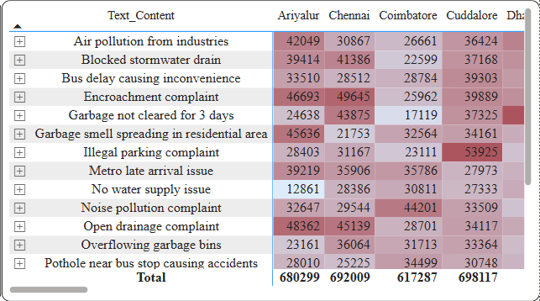
Future Insights
- Major cities like Chennai, Cuddalore, and Ariyalur all demonstrate very high cumulative sentiment scores across most issues, especially for problems such as open drainage complaints, encroachment, blocked stormwater drains, and air pollution from industries, highlighting these as the most frequent or emotionally charged issues for residents.
- Garbage-related concerns (uncollected garbage, overflowing bins, spreading smell) are persistent across all locations, showing the need for systematic improvements in waste management infrastructure and public health policy.
- Issues like "No water supply" and "Metro late arrival" show comparatively lower scores, which may reflect either lower incidence or less public distress but should still be monitored for localized spikes.
- The total volume of complaints and sentiment scores are all in the hundreds of thousands per city, suggesting a high level of civic engagement or widespread urban management challenges that impact quality of life.
Decision-Making
- Prioritize Waste Management: Accelerate clean-up programs, increase bin capacity, and enhance collection frequency in cities with high garbage-related complaint sentiment, such as Cuddalore and Chennai.
- Infrastructure Overhaul for Drainage and Pollution: Invest in upgrading urban drainage systems and enforce industrial emission controls in cities with the highest scores in those categories, like Ariyalur and Chennai, to protect against floods and improve air quality.
- Community Reporting Platforms: Enhance digital and mobile reporting tools in high-complaint cities to gather even more granular data, facilitate rapid response, and track emerging trends in real time.
- Active Stakeholder Engagement: Hold regular coordination meetings between city officials, sanitation departments, environmental agencies, and citizen groups to review complaint patterns and co-design local solutions.
- Thematic Task Forces: Set up dedicated teams for top issues (e.g., encroachment, blocked drains, air pollution) to intervene quickly and provide visible improvements, demonstrating responsiveness and rebuilding public confidence.
- Proactive Communication: Launch educational campaigns around complaint categories with lower engagement (e.g., noise pollution, metro delays) to raise awareness, clarify reporting channels, and gauge true problem scale.

11. Tools & Technologies
- Data Sources: 311 service request, Public transport usage, sentiment, demographic CSV.
- ETL: Power Query, DAX.
- Visualization: Power BI.
- Analytics: Correlation, trend analysis, key influencer modeling.

12. Results (Expected/Actual)
- Identified service request clusters in neighborhoods with under-served infrastructure.
- Negative sentiment spikes correlated strongly with delays in public transport.
- Dashboards revealed mismatches between resource allocation and high-complaint/high-sentiment-negative regions.
- Transit performance data demonstrated patterns where ridership dropped significantly after periods of prolonged downtime.

13. Challenges
- Incomplete or duplicate 311 service request entries.
- Noisy and irrelevant social media data requiring advanced filtering.
- Integrating diverse file formats and APIs into a unified data model.
- Power BI performance optimization for near real-time dashboards.

14. Future Enhancements
- Integrate IoT feeds like traffic congestion sensors or air quality monitors.
- Use predictive analytics to forecast potential service request surges.
- Build a citizen chatbot for collecting structured feedback directly.
- Extend dashboard coverage to multiple cities for benchmarking.

15. Conclusion
This project demonstrates how modern data analytics can bridge the gap between municipal decision-making and citizen needs. By integrating service requests, transport usage, and public sentiment, the dashboard guides evidence-based planning, transparent governance, and improved service delivery. The result is a tool that empowers city stakeholders to respond faster, allocate resources effectively, and enhance citizen satisfaction.

