**NAANMUDHALVAN Program: DIGITAL MARKETING**

**ASSIGNMENT**

4224 - UNIVERSITY COLLEGE OF ENGINEERING TINDIVANAM

Electronics and Communication Engineering

Final Year-Sem VII

Teem Members:

1. PANDIYAN M (422420106022)

NM ID: 903ABD844EAAF6EA3534BA6852402AE8

1. PRAKASH D (422420106024)

NM ID: 907D65EF10EE8818C6E4C33602B027C9

1. ASHOK E (422420106004)

NM ID: 4FD9031A0636750BA564FFE078758A81

1. PRAVEEN P (422420106025)

NM ID: 95B80E54608F731B1A046B257D5874F3

1. KARTHIK (422420106015)

NM ID: D978918839D177F99A64124627C9A983

Assignment Questions on Digital Marketing

1. Create a blog or website using Blogspot and WordPress. Customize the theme design and post new article with 500 words.

Response:

URL Link: <https://pandiyan1234.blogspot.com/2023/10/pdp-digital-works.html?m=1>

Immage:

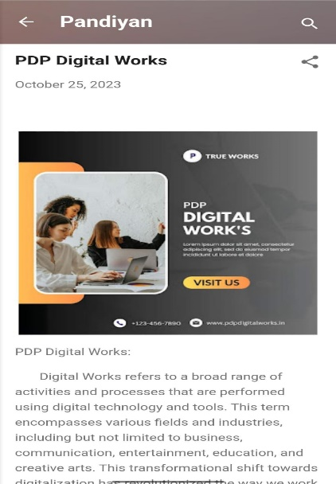

2. Create a New Facebook Business Page and post one social media poster for your brand.

Response:

Facebook Business Page URL Link: <https://www.facebook.com/profile.php?id=61550645548766&mibextid=ZbWKwL>

Immage:

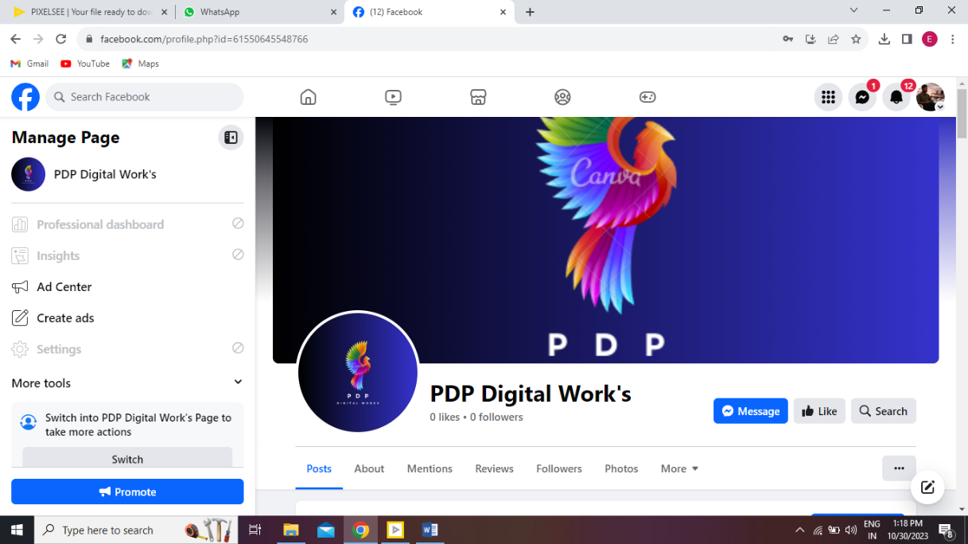

Social media poster URL Link: <https://m.facebook.com/story.php?story_fbid=pfbid05LeMuxTePn2sDoHk85t5m3eYnCF6n5ys9aCLyxNDaKvDAu6FzLXP9SfxrrQsjvUql&id=61550645548766&sfnsn=wiwspwa&mibextid=RUbZ1f>

Immage:

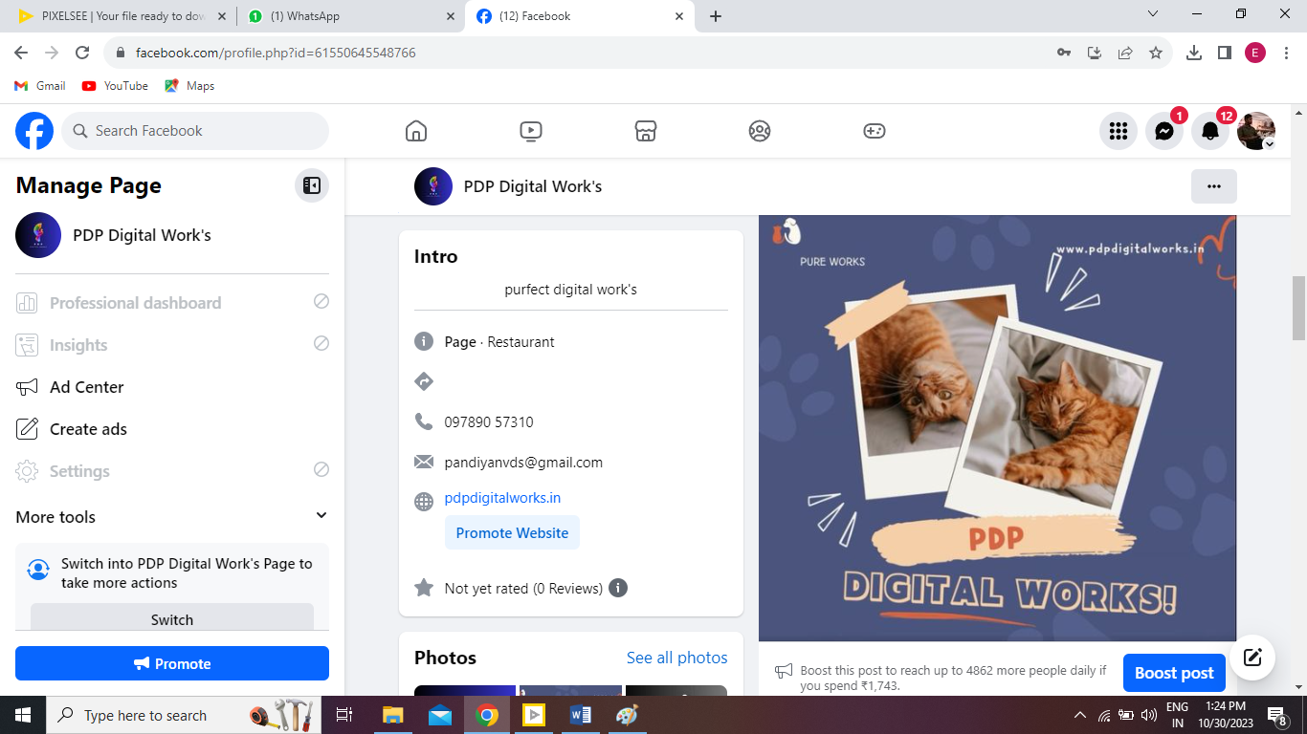

3. Create and design a social media advertisement poster using canva.

Poster:



4. Create email newsletter design using MailChimp or canva tool.

