CYBERPUNK CTF FORENSIC & SECURITY TOOLKIT

A PROJECT REPORT

Submitted by
Pankaj Saini

in partial fulfillment for the award of the degree of
BACHELOR OF ENGINEERING
IN
COMPUTER SCIENCE AND ENGINEERING

Chandigarh University
APRIL 2026

ABSTRACT
The Cyberpunk CTF Forensic Toolkit is a modular, web-integrated platform designed to simplify digital forensic investigations and Capture The Flag (CTF) challenges. By consolidating disparate command-line tools into a high-fidelity 'Cyberpunk' themed dashboard, the project enhances user engagement while maintaining technical rigor. The system provides modules for steganography, hash cracking, and web reconnaissance, all backed by a persistent SQLite audit trail.

1. INTRODUCTION
Digital forensics is a vital branch of cybersecurity that involves the identification, preservation, and analysis of electronic data. In competitive environments such as Capture The Flag (CTF) events, speed and accuracy are paramount. However, the current landscape of security tools is fragmented. Most industry-standard tools operate exclusively through complex command-line interfaces (CLI), which can lead to operational overhead and fatigue.
The 'Cyberpunk CTF Forensic Toolkit' addresses these challenges by providing a unified, visual orchestrator. It bridges the gap between raw CLI power and modern user experience (UX) aesthetics, allowing researchers to execute complex forensic operations through a single, responsive portal.

2. PROBLEM FORMULATION
Researchers and students face three primary hurdles in their forensic workflows:
- Fragmented Ecosystem: Security tools like Steghide, Zsteg, and Hashcat operate in isolation, requiring multiple terminal windows and inconsistent command syntax.
- Data Persistence Issues: Logging outputs, tracking uploaded files, and maintaining a chronological history of a forensic session is often manual and error-prone.
- Visual Fatigue: Traditional security interfaces are monochromatic and lack modern design principles, which can decrease efficiency during long investigations.

3. OBJECTIVES
The primary objectives of this project are:
- Consolidation: To integrate 15+ native security tools into a single Full-Stack web architecture.
- Automation: To implement smart wrappers for hash cracking that prioritize high-value wordlists like RockYou.txt automatically.
- Persistence: To maintain a robust SQLite database for tracking every tool execution, input parameters, and resulting outputs.
- Visual Fidelity: To apply high-end Cyberpunk UI design (glassmorphism/neon aesthetics) using React.js and Framer Motion.

4. METHODOLOGY
The system architecture is divided into four distinct layers:
- Frontend Layer (React.js): A modular SPA that handles file uploads, user interaction, and data visualization via Lucide icons and Framer Motion.
- API Layer (Node.js/Express): Acts as a middleware orchestrator, managing Multer file streams and routing requests to the tool engine.
- Execution Engine: Developed using Node's Child Process module to spawn asynchronous tasks for native C++/Python binaries.
- Data Layer (SQLite): Stores file metadata, upload paths, and a complete audit trail of tool status and outputs.

5. RESULTS AND OUTPUTS

5.1 Main Dashboard
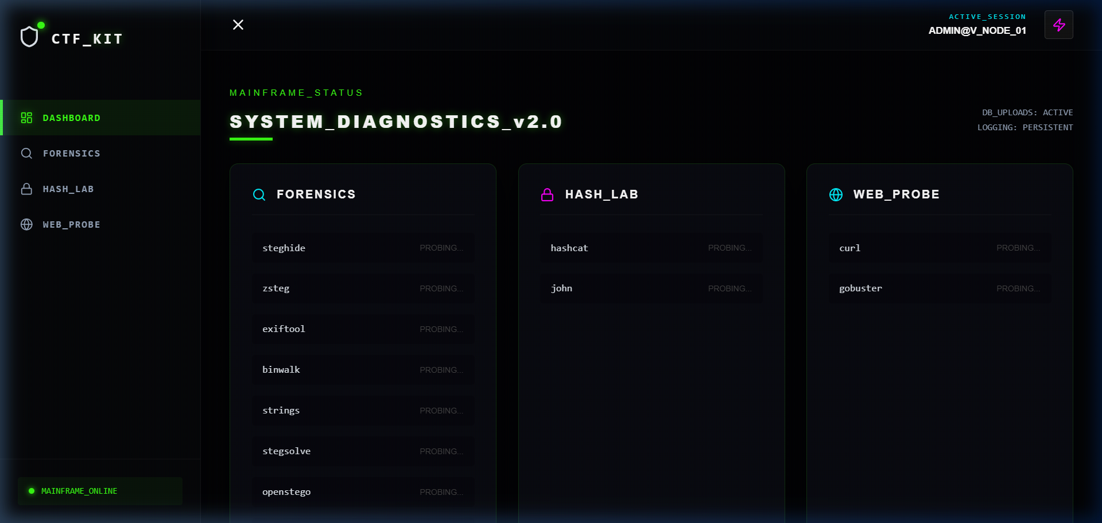
Figure 1: Central Command Dashboard showing real-time tool availability status.

5.2 Steganography Lab
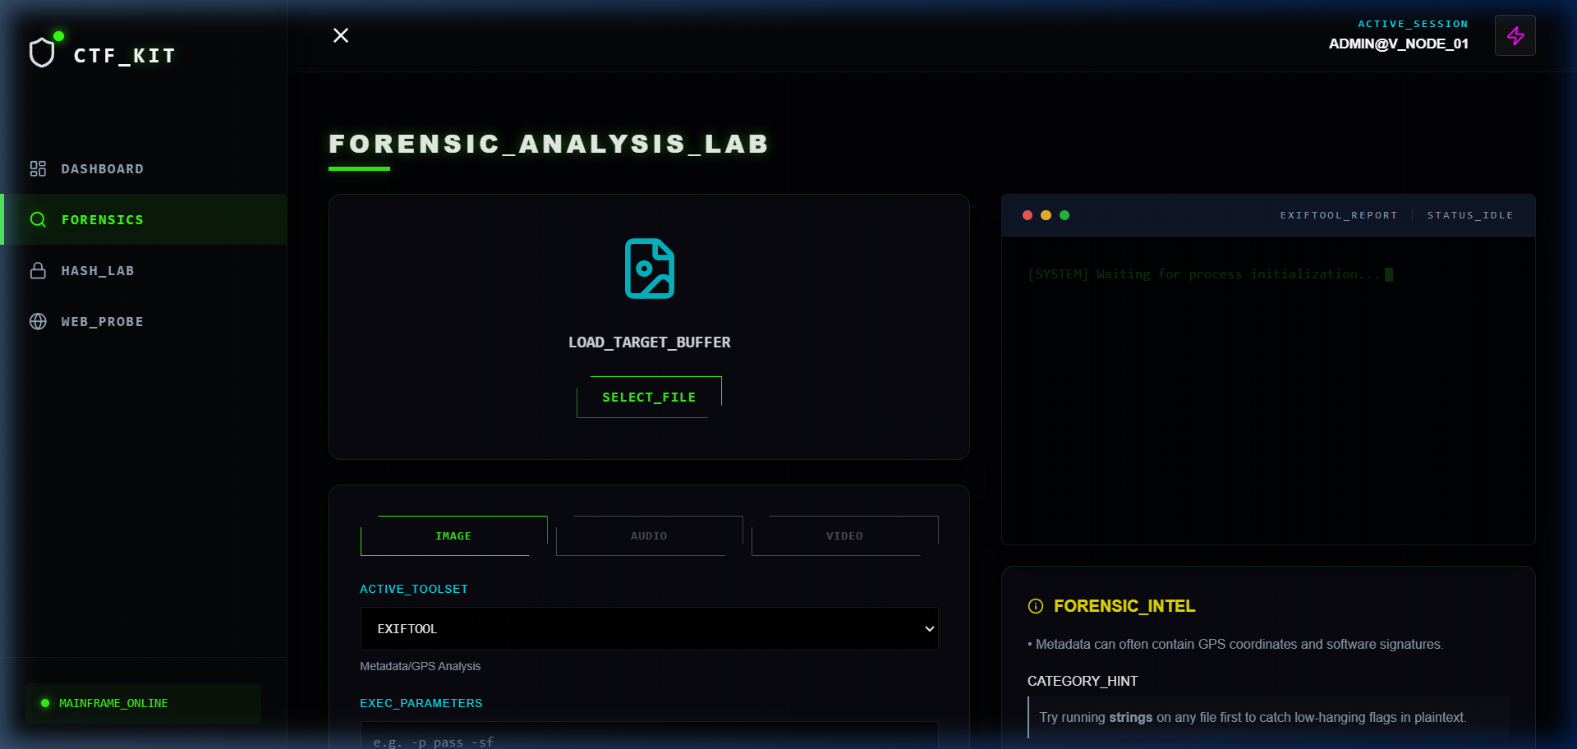
Figure 2: Forensic extraction interface utilizing Steghide and Zsteg integration.

5.3 Hash Cracking (Hash Lab)
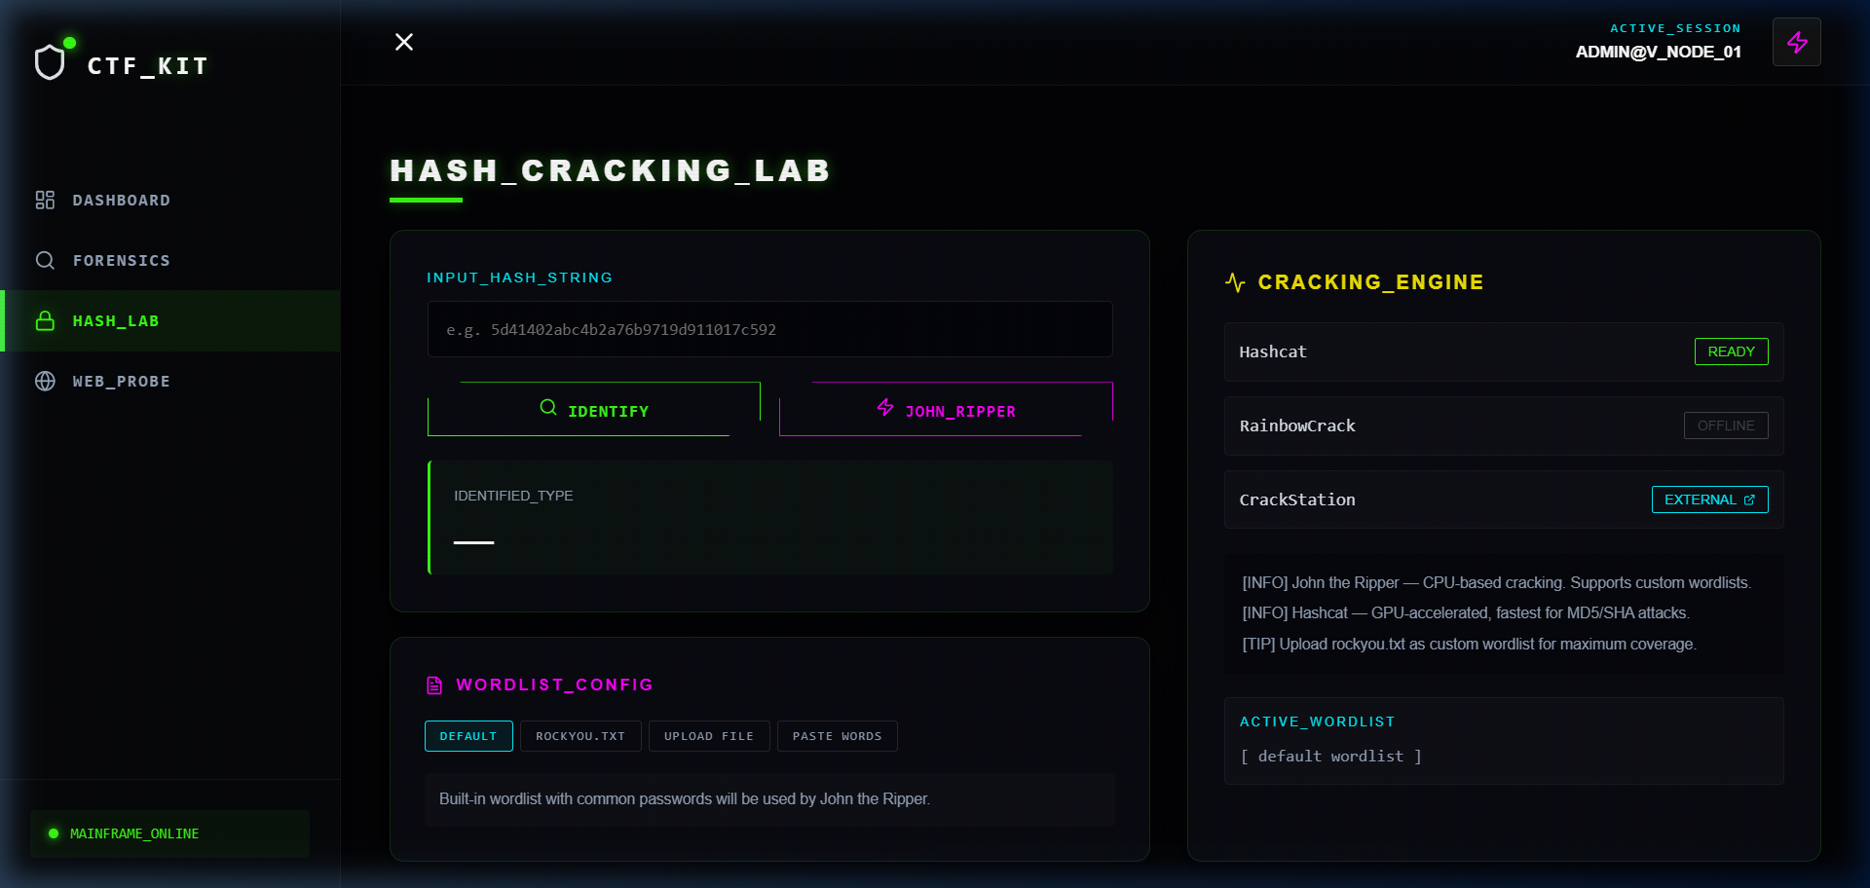
Figure 3: Multi-engine support for John the Ripper and Hashcat with custom wordlist uploads.

5.4 Web Probe
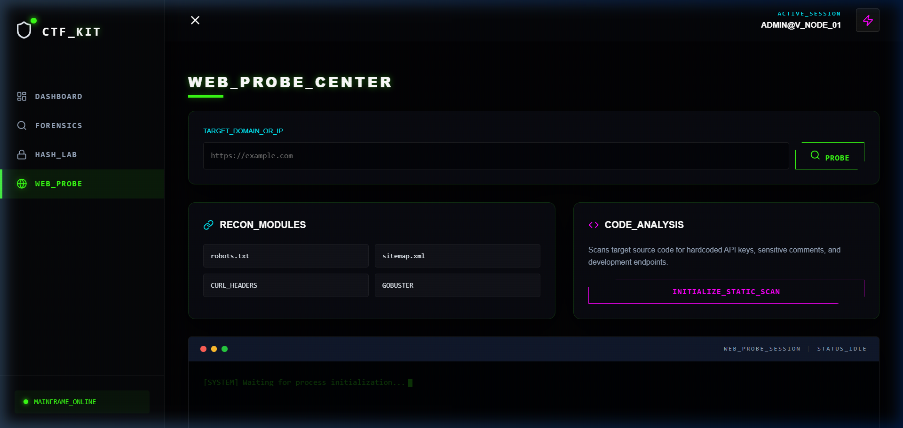
Figure 4: Automated analysis of target web resources (robots.txt/sitemap.xml).

5.5 Investigation History
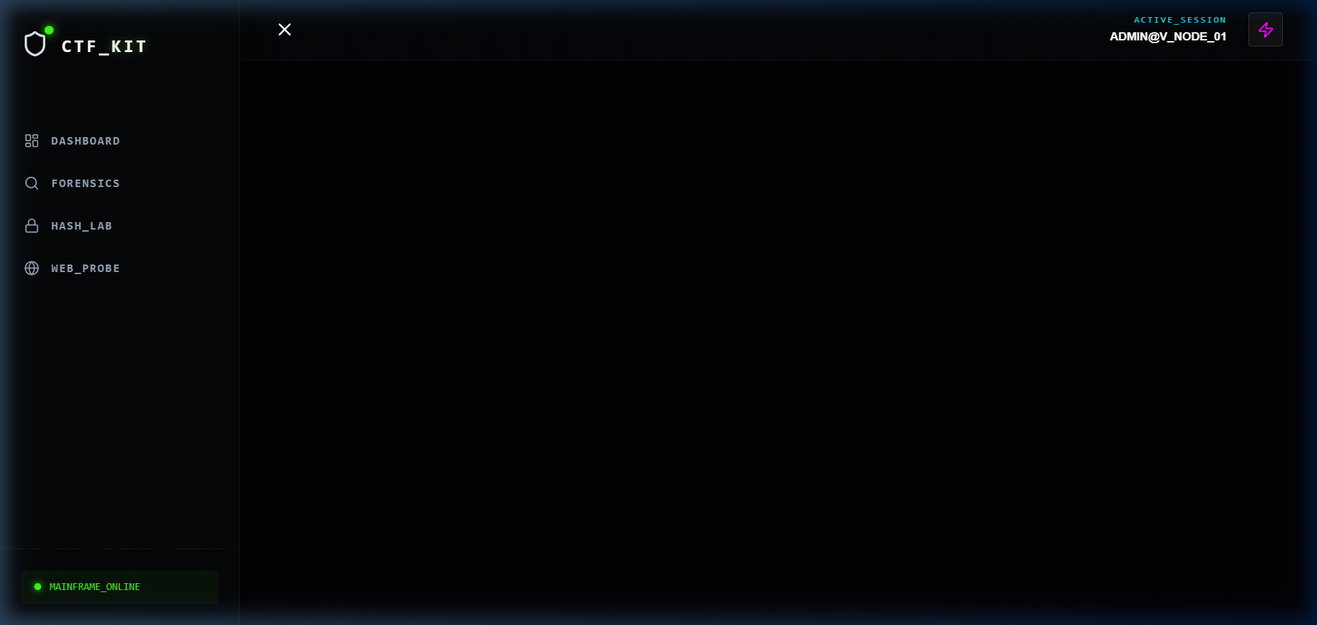
Figure 5: SQLite-backed audit logs providing a historical timeline of forensic activity.

6. CONCLUSION
The Cyberpunk CTF Forensic Toolkit successfully demonstrates that high-performance security tools can be integrated into a user-centric web environment without sacrificing power. It solves the problem of workflow fragmentation and provides a portable, cohesive platform for digital investigations. The project highlights the potential of using modern Full-Stack stacks to build professional-grade security software.

7. FUTURE SCOPE
Future enhancements for the toolkit include:
- Automated Reporting: One-click generation of PDF forensic reports summarizing all session findings.
- AI Integration: Utilizing LLMs to automatically suggest tool arguments based on uploaded file types.
- Network Forensics: Adding Wireshark/Tshark modules for packet capture and traffic analysis.

8. REFERENCES
1. Official Node.js Documentation [Internet]. 2024. Available from: https://nodejs.org
2. React Framework Guidelines [Internet]. 2024. Available from: https://react.dev
3. Hashcat Project [Internet]. 2024. Available from: https://hashcat.net
4. John the Ripper Documentation [Internet]. Available from: https://www.openwall.com/john/

