NAME-PANKAJ PRASHANT BOLIJ

PRN 2124UMLM2004

SET-08

A]CREATE TABLE

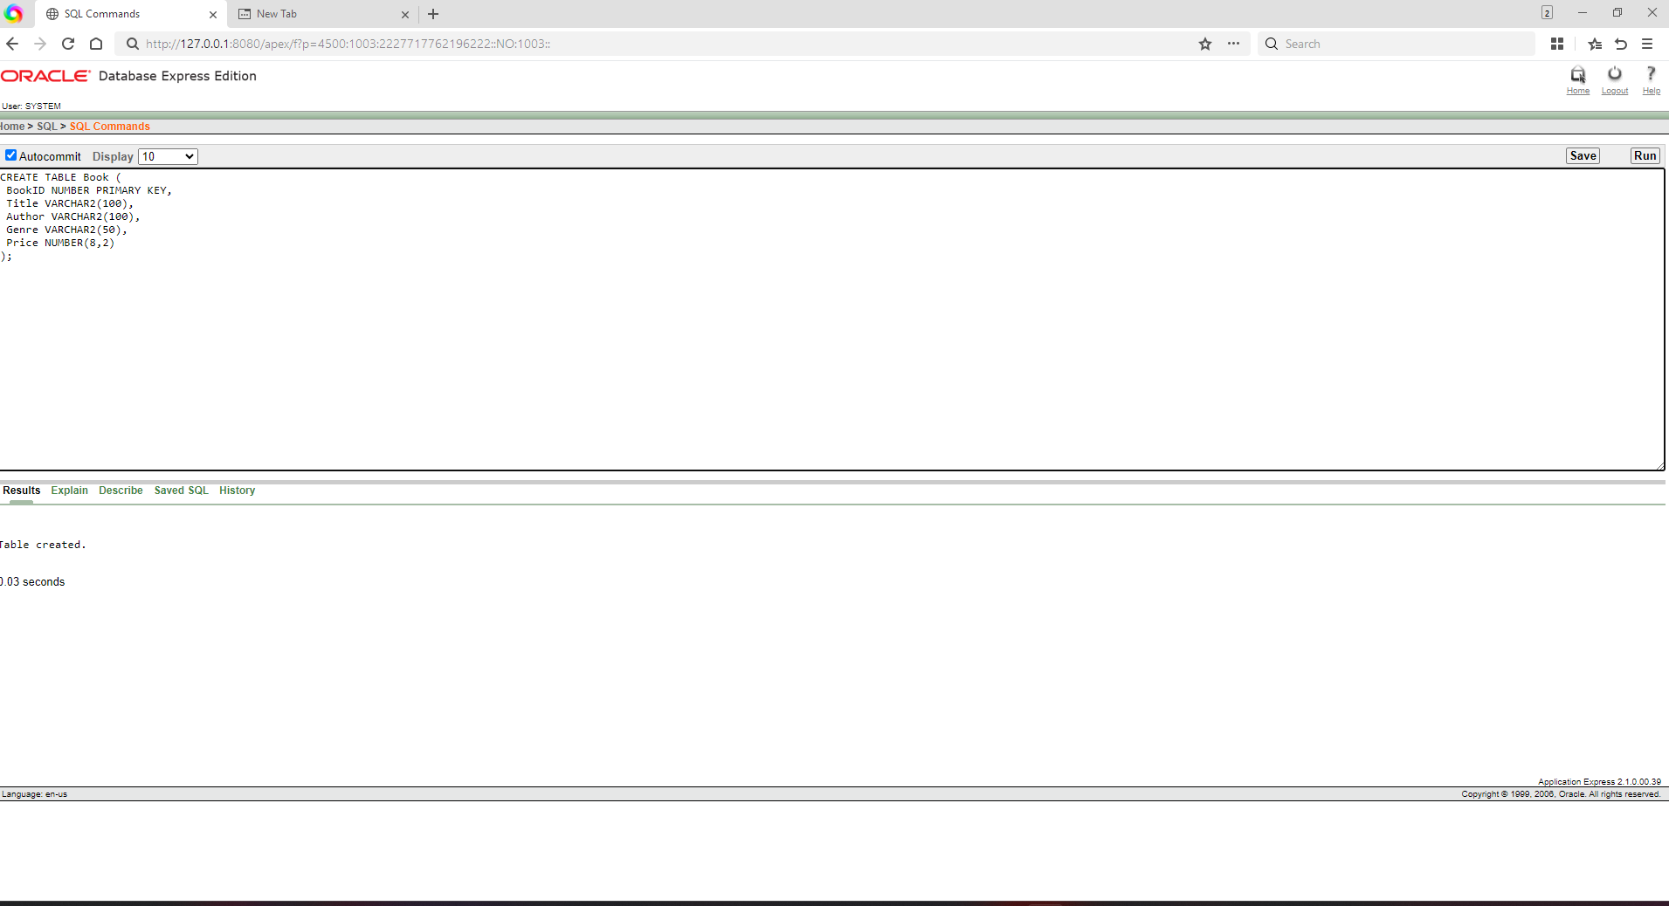

B]INSERT VALUES

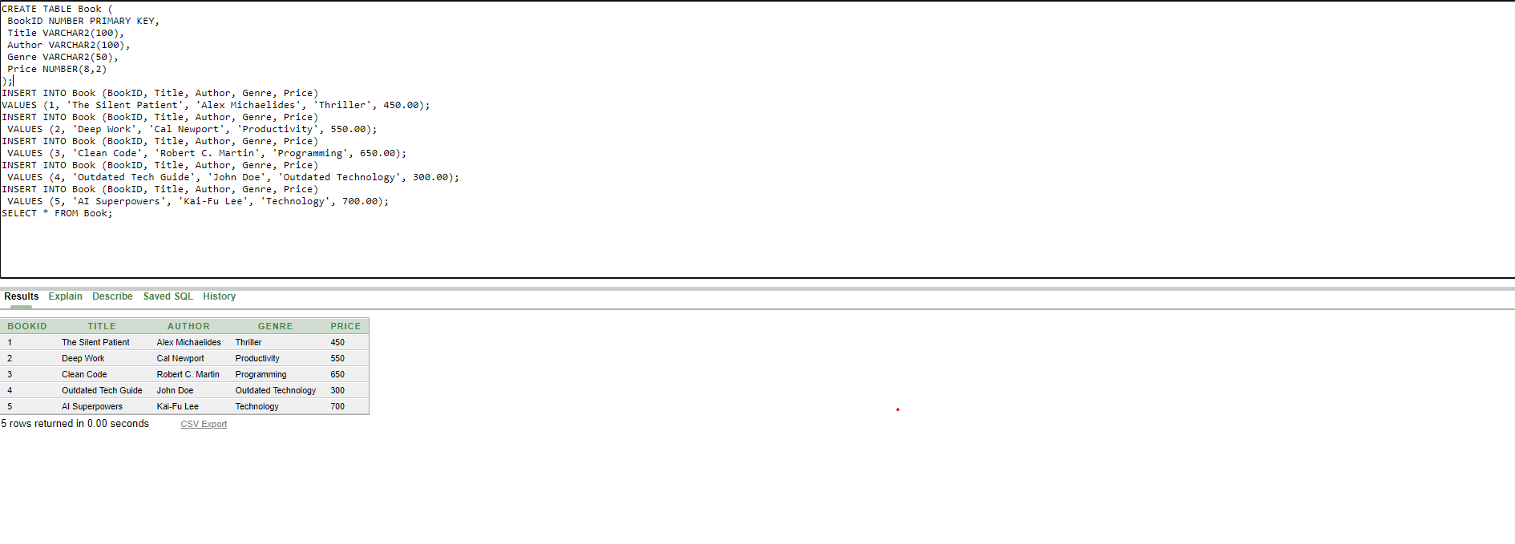

C]ADD COULME PUBLICTION YEAE

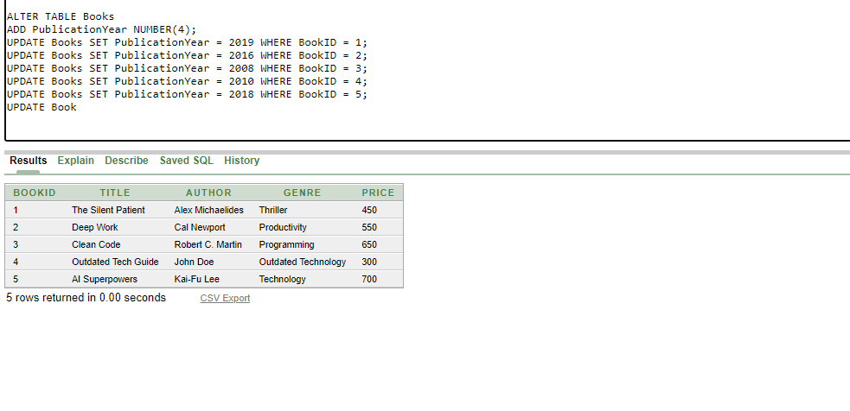

D]UPDATE PRICE FOR BOOK PUBLISH BEFORE 2020