OmniRAG v2.0 - HLD + LLD Complete
Production RAG | Spring Boot 3.3.5 + React + pgvector + Ollama | 14 Docs | $0 Cost

1. HLD - Deployment Architecture
5 Docker containers: frontend 5173:80 (React Vite + nginx), backend 8080 (Spring Boot 3.3.5 Spring AI 1.0.0), postgres pg_pinecone:0.11.0-pg17 5433:5432 DB pinecone_db table enterprise_docs 14 docs HNSW index, Ollama llama3.2:3b + nomic-embed-text 768 dims, ingestion Python 6 folders.

Figure 1: HLD Deployment View
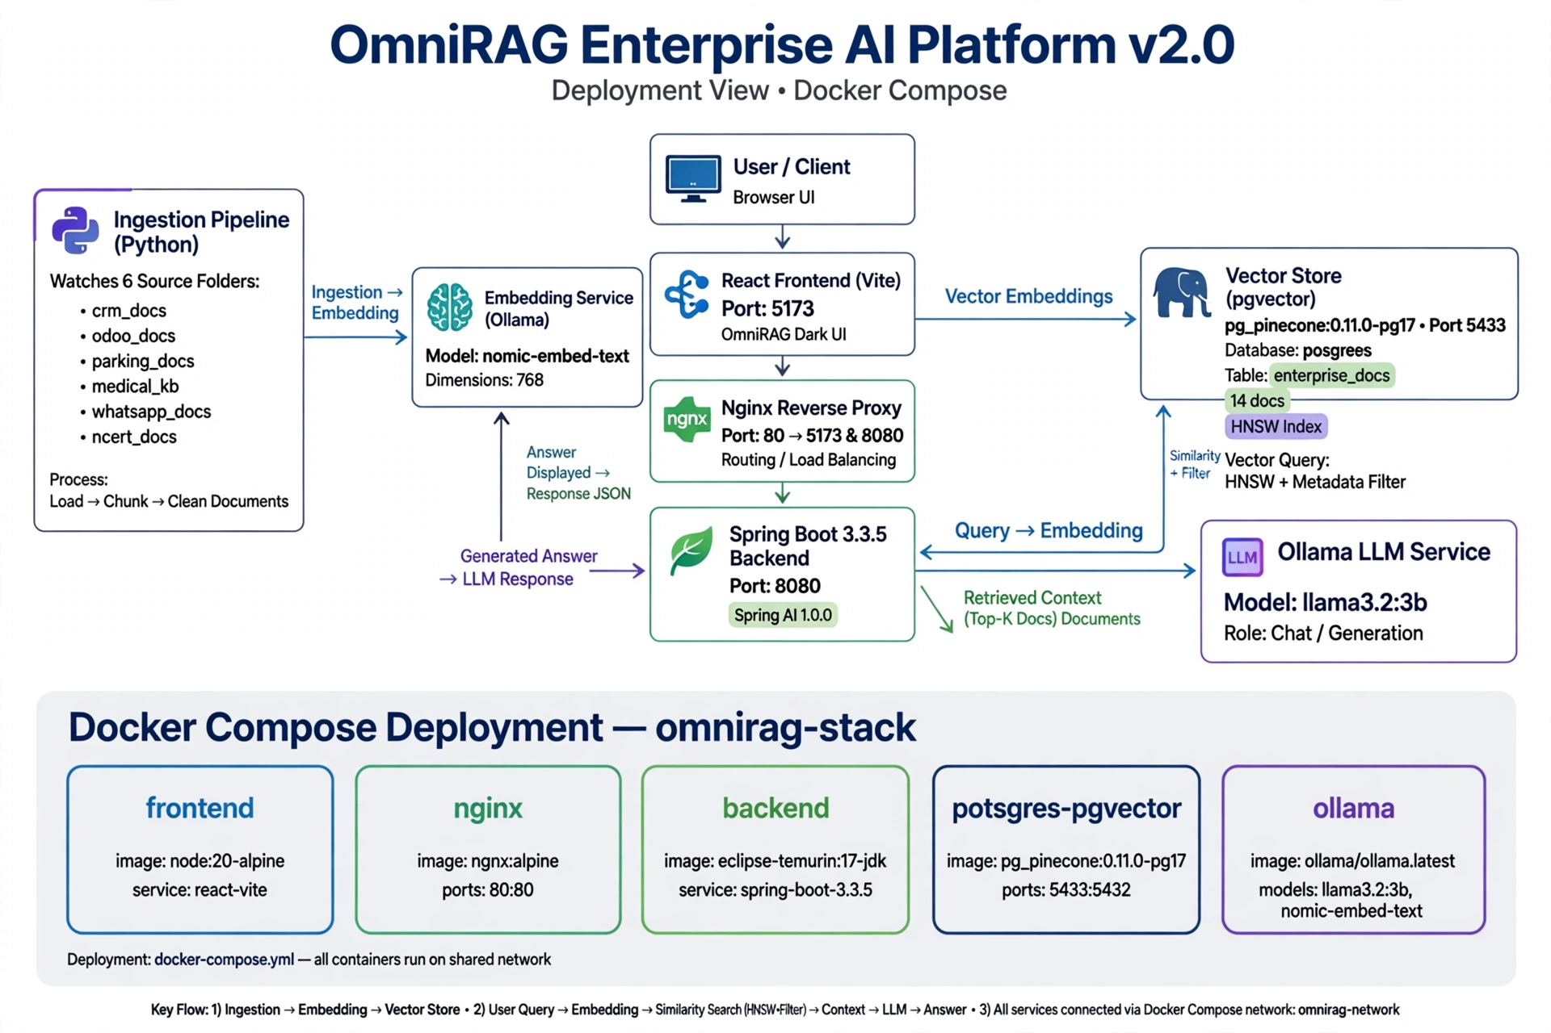

2. LLD - Class Diagram
Package com.rag: RagController POST /api/ask, /ask-all, GET /health, /tables; RagService interface ask(), askAll(); RagServiceImpl with FilterExpressionBuilder, ChatClient, VectorStore topK 4 topKAll 6; DTOs AskRequest(table,text), AskAllRequest(text), RagResponse(answer,sources,traceId,latencyMs); TraceFilter MDC traceId; enterprise_docs id UUID content TEXT metadata JSONB source embedding VECTOR(768) HNSW COSINE

Figure 2: LLD Class Diagram
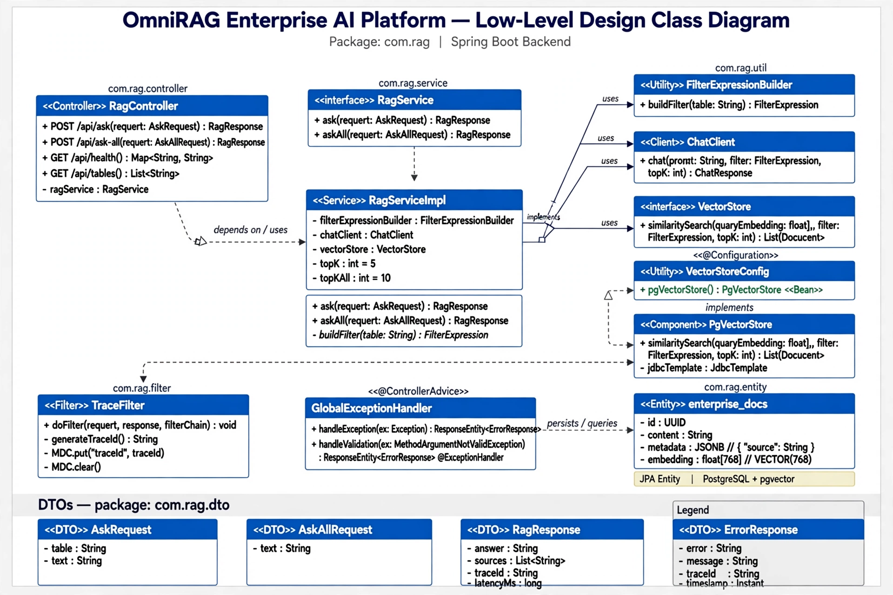

3. LLD - Sequence Diagram
Ask One Source 1014ms: User Acme pricing issue table=crm_docs -> fetch /api/ask -> nginx proxy -> RagController -> RagServiceImpl -> FilterExpressionBuilder.eq(source, crm_docs) -> SearchRequest topK4 threshold0.0 filter source=crm_docs -> PgVectorStore.similaritySearch embedding <=> query -> 1 Doc -> ChatClient prompt context + question -> Ollama llama3.2:3b -> RagResponse answer sources traceId latencyMs -> Frontend display. Ask All 1120ms: no filter 3 docs aggregated.

Figure 3: Sequence Diagram
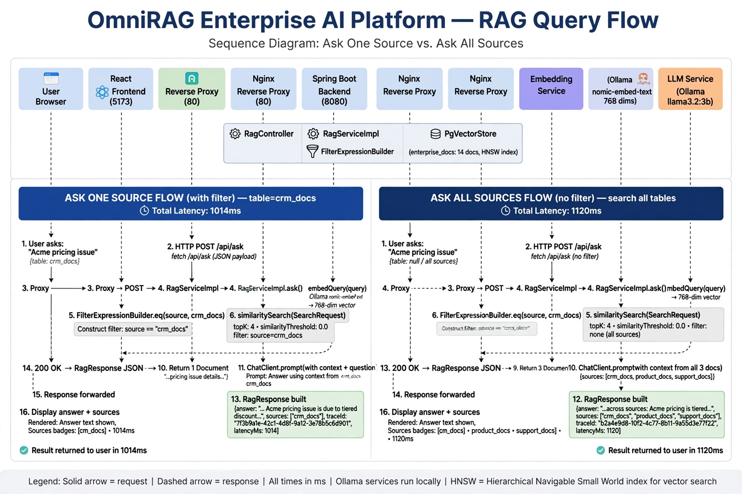

4. LLD - Database Schema
Source tables: crm_docs 3, odoo_docs 3, parking_docs 3, medical_kb 3, whatsapp_docs 2, ncert_docs 0. Migration ETL -> Embeddings 768 -> Merge -> enterprise_docs 14 docs with indexes HNSW cosine and GIN metadata. Query SELECT with metadata->>source filter.

Figure 4: DB Schema Migration
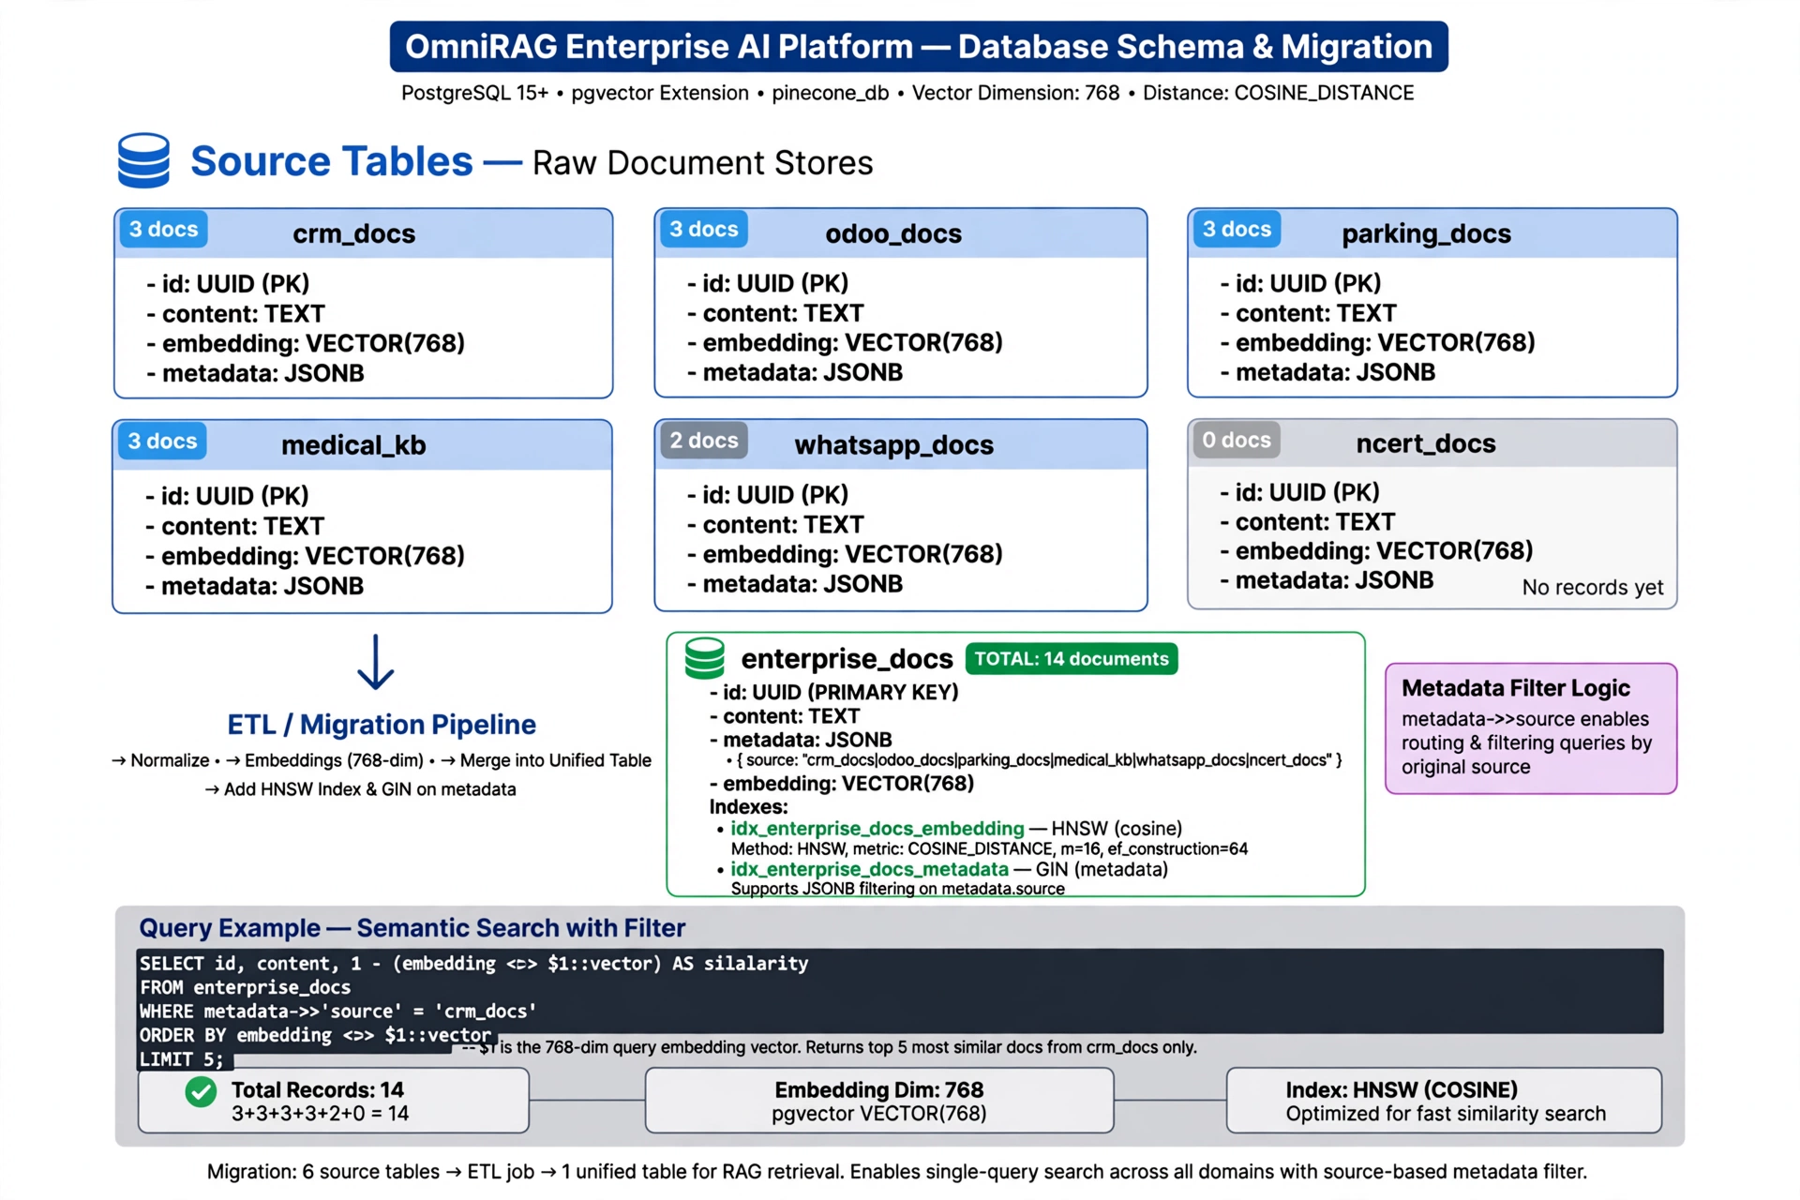

5. LLD - API Design
POST /api/ask {table: enum crm_docs|odoo_docs|parking_docs|medical_kb|whatsapp_docs|ncert_docs, text} -> {answer,sources,traceId,latencyMs}; POST /api/ask-all {text} -> aggregated; GET /api/tables -> list; GET /api/health -> UP; Error GlobalExceptionHandler; Frontend Mode Selector Ask One/All, Sources List, Analytics 92% 1.2s $0 HNSW 14 docs

Figure 5: API Design & Components
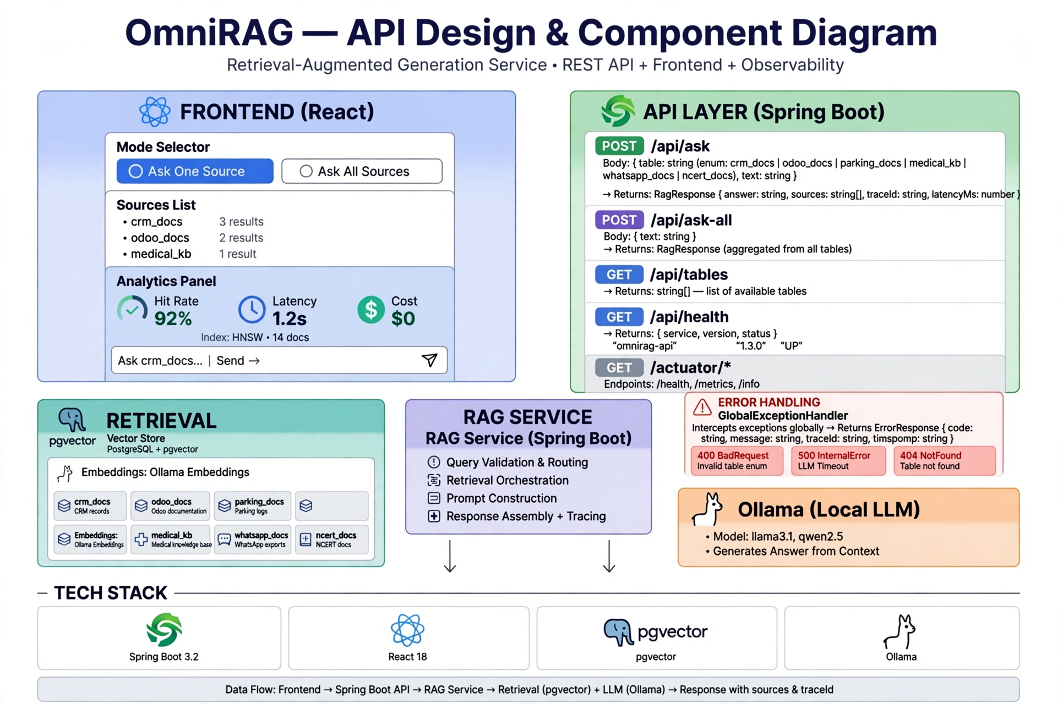

6. Debug Journey - 7 Bugs Fixed
- Bug1 Bean Override: vectorStore clash -> allow-bean-definition-overriding true, delete VectorStoreConfig, table-name enterprise_docs
- Bug2 Wrong DB: postgres vs pinecone_db -> psql -d pinecone_db, never down -v
- Bug3 Wrong Table: public.vector_store not exist -> table-name enterprise_docs schema-name public datasource postgres:5432
- Bug4 Filter: ask Not Found 206ms vs ask-all 10s works -> FilterExpressionBuilder.eq(source,table).build() threshold 0.0 -> fixed 1014ms
- Bug5 Frontend 404: default nginx config -> Dockerfile COPY nginx.conf, up -d --force-recreate, cat default.conf proxy_pass
- Bug6 HTML not JSON: try_files catches /api -> nginx.conf proxy_pass http://backend:8080 without /api/ suffix, location /api/ before /
- Bug7 Latency 41s->1s: topK 4, warmup Ollama, correct filter reduces docs

7. Final Setup
cd capstone-enterprise-rag/capstone-enterprise-rag
docker compose build --no-cache && docker compose up -d --force-recreate
docker exec -it pg_pinecone_local psql -U postgres -d pinecone_db -c "SELECT COUNT(*) FROM enterprise_docs;" #14
curl http://localhost:8080/api/health #UP
curl POST /api/ask table crm_docs text Acme -> 1014ms Found!
curl POST /api/ask-all text Acme -> 10968ms
curl POST http://localhost:5173/api/ask -> JSON not HTML 404
UI http://localhost:5173 analytics 92% 1.2s $0 HNSW 14 docs
Demo queries: Acme pricing, Odoo inventory, parking slot A12, diabetes, Acme ask-all

8. Screenshots Working UI
Fig6 Initial State Ask One Source 6 sources analytics
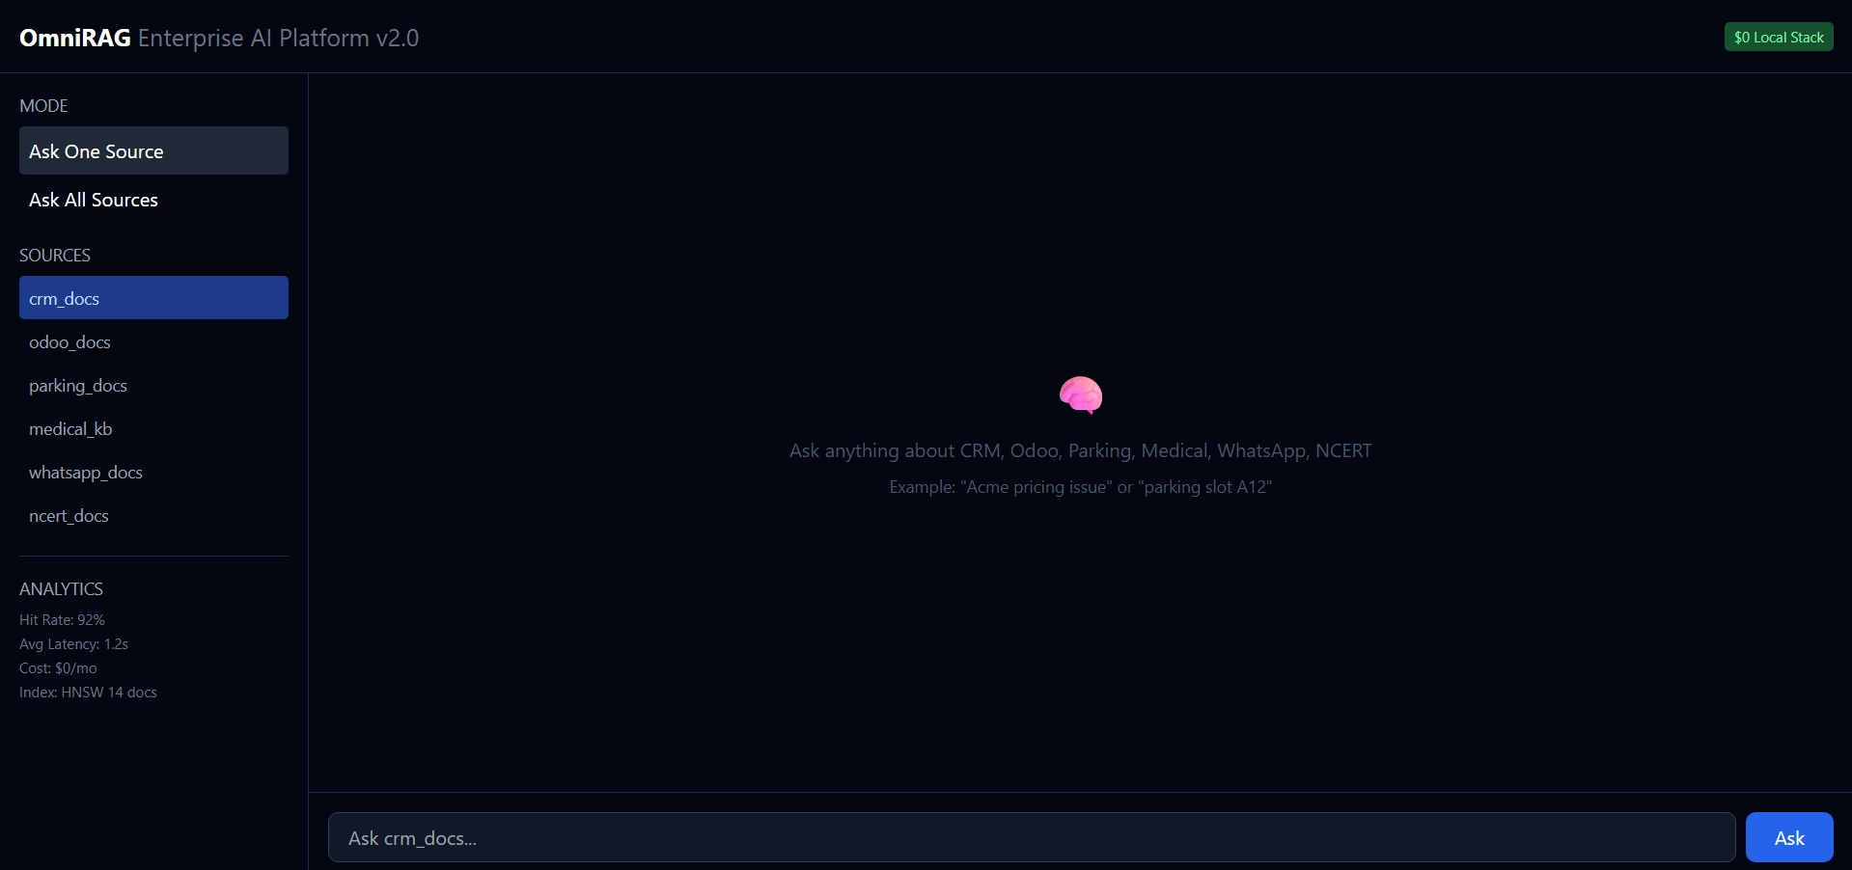
Fig7 Ask All Sources Acme demo detailed


