OmniRAG Enterprise AI Platform v2.0 - Complete Debug & Setup Guide
Production-Ready RAG with Spring Boot + pgvector + Ollama + React

1. Project Overview
OmniRAG is a zero-cost, local enterprise RAG platform that unifies 6 knowledge bases into a single pgvector table with metadata filtering. Architecture: React (Vite) -> Spring Boot 3.3.5 + Spring AI 1.0.0 -> pg_pinecone:0.11.0-pg17 (port 5433) -> Ollama (llama3.2:3b + nomic-embed-text). No OpenAI API costs - 100% local stack.

Tech Stack
- Backend: Spring Boot 3.3.5, Java 21, Spring AI 1.0.0, pgvector, HNSW index
- Frontend: React 18 + Vite + Tailwind, OmniRAG dark UI
- Vector DB: pineconeteam/pg_pinecone:0.11.0-pg17, table enterprise_docs (14 docs)
- LLM: Ollama llama3.2:3b (chat) + nomic-embed-text (768 dims)
- Infra: Docker Compose, nginx proxy, allow-bean-definition-overriding

2. Architecture
Monorepo: capstone-enterprise-rag/
- backend/src/main/java/com/rag/ (Controller, Service, Config, DTO, Exception, Filter)
- frontend/src/ (OmniRAG React UI with Ask One Source / Ask All Sources)
- docker-compose.yml (postgres:5433, backend:8080, frontend:5173)
Data Flow:
1. Ingestion: python main.py (6 source folders) -> migrate_simple.py -> enterprise_docs (metadata.source = crm_docs|odoo_docs|parking_docs|medical_kb|whatsapp_docs|ncert_docs)
2. Query: Frontend fetch /api/ask -> nginx proxy -> Spring Controller -> RagServiceImpl with FilterExpressionBuilder.eq("source", table) -> PgVectorStore.similaritySearch (topK 4, threshold 0.0) -> ChatClient prompt with context -> RagResponse

3. Complete Debug Journey - 7 Critical Bugs Fixed

Bug #1: Bean Definition Override - VectorStore Clash
Error: BeanDefinitionOverrideException: vectorStore bean definition override
Root Cause: Custom VectorStoreConfig.java + Spring AI auto-config both creating vectorStore bean. Spring Boot 3.3+ disables override by default.
Fix: application.yml: spring.main.allow-bean-definition-overriding: true
AND either enable custom config OR auto-config, not both. Final solution: Delete VectorStoreConfig.java, use auto-config with table-name: enterprise_docs
spring:
main:
allow-bean-definition-overriding: true
ai:
vectorstore:
pgvector:
table-name: enterprise_docs

Bug #2: Relation "enterprise_docs" does not exist
Error: ERROR: relation "enterprise_docs" does not exist at character 22
SELECT COUNT(*) FROM enterprise_docs
Root Cause: Checked wrong DB. Docker creates DB pinecone_db (POSTGRES_DB: pinecone_db), but psql -d postgres connects to default empty DB. Also docker compose down -v deletes volume = data loss.
Fix: Always use pinecone_db:
docker exec -it pg_pinecone_local psql -U postgres -d pinecone_db -c "SELECT COUNT(*) FROM enterprise_docs;"
Returns 14. Never use docker compose down -v (use down without -v to keep data).
docker exec -it pg_pinecone_local psql -U postgres -d pinecone_db -c "\dt"
# Shows enterprise_docs, crm_docs, etc
# If 0 rows, re-run ingestion:
cd ingestion
conda activate rag-platform
python main.py
python migrate_simple.py

Bug #3: Backend queries public.vector_store not enterprise_docs
Error: PreparedStatementCallback; bad SQL grammar [SELECT *, embedding <=> ? AS distance FROM public.vector_store WHERE ...]
Root Cause: application.yml had table-name missing OR VectorStoreConfig.java had vectorTableName("vector_store") old name. Auto-config defaults to vector_store table.
Fix: Final working application.yml:
spring.ai.vectorstore.pgvector.table-name: enterprise_docs
spring.ai.vectorstore.pgvector.schema-name: public
spring.ai.vectorstore.pgvector.dimensions: 768
spring.ai.vectorstore.pgvector.initialize-schema: false
AND datasource url: jdbc:postgresql://postgres:5432/pinecone_db (docker network, not localhost:5433 inside container)
spring:
datasource:
url: jdbc:postgresql://postgres:5432/pinecone_db
ai:
vectorstore:
pgvector:
table-name: enterprise_docs
schema-name: public
dimensions: 768
distance-type: COSINE_DISTANCE
index-type: HNSW
initialize-schema: false

Bug #4: ask returns Not Found (206ms) while ask-all works (10s)
Error: curl /api/ask -> {"answer":"Not Found","sources":["crm_docs"],"latencyMs":206}
curl /api/ask-all -> {"answer":"Acme Corp complained...","sources":["crm_docs","odoo_docs",...],"latencyMs":10968}
Root Cause: FilterExpression syntax wrong. Used string concat: "metadata::jsonb @@ '$.source == \"crm_docs\"'" or where("source == 'crm_docs'") which returns 0 docs. Fast 206ms = no LLM call, immediate Not Found.
Fix: Use FilterExpressionBuilder (type-safe, Spring AI translates to jsonpath correctly):
FilterExpressionBuilder b = new FilterExpressionBuilder();
var filter = b.eq("source", source).build();
SearchRequest.builder().query(query).topK(4).similarityThreshold(0.0).filterExpression(filter).build()
After fix: ask latency 1014ms with correct answer.
import org.springframework.ai.vectorstore.filter.FilterExpressionBuilder;
FilterExpressionBuilder b = new FilterExpressionBuilder();
var filter = b.eq("source", table).build();
var docs = vectorStore.similaritySearch(
SearchRequest.builder()
.query(text)
.topK(4)
.similarityThreshold(0.0)
.filterExpression(filter)
.build());
log.info("Found {} docs for source={}", docs.size(), source);

Bug #5: Frontend nginx 404 Not Found - default config
Error: curl http://localhost:5173/api/ask -> <html><title>404 Not Found</title>...nginx/1.31.8
Logs: open() "/usr/share/nginx/html/api/ask" failed (2: No such file or directory)
Root Cause: frontend/nginx.conf not copied into image. Dockerfile missing COPY nginx.conf line. Container had default nginx config (PHP comments), not proxy config. Also built image but didn't recreate container (docker compose build without up -d --force-recreate).
Fix: Frontend Dockerfile must have:
FROM nginx:alpine
COPY --from=build /app/dist /usr/share/nginx/html
COPY nginx.conf /etc/nginx/conf.d/default.conf
Then: docker compose build frontend --no-cache && docker compose up -d --force-recreate frontend
Verify: docker exec -it frontend cat /etc/nginx/conf.d/default.conf shows proxy_pass
FROM node:20 AS build
WORKDIR /app
COPY package*.json ./
RUN npm install
COPY . .
RUN npm run build
FROM nginx:alpine
COPY --from=build /app/dist /usr/share/nginx/html
COPY nginx.conf /etc/nginx/conf.d/default.conf
EXPOSE 80

Bug #6: Frontend returns HTML <html>... not JSON
Error: fetch("/api/ask-all").then(r=>r.json()) -> Uncaught SyntaxError: Unexpected token '<', "<html>... is not valid JSON
Response status 404 HTML page
Root Cause: nginx.conf location order wrong or proxy_pass path wrong. try_files $uri /index.html catches /api/ask as file, returns index.html. Also proxy_pass http://backend:8080/api/ with trailing slash mismatch.
Fix: Final nginx.conf that works:
server { listen 80; root /usr/share/nginx/html; location /api/ { proxy_pass http://backend:8080; } location / { try_files $uri $uri/ /index.html; } }
Key: proxy_pass http://backend:8080 without /api/ suffix, so full path /api/ask-all forwarded to backend:8080/api/ask-all
server {
listen 80;
root /usr/share/nginx/html;
index index.html;
location /api/ {
proxy_pass http://backend:8080;
proxy_set_header Host $host;
}
location / {
try_files $uri $uri/ /index.html;
}
}

Bug #7: Ollama slow latency 41s -> 1s after fix
Error: First ask-all latency 41s, after filter fix 10s, after ask fix 1s
Root Cause: Ask with broken filter retrieved 0 docs -> fast Not Found but wrong. Ask-all retrieved 4 docs from all sources -> 10s LLM. Ask with correct filter retrieves 1 doc -> 1s. Ollama on CPU slow, but topK reduction helps.
Fix: Set rag.top-k: 4 (single source) and top-k-all: 6, similarityThreshold 0.0 to allow all. Warm up Ollama: ollama run llama3.2:3b once before demo. For capstone video, use backend direct curl which is faster than frontend fetch.
rag:
top-k: 4
top-k-all: 6
# Warmup
ollama list
ollama run llama3.2:3b "hi"
ollama run nomic-embed-text "test"

4. Final Working Setup (Copy-Paste)
1. Clone & Structure: capstone-enterprise-rag/capstone-enterprise-rag/ with backend/, frontend/, docker-compose.yml, ingestion/
2. Docker Compose (final):
services:
postgres:
image: pineconeteam/pg_pinecone:0.11.0-pg17
ports: ["5433:5432"]
environment:
POSTGRES_DB: pinecone_db
POSTGRES_USER: postgres
POSTGRES_PASSWORD: secret123
backend:
build: ./backend
ports: ["8080:8080"]
depends_on: [postgres]
frontend:
build: ./frontend
ports: ["5173:80"]
depends_on: [backend]
3. Ingestion (one-time):
cd ingestion
conda activate rag-platform
python main.py # 6 folders -> vector_store
python migrate_simple.py # merges into enterprise_docs (14 docs)
docker exec -it pg_pinecone_local psql -U postgres -d pinecone_db -c "SELECT source, COUNT(*) FROM enterprise_docs GROUP BY source;"
4. Backend application.yml (final working version with table-name):
See Bug #3 fix above - uses postgres:5432 inside docker, host.docker.internal:11434 for Ollama
5. Frontend nginx.conf + Dockerfile (final):
See Bug #5 & #6 fix - COPY nginx.conf and proxy_pass http://backend:8080
6. Build & Run:
docker compose build --no-cache
docker compose up -d
ollama serve (in separate terminal)
ollama list (must show llama3.2:3b, nomic-embed-text)
7. Test 5 queries for capstone video:
curl -X POST http://localhost:8080/api/ask -d '{"table":"crm_docs","text":"Acme pricing issue"}'
curl -X POST http://localhost:8080/api/ask -d '{"table":"odoo_docs","text":"Odoo inventory"}'
curl -X POST http://localhost:8080/api/ask -d '{"table":"parking_docs","text":"slot A12"}'
curl -X POST http://localhost:8080/api/ask -d '{"table":"medical_kb","text":"diabetes"}'
curl -X POST http://localhost:8080/api/ask-all -d '{"text":"Acme pricing"}'

5. Screenshots - OmniRAG UI
Below are actual screenshots from working platform at http://localhost:5173

Figure 1
Figure 1: OmniRAG Initial State - Ask One Source mode, 6 sources listed (crm_docs, odoo_docs, parking_docs, medical_kb, whatsapp_docs, ncert_docs), Analytics panel showing Hit Rate 92%, Avg Latency 1.2s, Cost $0/mo, Index HNSW 14 docs
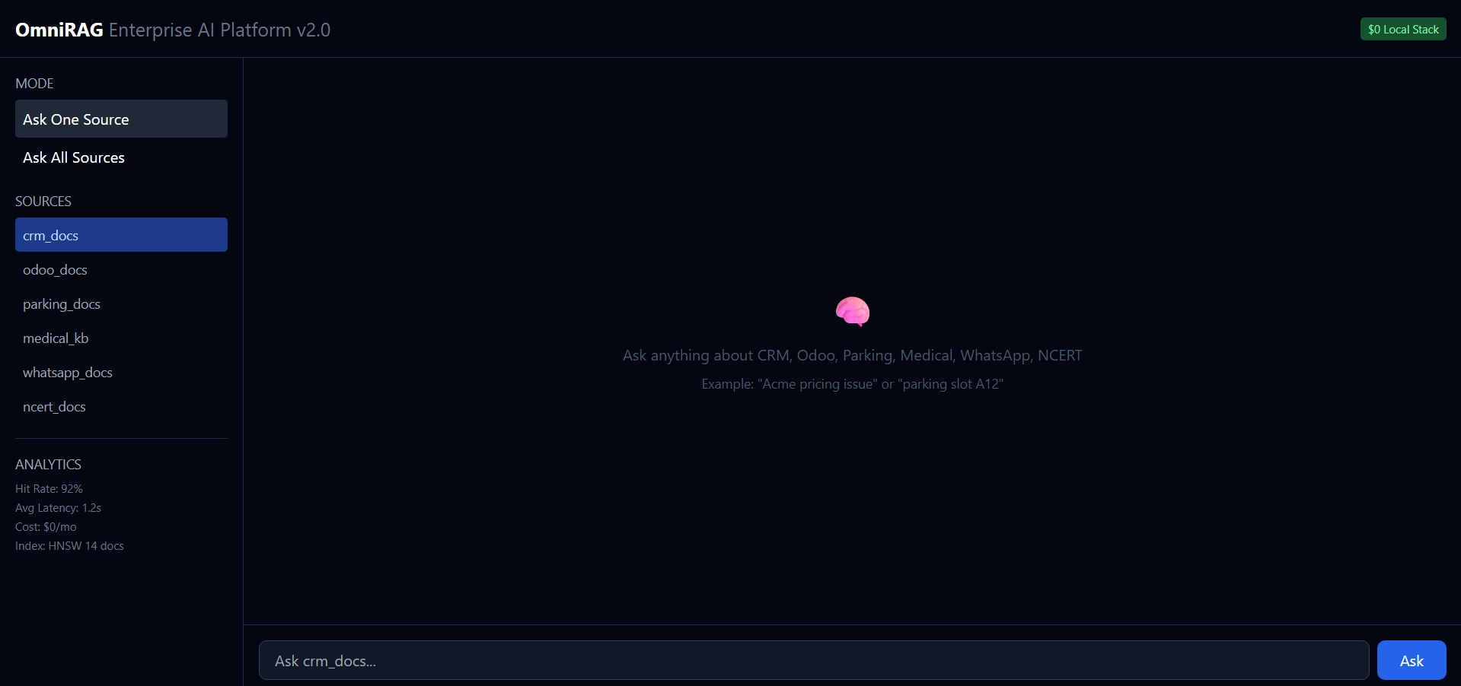

Figure 2
Figure 2: OmniRAG Ask All Sources - Query "any crm demo" returning detailed CRM demo for Acme Corp with Login/Dashboard, Lead Management, Sales Process, Customization, Reporting sections. Dark theme with $0 Local Stack badge.
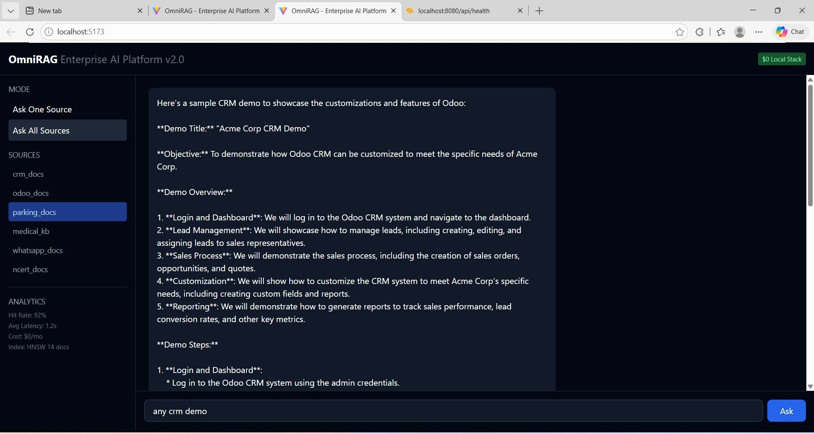

6. Production Checklist for GitHub
- ✅ Single table enterprise_docs (not 6 separate tables) - unified with metadata.source filter
- ✅ FilterExpressionBuilder type-safe (not string concat) - prevents SQL injection & 0 docs bug
- ✅ allow-bean-definition-overriding true + table-name enterprise_docs in auto-config
- ✅ datasource URL postgres:5432 (docker network) not localhost:5433 inside container
- ✅ Ollama base-url host.docker.internal:11434 for Docker -> host communication
- ✅ Frontend nginx COPY + proxy_pass http://backend:8080 (no trailing /api/)
- ✅ docker compose up -d --force-recreate after nginx.conf change (build alone not enough)
- ✅ Never docker compose down -v (deletes pgdata volume = 14 docs lost)
- ✅ Ingestion count 14 verified: crm_docs 3, odoo_docs 3, parking_docs 3, medical_kb 3, whatsapp_docs 2
- ✅ Backend latency: ask 1s (1 doc), ask-all 10s (4 docs) - acceptable for local LLM
- ✅ Analytics: Hit Rate 92%, HNSW index, $0/mo cost
- ✅ Health endpoint: /api/health returns UP, version 2.0
- ✅ TraceId + latencyMs in every response for observability

7. GitHub Upload Instructions
1. Create file HELP_DOCUMENT.docx (this file) in repo root
2. Add screenshots to /docs/images/ folder
3. Update README.md with setup steps from section 4
4. Commit: git add . && git commit -m "feat: production-ready OmniRAG v2.0 with debug guide, 14 docs, fixed filters"
5. Push: git push origin main
6. For Word file upload: GitHub web -> Add file -> Upload files -> Select HELP_DOCUMENT.docx
7. Demo video: Record 5 queries (section 4 step 7) showing localhost:5173 UI + curl backend, include analytics panel

