Pan Huijie 3035534622
Exercise 1:
How to bind a Message object instead of a string:
1. create a class which implements java.io.Serializable
2. implement to string method
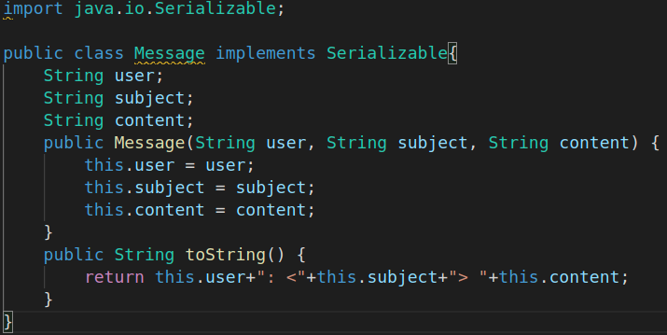
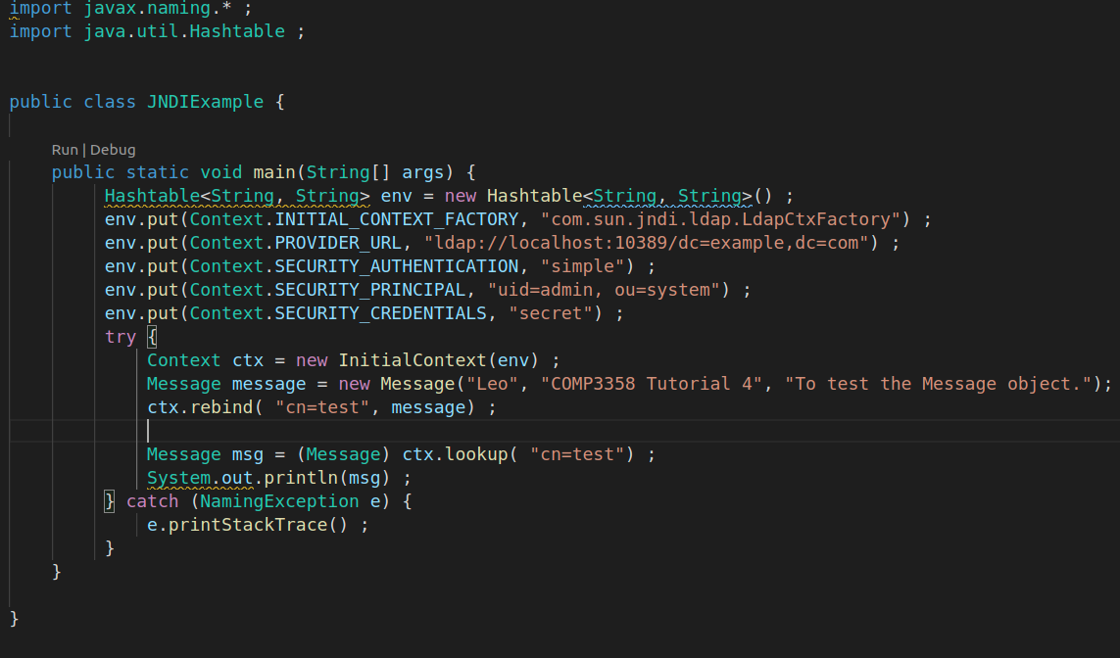
result:
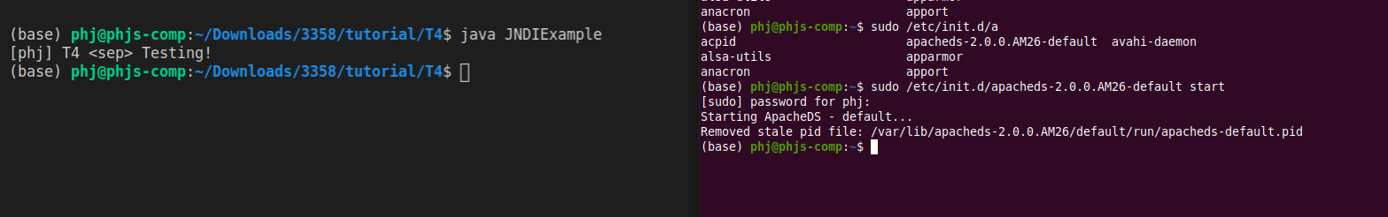

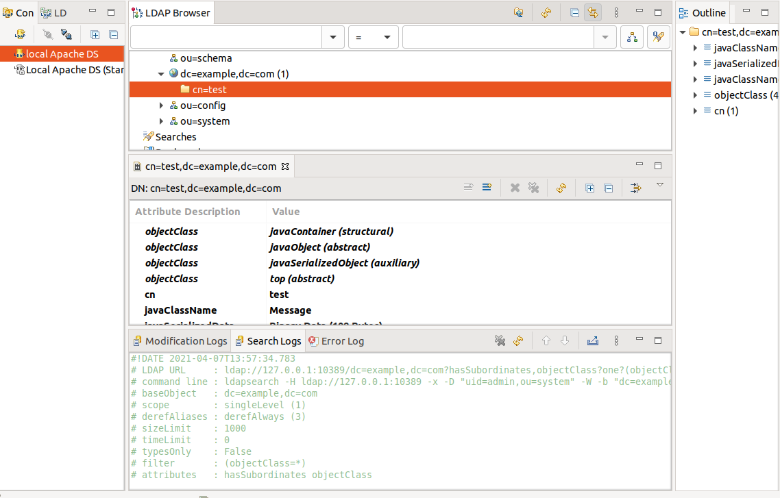

Exercise 2:
what need to do to modify the client?
1. create the Hash table env
2. get the TickMachine class use the Content lookup method
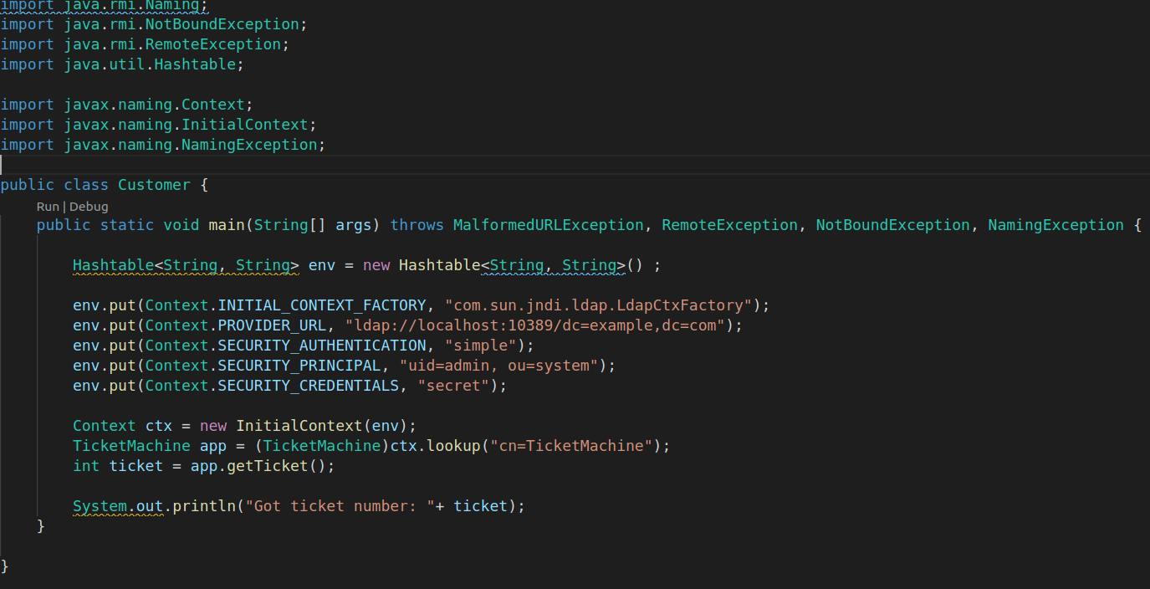
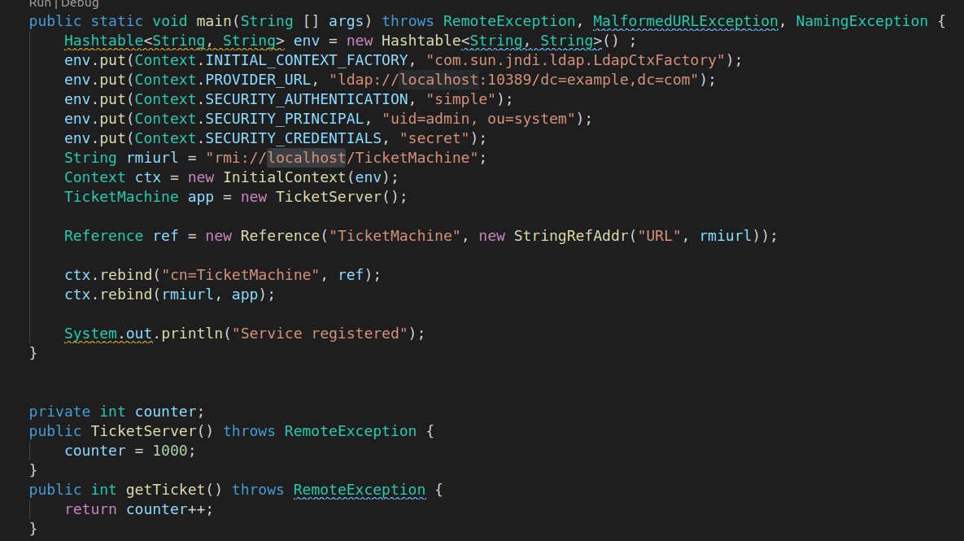
result:
to get the result you need to set up the environment just like tutorial 3
