COMP3358 Assignment1
Pan Huijie 3035534622

Q1: Modify the sample program in tutorial 3
save the file when the function count() call is similar with the update OnlineUser.txt function, which Is need in assignment1.
Just call this function insider the server count() function

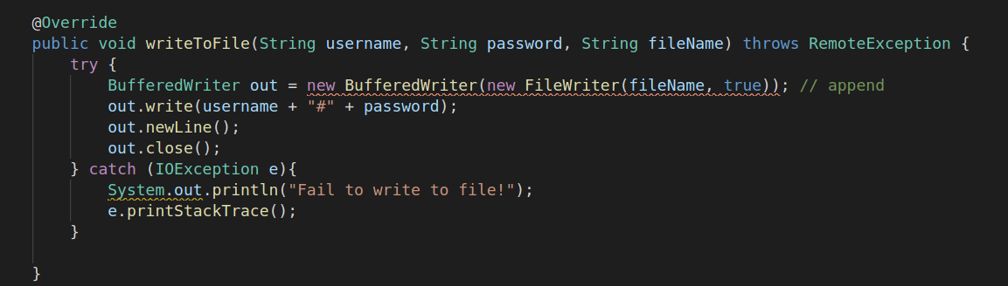
Assignment 1

1.How to run?
- Open the RMI under the sever program folder
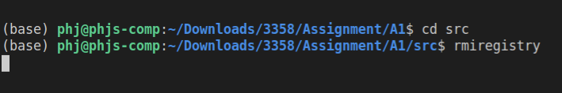
- Compile the Server.java and Client.java
- Run the Sever program with the -Djava.security.policy command
- Run the Client program

2. GUI appearance
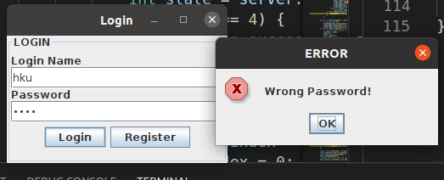
- Login Page
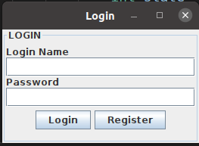
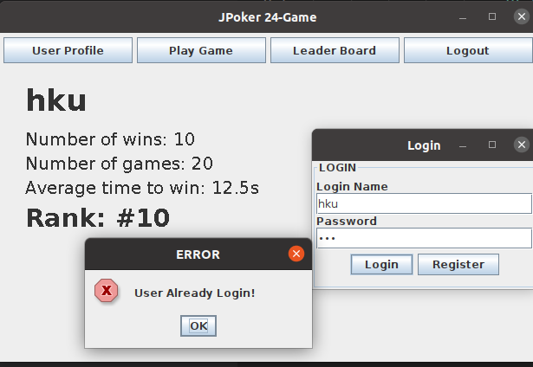
- Register Page
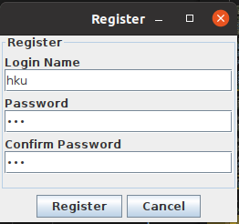
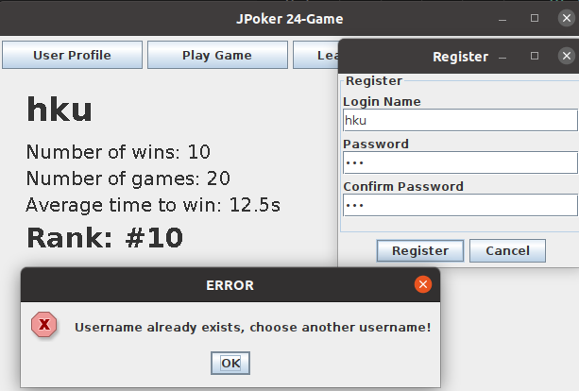
- Game Page

