COMP3358 Assignment 2
Pan Huijie 3035534622

screenshot of the output
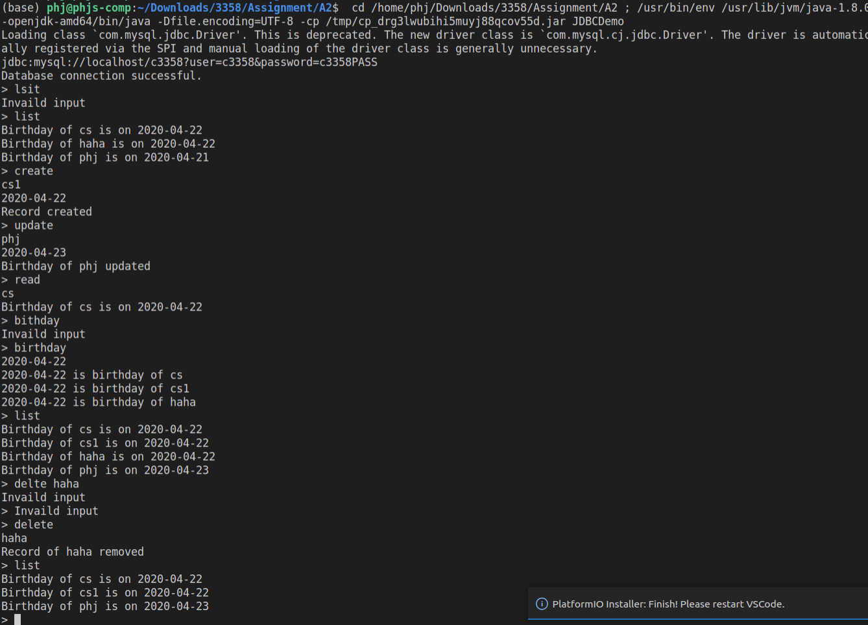
How to run?
- Insert the jar file to the reference library
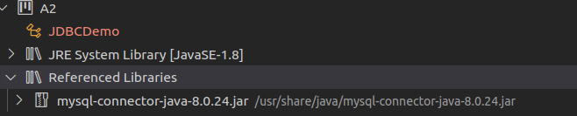
- create the database user and database in the localhost machine
