Assignment 3
Panhuijie 3035534622

How to run?
You should need 3 setup. There are JMS RMI JDBN
1. RMI
run the rmiregistry in the working directory
2. JMS
using the glassfish4 to register JMS connection factory, Topic, Queue

3. JDBC
open the local mysql server and input the follow command
CRATE DATABASE 24Game;
GRANT ALL ON c3358.* to 'c3358'@'localhost';
CREATE TABLE 24Game_UserList (
-> username varchar(16) NOT NULL,
-> password varchar(32) NOT NULL,
-> win_number INT(5),
-> game_number INT(5),
-> avg_time FLOAT(10),
-> PRIMARY KEY username (username)
-> );
4. compile the file
for the pre-require class
javac Game.java
for server
/usr/bin/env /usr/lib/jvm/java-1.8.0-openjdk-amd64/bin/java -Djava.security.policy=./security.policy -Dfile.encoding=UTF-8 -cp GameServer
for the client
cd software/Gminer/cd /home/phj/Downloads/test/JPoker_24_Game ; /usr/bin/env /usr/lib/jvm/java-1.8.0-openjdk-amd64/bin/java -Djava.security.policy=./security.policy -Dfile.encoding=UTF-8 -cp /tmp/cp_5odlhhubhghrelj2aapw57dyi.jar GameGUI 127.0.0.1
add the reference library into workplace
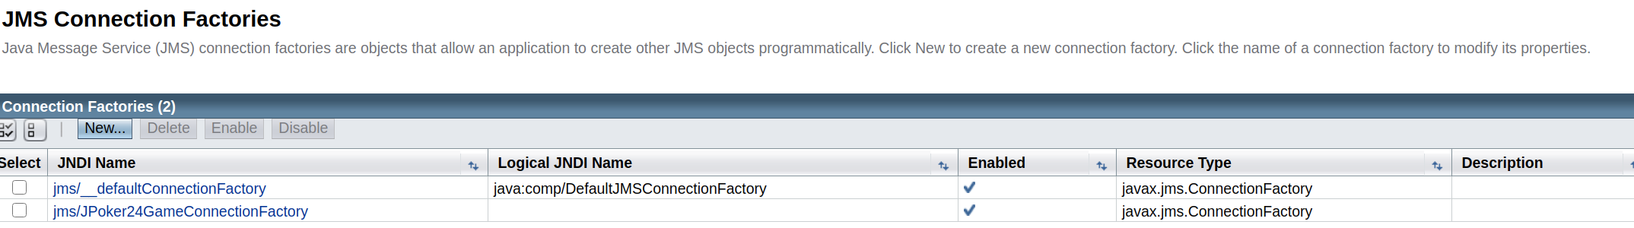
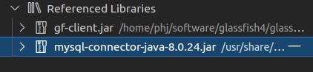

what is the appearance?
Front end
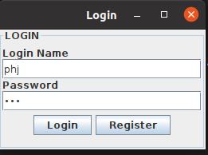
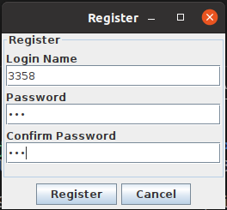
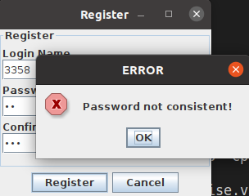

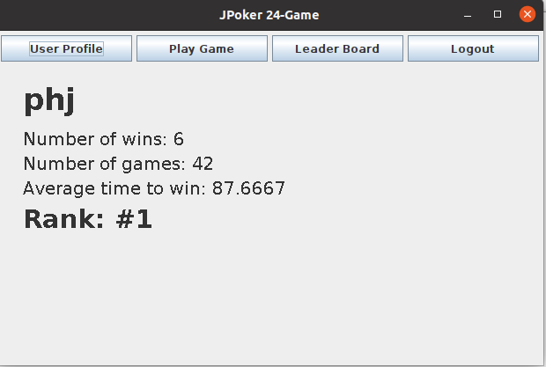
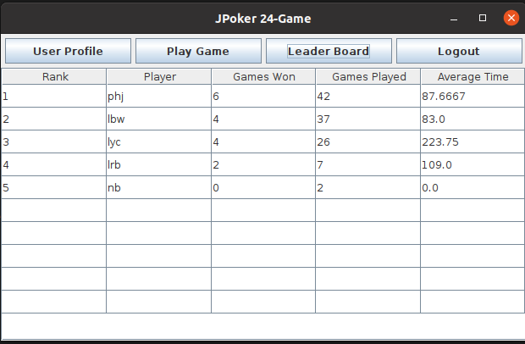

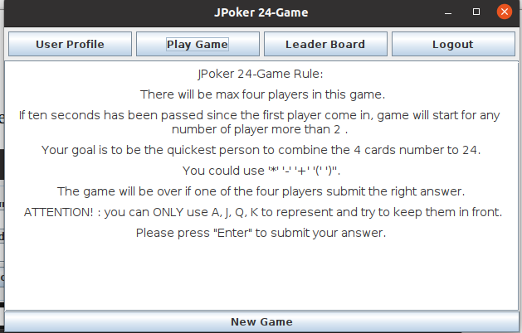
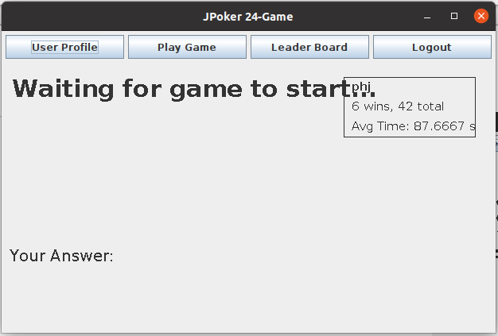

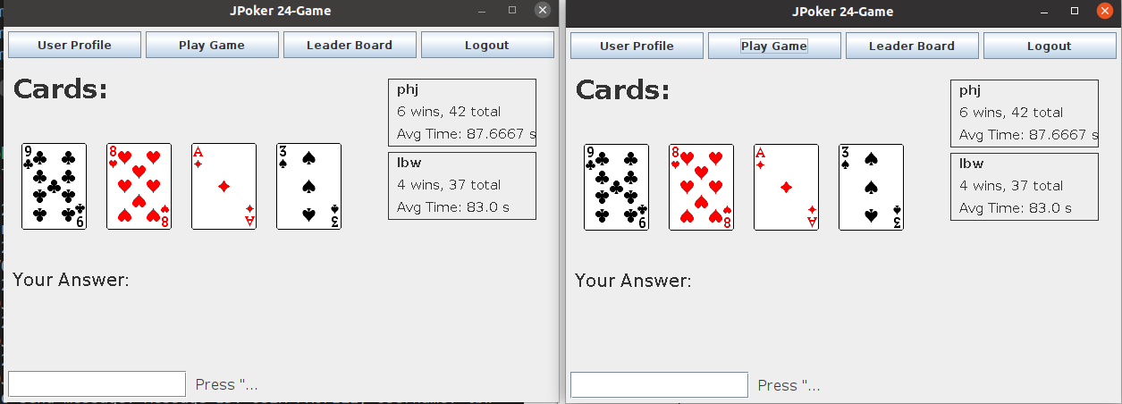

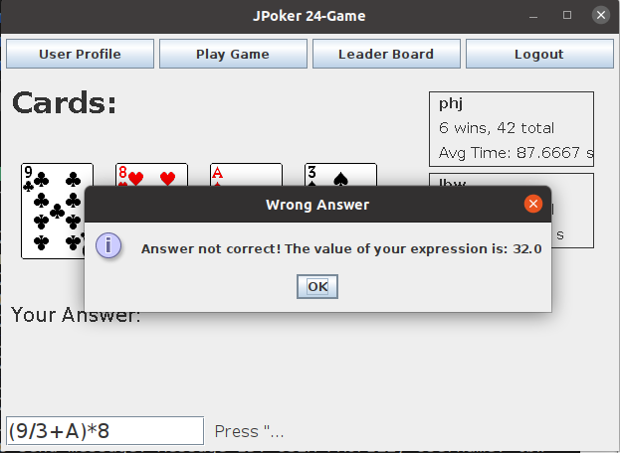
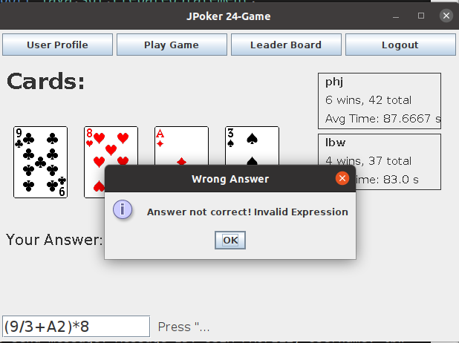

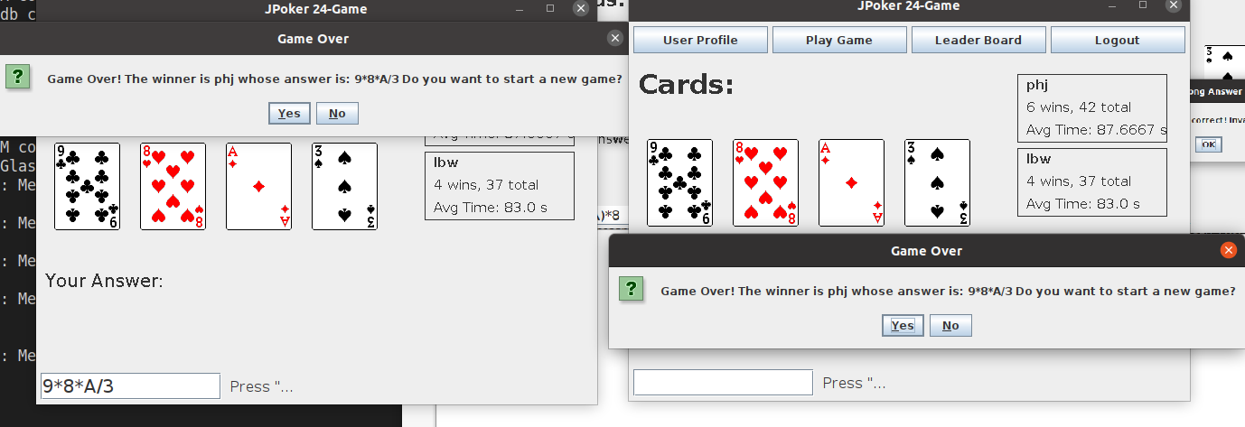
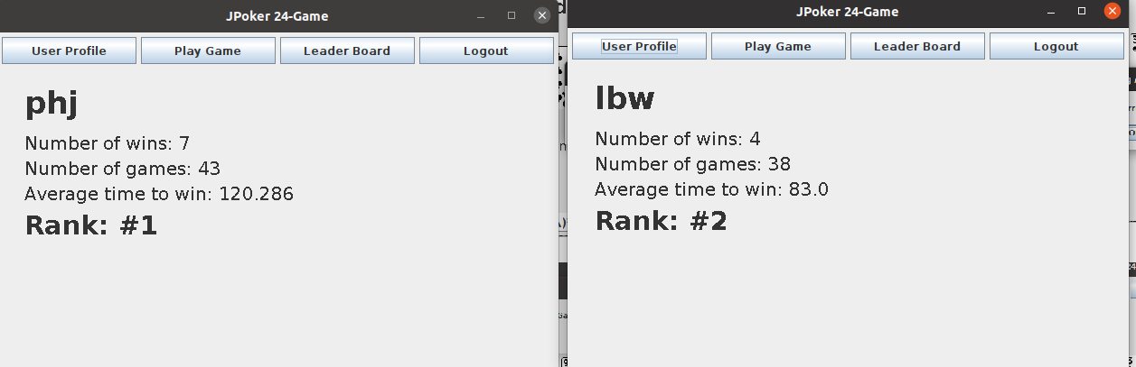

Back-end

