Unit-8: Graph
- A graph is a pictorial representation of a set of objects where some pairs of objects are connected by links. The interconnected objects are represented by points termed as vertices, and the links that connect the vertices are called edges.
- A graph consists of a set of nodes (or vertices) and a set of arcs (or edges). Each arc in a graph is specified by a pair of nodes.
- Formally, a graph is a pair of sets (V, E), where V is the set of vertices and E is the set of edges, connecting the pairs of vertices. Take a look at the following graph:
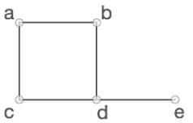
In the above graph, V = {a, b, c, d, e} and E = {ab, ac, bd, cd, de}
- Vertex− Each node of the graph is represented as a vertex. It is a connection point. A Graph has a set of Vertices, usually shown as V = {v1, v2, ..., vn}, V = {A, B, C} or V = {1, 2, ... N}. In the following example, the labeled circle represents vertices. Thus, A to G are vertices. The number of Vertices in a graph is |V|, but somtimes written in equations as just V. A Vertex may have no connections, one connection or many connections. A vertex may have any number of properties such as a name or a color.
- Edge − Edge represents a path between two vertices or a line between two vertices. In the following example, the lines from A to B, B to C, and so on represents edges. We can use a two-dimensional array to represent an array as shown in the following image.
- Adjacency − Two node or vertices are adjacent if they are connected to each other through an edge. In the following example, B is adjacent to A, C is adjacent to B, and so on.
- Path − Path represents a sequence of edges between the two vertices. In the following example, ABCD represents a path from A to D. The length of a path is the number of edges on that path.
- A path from a node to itself is called a cycle. Thus, a cycle is a path in which the initial and final vertices are same. If a graph contains a cycle, it is cyclic, otherwise it is acyclic.
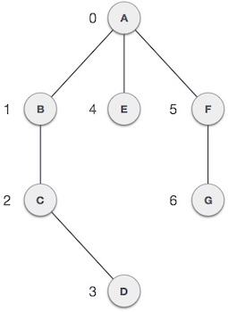
- A Graph is called Undirected if the edges have no implied direction. (v1, v2) is the same as (v2, v1), the edge just connects v1 to v2.
- A Graph is called Directed if the edges have a direction. (v1, v2) means an edge starting at v1 and go into v2. (v1, v2) is not the same as (v2, v1), i.e., if the pairs of nodes that make up the arcs are ordered pairs, the graph is said to be a directed graph (or diagraph).
- A Weighted Graph has edges with an additional property, a weight. Weights may be integers, real numbers, gallons per minute or any type of quantity. (v1, v2, 10GPM) would indicate an Edge from vertex v1 to v2 with a flow of 10 gallons per minute. There are special cases that may not allow zero or negative weights.
- An undirected graph is said to be connected if there is a path between every pair of nodes. Informally, an undirected graph is connected if it hangs in one piece.
- A graph is disconnected, if it does not contain at least two connected vertices. The following graph is an example of a Disconnected Graph.
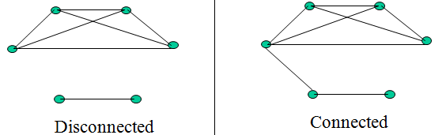
Applications of Graph: Graph theory has its applications in diverse fields of engineering:
- Electrical Engineering − the concepts of graph theory is used extensively in designing circuit connections.
- Computer Science − Graph theory is used for the study of algorithms. For example, Kruskal's Algorithm, Prim's Algorithm, Dijkstra's Algorithm
- Computer Network − The relationships among interconnected computers in the network follows the principles of graph theory.
- Science − The molecular structure and chemical structure of a substance, the DNA structure of an organism, etc., are represented by graphs.
- Linguistics − The parsing tree of a language and grammar of a language uses graphs.
- General − Routes between the cities can be represented using graphs. Depicting hierarchical ordered information such as family tree can be used as a special type of graph called tree.
Graph Representation: There are two computer representations of graphs:
- Adjacency matrix representation
- Adjacency lists representation
Adjacency Matrix Representation: In this representation, each graph of n nodes is represented by an n x n matrix A, that is, a two-dimensional array A:
  - The nodes are (re)-labeled 1,2,…,n
  - A[i][j] = 1 if (i, j) is an edge
  - A[i][j] = 0 if (i, j) is not an edge
Example:
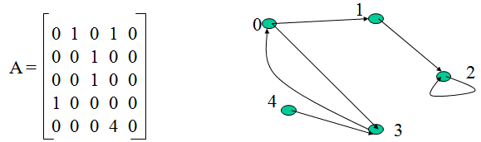
- Pros and cons of adjacency matrices:
  - Pros:
    - Simple to implement.
    - Easy and fast to tell if a pair (i, j) is an edge: simply check if A[i][j] is 1 or 0.
  - Cons:
    - No matter how few edges the graph has, the matrix takes O(n²) in memory.
Adjacency Lists Representation: A graph of n nodes is represented by a one-dimensional array L of linked lists, where:
  - L[i] is the linked list containing all the nodes adjacent from node i.
  - The nodes in the list L[i] are in no particular order.
Example of Linked Representation
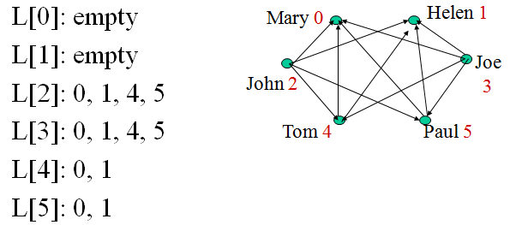
- Pros and Cons of Adjacency Lists
  - Pros:
    - Saves on space (memory): the representation takes as many memory words as there are nodes and edge.
  - Cons:
    - It can take up to O(n) time to determine if a pair of nodes (i,j) is an edge: one would have to search the linked list L[i], which takes time proportional to the length of L[i].
Forest and tree
- Trees are graphs that do not contain even a single cycle. They represent hierarchical structure in a graphical form. Trees belong to the simplest class of graphs. Despite their simplicity, they have a rich structure.
- A connected acyclic graph is called a tree. In other words, a connected graph with no cycles is called a tree.
- The edges of a tree are known as branches. Elements of trees are called their nodes. The nodes without child nodes are called leaf nodes.
- A tree with ‘n’ vertices has ‘n-1’ edges. The graph shown here is a tree because it has no cycles and it is connected. It has four vertices and three edges, i.e., for ‘n’ vertices ‘n-1’ edges as mentioned in the definition.
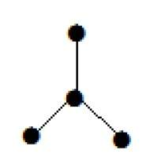
- A disconnected acyclic graph is called a forest. In other words, a disjoint collection of trees is called a forest.
- The following graph looks like two sub-graphs; but it is a single disconnected graph. There are no cycles in this graph. Hence, clearly it is a forest.
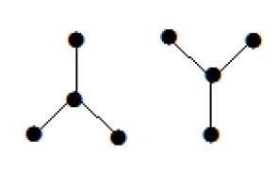
- Spanning Trees: A spanning tree is a subset of Graph G, which has all the vertices covered with minimum possible number of edges. Hence, a spanning tree does not have cycles and it cannot be disconnected. By this definition, we can draw a conclusion that every connected and undirected Graph G has at least one spanning tree. A disconnected graph does not have any spanning tree, as it cannot be spanned to all its vertices.
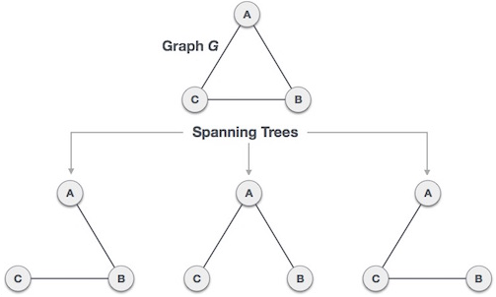
Algorithm of graph traversal:
- Depth First Search (DFS) algorithm traverses a graph in a depth-ward motion and uses a stack to remember to get the next vertex to start a search, when a dead end occurs in any iteration.
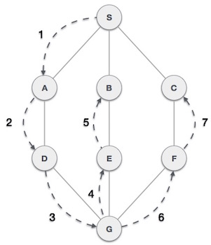
- It employs the following rules:
Rule-1: Visit the adjacent unvisited vertex. Mark it as visited. Display it. Push it in a stack.
Rule-2: If no adjacent vertex is found, pop up a vertex from the stack. (It will pop up all the vertices from the stack, which do not have adjacent vertices.)
Rule-3: Repeat Rule 1 and Rule 2 until the stack is empty.
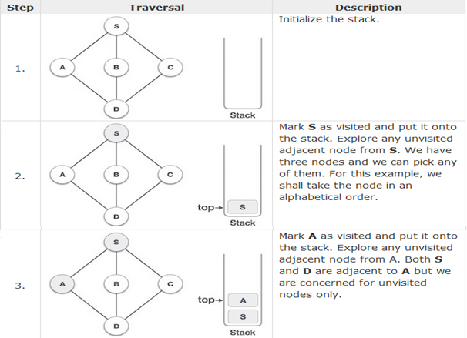
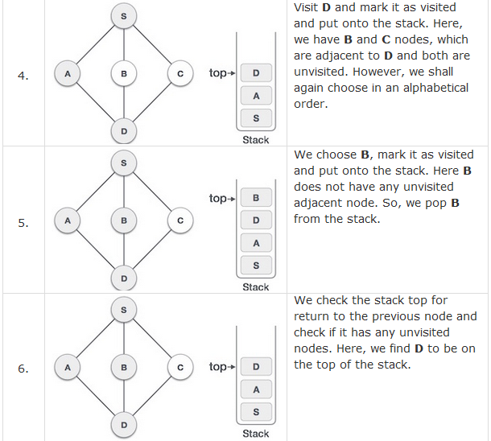
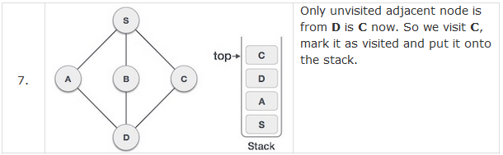
- As C does not have any unvisited adjacent node so we keep popping the stack until we find a node that has an unvisited adjacent node. In this case, there's none and we keep popping until the stack is empty.
- Breadth First Search (BFS) algorithm traverses a graph in a breadth-ward motion and uses a queue to remember to get the next vertex to start a search, when a dead end occurs in any iteration.
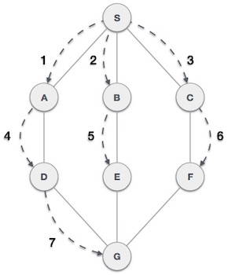
- It employs the following rules:
Rule-1: Visit the adjacent unvisited vertex. Mark it as visited. Display it. Insert it in a queue.
Rule-2: If no adjacent vertex is found, remove the first vertex from the queue.
Rule-3: Repeat Rule 1 and Rule 2 until the queue is empty.
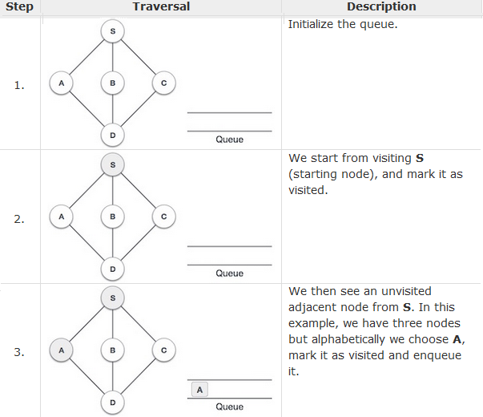

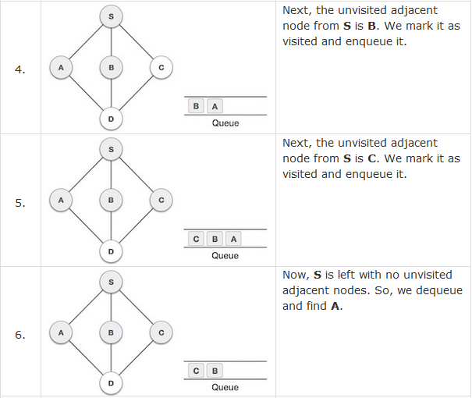
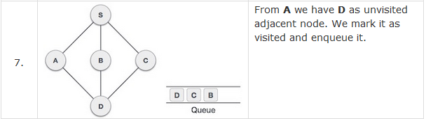
- At this stage, we are left with no unmarked (unvisited) nodes. But as per the algorithm we keep on dequeuing in order to get all unvisited nodes. When the queue gets emptied, the program is over.
DFS Edge Classification: The edges we traverse as we execute a depth-first search can be classified into four edge types. During a DFS execution, the classification of edge (u; v), the edge from vertex u to vertex v, depends on whether we have visited v before in the DFS and if so, the relationship between u and v.
  - If v is visited for the first time as we traverse the edge (u; v), then the edge is a tree edge.
  - Else, v has already been visited:
    - If v is an ancestor of u, then edge (u; v) is a back edge.
    - Else, if v is a descendant of u, then edge (u; v) is a forward edge.
    - Else, if v is neither an ancestor nor descendant of u, then edge (u; v) is a cross edge.

