**1.Take two numbers a and b, and add them. Print the sum on the screen.**

package assignment2;

public class AddTwoNumbers {

public static void main(String arg[]) {

int a=5,b=10;

System.out.println("Sum of two integer numbers is: "+(a+b));

}

}

**OUTPUT:**

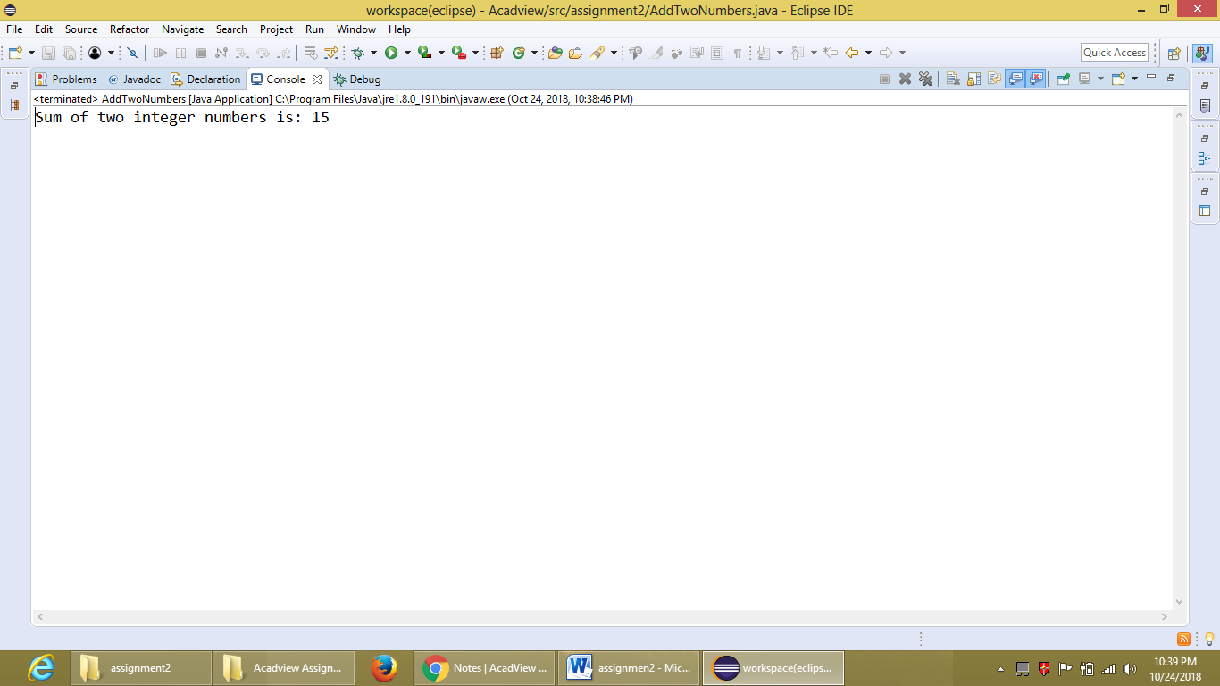

**2.Check if a given year is a leap year or not.**

package assignment2;

public class LeapYear {

public static void main(String arg[]) {

int year=2018;

if(year%4==0) {

System.out.println("The given year "+year+" is a leap year." );}

else

System.out.println("The Given year "+year+" is not a leap year.");

}

}

**OUTPUT:**

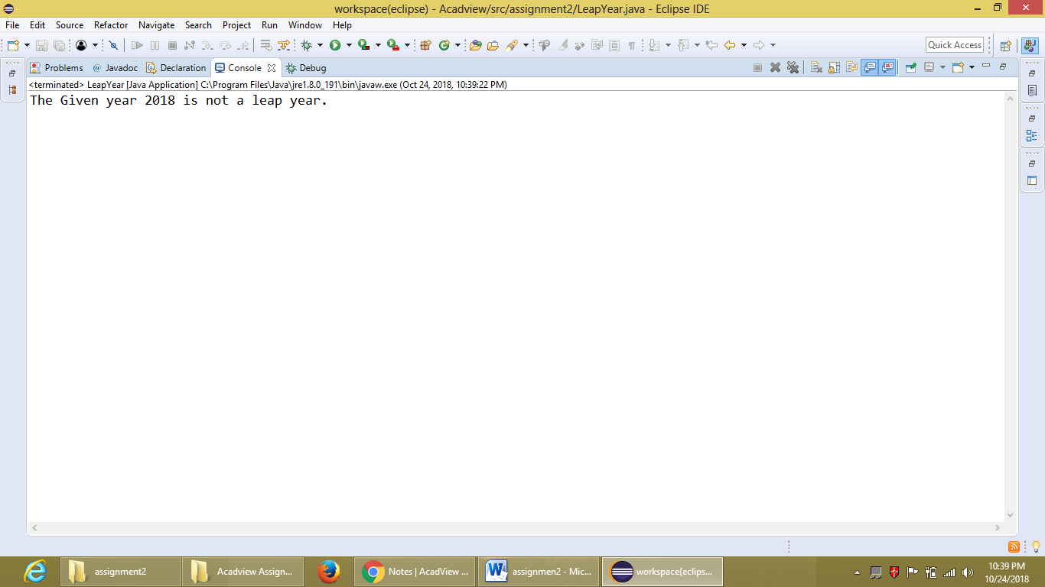

**3.Print the pattern:**

**\***

**\*\***

**\*\*\***

**\*\*\*\***

package assignment2;

public class Pattern {

public static void main(String arg[]) {

for(int i=0;i<4;i++) {

for(int j=0;j<=i;j++) {

System.out.print("*");}

System.out.println();

}

}

}

**OUTPUT:**

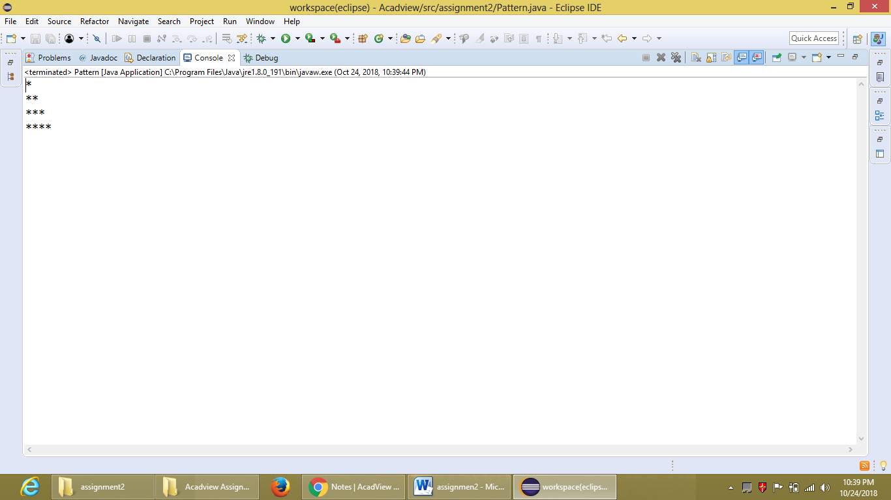

**4. Given three numbers a b c, write a Java program to find the biggest out of three numbers.**

package assignment2;

public class BiggestNumber {

public static void main(String arg[]) {

int a=7,b=15,c=27;

if(a>b&&a>c) {

System.out.println(a +" is biggest number than "+b+" and "+c);}

else if(b>a&&b>c) {

System.out.println(b +" is biggest number than "+a+" and "+c);}

else

System.out.println(c +" is biggest number than "+a+" and "+b);

}

}

**OUTPUT:**

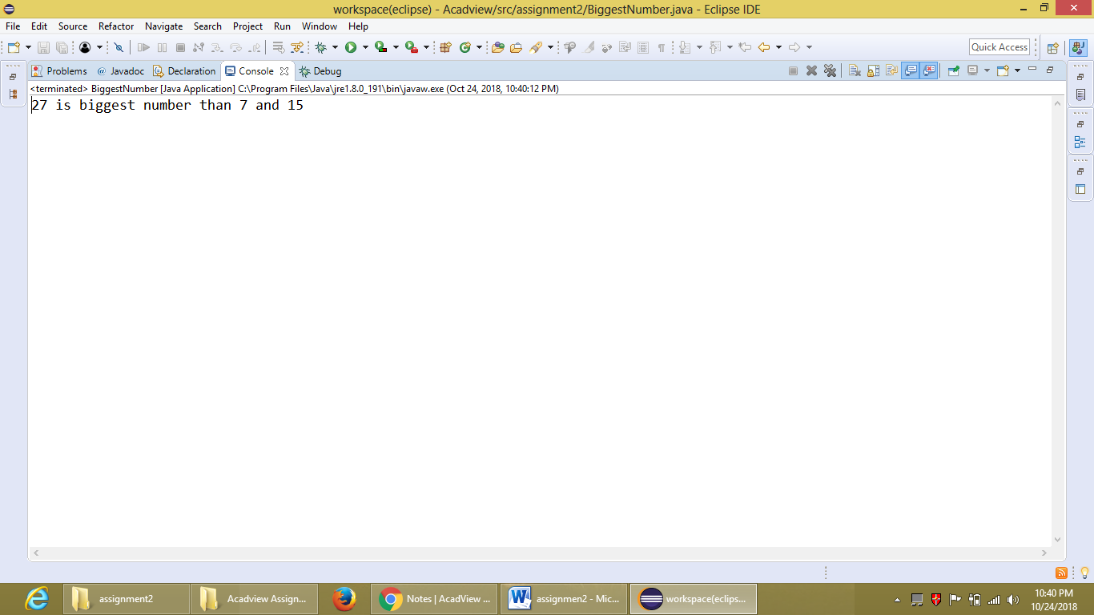

**5. Check if a number N is a palindrome or not.**

package assignment2;

public class Palindrome {

public static void main(String arg[]) {

int n=12321;

int p=0,r=n;

for(int i=0;r!=0;i++) {

p=p*10+r%10;

r=r/10;

//System.out.println(p);

}

if(n==p) {

System.out.println("The given number "+n+" is a palindrome.");}

else

System.out.println("The given number "+n+" is not a palindrome.");

}

}

**OUTPUT:**

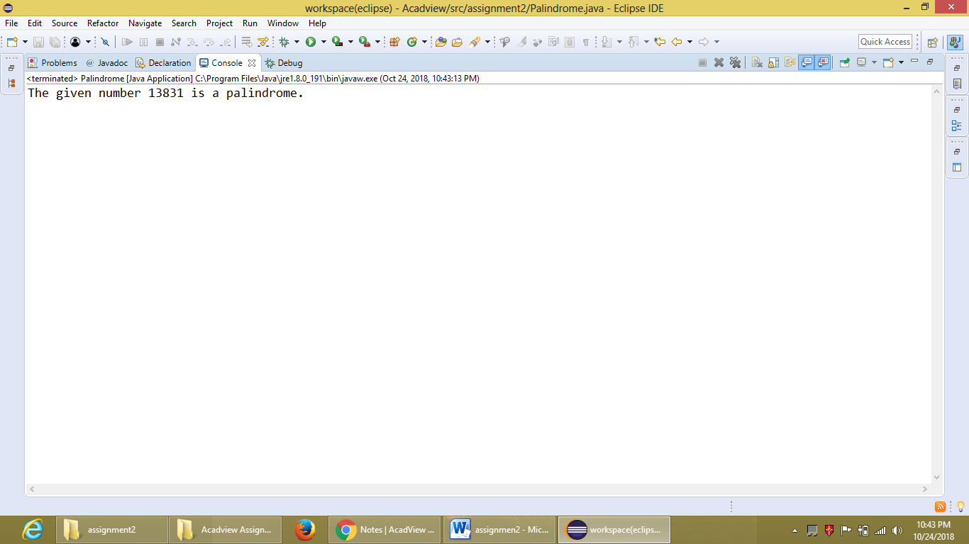

**6. Check if a number N is prime or not.**

package assignment2;

public class PrimeNumber {

public static void main(String arg[]) {

int n=37;

boolean b=true;

for(int i=2;i<10;i++) {

if(n%i==0) {

System.out.println("The given number "+n+" is not a prime number.");

b=false;

break;

}}

if(b==true)

System.out.println("The given number "+n+" is a prime number.");

}

}

**OUTPUT:**

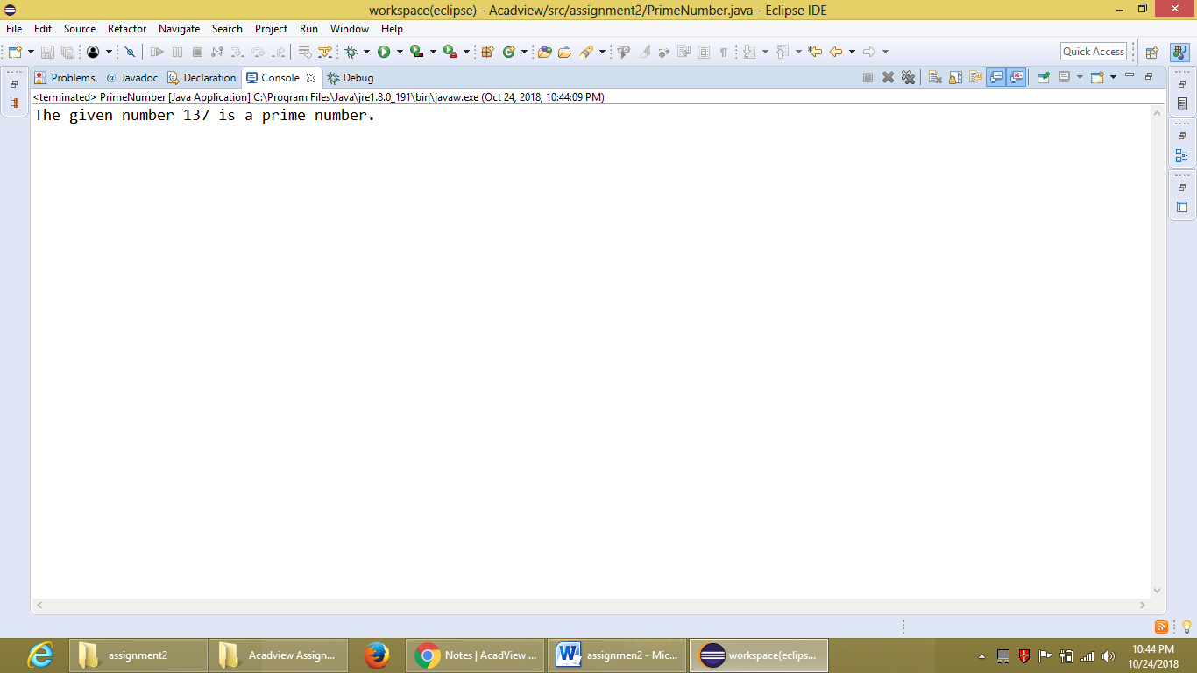

**7. Find the reverse of a number N.**

package assignment2;

public class ReverseOfNumber {

public static void main(String arg[]) {

int number=13457;

int result=0,r=number;

for(int i=0;r!=0;i++) {

result=result*10+r%10;

r=r/10;

System.out.println(result);

}

System.out.println("The reverse of the given number "+number+" is "+result);

}

}

**OUTPUT:**

