**ASSIGNMENT 10**

**1. Create a Dynamic Array Data Structure that performs all the actions of the ArrayList. It should create the new array of size 1.5 times the previous size. Hint: You need to create a class that extends and overrides all Arraylist's methods.**

package assignment10andminiproject;

import java.io.IOException;

import java.util.ArrayList;

import java.util.InputMismatchException;

import java.util.List;

import java.util.Scanner;

class ActionsOfTheArrayList extends ArrayList{

static Scanner scan=new Scanner(System.in);

int array[]=new int[10];

public int length=array.length;

int temp[];

public int increasingLength() {

int l=(int)((array.length)*1.5);

return l;

}

public void add(int a) {

outer:for (int i=0;i<array.length;i++) {

if((array[i]!=0)&&(i==array.length-1)) {

length=array.length;

temp=new int[array.length];

for(int j=0;j<array.length;j++) {

temp[j]=array[j];}

array=new int[increasingLength()];

System.out.println("**Now length of the array after increasing by 1.5 is: "+array.length);

for(int j=0;j<length;j++) {

array[j]=temp[j];

//System.out.println(array[j]);

}

array[length]=a;

//System.out.println("length:"+length+"new added element: "+a);

break outer;}

if(array[i]==0) {

array[i]=a;

break outer;}

}}

public void delete(int r) {

temp=new int[array.length];

for(int i=0;i<array.length;i++) {

if(array[i]==r) {

temp[i]=array[i+1];

}else

temp[i]=array[i];}

for(int i=0;i<array.length;i++) {

array[i]=temp[i];

}

}

void printArrayElements() {

//System.out.print("Here i am printing the elements of the array: ");

System.out.print("[");

for(int i=0;i<array.length;i++) {

System.out.print(array[i]);

if(i==array.length-1) {

continue;

}

System.out.print(", ");}

System.out.println("]");

}

}

public class CreateDynamicArrayDataStructure {

public static void main(String arg[]) throws InputMismatchException,IOException{

boolean b=true,p=true;

int element;

ActionsOfTheArrayList mylist=new ActionsOfTheArrayList();

try {

System.out.println("Please enter the 10 integer elements in the arraylist: ");

for(int i=0;i<10;i++) {

element=mylist.scan.nextInt();

mylist.add(element);}

while(b==true) {

System.out.println("1. Enter 'true' if you want to enter the numbers of elements of the arraylist." );

System.out.println("2. Enter 'false' if you don't want to print the elements of the arraylist." );

System.out.println("Please enter your option: ");

p=mylist.scan.nextBoolean();

System.out.println("Enter the element you want to add in the Arraylist: " );

//System.out.println("length of the array now: "+mylist.array.length);

element=mylist.scan.nextInt();

mylist.add(element);

System.out.println("1. Enter 'true' if you want to print the elements of the arraylist." );

System.out.println("2. Enter 'false' if you don't want to print the elements of the arraylist." );

System.out.println("Please enter your option: ");

p=mylist.scan.nextBoolean();

//System.out.println("Here you add "+element+" into the arraylist.");

if(p==true) {

System.out.println("The elements of the arraylist after adding "+element+" is: ");

mylist.printArrayElements();

}

System.out.println("1. Enter 'true' if you want to add more element in the arraylist." );

System.out.println("2. Enter 'false' if you don't want to add more element in the arraylist." );

System.out.println("Please enter your option: ");

b=mylist.scan.nextBoolean();

}

}catch(InputMismatchException ie) {

System.out.println("Please enter the valid data type for given options.");

}

catch(Exception e) {

System.out.println("Error has occured in the code.");

}

finally{

System.out.println("The elements of the arraylist are: ");

mylist.printArrayElements();

}

}}

**OUTPUT:**

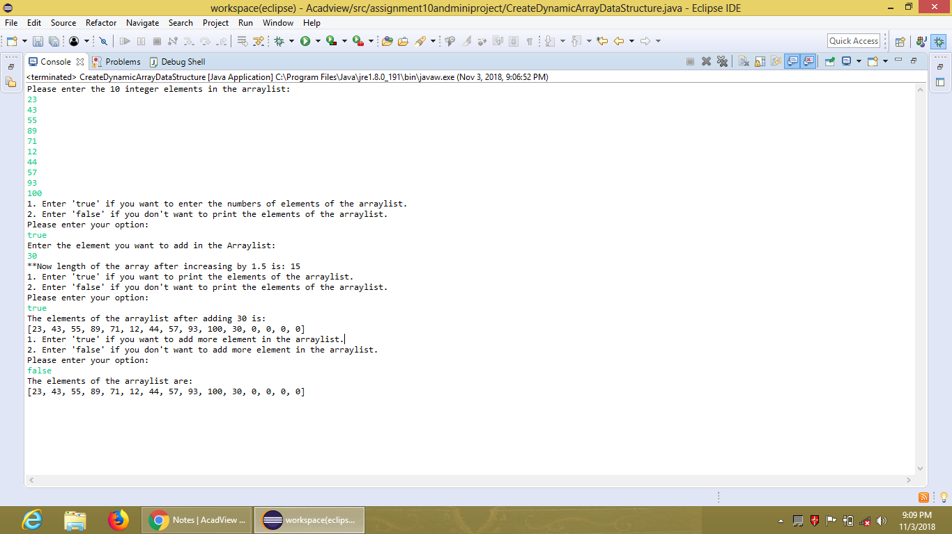

**2. Mini Project**

**So, summing up our last 3 assignments, we need to build a Mini Project with following steps: (Some of which have already been done as assignments in last 2 classes.)**

**(a) Create abc.txt with 2 paths.**

**(b) Recursively traverse all the files and folders to enlist all files with names and paths.**

**(c) Create an ArrayList of file paths.**

**(d) Create a csv file of the file names and file paths.**

package assignment10andminiproject;

import java.io.BufferedInputStream;

import java.io.BufferedOutputStream;

import java.io.File;

import java.io.FileInputStream;

import java.io.FileNotFoundException;

import java.io.FileOutputStream;

import java.io.IOException;

public class MiniProject {

public static void main(String arg[]) throws IOException {

File f=null;

File f1=null;

FileInputStream fin=null;

FileOutputStream fout=null;

BufferedInputStream bin=null;

BufferedOutputStream bout=null;

//boolean b=true;

try {

f=new File("E:/Acadview Assignment Files/mini project folders/abc.txt");

//f1=new File("E:/Acadview Assignment Files/mini project folders/output.txt")

fin=new FileInputStream(f);

//fout=new FileOutputStream(f1);

bin=new BufferedInputStream(fin);

// bout=new BufferedOutputStream(fout);

int c;

String s="",path="";

while((c=bin.read())!=-1) {

if(c!=10){

s=s+(char)c;

System.out.println(s);

}

else

//path=s;

System.out.println("path is"+s);

break;

// f=new File("s");

}

}

catch(FileNotFoundException fe) {

System.out.println("File is not found.");

}

catch(Exception e) {

System.out.println("Error has occurred in the code.");

}

finally {

bin.close();

//bout.close();

}

}

}

2.

package assignment10andminiproject;

import java.io.BufferedInputStream;

import java.io.BufferedOutputStream;

import java.io.File;

import java.io.FileInputStream;

import java.io.FileNotFoundException;

import java.io.FileOutputStream;

import java.io.IOException;

public class MiniProject {

public static void main(String arg[]) throws IOException {

File f=null;

File f1=null;

FileInputStream fin=null;

FileOutputStream fout=null;

BufferedInputStream bin=null;

BufferedOutputStream bout=null;

File files[];

//boolean b=true;

try {

f=new File("E:/Acadview Assignment Files/mini project folders/abc.txt");

//f1=new File("E:/Acadview Assignment Files/mini project folders/output.txt")

fin=new FileInputStream(f);

//fout=new FileOutputStream(f1);

bin=new BufferedInputStream(fin);

// bout=new BufferedOutputStream(fout);

int c,p=1,i=0;

String s="",path[]=new String[2];

// System.out.println("The content of the given file 'abc.txt' is:");

while((c=bin.read())!=-1){

if(c!=10){

s=s+(char)c;

path[i]=s;

p=++p;}

else {

bin.mark(p);

i=++i;

s="";

bin.reset();

}}

for(int z=0;z<path.length;z++) {

path[z]= path[z].replace('\', '/');

System.out.println("Path"+(z+1)+" is "+path[z]);

f=new File(path[z]);

System.out.println("Files under "+f+" are:");

files=f.listFiles();

for(int j=0;j<files.length;j++) {

System.out.println(j+1+". "+files[j].getName()+"; "+files[j]);

}}

}catch(FileNotFoundException fe) {

System.out.println("File is not found.");

}catch(Exception e) {

System.out.println("Error has occurred in the code.");}

finally {

fin.close();

bin.close();

//bout.close();

}

}

}