**ASSIGNMENT 11**

**1. Write a Java program to compare two sets and retain elements which are same on both sets.**

package assignment11;

import java.util.HashSet;

import java.util.Scanner;

import java.util.Set;

public class CompareTwoSets {

public static void main(String arg[]) {

Scanner in=new Scanner(System.in);

int element,no,limit=0;

Set<Integer> s1= new HashSet<>();

Set<Integer> s2= new HashSet<>();

Set<Integer> intersect= new HashSet<>();

System.out.println("Enter the numbers of elemets you want to enter in the set1: ");

no=in.nextInt();

if(limit<no) {

limit=no;}

System.out.println("Enter the "+no+" Integer elements that you want to enter in the set1: ");

for(int j=1;j<=no;j++) {

element=in.nextInt();

s1.add(element);}

System.out.println("Enter the numbers of elemets you want to enter in the set2: ");

no=in.nextInt();

if(limit<no) {

limit=no;}

System.out.println("Enter the "+no+" Integer elements that you want to enter in the set2: ");

for(int j=1;j<=no;j++) {

element=in.nextInt();

s2.add(element);}

intersect.addAll(s1);

intersect.retainAll(s2);

System.out.println("The elements which are same on both sets are: ");

System.out.println(intersect);

}}

**OUTPUT:**

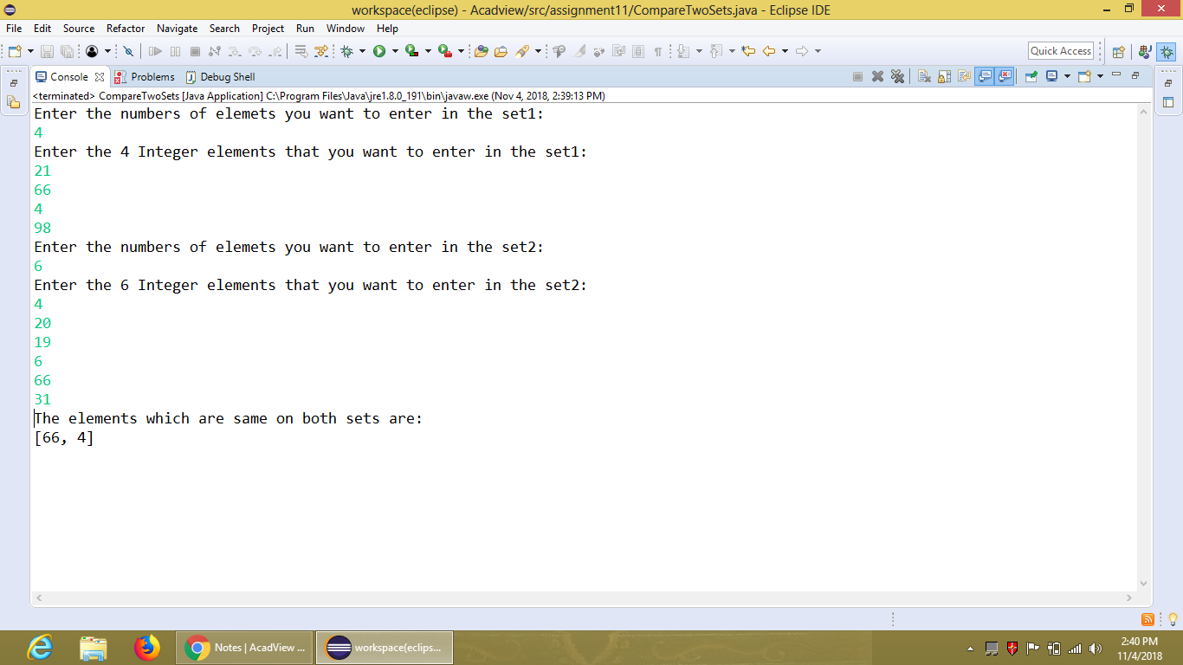

**2. Write a Java program to associate the specified value with the specified key in a HashMap.**

package assignment11;

import java.util.HashMap;

import java.util.Map;

public class MyHashMap {

public static void main(String arg[]) {

Map<Integer,String> ht=new HashMap<>();

ht.put(1, "Pardeep");

ht.put(2, "Harneet");

ht.put(3, "Deep");

System.out.println("The size of the HashMap is: "+ht.size());

System.out.println("The values of the HashMap are: "+ht.values());

System.out.println("Is HashMap contain the key 6: "+ht.containsKey(6));

System.out.println("Is HashMap contain the value 'Pardeep Kaur': "+ht.containsKey("Pardeep kaur"));

ht.remove(2);

System.out.println("The values of the HashMap after removed the key 2 are: "+ht.values());

ht.replace(3, "Deep", "Kaur");

System.out.println("The values of the HashMap after replaced the key 3 are: "+ht.values());

}

}

**OUTPUT:**

