**ASSIGNMENT 12**

**1.Create a program to input a Date from the user in dd/mm/yyyy format and print it in English.**

package assignment12;

import java.util.Map;

import java.util.Scanner;

import java.util.TreeMap;

class MyException extends Exception{

public MyException(String s) {

super(s);

}}

public class InputDate {

public static void main(String arg[]) throws MyException {

Scanner s=new Scanner(System.in);

int d=1,m=1,y=2018,temp;

String dy[]={"One","Two","Three","Four","Five","Six","Seven","Eight","Nine","Ten",

"Eleven","Twelve","Thirteen","Fourteen","Fifteen","Sixteen","Seventeen","Eighteen","Nineteen","Twenty","Twenty-One","Twenty-Two","Twenty-Three","Twenty-Four","Twenty-Five","Twenty-Six","Twenty-Seven","Twenty-Eight","Twenty-nine","Thirty","Thirty-One"};

String mh[]={"January","February","March","April","May","June","July","August",

"September","October","November","December"};

Map<Integer,String> day=new TreeMap<>();

for(int i=0;i<31;i++) {

day.put(i+1,dy[i]); }

Map<Integer,String> month=new TreeMap<>();

for(int i=0;i<12;i++) {

month.put(i+1,mh[i]);}

String first[]= {"One","Two","Three","Four","Five","Six","Seven","Eight","Nine","Ten",

"Eleven","Twelve","Thirteen","Fourteen","Fifteen","Sixteen","Seventeen","Eighteen","Nineteen"};

String second[]= {"Twenty","Thirty","Fourty","Fifty","Sixty","Seventy","Eighty","Ninety", "Hundred"};

Map<Integer,String> year=new TreeMap<>();

int z=0;

int x=30;

for(int i=1;i<100;) {

if(i<20) {

year.put(i, first[i-1]);

i=i+1;}

else {

for(int j=0;j<8;j++) {

if(i==20||i==30||i==40||i==50||i==60||i==70||i==80||i==90){

if(z<9) {

year.put(i,second[z]);

z =z+1;

i=i+1;}}

for(int k=0;k<9;k++) {

year.put(i,second[j]+" "+first[k]);

i=i+1;}

}

}

}

Boolean b;

do {

try {

b=false;

System.out.println("Enter the month in integer: ");

m=s.nextInt();

if((m<=0)||(m>12)) {

throw new MyException("You can enter the value from 1 to 12 only."); }}

catch(MyException mex) {

System.out.println("Exception: "+mex);

System.out.println("Please renter the value for month:");

b=true;

}}while(b==true);

do {

try {

b=false

System.out.println("Enter the day in integer: ");

d=s.nextInt();

if(d<=0||d>31) {

throw new MyException("You can enter the value from 1 to 31 only.");} }

catch(MyException mex) {

System.out.println("Exception: "+mex);

System.out.println("Please renter the value for day:");

b=true;

}}while(b==true);

do {

try {

b=false;

System.out.println("Enter the year in integer : ");

y=s.nextInt();

if(y<=1100||y>9999) {

throw new MyException("You can enter the value from 1100 to 9999 only.");}

}

catch(MyException mex) {

System.out.println("Exception: "+mex);

System.out.println("Please renter the value for year:");

b=true;

}}while(b==true);

System.out.println("Entered value for date is: "+m+"/"+d+"/"+y);

temp=y;

int ye[]=new int[2];

temp=y;

ye[0]=temp/100;

ye[1]=temp%100;

System.out.println("The given date in the english is: ");

System.out.print(month.get(m)+"/"+day.get(d)+"/");

if((ye[0]%10)==0) {

System.out.print(year.get(ye[0]/10)+" Thousand "); }

else {

System.out.print(year.get(ye[0])+" Hundred "); }

if(ye[1]!=00) {

System.out.print("and "+year.get(ye[1]));

}

}}

**OUTPUT:**

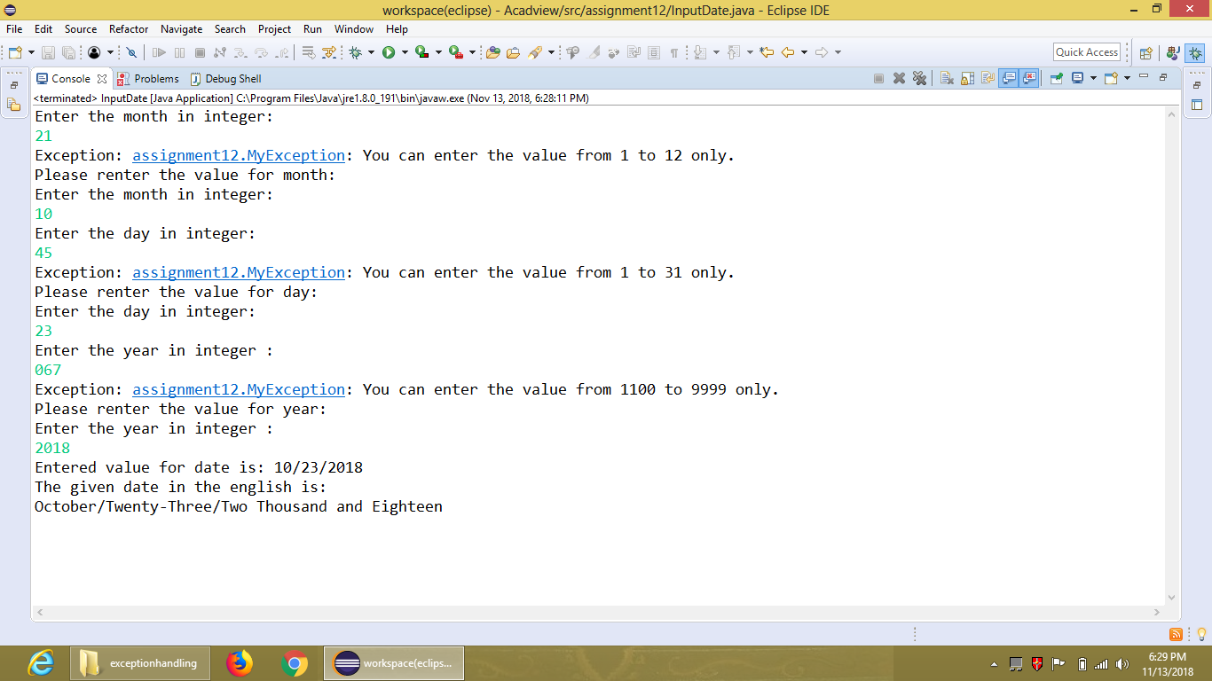

**2. Create a generic Sorting function that can sort any type of array (primitive types).**

package assignment12;

import java.util.ArrayList;

import java.util.Collections;

import java.util.List;

class Generic<generic> extends ArrayList {

//generic e;

ArrayList <generic>al;

Generic(){

al=new ArrayList<>(); }

void addElement(generic e){

al.add(e); }

void printList(List l) {

for(int i=0;i<l.size();i++) {

System.out.println(l.get(i));} }

}

public class SortGenericArray{

public static void main(String[] args) {

Generic gint=new Generic();

gint.addElement(10);

gint.addElement(7);

gint.addElement(1);

gint.addElement(3);

System.out.println("The elements of integer array before sorting are:");

gint.printList(gint.al);

Collections.sort(gint.al);

System.out.println("The elements of integer array after sorting are:");

gint.printList(gint.al);

Generic gchar =new Generic();

gchar.addElement('t');

gchar.addElement('c');

gchar.addElement('z');

gchar.addElement('a');

System.out.println("The elements of character array before sorting are:");

gchar.printList(gchar.al);

Collections.sort( gchar.al);

System.out.println("The elements of character array after sorting are:");

gchar.printList(gchar.al);

Generic gdouble =new Generic();

gdouble.addElement(12.0);

gdouble.addElement(1.04);

gdouble.addElement(1.00);

gdouble.addElement(7.50);

System.out.println("The elements of double type array before sorting are:");

gdouble.printList(gdouble.al);

Collections.sort( gdouble.al);

System.out.println("The elements of double type array after sorting are:");

gdouble.printList(gdouble.al);

Generic gfloat =new Generic();

gfloat.addElement(2.0f);

gfloat.addElement(1.04f);

gfloat.addElement(11.00f);

gfloat.addElement(5.50f);

System.out.println("The elements of float array before sorting are:");

gfloat.printList(gfloat.al);

Collections.sort( gfloat.al);

System.out.println("The elements of float array after sorting are:");

gfloat.printList(gfloat.al);

Generic gString =new Generic();

gString.addElement("hello");

gString.addElement("acadview");

gString.addElement("world");

gString.addElement("welcome");

System.out.println("The elements of string array before sorting are:");

gString.printList(gString.al);

Collections.sort( gString.al);

System.out.println("The elements of string array after sorting are:");

gString.printList(gString.al);

}

}

**OUTPUT:**

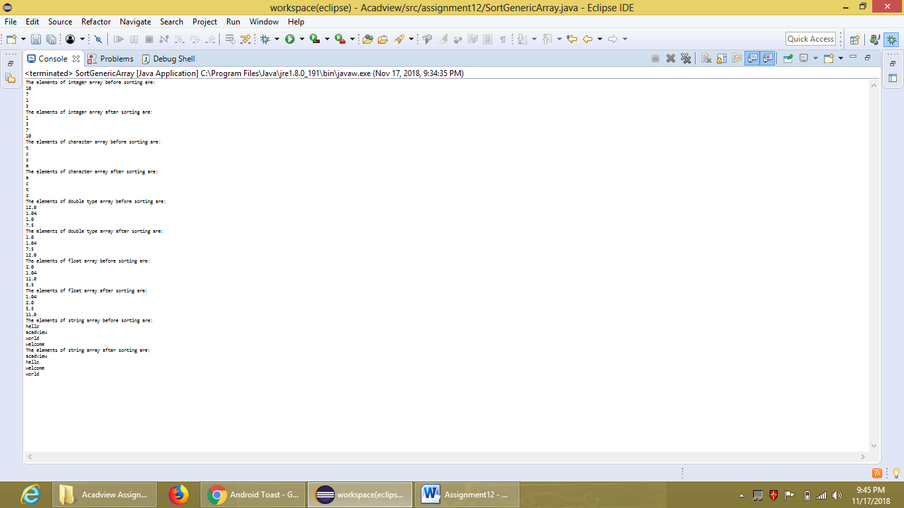

**3.Create a generic print function that can print all types of arrays (primitive types).**

package assignment12;

import java.util.Scanner;

class GenericPrint<print>{

print obj;

public GenericPrint(print value) {

obj=value;}

void PrintFunction() {

System.out.println(obj);}

}

public class GenericPrintFunction {

public static void main(String arg[]) {

Scanner scan=new Scanner(System.in);

GenericPrint p=new GenericPrint(1);

p.PrintFunction();

GenericPrint p1=new GenericPrint(1.56f);

p1.PrintFunction();

GenericPrint p2=new GenericPrint(567.98);

p2.PrintFunction();

GenericPrint p3=new GenericPrint("Hello Acadview");

p3.PrintFunction();

GenericPrint p4=new GenericPrint('c');

p4.PrintFunction();

System.out.println("Please enter the data that you want to print:");

String st=scan.nextLine();

GenericPrint g=new GenericPrint(st);

g.PrintFunction();

}

}

**OUTPUT:**

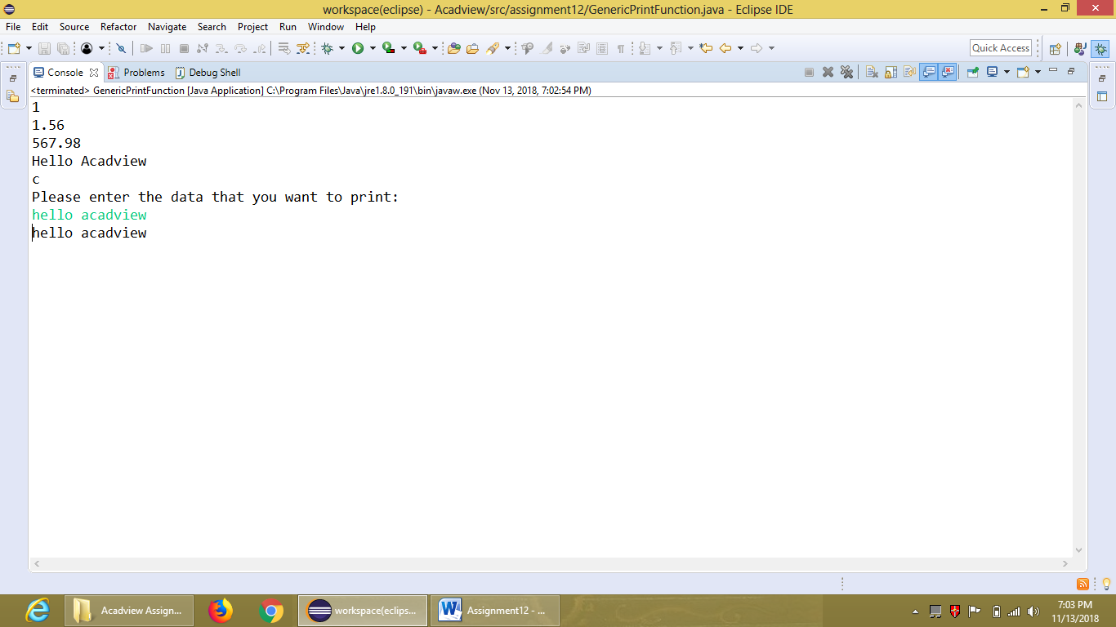

**4. Write a java program that sorts the list on the basis of age and name.**

package assignment12;

import java.io.IOException;

import java.util.ArrayList;

import java.util.Collections;

import java.util.Comparator;

import java.util.InputMismatchException;

import java.util.List;

import java.util.Scanner;

class MyList {

int age;

String name;

public MyList(String name, int age) {

this.name=name;

this.age=age;}

}

class SortByAge implements Comparator<MyList>{

public int compare(MyList o1, MyList o2){

if(o1.age<o2.age) {

return -1;}

else

return 1;

}

}

class SortByName implements Comparator<MyList>{

public int compare(MyList o1, MyList o2){

return (o1.name.compareTo(o2.name));

} }

public class SortstheList {

public static void main(String arg[]) throws IOException{

ArrayList<MyList> list=new ArrayList<>();

Scanner scan=new Scanner(System.in);

String n;

int a;

boolean b=true;

try {

while(b==true) {

System.out.println("Enter the name: ");

//n=scan.nextLine();

n=scan.next();

System.out.println("Enter the age: ");

a=scan.nextInt();

list.add(new MyList(n,a));

System.out.println("Please enter anyone option from following:");

System.out.println("1. Enter 'true' if you want to add more data.");

System.out.println("2. Enter 'false' if you don't want to add more data.");

b=scan.nextBoolean();

}}

catch(InputMismatchException in) {

System.out.println("You entered the wrong data.");}

catch(Exception e) {

System.out.println("Error has occured in the code.");}

finally {

SortByAge sa=new SortByAge();

Collections.sort(list, sa);

System.out.println("Data sorted according to age:");

for(int i=0;i<list.size();i++) {

System.out.println(list.get(i).name+" "+list.get(i).age);}

SortByName sn=new SortByName();

Collections.sort(list, sn);

System.out.println("Data sorted according to name:");

for(int i=0;i<list.size();i++) {

System.out.println(list.get(i).name+" "+list.get(i).age);}}

}}

**OUTPUT:**

