**ASSIGNMENT 13**

**1. Create a multi-threaded program with a synchronised method to print values from 1 to 1000 using 2 threads.**

**Method 1.**

package assignment13;

class Function implements Runnable {

String thread[]=new String[2];

int z,i=1;

public void run() {

z=0;

System.out.println(Thread.currentThread().getName()+" is entered in run method. ");

for(int j=0;j<2;) {

if(Thread.currentThread().getName()!=thread[0]) {

thread[j]=Thread.currentThread().getName();

j=++j;

}}

synchronized(this) {

//System.out.println(Thread.currentThread().getName()+" is entered in loop.");

while(i<=1000){

try {

Thread.currentThread().sleep(100);

}

catch(InterruptedException ie) {

System.out.println("Thread has interrupted.");

}

if(i%100==0) {

System.out.println();

System.out.println("Is "+thread[0] +" Alive:"+Thread.currentThread().isAlive());

System.out.println("Is "+thread[1] +" Alive:"+Thread.currentThread().isAlive());

}

System.out.print(i+", ");

i=++i;

}}

System.out.println();

System.out.println("Is "+thread[0] +" Alive:"+Thread.currentThread().isAlive());

System.out.println("Is "+thread[1] +" Alive:"+Thread.currentThread().isAlive());}

}

public class UseSynchcroInMultithreading {

public synchronized static void main(String[] args)throws InterruptedException {

System.out.println(Thread.currentThread().getName()+" starts here.");

Function f=new Function();

Thread t1=new Thread(f,"Thread1");

Thread t2=new Thread(f,"Thread2");

System.out.println("Thread1 is starting here.");

t1.start();

System.out.println("Thread2 is starting here.");

t2.start();

System.out.println("Is Thread1 Alive:"+t1.isAlive());

System.out.println("Is Thread2 Alive:"+t2.isAlive());

try {

t2.join();

}

catch(InterruptedException ie) {

System.out.println("Thread has interrupted.");

}

System.out.println(Thread.currentThread().getName()+" stops here.");

}

}

**OUTPUT:**

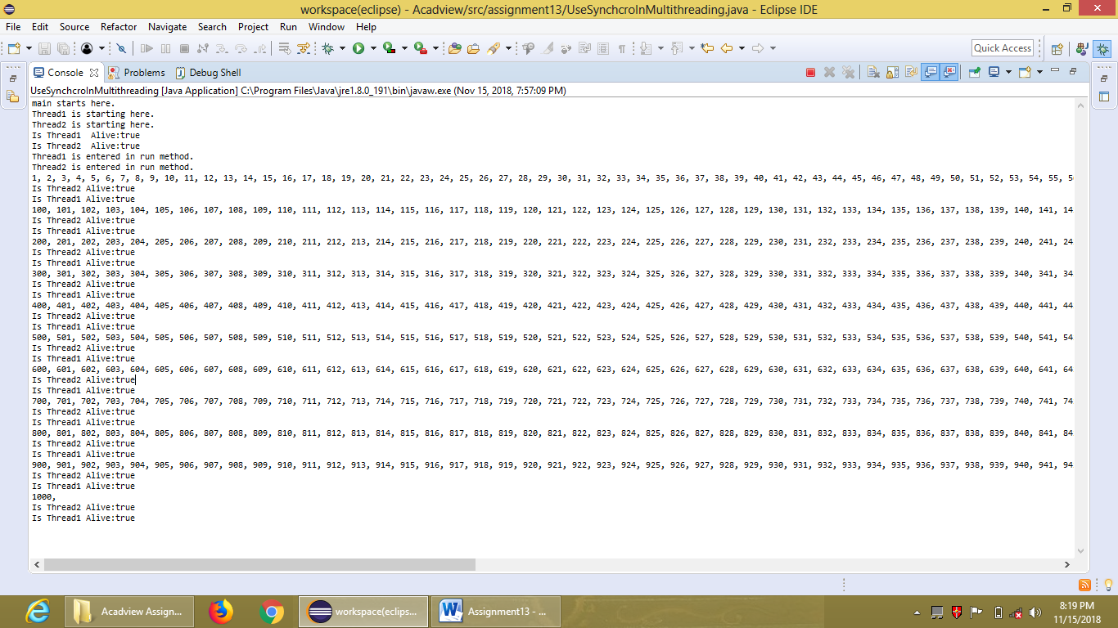

**Method 2.**

package assignment13;

class PrintValue implements Runnable{

public synchronized void run(){

System.out.println(Thread.currentThread().getName()+": ");

for(int i=1;i<=1000;i++) {

if(i%100==0) {

System.out.println();

}

System.out.print(i+", ");

try {

Thread.sleep(100);

}catch(InterruptedException ie) {

System.out.println("Thread is interrupted.");

}

}

System.out.println();

}

}

public class SynchronizationInMultithreading{/* extends Thread{

public void run(){

for(int i=0;i<=100;i++) {

System.out.print(Thread.currentThread().getName()+": ");

System.out.println(i);

/*try {

Thread.sleep(100);

}catch(InterruptedException ie) {

System.out.println("Thread is interrupted.");

}

}

}*/

public static void main(String[] args) { //throws InterruptedException{

System.out.println("Thread Main starts here.");

PrintValue p=new PrintValue();

Thread t1=new Thread(p,"Thread1");

Thread t2=new Thread(p,"Thread2");

t1.start();

t2.start();

try {

// t1.join();

t2.join();}

catch(InterruptedException ie) {

System.out.println("Thread has interrupted.");

}

System.out.println("Thread Main stops here.");

}

}

**OUTPUT:**

