**Assignment-14**

**1. Create a simple Hello World app.**

**Main Activity.java:**

package com.example.sr.assignment14;

import android.support.v7.app.AppCompatActivity;

import android.os.Bundle;

public class MainActivity extends AppCompatActivity {

@Override

protected void onCreate(Bundle savedInstanceState) {

super.onCreate(savedInstanceState);

setContentView(R.layout.activity_main);

}

}

**AndroidManifest.xml:**

<?xml version="1.0" encoding="utf-8"?>

<manifest xmlns:android="http://schemas.android.com/apk/res/android"

package="com.example.sr.assignment14">

<application

android:allowBackup="true"

android:icon="@mipmap/ic_launcher"

android:label="@string/app_name"

android:roundIcon="@mipmap/ic_launcher_round"

android:supportsRtl="true"

android:theme="@style/AppTheme">

<activity android:name=".MainActivity">

<intent-filter>

<action android:name="android.intent.action.MAIN" />

<category android:name="android.intent.category.LAUNCHER" />

</intent-filter>

</activity>

</application>

</manifest>

**Activity_main.xml:**

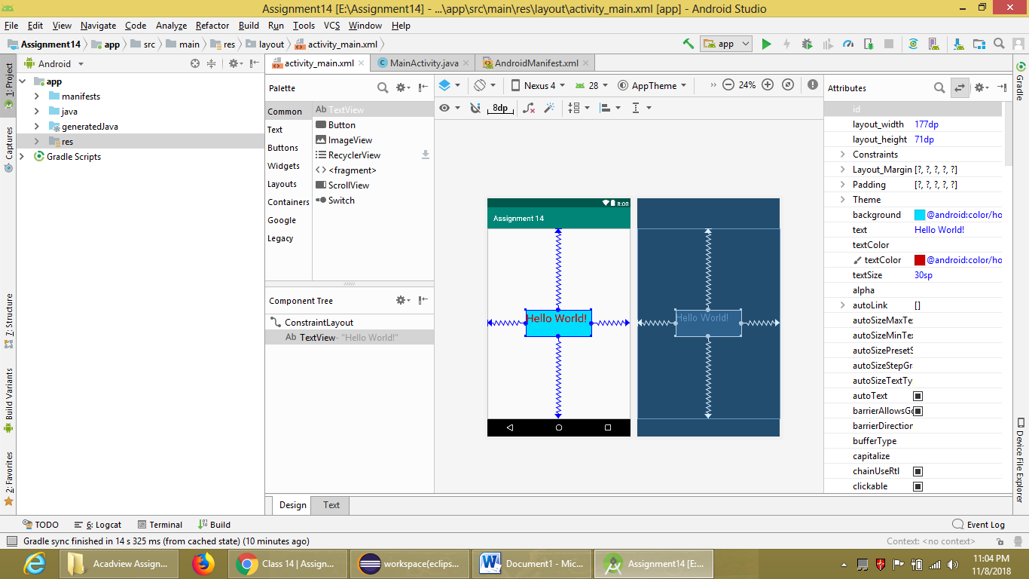

**OUTPUT:**

